ORMAP Taxlot Editing Toolbar version 3.0
Copyright © 2008 ORMAP Tech Group. All rights reserved.

The ORMAP Taxlot Editing Toolbar gives the user tools to edit taxlots and related features in compliance with the ORMAP standard.

Edit MapIndex Tool

General Description:
The Edit Map Index Tool edits the selected MapIndex polygon and underlying Taxlot polygons.

Prerequisites:
- Must have at least MapIndex and Taxlot feature classes loaded.

How to Use:
- Must have at least MapIndex and Taxlot feature classes loaded.

- Start editing the MapIndex feature class.

- Select a MapIndex polygon feature.

- Press the “Map Index” Tool button on the ORMAP toolbar.

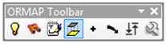

- In the dialog window press the Edit Button.

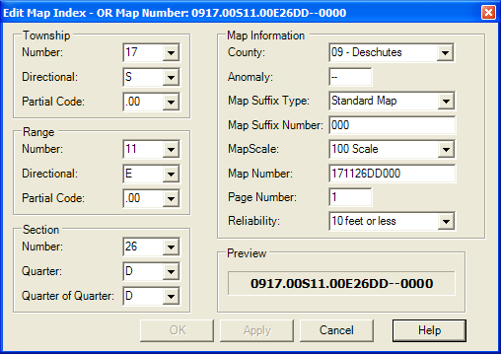

- Makes edits to the Map Index values.

- Press the Apply button to save your edits and keep the window open or press the OK button to save your changes and close the window.

- If you pressed Apply above, when done reviewing your changes, press the Cancel Button to close the dialog window.

Notes:
- Pressing the OK button is the same as pressing the Apply button and then the Cancel button.

- Changes to any field dynamically updates the ORMAP number preview in the lower right corner of the dialog window.

- Changes made to the Map Index update underlying Taxlot polygons.

- The Map Index Reliability Code does not update the Taxlot polygon reliability code. This allows for polygon specific reliability tolerances for each Taxlot.

Reporting Bugs and Requesting New Features:
For instructions on how to report a bug or request a new feature, go the bottom of the help form or to Editor ► Options ► ORMAP Taxlot Editor and click Report Bug or Request New Feature.

