ORMAP Taxlot Editing Toolbar version 3.0
Copyright © 2008 ORMAP Tech Group. All rights reserved.

The ORMAP Taxlot Editing Toolbar gives the user tools to edit taxlots and related features in compliance with the ORMAP standard.

Sort Cancelled Numbers Tool

General Description:
The Sort Cancelled Numbers Tool allows a user to sort, add, or remove taxlots from the cancelled numbers table.

Prerequisites:
▪ Must have the MapIndex and Taxlot polygon feature classes loaded into the active data frame of the current map document. The cancelled numbers table must contain a short integer field named “SortOrder”

How to Use:
- Press the Sort Cancelled Numbers tool on the ORMAP Editing Toolbar.

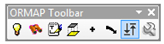

- The Sort Cancelled Numbers window will appear. Enter a MapNumber into the text input box and press Find.

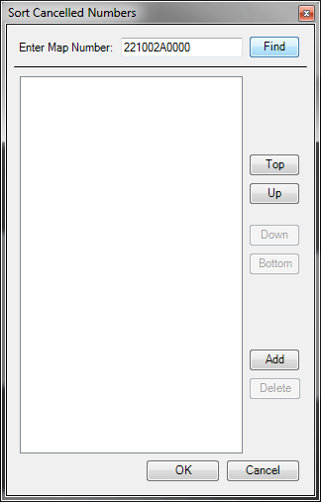

- Select a taxlot from the list and use the tools on the right to move the taxlot up or down in the list or to the top or bottom of the list.
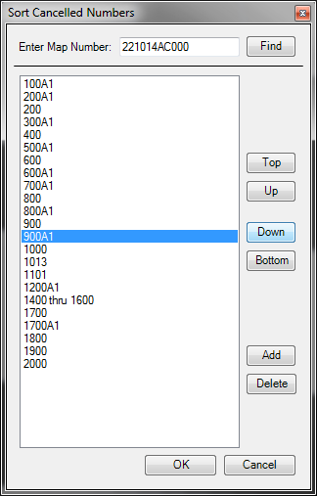

- Add a taxlot(s) by pressing the Add button and entering the taxlot or text in the box.
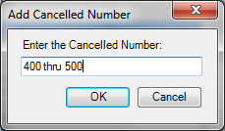

- Delete a taxlot by selecting the taxlot and pressing Delete.

Notes:
▪ The Map Number combo box updates to include any new map numbers that have been created whenever you close and then re-open the form. Changes are immediately saved. You must save your edits when stopping your edit session for the changes to be permanently saved.

Reporting Bugs and Requesting New Features:
For instructions on how to report a bug or request a new feature, go the bottom of the help form or to Editor ► Options ► ORMAP Taxlot Editor and click Report Bug or Request New Feature.

