ORMAP Spiral Toolbar version 1.0
Copyright © 2011 ORMAP Tech Group. All rights reserved.

The ORMAP Taxlot Editing Toolbar gives the user tools to edit taxlots and related features in compliance with the ORMAP standard.

Spiral-Curve-Spiral Transition Tool

General Description:

The Spiral-Curve-Spiral Transition tool creates three polyline features based on user inputs. The user form requires that you enter the length of the spirals and either the degree-of-curve or the radius of the central angle.

The tool requires that you enter the beginning point, a tangent point, and an end point. You may enter the point coordinates or get them of the map.

Prerequisites:
▪ Must use a polyline feature class.
▪ Editing enabled

How to Use:
To enable the tool:

- Press the Spiral-Curve-Spiral Tool on the Spirals Toolbar.

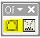

2. The Spiral-curve-spiral dock-able window with either display on (shift)left-mouse click or hide. The button will indicate the down position if the window is visible and the up position if the window is hidden. Because this is a dock-able window you have the option of either docking the window or using it as a standard window. Docking the window is helpful if you plan on leaving the window open for an extended period of time.

3. One the dock-able window, specify the direction of the spiral-curve-spiral. Right means the construction is going clockwise. Specify left if the construction is going counter-clockwise. Next, enter the lengths of the spirals.

There are two ways of specifying the central curve. The first way is by entering in the value of the curve’s radius. If the curve’s radius is not known, then enter in the degree of curve. The degree-of-curve value uses either a decimal number or degree minutes bearings. The format for the degree-of-curve is 00-00-00.

There are two ways of enter the input points. The first way is by entering in the values based from the key board. The other way is to query the map for the coordinates. That is done by clicking on the button in each coordinate group.

When all the input parameters are entered click the create button.

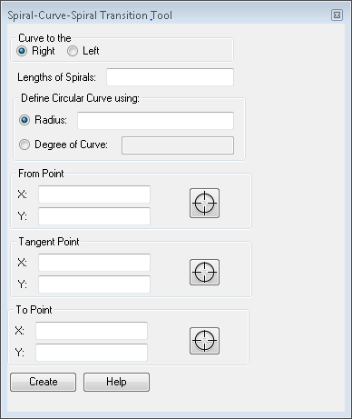

Reporting Bugs and Requesting New Features:
For instructions on how to report a bug or request a new feature, go the bottom of the help form or to Editor ► Options ► ORMAP Taxlot Editor and click Report Bug or Request New Feature.

