ORMAP Spiral Toolbar version 1.0
Copyright © 2011 ORMAP Tech Group. All rights reserved.

The ORMAP Taxlot Editing Toolbar gives the user tools to edit taxlots and related features in compliance with the ORMAP standard.

Spiral Tool

General Description:

The Spiral-Curve-Spiral Transition tool creates three polyline features based on user inputs. The user form requires that you enter the length of the spirals and either the degree-of-curve or the radius of the central angle.

The tool requires that you enter the beginning point, a tangent point, and an end point. You may enter the point coordinates or get them of the map.

Prerequisites:
▪ Must use a polyline feature class.
▪ Editing enabled

How to Use:
To enable the tool:

- Press the Spiral Tool on the Spirals Toolbar.

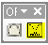

2. The Spiral dock-able window with either display on (shift)left-mouse click or hide. The button will indicate the down position if the window is visible and the up position if the window is hidden. Because this is a dock-able window you have the option of either docking the window or using it as a standard window. Docking the window is helpful if you plan on leaving the window open for an extended period of time.

3. One the dock-able window, specify the direction of the spiral. Right means the construction is going clockwise. Specify left if the construction is going counter-clockwise. Next, enter the beginning and end radius. Then either enter the length of the spiral or the delta angle. The tool requires that start point and a point is specified. The user can enter the point into the text boxes or by clicking on the cross hair button. The cross hair button allows the user to get the point from the map. This tool takes into account current snapping properties.

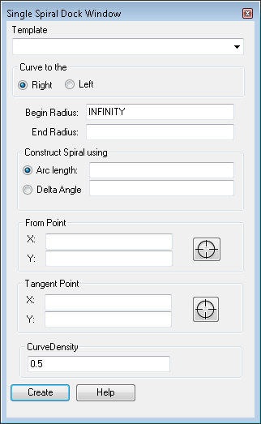

Reporting Bugs and Requesting New Features:
For instructions on how to report a bug or request a new feature, go the bottom of the help form or to Editor ► Options ► ORMAP Taxlot Editor and click Report Bug or Request New Feature.

