ORMAP Taxlot Editing Toolbar version 3.0
Copyright © 2008 ORMAP Tech Group. All rights reserved.

The ORMAP Taxlot Editing Toolbar gives the user tools to edit taxlots and related features in compliance with the ORMAP standard.

Taxlot Assignment Tool

General Description:
The Taxlot Assignment tool assigns taxlot numbers in sequence, based on a starting number and a step increment.

Prerequisites:
- Must have the MapIndex and Taxlot polygon feature classes and the Cancelled Numbers standalone table loaded into the active data frame of the current map document.

How to Use:
- Start editing the workspace containing the Mapindex and Taxlot feature classes.

- If desired, select the Autoupdate Features button to turn on field auto-updating. This will update all taxlot fields to match the new taxlot number.

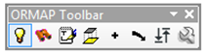

- Press the “Taxlot Assignment” button on the ORMAP Editing toolbar.

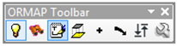

- Select the Type of Polygon.

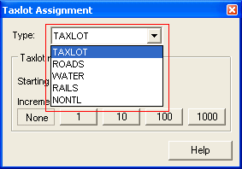

- Enter a Starting From value.

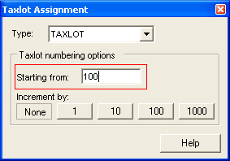

- Select an Increment By Option.

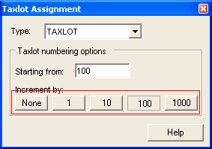

- Click a taxlot on the map. The attributes will be updated to match your selection and the Starting From number will increase by the increment amount.

- If the new taxlot number added already exists, a warning dialog window will appear asking you to confirm the assignment.

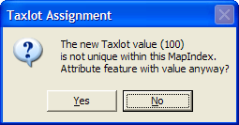

- If the taxlot already has a number, a warning dialog window will appear asking you to confirm the assignment.

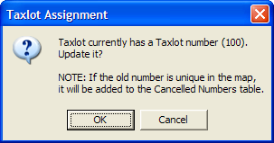

Notes:
- If the old taxlot number was unique in the map, and auto-update functionality is turned on, the old map and lot numbers will be added to the Cancelled Numbers table.

Reporting Bugs and Requesting New Features:
For instructions on how to report a bug or request a new feature, go the bottom of the help form or to Editor ► Options ► ORMAP Taxlot Editor and click Report Bug or Request New Feature.

