05/08/07

opet version 2.0, Copyright (C) 2006 opet programmers
opet comes with ABSOLUTELY NO WARRANTY; for details see the General Public License (GPL) file that came with this program or go to http://www.gnu.org/copyleft/gpl.html
This is free software, and you are welcome to redistribute it under conditions outlined in the sections named TERMS AND CONDITIONS FOR COPYING, DISTRIBUTION AND MODIFICATION of the GPL.

General Description:
The Locate Tool moves the map extent to either a map number or a map number and tax lot depending user input values.

How to Use:
- Must have at least MapIndex and Taxlot polygon feature classes loaded.
- Press the Locate Tool on the ORMAP Editing Toolbar.

- Select a map number or select a map number and enter a tax lot.
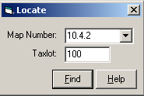
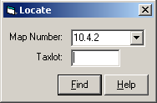

OR

- Press the Find button.

Notes:
- The “Locate” tool now selects the Taxlot polygon you are searching for, if it exists. The help dialog for this tool now appears in the default ArcMap dialog prompt on the lower left of your screen.
- The Map Number combo box updates when you save edits through the editor toolbar.

