ORMAP Taxlot Annotation Toolbar version 2.1.3
Copyright © 2008 ORMAP Tech Group. All rights reserved.

The ORMAP Save COGO Toolbar allows for the saving and proportioning COGO Distance and Bearing (Direction) attributes which would normally deleted by various ArcMap editing operations.

ORMAP Save COGO Toolbar

General Description:
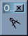
The Save COGO Toolbar provides a basic means of preserving COGO Distance and Bearing (Direction) attributes so that they may be reapplied after performing ArcMap editing operations. Lines are selected in an edit session and their COGO attributes preserved. If an edit operation is performed which creates new (children) lines from the original (parent), new attributes are determined for the parent and its children. Direction is copied directly, whereas distance is proportioned based on the following ratio calculation:

pL = Parent Legal distance (known from COGO)
pG = Parent Geometry distance (known from feature)
cL = Child Legal distance (unknown)
cG = Child Geometry distance (known from feature)

cL = pL ≡ cL = (pL)(cG)
cG pG pG

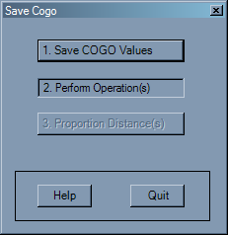
How to Use:
- Save COGO Values- Stores the COGO Distance and Direction attributes for all selected line features. Must be used prior to any edit commands, as the edit commands nullify the Distance and Direction values.

- Perform Operation(s)- The user performs the desired edit operation(s) on the selected line(s). Note that multi-step operations can be performed on a single line feature by reselecting it (for example, after a split), but the user must remember what other line feature’s attributes were saved.
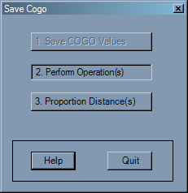
- Proportion Distance(s)- This button will proportionally (see above) recalculate Distance and reassign the original bearing attribute. These values are nullified by ArcMap edit processes.

Prerequisites:
- Because this tool operates under the OrmapTaxlotEditing umbrella (and relies on the AutoUpdate feature of that toolset), all needed ORMAP feature classes must be loaded:
  - Taxlot
  - MapIndex
  - TaxlotLines
- Must be in an edit session.
- Must have at least one line feature selected from TaxlotLines.
- Selected line(s) must have Distance and Direction values.

Notes:

Reporting Bugs and Requesting New Features:
For instructions on how to report a bug or request a new feature, go the bottom of the help form or to Editor ► Options ► ORMAP Taxlot Editor and click Report Bug or Request New Feature.

