ORMAP Taxlot Editing Toolbar version 2.0
Copyright © 2008 ORMAP Tech Group. All rights reserved.

The ORMAP Taxlot Editing Toolbar gives the user tools to edit taxlots and related features in compliance with the ORMAP standard.

Edit MapIndex Tool

General Description:
The Edit Map Index Tool edits the selected MapIndex polygon and underlying Taxlot polygons.

Prerequisites:
- Must have at least MapIndex and Taxlot feature classes loaded.

How to Use:
- Must have at least MapIndex and Taxlot feature classes loaded.

- Start editing the MapIndex feature class.

- Select a MapIndex polygon feature.

- Press the “Map Index” Tool button on the ORMAP toolbar.

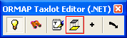

- In the dialog window press the Edit Button.

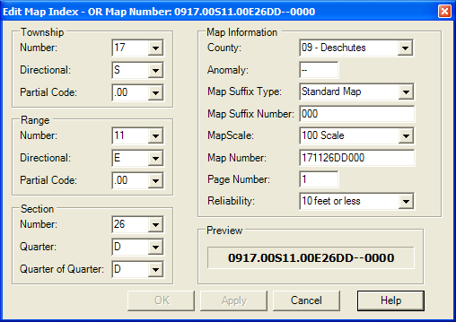

- Makes edits to the Map Index values.

- Press the Save Button.

- Press the Quit Button to close the dialog window.

Notes:
- The Map Index tool now dynamically updates the ORMAP number in the lower right corner of the dialog window.

- Changes made to the Map Index now updates underlying Taxlot polygons.

- The Map Index Reliability Code does not update the Taxlot polygon reliability code. This allows for polygon specific reliability tolerances for each Taxlot.

Reporting Bugs and Requesting New Features:
For instructions on how to report a bug or request a new feature, go the bottom of the help form or to Editor ► Options ► ORMAP Taxlot Editor and click Report Bug or Request New Feature.

