ORMAP Taxlot Editing Toolbar version 2.0
Copyright © 2008 ORMAP Tech Group. All rights reserved.

The ORMAP Taxlot Editing Toolbar gives the user tools to edit taxlots and related features in compliance with the ORMAP standard.

Locate Feature Tool

General Description:
The Locate Tool changes the map extent to the extent of either a MapIndex or Taxlot polygon depending on user input values (a map number or a map number and tax lot).

Prerequisites:
- Must have the MapIndex and Taxlot polygon feature classes loaded into the active data frame of the current map document.

How to Use:
- Press the Locate Tool on the ORMAP Editing Toolbar.

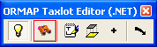

- Start typing in the Map Number box and a list of matching map numbers will appear in the drop-down below. Either type in the entire map number or select it from the list. If you wish to locate a taxlot instead of a map number you must first enter the map number then start typing in the taxlot number in the Taxlot drop-down. Taxlots present within the MapIndex map number that you entered will display in the Taxlot drop-down list.

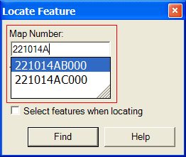 OR 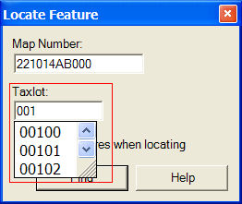

- If you wish to select the feature in addition to locating it (zooming to it), check the box labeled “Select features when locating”.

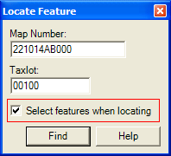

- Press the Find button.

Notes:
- The Map Number combo box updates to include any new map numbers that have been created whenever you close and then re-open the form.

Reporting Bugs and Requesting New Features:
For instructions on how to report a bug or request a new feature, go the bottom of the help form or to Editor ► Options ► ORMAP Taxlot Editor and click Report Bug or Request New Feature.

