05/08/07
opet version 2.0, Copyright (C) 2006 opet programmers
opet comes with ABSOLUTELY NO WARRANTY; for details see the General Public License (GPL) file that came with this program or go to http://www.gnu.org/copyleft/gpl.html
This is free software, and you are welcome to redistribute it under conditions outlined in the sections named TERMS AND CONDITIONS FOR COPYING, DISTRIBUTION AND MODIFICATION of the GPL.

General Description:
The “Taxlot Assignment” assigns tax lot numbers.

How to Use:
- Must have at least MapIndex and Taxlot polygon feature classes loaded.
- Start editing a feature class.
- Press the “Taxlot Assignment” button on the ORMAP Editing toolbar.

- Select the Type of Polygon.
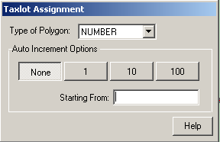

- Select an Auto Increment Option.
  - None
  - 1
  - 10
  - 100

- Enter a Start From value.
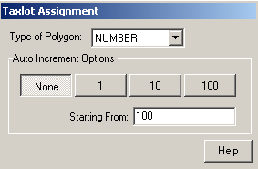

- Click on the map

Notes:
      - If the new number added already exists a warning dialog window will appear and ask a yes/no question.
