05/08/07
opet version 2.0, Copyright (C) 2006 opet programmers
opet comes with ABSOLUTELY NO WARRANTY; for details see the General Public License (GPL) file that came with this program or go to http://www.gnu.org/copyleft/gpl.html
This is free software, and you are welcome to redistribute it under conditions outlined in the sections named TERMS AND CONDITIONS FOR COPYING, DISTRIBUTION AND MODIFICATION of the GPL.

General Description:
The “Combine Taxlot” Tool combines tax lots in the Taxlot polygon feature class.

How to Use:
- Must have at least MapIndex, and Taxlot(polygon) feature classes loaded.
- Start editing the Taxlot polygon feature class.
- Select two tax lot polygons.
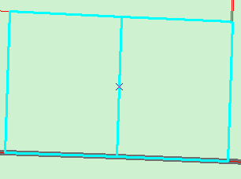

- Press the “Combine Selected Taxlots” button on the ORMAP Editing Toolbar.

- In the dialog window enter the new tax lot.
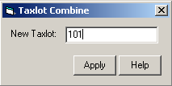

- Press the Apply button

Notes:
      - If the new tax lot number entered into the dialog window already exists then a warning message will be displayed and a new unique tax lot number must be entered into the dialog window.

