Notes about the 18x24 Map Tool

The four data frame must be named MapView, LocatorMap, Sections and Quarter Sections

In data frames LocatorMap, Sections, Quarter Sections the masking layer needs to start with Mask. Ex. Mask - Sections

Only shows up to 132 cancelled numbers.

In the page and print setup:
- set the printer to your plotter
- set the paper size to 18x24 (this may need to a custom size)
- may need to set the Paper Orientation to landscape
- Check User Printer Paper Settings in Map Page Size area
- Make sure Scale Map Elements proportionally to changes in Page size is unchecked.

Assumes that the plotter is set to minimum margins which are 5mm.

To use the Map Exception Tool, , you must use the Map Production Tool first to set the map. If you get:
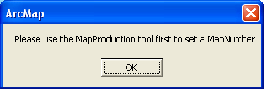

Run the Map Production Tool to set the map. Usually happens when first opened and no maps have been created using the Map Production Tool
For best results, on the Print Window, set the Output Image Quality to Best

