05/08/07
opet version 2.0, Copyright (C) 2006 opet programmers
opet comes with ABSOLUTELY NO WARRANTY; for details see the General Public License (GPL) file that came with this program or go to http://www.gnu.org/copyleft/gpl.html
This is free software, and you are welcome to redistribute it under conditions outlined in the sections named TERMS AND CONDITIONS FOR COPYING, DISTRIBUTION AND MODIFICATION of the GPL.

General Description:
The Map Index Tool edits the selected MapIndex polygon and underlying Taxlot polygons.

How to Use:
- Must have at least MapIndex and Taxlot feature classes loaded.
- Start editing the MapIndex feature class.
- Select a MapIndex polygon feature.
- Press the “Map Index” Tool button on the ORMAP toolbar.

- In the dialog window press the Edit Button.
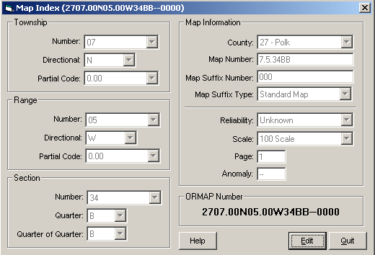

- Makes edits to the Map Index values.
- Press the Save Button.
- Press the Quit Button to close the dialog window.

Notes:
- The Map Index tool now dynamically updates the ORMAP number in the lower right corner of the dialog window.
- Changes made to the Map Index now updates underlying Taxlot polygons.
- The Map Index Reliability Code does not update the Taxlot polygon reliability code. This allows for polygon specific reliability tolerances for each Taxlot.

