**ORMAP BIG TOOLS MEETING Meeting Notes**

**Wed. September 28th - 11-12**

**Our Status (***From Google Form -**ArcPro/Fabric Conversion Status as reviewed by Dean)*

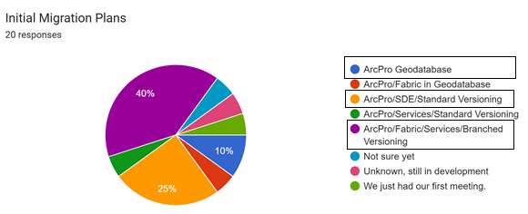

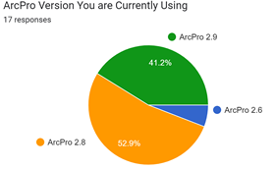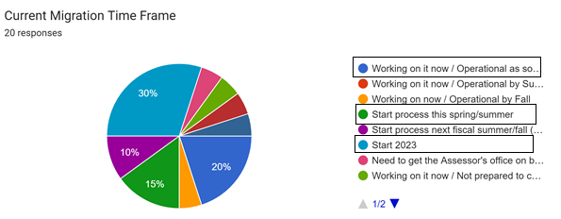

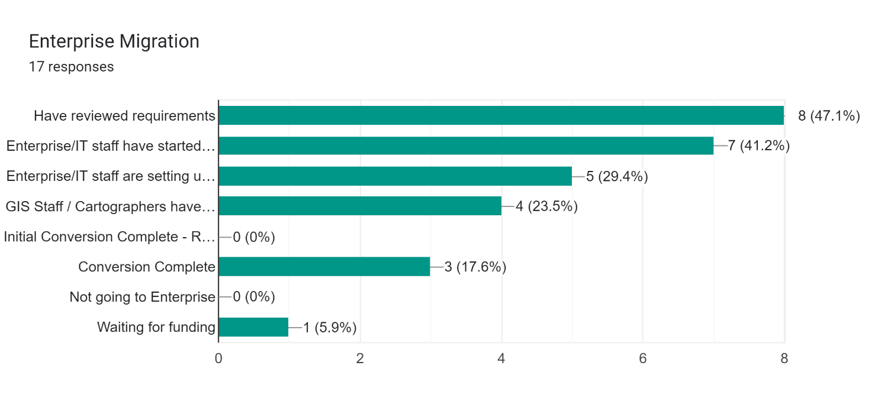

**Note:** D*on’t forget to update the Google Form: “ArcPro ArcPro/Fabric Conversion Status”*

*I will resend the link to everyone on the list. Please make updates and I will send out a summary to everyone in TWO WEEKS? HERE IS THE LINK: https://forms.gle/MFxUykwnHjGbqyMj9*

1. **ORMAP Database Design** (<https://ormaptools.github.io> – Thanks Brian!)

1a. Minor Design Change (ORMAP 3.0.1 - Standard ArcPro 2.94 with Parcel Fabric 5)  - Converted the CreatedByRecord Field Type  in non-fabric feature classes from Text to GUID. (done)

1b. Proposed Changes - Decision Time ----

* Add a field to Annotation Feature Classes  -  CoGoType - using the PF_CoGoType domain (Entered, From Geometry, Computed) - This will allow users to know what the source of annotation was. **(YES TO DO THIS**)
* Add a field to Taxlot and Taxlot_lines - RecordName - This will allow users to quickly see what the record name is **(YES TO DO THIS**)
* Add a new rule (CalcRecordName) - This will update the RecordName during Add and update **(YES TO DO THIS**)

**2. Tools & Support** -

2a. Tool Updates (see attached) - ORMAP3.0.1 – (<https://ormaptools.github.io/> )

The latest tool updates the ORMAP attributes from based on the ArcPro COGO calculated area.

Binh Co had issues with CoGo calculated area was not being calculated correctly. Seemed to have problems based on scale. They were doing the update as an attribute rule. Dean will work with Binh and find out if others are having similar issues.

2b. Support: A number of folks have asked how to get more support for tools committee folks. Dean will review the process as follows:

* Find Tools County willing to help (Polk, Clackamas, Multnomah, Deschutes, Washington, Clatsop)
* Develop a work plan for support (see attached)
* Take workplan to tools committee for approval (modify as needed)
* Send workplan to Phil
* Develop IGA (see attached) and have IGA and Workplan approved by both Counties
* Do work until done
* Notify committee of completed work (both counties)
* Upon approval Tools County sends bill for work completed to Phil

Tools Contacts: ([*bwilson@co.clatsop.or.us*](mailto:bwilson@co.clatsop.or.us)*,* [*anderson.dean@co.polk.or.us*](mailto:anderson.dean@co.polk.or.us)*, Binh_Le@co.washington.or.us, jonmcd@clackmas.us, nicholas.kovac@multco.us,* [*Michael.Mamic@deschutes.org*](mailto:Michael.Mamic@deschutes.org))

Ian – asked about how best to get support (ORMAP Grant or Tools). Phil summarized that you can use a Grant or the Tools process for get help with conversion or tool customization.  Grants are limited to the grant process but also can be integrated into other county ORMAP projects  Using Tools support can happen at any time and may work  best for smaller projects.

2c. Conversion Demo – I will be doing a short conversion review with Lincoln County within the next couple of weeks. Would be happy to do that via zoom and let others attend if interested. I will email everyone on the list.

**3. Next Steps** - Identify  steps that can be used to assist County's with migration.

* Review ESRI Training (ESRI) – Tabatha (ESRI) went over the ORMAP implementation strategy that has been sent out. Your county can take 3 class for FREE.
  + Creating & Editing Data with ArcGIS Pro (2 folks per county)
  + Working with Parcel Data (1 per county),
  + Configuring Branch Versioning (1 per county).
* Next Custom Fabric Training - VERY IMPORTANT to know ArcPro before taking this class!
* Other Opportunities - OSACA, etc.. .When do you want the next Training ?

--- OSACA – John R, John S, Dean, Klamath, Eric, Donna – We will get dates out…

**4. Other topics** **& discussion** (as time permits)