Real-Twin Automation Workflow for PTV Vissim
Progress report, October 2026 · Real-Twin team, Oak Ridge National Laboratory

Summary
Real-Twin now builds a complete, running PTV Vissim 2026 model from the same inputs it uses for SUMO: an OpenDRIVE network, GridSmart turning-movement counts and a Synchro signal export. Six Python scripts drive Vissim through its COM interface and write the network, demand, routing and actuated signal control; the user edits nothing in Vissim and fills one table row per counted junction. We tested the workflow on the Chattanooga Shallowford Road corridor and, this month, on a 70-junction Phoenix network the code had never seen. On both networks the Vissim model carries exactly the counts and signal timings in the source data.

1 Workflow
Figure 1 shows the six stages. Each script reads the previous stage's output and the city's own dataset folder, so no stage depends on a SUMO run.
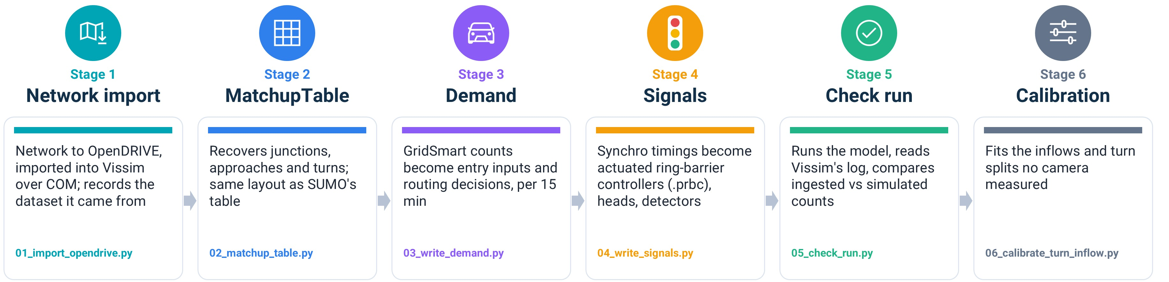
Figure 1. The six stages of the Vissim workflow, one script each.
- Network and MatchupTable (stages 1–2). Stage 1 imports the OpenDRIVE network and restores its true coordinates. Because Vissim has no junction object and renumbers every link, stage 2 matches each link to its OpenDRIVE road by geometry, length and lane count, then writes a MatchupTable of junctions, approaches and turns in SUMO's layout.
- Demand and routing (stage 3). The script places a vehicle input on each entry and a routing decision on each approach, carrying the GridSmart counts as 15-minute relative flows, so Vissim needs no external router.
- Signal control (stage 4). The script converts each Synchro plan into an actuated ring-barrier controller (.prbc), then places signal heads, detectors, conflict areas and right-turn-on-red stop signs. Conflict areas follow US right of way: movements that diverge from one approach see each other and neither yields; at a merge or crossing, the through movement has priority over a right, a right over a left and every movement over a U-turn; at unsignalised junctions the major road goes first and, where the roads are equally wide, the vehicle on the right; and a slip lane or ramp yields to the road it joins.
- Checks and calibration (stages 5–6). Stage 5 runs the model and compares the volumes and turn shares it delivers with those ingested; stage 6 calibrates the inflows and turn splits that no camera measured.

2 Test networks
The Chattanooga corridor has 186 links, 10 junctions and 6 signals, with 12 counted entries carrying 4,061 veh/h. The Phoenix network has 1,191 links, 70 junctions and 13 signals, with 15 counted entries carrying 9,843 veh/h; both models cover 08:00–09:00. Phoenix exposed three assumptions that Chattanooga never tested (count files with zeros for a missing leg, a non-numeric Synchro ID, and detectors without placement data), and the code now handles all three.
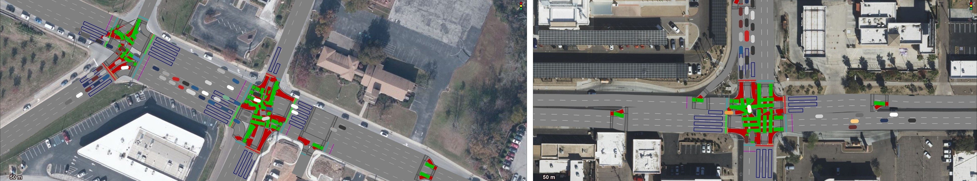
Figure 2. The generated models running in Vissim 2026: Chattanooga, Shallowford Rd @ Napier Rd (left), and Phoenix, Indian School Rd @ 7th St (right). Green and red areas are conflict areas, blue boxes are detectors. Background imagery © Microsoft, Maxar.

3 MatchupTable
The MatchupTable links the field data to the simulation network, with one row per turning movement: the approach and exit links, the turn, the GridSmart count code and the Synchro intersection. Vissim renumbers every link on import and has no junction object, so stage 2 pairs each Vissim link with its OpenDRIVE road by geometry, length and lane count, and groups the links into junctions. The user then names the GridSmart and Synchro file for each counted junction. Figure 3 shows the result for Shallowford Rd @ Gunbarrel Rd, the test case used throughout this report: the IDs are Vissim's own, and the movements match SUMO's table row for row.
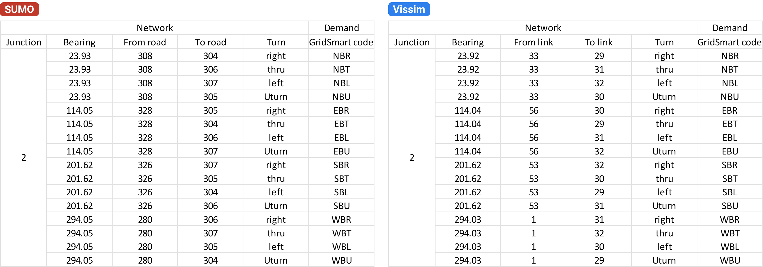
Figure 3. MatchupTable for Shallowford Rd @ Gunbarrel Rd, Chattanooga: SUMO (left) and Vissim (right).

4 Demand and signals
Demand. Stage 3 writes the GridSmart counts as vehicle inputs and routing decisions in 15-minute intervals. The resulting demand is the same as the demand RealTwin builds for SUMO from the same counts (Figure 4).
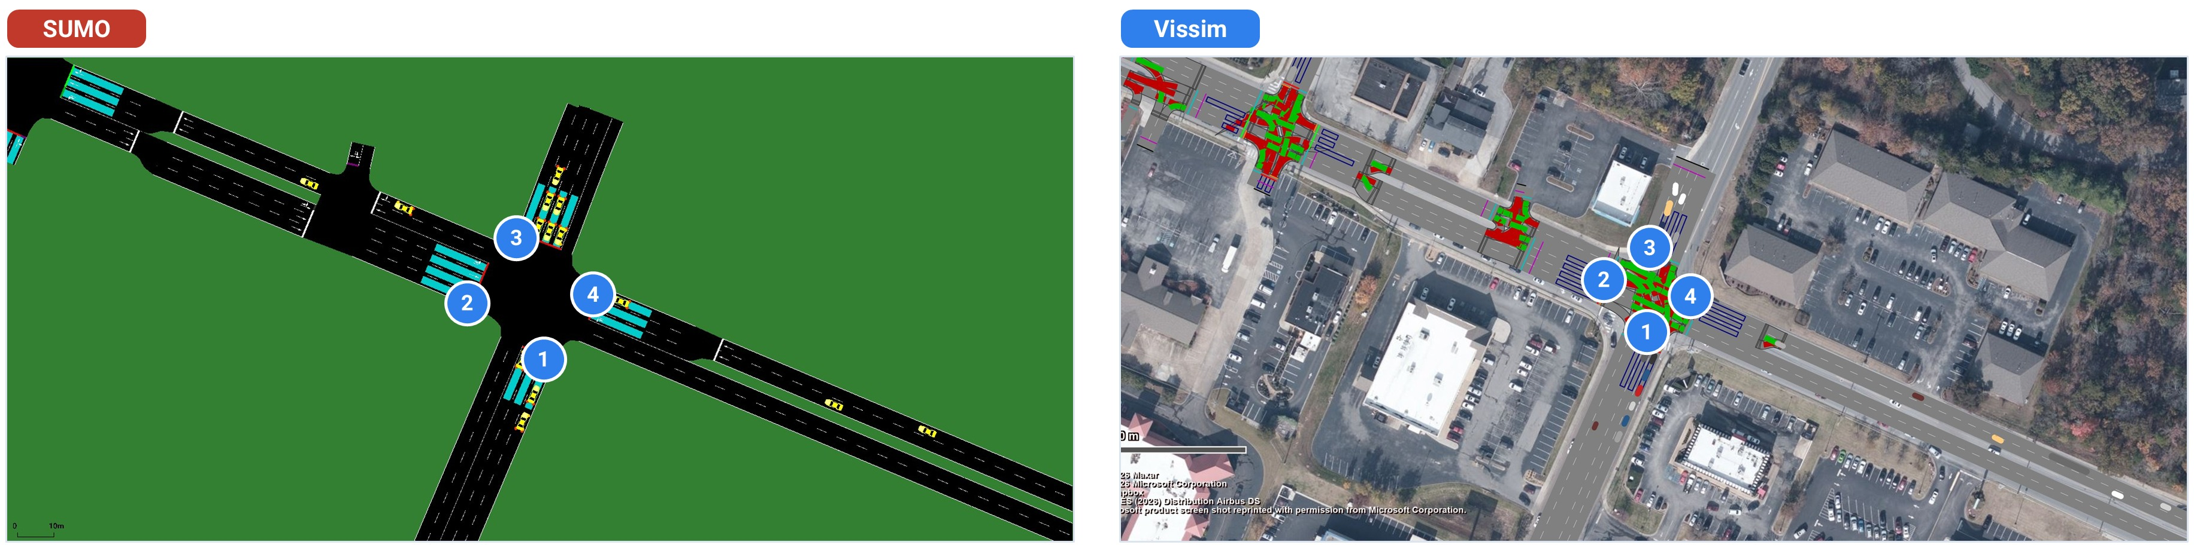
Figure 4. Shallowford Rd @ Gunbarrel Rd in SUMO (left) and Vissim (right), with the four counted approaches marked. Background imagery © Microsoft, Maxar.
Signals. Stage 4 writes each Synchro plan as an actuated ring-barrier controller and keeps every timing value: cycle, offset, minimum and maximum green, yellow, all-red, extension and recall (Figure 5).
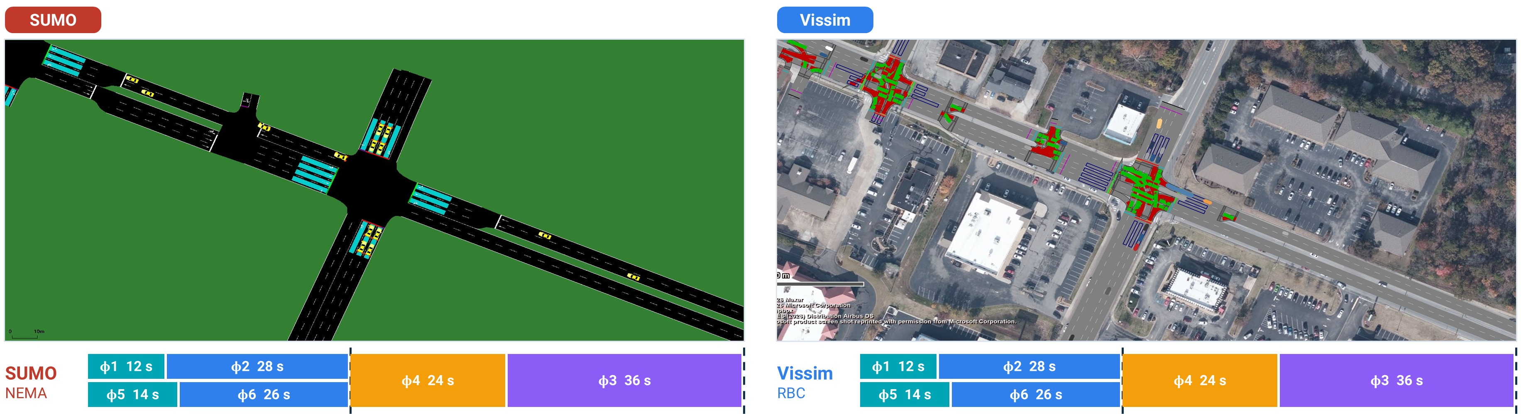
Figure 5. Shallowford Rd @ Gunbarrel Rd, 25 minutes into the run, with each simulator's ring-barrier diagram. Background imagery © Microsoft, Maxar.

5 Simulation and calibration
In an uncalibrated Phoenix run, 14 of 15 entry-fed approaches deliver their counted volume within GEH 5, and the network admits 95.7% of the counted entry traffic. The only shortfall is 7th St southbound at Indian School Rd, whose entry cannot take the counted 1,499 veh/h.
On Chattanooga, stage 6 calibrated the 12 inflows and turn splits that no camera measured, using a genetic algorithm over 110 simulations. The mean GEH per approach fell from 8.85 to 3.84, and the share of approaches under GEH 5 rose from 59.1% to 77.3% (Table 3), on par with SUMO's calibrated model.
Table 3. Chattanooga calibration, GEH against the GridSmart counts, 08:00–09:00.
Measure | As built | Calibrated
Mean GEH per approach | 8.85 | 3.84
Approaches with GEH < 5 | 59.1% | 77.3%
Mean GEH per movement | 3.69 | 1.75
Movements with GEH < 5 | 77.5% | 90.0%

6 Limitations and next steps
- Driver and vehicle settings. The models keep Vissim's default desired speed, vehicle mix and turn slow-down; we will carry SUMO's speeds and vehicle mix into Vissim.
- Unmeasured demand. Approaches fed by upstream junctions depend on mid-block sources that the counts do not see; stage 6 calibration will fit these volumes on Phoenix.
- Integration. We will fold the Vissim workflow into the Real-Twin Python package alongside SUMO and Aimsun for the next release.

