# *SoftwareX* software-update article template *Version 4 (October 2024)*

**Before you complete this template**, a few important points to note:

* This template is for an update to an existing *SoftwareX* article. If you are submitting an Original Software Publication (OSP), please use the *SoftwareX* submission template in Word or LaTeX found on the Guide for Authors.
* We will only consider software article updates submitted using this template.
* It is mandatory to **publicly share the updated code / software** referred to in this article. You’ll find information on our software sharing criteria in the *SoftwareX* [Guide for Authors](https://www.elsevier.com/journals/softwarex/2352-7110/guide-for-authors).
* It’s important to consult the [Guide for Authors](https://www.elsevier.com/journals/softwarex/2352-7110/guide-for-authors) when preparing your manuscript; it highlights mandatory requirements and is packed with useful advice.

**Still got questions?**

* Email our editorial team at [softwarex@elsevier.com](mailto:softwarex@elsevier.com).

Now you are ready to fill in the template below. As you complete each section, please carefully read the associated instructions. All sections are mandatory, unless marked *optional*.

**Once you have completed the template, delete this line and everything above it before submitting your article. In addition, please delete the instructions in the template (the text written in italics).**

- - - - - - - - - - - - - - - - - - - - - - - - - - - - - - - - - - - - - - - - - - - - - - - - - - - - - - - - - - - - - - - - - - - - - -

# *Title of your software-update*

# *You must use the format “Version [number] - [title of your first SoftwareX publication]”*

# *Names of authors / main developers (incl. affiliations, addresses, email)*

**Refers to**

*Please provide the citation of your first SoftwareX publication, including the DOI, so that we can link your software-update to your first publication. The DOI can be found below the list of authors and above the abstract in your article, as per the screenshot below:*

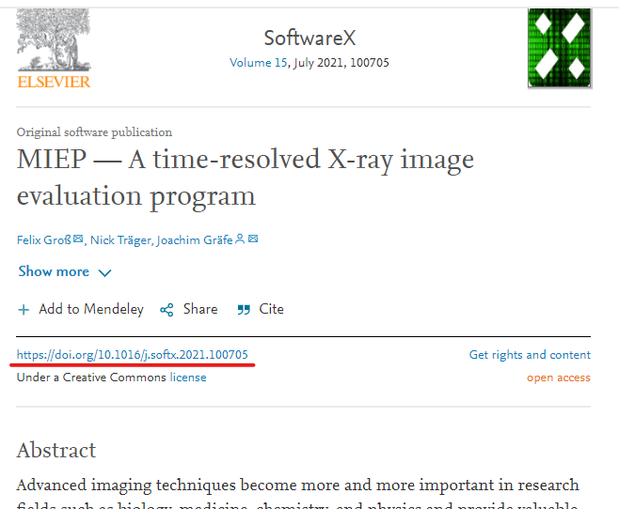

# Abstract

# *(ca. 100 words)*

# Keywords

# *(maximum of six)*

# Metadata

# *This ancillary data table is required for sub-version of the codebase. Please replace the italicized text in the right column with the correct information about your current code and leave the left column untouched.*

|  |  |  |
| --- | --- | --- |
| **Nr** | **Code metadata description** | ***Metadata*** |
| C1 | Current code version | *For example: v42* |
| C2 | Permanent link to code/repository used for this code version | *For example:* [*https://github.com/mozart/mozart2*](https://github.com/mozart/mozart2)*. Please note that a GitHub repository is mandatory.* |
| C3 | Permanent link to reproducible capsule | *For example:* [*https://codeocean.com/capsule/0270963/tree/v1*](https://codeocean.com/capsule/0270963/tree/v1) |
| C4 | Legal code license | *All software and code must be released under one of the pre-approved licenses listed in the* [*Guide for Authors*](https://www.elsevier.com/journals/softwarex/2352-7110/guide-for-authors)*, such as Apache License, GNU General Public License (GPL) or MIT License. Write the name of the license you’ve chosen here.* |
| C5 | Code versioning system used | *For example: svn, git, mercurial, etc. (put ‘none’ if none used)* |
| C6 | Software code languages, tools and services used | *For example: C++, python, r, MPI, OpenCL, etc.* |
| C7 | Compilation requirements, operating environments and dependencies |  |
| C8 | If available, link to developer documentation/manual | *For example:* [*http://mozart.github.io/documentation/*](http://mozart.github.io/documentation/) |
| C9 | Support email for questions |  |

# Description of the software-update

# *You are welcome to write up to two pages of text that describes your software-update.*

**Acknowledgements**

*Optional. You can use this section to acknowledge colleagues who don’t qualify as a co-author but helped you in some way.*

# References

*If the software repository you used supplied a DOI or another Persistent IDentifier (PID), please add a reference for your software here. For more guidance on software citation, please see our guide for authors or this* [*article on the essentials of software citation*](https://f1000research.com/articles/9-1257/v2) *by FORCE 11, of which Elsevier is a member.*

***Reminder: Before you submit, please delete all***

***the instructions in this document (the text in italics),***

***including this paragraph.***

***Thank you!***