Scientific Data Management System (SDMS) – Software Design Description

Oak Ridge National Laboratory
Oak Ridge Leadership Computing Facility
Advanced Data and Workflows Group
December, 2017

Architecture
The system architecture is shown in the diagram below. The system consists of a set of services and tools that utilize Globus GridFTP services and Grid Security Infrastructure (GSI). A central data store is provided and is managed by a “Central Service” with custom authentication and authorization modules installed in the associated GridFTP server. The Central Service permits users to access their data as well as specify fine-grained access control rules for their data.
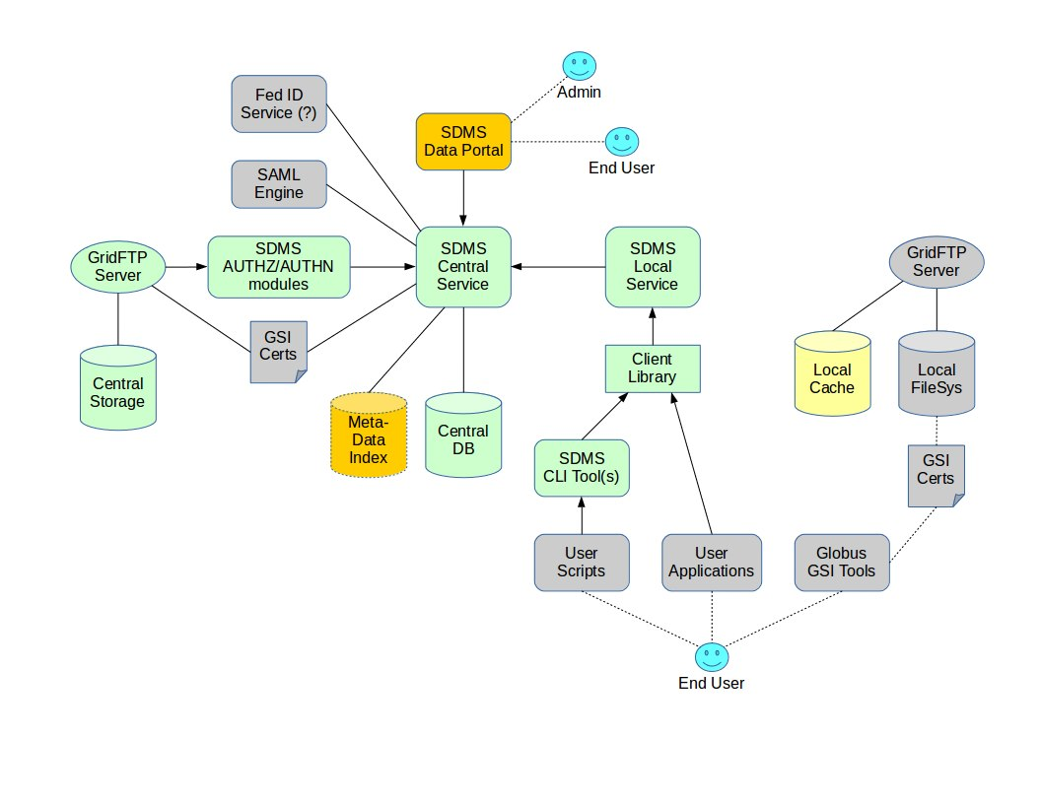
Data transfers are initiated using SDMS command line utilities from within a supported local environment (Globus Toolkit and GSI must be provided and managed by the local facility). Because the SDMS utilizes GSI, users must ensure their proxy certificates are enabled within the environments that they intend to use. (GSI certificate policy is under the control of local facility administration.) The SDMS CLI tools communicate with a facility-local SDMS service that, in turn, coordinates activities with the SDMS Central Service. These tools and services implement a management layer on top of GridFTP that simplifies and enhances data access (caching, concurrency control, aliases, version control, tagging, and metadata ingest/search). A Python client library is provided for direct integration with client applications.

A web service and front-end (Data Portal) is provided to allow users to browse and search for data, manage access control, and perform configuration activities. SDMS admins may also use the web service to manage accounts and general policies.

System Components

GridFTP Server (Central)

Custom Authentication Module

Custom Authorization Module

Central Storage

Central Service

Database
The central service database is a graph database (ArangoDB) that contains records for the following entities:
- Users
- User X.509 certificates
- Groups
- Projects
- Data records (information, no raw data) with structured metadata
- Collections
- Access Control Lists
- Tags
- Annotations

The schema of this graph data base is as follows:

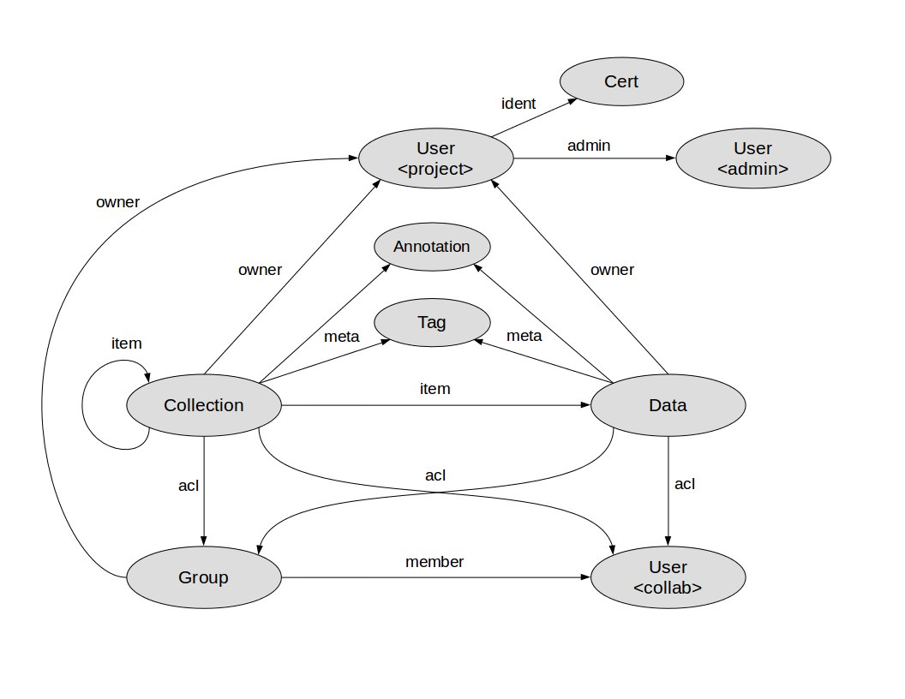
Database Web API
The central service database will be exposed to trusted processes via a REST API implemented as a micro-service running inside the database server process(es). The database relies on the trusted client processes to perform proper authentication of end-user requests using GSI X.509 certificates; however, clients do not need to know the federated identity of the end-user, as identity federation takes place within the central database. When end-user identity is required for a database API call, the X.509 certificate subject of the authenticated end-user is provided to the API, which then resolves this certificate to the federated identity of the caller.
The database API calls are described below, including permission requirements. Note that user-controlled permissions are set by ACLs and only apply to data records and collections. Other functions and record type utilize built-in permission rules (described in Section X) that cannot be modified by end-users.
- /user/create – Creates a new user account with one X.509 identity. This function can be used by administrators, or by a system account if self registration is supported (i.e. from the web portal).
- /user/view – Reads basic user account information (uid, name, email, etc).
- /user/list – Lists all user accounts with optional pagination and level of detail.
- /user/update – Updates attributes of user record (name, affiliations, email, phone numbers, etc.)
- /user/delete – Deletes a user account and all associated records from the database. Note that this call cannot purge raw data from central storage and/or local caches – these activities are performed by the Central Service.
- /user/cert/create – Adds an X.509 identity (subject) to an associated user account. This is needed to allow users to add certificate identities from additional supported facilities.
- /user/cert/list – Lists all X.509 identities (subjects) for an associated user account.
- /user/cert/update – Replaces an existing X.509 identity (subject) for an associated user account with a new X.509 identity. This is needed to replace expired certificates.
- /user/cert/delete – Removes an existing X.509 identity (subject) from an associated user account. Note that at least one active certificate identity must remain in the database, or the associated user will not be able to access the SDMS.
- /collection/create – Creates a new collection owned by calling client.
- /collection/view – Returns attributes of a collections (title, description, etc). Requires: PERM_VIEW.
- /collection/list – Lists all collections owned by client or a specific user. Requires: PERM_VIEW.
- /collection/search – Queries the database and returns basic identification attributes for collection matching a specified query. Requires PERM_VIEW on returned collections.
- /collection/update – Updates attributes (title, description, access controls, metadata, etc.) for an existing collection. Requires: PERM_UPDATE.
- /collection/read – Returns list of items in a collection. Requires: PERM_READ.
- /collection/write – Changes items (add/remove) that are in a collection. Requires: PERM_WRITE.
- /collection/delete – Deletes a collection (does not delete contained items). Requires: PERM_DELETE.
- /data/create – Creates a new data record owned by calling client. This function does NOT process the raw data associated with the data record – raw data must be processed by the Central Service.
- /data/view – Returns attributes of a data record (title, description, metadata, etc). Requires: PERM_VIEW.
- /data/list – Lists all data records owned by client or a specific user. Requires: PERM_VIEW.
- /data/search – Queries the database and returns basic identification attributes for data records matching a specified query. Requires PERM_VIEW on returned records.
- /data/update – Updates attributes (title, description, access controls, metadata, etc.) for an existing record. Does not handle raw data. Requires: PERM_UPDATE.
- /data/read – This function only verifies that the calling client has read access to a specified data record. Raw data processing is handled by the Central Service. Requires: PERM_READ.
- /data/write – This function only verifies that the calling client has write access to a specified data record. Raw data processing is handled by the Central Service. Requires: PERM_WRITE.
- /data/delete – Deletes a data record. Raw data processing is handled by the Central Service. Requires: PERM_DELETE.
- /group/create – Creates a new group owned by calling client.
- /group/view – Returns attributes of a group (title, description). Requires: PERM_VIEW.
- /group/list – Lists all groups owned by client.
- /group/update – Updates attributes (title, description) for an existing group.
- /group/read – Returns list of members in a group.
- /group/write – Changes members (add/remove) of a group.
- /group/delete – Deletes a group.
- /tag/update – Update tags associated with a data record or collection. Requires PERM_TAG on object being tagged.
- /tag/list – Lists tags associated with a data record or collection.
- /tag/search – Find existing tags based on specified query.
- /annotation/create – Creates an annotation owned by the calling client and associates it with a data record or collection. Requires PERM_ANNOTATE on target object.
- /annotation/view – Views annotation information. Requires PERM_VIEW on the object associated with the annotation.
- /annotation/list – Lists annotations either owned by the calling client, or associated with objects owned by the calling client.
- /annotation/update – Updates annotation information (or state) owned by the calling client, or associated with an object owned by the calling client.
- /annotation/delete – Deletes an annotation owned by the calling client, or associated with an object owned by the calling client.

Metadata Search Engine

Web Portal

GridFTP Server (Local)
The local GridFTP server is a standard installation managed by local facility administrators. It must use GSI certificates for user authentication, and user certificates must be synchronized with those cached at the central GridFTP server. (Tools may be provided to ease management of user certificates.)

Local Service

Local Cache

Client Library

Command Line Tools

