**Coursera Capstone**

**IBM Applied Data Science Capstone**

**Opening a New Restaurants in National Landing, Virginia**

February 2020

**Introduction.**

**Business Problem / Who would be interested**

Amazon announced that they will open second headquarter in Arlington, Virginia bringing up to 25,000 new employees. In addition, there can be 2 to 3 times that number indirectly supporting Amazon HQ2. For any potential entrepreneur, this provides a great opportunity to open new business (say a restaurant) supporting the influx of new employees. What restaurant and where in Arlington will provide the greatest potential for earning? This topic is of interests to any potential entrepreneurs wishing to open business around Amazon HQ2 catering to the future demand increase.

**Data**

The data for this project will be derived from the Foursquare location data for restaurants in Arlington focusing on area near where Amazon plans to build it's second headquarter. The project will first query for all restaurant within 6,000 meters of new Amazon HQ2. From there, the project will further categorize the restaurants by different types (Italian, Fine Dining, Fast Food, American, etc); then identify any potential unmet demand/needs in the area. The project will also segment the 6,000 meters radius of Amazon HQ2 further down into several sectors by distance. This should allow to see any potential unmet needs/demands within various sector around Amazon HQ2. Potential examples of data that can be derived are the list of restaurants in and around Amazon HQ2 location; segmented by distance from the Amazon HQ2. From the list, the study will attempt to deduce a potential shortfall (unmet need in the area).

**Methodology**

This project will look for the potential restaurant location within 1,500 meters (comfortable walking distance accommodating lunch outing) from proposed Amazon HQ2 in National Landing in Crystal City, Virginia.

The optimal restaurant type will be defined as the most frequent type between 1500 to 6000 meters from Amazon HQ2 that is not located within 1500 meters.

Each neighborhood within the 1,500 meters and 6,000 meters from proposed Amazon HQ2 will be segmented by 300 meter radius.

Once the optimal restaurant type is identified, the optimal location will be identified as the one with fewest restaurants.

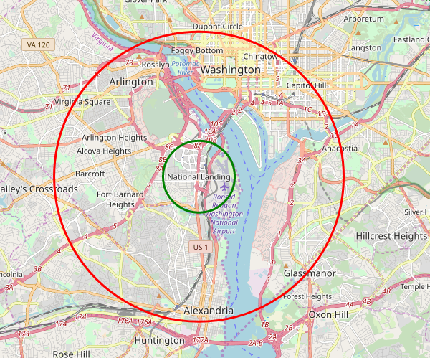

The study will be looking for the restaurants types that are between green and red and identify the ones that are most frequent that does not appear inside the green area.

**Results and Discussion**

There were 93 different types of restaurants that were between the green and the red area that were not present in the green area. The top 6 (all having 13 or more restaurants) are as follows.

| **Category** | **Count** |
| --- | --- |
| French | 28 |
| Tacos | 27 |
| Latin American | 26 |
| Southern/Soul | 16 |
| Korean | 13 |
| Vegetarian / Vegan | 13 |

Of the 30 potential location inside 1,500 meters from proposed Amazon HQ2 location, there are 7 locations with 0 restaurants. Four of those location is in the airport. Three locations remained; 161, 180, 181 (blue shaded circle) .   
  
What this study did not consider is the zoning of the neighborhoods. The resulting 3 location may be zoned as a residential area and may not allow a restaurants to be opened. This study did not seek out the necessary data to answer that specific question.   
  
If this study did have those information, then it could have factored those in and possibly looked at other area.

Other potential area are neighborhood section 123, 143, 144, 162, 200 (purple shaded circle). These sections only have one restaurants.

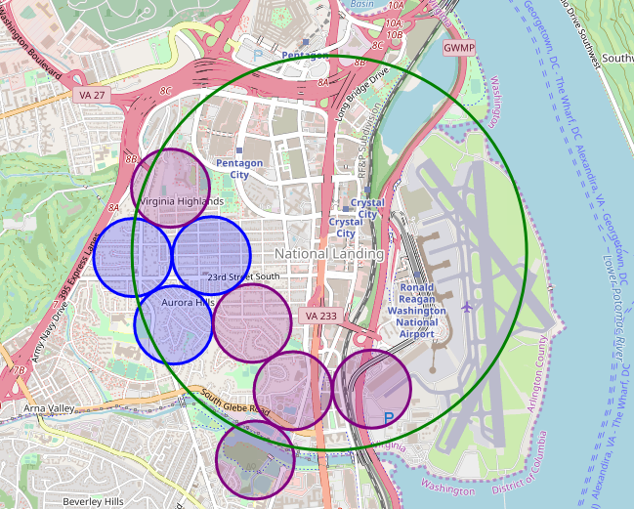

**Conclusion**

Purpose of this project was to first identify an optimal type of restaurants to open to cater to the potential influx of up to 75,000 people moving into National Landing area to either directly or indirectly work at Amazon HQ2. Secondly, this project was to identify the optimal location to open said restaurant.   
  
This study had narrowed the type of restaurant down to 5 and potential location to 8 different neighborhood sections within 1,500 meters from proposed Amazon HQ2 location. Ultimately, the stakeholders must make decision based on their specific needs.