

technical report of mineral cadastre system

prepared by: dr. safiur-rahman & anwar shamim

Mineral Cadastre SYSTEM

2014

Table of Contents

1. Abstract 6
2. Introduction 7

1.1. Preface 7

1.2. Purpose 7

1.3. Audience (Stakeholders) 7

1.4. Scope 8

1.5. Key Features 8

1.6. Benefits 8

1.7. Overview 9

1.8. Reference Material 9

1. System Overview 10

2.1. Introduction 10

2.2. Services Layer 10

2.3. Data Layer 10

2.4. External Systems 10

1. System Architecture 11

3.1. Architectural Design 11

3.2. Functional Requirement 11

1. Use Cases 14

4.1. UC-01 Enquiry: 14

4.2. UC-02 Submit Application: 17

4.3. UC-03 Lodging Application: 18

4.4. UC-04 Survey Plan: 19

4.5. UC-05 Approval of Application: 23

4.6. UC-06 Change System Settings: 24

4.7. UC-07 Transaction Audit: 24

4.8. UC-08 Administrative Security: 25

1. Workflows 26

5.1. Submit Application 26

5.2. Lodge Application 27

5.3. Initial Survey 28

5.4. Geo Survey 29

5.5. Higher Authority / Application Approval 30

5.6. Full Process 31

5.7. Transfer Application 32

5.8. Transfer Approval 33

5.9. Full Process for Transfer Application 34

5.10. Application for Mine Extension 35

1. Design Rationale 36

6.1. Platform 36

6.2. Database 36

6.3. IDE 38

6.4. Component Design 38

6.4.1. Module Description 38

6.4.2. Modules Integration 39

6.4.3. Overview of Human Interface Design 39

6.4.4. Requirements Matrix 40

Table of Figures

Figure 1: Architecture Overview of Presentation Layer 10

Figure 2: Doashboard Overview 11

Figure 3: MCS Packages Overview 11

Figure 4: Workflow of Submit Application 26

Figure 5: Workflow of Lodge Application 27

Figure 6: Workflow of Initial Survey 28

Figure 7: Workflow of Geo Survey 29

Figure 8: Workflow of Higher Authority / Application Approval 30

Figure 9: Workflow of Full Process 31

Figure 10: Workflow of Transfer Application 32

Figure 11: Workflow of Transfer Approval 33

Figure 12: Workflow of Full Process for Transfer Application 34

Figure 13: Workflow of Application for Mine Extension 35

Figure 14: MCS Human Interface Design 39

List of Tables

Table 1: Requirements of Architectural Significance 12

Table 2: MCS_Request_Master 36

Table 3: MCS_Request_Coordinates 37

Table 4: MCS_Application_Licence_Master 37

Table 5: MCS_Application_Licence_Details 38

Table 6: Requirements Matrix 40

# Abstract

This report is a formal description of the design of Mineral Cadastre System (MCS) and its core architecture. MCS is an integrated module of OpenM4 (OpenM4S is an acronym of National ICT R & D funded project titled “Design, Development and Deployment of an Open Source Mineral Resource Mapping, Modelling and Management System”). This report is a deliverable after the completion of project’s second quarter.

This design document serves as a basis for the detailed design and covers the following components:

* MCS architecture, scope, data design, and component design
* Requirements matrix and essential requirements

*Key words: Mineral Cadastre System, Software Design Document.*

# Introduction

## Preface

Mining Industry of Pakistan produces stones and gems which in turn are exported to generate high revenues for the Country; these minerals include Lime Stone, Coal, Chromite, Marble, Manganese, Fluorite and many others.

The Mining Industry mainly deals with minerals exploration and development and carries out different activities like geological mapping, geological investigation, drilling and reserve estimation. Mineral concession is another function of the department which includes grant of prospecting and mining licenses, and collection of royalty. Rescue operations and inspection of mines etc.

## Purpose

This document describes the architecture and system design of Mineral Cadastre system (MCS). It comprises scope of MCS, overview of document, brief system overview, general system architecture, data design of MCS, component design of MCS, human interface design and requirements matrix.It provides different views to depict different aspects of the system. It is intended to capture and convey the architecture decisions that have been made and elaborates on aspects of the system that are considered to be architecturally significant.

The views include use case view, logical view, deployment view and data view. Also described the drivers that have shaped the architecture of the system, the architectural mechanisms apply to MCS, its performance and security characteristics. MCS is intended for anyone who is interested in mapping application. Aiming to capture and transfer the architectural assessments that have been prepared in order to implement project.

## Audience (Stakeholders)

This is a technical document intended for developer and related technical resources. The audience for this document includes:

* *Client, Funding Agency & PI of the project*

The document may help these stakeholders to examine how the high level design meets the requirements.

* *Team leads, Developers, Internees, and Reviewers*

This document will be used in the design, implementation and testing phases of the Open M4S project.

* *End-Users of the Project - Administrators and Supervisors*

Administrator and supervisors of project may use this design document to understand the structure of the proposed system.

## Scope

This Software design document (SDD) represents the “as-is” architecture document of the MCS design, development and deployment snapshot. As, MCS is using the scrum software development methodology, this document will evolve during project sprints and additional details (generally marked as “to be completed”) will be included as appropriate to reflect decisions and outputs arising from design and implementation.

Mineral Cadastre System (MCS) is an important module of OpenM4S. MCS is useful to the applicant request can process through this Mineral Cadastre System. A simplified view of working of MCS is shown in Figure 1.

Figure goes here!

## Key Features

Key features and initial capabilities of MCS are presented as follows:

* Mines Owner online register
* Approval and rejection through MCS
* Expiry and Renewal process control through MCS

## Benefits

Major benefits of MCS are enlisted below:

* Reduce processing times for applications for registration and mineral cadaster changes
* Provide better access to Mines and Mineral information and improved delivery of registration and cadastral related services
* Ensure an acceptable of quality is maintained with respect to registration and license approval transactions and the associated official record of Mines and Mineral, rights, restrictions and right holders (Mines Owner)
* Reduce the processing effort for the maintenance of the official record of mines and minerals, restrictions and mine owner details.

## Overview

This document represents a big picture of MCS module. It takes account of:

* General idea of MCS
* System overview
* Suggested tools, database and programming language
* System architecture
* Data design
* Component design
* Human interface design
* Requirements matrix

## Reference Material

Here is list of references which were used as source of information while compiling this document:

* Sola
* LMS (Land Management System)
* Directorate of Mines and Mineral (KPK)

# System Overview



## Introduction

Mineral Cadastre is an interpretive process involving multiple departments of information.

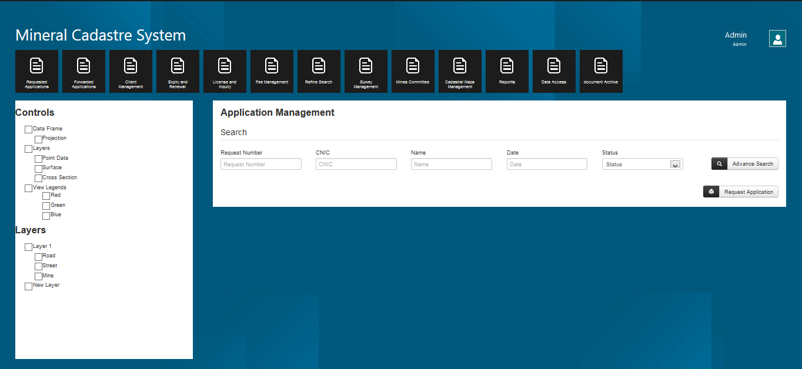

Figure 1: Architecture Overview of Presentation Layer

## Services Layer

The python drivers encapsulates the main business logic for DMS and will be implemented using eclipse and intended to be lightweight and functional.

## Data Layer

The data layer persists the MCS data into PostgreSQL database.

## External Systems

External systems identify the systems, MCS integrates with.

# System Architecture



## Architectural Design

Architecturally significant parts of the design and its decomposition into packages and subsystems comprise the logical view of MCS.

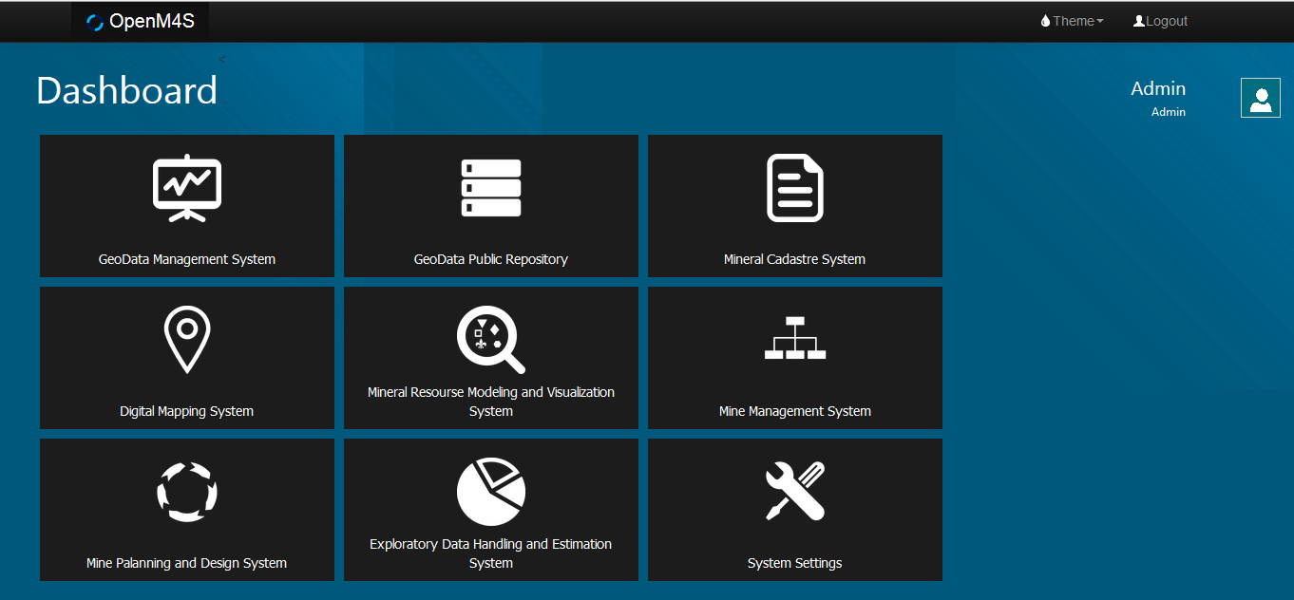

Figure 2: Doashboard Overview



Figure 3: MCS Packages Overview

## Functional Requirement

Table 1 identifies and discusses the functional requirements of MCS that have architectural significance.

Table 1: Requirements of Architectural Significance

|  |  |  |
| --- | --- | --- |
| **Requirements** | **Descriptions** | **Significance** |
| Applicant Request for License | The applicant can make request by providing Coordinates and Attachments. | The Applicant will make request for allotment of license. |
| License Inquiry | The system will information about different type license and requirement details. | Applicant can apply for concerned license |
| Display Fee | System will display licensing fee information for different type of license | Fee Details Information for applicant. |
| Search Record | System can provide facility to user for search record through multiple fields to search for the specific record. | Search facility for the user |
| Search Mines Record filter by License Type | System will do multiple search criteria for searching of Mines record by filter through different of license. | Searching License Information with different type filter |
| Application Approval | Approval Process | The application Approval Process. |
| Initial Survey | Physical survey and drawing and checking in Top sheet by Allotting number | Initial Survey. |
| Geological Survey | Get data from other module for mining information. | Confirm Coordinates |
| Combined Report | Combined will made so that it will be available for decision for allotment of licensing. | MCS to create Report for Higher Authority. |
| Mines Committee | Select Committee member from others modules to build Mine Committee. | Committee decision will will accept or reject the applicant request. |
| Final Survey | Prepare (proplan ) and make boundary to define area allotted to the applicant. | Boundary wall definition. |
| Printing | The system will provide facilities to support printing of both generated and imaged documents. | MCS to provide printing facility via MCS web portal. |
| Creation of Cadastral Maps | A mining cadastre is the cornerstone of a secure mineral rights system and records the geographical location, ownership and time validity of mining rights, and for compliance with the payment of fees and/or other requirements to keep a concession valid. |  |
| Reports Creation | Different types of Reports i.e. Issue license, expiry, renewal And inspection reports. | MCS to provide different reports at different intervals of time to facilitate the user. |
| Data Access | Extract Geospatial data of user interest data may be in raster or vector Format. | After extracting data one can draw different Maps based on such data. |
| Common Border | Border which connects two mines or pit is called common border. |  |
| Document Archive | Document Archive is to store and manage both generated and imaged documents. | MCS to implement document archive to support storage and retrieval of generated imaged documents from database. |

# Use Cases



## UC-01 Enquiry:

The client will come to the Directorate of Mines and Minerals office (or telephone or check it online) and be directed to the desk at the public counter dealing with service enquiries being either an enquiry about Specific service application or a general enquiry about what services are about provided by government, what information and supporting documents are required for each service, what are the fees for each service and what is the expected turn-around time for each service.

At the Service Enquiry Desk, the officer speaks with the client and determines the nature of their enquiry. The officer logs onto the system. The system records the starting time for the enquiry.

If it is an enquiry regarding a specific application, the officer will interrogate the system (by application number or applicant name or request number) and determine the status of the application and advise the client on how much longer it should take or what is stopping progress. An application/request status report may be printed for the client if requested.

Where the application being enquired about has been completed, the officer will retrieve any certificates or special reports resulting from the service application plus any supporting documents that are to be returned to the client and hand them over. A document receipt is printed by the system, the client signs and the signed copy of the document receipt is scanned and paper document receipt and its digital equivalent is added to paper and digital application file respectively. If all other necessary actions have been completed, the system records the paper based application file is ready for archiving by the Archivist.

Where the enquiry concerns a service that may be applied for, the officer will make such Information searches on the system as are required to verify the appropriateness of the enquired about service, what details and supporting documents are required for that service and the fees for that service. An information sheet for that service can be printed out for the client, if required. When the client leaves the service enquiry desk, the officer, notes on the system that the Enquiry has been completed. The system records the end time.

|  |  |  |
| --- | --- | --- |
| Identifier | Capability | Feature |
| FN – 1 | Display Service Requirements | Client explains their situation and officer determines the relevant Service. Officer enters type of service and system presents a checklist of supporting documents required for the selected service with the option to print this out for the client. |
| FN – 2 | Online Checking | Client check the status of his/her application or available areas and minerals for licensing |
| FN – 3 | Display.  Service Fee | Officer enters type of service and system presents the fee or the basis for how the fee for the service is calculated. The client has the option to request a print of the fee details |
| FN – 4 | Search  Records | System to present user with a sequence of screens starting with the search criteria (including owner name etc.), followed by a list of records meeting the search criteria and finally a full display of the search target record. |
| FN – 5 | Display search Results | System will search database using the search criteria and display a list of records meeting those criteria for the user to select the specific record that is of interest. |
| FN – 6 | Print Search | Registration Officer requests the current record to be printed. |
| FN – 7 | View Cadastral Map | This map viewer will have the following characteristics and functionality:   * The map should reflect the latest and most up-to-date cadastral boundaries; * When the Cadastral Map Viewer is first displayed, it should zoom to the extent. of the area served by the Office that the user is enrolled as a user; * Access to the Cadastral Map Viewer is strictly “Read-only” for all end users; * Have the spatial functionality to zoom in, zoom-out and pan * To display the scale of the map displayed on the screen * To display the current standard coordinate values of the cursor position * Print displayed map (of the map displayed on the screen or map at the specified scale cantered on the Centre of the screen). Print to have standard copyright and disclaimer notice, that the print is not for sale, and the name of the user initiating the print and the time and date * Simple Page Setup configuration associated with Print functionality [Portrait/Landscape, set margins, title for print-out] * Simple Layer Configuration by the user including the ability to turn on and off the standard layers any associated annotation * Layer display to be automatically controlled by the map display scale with these default values for the scales at which layers become visible being configurable by the system administrator * Ability to measure distance between two user selected points and also to show accumulated distance * Progressive Search function (similar to Google) based on the parcel identifier in the Cadastral Object/ Polygon table. Where the selected instance of the Cadastral Object/ Polygon table is not a parcel, the related parcel polygon will display * Information Tool whereby when a Cadastral Object/ Polygon parcel polygon is selected, a subset of the field values will be displayed in a Tool Tip form along with a function link to print this attribute data. For instances of parcel Cadastral Object/ Polygon, the parcel / property identifiers of related Cadastral Object/ Polygon will be listed. Similar functionality to be provided for any other spatial feature classes implemented within system * Functionality described above to be available through menu structure, toolbar icons and other software structures * Functionality described above to be capable of being manually enabled or disabled by the system administrator or to be controlled by software depending on context and the role of the user * User documentation, preferably context sensitive to be available to users * System to log each time the Cadastral Map Viewer is initiated, by which user and how long the session was |
| FN – 8 | View Work In Progress | System to generate a listing of all work – in –progress (Current Work). Each row to represent an application (registration or cadastre change). |
| FN – 9 | Note Actions | System to note the time and date, action completed. A completed action can also be manually noted by the officer with the current date and time being the default but editable value for the date time field. |
| FN – 10 | Attach  Supporting  Document To  Action | Officer is able to link scanned image of supporting/associated document to a recorded action. |
|  |  |  |

## UC-02 Submit Application:

Using forms approved by the Directorate of Mines and Minerals office, the client completes both the application form and the principal document that will be registered / approved / certified / recorded by the Directorate of Mines and Minerals office and, where there is form of title registration, annotated on the title certificate. Client can also apply online for license by filling the online form and attaching the scanned documents. If there is any fees for this step the client should pay the fees in the banks mentioned in the form then attach the receipt with the documents.

|  |  |  |
| --- | --- | --- |
| Identifier | Capabilities | Features |
| FN-11 | Create New Application | Client should be able to create new application online or he/she can come to directorate and inform officer to do so. |
| FN-12 | Edit Current Application | Current application could be edited by client online or he/she can come to directorate and inform officer to do so if there is some wrong information in the applicant personal profile (e.g. address or NIC, …) |
| FN-13 | Download Form | Client can download the form for submitting application online or he/she can come to directorate and inform officer to do so. |
| FN-14 | Document attachment | Client should be able to attach all the required documents online or he/she can come to directorate and inform officer to do so. |

## UC-03 Lodging Application:

Once the application is submitted the principal document will need to be signed by all parties and usually this signing will need to be witnessed or notarized by someone independent of the transaction recorded or auctioned by the principal document. The client also needs to ensure all the required supporting documents are available to be submitted as part of the application and that they have available sufficient documentation to verify their personal identity and that they are entitled to register a document with respect to the property identified in the principal document.

Where it is feasible and the user is able to accurately determine the applicable fees, and there is an agency that accepts payments on behalf of the Directorate of Mines and Minerals office, the payment can be made and the receipt included as a supporting document to the application.

The Client proceeds to the appropriate public counter dealing with the lodgements of applications (possibly assisted with automated queuing system). At the counter the Officer will validate the Client’s identity in so far as the Client being entitled to make the requested transaction and similarly that all the necessary supporting documents are present. The officer will then enter details of the application (applicant name and contact details), transaction type(s) and properties affected) directly into the computer. If there is any fees for this step the client should pay the fees in the banks mentioned in the form then attach the receipt with the documents.

## UC-04 Survey Plan:

In the case of the lodgement of a survey plan, the Public Counter will identify a point (or points) on the on-line cadastral map which locates the general location and extent of the survey plan. The system will generate a unique application number. The application is printed (office and client copies) with details of the fees that need to be paid. If there is any fees for this step the client should pay the fees in the banks mentioned in the form then attach the receipt with the documents. The application file is then stored at an appropriate place within the office until the application is complete and the system allocates the application to the “back office” team.

|  |  |  |
| --- | --- | --- |
| General (Cadastre and Registration) | | |
| Identifier | **Capabilities** | **Features** |
| FN-15 | Lodge checklist | Officer enters type of transaction and system presents a checklist of supporting documents required for selected transaction type. If all supporting documents are present, lodgement proceeds |
| FN-16 | Lodge Identify  Underlying  Property | Officer keys in parcel identifier in Google – like search. Where parcel has corresponding record or related title or map record, the user is informed and given the option to view them. Once assured that the underlying parcel / property has been identified or that the transaction applies to no specific parcel or property (e.g. power of attorney, standard form, or first registration), the officer will confirm that the parcel/ property has been correctly described. If not the application is returned. |
| FN-17 | Calculate Fees | The system shall calculate the fee applicable to the transaction. |
| FN-18 | Lodge New  Application | Officer records details on the person making the application (Owner or duly appointed person on behalf of owner) including contact details, records the receipt for the fees and the system allocates a unique application number (the next sequential number applicable to the transaction type of the application) |
| FN-19 | Lodge Survey  Plan | Officer locates general location of survey plan (cadastre change) in the Cadastral Map Viewer and then a point (or points) where a symbol and label of the survey plan number/identifier will appear as a “lodged but unapproved” survey plan |
| FN-20 | Application  Main Documents | Document details of the main document(s) to be registered/ approved are entered and links the scanned images of these documents to the appropriate  document record |
| FN-21 | Print Application | The completed application is then printed. |
| Registration Only | | |
| FN-22 | Record Rights  Restrictions  Details | Capture all the details describing the rights or restrictions affected by the transaction(s) in the application. Changes to reflect new situation are given status “pending registration/approval” and existing records to be superseded the status of “to be retired/cancelled/made historic on  Registration/approval”. |
| Identifier | **Capabilities** | **Features** |
| FN-23 | Identify Share  To Be Changed | Officer identifies parcel and system displays a list of Owners. User selects owner to be changed and likewise share to be changed if owner has more than 1 shareholding. Changes to reflect new situation are given status “pending registration/approval” and existing records to be superseded the status of “to be retired/cancelled/made historic on registration/approval” |
| FN-24 | Record New  Owner Details | Capture all the details describing the changed or new owner. Changes to reflect new situation are given status “pending registration/approval” and existing records to be superseded the status of “to be retired/cancelled/made historic on  registration/approval” |
| FN-25 | Record Transaction Title Changes | Capture all the changes to the title (apart from owner details) that will result from the registration/approval of the transaction(s) in the application. Changes to reflect new situation are given status “pending registration/approval” and existing records to be superseded the status of “to be retired/cancelled/made historic on registration/approval” |
| Documents only | | |
| FN-26 | Scan Documents | Principal and supporting documents are stored in a folder which is accessible to all authorized people such as licensing authority |
| FN-27 | Link Scanned  Images | Licensing Authority identifies the record that they wish to associate a scanned image. The Directorate goes to the central temporary repository of scanned images and identifies the relevant image file. The selected image file is renamed to a name that includes the record type and the record identifier. This renamed image file is then archived within the digital archive database, a link is stored from in the main record database and the image file is marked for deletion from the temporary image file repository at the end of each working day |
| FN-29 | Remove scanned image | Licensing authority must be able to delete a  scanned image and the link |
| FN-30 | View Scanned images | Licensing authority must be able to view scanned image (and potentially print the scanned image) from the associated database record when displayed in a form or as a link from a list of associated records (such as supporting documents). |
| Cadastre Only | | |
| Identifier | **Capabilities** | **Features** |
| FN-31 | Confirm  Underlying Parcel | System to present Surveyor with a map window highlighting the current underlying parcel as specified indeed. User to confirm or select another parcel which corrects parcel identification as entered in registration details window. System to amend status of map parcel to “subject to new survey – approval pending” |
| FN-32 | Record New  Survey | Surveyor records a point(s) which marks the general vicinity of a new survey. Surveyor can delete points defining the same (cadastre) application as is open. |
| N-33 | Attach Surveyors  Report | Surveyor links scanned image of surveyors report as supporting document for this application. |
| FN-34 | Import New  Survey Points | A comma delimited file containing Cartesian coordinates (Easting, Northing, Zone) in the native/standard (to the country) UTM coordinate system for the cadastre (from a geocentric projection such WGS 1984) is loaded, checked to see the coordinates are within the expected range and displayed on a working layer specific to this user session that can only be edited by the user. Coordinate file is added to digital archive for  cadastral surveys |
| FN-35 | Import XML file | A XML containing new parcel definitions in Cartesian coordinates (Easting, Northing, Zone) in the native/standard (to the country) UTM coordinate system (from a geocentric projection such WGS 1984) is loaded, checked to see the coordinates are within the expected range and the (parcel) polygons and boundary nodes displayed on a working layer specific to this user session that can only be edited by the user. XML file is added to digital archive for cadastral surveys |
| FN-36 | Edit Survey  Points | Ability to change survey category of any loaded point/node from “boundary Node” to “non Boundary Survey Point”. |
| FN-37 | Form New  Cadastre Polygon | Ability to connect boundary nodes to form cadastre polygons and to edit any boundary line in the user’s working layer. System to allocate parcel (cadastre object) identifier. User to specify type of cadastre polygon (parcel, building, easement, etc.) and enter legal/surveyed area and any other parcel details |
| Identifier | **Capabilities** | **Features** |
| -38 | Link New  Boundary Nodes To Existing  Cadastre Nodes | While displaying current cadastre layer(s) and the users working layer, use a drag-and-drop technique to link any new boundary nodes that also define nodes on existing cadastre layers. When linking is complete, system transforms new survey points into terms with existing coordinate values for the cadastre layer(s). Transformation holds the existing coordinate values for existing nodes and where a new boundary node was on an existing boundary vector, this relationship is maintained. Mean shift and standard error of transformation is displayed. Surveyor accepts or rejects. If accepted, the polygon(s) are copied to provisional layers and are viewable by other users. If rejected the user working layer is cleared. |
| FN-39 | Check New Parcel | Surveyor to initiate system check for topological correctness and report on any gaps, overlaps or other issues. These checks plus transformation details are written into the Quality Check for this (cadastre) application |
| FN-40 | Generate New  Parcel Plan | Surveyor to initiate generation of image file of all new parcels (in standard Parcel Plan layout and format) and their attachment as supporting documents to the (cadastre) application |

## UC-05 Approval of Application:

The Approving Officer will select an application ready for approval or registration from their Workspace. They will review, and where there are any critical issues examine them further before approving the transaction or sending it back to the “Back Office” Registration team for further action. If satisfied they:

* Approve each transaction within an application. The system will then change the status of all related records from “pending” to “current” / “approved” or “historic” (in the case of an existing record that is superseded or extinguished as a result of the registration/approval).
* Approve the cancellation or rejection of the application; the system will then change the status of all related records from “pending” to “cancelled” and the underlying original records to “current”.
* Approve the requisition to the applicant asking for remedial work. The system will change the status to “pending requisition”. When one of these approval decisions has been made by the Approving Officer, a notice will be generated and this notice, emailed, faxed or posted to the applicant. This will result (in some but not with all transaction types) the Client returning to the Directorate to collect documents.

|  |  |  |
| --- | --- | --- |
| Identifier | Capabilities | Features |
| FN-41 | View  Application | Registrar initiates approval and system displays transaction and related title records |
| FN-42 | Edit  Application | System to present Approval officer with a series of linked screens and, where practical, selection of values from a list of controlled values and default values to edit any details describing  the transaction |
| FN-43 | Cancel  Application | Approval officer can select option to cancel application with an appropriate comment in applications quality checklist. System generates Cancelation Notice sends it directly to applicant or to a Licensing Authority to send out. System also updates status  accordingly and removes transaction from “work in progress” |
| FN-44 | Re-assign  Application | Approval officer can select option to re-assign application to staff member with an appropriate comment in applications quality  Checklist |
| FN-45 | Register  Transaction | Approval officer can select option to register each transaction in an application. System updates status accordingly |
| FN-46 | Approve  Cancellation | Approval officer can select option to approve the cancellation of a previously registered right or restriction |
| FN-47 | Consider  Registration Notice | Upon registration/ approval, system generates notice of registration and attaches to application as supporting document and where feasible sends notice to applicant / relevant people |

## UC-06 Change System Settings:

The System Administrator will be responsible for making the changes to the Static Data definitions which populate system objects such as “drop down” lists and control the values permitted in certain fields The System Administrator will make no changes with respect to system settings without having obtained authorization from the Directorate.

|  |  |  |
| --- | --- | --- |
| Identifier | Capabilities | Features |
| FN-48 | Manage System  Settings | Local System Administrator to be able to add, modify or retire values in lists of controlled values (code lists) |

## UC-07 Transaction Audit:

The Directorate will designate one of their Officers as an Internal Auditor needs reporting tools to perform random systematic reviews of individual transactions as well as to investigate transactions where a potential performance problem has been identified either through the regular performance reports or where a complaint has been received from a Client.

The Internal Auditor needs to be able to review what actions were completed with respect to the transaction, how long each processing step took , what key data fields were changed, the before and after key data field values and who made the changes. (i.e. a process “trace” and a key data field “trace” for the transaction under review where mistakes are identified in the title or digital cadastral map, these must be initiated as a new type of transaction, a “Register & Cadastre Correction” transaction and processed as a regular application.

|  |  |  |
| --- | --- | --- |
| Identifier | Capabilities | Features |
| FN-49 | Audit Process  Trace | Internal Auditor and chief of office to request system to list all processes undertaken on a specified dealing (including changes to the cadastral map) including dates and staff member responsible for each process step |
| FN-50 | Audit Key  Data Field Trace | Internal Auditor and chief of office to request system to list all changes made to any key data field on a specified dealing, title,  Survey plan or map parcel polygon including dates and staff member responsible for each change to a key data field. |
| FN-51 | Approval officer  Correction  Initiate | Chief of office to be able to initiate a Record Correction transaction and assign it to staff member for action |

## UC-08 Administrative Security:

The System Administrator will be responsible for creating new user accounts and maintaining related details such as the definition of User Roles (within the computerized system) and what functions and privileges will be associated with different User Roles. The System Administrator will make no changes with respect to user accounts (creation, modification or “retirement”) without having obtained authorization from the Directorate.

|  |  |  |
| --- | --- | --- |
| Identifier | Capabilities | Features |
| FN-52 | Manage User  Privileges | Local System Administrator (any user for password change) to be able to change system settlings such as controlled value lists (code lists) and user privileges. |
| FN-53 | Manage User  Change Password | Any user to be able to change their own password to a new value. New password to be double entered to validate its correctness |
| FN-54 | Manage User  Privileges Roles | Local System Administrator to be able to add, modify or delete different roles and associate certain permitted actions with each role. |
| FN-55 | Manage User  Privileges Accounts | Local System Administrator to be able to add, modify, suspend or delete individual user accounts for the system |

# Workflows

This chapter describe the workflows of the whole process starting from submitting application till approval of license, transfer of license and extension of mines.



## Submit Application

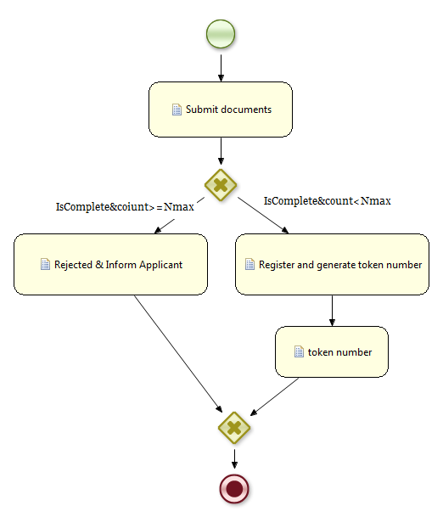

Figure 4: Workflow of Submit Application

## Lodge Application

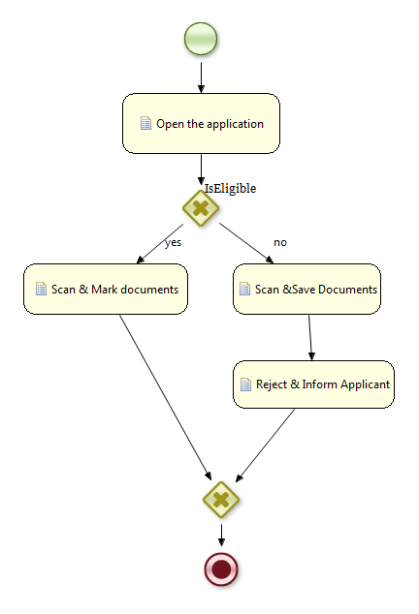

Figure 5: Workflow of Lodge Application

## Initial Survey

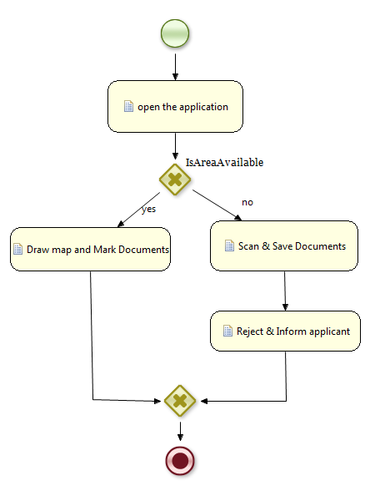

Figure 6: Workflow of Initial Survey

## Geo Survey

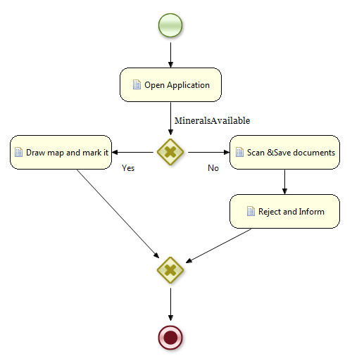

Figure 7: Workflow of Geo Survey

## Higher Authority / Application Approval

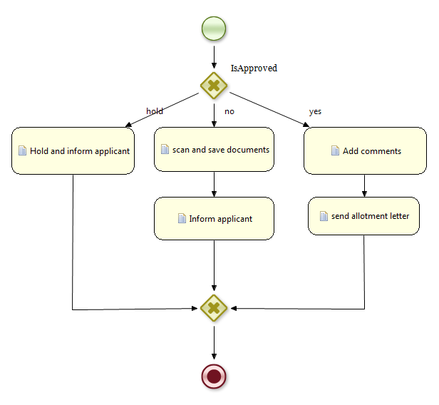

Figure 8: Workflow of Higher Authority / Application Approval

## Full Process

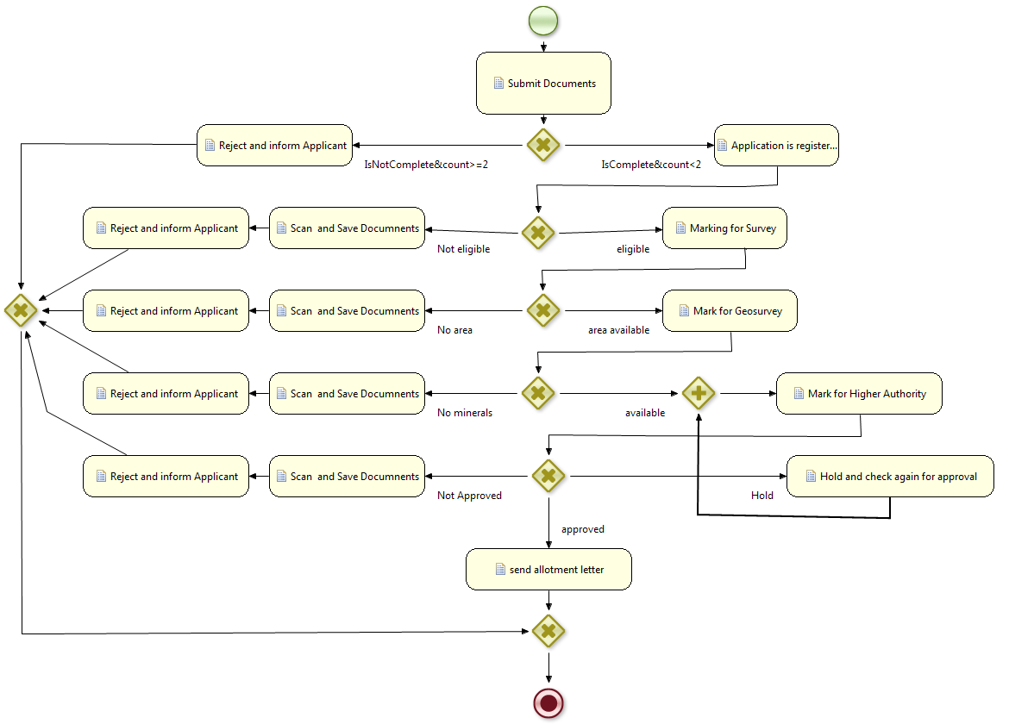

Figure 9: Workflow of Full Process

## Transfer Application

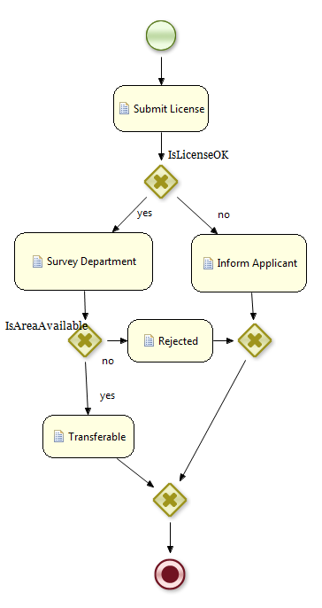

Figure 10: Workflow of Transfer Application

## Transfer Approval

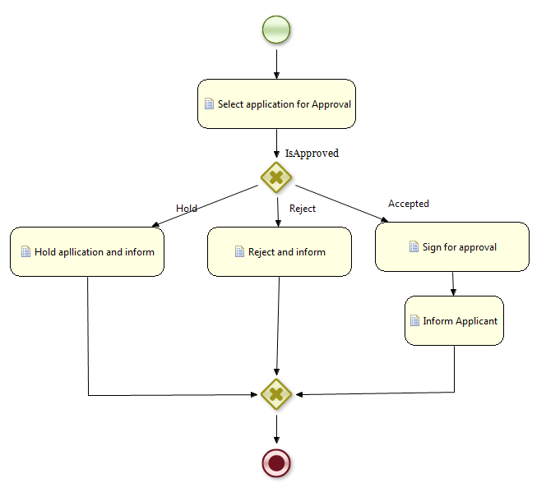

Figure 11: Workflow of Transfer Approval

## Full Process for Transfer Application

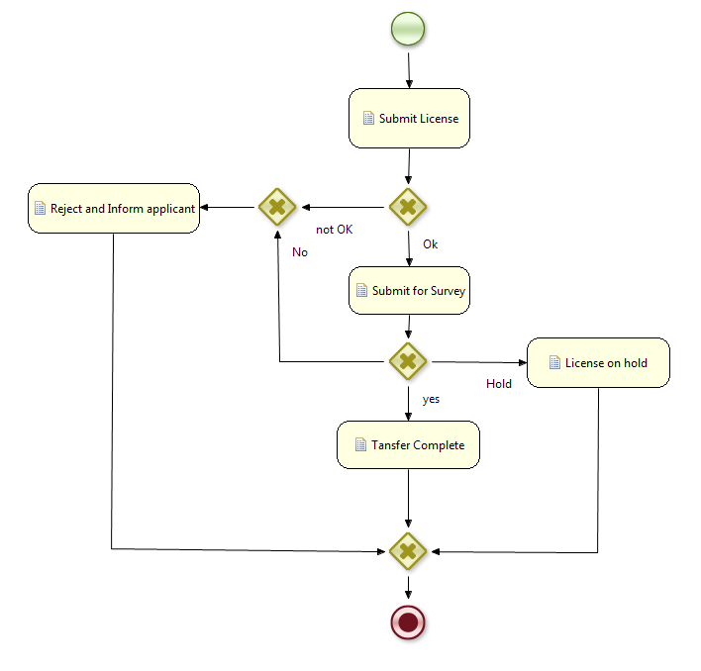

Figure 12: Workflow of Full Process for Transfer Application

## Application for Mine Extension

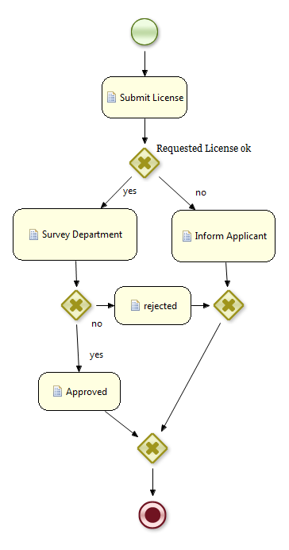

Figure 13: Workflow of Application for Mine Extension

# Design Rationale



## Platform

Java EE will be used as a platform for the development of MCS due to the following reasons:

* It uses Java as programming language which is a high level language suitable for a wide variety of programming tasks.
* With Java, one can create “Write Once Run Anywhere” applications, which means that a Java program running on one system will run as is on another Java enabled system.
* It provides APIs for developing multi-tiered, distributed web services and applications.

## Database

PostgreSQL ORDBMS will be used for storing and retrieving all cadastre-related information. Since we will also need to store information about geographic objects we will use PostGIS which will add support to PostgreSQL for storing and retrieving information about location and mapping. The reasons for preferring PostgreSQL to other free open source RDBMS such as MySQL are that it includes tools for caching, load-balancing and optimization and PostGIS is becoming a standard in open source GIS applications. License.

Table 2: MCS_Request_Master

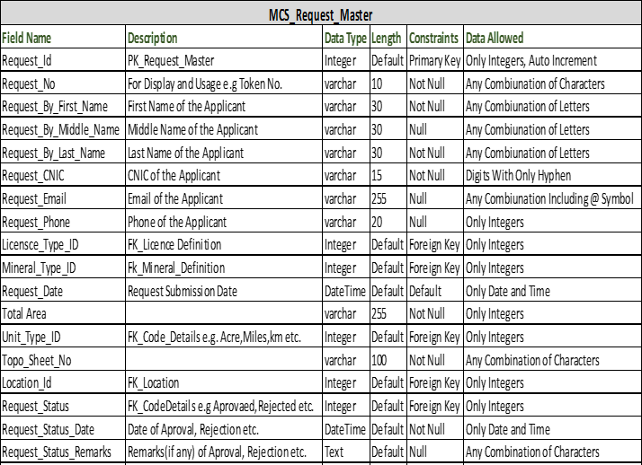

Table 3: MCS_Request_Coordinates

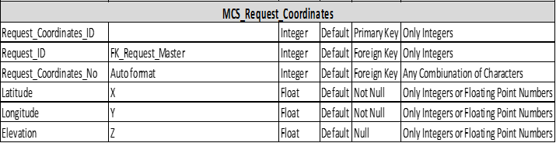

Table 4: MCS_Application_Licence_Master

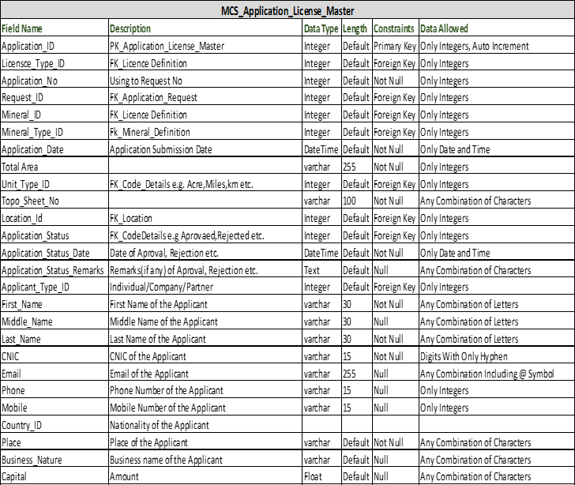

Table 5: MCS_Application_Licence_Details

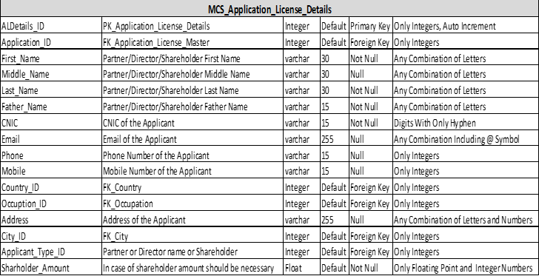

## IDE

Netbeans IDE bundle for Java EE will be used. It provides support for latest Java EE platform version and provide tools for working with Java Persistence API. It also provides ease of use and a tight integration between Java EE components and Glassfish Server. It has built-in wizard for JSF Templates and an editor for JSP files with features for code completion, debugging and error checking.

## Component Design

### Module Description

MCS is written in fully modular way in order to minimize the overhead. This allows the users to run the system or parts of it even in portable smart devices with limited RAM.

#### Request Module

This module describes apply for new license. This will use to record the initial information of Mine Owner and prerequisites about the license.

#### Application Form

This module check the eligibility of the applicant for the requested license.

#### Initial Survey

This module will record the physical survey information carried by survey department. This Module will explain about the availability of area and confirm the coordinates provided by applicant.

#### Geological Survey

This module record the Geological Survey carried by Geologist. It will cover geological information about applied area.

#### Mines Committee or Approval Authority

This module is related approval process of licensing authority and generate them Work order and Allotment letter.

### Modules Integration

Mineral Cadastre System Modules are organized in this manner which are well integrated and communicated for getting and share information.

### Overview of Human Interface Design

This section describes the details of the user interface. The user interface is a standalone application and must be run on the server. The user interface will be consisted of the following components as illustrated in Figure 17*.* The UI will provide a toolbar with buttons having appropriate icons which will make the navigation between the UI components easier.



Figure 14: MCS Human Interface Design

* **Help:** Brings up a help window.
* **Add New:** This will provide a wizard for adding a new request and validate if required details and documents are provided in proper format.
* **List:** This will list all the license information browser.
* **Map Viewer:** A map viewer will be provided which will allow the user to navigate the geospatial data related with the selected application. There will a separate button for this with a globe-like icon.
* **Editor:** Different features of Map can easily be edited by this Editor.
* **Reports:** It will generate different Reports e.g. Custom Graphics, Text Documents, Mining Lease and Prospect License etc.

### Requirements Matrix

A brief overview of major components of MCS module and their respective requirement is presented in Table 6.

Table 6: Requirements Matrix

|  |  |
| --- | --- |
| **Components** | **Requirement** |
| Java | Used as the main programming language |
| Java EE 7 | Provides an API for distributed and multi-tiered architecture, object-relational mapping and web services. |
| Glassfish Server Open Source Edition | An open-source application server for Java EE platform |
| PostgreSQL | An object-relational database management system for persisting all cadastre related information. |
| PostGIS | Used for storing and retrieving information about location and mapping in the PostgreSQL database. |
| Netbeans IDE | A development environment which provide ease for developing Java EE. |