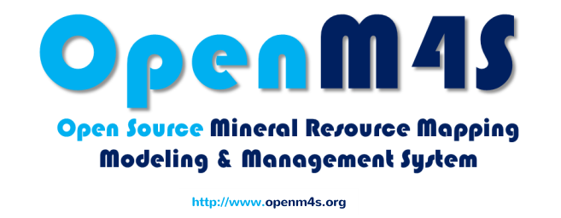

Detailed Software Requirements of Mineral Cadastre System

prepared by: MUHAMMAD YAHYA

Mineral Cadastre System

2014

Table of Contents

1. List of Tables 6
2. Introduction 10

1.1. Purpose 10

1.2. Scope of Project 10

1.3. Glossary 10

1.4. Overview 10

1. General Description 12

2.1. Product Perspective 12

2.2. Product Functions 12

2.3. User Characteristics 12

2.4. User Problem Statement 12

2.5. User Objective 13

2.6. General Constraints 13

1. Workflows 14

3.1. Submit Application 14

3.2. Lodge Application 15

3.3. Initial Survey 16

3.4. Geo Survey 17

3.5. Higher Authority / Application Approval 18

3.6. Full Process 19

3.7. Transfer Application 20

3.8. Transfer Approval 21

3.9. Full Process for Transfer Application 22

3.10. Conversion 23

3.11. Renewable 24

3.12. Application for Mine Extension 25

1. System Requirements 26

4.1. Functional Requirements 26

4.1.1. UC-01 Enquiry: 26

4.1.2. UC-02 Submit Application: 26

4.1.3. UC-03 Lodging Application: 27

4.1.4. UC-04 Survey Plan: 27

4.1.5. UC-05 Approval of Application: 33

4.1.6. UC-06 Change System Settings: 34

4.1.7. UC-07 Transaction Audit: 34

4.1.8. UC-08 Administrative Security: 34

4.2. Maintainability 36

4.3. Scalability 36

4.4. Reliability 36

4.5. Interface 36

1. Design Constraints 38

5.1. Layered Approach 38

5.2. Open Source Software 38

5.3. Software Constraints 38

5.4. Client side Constraints 38

1. Functional testing 40

6.1. Test Scenarios 40

6.2. Test cases 41

6.3. Validating the Software requirements 61

1. Preliminary Schedule 62
2. Conclusion 62

Table of Figures

Figure 1: Workflow of Submit Application 14

Figure 2: Workflow of Lodge Application 15

Figure 3: Workflow of Initial Survey 16

Figure 4: Workflow of Geo Survey 17

Figure 5: Workflow of Higher Authority / Application Approval 18

Figure 6: Workflow of Full Process 19

Figure 7: Workflow of Transfer Application 20

Figure 8: Workflow of Transfer Approval 21

Figure 9: Workflow of Full Transfer Application 22

Figure 10: Workflow of License Conversion Process 23

Figure 11: Workflow of Application Renewal 24

Figure 12: Workflow of Application for Mine Extension 25

Figure 13: Test Scenarios 40

Figure 14: Test Cases 41

Figure 15: Test Cases Continued 2 42

Figure 16: Test Cases Continued 3 43

Figure 17: Test Cases Continued 4 44

Figure 18: Test Cases Continued 5 45

Figure 19: Test Cases Continued 6 46

Figure 20: Test Cases Continued 7 47

Figure 21: Test Cases Continued 8 48

Figure 22: Test Cases Continued 9 49

Figure 23: Test Cases Continued 10 50

Figure 24: Test Cases Continued 11 51

Figure 25: Test Cases Continued 12 52

Figure 26: Test Cases Continued 13 53

Figure 27: Test Cases Continued 14 54

Figure 28: Test Cases Continued 15 55

Figure 29: Test Cases Continued 16 56

Figure 30: Test Cases Continued 18 57

Figure 31: Test Cases Continued 19 58

Figure 32: Test Cases Continued 20 59

Figure 33: Test Cases Continued 21 60

# List of Tables

Table 1: Glossary 10

Table 2: Use Case 01 (Enquiry) 28

Table 3: Use Case 02 (Submit Application) 30

Table 4: Use Case 03 & 04 (Lodging Application & Survey Plan) 30

Table 5: Use Case 05 (Approval of Application) 35

Table 6: Use Case 06 (Changes System Settings) 35

Table 7: Use Case 07 (Transaction Audit) 35

Table 8: Use Case 08 (Administrative Security) 36

Review History

|  |  |  |  |  |
| --- | --- | --- | --- | --- |
|  |  |  |  |  |
|  |  |  |  |  |
|  |  |  |  |  |
|  |  |  |  |  |
|  |  |  |  |  |
|  |  |  |  |  |
|  |  |  |  |  |
|  |  |  |  |  |

# Introduction

## Purpose

The purpose of this document is to present a detailed description of the Mineral Cadastre System. It will explain the purpose and features of the system, the interfaces of the system, what will it do, the constraints under which it must operate and how the system will react to external stimuli. This document is intended for both the stakeholders and the developers of the system and will be proposed to the higher authorities for its approval.

## Scope of Project

This system is a complete Mineral Cadastre System which will help public user in

* Checking the areas available for applying license
* Online registration and online apply for the License
* Checking the status of their application

This system will help the employee who are responsible for the administration of these application as

* To give information about the available areas for the license to public users.
* Geological team will edit the application coordinates if needed and approve for progress if area and minerals are available.
* Higher authority will check all the required things and if eligible the application is approved through this system and an allotment letter is generated.

## Glossary

Table 1: Glossary

|  |  |
| --- | --- |
| Terms | Definitions |
| UC | Use Case |
| FN | Functional Needs |
| UTM | Universal Transverse Mercator |
| WGS | World Geodetic System |
| MCS | Mineral Cadastre System |
| TS | Test Scenario |
| TC | Test Case |

## Overview

Further this document presents the General Description and complete workflows of the system depicting the working of the system. Functional requirements are described in the form of use cases and functional needs. Then there are the design constraints and test cases and test scenarios for checking the functionality of this system. And finally the document is concluded with Preliminary Schedule and Conclusion.

# General Description



## Product Perspective

This Mineral Cadastre system is a new system which will replace current manual system for applying for the license. With everything computerized and accessible from everywhere this system save a lot of time and effort of both applicant and administration. Also application can be approved by the higher authority from anywhere through this system. All the records can be saved and retrieved easily.

## Product Functions

With this system user can easily submit application online and can check the status of the application from any place. People can easily check the areas and minerals available for license. This system includes the mapping functionality which can be used by the user to select the area they want to apply for the license. User can easily edit their information. From the administration point of view as everything is saved in database so all records can be easily retrieved. Higher authority can approve the application from anywhere.

## User Characteristics

There are two types of user that will interact with this system: Public user and administration.

* Public user can check the available areas and minerals for license and submit application for the license .They can only view and edit their own profile.
* Administration can approve and reject the application. They are managing the overall system so there is no incorrect information within it .They can edit the application if needed for example changing the coordinates according to the available area.

## User Problem Statement

As it stands the whole procedure of applying for license is manual, it’s not electronic. Manual system needs lot of time and effort. User have to come to the office again and again to check the status of their application.

Similarly as nowadays there is a file system so searching any specific application will takes time and effort. File can be misplaced. Public user nowadays don’t have much knowledge about the available minerals and areas so they have to go to regional or main office for the information.

People in the administration have to check manually for the area on map every time user apply for license.

Clients mostly complaint about the transparency of the manual system that system is not transparent and they have to wait for very long for the processing of their application and they don’t know the status of their application.

## User Objective

The system should be easily usable. User should easily submit application and administration can easily do their part. User should easily check all the available areas and check the status of application.

## General Constraints

The development team has to design, develop and test this system with in the space of 4 months as they must work on other modules of the project.

The Internet connection is a constraint for the application. Since the application fetches data from the database over the Internet, it is crucial that there is an Internet connection for the application to function.

# Workflows

This chapter describe the workflows of the whole process starting from submitting application till approval of license, transfer of license and extension of mines.



## Submit Application

If a user wants to apply for a license he/she should submit the request first. By filling all the details required in a request form and also attach all the documents required. After the request is submitted the attached documents are checked whether the documents are complete or not. If documents are complete the applicant is informed and a token number is generated with the help of which this request can be tracked. If the documents are not complete the applicant is informed and he/she can apply for the license again if he/she didn’t reached the maximum limit for submitting application.

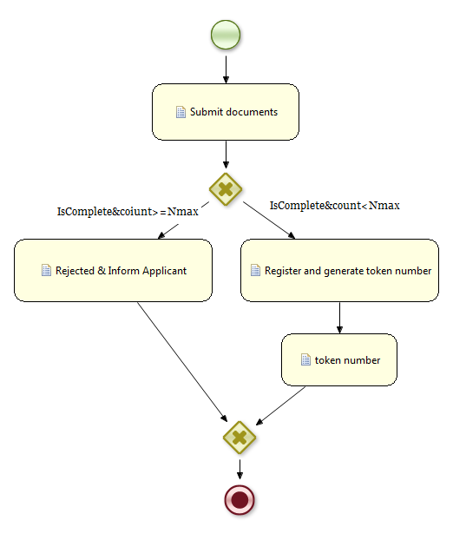

Figure 1: Workflow of Submit Application

## Lodge Application

Once it is checked that the documents are complete the applicant should submit the fee so that the authority verify the documents submitted by the applicant. If the documents are valid then the documents are scanned, saved and marked for the initial survey. If the documents are not valid the applicant is informed and he/she can apply for the license again if he/she didn’t reached the maximum limit for submitting application.

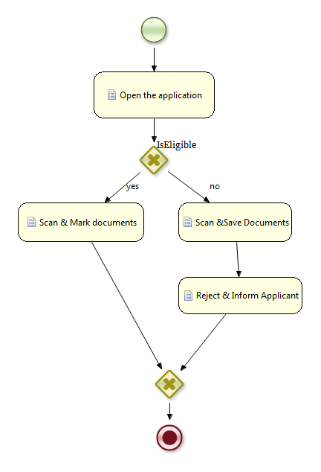

Figure 2: Workflow of Lodge Application

## Initial Survey

Once it is verified that the documents are valid the survey team check the coordinates and survey the place to check whether the coordinates are correct and area is available or not. If the area is available then they correct the coordinates if there is a small mismatch at the boundaries. On the basis of this survey, the survey team generates a survey report and draw the coordinates on map and mark it for the geo survey team. If the area is not available the documents are scanned and saved in rejected files. The applicant is informed and he/she can apply for the license again if he/she didn’t reached the maximum limit for submitting application.

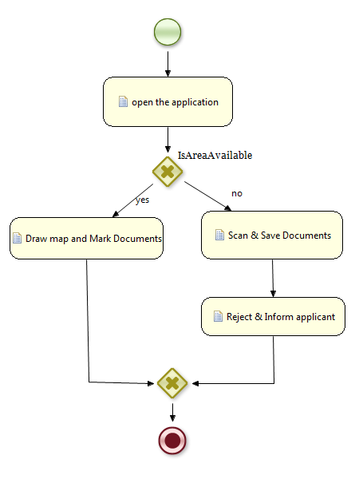

Figure 3: Workflow of Initial Survey

## Geo Survey

After initial survey, the geological team visit the site to confirm the minerals for which user applied actually exists or not. If minerals exists map is drawn, if not then documents are scanned and saved in rejected file. The applicant is informed and he/she can apply for the license again if he/she didn’t reached the maximum limit for submitting application.

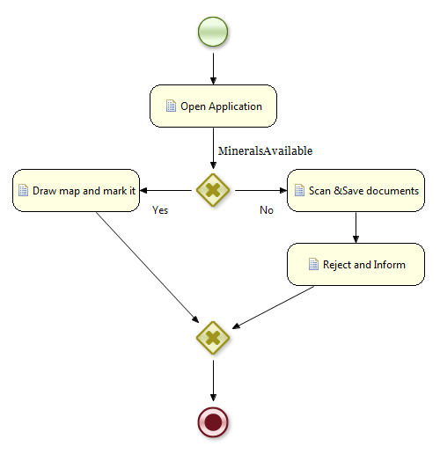

Figure 4: Workflow of Geo Survey

## Higher Authority / Application Approval

After geological survey has marked the documents the final stage is approval of this application by higher authority. There are 3 possibilities.

* Application is approved and allotment letter is issued and applicant is informed
* Application is rejected and applicant is informed and he/she can apply for the license again if he/she didn’t reached the maximum limit for submitting application.
* Application is on hold. Application is sent back to the higher authority and applicant is informed.

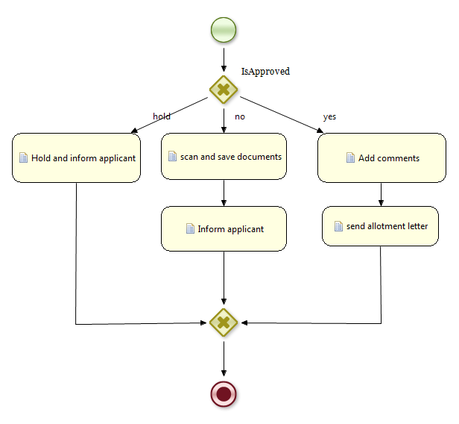

Figure 5: Workflow of Higher Authority / Application Approval

## Full Process

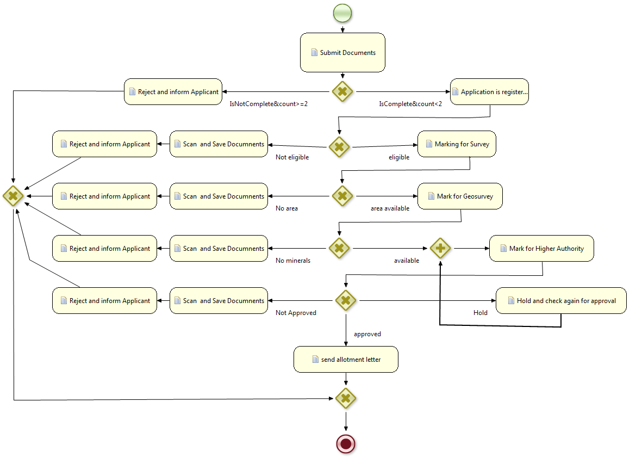

Figure 6: Workflow of Full Process

## Transfer Application

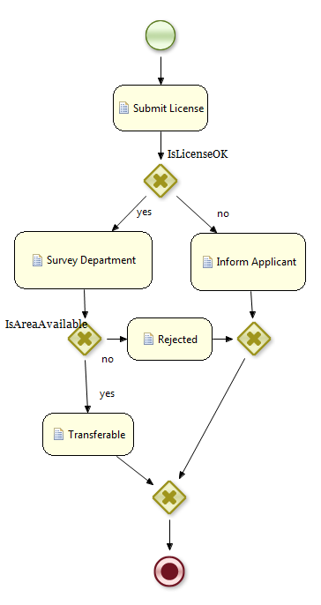

Figure 7: Workflow of Transfer Application

## Transfer Approval

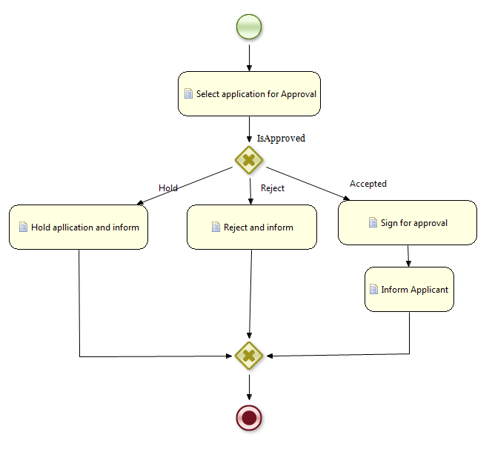

Figure 8: Workflow of Transfer Approval

## Full Process for Transfer Application

If a user wants to change the ownership of the license he/she own, he/she should apply for transfer. The process started by submitting license for transferring. At first the license is checked whether it is valid or not. If not, the applicant is informed that the license is not valid for transfer. If yes, then there is another check which checks whether the transfer is due to inheritance or user applied for the transfer. If the transfer is due to inheritance it is simply transfer to the person mentioned in next of kin ,but if user applied for the transfer then the license is submitted for the survey where it is checked whether the area is available or not. If area is not available the transfer is rejected if area is available then next step is marking the license to the higher authority for approval. There are 3 possibilities.

* License transfer is approved and applicant is informed
* License transfer is rejected and applicant is informed
* License transfer is on hold. License is sent back to the higher authority and applicant is informed.

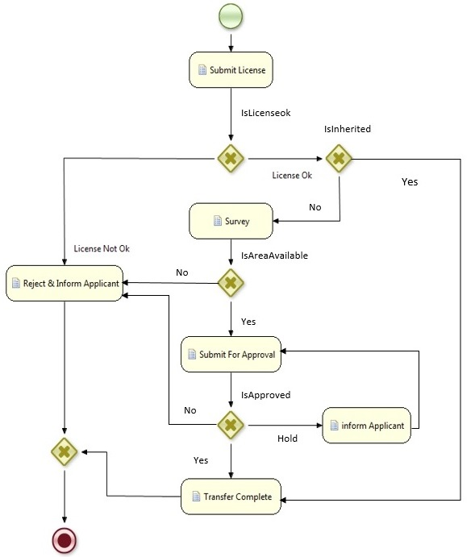

Figure 9: Workflow of Full Transfer Application

## Conversion

Converting license from one type to another is also an operational scenario. There are two possible cases in conversion mentioned below;

* System Initiated
* User Applied

System initiated means that user did not applied for the conversion of license instead system by itself invoked this process .we can recall it from renewal process where conversion was invoked. If this process is invoked by system then there is no need of checking whether it is convertible or not. If user apply for the conversion then first it is checked whether it convertible or not by evaluating few basic checks. If it is not convertible applicant is informed. If license is convertible then applicant is informed so that fee is submitted. Once fee is submitted the lodge application, survey, geo-survey, high authority Approval and allotment letter processes are invoked sequentially.

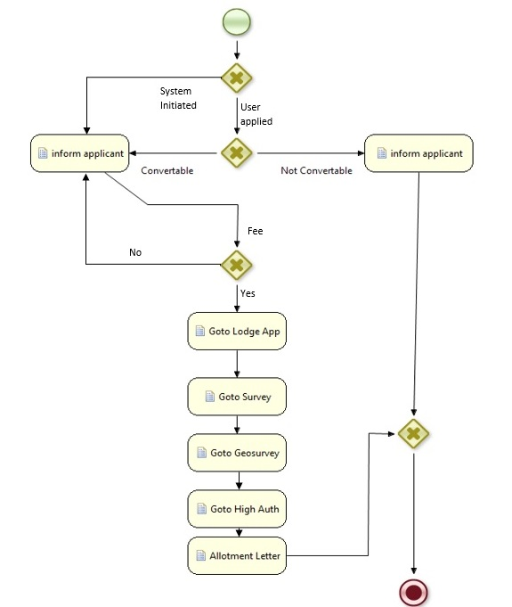

Figure 10: Workflow of License Conversion Process

## Renewable

If a license owner wants to renew the license, following steps will be followed.

The process starts with submitting license for renewal. Few checks are evaluated to check whether the license is renewable or not. Checks are mentioned below;

* Whether user has already reached the maximum limit for license renewal.
* The progress report is checked whether some improvement is done when the owner had the license previously
* Is there still some time remaining for the license renewal.

If the user has already reached the maximum limit then the conversion process is invoked instead of renewal process. If the progress report is not satisfactory and if there is also some time remaining in the current license, then the application is rejected and applicant is informed. If applicant meets all the requirements needed for renewal then the applicant is informed the license can be renewed and applicant should submit fee. Process will not continue until applicant submit the fee. Once fee is submitted the Lodge Application procedure is invoked. After lodging the next step is Geo survey for which Geo Survey Procedure is invoked and after that allotment letter is issued.

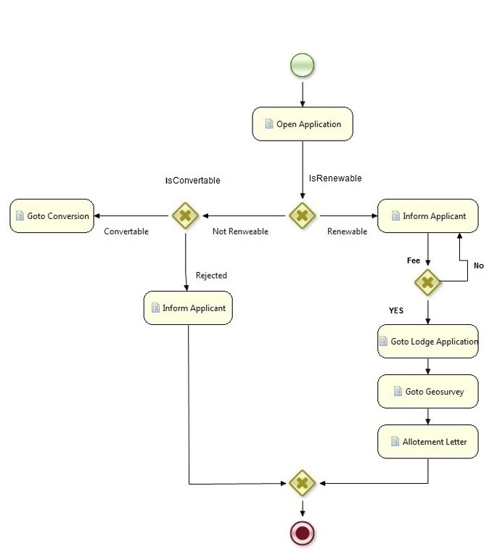

Figure 11: Workflow of Application Renewal

## Application for Mine Extension

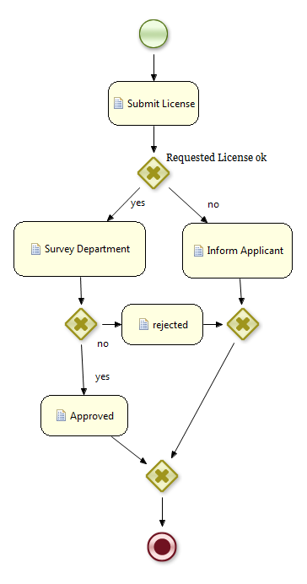

Figure 12: Workflow of Application for Mine Extension

# System Requirements



## Functional Requirements

### UC-01 Enquiry:

The client will come to the Directorate of Mines and Minerals office (or telephone or check it online) and be directed to the desk at the public counter dealing with service enquiries being either an enquiry about Specific service application or a general enquiry about what services are about provided by government, what information and supporting documents are required for each service, what are the fees for each service and what is the expected turn-around time for each service.

At the Service Enquiry Desk, the officer speaks with the client and determines the nature of their enquiry. The officer logs onto the system. The system records the starting time for the enquiry.

If it is an enquiry regarding a specific application, the officer will interrogate the system (by application number or applicant name or request number) and determine the status of the application and advise the client on how much longer it should take or what is stopping progress. An application/request status report may be printed for the client if requested.

Where the application being enquired about has been completed, the officer will retrieve any certificates or special reports resulting from the service application plus any supporting documents that are to be returned to the client and hand them over. A document receipt is printed by the system, the client signs and the signed copy of the document receipt is scanned and paper document receipt and its digital equivalent is added to paper and digital application file respectively. If all other necessary actions have been completed, the system records the paper based application file is ready for archiving by the Archivist.

Where the enquiry concerns a service that may be applied for, the officer will make such Information searches on the system as are required to verify the appropriateness of the enquired about service, what details and supporting documents are required for that service and the fees for that service. An information sheet for that service can be printed out for the client, if required. When the client leaves the service enquiry desk, the officer, notes on the system that the Enquiry has been completed. The system records the end time.

### UC-02 Submit Application:

Using forms approved by the Directorate of Mines and Minerals office, the client completes both the application form and the principal document that will be registered / approved / certified / recorded by the Directorate of Mines and Minerals office and, where there is form of title registration, annotated on the title certificate. Client can also apply online for license by filling the online form and attaching the scanned documents. If there is any fees for this step the client should pay the fees in the banks mentioned in the form then attach the receipt with the documents.

### UC-03 Lodging Application:

Once the application is submitted the principal document will need to be signed by all parties and usually this signing will need to be witnessed or notarized by someone independent of the transaction recorded or auctioned by the principal document. The client also needs to ensure all the required supporting documents are available to be submitted as part of the application and that they have available sufficient documentation to verify their personal identity and that they are entitled to register a document with respect to the property identified in the principal document.

Where it is feasible and the user is able to accurately determine the applicable fees, and there is an agency that accepts payments on behalf of the Directorate of Mines and Minerals office, the payment can be made and the receipt included as a supporting document to the application.

The Client proceeds to the appropriate public counter dealing with the lodgements of applications (possibly assisted with automated queuing system). At the counter the Officer will validate the Client’s identity in so far as the Client being entitled to make the requested transaction and similarly that all the necessary supporting documents are present. The officer will then enter details of the application (applicant name and contact details), transaction type(s) and properties affected) directly into the computer. If there is any fees for this step the client should pay the fees in the banks mentioned in the form then attach the receipt with the documents.

### UC-04 Survey Plan:

In the case of the lodgement of a survey plan, the Public Counter will identify a point (or points) on the on-line cadastral map which locates the general location and extent of the survey plan. The system will generate a unique application number. The application is printed (office and client copies) with details of the fees that need to be paid. If there is any fees for this step the client should pay the fees in the banks mentioned in the form then attach the receipt with the documents. The application file is then stored at an appropriate place within the office until the application is complete and the system allocates the application to the “back office” team.

Table 2: Use Case 01 (Enquiry)

|  |  |  |
| --- | --- | --- |
| Identifier | Capability | Feature |
| FN – 1 | Display Service Requirements | Client explains their situation and officer determines the relevant Service. Officer enters type of service and system presents a checklist of supporting documents required for the selected service with the option to print this out for the client. |
| FN – 2 | Online Checking | Client check the status of his/her application or available areas and minerals for licensing |
| FN – 3 | Display.  Service Fee | Officer enters type of service and system presents the fee or the basis for how the fee for the service is calculated. The client has the option to request a print of the fee details |
| FN – 4 | Search  Records | System to present user with a sequence of screens starting with the search criteria (including owner name etc.), followed by a list of records meeting the search criteria and finally a full display of the search target record. |
| FN – 5 | Display search Results | System will search database using the search criteria and display a list of records meeting those criteria for the user to select the specific record that is of interest. |
| FN – 6 | Print Search | Registration Officer requests the current record to be printed. |
| FN – 7 | View Cadastral Map | This map viewer will have the following characteristics and functionality:   * The map should reflect the latest and most up-to-date cadastral boundaries; * When the Cadastral Map Viewer is first displayed, it should zoom to the extent. of the area served by the Office that the user is enrolled as a user; * Access to the Cadastral Map Viewer is strictly “Read-only” for all end users; * Have the spatial functionality to zoom in, zoom-out and pan * To display the scale of the map displayed on the screen * To display the current standard coordinate values of the cursor position * Print displayed map (of the map displayed on the screen or map at the specified scale cantered on the Centre of the screen). Print to have standard copyright and disclaimer notice, that the print is not for sale, and the name of the user initiating the print and the time and date * Simple Page Setup configuration associated with Print functionality [Portrait/Landscape, set margins, title for print-out] * Simple Layer Configuration by the user including the ability to turn on and off the standard layers any associated annotation * Layer display to be automatically controlled by the map display scale with these default values for the scales at which layers become visible being configurable by the system administrator * Ability to measure distance between two user selected points and also to show accumulated distance * Progressive Search function (similar to Google) based on the parcel identifier in the Cadastral Object/ Polygon table. Where the selected instance of the Cadastral Object/ Polygon table is not a parcel, the related parcel polygon will display * Information Tool whereby when a Cadastral Object/ Polygon parcel polygon is selected, a subset of the field values will be displayed in a Tool Tip form along with a function link to print this attribute data. For instances of parcel Cadastral Object/ Polygon, the parcel / property identifiers of related Cadastral Object/ Polygon will be listed. Similar functionality to be provided for any other spatial feature classes implemented within system * Functionality described above to be available through menu structure, toolbar icons and other software structures * Functionality described above to be capable of being manually enabled or disabled by the system administrator or to be controlled by software depending on context and the role of the user * User documentation, preferably context sensitive to be available to users * System to log each time the Cadastral Map Viewer is initiated, by which user and how long the session was |
| FN – 8 | View Work In Progress | System to generate a listing of all work – in –progress (Current Work). Each row to represent an application (registration or cadastre change). |
| FN – 9 | Note Actions | System to note the time and date, action completed. A completed action can also be manually noted by the officer with the current date and time being the default but editable value for the date time field. |
| FN – 10 | Attach  Supporting  Document To  Action | Officer is able to link scanned image of supporting/associated document to a recorded action. |

Table 3: Use Case 02 (Submit Application)

|  |  |  |
| --- | --- | --- |
| Identifier | Capabilities | Features |
| FN-11 | Create New Application | Client should be able to create new application online or he/she can come to directorate and inform officer to do so. |
| FN-12 | Edit Current Application | Current application could be edited by client online or he/she can come to directorate and inform officer to do so if there is some wrong information in the applicant personal profile (e.g. address or NIC, …) |
| FN-13 | Download Form | Client can download the form for submitting application online or he/she can come to directorate and inform officer to do so. |
| FN-14 | Document attachment | Client should be able to attach all the required documents online or he/she can come to directorate and inform officer to do so. |

Table 4: Use Case 03 & 04 (Lodging Application & Survey Plan)

|  |  |  |
| --- | --- | --- |
| General (Cadastre and Registration) | | |
| Identifier | **Capabilities** | **Features** |
| FN-15 | Lodge checklist | Officer enters type of transaction and system presents a checklist of supporting documents required for selected transaction type. If all supporting documents are present, lodgement proceeds |
| FN-16 | Lodge Identify  Underlying  Property | Officer keys in parcel identifier in Google – like search. Where parcel has corresponding record or related title or map record, the user is informed and given the option to view them. Once assured that the underlying parcel / property has been identified or that the transaction applies to no specific parcel or property (e.g. power of attorney, standard form, or first registration), the officer will confirm that the parcel/ property has been correctly described. If not the application is returned. |
| FN-17 | Calculate Fees | The system shall calculate the fee applicable to the transaction. |
| FN-18 | Lodge New  Application | Officer records details on the person making the application (Owner or duly appointed person on behalf of owner) including contact details, records the receipt for the fees and the system allocates a unique application number (the next sequential number applicable to the transaction type of the application) |
| FN-19 | Lodge Survey  Plan | Officer locates general location of survey plan (cadastre change) in the Cadastral Map Viewer and then a point (or points) where a symbol and label of the survey plan number/identifier will appear as a “lodged but unapproved” survey plan |
| FN-20 | Application  Main Documents | Document details of the main document(s) to be registered/ approved are entered and links the scanned images of these documents to the appropriate  document record |
| FN-21 | Print Application | The completed application is then printed. |
| Registration Only | | |
| FN-22 | Record Rights  Restrictions  Details | Capture all the details describing the rights or restrictions affected by the transaction(s) in the application. Changes to reflect new situation are given status “pending registration/approval” and existing records to be superseded the status of “to be retired/cancelled/made historic on  Registration/approval”. |
| Identifier | **Capabilities** | **Features** |
| FN-23 | Identify Share  To Be Changed | Officer identifies parcel and system displays a list of Owners. User selects owner to be changed and likewise share to be changed if owner has more than 1 shareholding. Changes to reflect new situation are given status “pending registration/approval” and existing records to be superseded the status of “to be retired/cancelled/made historic on registration/approval” |
| FN-24 | Record New  Owner Details | Capture all the details describing the changed or new owner. Changes to reflect new situation are given status “pending registration/approval” and existing records to be superseded the status of “to be retired/cancelled/made historic on  registration/approval” |
| FN-25 | Record Transaction Title Changes | Capture all the changes to the title (apart from owner details) that will result from the registration/approval of the transaction(s) in the application. Changes to reflect new situation are given status “pending registration/approval” and existing records to be superseded the status of “to be retired/cancelled/made historic on registration/approval” |
| Documents only | | |
| FN-26 | Scan Documents | Principal and supporting documents are stored in a folder which is accessible to all authorized people such as licensing authority |
| FN-27 | Link Scanned  Images | Licensing Authority identifies the record that they wish to associate a scanned image. The Directorate goes to the central temporary repository of scanned images and identifies the relevant image file. The selected image file is renamed to a name that includes the record type and the record identifier. This renamed image file is then archived within the digital archive database, a link is stored from in the main record database and the image file is marked for deletion from the temporary image file repository at the end of each working day |
| FN-29 | Remove scanned image | Licensing authority must be able to delete a  scanned image and the link |
| FN-30 | View Scanned images | Licensing authority must be able to view scanned image (and potentially print the scanned image) from the associated database record when displayed in a form or as a link from a list of associated records (such as supporting documents). |
| Cadastre Only | | |
| Identifier | **Capabilities** | **Features** |
| FN-31 | Confirm  Underlying Parcel | System to present Surveyor with a map window highlighting the current underlying parcel as specified indeed. User to confirm or select another parcel which corrects parcel identification as entered in registration details window. System to amend status of map parcel to “subject to new survey – approval pending” |
| FN-32 | Record New  Survey | Surveyor records a point(s) which marks the general vicinity of a new survey. Surveyor can delete points defining the same (cadastre) application as is open. |
| N-33 | Attach Surveyors  Report | Surveyor links scanned image of surveyors report as supporting document for this application. |
| FN-34 | Import New  Survey Points | A comma delimited file containing Cartesian coordinates (Easting, Northing, Zone) in the native/standard (to the country) UTM coordinate system for the cadastre (from a geocentric projection such WGS 1984) is loaded, checked to see the coordinates are within the expected range and displayed on a working layer specific to this user session that can only be edited by the user. Coordinate file is added to digital archive for  cadastral surveys |
| FN-35 | Import XML file | A XML containing new parcel definitions in Cartesian coordinates (Easting, Northing, Zone) in the native/standard (to the country) UTM coordinate system (from a geocentric projection such WGS 1984) is loaded, checked to see the coordinates are within the expected range and the (parcel) polygons and boundary nodes displayed on a working layer specific to this user session that can only be edited by the user. XML file is added to digital archive for cadastral surveys |
| FN-36 | Edit Survey  Points | Ability to change survey category of any loaded point/node from “boundary Node” to “non-Boundary Survey Point”. |
| FN-37 | Form New  Cadastre Polygon | Ability to connect boundary nodes to form cadastre polygons and to edit any boundary line in the user’s working layer. System to allocate parcel (cadastre object) identifier. User to specify type of cadastre polygon (parcel, building, easement, etc.) and enter legal/surveyed area and any other parcel details. |
| Identifier | **Capabilities** | **Features** |
| FN -38 | Link New  Boundary Nodes To Existing  Cadastre Nodes | While displaying current cadastre layer(s) and the users working layer, use a drag-and-drop technique to link any new boundary nodes that also define nodes on existing cadastre layers. When linking is complete, system transforms new survey points into terms with existing coordinate values for the cadastre layer(s). Transformation holds the existing coordinate values for existing nodes and where a new boundary node was on an existing boundary vector, this relationship is maintained. Mean shift and standard error of transformation is displayed. Surveyor accepts or rejects. If accepted, the polygon(s) are copied to provisional layers and are viewable by other users. If rejected the user working layer is cleared. |
| FN-39 | Check New Parcel | Surveyor to initiate system check for topological correctness and report on any gaps, overlaps or other issues. These checks plus transformation details are written into the Quality Check for this (cadastre) application |
| FN-40 | Generate New  Parcel Plan | Surveyor to initiate generation of image file of all new parcels (in standard Parcel Plan layout and format) and their attachment as supporting documents to the (cadastre) application |

### UC-05 Approval of Application:

The Approving Officer will select an application ready for approval or registration from their Workspace. They will review, and where there are any critical issues examine them further before approving the transaction or sending it back to the “Back Office” Registration team for further action. If satisfied they:

* Approve each transaction within an application. The system will then change the status of all related records from “pending” to “current” / “approved” or “historic” (in the case of an existing record that is superseded or extinguished as a result of the registration/approval).
* Approve the cancellation or rejection of the application; the system will then change the status of all related records from “pending” to “cancelled” and the underlying original records to “current”.
* Approve the requisition to the applicant asking for remedial work. The system will change the status to “pending requisition”. When one of these approval decisions has been made by the Approving Officer, a notice will be generated and this notice, emailed, faxed or posted to the applicant. This will result (in some but not with all transaction types) the Client returning to the Directorate to collect documents.

### UC-06 Change System Settings:

The System Administrator will be responsible for making the changes to the Static Data definitions which populate system objects such as “drop down” lists and control the values permitted in certain fields The System Administrator will make no changes with respect to system settings without having obtained authorization from the Directorate.

### UC-07 Transaction Audit:

The Directorate will designate one of their Officers as an Internal Auditor needs reporting tools to perform random systematic reviews of individual transactions as well as to investigate transactions where a potential performance problem has been identified either through the regular performance reports or where a complaint has been received from a Client.

The Internal Auditor needs to be able to review what actions were completed with respect to the transaction, how long each processing step took , what key data fields were changed, the before and after key data field values and who made the changes. (i.e. a process “trace” and a key data field “trace” for the transaction under review where mistakes are identified in the title or digital cadastral map, these must be initiated as a new type of transaction, a “Register & Cadastre Correction” transaction and processed as a regular application.

### UC-08 Administrative Security:

The System Administrator will be responsible for creating new user accounts and maintaining related details such as the definition of User Roles (within the computerized system) and what functions and privileges will be associated with different User Roles. The System Administrator will make no changes with respect to user accounts (creation, modification or “retirement”) without having obtained authorization from the Directorate.

Table 5: Use Case 05 (Approval of Application)

|  |  |  |
| --- | --- | --- |
| Identifier | Capabilities | Features |
| FN-41 | View  Application | Registrar initiates approval and system displays transaction and related title records |
| FN-42 | Edit  Application | System to present Approval officer with a series of linked screens and, where practical, selection of values from a list of controlled values and default values to edit any details describing  the transaction |
| FN-43 | Cancel  Application | Approval officer can select option to cancel application with an appropriate comment in applications quality checklist. System generates Cancelation Notice sends it directly to applicant or to a Licensing Authority to send out. System also updates status  accordingly and removes transaction from “work in progress” |
| FN-44 | Re-assign  Application | Approval officer can select option to re-assign application to staff member with an appropriate comment in applications quality  Checklist |
| FN-45 | Register  Transaction | Approval officer can select option to register each transaction in an application. System updates status accordingly |
| FN-46 | Approve  Cancellation | Approval officer can select option to approve the cancellation of a previously registered right or restriction |
| FN-47 | Consider  Registration Notice | Upon registration/ approval, system generates notice of registration and attaches to application as supporting document and where feasible sends notice to applicant / relevant people |

Table 6: Use Case 06 (Changes System Settings)

|  |  |  |
| --- | --- | --- |
| Identifier | Capabilities | Features |
| FN-48 | Manage System  Settings | Local System Administrator to be able to add, modify or retire values in lists of controlled values (code lists) |

Table 7: Use Case 07 (Transaction Audit)

|  |  |  |
| --- | --- | --- |
| Identifier | Capabilities | Features |
| FN-49 | Audit Process  Trace | Internal Auditor and chief of office to request system to list all processes undertaken on a specified dealing (including changes to the cadastral map) including dates and staff member responsible for each process step |
| FN-50 | Audit Key  Data Field Trace | Internal Auditor and chief of office to request system to list all changes made to any key data field on a specified dealing, title,  Survey plan or map parcel polygon including dates and staff member responsible for each change to a key data field. |
| FN-51 | Approval officer  Correction  Initiate | Chief of office to be able to initiate a Record Correction transaction and assign it to staff member for action |

Table 8: Use Case 08 (Administrative Security)

|  |  |  |
| --- | --- | --- |
| Identifier | Capabilities | Features |
| FN-52 | Manage User  Privileges | Local System Administrator (any user for password change) to be able to change system settlings such as controlled value lists (code lists) and user privileges. |
| FN-53 | Manage User  Change Password | Any user to be able to change their own password to a new value. New password to be double entered to validate its correctness |
| FN-54 | Manage User  Privileges Roles | Local System Administrator to be able to add, modify or delete different roles and associate certain permitted actions with each role. |
| FN-55 | Manage User  Privileges Accounts | Local System Administrator to be able to add, modify, suspend or delete individual user accounts for the system |

## Maintainability

This system will be well documented and layered approach will be followed. Service oriented Architecture will help in maintainability of this system. This approach will make it easier for future developer to do the changes and update the system.

## Scalability

Both this system and its documentation will be scalable. All effort thus should be use the design that does not have built in size limitations.

## Reliability

This system will be reliable. There will be no data redundancy and system will be secured.

## Interface

The system will have a simple point and click interface using menus, buttons, text fields and all other interface of system will be graphical.

# Design Constraints



## Layered Approach

Architecture of this system will be layered so that business, data and web service layer are not dependent on one another.

## Open Source Software

Software used for developing this system will be open source.

## Software Constraints

Server side programming will be in Python and PHP. Client side will be written in JavaScript. System will run on Linux, Windows higher than 95 and Mac. The configuration files will be written in XML. Software used for database will be Postgres.

## Client side Constraints

Client accessing this system must have access to internet with high speed access such as cable or DSL.

# Functional testing



## Test Scenarios



Figure 13: Test Scenarios

## Test cases



Figure 14: Test Cases



Figure 15: Test Cases Continued 2



Figure 16: Test Cases Continued 3



Figure 17: Test Cases Continued 4



Figure 18: Test Cases Continued 5



Figure 19: Test Cases Continued 6



Figure 20: Test Cases Continued 7



Figure 21: Test Cases Continued 8



Figure 22: Test Cases Continued 9



Figure 23: Test Cases Continued 10



Figure 24: Test Cases Continued 11



Figure 25: Test Cases Continued 12



Figure 26: Test Cases Continued 13



Figure 27: Test Cases Continued 14



Figure 28: Test Cases Continued 15



Figure 29: Test Cases Continued 16



Figure 30: Test Cases Continued 18



Figure 31: Test Cases Continued 19



Figure 32: Test Cases Continued 20



Figure 33: Test Cases Continued 21

## Validating the Software requirements

This document will be given to the stakeholders and principal investigator for review so that if any changes are needed. These changes will incorporated in this document because it is more costly to implement changes at later stages.

# Preliminary Schedule

* The software Requirement document will be completed and submitted for review till May 9, 2014.
* The next step will be to amend this document on basis of feedback.
* A design document will then be produced and submitted for review.
* Testing will be performed at all stages.

# Conclusion

It is the development team’s hope that this document will be the first part of continuing series of interchanges between them and end-users. This will ensure that customer’s needs are met in cheap and timely fashion. It will be important to involve potential officers from the directorate as end-users as they have many unique insights that might not occur to software developer and people involve in managements.