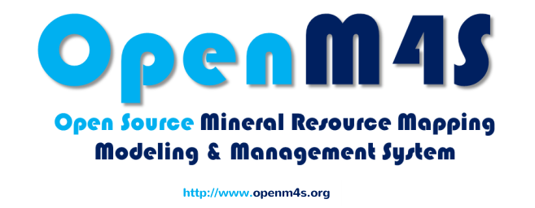

mcs development tools and technologies

prepared by: ziya-ur-rahman

Mineral Cadastre System

2014

Table of Contents

1. Web Technology 11

1.1. Types of Web Technology 11

1.2. Programming Languages 11

1. Server-Side Web Technologies and Tools 13

2.1. Frameworks 13

2.1.1. DJango 13

2.2. Languages 13

2.2.1. PHP 13

2.2.2. Python 13

2.3. Testing Tools 13

2.3.1. PHPUnit (PHP) 13

2.3.2. Unittest (Python) 13

2.3.3. SOAPUI 14

1. Client-Side Web Technologies and Tools 15

3.1. Frameworks 15

3.1.1. Sencha 15

3.1.2. MapFish 15

3.2. Languages and Standards 15

3.2.1. JavaScript 15

3.2.2. XHTML 15

3.2.3. HTML5 15

3.3. Libraries and Packages 16

3.3.1. jQuery 16

3.3.2. GeoExt 16

3.3.3. OpenLayers 16

3.3.4. WebGL 16

3.3.5. ExtJS 16

3.3.6. jBPM (eclipse) 16

1. Database Management System 17

4.1. PostgreSQL 17

4.2. PostGIS 17

1. IDE 19

5.1. Web Development IDE 19

5.2. Some IDEs are: 19

5.2.1. Aptana Studio (Windows / Mac OS X / Linux) 19

5.2.2. Adobe Dreamweaver 20

5.2.3. Eclipse (Windows / Mac OS X / Linux) 20

5.3. Plugin 21

5.3.1. Eclipse Plugins 21

5.3.2. Installing plugin in Eclipse (PyDev) 21

Table of Figures

Figure 1: Installing Plugin in Eclipse: Help > Install New Software 22

Figure 2: Installing Plugin in Eclipse: Add Update Site(s) 22

Figure 3: Installing Plugin in Eclipse: Select Update Packages 23

Figure 4: Installing Plugin in Eclipse: Install Details 24

Figure 5: Installing Plugin in Eclipse: Licence Agreement 24

List of Tables

Table 1: Percentage of Web Applications Using Various Server-Side Programming Languages 12

Table 2: Percentage of Web Applications Using Various Client-Side Programming Languages 12

Review History

|  |  |  |  |  |
| --- | --- | --- | --- | --- |
|  |  |  |  |  |
|  |  |  |  |  |
|  |  |  |  |  |
|  |  |  |  |  |
|  |  |  |  |  |
|  |  |  |  |  |
|  |  |  |  |  |
|  |  |  |  |  |

# Web Technology

Web technology relates to the interface between web servers and their clients. It includes markup languages, programming interfaces and languages, and standards for document identification and display. Though Web Technology can mean many things, the general idea is that it is used because it can reach many people all over the world on multiple platforms and operating systems, to make the Internet more powerful and easier to use.

## Types of Web Technology

Web technologies related to the interface between web servers and their clients. So there are a large number of interfaces available these days. A few of them are;

* CGI
* Perl
* PHP
* JavaScript
* VBScript,
* jQuery & AJAX
* JSP
* ASP & ASPX (ASP.Net) and various others.

## Programming Languages

Web technologies related to the interface between web servers and their clients, hence there are two kinds of programming languages available for web application development. There are;

* Server Side Programming Languages
* Client Side Programming Languages

PHP, ASP.NET, Java, ColdFusion, Perl, Ruby, Python and JavaScript are few examples of Sever Side Programming Languages. JavaScript, Flash and Silverlight are used for Client Side Programming.

The following tables show the usage of these different resources in the modern web application development.

Table 1: Percentage of Web Applications Using Various Server-Side Programming Languages

|  |  |
| --- | --- |
| PHP | 81.9% |
| ASP.NET | 17.6% |
| Java | 2.7% |
| ColdFusion | 0.8% |
| Perl | 0.6% |
| Ruby | 0.5% |
| Python | 0.2% |
| JavaScript | 0.1% |
| Lasso, Erlang, Scala, Tcl, Smalltalk, C++, Haskell, Lisp | Less than 0.1% |

Table 2: Percentage of Web Applications Using Various Client-Side Programming Languages

|  |  |  |  |
| --- | --- | --- | --- |
| None | |  |  | | --- | --- | |  | 12.1% | |
| [JavaScript](http://w3techs.com/technologies/details/cp-javascript/all/all) | |  |  | | --- | --- | |  | 87.7% | |
| [Flash](http://w3techs.com/technologies/details/cp-flash/all/all) | |  |  | | --- | --- | |  | 14.2% | |
| [Silverlight](http://w3techs.com/technologies/details/cp-silverlight/all/all) | |  |  | | --- | --- | |  | 0.2% | |
| [Java](http://w3techs.com/technologies/details/cp-javaruntime/all/all) | |  |  | | --- | --- | |  | 0.1% | |

# Server-Side Web Technologies and Tools



## Frameworks

### DJango

DJango is a high-level Python Web framework that encourages rapid development and clean, pragmatic design.

Developed by a fast-moving online-news operation, DJango was designed to handle two challenges: the intensive deadlines of a newsroom and the stringent requirements of the experienced Web developers who wrote it. It lets you build high-performing, elegant Web applications quickly.

## Languages

### PHP

More than 77% of all Web Applications are written in PHP. 20,000 more top 1 million sites use PHP than a year ago. The increasing use of content management systems contributes to this trend, as 13 out of the top 14 CMS's are written in PHP.

### Python

Python is an easy to learn, powerful programming language. It has efficient high-level data structures and a simple but effective approach to object-oriented programming. Python’s elegant syntax and dynamic typing, together with its interpreted nature, make it an ideal language for scripting and rapid application development in many areas on most platforms.

## Testing Tools

### PHPUnit (PHP)

PHPUnit is a programmer-oriented testing framework for PHP. It is an instance of the xUnit architecture for unit testing frameworks.

### Unittest (Python)

The [unittest](https://docs.python.org/3/library/unittest.html#module-unittest) unit testing framework was originally inspired by JUnit and has a similar flavor as major unit testing frameworks in other languages. It supports test automation, sharing of setup and shutdown code for tests, aggregation of tests into collections, and independence of the tests from the reporting framework.

To achieve this, [unittest](https://docs.python.org/3/library/unittest.html#module-unittest) supports some important concepts in an object-oriented way:

#### Test fixture

A test fixture represents the preparation needed to perform one or more tests, and any associate cleanup actions. This may involve, for example, creating temporary or proxy databases, directories, or starting a server process.

#### Test case

A test case is the individual unit of testing. It checks for a specific response to a particular set of inputs. [unittest](https://docs.python.org/3/library/unittest.html#module-unittest) provides a base class, [TestCase](https://docs.python.org/3/library/unittest.html" \l "unittest.TestCase" \o "unittest.TestCase), which may be used to create new test cases.

#### Test suite

A test suite is a collection of test cases, test suites, or both. It is used to aggregate tests that should be executed together.

#### Test runner

A test runner is a component which orchestrates the execution of tests and provides the outcome to the user. The runner may use a graphical interface, a textual interface, or return a special value to indicate the results of executing the tests.

### SOAPUI

SoapUI is a free and open source cross-platform Functional Testing solution. With an easy-to-use graphical interface, and enterprise-class features, SoapUI allows you to easily and rapidly create and execute automated functional, regression, compliance, and load tests. In a single test environment, SoapUI provides complete test coverage and supports all the standard protocols and technologies. There are simply no limits to what you can do with your tests. Meet SoapUI, the world's most complete testing tool!

# Client-Side Web Technologies and Tools



## Frameworks

### Sencha

Sencha creates development frameworks and tools that help you design, develop, deploy applications for desktop and mobile devices.

### MapFish

MapFish is a flexible and complete framework for building rich web-mapping applications. It emphasizes high productivity, and high-quality development.

MapFish is based on the [Pylons](http://pylonshq.com/) Python web framework. MapFish extends Pylons with geospatial-specific functionality. For example MapFish provides specific tools for creating web services that allows querying and editing geographic objects.

MapFish also provides a complete RIA-oriented JavaScript toolbox, a JavaScript testing environment, and tools for compressing JavaScript code. The JavaScript toolbox is composed of the [ExtJS](http://extjs.com/),[OpenLayers](http://www.openlayers.org/) , [GeoExt](http://www.geoext.org/) JavaScript toolkits.

MapFish is compliant with the [Open Geospatial Consortium](http://www.opengeospatial.org/) standards. This is achieved through OpenLayers or GeoExt supporting several OGC norms, like WMS, WFS, WMC, KML, GML etc.

MapFish is open source, and distributed under the [BSD](http://www.opensource.org/licenses/bsd-license.php) license.

## Languages and Standards

### JavaScript

JavaScript has always been the most important client-side programming language on the web. Another 26.500 sites started using it in 2011. It is almost a surprise that there are still 8.9% of the sites not using it.

### XHTML

In 2009 it was [predicted](http://w3techs.com/blog/entry/xhtml_usage_finally_exceeds_html_usage) that the use of XHTML will start to decline but XHTML is still gaining sites at the rate of 26,400 last year.

### HTML5

This specification defines the 5th major revision of the core language of the World Wide Web: the Hypertext Markup Language (HTML). In this version, new features are introduced to help Web application authors, new elements are introduced based on research into prevailing authoring practices, and special attention has been given to defining clear conformance criteria for user agents in an effort to improve interoperability.

## Libraries and Packages

### jQuery

jQuery gained an incredible 145.300 additional sites amongst the top 1 million Web Applications. That means that every single day of the year, 398 sites started using it. jQuery is now used by 42.8% of all Web Applications. Many see it as the de-facto standard for JavaScript libraries with a market share of 84.1%.

### GeoExt

GeoExt brings together the geospatial know how of [OpenLayers](http://openlayers.org/) with the user interface savvy of [Ext JS](http://www.sencha.com/products/js/) to help you build powerful desktop style GIS apps on the web with JavaScript.

### OpenLayers

OpenLayers makes it easy to put a dynamic map in any web page. It can display map tiles and markers loaded from any source. OpenLayers has been developed to further the use of geographic information of all kinds. OpenLayers is completely free, Open Source JavaScript, released under the [2-clause BSD License](https://raw.github.com/openlayers/openlayers/master/license.txt) (also known as the FreeBSD).

### WebGL

WebGL is a cross-platform, royalty-free API used to create 3D graphics in a Web browser. Based on OpenGL ES 2.0, WebGL uses the OpenGL shading language, GLSL, and offers the familiarity of the standard OpenGL API. Because it runs in the HTML5 Canvas element, WebGL has full integration with all Document Object Model (DOM) interfaces.

### ExtJS

Sencha Ext JS is the leading standard for business-grade web application development. With over 100 examples, 1000 APIs, hundreds of components, a full documentation suite and built in themes, Ext JS provides the tools necessary to build robust desktop applications. Ext JS also brings a rich data package that allows developers to use a model-view-controller (MVC) architecture when building their app. The MVC leverages features like Big Data Grids enabling an entirely new level of interactivity in web apps.

### jBPM (eclipse)

jBPM is a flexible, extensible framework for process languages which uses graph oriented programming as a foundation. The jBPM Eclipse plugin provides developers (and very technical users) with an environment to edit and test processes, and integrate it deeply with their applications. It provides the following features (on top of the Eclipse IDE):

#### Wizards for creation of

* A jBPM project
* A BPMN2.0 process

#### jBMP Perspective

showing the most commonly used views in a pre-defined layout

# Database Management System



## PostgreSQL

PostgreSQL is an object-relational database management system (ORDBMS) based on POSTGRES, Version 4.21, developed at the University of California at Berkeley Computer Science Department.

PostgreSQL is an open-source descendant of this original Berkeley code. It supports a large part of the SQL standard and offers many modern features:

* complex queries
* foreign keys
* triggers
* updatable views
* transactional integrity
* multi-version concurrency control

Also, PostgreSQL can be extended by the user in many ways, for example by adding new

* data types
* functions
* operators
* aggregate functions
* index methods
* procedural languages

## PostGIS

PostGIS is a spatial database extender for [PostgreSQL](http://postgresql.org/) object-relational database. It adds support for geographic objects allowing location queries to be run in SQL.

In addition to basic location awareness, PostGIS offers many features rarely found in other competing spatial databases

* Processing and analytic functions
* Raster map algebra
* Support for importing / exporting ESRI shapefile
* Packaged command-line for importing raster data
* Rendering and importing vector data
* Seamless raster/vector SQL callable functions
* 3D object support, spatial index, and functions
* Network Topology support
* Packaged Tiger Loader / Geocoder/ Reverse Geocoder / utilizing

# IDE

An integrated development environment (IDE) or interactive development environment is a [software application](http://en.wikipedia.org/wiki/Software_application) that provides comprehensive facilities to [computer programmers](http://en.wikipedia.org/wiki/Computer_programmer) for [software development](http://en.wikipedia.org/wiki/Software_development). An IDE normally consists of a [source code editor](http://en.wikipedia.org/wiki/Source_code_editor), [build automation](http://en.wikipedia.org/wiki/Build_automation) tools and a [debugger](http://en.wikipedia.org/wiki/Debugger). Most modern IDEs offer [intelligent code completion](http://en.wikipedia.org/wiki/Intelligent_code_completion) features.



## Web Development IDE

The IDE for the web development should have the following list of features for a complete independent development environment for web developers and programmers;

* [Back End Boxes](https://codio.com/s/features/85944871)
* [Abbreviations](https://codio.com/s/features/85868117)
* [AutoComplete](https://codio.com/s/features/)
* [Panels & Tabs](https://codio.com/s/features/#85906776)
* [Command Bar](https://codio.com/s/features/#85852403)
* [Quick Open](https://codio.com/s/features/#85852405)
* [Keyboard Shortcuts](https://codio.com/s/features/#85864550)
* [Beautification](https://codio.com/s/features/#85868118)
* [Bower](https://codio.com/s/features/#85901325)
* [File Templates](https://codio.com/s/features/#85901326)
* [Importing](https://codio.com/s/features/#85906685)
* [SSH](https://codio.com/s/features/#85908529)
* [Deployment](https://codio.com/s/features/#85908528)
* [Annotations](https://codio.com/s/features/#86012272)
* Additional Plugins Installation

## Some IDEs are:

### Aptana Studio (Windows / Mac OS X / Linux)

Aptana Is a really unique eclipse-based ide. If your work centers around Javascript and DHTML techniques and you don’t want to pay for your IDE, this is the one for you. Aptana seems to be an IDE geared towards DHTML development.

#### Pros

* If you do DHTML work, this is the IDE of your dreams
* If you do Ruby on Rails, this IDE is the perfect solution for a non-OSX machine. The Aptana OSX version is actually quite nice, but there’s other rails environments (which I’ll get to later) that are yet better.
* Jaxter is a verty cool new idea, I’m excited to see what the IDE+Jaxter will be able to produce (In terms of speed) in the future.

#### Cons

* There really aren’t really any weaknesses, I find it a bit bloated, but some people like their IDE to be bloated, because it’s synonymous for “feature-rich”. I guess that part’s up to you guys to decide.

### Adobe Dreamweaver

Dreamweaver is primarily a windows IDE, which does absolutely everything.

#### PROS:

* If you like ColdFusion, and you don’t care about crappy Javascript (if it works), AND you don’t know much about writing code, this is your dream-tool.
* It’ll even sync with your server for easy-uploading and on-the-server editing.
* Everything I’ve grown to expect from an advanced editor in 2008
* Built in documentation from O’reilly for a load of different web languages. That’s actually pretty sweet.

#### CONS:

* Leaves a GIANT memory footprint if you’re just using the editor
* On slower machines this takes FOREVER to start up and initialize
* It’s too rigid on what is and isn’t a part of the current project. I really don’t like that about it, you’ll have to go through like 2 modal windows just to add an existing file to your project.

### Eclipse (Windows / Mac OS X / Linux)

Eclipse is probably the most well-put-together open-source IDE I’ve ever encountered for Linux. Firstly, ECLIPSE IS FREE, which is awesome for how big of a product it really is.

#### PROS:

* DOES EVERYTHING. Absolutely. It’s extensible, so if it doesn’t do it already and you want it to, you can write a plugin
* Open source approach makes it available for absolutely free
* Java core minus swing makes for OS interoperability with no downsides

#### CONS:

* I think the interface is just not-so-slick in its design, but all the necessary parts are there. Sometimes things that could be small are very large (like in the file browser)
* Sometimes it’s a pain to find the right plugin, or follow the right tutorial for upgrading or adding functionality to Eclipse, but only as much as it ever is on Linux. Once it’s up and running you shouldn’t have any problems at all.

## Plugin

An independent transparent reusable piece of code to integrate in another Plugin or module or software etc. to facilitate it.

### Eclipse Plugins

There are many plugins in the marketplace of eclipse which you can download/install in the eclipse environment easily and facilitate your IDE like a complete development environment.

#### Aptana Studio 3 Plugin for Eclipse

Aptana Studio 3 plugin adds the functionality of Aptana Studio 3 to eclipse for the web development. It has support for HTML, DHTML, Javascript, PHP, Python and CSS etc.

#### EGit  Plugin (Distributed Version Control)

EGit is an Eclipse plug-in (software component) which allows you to use the distributed version control system Gitdirectly within the Eclipse IDE.

EGit is based on the JGit library. JGit is a library which implements the Git functionality in Java.

#### Mylyn (Project Management)

Mylyn is to integrate tasks into the Eclipse IDE and connect the current state of the Eclipse IDE, e.g. the context with such a task.

Software developers perform a variety of activities. They write source code for new functionality, fix bugs, write documentation, answer questions, and attend meetings and much more.

Developing software in the Eclipse IDE involves writing new classes or methods and modifying existing code.

Eclipse Mylyn allows the developer to record his activities in such a task while he is working on it. Each task has acontext which captures the involved classes, methods and the cursor position in the opened Java or text editor.

When switching between tasks, the corresponding context is restored and the editors which belong to this tasks are opened and the others are closed.

### Installing plugin in Eclipse (PyDev)

Plugin can be installed from the URL, so search it on the internet.  
The dialog to install Plugin is depicted in the following screenshot.

To install PyDev and PyDev Extensions using the Eclipse Update Manager, you need to use the **Help** > **Install New Software...** menu as shown in the Figure 1 (note that in older versions, this would be the 'Find and Install' menu).

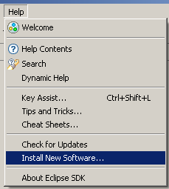

Figure 1: Installing Plugin in Eclipse: Help > Install New Software

In the next screen shown in Figure 2, enter the URL for plugin updates e.g. <http://pydev.org/updates> for PyDev updates.

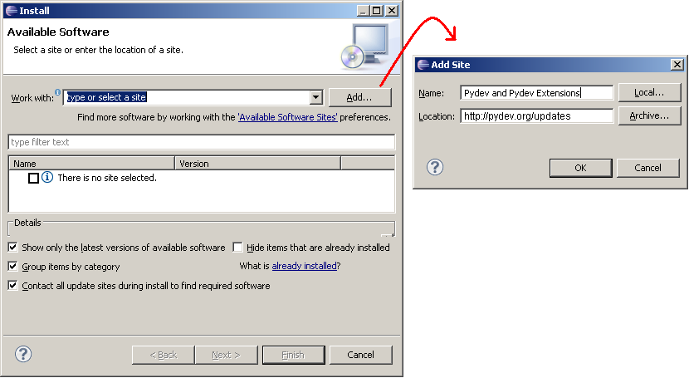

Figure 2: Installing Plugin in Eclipse: Add Update Site(s)

After entering the update sites, select the update site you entered or select **"All available sites"** and add a filter for PyDev so that it shows the contents of all the update sites that have PyDev, then select what you want to install and click **'Next'** as shown in Figure 3 and 4. **UNCHECK** the **'Contact all update sites during install to find required software'** and press **'Next'** again to confirm your selection.

And finally, read the license agreement and if you accept, select the **accept** radio button and click **'Finish'** as shown in Figure 5.

At that point, Eclipse should automatically download the plugin contents and present you to a dialog asking if you want to restart (to which you should say **'yes'**).

p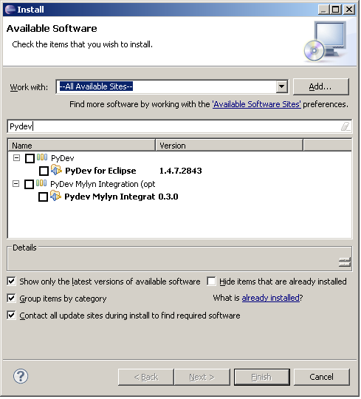

Figure 3: Installing Plugin in Eclipse: Select Update Packages

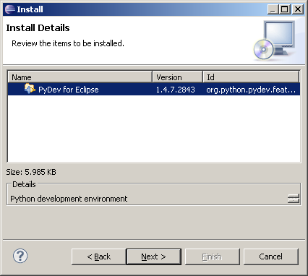

Figure 4: Installing Plugin in Eclipse: Install Details

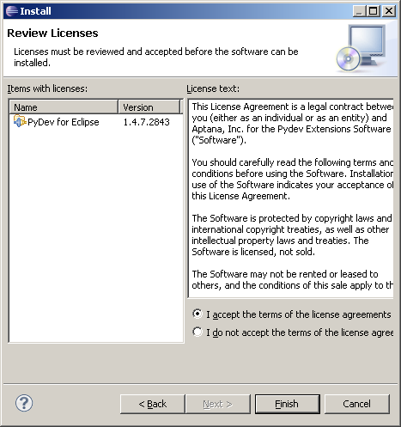

Figure 5: Installing Plugin in Eclipse: Licence Agreement

#### Possible issue on download

If you have any problem at this point with a message such as:

* An error occurred while collecting items to be installed
* No repository found containing: org.python.pydev/osgi.bundle/1.4.7.2843
* No repository found containing: org.python.pydev.ast/osgi.bundle/1.4.7.2843

That might indicate that the mirror you selected is having some network problem at that time, so, please follow the same steps with another mirror.