

***Section : 4A***

***Group Members***

***K190245 Inam Abbasi***

***20K0436 Ahmed Sheikh***

***K21-4545 Haseeb Khan***

**Downloading Kernel**

Our Initial step will be downloading a kernel. We will go to kernel.org then click the tarball option. Then after that make sure to extract it.

**Why download a new kernel?**

There is no possibility of dynamically adding new system call. So you need to modify the kernel source code in order to implement a new sys call.

**Kernel Source Package**

You will download a kernel source package according to Linux distribution you are using. I’ll be downloading 5.11.111

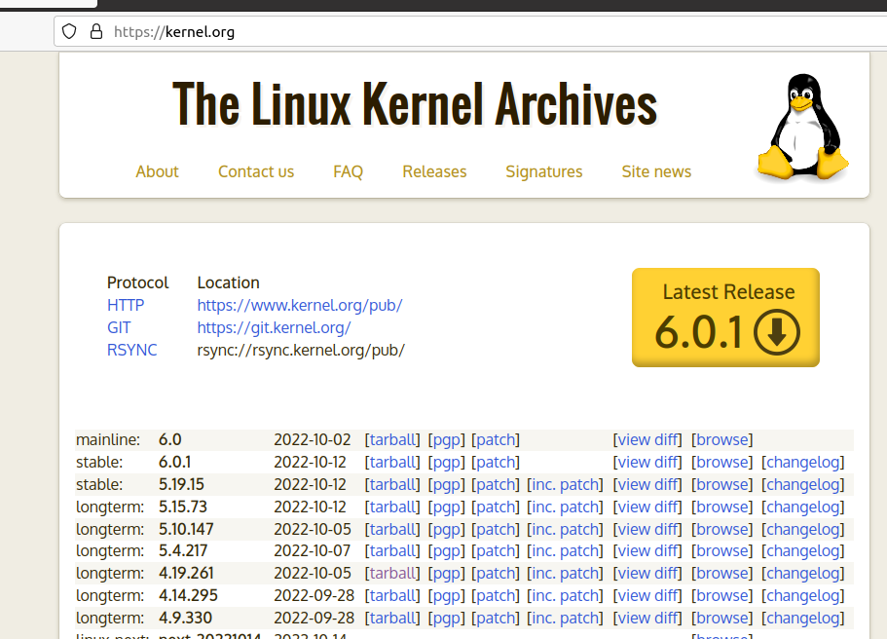

**Pre-Requirements**

Before we start making system call first we have to execute the below commands in our terminal. In order to ensure optimization.

* sudo apt-get install gcc
* sudo apt-get install libncurses5-dev
* sudo apt-get install bison
* sudo apt-get install flex
* sudo apt install make
* sudo apt-get install libssl-dev
* sudo apt-get install libelf-dev
* sudo add-apt-repository “deb <http://archive.ubuntu.com/ubuntu> $(lsb_release -sc) main universe”
* sudo apt-get update
* sudo apt-get upgrade

**Adding of dining_philosopher System call**

In this step, first we will create a dining_philosopher and sleep call **directory** in our newly installed kernel source package directory as shown below,

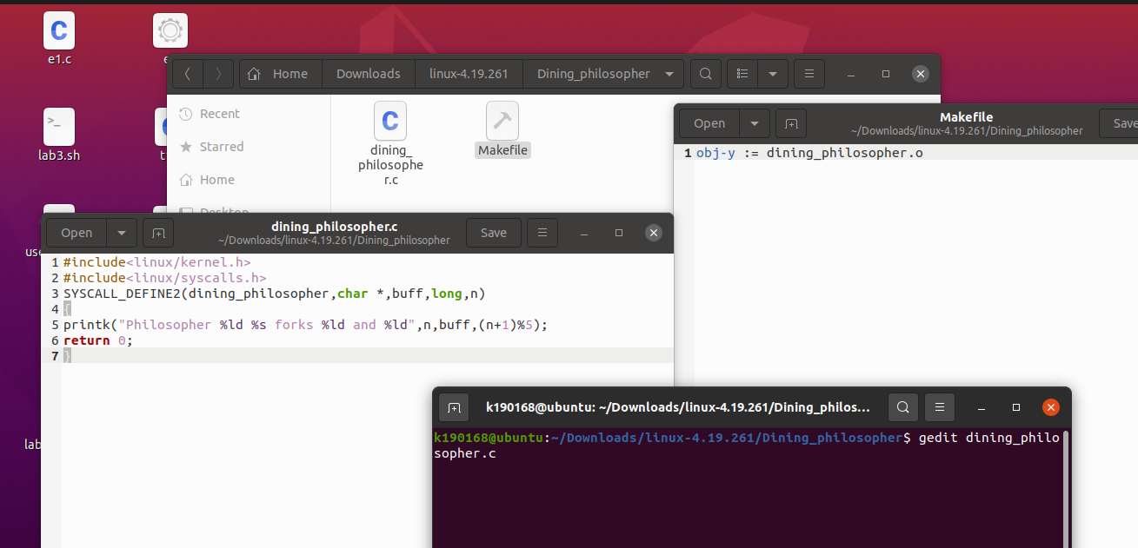

In **above picture**, a text editor was opened in which you have to write the following code and save it and then close the editor. The second command(Makefile) will register our file.

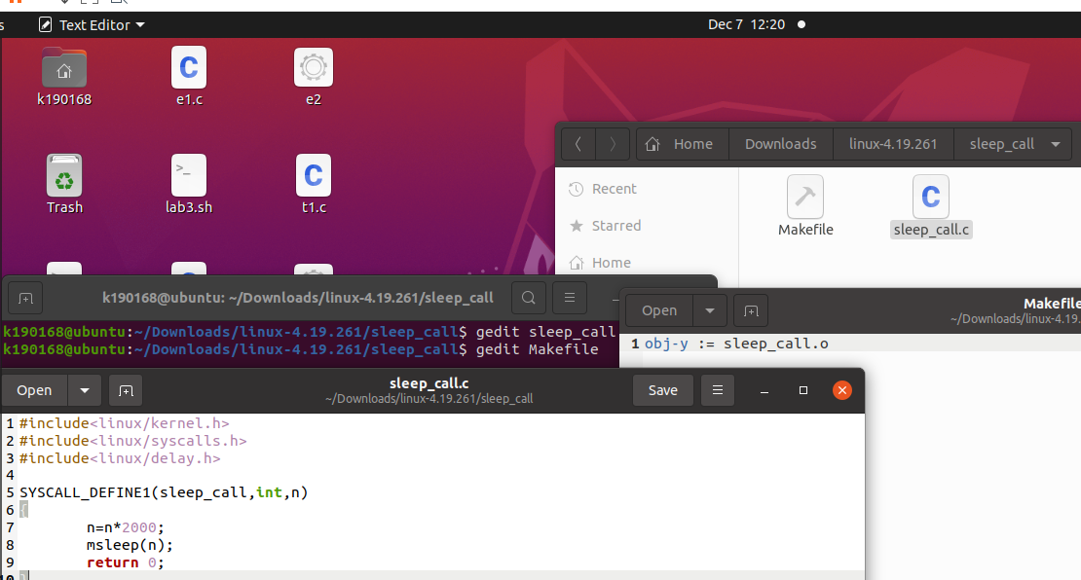

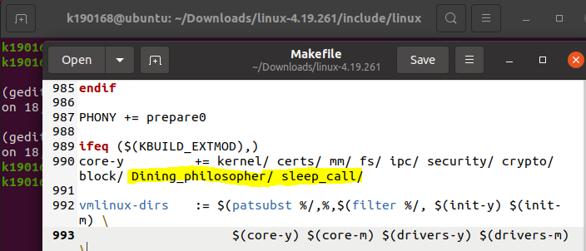

Then run this command **gedit syscall_64.tbl**

After that a .tbl will open which contains all system call numbers and entry vectors.

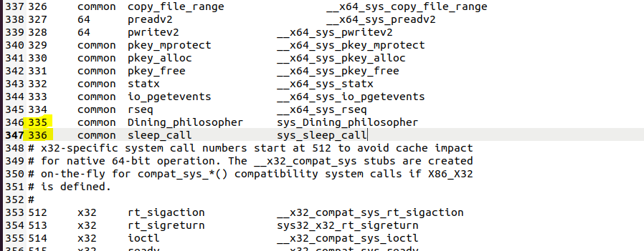

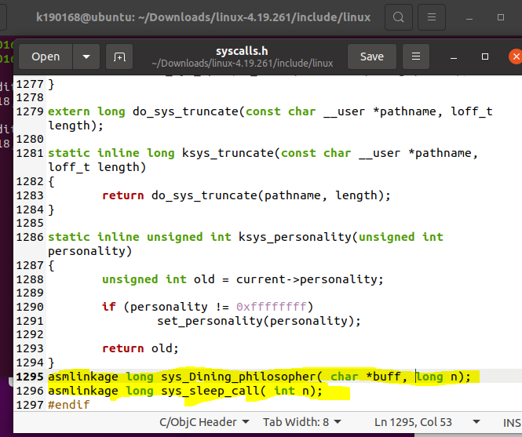

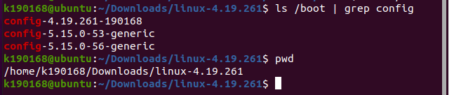

Then from 1 st command of above picture, copy any of the config then paste it in the command of below

picture and also include your working directory from second command of above picture. Doing copying

of directories and files from one location to another



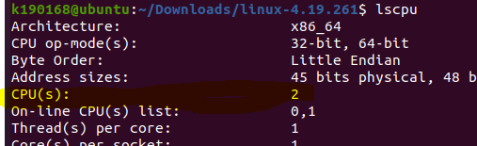

Now run the below command, I include 2 with -j because I have 2 available CPU(S) if I had 4 so I would

have included 4 with -j.

Make clean is a command that removes all executable files from a program binary and coding

directory. That means it removes all the object files that were created in the meantime. To get a super

clean build, it’s necessary to run the make clean command before recompiling.

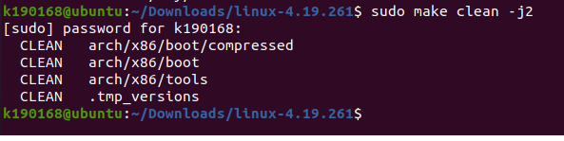

Now after that run the following commands one by one in your terminal as showing below,



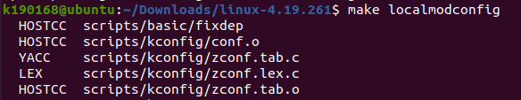

Press enter at all to take default values

