**Operating Systems**

**Project Proposal**

**A* Search Algorithm using Threads**

Overview: We will implement A* search algorithm using threads which is used to

approximate the shortest path in real-life situations, like- in maps, games where there can be many hindrances. We chose this topic to find the optimal path from source to destination quickly using parallelism techniques.

Concepts we will use:

1. We will use Pthreads to achieve parallelism
2. Mutex locks for mutual exclusion

**A pictorial representation of what A* search algorithm do**

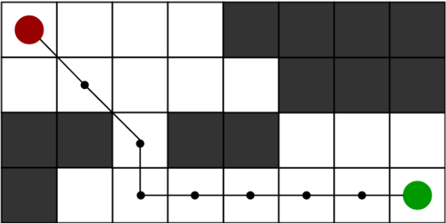

**Group Members:**

1. **Shiv [K213434]**
2. **Rohit Raja [K214616]**
3. **Lov Kumar [K214821]**