C104H/PCI Document

Resource Requirement:
- IRQ * 1
- I/O :
UART register : 32 bytes ( 8 bytes / port * 4port )
IRQ Vector register : 1 byte ( 1 bit/port * port = 4 bits )

PCI Configuration
1.MOXA Vendor ID = 0x1393
2.C168H/PCI Device ID = 0x1040
3.Hardware resource on Device Configuration register of PCI configuration space:
- IRQ 0x3C, BYTE
- Interrupt Vector 0x1C, DWORD
Bit 0 : Always 1
Bit 1 : Reserved
Bits 31: 2 : Interrupt Vector
- I/O Base Address 0x18, DWORD
Bit 0 : Always 1
Bit 1 : Reserved
Bits 31: 2 : I/O Base Address

UART register structure:
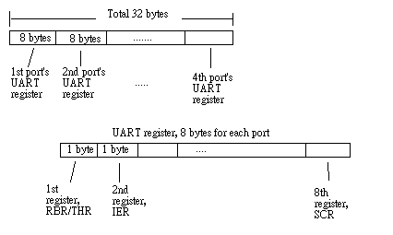
(For detailed UART register description, please refer to the TL16C550C data book.)
For Example, If C104H/PCI base address is 0x180:
1st port’s UART register I/O address is 0x180 .. 0x187,
1st register I/O address is 0x180,
2nd register I/O address is 0x181, …..

2nd port’s UART register I/O address is 0x188.. 0x18f,
1st register I/O register is 0x188,
2nd register I/O register is 0x189, …..
……

IRQ Vecter register structure:
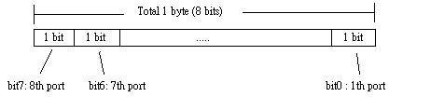(C104H/PCI only uses 4 bits.)

Bit Value | Status
0 | Interrupt pending. Please read the UART register to get the detail interrupt information *.
1 | No interrupt pending.

