Steps for running the D70Reader command line program on Windows XP:

- Download the program by going here:

http://home.comcast.net/~jonathan.oman/d70/index.html

- Use Windows Explorer to display the directory you downloaded the ZIP file to:

Start->All Programs->Accessories->Windows Explorer

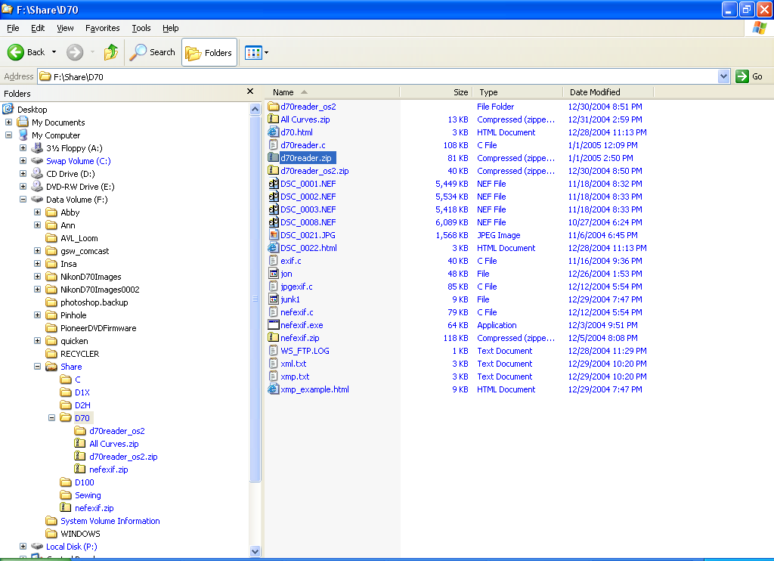

- Right click on ‘d70reader.zip’, and select ‘Extract All…’:

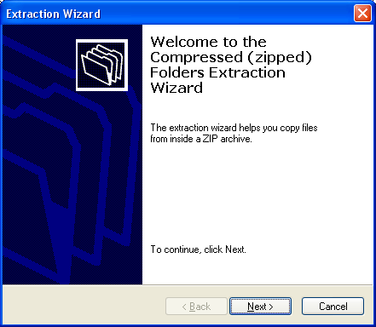

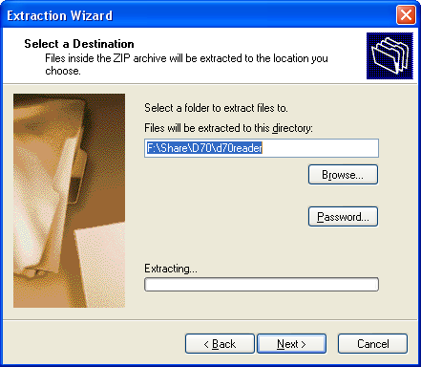

- Navigate to the d70reader directory from within Windows Explorer:

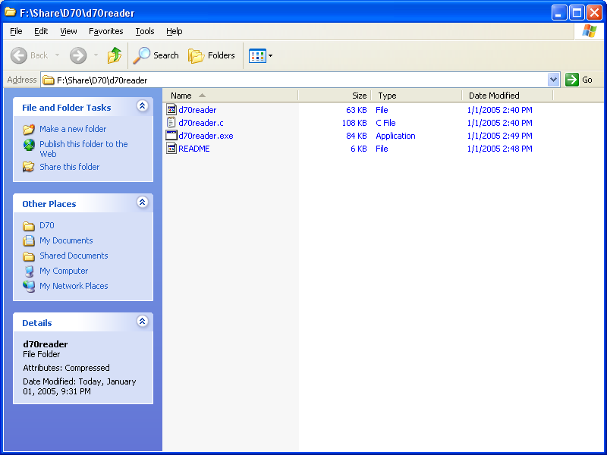

- Open a Command Prompt by doing this:

start->All Programs->Accessories->Command Prompt

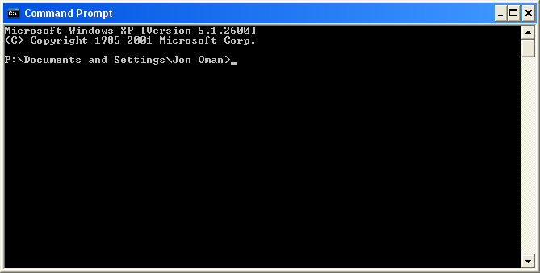

- At the prompt, type ‘path’ (without single quotes) and then press the Enter key:

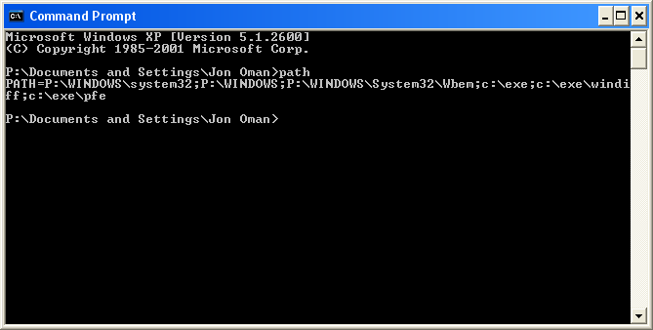

This displays the directories that the operating system searches for executable program files.

- Use Windows Explorer, or a Command Prompt to copy the ‘d70reader.exe’ file into one of the directories in the path statement:

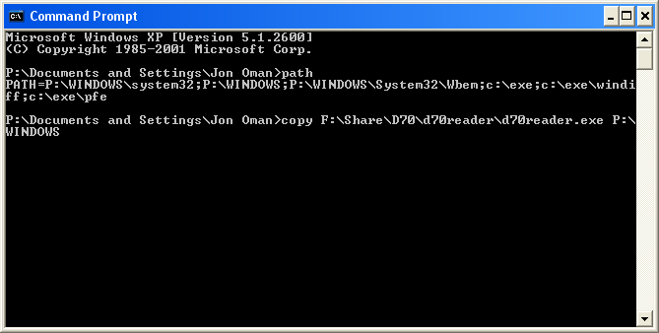

Now, whenever you open a Command Prompt window, you can run the ‘d70reader.exe’ program, no matter what directory you are in:

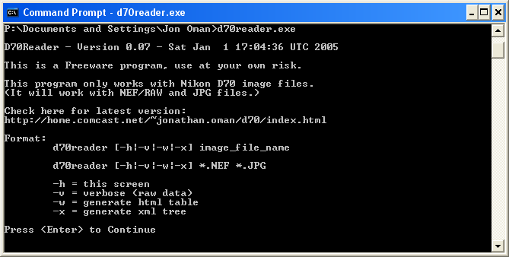

- Now, using the Command Prompt, navigate to one of your image directories:

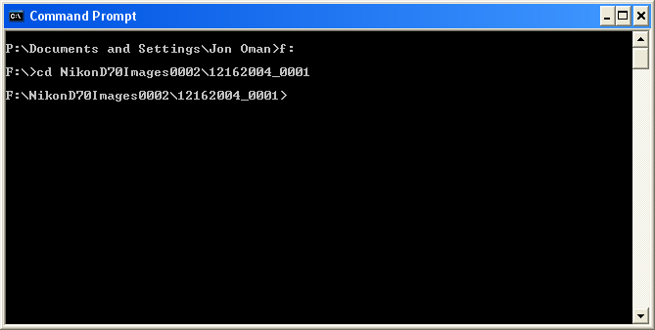

- To see a listing of your image files, do this:

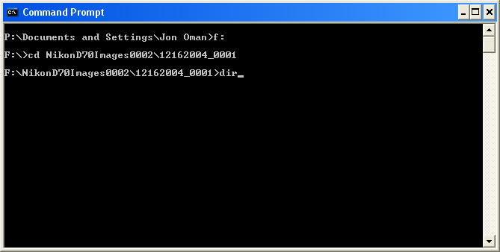

When you press the Enter key you will see something like this:

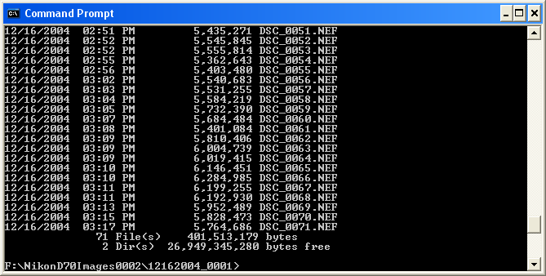

- Now, you can dump the EXIF data from one of the image files by doing this:

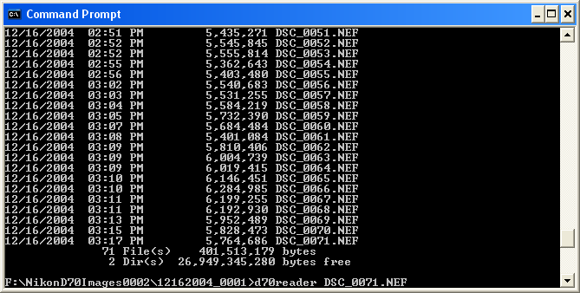

When you press the Enter key, you should see something like this:

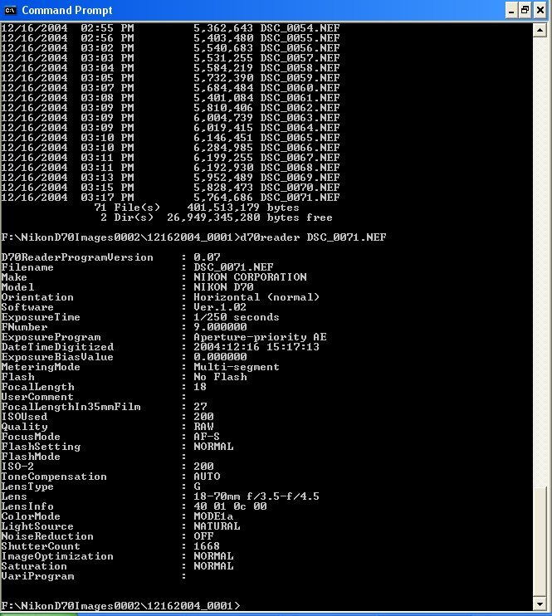

- Try the various options.

