How to use the d70reader with a Microsoft Access photos database
David Lal, February 2005

Suppose you want to create or have already created a database comprising all the Exif data for your images. You can of course manually use the d70 reader (or any other program that shows the data) to enter the data for each image, one by one – a tedious task.

A neater way is to have the d70reader generate a text file containing all the Exif data for every image in a given directory and then import that text file into the Access database.

You will need to have either added the d70reader.exe program to a directory that forms part of your PC's path environment or specifically modified the path to include the location of d70reader.exe.

Open a command window (sometimes called a DOS box) and navigate to the directory that contains your photos. To do so, you use the DOS CD command. When you have arrived in the image-containing directory, type the following command into the command window:

d70reader –c *.jpg >filelist.txt

If the images are Nef files then the command would be d70reader –c *.nef >filelist.txt

Depending on how many images there are in the directory, it will take a few seconds for the command to execute and you will see nothing in the command window. When the command is finished, the command prompt reappears and you can close the command window.

Here's a screen sample of the above:

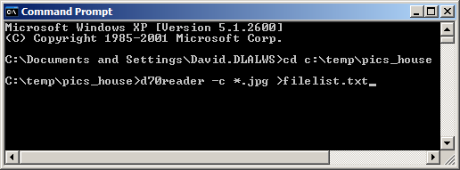

The next step is to read the Exif data that is now contained in the file filelist.txt into the database.

Open the database, select Tables in the database window then from the menu do Files > Get external data > Import

In the dialog box that then opens, navigate to the directory where you have just created filelist.txt. In the dialog set file type to Text Files (*.txt;*.csv;*.tab etc). Select filelist.txt and click the Import button.

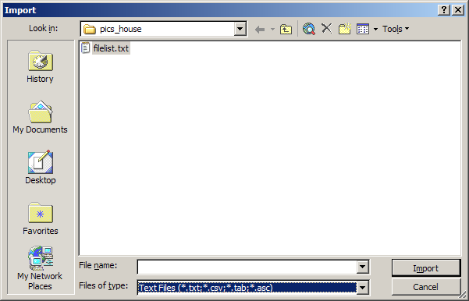

The Import Text Wizard starts. Click the Next button.
Specify that the comma is to be used as the field separator and that the double quote mark is the text qualifier (that is very important). Tick the check box to specify that the first row of the text file contains field names.
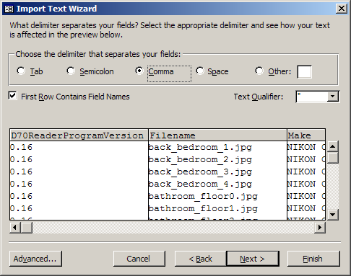
Click the Next button.

MS Access will now offer you the choice of creating a new table or adding to an existing one. That's up to you and depends on your database design.

d70exif_into_access.doc

