Facilitating the use of the d70reader in Windows XP
David Lal, February 2005

Explaining the path environment variable
In Windows XP (and all earlier Microsoft operating systems) a non-operating system program may be run by name from the command line only within the directory in which it is stored. Any attempt to run it from another directory will only work by typing the full path (i.e. directory name + program name).

In addition, unless the program and its data are stored in the same directory, the full path to the data may be required as well. This is extremely inconvenient, to say the least and in the case of d70reader could lead to command prompt lines like this:

c:\utilities\graphics\photography\d70\d70reader.exe –c c:\photos\2005\animals\*.jpg >c:\photos\2005\animals\filelist.txt

Making a typing mistake anywhere in a line like that would end up with either the program not running at all, running with the wrong data or generating output in the wrong place.

To ease this problem Microsoft uses a path 'environment variable' which is simply a list of directories that the operating system will look in if it has to find a program that has been specified by name alone. A typical path environment variable looks something like this:

%SystemRoot%\system32;%SystemRoot%;%SystemRoot%\System32\Wbem; C:\Program Files\Common Files\Adaptec Shared\System

(%SystemRoot% usually equates to C:\Windows)

Therefore, one solution is to store the program file (e.g. d70reader.exe) in one of the directories listed in the path environment variable, for instance, in C:\Windows. This greatly facilitates using the command line prompt since all one has to do is navigate to the directory containing the data then execute the program by name, for example:

CD c:\photos\2005\animals
d70reader –c *.jpg >filelist.txt

However, it is often regarded (rightly in my opinion) bad practice to store non-system files in system directories (like C:\Windows) or in directories mentioned in the path variable that are to do with other programs (like C:\Program Files\Common Files\Adaptec Shared\System).

A good solution is to modify the path environment variable to include the location of the program by appending a semi-colon and then the directory name where the program is located. For instance, if I have stored d70reader.exe in c:\d70reader then the path environment variable on my machine would be:

%SystemRoot%\system32;%SystemRoot%;%SystemRoot%\System32\Wbem; C:\Program Files\Common Files\Adaptec Shared\System;C:\d70reader

Great care must be taken a) to be accurate and b) not to alter the existing path.

How to alter the path environment variable
There are various ways of doing this. Perhaps the least error prone is to use the graphical interface provided by Windows Control Panel. Note that you need to have administrator privileges on the PC concerned.

Do Start > Settings > Control panel > System > Advanced > Environment variables > Path > Edit

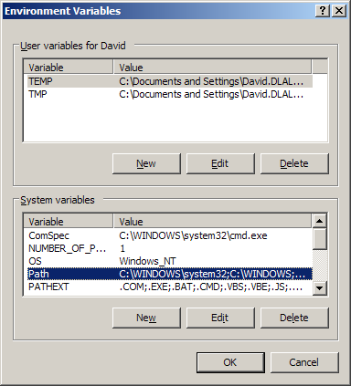

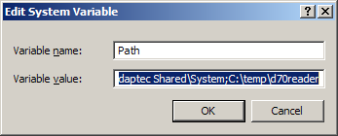

Place the cursor at the end of the Variable value, add a semi-colon and then the directory name where you have stored d70reader.exe (it helps if the name has no spaces and is short).

Click OK
That's it.

Now whenever you want to run the d70 reader, all you have to do is open a command window and navigate to the desired directory containing your images then issue whatever d70reader command you want.

Microsoft Powertoys 'Open Command Window Here'
OK, so far so good, the d70reader can now be launched from any directory but navigating to that directory is still a matter of opening a command window and typing "DOS" command line navigation instructions which is not only tedious but also potentially difficult if the directory is in fact a share on another machine on a network or nested deep down within the directory tree.

Fortunately, Microsoft make available a very useful and free utility which, with a mouse right click on any directory inside Windows Explorer offers the option to open a command window already navigated to the directory concerned.

You can obtain this utility from here: http://www.microsoft.com/windowsxp/downloads/powertoys/xppowertoys.mspx

Conclusion
These things together with the d70 reader make an excellent combination for documenting image collections.

d70reader_facilitate.doc

