MERLIN Resource Details View Module
  - Evidence and semantic boundaries with proposed design decisions
Research paper • Version 0.15 • 9 October 2026
Status: Appendix K tests a four-category System candidate, viewing-first inspection and scoped editing. Appendix J supplies the standards mapping; Appendix I retains the Integrator review. The header is owner-locked; category names and placements remain proposals. Requirements v0.8 and Guide v0.5 await owner review.

Abstract
MERLIN requires a Resource Details capability that can explain heterogeneous resources without weakening their identity or obscuring source semantics. This paper conducts a bounded design review using the supplied Discovery PBI, requirements workbook, semantic guide, and research handoff alongside selected visualization research, OGC standards, accessibility guidance, and implementation documentation. The central question is how to provide useful inspection in constrained and independent workspaces while preserving meaningful distinctions among resources, values, relationships, and operating states. The evidence supports stable identity, task-oriented reading order, explicit semantic qualifiers, accessible disclosure, and verification with realistic data. It does not establish an optimal MERLIN layout or require a particular component architecture. The paper therefore recommends a shared presentation contract with compositions adapted to the host, direct-value-first rendering, bounded relationship exploration, and explicit retrieval and restoration states. Supported schema and media-aware presentation is central to the intended resource experience; its coverage and interpretation rules still require definition. This expanded review places 18 illustrated project and precursor cases alongside external product and card-framework comparisons. The archival evidence includes broad Observation windows, image results, sensor descriptions, report representations and schema-specific forms; it supports resource-appropriate primary content within a recognizable standalone surface. These recommendations remain subject to product adjudication and task-based evaluation. A compact traceability appendix connects the principal proposals to evidence and verification questions, providing a finite basis for the next design step without prematurely drafting Jira acceptance criteria. This iteration records the product owner's business-card intent and hand-drawn concept, then examines broad card anatomy, presentation manifests and scientific media viewers. A common resource foundation with supported content variation is the principal hypothesis for evaluation; a data schema, media type or card component alone does not establish the best presentation. The latest clarification establishes a resource working view with category and subordinate tabs, expandable sections, supported editing and command workflows, security markings and useful visualizations. A companion requirements draft now provides a finite route into the PBI. System Integrator, MASINT IT Next, OmniSense and selected TRSS and SADU pages contribute configuration, imagery, status and association examples. The original UGS wireframes, live-testbed MASBUS captures, STORMFORCE guide and MERLIN report screenshot add a trace from common forms and result-aware content to fragmented legacy navigation and distinct report-viewing and authoring work. The requirements draft captures those lessons and the Symbol proposal, with explicit configuration effects, estimate qualifications, scoped participant summaries and a cross-vendor schema and operation comparison. One bounded review must settle initial coverage and dimensions before the PBI.

1. Introduction
Resource discovery and resource understanding are related tasks with different information demands. A Discovery table helps a user find a candidate through scanning, filtering, and comparison. Details must help that user establish what the candidate is, interpret its values, inspect relevant context, and decide whether to follow another resource or invoke a separate capability. Increasing the number of visible fields alone does not ensure understanding. A compact but semantically ambiguous display can mislead; a complete serialization can conceal the information needed for the immediate task. The clarified product direction in section 3.7 extends this purpose to permitted editing and supported operational work from the focal resource view.
The Resource Details module sits within an existing contract. MERLIN-932 requires a compact action associated with the exact resource in a Discovery row. Opening that resource creates a new Dockview module and retains the originating Discovery module. Selection remains a distinct operation. Supported related-resource actions similarly identify an exact associated resource, while the Source action leads to a known source landing page rather than an invented destination (MERLIN-932 2026, secs. 5.1–5.3). Details research must preserve those decisions rather than treat all interaction patterns as available for redesign.
The semantic guide adds a second constraint. It separates source semantics, MERLIN presentation semantics, and module rendering. Shared labels facilitate interpretation across modules, but similar labels do not make unlike source concepts interchangeable. The supplied guide remains version 0.4 and a draft; its mappings are evidence of the current design basis, not permission to silently broaden that basis (MERLIN Semantic Guide 2026, secs. 1–5). The handoff identifies unresolved questions about composition, mappings, retrieval, relationships, structured content, actions, provenance, missing states, and persistence (PITON Handoff 2026).
This paper asks: what evidence and semantic constraints should govern inspection of an exact MERLIN resource in an anchored context and an independent workspace? It addresses the information contract and observable behavior needed to answer that question. It does not choose a frontend library, specify final pixel dimensions, authorize command execution, or complete the receiving PBIs for maps, feeds, video, or other capabilities. It also does not convert the earlier two-presenter proposal into an accepted architecture.
The contribution is a critical synthesis with concrete, reviewable proposals. Standards establish what resource information means and how it is represented. Empirical and design research informs how that information may be organized and assessed. Existing products demonstrate feasible conventions. These forms of evidence carry different authority. Keeping those distinctions visible allows the paper to recommend a direction while acknowledging where MERLIN still needs local validation. The intended outcome is a bounded decision basis for design, followed by requirements drafting after the substantive choices are settled.

2. Review method and limits
The review followed the supplied research template and annotated bibliography (MERLIN Research Template 2026). Internal sources were examined first: the handoff, Guide v0.4, the final Discovery PBI, and the revised workbook. The PDF PBI required OCR because text extraction did not preserve readable characters; relevant invocation and navigation clauses were checked against the resulting readable text. Workbook presets were considered in their Discovery context (MERLIN Discovery Workbook 2026). Their default column visibility was not treated as an ordering rule for Details.
The external review concentrated on six planned research sources: unfolding visualizations, responsive breakpoints, responsive maps, dashboard text, screen-reader visualization, and visualization design handoff. Primary full texts or author manuscripts were inspected, with critical reading concentrated on methods, findings, discussion, and limitations. Bibliographic details were checked against final publication records where the accessible text was an author version. Thus the cited publication year can differ from the accessible manuscript’s posting year. This was a targeted full-text review, not a claim that every page of every source in the template received exhaustive appraisal.
A limited gap pass addressed questions that the research papers could not settle: exact resource identity, parent context and schemas, structured data, accessibility interaction, safe source-content rendering, HTTP freshness, and Dockview restoration. Official standards and documentation were preferred for these questions. The main research search and retrieval were completed on 3 October 2026. The review retained sources that directly informed a live Details decision; it did not expand into a general survey of visualization, operational command workflows, or enterprise security architecture.
Each source was assessed for the nature of its claim, the studied task and population, the evaluation method, and the distance between the original setting and MERLIN. A workshop taxonomy was not interpreted as a comparative usability result. A normative accessibility criterion was not treated as proof of a preferred layout. An implementation API was not treated as evidence that the application already restores resources correctly. Product documentation served as precedent, with attention to the resource types to which its behavior actually applies.
The comparative pass selected six cases for distinct questions: format-aware resource content, media with related feature context, asset choice, descriptive object hierarchy, secondary technical inspection, and Observation encoding. Product documentation and its original images were inspected on 3 October 2026. Screenshots are published examples, not fresh runtime captures. The cases do not establish usability, accessibility conformance, or MERLIN suitability; each separates documented behavior from the paper’s interpretation and discussion questions. The 2022 STAC plugin guide is identified as a historical precedent.
A subsequent project-archive pass searched MASBUS and MERLIN materials in Google Drive, followed parent folders and historical precursor terms, and inspected the selected presentations, PDF, AAR and original images. All 86 slides of the three MASBUS wireframe versions were reviewed; additional source coverage is recorded in Appendix B. Repeated screens across deck versions are mapped together. Archived screenshots establish visible presentation, and proposed wireframes establish design intent. Neither establishes current runtime behavior, media dispatch, API conformance or usability. Cover dates, upload dates, event times and screenshot capture dates are kept distinct. The pass is bounded coverage of identified sources rather than exhaustive traversal of all Drive content.
A further online pass followed the product owner's business-card framing into card design systems, presentation frameworks and scientific content viewers. It examined primary documentation and published visual examples, including their resource subjects, host assumptions, supported body types and fallback limits. The hand-drawn concept is recorded as product-owner evidence and evaluated independently of those precedents. These comparisons describe feasible patterns and interpretation questions; they do not establish comparative task performance or choose a MERLIN implementation.
The first review pass ended after the six-source critical reading and targeted gaps. Research has now continued with a comparative example pass, responding to the need to evaluate actual precedents before settling a design. Not all of the template’s wider bibliography was retained. Internal artifacts are cited by descriptive short title because verified individual authorship was not supplied. Some product pages were unavailable in inspectable form; no substantive claim rests on those pages. Unverified study claims were excluded. There was no MERLIN user study, prototype trial, performance benchmark, or repository inspection. Consequently, this paper supports a reasoned first design direction, not demonstrated superiority, an implementation audit, or a declaration of accessibility conformance.
A supplemental pass inspected all 21 image-only slides in the user-supplied System Integrator screenshot deck. The source is a developer side project and is not treated as an adopted MERLIN design or an audited implementation of OGC Connected Systems. Original screenshots are reproduced for three representative views; Appendix C locates the remaining inspected screens. Visible fields and controls establish presentation evidence, while persistence, command execution, playback, permission enforcement and complete resource coverage remain unverified. Measurements refer to pixels in the 1920 × 1200 source screenshots, not recovered CSS dimensions (Bolling 2026, supplemental screenshots).
A further source-specific pass inspected all 23 slides of MASINT IT Next Demo Screenshots 24MAY2021 v2. Each contains one original 1363 × 768 screenshot, with no substantive slide text or notes. The filename carries May 24, while visible capture clocks show May 21, 2021; neither is asserted as a verified release date. Nine representative screenshots are reproduced in section 7.16 and all slides are indexed in Appendix D. These captures establish visible content, grouping and controls, not backend persistence, authoritative access enforcement, exhaustive relationship retrieval or a CSAPI mapping. The comparison asks which operational distinctions belong in the common Resource Details requirements (MASINT IT Next Demo Screenshots 2021).
The Symbol proposal prompted a bounded check of current ASSIST catalogue records, a reproduced APP-06 publication cover, the user-linked MilSymbol repository and the approved Connected Systems Observation model. The repository inspection is pinned to commit f5134380157f475cbf5a9bdec69b6c33cf66e0e7, dated September 18, 2026. This pass establishes catalogue metadata and documented renderer behavior. It does not audit MERLIN’s custom EOBSREP schema, verify the full latest APP-06 publication or select an implementation library (Defense Logistics Agency 2026a, 2026b; NATO Standardization Office 2025; Beckman 2026).
All 52 pages of the supplied OmniSense System Operation training presentation were read and visually inspected. Five original PDF pages are reproduced in section 7.18; Appendix E maps the complete coverage. This is a direct source review, distinct from the OmniSense and SENTINEL screenshots previously encountered in other decks. The filename carries May 11, 2010, while PDF creation metadata records October 9, 2014; publication date and individual authorship remain unverified. Handheld clock and image dates are example values. The static training source establishes visible screens and described procedures, not current device behavior, MERLIN mappings or successful backend execution (OmniSense System Operation n.d.).
All 76 original screenshots in the supplied TRSS Details View Research presentation were visually inspected at their stored resolution, including the surrounding manual explanation. The visible source is Sentinel 1.0.7.2 Software Users Manual, N65236-TRSS-SUM-0005-2.00; legible edition footers are dated 31 July 2014 and marked UNCLASSIFIED. This is a direct review of selected manual pages, not of the complete 281-page PDF indicated by Acrobat. Appendix F records each supplied slide and separates directly visible printed folios from reader page numbers. Eight original images are embedded without altering their pixels; document cropping omits reader margins and desktop controls while retaining the reproduced manual content and any visible source markings. This historical documentation establishes described functions and examples, rather than contemporary integration, permissions or successful equipment operation (Sentinel 1.0.7.2 Software Users Manual 2014).
All 109 supplied SADU screenshots were visually inspected at their native 1920 × 1200 resolution, including the manual explanation around each illustrated window. Every visible footer identifies OmniSense System User’s Manual Central Computer/Server and User Interface and © McQ Inc 2008. The copyright year does not establish publication date or edition; no cover or version 2.3 statement is visible. This pass directly reviews selected excerpts of that manual family, not the complete 313-page document shown in Acrobat. Appendix G provides complete supplied-slide coverage and exact printed/reader locators. Nine original screenshots are embedded with unchanged image pixels and document-level cropping of reader chrome. The comparison is historical design evidence; current software behavior, engineering equivalence, live CSAPI integration and hardware operation were not independently tested (OmniSense Central Computer Manual n.d.).
This final supplied-source pass read all twelve original UGS slides and their thirteen pictures, all six MASBUS screenshot slides, all twelve STORMFORCE guide pages and the MERLIN report screenshot. Full slide/page compositions and enlarged original pixels were checked; text extraction was a finding aid. The four exact filenames were absent from the preceding twenty-four-file source inventory, and their complete screenshot bytes/pixels do not match the paper’s seventy-three existing images. There is partial reuse: UGS slides 10–11 use the same example scene as TRSS Figure 62; the MASBUS editor resembles Figure 18; and the MERLIN selected-observation frame resembles Figure 2 with a different result body. Appendix H records complete coverage and these limits. Five unchanged source examples are added. Historical SensorML 2.0 was checked against its primary standard, separately from the captured XML’s explicit 1.0.1 declaration. This pass does not audit either server, reconstruct an unavailable live Observation or prove the reported SWE/USMTF pipeline (UGS Client Development Wireframes n.d.; MASBUS Details View Captures 2026; MASBUS STORMFORCE User Guide 2019; MERLIN Report Workspace Screenshot 2026; OGC 2014).

3. Users, tasks, resources, and contexts

3.1. Questions that Details must help answer
The proposed task model begins with six practical questions: what resource am I viewing; which information is directly about it; what do its values and times mean; which other resources explain it; how current and complete is the displayed information; and what supported action can I take next? These are design hypotheses for review, not personas derived from field observation. They should be tested with representative MERLIN users and resource fixtures before claims about operational efficiency are made.
Identity deserves priority because other judgments depend on it. A display name is useful when the source provides one, but many occurrences may have no name. A nameless observation still needs an unmistakable resource identity. Likewise, identical local IDs from two sources must not collapse into one apparent object. The proposed identity block combines the established resource classification, source context, and local Resource ID; it shows a supplied name and UID when present. A neutral display fallback can orient the user, but it must not be presented as a source-provided Name.
The next task is interpretation. A user looking at a value of 42 needs to know which property it represents, whether a unit is supplied, whether it is missing or invalid, and which time applies. A user reading a Command needs to distinguish issued context, execution extent, and current status. A relationship can supply context, but parent identity is not evidence that a parent’s position or status belongs to the focal occurrence. Details should make those distinctions easier to see than they are in a compressed Discovery row.
The final task is continuation. Opening a related object, copying a value, inspecting source content, and launching another receiving module serve different purposes. Their labels should express the consequence. Merely clicking a row, expanding a section, or moving keyboard focus should not be enough to issue a command or start a new operational workflow. The initial proposal therefore centers on inspection and navigation, with additional capabilities governed by their own contracts.

3.2. Resource families and semantic variation
The resource scope includes Systems, Deployments, Procedures, Sampling Features, Properties, DataStreams, Observations, ControlStreams, Commands, CommandStatus resources, System Events, and generic Features. This coverage does not imply that every instance supplies the same fields or encoding. Nor does it justify synthesizing missing values to fill a uniform card. The internal guide establishes the intended shared labels and their qualified meanings; the OGC standards provide the source-level distinctions behind them (MERLIN Semantic Guide 2026; OGC 2025a, 2025b, 2025c, 2025d).
Descriptive resources can require richer metadata and nested structure than occurrences. A System may expose classification and capabilities; a Procedure may describe a process; a Sampling Feature may provide geometry. SensorML’s DescribedObject model supports multiple metadata categories, and extensions are not necessarily comprehensible to every parser (OGC 2025c, sec. 8.2.2). The MERLIN implication is to preserve meaningful structure without pretending that every extension has already been mapped. Resource Type, Type Detail, and Asset Type should remain distinct wherever the guide distinguishes them.
Streams and occurrences pose a different problem. Their results or parameters can require a schema and context from a related stream. Connected Systems defines Observation schemas by DataStream and format and Command schemas by ControlStream and format (OGC 2025b, secs. 9.6, 10.6). This establishes a possible route to interpretation, not a mandate for unrestricted enrichment. A directly supplied result should remain inspectable while additional context is unavailable. The interface must distinguish a source key, a verified semantic label, and an interpretation that cannot yet be established.
The guide’s temporal and spatial distinctions are especially important in Details. Start and End are useful shared table labels, but an instant does not need to be presented twice merely to reproduce a table convention. The detailed display can identify the applicable phenomenon, validity, execution, or event time explicitly. Result Time and Issue Time remain distinct concepts. Focal Location must come from supported focal geometry or position; a System or feature of interest must not silently donate its location to the displayed occurrence (MERLIN Semantic Guide 2026, temporal and Location mappings).
Generic Features test the fallback policy. OGC API—Features standardizes collection and item access without supplying a universal application-specific naming vocabulary (OGC 2022, secs. 7.14–7.16). The proposed display follows the guide’s supported classification precedence and uses a neutral Feature fallback where necessary. A collection title alone must not become the feature’s type. Unknown properties remain under their actual keys, and unsupported interpretations remain visible as limitations rather than being rewritten into familiar MERLIN concepts.

3.3. Host and entry conditions
The full workspace is entered from Discovery under an accepted new-module contract. The potential anchored context arises when a user inspects an identified object while retaining a map or another host view. The handoff makes compact and full composition a research question; it does not establish that every source or invocation must support both. Anchored inspection should therefore be evaluated as a proposed capability, while Discovery-to-Dockview behavior is inherited.
The intended standalone Details surface is a square or broad rectangle that reads like a business card within Dockview. Its proportions should support an appropriate balance between the resource’s primary content and its semantic context. Width alone does not define the host: a large monitor can contain a narrow Dockview region. Narrowness is therefore a reflow condition to handle, rather than the default composition to design around. An anchored surface, if adopted, prioritizes orientation and offers independent inspection. Promotion must preserve the exact resource and the distinctions necessary to interpret it.

3.4. Product owner intent for the resource card
Sam Bolling describes the desired Resource Details experience as a modern, digital, highly-useful business card for the resource it conveys. The standalone surface belongs in Dockview and should have square or broad rectangular proportions. It should give the selected resource a useful, recognizable home with enough space to explain itself. This statement supplies product intent; it does not adopt a finished layout or frontend architecture (Bolling 2026).
The view is intended to be universal across resources while balancing the best presentation for each kind. Its consistent foundation should permit deliberate variation, including an actual image for a supported image result and playback for a supported video result. Resource identity, source meaning and dependable interaction should remain recognizable as the primary content changes. Bolling therefore identifies a flexible framework as a likely need, with resource, schema and media awareness at the client level rather than an identical field list for every resource.
The request also clarifies what best of breed means for this research: compare relevant product examples and UI/UX literature, evaluate them against MERLIN's needs, and continue iterating before settling the design. The senior developer's interest in card display is a lead to examine through published patterns, rather than evidence that a particular pattern has already been selected. The hand-drawn wireframe is Bolling's latest concept for the PBI and should be examined beside the archive examples. The research should establish which conventions provide reliable, consistent value and where MERLIN needs its own resource-specific interpretation or evaluation.

3.5. Hand drawn wireframe and evaluation
The supplied drawing depicts a broad rectangle with eight upper labels: Details, Map, Comms, Battery, Observations, Contact, Type and Update. The visible body contains Sensor ID, Sensor Name, MGRS Location, Altitude, Unit, AOR, Mission, Start Date, End Date and Battery Life. Along the lower edge are an unlabeled wavy placeholder, Comments, GeoJSON, Full and Short. Bolling subsequently clarified that the upper row contains information categories and the lower row contains optional subdivisions of the selected upper category. The literal labels remain provisional; the two-level information hierarchy is explicit (Bolling 2026).
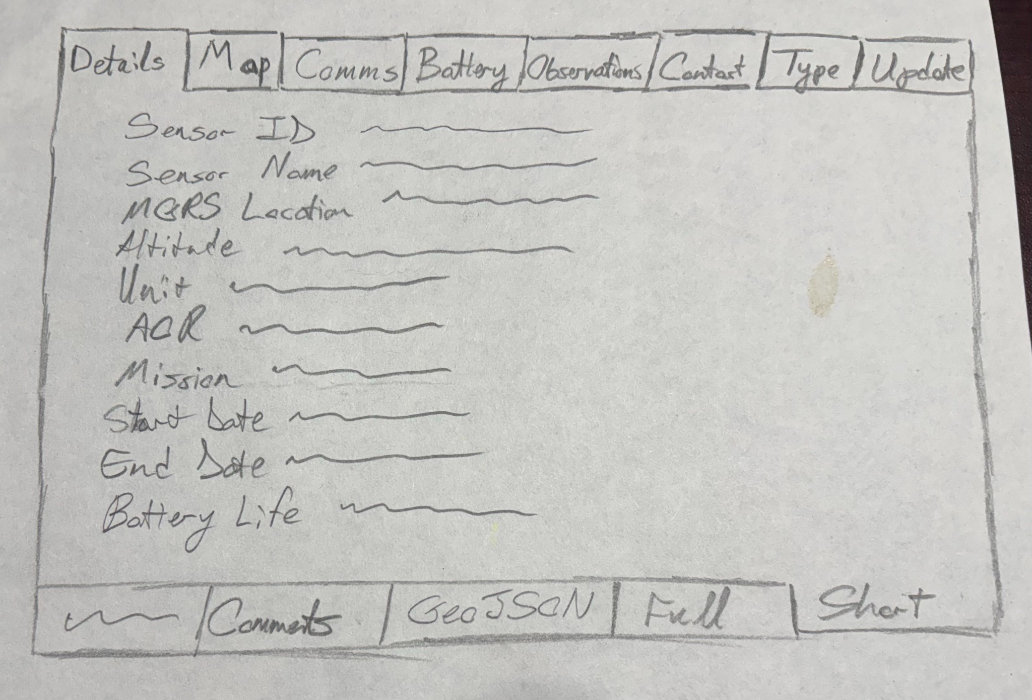
Figure 1. Sam Bolling's hand-drawn Resource Details concept, supplied October 3, 2026. Original photograph reproduced at reduced scale without altering its labels. It depicts a sensor-oriented state within a broad rectangular surface; control semantics and the intended resource adaptations remain design questions.
The strongest feature is its coherent, generously sized resource surface. It resembles the separate MERLIN sensor cards and broad 2015 Sensor Information window, while making several information areas directly discoverable. Battery Life in the summary and a separate Battery area could support a useful summary-to-detail path if both preserve the same value, source and temporal meaning. The drawing's central canvas also offers room for a richer description or primary content without adopting the narrow inspector geometry rejected earlier.
This visible state is sensor-oriented, so its universality depends on how the frame changes for other subjects. A System card might explain the instrument and its outputs, whereas a single Observation should prioritize its own result, including an image or video when supported. The sensor's Observations area would then expose related resources, with the sensor identity still explicit. The proposed extension is to retain a recognizable identity and source foundation across sections while adapting the body and applicable sections to the focal resource; those persistent elements are not depicted in this sketch.
The two rows represent a category and subcategory hierarchy. The lower row changes with the selected upper category and appears only when that category needs subdivision. Expandable sections provide further depth within the selected content without adding another tab level. Edit, Save, Refresh and Send Command are actions placed with the information they affect; selecting a category does not perform those actions. The final labels, selection cues and reflow remain design choices. Both tab levels need predictable keyboard behavior, with explicit activation when remote loading introduces latency (Sunwall 2024; W3C n.d.c).
Several field meanings require source confirmation before the drawing becomes a specification. Unit may identify an organization here and should not silently become a measurement unit; AOR, the date interval and Battery Life similarly need explicit meanings. MGRS presentation and Altitude need verified geometry, reference and unit information, while battery state may be a timed observation rather than a timeless sensor attribute. These questions concern the interpretation of supplied information and relationships, and the sketch leaves their provenance, freshness and unavailable states open.

3.6. Inputs to a resource aware presentation
Resource awareness starts with the subject of the card and the role of its content. An instrument photograph describes a System, while a camera Observation's image is its result; identical image bytes do not make those roles interchangeable. A Map section may show focal geometry, and a related resource may provide separately labelled location context. The framework therefore needs a supported interpretation of resource family and content role before selecting a useful body.
Schema awareness supplies the meaning of structured values, including properties, units, reference frames and source nils where the applicable schema provides them. Connected Systems describes the Observation result using its parent DataStream schema, and shows a JSON Observation format with a linked PNG result (OGC 2025b, secs. 16.1.4–16.1.5). Media type, commonly called MIME type, identifies the representation format; RFC 6838 treats that label as a type, subtype and optional parameters used across HTTP and MIME (Freed, Klensin, and Hansen 2013, sec. 1). These are complementary inputs, so an application/json envelope alone does not establish whether the appropriate result body is a scalar, record or image.
Presentation rules remain a separate responsibility. A data schema can establish what a field means, while a card manifest or UI schema describes how an application chooses to arrange it. Renderer and host capabilities then determine what can actually be displayed in the available space. The proposal is a deliberate combination of those inputs with visible interpretation limits, rather than treating any one type string or schema as a complete layout decision.
JSON Forms provides a concrete example of separating a data schema, a UI schema for ordering and layout, and a registry of renderers that can be extended (EclipseSource n.d.a, n.d.b). Its default purpose is generating forms, and read-only mode disables controls (EclipseSource n.d.c). That separation is useful for the proposed framework, but an automatically generated disabled form does not by itself supply a useful resource Details body. Media, scientific dimensions and the priority of information still need explicit presentation decisions.
Presentation input | Example | Responsibility
Resource and content role | System description versus one Observation result | Choose the focal subject and useful primary content.
Applicable data schema | Quantity, vector, unit, reference frame and nil meaning | Interpret values using a verified binding; retain unresolved meanings.
Representation and encoding | Observation JSON envelope and a linked image/png result | Decode and select supported media without confusing envelope and payload.
Presentation policy | Shared identity foundation and family-specific body | Arrange meaningful content; this policy is distinct from the data schema.
Renderer and delivery | Image available, video unsupported, schema unavailable | Display a supported body or an explicit recovery/fallback state.
Host and user task | Broad Dockview surface and reduced container width | Adapt layout and disclosure while preserving identity and qualifiers.
The rows separate information needed to understand a resource from rules used to compose its display. They describe proposed responsibilities, with source examples identified in the accompanying prose. They are a comparison aid rather than an adopted component boundary or a promise of support for every format.

3.7. Clarified categories and resource working view
Bolling’s subsequent clarification establishes top tabs as categories of information about the focal resource and the bottom row as optional subdivisions of whichever category is selected. A category can therefore have its own sub-tabs while using common names and interaction conventions wherever their purposes match. Sections within the selected content can begin with a useful short view and expand when the user wants greater depth. The card remains square or broadly rectangular in the standalone Dockview module (Bolling 2026).
The resource card is also the resource’s working viewpoint. It must support editing values that are both appropriate and permitted to edit, sending supported commands and scheduling future work. Bolling’s examples include taking an image, changing device configuration, requesting a status update and collecting at a future time. These require clear targets, supported parameters and visible outcomes. Device status requests are separate from refreshing already reported information. Classification banners and portion markings remain part of the experience, including its maps, results, visualizations and expanded content.
The clarified direction calls for concrete requirements by resource type now, beginning with Systems and Deployments. The Product Owner rejects an oversized, website-like rendering and decorative card styling: the standalone Dockview surface remains a compact square or broad rectangle, with categories, optional subcategories and expandable sections supplying depth. The latest MASINT IT Next discussion makes the resource-centered purpose explicit for every family, including Features and operational Targets, with useful links to their associated resources. The companion requirements draft carries that direction; one bounded review should settle initial coverage, component size, typography, controls and spacing before the PBI. No drawing or pixel specification is adopted here (Bolling 2026).

3 8 Proposed Symbol category and report workflow
Bolling proposes a top-level Symbol category that shows the symbol representing the focal resource. Its bottom row could select among applicable standardized symbol systems, beginning with MIL-STD-2525 and NATO APP-6 for relevant Feature resources. The common card retains identity and markings while this category changes its body. Other resource families may use other schemes or have no verified symbol mapping. Where a military scheme is available, Bolling suggests it may be the preferred initial representation; applicability and default selection remain decisions to refine rather than a universal requirement (Bolling 2026).
His operational example begins with an unknown military unit represented as a Feature of Interest. From that resource’s view, an authorized user could report a new location through an Enemy Observation Report (EOBSREP). Bolling describes MERLIN’s existing JSON adaptation of USMTF EOBSREP as an Observation whose result follows a SWE Common schema declared by the reporting military unit’s DataStream. A subsequent report could supply information establishing the observed unit’s adversarial affiliation, from which its displayed symbol changes. The observed unit and the reporting unit have different roles. This account is the product owner’s implementation description; the actual report schema and association path are dependencies for a concrete editor.
The proposal also includes editing symbology for an individual resource or a resource type, potentially through a privileged role. We should define those operations by their effect: personal display preferences, shared type mappings, an instance override and a new assertion about location or affiliation need separate authority and persistence rules. Changing icon size is a presentation choice; changing a symbol code that asserts hostile affiliation can express an intelligence judgment. The Symbol category should support the appropriate verified operation, preserve the supporting information and show the resulting state. The role name, mapping precedence and report-to-resource update policy remain open for refinement.

3 9 TRSS precursor and levels of commonality
Sam Bolling identifies TRSS Details View as the original inspiration for MASBUS wireframes implemented more than eleven years before this review. He reports that those views served the program for a long time, although MASBUS did not reach the intended completeness. He also recalls TRSS integrating equipment from Northrop Grumman, Xetron, Harris, McQ and other suppliers. This account supplies important design history and the reason for examining the source. The excerpts directly document several device families and a Scorpion configuration path; they do not independently establish the MASBUS implementation date, its duration of use or the complete vendor roster (Bolling 2026; Sentinel 1.0.7.2 Software Users Manual 2014, supplied slides 1–9, 58–60).
The proposed universal view needs a consistent foundation with adaptable contents. Identity, Source, markings, navigation and qualified operation outcomes belong to the shared interaction. Subjects such as battery information, camera settings, communications and firmware recur where a resource has those capabilities. A verified source or device profile then supplies the particular fields, constraints and actions within the relevant subject. Frequency in this selected screenshot set cannot establish prevalence across all resources. These levels organize the evidence and proposed presentation responsibilities, while preserving the resource family and schema distinctions already established in section 3.6.
The Deployment battery suggestion tests that organization directly. A System can show its own available battery information; a Deployment can show corresponding information about eligible participants while keeping the Deployment as the focal resource. The latter needs explicit membership, period and retrieval scope. The absence of a battery on the Deployment itself does not make participant information inapplicable. Conversely, missing reports, denied access or an incomplete member list cannot justify a confident claim that no eligible participant exists. The source and proposal are examined separately in section 7.19.5; the useful initial arrangement is an applicable Status category with Battery or Participant Batteries subdivisions, subject to the measured card review (Bolling 2026; Sentinel 1.0.7.2 Software Users Manual 2014, supplied slide 76, printed p. 230).

3 10 McQ and TRSS comparison as a resource-aware design test
Sam describes TRSS and McQ as different vendor solutions working from essentially the same engineering requirements for unattended ground sensors. He asks this review to extract the full value of their similarities and differences, and to explain how CSAPI and a client such as MERLIN can accommodate both. That is a product-owner account of their engineering context, not an independently checked requirements comparison or conformance finding. The supplied sources do substantiate closely related tasks: inspect sensor identity and location, review detections and imagery, understand power and communications, change supported configuration, and follow operations (Bolling 2026; OmniSense Central Computer Manual n.d.; Sentinel 1.0.7.2 Software Users Manual 2014).
This makes the pair especially useful for testing commonality. A Battery subject can recur while its useful contents differ between measured voltage and estimated remaining life. An image can be the primary content in both systems while acquisition prerequisites, camera controls and renditions vary. Even one vendor’s Status caption can describe different effects for different sensor families. MERLIN therefore needs consistency at the level of user purpose and interaction, with verified meaning, applicability and operation scope carried into each body. Sections 7.20 and 8.11 separate observed evidence, proposed CSAPI mappings and client presentation responsibilities; they do not prescribe a new framework or another vendor-specific application.

3 11 Original design intent and the implemented MASBUS view
Sam identifies the supplied UGS deck as his original clean wireframes and the new screenshots as the sensor Details implementation he recently explored in a live MASBUS testbed. He describes the implementation as flat, simple HTML/JSP and says he did not request its expansion into an independent page with bottom links opening further browser tabs. He nevertheless sees those links as evidence that several useful subjects need organization. This is an attributed owner assessment, complemented by visible summary, full-description, raw-source and editing routes; screenshots alone are not a click trace or a complete implementation audit (Bolling 2026; UGS Client Development Wireframes n.d.; MASBUS Details View Captures 2026).
No Observations were available during that testbed session, according to Sam. He recalls historical Observation Details with small maps, raw-information access and image-aware results. He also explains his MERLIN architecture: intelligence reports are Observations with declared SWE Common result schemas, whose presentation should recognize their report type. The guide and new MERLIN screenshot substantiate image-feed/reporting work and a report body in a selected-observation frame, while leaving that exact schema and publication pipeline unverified. His concern about underusing SensorML 2.0 remains his historical recollection; the particular raw document visible in the new capture declares version 1.0.1. Neither establishes a server-wide version or conformance finding (MASBUS Details View Captures 2026, slide 4; MASBUS STORMFORCE User Guide 2019, PDF pp. 7–12; MERLIN Report Workspace Screenshot 2026; Bolling 2026).

4. Findings and implications for presentation

4.1. Hierarchy and progressive disclosure
Bludau et al. (2025, secs. 2, 4, 6–8) classify 101 unfolding visualization techniques and examine how detail is revealed through different controls, scopes, and abstraction changes. Their definition concerns integrated transformations of a base visualization, so the survey is not direct validation of a generic popup. Its evaluations are heterogeneous, and the discussion leaves important questions about anticipation and transition behavior open. The transferable finding is a vocabulary for evaluating disclosure, not proof that fewer initially visible fields improve every task.
For MERLIN, disclosure is most defensible when it separates optional depth from essential meaning. Identity, focal resource classification, the meaning of the main value or status, and relevant time qualifiers should not depend on discovering an unlabeled expansion. Lengthy metadata, detailed schema structure, source payload, and large relationship sets are stronger candidates for disclosure. A section title should reveal its purpose and, where reliable, its amount of content. Users should be able to predict whether expanding it will reveal information already held or initiate a request.
This distinction prevents a common ambiguity: collapsed content and absent content can look identical. The proposed design shows a section’s unavailable, loading, empty, or populated state explicitly. It also avoids claiming a relationship count is complete when only a page has been retrieved. Expansion state should not alter the focal resource. These are MERLIN proposals derived from the task model and data contract; the unfolding survey does not validate their exact wording or implementation.
The initial hierarchy should therefore be semantic rather than a fixed row quota. A summary gives orientation; task-relevant value and timing follow; descriptive metadata and relationships provide depth; technical source inspection remains available separately. The order can vary by family. An Observation’s result may deserve prominence that a Procedure’s documentation does not. Applying one identical field sequence to every resource would sacrifice that relevance merely to obtain visual uniformity.

4.2. Responsive composition and anchored inspection
Schöttler, Dykes, et al. (2025, secs. IV–VI) propose constraint-based breakpoints using measurable properties of visualization content. Their demonstrations make the case for considering content conditions rather than relying solely on device widths; they do not establish optimal MERLIN breakpoints or report a controlled MERLIN comparison. The appropriate inference is to inspect actual container constraints and legibility. Adopting their framework or dependency is not necessary to use that reasoning.
The responsive-map study used workshops with eight professional designers and derived challenges and adaptation strategies from two map cases. It exposes tradeoffs around context, text, crowding, and interaction, while acknowledging that many proposed strategies need end-user evaluation (Schöttler, Hinrichs, and Bach 2025, secs. 3–4, 6). A MERLIN map anchor can borrow these questions, but the study does not answer whether a popup, side panel, or floating inspector is best for MERLIN’s tasks.
The recommended starting point is a host-sensitive composition over a common semantic contract. In a constrained anchor, the display should show enough identity and meaning to avoid confusion and provide a clearly named action for independent inspection. In a full module, the same resource can expose sustained reading and more optional sections. Reflow should preserve reading order and avoid moving important controls unpredictably as content arrives. Long IDs, large values, and narrow containers belong in evaluation fixtures, not just in final polish.
This recommendation does not require two separately maintained renderers. A single adaptive renderer, shared primitives with two compositions, or another arrangement could implement it. The evidence concerns observable readability, semantic consistency, and continuity of context. Component boundaries remain an engineering decision informed by implementation cost and testing. Neither a fixed count of summary rows nor a universal pixel threshold is justified by the reviewed research.

4.3. Labels, explanations, and status meaning
Sultanum and Setlur (2025, secs. 3–5, 7) examined 190 public dashboards and interviewed 13 authors, producing a taxonomy and 12 writing heuristics. The work emphasizes text’s roles in navigation, interpretation, and communication. Its sample and qualitative analysis do not demonstrate causal improvements for a MERLIN label set. It nevertheless supports evaluating labels as part of interaction design rather than as decoration added after layout.
MERLIN’s label review should ask whether a reader can tell what a displayed fact applies to. “Status” without a subject can confuse stream availability with a command’s current state. “Time” without a semantic qualifier can confuse when a phenomenon applied with when a result became available. The guide supplies those distinctions; Details should expose them visibly where the compact table could not. Tooltips can supplement unfamiliar terms, but should not carry the only explanation needed for a central judgment.
Source and provenance also require precise language. The MERLIN Source identifies application provenance and navigation context; it is not interchangeable with a payload property named source. Resource ID and UID serve different purposes. Connected Systems scopes local IDs by resource type and describes UID separately from the canonical resource URL (OGC 2025a, secs. 8.4–8.5). The proposed display uses separate labels and copy actions, preserving the endpoint or canonical link needed to disambiguate identity without implying that a display title is a stable identifier.
Values should preserve supplied units and meaningful precision. Formatting may improve readability, but the original value should remain recoverable when conversion or abbreviation changes its representation. Unknown units must not be guessed. A null is not automatically equivalent to zero, an empty string, or a source-defined nil with a reason. The guide’s supported mappings and the actual encoding determine what can be stated. Where that determination fails, the display should admit the uncertainty directly.

4.4. Relationships and navigation
Relationship inspection serves explanation as well as movement. A relationship row should identify its role, the known target, and the consequence of activation. “System,” “Stream,” and an undifferentiated “Related” group do not carry the same meaning. The initial proposal exposes directly supported associations and avoids traversing a graph merely because it can be traversed. Parent context may be useful, but it should remain labeled as context rather than being blended into focal properties.
QGIS provides a useful bounded precedent. Its Identify interface distinguishes inspection from selection, offers choices when multiple features are encountered, and can refocus identification through related features. Its table and graph Identify modes apply specifically to raster results, so they should not be cited as a universal feature-inspection layout (QGIS Project n.d., sec. 8.4.2). The transferable questions concern candidate choice, focal identity, and clear navigation consequences.
For MERLIN, the proposed initial related-resource action opens a new full Details module, retaining the original inspector. This extends a familiar Discovery convention but is a new Details decision, not an inherited obligation. It favors comparison and traceability over compact local history. A same-module replacement mode could reduce workspace clutter, but would require explicit back behavior and restoration of section state. That alternative should be evaluated if users routinely traverse long chains; it need not be included in the first scope.
Relationship lists should handle multiplicity, pagination, cycles, and inaccessible targets without claiming complete knowledge. An unavailable target can retain a known identity and explain the retrieval failure. Repeated targets should not cause automatic recursion. Navigation should be triggered by an explicit action, while expanding a relation group should have a separate consequence. A product decision is still needed on which discovered relationship roles belong in the first supported set.

4.5. Structured and unfamiliar content
SWE Common defines simple components, records, arrays, encodings, units, and nil values with reasons. A nested object therefore cannot be interpreted correctly by treating every key as an interchangeable label-value pair (OGC 2025d, secs. 7.4.2, 8.2–8.5). For MERLIN, the practical implication is to separate inspection of a supplied structure from verified domain interpretation. A JSON tree may be useful even when an operational meaning has not been established.
The recommended display has a readable mapped layer and an available source-content layer. Known scalar fields can use established semantic labels. Repeated records or arrays can use a table or navigable structure when their shape is understood. Complex or unfamiliar content keeps source keys, ordering where meaningful, and a clear indication of interpretation limits. Large content needs bounded loading or display; clipping must offer an explicit way to inspect the remainder rather than silently hiding it.
Schema and media-aware presentation is a central part of the intended Details experience. Its supported coverage and interpretation rules need explicit review. It involves selecting the correct format and stream, obtaining the schema, associating it with the displayed resource, handling unavailable or changing schemas, and deciding which derived labels are trustworthy. A successfully retrieved current schema does not prove that it describes an older occurrence. Where a binding or version cannot be verified, Details should not present a confident interpretation. The direct representation should remain usable.

4.6. Accessibility and interaction structure
Zong et al. (2022, secs. 3, 5–6) studied structured, navigable visualization descriptions with 13 blind or low-vision participants. The exploratory, guided study supports attention to structure, navigation, and description, while its results also show learning tradeoffs; the multi-view prototype was harder to learn than the table baseline on one rating. It is evidence for accessible information organization, not a mandate for bespoke keyboard navigation in a resource inspector.
The proposed Details baseline uses semantic headings, labeled controls, readable relationships, and meaningful reading order. Disclosure can use conventional button behavior. A visual popup is not automatically a modal dialog: modality depends on whether the remaining interface is inert. The WAI-ARIA disclosure and modal-dialog patterns provide different keyboard and focus obligations (W3C n.d.a, n.d.b). An anchored nonmodal inspector should preserve access to its host; a deliberate modal design would need the corresponding focus containment and return behavior.
WCAG supplies normative criteria rather than a preferred visual arrangement. Relevant checks include information relationships, meaningful sequence, reflow, keyboard access, focus order and visibility, unobscured focus, and accessible status messages (W3C 2024, criteria 1.3.1–1.3.2, 1.4.10, 2.1.1–2.1.2, 2.4.3, 2.4.7, 2.4.11, 4.1.2–4.1.3). The two-dimensional exceptions for certain content do not exempt the entire inspector’s surrounding prose and controls from reflow. WCAG 2.2 AA is proposed as the evaluation baseline; conformance has not been tested.
Focus behavior needs task-based verification. Opening independent Details deliberately should place users in a predictable location without destroying Discovery state. Loading announcements should communicate a change without repeatedly interrupting reading. Closing an anchored inspector should return focus sensibly when the origin still exists. Expanding optional information should preserve orientation. These behaviors are central to usability for keyboard and assistive-technology users and should be exercised in the same resource scenarios as visual layout.

5. Retrieval, freshness, failure, and persistence

5.1. A bounded retrieval contract
The proposed retrieval model distinguishes held focal content, a focal-resource request, and enrichment. Where the invocation already carries sufficient resource data, Details can show it immediately and identify its retrieval context. Where only an identity is available, it requests that exact resource. Related-resource or schema requests should be separately attributable to a section or action. This is a proposed Details contract; Discovery’s no-extra-hop rule for basic table population does not automatically prohibit all Details requests (MERLIN-932 2026; PITON Handoff 2026).
The first implementation should not block the entire inspector while optional enrichment runs. It should show what is known and the status of what is being requested. A retry must retain identity and recoverable content. A source error, inaccessible resource, unsupported encoding, empty collection, and missing field are different states. The display can explain what happened without implying that it knows whether a resource was deleted, hidden, or never present when the response does not establish that distinction.
Schema retrieval and payload delivery require explicit coverage decisions before implementation commitments are finalized. The proposed first behavior is bounded interpretation and presentation of supported stream, schema, and media combinations, with an inspectable fallback. Supported primary content should appear without requiring the reader to discover a technical expansion merely to see an image or video. Arbitrary graph enrichment, inferred units, and generalized decoding of every advertised format should remain outside that initial promise. Requests initiated by expansion should be evident to the user and should not recur indefinitely merely because a section remains open.

5.2. Freshness and incomplete information
Transport freshness and operational recency are separate. HTTP caching defines freshness and validation mechanisms; it does not determine whether an observation is operationally recent or a command state remains current (Fielding et al. 2022, secs. 4.2–4.3). MERLIN should distinguish a resource’s semantic times, the client retrieval time, and any indication that displayed content is retained after a failed refresh. A generic “Live” badge would risk merging those concepts.
The recommended initial refresh control re-fetches the focal resource explicitly and reports the result. Automatic polling or subscriptions require additional scope, cost, and lifecycle decisions; they should not be implied by the existence of a stream association. If a refresh fails, retaining earlier content can support continuity, provided the display marks it as retained and preserves its last successful retrieval context. A changed resource identity should never be treated as a routine refresh of the original.
Missing data should be represented by a small, defined vocabulary. “Not supplied,” “not retrieved,” “unavailable,” and a source-defined nil reason express different evidence. These terms should be used only when supported by the known state. An omitted optional field need not occupy a permanent empty row, but absence affecting interpretation should be explained. A loading skeleton should not look like a valid blank result once retrieval has failed.

5.3. Restoration and source-content handling
Dockview documents layout serialization through toJSON and restoration through fromJSON. That mechanism does not demonstrate restoration of MERLIN resource identity, authorization, payloads, or active requests (Dockview n.d.). The proposed saved state contains a versioned resource locator and approved presentation preferences, rather than treating a serialized payload as current truth. Restoring a module should make its identity and retrieval state visible and obtain the resource within the current source and access context. Unresolvable identities should produce a recoverable unavailable state.
This proposal requires implementation inspection before adoption: the team must determine what the current Dockview integration actually saves and which identifiers are stable enough to restore. Sensitive or large source payloads and active subscriptions should not be assumed to belong in layout state. Section expansion can be restored only where it remains meaningful and does not initiate an unbounded request chain. Restoration should be evaluated with changed sources and unavailable resources, not merely with a successful layout round trip.
Source-content inspection also requires safe rendering. OWASP’s guidance distinguishes text-safe sinks from HTML contexts that require appropriate handling (OWASP Foundation n.d., “Safe Sinks”). The proposal treats supplied content as data, validates actionable URLs, and avoids executing embedded markup. This is a focused rendering requirement, not a claim that the paper has specified MERLIN’s full security model. It preserves inspectability while leaving source permissions and operational policy to their governing contracts.

6. Project and precursor examples from Google Drive
The project archive provides a closer starting point than the external product survey. It contains broad resource windows, actual image results and near-square sensor cards, as well as report and feature examples that reveal where presentation must understand the resource’s meaning. The cases below use original embedded screenshots, faithful slide renders or explicitly identified crops. They are evidence to evaluate, not adopted designs. Source files and exact slide or page locations appear in captions and Appendix B.
The strongest immediate comparisons are the existing MERLIN floating image window, the separate MERLIN sensor cards and the 2015 contextual-versus-image Observation concepts. Together they let us discuss a broad standalone surface with a stable identity and a body appropriate to each resource. Later cases test that idea against equipment photographs, structured reports, coded feature properties and signal content. Editing screens and monitoring workspaces are identified where their evidence is useful but their interaction scope differs.

6.1. MERLIN floating image Observation window
The MERLIN composite places a floating rectangular window titled “Selected Observations - TBAV” over a temporal monitoring view. Its main content is an actual camera image, followed by Classification, Details, Timestamp, Location, Sensor ID, and Sensor Type. The briefing’s red arrows connect the image window with an event in TBAV and a sensor on a map. This is particularly relevant to the proposed standalone resource view: the project already has a precedent for presenting an image and its context together in a separate rectangular surface. The image is the subject of attention, while its metadata helps the viewer interpret it.
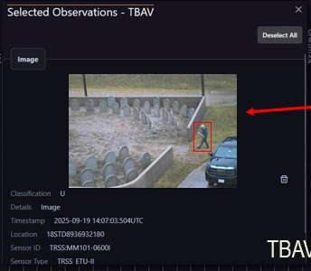
Figure 2. MERLIN Selected Observations TBAV floating window. Crop of the original briefing composite in MERLIN MVP Demo AUG2026.pptx, slide 14. The crop retains the window title, image and contextual fields. Displayed Observation time is September 19, 2025; capture date is unverified.
A second MERLIN example, the Standards in Action brief’s slide 2, presents similar image-and-metadata content inside the TBAV Details sidebar. Together, these screenshots let us evaluate the content independently of its enclosing geometry. They support investigating a broad card that retains visible imagery and selected-resource context when placed in Dockview. They do not show MIME detection, schema-based dispatch, video support, or a complete identification contract. The floating window also refers to selected observations, so we must examine how one focal resource would be identified when several are selected. Existing actions and timestamp or location labels require review before adoption.
Discussion question: When this content is detached from TBAV, which identity, producer, time, and spatial context must remain visible for the card to stand on its own?

6.2. MERLIN separate sensor cards
The demonstration AAR reproduces three independently bounded sensor cards over a Resource Table: RV814, IMG925 and MV36A. Each card has its own title and close control, followed by a sensor name, classification and a short list of attributes. Sensor ID, Sensor Name, Location, Altitude, Unit, Mission Name and Timestamp recur across the RedVox, TRSS and MultiVox examples. These cards already have the near-square proportions requested for the standalone view. Their side-by-side appearance lets us examine what a shared identification and contextual structure achieves across heterogeneous sensors (MERLIN Demonstration AAR 2026, fig. 14).
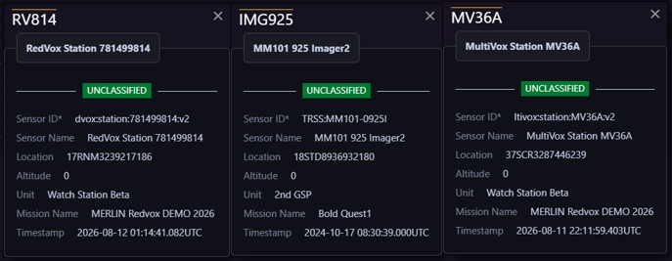
Figure 3. Three MERLIN sensor cards. Crop of (U)_MERLIN_Demo_AUG2026_AAR_v1_2.docx, original figure 14, Normalized Data Across the Enterprise. The crop preserves all three card bodies and headings; the surrounding discovery table is omitted.
The common structure makes the records easy to compare, but it also exposes the limits of a universal field list. The screenshot supplies little explanation of the different instruments or their capabilities. A future System body could use description, characteristics and available outputs to explain those differences while keeping identity recognizable. Timestamp is not qualified by its role, and the displayed altitude of zero does not prove whether it was measured or defaulted. The AAR is version 1.2 for the August demonstration, while this screenshot shows a September 4 desktop date; the figure is archival evidence of presentation, not a fresh test of that demonstration or of current behavior.
Discussion question: What additional content would help us understand each sensor without losing the compact, comparable identity of these cards?

6.3. 2015 contextual and image Observation windows
The paired Observation windows are an especially relevant internal precedent. One uses a wide rectangle for the selected observation’s identifier, type, procedure, sensor, description and time fields. The other gives most of a separate window to an image area, with a short contextual strip above it. Slides 19 and 20 explicitly describe opening detailed information or an image as applicable, from either the observation table or the strip chart. This makes two ideas visible in the project’s own lineage: the same observation can be reached through several entry points, and its body can change to suit its content (Chen and Bolling 2015, slides 19–20).
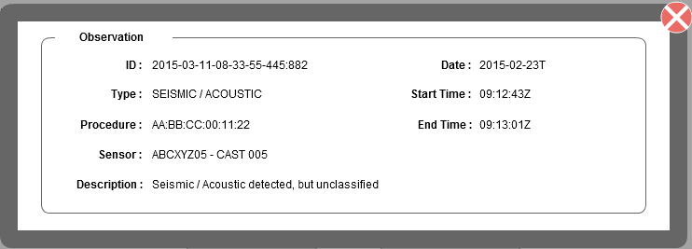
Figure 4. Contextual Observation modal, cropped from APR2015 SWE Quarterly v1.pptx, slides 19–20. The source is a prototype wireframe with sample values.
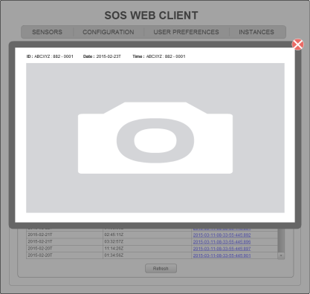
Figure 5. Alternate image Observation window from the same 2015 prototype, slides 19–20. The camera symbol is a placeholder rather than an observed image payload.
These are prototype concepts. The image area contains a camera placeholder, and the sample header values include inconsistencies; neither figure proves image delivery or MIME-based dispatch. The non-image panel describes an observation but does not show how a scalar, waveform or structured result would be presented. We can therefore use the pair to examine the balance of context and content, then test that balance with realistic resources. The intended broad standalone Dockview surface can preserve this distinction while supplying the actual supported image, video or semantic result.
Discussion question: Which facts should stay recognizable across Observation bodies, and which should yield space to the actual result?

6.4. 2015 broad sensor description with related observations
The 2015 Sensor Information concept is almost square. Device identity, type and description occupy the left of its descriptive region; coordinates and operational attributes occupy the right. A linked observations table sits below. Slides 16–18 connect this view to sensor selection from the strip chart and to the observation list. It is a direct precedent for giving a descriptive resource enough width to explain itself while exposing a path to its observations (Chen and Bolling 2015, slides 16–18).
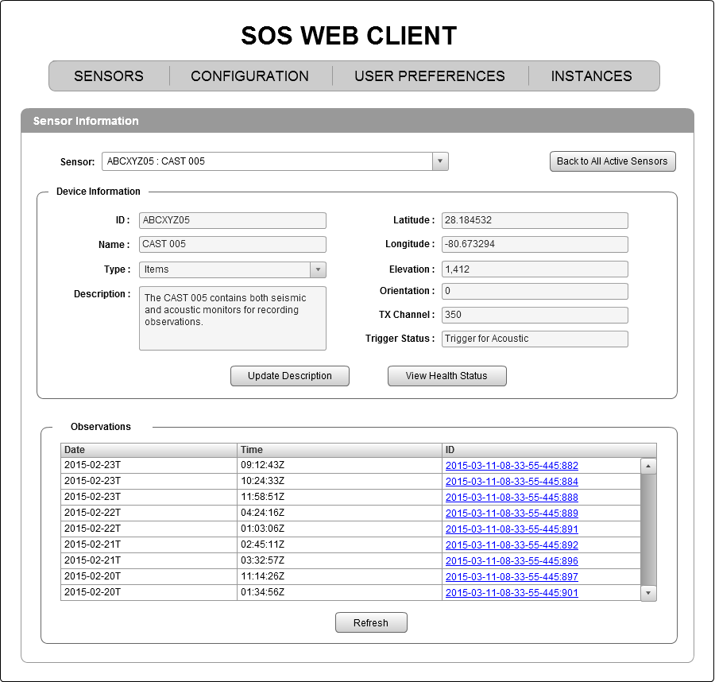
Figure 6. SOS Web Client Sensor Information design concept. Source: APR2015 SWE Quarterly v1.pptx, slides 16–18. Original embedded prototype image; editing controls and sample data are retained.
The concept also contains editable fields, Update Description and View Health Status. Its grouping and relationship navigation can be evaluated separately from that management workflow. A modern System card would need verified schema meanings for dates, location, elevation and characteristics; the sample fields do not define universal requirements. Showing a recent observation or a related list may be useful, but should not obscure which sensor the card describes. The broad shape is useful evidence of the intended experience, while its dummy data and field choices remain subjects for evaluation.
Discussion question: Which descriptive facts belong on the sensor card, and which belong in related observations, health or configuration views?

6.5. Pursuer sensor description and instrument photograph
The Pursuer screenshot shows a service-and-sensor tree beside a broad, separate dialog for an Omnisense Imager. The dialog distinguishes Sensor Description from Observation through two tabs. The description includes identifiers, sensor classification, Valid Time, security constraints, and physical or operational characteristics such as detection range, field of view, weight, and dimensions. A photograph labelled Sensor Image appears within those characteristics. This is a concrete example of an image serving a descriptive role: it depicts the instrument itself. It is therefore different from the camera-result imagery in the MERLIN Observation examples, even though both presentations contain images.
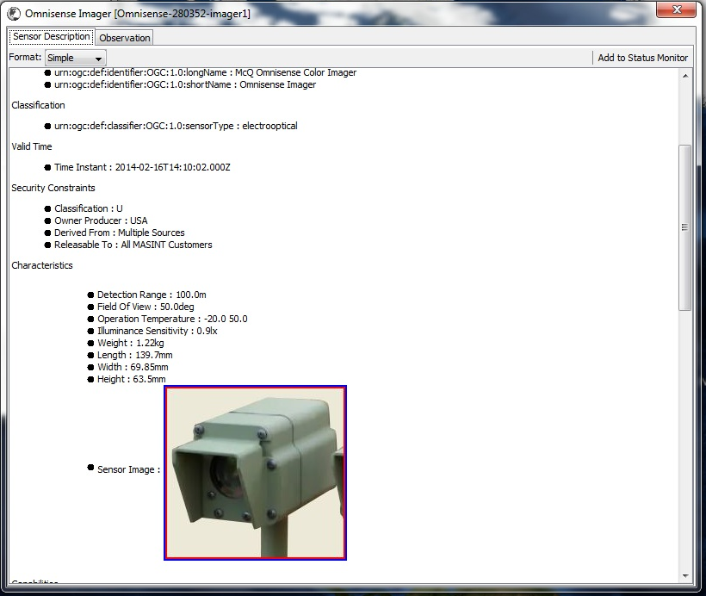
Figure 7. Pursuer Omnisense Imager Sensor Description dialog. Crop of the original screenshot in PBI - Sensor Search View.pdf, page 5, upper screenshot. The sensor photograph is descriptive content. The narrative identifies a 2012 collaboration; the display includes a 2014 Valid Time, and its capture date is unverified.
The implication is that presentation should account for an image’s relationship to the focal resource as well as its media type. A System might use a photograph to help identify equipment, while an image Observation would make its result central. The historical dialog also exposes limitations worth discussing: long URNs, indented bullets, and extensive scrolling make the information difficult to scan. The screenshot documents visible content in a thick-client plugin; it does not verify its parsing rules or establish contemporary CSAPI behavior. We should investigate how to preserve descriptive richness while deciding which characteristics deserve prominence in a broad resource card.
Discussion question: How should the card distinguish a photograph identifying a System from an Observation result, an attachment, or a preview of related content?

6.6. MASBUS image aware Observation feed
The MASBUS observation-feed proposal provides a direct internal precedent for the current resource-view problem. It places linked sensor identity and separate Collect Time and System Time labels around successive observations, then gives an image result an actual image region. The annotation, “If result is an image, parse & display,” makes the intended presentation decision explicit. This example occurs in the FY18 proposal and both FY20 versions, rather than appearing only in a recent discussion (Bolling 2017, slide 9; 2020a, slide 11; 2020b, slide 12). The image is visible alongside ordinary text results, so the body already changes according to what an observation contains.
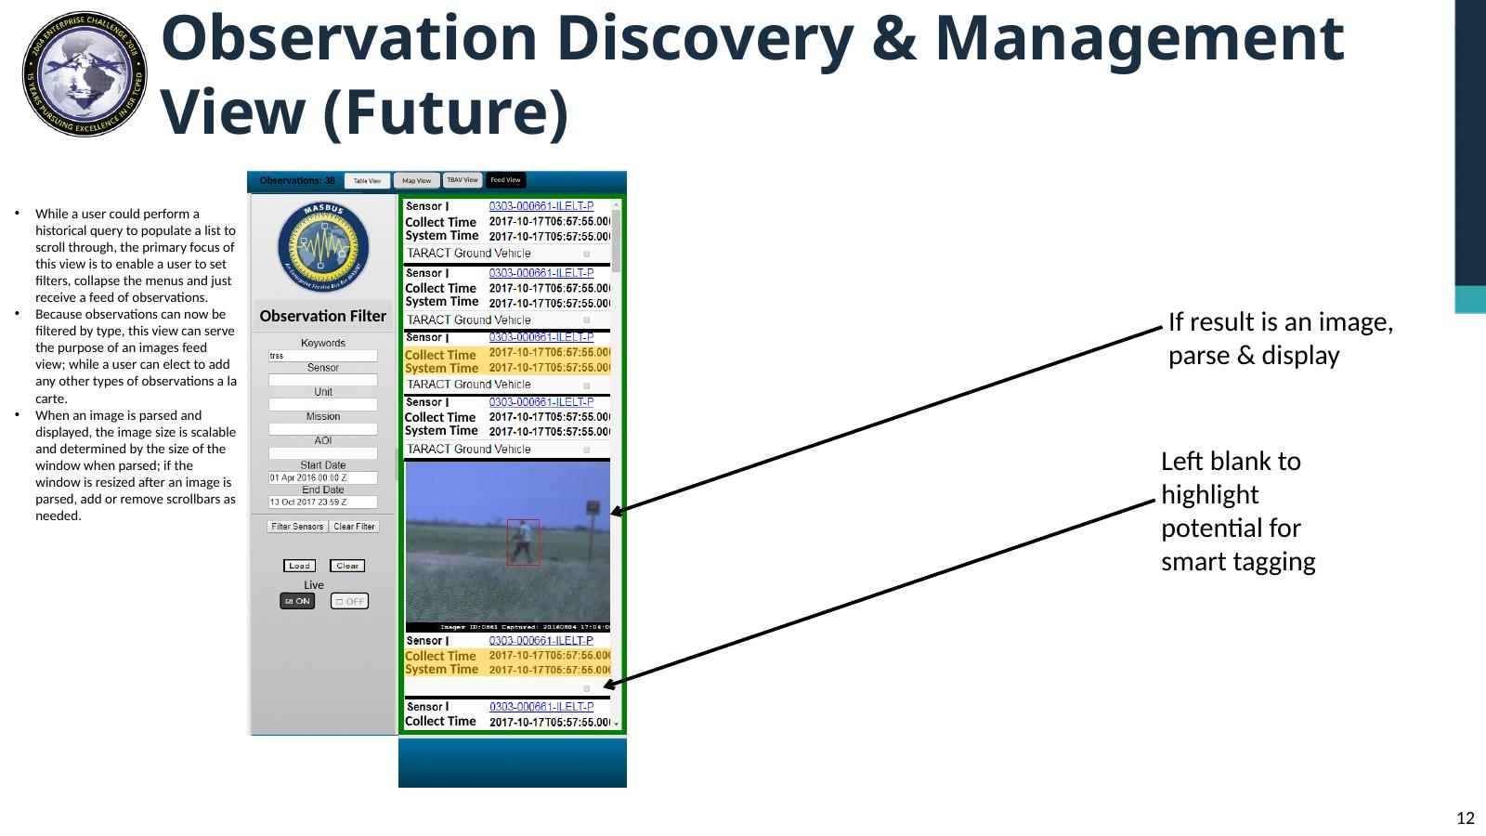
Figure 8. Proposed Observation Discovery and Management feed. Source: FY20 MASBUS Wireframes Update v6.pptx, slide 12; faithful rendering retains the native text and annotations. Earlier appearances: FY18 slide 9 and FY20 V1 slide 11.
For MERLIN, the useful comparison is between these result bodies and the resource context that survives the change. A standalone view should let an analyst see an image, watch a supported video, or read a structured result while retaining the identity, time and relationship information needed to understand it. The old feed's narrow geometry does not answer the user's broad-card requirement, and its resize/scrollbar proposal should not become a current requirement. The example establishes historical design intent, not universal decoder support or demonstrated usability. Our evaluation should ask which context remains visible and which presentation changes for each supported schema or media type.
Discussion question: How should text, image, video and structured result bodies change while keeping a single Observation’s context clear?

6.7. Legacy UGS image result with acquisition context
The Automatic Imagery window supplies a real image-content precedent alongside the 2015 prototypes. Its header identifies the ISU and an image date and time; the body shows dimensions, compression, an image number and activity labels before the image. Red and yellow boxes and arrows mark objects within the image. This is a historical UGS Portal screenshot reproduced on slide 22, rather than evidence that the adjacent prototype was implemented. The displayed image date is October 29, 2009 (Chen and Bolling 2015, slide 22).
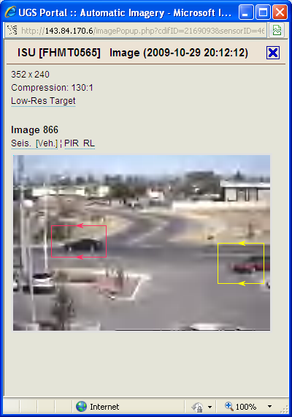
Figure 9. UGS Portal Automatic Imagery popup with actual image content and annotations. Source: APR2015 SWE Quarterly v1.pptx, slide 22. Original screenshot; visible acquisition date is in 2009.
The example asks which image attributes matter during inspection. Resolution, compression and visible analyst or detector markings can affect interpretation, so some may deserve prominence beside the image rather than being hidden among technical properties. Their exact origin and meaning must be established; the screenshot does not tell us whether markings are baked into the result or overlaid by the viewer. Its portrait geometry is a historical host choice. For the broad card, we can retain acquisition context while giving the image a viewing area appropriate to its aspect ratio. The window does not prove a video result merely because other software supports playback.
Discussion question: Which acquisition facts and annotation roles must be visible to interpret the image correctly?

6.8. MASBUS image Observation and reporting actions
The 2020 demonstration composite shows a map, an image result window, a TBAV and a results table. The image window presents actual imagery with a linked Sensor identifier and separate Phenomenon Time and Result Time labels. Generate SENREP and Generate EOBSREP actions appear beside that context. This is a closer operational precedent than a generic attachment page: an Observation’s actual content remains visible while the analyst can act on the selected information (Bolling 2020c, slide 13).
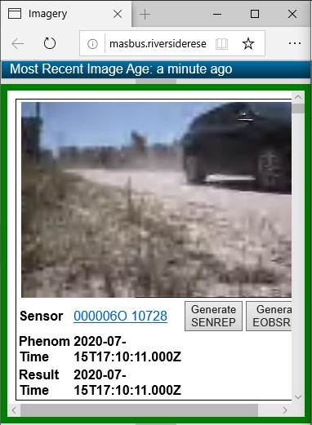
Figure 10. Image window cropped from DCGS MASINT FT MSSC Presentation 16JUL2020.pptx, slide 13. The actual camera result, Sensor link and two time labels are visible; the original clipping of a reporting action is retained.
The screenshot also helps us separate viewing from the task that follows it. Reporting actions may be useful for this resource and workflow, but they need not dominate every resource family’s card. The cropped source includes a horizontal scrollbar and a partly clipped action; that is evidence to critique, not a composition to repeat. A broad standalone surface could give the image and meaningful context sufficient room, with resource-appropriate actions in a consistent place. The screenshot does not validate the timestamp mappings, the reporting output, or support for other payload types.
Discussion question: Which actions help inspect or use this Observation without overwhelming its primary content?

6.9. Report Quick Views and encoded message bodies
The archive contains two report-content examples on one slide: JWARN's APP-11 Quick View and a SENREP Manager that places a selected message body below its list. JWARN labels separate Report, Header and Quick View representations; the SENREP example retains sender, precedence and classification within the displayed report text (Bolling 2020b, slide 13). A further JWARN screenshot shows the selected report's Quick View beside an event/report hierarchy (slide 18). These are concrete evidence that the content of a report deserves a substantial presentation region rather than disappearing into a generic metadata list.
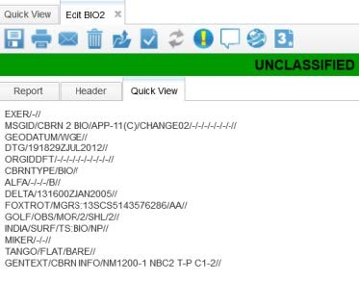
Figure 11. JWARN APP-11 Quick View. Source: FY20 MASBUS Wireframes Update v6.pptx, slide 13. Historical screenshot reproduced by the deck, which cites JWARN SUM pages 29–30; that manual was not independently inspected.
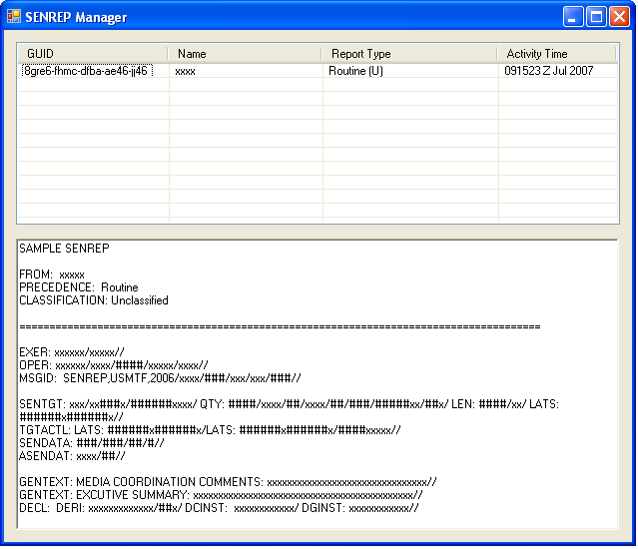
Figure 12. SENREP Manager sample report body beneath a record list. Source: the same deck, slide 13. The system identity beyond the visible title is unverified.
For MERLIN, a readable summary and a faithful encoded report serve different analytical purposes. The summary can explain the meaningful facts, while the encoded representation lets an analyst verify line designators or compare a source report with its interpretation. Their relationship should be explicit, and changing representation should preserve the focal resource identity. The archive does not establish that SENREP Manager is a current MASBUS component, and its sample message is not evidence of current interoperability. The nearby SENTINEL screenshot is a filtering screen, not a report-details view; it belongs in the search/navigation comparison rather than being counted as another content renderer.
Discussion question: Should the default report body be a readable semantic summary, formatted report or encoded message, and how should alternate representations be labelled?

6.10. Formatted UMS report as primary content
The Common Report Format briefing contains an HTML report with labelled identity and event fields followed by an Executive Summary, Event Description and Analysis Comments. Graphic Products offers links named Day/Night Video and Q24A Snippet. Unlike a record inspector, the page presents the report itself as the main content, with its narrative and supporting products readable together. Slide 6 shows this output; the input form and XML output elsewhere in the deck are separate representations (Strehle 2017, slide 6).
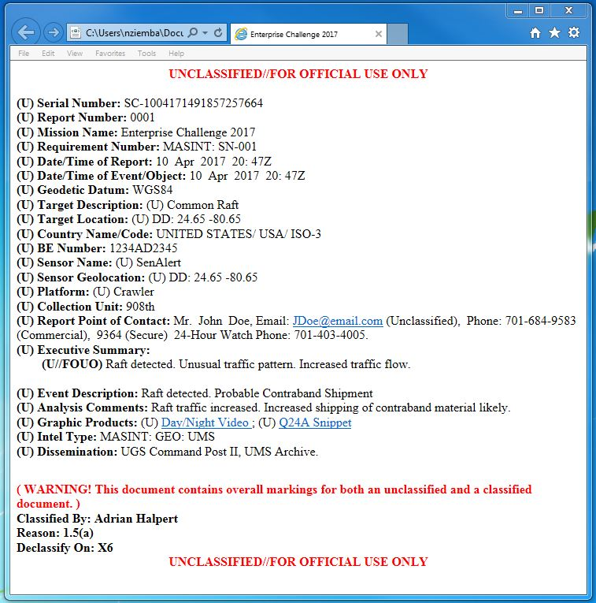
Figure 13. Formatted sample UMS report. Source: MSSC 20 April 2017 UMS Common Report Format bef nz kj dc v4.pptx, slide 6. Original sample and its historical marking warning are retained.
This example extends the comparison beyond sensors and observations. A report resource can require narrative reading and supporting-product navigation rather than a large media slot or a uniform field grid. Its displayed markings and mixed-marking warning are part of the historical sample; they do not establish contemporary handling rules or a valid current report. The video link is evidence of a referenced product, not a verified playable video detail view. We should test whether the broad resource card shows the formatted report directly, summarizes it with a deliberate Open Report action, or provides both representations while preserving exact report identity.
Discussion question: How much of a report should be directly readable in its standalone details surface?

6.11. JWARN alert detail and its underlying report
The JWARN Alert tab describes an alert with a date and time, an Operations region, contextual fields and an invalid-entry explanation. Acknowledge and View Report sit beneath it. The surrounding event and report hierarchy shows that the alert belongs to a wider reporting workflow. The wireframe author explicitly distinguishes this invalid-entry notification from parsing the APP-11 report content (Bolling 2020b, slide 16). The selected alert and the underlying report are related subjects with different content.
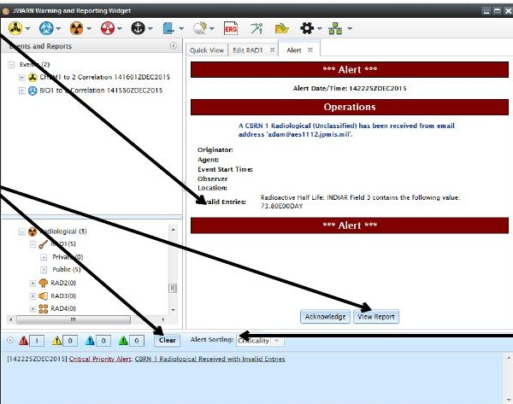
Figure 14. JWARN Alert details and View Report action. Crop from FY20 MASBUS Wireframes Update v6.pptx, slide 16, retaining its annotations. The deck reproduces historical manual material.
That distinction is useful for a universal view. A content-delivery error, a validation finding and a sensor Observation should not acquire the same meaning just because each is displayed as a card. The view should identify whose status it describes and what opening the report changes. Acknowledge is an operational action in this historical example; it does not become a default action for every resource. The source crop retains explanatory arrows from the deck, so it documents the author’s comparison as well as the archived UI. It is not a fresh runtime test of alert behavior.
Discussion question: How should an alert or validation finding identify its subject and lead to the resource that needs inspection?

6.12. JWARN bodies adapted to report schemas
Three JWARN screenshots show why a single property layout can conceal useful distinctions. The BIO report groups incident serial number, incident times, incident location and release information. The CHEM4 form gives substantial space to sample/reading/detection information and contamination/decay information. The CHEM1 form explicitly separates observer position from incident location (Bolling 2020b, slides 22–24). Each retains Report, Header and Quick View navigation while the report body changes. These are editable report forms, but their field grouping demonstrates how a stable surrounding view can support meaningfully different content for different schemas.
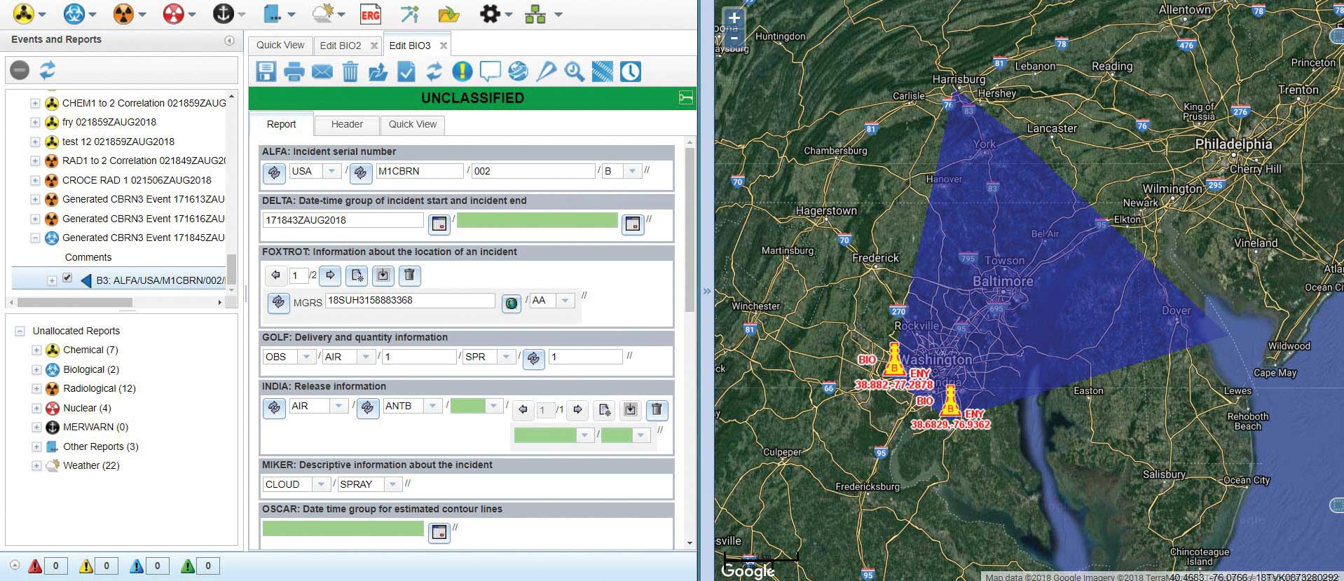
Figure 15. BIO2/BIO3 editable report form and adjacent map. Source: FY20 MASBUS Wireframes Update v6.pptx, slide 22; also FY20 V1 slide 21. Original screenshot.
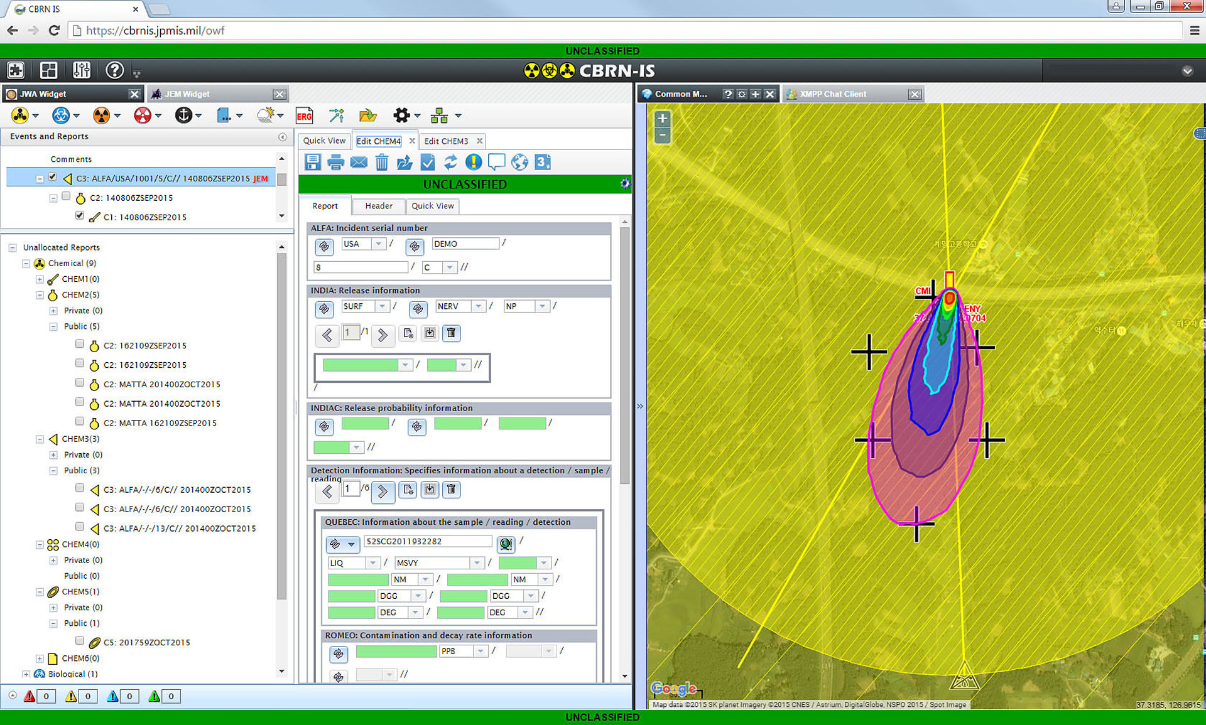
Figure 16. CHEM4 editable report form and contours. Source: the same deck, slide 23; also FY20 V1 slide 22. It presents different report groups from the BIO form.
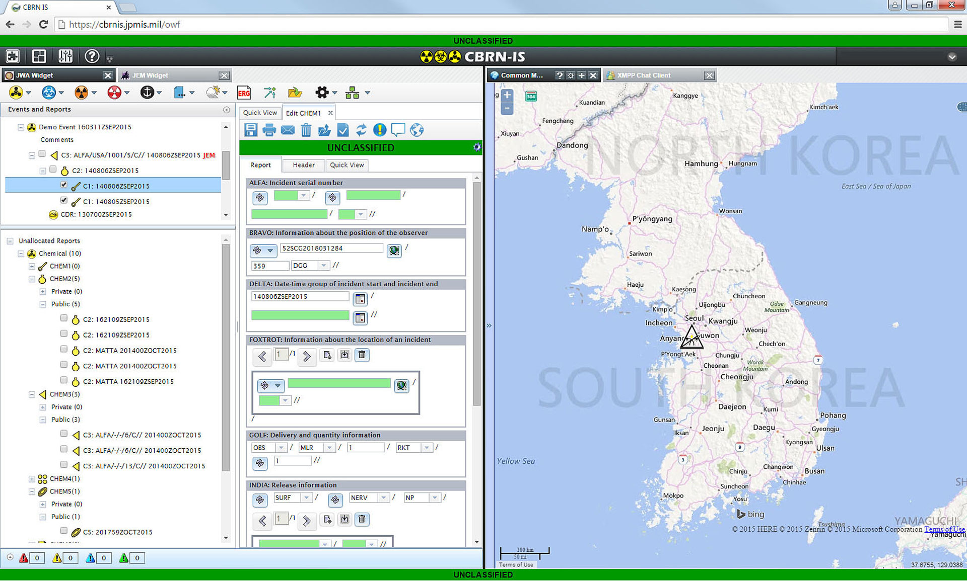
Figure 17. CHEM1 editable report form. Source: the same deck, slide 24; also FY20 V1 slide 23. BRAVO observer position and FOXTROT incident location are separately labelled.
The most useful MERLIN lesson concerns semantics rather than copying the widgets. Observer position, incident location and sensor location are different facts; the interface must label them before deciding whether to show a map. Likewise, a detection value needs the measurement meaning and units supplied by its schema. A universal resource view can preserve a common identification area while using a suitable report or result body. The screenshots do not justify universal map display, automatic hazard contours or copying these report-editing controls wholesale. They give us concrete structures to compare when deciding what a resource summary must retain and what can be expanded.
Discussion question: Which schema-defined distinctions must survive in a readable summary, especially when a resource contains several positions, times or measurement roles?

6.13. MASBUS sensor description and authoring provenance
The Sensor Description Editor is an internal resource-description specimen with familiar information groups: identity/type, MGRS location and altitude, start/end dates, mission, contact details, emplacement/ownership, AOI and comments. A composite slide connects selected user-profile fields to suggested defaults in that editor and a SENREP originator field (Bolling 2020b, slide 4). It therefore contains both a historical resource-editing screen and a proposed interaction for populating it. The relationship to the user's own work is considerably closer than a generic business object page, although the screenshot does not supply a finished readonly card.
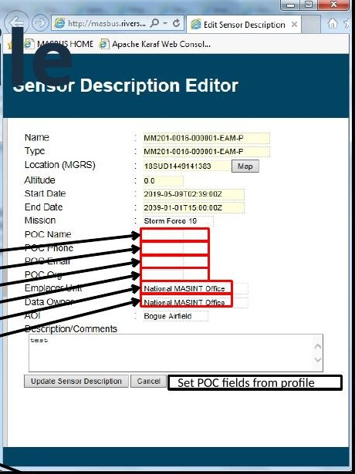
Figure 18. Sensor Description Editor with proposed profile defaults. Crop from FY20 MASBUS Wireframes Update v6.pptx, slide 4. Original source annotations remain visible; this is an editor, not a completed read-only card.
A MERLIN resource view could use this example to evaluate which facts help an unfamiliar analyst understand a System-like resource, then map those facts to the current resource schema. Contact and ownership information should be presented as labelled facts or relationships when supplied, while authoring defaults remain part of the editing workflow. The historical Mission and AOI fields must not become universally required metadata simply because they appeared in this editor. A broad Details card should explain the resource, preserve provenance, and expose the appropriate content for its type without recreating the old form or treating profile-population arrows as approved behaviour.
Discussion question: Which facts explain the selected sensor, and which values originate in an authoring profile or operational relationship?

6.14. PulseNet grouped selected sensor information
The archived PulseNet Client Viewer combines a sensor results table, a map, and a selected-sensor information panel. The panel groups information under INFO, LOCATION, and OWNER rather than presenting one undifferentiated list of properties. The visible record identifies KCTY and describes a weather station measuring temperature, humidity, pressure, wind, and rainfall. Location is presented through longitude, latitude, and altitude. The results table separately supports comparisons through columns such as ID, description, type, and taskability. This early example gives us a concrete way to discuss how a selected resource’s description differs from a collection-oriented discovery display.
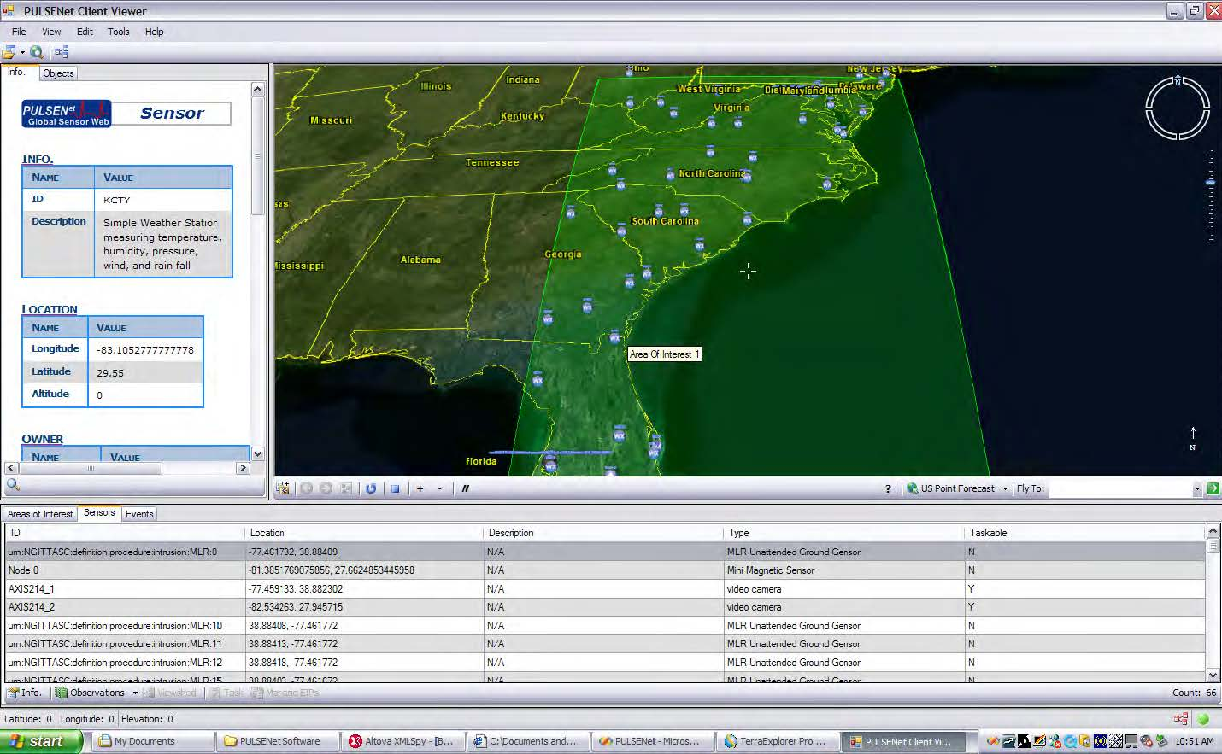
Figure 19. PulseNet selected-sensor information beside a map and results table. Source: PBI - Sensor Search View.pdf, page 3, upper screenshot; embedded image reproduced unchanged. The historical narrative identifies this as Empire Challenge 2007 material.
The useful precedent is the grouping of related facts and the retention of a descriptive account of the sensor. Its tall narrow panel should not dictate the proposed standalone card’s proportions. Instead, we can evaluate whether the same conceptual groups become clearer in a broad rectangle, with enough room for a readable description and resource-specific content. The screenshot is historical and provides no evidence of a universal renderer, media handling, or usability testing. Some information is below the captured viewport, and the displayed altitude of zero does not establish that a measured altitude was available. Those limitations help identify what a complete example must show.
Discussion question: Which of these information groups would remain stable across resource families, and which should change when the focal resource is an Observation, Deployment, or non-point Feature?

6.15. MERLIN generic feature properties and invalid location
The MERLIN integration screenshot shows a map containing points, lines, and polygons, with a Selected Features panel on the right. One expanded entry is identified simply as “9.” Its properties include Type Waterwork_S, FFN** 360, FCODE** BH220, SHAPE_Length**, and SHAPE_Area**. The Location field contains a string of NaN values. These are visible shortcomings in an archived example, rather than evidence of a current product defect. They make the research problem tangible: putting returned properties into a readable card is not sufficient when identity is weak, codes are unexplained, units are absent, or a spatial representation is invalid.
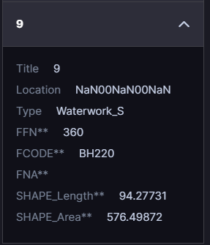
Figure 20. Expanded feature 9 in MERLIN Selected Features. Crop of MERLIN slides for Standards in Action Brief.pptx, slide 4. Raw property names, unexplained codes and the NaN location are retained as observed. This archival screenshot does not establish a current defect.
This case supports investigating presentation that understands known feature schemas and geometry types. A broad card could devote space to meaningful identification, a trustworthy spatial summary, and understandable attributes, while preserving access to the original properties. That is a design hypothesis, not a capability demonstrated by this screenshot. We have not decoded the DGIF codes or verified their definitions and units. Nor should the invalid location be replaced by an invented point or centroid. The example also exposes a useful evaluation boundary: an unknown or unusable value needs an honest presentation, and a polygon should not be forced into the display conventions of a point.
Discussion question: What should identify and spatially summarize a polygon resource when the source provides neither a useful name nor a reliable point location?

6.16. MASLink CASSE broad observation summary
The MASLink demo shows a broad CASSE modal titled Ground Vehicle and MASINT. A location and date/time precede procedure, observed-property and identifier strings, an EPSG:4979 value under System, a Ground Vehicle detail and Amp Hours Remaining. A MASLink details link provides a route to another surface. This is a useful business-card-like geometry for a non-image observation summary: a title or short interpretation leads, with contextual and technical facts below (MASLink Demo n.d., slide 11).
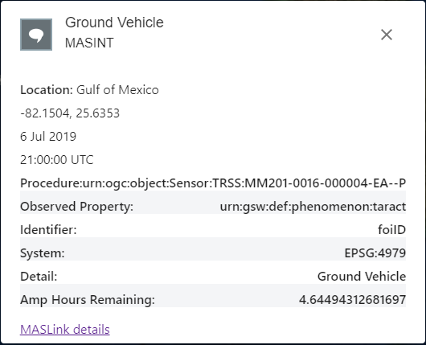
Figure 21. CASSE Ground Vehicle summary from MASLink Demo.pptx, slide 11, CASSE Integration. Crop of the original screenshot retaining the whole modal. Event values show July 6, 2019; presentation publication date is unverified.
The same figure exposes semantic work the card cannot leave to the reader. System here contains a coordinate reference identifier; it is not evidence that the label identifies a current CSAPI System resource. The long procedure and property URNs dominate space, while the numeric battery quantity is shown at excessive precision. The date/time roles and basis of the place label are unverified. A modern broad card should retain inspectable identifiers but use verified schema and relationship meanings to label its main facts. The 2019 values inside this archived screenshot do not date the presentation or verify its current behavior.
Discussion question: Which semantic summary and verified quantities should lead, and which exact identifiers should remain available through secondary inspection?

6.17. CSAPI Explorer deployed system and related content
The CSAPI Explorer screenshot presents a Deployed System card for NIMS Camera 12439500 beside a map. The card includes a site description, a live-camera image with a time label and View Timelapse action, outputs named Discharge, Gage Height, and NIMS Station Image, a context breadcrumb, an Occupant name, and an Updated indicator. Unlike a flat property list, it makes several relationship roles visible. The camera content and deployment context can be examined together, while the outputs suggest additional information associated with the selected subject. This is a related implementation captured in a MERLIN briefing, not a MERLIN interface.
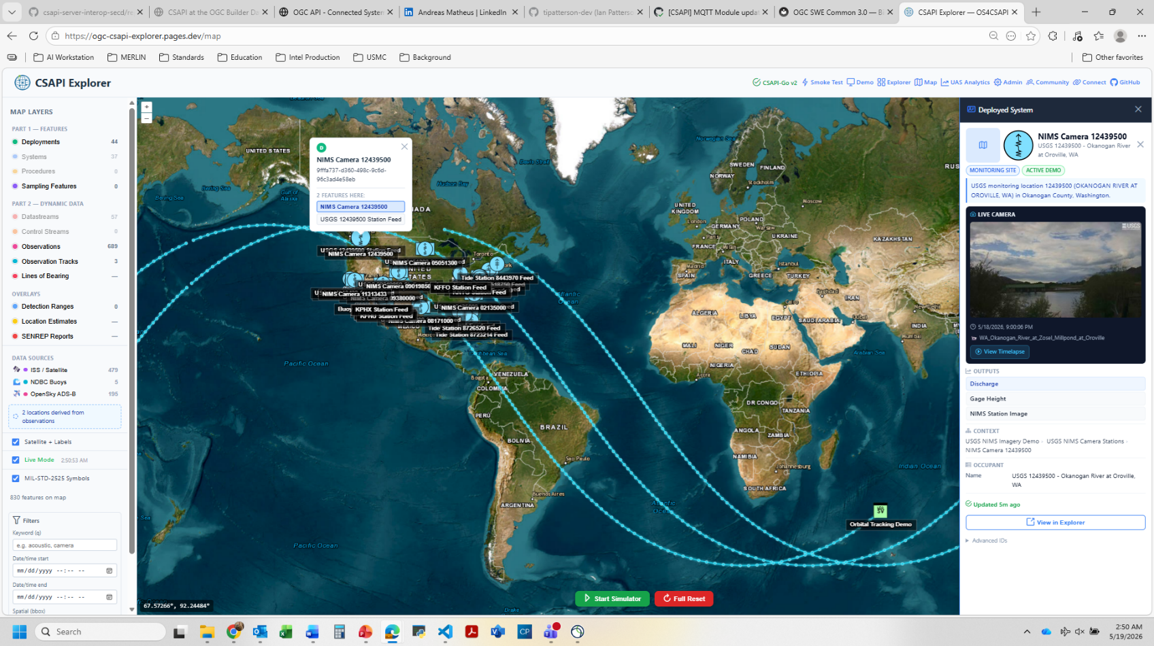
Figure 22. CSAPI Explorer Deployed System card for NIMS Camera 12439500. Source: MERLIN MVP Demo AUG2026.pptx, slide 16; embedded screenshot reproduced unchanged. This is a separate implementation from MERLIN. The desktop displays May 19, 2026.
The case is useful precisely because it raises a question about focal identity. A deployment-related surface may legitimately include content from a camera or Observation, but the viewer needs to understand which resource the card describes and which content comes from related resources. The screenshot cannot establish the underlying API relationships, whether the image is current, or what the Updated indicator measures. Its narrow enclosing panel is also separate from the desired broad-card geometry. We can nevertheless evaluate its explicit context and output groups as candidate presentation ideas, then test whether they remain understandable when the card is used independently of the map.
Discussion question: When a card embeds media from a related resource, what must identify the focal resource, the media’s producer, and the specific observation or time being shown?

6.18. MERLIN waveform spectrogram and detection context
The demonstration AAR includes a Spectrogram surface with a waveform above a frequency-and-time display. Coloured regions and a tooltip identify a detection from an ML model; the tooltip offers further details. This shows that resource-appropriate content in MERLIN already extends beyond photographs and text. The main area helps an analyst inspect temporal and spectral structure, while labels and controls retain context for the signal and detections (MERLIN Demonstration AAR 2026, fig. 10).
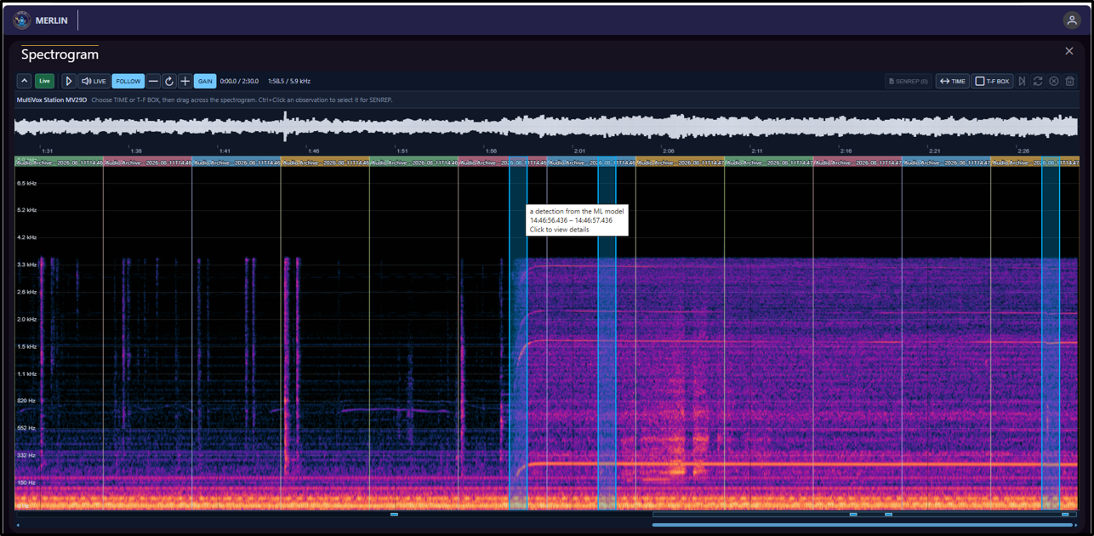
Figure 23. MERLIN Spectrogram with waveform and detection tooltip. Source: (U)_MERLIN_Demo_AUG2026_AAR_v1_2.docx, original figure 10. This is adjacent typed-content evidence rather than a verified standalone resource card.
This is a monitoring and payload-inspection view rather than a complete one-resource details card. It should support research into an audio or waveform body, without being counted as proof that every audio Observation has a standalone renderer. A selected Observation could need a bounded waveform or spectrogram, playback where supported, and explicit relationships to derived detections. We must establish the source interval, units, processing and resource bindings before presenting those as facts. The full monitoring workspace is not necessarily the right body to embed unchanged in a card; the example helps us decide when a dedicated viewer should remain a separate destination.
Discussion question: What bounded signal content belongs in Details, and what task requires opening the dedicated waveform or spectrogram viewer?

6.19. What the internal examples establish
The archive makes the presentation direction more concrete. Broad Observation windows and actual image results belong to this project’s history; they need not be inferred from an unrelated product. A System photograph, an image Observation, a report, a polygon feature and a spectrogram also demonstrate different information roles. A shared outer resource contract can coexist with distinct bodies, but the screenshots do not establish how to select those bodies, verify historical schemas or deliver their media.
The next evaluation should compare the floating image Observation with a descriptive System and the DGIF feature case, using verified current resource fixtures in a square or broad rectangular Dockview host. It should then add structured measurements, audio and a playable video Observation. The recovered material contains image viewers, spectrograms and video-product links; this pass did not verify a standalone video-result card. MFK reading details and MTK message or Equipment Properties screens remain leads described by the archive but not pictured. These are focused gaps for continued research, not substitutes for those missing examples.

7. Comparative examples and external precedents
These examples are intended to be read beside the earlier findings. We can examine the actual content area, ask what helps us understand the focal resource, and identify where a useful convention becomes the wrong product behavior. Universal presentation means a dependable resource identity and context with a body appropriate to the resource. It does not imply an identical grid, a mandatory media slot, or a promise to decode every advertised format. The figures reproduce source images at reduced scale; figure 28 is a selected frame from a published animation. They are not proposed MERLIN wireframes.

7.1. CKAN resource views for images video and tables
CKAN offers a particularly direct comparison because its resource page can contain several views of the same resource. The 2.12 documentation shows separate image, video, and DataTables views. View plugins determine suitability, generally from resource format or DataStore availability. The image view supports common image formats; the video view embeds a player and documents MP4, WebM, and OGG. DataTables requires data in the DataStore (CKAN n.d., “Overview,” “DataTables view,” “Image view,” and “Video view”).
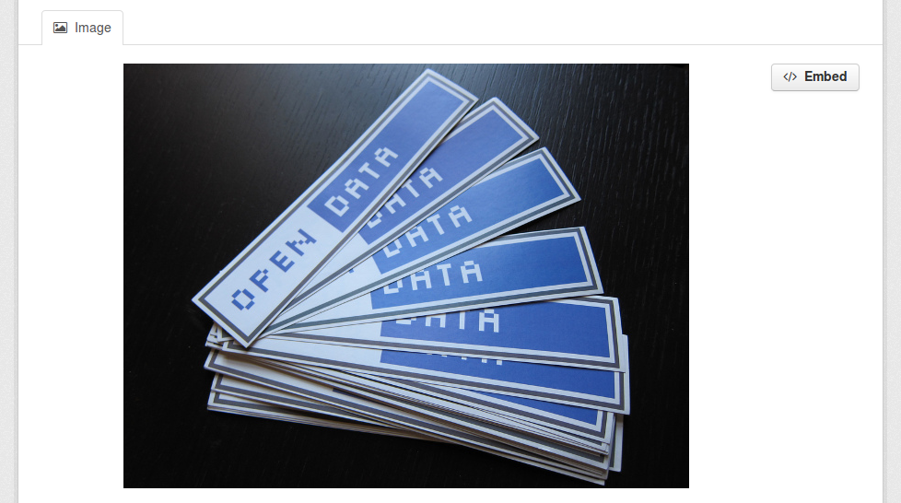
Figure 24. CKAN image resource view. Source: CKAN 2.12 documentation, “Image view,” _images/image_view.png. © Open Knowledge Foundation and contributors, CC BY-SA 3.0. Image reproduced unchanged apart from scale.
The useful design lesson is the amount of space given to the actual content. Figure 24 lets the reader see the image; it does not substitute its filename or MIME type for the image. Figure 25 similarly gives video a playable content region. For a MERLIN image Observation, this suggests an image beside or above its observation context, with exact identity and meaningful times retained. For a System or Procedure, the same overall surface could prioritize description and characteristics instead. These are proposed transfers, not capabilities demonstrated in MERLIN.
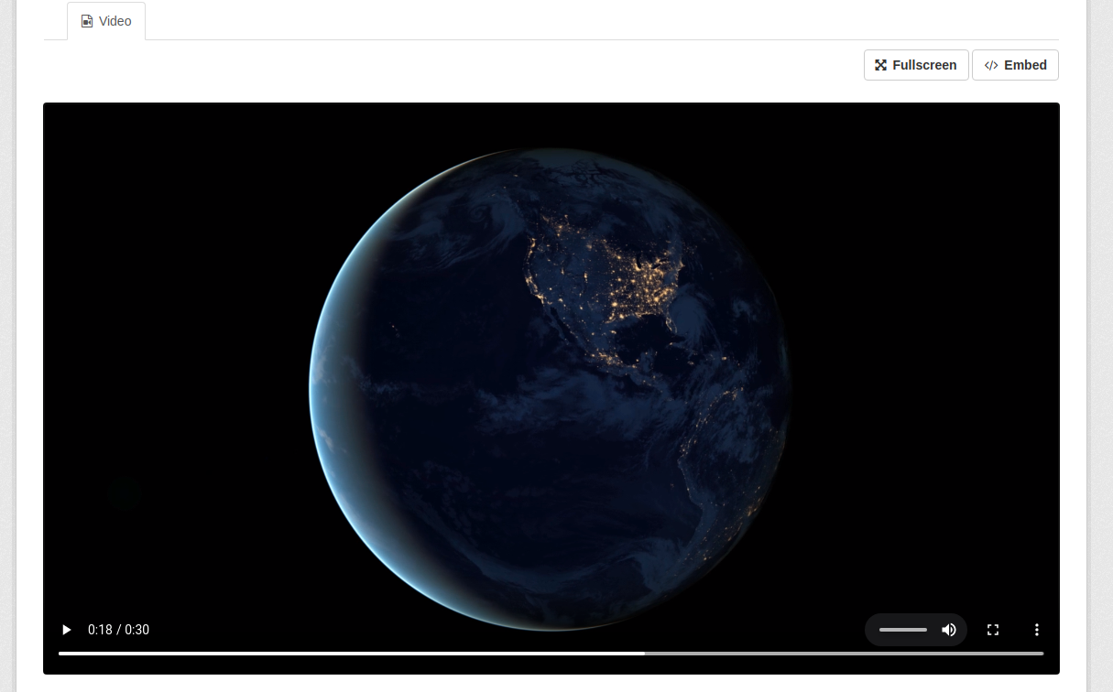
Figure 25. CKAN video resource view. Source: CKAN 2.12 documentation, “Video view,” _images/video_view.png. © Open Knowledge Foundation and contributors, CC BY-SA 3.0. Image reproduced unchanged apart from scale.
The limits matter. The documentation describes configured, supported views, not automatic understanding of any MIME type. A table of a dataset’s records also solves a different task from the details of one occurrence. We should borrow content-aware presentation while deciding independently which schemas and media MERLIN supports. Discussion question: when an Observation contains an image or clip, what context must remain visible while it is viewed, and what should happen when playback or interpretation fails?

7.2. ArcGIS Attachment Viewer puts media beside feature context
Esri’s October 2025 Attachment Viewer example places a selected feature’s attachment in a large region beside map and attribute context. The application handles associated images, videos, and PDFs. Its updated attachment-focused layout begins with a gallery; selecting a feature opens the attachment-centric interface. A filmstrip can expose other features while a selected feature remains open (McDonald 2025, “An updated interface”). Figure 26 shows the selected-feature state, rather than only the initial gallery.
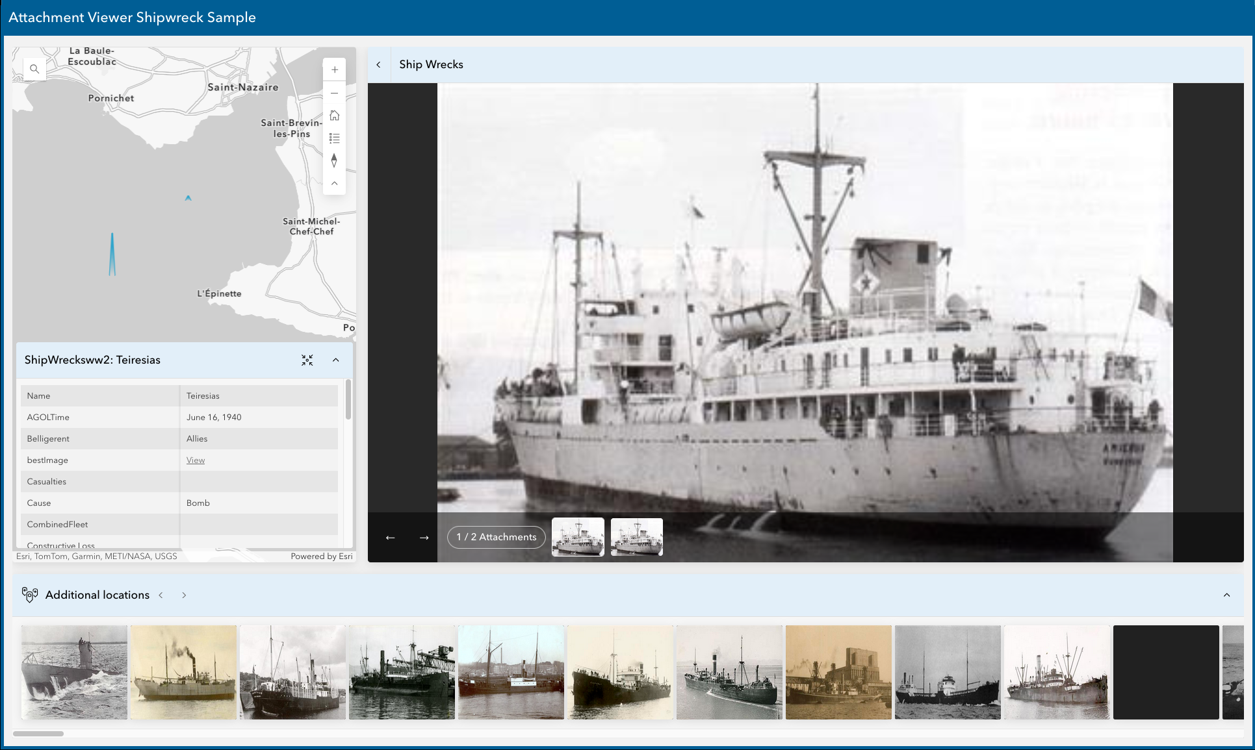
Figure 26. Selected feature in ArcGIS Attachment Viewer, attachment-focused layout. Source: Sarah McDonald, “Attachment Viewer: A New Attitude,” Esri, October 22, 2025; published AFfilm.png. © Esri.
This is a useful spatial precedent for the broad rectangle the standalone MERLIN view should occupy. Media and context can be simultaneously legible, with the content receiving most of the area. The screenshot also reveals two different kinds of movement: between attachments belonging to the selected feature, and between other features. That distinction would be critical in MERLIN. Changing the displayed asset should not silently change the focal Observation; opening a related resource should have an explicit consequence for resource identity and module state.
A feature attachment is not necessarily an Observation’s measured result. MERLIN must identify whether an image is the result, a thumbnail, a related attachment, or descriptive context before assigning it prominence. The map in this example is justified by the feature domain; it is not evidence that every MERLIN card needs a map or a parent-derived location. Discussion question: does this media-and-context balance work for our image and video cases, and which navigation controls would create confusion if copied into an independent Details module?

7.3. QGIS STAC assets distinguish previews from source content
The STAC API Browser plugin guide shows an asset dialog reached from a search result item. In figure 27, an RGB COG tile, metadata, a thumbnail, TileJSON, and a rendered preview are separate entries. The guide distinguishes adding an asset as a QGIS layer from downloading it, and documents layer loading for Cloud Optimized GeoTIFFs. Its last update is August 23, 2022; this is a historical plugin example, not an assertion about current QGIS core behavior (STAC Utilities 2022, “Adding and downloading item assets”).
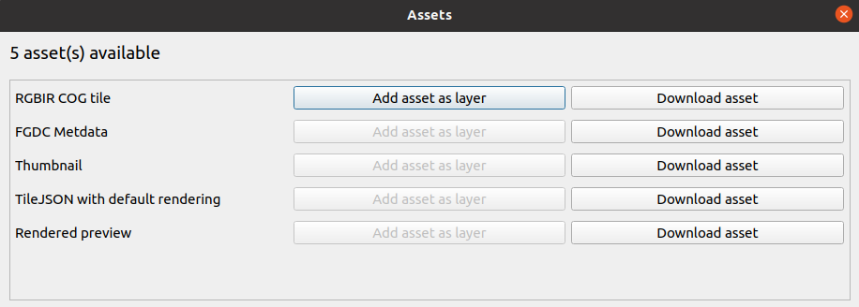
Figure 27. STAC item assets in the QGIS STAC API Browser plugin. Source: STAC Utilities, User Guide, updated August 23, 2022; images/assets_dialog.png. Published screenshot reproduced at reduced scale.
Its strongest contribution is semantic rather than visual polish: one catalog item can refer to several things with different purposes and display capabilities. For MERLIN, the analogous question is which representation belongs in the main content area and how the reader can tell whether it is a preview or the source result. A visually attractive thumbnail must not acquire the implied authority of the full data. Media type helps select a renderer, but role and schema can still be needed to decide what the asset means.
The dialog is also a useful counterexample. It exposes asset choice clearly but leaves the reader to open or download content elsewhere; that would under-serve an image Observation whose main task is inspection. MERLIN could keep explicit representation labels while showing the supported primary content directly. Discussion question: with several result links or representations, should Details choose one, offer a selector, or defer to a dedicated viewer—and how do we communicate the basis for that choice?

7.4. OpenUI5 object pages organize descriptive resource information
OpenUI5’s ObjectPageLayout tutorial supplies a contrasting case for resources whose principal content is descriptive. It structures a business object through a dynamic header, an optional anchor bar, sections, and subsections. The example defines header categories and price, general information, and suppliers. Figure 28 is a frame from the tutorial animation; its detail fields are layout placeholders rather than a fully populated resource record (OpenUI5 Project n.d., “Step 5”).
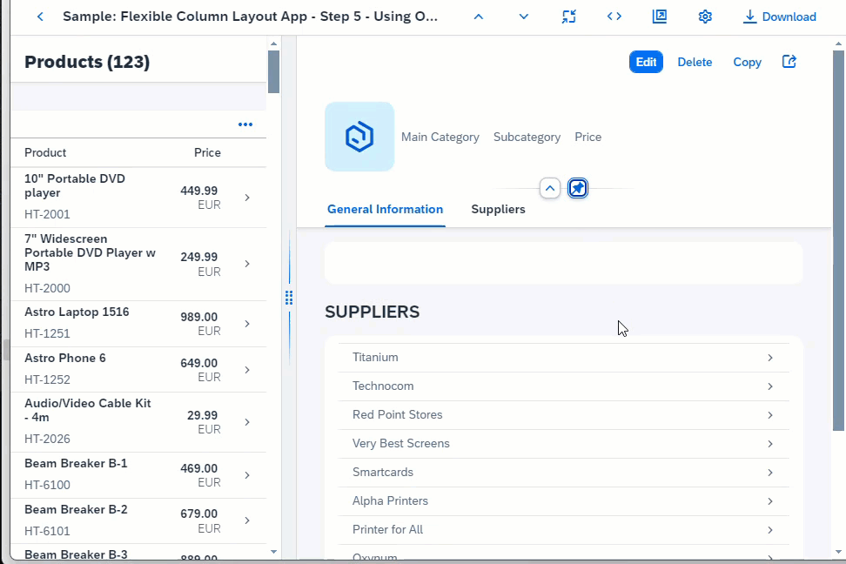
Figure 28. OpenUI5 ObjectPageLayout tutorial in a flexible column host. Source: OpenUI5 Project, “Step 5: Using Object Page Layout as a Detail Page,” frame 225 of its published preview animation. Screenshot includes placeholder detail fields.
The transferable idea is purposeful grouping for a descriptive object. A System could foreground its description, characteristics, and available streams rather than inherit an empty image frame from an Observation design. The same identity and action conventions can coexist with a different body. Header facts should be chosen because they orient the reader, and section labels should answer a meaningful question about that family. The tutorial does not establish which MERLIN fields belong in a header or how many will fit.
Its host is deliberately a list-and-detail arrangement, so the screenshot is not our target standalone geometry. The business-object actions illustrate possible work; MERLIN’s editing and command scope is now grounded in the product direction recorded in section 3.7. A dense business object page could become too long for a concise card if imported wholesale. Discussion question: which few facts let us recognize and understand a System immediately, and which sections deserve expansion only when the current task needs them?

7.5. Grafana panel inspection is a secondary technical layer
Grafana documents a panel inspector with Data, Stats, JSON, Query, and conditional Error tabs; availability varies with panel type. The Data view applies transformations but does not apply field overrides or value mappings by default. JSON can expose panel or data-frame representations (Grafana Labs n.d., “The panel inspect view”). This example is discussed from its documentation rather than presented as a captured interface.
The useful transfer is the separation between the presented content and the representations needed to examine it. MERLIN could make a raw payload and its schema inspectable without asking the reader to use them as the main image, video, or semantic result view. The distinction between transformed data and final formatting also warns against an ambiguous “Raw” label: a user should know whether a display reflects original source content or a mapped representation.
A panel inspector is a secondary diagnostic task. It supplies little justification for making every resource’s primary Details view resemble a technical sidebar. Discussion question: what would a reader need to verify about the displayed result, and can that verification be reached without displacing the ordinary resource presentation?

7.6. Connected Systems examples test the Observation assumption
The Connected Systems standard provides a source-level comparison that product screenshots cannot settle. Its Observation examples include a numeric result, a structured position result, and an image carried through result@link. Its schema example distinguishes the Observation format application/json from a linked result’s image/png media type (OGC 2025b, secs. 16.1.4–16.1.5). Thus the outer JSON representation alone cannot determine the appropriate content presentation.
For MERLIN, a scalar result suggests a prominent value with a verified property and unit. A structured result suggests readable components, with their meanings established by the applicable schema. A supported image result suggests an actual image viewer with observation context. Video is an important evaluation fixture from the product intent and the media precedents above; this paragraph does not claim the cited standard specimen contains a video example. These are candidate presentations, not a new interpretation of the standard’s requirements.
The central test is whether one broad Details surface can accommodate these bodies while keeping identity, phenomenon time, result time, and interpretation limits coherent. A verified DataStream schema may supply needed meaning; a current schema must not be presumed to describe an older occurrence. An unavailable image is a content-delivery state, not proof that the Observation is absent. Discussion question: when binding, decoding, or media delivery is unresolved, which direct facts and recovery actions let us inspect the resource without implying a successful interpretation?

7.7. What card display contributes to this experience
Published card guidance provides a defensible kernel for the card-display idea. Laubheimer (2016) describes a bounded container that groups related pieces of information and accommodates heterogeneous content. He also distinguishes the common summary component from an older full-page card model. This helps explain why merely placing a sensor field list inside a border would deliver only part of the desired resource experience.
MERLIN's selected-resource view needs the grouping and recognizable identity associated with the business-card metaphor, together with enough depth to use the resource. A discovery card often opens another details destination, whereas this Dockview module is already that destination. Its image or video result should therefore be usable within the supported view, and a descriptive resource should have room for its explanation. The metaphor suggests a coherent resource home; it does not impose physical business-card dimensions, tiny text, a fixed maximum field count or a whole-card navigation target.
The card component, a collection laid out as cards and the selected-resource Details view consequently answer different questions. Laubheimer warns that variable card arrangements can impede scanning and comparison, which matters when considering collections rather than one focal card. The accepted Discovery table remains the entry point, and the present research concerns the resource opened from it. The cases that follow examine containment, structured content and extensibility separately so that a familiar card appearance does not stand in for validated usability.

7.8. Fluent and Material card anatomy and limits
Fluent 2 treats a card as information and actions about one object, but leaves its header, body and footer optional. Its published examples rearrange the image and identity regions, while its sizing guidance permits fixed, content-sized or container-sized dimensions. This makes the example useful for the requested broad rectangle: recognizable grouping does not require a narrow column or the same internal arrangement for every resource. The horizontal document example also shows how little content can legitimately occupy a card (Microsoft n.d.).
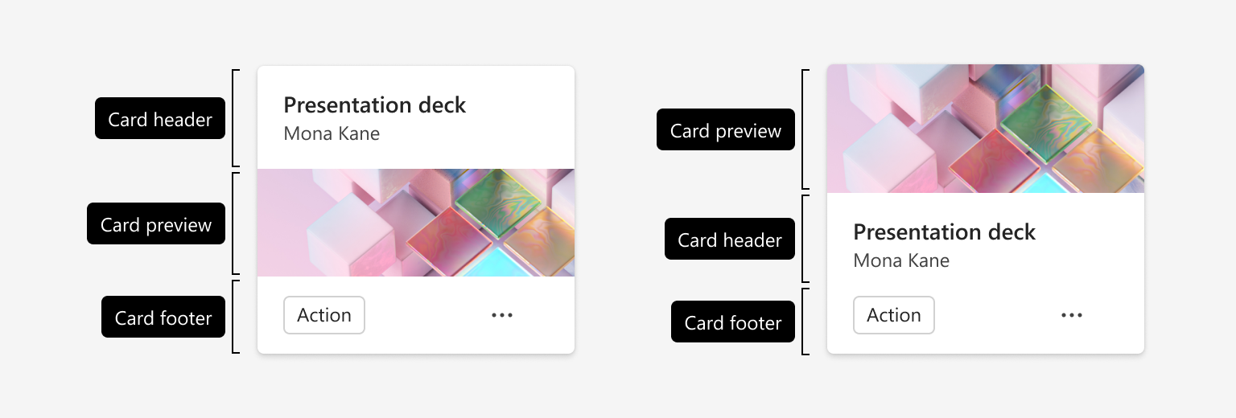
Figure 29. Microsoft’s published Fluent 2 anatomy variants rearrange image, header and action regions; these are preview examples. Source: Microsoft (n.d.). Published illustration reproduced at reduced scale.
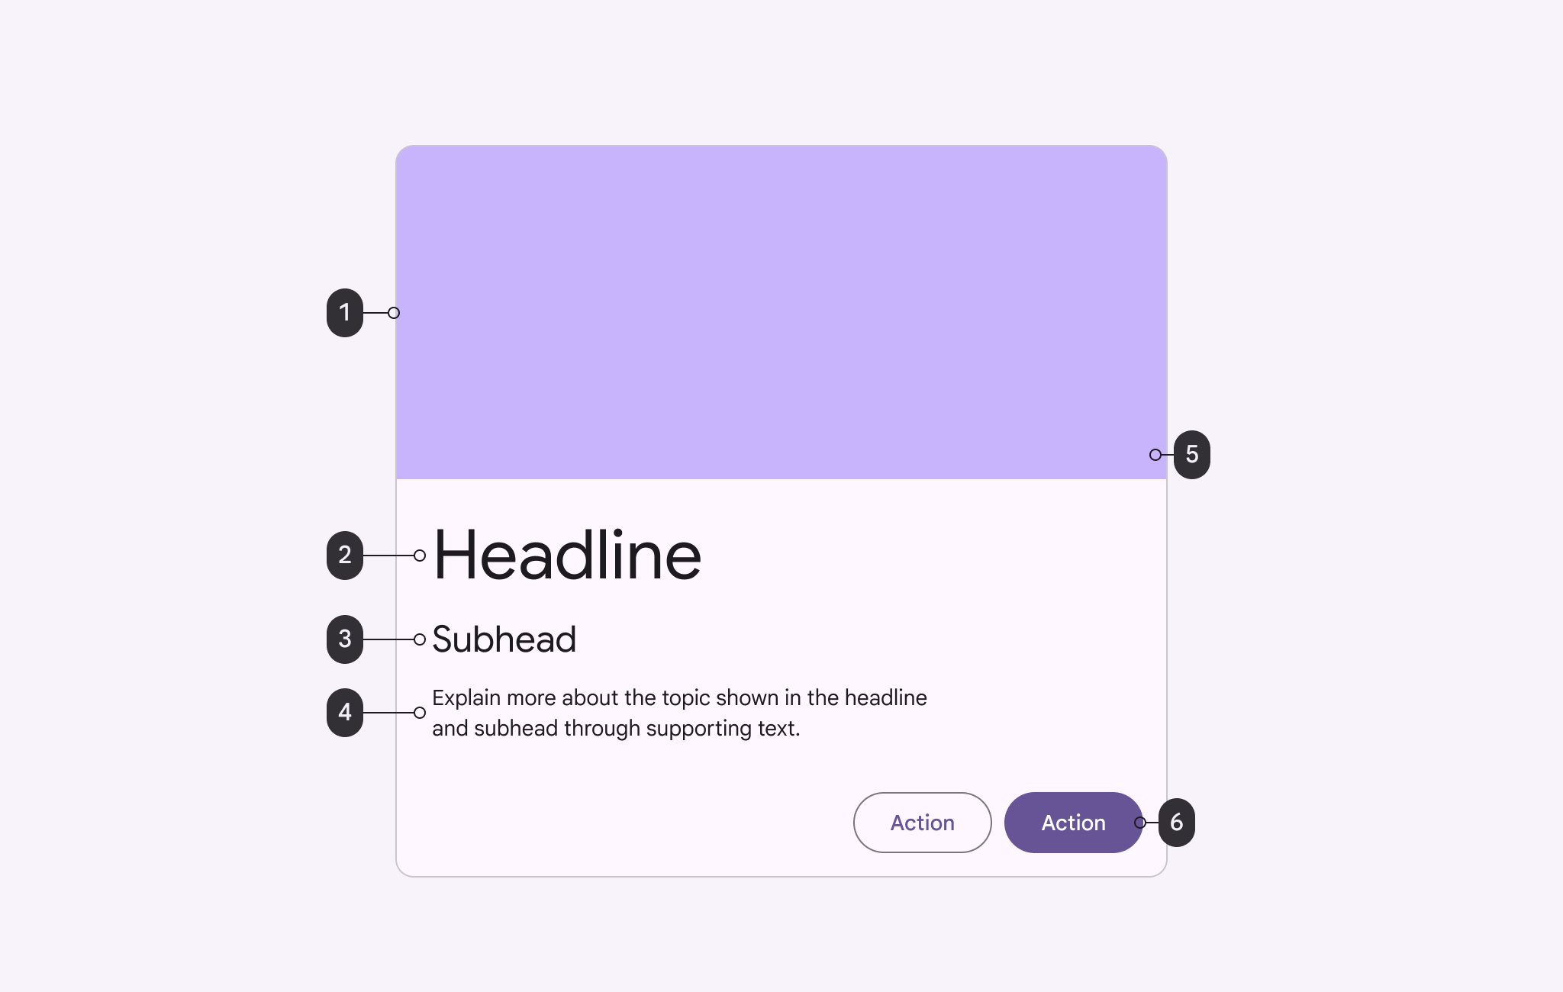
Figure 30. Google’s official Material anatomy illustration separates the subject’s image, heading, supporting text and actions. Source: Google (n.d.). Published illustration reproduced at reduced scale.
Material supplies a similar visual vocabulary: one subject, a headline, supporting information, an optional image and actions. The anatomy illustration makes these roles visible without prescribing a resource schema. Google’s current Compose guide also distinguishes a card from the structure of an entire screen and makes surface clicking optional. Thus, the border and hierarchy can help a selected resource feel like a coherent object, but they do not establish how much information belongs in its complete Details view (Google n.d.; Google 2026).
The limit matters. Fluent expressly aims at short previews that lead to an action or further information; Material usually places cards inside larger layouts. Neither example demonstrates a complete, schema-aware inspector. For MERLIN, the inference to evaluate is a stable identity and action frame around a body appropriate to the resource. We should test that frame with an image, a numeric observation and a structured object before treating the attractive preview anatomy as a sufficient Details design (Microsoft n.d.; Google 2026).
Discussion question: Which parts should remain recognizable across resources, and which should change when the body is a value, image or structured result?

7.9. SAP flexible card compositions
SAP’s current CardSystem is the closest visual example of a card family with varied interiors. Its demo places hotel imagery above, beside or within the information regions. Flexible horizontal composition is explicit, and the same guide illustrates a body containing a progress indicator, table, key–value information and description without any image (SAP SE 2026).
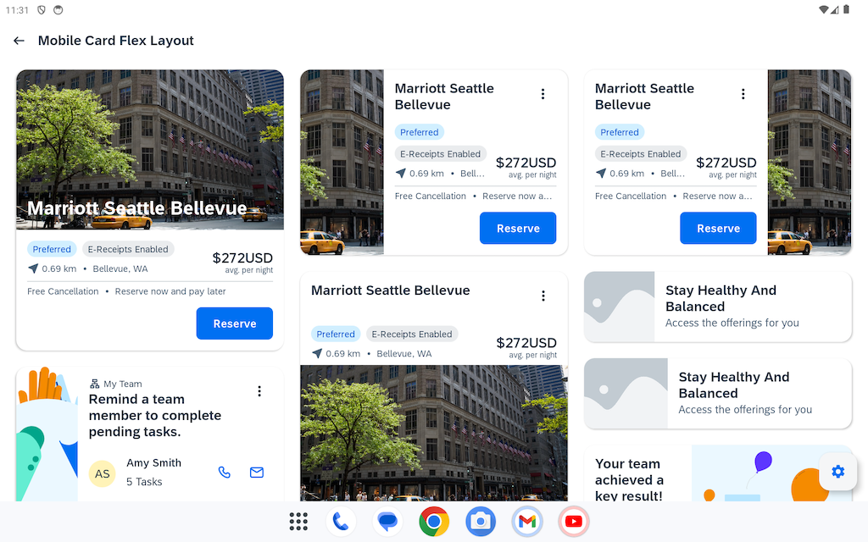
Figure 31. SAP’s published demo screenshot compares image placement within a collection of cards. Source: SAP SE (2026). Published illustration reproduced at reduced scale.
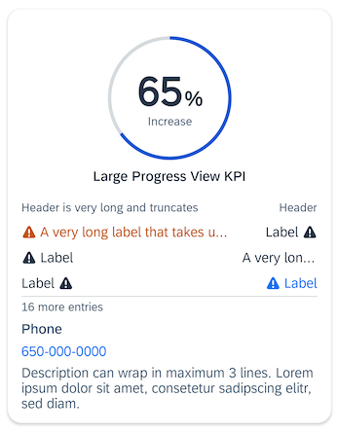
Figure 32. SAP’s body-only card combines progress, table, key–value and description content. Source: SAP SE (2026). Published illustration reproduced at reduced scale.
The useful inference is that a common outer frame can accommodate different evidence: media can dominate when informative, while values or structured content can occupy the body directly. The body-only example also exposes a problem to evaluate: several labels truncate. An inspection surface needs a way to reveal meaningful content rather than inherit preview-sized ellipses (SAP SE 2026).
SAP still defines these cards as previews leading to fuller details, and its built-in Media body element supports images only. The figures therefore support adaptable composition, not video playback or automatic schema selection. For MERLIN, evaluate both media and nonmedia resources at the same broad size; retain essential identity and inspectability as the body changes (SAP SE 2026).
Discussion question: Can the same broad frame make both media and nonmedia results legible?

7.10. SAP UI5 Integration Cards and declared bodies
SAP’s Integration Card defines a common container, header and content area. The official analytical illustration repeats a bounded card language while varying the numeric summary and chart. The host sets dimensions and handles declared actions. The useful precedent is therefore a stable envelope with a body suited to its declared content family; a broad rectangle is compatible with the model. The pictured chart is an anatomy example, not a complete resource details screen or a reason to make every resource a KPI (SAP SE n.d.a).
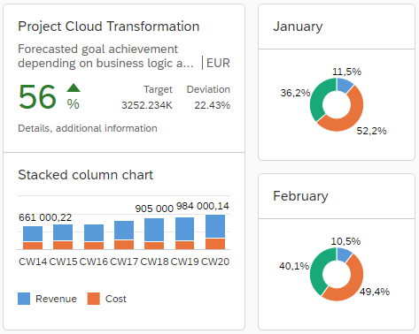
Figure 33. SAP’s official Integration Card illustration shows a stable card boundary and header with a typed analytical body. This is an anatomy precedent, not an example of complete resource details. (SAP SE n.d.a).
The manifest names a card type and gives the content a structure for that type, with Object, Analytical, List, Table, Timeline, Calendar and other families available. Object Cards organize information into groups and can include image items as well as text, status and numeric information. Image items have their own sizing, fit, position, alternative text and fallback-image properties. Data can be supplied separately as static JSON, requested from an endpoint or provided through an extension. For MERLIN, this supports a useful distinction: a shared resource envelope can coexist with authored presentations for an image, a sensor description or a structured observation. The application still has to decide which family and fields fit the resource; a JSON response alone does not choose the presentation (SAP SE n.d.b, n.d.c, n.d.d).
The boundary matters. SAP distinguishes manifest-driven Integration Cards from freely composed sap.f.Card, and documents host differences: not every card type works in mobile native environments; some analytical and timeline controls depend on SAPUI5 rather than OpenUI5. Object Card properties are versioned, with specific features unavailable in mobile native cards (SAP SE n.d.a, n.d.c). For MERLIN, the conceptual fit is dependable content families inside a recognizable card, with custom content where necessary. This does not establish support for every MIME type, scientific schema or complete application workflow. Adoption would require a separate compatibility assessment.
Discussion question: Which resource families deserve an authored card body, and what dependable fallback should appear when no specialized family applies?

7.11. Adaptive Cards media and host capabilities
The official desktop examples are useful precisely because they are broad rectangles. The hero example places a title, subtitle, short description and actions beside a substantial image; the media example keeps recognizable identification and facts while substituting an audio player. This is a closer visual precedent for the proposed resource business card than a narrow inspector. The transferable idea is an identifiable card whose body changes with the evidence the resource actually offers: an image should have room to be seen, and a playable recording should offer playback. These are published design examples in Microsoft’s Teams guidance, which is now explicitly labelled legacy; they demonstrate a composition, not proof that every current host implements every element (Microsoft 2026).
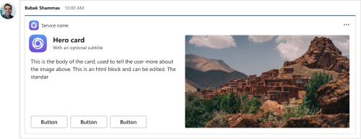
Figure 34. Official desktop hero-card example: a wide rectangular card pairs identification, text and actions with a large image. Published in Microsoft’s now-legacy Teams design guidance. (Microsoft 2026).
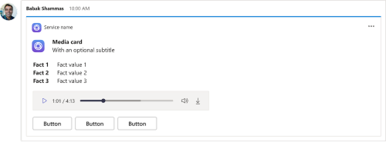
Figure 35. Official desktop media-card example: facts and an audio player occupy the card body while identification and actions retain a familiar structure. (Microsoft 2026).
The Media specification makes the presentation decision explicit. It declares media-source URLs and their MIME types, an optional poster and alternative text; caption sources are a later, versioned addition. The Product Video sample separates the data object from the card template and puts a Media element before descriptive text and an action. A useful inference for MERLIN is that media belongs within the resource’s main content area rather than being reduced to a filename. Yet the AdaptiveCard schema describes UI elements and actions. It does not infer that an observation is an image, understand a SWE result schema, or decide which scientific fields are meaningful. Those decisions still require resource semantics and a mapping from payload to presentation (Microsoft 2025a, 2025b, 2025c).
The host remains consequential. HostConfig controls typography, spacing, image sizes, actions and whether media plays inline or externally. The top-level card declares a required schema version and can supply fallback text; individual elements can declare required features and substitute fallback content when those requirements are unmet. For a Dockview resource card, the relevant lesson is to preserve identity, a meaningful summary and a route to the content when a preferred renderer cannot run. A card definition is therefore a negotiated presentation contract, not a guarantee that an arbitrary file, codec or schema will render. These mechanisms are worth evaluating as design precedents without committing the application to Adaptive Cards (Microsoft 2021, 2025a, 2025b).
Discussion question: Which parts of the resource identity must stay recognizable when the body changes from a photograph to a recording, structured measurement or document?

7.12. Open MCT imagery and telemetry views
NASA’s guide presents two selected objects in the same application frame. ORNT_OFS_X occupies the broad central area as a time plot; NavCamStereo_left_image_url occupies it as a large monochrome image with a dated thumbnail sequence. Both retain a title, navigation context and a secondary inspector showing the object type and original location. The imagery section adds camera direction, rover attitude and freshness context. The visible tree places these examples under VIPER_SIMULATOR; these are illustrated simulator resources, not evidence of images from an operational lunar mission (Hacskaylo and Truong 2021, pp. 26, 37–38).
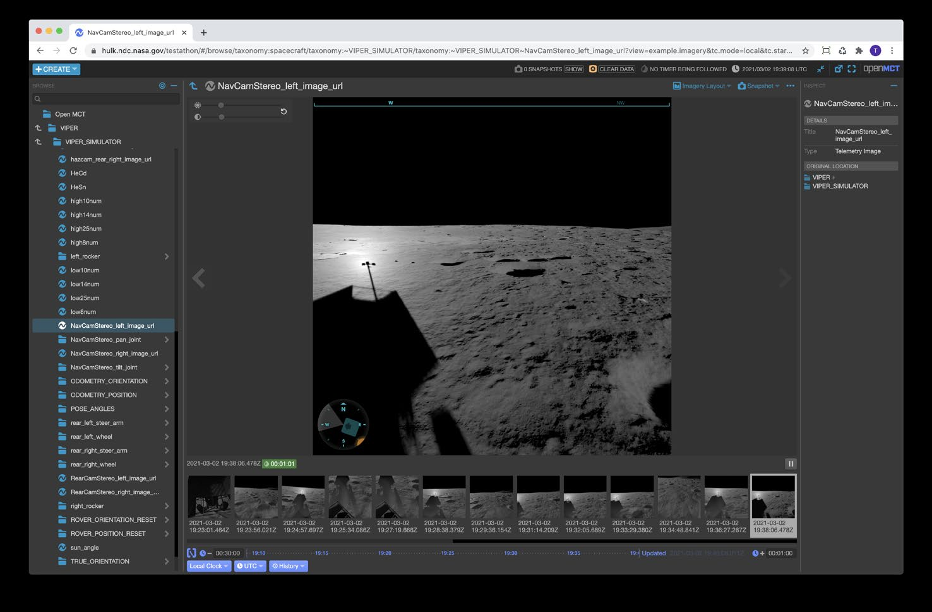
Figure 36. Open MCT imagery under VIPER_SIMULATOR, with selected-object identity and a dated thumbnail sequence. Source: Hacskaylo and Truong (2021), p. 37. Original embedded screenshot. Lossless PNG conversion for embedding.
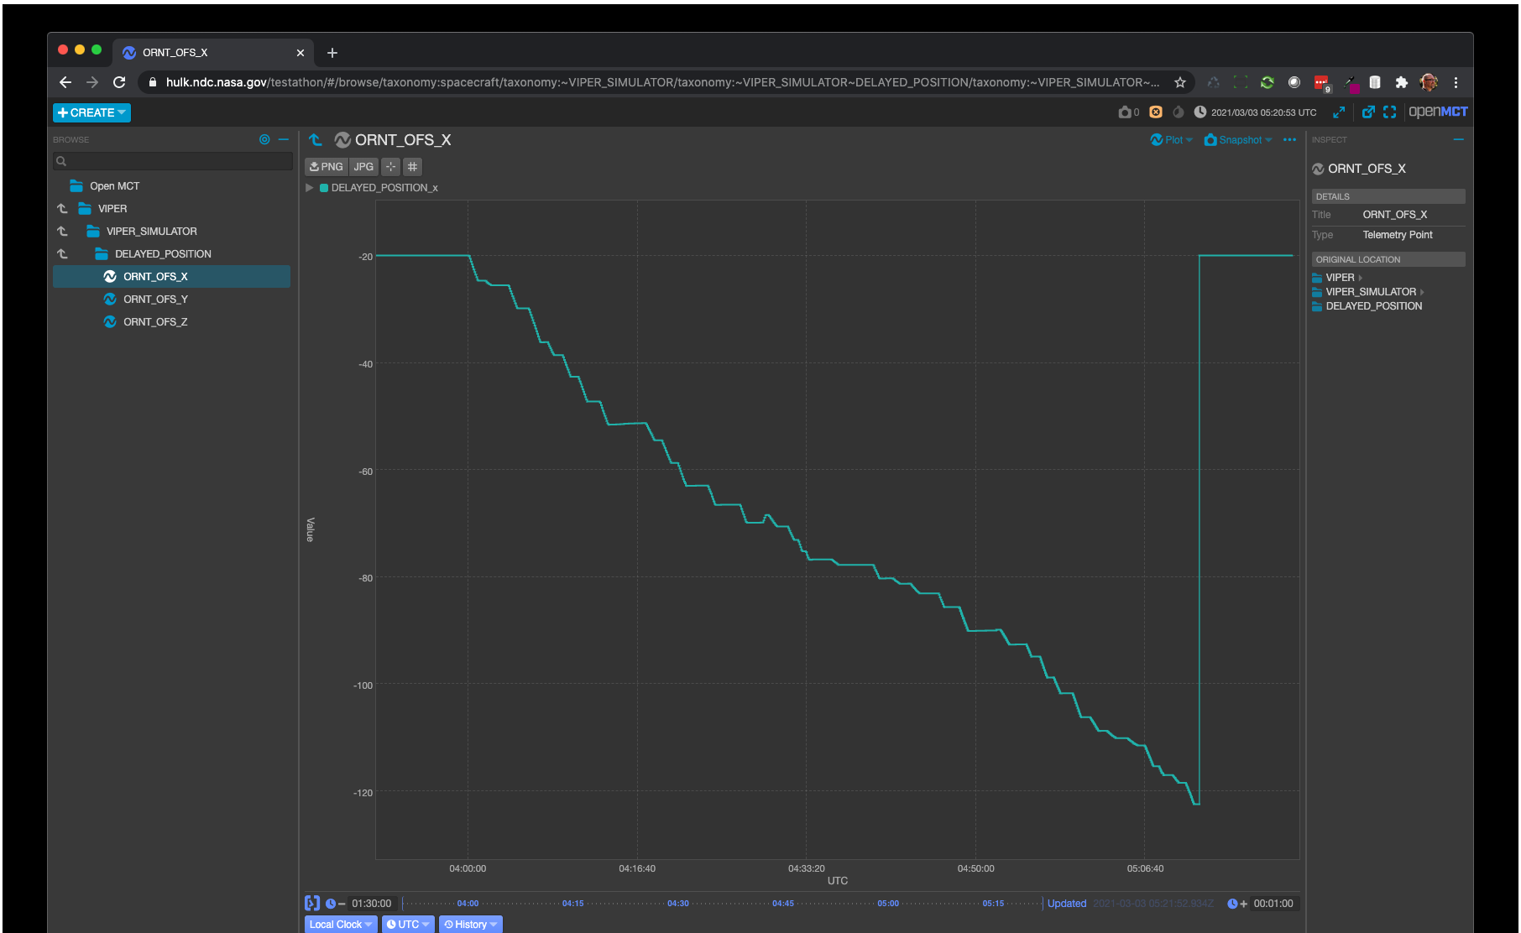
Figure 37. Open MCT telemetry plot for ORNT_OFS_X, type Telemetry Point. Source: Hacskaylo and Truong (2021), p. 26, upper screenshot. Original embedded screenshot.
This offers a useful precedent for a universal resource view: a familiar host can give most of its space to the representation that makes the selected object understandable. The supporting API documentation makes the distinction more explicit. It describes typed domain objects and telemetry value hints, including domain and range hints for plots and an image hint for a value interpreted as an image URL. The implication for MERLIN is to use resource meaning and declared content capabilities when selecting a body, then keep the resource’s identity legible around that body. A generic JSON object or image MIME type alone would not supply all this context (NASA n.d.).
The limit is architectural and geometric. These figures document Open MCT release 1.6.0 in 2021, rather than proving its current layout. They show a large operations workspace with a separate inspector, rather than the standalone MERLIN card itself. The transferable part is the relationship between stable identity, a substantial content body and domain-specific context; adopting the whole mission-control frame would introduce more controls and navigation than the proposed Details card needs (Hacskaylo and Truong 2021).
Discussion question: When the same resource has both useful imagery and telemetry, should its Details card choose one primary body and offer an alternate view, or show a compact companion representation beside it?

7.13. OMERO scientific image dimensions and display state
The official OMERO.iviewer walkthrough shows a selected microscopy image named VRAQ_03.r3d_D3D.dv. The image dominates the viewer, while a Z-position control, calibrated scale bar and channel rendering settings make the displayed plane interpretable. A companion figure compares two views of one image with different channels enabled. This is stronger than an ordinary image preview: the body exposes dimensions and display choices that matter to the resource’s interpretation, while the filename keeps the selected image identifiable (Open Microscopy Environment n.d.b).
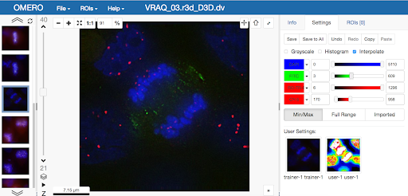
Figure 38. OMERO.iviewer with selected image VRAQ_03.r3d_D3D.dv, channel controls and calibrated scale. Source: Open Microscopy Environment (n.d.b), step 4. Original guide screenshot.
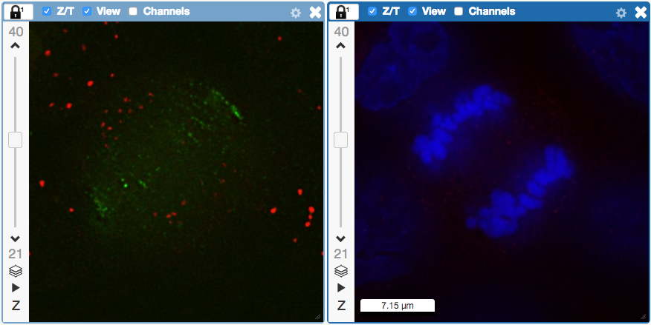
Figure 39. Two renderings of the same image with different channels enabled. Source: Open Microscopy Environment (n.d.b), step 15. Original guide screenshot.
The OME product documentation explains the scientific information behind those controls: image dimensions, pixel sizes and acquisition and import dates are available in the Info tab, and pixel-size metadata supports scale bars that change with zoom. That distinction matters for MERLIN. Recognizing an image MIME type can justify showing pixels, but scientific metadata may also be needed to choose a plane, describe a channel or establish physical scale. The proposed Details view could preserve one recognizable frame while allowing a scientific-image body to carry a small set of meaningful controls. This is a design inference from the example, rather than evidence that MERLIN already possesses these capabilities (Open Microscopy Environment n.d.a).
The full analysis viewer has a broader scope than a resource card. Changing the display does not alter source intensities, while saving a projection creates a new image (Open Microscopy Environment n.d.b). The proposed card should therefore disclose its rendering state and distinguish a displayed view from a derived resource. Channel editing, comparison and ROI workflows need their own scope assessment, and the pictured filename alone does not establish a biological subject.
Discussion question: Which scientific-image controls are essential to understanding the resource in its Details card, and which should open a dedicated analysis view?

7.14. What the comparisons establish and leave open
The cases give us a concrete direction to examine: stable identity and context around resource-appropriate primary content, with secondary inspection available. They also expose different layers that should not collapse together: focal resource family, payload schema, encoding, media type, representation role, and available renderer. This is a synthesis of the comparisons. No cited example implements MERLIN’s entire resource model, and none validates a universal business-card layout for our users.
The project archive in section 6 supplies concrete MERLIN and precursor examples, and the following supplied side-project case adds audio-oriented controls and category-based editing. The next evaluation should use verified current fixtures: a descriptive System, an image or video Observation with known schemas, and an unfamiliar structured resource. Remaining uncertainties concern actual media interaction, multiband or georeferenced imagery, large nested records, and unavailable or unsupported content. These are targeted fixture and contract questions for the bounded review, rather than a reason to repeat the broad research pass. The comparisons do not adopt a component architecture, promote the draft semantic guide, or settle acceptance criteria.

7.15. Supplied System Integrator evidence
The supplied screenshots show a developer side project that Sam describes as a purist interpretation of OGC Connected Systems. Its useful contribution is the organization of a resource editor into information categories, with a persistent resource title and Save Changes/Cancel controls. Identity distinguishes inherited Procedure keywords from system-specific additions; structured identifiers and classifiers have their own category; and capabilities and characteristics are grouped separately (slides 7–14). These divisions can inform the content model and editing context. Sam expressly rejects the oversized, decorative styling and thoughtless tag placement as the desired MERLIN experience. The technical client-resolution explanation under Procedure & Config also needs translation into useful resource context. Its presence does not demonstrate device command submission, device-applied configuration, scheduling or successful persistence (Bolling 2026, supplemental screenshots).
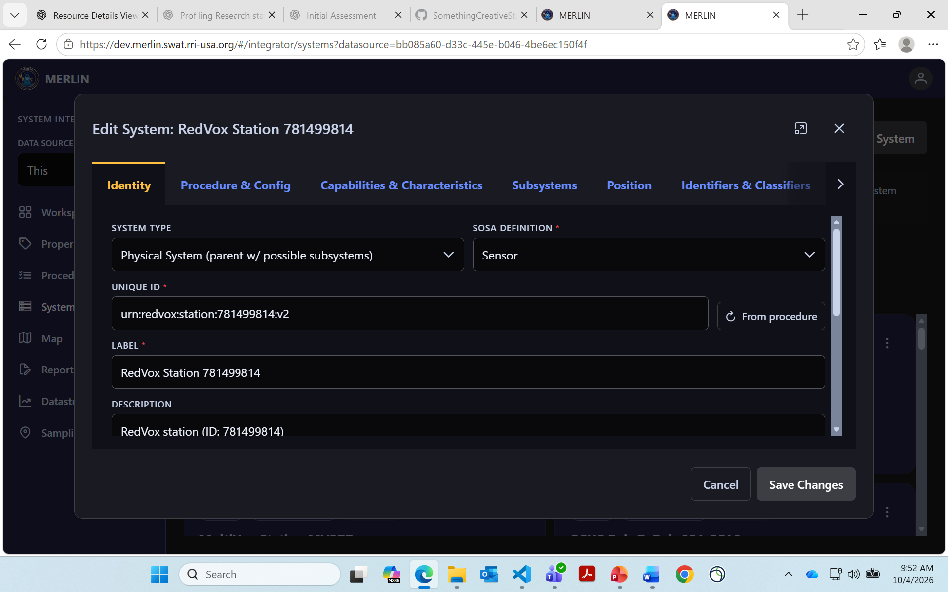
Figure 40. System identity editor with information categories and explicit edit controls. Source: Bolling (2026), supplemental System Integrator screenshots, slide 7. Original supplied screenshot.
Inherited and additional values are a particularly useful distinction to retain. The capabilities screen labels Procedure-derived groups separately from System additions, while the identity screen marks inherited keywords (slides 8 and 12–13). Expansion and override behavior are described by helper text but are not demonstrated. The same screens expose the size problem: the editor occupies approximately 1620 × 862 screenshot pixels, with its title region, tab row and footer taking roughly 45 percent of its height. Long category names still compete for space, and empty groups receive large explanatory blocks. Browser zoom, operating-system scaling and device pixel ratio are unknown, so these measurements diagnose visual allocation rather than establish CSS specifications. Visible modal and background scrollbars identify a scrolling design question; screenshots alone do not establish faulty scroll interaction (Bolling 2026, supplemental screenshots, slides 8–14).
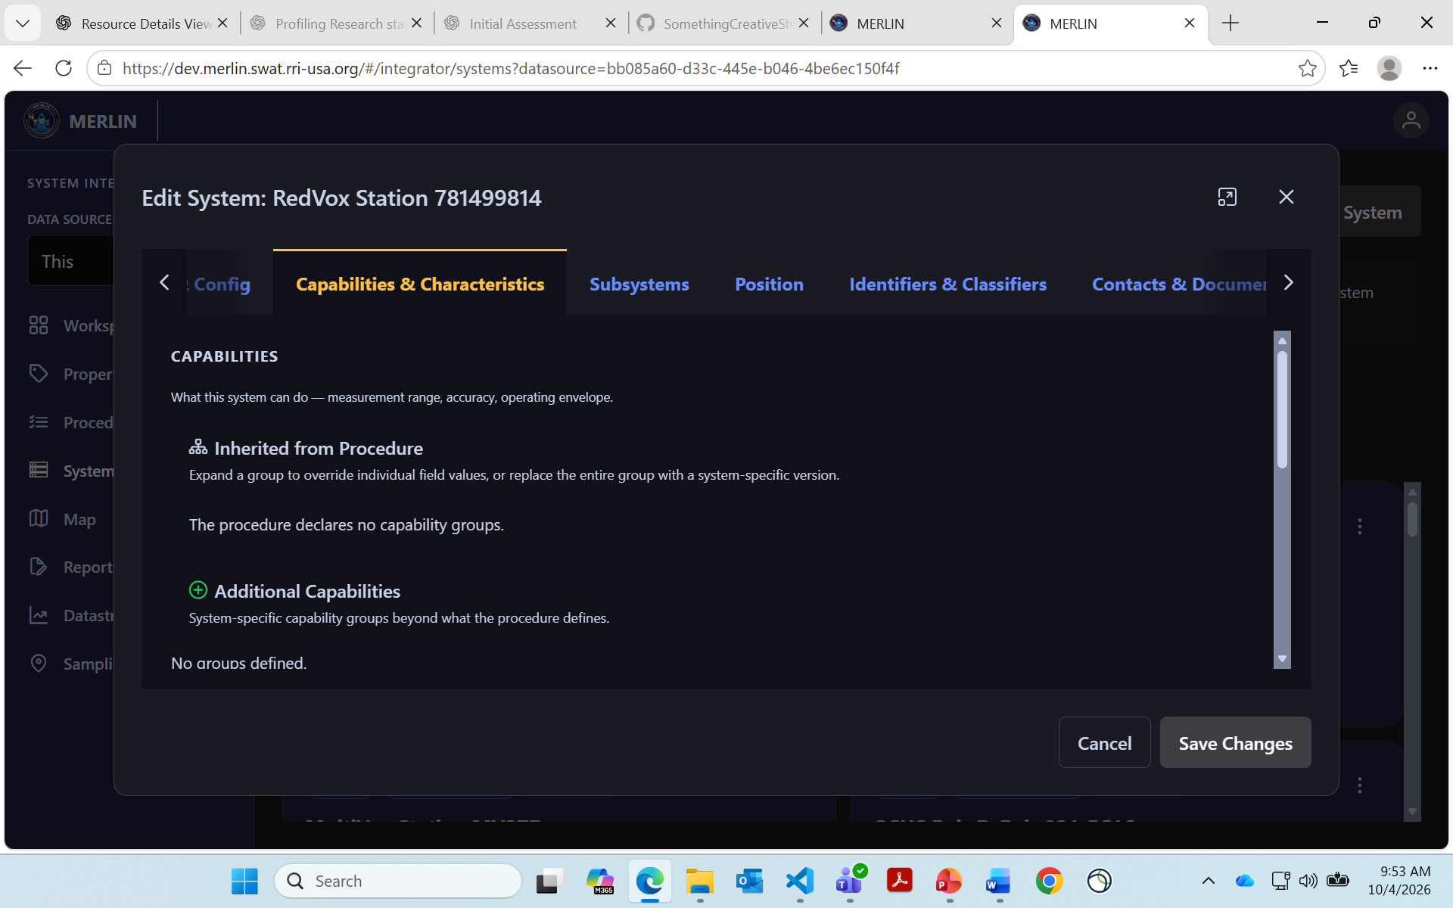
Figure 41. Inherited capability and characteristic groups within the large editor. Source: Bolling (2026), supplemental System Integrator screenshots, slide 12. Original supplied screenshot.
The collection views expose useful datastream provenance and sampling-feature relationships, but their grid layout is a collection-browser precedent rather than a default focal resource layout (slides 15–16). The selected-system map popup is closer to the intended resource-aware principle: audio receives load and download controls, sample rate and temperature retain units, battery combines a number and bar, and each result has a datastream and observation time (slide 21). Its content is clipped at the map viewport edges, while the adjacent Resource Feed is empty (slides 20–21). August 13 observation times in an October 4 capture also distinguish latest available data from current conditions. Audio playback and download success are not shown. No classification banner or portion-marking treatment is demonstrated, so the product requirement for markings remains an independent design obligation (Bolling 2026, supplemental screenshots).
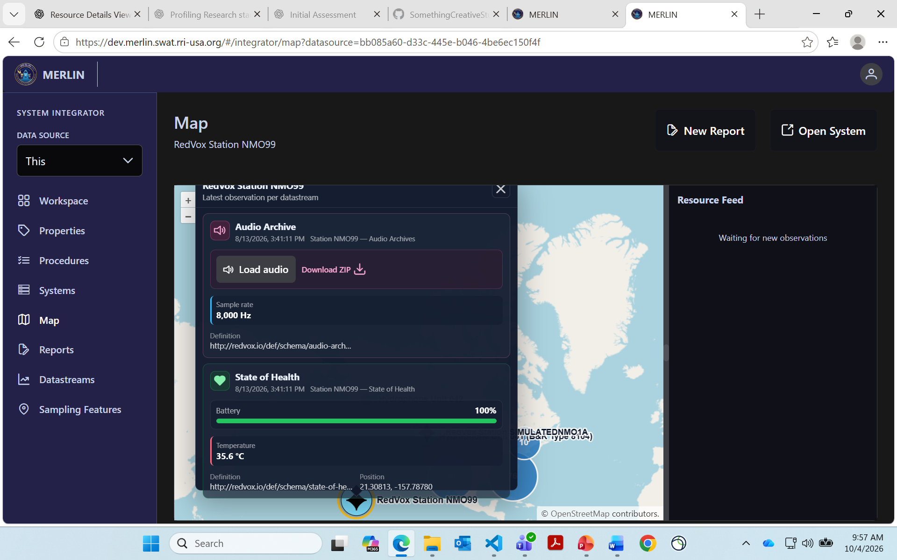
Figure 42. Selected-system popup with audio-oriented controls and structured observation results. Source: Bolling (2026), supplemental System Integrator screenshots, slide 21. Original supplied screenshot.

7.16. MASINT IT Next mission resource examples
The Product Owner identifies this demonstration as an operational MASINT counterpart to the CSAPI-centered Sensor Integrator. Its contribution is the subject-centered organization of mission work: a Requirement can expose Targets, Essential Elements of Information (EEIs), particular Target–EEI associations, contacts, attachments, Sensors and Products. The focal subject is more than an identifier beside technical properties. Its own viewpoint should help users understand and explore the relationships that make it useful. The common foundation remains compact and recognizable across resource families; the demo does not replace that foundation with its creation wizard, dashboard or narrow map host (Bolling 2026; MASINT IT Next Demo Screenshots 2021, slides 2–13, 20–23).
These examples are best read as evidence of content and task distinctions. A searchable result card summarizes a candidate; a focused editor changes a particular item; and a selected-resource body shows its details and surrounding context. Those roles should not be collapsed into one universal screen. Visible save and create feedback demonstrates displayed workflow states, while backend effects and security enforcement remain unverified. Literal “(U)” prefixes and portion-marking placeholders show marking intent without establishing a complete banner or trusted-label scheme. Existing security requirements therefore remain necessary across the transferred patterns.

7.16.1. Target creation and explicit information associations
Create Target provides Target Name, Type, Country, BE Number, Suffix and Group, with Create and Cancel, while the surrounding Requirement workflow retains target search and a selected-target roster (slide 8). No geometry or map is shown in this dialog. These are useful candidate properties for a source-defined Target profile, not required fields for every Feature. A compact contextual editor can expose supported values without expanding the entire card into a large authoring surface. Target creation and association with the focal Requirement are separate effects that a client must identify and confirm through its actual source contract.
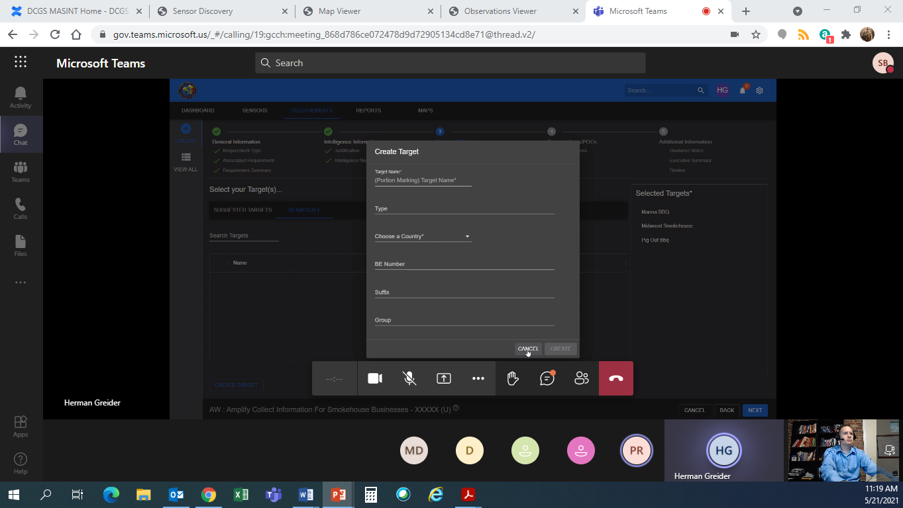
Figure 43. Focused Target creation within Requirement target selection. Source: MASINT IT Next Demo Screenshots (2021), slide 8. Original supplied screenshot.
Slide 10 supplies the crucial relationship distinction: particular EEIs are associated with each selected Target inside this Requirement. Separate lists of Targets and EEIs would lose which questions apply to which subject, and joining every selected Target to every selected EEI would invent relationships. Preserve the participants, owning Requirement and supplied association role or state, such as Considered For Collection. Suggested items, selected draft items and persisted associations also need distinct states. The useful transfer is the exact contextual association, independent of the wizard used to author it (MASINT IT Next Demo Screenshots 2021, slides 8–10).
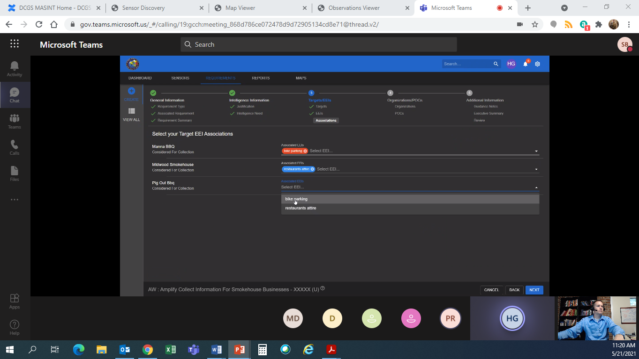
Figure 44. Target-specific EEI associations within the owning Requirement. Source: MASINT IT Next Demo Screenshots (2021), slide 10. Original supplied screenshot.

7.16.2. Contacts and supporting attachments
Edit Point of Contact groups name, email, phone/type and Organization with Save and Cancel (slide 11). The surrounding Requirement retains its identity and task context. This supports a focused editor for source-backed contact information, including the person or organization’s role relative to the focal subject. Changing that contact and attaching or detaching it from this Requirement are different operations. The common edit rules already supply staging, validation, permissions, draft protection and explicit commit; no additional universal contact service is implied.
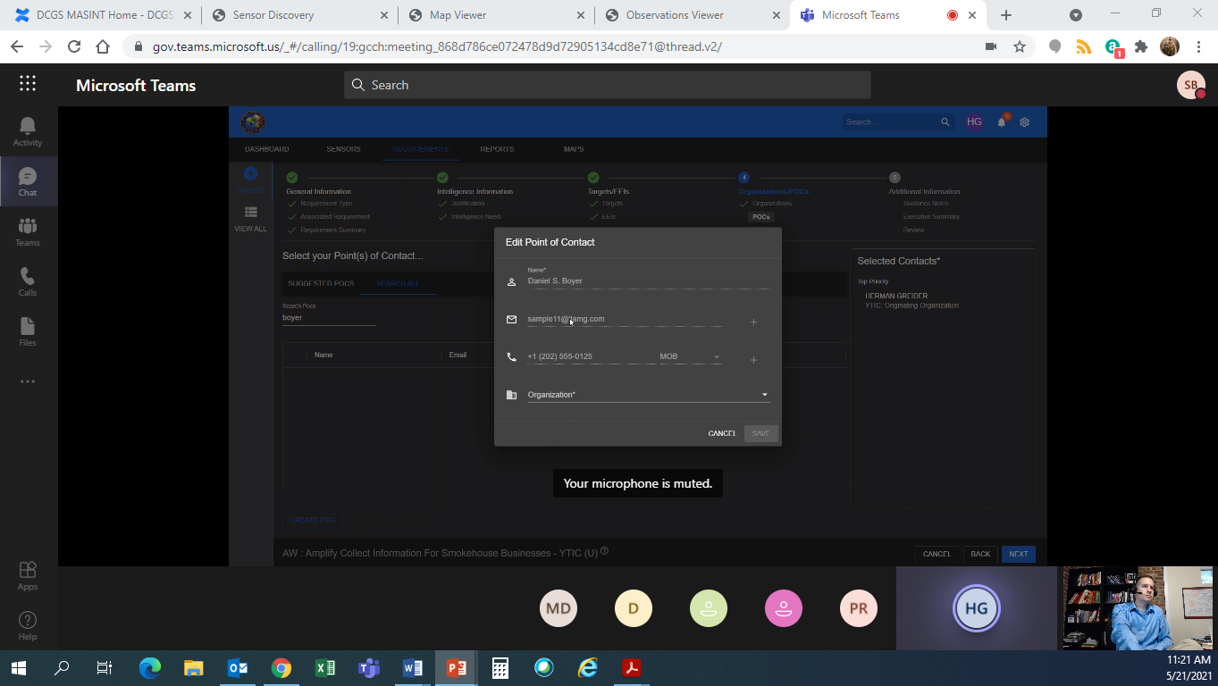
Figure 45. Point-of-contact editing with an explicit commit. Source: MASINT IT Next Demo Screenshots (2021), slide 11. Original supplied screenshot.
File Attachment supplies Description, Browse and Attach/Cancel while the Requirement body groups Targets, EEIs, Target–EEI Associations, Points of Contact, Attachments and Comments (slide 13). Section pencils and plus controls locate work near its subject. Supporting documents should retain their supplied identity, description, format and source, with useful permitted preview or access; an attachment is not automatically an Observation result or instrument photograph. Source-backed comments can preserve author, time and scope when available. The screenshot demonstrates these affordances without proving upload success, a collaboration API or permission enforcement (MASINT IT Next Demo Screenshots 2021, slides 11–13).
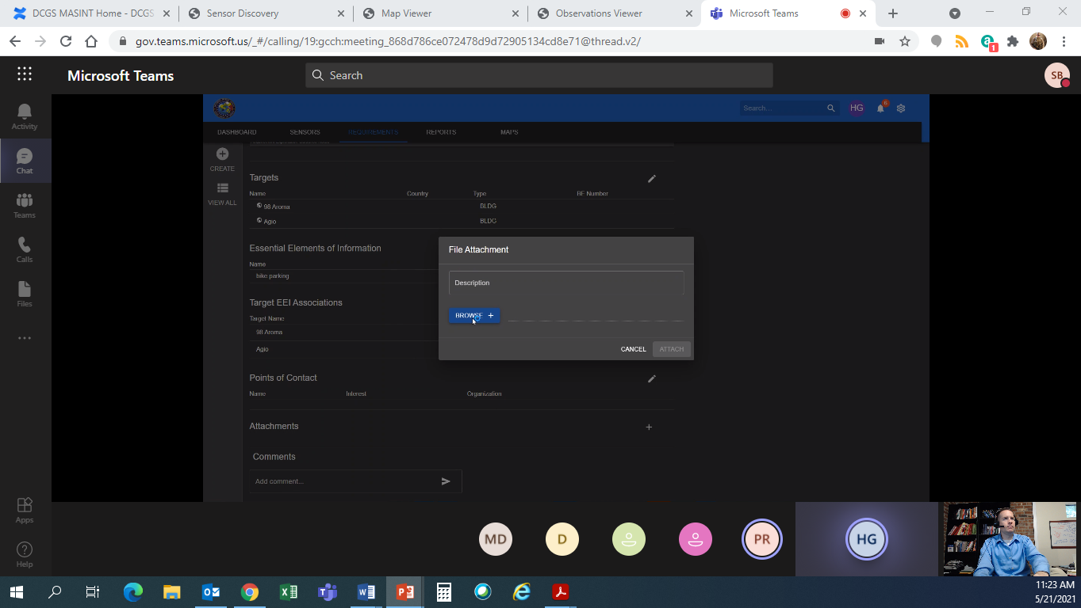
Figure 46. Attachment action within the focal Requirement’s supporting information. Source: MASINT IT Next Demo Screenshots (2021), slide 13. Original supplied screenshot.

7.16.3. Search cards and access to the selected subject
The Product results show an article title, source/publication context, abstract, tags, disclosure and Go to Product (slide 17). Slide 18 displays an external DOAJ article record. These examples support a useful summary and an exact route to the content; they do not establish a full embedded Product viewer or a common Product/Report schema. A selected Product can inherit the shared identity, markings, source inspection and media-aware content rules once its source meaning is known. Tags are supplied presentation evidence, not a mandate to generate new tags for every resource.
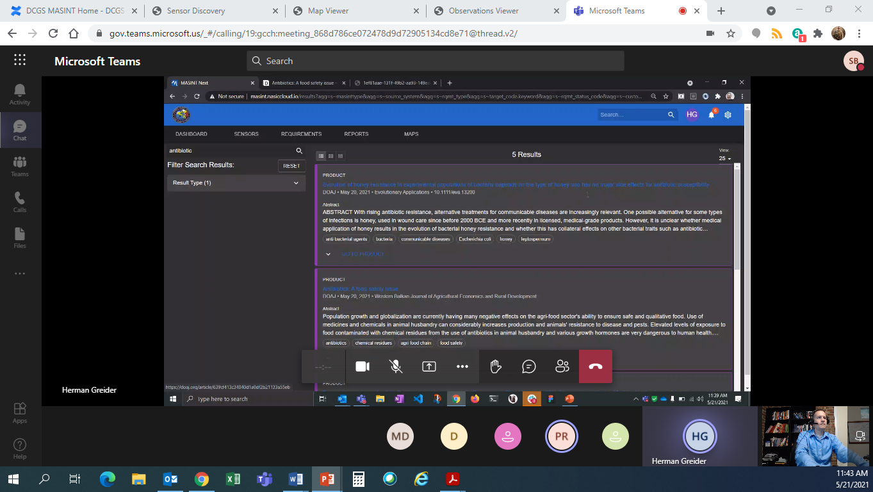
Figure 47. Product discovery summaries with an explicit content access action. Source: MASINT IT Next Demo Screenshots (2021), slide 17. Original supplied screenshot.
The mixed Requirement and Target collection uses different summaries within a recognizable result structure (slide 19). Target entries include a type/code and country context, plus qualified latitude, longitude, elevation and date where supplied. “BLDG • Aruba” is a displayed code/context pair, not a verified Source label. The lesson is resource-aware summary content and exact identity, followed by that subject’s own Details view. These collection cards do not determine the standalone card’s footprint or require its entire properties list in every search result (MASINT IT Next Demo Screenshots 2021, slides 17–19).
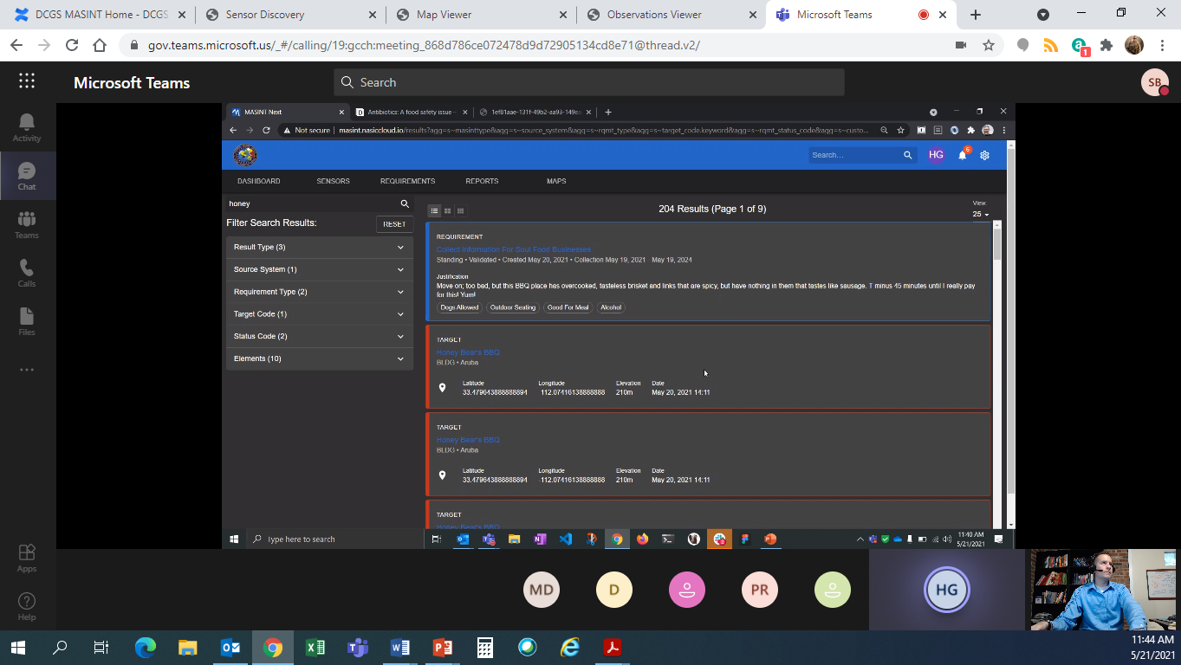
Figure 48. Mixed Requirement and Target summaries in a paged result collection. Source: MASINT IT Next Demo Screenshots (2021), slide 19. Original supplied screenshot.

7.16.4. Focal details with related spatial context
The RQMT-133 map sidebar groups Targets, Sensors and Products around the selected Requirement, with identities and qualified coordinates; Sensor entries also show status and next-collection context (slide 20). This is a strong association pattern for the universal view. Related entities should be grouped by meaningful role, with a route to their precise Details and useful spatial context. The Requirement is the map’s focal subject, but its related points do not thereby become its own location. Neither geographic proximity nor common display is sufficient evidence of a stored association.
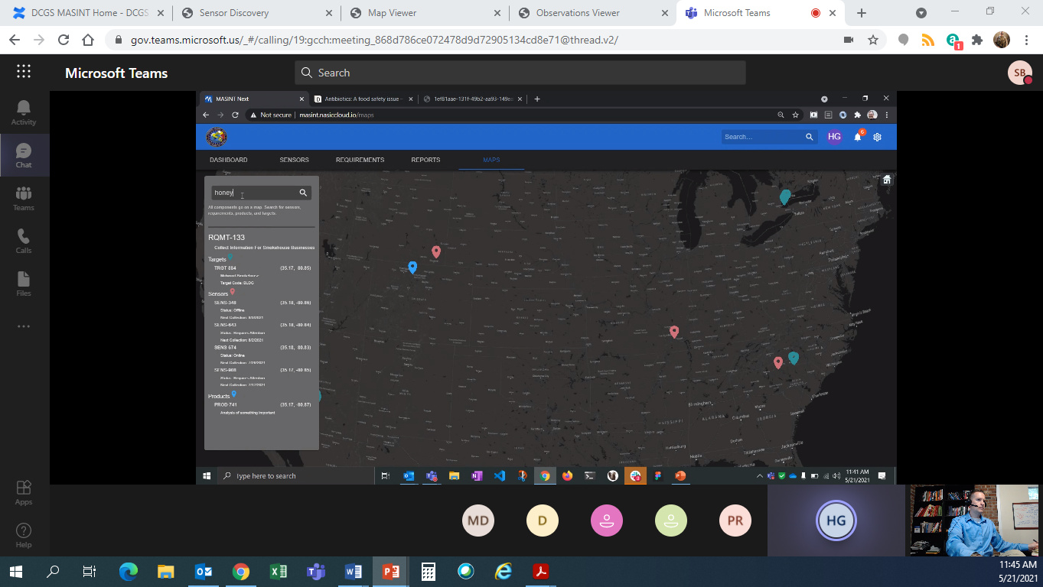
Figure 49. Selected Requirement with grouped related entities beside the map. Source: MASINT IT Next Demo Screenshots (2021), slide 20. Original supplied screenshot.
Slide 21 supplies a fuller focal Requirement body: date context, Status, Justification, Intelligence Need, Guidance Notes and Targets, with section-edit affordances. Its mission workflow state and collection interval should remain distinct from a device’s CommandStatus or executed schedule. These content divisions can become applicable categories, sub-tabs or expandable sections within the compact common shell; they do not require reproducing the whole page. Slide 23 independently shows RQMT-141 with one Target, three Sensors and two Products, reinforcing the grouping across another subject. No command execution is shown (MASINT IT Next Demo Screenshots 2021, slides 20–21, 23).
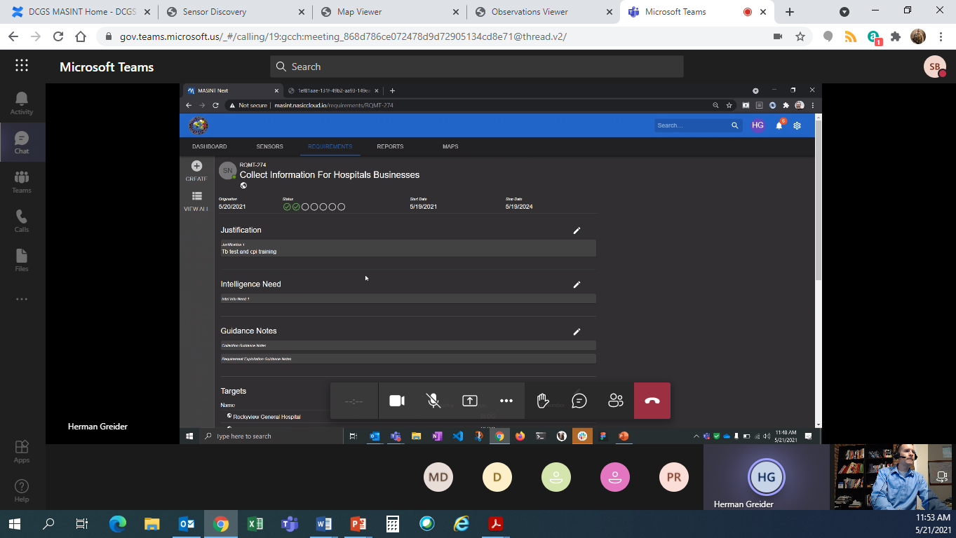
Figure 50. Requirement body with mission context and section-level editing. Source: MASINT IT Next Demo Screenshots (2021), slide 21. Original supplied screenshot.

7.16.5. Selectable results within a scoped map
Slide 22 shows selectable Requirement summaries for the search “test,” with Requirement IDs, names, dates and a vertical result scrollbar beside the map. Selection needs to stay understandable in both the list and spatial view, while the selected subject remains identifiable. Slide 23 shows a different focal Requirement; the static captures do not verify a same-resource transition between those screens. The useful transfer is coordinated selection and declared query/entity scope, with a bounded list and access to fuller details. The narrow sidebar is a map-host composition, not the agreed standalone business-card geometry (MASINT IT Next Demo Screenshots 2021, slides 22–23).
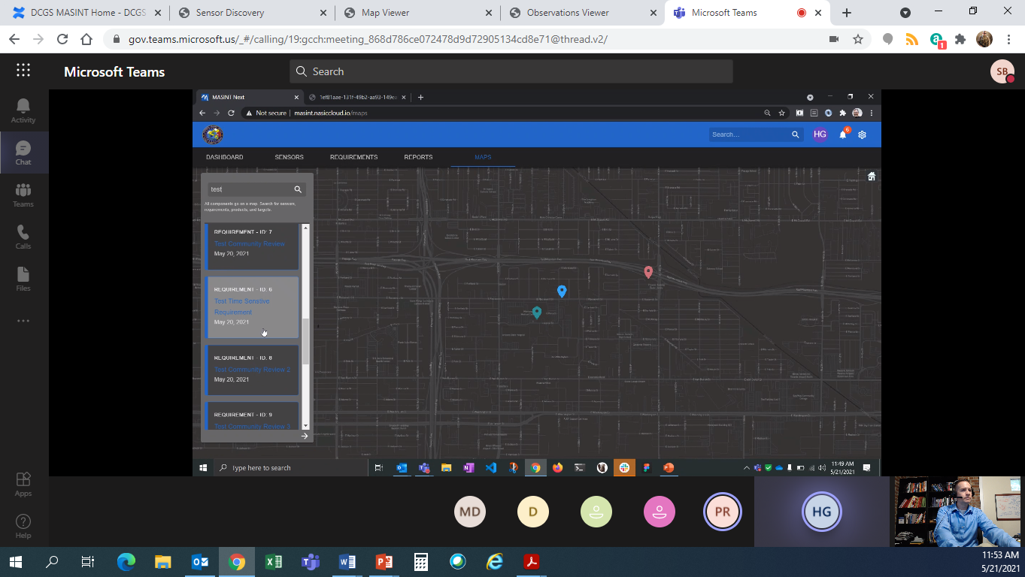
Figure 51. Selectable Requirement summaries beside a map. Source: MASINT IT Next Demo Screenshots (2021), slide 22. Original supplied screenshot.

7 17 Military symbology standards and MilSymbol
The latest MIL-STD-2525 entry in the authoritative ASSIST catalogue is Revision E with Change 1 incorporated, dated March 2, 2025. The APP-6 entry identifies active Revision E Amendment 2, promulgated October 16, 2025. A public reproduction of the NSO cover reads APP-06, Edition E, Version 2, October 2025. The catalogue wording and cover wording are recorded separately. They support identifying current profiles, but this pass does not establish identical symbol inventories or interchangeable codes. The table distinguishes current publication metadata from the renderer’s documented support (Defense Logistics Agency 2026a, 2026b; NATO Standardization Office 2025).
Profile or component | Verified basis | Consequence for Resource Details
MIL-STD-2525 | ASSIST: active Revision E, Change 1 incorporated; March 2, 2025; 749 pages; distribution A. | Record the exact edition/change in the configured symbol profile; verify required symbols and modifiers against that publication.
NATO APP-6 | ASSIST: active Revision E Amendment 2, October 16, 2025. Reproduced NSO cover: Edition E Version 2, October 2025. Full current publication content not verified in this pass. | Keep the NATO profile explicit. Confirm the governing publication and required coverage before promising equivalence or conversion.
MilSymbol | Pinned master package metadata: 3.0.5; latest published GitHub release at review: v3.0.4. README lists E-family and selected older schemes. | Pin a tested release/profile if adopted. Library version, input-code edition and standard family are separate facts.
MilSymbol is a credible renderer candidate for this category. Its MIT-licensed core accepts a Symbol Identification Code (SIDC) and options and produces SVG or Canvas output. The documented standard selector chooses 2525 or APP6; it is not an independent edition picker. The README says version 3 aims for E-era appearance even with older codes and normalizes some inconsistent illustrations. Consequently, supported input codes alone do not prove exact reproduction of every original edition. A bottom tab can select a verified profile, but MERLIN must retain its edition, source code and mapping policy. No library is adopted by this research (Beckman 2026).
The API also distinguishes the base icon size from the complete rendered bounds, which can grow with text and modifiers. The preview should fit the whole supported graphic and retain a readable explanation of its meaning, with deeper modifiers available through expansion. MilSymbol can update a local rendering object; persistence, authorization and report processing belong to MERLIN and its sources. Renderer-derived metadata or code diagnostics do not validate a resource schema or establish standards conformance. These limits favor a small adapter with verified mappings and a useful unmapped state, rather than a universal military symbol generated for every resource (Beckman 2026).

7 18 Supplied OmniSense operation evidence
This presentation provides a compact operational counterpart to the project archives and the two recently supplied demo decks. The handheld programmer exposes device actions and separate configuration subjects, then presents acquired imagery and device status in small working screens. It is relevant because the selected System supports inspection and operational work from a recognizable context. The demonstrated interface uses flat scrolling tabs and modal screens; the proposed Dockview card still requires the shared category hierarchy, optional sub-tabs and expansion established by the product direction. The source figures retain their original instructional annotations and historical markings (OmniSense System Operation n.d., pp. 15–18, 19–43).

7 18 1 Configuration subjects and operating windows
The Configure Imaging Sensor Unit screen separates Location, Mode, Comms, Transducers, Algorithms, Rules, Imagery, Sleep and FOV/PTZ subjects. Figure 52 shows per-camera type, activation time, resolution and image type together with the shared low-resolution-first option. The source distinguishes detected transducers from enabled algorithms. It also describes dependencies: Mode and Algorithms select Rules, only one camera can operate at a time, and Activity Detection disables camera reporting. Those dependencies make a configuration editor more than an independent list of editable values. A MERLIN proposal should expose the verified consequences of a staged change even when the affected value or capability belongs to another sub-tab (pp. 19–25, 44).
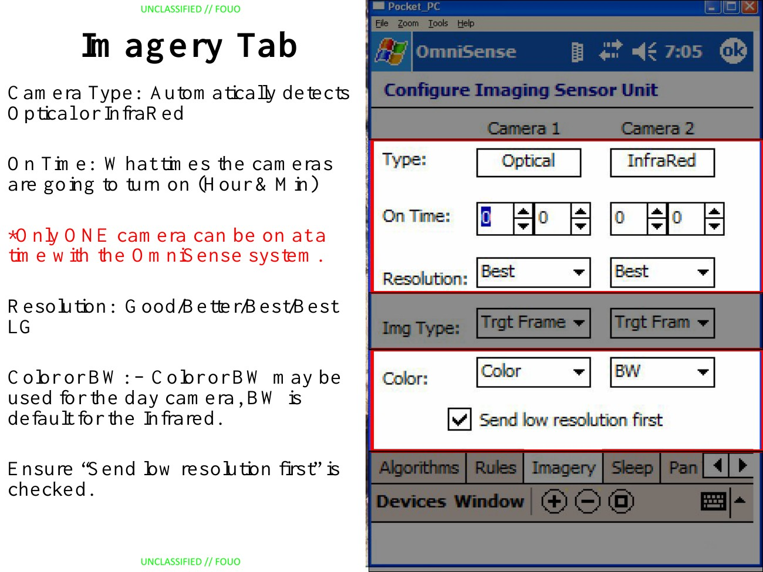
Figure 52. Imagery configuration with separate camera settings and a shared delivery option. Source: OmniSense System Operation (n.d.), PDF page 25. Original rendered source page.
The Sleep screen uses weekday, GMT start time and duration in hours and minutes, with Add and Delete controls (Figure 53). It is recurring device operating-window configuration, distinct from issuing a future collection command. The source-specific limit of fifteen schedules belongs to this device example rather than the universal view. Likewise, the instruction not to change the RUDICS Group is not a permission model, and visible PTZ fields do not establish available hardware: page 32 explicitly says that the PTZ camera is unavailable. Actual supported values, dependency rules, recurrence and authorization must come from the selected integration (pp. 21, 31–33).
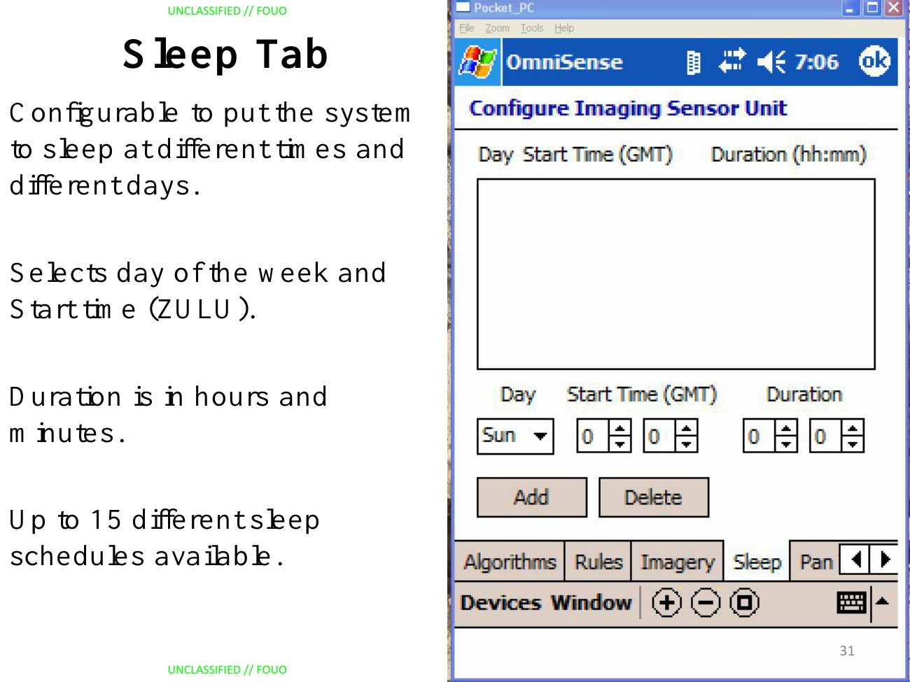
Figure 53. Recurring sleep configuration with weekday, GMT start time and duration. Source: OmniSense System Operation (n.d.), PDF page 31. Original rendered source page.

7 18 2 Camera requests and returned imagery
Command Image opens a focused request form with camera selection, resolution, a Color choice and explicit Cmd Image and Cancel actions (Figure 54). The following day-camera screen gives the image most of the body and retains a name, device number and image timestamp below it, together with Save and Close (Figure 55). The thermal sequence similarly selects Camera 2, requests an image and shows a returned preview; its instructions describe 1/X as a polarity control. These are useful precedents for a concise System action followed by content appropriate to the returned result. The static sequence does not demonstrate a command identifier, timeout handling or a verified Observation relationship, so the existing command/result correlation rules remain necessary (pp. 34–38).
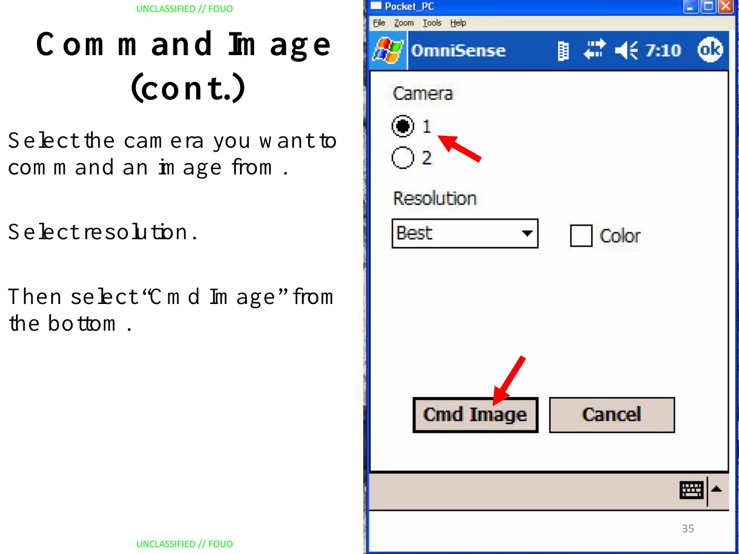
Figure 54. Camera and resolution choices with explicit image request and cancellation. Source: OmniSense System Operation (n.d.), PDF page 35. Original rendered source page.
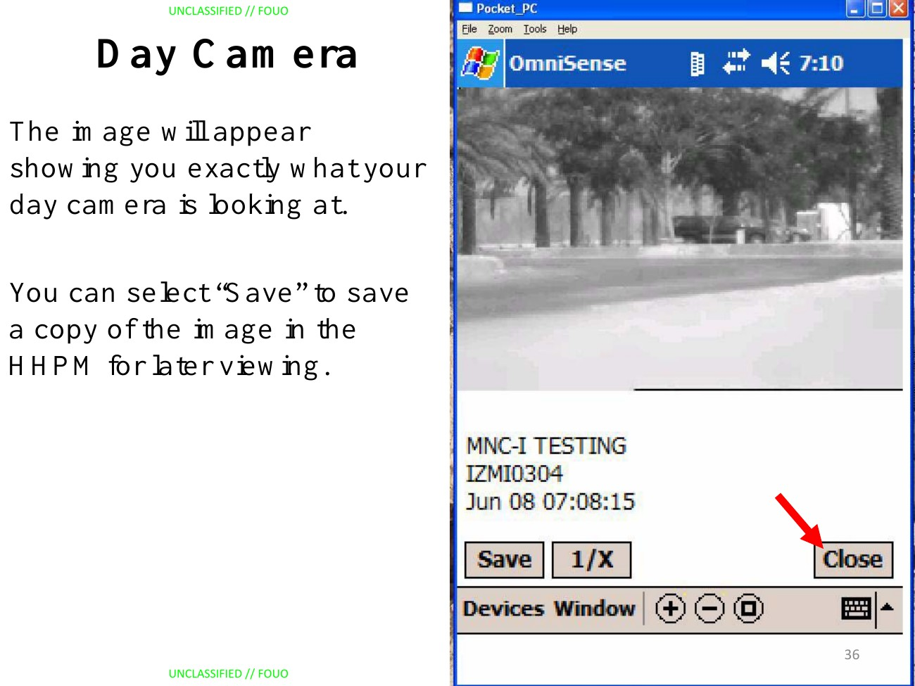
Figure 55. Day-camera preview with device identity, image timestamp and Save control. Source: OmniSense System Operation (n.d.), PDF page 36. Original rendered source page.
The imagery examples also clarify representation semantics. Target Track Clip is illustrated as a crop around the detected target; the three-clip example is an ordered before/during/after set of cropped still images. The word Clip therefore does not establish video playback. Full frames, target crops, related frame sequences and thermal display polarity deserve appropriate inspection while their acquisition context remains visible. A display polarity change does not constitute a new observation, and a low-resolution-first option does not prove the actual resolution of every returned image. The source supports these distinctions without establishing delivery encodings, MIME types, modern rendering support or a multi-image browser (pp. 25–30, 38).

7 18 3 Status evidence and command acknowledgement
Device Status presents the device name and a status timestamp, a Battery value identified by the instructor as voltage, separately labelled Analog, Digital and Mag readings, Mode, Report Interval, named BITE diagnostic results, transmission successes/attempts and On Time (Figure 56). Its SBD value is 2/2 and RUDICS is 0/0. Those counters should remain interpretable as reported evidence: 0/0 does not show a failed transmission, and a successful count does not establish continuous connectivity. The status timestamp is distinct from the handheld clock, while On Time is a duration. Units for the other numeric channels and freshness policy are not established by this screen (pp. 41–42).
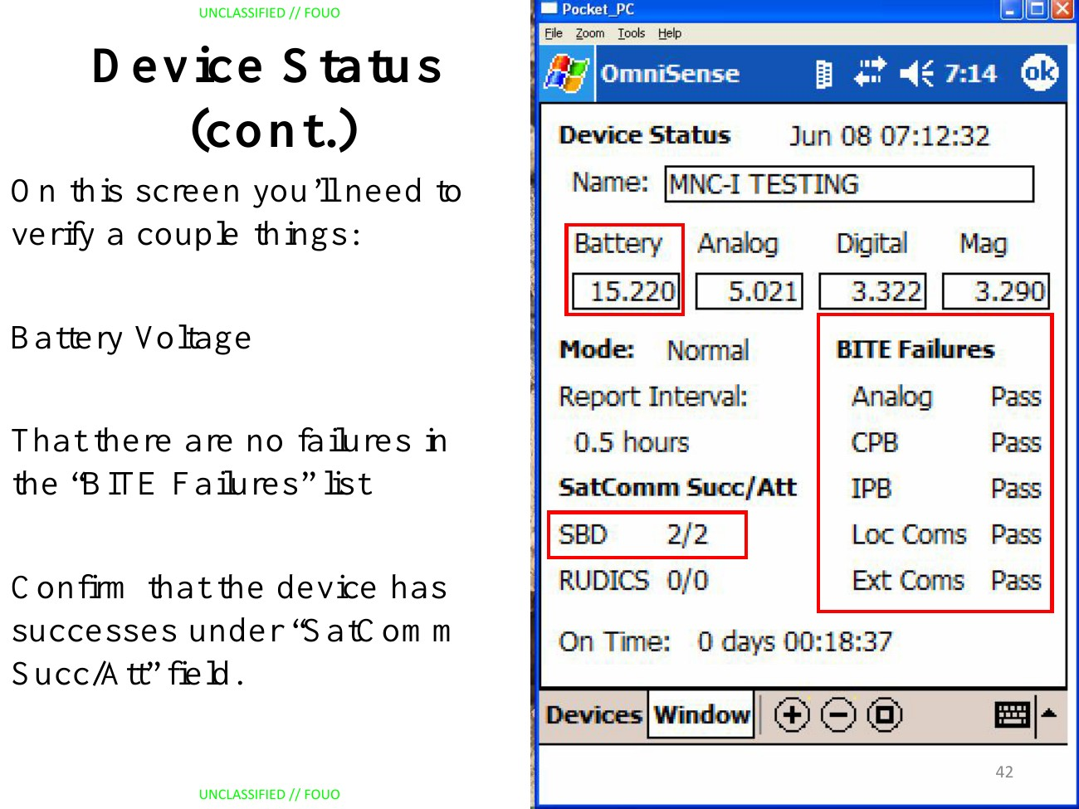
Figure 56. Device status with separate power readings, diagnostic results and transport counters. Source: OmniSense System Operation (n.d.), PDF page 42. Original rendered source page.
Begin Operation is followed by a message that the sensor received the command. The instructional objective separately requires successful SATCOM transmissions. This gives a concrete fixture for distinguishing a command receipt from evidence of subsequent operational behavior. A compact MERLIN status body could show the most useful current readings and supplied diagnostic summary, with individual checks and transport counters expandable; such ordering remains a proposal to evaluate. It must not invent an overall healthy state from selected Pass fields or treat a configuration value, command receipt or checked application GPS setting as proof of current device health or position (pp. 39–43, 48, 51).

7 19 TRSS Sentinel manual excerpts
The selected manual pages describe a resource working view in operational terms: inspect a device, maintain its supported information and configuration, and perform available work. Their greatest value is the combination of recurring subjects with explicit differences among devices. The screenshots also show why MERLIN must retain the meaning and target of a value or action instead of copying a field label. The original narrow, vertically scrolling windows are evidence of organization and functionality; the proposed compact square or broad rectangle and clarified two-level navigation remain the product direction (Sentinel 1.0.7.2 Software Users Manual 2014, supplied slides 1–9, 20–60).

7 19 1 Selection and conditional device details
The Master Details View follows the single device selected in the Tree or Map. A separately opened floating Details View retains its originally selected device as the user explores elsewhere. The manual explicitly states that the tabs and settings change for SDR-II, HHPM, RR, Imager-II, ETU-II, Scorpion, CAST or EUGS. Figure 57 gives a recognizable example of Sensor, Position and String groups with distinct Direct Configure, Remote Configure, Remote Commands and Save to Plan actions. These are useful precedents for stable resource identity, predictable groups and capability-dependent work. The visible two rows of tabs are a wrapped flat tab control, rather than evidence of the requested parent category and subordinate tab hierarchy (Sentinel 1.0.7.2 Software Users Manual 2014, supplied slides 1–7, Acrobat pp. 51–57).
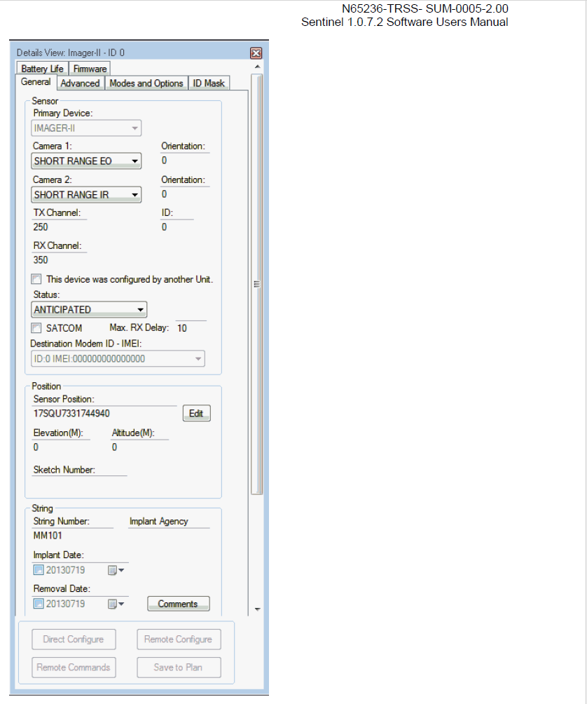
Figure 57. Imager-II details with recurring information groups and separate configuration and plan actions. Source: Sentinel 1.0.7.2 Software Users Manual (2014), supplied slide 4, Acrobat p. 54; printed folio not visible. Original screenshot; reader chrome omitted.
The common groups preserve useful operational context while their contents vary. CAST has a smaller General view; ETU-II introduces attached detector slots and a Trigger Status relationship naming an Imager-II. Slot compatibility and orientation differ: Seismic/Acoustic can occupy Detector 1, and orientation is inapplicable for that detector. Emplacement and planned removal dates belong to planning context, while a displayed ANTICIPATED state does not establish receiver-reported device health. The manual warns that manually changing automatically populated values can adversely affect Sentinel. MERLIN should preserve the origin and meaning of such values and expose only its verified edit route; that warning supplies no transferable authorization policy (supplied slides 8–13, Acrobat pp. 173–178).
The full Monitor configuration and reduced HHPM-only example provide another useful comparison: the available tabs depend on the configured equipment. Known absent components, unsupported capabilities, values not received yet and access denial therefore need different explanations. The component should include a useful supported subject without manufacturing a mandatory empty panel for every resource. Source-defined state and constraints determine applicability; a manufacturer label, an absent field or a disabled control in one historical screenshot is insufficient (supplied slides 30, 37–46, printed pp. 191, 198–207).

7 19 2 Related devices and configuration effects
Imager-II Advanced exposes camera schedules, target speeds, capture duration, image size and named triggering devices (Figure 58). Its explanation supplies relationships among those settings: Camera 2 timing follows Camera 1 timing, and Manual target speed enables a duration input. A trigger identity needs to be maintained in the correct receiving-device configuration. Communication-path edits can also require inbound or outbound IDs and channels to be corrected for each affected device. A useful editor must reveal those verified dependencies and exact affected subjects, including related resources outside the current sub-tab. Existing configuration and relationship rules provide the governing interaction; the historical parameters do not become a universal camera schema (Sentinel 1.0.7.2 Software Users Manual 2014, supplied slides 20–25, Acrobat pp. 185–190; slides 48–49, printed pp. 209–210).
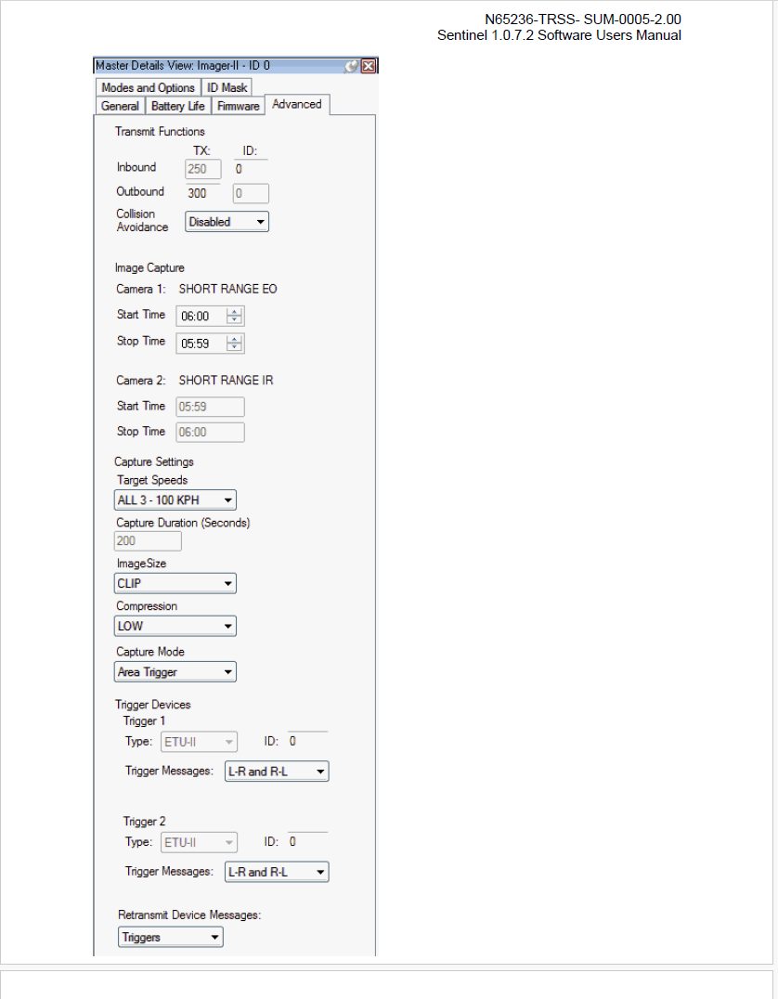
Figure 58. Imager-II camera parameters and triggering-device settings within Advanced configuration. Source: Sentinel 1.0.7.2 Software Users Manual (2014), supplied slide 23, Acrobat p. 188; printed folio not visible. Original screenshot; reader chrome omitted.
Scorpion demonstrates a specialized composition within the same general working-view concept (Figure 59). Its Tools tree groups Phoenix Day and Phoenix Thermal cameras with trigger sensors. The view includes full-size or thumbnail delivery, periodic snapshots, health-report intervals and separate camera controls. Its manual describes Verify and Export Mission File, and says that this equipment is excluded from the Device Configuration Wizard and configured separately. That is a concrete reason to let a verified device profile supply a focused configuration route. The screenshot and following prose also differ about an IR optical-zoom control, so they cannot establish uniform camera capability (supplied slides 58–60, printed pp. 219–221).
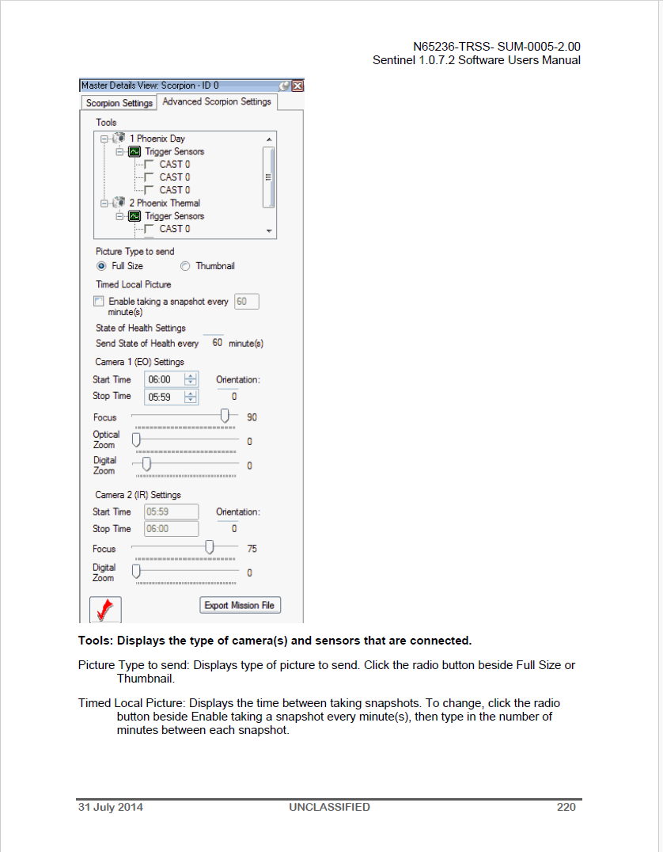
Figure 59. Scorpion camera and trigger relationships with specialized acquisition and configuration controls. Source: Sentinel 1.0.7.2 Software Users Manual (2014), supplied slide 59, printed p. 220; Acrobat p. 224. Original screenshot; reader chrome omitted.
The commit destination matters as much as the form. Save to Plan explicitly saves settings in Sentinel without reconfiguring an Imager-II or RR. HHPM settings may require a manual hardware front-panel change. Commands show response, progress and timeout feedback separately. Further, Imager-II Store records images, while RR Store explicitly does not store images. The same label therefore cannot justify a shared guessed operation. MERLIN should name the actual effect, route and target, preserve requested versus confirmed state, and disclose any supported prerequisite. These examples strengthen RD-CE01–09 and the System/control profiles without duplicating them as a requirement for each vendor (supplied slides 26, 32–34, 39, 41, 46–48, 54, 56, printed pp. 187, 193–195, 200, 202, 207–209, 215, 217).

7 19 3 Power information and estimate qualifications
The battery pages make a strong case for common presentation with qualified meanings. ETU-II explicitly does not return battery voltage. Nevertheless, its Battery Life view presents battery type and count, installation time, an assumed average temperature and Current Estimated Capacity (Figure 60). It can display 100.0% while also saying that data are still being collected and showing zero received messages and elapsed time. The Imager-II example similarly presents 99.9% while collecting data. A percentage or green bar must retain that qualification; it cannot become a confident direct measurement merely because it is visually prominent (Sentinel 1.0.7.2 Software Users Manual 2014, supplied slides 14–15, Acrobat pp. 179–180; slides 28–29, printed pp. 189–190).
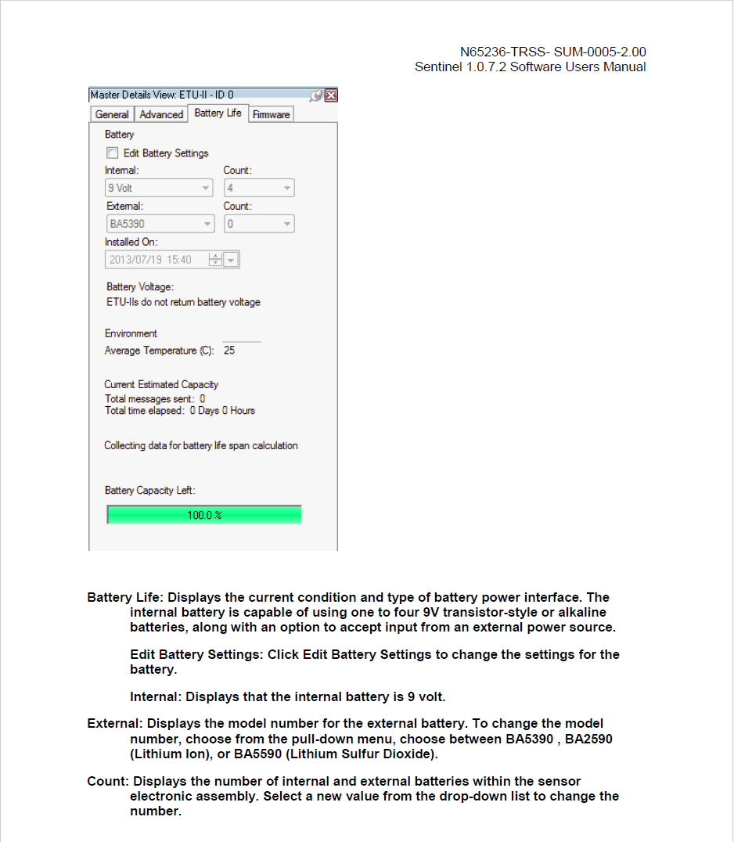
Figure 60. ETU-II battery assumptions and estimated capacity, with no voltage reporting and an explicit collecting-data state. Source: Sentinel 1.0.7.2 Software Users Manual (2014), supplied slide 14, Acrobat p. 179; printed folio not visible. Original screenshot; reader chrome omitted.
The RR example has a Battery Voltage field but currently says that no voltage information has been reported (Figure 61). That differs from ETU-II not supporting voltage reporting. The explanatory pages warn that changing battery inputs changes the remaining-life calculation and may make it inaccurate. They also explain that the sent-message count actually uses messages received by SDR-II; missed receptions can bias the estimate. Battery model, count, installation time and temperature are therefore estimator inputs, while voltage, percentage and remaining duration are separately interpreted outputs. No estimate accuracy, timestamp or confidence interval should be invented when the actual integration does not supply it (supplied slides 51–52, printed pp. 212–213; slide 64, printed p. 231).
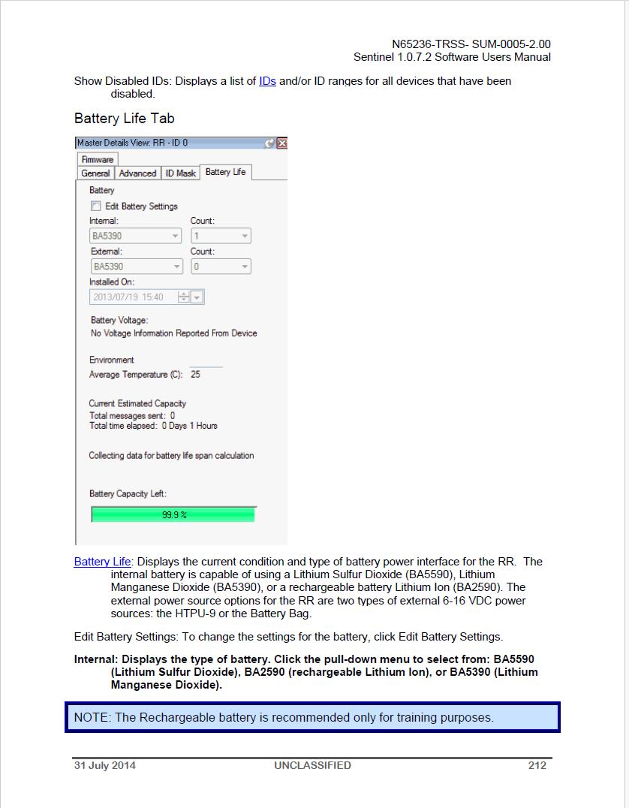
Figure 61. RR battery settings and an estimated capacity alongside voltage information not yet reported. Source: Sentinel 1.0.7.2 Software Users Manual (2014), supplied slide 51, printed p. 212; Acrobat p. 216. Original screenshot; reader chrome omitted.
The transferable requirement is broader than a battery gauge: distinguish measurements and reported state from estimates and their inputs. A short Power or Battery section can show the useful value with its basis, time and known limitation; expansion can reveal supplied assumptions and supporting readings. Permitted input edits need to identify whether they change an estimator, shared record or local presentation, rather than implying that the physical battery changed. RD-V08 captures this gap while the existing value, freshness, editing and security rules continue to apply. The module need not implement a new estimator to present source-calculated results honestly.

7 19 4 Image review and specialized visual editing
The separate Image View makes the image the principal content and retains the producing imager and UTC capture time (Figure 62). Its Rewind, Pause, Play, Fast-Forward and Live controls navigate still-image history and the automatic arrival of new images. A motion-detection box and an ID/time banner have different meanings from security markings. The source also documents receiving images from multiple imagers in one viewer, with contributing IDs in the title. These are useful media and related-content precedents, but they do not demonstrate a video resource or a Deployment membership relationship (Sentinel 1.0.7.2 Software Users Manual 2014, supplied slides 65–67, printed pp. 249–251; slide 71, printed p. 255).
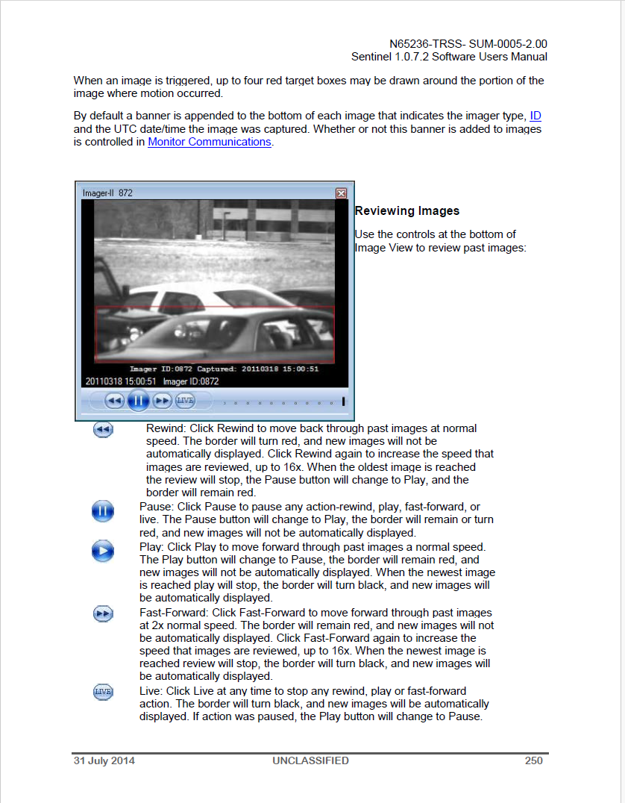
Figure 62. Image review with producing-device identity, capture time and still-image history controls. Source: Sentinel 1.0.7.2 Software Users Manual (2014), supplied slide 66, printed p. 250; Acrobat p. 254. Original screenshot; reader chrome omitted.
Actions depend on the producing imager. The source describes JPEG export for Imager-II and Scorpion, while base-image work applies to Imager-II. An image acquisition command can send Stop before Capture and targets the camera that produced the selected image. This means media type alone cannot determine whether the action is valid or which device receives it. A compact result body should retain acquisition context and link to a clearly targeted supported task, with receiver and result states kept distinct. Reviewing stored imagery, acknowledging new imagery and issuing device work are different interactions (supplied slides 67–68, printed pp. 251–252).
The FOV mask editor is a particularly useful example of specialized visual work (Figure 63). It edits a mask against the displayed camera image, showing excluded pixels in blue mesh and exposing separate remote-configuration and save actions. Save and Close saves the mask without configuring the Imager-II; Send Remote FOV Configure also submits a device change. MERLIN can offer a focused visual editor when a supported value benefits from that interaction, with a route to a fuller viewer when the compact card is insufficient. An image-coordinate mask must not be relabelled as geographic sampling geometry, a security redaction or an automatically supported operation on every camera (supplied slides 69–70, printed pp. 253–254).
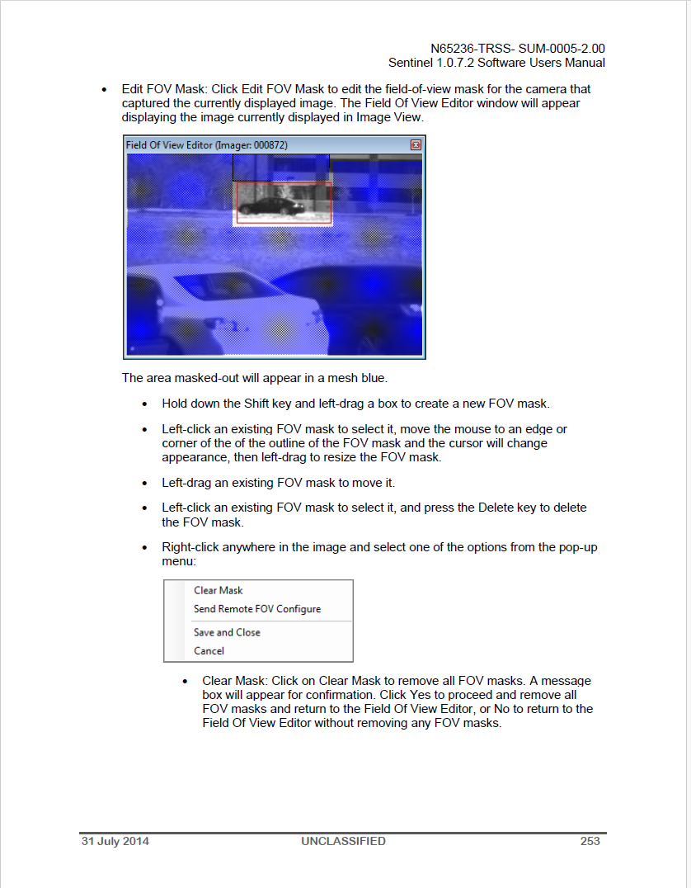
Figure 63. An image-based FOV mask editor with separate remote-configuration and local-save actions. Source: Sentinel 1.0.7.2 Software Users Manual (2014), supplied slide 69, printed p. 253; Acrobat p. 257. Original screenshot; reader chrome omitted.

7 19 5 Battery overview and the Deployment proposal
The Battery Life window is explicitly described as presenting one or more devices. Figure 64 shows one populated row with ID, Location, Days Left and Percent Power Left; the example reports 66 Days 5 Hours and 95%. The manual also states that the opening action is not available for every device. This establishes a documented multiple-device scope, although the captured screen demonstrates only one row and does not include the second opening procedure or prove any Deployment association (Sentinel 1.0.7.2 Software Users Manual 2014, supplied slide 76, printed p. 230).
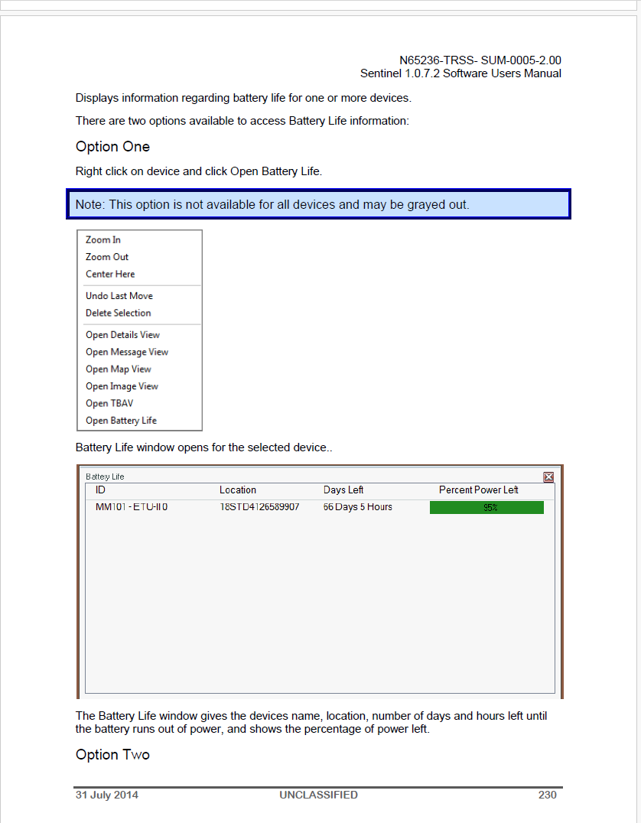
Figure 64. Battery Life overview documented for one or more devices, with one illustrated device row. Source: Sentinel 1.0.7.2 Software Users Manual (2014), supplied slide 76, printed p. 230; Acrobat p. 234. Original screenshot; reader chrome omitted.
Sam proposes applying this idea to a Deployment so that its view can present battery information for related resources. A useful version would list eligible deployed Systems with each exact identity and Source, the available metric and unit, its time and measured or estimated basis, and navigation to that System. Membership might mean direct participants or an explicitly included set of subdeployments; the display must state that choice and the applicable Deployment period. The Deployment remains the subject of the card, while the battery values describe its participants. A Deployment-wide average or a synthetic battery property is unnecessary and would require a separate verified method (Bolling 2026; proposal RD-DEP-9).
The category should remain useful when an eligible device has no report yet, when part of the member list is unresolved, or when access to a reading is denied. A verified complete set with no relevant capability can omit the irrelevant subject or explain that scoped result. Missing data alone cannot establish inapplicability. A compact table is appropriate for repeated participant facts, but voltage, modelled capacity and predicted days must retain their distinct meanings and known qualifications. The proposed Status → Participant Batteries arrangement gives the same capability a predictable home in System and Deployment views, while leaving the exact label and initial visual allocation to the existing card review. RD-DEP-9 makes this operational summary explicit without importing the entire monitoring application.

7 20 SADU and McQ Central Computer manual excerpts
The supplied compilation covers CORE, OMNI 1351 ISU, OMNI 1251 ISU and Repeater chapters. It combines device editors with operational commands, detection/media viewers, current and historical status, configuration/message histories, and user/security settings. These are examples of an individual resource’s working viewpoint, although the source spreads work among separate legacy windows. The useful evidence is their organization, meaning and connected work, rather than their appearance or size. The proposed MERLIN surface remains the compact square or broad rectangle with stable identity, Source and markings, top categories, optional subordinate tabs and expansion within sections (OmniSense Central Computer Manual n.d., supplied slides 1–109).

7 20 1 Identity, applicable content and queued configuration
Figure 65 shows a CORE editor with recurring Location, Mode, Communications, Transducers, Algorithms, Sleep Schedule and Rules subjects. The user-defined Number can be shared among sensors, while factory/service identifiers and component firmware have other roles. The manual permits descriptor edits at different workstations and states that the latest entry wins. Those behaviors argue for exact source/canonical identity, inspectable aliases and explicit concurrency handling. Location also has different authorities: entered coordinates, device GPS and, for the 1251, HHPM emplacement altitude. A map update or saved descriptor must retain its actual source and pending state (OmniSense Central Computer Manual n.d., slides 1–3, 24–26, 63–64, 92–94; printed pp. 6-1–6-3, 7-1–7-3, 8-2–8-3, 9-1–9-3).
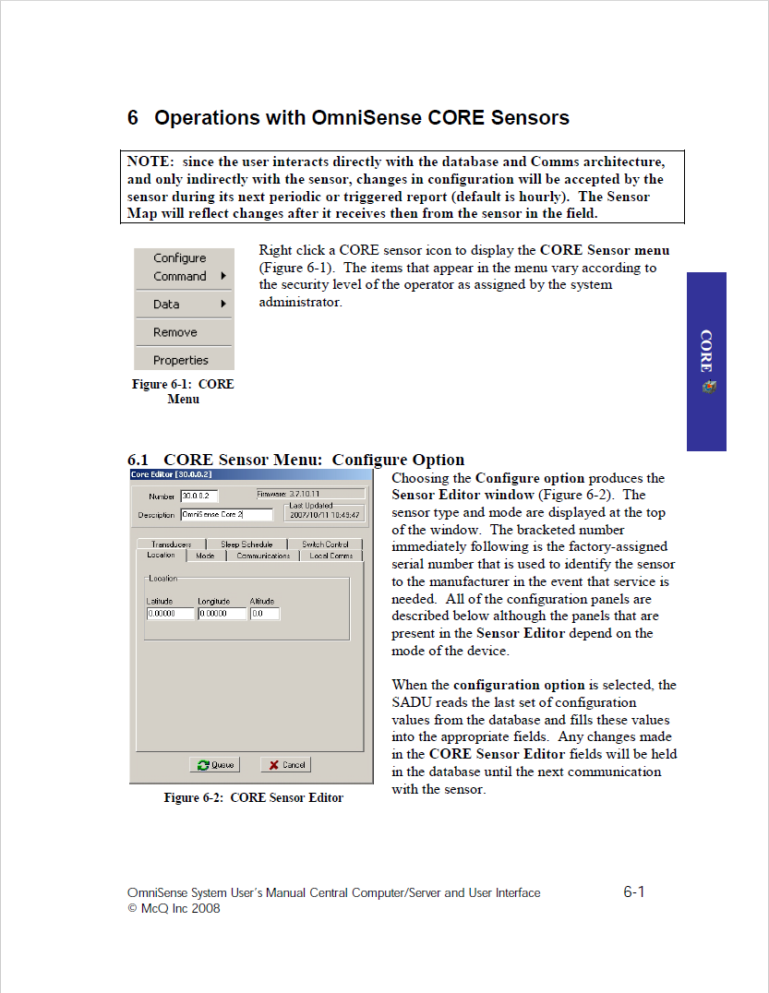
Figure 65. CORE configuration editor with recurring device subjects and a Queue action. Source: OmniSense System User’s Manual Central Computer/Server and User Interface (n.d.), supplied slide 1, printed p. 6-1; Acrobat p. 161. Original screenshot; reader chrome omitted.
Queue is particularly important: the submission can include configuration from every editor panel, not merely the active tab. CORE excludes Sleep Schedule unless the user explicitly includes it; the 1351 and 1251 explanations likewise warn that queued settings cross panels. The editor initially presents the database’s last configuration, and device application can await periodic or triggered communication. Updated map information follows returned device data. MERLIN should let the user review the actual affected groups, preserve draft/requested values separately from reported values, and identify evidence of application. The category hierarchy cannot define the submission boundary or turn a database acceptance into proof that the device changed (OmniSense Central Computer Manual n.d., slides 1–2, 8, 24–25, 58, 62–63, 89, 92, 106).
Applicable content depends on device variant, installed component, mode and transport. The 1351 description includes activity-only, self-triggered imaging, externally triggered imaging and cueing roles; imaging is not available in its activity-detection mode. Repeater contact also differs between a wired Bridge and an indirect relay path. These qualifications refine the same approach used for TRSS: a recognizable category can contain different supported sections and focused controls. They do not justify permanent vendor tabs or a universally enabled camera form (OmniSense Central Computer Manual n.d., slides 27–35, 62–71, 92–99, 109; Sentinel 1.0.7.2 Software Users Manual 2014, slides 1–9, 37–60).

7 20 2 Operation meaning, camera effects and future policies
The CORE Command → Status description requests current sensor status. The 1351 Command → Status description instead requests device status from the database; its Location action reacquires GPS from the sensor. A copied Status label would conceal that distinction. The source also separates read-only, last-reported PTZ values from the explicit image/PTZ request. Figure 66 documents an absolute PTZ request that changes the device into PTZ mode, establishes a 30-second SADU communication interval and leaves that mode 30 minutes after the last Image/PTZ command. Those are source-specific operational effects to disclose when that verified operation is supported (OmniSense Central Computer Manual n.d., slides 10, 35, 38–41; printed pp. 6-10, 7-12, 7-15–7-18).
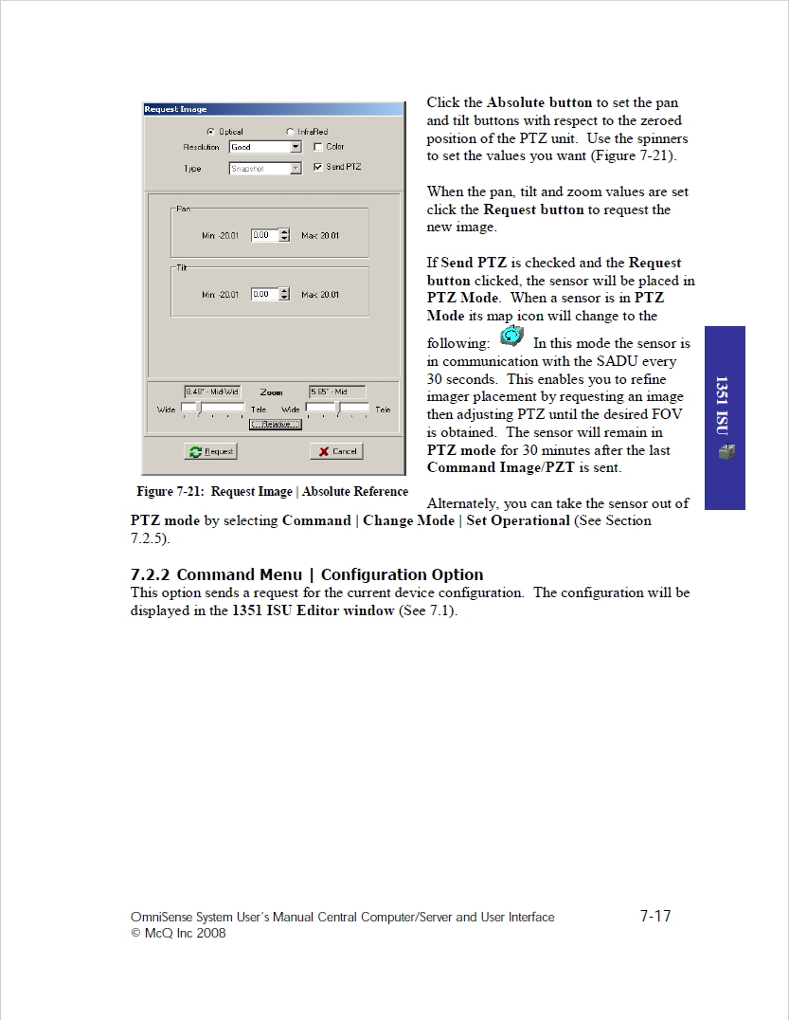
Figure 66. Absolute PTZ request with documented persistent mode and contact effects. Source: OmniSense System User’s Manual Central Computer/Server and User Interface (n.d.), supplied slide 40, printed p. 7-17; Acrobat p. 201. Original screenshot; reader chrome omitted.
Tamper Report, Disable and Kill choices configure a future response to a tamper condition; their appearance does not prove an immediate remote Kill command. The source distinguishes HHPM recovery from Disable and manufacturer return after Kill. Weekly sleep configuration also has explicit timing and inclusion rules, with source-specific recovery: CORE and 1351 describe local HHPM reconfiguration, whereas the 1251 describes reconnecting the battery pack in the field. A future collection task, a recurring sleep policy and a configured destructive response require their own supported meanings. TRSS similarly exposes physical prerequisites, receiver timeouts and device-specific configuration paths. For MERLIN, shared editing and operation controls must show the affected target, consequences, prerequisites and permitted submission route without implying unsupported reachability or recovery (OmniSense Central Computer Manual n.d., slides 7–8, 32–36, 67–69, 97; Sentinel 1.0.7.2 Software Users Manual 2014, slides 12–16, 32–34, 41, 59–60, 68–75).

7 20 3 Detection context, still imagery and structured signals
The activity tables link detection time and detector type with image identifiers, pre/target/post images and, for supported devices, MASINT records. Target ID identifies a particular detection for correlation; these excerpts do not establish a persistent Target or Feature of Interest resource. Figure 67 provides a useful broad rectangular image precedent: the image is primary, with producer identity and acquisition time in the title and characteristics, detection context and local tools nearby. MERLIN can retain that reading order within its own compact surface. A System’s Observations category can lead to the exact image Observation, while the Observation keeps its own result and typed producer/trigger/subject context (OmniSense Central Computer Manual n.d., slides 11, 42–43, 49–54, 73, 80–84; printed pp. 6-11, 7-19–7-20, 7-26–7-31, 8-12, 8-19–8-23).
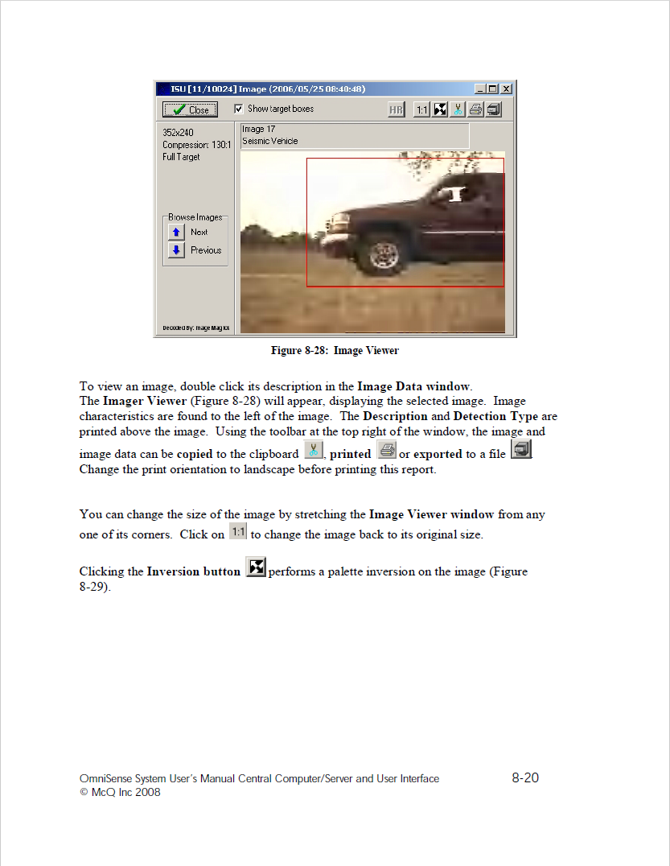
Figure 67. Still image as primary content, with producer, acquisition time and detection context. Source: OmniSense System User’s Manual Central Computer/Server and User Interface (n.d.), supplied slide 81, printed p. 8-20; Acrobat p. 242. Original screenshot; reader chrome omitted.
Local resizing, palette inversion, brightness/contrast and target-box display differ from requesting a higher-resolution counterpart from the device. The source’s gray HR button has two documented possibilities: no counterpart is available, or the viewer already displays it. A limited thumbnail set is not the full history, and saved JPEG output can include current display adjustments and boxes. These details strengthen resource/media/MIME-aware presentation: preserve rendition, acquisition and export meaning; offer actual supported display actions; distinguish local presentation from acquisition. The manual’s still-image sequence does not establish a video representation. TRSS’s still-image log and focused FOV/mask editor supply related but distinct precedents (OmniSense Central Computer Manual n.d., slides 49–52, 80–84; Sentinel 1.0.7.2 Software Users Manual 2014, slides 65–71).
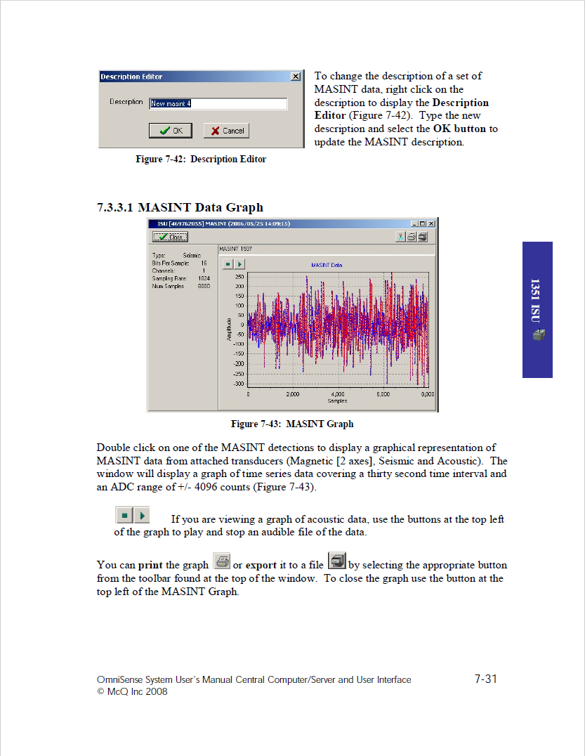
Figure 68. Structured seismic waveform and metadata, with documented acoustic playback for supported data. Source: OmniSense System User’s Manual Central Computer/Server and User Interface (n.d.), supplied slide 54, printed p. 7-31; Acrobat p. 215. Original screenshot; reader chrome omitted.
Figure 68 adds a result type beyond a generic image card. Its waveform shows a signal plot with channel, sample-count and sample-rate context; the prose documents playback for an acoustic file. Actual encoding, codec and renderer support still need verification. The description calls the sample thirty seconds long while the illustrated count and rate do not establish that duration. Likewise, the 1251 Rules page mentions MASINT but its activity explanation states that this device provides none. Neither discrepancy should become an invented client capability or silently corrected measurement. Preserve source values and resolve the selected integration’s units, duration and applicability. This is a reason for structured-signal presentation and inspectable fallback, not evidence that TRSS lacks such data (OmniSense Central Computer Manual n.d., slides 54, 70, 73; printed pp. 7-31, 8-9, 8-12).

7 20 4 Power, current reports and historical readings
Figure 69 separates current status from history and BITE evidence. SADU reports measured battery voltage in VDC with a Status Time and other device properties; Figure 70 presents voltage history over a selected interval. Current status is the latest stored record on opening, while documented historical refresh depends on a changed range. These are not guarantees of continuously live telemetry or a newly contacted sensor. Source prose also describes On Time inconsistently in seconds versus hours while the screen uses days/hours. A supported client must retain confirmed quantity, unit, report time, basis and retrieval state, rather than guessing a uniform interpretation (OmniSense Central Computer Manual n.d., slides 17–20, 55–56, 85–87, 101–104; printed pp. 6-17–6-20, 7-32–7-33, 8-24–8-26, 9-10–9-13).
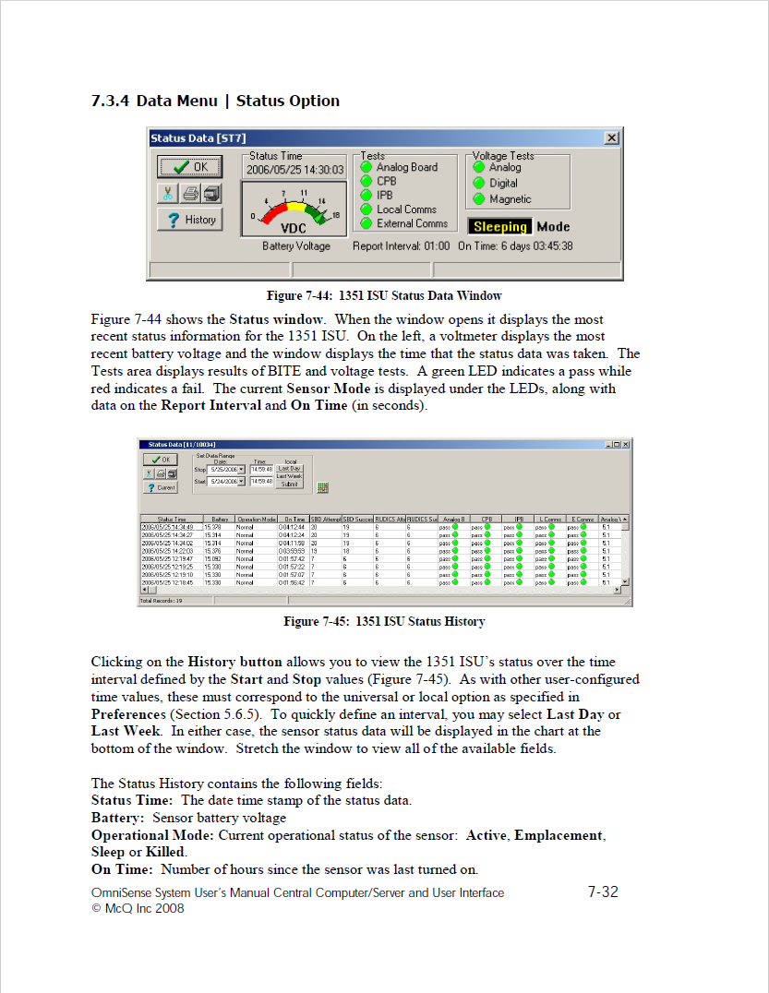
Figure 69. Reported battery voltage, status time, BITE and current/history separation. Source: OmniSense System User’s Manual Central Computer/Server and User Interface (n.d.), supplied slide 55, printed p. 7-32; Acrobat p. 216. Original screenshot; reader chrome omitted.
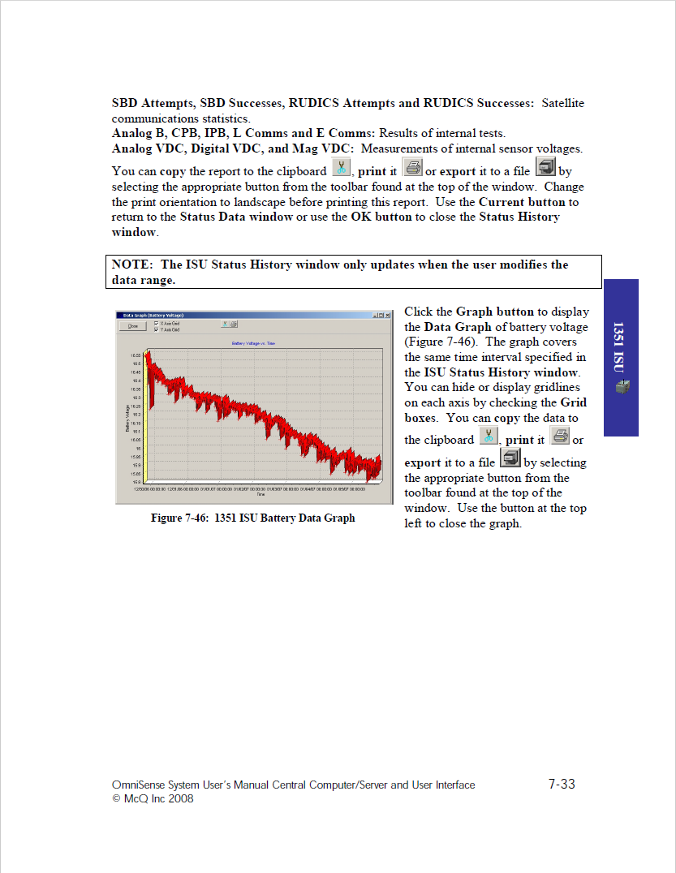
Figure 70. Battery-voltage history with the selected temporal interval. Source: OmniSense System User’s Manual Central Computer/Server and User Interface (n.d.), supplied slide 56, printed p. 7-33; Acrobat p. 217. Original screenshot; reader chrome omitted.
The TRSS comparison is a direct test of useful commonality. TRSS can report modelled percent capacity and remaining life, with estimator inputs and caveats when voltage or receptions are absent; SADU here reports voltage measurements and their history. A shared Status → Battery subject can prioritize the available value and expose its context on expansion. Voltage alone does not produce a justified remaining-life estimate. For a Deployment, list eligible participants with exact System/Source, metric, unit, time and measured or estimated basis. Preserve unknown, denied and partial cases; do not compute a common health score or synthetic Deployment battery without a verified method (Sentinel 1.0.7.2 Software Users Manual 2014, slides 14–15, 28–29, 51–52, 64, 76; OmniSense Central Computer Manual n.d., slides 55–56, 101–104; proposed RD-V08 and RD-DEP-9).

7 20 5 Communications, reported neighbors and route selection
The current/history distinction also applies to communication relationships. CORE describes up to ten reported RF neighbors; the Repeater describes up to twenty-five and Figure 71 pairs RF reachability, RSSI and packet counters with a selected status report. This is time-qualified reported network evidence, not proof of a complete current topology, permanent subsystem ownership or Deployment membership. The source separately provides selection of a reported neighbor as the next hop toward the server for a route command. A compact communications summary can disclose its report time and scope, then expand to a table or meaningful supported visualization. Viewing neighbors, opening a related resource and changing a route remain different actions (OmniSense Central Computer Manual n.d., slides 19, 99, 101–102; printed pp. 6-19, 9-8, 9-10–9-11).
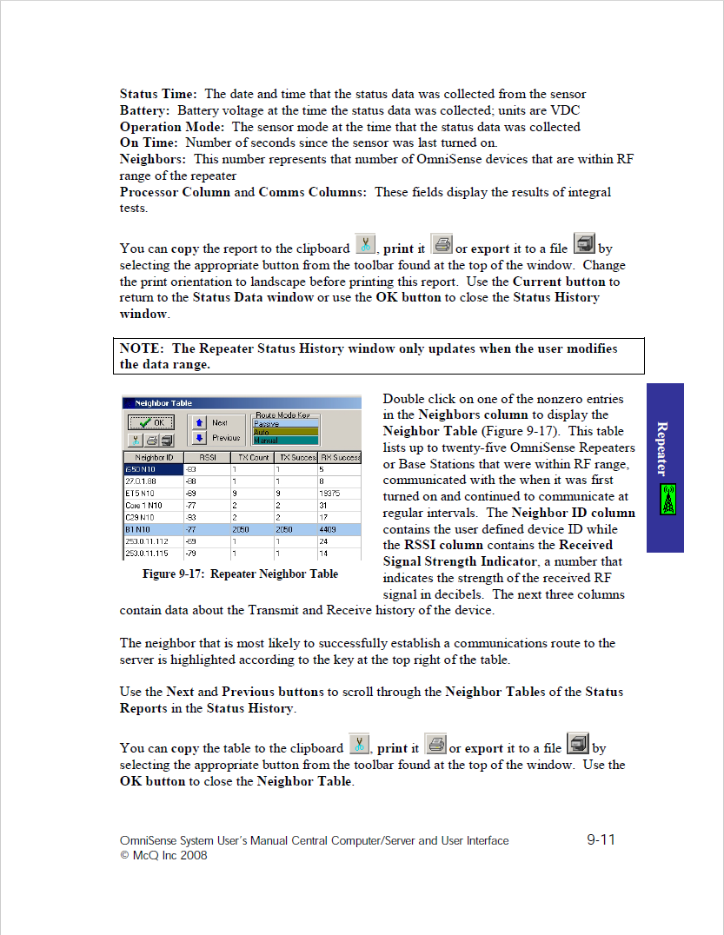
Figure 71. Reported RF neighbors tied to a particular status report, with signal and packet fields. Source: OmniSense System User’s Manual Central Computer/Server and User Interface (n.d.), supplied slide 102, printed p. 9-11; Acrobat p. 263. Original screenshot; reader chrome omitted.
TRSS’s related detectors, strings, triggers and communication paths show that useful links already recur across the two sources. Their roles differ: an attached detector, an event-triggering sensor, a reporting producer and an RF neighbor answer different questions. MERLIN should preserve exact relationship role, direction, subject and applicable time and show partial/unresolved retrieval. A network drawing becomes useful only if those distinctions remain understandable; a small table may serve the first card iteration better. The operational mission examples add Target and Requirement associations without turning all these relations into one undifferentiated Related list (Sentinel 1.0.7.2 Software Users Manual 2014, slides 8–13, 20–25, 48–50; MASINT IT Next Demo Screenshots 2021, slides 8–10, 20–23).

7 20 6 Histories, audience, preferences and security
Figure 72 names Message Time as the database queue time, then distinguishes message status and device Response. Sending, Sent, Sent-Acknowledged and Error are historical message states whose mapping to modern command progress requires verification. The User column is administrator-only. These examples support inspectable operation history, exact correlation and authorized actor information; they do not establish that acknowledgement proves application. Configuration histories likewise distinguish reported and queued records. MERLIN should preserve the pending request and returned evidence rather than replacing the displayed current state with its own submission (OmniSense Central Computer Manual n.d., slides 20–22, 57–59, 87–90, 104–107).
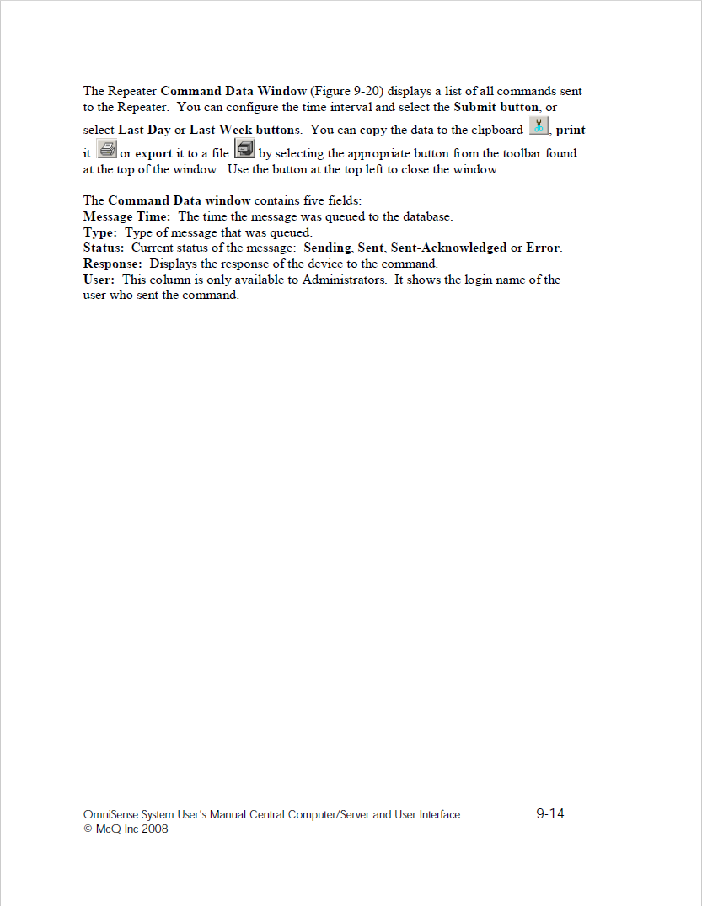
Figure 72. Command-history field definitions distinguish queue time, transport state, device response and restricted actor information. Source: OmniSense System User’s Manual Central Computer/Server and User Interface (n.d.), supplied slide 105, printed p. 9-14; Acrobat p. 266. Original screenshot; reader chrome omitted.
Figure 73 defines Enabled as a user’s receipt/display of detections while collection continues. Remove clears the device from the shared map for users with access, retains its database record and allows reappearance after a new report. These have different owners, affected audiences and effects from a physical detector Off setting or deleting a resource. The security editor offers granular command, configuration and view rights, but this historic role model is not a MERLIN authorization contract. IBS export dialogs let a user select SECRET or UNCLASS; those choices do not classify the manual or establish classification propagation. Preserve the existing trusted banner/portion-marking requirements and verify binding and export behavior through the governing profile (OmniSense Central Computer Manual n.d., slides 17, 22–23, 48, 53, 60–61, 79, 85, 90–91, 107–109).
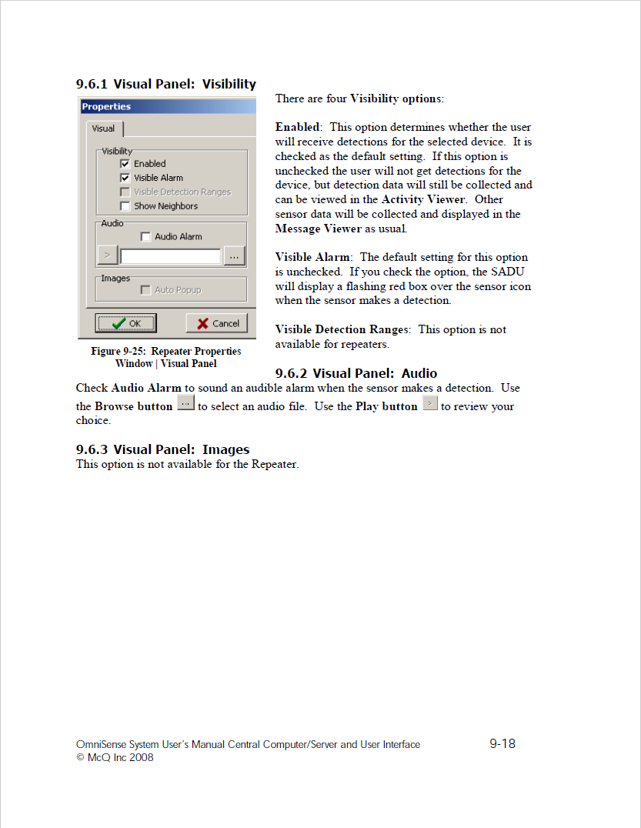
Figure 73. Per-user detection preferences; Enabled is explicitly separate from continued data collection. Source: OmniSense System User’s Manual Central Computer/Server and User Interface (n.d.), supplied slide 109, printed p. 9-18; Acrobat p. 270. Original screenshot; reader chrome omitted.

7.21. Original UGS intent, MASBUS implementation and MERLIN reports

7.21.1. A recurring sensor form and an image-first Observation
UGS slides 6–8 reuse a Sensor Description Viewer for TRSS_IMG, OmniSense II and TRSS_ETU II. Identity, classification, location, period, contacts, unit/mission, communications, components and comments retain a common position while actual values and component contents differ. Figure 74 makes the original intent concrete: a recognizable individual sensor viewpoint with useful connected work. Slide 8 also lists a related TRSS_IMG trigger target, making an associated-resource role explicit. The lower area combines description update, map, Observations and Image Viewer actions with a date interval. Those are different operations and contexts; the date controls do not establish future scheduling, and a wireframe Update button does not prove device configuration support (UGS Client Development Wireframes n.d., slides 6–8).
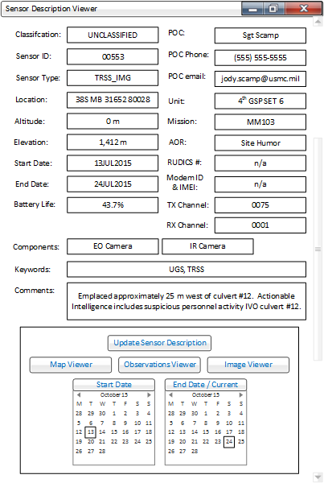
Figure 74. Original Sensor Description Viewer reused across device examples. Source: UGS Client Development Wireframes n.d., slide 6. Original source image.
Section F includes compact detection/counter descriptions on slide 9 and an actual image result on slide 10. Figure 75 puts the result first, then classification, phenomenon time, producer identity/type, mission and Feature of Interest context. Slide 11 separately addresses an image sequence with two contributing Sensor IDs, while slide 12 supplies a spatial overview and cross-view navigation. That distinguishes an individual Observation’s result, a System’s bounded observation collection and a map task. The Feature of Interest field is n/a, not an instantiated Feature relationship. The TRSS_IMG example’s ID differs between slides 6/12 and slide 10, so prototype values cannot be treated as a verified inventory. The same grayscale scene/red rectangle appears in TRSS Figure 62 and UGS slides 10–11; these are presentation variations of an illustrative image, not independent new capture evidence (UGS Client Development Wireframes n.d., slides 9–12; Sentinel 1.0.7.2 Software Users Manual 2014, slide 66).
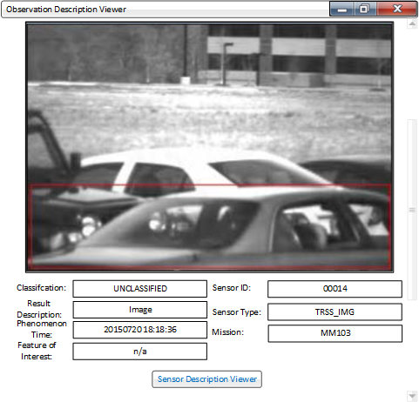
Figure 75. Image Observation result with phenomenon time and producer/Feature context. Source: UGS Client Development Wireframes n.d., slide 10. Original source image.
The proposed transfer is the form’s continuity and the result’s priority, with today’s stronger identity, source and marking contracts. Useful metadata can start short and expand; image, report and structured-result bodies can occupy the same main region through verified interpretation. Long comments, dense communications and image-sequence tools should not all compete in the initial card. The old window proportions, individual fields and desktop controls remain design evidence, rather than adopted pixel specifications.

7.21.2. The live sensor summary and its separate destinations
Figure 76 is a focal Sensor summary for MM101-0010E. A location map sits beside label/value fields for name/type, MGRS, altitude, dates, contacts, ownership, mission and AOI; many labels have no visible value. Four bottom links lead toward Full Sensor Description, Raw SensorML, Edit Sensor and Observations. Slides 2–3 show a much longer full description, with typed identifiers, raw definition URNs, repeated classifier headings, role-qualified contacts, characteristics, location and output labels. This supports the owner’s organization concern: the information is reachable but the large flat surface asks the user to interpret technical groups and empty labels (MASBUS Details View Captures 2026, slides 1–3).
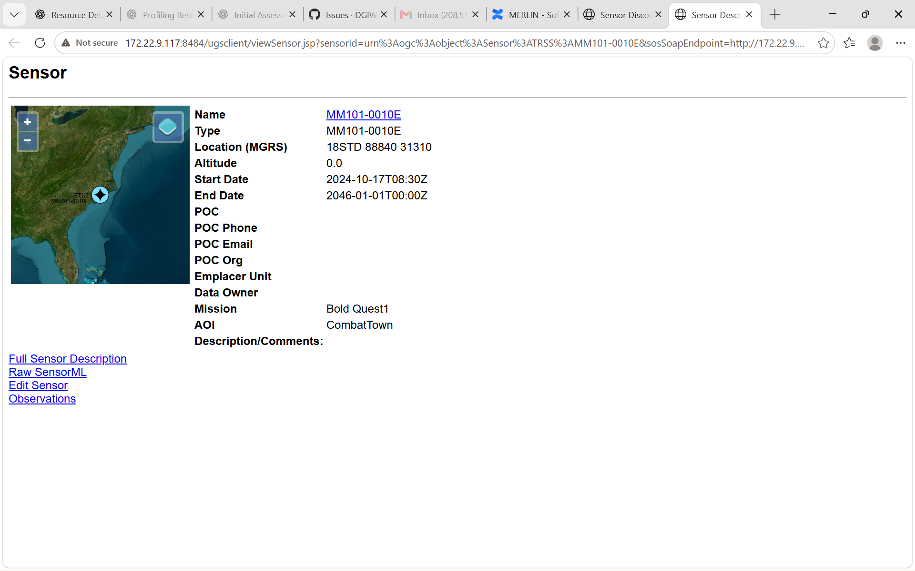
Figure 76. Implemented MASBUS Sensor summary, map and four linked work destinations. Source: MASBUS Details View Captures 2026, slide 1. Original source image.
Slides 4–6 distinguish raw XML, a description editor with Update Sensor Description/Cancel, and a map location editor with OK/Cancel. The raw document explicitly declares SensorML 1.0.1. Visible JSP/SOS-route names do not establish CSAPI behavior, and the editable location does not prove a device-position command. The summary’s Type repeats the name, the altitude has no displayed unit, and start/end semantics are not defined here. The classification/source metadata in the full description cannot substitute for persistent display markings. Retain exact field definitions and roles; do not normalize these examples by guessing. The editor shares the earlier Figure 18 field order/style, but its resource values and map overlay are distinct evidence (MASBUS Details View Captures 2026, slides 1–6).
For MERLIN, the four destinations suggest purposeful organization: concise descriptive content, expandable typed depth and raw source, a permitted focused editor, and bounded related Observations. They do not require four browser pages or four permanently present tabs. Keep the focal resource’s identity visible while the selected category changes; open another resource through its exact inherited Details action. Treat Source as the known source destination and raw representation as inspection of this resource. This preserves the existing Discovery/Dockview opening contract while removing the legacy page hierarchy from the proposed card (MERLIN-932 2026; MASBUS Details View Captures 2026).

7.21.3. STORMFORCE image context and evidence-based report preparation
The DRAFT guide dated May 5, 2019 carries UNCLASSIFIED page banners. PDF page 7/printed page 6 expressly describes TBAV hover links to a System Description or Observation Description in a new tab/window, without picturing those destination bodies. Its Image Feed shows imagery with Sensor, Phenomenon Time, Result Time, relative image age, temporal range and a live-connection indication. Figure 77 therefore confirms result-aware imagery and navigation in documented MASBUS work, supplementing the owner’s account without fabricating the unavailable testbed Observation. A green connection frame identifies connection state, not proof each image is current; one image’s capture banner reads 2016 while the surrounding Observation times read 2019. Preserve these different clock roles and resolve provenance rather than silently reconciling them (MASBUS STORMFORCE User Guide 2019, PDF pp. 6–7, printed pp. 5–6).
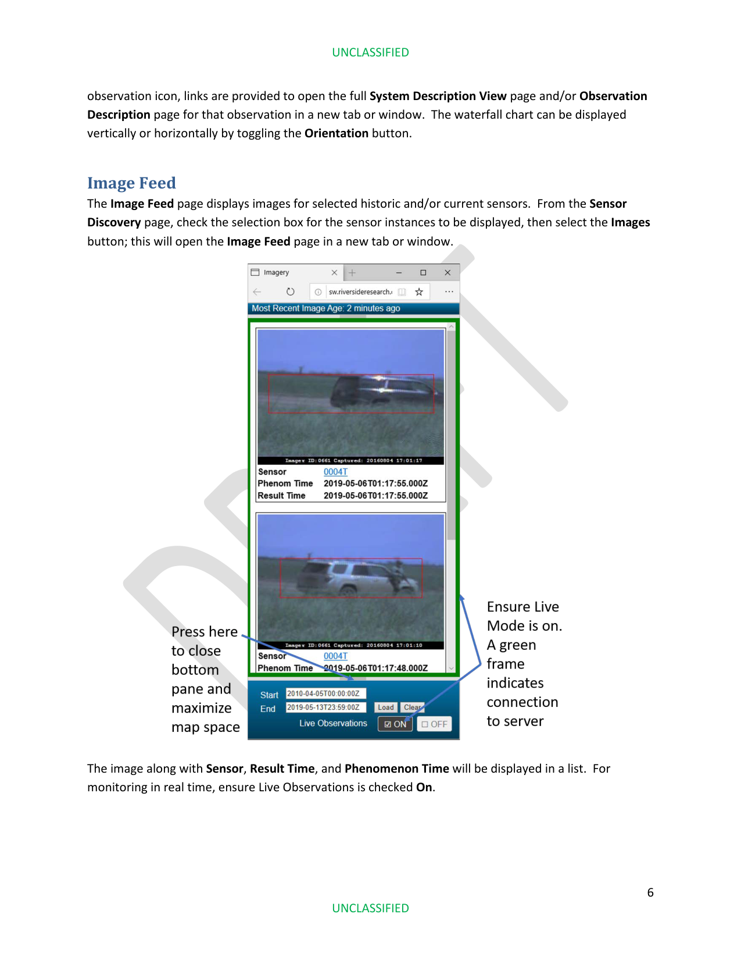
Figure 77. Documented image feed, Observation time context and legacy Details navigation. Source: MASBUS STORMFORCE User Guide 2019, PDF p. 7 / printed p. 6. Original source image.
PDF pages 8–12/printed pages 7–11 describe creating a SENREP from selected TBAV observations: reference fields, defaults and missing-field checks, two observations per target-detection block to derive speed/direction, optional report groups opened or closed with +/−, an executive summary, report preview and OK submission. This is an evidence-based report-authoring workflow; it is neither a sensor command nor an edit to a stored Observation’s result. Target classification is separate from document/report security classification. Preserve contributing Observation identity, any verified derivation and report provenance when such work is supported. The screenshot sequence and described Submit control do not prove a current endpoint, successful publication or formal USMTF/SWE/CSAPI compliance (MASBUS STORMFORCE User Guide 2019, PDF pp. 8–12).

7.21.4. A report result beside its separate draft composer
Figure 78 shows MERLIN with Resource Map at left, Report authoring above, Selected Observations – TBAV below and TBAV at right. The selected-observation body uses a Sensor Report tab and visible slash-delimited SENREP text, including reference, target and executive-summary groups. The upper draft exposes a SENREP form, an UNCLASSIFIED banner, Quick Preview/Reset/Save Defaults/Transmit actions and one validation error with Transmit disabled. Its timestamp differs from the selected report below. The two panes must not be collapsed into one resource or interpreted as a successful transmission (MERLIN Report Workspace Screenshot 2026).
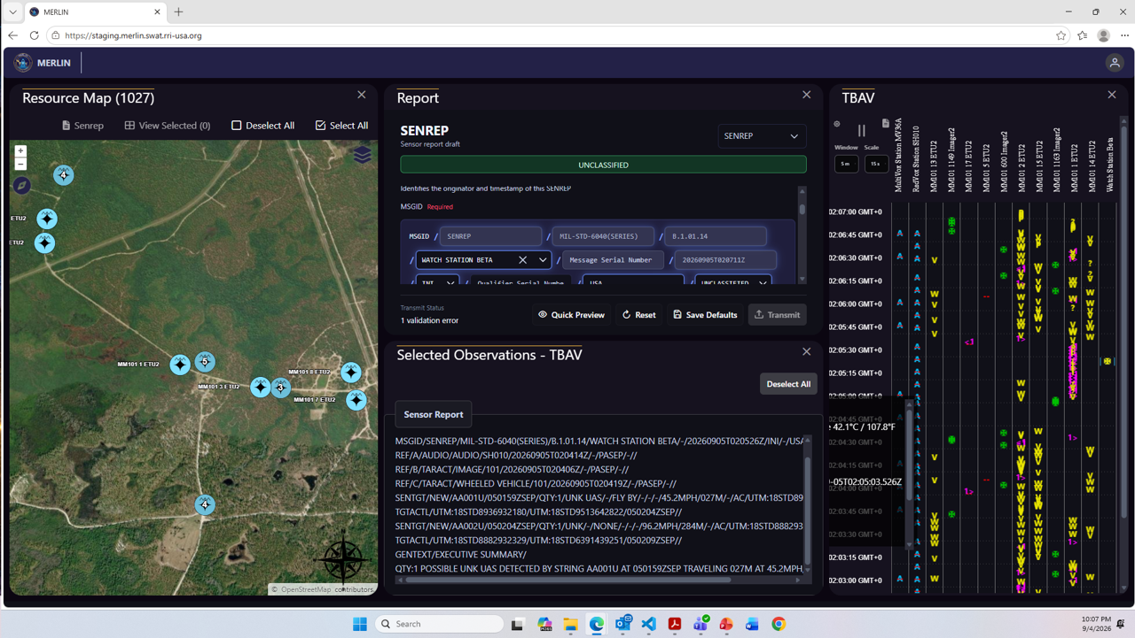
Figure 78. MERLIN report body in selected Observations beside a distinct SENREP draft editor. Source: MERLIN Report Workspace Screenshot 2026, full screenshot. Original source image.
Compared with Figure 2, the selected-observation frame and Deselect All affordance recur while the body changes from Image to Sensor Report. Compared with the older Figure 12 SENREP Manager, reporting remains separate work with its own state. This is direct evidence of a useful result-specific presentation pattern, although the visible report still uses USMTF group mnemonics rather than a verified field-labelled semantic renderer. Scrollbars clip parts of the report and form; no DataStream, resultSchema or MIME binding is exposed. It is a multi-pane workspace example, not proof of a standalone single-Observation Details implementation. The visible SENREP also remains distinct from the owner’s earlier EOBSREP/Symbol scenario (MERLIN Report Workspace Screenshot 2026; Bolling 2026).
The proposed card can place a supported report’s readable content in the primary Observation body, retain producer/time/subject context and make the exact original payload inspectable separately. Where verified structured fields exist, labels and bounded expansion can improve reading without rewriting the underlying message; unsupported interpretation retains a readable text/source fallback. A draft composer is invoked only as supported work with a distinct target and submission state. This follows the image-aware precedent while making schema/profile knowledge, actor permissions and source provenance explicit.

8. Discussion and proposed decision basis

8.1. Comparing plausible design directions
Three directions remain plausible. A single adaptive inspector minimizes compositional divergence but can become a complicated conditional layout. Separate host-oriented compositions over a common contract can prioritize each task, but require checks that meanings and actions do not drift. A source-first technical inspector minimizes unsupported interpretation, but makes routine understanding depend on the reader’s knowledge of encodings. None is empirically established as best for MERLIN by the reviewed sources.
The recommended direction is a common semantic and operating contract with host-oriented composition. This keeps the accepted Discovery invocation intact, provides a defensible basis for anchored inspection, and allows resource families to prioritize different information. The technical source layer remains available as a complement. Engineering can choose whether that results in one renderer or multiple compositions; the product decision concerns what users see and what actions mean.
The principal tradeoff is between compactness and interpretive sufficiency. A smaller surface may improve spatial continuity yet demand more expansion and movement. A fuller surface can support comparison yet obscure the host context. The proposed design avoids resolving that tradeoff through arbitrary field counts. Instead, it asks whether identity, main value or status, and applicable semantic qualifiers remain understandable in the actual container. That criterion can be evaluated before detailed styling or component boundaries are fixed.

8.2. Decisions recommended for adjudication
The first recommended decision is to adopt the exact-resource identity contract across Details entry points. Name remains optional; resource type, source context, and the necessary local identity remain explicit. Focal geometry and directly mapped values stay separate from relationship-derived context. The existing guide’s semantic distinctions are retained, with any Details-specific clarification proposed as a reviewed addition rather than a silent amendment.
The second decision is to use a task-oriented reading order and conventional disclosure. Essential qualifiers remain visible with the facts they qualify. Family-specific ordering is permitted within the shared contract. An anchored composition offers orientation and explicit promotion to a new independent module; its availability for particular hosts remains a scope decision. The full module offers sustained inspection, source content, and optional relationship depth.
The third decision is to bound data acquisition. Initial rendering distinguishes held data from newly retrieved data. Optional relationships do not block the whole display. Where primary content needs schema resolution or media delivery, loading and failure apply visibly to that content while identity and available context remain readable. Manual refresh is the proposed first freshness behavior. Schema support is adopted only for explicitly supported combinations with a fallback that preserves direct inspection. These decisions can be challenged during adjudication, but should not be left implicit when requirements are drafted.
The fourth decision concerns movement, persistence and supported work. Related-resource inspection initially opens a new module and retains the focal context. Restoration saves a resource locator and useful presentation preferences, then resolves within the current context. The product owner now requires permitted edits, device commands and future scheduling from the resource view, with explicit targets, validated inputs and visible outcomes. These operations belong within the relevant information categories; they require confirmed source contracts and current authorization. Opening, restoring or expanding a view must not repeat an operational command.
The fifth decision is to treat accessibility and safe rendering as part of the information contract. Standard reading order and disclosure behavior are the starting point. Keyboard, focus, status announcements, reflow, and source-content rendering are checked with realistic resources. A successful visual review cannot substitute for those checks. These proposals define an evaluation direction; neither the paper nor the cited documentation establishes that an implementation already satisfies it.

8.3. Resource scenarios that can challenge the proposal
A useful evaluation set should include a named System with rich metadata, nameless Observations with scalar, structured, image, and video results, a Command with current status and separate status reports, a System Event, a generic Feature with unfamiliar properties, and a Procedure or Sampling Feature with nested content. It should also include duplicate local IDs across sources, long identifiers, absent names, source-defined nils, nonpoint geometry, and schema mismatch or unavailability. The cases are chosen to challenge semantic assumptions, not to reproduce only the easiest screenshots. Media scenarios should include a preview that differs from the original, several linked assets, unsupported playback, unavailable delivery, and a historical schema that cannot be verified.
Each scenario should first be exercised in a square or broad rectangular standalone Dockview module, reflecting the intended business-card-like surface. Narrow containers are a reflow stress case. Where proposed, an anchored host should also be evaluated. Users should identify the resource, explain the main fact and time, distinguish focal from related information, navigate a known relation, and recover from a failed request. Keyboard and screen-reader checks should cover the same tasks. These are evaluation questions rather than Jira acceptance criteria. The result should show which decisions remain viable and which need revision.
Walny et al. (2020, secs. 3, 5–6) draw on reflective accounts from five multidisciplinary projects to describe data-dependent challenges in visualization handoff, including edge cases, mappings, and integrity across iterations. Their work does not quantify a requirements method’s effectiveness, but it supports carrying data-dependent behavior into handoff artifacts. MERLIN’s next design basis should therefore contain representative resources and state transitions, not just a polished static layout.

8.4. From research to requirements
The appendix offers a compact bridge from need through evidence to proposal and verification. It deliberately avoids turning every cited observation into a mandatory requirement. NASA’s systems engineering guidance distinguishes clear, verifiable requirements and traceability from validation of the stakeholder need (NASA 2016, app. C). That distinction matters here: a reliably implemented panel can still fail to answer the user’s question if the chosen hierarchy hides the relevant meaning.
The companion Resource Details Requirements v0.7 captures shared interaction, markings, supported edits and commands, media and maps, core resource profiles and a proposed category map. It now refines Feature/Target coverage, contextual associations, contacts and supporting assets, with source-dependent Mission Requirement and Product extension candidates and six proposed Symbol rules. The Feature walkthrough can also examine a verified reporting-based symbol update. One bounded review using compact Systems from the two vendors, image and formatted-report Observations and the Deployment participant-power summary at intended scale should settle measured dimensions, initial coverage and source-contract dependencies. Seven representative task walkthroughs, including Feature/Target relationship exploration, then test omissions before the single PBI. Additional research should answer a named blocking question.

8.5. Comparing the common foundation and resource specific bodies
The strongest combined hypothesis is a broad resource card with a persistent identity and source foundation, a primary body selected for the resource's meaning and supported content, and predictable access to additional information. The hand drawing provides its own candidate organization for a sensor, while SAP and Adaptive Cards supply examples of common containment with different bodies. Open MCT and media-resource precedents can test whether the actual information receives sufficient room. This is a proposed presentation contract; the cited examples do not require MERLIN to adopt any of those frameworks.
A useful comparison should hold the resource fixture and task constant while varying the presentation. For a sensor, ask whether the reader can identify the instrument, explain a key capability and distinguish its battery observation from static description. For an image or video Observation, ask whether the reader can inspect the content, explain its acquisition context and recognize a preview or unsupported playback state. For an unfamiliar structured result, ask whether the reader can identify what is understood, what remains unresolved and how to inspect the direct source content.
Best of breed should be judged through task success, interpretation accuracy, findability, useful content area, keyboard access and recovery from missing or unsupported content. A framework should additionally be assessed for supported semantic mappings, extension behavior and predictable fallback across the required hosts. These dimensions now support a finite requirements review and concrete task walkthroughs. The working view must also accommodate a Deployment, permitted edits, image/configuration/status commands and future collection scheduling, with marking, failure and reduced-width states. Detailed refinements should progress against the companion requirements draft.

8.6. Dimensions and density for the PBI
The Product Owner proposes specifying dimensions once the card’s size and shape are jointly agreed, as in the previous PBI. This is a useful handoff decision: business-card language alone does not tell an implementer how much space to allocate to a title, tabs, buttons or the resource body. A compact System fixture and an image Observation should be evaluated in the actual Dockview allocation, with the common foundation held consistent. The approved values should then be recorded as CSS dimensions or design tokens, distinguishing defaults, minimum usable sizes and behavior when the available space changes (Bolling 2026).
The table identifies what needs a concrete value or behavior in that review. It deliberately supplies no final numbers. Readability and usable controls constrain compression: the existing WCAG 2.2 evaluation baseline includes target size, text enlargement and reflow, while security banners and portion markings remain visible within the component’s space budget. Long labels, missing data and unsupported media should be part of the same review, because attractive short-label fixtures can conceal overflow and loss of meaning (W3C 2024).
Specification area | Decision to record after review
Card bounds | Default width and height; minimum usable footprint; expansion and resizing behavior in Dockview.
Persistent regions | Height budget for markings, identity, category tabs, optional sub-tabs and actions; useful body space.
Typography | Font family, sizes, weights and line heights for identity, labels, values and secondary context; text enlargement behavior.
Tabs and controls | Tab and button heights, padding, icon size, spacing, target sizes, focus cues and selected states.
Surface and spacing | Border width and color, corner radius, outer padding, field gaps and section spacing.
Overflow and disclosure | Long-value wrapping and full-value access; tab overflow; scrolling ownership; collapsed and expanded states.
Media and reflow | Preview bounds and fitting rules; map/chart space; preserved units and times; narrow-host and enlarged-text behavior.
Once those decisions are made, attach the reviewed component examples and their dimension annotations to the PBI. Resource-specific bodies may vary within the same foundation, and edit or command workflows may reveal additional controls when needed. Review should establish that identity, markings, the primary content and supported actions remain useful at the agreed size. Further iteration is warranted only for a concrete task failure or unresolved source contract; the dimension exercise should finish in implementation-ready choices, not another general research cycle.

8.7. Resource centered associations and Feature coverage
The shared foundation should make the focal resource the subject of each category, operation and relationship group. A useful relationship carries its exact participants, role, direction relative to the focal subject, owning context and supplied state. The view can expose outgoing and incoming associations when the source provides them or supports a scoped lookup. It must identify retrieval scope and known completeness, distinguishing no returned relationships from unavailable or partial retrieval. The demo establishes grouped presentation, not reverse-link endpoints or exhaustive traversal. Suggested or locally staged relationships should remain distinct from saved source associations; supported association edits must remain distinct from editing or deleting the related entity itself.
The Product Owner’s Target proposal fits a domain Feature profile when the source gives it that meaning. Part 1 treats ultimate Features of Interest as domain subjects independent of the sampling strategy; a Sampling Feature instead represents the sampling structure and can link through sampled-feature relationships. A System can itself play a Feature-of-Interest role without losing its System identity. A Target therefore should not automatically become a Sensor, System or Sampling Feature, nor every Feature a point. Baseline Feature inspection should provide its own identity, schema-aware properties, supported geometry and exact relationships, even if richer Target authoring is deferred. Available Observations, streams, Systems, deployments or mission associations need their verified source roles and retrieval paths (OGC 2025a, secs. 14.2–14.3, 16.11; OGC 2025b, sec. 9.2).
Mission Requirements, Products, contacts, attachments and annotations can use the same presentation conventions through explicit source profiles. They are not additional core CSAPI resource definitions established by this deck. A mission collection window does not constitute a submitted schedule, and a Product’s external delivery link does not prove an embedded viewer. Keep the fourteen existing core profiles and their security, command and time distinctions; refine the shared association behavior and conditional extensions in the single requirements draft. The next review chooses initial coverage and dimensions from concrete tasks, rather than adding another broad research cycle.

8 8 Symbol meaning and report derived resource state
The Symbol category should expose the representation and the information that explains it. A compact preview can show the configured standard profile, a readable type and affiliation, and applicable effective time without requiring the user to decode a raw SIDC. Expansion can reveal the source code, mapped modifiers and supporting reports. Related maps and other resource summaries should use the same resolved meaning for the same source context; their graphic sizes can differ. Affiliation and symbol status remain distinct from security classification, and existing banner, portion-marking and access rules continue to apply.
A supported reporting action should identify the observed Feature separately from the reporting System and its DataStream, validate the actual declared result schema and show an explicit submission outcome. Approved Part 2 supplies Observation creation where its write conformance class is implemented and requires compatibility with the parent stream’s schema. It does not define an automatic update of a domain Feature’s geometry or symbol after a report is stored. Part 1 also distinguishes the ultimate domain Feature from Sampling Feature associations. The custom EOBSREP profile must therefore establish its subject link and its rule for applying reported values; a field named foi@id alone is insufficient to choose that path (OGC 2025a, sec. 14.2; OGC 2025b, secs. 9.2, 9.7, 14.1–14.3).
The remaining decisions are concrete: obtain the actual EOBSREP result schema and subject-link mapping; decide whether a source publishes resolved Feature state or MERLIN derives it; define authority, effective-time precedence and conflict handling across reports; and specify permissions and scope for shared symbol configuration. A later-arriving old report should not silently replace a newer effective location merely because it was received last. Until a supported resolution rule confirms a change, the view should distinguish submitted evidence from the retained resource state. Requirements v0.5 records six Symbol candidates. The existing Feature walkthrough can test an unknown-to-adversarial reporting example when a verified fixture is available, without opening another general research cycle.

8 9 Configuration effects and operational evidence
The OmniSense example strengthens the distinction between current known configuration, proposed changes, command state and reported device evidence. Its useful transfer is a focused task within the selected resource context. A camera request can expose only supported parameters, then lead to the returned image without forcing a dashboard into the card. A status view can begin with useful values and disclose named diagnostics and counters on demand. The source does not establish a final category map, a current System schema or automatic status retrieval; those contracts still need verification for the first selected source (OmniSense System Operation n.d., pp. 25, 34–42).
One additional candidate is justified by the dependency examples: RD-CE09 asks the editor to explain verified indirect changes and capability effects before submission. Recurring sleep windows strengthen the existing configuration fixture rather than adding another schedule requirement. Existing imagery, status and lifecycle requirements already cover the other findings. The preceding OmniSense pass in Requirements v0.4 retained all 125 earlier rules and added RD-CE09. The same seven task walkthroughs and five source contracts remain the bounded path to the PBI; the System walkthrough can now test a dependency across sub-tabs, a recurring operating window, an image request and the difference between receipt and reported device behavior.

8 10 Commonality and resource specific capabilities
The TRSS comparison supports a concrete composition approach. Keep the common foundation small and consistent, use recurring capability subjects where they are useful, and allow verified source or device profiles to supply their specialized fields and focused operations. Shared category names preserve the purpose of a subject while its body adapts to the actual resource. Schema-defined values and source capabilities govern that body alongside media support and available space. A generic disabled form or a manufacturer-name dispatch alone would lose the meaning of estimate inputs, attached detectors, trigger relationships and local versus physical configuration. The evidence supports these presentation responsibilities; it does not choose a frontend library or establish every integration contract.
This approach also gives the common-versus-unique question a finite review method. For each selected resource, identify the user question, the recurring subject that answers it, the verified fields and operation targets, and any extra visualization or focused editor needed. If a specialized detail fits a shared section, preserve that placement and disclose it on demand. If work exceeds the card, retain context and open its purposeful fuller editor. Use source inspection for unsupported interpretation rather than manufacturing a new category for every key. TRSS functions should become supported fixtures and profiles, not a requirement to reproduce all historical controls or separate interfaces for each supplier.
The preceding TRSS pass justified two additional draft rules: RD-V08 for operational estimates and their basis, and RD-DEP-9 for a relationship-scoped participant status summary. All 126 prior rules remain verbatim. Extend the existing System task with battery-reporting versus estimate states and Save to Plan versus applied configuration; extend the Deployment task with heterogeneous participant batteries and incomplete scope. The seven walkthroughs and five contract groups still lead to one Resource Details PBI. The full selected-source index, eight reproduced examples and requirement map provide material for that review without opening another general survey (Sentinel 1.0.7.2 Software Users Manual 2014; Requirements v0.5).

8 11 CSAPI and client handling of cross-vendor similarities and differences
The approved CSAPI editions define resource and protocol contracts, with modular conformance. Part 1 distinguishes System instances, Procedures and typed relationships; Part 2 associates streams with producer/receiver resources, schemas, observations and commands. CommandStatus concerns a particular submitted command, not a generic sensor status report. SensorML describes systems, models, components and parameters; SWE Common carries typed structures, definitions, units, constraints, quality and reference frames. A changeable parameter is not by itself proof of a permitted remote write. These provide inputs to a resource-aware client, not a mandated card layout (OGC 2025a, §§9.2, 13.1, 17; 2025b, §§9–10, 16; 2025c, §§7–8; 2025d, §8.2).
The proposed division of responsibility has three parts. First, retain the exact resource, advertised representation, schema and operation contracts. Second, verify a provider/device profile that binds field meanings, installed variants and modes, settings ownership, submission scope, physical consequences and response evidence. Third, let MERLIN compose the common card from those facts: stable identity and security, predictable categories, generic typed inspection, appropriate media/signal viewers and focused supported editors. Unknown fields remain inspectable and unresolved controls remain unavailable with a useful reason. Matching labels, units or engineering purposes are insufficient to declare values interchangeable; a reusable mapping also needs compatible quantity, derivation, subject and time. The matrix below makes that recommendation concrete; it does not claim either legacy application implements CSAPI.
Example and exact evidence | Standard meaning | Verify provider/device contract | Proposed compact Details use
Identity and model. Number can be shared; factory/service identity and model/component firmware differ. SADU slides 2, 24, 25, 63; TRSS slide18 / p.179; slide57 / p.218. | System is an instance; Procedure can describe a model or method; identifiers retain distinct meanings. | Bind aliases, manufacturer identifiers and canonical identities; verify model links, component versions and mutable-field concurrency. | Consistent identity header; expand model/component details without treating Number as unique or every device as one firmware scalar.
Location authority and pending state. GPS, user-provided coordinates and emplacement HHPM altitude have different authorities; map updates can follow later returned state. SADU slides 3, 26, 64, 94; TRSS slides60–63 / pp.221–224. | Description validity, System location, coordinate reference and observation times are separate contexts. | Declare subject, measured/asserted source, CRS/vertical reference, applicable time and readback rule. | Show qualified coordinates and pending changes; map position must not imply fresh measurement or confirmed physical movement.
Whole-editor Queue and deferred application. Queue crosses editor tabs; CORE Sleep requires explicit inclusion; later device contact can govern application. SADU slides 2, 8, 24, 25, 63; TRSS slide34 / p.195; slide56 / p.217; slide48 / p.209. | A command may carry a parameter record; requested values and resulting state can differ. | Define full/partial payload, omission semantics, included groups, dependencies, reachability, acknowledgement and actual application evidence. | Review affected settings across tabs; distinguish database acceptance, delivery, requested values and returned applied values.
Status retrieval versus active request. CORE Status requests sensor status; 1351/1251 Status reads the database; queued time, message state and response differ. SADU slides 10, 41, 72, 98, 105; TRSS slides31–33 / pp.192–194; slide45 / p.206. | CommandStatus concerns one submitted command; status observations concern reported System properties. | Define cached retrieval versus device acquisition, data age, delivery/result correlation and exact meaning of acknowledgement. | Place related work consistently but name its verified effect; show report time and pending request separately.
Conditional PTZ and consequential effects. PTZ readouts are last-reported; separate controls act on selected cameras; 1251 lacks PTZ; sending PTZ changes mode/contact behavior. SADU slides 35, 38, 39, 40, 71; TRSS slides59–60 / pp.220–221; slide41 / p.202. | Stream parameter schemas identify command inputs; description parameters do not establish remote-control support. | Verify installed camera, mode, input, parameter/reference convention, transport and persistent side effects for the selected variant. | Keep reported values inspectable; compose only supported controls and disclose operational effects before submission.
User preferences and shared map Remove. Enabled changes a user’s detection visibility while collection continues; Remove retains the database record and affects other authorized users. SADU slides 22, 23, 60, 61, 107, 109; TRSS slide39 / p.200; slide70 / p.254. | Changeability flags do not define ownership, permission or device effect; resource deletion is a distinct operation. | Identify owning configuration/view, audience, persistence, rights, reappearance rule and actual canonical operation. | Explain who and what changes; do not map Enabled to detector disable or Remove to deleting the System.
Voltage, derived life and participant summaries. SADU voltage/history differs from TRSS modeled life; a separately powered PTZ component has its own voltage. SADU slides 17, 18, 39, 55, 56, 101, 102, 103; TRSS slides14–15 / reader pp.179–180 (footers cropped); slides51–52 / pp.212–213; slide76 / p.230. | Properties, units, statistic/qualifiers, producing System and applicable time preserve quantitative meaning. | Verify measured/estimated basis, estimator inputs and quality; use verified Deployment membership/period and comparable-property mappings. | Common Battery section with qualified metrics; participant rows retain source, System, time and basis without inventing a Deployment battery.
Correlation and communication relationships. Target ID correlates one detection; RF neighbors/routes are time-specific communication evidence rather than deployed-System membership. SADU slides 19, 42, 49, 73, 102; TRSS slides24–25 / pp.185–186; slide71 / p.255. | Observation subjects and typed System/Deployment relationships preserve role and scope. | Define correlation-key lifetime, producing/triggering roles, authoritative resource resolution, relationship time and retrieval completeness. | Navigate related evidence with named roles and timestamps; do not promote event IDs to persistent Features or neighbors to Deployment participants.
Images, crops and fuller renditions. Crops and frame sequences remain still-image results; high-resolution retrieval differs from local zoom/inversion; saved comparison renditions freeze adjustments. SADU slides 35, 49, 50, 51, 52, 79, 83, 84; TRSS slides66–70 / pp.250–254. | Observation schemas distinguish inline structures and result-link media; command outputs have typed result associations. | Define original/preview/crop/sequence/rendition, source/capture identity, media access and remote-retrieval outcome. | Show useful image first; label rendition and availability; separate local display transformations from retrieval or capture.
Multi-channel MASINT interpretation. Magnetic two-axis, seismic and acoustic products need distinct channel/media semantics; historical duration/rate examples conflict. SADU slides 42, 53, 54; Selected TRSS deck reviewed separately; no matching waveform example established. | Record/array structure, definitions, units and reference axes support typed result interpretation. | Verify channels, units, sample rate, sample-time basis, duration, encoding and conditional playback support. | Use appropriate waveform/record/audio presentation with inspectable labels and source data; retain readable fallback when meaning is unresolved.
The matrix uses the edition-pinned OGC sources above and their associated schemas; Appendix G supplies exact SADU folios/readers, and Appendix F supplies the TRSS locators. Its final two columns are integration questions and design recommendations. Scheduling also remains source-specific: a reported execution time is not a universal writable scheduling field, and a sleep window is not a collection request. Resolve an actual future-collection input contract instead of copying a date field. The approved stream schema and declared encoding must drive supported typed forms; a MIME type identifies a representation but does not establish the complete semantics, constraints or best presentation (OGC 2025b, §§9.6, 10.6–10.7, 16.1–16.2). This pass adds no requirement IDs. All 128 prior rules remain verbatim in Requirements v0.6, with the same fourteen core and two conditional profiles, seven task walkthroughs and five contract groups. Extend those fixtures with the observed counterexamples, then compare one System from each vendor, an image Observation and the heterogeneous Deployment battery summary at the intended card scale. Settle dimensions, category coverage, primary content, expansion and supported operations in that review. Only named integration gaps need further research; the outcome remains one Resource Details PBI.

8 12 Stable resource organization and result-specific presentation
The new sources reinforce a common working surface with useful variation: one sensor form across devices, a result-led Observation body, exact routes into related resources and separate purposeful work. Historical SensorML 2.0 already distinguishes capabilities from characteristics, supports grouped SWE records and component hierarchy, and requires suitable aggregates for dependent input/output/parameter data. Those structures can inform grouped presentation, but the standard does not mandate a card layout. The captured 1.0.1 XML cannot establish how much SensorML 2.0 the implementation used. Select the actual source edition and populated meanings; retain definitions, roles, grouping and unknown fields through supported inspection (OGC 2014, §§7.2.2.8–9, 7.2.3.1, 8.1.3.11–12, 8.3.2; MASBUS Details View Captures 2026, slide 4).
For Observations, schema, representation and renderer are complementary inputs. CSAPI Part 2 distinguishes the Observation envelope from result and optional parameter schemas; for application/json, the latter are SWE component trees. A report-like text body does not prove a structured report profile or compliance. Verify the specific result/schema version, producer and observed-subject links, report profile, representation and original-payload access before selecting a semantic renderer. Keep resource serialization, report result text and a report draft distinct. This same rule lets an image, structured signal or report become useful primary content without allowing MIME alone to decide its meaning (OGC 2025b, §§9.6, 16.1.4–16.1.5; 2025d, §8.2.5; MERLIN Report Workspace Screenshot 2026).
This pass retains all 128 requirement paragraphs verbatim and adds no IDs. Requirements v0.7 refines the existing System and Observation fixtures and the same five contracts/seven walkthroughs. The recommended next step is one bounded product-and-development review with to-scale System, image Observation and formatted-report Observation examples, plus the Deployment participant-power summary and the existing other tasks. Decide initial category coverage, useful default content, expansion, supported edits/operations and measured dimensions, then draft one Resource Details PBI. Use the old sources to test meaning and continuity; no additional broad survey or framework decision is a prerequisite. Reopen research only for a named blocking contract.

9. Conclusion
Resource Details requires more than a larger version of a Discovery row. It needs a stable identity, explicit interpretation boundaries, a readable hierarchy, and clear operating states. The accepted Discovery contract and the draft semantic guide provide substantial constraints; external evidence helps explain how to evaluate presentation and interaction without establishing a unique MERLIN architecture.
The recommended first direction is a shared semantic and operating contract with composition adapted to the host. Essential meaning remains visible, optional depth is disclosed predictably, relationships are bounded, and direct source content remains inspectable when interpretation is incomplete. Retrieval, freshness, failure, and restoration are explicit parts of the design rather than implied implementation details. Supported schema and media-aware rendering belongs in the primary resource experience, with coverage explicitly defined and direct-content fallback when interpretation or playback is unavailable.
The detailed recommendations remain proposals for review. The Product Owner has clarified the two-level tab structure, supported work, compact footprint and individual viewpoint for every resource, including Features and Targets. The technical side project contributes categories, provenance and content-aware controls; the mission demo adds contextual associations, contacts, supporting assets and operational content distinctions. The Symbol proposal adds applicable standardized representations and separates presentation configuration from reported resource facts. Requirements v0.7 consolidates these lessons without adopting the demo layouts or declaring a universal Target schema. No new user study was conducted or implementation audited. One bounded review should settle visual dimensions and initial coverage before the PBI, with focused follow-up only for a named dependency. The directly reviewed OmniSense source adds configuration, imagery and status fixtures, with one candidate concerning visible dependency effects. Its handheld dimensions and legacy controls are not adopted as the MERLIN card. The selected TRSS manual excerpts add device-dependent composition, specialized configuration and media work, and a documented one-or-more-device battery window. The Deployment battery summary is a proposed use of that capability; estimate provenance and participant scope are the two new requirement gaps. The SADU excerpts further expose cross-tab submission, mode-dependent camera work, measured power, signal results, time-qualified RF links and per-user versus shared effects. The resulting CSAPI comparison refines existing contracts and fixtures without new requirement IDs or a framework decision. The original UGS/MASBUS/MERLIN pass adds five source figures and preserves the distinction between result-aware viewing, raw-resource inspection and supported authoring. The next review can now settle the compact card with System, image and report bodies rather than extending the survey.

References
Beckman, Måns. 2026. Milsymbol README and API Documentation. GitHub repository, commit f5134380157f475cbf5a9bdec69b6c33cf66e0e7, September 18. Accessed October 4, 2026. https://github.com/spatialillusions/milsymbol/blob/f5134380157f475cbf5a9bdec69b6c33cf66e0e7/README.md and https://github.com/spatialillusions/milsymbol/blob/f5134380157f475cbf5a9bdec69b6c33cf66e0e7/docs/README.md. Published release metadata: https://github.com/spatialillusions/milsymbol/releases/tag/v3.0.4.
Bludau, Mark-Jan, Marian Dörk, Stefan Bruckner, and Christian Tominski. 2025. “Fluidly Revealing Information: A Survey of Un/foldable Data Visualizations.” Computer Graphics Forum 44 (3): e70152. https://doi.org/10.1111/cgf.70152.
Bolling, Sam. 2017. FY18 MASBUS Wireframes Update V1. Presentation, cover dated October 27. Google Drive archival source
Bolling, Sam. 2020a. FY20 MASBUS Wireframes Update V1. Presentation, cover dated February 19. Google Drive archival source
Bolling, Sam. 2020b. FY20 MASBUS Wireframes Update v6. Presentation, cover dated May 19; archival copy includes later material. Google Drive archival source
Bolling, Sam. 2020c. DCGS MASINT FT MSSC Presentation 16JUL2020. Archived presentation. Google Drive archival source
Bolling, Sam. 2026. Resource Details Product Intent and Hand Drawn Wireframe with Subsequent Clarifications and Supplemental Examples. User-provided statements and photograph, October 3–4; System Integrator and MASINT IT Next presentations supplied October 4. Unpublished. Clarifications include compact standalone geometry, supported resource work, Feature/Target coverage and resource-centered associations, the proposed Symbol category and a JSON EOBSREP reporting workflow; neither supplemental interface is adopted as the MERLIN design. Additional October 4 context identifies TRSS as the original MASBUS inspiration, describes the common-versus-specific design question and proposes participant battery information within a Deployment; TRSS screenshot compilation supplied the same day. The subsequent SADU submission asks for a rigorous McQ/TRSS comparison and describes the vendors as serving essentially the same UGS engineering requirements; that engineering equivalence is attributed to the owner and not independently verified.
Chen, Eric, and Sam Bolling. 2015. APR2015 SWE Quarterly v1. Presentation, April 27. Google Drive archival source
CKAN. n.d. “Data Preview and Visualization.” CKAN 2.12.0 documentation. Accessed October 3, 2026. https://docs.ckan.org/en/2.12/maintaining/data-viewer.html.
Defense Logistics Agency. 2026a. “MIL-STD-2525 Joint Military Symbology.” ASSIST Quick Search document details, identifier 114934. Catalogue updated September 30; accessed October 4. Latest entry: Revision E Change 1 incorporated, March 2, 2025. https://quicksearch.dla.mil/qsDocDetails.aspx?ident_number=114934.
Defense Logistics Agency. 2026b. “APP-6 NATO Joint Military Symbology.” ASSIST Quick Search document details, identifier 275338. Catalogue updated September 30; accessed October 4. Latest entry: Revision E Amendment 2, October 16, 2025. https://quicksearch.dla.mil/qsDocDetails.aspx?ident_number=275338.
Dockview. n.d. “Loading State.” Accessed October 3, 2026. https://dockview.dev/docs/core/state/load/.
EclipseSource. n.d.a. “What Is JSON Forms?” JSON Forms Documentation. Accessed October 4, 2026. https://jsonforms.io/docs
EclipseSource. n.d.b. “Custom Layouts.” JSON Forms Documentation. Accessed October 4, 2026. https://jsonforms.io/docs/tutorial/custom-layouts
EclipseSource. n.d.c. “ReadOnly.” JSON Forms Documentation. Accessed October 4, 2026. https://jsonforms.io/docs/readonly
Fielding, Roy T., Mark Nottingham, and Julian Reschke, eds. 2022. “HTTP Caching.” RFC 9111. https://www.rfc-editor.org/rfc/rfc9111.html.
Freed, Ned, John Klensin, and Tony Hansen. 2013. Media Type Specifications and Registration Procedures. RFC 6838, January. https://www.rfc-editor.org/rfc/rfc6838.html
Google. 2026. “Card.” Jetpack Compose documentation. Last updated October 1. https://developer.android.com/develop/ui/compose/components/card
Google. n.d. “Cards.” Material Components for Android documentation. Accessed October 4, 2026. https://github.com/material-components/material-components-android/blob/master/docs/components/Card.md
Grafana Labs. n.d. “The Panel Inspect View.” Grafana documentation. Accessed October 3, 2026. https://grafana.com/docs/grafana/latest/visualizations/panels-visualizations/panel-inspector/.
Hacskaylo, Charles, and Tiffany Truong. 2021. Open MCT User’s Guide. Release 1.6.0, document version 1.0. NASA Ames Research Center, March 9. https://nasa.github.io/openmct/static/files/Open_MCT_Users_Guide.pdf
Laubheimer, Page. 2016. “Cards: UI-Component Definition.” Nielsen Norman Group, November 6. https://www.nngroup.com/articles/cards-component/
MASBUS Details View Captures. 2026. MASBUS Details View.pptx. Six screenshots supplied by Sam Bolling for this October 5 research pass, described by him as captures from a live testbed. All supplied images reviewed. Browser routes and the captured SensorML 1.0.1 declaration are directly visible; source release, capture date and full application behavior are not independently established.
MASBUS STORMFORCE User Guide. 2019. MASBUS Website User Guide for STORMFORCE 2019.pdf. Cover title: MASBUS / User Guide for STORMFORCE 2019; dated May 5, marked DRAFT and UNCLASSIFIED. All twelve PDF pages reviewed; printed page numbers are one less than PDF page numbers after the unnumbered cover. PDF metadata names Sam Bolling and records creation May 6; this is artifact metadata, not a separate publication date.
MASINT IT Next Demo Screenshots. 2021. MASINT IT Next Demo Screenshots 24MAY2021 v2. Presentation supplied by Sam Bolling, October 4, 2026. Twenty-three image-only screenshots; visible capture clocks show May 21, 2021. Unpublished. Author and implementation version are not established by the supplied deck.
MASLink Demo. n.d. MASLink Demo.pptx. Archived presentation, slide 11. Google Drive archival source
McDonald, Sarah. 2025. “Attachment Viewer: A New Attitude.” ArcGIS Blog, October 22. https://www.esri.com/arcgis-blog/products/instant-apps/mapping/attachment-viewer-a-new-attitude.
MERLIN Demonstration AAR. 2026. MERLIN August 2026 Demonstration After Action Report. Version 1.2, demonstration date August 13; screenshot dates vary. Google Drive archival source
MERLIN Discovery Workbook. 2026. “Resource Discovery Table Requirements.” Revised September 20. Internal requirements workbook supplied for this review.
MERLIN MVP Demo. 2026. MERLIN MVP Demo AUG2026.pptx. Archived presentation, slides 14 and 16. Google Drive archival source
MERLIN Research Template. 2026. “Resource Details Research Template and Annotated Bibliography.” Version 0.1. Internal research scaffold.
MERLIN Semantic Guide. 2026. “Semantic Presentation and Interaction Guide.” Version 0.4. Draft internal project artifact supplied for this review.
MERLIN Standards in Action Brief. n.d. MERLIN slides for Standards in Action Brief.pptx. Archived presentation; slide dates are placeholders. Google Drive archival source
MERLIN-932. 2026. “Resource Discovery View Module.” Final PBI supplied for this review. Internal project artifact.
Microsoft. 2021. “What Is HostConfig?” Microsoft Learn. Updated March 10, 2021. Accessed October 4, 2026. https://learn.microsoft.com/en-us/adaptive-cards/rendering-cards/host-config
Microsoft. 2025a. “AdaptiveCard Element.” Microsoft Learn. Updated December 9, 2025. Accessed October 4, 2026. https://learn.microsoft.com/en-us/adaptive-cards/schema-explorer/adaptive-card
Microsoft. 2025b. “Media Element.” Microsoft Learn. Updated December 15, 2025. Accessed October 4, 2026. https://learn.microsoft.com/en-us/adaptive-cards/schema-explorer/media
Microsoft. 2025c. “Product Video.” Microsoft Learn. Updated December 17, 2025. Accessed October 4, 2026. https://learn.microsoft.com/en-us/adaptive-cards/samples/product-video
Microsoft. 2026. “Designing Adaptive Cards for Your Microsoft Teams App.” Microsoft Learn. Updated August 5, 2026. Accessed October 4, 2026. https://learn.microsoft.com/en-us/microsoftteams/platform/task-modules-and-cards/cards/design-effective-cards
Microsoft. n.d. “Card Preview.” Fluent 2 Design System. Accessed October 4, 2026. https://fluent2.microsoft.design/components/web/react/core/card/usage/
NASA. 2016. NASA Systems Engineering Handbook. Rev. 2. NASA/SP-2016-6105. Appendix C, “How to Write a Good Requirement.” https://www.nasa.gov/reference/appendix-c-how-to-write-a-good-requirement/.
NASA. n.d. “Open MCT API.” Repository documentation. Accessed October 4, 2026. https://github.com/nasa/openmct/blob/master/API.md
NATO Standardization Office. 2025. APP-06 NATO Joint Military Symbology. Edition E, Version 2, October. Publication cover reproduced as APP-06 EDE V2 E.png on Wikimedia Commons; cover inspected October 4, 2026. Cover evidence only, not a review of the full publication. https://commons.wikimedia.org/wiki/File:APP-06_EDE_V2_E.png.
MERLIN Report Workspace Screenshot. 2026. MERLIN rep in same layer.png. User-supplied 1280 × 721 screenshot reviewed in this October 5 pass. Desktop date/time displays September 4, 2026, 10:07 PM; the report bodies carry September 5 timestamps. These are displayed clocks, not a verified publication date. Shows a SENREP draft, a selected-observation report body, map and TBAV; underlying schemas and submission pipeline are not exposed.
OGC (Open Geospatial Consortium). 2022. “OGC API—Features—Part 1: Core.” Version 1.0.1. OGC 17-069r4. https://docs.ogc.org/is/17-069r4/17-069r4.html.
OGC (Open Geospatial Consortium). 2014. OGC SensorML: Model and XML Encoding Standard. Version 2.0.0, OGC 12-000. Edited by Mike Botts and Alexandre Robin. Approved December 10, 2013; published February 4, 2014. Historical edition checked for the owner’s account; it is not the version declared by the captured MASBUS XML. https://docs.ogc.org/is/12-000/12-000.pdf
OGC (Open Geospatial Consortium). 2025a. “OGC API—Connected Systems—Part 1: Feature Resources.” Version 1.0. OGC 23-001. https://docs.ogc.org/is/23-001/23-001.html.
OGC (Open Geospatial Consortium). 2025b. “OGC API—Connected Systems—Part 2: Dynamic Data.” Version 1.0. OGC 23-002. https://docs.ogc.org/is/23-002/23-002.html.
OGC (Open Geospatial Consortium). 2025c. “OGC SensorML Encoding Standard.” Version 3.0. OGC 23-000. https://docs.ogc.org/is/23-000/23-000.html.
OGC (Open Geospatial Consortium). 2025d. “OGC SWE Common Data Model Encoding Standard.” Version 3.0. OGC 24-014. https://docs.ogc.org/is/24-014/24-014.html.
OmniSense Central Computer Manual. n.d. OmniSense System User’s Manual Central Computer/Server and User Interface. Visible footers identify © McQ Inc 2008; this is a copyright year, not a verified publication date. Selected pages reproduced in SADU Details View Research.pptx, 109 screenshots supplied by Sam Bolling October 4, 2026. The short citation title identifies this source. No cover, edition or publication date is established by the excerpts; the previously requested version 2.3 is not verified. Review covers all supplied screenshots, not the complete 313-page manual indicated by the reader. Exact printed and reader locators appear in Appendix G of the research paper.
OmniSense System Operation. n.d. Training presentation, 52 pages. Supplied PDF: Place the OmniSense System into Operation 11 MAY 10.pdf. The filename is dated May 11, 2010; PDF creation metadata records October 9, 2014. Publication date and individual authorship are unverified. Reviewed October 4, 2026.
Open Microscopy Environment. n.d.a. “OMERO.iviewer.” Product documentation. Accessed October 4, 2026. https://www.openmicroscopy.org/omero/iviewer/
Open Microscopy Environment. n.d.b. “View Images in OMERO.iviewer.” OMERO Guide. Accessed October 4, 2026. https://omero-guides.readthedocs.io/en/latest/iviewer/docs/iviewer_viewing.html
OpenUI5 Project. n.d. “Step 5: Using Object Page Layout as a Detail Page.” OpenUI5 Markdown Documentation. Accessed October 3, 2026. https://ui5.github.io/docs/03_Get-Started/step-5-using-object-page-layout-as-a-detail-page-d1ffe61.html.
OWASP Foundation. n.d. “Cross Site Scripting Prevention Cheat Sheet.” Accessed October 3, 2026. https://cheatsheetseries.owasp.org/cheatsheets/Cross_Site_Scripting_Prevention_Cheat_Sheet.html.
PITON Handoff. 2026. “MERLIN Resource Details View Module Research Handoff.” October 3. Internal project artifact supplied for this review.
QGIS Project. n.d. “Interacting with Features.” QGIS 3.44 User Guide, sec. 8.4.2, “Identify Features.” Accessed October 3, 2026. https://docs.qgis.org/3.44/en/docs/user_manual/introduction/general_tools.html.
SAP SE. 2026. “Card System.” SAP Mobile Services Documentation. Last updated January 23. https://help.sap.com/doc/f53c64b93e5140918d676b927a3cd65b/Cloud/en-US/docs-en/guides/features/fiori-ui/android/compose/mobile-cards.html
SAP SE. n.d.a. “Cards.” OpenUI5 Markdown Documentation. Accessed October 4, 2026. https://ui5.github.io/docs/08_More_About_Controls/cards-5b46b03.html
SAP SE. n.d.b. “Card Manifest.” UI Integration with Cards, Card Explorer. Accessed October 4, 2026. https://ui5.sap.com/test-resources/sap/ui/integration/demokit/cardExplorer/webapp/topics/learn/cardManifest.html
SAP SE. n.d.c. “Object Card.” UI Integration with Cards, Card Explorer. Accessed October 4, 2026. https://ui5.sap.com/test-resources/sap/ui/integration/demokit/cardExplorer/webapp/topics/learn/typesDeclarative/object.html
SAP SE. n.d.d. “Data Handling.” UI Integration with Cards, Card Explorer. Accessed October 4, 2026. https://ui5.sap.com/test-resources/sap/ui/integration/demokit/cardExplorer/webapp/topics/learn/features/data.html
Schöttler, Sarah, Jason Dykes, Jo Wood, Uta Hinrichs, and Benjamin Bach. 2025. “Constraint-Based Breakpoints for Responsive Visualization Design and Development.” IEEE Transactions on Visualization and Computer Graphics 31 (9): 4593–4604. https://doi.org/10.1109/TVCG.2024.3410097. Author manuscript consulted: https://arxiv.org/abs/2409.01339.
Schöttler, Sarah, Uta Hinrichs, and Benjamin Bach. 2025. “Practices and Strategies in Responsive Thematic Map Design: A Report from Design Workshops with Experts.” IEEE Transactions on Visualization and Computer Graphics 31 (1): 1148–57. https://doi.org/10.1109/TVCG.2024.3456352.
Sensor Search PBI. 2026. PBI - Sensor Search View.pdf. Archived historical account and draft PBI; inspected pages 3, 5, 7 and 10. Google Drive archival source
Sentinel 1.0.7.2 Software Users Manual. 2014. N65236-TRSS-SUM-0005-2.00. Visible edition footers dated July 31. Selected pages reproduced in TRSS Details View Research.pptx, 76 screenshots, supplied by Sam Bolling October 4, 2026. Individual authorship and issuing organization are not established by the supplied excerpts. Review covers every supplied screenshot, not the complete 281-page PDF shown in the reader. Reviewed October 4, 2026.
STAC Utilities. 2022. “User Guide.” QGIS STAC API Browser. Last updated August 23. Accessed October 3, 2026. https://stac-utils.github.io/qgis-stac-plugin/user-guide/.
Strehle, Matt. 2017. MSSC 20 April 2017 UMS Common Report Format bef nz kj dc v4. Archived presentation, slide 6. Google Drive archival source
Sultanum, Nicole, and Vidya Setlur. 2025. “From Instruction to Insight: Exploring the Functional and Semantic Roles of Text in Interactive Dashboards.” IEEE Transactions on Visualization and Computer Graphics 31 (1): 382–92. https://doi.org/10.1109/TVCG.2024.3456601.
Sunwall, Evan. 2024. “Tabs, Used Right.” Nielsen Norman Group, August 2. Last reviewed September 2, 2026. https://www.nngroup.com/articles/tabs-used-right/
UGS Client Development Wireframes. n.d. UGS Client Development Wireframes.pptx. Twelve-slide original design deck supplied by Sam Bolling and attributed by him to his historical MASBUS work. All slides, thirteen embedded images and full slide compositions reviewed. No cover publication date or named author is visible. Illustrative dates within prototype fields do not date the deck; the repeated sample image is also present in the TRSS manual example.
W3C (World Wide Web Consortium). 2024. “Web Content Accessibility Guidelines (WCAG) 2.2.” W3C Recommendation, December 12. https://www.w3.org/TR/2024/REC-WCAG22-20241212/.
W3C (World Wide Web Consortium). n.d.a. “Dialog (Modal) Pattern.” WAI-ARIA Authoring Practices Guide. Accessed October 3, 2026. https://www.w3.org/WAI/ARIA/apg/patterns/dialog-modal/.
W3C (World Wide Web Consortium). n.d.b. “Disclosure (Show/Hide) Pattern.” WAI-ARIA Authoring Practices Guide. Accessed October 3, 2026. https://www.w3.org/WAI/ARIA/apg/patterns/disclosure/.
W3C (World Wide Web Consortium). n.d.c. “Tabs Pattern.” WAI-ARIA Authoring Practices Guide. Accessed October 3, 2026. https://www.w3.org/WAI/ARIA/apg/patterns/tabs/
Walny, Jagoda, Christian Frisson, Mieka West, et al. 2020. “Data Changes Everything: Challenges and Opportunities in Data Visualization Design Handoff.” IEEE Transactions on Visualization and Computer Graphics 26 (1): 12–22. https://doi.org/10.1109/TVCG.2019.2934538. Author manuscript consulted: https://arxiv.org/abs/1908.00192.
Zong, Jonathan, Crystal Lee, Alan Lundgard, JiWoong Jang, Daniel Hajas, and Arvind Satyanarayan. 2022. “Rich Screen Reader Experiences for Accessible Data Visualization.” Computer Graphics Forum 41 (3): 15–27. https://doi.org/10.1111/cgf.14519.

Appendix A. Evidence-to-PBI traceability
These records are a design bridge, not acceptance criteria. “Inherited” denotes the supplied final PBI contract; all new behaviors remain proposals. Short internal titles refer to the reference list. Verification questions identify what the next design pass should challenge.
Need / decision | Evidence and locator | Finding / proposal | Verification question
Exact resource and entry contract | MERLIN-932 (2026), §§5.1–5.3; OGC (2025a), §§8.4–8.5. | Inherited Discovery action opens a new module and retains its origin. Proposal: preserve source, type, local ID, and supplied UID across all Details entries. | Use duplicate local IDs and nameless resources. Does each action open the intended object without changing selection?
Meaningful content order | Bludau et al. (2025), §§2, 4, 6–8; MERLIN Semantic Guide (2026), §5. | Proposal: keep essential qualifiers with the main fact; disclose optional depth using predictable sections. Family ordering may differ. | Can a reader identify the resource and explain its main value, status, and time before optional expansion?
Anchored and full composition | Schöttler, Dykes, et al. (2025), §§IV–VI; Schöttler, Hinrichs, and Bach (2025), §§3–4, 6. | Proposal: common semantic contract, composition adapted to host. Component architecture and precise thresholds remain engineering choices. | Test broad standalone cards, narrow reflow, long values, and anchor promotion. Is identity preserved and essential content readable?
Labels and temporal meaning | Sultanum and Setlur (2025), §§3–5, 7; MERLIN Semantic Guide (2026), §§5.6–5.9, 5.14. | Proposal: qualify Status and temporal meanings visibly. Do not equate stream state with Command state, or semantic time with retrieval time. | Ask users what each status and time refers to; check Observation, Command, and System Event fixtures.
Focal versus related context | MERLIN Semantic Guide (2026), §§5.3–5.4, 5.10; OGC (2025b), §§9.7, 10.7. | Proposal: label related context separately. Do not substitute parent location or other unsupported parent values for focal facts. | Use an occurrence without geometry and a positioned parent. Does the display correctly retain the focal absence?
Bounded relationship navigation | MERLIN-932 (2026), §5.2; QGIS Project (n.d.), §8.4.2; PITON Handoff (2026). | Proposal: supported target roles, explicit new-module action, bounded lists. Details navigation is a new decision; same-module history is deferred. | Exercise many targets, cycles, partial pages, and inaccessible targets. Are identity and completeness limits clear?
Structured content and schema | OGC (2025b), §§9.6, 10.6; OGC (2025d), §§7.4.2, 8.2–8.5. | Proposal: direct content remains inspectable. Supported schema and media presentation is central, with verified binding and fallback for unsupported content. | Test arrays, source nil reasons, unknown keys, unavailable schema, and historical-schema mismatch. Is uncertainty visible?
Retrieval and missing states | MERLIN-932 (2026), Discovery population constraints; PITON Handoff (2026), open retrieval questions. | Proposal: separate held focal data, exact focal request, and optional enrichment. Define loading, missing, empty, and unavailable states. | Inject failures per section. Can the user inspect held data and retry without losing the focal identity?
Freshness and refresh | Fielding et al. (2022), §§4.2–4.3; MERLIN Semantic Guide (2026), §§5.7–5.8. | Proposal: explicit focal refresh initially; distinguish semantic times, retrieval context, and retained content after failure. Polling is separate scope. | Refresh changing content, then fail. Can the reader tell what was retrieved when and what is retained?
Keyboard and accessible structure | Zong et al. (2022), §§3, 5–6; W3C (2024), listed criteria in §4.6; W3C (n.d.a–b), named patterns. | Proposal: conventional headings, disclosure, focus, and status behavior; WCAG 2.2 AA evaluation baseline. Determine actual modality. | Complete core tasks using keyboard and screen reader; test reflow, focus return, and asynchronous announcements.
Restoration and safe inspection | Dockview (n.d.), fromJSON / toJSON; OWASP Foundation (n.d.), “Safe Sinks.” | Proposal: versioned locator and approved presentation state; retrieve in current context. Render supplied content as data and validate actionable URLs. | Restore with changed or unavailable sources. Test hostile markup as text; inspect actual saved state before adoption.
Finite design-to-PBI handoff | Bolling (2026), clarified product direction; Walny et al. (2020), §§3, 5–6; NASA (2016), app. C. | Companion requirements draft now captures shared and resource-specific working-view behavior. One focused review and named contract dependencies lead into the single PBI. | Do the seven task walkthroughs expose a concrete omission? Resolve that omission or its named dependency, then draft the PBI.
Compactness and visual dimensions | Bolling (2026), compactness clarification and supplemental screenshots, slides 7–14 and 20–21; W3C (2024). | Product direction: compact square or broad rectangle. Proposal: agree a measured component, then specify bounds, typography, controls, spacing and reflow in the PBI. | At intended scale, can a System and image Observation retain useful content, identity, markings and supported actions? Set values after this review.
Feature and operational Target viewpoint | Bolling (2026); MASINT IT Next Demo Screenshots (2021), slides 8, 19–23; OGC (2025a), sec. 14.2. | Product direction: Features receive their own useful view. Proposal: source-defined Target role and fields within Feature coverage; richer authoring can follow baseline inspection. | Can an unfamiliar Feature and a supported Target remain useful, correctly typed and connected to exact related resources?
Contextual associations and supporting work | MASINT IT Next Demo Screenshots (2021), slides 10–13, 20–23. | Proposal: typed, scoped links; preserve Target–EEI pairs and owning context. Contacts, attachments and association writes depend on source contracts. | Can the user identify each relationship, follow it, and distinguish suggested, unsaved and persisted changes without losing the focal subject?
Applicable Symbol category and profiles | Bolling (2026); Defense Logistics Agency (2026a, 2026b); Beckman (2026). | Proposal: top Symbol category with applicable standard-specific sub-tabs; exact profile and useful meaning retained. Primary scheme and renderer coverage remain decisions. | Can a configured military Feature show a useful symbol at the agreed card size while an unmapped resource remains understandable?
Report evidence and symbol configuration | Bolling (2026), EOBSREP example; OGC (2025a), sec. 14.2; OGC (2025b), secs. 9.2, 9.7, 14.1–14.3. | Proposal: preserve observed and reporting identities, actual report schema, effective time and supporting evidence; separate report submission from resolved Feature update and presentation settings. | Can the user follow a supported report through submission and resolved state without treating a styling change or receipt alone as a confirmed fact?
Configuration dependencies and recurrence | OmniSense System Operation (n.d.), pp. 24–25, 31–33, 44. | Proposal: expose verified indirect setting changes and capability effects; distinguish recurring device operating windows from collection tasks. | Can a mode change reveal its known effects across sub-tabs before submission, with requested and confirmed configuration distinct?
Requested imagery and reported status | OmniSense System Operation (n.d.), pp. 27–30, 34–42, 48, 51. | Existing rules strengthened: separate the image request, returned media, command receipt and device-status evidence; preserve actual timestamps, diagnostics and counters. | Can users inspect the correct returned image and explain status evidence without treating a crop as video or a receipt as continuous connectivity?
Common and specialized presentation | Sentinel manual (2014), supplied slides 1–13, 20–25, 37–60, 65–75. | Recurring subjects with verified device fields and operations; retain action target/effect and source-state meanings. | Can the same compact card explain a standard System and a specialized camera/trigger configuration without unrelated vendor tabs?
Operational estimates and related participant condition | Sentinel manual (2014), slides 14–15, 28–29, 51–52, 64, 76; Bolling (2026). | RD-V08 and RD-DEP-9 proposals; battery input/estimate meaning and Deployment membership scope. | Can users distinguish voltage, estimates and missing reports, and inspect each eligible Deployment participant without a fictitious aggregate?
Cross-vendor meaning and applicable composition | OmniSense Central Computer Manual n.d., all 109 supplied screenshots; OGC 2025a–d; section 8.11. | Separate standard resource/schema contracts, verified provider meanings and MERLIN presentation. Reuse a subject only with compatible quantities and operations. | Can one compact card explain measured voltage versus estimated life, reported versus requested configuration, and each variant’s supported content without invented equivalence?
Operation scope and audience | OmniSense Central Computer Manual n.d., slides 2, 8, 10, 40–41, 105, 107–109. | Existing rules, five contracts and seven fixtures: whole-editor Queue, deferred application, meaningful status request, personal preferences and shared map effects. | Can users predict all submitted groups, contact/mode effects, affected audience and exact confirming evidence before and after an action?
Common form and purposeful categories | UGS Client Development Wireframes n.d., slides 6–12; MASBUS Details View Captures 2026, slides 1–6; §7.21 | Reuse identity/roles and useful result bodies; expand description/source and focus edits without page growth. | Can users inspect sensor facts and raw source, then edit or follow an exact Observation without losing focal identity or confusing operation scope?
Report result and report draft | MASBUS STORMFORCE User Guide 2019, PDF pp. 8–12; MERLIN Report Workspace Screenshot 2026; §7.21.4/8.12 | A stored Observation’s result and a new report composer have distinct identity, times and commit meaning. | Does a supported formatted SENREP remain readable with exact original payload, contributing evidence and separate authoring state?
Version and clock provenance | MASBUS Details View Captures 2026, slide 4; MASBUS STORMFORCE User Guide 2019, PDF p. 7; OGC 2014 | Captured SensorML 1.0.1, historical 2.0 account and differing image/Observation clocks stay explicit. | Can source version, typed location and time roles be interpreted without guessed equivalence or clock repair?

Appendix B. Project archive sources and candidate catalogue
This catalogue records inspected evidence, including candidates that do not show a focal resource body. It makes the recovery effort reviewable without counting every search result, repeated screenshot or described-but-missing screen as a new details view. Source codes link to exact Drive files; page and slide numbers refer to those originals. The catalogue is grouped by presentation, so several resources or deck appearances can belong to one record.

B.1. Inspected source inventory
Source | Exact source file | Inspection and limits
S01 | FY18 MASBUS Wireframes Update V1.pptx | 19 slides; all slide text and rendered candidates reviewed; repeated views mapped.
S02 | FY20 MASBUS Wireframes Update V1.pptx | 26 slides; all slide text and rendered candidates reviewed; repeated views mapped.
S03 | FY20 MASBUS Wireframes Update v6.pptx | 41 slides; all slide text and rendered candidates reviewed; repeated views mapped.
S04 | APR2015 SWE Quarterly v1.pptx | All slide XML text and all embedded raster images screened; relevant images visually inspected at full size.
S05 | MSSC 20 April 2017 UMS Common Report Format bef nz kj dc v4.pptx | All slide XML text and embedded images screened; report output visually inspected full size.
S06 | DCGS MASINT FT MSSC Presentation 16JUL2020.pptx | All slide XML text and all embedded raster images screened; relevant screenshots visually inspected full size.
S07 | NMO MASBUS UGS Presentation 21DEC2017 movable sensor graphics.pptx | All slide XML text and raster media screened. Detail/media screenshots are examples catalogued elsewhere in this review.
S08 | MASBUS Introduction 04MAR2019.pptx | All slide XML text and raster media screened. Old image card composite and textual SENREP preview examples catalogued elsewhere in this review.
S09 | NMO DTRA MASBUS Presentation 14OCT2016.pptx | All slide XML text and raster media screened. Mostly architecture and EC16 finished products. No additional resource details example.
S10 | 10JAN2014 SWE Quarterly.pptx | All slide XML text and raster media screened. Slide18 early DSOSRI map/discovery screenshot, no selected-resource detail.
S11 | 14AUG2014 SWE Meeting Draft.pptx | Readable text screened; architecture/exercise material. No download or full visual inspection performed.
S12 | DSOSRI as a Shared Space.pptx | Readable text screened; two architecture slides, no detail-view evidence.
S13 | MASLink Demo.pptx | 12 slides; slide text and substantial embedded media inspected.
S14 | MASBUS Capabilities Brief 08MAR2019.pptx | 36 slides; slide text and substantial embedded media inspected; feed and workspace images repeat earlier lineage.
S15 | (U)_MERLIN_Demo_AUG2026_AAR_v1_2.docx | Version 1.2; all substantial embedded figures and adjacent captions inspected.
S16 | PBI - Sensor Search View.pdf | 14 pages; historical screenshots and captions inspected.
S17 | MERLIN slides for Standards in Action Brief.pptx | 6 slides; all slide text and substantial images inspected.
S18 | MERLIN MVP Demo AUG2026.pptx | 23 slides; text and embedded screenshots inspected.
S19 | MERLIN EC16 Data Example 10JUN2025.png | Original image inspected; alternate image Observation record.
S20 | MERLIN_August_2026_Demo_13AUG2026_FINAL.pdf | 18 slides; text and screenshot candidates inspected.
S21 | (U) MERLIN Brief 06APR2023.pptx | 11 slides; architecture images, no usable details-view screenshot.
S22 | Place the OmniSense System into Operation 11 MAY 10.pdf | Supplied 52-page training PDF; every page read and visually inspected. Five original pages in section 7.18; complete coverage in Appendix E. Static historical evidence; author/publication date unverified.
S23 | TRSS Details View Research.pptx | Supplied 76-slide manual screenshot compilation; every original inspected. Sentinel 1.0.7.2 / N65236-TRSS-SUM-0005-2.00, visible footer date 31 July 2014. Eight figures in section 7.19; exact coverage in Appendix F. Underlying complete manual not reviewed.
S24 | SADU Details View Research.pptx | 109 selected Central Computer/Server manual screenshots; all original images inspected. Footer © McQ Inc 2008; publication/edition and version 2.3 unverified. Nine figures in section 7.20, cross-vendor matrix in 8.11 and full supplied-source coverage in Appendix G. Complete 313-page manual not reviewed.
S25 | UGS Client Development Wireframes.pptx | All 12 slides/13 images and full compositions inspected. Original intent attributed to Sam; deck date unverified. Two unchanged figures; image scene reused in TRSS. Full coverage Appendix H.
S26 | MASBUS Details View.pptx | All 6 original captures inspected: summary, full description, raw SensorML 1.0.1, editor and location editor. One figure; live-testbed context attributed. No testbed Observation supplied. Appendix H.
S27 | MASBUS Website User Guide for STORMFORCE 2019.pdf | All 12 pages read and visually inspected; dated DRAFT May 5, 2019, UNCLASSIFIED. One page figure. Printed/PDF locators and complete coverage Appendix H.
S28 | MERLIN rep in same layer.png | Full original screenshot and readable detail inspected. One unchanged figure; selected report preview separate from draft. Schema/pipeline and standalone Details not established. Appendix H.
Folder listings included MASBUS, 2020 FY UI Dev Stuff, Images to use for paper and its Archive. The gap pass returned 7, 9, 54 and 1 direct items respectively; other parent folders and metadata searches supplied additional leads. Five additional loose images were inspected: new mv and rv data11AUG2026.png, MV27 Monitoring during Demo.png, EC16 04AUGV2 Data for SENREP.png, access from anywhere.png and Simulated sample sensor data.png. They supplied repeated workspaces, an image-card composite, architecture and equipment photographs, rather than five new focal details patterns. Broad full-text matches, uninspected revision copies and unexpanded archive files remain outside the verified visual coverage.

B.2. Candidate views and their exact locations
Record | View or candidate | Original location | Evidence role
MB01 | Observation feed with inline image result | S01 slides 9; S02 slides 11; S03 slides 12 | Proposed MASBUS wireframe with resource-level cards
MB02 | JWARN report Quick View | S01 slides 10; S02 slides 12; S03 slides 13 | Historical product screenshot reproduced in the wireframe deck
MB03 | SENREP Manager report selection and message body | S01 slides 10; S02 slides 12; S03 slides 13 | Historical screenshot reproduced in the wireframe deck; original system identity beyond window title unverified
MB04 | JWARN alert detail and View Report transition | S01 slides 13; S02 slides 15; S03 slides 16 | Historical product screenshot with reproduced manual description
MB05 | JWARN selected report Quick View beside event hierarchy | S01 slides 15; S02 slides 17; S03 slides 18 | Historical product screenshot reproduced in the wireframe deck; variant of MB02
MB06 | JWARN BIO2/BIO3 structured report editor with map | S02 slides 21; S03 slides 22 | Historical product screenshot; editable schema-specific form
MB07 | JWARN CHEM4 structured report editor with contours | S02 slides 22; S03 slides 23 | Historical product screenshot; distinct schema-specific form
MB08 | JWARN CHEM1 structured report editor with observer/incident separation | S02 slides 23; S03 slides 24 | Historical product screenshot; distinct schema-specific form
MB09 | MASBUS Sensor Description Editor | S03 slides 4 | Historical screen with proposed profile-population annotations
MB10 | MASBUS SENREP structured editor | S03 slides 4 | Historical report-authoring screenshot with profile-population annotation
MB11 | Confluence user profile and later MERLIN Editing Profile | S02 slides 4; S03 slides 4, 39 | Adjacent profile/editing precedents, not observation/resource payload details
MB12 | MFK Readings table and documented reading drill-in | S01 slides 12; S02 slides 14; S03 slides 15 | Adjacent discovery screen with documented details transition; focal details screen not pictured
MB13 | MFK notifications popup and detachable workspace | S01 slides 16, 17; S02 slides 18, 19; S03 slides 19, 20 | Adjacent notification/workspace evidence; no full result detail pictured
MB14 | MTK Alert Tool and Alert Activity | S01 slides 14; S02 slides 16; S03 slides 17 | Adjacent query/alert list; described message drill-in not visually shown
MB15 | MTK Asset Manager and Edit Asset affordance | S01 slides 19; S02 slides 25; S03 slides 26 | Proposed/legacy design draft screenshot; asset property screen not pictured
MB16 | Observation Table and TBAV representations | S01 slides 7, 8; S02 slides 9, 10; S03 slides 10, 11 | Adjacent collection visualizations, not standalone Details
MB17 | Consumer Reference View “Sears Catalog” concept | S01 slides 5 | Described proposal without an actual catalogue-card visual
MB18 | JWARN hazard-circle and plume map displays | S01 slides 18; S02 slides 20, 24; S03 slides 21, 25 | Adjacent spatial visualization, not a focal resource card
MB19 | OmniSense Admin Activity Viewer and map | S03 slides 27, 28 | Adjacent historical collection and spatial workspace
MB20 | MASBUS report search, NGA portal and MERLIN result tables | S02 slides 26; S03 slides 29, 30, 38, 40 | Adjacent discovery screens and variants
MB21 | SENTINEL message filtering | S01 slides 11; S02 slides 13; S03 slides 14 | Adjacent search/filtering screen, not message Details
MR01 | Floating image Observation | S18 slide 14 | Focal media window; section 6.1
MR02 | TBAV image Observation card | S17 slide 2; S19 original image | Media card in sidebar; alternate direct EC16 PNG
MR03 | Pursuer description with sensor photograph | S16 page 5 upper | Historical focal description; section 6.5
MR04 | DGIF selected feature properties | S17 slide 4 | Focal feature card; invalid location; section 6.15
MR05 | SensorWeb SIR selected sensor | S16 page 3 lower | Administrative record with fields and management actions
MR06 | PulseNet Sensor info | S16 page 3 upper | Historical focal description; section 6.14
MR07 | CSAPI Explorer Deployed System | S18 slide 16 | Related app; focal/related content; section 6.17
MR08 | Selected Endpoint form | S17 slide 3 | Configuration editor; outside core data-resource details
MR09 | Google Earth image overlays and playback | S16 page 5 lower | Collection and timeline; playback does not prove video payload
MR10 | DSOSRI selected results | S16 page 7 | Discovery plus partial metadata; no complete standalone card
MR11 | EC15 image and Device Summary workspace | S16 page 10 | Multiple windows; actual imagery and message listings
MR12 | Infrasound spectrogram | S20 slide 13 | Typed monitoring content; no complete single-resource card
GAP-01 | 2015 sensor description and linked observations | S04 slides 16, 17, 18 | Prototype wireframe
GAP-02 | 2015 single Observation detail | S04 slides 19, 20 | Prototype wireframe
GAP-03 | 2015 image Observation presentation | S04 slides 19, 20 | Prototype wireframe with image placeholder
GAP-04 | Legacy UGS Portal automatic image detail | S04 slides 22 | Legacy application screenshot used as a precedent in a 2015 deck
GAP-05 | 2017 human-readable UMS report output | S05 slides 6 | HTML report example
GAP-06 | 2020 live image Observation with reporting actions | S06 slides 13 | Demonstration screenshot
RT01 | Three independent MERLIN sensor cards | S15 original figure 14 | Focal sensor descriptions; section 6.2
RT02 | Waveform spectrogram and detection tooltip | S15 original figure 10 | Adjacent typed-content view; section 6.18
RT03 | CASSE Ground Vehicle summary | S13 slide 11 | Focal observation summary; section 6.16
RT04 | MASBUS mobile image feed and enterprise workspace | S14 slides 5 and 19 | Media content and monitoring; overlaps historical image-card family
OS01 | Tabbed device configuration | S22 pp. 19–25, 32–33, 44 | Direct operational source; Figure 52 and section 7.18.1
OS02 | Recurring sleep configuration | S22 p. 31 | Direct operating-window example; Figure 53; distinct from a collection task
OS03 | Camera request and image result | S22 pp. 27–30, 34–38 | Focused command form and actual image body; Figures 54–55; Clip examples are still-image crops
OS04 | Device status and operation receipt | S22 pp. 39–43, 48, 51 | Timestamped diagnostics/counters; Figure 56; command receipt distinct from reported operational evidence
TR01 | Independent and selection-following device details | S23 slides 1–9; Acrobat pp. 51–57, 173–174 | Common field groups and type-dependent subjects; Figure 57; wrapped flat tabs, not adopted geometry
TR02 | Configuration dependencies and related devices | S23 slides 10–13, 20–25, 48–50 | Detector compatibility, camera timing, trigger and communication-path effects; Figure 58
TR03 | Estimated battery information | S23 slides 14–15, 28–29, 51–52, 64 | Inputs, missing voltage, capacity and life estimates with reception caveats; Figures 60–61
TR04 | Monitor composition and actual commit effect | S23 slides 32–46, 54–56, 70 | Hardware-dependent subjects; Save to Plan distinct from configuring equipment; source-specific routes
TR05 | Scorpion specialized imaging configuration | S23 slides 58–60; printed pp. 219–221 | Constituent cameras, triggers, timing and mission-file route; Figure 59; individual controls require verification
TR06 | Still-image history and provenance | S23 slides 65–68, 71; printed pp. 249–252, 255 | Capture-time and producer context, still-image review and capability-specific tasks; Figure 62
TR07 | Focused visual and firmware maintenance | S23 slides 69–70, 72–75 | Image-coordinate mask and explicit save/apply distinction; Figure 63. Firmware permissions and physical setup are separate source procedures
TR08 | Multiple-device battery overview | S23 slide 76; printed p. 230 / Acrobat p. 234 | One or more devices documented; one row illustrated; Figure 64. Deployment-scoped use is owner proposal
SD01 | Identity and whole-editor queued configuration | S24 slides 1–8, 24–25, 62–69, 92–97 | Figure 65; aliases, cross-tab submission, CORE sleep inclusion and later returned state
SD02 | Mode-specific image/PTZ commands | S24 slides 27–41, 71–72, 98–99 | Figure 66; reported values, actual request and consequential contact/mode behavior
SD03 | Resource-centric still-image viewer | S24 slides 49–52, 80–84 | Figure 67; primary image, acquisition context, local presentation and fuller-rendition request
SD04 | Structured signals and acoustic playback | S24 slides 53–54, 70, 73 | Figure 68; waveform/sample metadata and documented audio; encoding and source contradictions unresolved
SD05 | Qualified current device status | S24 slides 17–20, 55, 85–86, 101–102 | Figure 69; VDC, report time, BITE and stored/current versus historical scope
SD06 | Measured power history and heterogeneous batteries | S24 slides 56, 87, 103–104; S23 slides 14–15, 51–52, 64, 76 | Figure 70; voltage time series versus derived life and eligible Deployment participant rows
SD07 | Timed communications and route relations | S24 slides 19, 99, 101–102 | Figure 71; RF neighbors scoped to report, signal/counters and separate route command
SD08 | Queue/message/application evidence | S24 slides 20–22, 57–59, 87–90, 104–107 | Figure 72; message time, acknowledgement, response and restricted actor; no assumed completion mapping
SD09 | Per-user preferences, shared map and permissions | S24 slides 22–23, 60–61, 90–91, 107–109 | Figure 73; Enabled leaves collection active, shared Remove retains record; historical export selections do not define marking policy
UG01 | Recurring original sensor form | S25 slides 6–8 | Figure 74; one form/variable components, focus on identity/roles rather than inherited pixel geometry
UG02 | Image and compact typed Observation descriptions | S25 slides 9–10 | Figure 75; result first/producer/time/FOI placeholder. Scene reuse with Figure 62 disclosed
MB22 | Live summary/full/raw/editor organization | S26 slides 1–6 | Figure 76; separate routes and exact 1.0.1 declaration, owner rejects page growth
MB23 | STORMFORCE image and derived report work | S27 PDF pp. 6–12 / printed pp. 5–11 | Figure 77; result context, navigation and selection→report derivation, no pictured Details destination
MR13 | Report body in selected-observation frame | S28 full PNG | Figure 78; variation from Figure 2 Image body, distinct SENREP draft/state, pipeline unverified
Repeated views are grouped in the records above. JWARN Quick View layout variants and the three structured report forms remain separately locatable, while editing, configuration, collection and monitoring records are labelled by their actual role. MFK focal readings, MTK triggering-message bodies and Equipment Properties were described but not pictured. Video-product hyperlinks were found, but no standalone video-result details card was visually verified. These limits define the next archive leads to pursue.

Appendix C Supplied System Integrator screenshots
All 21 slides of Screenshots from Side Project System Integrator Work were inspected as original embedded images. Each slide contains one 1920 × 1200 screenshot and no slide text or notes. The table records screen locations rather than claiming 21 distinct Resource Details designs. The source supplies visible presentation evidence only; the side project’s behavior and standards conformance were not audited.
Source attachment: Screenshots from Side Project System Integrator Work
Original slides | Inspected content | Evidence and limits
1 | Data-source chooser | Source selection and an unconfigured-source warning; not a focal resource body.
2–4, 15–16 | Property, System, Procedure, DataStream and Sampling Feature collections | Collection metadata, provenance and relationship cues; collection grids do not establish the focal card footprint.
5–14 | System creation and editing | Identity, inherited keywords, contacts, position, identifiers/classifiers, capabilities/characteristics and Procedure configuration. Editor controls are visible; execution and persistence are unverified.
17–19 | Sampling Feature editing | Identity, sampled-feature relationship, geometry type, map, coordinates and GeoJSON controls. Editing affordances are shown without a verified save outcome.
20–21 | Map workspace and selected System popup | Latest available observations, audio controls, units, simple battery visualization, timestamps and position. Viewport clipping is visible; playback and download are unverified.

Figures 40–42 reproduce slides 7, 12 and 21 without modifying their image content. Source screenshot dimensions and approximate screen measurements cannot be converted into CSS requirements without knowing browser zoom, scaling and device pixel ratio. The Product Owner’s compactness and styling constraints are recorded separately from the observed interface.

Appendix D MASINT IT Next screenshot evidence
All 23 slides of the supplied MASINT IT Next Demo Screenshots 24MAY2021 v2 were reviewed from the local attachment. Every slide has one original 1363 × 768 screenshot; native placeholders contain no meaningful slide annotations or notes. The filename and visible capture dates are recorded separately. This index captures useful screen roles without asserting 23 distinct Resource Details designs or verified backend behavior.
Source attachment: MASINT IT Next Demo Screenshots 24MAY2021 v2
Original slides | Inspected content | Evidence and limits
1 | Mission dashboard | Requirement workflow metrics and map; collection overview rather than a focal card.
2–7 | Requirement creation categories | General/intelligence information, associated Requirement search, UTC collection interval, justification and draft feedback. Sequential authoring steps do not define persistent Details tabs or prove save effects.
8–10 | Targets, EEIs and explicit associations | Source-defined Target fields, search/suggestions and selected rosters; particular Target–EEI pairings with owning Requirement context. No geometry is shown in Create Target.
11–13 | Contacts, review and supporting assets | Focused contact editor, displayed Requirement creation feedback, attachment description/file selection and focal sections. Persistence, upload and permissions are not verified.
14–16 | Dashboard visualization settings | Scoped widget counts and map entity/ID options; useful scope distinctions without adopting dashboard customization in the card.
17–19 | Product and mixed-resource results | Product summaries and external DOAJ delivery; mixed Requirement/Target summaries with qualified Target spatial values. Result cards are collection patterns.
20–21 | Selected Requirement context | RQMT-133 grouped map relationships; fuller Requirement body with status, mission rationale, guidance, Targets and edit controls. Related positions are not the Requirement’s own location.
22–23 | Map selection and another focal Requirement | Search-result selection followed by an independently captured RQMT-141 with Target/Sensor/Product groups. Different identities prevent claiming a verified same-resource transition.

Figures 43–51 reproduce slides 8, 10, 11, 13, 17, 19, 20, 21 and 22 without altering their screenshot bytes. The focused dialogs occupy approximately 322 × 328 (Target), 322 × 246 (contact) and 322 × 156 (attachment) screenshot pixels. Shared-screen scaling and unknown browser zoom prevent treating those measurements as production CSS dimensions. Their useful lesson is focused, contextual work; the compact card specification still requires the joint review described in section 8.6.

Appendix E OmniSense training evidence
All 52 original PDF pages were read and visually inspected. The table groups the complete coverage and preserves the distinction between illustrated interfaces, instructional text and demonstrations. Page numbers refer to the supplied PDF and agree with the visible slide numbers. Figures 52–56 reproduce original rendered pages without redesigning their controls or removing visible source markings.
PDF pages | Inspected content | Evidence and limits
1–11 | Objective, administrative guidance, assembly and components | Operational context and physical equipment; not resource-card UI. Objective includes successful SATCOM transmission evidence.
12–18 | Clock, application preferences and device actions | Handheld clock and communication settings are distinct from resource times and device position. Devices menu exposes status, image, configuration and operation actions.
19–24 | Location, Mode, Comms, Transducers, Algorithms and Rules | Configuration categories, detected-versus-enabled distinctions and derived rules. Detection Classification is distinct from security classification; instructions do not establish a permission model.
25–30 | Imagery settings and frame/crop examples | Per-camera parameters, shared low-resolution-first option and one-camera constraint. Image montages are teaching illustrations; Clip denotes cropped still-image examples rather than demonstrated video.
31–33 | Sleep, unavailable PTZ and configuration submission | Weekday, GMT start and hh:mm duration; source-specific schedule count. PTZ hardware explicitly unavailable; repeated OK/Yes/No flow is not a recommended MERLIN commit interaction.
34–38 | Camera request, day image and thermal image | Camera/resolution selection followed by named/timed image preview, Save and polarity control. Command correlation, delivery format and confirmed persistence are not independently verified.
39–43 | Begin Operation, receipt, status and exit | Receipt message, timestamped power/diagnostic/counter evidence, duration and checked GPS application setting. No automatic whole-System health or live-connectivity claim.
44–52 | Knowledge check, demonstration, exercise and recap | Mode consequence and historical guidance; demonstration text corroborates subjects. Successful transmission objective is separate from receipt. No additional UI screen or current implementation validation.

Appendix F TRSS manual screenshot evidence
Every supplied slide was visually inspected at original resolution. This is complete coverage of the 76-slide compilation, not of the underlying manual. Printed folios are used only where legible; early crops retain Acrobat page numbers instead. The reader page count is 281. The page sequence is intentionally nonmonotonic because slides 72–75 return to firmware maintenance and slide 76 returns to Battery Life. Original page dates and UNCLASSIFIED markings are retained where visible; they do not establish a new marking policy for this research paper.
Slides | Visible source locators | Inspected subjects | Evidence and limits
1–7 | Acrobat 51–57; printed folios not visible | Details opening, master/floating identity, flat wrapped tabs and no/multiple selection | Independent resource view and conditional content; source narrow geometry and wording inconsistencies not adopted
8–11 | Acrobat 173–176; printed folios not visible | CAST and ETU-II General, fields, detectors and trigger relationship | Recurring groups with component-specific validity; planning state separate from reported health
12–13 | Acrobat 177–178; printed folios not visible | ETU-II Advanced, target filters, tamper and operating windows | Consequences and enabled inputs are source-defined; target classes are not security classification
14–16 | Acrobat 179–181; printed folios not visible | ETU-II battery estimate, assumptions, firmware and configure/timeout | No voltage reporting; missing receptions affect estimates; receipt and physical execution distinct
17–19 | Acrobat 183–184; slide 17 shows preceding-page footer 178; slide 18 shows printed 179; slide 19 folio not visible | EUGS operating effects, General and field explanations | Known physical/manual and sleep effects; do not invent folios from a fixed reader offset
20–25 | Acrobat 185–190; slide 24: printed 185; slide 25: printed 186 | Imager-II General/Advanced, timing, triggers and communication paths | Use exact slide/Acrobat locator for cropped page; affected related-device configuration explicit
26–30 | Printed 187–191; Acrobat 191–195 | Image size/modes, masks, battery inputs and firmware | Clip is a still-image region; battery assumptions and missing-reception limits; blank firmware not assumed absent
31–36 | Printed 192–197; Acrobat 196–201 | Imager commands, target selection, masks and remote configuration | Progress/response/timeout and Save to Plan; capture may have Stop prerequisite
37–46 | Printed 198–207; Acrobat 202–211 | Full monitor versus HHPM-only subjects, channels, communications, SATCOM and firmware | Composition depends on hardware; manual hardware setup distinct from application settings
47–50 | Printed 208–211; Acrobat 212–215 | RR General/Advanced, communication path, filters and tamper | Store differs from Imager-II semantics; cross-device dependencies and consequential settings
51–57 | Printed 212–218; Acrobat 216–222 | RR battery/firmware, commands and FOV masks | Estimate inputs and reported-voltage state; save/apply distinction; configured masks may be related-device properties
58–60 | Printed 219–221; Acrobat 223–225 | Scorpion General/Advanced, cameras, triggers, schedules and mission file | Specialized profile and separate configure route; IR optical-zoom discrepancy retained
61–64 | Printed 222–223, 229, 231; Acrobat 226–227, 233, 235 | Coordinates, comments, battery follow-up | Coordinate formats and invalid-input feedback; active-device edit caution; source time/estimate semantics
65–71 | Printed 249–255; Acrobat 253–259 | Image View, provenance, still-image history, export, commands, FOV and multiple imagers | Image primary; producer/time and capability-specific work; image mask is not geographic geometry
72–75 | Printed 124–127; Acrobat 128–131 | Firmware permissions, inventory and physical upgrade setup | Maintenance context and physical prerequisites; family/package inventory not Deployment membership
76 | Printed 230; Acrobat 234 | Battery Life window for one or more devices | One illustrated row; conditional availability; Deployment relationship scope remains proposed

Appendix G SADU manual screenshot evidence
Every one of the 109 supplied screenshots was visually inspected at native resolution. This index covers the compilation, not all 313 pages of the underlying manual. Each footer names OmniSense System User’s Manual Central Computer/Server and User Interface with © McQ Inc 2008; no supplied cover or version statement establishes edition 2.3. Reader and printed numbers are directly visible. Slides 1–23 cover reader pages 161–183, slides 24–61 cover 185–222, slides 62–91 cover 223–252, and slides 92–109 cover 253–270. Reader page 184 is not supplied. The compilation contains no verified manual classification marking; IBS export choices do not establish one.
Supplied slides | Printed folios / Acrobat | Inspected subjects | Meaning and limits
1–3 | Printed 6-1–6-3; Reader 161–163 | CORE configuration: mode-dependent editor, factory serial and mutable Number/Description; complete-panel Queue with explicit Sleep Schedule inclusion exception; last-configuration time and emplacement GPS/location edits. | Database intent, later sensor acceptance, and returned map state differ. Number may be shared among sensors. Wrapped flat tabs do not establish hierarchical navigation. CORE sleep inclusion differs from later ISU editors; GPS provenance and altitude’s map omission do not establish CRS, accuracy or current live position.
4–6 | Printed 6-4–6-6; Reader 164–166 | CORE ADS/CS sensing profiles, temporary Emplacement/local access, status-report cadence, local network compatibility, reported connected transducers and configured detector algorithms/sensitivity. | ADS provides no imagery; CS can cue a different producing System. Status cadence is not sampling or UI refresh. Local network compatibility affects peers. Hardware inventory differs from enabled processing. Historic modes, enums and limits require source-defined meanings; they are not universal CSAPI defaults.
7–10 | Printed 6-7–6-10; Reader 167–170 | CORE algorithm prerequisites; future tamper-response policies and recovery warnings; weekly Sleep Schedule with Include New Sleep Schedule; Switch Control rules; command requests for configuration/GPS/status and Set Operational. | Report, Disable and Kill have different outcomes; HHPM versus manufacturer recovery differs. Sleep cannot be ended early except through HHPM reconfiguration. Classification here is target class. Queuing rules and requesting a switch/status action differ; sent confirmation does not prove execution. Device-specific recovery and schedule constraints are conditional requirements.
11–16 | Printed 6-11–6-16; Reader 171–176 | CORE detection log with pre/target/post images when it cues an ISU, unsupported MASINT field, sensor-generated detection Target ID, and four activity representations: log, type-by-hour, hour/day and type totals, with tables and charts. | Detector and image producer may differ. Target ID correlates a particular detection; it is not proven persistent Feature identity. Explicitly unsupported output differs from unknown/missing data. Chart subject, interval and count meanings matter; zeros or Total Records do not establish complete telemetry. Shared analytical patterns do not standardize vendor detector classes.
17–19 | Printed 6-17–6-19; Reader 177–179 | CORE IBS export classification/addressee; latest status voltage, tests, report interval and on-time; status history; per-report Neighbor Table (up to ten RF peers) and voltage graph using the same interval. | SECRET/UNCLASS is an export-form example, not manual classification. Latest report is not automatically live health. Voltage is not capacity/life estimate. On Time seconds versus formatted display needs contract clarity. Neighbor snapshots and dB RSSI are communication evidence, not Deployment membership or exhaustive topology; no dBm conversion or label-propagation compliance inferred.
20–23 | Printed 6-20–6-23; Reader 180–183 | CORE battery graph and command history; queued time, transport status, device response and administrator-only sender; configuration history with Received Time versus Update Time; historical snapshot; map Remove; alarm/display Properties. | Queue, receipt and device-action timestamps differ. Actor visibility is separate from execution permission. Remove leaves database resource and reporting can restore icon; it is not physical destruction or server DELETE. Personal Enabled suppresses incoming detections while collection continues. Configuration snapshots, current editable values and local rendering preferences must remain distinct.
24–28 | Printed 7-1–7-5; Reader 185–189 | OMNI-1351 repeats identity/editor/database lifecycle but adds component firmware and mode-dependent imaging roles: ADS, STIS, ETIS, CS and Custom; editable emplacement position; scheduled Bluetooth/Emplacement access and Set Operational. | Whole-editor Queue has no CORE Sleep exception stated. Mutable labels may be reassigned from other workstations. Same imaging hardware can have no imagery in its active mode; self-trigger, external cue and cueing another producer differ. Prose says six modes but five sensing profiles are named here. Temporary access schedule is not a collection schedule.
29–31 | Printed 7-6–7-8; Reader 190–192 | OMNI-1351 communications: RUDICS Group/IMEI, status interval, retry/ACK limits; Local Comms required by cueing/external-trigger modes and matching Network; autodetected transducers and dependent configured algorithms. | Immutable component identifier differs from writable communication behavior. Database submission is not confirmed application. ACK timing applicability and ranges are product-specific. External Trigger alone does not identify the related resource. Enabled algorithm without required transducer still produces no reported detections; capabilities depend on mode, components and schema.
32–37 | Printed 7-9–7-14; Reader 193–198 | OMNI-1351 tamper policies; camera model/resolution and five still-image product types; GMT optical/IR activation; low-resolution-first with retained larger counterpart; reported PTZ values versus writable Heading; weekly Sleep; bounded trigger rules including mode-generated noneditable rules. | Clip is a still-image crop, not video. Resolution names encode transport/quality; camera activation is coupled. PTZ state is last reported, Heading queued, high-resolution counterpart later retrieved. Sleep needs HHPM intervention for early wake. Noneditable intrinsic rules differ from permission denial. Generic schema widgets alone cannot explain tamper recovery or these operational dependencies.
38–41 | Printed 7-15–7-18; Reader 199–202 | OMNI-1351 Image/PTZ request parameters; capability-driven expanded visual aim, relative/absolute pan/tilt, separately powered PT unit voltage; request side effects entering PTZ mode with communication cadence/expiry; device GPS reacquisition, database Status query, Set Operational and MASINT request. | Last-image PTZ position and PT-unit voltage are not current sensor battery/state. Red aiming frame is not target/security marking. Capture has temporary operational-mode side effects. GPS request differs from reading database status. Current menu names do not prove fresh field data, completed request, generic cancellation/rollback, or portable CSAPI command schemas.
42–47 | Printed 7-19–7-24; Reader 203–208 | OMNI-1351 activity with linked pre/target/post images, available MASINT needing retrieval, detection Target ID, and repeated time/type tables and graphs with producing resource and interval in title. | Detection/image/MASINT links are typed event relationships, not arbitrary tags or permanent target identity. Available output may require a remote retrieval action. Adjacent examples use different intervals/totals; no reconciliation by guess. Categories mix detector phenomena and target classes. Images/Events table and chart dimensions differ; neither zeros nor aggregates prove complete coverage.
48–52 | Printed 7-25–7-29; Reader 209–213 | OMNI-1351 IBS export and range-driven activity refresh; image list with editable Description, bytes/pixels/compression/processing/camera/capture context; native viewer, HR retrieval, target boxes, local transforms, save/copy, saved-JPEG Blink comparison and up to 32 timestamped thumbnails. | Metadata editing differs from pixel/result mutation. Compression prose versus 130:1 example requires declared semantics. HR is remote retrieval, not local zoom; disabled may mean unavailable or already displayed. Target-box absence can reflect capture type. Comparison freezes chosen rendering in exported file; it is neither video nor proven automatic change detection. Thumbnail display bound is not complete history.
53–54 | Printed 7-30–7-31; Reader 214–215 | OMNI-1351 MASINT data list, IBS export and editable Description; magnetic two-axis/seismic/acoustic graphs; documented ADC counts and time interval; conditional acoustic Play/Stop. | Encoding, channel/sample/rate meaning must come from declared result schema. Thirty-second prose and sample-count/rate examples conflict; graph sample index is not absolute acquisition time. ADC counts are not automatically calibrated physical units. Acoustic playback does not imply every numeric series should play audio. No MIME format, current API, classification enforcement or source-data mutation inferred.
55–61 | Printed 7-32–7-38; Reader 216–222 | OMNI-1351 latest status, BITE/internal voltages and communications counters; status history/voltage graph; command lifecycle and administrator actor; queued configuration history/snapshot; map Remove; local alarm/image preferences and per-ISU delivery override. | Source On Time prose conflicts between seconds and hours; retain declared basis rather than normalize. Latest and range-driven snapshot are not live. Battery voltage is not remaining life. Command status prose and split screenshot response differ. Remove, viewer Enabled and detector configuration are different scopes. Per-resource delivery override is distinct from global preference; security level is authorization, not content classification.
62–66 | Printed 8-1–8-5; Reader 223–227 | OMNI-1251 database-delivered whole-editor Queue, factory serial versus shared mutable labels, reported firmware and configuration time; user-supplied emplacement Location with HHPM GPS altitude; communications intervals/retries/IMEI; detected transducers and configured algorithms. | Sensor acceptance waits for next report; map waits for returned information. User-supplied location is not live sensor GPS; altitude has separate emplacement provenance. IMEI identifies communications component. RUDICS Phone/Group wording is not fully reconciled. One-panel submit sends all panels. Algorithm On is insufficient without correct transducer; historic ranges and last-entry label policy are not universal contracts.
67–70 | Printed 8-6–8-9; Reader 228–231 | OMNI-1251 tamper Report/Disable/Kill with different recovery, detected camera types and conditional color, cropped Target Clip, optical/IR on-times, weekly Sleep unavailable on some systems/no early remote wake, and five-rule trigger editor. | Disabling and killing require HHPM versus manufacturer recovery despite common X icon. Clip remains still imagery. Prose says five product types but only three are defined here. Start timezone follows preferences; sleep requires battery reconnection for early wake. Rules Classification is target class. Rule prose claims MASINT output, contradicted by explicit 1251 no-MASINT statement on slide 73.
71–73 | Printed 8-10–8-12; Reader 232–234 | OMNI-1251 Image/PTZ menu and image request despite explicit no PTZ; resolution/color/transport constraints; configuration and database-status queries; Activity log with image/detection correlation, timestamps and explicitly inapplicable MASINT field. | Shared menu label does not establish PTZ capability. Resolution labels carry SBD/RUDICS differences. Request form differs from returned result. Database status is not a fresh device command. Target ID identifies particular detection, not persistent Feature. Explicit no MASINT limits the inconsistent earlier rule prose; do not invent absent outputs or resources.
74–78 | Printed 8-13–8-17; Reader 235–239 | OMNI-1251 activity representation selector and repeated type-by-hour, hour/day and type-total tables/graphs; selected period, sensor label, underlying counts and optional grid/copy/print controls. | These repeat usable visualization grammar across models rather than add universal permanent charts. Time buckets, units and dataset scope must remain visible. Different examples/totals are not one dataset. Unknown classifier category differs from unavailable telemetry; zero counts do not prove complete observation, and no cross-System or Deployment aggregation is established.
79–84 | Printed 8-18–8-23; Reader 240–245 | OMNI-1251 classification-aware IBS export and explicit range-only activity refresh; image metadata/Description editor; rectangular image-first viewer retaining producer/capture context; overlays, resize/inversion, HR request, context export and saved-file Blink comparison/thumbnail grid. | SECRET export choice is not manual marking or proof portion-label propagation. File bytes, original camera pixels, compression and target processing differ. Editable description is annotation. Local rendering differs from remote HR request; disabled HR has two possible meanings. Target boxes are not security markings. Saved comparison freezes adjustments; 32 thumbnails is display bound, not exhaustive result retrieval.
85–91 | Printed 8-24–8-30; Reader 246–252 | OMNI-1251 repeated IBS export; latest status and report-time voltage/tests/mode; snapshot history and voltage graph; commands with admin actor; queued configuration history and snapshot; map Remove and local display/alarm/image properties with delivery override. | Repeated evidence confirms category commonality while retaining model-specific fields. Latest is supplied report, not guaranteed current field health. Voltage is measured history, not life prediction; sleeping mode is not failure. Actor-view permission differs from execution. Configuration time is queued time. Remove leaves database, notifications leave collection running, image popup requires capability/attachment. No classification or authorization backend is established.
92–96 | Printed 9-1–9-5; Reader 253–257 | Repeater mode-dependent editor and factory/user identities; queued configuration and emplacement GPS; Bridge versus Relay roles; wired bridge reachability versus report-driven delivery; DHCP-dependent network fields/server destination, status cadence, local Network compatibility and Tamper. | Mode/connectivity changes communication behavior, not merely display. One-panel Queue affects all editor panels; last labels may come from another user. Device address and destination server differ from MERLIN Source identity. Altitude lacks stated unit/datum and map depiction. Shared local Network is compatibility, not Deployment membership. Figure cross-reference error and historic limits remain qualified.
97–99 | Printed 9-6–9-8; Reader 258–260 | Repeater tamper policies and recovery warnings; configuration/GPS/status requests, Set Operational; selected neighbor manual next-hop Set Route versus automatic Discover Route. | Future tamper policy is not immediate Kill. Report/Disable/Kill recovery differs. Immediate-response prose must retain opening Bridge/connectivity qualification. Sent confirmation is not receipt/effect. Next-hop routing relationship is neither containment nor Deployment membership. No global route completeness, algorithm, atomicity, rollback or portable routing schema is proved.
100–102 | Printed 9-9–9-11; Reader 261–263 | Repeater Activity restricted to Tamper and explicit range-only refresh; latest status voltage/tests/mode; history and per-report Neighbor Table up to 25 Repeaters/Base Stations, dB RSSI, transmit/receive counts and highlighted route candidate. | Shared Activity category does not imply seismic/acoustic outputs. Latest report versus historical snapshot, voltage versus prediction, and RF-neighbor snapshot versus deployment association differ. Neighbor capacity is source-specific and differs from CORE. User neighbor IDs are not stable API IDs; no dBm conversion, success denominator/rate or complete current network topology is inferred.
103–105 | Printed 9-12–9-14; Reader 264–266 | Repeater voltage graph over status-history interval, repeated graph example, command records with raw protocol statuses/response and administrator sender; explicit queue time and documented Sending/Sent/Sent-Acknowledged/Error. | Repeated screenshot is not independent measurement. Voltage curve does not establish depletion model, sampling completeness or interpolation. ISU reference in Repeater prose is stale. Raw RRB/RMN codes are not expanded; do not map by guess. Transport acknowledgement, response and execution differ; absent User may be visibility restriction rather than absent attribution.
106–107 | Printed 9-15–9-16; Reader 267–268 | Repeater configuration history with database-queued time, user labels and time-qualified mode/location; historical configuration snapshot; confirmed map Remove retaining database resource with later reporting reappearance. | History of intent/sent configuration is not confirmed physical state. Number’s prose duplicates Description; zero coordinates are not defined as unknown or valid emplacement. Browsing snapshots concerns records, not switching resource subject. Remove does not establish CSAPI DELETE, physical decommission or user-local preference. Preserve described multiuser effect without assuming modern backend semantics.
108–109 | Printed 9-17–9-18; Reader 269–270 | Administrator Repeater Security Level Editor separates command, configuration and viewing domains; shared broader privilege vocabulary; local alarm/display Properties and explicit Repeater unavailability of Detection Ranges and Images. | Authorization editor is not security classification/portion-marking model. Listed imaging/MASINT privilege domains do not prove Repeater hardware support. Source permission matrix does not define MERLIN roles/enforcement. Viewer Enabled leaves collection running. Explicit unavailable Images/Detection Ranges supplies negative capability evidence for this model, not all repeaters/vendors. Illustration checked state does not establish default.
Coverage limits: the selected excerpts document historical described behavior and illustrated values. They do not establish current equipment execution, codecs, schemas, exact engineering-requirement equivalence or a live CSAPI implementation. Source conflicts concerning duration, On Time units and 1251 MASINT remain explicit integration questions. None requires an extra resource profile or a second PBI.

Appendix H Original UGS, implemented MASBUS and MERLIN source coverage
All four supplied sources were reviewed in full. S25 has 12 slides and 13 embedded pictures; slide 9 contains three Observation forms. S26 has six screenshot slides. S27 has twelve PDF pages, with printed page 1 on PDF page 2; its cover is DRAFT, May 5, 2019 and UNCLASSIFIED. S28 is one 1280 × 721 screenshot. No exact complete-image match exists among the preceding 73 paper images. Shared sample imagery, recurring editor styling and the selected-observation frame are disclosed below; they are not independent product or capture cases.
Review proves what is visible and what the guide describes. Owner recollections, original design authorship and fresh testbed provenance remain attributed. The original deck’s availability in earlier archive listings is not established by the prior inventory; related prototypes were already reviewed, but the exact deck was not recorded as inspected. No current service login, successful edit/command, live Observation, server-wide conformance, full report validation or USMTF/SWE/CSAPI publication pipeline is established by this pass.
Source and exact coverage | Inspected subjects | Evidence and limits
S25 slides 1–2 | Deck title; Section A Time Based Activity Viewer | Cover and TBAV organization; not a focal Details body. Deck publication date absent.
S25 slides 3–4 | Sections B/C: discovery table and map alternatives | Selection/discovery/spatial context; columns are not prescribed Details ordering.
S25 slide 5 | Section D: selected observations/time view | Contextual exploration; no independently verified query contract.
S25 slides 6–8 | Section E: three Sensor Description examples | Common metadata/roles; variant communications/components; update/map/Observations/image sequence and date context. Figure 74.
S25 slide 9 | Section F: three compact Observation forms | Detection/counter bodies with classification, phenomenon time, producer and Feature of Interest n/a; field values remain prototype examples.
S25 slides 10–11 | Image Observation and separate image sequence | Figure 75; same parking scene reused by TRSS Figure 62. TRSS_IMG IDs differ across prototypes. No standalone video result.
S25 slide 12 | Section H spatial context | Resource-labelled map/navigation; no verified geometry/symbol/relationship binding.
S26 slides 1–3 | Sensor summary; two full-description segments | Figure 76; map/name/typed IDs/classifiers/contacts/characteristics/output labels. Full record below scroll not independently recovered.
S26 slide 4 | Raw SensorML | Version 1.0.1 directly declared. JSP/SOS route is historical source evidence, not CSAPI or server-wide conformance proof.
S26 slides 5–6 | Description editor; location map editor | Update/Cancel and OK/Cancel states; resembles earlier Figure 18 form. No successful commit or physical device write shown.
S27 PDF pp. 1–3 / unnumbered cover, printed pp. 1–2 | DRAFT cover, contents, landing/login and Sensor Discovery | May 5, 2019, UNCLASSIFIED; metadata author Sam Bolling/creation May 6. Described access context only.
S27 PDF pp. 4–5 / printed pp. 3–4 | Discovery instructions, Observation Map/Table and TBAV introduction | Selection relates systems and requested observation scope; temporal/map/table tasks are not themselves a Details body.
S27 PDF pp. 6–7 / printed pp. 5–6 | Observations/TBAV, hover routes and Image Feed | Figure 77; links documented new tab/window; live connection, image/Observation clocks and range remain distinct.
S27 PDF pp. 8–10 / printed pp. 7–9 | SENREP evidence selection/references/form/defaults | Report draft from selected observations; missing-field checks; not stored result correction or device command.
S27 PDF pp. 11–12 / printed pp. 10–11 | Paired detections, derived speed/direction, summary and preview | Readable report/OK submission described, not verified modern pipeline. Preserve derivation, evidence and report security separately.
S28 full screenshot | Resource Map, draft Report, Selected Observations – TBAV and TBAV | Figure 78; Sensor Report text body varies earlier Figure 2 Image frame. Draft has different timestamp, one validation error/disabled Transmit. Scroll-clipped report/form; no schema/MIME binding.

Appendix I System Integrator evidence and System view design
This 9 October update reviews all fourteen newly supplied screenshots and reconciles their useful information with the current System review. It adds five original-source details, a complete slide catalogue, verified field mappings and a six-category proposal. It also incorporates Sam’s preceding correction about legacy Comments. The historical body remains as research history; the current reentry point is System Details → Summary under the latest PITON, with the identity header already locked.

I 1 Owner direction and scope
Sam describes Dave and Eric’s preference for organizing the interface according to CSAPI, recognizes why the standardized grouping is compelling, and asks us to retain that foundation while presenting information for MERLIN’s business case. The design problem is a universal resource view with useful variation for each resource and its users. This is a direction about presentation, not permission to redefine source fields. He asks for this source to inform the System’s categories and subcategories, and for both the research paper and PITON to be updated (Bolling, personal communication, October 9, 2026).
The supplied deck is an image-only presentation with fourteen slides, one original PNG per slide. All screenshots were inspected at original detail, including scroll continuations and blank add forms. The repeated title identifies an Edit System workflow for MM101-1163I. It is a SensorML-oriented descriptor editor with SWE-style component authoring, rather than simply a copy of the CSAPI collection hierarchy. The visible browser clock supports a 9 October capture on some slides; deck publication date, exact software build and formal conformance are not established. The first collection image is distinct from the thirteen focal editor images (System Integrator System Screenshots 2026, slides 1–14).
Static controls demonstrate available authoring affordances. They do not demonstrate successful persistence, effective permissions, model resolution, device-applied settings, task execution, live reports or classification enforcement. The new deck is distinct from the earlier supplemental Integrator deck in Section 7.15; repeated styling and recurring subjects are not independent usability validation. No framework, final pixel dimensions or new requirement IDs are adopted.

I 2 What the screenshots add
Identity now gives us a concrete test of the description question. The editor shows Sentinel TRSS sensor in Description, with no inherited marker. Keywords explicitly separate two inherited terms, TRSS and Sentinel, from five local terms. The model pane identifies TRSS Sensor and reports one inherited output and two keywords. This supports a provenance-aware reading experience, but not the claim that every description is inherited or cannot be edited. It also shows why the generic-looking string alone may be too weak to orient an unfamiliar enterprise user (System Integrator System Screenshots 2026, slides 1–3).
Capabilities and Characteristics expose useful families for deeper inspection. The source describes measurement/operating limits separately from physical/electrical attributes. Empty inherited groups and local additions are visible, but override behavior is only asserted by helper text. The local Characteristics group contains Text channels named sensorstate, sensor_string, inbound_channel, device_id, plan_name, plan_owner and comments. No channel is selected, and no value, definition detail or observation time is displayed. Neither sensorstate nor comments can be promoted into authoritative current status or deployment notes solely from its name (slides 5–6).
The scrolled output pane is a component authoring tool. Its Quantity, range and composite choices, definition, unit and default-value controls describe a structure that could carry data; they are not a measurement history. The Subsystems form similarly authors a new object, with identity and model fields. The composition-versus-Deployment helper follows CSAPI Part 1 §10.2, as corrected in Appendix O; actual server support still needs verification. Standard process outputs, embedded components and linked DataStreams or System resources remain distinguishable (slides 3–4 and 7).
The Position tab pairs a map with editable numeric fields and a representation selector. The displayed altitude is 0 M; the screenshot does not identify the vertical reference, effective time or whether that zero came from source data or a form policy. Text, Point, Bounding Box, Pose and Datastream are visible choices. The datastream form shows a reference field and a read-time resolution explanation without a resolved coordinate. Location inspection therefore needs both a useful map and readable source qualifiers; a reference to a position stream is not itself a geographic point (slides 8–10).
Identifiers and Classifiers retain label, value and definition URI as separate entries. planName and missionName both contain Bold Quest1, but that does not establish a linked Deployment identity or period. Contacts retain individual/organization distinctions and roles such as pointOfContact, dataOwner and sensorEmplacer; expanded contact details expose communication and address fields. Documents expose URL/media metadata in a blank add form. These justify support for typed supporting information, not universal mandatory empty forms, a demonstrated upload service or classification derived from a generic classifier row (slides 11–14).

I 3 Selected original examples
The following details preserve original image bytes and use display cropping to make the relevant evidence readable. The complete source presentation remains the route to each full screenshot. The captions identify the cropped scope, so omitted controls are not mistaken for absent functionality.
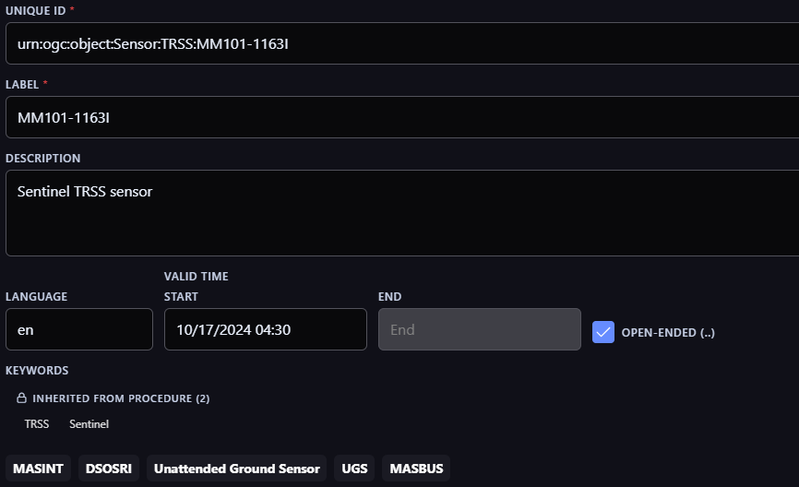
Figure 79. Identity text and explicit inherited keywords. Source: System Integrator System Screenshots 2026, slide 2. Original PNG bytes retained; display crop only.
The instance Description reads Sentinel TRSS sensor; inheritance is explicitly marked for keywords. This left-side detail does not establish ownership of the Description value.
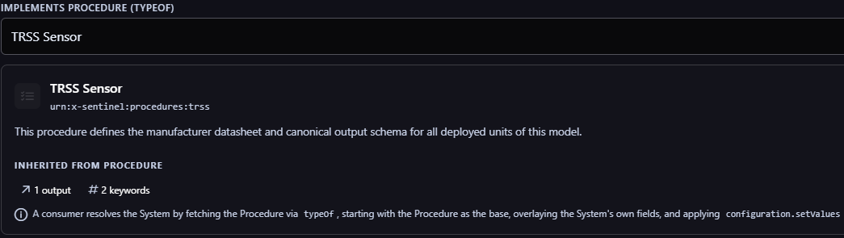
Figure 80. Linked model and inheritance explanation. Source: System Integrator System Screenshots 2026, slide 3. Original PNG bytes retained; display crop only.
The selected TRSS Sensor Procedure and inherited counts are visible. The full screenshot also describes a base/overlay algorithm, which remains an implementation claim requiring exported-data verification.
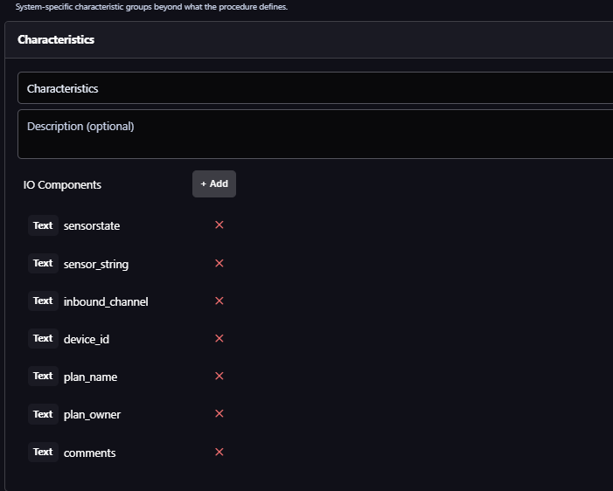
Figure 81. Local Characteristics and named channels. Source: System Integrator System Screenshots 2026, slide 6. Original PNG bytes retained; display crop only.
This left-side detail retains the seven Text channel names, including comments. There are no selected channel values or report times; channel names alone cannot establish current operational facts.
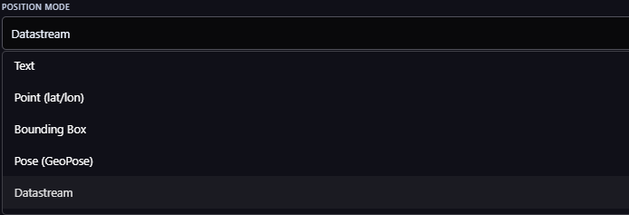
Figure 82. Position representation choices. Source: System Integrator System Screenshots 2026, slide 9. Original PNG bytes retained; display crop only.
The selector offers five visible options. Bounding Box has no demonstrated binding to the audited SensorML position schema; Datastream requires retrieval and time selection before a coordinate can be shown.
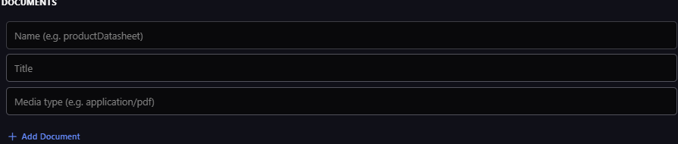
Figure 83. Document authoring metadata. Source: System Integrator System Screenshots 2026, slide 14. Original PNG bytes retained; display crop only.
This left-column detail shows name, title, media-type placeholder and Add Document. Role, URL and description are in the right column of the full screenshot; no file upload or image retrieval is demonstrated.

I 4 Standards mapping and remaining bindings
The table records available standard representations, not a claim that every screenshot control writes that exact property. Exported source payloads or implementation evidence are still required for the actual binding. CSAPI’s System mappings distinguish its resource attributes and associations from the SensorML representation; the schemas supply the deeper descriptor vocabulary (OGC 2025a, Tables 48–50; OGC 2025c, secs. 8.2 and 9.1; OGC n.d., SensorML JSON schemas).
Information family | Verified standard path | Meaning and binding limit
Name, description, language | $.label; $.description; $.lang | DescribedObject.json. Description optional; no universal model-purpose restriction or display length.
Validity and keywords | $.validTime; $.keywords[i] | Descriptor validity and discovery tokens. Keywords are not typed classifiers or generated operational facts.
Identifier and classifier terms | $.identifiers[i]; $.classifiers[i] | Each Term retains label/value and optional definition/codeSpace. A mission-name term is not automatically a Deployment link.
System model and settings | $.typeOf; $.configuration | AbstractProcess.json / Settings.json. systemKind maps to typeOf; plural procedures is separate. Actual resolution and ownership remain explicit.
Inputs, outputs and parameters | $.inputs[i]; $.outputs[i]; $.parameters[i] | Named component definitions, not automatically DataStreams, values or device command interfaces.
Capabilities and characteristics | $.capabilities[g].capabilities[i]; $.characteristics[g].characteristics[i] | DescribedObject.json. Keep group definitions/conditions and individual semantics. Static operating lifetime differs from battery remaining.
Composition and related Systems | $.components[i]; $.connections[i]; links with rel ogc-rel:subsystems | PhysicalSystem / AggregateProcess and CSAPI Table 50. Embedded/linked subprocesses and CSAPI resource associations are not interchangeable by name.
Physical parent and position | $.attachedTo; $.position | AbstractPhysicalProcess.json. Text, Point, Pose, Process and Datastream link are supported alternatives; reference frames and actual retrieval matter.
Bounding Box menu option | No verified position path | Not declared by the audited Position schema. Wider CSAPI geometry wording is a binding question; no exported response proves a defect or support.
Contacts | $.contacts[i] | Inline ResponsibleParty or ContactLink. Preserve actual role and person/organization/link scope; menu labels do not prove valid stored role URIs.
Documents and photographs | $.documents[i]; $.documents[i].link | Document.json, with purpose role and media type. Standard photo-link example supports images as documentation; screenshot does not demonstrate one.
Deployment participant | Deployment $.deployedSystems[i] | Participant name/system required; description/configuration optional. Values belong to that Deployment participation, not automatically to the System descriptor.

The Quantity schema requires type, definition, label and unit reference; its value is optional. A containing named property also requires name. The source’s visible definition/label/unit validation is therefore substantially grounded in the schema, while a numeric zero in a form does not establish an observed default. SWE optional/updatable semantics do not confer user authorization. Settings setValues refers to process parameters under the conceptual requirement; saving this metadata does not demonstrate sending a device command (OGC n.d., Quantity.json, AbstractDataComponent.json and Settings.json; OGC 2025c, req. 41).
Broader descriptor coverage remains available even when it is not populated or shown in this source: security/legal constraints, descriptor history, process inputs and modes, features of interest, local reference frames, time frames, interfaces and internal connections. Keep supported unfamiliar content inspectable in Full details or Source data and add purposeful sections only after its meaning is bound. Descriptor history is not automatically a CSAPI SystemEvent feed or an authoritative audit service. The absence of marking controls in these screenshots does not weaken our classification-banner and portion-marking requirement (OGC n.d., DescribedObject.json, AbstractProcess.json, AbstractPhysicalProcess.json and AggregateProcess.json).

I 5 DeployedSystem in ordinary terms
A System identifies the particular sensor. A Deployment describes a particular installation, mission or use involving one or more systems. DeployedSystem is that sensor’s participation entry inside the Deployment: it references the existing System and adds a deployment-local code name, specific description and settings. It does not create a second sensor identity. In JSON, the entries are in deployedSystems; each entry’s system link points back to the existing System (OGC 2025c, sec. 8.9.3, Table 3; OGC n.d., Deployment.json and DeployedSystem.json).
The populated CSAPI example makes this concrete: one temperature sensor is mounted on a vessel’s boom, another on its keel and a wind sensor on its mast. Each participant has its own installation description; one also has a referenced sampling-rate setting. Those notes explain this installation while the linked Systems retain their identity. The association is useful for the System’s resource-centric view because it lets the user inspect participation without rewriting the System’s own description (OGC 2025a, sec. 19.2.6).
For a hypothetical UGS example, System S17 participates in Perimeter Watch during 3–10 October. Its participant name is Gate_2 and its description explains its burial beside the north approach. Its declared configuration references the relevant process parameter. A later deployment can have another entry and period while S17 remains the same System. The System card could show the applicable deployment’s note with its name, period and source. Editing that note targets the owning Deployment; a reported battery reading or device-applied setting remains separate evidence. This example illustrates the model and does not assert a MERLIN source binding.
Select participation through a supported association and matching System identity; follow the advertised deployments link when available. Missing association evidence is not proof that the System was never deployed. Multiple relevant deployments need a selector or an established source rule, not an automatic “most recently edited equals current” choice. DeployedSystem has no separate per-entry validity member in the audited schema. Deployment area also differs from the focal System’s position. These distinctions guide what may enter Summary and what should remain accessible through Related (OGC n.d., DeployedSystem.json; OGC 2025a, req. 17 and Table 10).

I 6 Business case organization within a universal view
The standards supply an inventory and precise meanings. MERLIN supplies the order in which users encounter and use that information. A consistent frame can retain identity, markings, category/subcategory behavior, source inspection and permitted actions while each resource has an appropriate primary body. A System should explain itself and its operational relationships; an image Observation should present its image result. Universality is therefore a common interaction and traceability contract, with resource-specific content. It does not require every schema property to become a visible tab or every resource to display the same empty fields.
For Systems, Dave’s families can serve as a coverage checklist and as sections in Full details. Summary should bring together the supplied System text, a clearly attributed model explanation when available, and useful deployment-specific information after the actual association is verified. Reported condition stays time-qualified and does not replace the description. Editing belongs beside the information it actually changes, with Save/Cancel and the owning resource explicit. Deep schema/component authoring is a deliberate supported editing task; it should not dominate ordinary inspection.
This is a six-category review candidate, not a newly accepted tab specification. It carries forward the current review’s combined Activity, Details/Map/source-inspection and conditional Symbol proposals. Configuration remains a conditional Details subdivision from Requirements v0.8. Dave’s metadata families become readable sections under Full details, rather than seven more top-level tabs. Retain the fixed identity header, top and bottom markings, the active category’s adjacent sub-tabs and section disclosure. Exact tab visibility, overflow and dimensions still need review at the compact Dockview size.
Candidate category | Candidate subcategories | Purpose and change from earlier proposal
Details | Summary; Full details; Map; conditional Configuration; Source data | Explain this System, inspect descriptor groups, locate it and inspect its actual representations. Map and Source data move under Details in this candidate; Full details replaces the ambiguous scalar Description label.
Status | Battery; Communications; other supplied diagnostics | Present reported operational condition with subject, units, time and measured/estimated basis. Static battery lifetime or schema defaults stay distinct. Battery includes useful indicators and available history.
Activity | Table; Charts; Feed | Combine source-backed Observations, Commands and System Events with type filters. Reuse the Discovery semantic approach after exact column bindings are checked. Charts depend on meaningful quantities; feed/cards on useful result content. Live mode remains conditional.
Commands | Available; Schedules when supported | Compose supported operations and review their parameters/effects. Follow issued requests in Activity with status/results attached to the identified command; do not duplicate independent histories. Scheduling needs a verified operation.
Related | Relationships; Contacts; Documents when useful | Group actual hierarchy, model/Procedure, Deployment, stream and Feature links by role. Contacts retain roles and Documents retain role/media type; increase subdivision only when content warrants it.
Symbol | Applicable scheme and edition | Show the supported symbol and its interpretation. The screenshots do not establish this capability. Retain Sam’s existing conditional proposal and keep symbol configuration distinct from reported resource facts.

Full details can contain collapsible Identity/identifiers, Classification, Model, Capabilities, Characteristics and other supported descriptor sections. Related holds navigable resource associations and deeper supporting information. A document preview, map or result chart belongs where it answers the active question; media type alone does not establish the business meaning. Charts require compatible quantities and time semantics. Commands require an actual supported control interface; a capability range does not authorize an operation. Status/Battery keeps measured voltage, capacity estimates and life estimates visibly distinct, including their time and basis.
The candidate removes the older split between top-level Observations and a vendor-specific Activity while retaining useful Table/Charts/Feed views and type filters. This is an application presentation of distinct source resources, not a new common CSAPI resource or fabricated event service. It also avoids separate top-level Map and Source Data in the compact System candidate. These are refinements to review with Sam one view at a time; no category is locked by this research pass. Selective useful section expansion remains preferable to opening a generic form of empty fields in the default card.

I 7 Description correction and finite next action
Sam corrects the earlier chat’s reading of Figures 74 and 76. The old Sensor Description Viewer title named the whole view, analogous to our Details view. Its Comments are specific emplacement information. The implemented Description/Comments field is blank; Sam attributes the widespread blanks to inconsistent comment-entry practice. These sources do not support the asserted generic-description function or precise placement, editing or truncation. Their raw storage binding is unverified. This correction governs any earlier implication to the contrary (Bolling, personal communication, October 9, 2026; UGS Client Development Wireframes n.d., slide 6; MASBUS Details View Captures 2026, slide 1).
Keep the accepted header. Before deciding a character cutoff or expansion control, settle one concrete System Summary: what does this instance supply, what does its linked model explain, and which deployment participation or reported values are applicable? The screenshots supply a useful fixture but not an exported payload. The narrow remaining evidence request is the selected System’s actual descriptor, linked model and applicable Deployment, plus the precise write targets. If unavailable, retain a labelled illustrative mapping and the gap. Then review that one Summary, followed by each remaining candidate category. Only a named binding or task failure should reopen research; a wider UI survey is not a prerequisite.
The exact current Discovery FINAL workbook/PDF Description mapping remains an access gap from the previous pass. Guide v0.5 supports source meaning and separate related values, but its purpose-oriented description wording and the Requirements v0.8 Description route remain candidates to reconcile after owner review. This update changes the paper and PITON, not those documents, the Discovery PBI or unrelated domain judgments.

I 8 Source register and complete coverage
Source ID | Exact supplied source | Review coverage
S29 | System Integrator Screenshots for System Resource.pptx | 14 slides / 14 original PNGs; all directly inspected. Native identity libfile_c714f1ec5b0c8191941b2796c1559407. Earlier Integrator source remains separate.

Slide | Inspected subject | Evidence and limits
1 | System collection and varied cards | Generic descriptions, repeated-ID prose, Procedure labels and visible keywords; collection browsing is distinct from a focal Details card.
2 | Identity | Type/definition, UID, label, description, language, validity and inherited versus local keywords. Description has no inheritance marker.
3 | Procedure and Config | Linked TRSS model, inherited output/keyword counts, no declared parameters, additional outputs. Helper text claims a resolution algorithm.
4 | Additional output editor after scrolling | Typed scalar/range/composite/advanced choices; metadata, units, default value and validation. Schema authoring, not observed values.
5 | Capabilities and Characteristics | Empty inherited groups, local Characteristics and initial Text channels; group expansion/override instructions are not demonstrated resolution.
6 | Characteristics continuation | Seven Text channels including sensorstate, plan_name, plan_owner and comments. No channel selected and no value/time shown.
7 | Subsystems and New Subsystem | Template option, identity/type/model inputs, empty hierarchy and creation controls. Composition/Deployment helper is an application claim.
8 | Point position | Map, latitude/longitude, altitude 0 M and edit instructions. CRS, altitude reference and position time absent from this view.
9 | Position selector | Text, Point, Bounding Box, Pose and Datastream options. Menu presence does not establish each serialization or renderer.
10 | Datastream position form | Reference entry plus DataRecord/read-time-resolution helper. No resolved position shown; muted URI may be placeholder.
11 | Identifiers and Classifiers | Eleven populated label/value/definition rows and empty additions. planName and missionName do not themselves prove Deployment associations.
12 | Contacts and Documents | Individual/Organization, contact roles and collapsed detail; no documents. Names for organizations are empty.
13 | Expanded contact information | Phone/fax/web/service instructions, address and email fields, mostly placeholders; body scrolling preserves editor frame.
14 | Added contact and document form | Blank contact plus document name/role/title/URL/media type/description inputs. No upload, retrieved image or successful save shown.

I 9 References for this update
System Integrator System Screenshots. 2026. System Integrator Screenshots for System Resource.pptx. Fourteen-slide screenshot presentation supplied by Sam Bolling, October 9. Unpublished. Dave’s authorship and purpose are attributed to the owner; formal release and publication date are unverified. All supplied images reviewed.
OGC (Open Geospatial Consortium). n.d. SensorML 3.0 and SWE Common 3.0 JSON Schema Collections. Official schemas accessed October 9, 2026. Exact files cited below; OGC 2025a–d refer to the standards entries in the main References section.
CSAPI Part 1 System mappings and populated Deployment example
SensorML 3 Deployment and DeployedSystem classes
SensorML 3 DescribedObject schema
SensorML 3 AbstractProcess schema
SensorML 3 AbstractPhysicalProcess schema
SensorML 3 AggregateProcess schema
SensorML 3 PhysicalSystem schema
SensorML 3 Settings schema
SensorML 3 Deployment schema
SensorML 3 DeployedSystem schema
SensorML 3 ResponsibleParty schema
SensorML 3 ContactLink schema
SensorML 3 Document schema
SensorML 3 Pose schema
SensorML 3 commonDefs schema
SWE Common 3 Quantity schema
SWE Common 3 AbstractDataComponent schema

Appendix J. System access priorities and standards coverage

J1. What this pass changes
Sam’s 9 October clarification establishes the opening view as access to the selected resource: understand its useful present or last reported condition, inspect the relevant deployment and reach its data and supported actions. The operational manuals and original wireframes set these priorities. Dave’s Integrator contributes one implementation example. CSAPI, SensorML and SWE Common establish the other end of the mapping independently of his editor. This does not make the opening card a copy of a manual window or a schema editor.
The pass is bounded to System information families and the opening Summary. It rechecks the operational evidence already catalogued in §§7.18–7.21 and Appendix I, then reads the published CSAPI 1.0 Parts 1–2, SensorML 3.0 and SWE Common 3.0 and selected official JSON schemas. The current standards are a design reference, not a claim that the historical systems used them. No live provider responses, permissions, conformance declarations or successful device operations were supplied. Every mapping below is therefore a verified standard route or an explicitly unresolved domain binding—not a recovered implementation binding.
A consequential finding: CSAPI Part 2 §9.2.2, Table 3 defines a DataStream type of status for observations of the parent System or one of its subsystems. Battery, mode and diagnostics can therefore arrive as observations about the equipment itself. The standard does not define universal battery, health or mode properties. The stream’s declared result schema must identify each property, the equipment it describes, its units or codes and its time. A stream producer and the subject of its readings may differ. [N2, N5–N7]
Dave’s screenshots cannot establish complete coverage. They show selected descriptor and editing families, but not all inherited process classes, the dynamic-data resource lifecycle, every encoding, transaction or temporal capability. Conversely, an unshown field is not proof his implementation lacks it. This audit evaluates the evidence, not Dave’s software conformance. The standards are also extensible: covering their information families cannot enumerate every vendor property or guarantee a specialized visualization for each one.
Three meanings remain separate throughout: a descriptor says what the System is or is configured to represent; a Deployment participation says how that same System is used in a particular deployment; an Observation reports a property at a time. Commands request changes, and their status reports describe progress. A UI can place these together while retaining their separate owners and provenance. Figures 74 and 76 remain evidence of emplacement Comments and legacy Description/Comments, not proof of a generic model-description field.

J2. Operational need → standard route → presentation
Paths use the published JSON representations. “result / declared field” means a path resolved from the actual result schema; it is not a literal JSON member. N-references are listed in J7. Figure and slide locators refer to the unchanged source catalogue. Each row remains subject to the server’s actual supported representation and resource links.
Operational evidence | Authoritative route and meaning | System-view implication / unresolved binding
Recognize this device  UGS slide 6 / Fig. 74; MASBUS slide 1 / Fig. 76. | System id; GeoJSON properties.name or SensorML label; uniqueId / properties.uid is a different identifier. Model association: properties.systemKind@link or typeOf. [N1, N3–N4] | Keep the locked Name and Resource Type / ID / Source header. Source is retained MERLIN server context. Model and serial remain distinct; do not manufacture Name or treat TRSS_IMG as assetType.
Reported condition and operating mode  OmniSense training pp. 41–42 / Fig. 56; McQ slide 55, printed 7-32 / Fig. 69. | DataStream.type=status plus Observation result / declared field, phenomenonTime and resultTime. SWE definition, Category codeSpace and units describe the actual fields. [N5–N7, N15] | Show the most useful verified readings with their subject and report/measurement time. No universal System.status or inferred overall health. ANTICIPATED in TRSS is a planning state, not a measured condition.
Battery condition  TRSS slides 14–15, 28–29, 51–52; McQ slides 55–56, printed 7-32–7-33. | Dynamic result property with definition and unit; estimate additionally needs its method/inputs or declared provenance. SensorML characteristics/capabilities may describe static battery properties. [N3, N5–N7, N15] | A verified capacity percentage can use a compact bar. Voltage uses volts and useful history; do not convert it to capacity without a justified model. Unknown, not reported, unsupported and estimated are different states.
Location and map  TRSS slides 1–7 / Fig. 57; UGS Fig. 74; MASBUS Fig. 76. | System GeoJSON geometry or SensorML position. Physical position can be a point, pose, text, process or stream-linked form; local reference frames can qualify it. [N1, N12] | Show a concise location and a route to Map when usable. Position time needs its own source: descriptor validTime is not location time. Deployment area and System point are not interchangeable.
Emplacement notes and period  TRSS slide 4 / Fig. 57; UGS slide 6 / Fig. 74; blank MASBUS Description/Comments in Fig. 76. | Deployment.deployedSystems[i] holds participant name, system link, description and configuration; Deployment.validTime supplies the deployment period. [N13] | A credible home for deployment-specific notes, not a proven migration of every legacy comment. Show owning deployment and resolve multiple applicable deployments. Implant/removal dates need exact bindings; no participant-specific validTime is established.

J2 continued. Configuration, actions and access
Operational evidence | Authoritative route and meaning | System-view implication / unresolved binding
Configuration and model settings  TRSS Save to Plan and Remote Configure; McQ CORE slides 1–3 / Fig. 65. | SensorML typeOf links the base process; configuration uses Settings ref/value entries. Deployment participant configuration has its own owner. Inputs, outputs, parameters and modes describe process structure. [N4, N11, N13] | Provide access to declared settings. Keep staged edits, stored declarations, last reported device settings and confirmed effects distinct. No assumption that editing SensorML sends a device command.
Request status, capture image, update settings  OmniSense training pp. 34–38; TRSS command variants; McQ Command Status versus stored Status. | ControlStream.schema defines valid command parameters and possible results. Command.parameters, issueTime and executionTime; CommandStatus.statusCode, reportTime and results. [N8–N10] | Offer only the operation supported for the selected receiver. Refresh retrieves existing records; Request status creates new work. Acceptance is not completion. Image capture may have prerequisites; its returned Observation requires a verified relation.
Scheduled work  OmniSense sleep schedules p. 31; TRSS periodic images; McQ sleep/rules. | Command executionTime and SCHEDULED status can represent supported scheduled work. A recurring device policy may instead be a declared parameter or a configuration command payload. [N8–N11] | Do not equate a sleep policy, repeating capture rule and one future command. Show scheduling only when the specific operation, clock, recurrence semantics and modification/cancellation capability are known.
Readings, images and history  TRSS slides 65–67 / Fig. 62; McQ image/signal and status histories; UGS Observation links. | System datastreams association → DataStream → Observations. Observation result or result@link follows the declared result schema and supported encoding. [N1, N5–N7] | Provide a direct route into System-scoped Activity. Table, charts and media/feed presentations depend on content semantics. Parent stream results may include subsystems; retain producer and subject rather than relabeling them as the parent.
Commands and events beside observations  Existing MERLIN analogous presentation guidance; TRSS/McQ queues illustrate different clocks and states. | ControlStream → Commands → status/results; System events association → SystemEvent. Event JSON inherits SensorML Event semantics. SensorML history is a separate embedded source. [N8–N10, N14] | Candidate Activity co-displays resource types with filters; no universal activity endpoint is implied. Preserve type, origin, relevant time and per-command progress. Do not infer recursive events from the subsystem stream rule.

J2 continued. Supporting context without crowding the opening
Operational evidence | Authoritative route and meaning | System-view implication / unresolved binding
Communications, components and neighbors  TRSS device/detector roles; McQ slides 19, 99, 101–102. | PhysicalSystem/AggregateProcess components and connections; CSAPI subsystem association; attachedTo for physical parent. RF metrics need declared Observation properties or explicit domain relations. [N1, N12, N16] | Subsystem, physical mounting, Deployment membership and radio reachability are distinct. No universal neighbor or online property is established. Communications depth may show time-qualified signal or packet measurements.
Model explanation and full description  Dave slides 2–6; MASBUS Full Sensor Description; enterprise users unfamiliar with equipment. | System description and linked typeOf Procedure description retain their own ownership. Capabilities/characteristics carry typed values and conditions. Inheritance requires actual resolution, not a screenshot assumption. [N3–N4] | Keep concise model help accessible and Full details readable. It need not lead Summary. Neither legacy Comments nor the standard establishes a universal read-only model description or a universal editable instance comment.
Contacts, manuals and system photographs  UGS/MASBUS POC; Dave slides 12–14. | SensorML contacts[i] uses ResponsibleParty or ContactLink; documents[i] uses Document with a link and media information. [N3, N17] | Present role-qualified contacts and useful documents. A photograph documenting the equipment is different from an image Observation it produced. System, model and Deployment contacts must retain their owner.
Source representations and editing  MASBUS slides 2–6: full rendering, raw SensorML and editors. | Supported representation at the canonical resource URI, with content negotiation and advertised API operations. SensorML/SWE schema constraints describe data; server permissions govern allowed writes. [N1, N3, N15] | Details → Full details and Source data remain candidates. Identify actual encoding/version. Editing targets the owning resource; updatable does not confer permission. Captured MASBUS XML is explicitly SensorML 1.0.1.
Security and Symbol  Owner requirements; existing Symbol research §7.17; source marking conventions. | SensorML securityConstraints and legalConstraints support descriptor-level information; property marking needs a declared extension/profile. No universal MIL-STD-2525 or APP-6 symbol member is established here. [N3] | Preserve top/bottom classification banners and correct portion markings using the applicable security profile. Symbol remains conditional by scheme/edition and mapped facts; neither a classifier nor a document icon alone defines its full meaning.

Common structure should follow these semantic distinctions across vendors. Adapt content to verified properties and supported operations, not a manufacturer name or the tabs a screenshot happens to show. A static field named sensorstate, a device status observation and a command’s status can all exist; their matching English words do not make them the same value.

J3. Standards → useful information that examples may omit
This reverse check covers the main System-relevant information families in the reviewed standards. It is not an exhaustive conformance audit or a requirement to show every optional family. “Review destination” is a proposed UI disposition; these are not standard-defined tabs. Values remain inspectable in Full details/Source data when a specialized renderer is unavailable.
Standard information family | Coverage and review destination
Identity, text, language and discovery terms [N3] | label, description, lang, keywords, identifiers and classifiers. Locked identity stays visible; typed identifiers and classifications go in Full details. Preserve labels, definitions and code spaces. Do not fill Summary with discovery tokens.
Descriptor validity and provenance [N1, N3] | validTime governs the descriptor’s validity, not a universal report time, last contact or emplacement period. Actual version/temporal support determines historic inspection. Keep retrieval time and source identity separately labeled.
System kind and other Procedures [N1, N4] | typeOf / systemKind describes a base kind; procedures is a separate association to implemented Procedures. Show distinct relationship roles and inherited provenance. No wholesale copying of model fields into writable instance data.
Characteristics and capabilities [N3] | Groups carry individual properties, definitions and optional conditions. Full details can expand these groups without discarding qualifiers. Promote only task-relevant values. Operating lifetime capability is not remaining battery charge.
Inputs, outputs and parameters [N4, N15] | Named SWE components describe process interfaces and constraints. They are not automatically live streams, current observations or command endpoints. Configuration and Full details use the actual component semantics.
Modes and configuration [N4, N11] | modes describes choices; Settings can set values, arrays, modes, constraints and enabled/disabled status of referenced components. setStatus is not an overall health field. Keep definition, stored setting and observed behavior distinct.
Process method and composition [N16] | SimpleProcess/PhysicalComponent method and AggregateProcess/PhysicalSystem components/connections support more than a standalone physical sensor. Show appropriate process or component detail; do not force map, battery or hardware assumptions onto every System.
Physical position and frames [N12] | position, attachedTo, localReferenceFrames and localTimeFrames qualify physical descriptions. Map needs a resolvable coordinate/reference binding; pose or relative coordinates may need the parent transform. Retain a readable fallback.
Deployment and participation [N13] | Deployment location/platform/deployedSystems can add operational context without changing System identity. Display the applicable association explicitly; several deployments may exist. Owner/time selection is a real binding decision.

J3 continued. Relationships, dynamic data and operation support
Standard information family | Coverage and review destination
Feature and sampling relationships [N1, N4–N5, N8] | featuresOfInterest and the samplingFeature/featureOfInterest stream relations distinguish what is observed or affected from who produces/receives. Related and Activity should preserve these roles; a detector Target ID does not automatically identify a persistent Feature resource.
Contacts and documents [N3, N17] | Role-qualified people/organizations and linked documentation support POC, manuals and photographs. Related is a candidate home; an operationally important contact can be exposed sooner. Do not infer upload capability from a document-link field.
Security and legal conditions [N3] | securityConstraints, legalConstraints and supported extensions require profile-aware handling. Banner/portion markings and access checks remain distinct. No standardized universal marking vocabulary or authorization rule is inferred from the container alone.
History and events [N3, N14] | Embedded SensorML history and linked CSAPI SystemEvents can support maintenance or other events. Activity needs explicit source handling and deduplication if both represent the same event. Event type must come from its definition, not the word “activity.”
Streams, observations and results [N5–N7] | Status versus other observations, observed properties, result types, schema, time extents and result links inform presentation. Time extents summarize a collection; they are not the timestamp of every displayed reading. Charts require meaningful quantities and compatible units.
Control, progress and results [N8–N10] | ControlStream schema, controlled properties, live/async metadata, Command and CommandStatus support discoverable actions and subsequent progress. Feasibility/result schemas are conditional. Scheduling and execution behavior must be supported by the specific interface.
SWE value semantics and structures [N15] | Definitions, units, categories, ranges, constraints, nil reasons, records, vectors, choices and arrays guide readable fields and visualization. Schema defaults are not observations. Preserve quality and reference metadata when supplied; avoid assuming any numeric field is a percentage.
Representations, writes and temporal/live support [N1–N2] | Server conformance and API descriptions determine encodings, transactions, temporal queries, snapshots and streaming capabilities. The published breadth is not a promise a provider implements all of it. Source fallback, refresh and permitted editing need capability checks.

The standards review therefore broadens the inventory beyond Dave’s visible forms while keeping a finite implementation boundary: shared reading and navigation, specialized renderers for selected well-defined properties/results, and faithful structured/raw inspection for everything else. Missing data, unavailable permission, unsupported capability and unresolved mapping must not all become the same empty field.

J4. Proposed opening Summary for the next owner review
Retain Details → Summary as the working entry point and the locked identity/classification frame. “Summary” describes a compact selection of useful information, not another standard property. The proposal below changes priority within that view; it does not accept the six-category structure, final labels, dimensions or disclosure cutoff.
Order | Proposed content | Why it earns opening space
Persistent frame | Top classification banner; supplied Name; Resource Type, ID and Source; category/subcategory navigation; bottom classification banner. | Already owner-locked. Identity remains stable while the body changes. Keep the compact square or broad rectangle.
1. Reported condition | A small selection of supplied operating mode, a meaningful condition/diagnostic and battery reading where applicable. Keep time visible; identify estimates. | TRSS and OmniSense/McQ emphasize checking the equipment’s condition. Use verified readings, not a generated health score or mandatory blank sensor fields.
2. Location and deployment | Concise location, applicable deployment and short emplacement note when supplied. Use clear labels such as Deployment or Emplacement note only after the bindings justify them. | Operational users need the particular installed system. Keep deeper geometry, dates and notes behind useful disclosure or Map access; no vague “collection context” bundle.
3. Direct access | Make the route to readings/history, configuration and supported commands obvious through the category controls. Add a small contextual shortcut only when it materially helps the task. | Access is the point of entry. Avoid duplicating every tab as a button grid. Refresh is distinct from Request status; device work opens an explicit action flow.
Secondary explanation | Model and concise supplied description remain reachable in Full details or a short disclosure, promoted when operational context is sparse or users need identification help. | Preserves the enterprise explanation use case without making generic prose dominate equipment access.

This is a priority order, not five mandatory stacked panels. On a small card, the condition row may contain only two useful readings and a time; the location/deployment area may be equally short. If the resource is a process, group or a system with no verified physical telemetry, use its available task-relevant content. Do not fabricate battery, location or health to preserve visual symmetry. Confirm selected information at the actual card size during the next single-view review.
A battery indicator must match its quantity: a percentage bar for validated remaining capacity, a numeric voltage with trend for voltage, or an explicit unavailable/collecting state. A stale reading retains its last value and time with a source/profile-backed freshness rule. Different readings may have different times; do not place a common “as of” over them unless it genuinely applies to the whole record.

J5. A finite binding check before implementation
For each displayed value, retain a compact trace record: user need and exact evidence locator; owning resource and canonical link; representation/schema and exact path; semantic definition and subject; unit/code/quality; relevant time; derivation or inheritance; supported edit/action target; and UI placement. This is an implementation mapping, not another user-facing metadata panel. The matrices above supply the standards end; actual provider exports must close the remaining paths.
The narrow evidence packet is one selected System response and its supported SensorML representation; the linked kind/Procedure and applicable Deployment; one status DataStream schema plus representative observations; and one ControlStream schema with example command/status resources if supported. Conformance/API metadata and applicable permissions establish which operations exist. Add only the specific missing evidence that blocks a chosen field. No broad new UI survey is needed to review the proposed Summary.
Check the proposed mapping against four concrete failure cases: a subsystem’s status must not become the parent’s reading; old telemetry must not appear current; a saved descriptor or queued command must not be described as applied configuration; and an unavailable battery estimate must not appear as a confident full battery. These cases come directly from the operational evidence and semantic distinctions, rather than test cases that merely repeat UI code.

J6. What is accepted, proposed and next
Accepted direction: prioritize access to the selected resource; use operational evidence to choose what matters; map against the standards independently of Dave’s implementation; retain the locked header and classification frame. Proposed: the opening content order in J4, specialized visuals and the existing six-category inventory. Unresolved: exact provider bindings, content selection at size, expansion mechanism, permissions, tab visibility and final pixel criteria.
Requirements v0.8 §6.1.1.1 and Guide v0.5 §10.1.2 contain the earlier purpose/description-led opening recommendation. This new owner direction reopens that priority; those artifacts are intentionally not edited in this research pass. Their identity and semantic contracts remain useful. Reconcile the opening-priority wording and category placement after Sam reviews this one Summary; do not treat older prose as overriding the latest direction. No wireframe has been redrawn or accepted in this pass.
The immediate next step is a narrative, item-by-item review of Details → Summary, starting with the first body group, reported condition. Show the operational example, the standard meaning and the specific candidate binding together. Settle what belongs on that view before moving to another. Source exports can resolve implementation gaps in parallel with that discussion; their absence does not justify another unbounded research cycle.

J7. Primary reference register for this pass
Official editions reviewed on 9 October 2026: CSAPI 1.0 Parts 1–2, SensorML 3.0 and SWE Common 3.0. Linked schemas specify the cited JSON paths; XML and alternative Observation formats must use their own verified bindings. The local audit retains retrieved source files and SHA-256 values. Operational source locators are in J2 and the existing source appendices; no historical source image was altered or newly substituted.
N1 — OGC 23-001, Connected Systems Part 1 (System model and encoding mappings, Tables 39–41 and 48–50).
N2 — OGC 23-002, Connected Systems Part 2 (§9.2.2 status streams; Observation and command models).
N3 — SensorML DescribedObject schema.
N4 — SensorML AbstractProcess schema.
N5 — CSAPI DataStream schema.
N6 — CSAPI Observation schema.
N7 — CSAPI JSON Observation schema descriptor.
N8 — CSAPI ControlStream schema.
N8a — CSAPI JSON command schema descriptor.
N9 — CSAPI Command schema.
N10 — CSAPI CommandStatus schema.
N11 — SensorML Settings schema; OGC 23-000 §§8.8.1–8.8.2 explain modes/settings.
N12 — SensorML AbstractPhysicalProcess schema (position and reference frames).
N13 — SensorML Deployment schema and its referenced DeployedSystem schema.
N14 — CSAPI SystemEvent schema, inheriting SensorML Event.
N15 — OGC 24-014, SWE Common 3.0 (data components, semantics and encodings).
N16 — OGC 23-000, SensorML 3.0 (physical and nonphysical process classes).
N17 — SensorML Document schema; ResponsibleParty and ContactLink are referenced by N3.

Appendix K System categories and viewing before editing

K1 Where the proposed themes came from
The recommended candidate for the next System review has four peer categories: Operational, Activity, Commands and Details. Details is a working label for readable descriptive information with permitted editing. Map sits under Operational in this candidate. Symbol provisionally sits there too, with a scheme-and-edition selector; a peer Symbol category remains an alternative if its tasks justify the space. These are authored design recommendations, not categories defined by CSAPI or accepted by the owner.
The preceding “reported condition,” “location and deployment,” and “direct access” themes were the assistant’s synthesis. TRSS General Sensor and battery examples, McQ Status, and the UGS/MASBUS location and emplacement information support their contents (Figures 57, 60–61, 69, 74 and 76). They do not prescribe those headings. The third theme described an interaction objective rather than an information subject. Appendix J therefore established opening priorities, not a coherent top-level taxonomy. Sam’s request for objective evaluation correctly exposes this distinction (Bolling, personal communication, October 9, 2026).
This pass is an expert task walkthrough against existing sources, not an observed usability test, measured performance comparison or proof of a best layout. It checks whether users have a plausible starting point, whether source ownership and effects stay clear, whether navigation becomes duplicated, and whether compactness is merely traded for crowded subtabs. Standard paths remain those in Appendix J; reorganizing presentation does not redefine the data.
Peer category | Candidate subviews | Boundary
Operational | Overview; Map; Status; Relationships; conditional Symbol | Understand this selected System in use. Overview is the proposed entry. Status contains expandable Battery, Communications and other supplied diagnostics; these are sections, not a third tab row.
Activity | Table; Charts; Feed when supported | Inspect Observations, Commands and System Events with type filters and explicit System/member scope. Alternate renderings use the applicable records; charts need suitable quantities.
Commands | Available; Scheduled when supported | Find and compose supported operations; inspect/manage scheduled work when the interface allows it. Issued-command details and progress use the same record as Activity.
Details — working name | General; Model and settings; Capabilities; Components; Contacts and documents; Source data | Read the descriptive record and supporting information. Specific editable groups expose Edit. This is not an administrator-only category or an automatic schema editor.

K2 Task walkthrough of the candidate structure
The routes below are proposed task paths, not measured click counts. A shortcut may open the same destination directly; it must not create a second independent workflow. Outcomes identify useful choices and remaining problems instead of assigning invented usability scores.
Task and evidence | Proposed route | Outcome and necessary distinction
1 Check battery  TRSS slides 14–15, 51–52; McQ slides 55–56. | Operational → Overview for a key reading; Status → Battery section for detail/history. | A short value and a deeper battery presentation serve different depths. Capacity, voltage and estimates retain their meanings. A “Battery details” action should open that section, avoiding a search through unrelated status.
2 Inspect emplacement notes  TRSS slide 4; UGS slide 6 / Fig. 74. | Operational → Overview; expand the relevant note or deployment information. | No generic description substitution. Show the owning Deployment/participant when verified. An edit targets that owner, not the linked model or an unrelated System text field.
3 Locate the system  TRSS General Sensor; Dave slides 8–10. | Operational → Map. | A map can have an ordinary information-category home. Text/relative/stream-derived position needs an appropriate fallback and source qualifiers. Opening Map does not enter position editing.
4 View a collected image  TRSS slides 65–67; McQ imagery examples. | Activity → Feed, or Table → selected Observation. | Read the actual result using its schema/media type. Keep the selected System as the card’s focus unless the user explicitly opens the Observation’s own Details. A system photograph belongs to documentation instead.
5 Request fresh status  OmniSense training pp. 41–42; McQ Command Status distinction. | Commands → Available → supported status request; optional shortcut from Operational. | A separate Commands category makes this discoverable without treating it as administration. Refresh only retrieves existing data. Show request progress and any linked returned evidence; do not claim that the request itself refreshed every reading.
6 Take an image  OmniSense training pp. 34–38; TRSS acquisition prerequisites. | Commands → Available → supported acquisition operation. | Use one composer and receiver. A shortcut from Activity may open it. Preserve prerequisites, parameters and returned-result links; pressing the action is not evidence of successful acquisition.

K2 continued Management history and representation tasks
Task and evidence | Proposed route | Outcome and necessary distinction
7 Change configuration  TRSS Save to Plan/Remote Configure; McQ Queue; Dave slide 3. | Details → Model and settings for declarations; Commands for supported device configuration. | The read view must distinguish declared settings from reported device settings. “Edit settings” and “Send configuration” cannot be two labels for an unspecified Save. A shortcut can carry verified values into the command composer.
8 Review command progress  McQ queue examples; CSAPI CommandStatus. | Activity filtered to Commands → command detail; Scheduled may open the same detail. | Keep a single command identity and progress presentation. Activity is the cross-type history; Commands is the tasking home. Filtering or cross-linking is useful; separate inconsistent histories are not.
9 Schedule work  TRSS periodic images; OmniSense sleep schedule. | Commands → Available for a supported future request; Scheduled to inspect/manage it. | A recurring device policy is not necessarily an individually scheduled CSAPI command. Populate Scheduled only from a known representation/query and supported operations. Do not promise cancellation or recurrence editing from the tab name.
10 Find a contact or manual  UGS POC; Dave slides 12–14. | Details → Contacts and documents; a relevant operational POC may be linked from Overview. | Read role-qualified entries before any edit form. Editing a linked contact may affect more than this System; identify the owner. A document URL editor does not establish an upload service.
11 Understand or change the symbol  Owner proposal; paper §7.17. | Operational → Symbol, then scheme/edition selector; focused configuration action where supported. | Avoid a third tab row. Separate rendering preference from reported affiliation/location or other source facts. A report-based correction follows its verified observation workflow; editing an icon is not equivalent.
12 Inspect exact source data  MASBUS raw SensorML; Dave descriptor forms. | Details → Source data, with actual representation/version selector. | Retains a place for full structured/raw inspection. Use supported encodings at the canonical resource. Do not promise raw JSON for captured XML or silently expose a general raw-document editor.

The walkthrough supports Commands as a peer and Map beneath Operational. It also reveals the main weakness: Operational and Details can accumulate too many subviews. Status groups battery/communications as expandable subjects, while the Details mapping below combines compatible descriptive families. These measures need a later to-scale check; fewer peer tabs alone do not establish lower cognitive load.

K3 Reusing Dave’s information organization
Dave’s fourteen screenshots describe an Edit System workflow, not a verified read-only counterpart. Their value is the recognizable information families, structured fields and potential editor behavior. Reuse should be evaluated in three layers: information grouping, field semantics/validation and software components. The first is visible; the second requires the actual serialization and definitions; the third requires code inspection. This pass does not establish reusable implementation code (System Integrator System Screenshots 2026, slides 1–14; Appendix I).
Dave’s source family | Candidate reading view | Reuse and boundary
Identity; Identifiers and Classifiers  Slides 2, 11 | Details → General | Combine readable identity, description, language, validity, terms and definitions. The locked header remains above. Distinguish additional identifiers, classifications and inherited values; do not equate a mission-name term to a Deployment link.
Procedure and Config; output editor  Slides 3–4 | Details → Model and settings | Show linked model, declared settings and interface definitions. Retain input/output/parameter distinctions. Schema authoring is a specialized permitted edit, not a way to change an observation value.
Capabilities and Characteristics  Slides 5–6 | Details → Capabilities | Use separate expandable Characteristics and Capabilities groups, keeping source definitions and conditions. The shorter tab label is provisional; it must not conceal characteristics or imply that named Text channels are live status.
Subsystems  Slide 7 | Details → Components | Inspect components and their roles, with a supported add/edit workflow separately invoked. Related System resources open their own Details explicitly. Components, physical parent and Deployment participation remain distinct.
Position  Slides 8–10 | Operational → Map; structured position inspectable in Details | Reuse a verified position editor only after an explicit edit action. A position-stream link, device-reported coordinate and manually maintained descriptor geometry need different ownership rules. Do not create a competing Position tab merely to copy the editor.
Contacts and Documents  Slides 12–14 | Details → Contacts and documents | Read role-qualified contacts and usable links/media first. Allow focused editing of the selected owner. Reuse blank add forms only after Add/Edit; a documentation image is not an equipment-produced Observation.

Source data is retained from the broader MASBUS/standards requirement, independently of Dave’s editor. Relationships remains available under Operational for deployment, mission and associated-resource exploration; model/components/contact views also expose their specific links. These are different routes into the same authoritative resources. Full structured inspection must preserve additional supported SensorML content even when no dedicated renderer exists.

K4 Viewing first and editing a defined target

K4 1 The normal reading state
Opening a descriptive subview shows readable labels and values, useful linked resources, units, times and provenance. It does not show disabled input controls, empty add menus or an implicit draft. A concise Edit action belongs to the smallest coherent group that has one clear save target; Add may remain appropriate for supported repeatable entries. If a subview has several resource owners, a single ambiguous “Edit everything” button is inappropriate.
Permission to read does not imply permission to edit. Offer editing only when the operation, target and user authorization are established; server enforcement remains authoritative. Missing source data is identified honestly, and an authorized Add action can be offered where creation is supported. Unknown capability, denied access and unsupported editing need distinct handling without scattering alarming messages through the normal view. The GOV.UK summary-list pattern supports readable key/value information with clearly associated change actions; it does not establish MERLIN’s category arrangement or require a link beside every field (Government Digital Service n.d.).

K4 2 Entering and leaving an edit
An explicit Edit action enters a focused editing state inside the same compact view where feasible. Retain identity and security markings, prepopulate actual values, distinguish inherited values from non-editable fields and state what will be saved. A permitted local override identifies its scope rather than silently editing the model. Cancel returns without writing. Validate applicable schema and cross-field constraints before submission and show necessary corrections. Report Save as successful only after the authoritative response; asynchronous acceptance remains pending until the relevant confirmation is available.
If the source changes during editing, use its supported version/concurrency mechanism to detect the conflict; do not silently overwrite newer data. If saving fails, retain the draft and explain the actionable error. Leaving with unsaved changes must preserve the draft or ask the user to discard it explicitly. Avoid confirmations for ordinary navigation with no draft. Refresh is available where meaningful but cannot silently replace an active draft; its scope must be clear.

K4 3 Saving metadata and tasking equipment
Save describes an identified metadata write. Send configuration, Request status and Capture image describe supported commands with explicit receivers and effects. A descriptor edit does not become device tasking merely because the field is called configuration. If a workflow needs both operations, show their separate outcomes; do not assume a cross-resource atomic save. Submission, acceptance, execution and fresh reported evidence stay distinguishable (Appendix J, N8–N11).
The same rule applies to location and symbols. An edit may update manually maintained geometry, a deployment note or a presentation profile, depending on the binding. A reported fact may instead require a new authorized observation/report. Keep the actual owner and effective time visible in the workflow. Editing mode belongs to a particular task and target, not to the whole resource card.

K5 Map Symbol and the limits of two tab rows

K5 1 Map has a useful proposed home
Operational → Map fits tasks centered on the selected System’s location and deployment relationships. It accommodates meaningful overlays with clear System/deployment/feature roles while preserving the focal resource. Spatial exploration that grows into a workspace task can use the relevant map module without turning the card itself into a full application. A persistent miniature map on Overview is not required by this placement; it must justify its space separately.

K5 2 Symbol remains a deliberate provisional choice
Operational → Symbol is the provisional reading route because the immediate question is how this resource is represented. A scheme-and-edition selector changes the representation within that subview, rather than adding a third tab row. Show only verified applicable representations, with useful explanations of symbol meaning and provenance. Scheme availability must not imply that different editions/profiles encode exactly the same facts. A map symbol may provide a direct route to the same Symbol view.
Promote Symbol to a peer category only if source-backed tasks demonstrate frequent comparison, substantial independent configuration, or enough distinct standardized presentations to warrant it. That would permit schemes as subtabs without another navigation level. The present evidence does not settle that choice. The owner’s earlier scheme-tab idea is retained, not discarded. Symbol configuration permissions and instance/type scope remain unresolved until bindings are defined.

K5 3 Avoid moving the crowding down one row
The candidate uses exactly two category levels; expandable subjects and ordinary selectors do not become extra tab bars. Keep the selected subview recognizable and discoverable if the complete row cannot fit. Do not wrap labels into an accidental third row or silently hide the active tab. A compact overflow control remains a candidate to test at the working card size, not an accepted specification. Do not abbreviate unfamiliar labels simply to force a fit.
WAI-ARIA’s Tabs Pattern supplies keyboard, focus and selected-panel behavior, not the information architecture. Each tab set needs a meaningful accessible identity and correct association with its panel; applying the pattern to two sets requires testing their interaction. Automatic activation is appropriate only when panel display is sufficiently prompt. A loading tab, a failed request and an unavailable capability must remain distinguishable (World Wide Web Consortium n.d.).

K6 Recommendation and bounded next review
Advance the four-category candidate to a single-view review. The main refinement is replacing the earlier Details → Summary entry proposal with Operational → Overview, while retaining Appendix J’s access priorities and source distinctions. Status and broad Relationships move beneath Operational in this candidate; descriptor families consolidate beneath Details; Commands remains a peer; Activity retains the mixed-resource and alternative-rendering proposal. These are explicit proposed changes to Appendix I’s six-category map, not previously settled decisions.
Details is preferred over Management as the temporary descriptive-category label because reading is its normal purpose and editing is an available action. Its weakness is breadth: the module as a whole is already a details view. “System record” is a plausible alternative if users recognize it; neither label is validated. Likewise, “Capabilities” may need a better label if it conceals Characteristics. Decide those names after testing the actual reading content rather than inventing a new conceptual taxonomy.
The next review should address only Operational → Overview at the compact working size: the persistent locked header; a small meaningful reported-condition selection; concise location/deployment information; and clear routes to deeper views and supported actions. It should identify source meaning beside each proposed field in the review material, while keeping that traceability out of the user-facing card. This review can proceed with source-labeled examples and explicit binding gaps. Do not restart a broad survey or require a complete server implementation merely to decide presentation.

K6 1 Decisions not made by this increment
Proceed authorizes this evaluation and literature update. It does not lock four categories, their labels or subtabs, Symbol placement, pixel dimensions, an overflow mechanism or implementation reuse. Requirements v0.8 and Guide v0.5 remain unchanged. Their purpose-led entry wording and candidate navigation will need reconciliation after owner review. No field binding, permission rule, security marking profile or device operation was established by this walkthrough.

K6 2 References added for the interaction check
Government Digital Service. n.d. “Summary List.” GOV.UK Design System. Accessed October 9, 2026. Used for readable key/value information and associated change actions, not as evidence for the proposed categories.
GOV.UK Design System summary list
World Wide Web Consortium. n.d. “Tabs Pattern.” WAI-ARIA Authoring Practices Guide. Accessed October 9, 2026. Used for tab interaction and accessibility behavior, not proof of an optimal hierarchy.
WAI-ARIA Authoring Practices tabs pattern
Operational and Integrator evidence remains cited through the exact source locators in K2–K3 and the existing research appendices. Standards ownership, schema and command-effect mappings remain those verified in Appendix J. Sam’s latest statements are preserved verbatim in the companion PITON Section 16.

Appendix L Common presentation with precise system differences
This increment follows Sam’s 9 October direction to begin with TRSS General, the original MASBUS wireframes and the implemented MASBUS view, then reconcile operational meaning with the standards. It supersedes Appendix K6’s condition-led next-review order. The current proposal treats Operational as access to this particular system as employed: location, assignment, emplacement, responsibility, setup and relevant condition. These are subjects to evaluate, not six new tabs or a settled information architecture.

L1 A stable presentation with specific contents
The common foundation should be the user’s question and a predictable interaction. Standardization, frequency across resources and operational importance are separate considerations. A rare property can be essential to the selected system; a standardized property need not occupy the opening card. Build outward by adding verified fields and small specialized presentations within familiar subjects, rather than giving every vendor a new layout or relegating all unusual information to an advanced tab.
Presentation situation | Proposed behavior
Known common meaning | Use the agreed label, placement and visual pattern. Retain source, effective time and applicable units.
Known specialized meaning | Keep the relevant subject in the same place; add the specific labeled values or compact visual there. Importance determines initial visibility.
Known data structure but unfamiliar meaning | Show the supplied label, typed value, units and source grouping in the readable record. Do not infer an operational role from a label alone.
Unsupported representation | Keep the content reachable through supported source inspection or a linked file; identify the limitation without fabricating a richer view.
Use compact label/value rows for scalars and short tables or lists for repeated items. An explicitly labeled chevron disclosure expands supporting details in place; preserve the useful headline value when collapsed. Use a subtab only for a distinct task or sustained view, not because a field is uncommon. Preserve the two tab levels and the fixed identity/security frame. Do not show permanent empty controls for every theoretically possible SensorML property; distinguish unavailable expected data from an inapplicable feature. Editing begins explicitly and targets a defined resource.

L2 What Dave derives from the standard
The repeated families in the TRSS and RedVox editors closely follow SensorML’s descriptive and process structures. Their arrangement is therefore substantially standard-derived. Pairing these families into tabs, their order, and the placement of a particular legacy field remain application decisions. The screenshots establish an editor’s visible organization, not exhaustive standards coverage or semantic correctness of every field.
Dave’s family | Standard basis
Identity; Identifiers and Classifiers | DescribedObject label, uniqueId, description, validTime, identifiers and classifiers.
Procedure and Config | AbstractProcess typeOf, configuration, inputs, outputs and parameters.
Capabilities and Characteristics | Separate SensorML property groups with typed SWE content and applicable conditions.
Subsystems; Position | Physical-system composition and positioning concepts.
Contacts and Documents | Role-qualified contacts and linked documentation.
Sources: SensorML 3.0 §§8.2–8.6 and its official DescribedObject.json and AbstractProcess.json schemas; System Integrator Screenshots for System Resource, slides 2–14. The earlier 21-slide Integrator deck shows RedVox Station 781499814, including its populated editor on slides 7–14. No OmniSense System description was found in either supplied Integrator deck. OmniSense comparisons below therefore use the manual and historical UGS wireframe, not a verified Dave/Eric OmniSense mapping.

L3 Worked fields from TRSS and OmniSense

Sensor string and assignment
TRSS General places String Number with agency, emplacement/removal dates and Comments. The manual defines the field only as the device’s string number. Dave’s slide 11 stores sensorString = MM101 as an identifier with a DSOSRI definition URN; slide 6 also lists a Text characteristic named sensor_string without exposing its definition/value. This demonstrates representational capacity, not equivalence between those entries or a formal Deployment relationship. Show the verified value as Sensor string near employment information. Preserve both source entries during inspection; do not invent a link or merge them until equivalence and precedence are established. Sources: TRSS slides 20–22, reader pp. 185–187; Dave slides 6 and 11.

Communications
TRSS defines TX as transmit and RX as inbound receive channel. Dave shows inboundChannel = 45 as an identifier and a separate Text inbound_channel characteristic. RX is a plausible mapping, still unconfirmed without the actual definitions and payload. OmniSense 1351 separates long-haul communications (RUDICS Group, report interval, retry/acknowledgement settings and IMEI) from Local Comms (Network and External Trigger). A consistent Communications section can retain these exact labels. RUDICS Group must not become a generic Channel, and the transceiver IMEI must not silently replace the focal System ID. Expand timing and routing details near the principal values. Sources: TRSS slides 21–22; Dave slides 3, 6 and 11; SADU slides 29–30, printed pp. 7-6–7-7 / reader pp. 190–191.
Candidate standard binding: a declared process parameter/configuration can describe a setting; an identifier can carry an identifier; a status result can report its current value. These are different facts. Editing Dave’s identifier or characteristic does not prove radio reconfiguration. TRSS warns that changing General TX/RX alone may leave the communications path incomplete; OmniSense Queue applies the gathered editor configuration. MERLIN requires the actual write/command contract before offering equivalent effects.

Emplacement notes and dates
TRSS distinguishes when a device was placed from when it is to be removed. The latter is planned removal, not confirmation that removal occurred. Its Comments permits notes; the original UGS slide 6 illustrates location-specific emplacement instructions. Dave’s comments Text field is present, while matching date/agency fields are not established by the captures. Keep these concepts distinct from the generic description of the sensor and from System descriptor validity. A deployed participant’s description is a candidate for deployment-specific notes when a real Deployment and participant relationship exist; it is not an automatic migration rule for every comment. Sources: TRSS slides 12 and 22, reader pp. 177 and 187; UGS slide 6; Dave slides 2 and 6; SensorML DeployedSystem.json; CSAPI Part 1 §§9.2 and 11.2.

Location and installed equipment
A stable Location presentation can support the TRSS coordinates and OmniSense positions, with acquisition time and source explained where needed. Even OmniSense models differ: 1351 describes emplacement GPS and returned updates; 1251 describes user-provided location and altitude obtained from the handheld at emplacement. Do not select authority merely from vendor name. Installed equipment also differs from enabled processing: OmniSense reports transducers separately from configurable detection algorithms; TRSS describes camera/detector slots and orientation constraints. Dave’s TRSS Subsystems pane says no subsystems are registered. Its camera placeholder is not an actual component. Sources: TRSS slides 10–11 and 20–21; Dave slide 7; SADU slides 26, 31 and 64, printed pp. 7-3, 7-8 and 8-3.

Battery and device state
TRSS ETU-II explicitly does not report battery voltage; its battery view uses estimation inputs and a capacity bar. A different TRSS example says no voltage information has been reported, which is a different absence. OmniSense shows reported voltage, report time and historical graphs. Battery can keep a common location and disclosure pattern while displaying estimated capacity or measured voltage accurately. Never manufacture a percentage, remaining life or colored threshold from volts alone. Expand the estimate assumptions or time series where available. Similarly, TRSS ANTICIPATED is not evidence of healthy or online. Dave’s unexpanded sensorstate Text component does not establish its code meanings. Sources: TRSS slides 14–15, 20–21 and 51–52; Dave slide 6; SADU slides 55–56, printed pp. 7-32–7-33 / reader pp. 216–217.

L4 How the client can support this reliably
SensorML supplies optional and repeatable structures; individual values can use existing SWE types. A new vendor field does not ordinarily require a new structural JSON schema. The model reference typeOf identifies a base process description; it is not the vendor’s JSON schema. Stream resultSchema and command parametersSchema serve their separate contracts. A domain definition or agreed profile may still be necessary to establish meaning across clients. SWE labels help people read a value; they are insufficient for dependable automatic semantic mapping.
For each promoted field, record the resource owner, exact source path/definition, meaning, units and time, reading presentation, and supported edit or command. Choose a richer renderer only from a verified semantic binding and compatible data type. Otherwise use the supported typed display in its source group. When an identical fact appears in Operational and the full readable record, use the same binding and editor; do not maintain competing copies. Preserve additional source fields during edits and make unreadable or unsupported content reachable without claiming full interpretation.
The next discussion is one content group: TRSS sensor string, emplacement agency, emplacement date, planned removal date and notes, shown compactly within the candidate Operational view. Review what each value means and whether it belongs there before settling its exact heading or extending the tab tree. The next integration evidence is the actual TRSS descriptor and definitions for sensor_string, inbound_channel, sensorstate and comments. That evidence is needed to finalize bindings, not to postpone all presentation work. An OmniSense descriptor would enable the missing second implementation comparison.

L5 Source notes and status
The original screenshots remain in their existing research figures and appendices; this increment adds a field-level comparison rather than duplicate illustrations. One locator correction: supplied TRSS slide 63 shows invalid Decimal Lat/Long feedback, printed p. 224 / Acrobat p. 228; it is not the comments example implied by the earlier Appendix F grouping. The SADU compilation does not independently establish manual edition 2.3. Historic interfaces are evidence of tasks and meanings, not proof of modern CSAPI compliance.
Official references checked 9 October 2026: OGC SensorML 3.0 (23-000), https://docs.ogc.org/is/23-000/23-000.html; schemas https://schemas.opengis.net/sensorML/3.0/json/DescribedObject.json, AbstractProcess.json and DeployedSystem.json; OGC SWE Common 3.0 (24-014), https://docs.ogc.org/is/24-014/24-014.html, and https://schemas.opengis.net/sweCommon/3.0/json/AbstractDataComponent.json; OGC API Connected Systems 1.0 Parts 1 and 2, https://docs.ogc.org/is/23-001/23-001.html and https://docs.ogc.org/is/23-002/23-002.html. These references support structure and semantics; the presentation rules in this appendix are MERLIN recommendations.
Guide §10.1.7 captures the reusable presentation principle. PITON §17 preserves the owner’s direction, this comparison and the next review. No new requirement IDs, category locks, dimension specifications, successful server mappings or implementation-reuse claims are introduced.

L6 TRSS emplacement information and compact presentation
The recommended reading treatment is one compact Emplacement section within the candidate Operational Overview. It begins open, with sensor string, emplacing party, emplacement date and planned removal in short labeled rows, followed by notes. The section heading is a proposed MERLIN presentation label, not a SensorML class or an additional tab. Sensor string remains a distinct association value placed near the emplacement facts for convenience; the arrangement does not assert that the other facts describe the entire string.
TRSS General supplies the grouping evidence. Its Imager-II view places String Number, Implant Agency, Implant Date, Removal Date and Comments together; the adjacent manual text calls the agency/date fields Emplacement Agency and Emplacement Date. The manual defines the agency as who previously deployed the device, the emplacement date as when it was placed, and removal as when it is to be removed. It permits any comments, so a generic comments field must be understood before MERLIN renames its contents Emplacement notes (Sentinel SUM, supplied slides 20–22; Acrobat pp. 185–187).
Reading label | Meaning for this view | Standards route and present limit
Sensor string | The supplied string designation associated with this system. | An identifiers[] Term can carry the designation and definition. Dave’s sensorString identifier is visible; equivalence with sensor_string in Characteristics remains unverified. No Deployment link is established.
Emplaced by | The party that placed the equipment. | A role-qualified contact can use organisationName and role. The owner and emplacement role must be explicit. Event.contacts[] can scope a party to a particular emplacement event; a generic owner contact cannot substitute.
Emplaced | The recorded date of placement. | SensorML history[] Event.time supports a dated deployment event when that event is supplied and identified. A specifically defined typed property is another possible source. No TRSS payload binding has been verified.
Planned removal | The intended removal date. | Use a specifically defined planned-removal property when supplied. Do not derive it from descriptor validity or assume that a Deployment end date has this per-system planning meaning.
Emplacement notes | Notes specifically about this emplacement. | Deployment.deployedSystems[].description can describe this system in that deployment. A verified comments Text property can also be displayed. Neither route proves that all generic comments are emplacement notes.
The paths above identify available standard mechanisms, not a recovered five-field TRSS schema. They require the actual resource, definition and value before a production binding is accepted. The official DeployedSystem JSON schema exposes description, system and configuration; it does not itself define emplacement date, planned removal or emplacing-party properties. Contacts and history are available on DescribedObject-derived resources, including System descriptions and Deployments, while Event has its own contacts and time (OGC 2025, SensorML 3.0, §§8.2.6, 8.2.8, 8.9.3; official JSON schemas listed below).

L7 Reading behavior and the remaining decision
Keep the four short facts visible when the section is open. Use the section chevron to collapse the group, retaining a labeled sensor-string summary where that value exists. For long notes, show a two-line preview with Show more and Show less; show short notes in full. This is a proposed line-based treatment rather than a fixed character cutoff. Notes may wrap differently at different card widths. Do not silently add this operational information to the generic description of the sensor model.
A focused Edit action is appropriate only after the write target and permission are established. If the fields come from different resources, their convenient display grouping does not create a single save transaction. An amendment to planned removal records a plan; it does not task equipment or prove removal. Show a confirmed missing value plainly where the fact is expected, while distinguishing unrequested or inaccessible data. Preserve date-only precision rather than fabricating midnight timestamps or an unstated time zone.
A System may participate in more than one Deployment, or have several emplacement events. The view must identify which occurrence it is presenting before combining dates, people and notes. Use an explicitly selected occurrence or a documented source-selection rule; do not silently choose an arbitrary latest record. A whole Deployment validTime describes that Deployment’s temporal scope. Individual systems may join or leave at different times, and a planned removal requires a distinct planning interpretation (OGC 2025, CSAPI Part 1, §§9.2 and 11.2).
The inline review example uses explicitly illustrative values: Sensor string MM101; Emplaced by Example emplacement team; Emplaced 6 Oct 2026; Planned removal 20 Oct 2026; notes about a culvert and an emplacement sketch. These are not a recovered deployment record. The TRSS screenshot’s calendar controls display 20130719 but appear inactive or unchecked; the image alone does not establish that those dates were recorded. The mockup shows the body section only, within the previously agreed identity and security frame. It proposes no final dimensions or new category tree.
Recommendation for owner review: include these five meanings in Operational when applicable and available, with the proposed compact reading behavior. Treat Emplacement as a temporary section title. Retain generic Comments when the source’s meaning is broader. Before implementation, verify the payload paths and semantic definitions, resource/occurrence ownership, missing-value states and supported writes. The immediate review decision concerns this section’s content and behavior; no additional information group is advanced here.
References: Sentinel 1.0.7.2 Software Users Manual, N65236-TRSS-SUM-0005-2.00, supplied TRSS Details View Research slides 20–22. OGC. 2025. SensorML 3.0, https://docs.ogc.org/is/23-000/23-000.html; official schemas https://schemas.opengis.net/sensorML/3.0/json/DeployedSystem.json, DescribedObject.json, ResponsibleParty.json and Event.json. OGC. 2025. OGC API Connected Systems Part 1, https://docs.ogc.org/is/23-001/23-001.html. Accessed October 9, 2026. Dave’s screenshots and the duplicate-field caveat remain documented in Appendix L3.

M Second TRSS system and presentation mapping
Assessment added 9 October 2026, following review of all 16 slides in System Integrator Screenshots for System Resource TRSS 2.pptx. The focal system is MM101-0005E. Comparison uses the earlier 14-slide System Integrator Screenshots for System Resource.pptx, particularly slides 3, 6, 11 and 12, for MM101-1163I. Screenshot values describe the displayed editor states; they do not establish that edits were saved or validate a server representation.

M1 Principal finding and source coverage
The two instances support the same compact reading framework. They expose the same procedure reference and seven characteristic names, with changes in identity and optional information. This strengthens the case for familiar sections populated from verified meanings. It does not establish that every TRSS device has the same capabilities, that a generic TRSS procedure identifies the precise equipment variant, or that the available editor covers the full standards.
Sam endorsed the integrated card as very close to his intended visual direction. He explicitly reserved the exact category and subcategory selections and placement, and remained uncertain about mappings and variation across systems. Preserve the current frame and interaction pattern as the working visual baseline. The next task is to explain and verify individual bindings within that frame, rather than redesign the navigation or launch another broad survey.
Slides | Visible evidence | Evidence limit
1 | Systems list, including TRSS, OmniSense, RedVox and other entries. | The list locates comparison candidates; it does not expose their detailed models.
2–4 | Identity, changed UID state, procedure reference and inheritance summary. | Displayed edits and editor explanations are not confirmed writes or normative rules.
5–9 | SWE type chooser, existing characteristic names, blank added groups. | Existing characteristic value/definition panels remain unselected.
10–12 | No registered subsystems, Add Subsystem form, Datastream position mode. | No installed child or resolved position stream is demonstrated.
13 | Ten populated identifier label/value/definition entries. | Identifier text is not a resource relationship or confirmed vocabulary definition.
14–16 | Contact roles, expanded contact form, blank added document row. | Emplacing and data-owning organizations remain blank; no actual document shown.

M2 Comparison of the two TRSS instances
Visible item | Earlier MM101-1163I | New MM101-0005E
Short name | MM101 1163 Imager2 | MM101 5 ETU2
Device identifier | 1163 | 5
Sensor string | MM101 | MM101
Manufacturer and system | L-3; TRSS | L-3; TRSS
Plan and mission identifiers | planName = Bold Quest1; missionName = Bold Quest1 | planName = Bold Quest1; missionName = Bold Quest1
Inbound channel identifier | inboundChannel = 45 | No inboundChannel identifier row shown
Characteristic names | sensorstate, sensor_string, inbound_channel, device_id, plan_name, plan_owner, comments | Same seven names, each shown as Text
Procedure summary | TRSS Sensor; 1 inherited output; 2 inherited keywords; no declared parameters | Same summary
Contacts | DEFAULT / pointOfContact; blank organizations for dataOwner and sensorEmplacer | Same contact pattern
Sources: earlier slides 3, 6, 11–12; new slides 4, 6, 9, 13–14. The short names suggest different equipment variants, but are not sufficient to select an imagery renderer or infer supported measurements. Both reference urn:x-sentinel:procedures:trss, so that generic procedure reference alone does not distinguish them.
The channel difference is a useful test of graceful variability. The new system lacks the identifier row that carried 45 for the earlier system, yet still lists an inbound_channel Text characteristic. Its unselected value might be populated, blank or otherwise different. Do not copy 45, infer zero, or label the new system as having no receive channel. Keep source entries distinct until meaning and precedence are established.
The sensorEmplacer role was already visible in the earlier deck, slide 12. This review corrects the earlier analysis by explicitly recognizing that evidence. A role-based carrier is demonstrated in the editor; the actual emplacing organization remains unprovided. Earlier statements about missing agency information should be read as a missing value and unresolved binding, not an absence of a contact-role mechanism.

M3 What can now be traced toward the card
A display binding needs both a structural location and an understood meaning. SensorML defines identifier Terms and role-qualified contacts, while SWE Common supplies typed components for characteristic records. MERLIN may present selected information from these different families together because the operational task calls for it. Moving a fact visually does not change its owning resource or create a second editable copy (OGC 2025a, §§8.2.2.3, 8.2.5–8.2.6; OGC 2025b, §8.2.2).
Candidate card field | Observed source in the new deck | Current conclusion
Sensor string | Slide 13 identifier sensorString = MM101; definition urn:ogc:def:identifier:DSOSRI:1.0:sensorString. | A concrete label/value/definition entry is visible. Definition authority and duplicate-characteristic precedence still need checking.
Emplaced by | Slide 14 organization contact with role urn:ogc:def:classifiers:OGC:contactType:sensorEmplacer; organization name blank. | Role-based route is visible. Display no invented organization; verify the role and relevant emplacement occurrence.
Comments | Slides 6/9 list Text component comments in Characteristics. | Field existence is visible; its content and definition are not. Retain Comments until operational specificity is confirmed.
Emplaced and planned removal | No corresponding populated fields are exposed in this deck. | Continue to treat the mockup dates as illustrative. Do not substitute System validTime.
Plan and mission | Slide 13 has two distinct identifier definitions and the same value Bold Quest1. | Preserve both meanings. Equal text does not justify merging them or linking to an assumed Deployment.
For Sensor string, the complete human-readable explanation is: Dave places an identifier Term in the System description; its displayed definition identifies the sensor-string concept; its displayed value is MM101; our proposed Operational section makes that value easy to find. This explains a candidate mapping without claiming an exported JSON path. The separate sensor_string characteristic requires the same inspection before choosing a source or resolving a conflict.
For Emplaced by, the proposed rule selects a contact by its verified role, then displays that party’s name. A dataOwner contact must remain Data owner unless an additional relationship establishes equipment ownership or command authority. The published ResponsibleParty schema supports URI-valued roles but does not enumerate these particular terms. An urn:ogc prefix alone does not prove a registered or normative vocabulary definition (OGC 2025a, ResponsibleParty.json).

M4 Lessons from the standards and editor behavior
Inheritance is visible but limited. Slide 2 explicitly marks two keywords, TRSS and Sentinel, as inherited. Slide 4 reports one inherited output and no procedure parameters; slide 6 reports no inherited capability or characteristic groups. The same description text on two systems does not prove its origin. SensorML typeOf supports a general description plus instance information, with configuration handled by its defined rules. It does not authorize a universal “local fields win” merge or determine user permissions. Preserve provenance per field, and verify the resolver before reusing its behavior (OGC 2025a, §8.2.9.3).
The typed editor is valuable evidence for a reusable presentation framework. Its scalar, range and composite choices can guide supported reading controls: labeled text, values with units, records and repeating structures. They do not themselves select an operational meaning. The Quantity 0 in slides 5/8 appears in a blank added component with missing metadata; it is not evidence of a sensor reading. SWE Common permits a value to be an asserted value in a container or a default in a descriptor. Preserve that distinction rather than interpreting the editor caption alone (OGC 2025b, §8.2.3).
Position may legitimately be dynamic. Slide 12 shows Datastream mode, a gray example ID and explanatory text about a DataRecord placeholder. It does not reveal a verified stream link, coordinates or a report time. The published AbstractPhysicalProcess schema explicitly supports a Datastream reference; its retained DataRecord/Vector/DataArray position forms are marked deprecated. Dave’s placeholder-resolution explanation is implementation-specific. A common Location display can accommodate different verified sources while retaining reference frame, source and relevant time (OGC 2025a, AbstractPhysicalProcess.json).
Composition can include sensing, acting and computational components. Correction from the OmniSense review: the Integrator’s permanent-versus-interchangeable guidance directly follows CSAPI Part 1 §10.2; it is not merely an application recommendation. SensorML §8.6 describes component structure, while CSAPI supplies this API distinction. An empty Subsystems list does not establish the physical equipment present. The EO/IR text in a new-subsystem form is an example, not an installed device. See Appendix O for the corrected relationship model and evidence limits.
The identifier on slide 2 is urn:ogc:object:Sensor:TRSS:MM101-0005E. Slide 3 instead shows urn:x-sentinel:procedures:trss#instance-1791589719751, while slide 13 retains the original value in identifier rows. The screenshots do not show which interaction caused this or whether anything was saved. This is a reason to preserve existing identity during ordinary editing and make any deliberate identity change explicit. It is not evidence of server corruption. None of these screenshots establishes the server-local CSAPI resource ID to use in the locked header.
Blank classifier forms and a hint mentioning security classification do not supply a trustworthy security label. Keep the established top/bottom banners and portion markings tied to supported security metadata. In particular, do not turn an empty classifier into UNCLASSIFIED. The earlier wireframe’s markings belonged to its explicitly illustrative data.

M5 Presentation recommendations and bounded follow up
Keep the broad compact card, fixed resource identity, security framing and two navigation levels. Sam’s positive response endorses this visual direction while leaving exact tabs provisional. Retain read-first content with local disclosure, followed by an authorized focused edit where supported. The new evidence does not require another main tab or a vendor-specific layout.
Operational should draw understandable facts from the appropriate sources. A full readable record under the still-provisional Details category can retain SensorML families for completeness and inspection. For a value shown in both places, use one binding and one write target. An optional source disclosure can show the originating resource, field definition, inherited/local status, time and write behavior without exposing those mechanics on every ordinary reading row. This is a proposed refinement, not a newly locked control.
Treat expected missing information, uninspected information and unsupported information separately. A blank emplacing-party name in these captures is different from a characteristic whose editor panel was never opened. Additional capability groups, unnamed Quantity fields, new subsystem forms and blank document rows show authoring affordances. They should not expand the normal reading card until they represent actual supported content.
The next evidence request is deliberately small: open the existing sensor_string, inbound_channel, comments and sensorstate entries under Characteristics and capture their selected property panels, scrolling only enough to include Name, Label, Definition, value and any relevant constraints. Do not add a new field or save a change for this exercise. plan_owner is a useful optional fifth item. This can resolve more than another tour of blank Add menus, and requires no raw-data export.
After those fields, a populated OmniSense example would test cross-vendor variation. The new systems-list screenshot confirms candidate OmniSense entries, but no detailed OmniSense model has yet been inspected. Its existing identity, characteristics, identifiers and contacts are the relevant first views. Request that comparison only after the immediate TRSS fields, unless Sam prefers otherwise.
Current decision: continue from the accepted visual direction and explain one field at a time. Begin with Sensor string, whose identifier entry is actually visible, then Emplaced by, whose role is visible but value is blank. Leave dates, comments specificity, component content and telemetry as unresolved until supported. The Guide and Requirements are unchanged; this appendix records findings and recommendations rather than new acceptance criteria.

M6 References and evidence status
Bolling, Samuel. 2026. System Integrator Screenshots for System Resource TRSS 2. Sixteen-slide capture supplied October 9. All slides inspected. Earlier comparison: System Integrator Screenshots for System Resource, fourteen-slide capture supplied October 9, especially slides 3, 6, 11 and 12. These user-provided captures document application states, not a conformance test.
OGC. 2025a. OGC SensorML Encoding Standard. Version 3.0. OGC 23-000. https://docs.ogc.org/is/23-000/23-000.html. Published schemas: https://schemas.opengis.net/sensorML/3.0/json/commonDefs.json; ResponsibleParty.json; AbstractPhysicalProcess.json; AbstractProcess.json. Schema names after the first URL share its directory. The Term JSON schema requires label and value but does not require definition or codeSpace; MERLIN must therefore handle incomplete semantic declarations.
OGC. 2025b. OGC SWE Common Data Model Encoding Standard. Version 3.0. OGC 24-014. https://docs.ogc.org/is/24-014/24-014.html. Standards and schemas checked October 9, 2026. The exact DSOSRI identifier definitions and sensorEmplacer/dataOwner role definitions remain unverified; this review preserves the visible strings without certifying their vocabulary authority.

N Military units as resources and responsible parties
Added 9 October 2026. Sam proposed modeling a friendly military unit as a feature resource, potentially a System, so that an emplacing sensor employment team or ground sensor platoon could be referenced from Emplaced by. He also identified SENREP originator as a possible reference to the unit that creates and submits a report. This is a supported modeling direction, with the precise relationship bindings still to be defined.

N1 What the standards establish
CSAPI Part 1 §9.2.2, Table 7 defines the Human asset type to include one or more people following well-defined procedures. A team can therefore be represented as a human System when its modeled role is performing observations or another system function. Plural membership alone does not require assetType Group. Section 9.2.1 establishes that a System is itself a feature resource. Applying this to a particular military reporting team is our domain interpretation, not a military-unit class prescribed by OGC.
An organization maintained only for its identity and relationships can instead be a domain feature. Part 1 §14.2 permits abstract features, including legal entities, and explicitly allows a System also to serve as the feature of interest of observations. Being the subject of a report is a role in that report, not the definition of every unit resource. Friendly affiliation should remain an explicitly modeled domain property rather than deciding whether the resource is a System.
Sam correctly recalled the Reviewers Guide: §7.1.22 describes Human as Sensor (p. 102), §7.1.23 Human as Platform (p. 104), and §4.2.4.2 explains procedures for systems involving one or more people (p. 27). These explanatory examples support the interpretation; the published Part 1 clauses provide the normative basis. If encoded in SensorML, Part 1 Requirement 95 specifies PhysicalComponent or PhysicalSystem for human observers. The appropriate class still depends on the intended model.

N2 Keep the unit separate from its relationship roles
Emplaced by identifies responsibility for an emplacement. SensorML §8.2.6 supports responsible parties for deployment and other activities. Its published ResponsibleParty schema supports an organization name and a URI role. The contacts array also permits ContactLink, which has a name, a link and an optional role. However, that link is defined as pointing to complete contact information. It does not, by itself, prescribe a reference to an arbitrary CSAPI military-unit feature. A unit/contact representation or explicit domain relationship must establish that connection.
An emplacement relationship also needs the relevant occurrence or time if a sensor has been placed more than once. The unit that emplaced it need not be the data owner, current operator or report originator. Preserve each role even when several roles resolve to one unit. A unit name alone is insufficient to establish that two records identify the same organization.

N3 SENREP and the proposed presentation
Sam reports that MERLIN represents SENREP as an observation with a declared result schema containing an originator field. That specific schema and field definition have not been inspected for this note. Part 2 §9.2 requires one producing System per datastream; §9.7 associates each observation with its datastream. If a team genuinely produces those observations, that team is a plausible producing System. A report originator, underlying observer, forwarding service and authenticated submitter can be different parties. Their equivalence must be demonstrated rather than inferred from the word originator.
The result schema can preserve a report-specific originator value. MERLIN would need an agreed identifier and resolution rule to turn that value into a trustworthy unit link. This mapping must not change the meaning of the report, replace its originating-unit value with the uploader, or make the originating unit the feature of interest merely because its name appears in the report. The feature of interest is the thing whose properties the observation concerns; the API also distinguishes the associated sampling feature.
Proposed UI behavior: retain the concise row Emplaced by: Ground Sensor Platoon, with the name opening that unit’s own details when an explicit resolvable relationship is available. A report can similarly show Originator: Ground Sensor Platoon using its own verified binding. If only contact text or a report code is supplied, present that value faithfully without fabricating a link. The unit view may offer relevant reports and sensor associations where supported, while using the same compact framework. These are design recommendations; no new tab, resource class, acceptance criterion or implementation capability is locked by this note.
The next useful evidence is one representative SENREP originator value together with its definition or schema fragment, if accessible. A screenshot or redacted example is sufficient to begin; unavailable exports should not block the present TRSS work. Check how it identifies a unit and whether the datastream producer represents that same unit. Continue the existing field-by-field TRSS review in parallel with this bounded modeling question.

N4 References
OGC. 2025. OGC API – Connected Systems – Part 1: Feature Resources, 23-001, §§9.2.1–9.2.2, 14.2, Requirement 95. https://docs.ogc.org/is/23-001/23-001.html
OGC. 2025. OGC API – Connected Systems – Part 2: Dynamic Data, 23-002, §§9.2, 9.6–9.7. https://docs.ogc.org/is/23-002/23-002.html
OGC. 2025. OGC SensorML Encoding Standard, 23-000, §8.2.6. https://docs.ogc.org/is/23-000/23-000.html. Published JSON schemas: https://schemas.opengis.net/sensorML/3.0/json/DescribedObject.json; ResponsibleParty.json; ContactLink.json (the latter two share the same directory).
OGC. 2025. OGC API – Connected Systems Standard v1.0 Reviewers Guide, 23-053r1, §§4.2.4.2, 7.1.22–7.1.23. https://docs.ogc.org/guides/23-053r1.pdf. All sources checked 9 October 2026.

O OmniSense equipment and deployment review
Added 9 October 2026. All 15 slides of System Integrator Screenshots for System Resource Omni were visually reviewed. Sam supplied the captures but cannot identify whether Dave, Eric, or both authored the modeled systems. Earlier personal attribution is therefore not evidence of authorship. The source records editor states; it does not establish persisted server content or full standards conformance.

O1 What this changes
The evidence supports a compact Equipment section that can explain what belongs to the focal System and what is attached for a particular period. It does not support populating that section from modality keywords, available settings, or repeated imager field names. The standards already provide a relevant model; the remaining work is to bind actual source relationships and values to the presentation.
Correction to Appendix M: CSAPI Part 1 §10.2 explicitly assigns integral components to composition and interchangeable components to Deployment-based aggregation. Section 10.5 requires the subsystem endpoint to expose permanent components and permits it to include currently deployed components. Section 17.3 explicitly lacks a subsystem move operation and describes deletion/recreation. Sam identified a real limitation, but it does not make deletion the intended workflow for interchangeable equipment. The Integrator’s helper follows this CSAPI distinction.
Our proposed domain mapping is to retain separate identities for individually managed core boxes and detachable sensors, then describe each installed arrangement through a Deployment. A core box may serve as the arrangement’s host/platform where that accurately represents its role. Plugs alone do not establish the resource’s type, and a resource may describe a complete assembled sensor rather than only its electronics box.
Domain concept | Candidate standards representation | Presentation consequence
Core box or tracked detector | System instance | Keep its own identity and history.
Integral component | Nested System composition | Show component relationship.
Interchangeable detector on a host | Deployment aggregation | Show the applicable arrangement and period.
Field emplacement | Deployment, when its purpose and period fit | Keep placement facts distinct from later equipment changes.
Mission or sensor string | Possible parent Deployment only with an actual modeled relationship | Never manufacture a link from a matching name.

These are recommended domain mappings, not relationships demonstrated for the captured EC17 System. Generic deployment co-membership does not by itself prove a cable or physical attachment to this particular box.

O2 What the OmniSense screenshots actually show
No. | View | Observed evidence | Interpretation boundary
1 | Identity | McQ Omnisense Sensor-EC17; Physical System; Sensor; description “Sentinel OMNISENSE sensor”. | Description validity starts 25 June 2025 at 11:41; this is not an emplacement time.
2 | Procedure and Config | Selector says OmniSense Sensor; reference card says TRSS Sensor with urn:x-sentinel:procedures:trss. | Unresolved display/reference mismatch. Do not infer cause or successful save.
3–11 | Capabilities and Characteristics | One large local Characteristics group; visible components marked Text; repeated field names. | No selected property panels show values, units, constraints or individual definitions.
12 | Subsystems | No subsystems registered yet; composition/aggregation explanation. | This displayed empty list does not prove that no equipment is attached or deployment-linked.
13 | Position | Point mode; latitude 0.00, longitude 0.00, altitude 1,289 m; two different map marks. | No demonstrated current fix or explanation for the marks. Zero coordinates are not universally missing.
14 | Identifiers | URN, uniqueID, longName, shortName, manufacturer and missionName; no classifiers. | shortName is 10548-EC17; missionName is Mission. Neither establishes a deployment link.
15 | Contacts and Documents | Kelly Operations as Individual/planOwner; Data Owner and Sensor Emplacer as Organizations; no documents. | Visible names and roles do not establish actual unit resources; collapsed contact details remain uninspected.

The unique identifier is urn:ogc:object:Sensor:McQ:Omnisense-10548-EC17. It appears again in the identifier list. Preserve that distinction from the API local ID and from the short name. Repeated labels or values are not permission to collapse fields without an identity rule.
The inherited TRSS and Sentinel keywords reinforce the procedure-reference question. They do not establish that an OmniSense device implements a TRSS model. The screen may reflect selection state, imported content or a modeling issue; the available evidence does not choose among these explanations. Present inherited values with their declared origin and withhold unsupported effective-value resolution.
The new identifiers and contacts differ from the earlier TRSS captures. That difference is evidence of supplied content, not a reason for different meanings or arbitrary layouts. Reuse the same role-aware reading pattern and show only relationships that can actually be resolved.

O3 Field structure and the route to useful presentation
The local Characteristics group has definition urn:x-sentinel:characteristics. Its visible names span detector sensitivity, algorithms, imagers, acoustics, PTZ, position accuracy, scoring and MASINT/imagery identifiers. Every visible component is tagged Text. This is useful evidence of what the modeler tried to describe, but it does not establish the semantics or current value of those fields.
Information needed | Standards location to verify | Rule for the card
Descriptive or performance facts | SensorML characteristics or capabilities, with declared definitions and SWE component types | Use semantic definition, scoped path, value and units. A label alone is insufficient.
A configurable setting | Declared parameter and applicable configuration/setValue binding | Separate descriptor editing from a command that changes physical equipment.
A current reading or status | Actual datastream/result schema and observation, or another explicit source contract | Show source time and subject; never treat a default as live telemetry.
Installed equipment | Explicit component or relevant deployment/host relationship | Retain related identity, relationship role and applicable period.
A camera or PTZ operation | Supported control stream and input schema | Do not create an action merely because an imager or PTZ field exists.

These are candidate binding routes, not verified JSON paths for EC17. SensorML organizes the carriers; domain definitions explain what individual values mean. SWE types support an appropriate value display. The actual instance binding still requires the selected property definition and value, a resolved relationship, or a declared stream schema.
A repeated camera_number or heading must retain its record/component scope. Names such as imager_elements_1, imager_elements_2 or ptzcapabilitiespresent do not prove two installed cameras or an available PTZ command. Preserve the supplied structure and unresolved text in the readable Details view. Enhance a field into a chart, unit-aware value, state indicator or control only through a verified mapping.
This gives the universal card a practical progression: common resource identity; reusable, semantically verified equipment and status displays; then source-specific details with faithful fallback. The fallback remains available without forcing the operational front door to become the Integrator’s full authoring form. Authenticated users can enter supported edit modes, with one binding and one write target for a value shown in more than one place.
The screenshot evidence does not justify a new category or a vendor-specific card. Keep the accepted compact frame, fixed identity, classification banners and nearby subtabs. Operational, Activity, Commands and Details remain provisional working categories; this review refines the Equipment content rather than locking the taxonomy.

O4 Physical equipment and deployment intervals
The earlier Place the OmniSense System into Operation 11 MAY 10 source supplies the missing physical comparison. PDF pages 6–7 show the core and cabled imagery, microphone and PIR connections. Page 11 says components must be connected before power is applied to be recognized. Interchangeability therefore must not be described as hot swapping for this historical system.
Manual page | Separate concept | UI implication
22 | Transducers are detected as connected. | Equipment presence has its own evidence.
23 | Algorithms can be enabled or disabled and have sensitivity settings. | Connected does not mean enabled.
25 | Optical and infrared cameras have separate settings; only one can be on at a time. | Connected, enabled and actively operating are different states.

These pages establish behavior for the documented historical OmniSense configuration, not the specific EC17 instance. Checked transducer modalities do not by themselves identify separate external devices. The training pages retain their original UNCLASSIFIED // FOUO markings; no source image is reproduced here.
For TRSS, the L-3 ETU-II manufacturer sheet corroborates seismic/acoustic functionality and external IRID/MAGID support. Sam’s more specific maximum-two and compatibility restrictions remain expert-provided for this review; the retrieved manufacturer sheet does not establish the full matrix. Use a verified equipment profile before offering port choices or enforcing combinations.
SensorML §§8.9.2–8.9.3 let a Deployment express the circumstances of using Systems and give each deployed-System entry a reference, description and configuration. The published Deployment schema has a platform and deployedSystems entries. DeployedSystem.json has no independent member time interval. Our proposed record strategy therefore bounds successive installed arrangements at the Deployment level rather than inventing an attachment date on that entry.
An equipment swap can end one arrangement and begin another while preserving both sensor identities. Keep the original physical emplacement date when the box has not moved. A cabled detector can also retain a position distinct from its host. A mission or site can contain subordinate deployments when that operational grouping is real; a missionName or sensorString value alone is insufficient.
Deployment and subdeployment write support is conditional on the server. The standard does not promise an atomic swap, rollback or a dedicated subdeployment move operation. Any supported editor needs conflict handling and clear confirmation of each affected relationship. Detach must never silently become deletion of the sensor resource.

O5 PBI changes and the next bounded review
This pass updates the existing Requirements document rather than adding another set of requirement IDs. RD-SYS-2, RD-SYS-4, RD-SYS-7, RD-SYS-9 and RD-R04 carry the refinements; the OmniSense fixture tests them against the same common contracts. No implementation capability or tab placement is claimed to be approved by this evidence alone.
The Equipment section should combine supported component and relevant deployment associations, retain source and stable identity, and avoid duplicate device rows when both routes expose the same item. Expansion shows the actual relationship, period and supplied port or role. Co-deployed participants remain distinguishable from attached equipment. An unavailable or unqueried deployment route must not be presented as a confirmed absence of sensors.
For the captured OmniSense record, the truthful starting state is that the editor shows no registered subsystems and attachment relationships have not been verified. Do not replace that uncertainty with a fabricated list of cameras or detectors. A populated synthetic fixture can exercise the proposed behavior without claiming it describes EC17.
The next design review should remain on Operational → Overview, with Equipment expanded in the accepted card. Check one fixed component, one deployment-linked detector, the same detector exposed through both routes, and a historical arrangement after replacement. Confirm that identity, period and physical emplacement remain understandable before moving to another tab.
Sam subsequently confirmed from the backlog that Dave has not implemented the Integrator Deployments page. Do not ask for a screenshot of that unbuilt page or infer that the server lacks Deployment support or records. Proceed with the consolidated card preview and proposed source bindings. An optional existing imager or detector field showing its definition, value and enclosing scope would still help; raw exports and further empty Add forms are unnecessary.

Sources and exact locators
System Integrator Screenshots for System Resource Omni. Fifteen-slide capture supplied by Sam Bolling on 9 October 2026; system-model authorship unknown. All slides reviewed. Source file retained as supplied.
Place the OmniSense System into Operation 11 MAY 10. Supplied training PDF, pp. 6–7, 11, 22–23 and 25 visually rechecked. L-3 Communications. ETU-II manufacturer sheet, ETUII-03/05, pp. 1–2. https://cdn.thomasnet.com/ccp/00713997/107923.pdf
OGC. OGC API – Connected Systems – Part 1, 23-001, §§10.2, 10.5, 11–12, 17.2–17.5 and 18.3. https://docs.ogc.org/is/23-001/23-001.html
OGC. SensorML 3.0, 23-000, §§8.6, 8.8 and 8.9.2–8.9.3. https://docs.ogc.org/is/23-000/23-000.html. Published schemas: https://schemas.opengis.net/sensorML/3.0/json/Deployment.json and https://schemas.opengis.net/sensorML/3.0/json/DeployedSystem.json. Standards checked 9 October 2026.

