
Performance Measurement Application for the Dynamic Mobility Applications Program: Software Guidelines

www.its.dot.gov/index.htm
February 20, 2012

Notice

This document is disseminated under the sponsorship of the Department of Transportation in the interest of information exchange. The United States Government assumes no liability for its contents or use thereof.

Produced by Name of Contract
ITS Joint Program Office
Research and Innovative Technology Administration
U.S. Department of Transportation

Technical Report Documentation Page
1. Report No.  FHWA-JPO- | 2. Government Accession No.  (Remove; Insert Information Here or leave blank) |  |  | 3. Recipient’s Catalog No.  (Remove; Insert Information Here or leave blank)
4. Title and Subtitle  Performance Measurement Application for the Dynamic Mobility Applications Program: Software Guidelines |  |  |  | 5. Report Date  February 20, 2012
6. Performing Organization Code
(Remove; Insert Information Here or leave blank)
7. Author(s)  Meenakshy Vasudevan, Jim Larkin, and Karl Wunderlich |  |  |  | 8. Performing Organization Report No.  (Remove; Insert Information Here or leave blank)
9. Performing Organization Name And Address  Noblis, Inc., 600 Maryland Ave, SW, Suite 755, Washington, DC 20024 |  |  |  | 10. Work Unit No. (TRAIS)  (Remove; Insert Information Here or leave blank)
11. Contract or Grant No.
DTFH61-11-D-00018
12. Sponsoring Agency Name and Address  ITS Joint Program Office (ITS JPO)  1200 New Jersey Avenue, SE, Washington, DC 20590 |  |  |  | 13. Type of Report and Period Covered  Draft Report
14. Sponsoring Agency Code
(Remove; Insert Information Here or leave blank)
15. Supplementary Notes
(Remove; Insert Information Here or leave blank)
16. Abstract
In 2010, the United States Department of Transportation (USDOT) Dynamic Mobility Applications (DMA) Program sponsored the development of an open source application to estimate system productivity and traveler mobility performance measures. It is the intent of the DMA Program to release the the application and supporting documents and data in an open data/open source environment through the DMA Program’s Open Source Applications Development portal, which is currently under development. This document presents guidelines for a researcher interested in using, adapting or enhancing the performance measurement application.

The DMA performance measurement application estimates mode-independent, trip-based system productivity and traveler mobility performance measures. The application was developed by making use of trip-based system performance measure algorithms developed as part of the USDOT’s Integrated Corridor Management (ICM) Program and adapting them for use with observed data to measure impact in mobility and productivity. The algorithms developed under ICM, estimate key measures of corridor performance (delay, travel time reliability, and throughput) from time-variant traffic simulation outputs.

The software code for the performance measurement application will be released through the DMA Program’s Open Source Application Development portal under a permissive open source license (the specific license is to be determined). Developers are encouraged to share enhancements and modifications with the community, however this is not required. The code, whether modified or not, can be incorporated into proprietary software.
17. Key Words  (Remove; Insert Information Here or leave blank) |  |  | 18. Distribution Statement  (Remove; Insert Information Here or leave blank)
19. Security Classif. (of this report)  (Remove; Insert Information Here or leave blank) |  | 20. Security Classif. (of this page)  (Remove; Insert Information Here or leave blank) |  |  | 21. No. of Pages  (Remove; Insert Information Here or leave blank) | 22. Price  (Remove; Insert Information Here or leave blank)
Form DOT F 1700.7 (8-72) Reproduction of completed page authorized

Acknowledgements
The authors wish to acknowledge several contributors to this study:

DMA Performance Measurement Task Lead: Ben McKeever (FHWA Office of R&D), for his support and comments.

DMA Performance Measurement Task Key Content Review Team: Gene McHale (FHWA Office of R&D), James Pol (RITA/ITS JPO), and Bob Rupert (FHWA Office of Operations), for their review and comments.

Sponsors of the Task: Kate Hartman (RITA/ITS JPO) and Brian Cronin (RITA/ITS JPO), for their support.

Noblis: Marcus Alzona and Rick Glassco for their review.

In addition, we would like to acknowledge the Integrated Corridor Management (ICM) Program and the FHWA Traffic Analysis Tools Program for provision of the ICM Performance Measurement algorithms and the VISSIM test data set, respectively.

Table of Contents
Acknowledgements iii
Executive Summary 1
Chapter 1. Introduction 2
Background 2
Purpose 4
Benefits of Application 5
Intellectual Property and Licensing 5
Contributors 5
Chapter 2 User Guide 6
Software Objectives 6
Software Documentation 7
Input Data 8
Control File 8
Free Flow Travel Time File 10
Trips File 10
Vehicle Trajectory File 11
Output Data 13
Conditions Table 13
Free_Flow Table 14
Trips Table 14
Condition_Results Table 15
Weighted_Results Table 17
System_Results Table 18
Chapter 3 Installation Guide 19
Required Hardware 19
Required Software 19
How to Install 20
How to Run 21
References 22

List of Tables

Table 2-1. Description of the Fields in the Control File 9
Table 2-2. Description of the Fields in the Free Flow Travel Time File 10
Table 2-3. Description of the Fields in the Trips File 11
Table 2-4. Description of the Fields in the Vehicle Trajectory File 12
Table 2-5. Description of the Fields in the Conditions Table 13
Table 2-6. Descriptions of the Fields in the Free_Flow Table 14
Table 2-7. Description of the Fields in the Trips Table 15
Table 2-8. Description of the Fields in the Conditions_Results Table 16
Table 2-9. Description of the Fields in the Weighted_Results Table 17
Table 2-10. Description of the Fields in the System_Results Table 18

List of Figures

Figure 1-1. A Simple Two Route Network 3
Figure 1-2. Use of Screen Lines to Estimate System Throughput 3
Figure 2-1. DMA Performance Measurement Application Data Diagram 8
Figure 2-2. Sample Control File 9
Figure 2-3. Sample Free Flow Travel Time File 10
Figure 2-4. Sample Trips File 11
Figure 2-5. Sample Vehicle Trajectory File 12
Figure 2-6. Sample Conditions Table 13
Figure 2-7. Sample Free_Flow Table 14
Figure 2-8. Sample Trips Table 15
Figure 2-9. Sample Conditions_Results Table 16
Figure 2-10. Sample Weighted_Results Table 17
Figure 2-11. Sample System_Results Table 18

Executive Summary
In 2010, the United States Department of Transportation (USDOT) Dynamic Mobility Applications (DMA) Program sponsored the development of an open source application to estimate system productivity and traveler mobility performance measures. It is the intent of the DMA Program to release the the application and supporting documents and data in an open data/open source environment through the DMA Program’s Open Source Applications Development portal, which is currently under development. This document presents guidelines for a researcher interested in using, adapting or enhancing the performance measurement application.

The DMA performance measurement application estimates mode-independent, trip-based system productivity and traveler mobility performance measures. The application was developed by making use of trip-based system performance measure algorithms developed as part of the USDOT’s Integrated Corridor Management (ICM) Program [1] and adapting them for use with observed data to measure impact in mobility and productivity. The algorithms developed under ICM, estimate key measures of corridor performance (delay, travel time reliability, and throughput) from time-variant traffic simulation outputs.

The software code for the performance measurement application will be released through the DMA Program’s Open Source Application Development portal under a permissive open source license (the specific license is to be determined). Developers are encouraged to share enhancements and modifications with the community, however this is not required. The code, whether modified or not, can be incorporated into proprietary software.

The performance measurement algorithmic statements were initially developed by Karl Wunderlich, Noblis for the ICM Program. The algorithmic statements were adapted for the DMA Program by Noblis researchers. The data set used for developing and testing the application was derived from a VISSIM simulation model built for the I-44/I-270 interchange southwest of St. Louis. The VISSIM model, which was built by Crawford, Bunte, Brammeier for the Missouri Department of Transportation in 2003, was provided to Noblis by USDOT.

Key contributors to the development of the performance measurement application, modification of the VISSIM test data set, and development of the documentation include: Meenakshy Vasudevan, Jim Larkin, and Karl Wunderlich of Noblis.

Chapter 1. Introduction
In 2010, the United States Department of Transportation (USDOT) Dynamic Mobility Applications (DMA) Program sponsored the development of an open source application to estimate system productivity and traveler mobility performance measures. It is the intent of the DMA Program to release the the application and supporting documents and data in an open data/open source environment through the DMA Program’s Open Source Applications Development portal, which is currently under development. This document presents guidelines for a researcher interested in using, adapting or enhancing the performance measurement application.

Background
Traditional facility-centric, aggregate system performance measures are often incapable of accurately representing the performance of multi-modal corridors, the transportation system as a whole or impacts of incremental deployment of Intelligent Transportation Systems (ITS) from the traveler’s perspective. For example, current guidance on reliability measures is to compute travel time and reliability measures for individual roadway facilities [2]. A simple aggregation of facility travel time measures cannot be used to estimate travel time reliability for a trip that spans over multiple facilities. Such aggregation does not capture the impact of ITS deployments on travelers who alter mode, time of departure and/or route in response to varying operational conditions (i.e., varying travel demand, weather conditions, and incidents). Even for a single mode, simple aggregation is not the best option since travel times, throughput and delays on various facilities are not independent of each other. For example, changes in throughput on one facility affects the throughput, delays, and travel times on the adjacent facilities. Further, depending on underlying patterns and predictability of delay, travelers may experience reliable or unreliable travel at rates unrelated to simple aggregation of facility-level measures.

Travel time reliability, considered from the traveler’s perspective, is a measure of the consistency or dependability in travel times based on the choices that the traveler makes. Travel time reliability of the system should therefore capture the informed or un-informed decisions made by the travelers (system users) as a result of ITS improvements. As an example, consider the simple network in Figure 1-. Consider a traveler that regularly makes a trip from node 1 to node 2 leaving at 8 AM with a target arrival time at node 2 of 9 AM. Each day, the traveler chooses between route A and route B. Both route A and route B have average travel times of 60 minutes, and these travel times vary uniformly between 45 minutes and 75 minutes. Each route (facility) can be described as being 50% reliable for our example traveler who would like to be on-time at 9 AM at node 2. A simple facility-based reliability analysis would take the average of the two facilities: 50%. Such a calculation would be correct if the traveler randomly selects a route each day and route delay is independent. However, consider a situation where route travel times are predictable and that route delays are inversely correlated between route A and route B (i.e., when travel time on route A is greater than 60 minutes, the travel time on route B is always less than 60 minutes). In such a system, if our example traveler always chooses the route with the lower travel time, he would always have a travel time of less than 60 minutes and would have an on-time reliability performance of 100%. Conversely if we consider that our traveler receives guidance that is reliably inaccurate, he will always take the route with the higher travel time and have an on-time performance over time of 0%. This example underscores the need to express system-level travel time, delay and reliability from the trip-level unit of observation (traveler’s perspective) rather than the from a route or facility unit of observation. Simply put, the performance of the transportation system is the aggregated experience of all individual travel experiences in the system – not the aggregated performance of all facilities in the system.
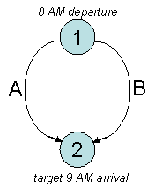
Figure 1-. A Simple Two Route Network
Similarly, system throughput is poorly estimated through the aggregation of facility-level count data. A typical method is to establish one or more screen lines (Figure 1-) and measure flow on links that cross this boundary. For simple networks with highly directional travel, this approach is reasonable. However, congested transportation systems are increasingly non-directional, which necessitates the use of screen lines in each possible direction of travel. In a complex network, the number of required screen lines to estimate throughput becomes so large that it approaches the number of distinct trips in the network. At this point, it is simpler to directly estimate trips and count these as aggregate system throughput. Further, current notions of system throughput are quality-independent. For example, two trips that have an expected travel time of 20 minutes are counted equally even if the experienced travel time on one trip is three times more than the travel time on the other trip. It is clear that trip quality or reliability should be incorporated into the aggregation of successful trip making. As in the case with reliability, system throughput is best represented by the aggregate number of successful trips supported by the system, and not estimated by the aggregation of a collection of facility-specific screen lines.
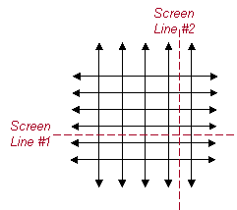
Figure 1-. Use of Screen Lines to Estimate System Throughput
Although there is a strong case for trip-level system performance measures, current data requirements for estimating such trip-specific performances are significant. A few states and regions have invested in trip-specific data collection, but these efforts are fairly expensive and usually restricted to a few congested corridors. With wireless connectivity between vehicles, the infrastructure, and travelers’ communication devices, the data required for this type of analysis might increasingly become available. Until there is sufficient saturation of connectivity, there is a need for structured, cost-effective methods that combine this data with data that are currently available from existing infrastructure sensors for estimating trip-based system measures. Providing such estimation methods and guidance will enable system managers, operators, and planners to measure, monitor and report the performances of their systems in a consistent and comparable manner.

Purpose
The DMA performance measurement application estimates mode-independent, trip-based system productivity and traveler mobility performance measures. The application was developed by making use of trip-based system performance measure algorithms developed as part of the USDOT’s Integrated Corridor Management (ICM) Program [1] and adapting them for use with observed data to measure impact in mobility and productivity. The algorithms developed under ICM, estimate key measures of corridor performance (delay, travel time reliability, and throughput) from time-variant traffic simulation outputs.

The DMA performance measurement application estimates the following three key measures:

- Travel Time Reliability: Travel time reliability is a measure of the consistency or dependability in travel times experienced by a traveler making the same trip over many days over the course of a year. The performance measurement application uses planning time index as a measure of the travel time reliability. Planning time index represents the total time a traveler should plan for to ensure an on-time arrival.

- Delay: Delay is defined as the travel time in excess of some subjective minimum travel time threshold. The performance measurement application identifies delays experienced over all modes in comparison to the free flow travel time.

- Reliable Throughput: Reliable throughput is defined as traveler trips or traveler miles delivered reliably by the system. The performance measurement application estimates reliable traveler trips as the total number of trips with travel times less than or equal to the 95th percentile travel time for that trip. Reliable traveler miles delivered are computed as the total miles traveled on the reliable trips.

The application computes these performance measures for traveler trips, which suggests complete knowledge of these trips, including the origin, destination, trip start time, mode, and travel times. However, if the data source does not contain detailed information on traveler trips, the user will have to first generate disaggregate (individual) time-variant synthetic trips between logical origins and destinations before using the performance measurement application.

Benefits of Application
The performance measurement application provides an unambiguous, application-independent method of calculating travel time reliability, delay, and throughput. This provides a level playing field when considering system level impacts among various transformative applications. For example, the IDTO (Integrated Dynamic Transit Operations) bundle, which is one collection of high-priority applications sponsored by the Dynamic Mobility Applications Program, the highest impact might be seen in the increase of ridership, schedule adherence, miles between road failures, etc. The highest impact from another high-priority bundle, the FRATIS (Freight Advanced Traveler Information System) bundle, might be seen in the reduction of empties, truck idle time at terminals, truck emissions, etc. Both applications, however, will also ultimately improve mobility and productivty of the surface transportation in which they operate. For example, increased transit ridership under incident conditions will result in reduced overall delay and improved passenger throughput. The proposed performance measurement application provides a mechanism to compare the overall system impacts of the two bundles.

Intellectual Property and Licensing
The software code for the performance measurement application will be released through the DMA Program’s Open Source Application Development portal under a permissive open source license (the specific license is to be determined). We encourage developers to share enhancements and modifications with the community, however this is not required. The code, whether modified or not, can be incorporated into proprietary software.

Contributors
The performance measurement algorithmic statements were initially developed by Karl Wunderlich, Noblis for the ICM Program. The algorithmic statements were adapted for the DMA Program by Noblis researchers. The data set used for developing and testing the application was derived from a VISSIM simulation model built for the I-44/I-270 interchange southwest of St. Louis. The VISSIM model, which was built by Crawford, Bunte, Brammeier for the Missouri Department of Transportation in 2003, was provided to Noblis by USDOT.

Key contributors to the development of the performance measurement application, modification of the VISSIM test data set, and development of the documentation include: Meenakshy Vasudevan, Jim Larkin, and Karl Wunderlich of Noblis.

Chapter 2 User Guide
This section provides guidance to a user interested in using the DMA performance measurement application. Users are expected to be familiar with running an application from a command prompt and should have basic knowledge of SQL database.

Software Objectives
The DMA performance measurement application estimates mode-independent, trip-specific mobility meaures. The three key measures that the application estimates are travel time reliability, delay and throughput. The basic unit of observation for each measure described below is a trip that starts within a specific time interval (t) from a given origin (o) and ends at given destination (d) using a specific mode (m).

Travel Time Reliability: Travel time reliability is a measure of the consistency or dependability in travel times experienced by a traveler making the same trip over many days and operational conditions. Operational conditions describe the frequency and intensity of specific traffic conditions experienced by the traveler over the course of a year. Operational conditions are identified by a combination of specific traffic demand levels (e.g., low, medium or high demand), incident (e.g., no impact, medium impact, high impact) and weather (e.g., clear, rain, snow, ice) conditions. The FHWA Office of Operations has recommended four measures to characterize travel time reliability [3]: (i) 90th or 95th percentile travel time, (ii) buffer index, (iii) planning time index, and (iv) frequency that congestion exceeds some expected threshold. The DMA performance measurement application uses planning time index, which represents the total time a traveler should plan for to ensure an on-time arrival. It is computed as the ratio of the travel time on the worst day compared to the time required to make the same trip at free-flow speeds. Statistically, the “worst day” is the 95th percentile travel time [4]. The 95th percentile time is calculated over travel times for similar trips (i.e., with the same o, d, t, and m) experienced over all operational conditions (k). The free flow travel time is computed as the minimum travel time for similar trips (i.e., with the same o, d, t, and m) experienced over all operational conditions (k). Travel time reliability is estimated as follows:

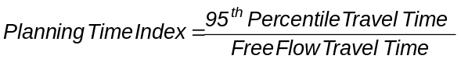

Delays: Delay is defined as the travel time in excess of some subjective minimum travel time threshold. Typically, discussions of delay focus solely on roadway-only travel and delays are estimated with respect to travel times at posted speeds or 85th percentile speeds [1]. The DMA performance measurement application identifies delays experienced over all modes. It is computed by subtracting the minimum travel time for similar trips (i.e., with the same o, d, t, and m) over all operational conditions (k) from the travel times experienced for the corresponding trips.

Reliable Throughput: Reliable throughput is defined as traveler trips or traveler miles delivered reliably by the system. Typically, throughput is defined as a point measure. Traveler trips and miles traveled (without considering reliability) are often ineffective measures when differentiating a well-managed system and a poorly managed system [1]. For example, a twenty-mile trip completed in 25 minutes counts equally with the same twenty-mile trip completed in one hour. The DMA performance measurement application computes reliable throughput by identifying trips that are successfully completed with travel times below a specified reliability threshold (taken as the 95th percentile travel time). Reliable traveler trips are computed as the total number of trips with travel times less than or equal to the 95th percentile travel time for that trip. Reliable traveler miles delivered are computed as the total miles traveled on the reliable trips.

The software application computes these performance measures for individual vehicle trips or trajectories, and aggregates them for system-wide performance measures. If trip or trajectory level data are not available, then the user will have to first generate disaggregate (individual) time-variant synthetic trips between logical origins and destinations before using the performance measurement application.

Software Documentation
Software documentation is provided within the software code as inline comments. Figure 2- presents the software data diagram that shows the input files required to run the DMA performance measurement application (depicted in the center of the figure), and the output files that are generated by the application. The output files are stored in a SQLite Database. The database includes both the input as well as the output information. The input tables are an echo of the user inputs to allow easy access to the input data in the database. For detailed information on the input and output files, please refer sections on Input Data and Output Data.
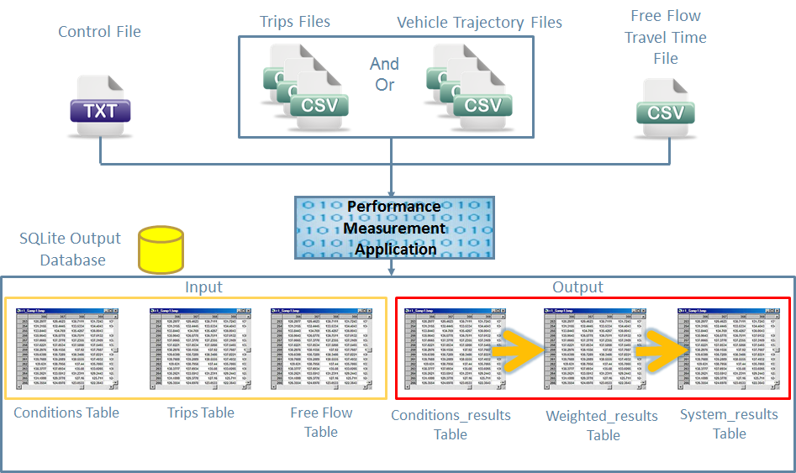
Figure 2-. DMA Performance Measurement Application Data Diagram

Input Data
The performance measurement application requires three input files:
- Control File: This file identifies the control parameters, the names and locations of the other two user input files, and the name and desired location of the output file (i.e., the database).
- Free Flow Travel Time File: This file identifies the minimum travel time for each origin-destination pair in the network.
- Trip OR Vehicle Trajectory File: This file has the trip information or vehicle trajectory information for each origin-destination pair in the network for a specific operational condition.

Control File
The Control File identifies the control parameters, the names and locations of the other two user input files, and the names and desired location of the output file (i.e., the database). The file is configured as a standard text file. Error: Reference source not found shows a sample Control file, and Table 2- describes the fields in the Control File.

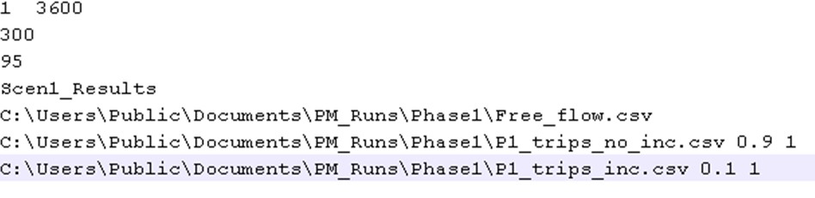
Figure 2-. Sample Control File

Table 2-. Description of the Fields in the Control File
Line | Field | Description | Unit | Value Type
1 | 1 | Evaluation start time. | Seconds | Integer
1 | 2 | Evaluation end time. | Seconds | Integer
2 | 1 | Duration of the time window (or time interval) for grouping trips with similar start times. For e.g., 300 seconds will group trips in five-minute groups for evaluation. | Seconds | Integer
3 | 1 | Reliability threshold used for computing travel time reliability. For e.g., if the threshold is specified as 95%, then a trip is classified as reliable if the travel time experienced on the trip is less than or equal to the 95th percentile travel time for similar trips (i.e., trips with the same origin, destination, and start time interval). | Percent | Integer
4 | 1 | Name of the database output file. If this value does not end in “.s3db,” the standard filename extension for SQLite database, it will be added to the end. For example, the value “test” in this field will produce the database “test.s3db.” | N/A | String
5 | 1 | Name and optional location of the Free Flow Travel File. | N/A | String
6+ | 1 | Name and optional location of Trip File or Vehicle Trajectory File for a specific operational condition. The DMA performance measurement application can read in any number of these files. | N/A | String
 | 2 | Probability of occurrence of the operational condition that corresponds to the file referenced in field 1 of line 6. Note, the probabilities of all operational conditions should add up to 1. | N/A | Real
 | 3 | Type of file:  - If the type =1, then the DMA performance measurement application will load the file as a Trip File (Please see description on Trips File.).  - If the type = 0 then the DMA performance measurement application will load the file as a Vehicle Trajectory File (Please see description on Vehicle Trajectory File.) | N/A | Integer

Free Flow Travel Time File
The Free Flow Travel Time File identifies minimum travel times for each origin-destination pair in the network, which are used to determine delays. The file is configured as a Comma Separated Values (CSV) file. A sample Free Flow Travel Time File is shown in Figure 2-, and the fields are described in Table 2-.

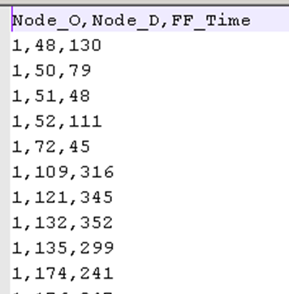
Figure 2-. Sample Free Flow Travel Time File

Table 2-. Description of the Fields in the Free Flow Travel Time File
Line | Field | Description | Unit | Value Type
1 | 1 | Title line for the file, typically the column headers for the file. | N/A | String
2+ | 1 | Origin node number. | N/A | Integer
 | 2 | Destination node number. | N/A | Integer
 | 3 | Minimum travel time experienced between the origin and destination, identified in the previous two fields. Alternately, specify the free flow travel time between the origin and destination. | Seconds | Real

Trips File
To run the DMA performance measurement application, either the Trips File or the Vehicle Trajectory File may be used. The Trips File has aggregated information for a trip between each origin-destination pair in the network for a specific operational condition. Each operational condition should have a corresponding Trips File. The Trips File is specified as a CSV file. Figure 2- shows a sample Trips File, and Table 2- describes the fields in the file.
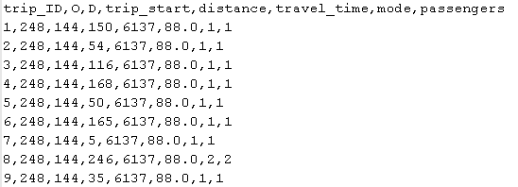
Figure 2-. Sample Trips File

Table 2-. Description of the Fields in the Trips File
Line | Field | Description | Unit | Value Type
1 | 1 | Title line for the file, typically the column headers for the file. | N/A | String
2+ | 1 | Unique ID for the trip. Typically, this is an increasing primary key. | N/A | Integer
 | 2 | Origin node number. | N/A | Integer
 | 3 | Destination node number. | N/A | Integer
 | 4 | Start time of the trip. | Seconds | Real
 | 5 | Distance traveled on the trip. | Miles | Real
 | 6 | Travel time experienced for the trip. | Seconds | Real
 | 7 | Mode number for the trip. Mode numbers are defined by the user. For example, a passenger car may be specified as “1”, transit may be specified as “2”, etc. The mode numbers should start with 1 and incremented by 1 to define additional mode types. | N/A | Integer
 | 8 | Number of passengers on the trip. | N/A | Real

Vehicle Trajectory File
The Vehicle Trajectory File has detailed trajectory information for all vehicles that travel between each origin-destination pair in the network for a specific operational condition. The DMA performance meaurement application aggregates the vehicle trajectory information into trips information, which is then further aggregated to estimate the performance measures. Each operational condition should have a corresponding Vehicle Trajectory File. The Vehicle Trajectory File is specified as a CSV file. Figure 2- shows a sample Trips File, and Table 2- describes the fields in the file.

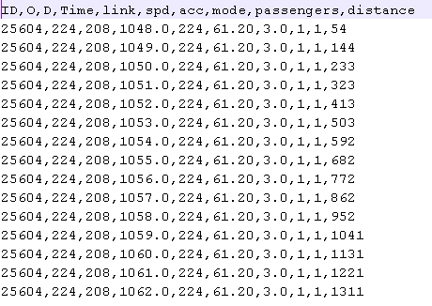
Figure 2-. Sample Vehicle Trajectory File

Table 2-. Description of the Fields in the Vehicle Trajectory File
Line | Field | Description | Unit | Value Type
1 | 1 | Title line for the file, typically the column headers for the file. | N/A | String
2+ | 1 | Unique ID for the vehicle. | N/A | Integer
 | 2 | Origin node number. | N/A | Integer
 | 3 | Destination node number. | N/A | Integer
 | 4 | Current time. | Seconds | Numeric (Integer or Real)
 | 5 | Current link the vehicle is traveling on. | N/A | Integer
 | 6 | Speed of the vehicle. This field is currently not used by the DMA performance measurement application but should be specified for the application to run. If speed is unknown, a zero may be specified. | mph | Real
 | 7 | Acceleration of the vehicle. This field is currently not used by the DMA performance measurement application but should be specified for the application to run. If acceleration is unknown, a zero may be specified. | m/s² | Real
 | 8 | Mode number for the vehicle. Mode numbers are defined by the user. For example, a passenger car may be specified as “1”, transit may be specified as “2”, etc. The mode numbers should start with 1 and incremented by 1 to define additional mode types. | N/A | Integer
 | 9 | Number of passengers in the vehicle. | N/A | Real
 | 10 | Distance traveled by the vehicle on the trip. | Miles | Real

Output Data
All output data from the DMA performance measurement application is stored in the SQLite Database. The system-wide performance measures are also displayed on the computer screen at the completion of the program. Two types of information are stored in the SQLite Database:

- Input information: The information in the input files are stored in tables for easy access.
  - The Conditions Table stores information about each operational condition file that is specified in the Control File.
  - The Free_Flow Table stores information that is specified by the user in the Free Flow Travel Time File.
  - The Trips Table stores the trip information between each origin-destination pair in the network for all operational conditions.
- Output information:
  - The Condition_Results Table shows the performance measures that are computed for all trips with the same origin, destination, trip start time window, mode, and operational condition.
  - The Weighted_Results Table shows the performance measures that are computed for all trips with the same origin, destination, trip start time window, and mode.
  - The System_Results Table shows the system-wide performance measures.

Conditions Table
The Conditions Table stores information about each operational condition file that is specified in the Control File. Figure 2- shows a sample Conditions Table and Table 2- describes the fields.

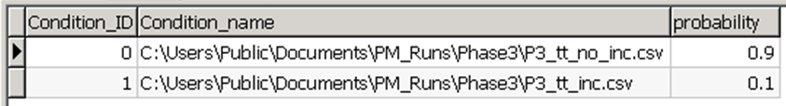
Figure 2-. Sample Conditions Table

Table 2-. Description of the Fields in the Conditions Table
Field | Description | Unit | Value Type
Condition_ID | Primary key for the operational condition. The Condition ID starts with zero for the first file read in. The key is increased by one for each additional file that is read in. | N/A | Integer
Condition_Name | File name and path that the operational condition represents. | N/A | String
Probability | Probability of occurrence of the operational condition. | N/A | Real

Free_Flow Table
The Free_Flow Table stores information that is specified by the user in the Free Flow Travel Time File. A sample Free_Flow Table is shown in Figure 2-, and the fields are described in Table 2-.

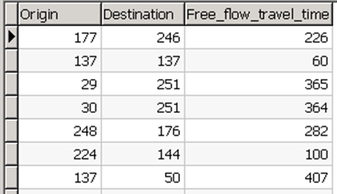
Figure 2-. Sample Free_Flow Table

Table 2-. Descriptions of the Fields in the Free_Flow Table
Field | Description | Unit | Value Type
Origin | Origin node number. | N/A | Integer
Destination | Destination node number. | N/A | Integer
Free_flow_travel_time | Minimum travel time or the free flow travel time between the origin and destination. | Seconds | Real

Trips Table
The Trips Table stores the trip information between each origin-destination pair in the network for all operational conditions. As indicated in the section on Input Data, a user may specify either trip information using the Trips File or vehicle trajectory information using the Vehicle Trajectory File. If a Vehicle Trajectory File is specified, the DMA performance measurement application will convert the information into trip records by aggregating the trajectory information into summary trip information.
Figure 2- shows a sample Trips Table and Table 2- describes the fields.

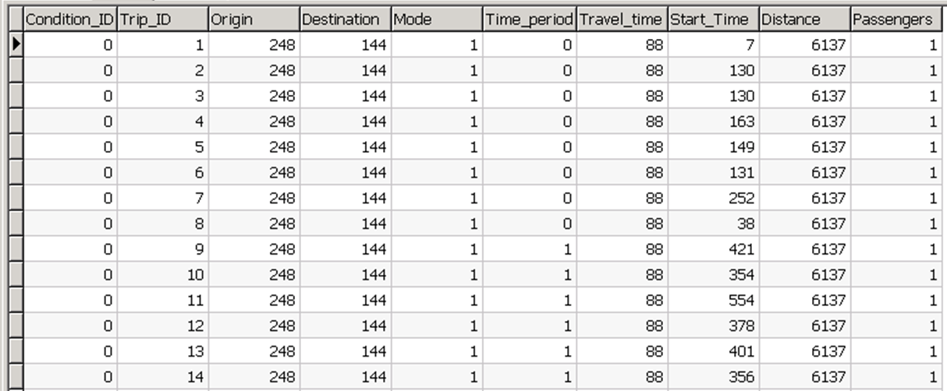
Figure 2-. Sample Trips Table

Table 2-. Description of the Fields in the Trips Table
Field | Description | Unit | Value Type
Condition_ID | Foreign key to the Conditions Table that identifies the operational condition file this trip was read in from. | N/A | Integer
Trip_ID | Unique ID for the trip or vehicle. | N/A | Integer
Origin | Origin node number. | N/A | Integer
Destination | Destination node number. | N/A | Integer
Mode | Mode number for the trip or vehicle. | N/A | Integer
Time_period | Start time window of the trip. The trip start time window is calculated by the DMA performance measurement application using the duration of the time window specified in the Control File, and the trip start time. | N/A | Integer
Travel_time | Travel time experienced for the trip. | Seconds | Real
Start_Time | Start time of the trip. | Seconds | Real
Distance | Distance traveled on the trip. | Miles | Real
Passengers | Number of passengers on the trip. | N/A | Real

Condition_Results Table
The Condition_Results Table shows the performance measures that are computed for all trips with the same origin, destination, trip start time window, mode, and operational condition. The DMA performance measurement application aggregates the information stored in the Trips Table to calculate the performance measures shown in the Conditions_Results Table. This is the first step in computing the system-wide performance measures. Figure 2- shows a sample Conditions_Results Table and Table 2- describes the fields.

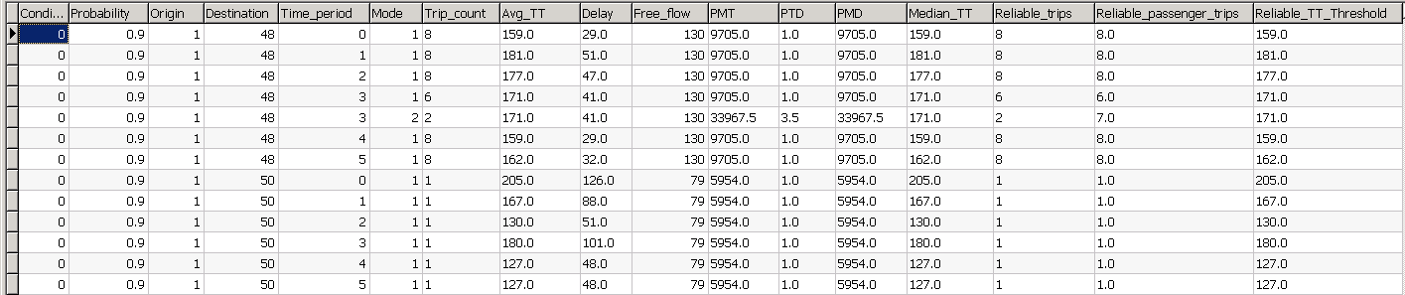
Figure 2-. Sample Conditions_Results Table

Table 2-. Description of the Fields in the Conditions_Results Table
Field | Description | Unit | Value Type
Condition_ID | Foreign key to the Conditions Table that identifies the operational condition file this trip was read in from. | N/A | Integer
Probability | Probability of occurrence of the operational condition. | N/A | Real
Origin | Origin node number. | N/A | Integer
Destination | Destination node number. | N/A | Integer
Time_period | Start time window of the trip. The trip start time window is calculated by the DMA performance measurement application using the duration of the time window specified in the Control File, and the trip start time. | N/A | Integer
Mode | Mode number for the vehicle. Note this value can be NULL. If it is NULL, then the row shows the summary trip information across all modes for the given origin, destination, start time window, and operational condition. | N/A | Integer
Trip_count | Total number of trips for the given origin, destination, trip start time window, mode, and operational condition. | N/A | Integer
Avg_TT | Average travel time experienced on trips for the given origin, destination, trip start time window, mode, and operational condition. | Seconds | Real
Delay | Average delay experienced on trips for the given origin, destination, trip start time window, mode, and operational condition. | Seconds | Real
Free_flow | Minimum travel time or the free flow travel time for trips for the given origin, destination, trip start time window, mode, and operational condition. | Seconds | Real
PMT | Average passengers miles traveled on trips for the given origin, destination, trip start time window, mode, and operational condition. It is computed as the ratio of the total passenger miles traveled to the total trips. | Miles | Real
PTD | Average number of passenger trips delivered reliably for the given origin, destination, trip start time window, mode, and operational condition. It is computed as the ratio of the total reliable passenger trips to the total trips. | N/A | Real
PMD | Average passenger miles delivered reliably on trips for the given origin, destination, trip start time window, mode, and operational condition. It is computed as the ratio of the total reliable passenger miles traveled to the total trips. | Miles | Real
Median_TT | Median travel time for trips for the given origin, destination, trip start time window, mode, and operational condition. | Seconds | Real
Reliable_trips | Total number of trips that were reliable for the given origin, destination, trip start time window, mode and operational condition. | N/A | Real
Reliable_ passenger_ trips | Total number of passengers on trips that were reliable for the given origin, destination, trip start time window, mode and operational condition. | N/A | Real
Reliable TT Threshold | Travel time that corresponds to the reliability threshold specified in the Control File. For e.g., if the reliability threshold was specified as 95%, then this field shows the 95th percentile travel time. | Seconds | Real

Weighted_Results Table
The Weighted_Results Table shows the performance measures that are computed for all trips with the same origin, destination, trip start time window, and mode. The DMA performance measurement application aggregates the information stored in the Conditions_Results Table by assigning a weight to each trip measure equal to the probability of occurrence of the operational condition corresponding to the trip. This is the second step in computing the system-wide performance measures. Figure 2- shows a sample Weighted_Results Table and Table 2- describes the fields.

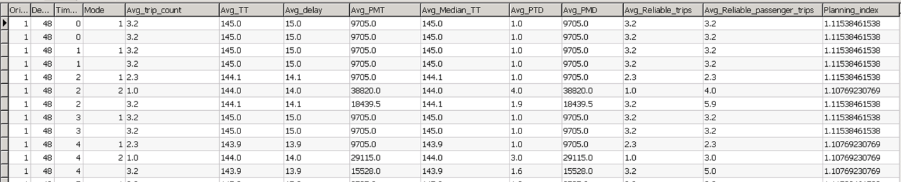
Figure 2-. Sample Weighted_Results Table

Table 2-. Description of the Fields in the Weighted_Results Table
Field | Description | Unit | Value Type
Origin | Origin node number. | N/A | Integer
Destination | Destination node number. | N/A | Integer
Time_period | Start time window of the trip. The trip start time window is calculated by the DMA performance measurement application using the duration of the time window specified in the Control File, and the trip start time. | N/A | Integer
Mode | Mode number for the vehicle. Note this value can be NULL. If it is NULL, then the row shows the summary trip information across all modes for the origin, destination, and start time window. | N/A | Integer
Avg_Trip_count | Average number of trips for the given origin, destination, trip start time window, and mode, taken over all operational conditions. | N/A | Real
Avg_TT | Average travel time experienced on trips for the given origin, destination, trip start time window, and mode, taken over all operational conditions. | Seconds | Real
Avg_Delay | Average delay experienced on trips for the given origin, destination, trip start time window, and mode, taken over all operational conditions. | Seconds | Real
Avg_PMT | Average passengers miles traveled on trips for the given origin, destination, trip start time window, and mode, taken over all operational conditions. | Miles | Real
Avg_PTD | Average number of passengers delivered reliably if the trip is reliable. It is computed as the ratio of the average number of passenger trips delivered reliably to the total number of reliable trips for the given origin, destination, trip start time window, and mode, taken over all operational conditions. | N/A | Real
Avg_PMD | Average passenger miles delivered reliably on trips for the given origin, destination, trip start time window, and mode, taken over all operational conditions. | Miles | Real
Avg_Median_TT | Average median travel time for trips for the given origin, destination, trip start time window, and mode, taken over all operational conditions. | Seconds | Real
Avg_Reliable_ trips | Average number of trips that were reliable for the given origin, destination, trip start time window, and mode, taken over all operational conditions. | N/A | Real
Avg_Reliable passenger_trips | Average number of passengers on trips that were reliable for the given origin, destination, trip start time window, and mode, taken over all operational conditions. | N/A | Real
Planning_index | Planning index for all trips with the same origin, destination, trip start time window, and mode, taken overall all operational conditions. | N/A | Real

System_Results Table
The System_Results Table shows the system-wide performance measures. The DMA performance measurement application aggregates all trip information stored in the Weighted_Results Table. This is the final step in computing the performance measures. Figure 2- shows a sample System_Results Table and Table 2- describes the fields.

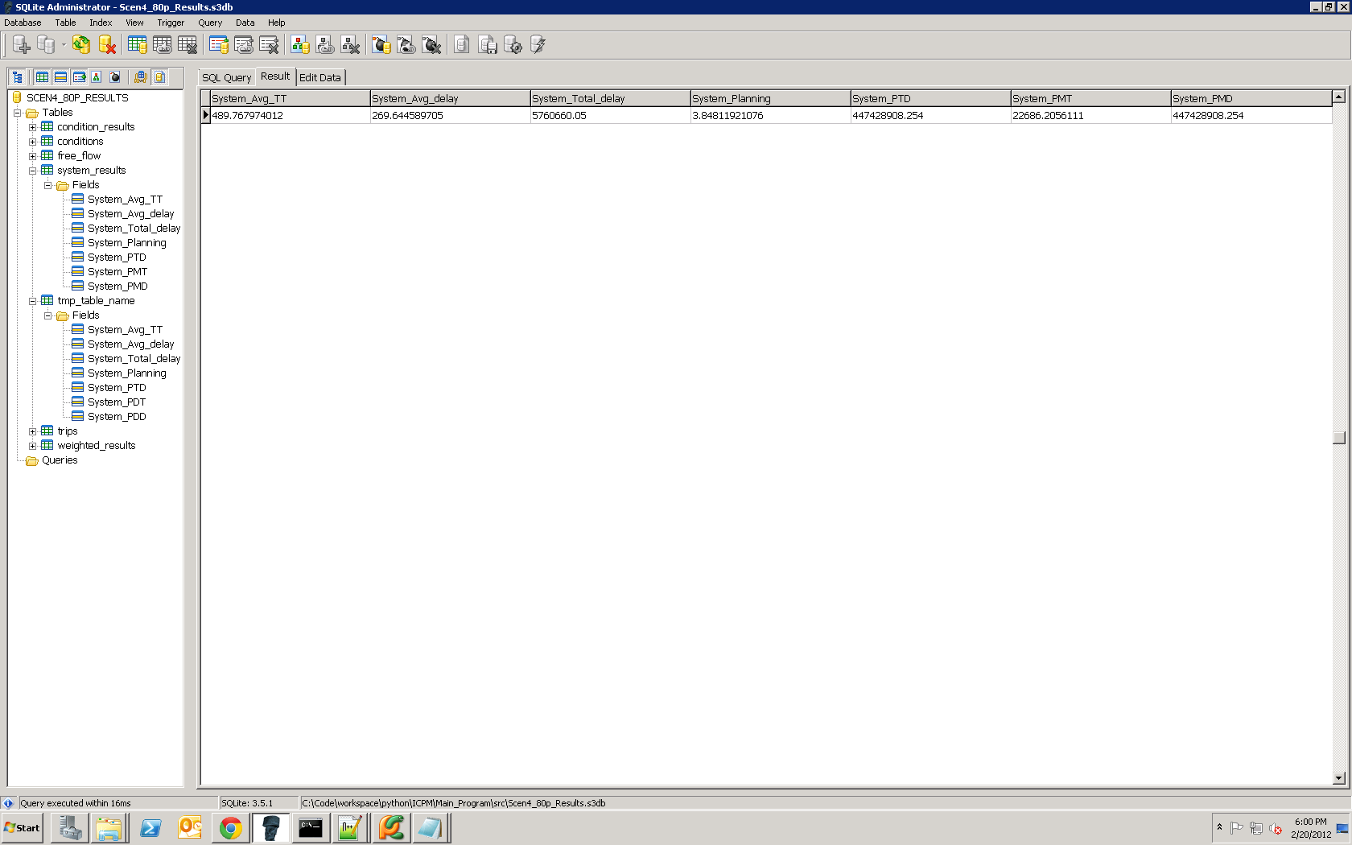
Figure 2-. Sample System_Results Table

Table 2-. Description of the Fields in the System_Results Table
Field | Description | Unit | Value Type
System_Avg_TT | System wide average travel time | Seconds | Real
System_Avg_delay | System wide average delay | Seconds | Real
System_Total_delay | System wide total delay | Seconds | Real
System_Planning | System wide planning index | N/A | Real
System_PMT | System wide passengers miles traveled | Miles | Real
System_PTD | System wide passenger trips delivered reliably | N/A | Real
System_PMD | System wide passenger miles delivered reliably | Miles | Real

Chapter 3 Installation Guide
This section of the document covers the hardware and software needed to install and run the DMA performance measurement application.

Required Hardware
The DMA performance measurement application software can run on most standard Window or Linux based computers with Pentium core processers, with at least two gigabits of RAM and at least 100 MB of drive space. Performance of the software will be based on the computing power and available RAM in the system. Larger datasets can require much larger space requirements depending on the amount of data being read into the software.

To ensure you have adequate space to run the DMA performance measurement application, the general rule of thumb is to have computer space of about one and half times the size of your input files. For example, if the input files are 100 MB in size then you should have at least 150 MB of space available on the computer to run the application and store the output.

Space requirements can be reduced if the DMA performance measurement application software is run with a reduced evaluation time period. The application ran in about 20 minutes on a Windows 7 computer with four gigabits of RAM, when calculating performance measures over an evaluation period of one hour for two operational conditions with approximately 1.5 gigabits of input data that included 40,800 vehicles.

Required Software
The DMA performance measurement application was developed using the open source programming language Python 2.7 (www.python.org). The application requires Python 2.7 or higher to run. Note that Python 3.0 is a change from Python 2.X language and will not run the DMA performance measurement application. Python versions 2.7.X – 2.9.X will work.

The application can be run on Windows, Linux, or Mac operating systems. Python is installed by default on many Linux and Mac operating systems.

To check if Python is already installed and the version, if installed, type the following instructions at a command prompt:

>>python –v

Or if Python is not in the system path, type:

>> [directory with python]python -v
The DMA performance measurement application stores the input and output information in a SQLite database. SQLite is an open source, file-based database that is included with the Python 2.7 program. For more information on SQLite database and its usage please visit the SQLite website (www.sqlite.org). No additional software is required to run the DMA performance measurement application except Python 2.7.

To view the database, it is recommended that a SQLite program/viewer be used. Given below is a list of SQLite programs that can be used to view the database:

- Open source / Free SQLite Viewers
  - SQLite command tool: This tool can be downloaded from the SQLite web site (www.sqlite.org). It allows users to view SQLite database in a command line format.
  - SQL Administrator: Windows-based graphical interface for viewing and modifying SQLite databases (http://sqliteadmin.orbmu2k.de/)
  - SQLite Database Browser: SQLite database viewer for Windows, Linux, or Mac operating systems (http://sqlitebrowser.sourceforge.net/)
- Commercial SQLite Viewers
  - SQLite Maestro: More robust SQLite viewer with more features than the open source or free versions (http://www.sqlmaestro.com/products/sqlite/maestro/)
  - RazorSQL: General purpose database viewer that can view SQLite and runs on Linux, Windows, and Mac operating systems (http://www.razorsql.com/)

For additional tools for working with SQLite visit the SQLite Management Tools Website (http://www.sqlite.org/cvstrac/wiki?p=ManagementTools).

How to Install
To install the DMA performance measurement application you need to follow these steps:

- Install Python 2.7 (http://www.python.org/download/) or higher (i.e., versions 2.7.X – 2.9.X).

- Test to make sure Python is installed correctly by typing the following in a command prompt:
>>python –v
Or if Python is not in the system path, type:
>> [directory with python]python -v

This will return the Python version number if Python is correctly installed.

- Move all four python files to a directory that contains the input files:
  - DPM.py: Main program
  - Sqlload.py: SQL interface
  - Files.py: Code to read in the various input files
  - Timeslice.py: Code for generating and determining various time slices

- Run the program

How to Run
The DMA performance measurement application is run directly from a command prompt and does not have a direct user interface. All input information is gathered through text-based input files, and output information are stored in a SQLite database. The system-wide output is also displayed on the command prompt window.

There are a variety of SQLite database viewers that can be used to review the output. There is a list of both commercial and free SQLite viewers in the Required Software section of this document. For information on the user interface of these SQLite viewers please refer the corresponding viewer websites.

To run the DMA performance measurement application software make sure all files are located in the same directory. Type the following in a command prompt:

>>python DPM.py –file [your control file name]

If using the default input control file name of “master.in” you can drop the control file name from the line and just type:

>> python DPM.py

The DMA performance measurement application will begin to run and create a new SQLite database for the output in the same directory the program is run in or at the location specified in the Control File. Once completed, the DMA performance measurement application will display the system-wide performance measures on the screen.

References
- Wunderlich, K., INTEGRATED CORRIDOR MANAGEMENT (ICM) PROGRAM: CALCULATING MULTI-MODAL CORRIDOR PERFORMANCE MEASURES FROM SIMULATION OUTPUTS, Proceedings of the 18th World Congress on Intelligent Transportation Systems, October 2011, Orlando, Florida, TS118-1334.

- Cambridge Systematics. Cost-Effective Performance Measures for Travel Time Delay, Variation, and Reliability, NCHRP Report 618, Transportation Research Board, 2008.

- Federal Highway Administration. Traffic Congestion and Reliability: Trends and Strategies for Advanced Mitigation, prepared by the Cambridge Systematics and Texas Transportation Institute for the Federal Highway Administration, September 2005.

- Schrank, D., Lomax, T., and Turner, S. The 2010 Urban Mobility Report, Texas Transportation Institute, December 2010.

U.S. Department of Transportation
ITS Joint Program Office-HOIT
1200 New Jersey Avenue, SE
Washington, DC 20590
Toll-Free “Help Line” 866-367-7487
www.its.dot.gov
[FHWA Document Number]



