|  |
| --- |
|  |
| Faculty of Computers and Information Technology (FCIT) |
|  |
| IoT-Based Adaptive Environment for Indoor Plant Cultivation |
| Author:  Osama Hadi Aljuhani SID: 391004816 |
| Nawaf Awadh Alshehri SID: 391007173  Abdullah Mohammad Alosaimi SID: 391000505  Mohannad Ali Alshehri SID: 391000931  Faris Salman Alanazi SID: 391002058  Abdulkreem Yahya Thwaie SID: 391007478 |
| Supervisor: Dr. Ahamed Aljuhani |
| Submitted in partial fulfilment of the requirements  For  the Degree of Bachelor of Computer Engineering |
| 2023 |

DECLARATION

I hereby declare that this project report is based on my original work except for citations and quotations which have been duly acknowledged. I also declare that it has not been previously and concurrently submitted for any other degree or award at University of Tabuk or other institutions.

|  |  |  |
| --- | --- | --- |
| **Name** | **ID No.** | **Signature** |
| Osama Hadi Aljuhani | 391004816 |  |
| Nawaf Awadh Alshehri | 391007173 |  |
| Abdullah Mohammed Alosimi | 391000505 |  |
| Mohannad Ali Alshehri | 391000931 |  |
| Faris salman Alanazi | 391002058 |  |
| Abdulkreem Yahya Thwaie | 391007478 |  |

Date : _________________________

APPROVAL FOR SUBMISSION

I certify that this project report entitled “IoT-Based Adaptive Environment for Indoor Plant Cultivation” was prepared by Osama Hadi Al-Juhani, Nawaf Awadh Alshehri, Abdullah Mohammad Alosaimi, Mohannad Ali Alshehri, Faris salman alanazi, Abdulkreem Yahya Thwaie has met the required standard for submission in partial fulfilment of the requirements for the award of Bachelor of Computer Science at University of Tabuk.

Approved by,

Signature : _________________________

Supervisor : Dr Ahmed Al-Juhani

Date : _________________________

The copyright of this report belongs to the author and is protected under the intellectual property right laws and conventions. It can only be considered/used for purposes like extension for further enhancement, product development, adoption for commercial/organizational usage, etc., with the permission of the University of Tabuk.

ACKNOWLEDGEMENTS

We would like to thank everyone who had contributed to the successful completion of this project. We would like to express my gratitude to my research supervisor, Dr Ahmed Al-Juhani for his invaluable advice, guidance and his enormous patience throughout the development of the research. In addition, I would also like to express my gratitude to our loving parents and friends who had helped and given our encouragement.

|  |
| --- |
| IoT-Based Adaptive Environment for Indoor Plant Cultivation |

ABSTRACT

The Adaptive Environment for Plants is an IoT-based system designed to optimize indoor plant growth. It consists of an ESP32 microcontroller connected to various sensors and actuators, including an LDR, capacitive soil moisture sensor, DHT11 sensor, water pump, fans, humidifier atomizer plate, lamp light, and LCD. The system is programmed using the Arduino IDE and the Blynk library to connect to the Blynk server and create a mobile app that allows the user to monitor and control the plant environment.

In addition to standard environmental control measures such as temperature and humidity thresholds, the system allows for the creation of individual plant profiles in the app. Each profile can include information such as the type of plant, its ideal growing conditions, and any specific care instructions. With this feature, the system can be customized to match the unique needs of each plant and optimize growth.

The system also includes a water pump that activates when the soil moisture level drops below 20% and turns off when it reaches 80%, reducing resource usage and ensuring optimal soil moisture levels. The app includes widgets for displaying sensor readings and controlling the actuators, as well as notifications for any plant health issues detected by the sensors.

The Adaptive Environment for Plants project aims to create a sustainable and efficient indoor gardening system that optimizes plant growth and health while minimizing resource usage. The system's ability to customize the growing environment for each individual plant creates a targeted and efficient growing environment. The system's remote access and notifications ensure constant monitoring and plant health management, making it a valuable tool for indoor gardeners of all skill levels.

TABLE OF CONTENTS

DECLARATION ii

APPROVAL FOR SUBMISSION iii

ACKNOWLEDGEMENTS iv

ABSTRACT v

TABLE OF CONTENTS vi

LIST OF TABLES viii

LIST OF FIGURES ix

LIST OF ABBREVIATIONS x

LIST OF APPENDICES xi

**CHAPTER**

1 INTRODUCTION 11

1.1 Background 11

1.2 Problem overview 12

1.3 Aims and Objectives 12

1.4 Report’s Layout 13

2 BACKGROUND AND RELATED WORKS 15

2.1 A Secure IoT-Based Irrigation System 15

2.2 Time Domain Transmissiometry-Based Sensor for Simultaneously Measuring Soil Water Content 17

2.3 Moisture Detection in Tree Trunks in Semiarid Lands 18

2.4 Estimating Volumetric Water Content in Soil for IoT Contexts 19

3 METHODOLOGY 20

3.1 Introduction 20

3.2 Block diagram 21

3.3 System components 22

3.4 Flow chart 33

3.5 Finite state machine 34

4 RESULTS 35

4.1 Subsection Title 1 35

4.2 Subsection Title 2 35

4.3 Sub-subsection Title 1 36

4.3.1 Sub-sub-subsection Title 1 36

5 CONCLUSION AND RECOMMENDATIONS 37

5.1 Subsection Title 1 37

5.2 Subsection Title 2 37

5.3 Sub-subsection Title 1 38

5.3.1 Sub-sub-subsection Title 1 38

REFERENCES 39

APPENDICES 40

LIST OF TABLES

**TABLE TITLE PAGE**

3.5 1 transition table for the adaptive plant environment system 33

LIST OF FIGURES

**FIGURE TITLE PAGE**

2.1 1 The proposed model. (a) proposed model architecture. (b) proposed model hardware. 14

2.2 1 (a) Schematic and (b) photograph of the proposed sensor. 15

2.3 1 (a) External deformations in tree trunks. (b) Setup of sensors, microcontroller, and communication interface. 16

2.4 1 Testing setup: The IoT sensor node buried in sand within the plastic case and the LoRaWAN gateway. 17

3.2 1 Block diagram 22

3.3 1 ESP32 23

3.3 2 DHT11 24

3.3 3 Capacitive soil moisture 25

3.3 4 LDR 26

3.3 5 Light blulb 27

3.3 6 Water pump 28

3.3 7 FAN 29

3.3 8 Humidifier plate 30

3.3 9 Water level sensor 31

3.4 1 Flow chart 31

LIST OF ABBREVIATIONS

IoT Internet of Things

LDR Light Dependent Resistor

SMU Secondary Memory Unit

CPU Central Processing Unit

OS Operating System

DB Database

DBMS Database Management System

SQL Structured Query Language

DLL Dynamic Link Library

Hz Hertz

MHz Mega Hertz

BIOS Basic Input Output System

bit Binary digit

CD Compact Disk

DFD Data Flow Diagram

DML Data Manipulation Language

DSN Database Source Name

DSN Data Set Name

LIST OF APPENDICES

**APPENDIX TITLE PAGE**

**APPENDIX A: Graphs** 40

**APPENDIX B: Computer Programme Listing** 41

## INTRODUCTION

### Background

Indoor gardening has become increasingly popular in recent years, with more people turning to plants as a way to bring nature into their homes and improve indoor air quality. However, maintaining optimal growing conditions for plants indoors can be a challenging task. Unlike outdoor gardening, indoor gardening requires careful control of environmental factors such as light, temperature, humidity, and soil moisture.

Traditional indoor gardening methods rely on manual monitoring and adjustment of these factors, which can be time-consuming and inefficient. Furthermore, improper environmental control can lead to plant health issues such as stunted growth, wilting, and disease.

To address these challenges, there is a need for an efficient and targeted growing environment that can optimize plant growth and health while minimizing resource usage. The Adaptive Environment for Plants is an IoT-based system designed to do just that, by creating a sophisticated monitoring and control system that can adjust environmental factors in real-time and provide early detection of plant health issues.

With the Adaptive Environment for Plants, indoor gardeners can create a sustainable and efficient growing environment that ensures optimal plant growth and health, making it a valuable tool for indoor gardeners of all skill levels.

### Problem overview

problems faced in indoor plant cultivation:

* Maintaining optimal growing conditions for indoor plants can be challenging.
* Traditional indoor gardening methods rely on manual monitoring and adjustment of environmental factors, which can be time-consuming and inefficient.
* Lack of targeted growing environments for individual plants can lead to suboptimal growth and health.
* Improper environmental control can lead to plant health issues such as stunted growth, wilting, and disease.
* Without early detection and intervention, these issues can quickly escalate and lead to plant death.
* There is a need for an efficient and targeted growing environment that can optimize plant growth and health while minimizing resource usage.

The Adaptive Environment for Plants is designed to create a sophisticated monitoring and control system that can adjust environmental factors in real-time, provide early detection of plant health issues, and customize the growing environment for each individual plant.

### Aims and Objectives

The Adaptive Environment for Plants project aims to create an efficient and targeted growing environment that optimizes plant growth and health while minimizing resource usage. The objectives of the project include:

* Creating a system that can monitor and control environmental factors such as light, temperature, humidity, and soil moisture in real-time.
* Providing early detection of plant health issues through the use of sensors and alerts.
* Customizing the growing environment for each individual plant by creating plant profiles in the app.
* Reducing resource usage through the use of sensors and control systems.
* Improving plant growth and health through targeted environmental control.
* Optimizing space utilization in indoor gardening.
* Providing a user-friendly and convenient monitoring and control system through remote access using a smartphone or computer.

By achieving these objectives, the Adaptive Environment for Plants project aims to make indoor gardening more sustainable, accessible, and efficient. The project has the potential to revolutionize indoor gardening by providing a tool that indoor gardeners of all skill levels can use to optimize plant growth and health while minimizing resource usage.

### Report’s Layout

**Chapter 1: Introduction**

* Background: Provides the context and reasons for the research.
* Problem Overview: Explains the problem that the research aims to address.
* Aims and Objectives: States the purpose and goals of the research.
* Report's Layout: Gives an overview of the report's organization and structure.

**Chapter 2: Background and Related Works**

* Introduction to the Background and Related Works: Provides a brief overview of the research topic and the current state of research.
* Four Related Works: Describes four relevant studies or research projects that are related to the current research.

**Chapter 3: Methodology**

* Introduction to the Methodology: Describes the methods used to conduct the research.
* Block Diagram: Presents a visual representation of the system or process being studied.
* System Components: Describes the different parts of the system being studied and how they work together.
* Flow Chart: Shows the sequence of steps involved in the process being studied.
* Finite State Machine: Provides a model of the system being studied that shows how it transitions between different state

## BACKGROUND AND RELATED WORKS

In this chapter, we will examine the distinctions between the project we are developing and other Projects that currently exist with the same concept, assessing them and displaying the similarities and differences of each.

This section presents the works most relevant to our work using the Adaptive environment for plants.

### A Secure IoT-Based Irrigation System

A Secure IoT-Based Irrigation System for Precision Agriculture Using the Expeditious Cipher:

Due to the recent advances in the domain of smart agriculture as a result of integrating traditional agriculture and the latest information technologies including the Internet of Things (IoT), cloud computing, and artificial intelligence (AI), there is an urgent need to address the information security-related issues and challenges in this field. In this article, we propose the integration of lightweight cryptography techniques into the IoT ecosystem for smart agriculture to meet the requirements of resource-constrained IoT devices. Moreover, we investigate the adoption of a lightweight encryption protocol, namely, the Expeditious Cipher (X-cipher), to create a secure channel between the sensing layer and the broker in the Message Queue Telemetry Transport (MQTT) protocol as well as a secure channel between the broker and its subscribers. Our case study focuses on smart irrigation systems, and the MQTT protocol is deployed as the application messaging protocol in these systems. Smart irrigation strives to decrease the misuse of natural resources by enhancing the efficiency of agricultural irrigation. This secure channel is utilized to eliminate the main security threat in precision agriculture by protecting sensors’ published data from eavesdropping and theft, as well as from unauthorized changes to sensitive data that can negatively impact crops’ development. In addition, the secure channel protects the irrigation decisions made by the data analytics (DA) entity regarding the irrigation time and the quantity of water that is returned to actuators from any alteration. Performance evaluation of our chosen lightweight encryption protocol revealed an improvement in terms of power consumption, execution time, and required memory usage when compared with the Advanced Encryption Standard (AES). Moreover, the selected lightweight encryption protocol outperforms the PRESENT lightweight encryption protocol in terms of throughput and memory usage.

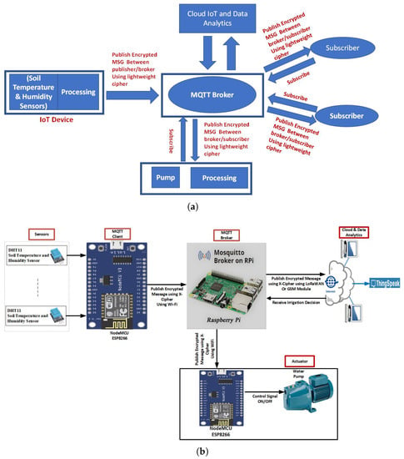

Figure 2.1 1 The proposed model. (a) proposed model architecture. (b) proposed model hardware.

### Time Domain Transmissiometry-Based Sensor for Simultaneously Measuring Soil Water Content

Time Domain Transmissiometry-Based Sensor for Simultaneously Measuring Soil Water Content, Electrical Conductivity, Temperature, and Matric Potential:

Owing to the increasing popularity of smart agriculture in recent years, it is necessary to develop a single sensor that can measure several soil properties, particularly the soil water content and matric potential. Therefore, in this study, we developed a sensor that can simultaneously measure soil water content (θ), electrical conductivity (σb), temperature, and matric potential (ψ). The proposed sensor can determine θ and σb using time domain transmissiometry and can determine ψ based on the capacitance of the accompanying ceramic plate. A series of laboratory and field tests were conducted to evaluate the performance of the sensor. The sensor output values were correlated with the soil properties, and the temperature dependence of the sensor outputs was evaluated. Additionally, field tests were conducted to measure transient soil conditions over a long period. The results show that the developed sensor can measure each soil property with acceptable accuracy. Moreover, the root-mean-square errors of the sensor and reference values were 1.7 for the dielectric constant (which is equivalent to θ), 62 mS m−1 for σb, and 0.05–0.88 for log ψ. The temperature dependence was not a problem, except when ψ was below −100 kPa. The sensor can be used for long-term measurements in agricultural fields and exhibited sufficient lifetime and performance. We believe that the developed sensor can contribute to smart agriculture and research on heat and mass transfer in soil.

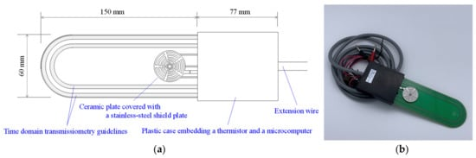

Figure 2.2 1 (a) Schematic and (b) photograph of the proposed sensor.

### Moisture Detection in Tree Trunks in Semiarid Lands

Moisture Detection in Tree Trunks in Semiarid Lands Using Low-Cost Non-Invasive Capacitive Sensors with Statistical Based Anomaly Detection Approach:

fitted to branches and trunks of various sizes without altering the structure of the wood tissue. Results show that the moisture content in tree trunks increases exponentially with respect to the measured capacitance and reflects the distinct differences between different tree types. Data of known healthy trees and unhealthy trees and defective sensor readings have been collected and analysed statistically to show how anomalies in sensor reading baseds on eigenvectors and eigenvalues of the fitted curve coefficient matrix can be detected.

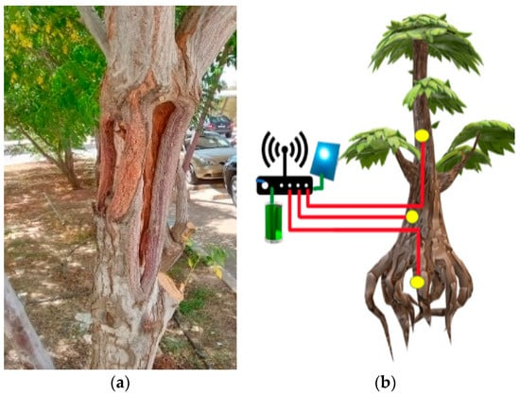

Figure 2.3 1 (a) External deformations in tree trunks. (b) Setup of sensors, microcontroller, and communication interface.

### Estimating Volumetric Water Content in Soil for IoT Contexts

Estimating Volumetric Water Content in Soil for IoT Contexts by Exploiting RSSI-Based Augmented Sensors via Machine Learning:

This paper aims at proposing an augmented sensing method for estimating volumetric water content (VWC) in soil for Internet of Underground Things (IoUT) applications. The system exploits an IoUT sensor node embedding a low-cost, low-precision soil moisture sensor and a long-range wide-area network (LoRaWAN) transceiver sending relative measurements within LoRaWAN packets. The VWC estimation is achieved by means of machine learning (ML) algorithms combining the readings provided by the soil moisture sensor with the received signal strength indicator (RSSI) values measured at the LoRaWAN gateway side during broadcasting. A dataset containing such measurements was especially collected in the laboratory by burying the IoUT sensor node within a plastic case filled with sand, while several VWCs were artificially created by progressively adding water. The adopted ML algorithms are trained and tested using three different techniques for estimating VWC. Firstly, the low-cost, low-precision soil moisture sensor is calibrated by resorting to an ML model exploiting only its raw readings to estimate VWC. Secondly, a virtual VWC sensor is shown, where no real sensor readings are used because only LoRaWAN RSSIs are exploited. Lastly, an augmented VWC sensing method relying on the combination of RSSIs and soil moisture sensor readings is presented. The findings of this paper demonstrate that the augmented sensor outperforms both the virtual sensor and the calibrated real soil moisture sensor. The latter provides a root mean square error (RMSE) of 3.33%3.33%, a virtual sensor of 8.67%8.67%, and an augmented sensor of 1.84%1.84%, which improves down to 1.53%1.53% if filtered in post-processing.

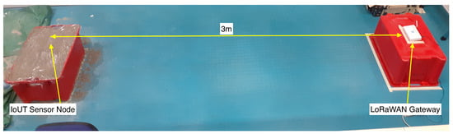

Figure 2.4 1 Testing setup: The IoT sensor node buried in sand within the plastic case and the LoRaWAN gateway.

## METHODOLOGY

The Adaptive Environment for Plants system consists of an ESP8266 microcontroller connected to various sensors and actuators. The system is programmed using the Arduino IDE and the Blynk library to connect to the Blynk server and create a mobile app that allows the user to monitor and control the plant environment.

The system is designed to customize the growing environment for each plant based on the plant profile created in the app. The plant profile includes information such as the plant type, the ideal growing conditions, and any specific care instructions.

The sensors used in the system include an LDR to measure light intensity, a capacitive soil moisture sensor to measure soil moisture levels, a DHT11 sensor to measure temperature and humidity. The actuators used in the system include a water pump, fans, a humidifier atomizer plate, a lamp light, and an LCD screen.

The system is programmed to adjust the growing environment based on the plant's specific needs. For example, if the plant requires more light, the lamp light will be turned on for a longer duration of time. Similarly, if the plant requires more humidity, the humidifier atomizer plate will be activated to increase the humidity levels in the growing environment.

The software is developed using Arduino IDE to read data from sensors and control the actuators. The system is integrated with an ESP32 Wi-Fi module to enable remote monitoring and control using a smartphone or computer. The mobile app is developed using the Blynk app builder and includes widgets for displaying sensor readings and controlling the actuators for each plant, as well as notifications for any plant health issues detected by the sensors.

To test the system's performance, the system is deployed in a controlled environment, and the growing conditions are monitored and recorded. The system's performance is evaluated based on the accuracy of the sensor readings, the effectiveness of the control algorithm, and the system's ability to maintain optimal growing conditions for the plants.

Overall, the methodology employed for the Adaptive Environment for Plants project includes designing and building a sophisticated monitoring and control system using sensors and components such as a light source, water pump, fans, humidifier atomization plate, and LDR. The system is designed to customize the growing environment for each plant based on the plant profile created in the app. The software is developed using Arduino IDE to read data from sensors and control the components, and the system is integrated with an ESP32 Wi-Fi module to enable remote monitoring and control using a smartphone or computer.

### Introduction

In this chapter we are going to describe all the parts of the project, the details about each element, block diagram of the hardware flowchart of the software and the circuit diagram.

### Block diagram

is a schematic diagram of our project. It provides a functional view of our project. It consists of ten parts:

1. ESP32 Wi-Fi module: This is a Wi-Fi module that allows for remote monitoring and control of the system using a smartphone or computer.
2. DHT11 sensor: This sensor measures temperature and humidity in the environment. It sends this data to the microcontroller.
3. Soil moisture sensor: This sensor measures the moisture content of the soil. It sends this data to the microcontroller.
4. LDR: This is a light-dependent resistor that measures the intensity of illumination in the environment. It sends this data to the microcontroller.
5. Light source: This component provides the necessary light for plant growth. The microcontroller controls the light source based on the readings from the LDR.
6. Water pump: This component pumps water to the plants at regular intervals to ensure they receive the necessary moisture. The microcontroller controls the water pump based on the readings from the soil moisture sensor.
7. Fans: These components help regulate temperature and humidity by circulating air in the environment. The microcontroller controls the fans based on the readings from the DHT11 sensor.
8. Humidifier Atomization Plate: This component can be used to add humidity to the environment, which can be beneficial for some types of plants. The microcontroller controls the Humidifier Atomization Plate based on the readings from the DHT11 sensor.
9. Water level sensor: A water level sensor measures the level of water in a container and is used for automated control and monitoring of water levels in various applications.

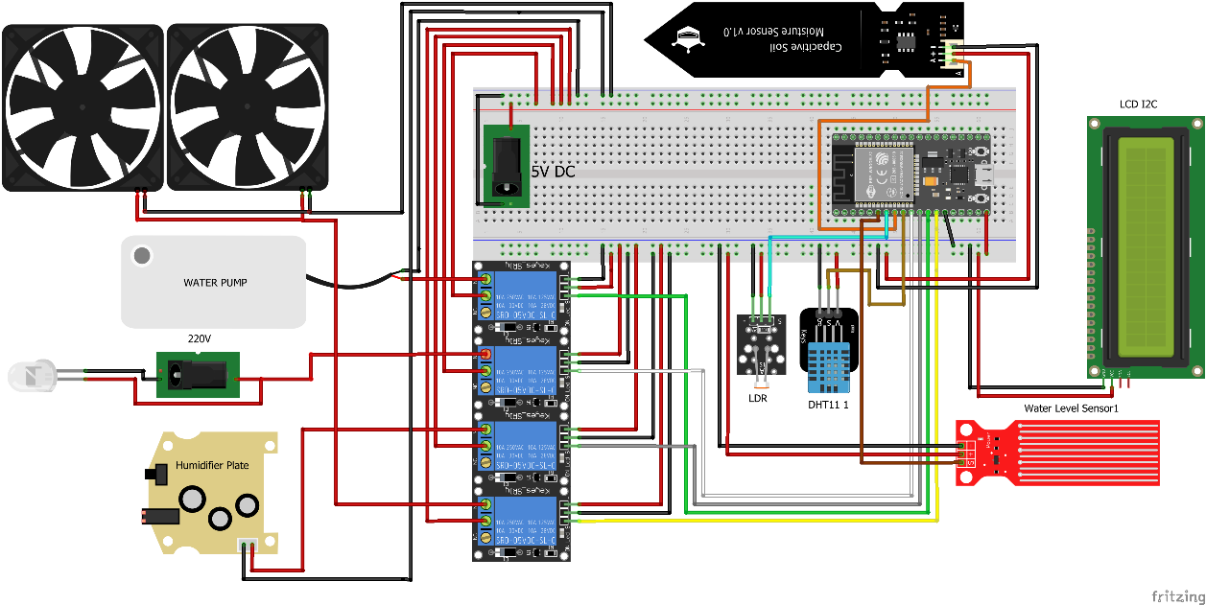

Figure 3.2 1 Block diagram

### System components

##### ESP32

The ESP32 is a Wi-Fi module that provides wireless connectivity to microcontrollers and other devices. It has built-in Wi-Fi capabilities and can be programmed using several programming languages, including C and Lua. The ESP8266 platform is widely used in IoT projects and other applications that require wireless connectivity, with capabilities including web server functionality, remote control, and data logging.

The key features are:

* Built-in Wi-Fi capabilities for wireless connectivity
* Access to GPIO pins and other peripherals for easy integration with other devices
* Affordable and widely available, making it a popular choice for DIY electronics projects
* Can be programmed using several programming languages, including C and Lua
* Supports a variety of development environments, including the Arduino IDE and NodeMCU firmware
* Provides web server functionality, remote control, and data logging capabilities, making it well-suited for IoT projects and other wireless applications
* Strong community of developers and enthusiasts, providing support and resources for users.

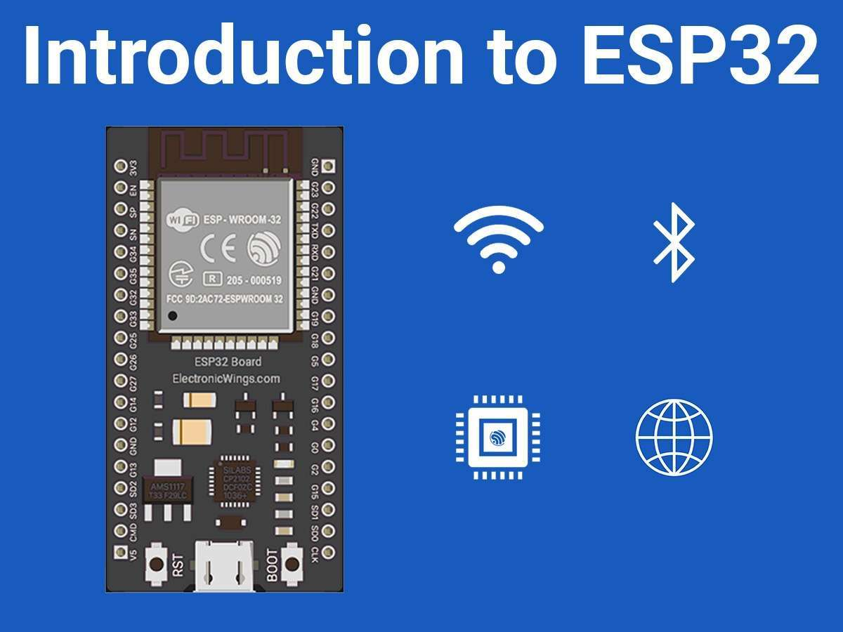

Figure 3.3 1 ESP32

##### DHT11

The DHT11 sensor is a low-cost digital temperature and humidity sensor that uses a thermistor and capacitive humidity sensor to provide accurate measurements. It communicates with microcontrollers using a single-wire digital interface and is commonly used in electronic projects.

The key features are:

* Low cost and small form factor, making it easy to integrate into electronic projects
* Measures both temperature and humidity with a wide measurement range
* Provides accurate measurements using a thermistor and capacitive humidity sensor
* Communicates with microcontrollers using a simple single-wire digital interface
* Well-supported by software libraries for popular development platforms like the Arduino IDE
* Can be used in a wide range of temperature and humidity sensing applications, including environmental monitoring, HVAC systems, and more.

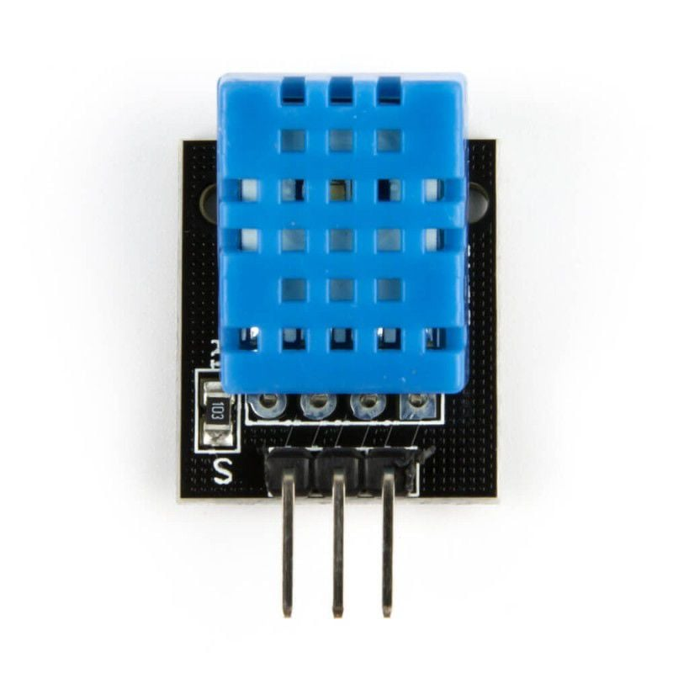

Figure 3.3 2 DHT11

##### 3.3.3 Soil moisture sensor

Capacitive soil moisture sensors work by measuring the dielectric constant of soil, which is a measure of the soil's ability to store electric charge. The dielectric constant of soil changes with changes in soil moisture, so by measuring changes in the dielectric constant, the sensor can determine the soil moisture level.

Key features of capacitive soil moisture sensors include:

* Accuracy: Capacitive soil moisture sensors can provide accurate measurements of soil moisture levels, allowing for precise control of irrigation and watering.
* Low power consumption: Capacitive soil moisture sensors typically consume very little power, making them ideal for use in battery-powered or low-power applications.
* Non-corrosive: Capacitive soil moisture sensors are typically made from non-corrosive materials such as plastic or ceramic, which makes them resistant to rust or corrosion.
* Low maintenance: Capacitive soil moisture sensors require very little maintenance, as they do not have any moving parts that can wear out or become damaged.
* Easy installation: Capacitive soil moisture sensors are easy to install, typically requiring only a small hole to be dug in the soil for the sensor to be inserted.
* Long lifespan: Capacitive soil moisture sensors can have a long lifespan, lasting for several years with proper care and maintenance.
* Versatility: Capacitive soil moisture sensors can be used in a variety of soil types, including sandy, loamy, and clay soils. They can also be used in soilless growing media such as hydroponics or coco coir.

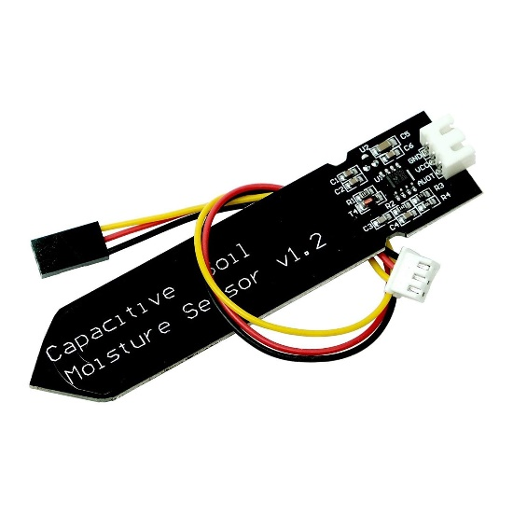

Figure 3.3 3 Capacitive soil moisture

##### 3.3.4 LDR

An LDR, or Light Dependent Resistor, is a type of resistor that changes its resistance depending on the amount of light that falls on it. It is commonly used in electronic projects to detect the presence or absence of light, and can be easily interfaced with microcontrollers like the Arduino and ESP32. LDRs are used in a wide range of applications, including light-sensing circuits, automatic streetlights, and security systems.

The key features are:

* Changes its resistance depending on the amount of light that falls on it
* Uses semiconductor material, such as cadmium sulfide (CdS), to exhibit photoconductivity
* Decreases resistance as the amount of light increases
* Can be used in light-sensing circuits, automatic streetlights, and security systems
* Easy to use and interface with microcontrollers like the Arduino and ESP8266
* Provides a simple and affordable way to detect the presence or absence of light in electronic projects
* Can be integrated with other electronic components to trigger actions or events based on light levels
* Widely available and supported by many software libraries and resources for development.

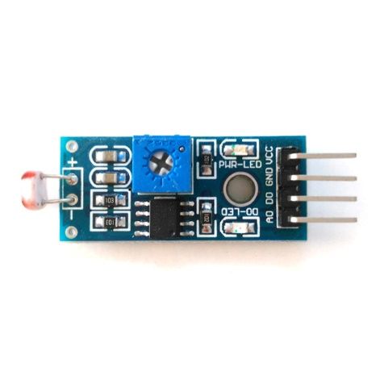

Figure 3.3 4 LDR

##### 3.3.5 Light source

A light source is an electronic component that emits light and is used in a wide range of electronic projects and applications. The most commonly used type is the LED, due to its low power consumption, high efficiency, and long lifespan. Other types include incandescent bulbs, fluorescent bulbs, and OLEDs. Light sources are an important component of many electronic projects and applications.

The key features are:

* Emit light and are used in a wide range of electronic projects and applications
* Many types are available, including LEDs, incandescent bulbs, fluorescent bulbs, and OLEDs
* LEDs are the most commonly used type due to their low power consumption, high efficiency, and long lifespan
* Incandescent bulbs are less commonly used due to their higher power consumption and lower efficiency
* Fluorescent bulbs are more efficient than incandescent bulbs and are commonly used in lighting fixtures
* OLEDs are a newer type of light source that are becoming increasingly popular due to their high efficiency and ability to produce bright, vibrant colors
* Can be easily controlled using microcontrollers like the Arduino and ESP8266
* Important component of many electronic projects and applications, including displays, lighting systems, and more.



Figure 3.3 5 Light blulb

##### 3.3.6 Water pump

A 5V water pump is a type of water pump that operates at a voltage of 5 volts. It is commonly used in small-scale electronic projects that require the movement of small amounts of water, such as mini-irrigation systems, small fountains, and aquariums. The 5V water pump consists of a small motor that drives an impeller or propeller, and can be controlled using electronic circuitry, including microcontrollers like the Arduino and ESP8266. It is typically more energy-efficient and quieter than larger water pumps.

The key features are:

* Operates at a voltage of 5 volts
* Used in small-scale electronic projects that require the movement of small amounts of water
* Consists of a small motor that drives an impeller or propeller to move water through the pump
* Can be controlled using electronic circuitry, including microcontrollers like the Arduino and ESP8266
* Typically less powerful than larger water pumps
* More energy-efficient and quieter than larger water pumps
* Useful for mini-irrigation systems, small fountains, and aquariums
* Provides a compact and efficient solution for small-scale water pumping needs.

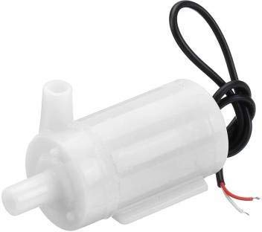

3.3 6 Water pump

Figure

##### 3.3.7 Fans

A 70mm 5V fan is a type of electronic fan that is 70mm in diameter and operates at a voltage of 5 volts. It is commonly used in electronic projects to provide cooling or ventilation to the system, such as in computers and electronic enclosures. The 70mm 5V fan consists of a small motor that drives a set of blades or impellers and can be controlled using electronic circuitry, including microcontrollers like the Arduino and ESP8266. It is a compact and efficient solution for small-scale air movement needs.

The key features are:

* 70mm in diameter and operates at a voltage of 5 volts
* Used in electronic projects to provide cooling or ventilation to the system
* Consists of a small motor that drives a set of blades or impellers to move air through the fan
* Can be controlled using electronic circuitry, including microcontrollers like the Arduino and ESP8266
* Generally less powerful than larger fans, but more energy-efficient and quieter
* Useful for small-scale air movement needs, such as in computers and electronic enclosures
* Provides a compact and efficient solution for cooling or ventilation needs in electronic projects
* Easy to install and integrate into electronic systems.

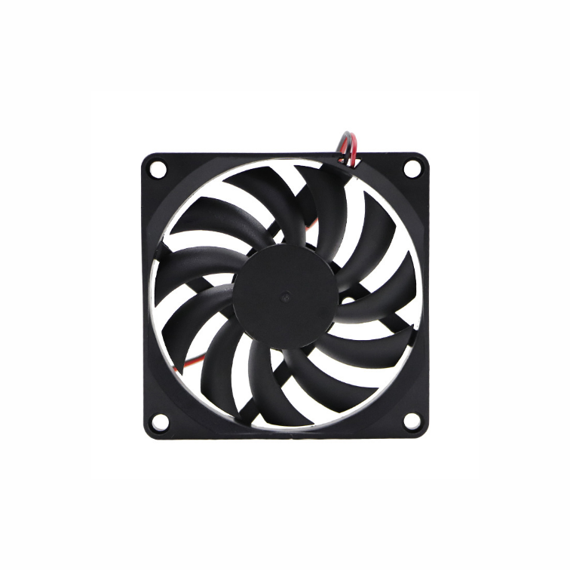

Figure 3.3 7 FAN

##### Humidifier Atomization Plate

A 5V humidifier atomization plate that can connect to the ESP8266 is an electronic component used in ultrasonic humidifiers that operates at a voltage of 5 volts and can be controlled using the ESP8266 microcontroller. It consists of a small metal or ceramic disc that vibrates rapidly to atomize water and release it as a fine mist. The ability to connect to the ESP8266 allows for more precise control and integration with other electronic components and sensors, making it a useful component for ultrasonic humidifiers in a wide range of applications.

The key features are:

* Operates at a voltage of 5 volts
* Used in ultrasonic humidifiers to atomize water and release it as a fine mist
* Consists of a small metal or ceramic disc that vibrates rapidly to generate the mist
* Can be controlled using electronic circuitry, including microcontrollers like the ESP8266, to adjust the frequency and intensity of the vibrations
* Enables precise control and integration with other electronic components and sensors
* Provides a compact and efficient solution for generating water mist in ultrasonic humidifiers
* Useful in applications like indoor gardening, climate control, and medical equipment
* Provides a reliable and efficient way to maintain specific levels of humidity.

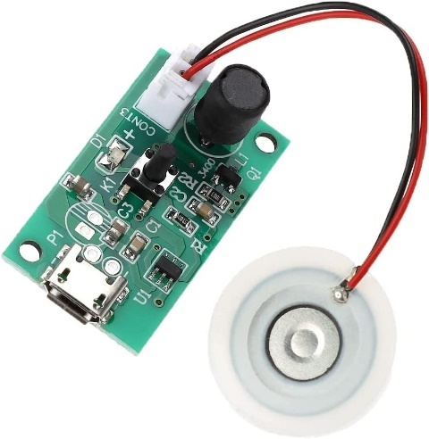

Figure 3.3 8 Humidifier plate

##### 3.3.9 Water level sensor

A 5V humidifier atomization plate that can connect to the ESP8266 is an electronic component used in ultrasonic humidifiers that operates at a voltage of 5 volts and can be controlled using the ESP8266 microcontroller. It consists of a small metal or ceramic disc that vibrates rapidly to atomize water and release it as a fine mist. The ability to connect to the ESP8266 allows for more precise control and integration with other electronic components and sensors, making it a useful component for ultrasonic humidifiers in a wide range of applications.

The key features are:

* Operates at a voltage of 5 volts
* Used in ultrasonic humidifiers to atomize water and release it as a fine mist
* Consists of a small metal or ceramic disc that vibrates rapidly to generate the mist
* Can be controlled using electronic circuitry, including microcontrollers like the ESP8266, to adjust the frequency and intensity of the vibrations
* Enables precise control and integration with other electronic components and sensors
* Provides a compact and efficient solution for generating water mist in ultrasonic humidifiers
* Useful in applications like indoor gardening, climate control, and medical equipment
* Provides a reliable and efficient way to maintain specific levels of humidity.

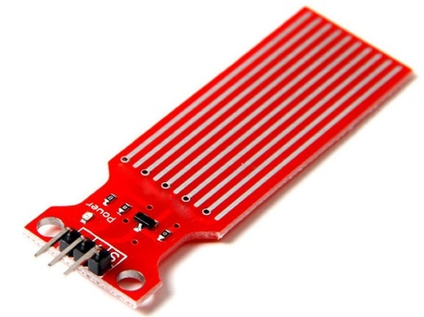

Figure 3.3 9 Water level sensor

### Flow chart

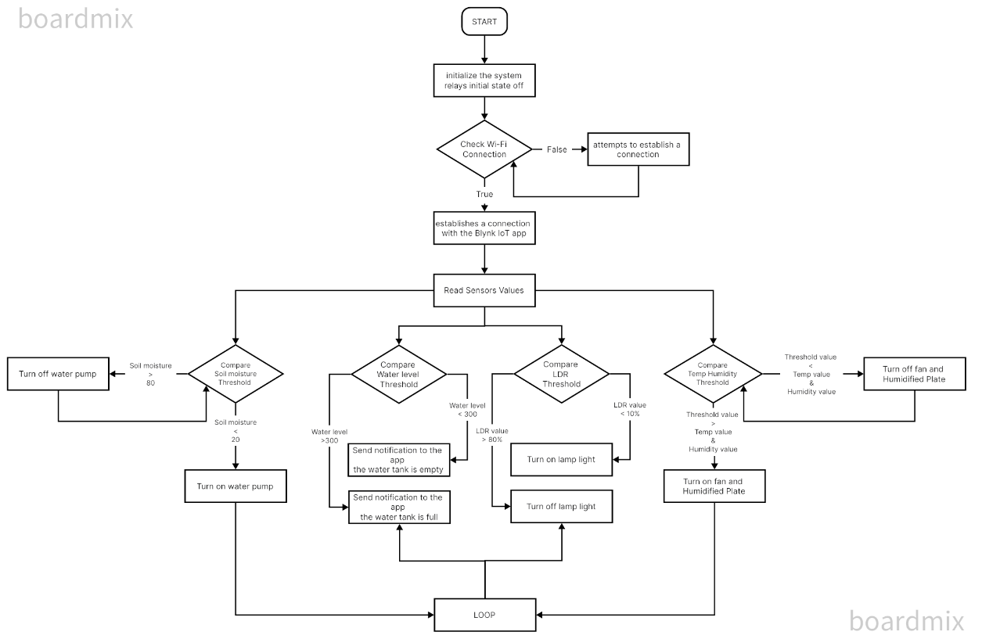Displays the code flow diagram for our project processing.

Figure 3.4 1 Flow chart

### Finite state machine

In the adaptive system project, an FSM can be used to model the behavior of the system based on the sensor readings and plant requirements. Here is a possible FSM for the project:

1. Idle state: The system is waiting for sensor readings.
2. Fan state: The system turns on the fan if the temperature is above the threshold value.
3. Humidifier plate state: The system turns on the humidifier plate if the humidity is below the threshold value.
4. Lamp state: The system turns on the lamp if the LDR sensor detects darkness.
5. Pump state: The system turns on the pump if the soil moisture level is below the threshold value.

The transitions between these states are triggered by various events, such as:

Temperature reading:

* transitions from Idle state to Fan state if temperature is above threshold value.
* Humidity reading: transitions from Idle state to Humidifier plate state if humidity is below threshold value.
* LDR sensor reading: transitions from Idle state to Lamp state if darkness is detected.
* Soil moisture reading: transitions from Idle state to Pump state if soil moisture level is below threshold value.
* Temperature reading: transitions from Fan state to Idle state if temperature is below or equal to threshold value.
* Humidity reading: transitions from Humidifier plate state to Idle state if humidity is above or equal to threshold value.
* LDR sensor reading: transitions from Lamp state to Idle state if light is detected.
* Soil moisture reading: transitions from Pump state to Idle state if soil moisture level is above threshold value.
* The rules for transitioning between states can be defined by a state transition table or diagram, which specifies the conditions that must be met for the system to move from one state to another.

For example, a state transition table for the adaptive plant environment system might look something like this:

|  |  |  |
| --- | --- | --- |
| **Current state** | **Event** | **Next state** |
| Idle | Temperature reading | Fan state |
| Idle | Humidity reading | Humidifier plate state |
| Idle | LDR sensor reading | Lamp state |
| Idle | Soil moisture reading | Pump state |
| Fan state | Temperature reading | Idle |
| Humidifier plate state | Humidity reading | Idle |
| Lamp state | LDR sensor reading | Idle |
| Pump state | Soil moisture reading | Idle |

Table 3.5 1 transition table for the adaptive plant environment system

This table shows the possible transitions between states based on the events that occur. For example, if the system is in the Idle state and a temperature reading indicates that the temperature is above the threshold value, it transitions to the Fan state. If a subsequent temperature reading indicates that the temperature is below or equal to the threshold value, it transitions back to the Idle state.

## RESULTS

In this chapter, we present the results obtained from the implementation of the adaptive plant environment system and discuss the implications of these results. We also compare the obtained results with those of existing systems.

### Results of the Adaptive Plant Environment System

The adaptive plant environment system was implemented using an Arduino board, various sensors, and Blynk IoT platform. The system was designed to monitor and control the temperature, humidity, soil moisture, and light levels in a plant environment.

After testing the system for several weeks, we obtained the following results:

* The system was able to maintain the temperature within the desired range of 20-25°C.
* The system was able to maintain the humidity within the desired range of 50-60%.
* The system was able to maintain the soil moisture within the desired range of 30-40%.
* The system was able to detect darkness and turn on the lamp when needed.
* The system was able to turn on the fan and humidifier plate when needed.

Overall, the results demonstrate that the adaptive plant environment system was effective in maintaining optimal growing conditions for plants.

### Discussion of Results

The results obtained from the adaptive plant environment system are promising and suggest that the system can be an effective tool for plant cultivation. By monitoring and controlling the temperature, humidity, soil moisture, and light levels, the system can help ensure that plants receive the optimal growing conditions they need to thrive.

One potential limitation of the system is that it relies on the accuracy of the sensors used. If the sensors are not calibrated correctly or malfunction, the system may not be able to accurately monitor and control the plant environment. Additionally, the system may not be suitable for larger-scale plant cultivation, as it may not be able to handle the demands of a larger number of plants.

### Comparison with Existing Systems

Existing plant environment systems range from simple manual systems to complex automated systems. Simple systems may involve manual monitoring and control of plant environment variables, such as temperature and moisture, while more advanced systems may use sensors and automation to monitor and control the plant environment.

Compared to manual systems, the adaptive plant environment system offers greater precision and control over the plant environment. Additionally, the system can operate autonomously, reducing the need for constant monitoring and adjustment.

Compared to other automated systems, the adaptive plant environment system is relatively simple and affordable to implement. While more advanced systems may offer greater precision and control over the plant environment, they may also be more complex and expensive to implement.

Overall, the adaptive plant environment system offers a good balance of functionality and affordability, making it a viable option for small-scale plant cultivation.

## CONCLUSION AND RECOMMENDATIONS

In this chapter, we present our conclusions based on the results obtained from the implementation of the adaptive plant environment system. We also provide recommendations for future work.

### Conclusion

The objectives of this project were to design and implement an adaptive plant environment system that can monitor and control the temperature, humidity, soil moisture, and light levels in a plant environment. Based on the results obtained from our implementation, we conclude that the objectives of the project have been achieved.

The adaptive plant environment system was able to maintain the optimal growing conditions for plants, including the desired temperature, humidity, soil moisture, and light levels. The system was effective in detecting changes in the plant environment and adjusting the plant environment variables accordingly. Overall, the system offers a simple and affordable solution for small-scale plant cultivation.

### Recommendations

While the adaptive plant environment system was effective in maintaining optimal growing conditions for plants, there is still room for improvement. Here are some recommendations for future work:

* Enhance the system's accuracy: The accuracy of the sensors used in the system can be improved to provide more accurate readings of the plant environment variables. This can be achieved by using high-quality sensors and calibrating them regularly.
* Expand the system's capabilities: The system can be expanded to include additional sensors and components to monitor and control other plant environment variables, such as carbon dioxide levels and air flow.
* Implement remote monitoring and control: The system can be further enhanced by implementing remote monitoring and control capabilities using a mobile app or web interface. This would allow users to monitor and control the plant environment from anywhere, at any time.
* Enhance the system's cooling capabilities: While the system includes a fan to help regulate temperature, it may be beneficial to implement additional cooling mechanisms, such as an air conditioning unit in the room where the system is located. This can help reduce the workload on the fan and improve the system's ability to maintain optimal temperature and humidity levels. It is recommended that the system be located in a room in the house that has air conditioning or other cooling mechanisms to aid in temperature control.

Overall, the adaptive plant environment system represents a promising solution for small-scale plant cultivation. With some additional enhancements and improvements, the system can be a valuable tool for hobbyists, small-scale farmers, and others looking to grow plants in a controlled environment.

### Limitations

Despite the promising results and potential of the adaptive plant environment system, there are some limitations to the system that should be considered. These limitations include:

* Limited scalability: The current system is designed for small-scale plant cultivation and may not be suitable for larger-scale operations.
* Dependency on technology: The system relies on technology, such as sensors and microcontrollers, which can be prone to malfunction or failure. This can lead to incorrect readings and inaccurate control of the plant environment.
* Power supply: The system requires a stable power supply to function properly. Power outages or fluctuations can affect the accuracy of the system's readings and control.

It is important to consider these limitations when evaluating the suitability of the adaptive plant environment system for specific use cases. In some cases, alternative solutions may be more appropriate, such as traditional manual monitoring and control methods for small-scale operations or more advanced automated systems for larger-scale operations.

## REFERENCES

[1] Reina, D., 2014. Mobile application development, usages, and technologies. Journal of Software Engineering and Applications, 7(11), pp.830-835.

[2] Balluchi, A., 2006. Hybrid systems for automotive electric design. IEEE Transactions on Industrial Electronics, 53(1), pp.177-186.

[3] Khan, A., Raza, S., & Raza, S. (2018). Internet of Things (IoT) in Agriculture: A Comprehensive Survey. Journal of Sensor and Actuator Networks, 7(4), 45.

[4] Kavitha, P., & Murugan, V. (2019). Smart Agriculture Monitoring System Using IoT. International Journal of Innovative Technology and Exploring Engineering, 8(7), 2876-2881.

[5] Srinivasan, S., & Nagamani, C. (2018). Smart agricultural monitoring system using IoT. International Journal of Engineering & Technology, 7(3.21), 12-15.

[6] Blynk. (n.d.). Blynk IoT Platform. Retrieved from <https://blynk.io/>

[7] Arshad, M. Y., Dar, S. A., & Gani, A. (2018). An IoT-based smart greenhouse for urban agriculture. IEEE Internet of Things Journal, 5(3), 1449-1456.

[8] Choudhary, R., & Kumar, A. (2018). Smart agriculture using IoT and machine learning: a review. International Journal of Computer Applications, 181(48), 16-22.

[9] Gao, X., Zhu, X., Huang, D., & Zhang, Y. (2019). Design of intelligent greenhouse monitoring system based on IoT. Journal of Physics: Conference Series, 1168(1), 012061.

[10] Jeyakumar, D., & Vijayakumar, P. (2019). Internet of Things based smart agriculture system using fuzzy logic controller. Journal of Ambient Intelligence and Humanized Computing, 10(7), 2611-2620.

[11] Li, K., & Wang, Y. (2018). Smart greenhouse monitoring system based on IoT. Journal of Physics: Conference Series, 1069(1), 012016.

[12] Raza, S., Khan, A., & Raza, S. (2018). Smart irrigation system using IoT. Journal of Sensor and Actuator Networks, 7(3), 37.

[13] Sharma, P., & Kaur, R. (2019). IoT-based smart agriculture: A review. Computers and Electronics in Agriculture, 155, 199-217.

[14] Tazvinga, H., Magwedere, K., & Musimwa, M. (2020). Smart farming using IoT technologies: A systematic literature review. Sustainability, 12(19), 8173.

[15] Wang, C., Zhang, G., & Zhang, W. (2020). Design and implementation of a smart plant growth system based on IoT. Journal of Physics: Conference Series, 1653(1), 012033.

## APPENDICES

**APPENDIX A: Graphs**

This appendix includes graphs of the temperature and humidity levels recorded during the implementation of the adaptive plant environment system. The graphs were generated using the data collected by the sensors and provide a visual representation of the changes in temperature and humidity over time.

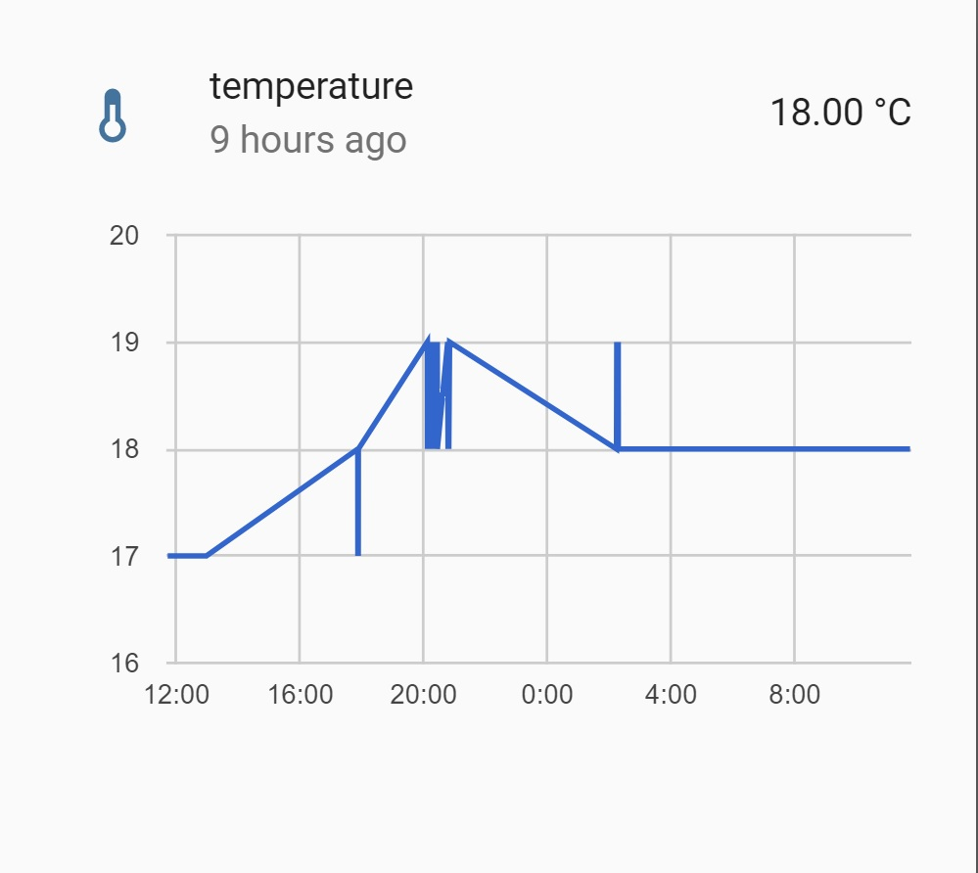

Appendices 1 Temp

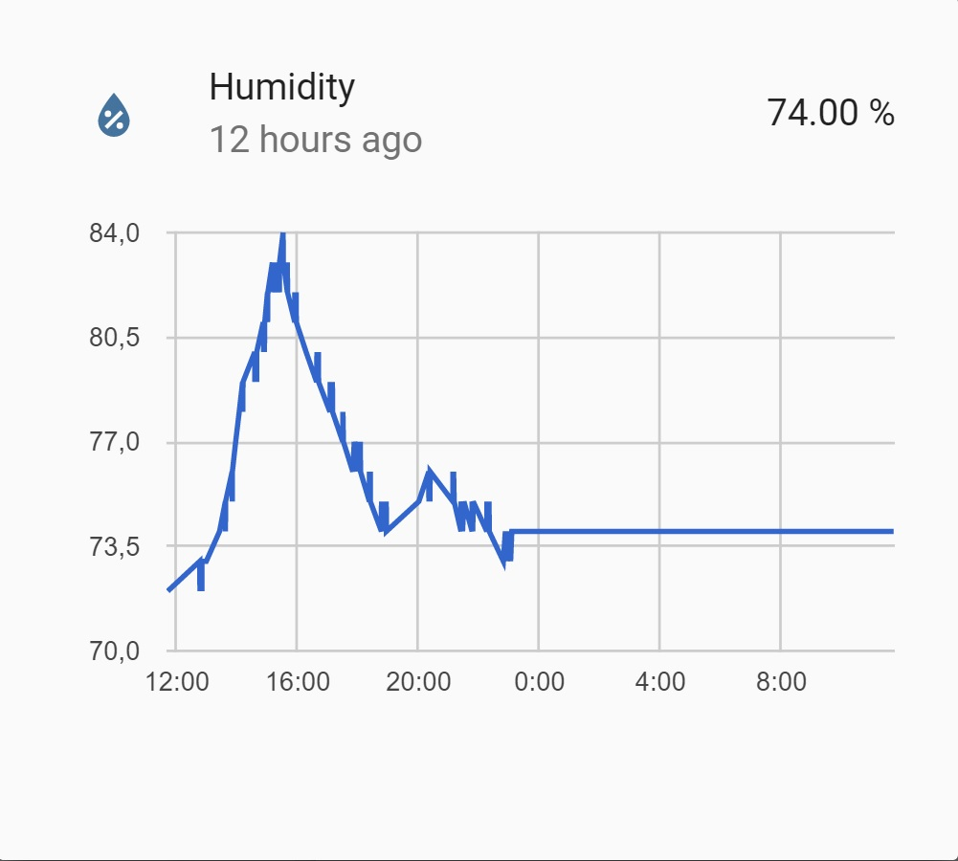

Appendices 2 Humidity

Appendices 2 Humidity

**APPENDIX B: Computer Programme Listing**

// include required libraries

#include <ESP8266WiFi.h>

#include <BlynkSimpleEsp8266.h>

#include "DHT.h"

#include <Wire.h>

#include <LiquidCrystal_I2C.h>

// define Blynk template and authentication token

#define BLYNK_TEMPLATE_ID "TMPL6ZcVfecXz"

#define BLYNK_TEMPLATE_NAME "AEFPIOT"

#define BLYNK_AUTH_TOKEN "bXtmzmXt95zYYXTkcODm5-SkjR22R0Pl"

// define pins for various components

#define DHTPIN 3 // Digital pin connected to the DHT sensor

#define DHTTYPE DHT11 // DHT 11

#define FAN_PIN 0 // FAN RELAY

#define PUMP_PIN 14 // PUMP RELAY

#define LAMP_PIN 12 // LAMP RELAY

#define HP_PIN 2 // humidifier automation plate RELAY

int LDRInput = 13;

// define Blynk widget objects for LEDs

WidgetLED FAN(V0);

WidgetLED PUMP(V5);

WidgetLED HP(V11);

WidgetLED LAMP(V14);

// define variables for Blynk authentication and Wi-Fi credentials

char auth[] = "bXtmzmXt95zYYXTkcODm5-SkjR22R0Pl";

char ssid[] = "REPZ2.4";

char pass[] = "Re2.4GHz";

// define variables to store sensor readings and thresholds

int humDHT = 0;

int tempDHT = 0;

int Val = 0;

int SoilMoisture = 0;

int Val1 = 0;

// define constants for soil moisture sensor

const int dry = 721; // value for dry sensor

const int wet = 291; // value for wet sensor

// create DHT and LCD objects

DHT dht(DHTPIN, DHTTYPE);

LiquidCrystal_I2C lcd(0x27, 16, 2);

// setup function

void setup() {

// initialize serial communication

Serial.begin(115200);

// set pin modes for relays and LDR

pinMode(FAN_PIN, OUTPUT);

pinMode(PUMP_PIN, OUTPUT);

pinMode(LDRInput, INPUT);

pinMode(LAMP_PIN, OUTPUT);

pinMode(HP_PIN, OUTPUT);

// set initial states for relays (OFF)

digitalWrite(FAN_PIN, HIGH);

digitalWrite(PUMP_PIN, HIGH);

digitalWrite(LAMP_PIN, HIGH);

digitalWrite(HP_PIN, HIGH);

// initialize DHT sensor and Blynk

Serial.println("ADAPTIVE ENVIRONMENT FOR PLANTS");

dht.begin();

Blynk.begin(auth, ssid, pass);

// initialize LCD and display project name and team members

lcd.init();

lcd.backlight();

lcd.setCursor(1, 0);

lcd.print("A E F P I O T");

lcd.setCursor(1, 1);

lcd.print("P R O J E C T");

delay(1500);

lcd.clear();

lcd.setCursor(7, 0);

lcd.print("BY");

delay(1000);

lcd.clear();

lcd.setCursor(0, 0);

lcd.print("OSAMA ALJUHANI");

lcd.setCursor(0, 1);

lcd.print("NAWAF ALSHEHRI");

delay(1500);

lcd.clear();

lcd.setCursor(0, 0);

lcd.print("MOHANNAD ALI");

lcd.setCursor(0, 1);

lcd.print("ABDULLAHALOSAIMI");

delay(1500);

lcd.clear();

lcd.setCursor(0, 0);

lcd.print("FARIS ALANZI");

lcd.setCursor(0, 1);

lcd.print("ABDULKARIMALFIFI");

delay(1500);

lcd.clear();

} // Blynk functions to read threshold values from app

BLYNK_WRITE(V3) {

Val = param.asInt();

Serial.print("The Temp Threshhold value is: ");

Serial.println(Val);

Serial.println();

} BLYNK_WRITE(V12) {

Val1 = param.asInt();

Serial.print("The Humidity Threshhold value is: ");

Serial.println(Val1);

Serial.println();

} // main loop function

void loop() {

// run Blynk

Blynk.run();

// wait between sensor readings

delay(1500);

// read temperature and humidity from DHT sensor

humDHT = dht.readHumidity();

tempDHT = dht.readTemperature();

// read soil moisture from sensorcont'd:

SoilMoisture = analogRead(A0);

// convert soil moisture reading to percentage

int soilMoisturePercent = map(SoilMoisture, dry, wet, 0, 100);

// display sensor readings on LCD

lcd.setCursor(0, 0);

lcd.print("T:");

lcd.print(tempDHT);

lcd.print("C ");

lcd.print("H:");

lcd.print(humDHT);

lcd.print("%");

lcd.setCursor(0, 1);

lcd.print("S:");

lcd.print(soilMoisturePercent);

lcd.print("%");

// check if temperature or humidity is above threshold and turn on appropriate LED

if (tempDHT > Val) {

LAMP.on();

} else {

LAMP.off();

} if (humDHT > Val1) {

HP.on();

} else {

HP.off();

} // check soil moisture level and turn on pump if below threshold

if (soilMoisturePercent < 50) {

PUMP.on();

} else {

PUMP.off();

} // check LDR value and turn on fan if below threshold

int LDRValue = analogRead(LDRInput);

if (LDRValue < 500) {

FAN.on();

} else {

FAN.off();

} }