APPENDIXE

Al-Wakeel Al-Shamel
Order Management System

User Manual

Version: 1.0
Date: June 2026
Developer: Osama Al-Hossam
Website: https://alwakeel-alshamel.vercel.app

1. Introduction

1.1 Purpose
This manual describes how to use the Al-Wakeel Al-Shamel Order Management System (OMS) — a web application for selling premium phone accessories online and managing orders, inventory, and business reports.

1.2 Intended Users
Role | Description
Customer | Browses products, places orders, and manages their account
Administrator | Manages products, customers, orders, and sales reports
Retail Salesperson | Views sales performance and customer orders
Warehouse Manager | Manages stock levels and inventory check-ups

1.3 Live System Access
Component | URL
Website (Frontend) | https://alwakeel-alshamel.vercel.app
API (Backend) | https://oms-api-23gt.onrender.com

Note: The backend runs on Render's free tier. If the site has been idle for 15+ minutes, the first action may take up to one minute while the server wakes up.

2. System Overview

2.1 Main Features
- Online product catalogue (chargers, earphones, power banks, phone cases)
- Shopping cart and secure checkout
- Payment by Credit Card or Cash on Delivery
- Automatic FedEx Express shipping on all orders
- Email verification for new customer accounts
- PDF invoices and order confirmation emails
- Role-based dashboards for Admin, Sales, and Warehouse staff
- Mobile-friendly layout with a collapsible navigation menu (☰)

2.2 User Roles and Access
Each user account is assigned one role. After login, you only see the menus and pages allowed for your role.
Role | Pages Available
Customer | Products, Cart, Orders, Profile
Retail Salesperson | Sales Dashboard, Orders
Warehouse Manager | Products (view), Inventory, Warehouse Dashboard
Administrator | Admin Panel: Dashboard, Products, Orders, Customers, Reports

3. Getting Started

3.1 Supported Browsers and Devices
- Browsers: Chrome, Edge, Firefox, Safari (latest versions recommended)
- Devices: Desktop, laptop, tablet, and smartphone
- On mobile, tap the ☰ menu icon in the top bar to open navigation links

3.2 Demo Accounts (Testing)
The system includes pre-configured demo accounts. All use the password: DemoPass!123
Role | Email | Login Page
Customer | customer@demo.local | Main Login
Administrator | admin@demo.local | Admin Login (/admin/login)
Retail Salesperson | sales@demo.local | Main Login
Warehouse Manager | warehouse@demo.local | Main Login

3.3 Logging In
- Open the website: https://alwakeel-alshamel.vercel.app
- Click Login in the top-right corner.
- Enter your email and password.
- Click Sign In.
- You are redirected to your role's home page (e.g. Products for customers).

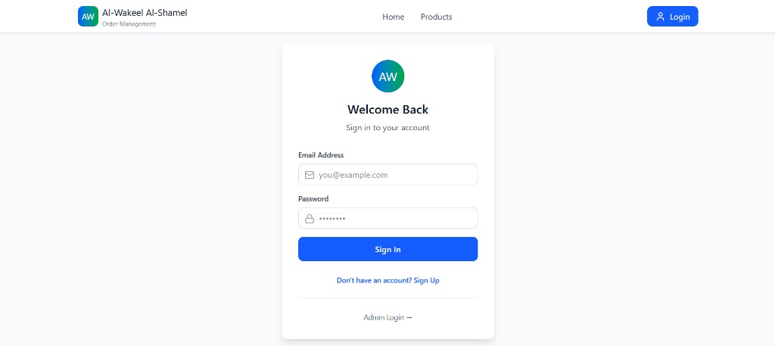
Figure 1 — Login Page
Administrators must use the separate admin login at /admin/login. Click 'Admin Login →' at the bottom of the main login page.

3.4 Logging Out
Click Logout in the top-right corner. You will be returned to the login page.

3.5 Creating a New Customer Account
- Click Sign Up on the home page or login page.
- Fill in your full name, phone number, email address, delivery address, and password.
- Click Create Account.
- A verification email is sent to your inbox.
- Open the email and click the verification link.
- After verification, log in and start shopping.

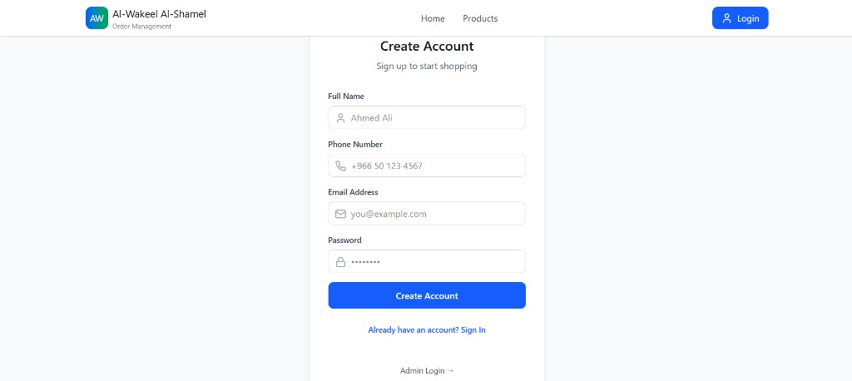
Figure 2 — Create Account form
Important: You must verify your email before you can use the cart or place orders. If the email does not arrive, check your spam folder or resend from Profile.

4. Customer Guide

4.1 Home Page
The home page introduces Al-Wakeel Al-Shamel and provides:
- A Browse Products button (redirects to login if not signed in)
- A Sign Up button for new visitors
- A 'Why Shop With Us?' section highlighting key benefits
- Popular Categories — visual links to Chargers, Earphones, Power Banks, and Phone Cases

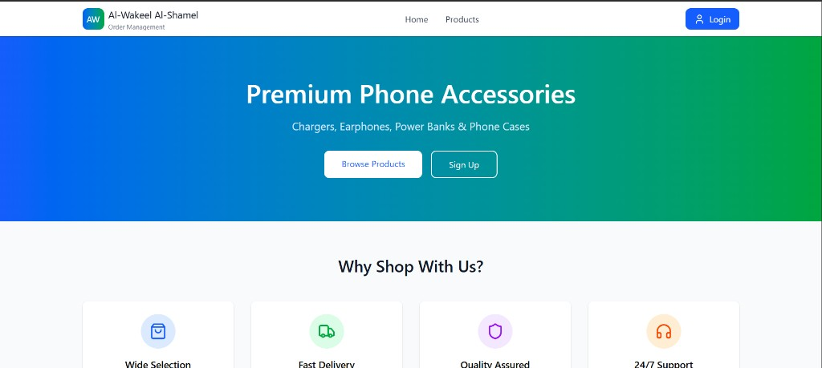
Figure 3 — Home Page hero banner
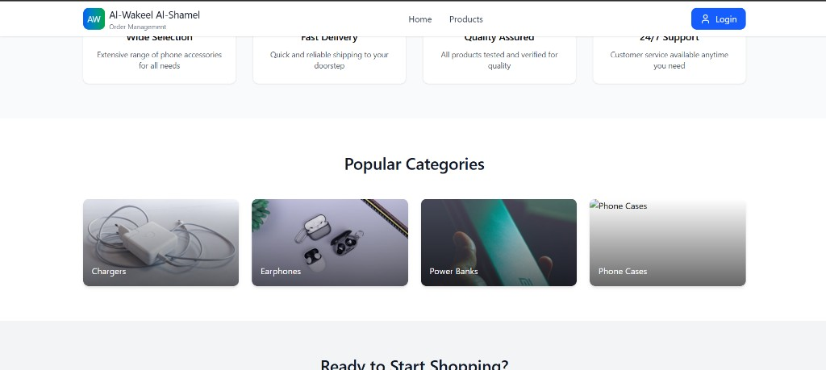
Figure 4 — Popular Categories section
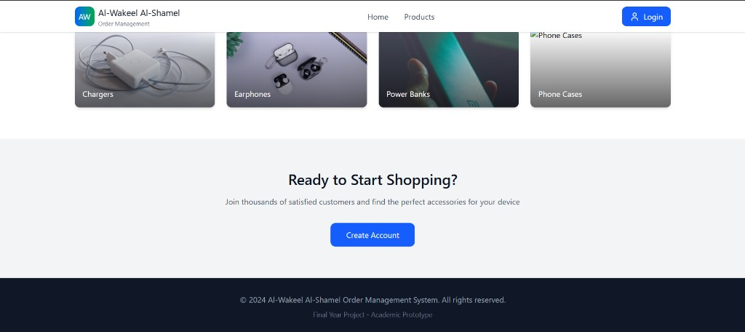
Figure 5 — Call-to-action and footer

4.2 Browsing Products
- After logging in, click Products in the navigation bar.
- Use the search bar to find products by name.
- Use the category filter dropdown (All, Chargers, Earphones, etc.) to narrow results.
- Each product card shows the image, name, description, price, and stock level.
- Click any product card to open the Product Details page.
- On the details page, review the description, price, stock level, and product features.

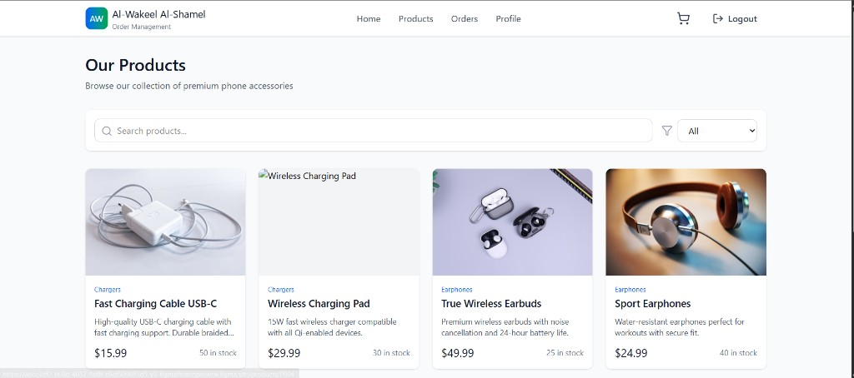
Figure 6 — Products Page with search and category filter
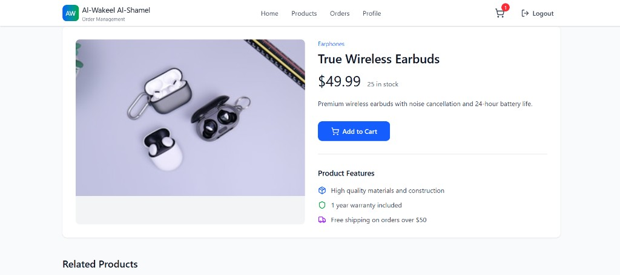
Figure 7 — Product Details page

4.3 Adding Items to the Cart
- On the Products page, click Add to cart on any in-stock product card.
- Or open a product's detail page, set the quantity, and click Add to Cart.
- The cart icon (🛒) in the top bar shows a badge with the total number of items.

4.4 Managing the Shopping Cart
Click the cart icon in the top bar to open the Shopping Cart page.
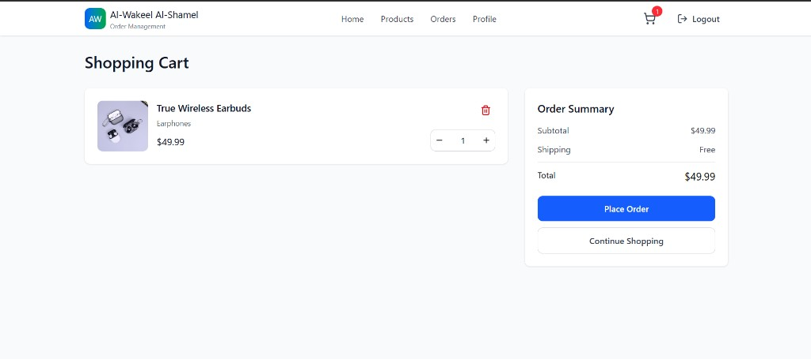
Figure 8 — Shopping Cart with Order Summary panel
Action | How
Change quantity | Use the − and + buttons next to an item
Remove an item | Click the 🗑 (trash) icon
Review totals | See subtotal, FedEx shipping (Free), and total in the Order Summary panel

Shipping: All orders ship via FedEx Express (estimated 3–5 business days). Shipping is free on all orders.

4.5 Checkout and Payment
From the Cart page, select a payment method and complete checkout. The process follows four steps shown at the top of the page:
Cart → Payment Verification → Order Confirmation → Invoice
Step 1 — Cart (Order Details)
- Select a Payment Method: Credit Card (pay online now) or Cash on Delivery (pay on arrival).
- If paying by Credit Card, enter: Cardholder name, Card number, Expiry date (MM/YY), and CVV.
- Click Proceed to Payment Verification.
For testing, use card number 4111 1111 1111 1111 with any valid future expiry date and a 3-digit CVV.
Step 2 — Payment Verification
For card payments, a short verification screen simulates payment processing. Wait for the countdown or click Proceed when ready. For Cash on Delivery, this step confirms your order details before finalising.
Step 3 — Order Confirmation
You see your Order ID, total amount, payment method, and FedEx tracking number. A confirmation email with a PDF invoice is sent to your registered email address.
Step 4 — Invoice
View the full invoice on screen. Options: Download PDF, Print, or return to Order History.

4.6 Order History
- Click Orders in the navigation bar.
- View all past orders with order ID, date, status, items, prices, and FedEx tracking number.
- Filter by status using the dropdown at the top (Placed, Processing, Shipped, Delivered, Cancelled).

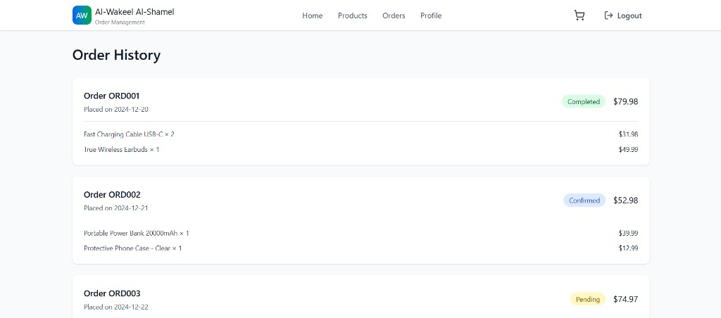
Figure 9 — Order History with status badges and item breakdown
For each order you can:
- View invoice — opens the invoice page
- Download PDF — saves the invoice as a PDF file
- Reorder — copies items back into your cart

4.7 My Profile
- Click Profile in the navigation bar.
- View your account details: name, email, phone, address, and member-since date.
- The Account Statistics section shows total orders, total amount spent, completed orders, and pending orders.
- Edit profile: Update your name, phone, or address → click Save Changes.
- Change password: Enter your current and new password → click Update Password.
- Email verification: If your email is not yet verified, click Resend verification email.

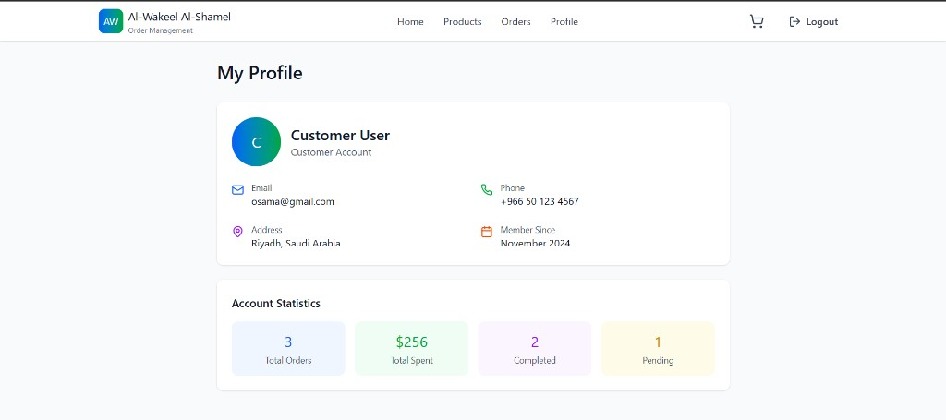
Figure 10 — My Profile page with Account Statistics

5. Administrator Guide
Administrators use a separate dark-themed Admin Panel with its own navigation bar.

5.1 Accessing the Admin Panel
- Go to https://alwakeel-alshamel.vercel.app/admin/login
- Log in with an Admin account (e.g. admin@demo.local / DemoPass!123).
- You are taken to the Admin Dashboard.

5.2 Admin Dashboard
The dashboard provides a real-time overview of the entire business.
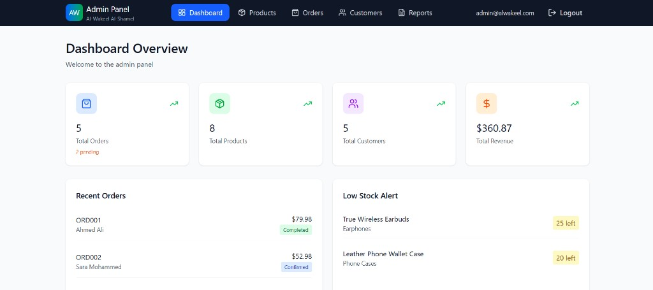
Figure 11 — Admin Dashboard with KPI cards, Recent Orders, and Low Stock Alert
Card | Description
Total Orders | All orders in the system; pending count shown in amber
Total Products | Number of active products in the catalogue
Total Customers | Number of registered customer accounts
Total Revenue | Cumulative cash revenue across all orders
Recent Orders | Latest orders with customer name, status badge, and total
Low Stock Alert | Products at or near minimum stock threshold

Click Refresh to reload the latest data from the server.

5.3 Product Management
Navigation: Admin Panel → Products
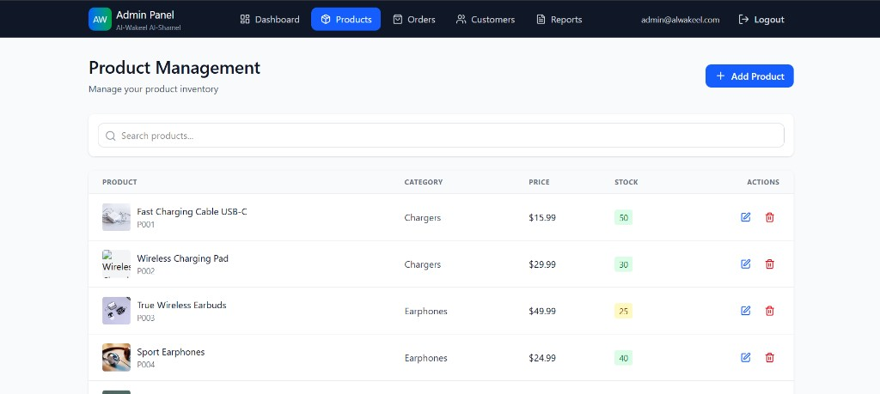
Figure 12 — Admin Product Management with edit and delete actions
Task | Steps
View all products | Scroll the product table; use the search box to filter by name or ID
Add a product | Click + Add Product, fill in the form (ID, Name, Category, Price, Stock, Description, Image URL), then click Save product
Edit a product | Click the ✎ (pencil) icon on a row — the form fills with current data. Modify fields, then click Save product
Delete a product | Click the 🗑 icon and confirm the deletion

Image URL tip: Use paths like /images/products/charger.jpg for images stored in the public folder, or supply a full external URL.

5.4 Order Management
Navigation: Admin Panel → Orders
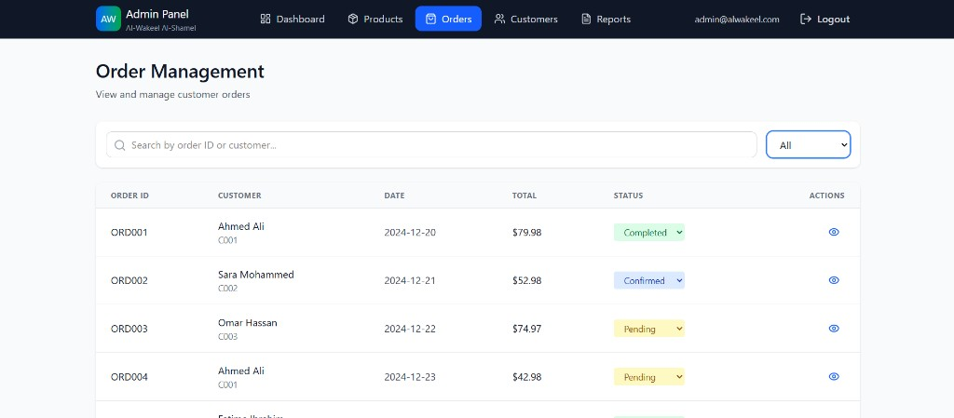
Figure 13 — Admin Order Management table
- View all customer orders in a searchable table.
- Columns: Order ID, Customer (name and ID), Date, Total, Payment Method, Shipping (FedEx tracking and ETA).
- Use the search box to find orders by Order ID or customer email.
Orders are fulfilled automatically via FedEx after checkout — no manual status changes are required.

5.5 Customer Management
Navigation: Admin Panel → Customers
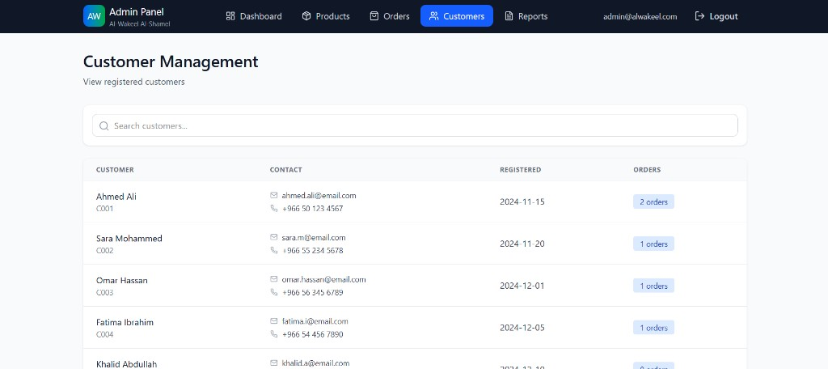
Figure 14 — Admin Customer Management table
- View all registered customers with name, customer ID, email, phone number, registration date, and order count.
- Use the search box to find a specific customer by name or email.

5.6 Sales Reports
Navigation: Admin Panel → Reports
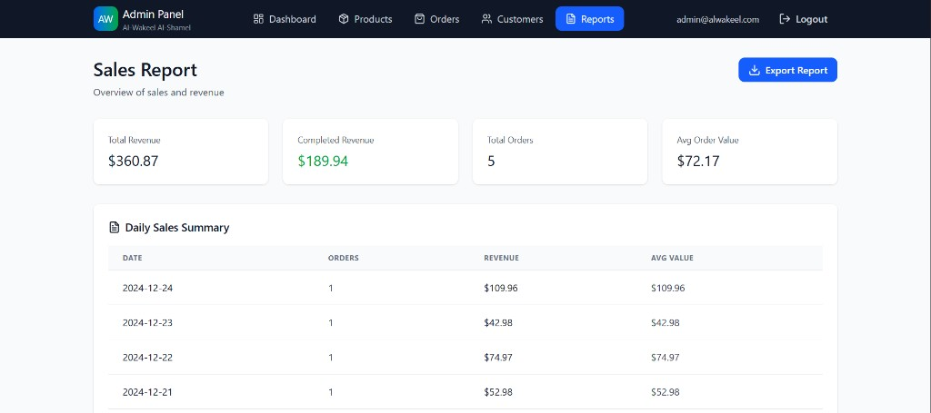
Figure 15 — Sales Report KPI cards
Metric | Description
Total Revenue | Gross revenue across all orders
Completed Revenue | Revenue from fully completed orders only
Total Orders | Total number of orders placed
Avg Order Value | Average spend per order

Scrolling down shows detailed breakdowns:
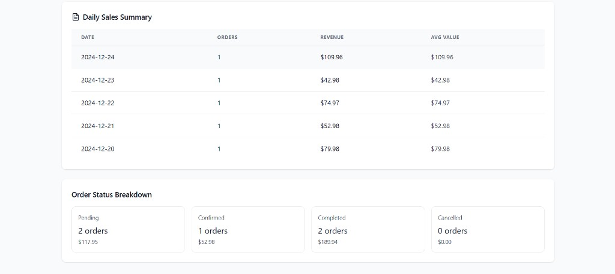
Figure 16 — Daily Sales Summary and Order Status Breakdown
- Daily Sales Summary — orders and revenue per day, sorted by most recent date.
- Order Status Breakdown — count and revenue split by Pending, Confirmed, Completed, and Cancelled.
Click Export Report to download the report data for offline use.

6. Retail Salesperson Guide

6.1 Sales Dashboard
Navigation: After login → automatically redirected to the Sales Dashboard.
The Sales Dashboard shows:
- Total orders, cash orders, and cash revenue metrics
- A table of recent customer orders (Order ID, customer email, status, total, and date)

6.2 Viewing Orders
Navigation: Orders in the top menu.
- Read-only list of all customer orders.
- Displays payment method, FedEx shipping details, and order totals.
- Use this page to answer customer enquiries and monitor sales activity.
Sales staff cannot modify orders or approve payments — all orders are processed automatically at checkout.

7. Warehouse Manager Guide

7.1 Warehouse Dashboard
Navigation: After login → Dashboard.
The Warehouse Dashboard shows:
- Low Stock alerts — products at or below the stock threshold, sorted by quantity ascending
- Recent Inventory Activity — a timestamped log of stock received, check-ups, and order deductions

7.2 Inventory Management
Navigation: Inventory in the top menu. The page has two action panels at the top and a full inventory table below.
Receive Stock
- Select a product from the dropdown list.
- Enter the quantity received (minimum 1).
- Add an optional note (e.g. 'Supplier delivery #4521').
- Click Receive.
- The product's available quantity and stock level increase automatically.
Log Check-up
- Select an inventory location from the dropdown list.
- Add an optional note describing the check-up findings.
- Click Log check-up.
- The Last Check-up date for that inventory row is updated.

Inventory Table Columns
Column | Description
Product | Product name and Product ID
Location | Warehouse location code
Available | Units currently available for sale
Reserved | Units reserved for pending orders
Last Check-up | Date and time of the most recent check-up

7.3 Viewing Products
Warehouse managers can open the Products page to view the full catalogue and current stock levels (read-only). Product editing is performed by Administrators only.

8. Troubleshooting

8.1 Common Issues
Problem | Likely Cause | Solution
Page loads slowly on first visit | API server waking from sleep (Render free tier) | Wait 30–60 seconds and refresh
'Failed to load profile' or blank data | Stale login token | Log out and log in again
Cannot access Cart or Checkout | Email not verified | Click the link in your verification email, or resend it from Profile
Login fails for demo accounts | Typo in email or password | Use exact emails from Section 3.2 with password DemoPass!123
Credit card payment rejected | Invalid test card details | Use 4111 1111 1111 1111 with a future expiry date and any 3-digit CVV
No verification email received | Email may be in spam folder | Check spam/junk; contact the administrator if still missing
Products show zero stock | Inventory depleted | Warehouse Manager receives new stock, or Admin increases the stock level
Navigation not visible on mobile | Menu is collapsed | Tap the ☰ icon in the top bar to expand the menu

8.2 Clearing Browser Session
If you experience persistent errors after a system update:
- Click Logout.
- Clear your browser cache, or open the site in a private/incognito window.
- Log in again.

8.3 Getting Help
For technical support, contact the system developer or your course instructor and include:
- Your role and the email address used to log in
- The page where the error occurred
- A screenshot of any error message displayed
- The approximate date and time of the issue

9. Appendix

9.1 Glossary
Term | Definition
OMS | Order Management System
SKU / Product ID | Unique code for each product (e.g. P001)
COD | Cash on Delivery — payment collected when the order arrives
FedEx Express | Courier service used for all shipments in this system
JWT | Secure token used to keep the user logged in between pages
Invoice | PDF document listing order items, totals, and payment details

9.2 Pre-loaded Demo Products
Product ID | Name | Category
P001 | Fast Charging Cable USB-C | Chargers
P002 | Wireless Charging Pad | Chargers
P003 | True Wireless Earbuds | Earphones
P004 | Sport Earphones | Earphones

9.3 Checkout Flow Diagram
┌─────────┐ ┌──────────────────────┐ ┌─────────────────┐ ┌─────────┐
│ Cart │ → │ Payment Verification │ → │ Confirmation │ → │ Invoice │
│ │ │ (card or COD) │ │ + Email sent │ │ (PDF) │
└─────────┘ └──────────────────────┘ └─────────────────┘ └─────────┘
↓
FedEx order created
Tracking number assigned

9.4 Document Revision History
Version | Date | Changes
1.0 | June 2026 | Initial user manual for production deployment

End of User Manual

