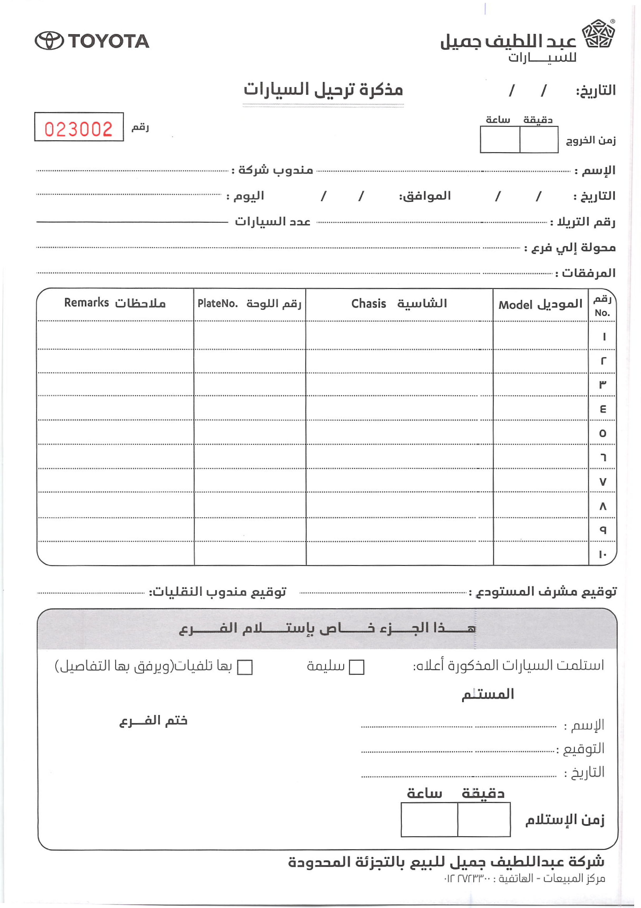
023002
05
07
2026
30
10
Ahmed
Toyota
01
07
2026
01
07
2026
Sunday
T1
1
Jeddah
Keys
W
D
☑
☐
R
S
05/07/2026
15
11

Camry
VIN123
ABC
OK

