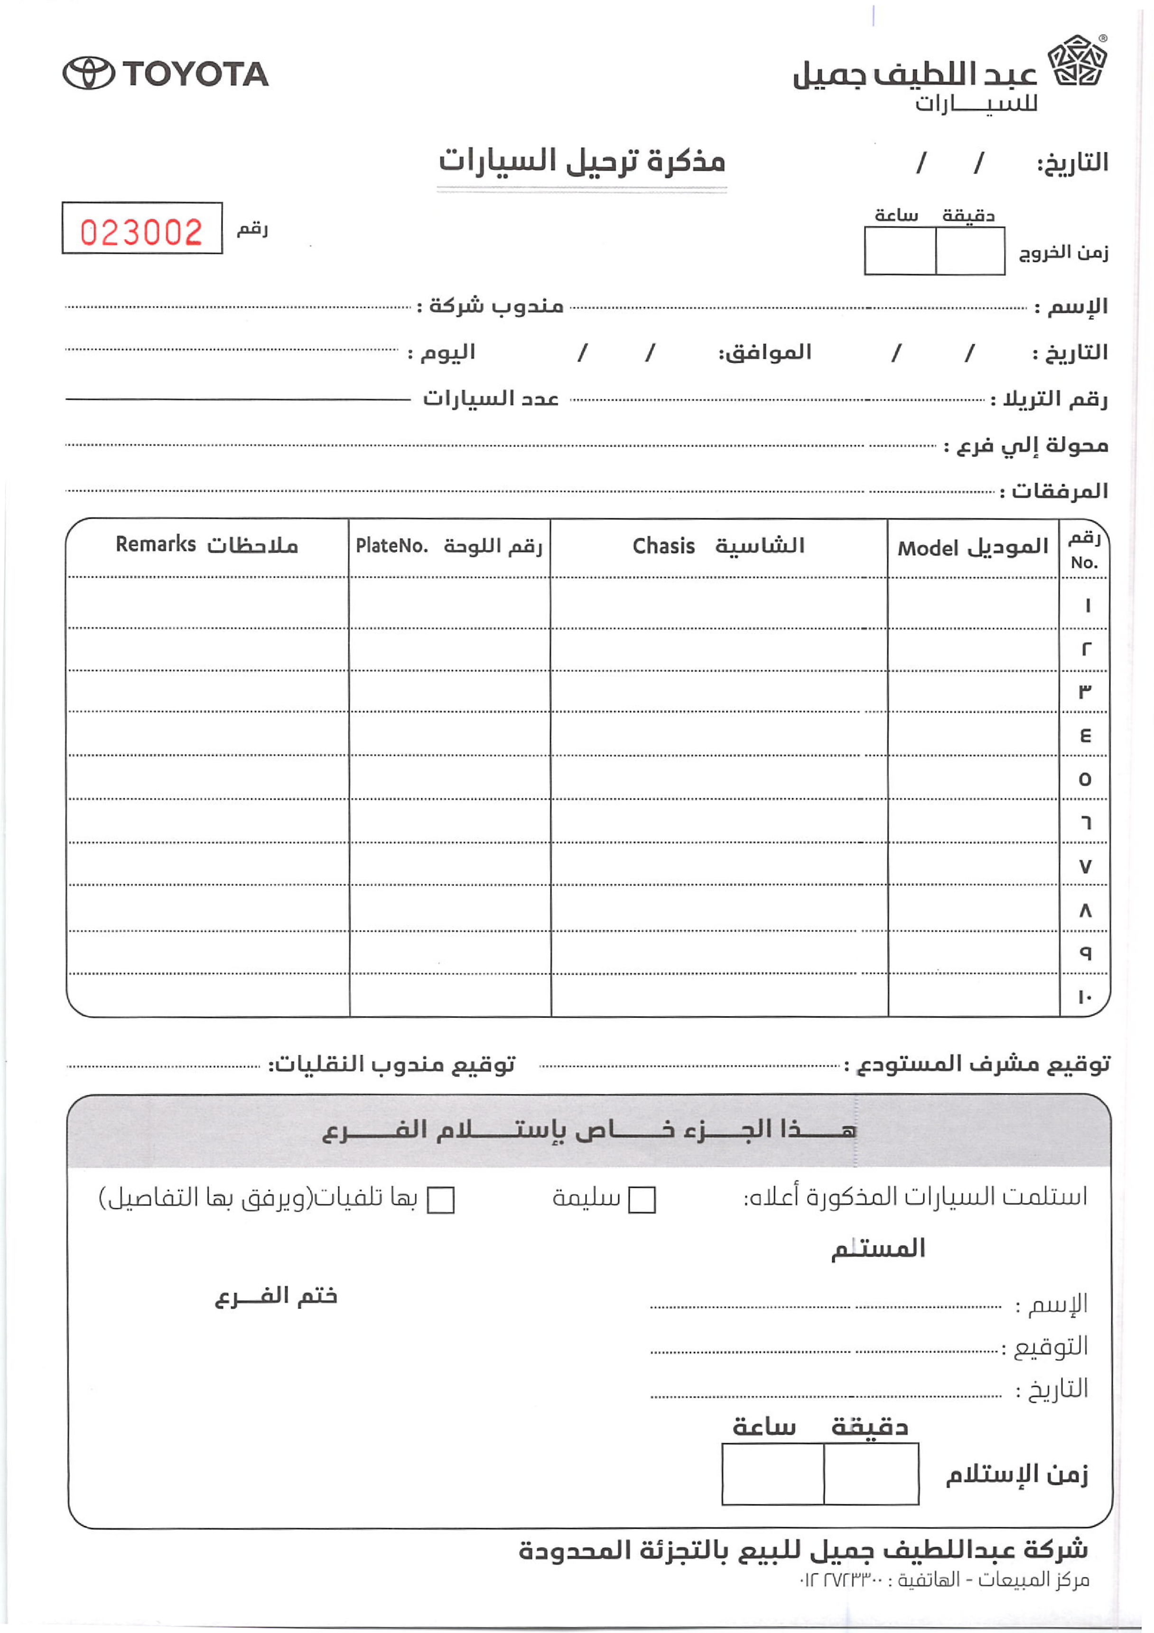
{invoice_number}
{date_d}
{date_m}
{date_y}
{dep_hour}
{dep_minute}
{customer_name}
{company_rep}
{day_name}
{corresponding_d}
{corresponding_m}
{corresponding_y}
{transfer_d}
{transfer_m}
{transfer_y}
{car_count}
{trailer_number}
{branch_to}
{attachments}
{transport_rep_sign}
{warehouse_supervisor_sign}
{received_intact_mark}
{received_damaged_mark}
{recipient_name}
{recipient_signature}
{recipient_date}
{branch_stamp}
{rec_minute}
{rec_hour}
{car1_remarks}
{car1_plate}
{car1_chassis}
{car1_model}
{car2_remarks}
{car2_plate}
{car2_chassis}
{car2_model}
{car3_remarks}
{car3_plate}
{car3_chassis}
{car3_model}
{car4_remarks}
{car4_plate}
{car4_chassis}
{car4_model}
{car5_remarks}
{car5_plate}
{car5_chassis}
{car5_model}
{car6_remarks}
{car6_plate}
{car6_chassis}
{car6_model}
{car7_remarks}
{car7_plate}
{car7_chassis}
{car7_model}
{car8_remarks}
{car8_plate}
{car8_chassis}
{car8_model}
{car9_remarks}
{car9_plate}
{car9_chassis}
{car9_model}
{car10_remarks}
{car10_plate}
{car10_chassis}
{car10_model}

