Date | Classification  Debug /  Creation /  Testing / | Evidence | Description of work done | Description of problem solved if applicable
29/07 | Creation  Debug | 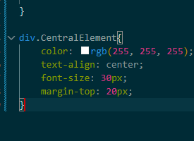  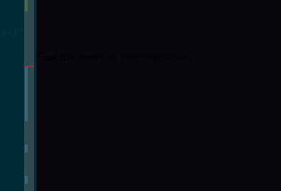   | Coding the basic version of the home page of my Investment Journal  I added a button which I found on this website Button by alexmaracinaru made with CSS | Uiverse.io  Debugging why the text isn’t showing up properly | I needed to remove the space between Central and Element to ensure the syntax was correct so that my div could detect the right CSS and apply it
2/08/26 | Stylistic additions |  | I added a new button that looks like a neon sign and gave the websites landing page a more distinctive colour scheme, now it feels unique.
3/08/26 | Stylistic additions |   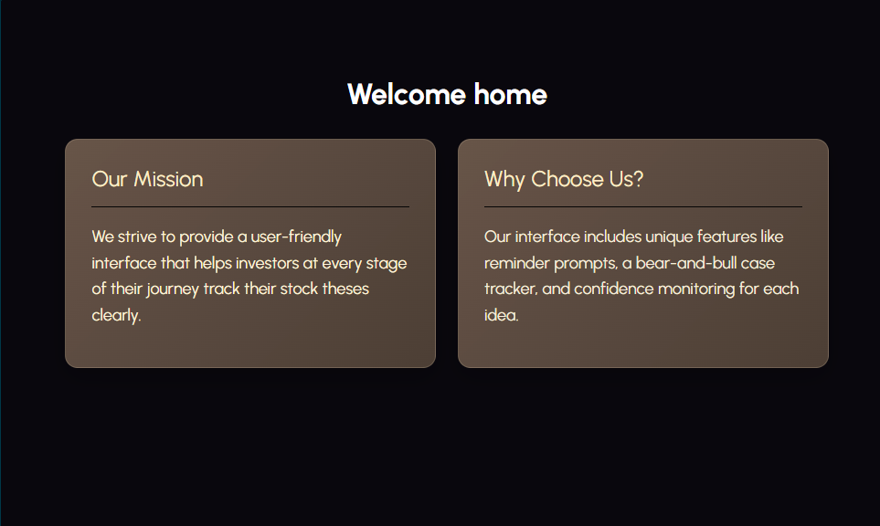 | I updated the colour schemes, I think this is a good change. I think the landing page especially looks really refined now.
3/08/26 | Stylistic additions | 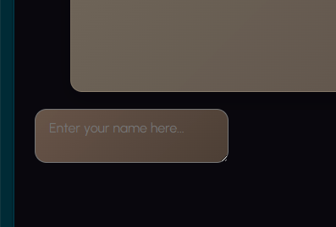 | I need a way for users to enter their name so that the system has a more personal touch. I will do this through a typing box and a send / enter button. | I will do this through some basic textarea code tutorial found at this website: HTML Text Box Code  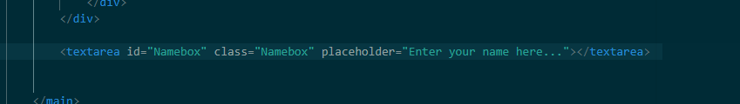
3/08/26 | Debug | 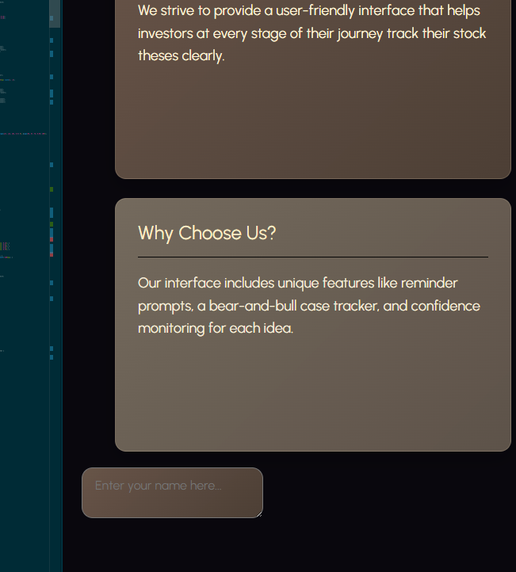 | The Text box is not aligning to the centre of the page when I try to use align-items: centre; | I needed to add these four lines of code under home-shell rather than Namebox, because the name box is also under home-shell. I made some changes to the layout so that the main content is now centered on the page, rather than being stuck too high up or following the usual flow of the document. This gives it a neater look. I also tidied up the container to make it look more streamlined and kept the spacing consistent, which makes the page feel more polished. The headings and content blocks look more organized and the whole page is easier to read and more balanced.  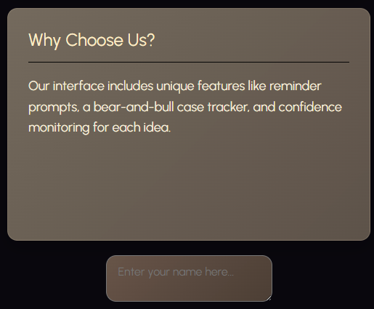  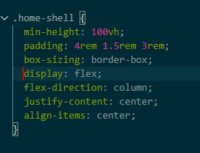
4/08/26 | Creation | 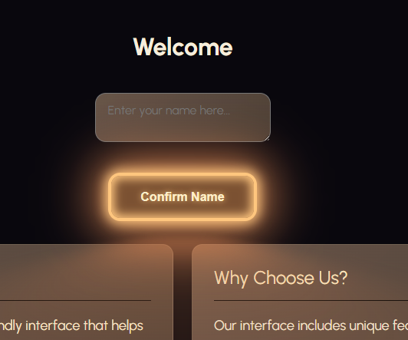  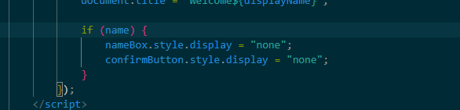 | I added a feature to let the user enter their name to give the system a more personal touch. This allows the user to type their name into the box below the welcome sign, press confirm name, and then it personalises the welcome message like welcome (Name). After the system listens for the button click it reads the entered name and puts it into the welcome message framework. The button and textbox hide after a name has been entered to make the interface appear more cleanly.
6/08/26 | Creation |  | I added a basic stock ticker list to display the stocks and their percentage changes and values
10/08/26 | Stylistic additions | 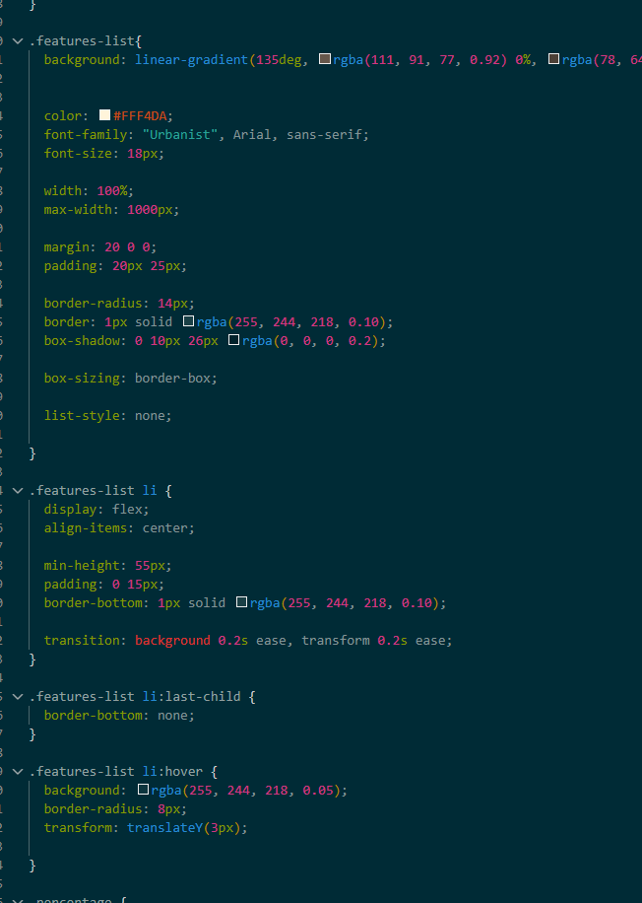  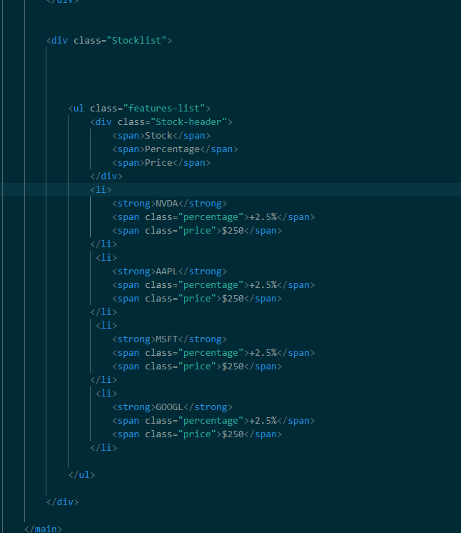  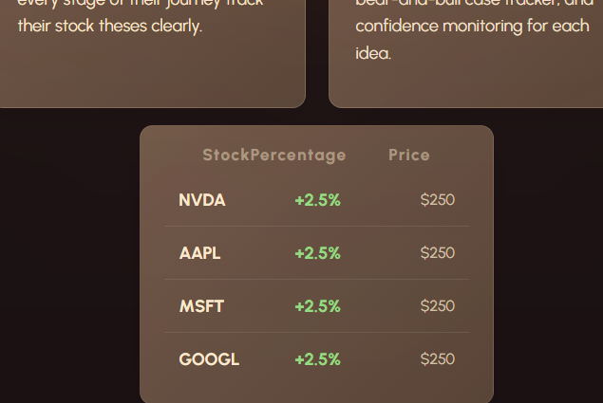 | I restyled the Stock ticker list so that it looks more visually appealing and fills up more of the screen  What I changed / did in terms of code:  CSS:  List-style: none has been used to remove the bullet points that <ul> usually puts in  Display:flex arranges the items horizontally, within the row. And they are also centered  Margin-left: auto pushes all the percentage price and name to the left so that there aren’t really large gaps in between, and it looks uniform  Specified with on price gives each price the same amount of horizontal space  Padding on the list of 20px makes the list compact and easy to read  Border-bottom creates a horizontal line underneath each stock  .features-list li:last-child { border-bottom: none; }  Removes the horizontal line under the last card so it doesn’t look bad  .percentage.negative {  color: #FF8A8A;  }  Negative percentage colour because it could be confusing having green negatives | <div class="ExplanationRow">  <div class="Explanation">  <h2>Our Mission</h2>  <hr>  <p>We strive to provide a user-friendly interface that helps investors at every stage of their journey track their stock theses clearly.</p>  </div>  <div class="Explanation2">  <h2>Why Choose Us?</h2>  <hr>  <p>Our interface includes unique features like reminder prompts, a bear-and-bull case tracker, and confidence monitoring for each idea.</p>  </div>  </div>  </div>
11/08/2026 | Extra Ideation | 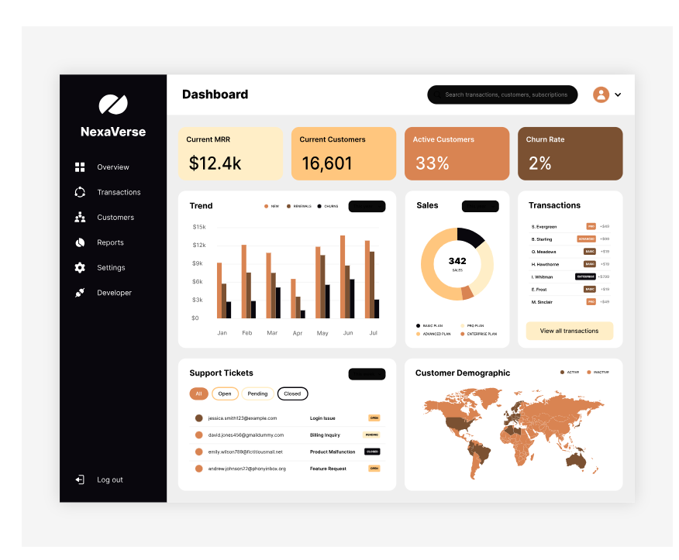 | I think I want to change my direction for my home page, it should look more like a dashboard than a welcome page that tells the user what the interface does, that can be for another place.
11/08/2026 | Creation |   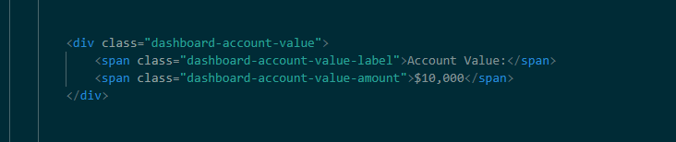 | Basic account value box for the dashboard to ensure the user knows how much money they are dealing with.  I did this with a basic div inside my dashboard home shell main. I reused the CSS from the explanation boxes because its similar to what I wanted here.  font-family: "Urbanist", sans-serif;  color: #F7EEDC;  text-align: left;  font-size: clamp(2rem, 4vw, 3.2rem);  letter-spacing: 0.16em;  margin: 0;  font-weight: 700;  line-height: 1;
11/08/2026 | Debug |  | The real holding value is not displaying on a separate line to the actual dollar amount, which I think is necessary for a clear user experience. |   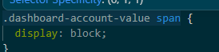  I fixed it by adding  .dashboard-account-value span {  display: block;  }  With display:block; each span element within the .dashboard-account-value div takes up its own line rather than the default inline. This means that the value and the title which are in different spans but are under the same div separate into two lines.
11/08/2026 | Debug | 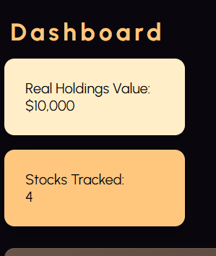  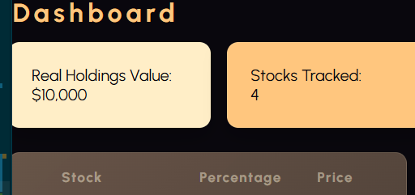 | Second widget with very similar code to the Real Holdings value added but its not displaying side by side, like my reference picture  The code I used to fix this:  .dashboard-widgets {  display: flex;  flex-direction: row;  flex-wrap: nowrap;  }  .dashboard-account-value,  .dashboard-stocks-tracked {  flex: 0 0 auto;  }  It turns dashboard-widgets into a flex container, and then orders the flexbox to arrange the items horizontally, which means they sit side by side on a full VW screen.
11/08/2026 | Debug | 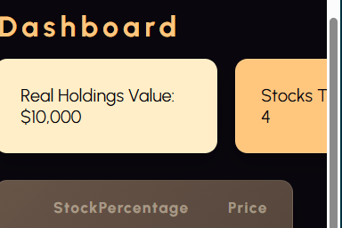 | When I make the VW smaller instead of flexing around to another row the widgets are forced off the screen. This is bad because on mobile phone screens users will not be able to see the other widgets.  The error is occurring because of flex-wrap:nowrap; which physically stops the widgets from wrapping around if the vw isn’t wide enough onto the next row.  Removal of this doesn’t fix the issue yet. But I can fix it using media queries. If the VW becomes less than two boxes are wide I can make it set flex-wrap to wrap; which will force the other box onto the second row. I cannot just use universal flex-wrap: wrap; as then the boxes don’t sit side by side. | 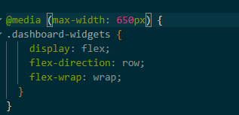  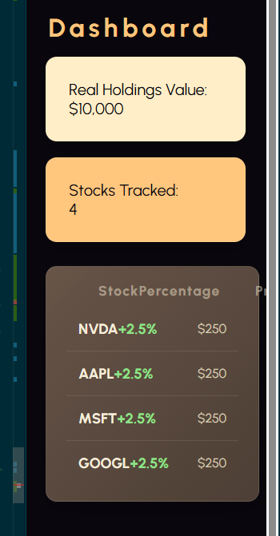
11/08/2026 | Refining and simplifying code | 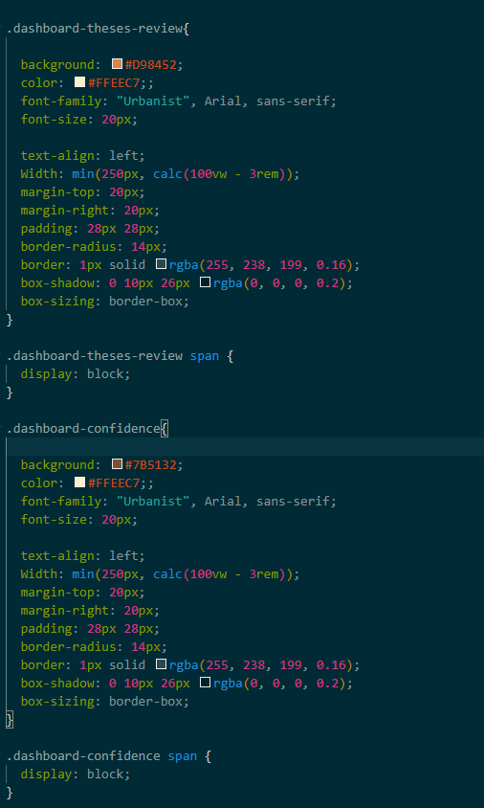 | Currently each of the four widgets has its own styling blocks, for every property. This takes up a large amount of space on my CSS and could easily be simplified, as the only thing different across them is background colour and regular colour. | 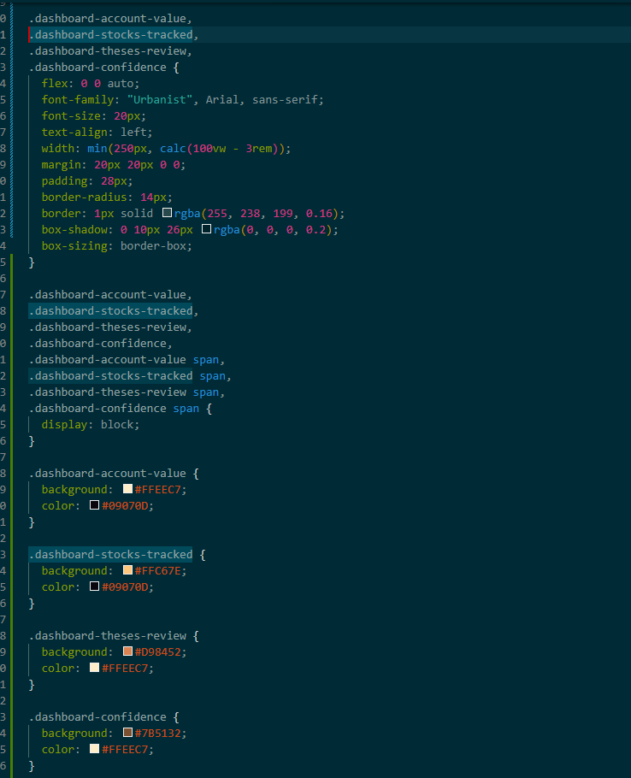
11/08/26 | Creation + debug | 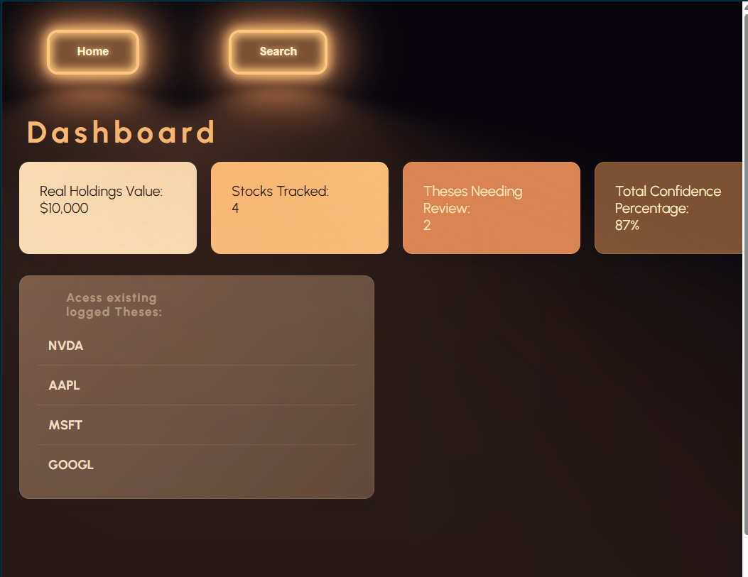 | Added a basic navigation bar.  I really like the border and lighting effect from these buttons but I think it looks weird to have two of them. I’m going to apply the effect to the navigation panel and style the buttons regularly. | 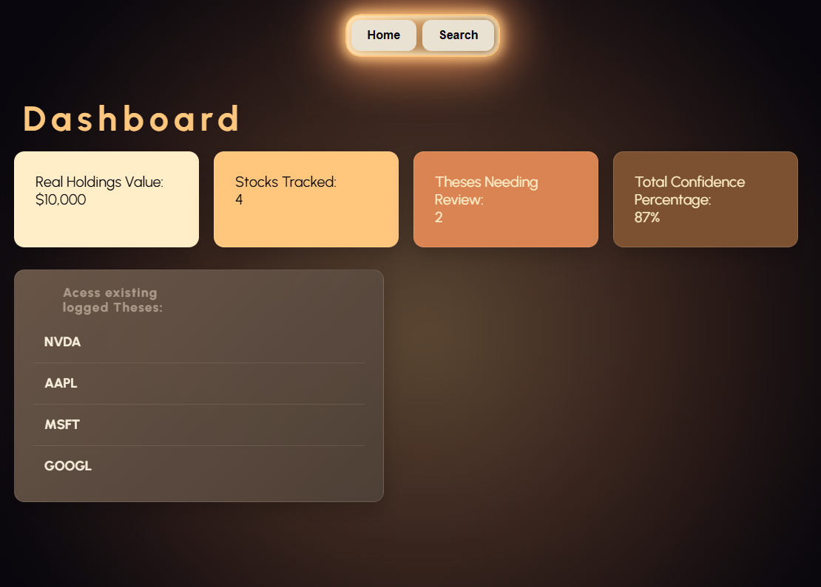  I changed the styling so that the individual buttons of the nav bar didn’t glow, the navigation panel around them did.  Debug:  - The special imported button style was applied globally to all <button> buttons.  - I added ‘regular-button’ classes to the two buttons I wanted in the navigation bar.  - I ensured that I styles these to have no boarder, box shadow or text shadow and after glow, to make them as plain as possible.  - I tigheted the navigation shell sizing to ensure the border lines up with the buttons correctly
11/08/26 | Creation + ideation | 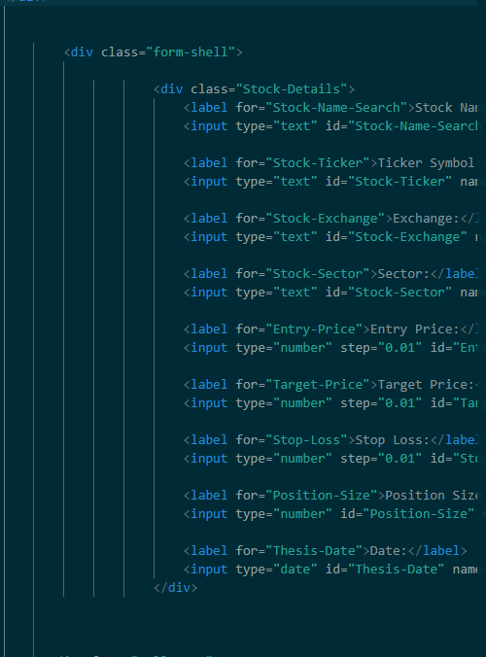  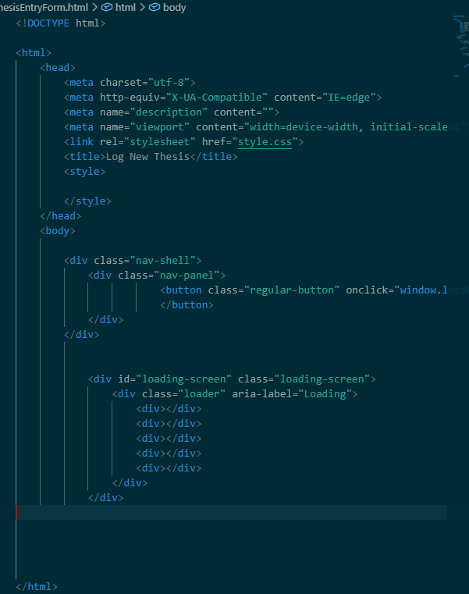 | I need a way for users to enter their thesis for new stocks. I think the best way to do this is to like one of the buttons at the top to a new document where the user can select the stock and enter their thesis.  I will use a new HTML doc for clarity.  I used the same basic structure as my JournalHome.html with the same loading screen and button style for the navigation.  I think I should use a json to log user thesis by stock then I can use it to populate the journalhome.html even though its recorded on the newthesisform html  I essentially just added a bunch of input boxes, which I am yet to style, using <input>  I used a slider for entering the users confidence level. There is some simple javascript that makes this work and makes it update the lettering beside it. The function reads the current value of the slider using confidenceSlider.value, and then creates a string from 0 – 100. This is then written into the confidence value span, which is like a template that adds the percentage on after it.  confidenceSlider.addEventListener('input', updateConfidenceValue);  updateConfidenceValue();  makes the display update live and updates the span every time the page loads. | 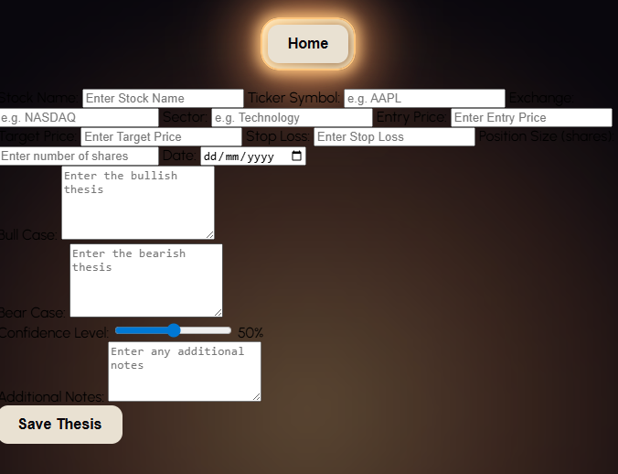
13/08/2026 | Debug | 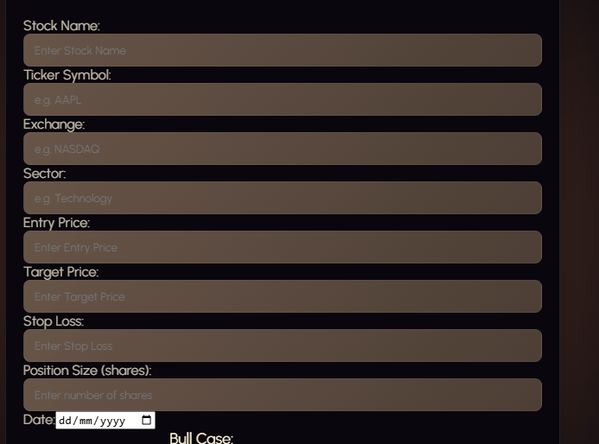 | Currently there’s no space between the lines in my new thesis form. This makes it visually challenging to read, and is not very visually appealing. How I solved this issue: | When trying to use stock-details in my css and adding a margin-top of 20px, it applied it to the whole div, so every different category inside the Stock-Details div was just shifted down 20px. I used <label> when coding the html for each category. To add Css for this I needed to address all of the labels within the Stock Details div, so I used the header .Stock-Details label {}, and it worked nicely. I added a margin-top of 20px; for some visual separation and it looks much better now.  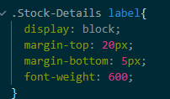  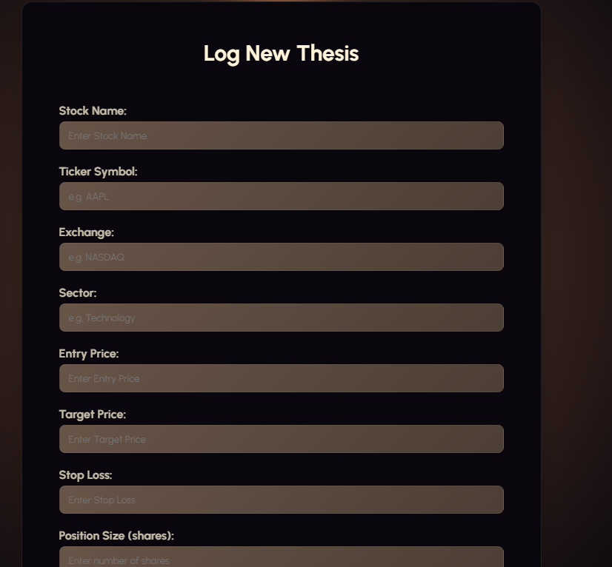
13/08/2026 | Stylistic aditions | 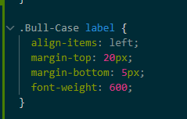 | The other parts of my form lie outside the Stock-details div. so for Bull-Case, Bear-case, etc hence do not get the spacing applied to them. I will create separate CSS blocks for them with the same code | 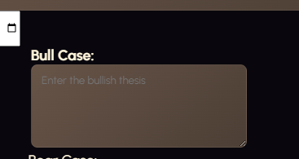
13/08/2026 | Debug | 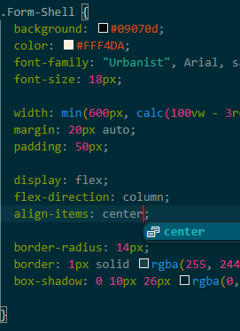 | Its not letting me align the bull-case left using its label CSS, which it should be. | 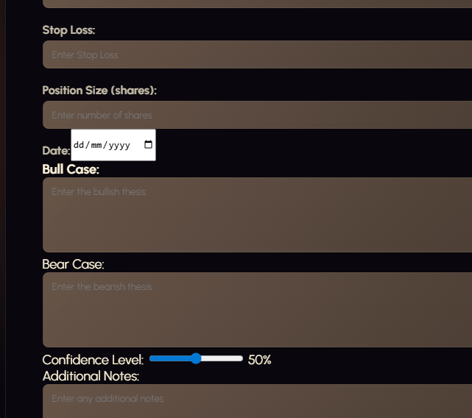  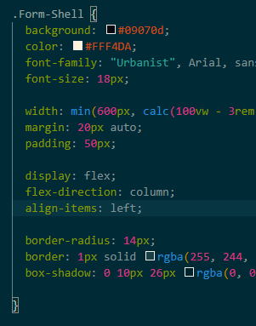  The is is that its being set ‘items-align’ center within the form-shell css above it. So to fix this problem I need to change that to left.
13/08/2026 | Debug |   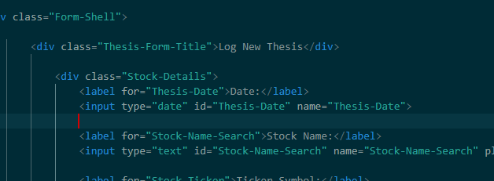 | Due to its special function with the date entry box the  .Stock-Details label {  display: block;  margin-top: 20px;  margin-bottom: 5px;  font-weight: 600;  }  Isn’t applying to it well, and it just looks bad, there is a way to style it using  #Thesis-Date { margin-top: 20px; }, but the actual date box looks off, and has it placed randomly next to the text. Its also making the label for the stock-name section stick to it on the wrong line.  To solve this issue, I’m going to create the date section its own div to ensure I can style it directly, and make it look visually appealing. | Giving the date section its own div creates a container around the date label and input, it gives me a specific target for CSS allowing me to make custom changes just for that section, which include the label and input – so I can change it from the white colour that doesn’t match my colour scheme.  This also lets me control the layout of the date section independently.  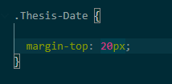  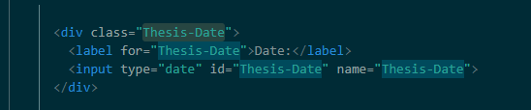
13/08/2026 | Debug |  | I need to stop the stock name title from sticking to the same line as the date. I think this is happening because the date section is built differently to the other parts of my stock-details div, hence it may not be taking up the full width of the form and allowing the Stock Name title to flex up onto the same line as it.  I will try to fix this by setting the width of the thesis-date div specifically to 100%  Problem solved. | 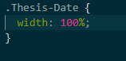  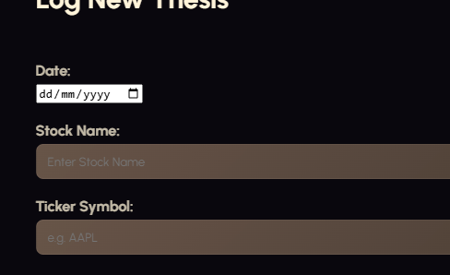
13/08/2026 | Stylistic additions |   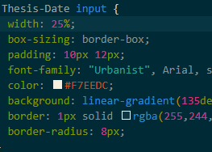 | Styled the date section like all the other boxes, I need to test the inputs that this date box lets my use because it shouldn’t be letting me enter dates well into the future.
13/08/2026 | Stylistic additions |  | I wated to give the slider some styling because I thought it looked bare without it.  .Confidence-Level input[type="range"] {  width: 70%;  margin-top: 20px;  margin-bottom: 10px;  }  Confidence-level finds an element with the class-confidence level. Then input[type=”range”] means find an input within the confidence level whose input type is range, so it targets my slider. Then it applies the 70% width property to stretch it across 70% of the stock-details div. and the usual margin properties.  #Confidence-Level::-webkit-slider-runnable-track {  height: 6px;  background: rgb(97, 97, 97);  border-radius: 5px;  }  Similar to the code from before, but the :: double colon is for a pseudo-element, essentially it targets the track belonging to the range with the class confidence-level my properties make it gray and change its width.  #Confidence-Level::-webkit-slider-thumb {  appearance: none;  width: 18px;  height: 18px;  background: #a79797;  border-radius: 50%;  cursor: pointer;  margin-top: -6px;  }  Is essentially the same thing but for the little circle, the margin top is used to align it on the track, I gave it a size, but the background colour doesn’t work for some reason. That’s ok.  Overall my form looks a lot better. |   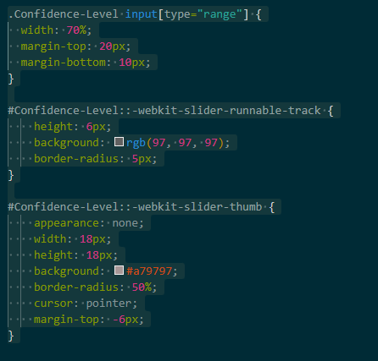  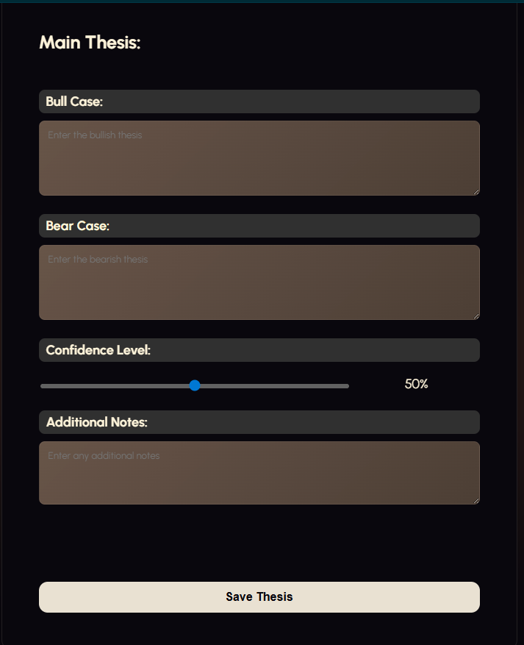
13/08/2026 | Relevant implications addition – Privacy | 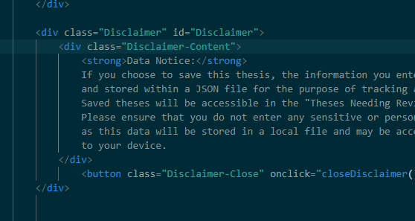  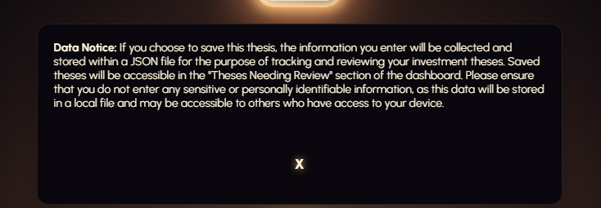 | I need to add a disclaimer at the top of my new thesis form telling users that if they save their thesis it’s going to record their data.  My disclaimer is pretty basic, its just a div with some text and a button which I needed to manually remove all the styling from because my <button> is set to glow like a neon light.  Because I’ve talked about how I code divs before the only really unique thing is the small javascript function that makes the message disappear  function closeDisclaimer() {  document.getElementById("Disclaimer").style.display = "none";  }  closeDisclaimer is the name of the function linked to my button, and when it is pressed the HTML doc is searched for a div with class Disclaimer – being my disclaimer message, and it sets all of its CSS display properties to none so that it cannot be seen
14/08/2026 | Relevant implications addition – Privacy | 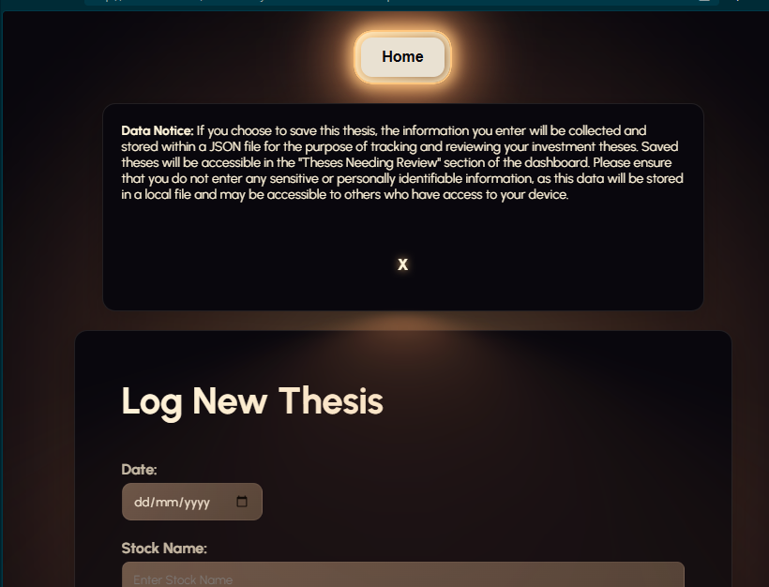 | Currently the disclaimer message just pops up at the top of the screen below the nav bar, and pushes the rest of the content down. I not only think this looks bad, but it means the user can still access the form to log a new thesis without confirming their opinion on the data usage. This is bad because it means if the user chooses to ignore the disclaimer like many do, they won’t be informed about the saving of their data.  To solve this I will make the disclaimer popup on the screen in the centre, when the page is opened. I will also blur the background around it to put all of the users focus on it.
14/08/2026 | Debug | 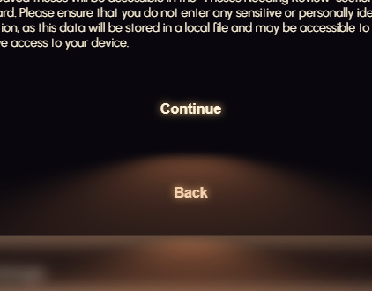 | Because the special imported button from UI verse applies styling to the basic buttons, I have to manually remove the styles where I want to. I want to get rid of this blurred triangular glow effect from the buttons. To solve this problem I searched for the styling on the regular buttons that could be producing this  Button::after pseudo-element has filter: blur(2em) which is potentially creating the flow effect. Essentially this blur effect was also applying to my disclaimer-close buttons.  To solve this I added a disclaimer-close::after pseudo element as well and set it so that nothing from the after pseudoelement displayed, so that the blur would stop being there.  .Disclaimer-Close::after {  content: none;  display: none;  }  Content-none; removes the content of the pseudo element and display: none; hides it entirely so that it does not render  Button::after pseudo element created the blur effect with  button::after {  pointer-events: none;  content: "";  position: absolute;  top: 120%;  left: 0;  height: 100%;  width: 100%;  background-color: var(--glow-spread-color);  filter: blur(2em);  opacity: .7;  transform: perspective(1.5em) rotateX(35deg) scale(1, .6);  }  Background color gives the browny beig colour  Filter: blur gives it that blurred gradient effect  Transform skews it into a triangle shape positioned below the triangle, so  Disclaimer-Close::after {  content: none;  display: none;  }  Stops all these properties applying to the disclaimer close button. | 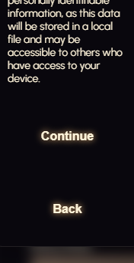
17/08/26 | Debug | 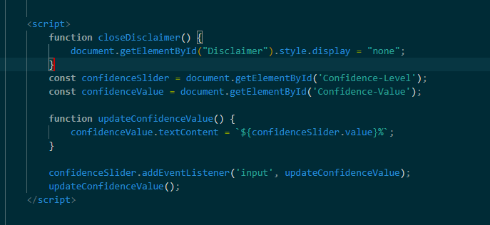  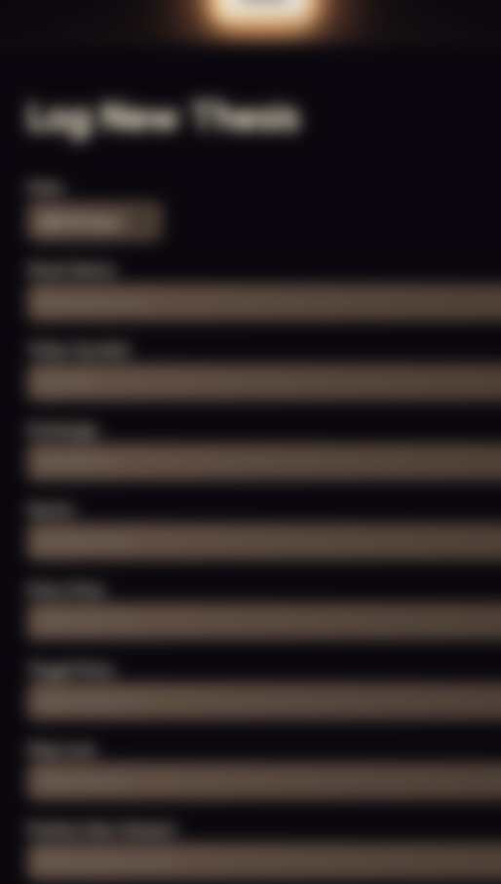 | The blur overlay wasn’t disappearing when I pressed the continue button  Essentially the code before was only making the note disappear leaving the blurred section behind, this is why to fix the issue I added  const disclaimerOverlay = document.getElementById("Disclaimer-Overlay");  disclaimerOverlay.style.display = "none";  which searches the HTML document when closeDisclaimer button is pressed for an element called disclaimer-ovelay, and then sets its styles to none so the blur goes away. | 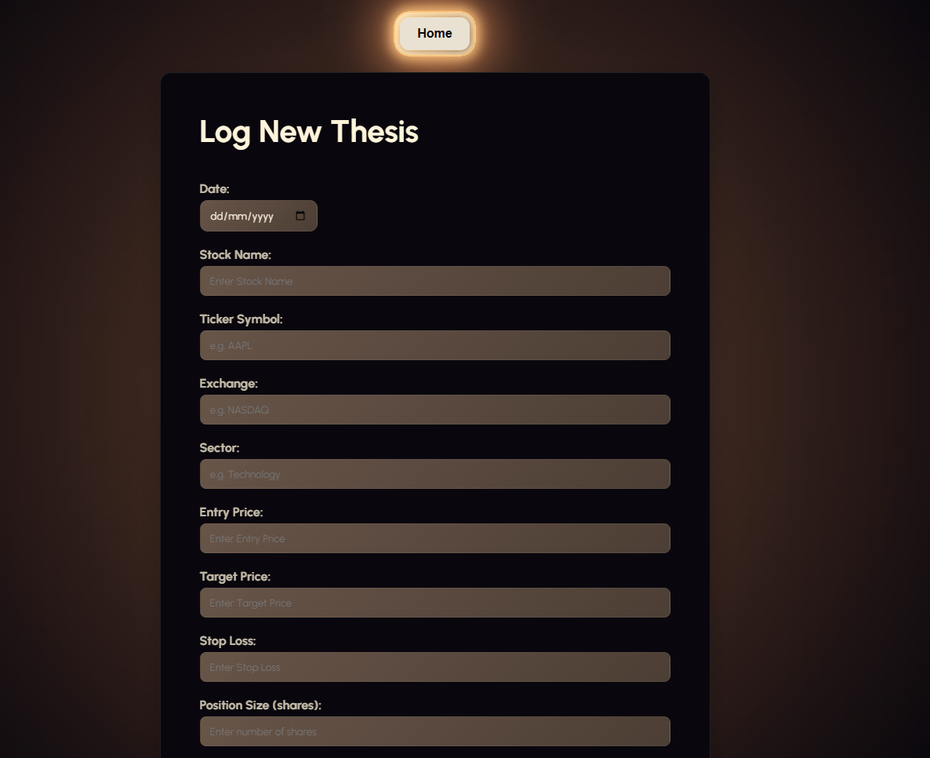  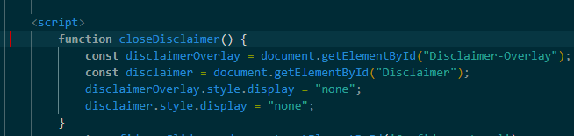
17/08/26 | Adding JSON functionality from the form |   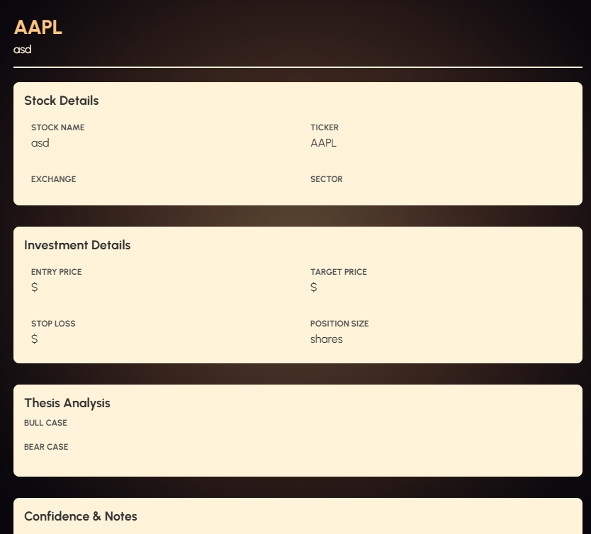 | I have used JSON serialization to convert the javascript objects to and from text format in the localstorage.  const thesis = {  date: document.getElementById('Thesis-Date').value,  stockName: document.getElementById('Stock-Name-Search').value,  ticker: document.getElementById('Stock-Ticker').value,  exchange: document.getElementById('Stock-Exchange').value,  sector: document.getElementById('Stock-Sector').value,  entryPrice: document.getElementById('Entry-Price').value,  targetPrice: document.getElementById('Target-Price').value,  stopLoss: document.getElementById('Stop-Loss').value,  positionSize: document.getElementById('Position-Size').value,  bullCase: document.getElementById('Bull-Case-Reasoning').value,  bearCase: document.getElementById('Bear-Case-Reasoning').value,  confidence: document.getElementById('Confidence-Level').value,  notes: document.getElementById('Thesis-Notes').value  };  Creates a javascript object with all of the thesis data entered on the form.  let theses = JSON.parse(localStorage.getItem('theses')) || [];  this looks inside of the browser’s local storage for an item under the same theses  local storage can only contain strings, so JSON.parse converts the text back into a javarscript object for the code to work with  || [];  Means if there aren’t any stored theses use an empty array instead, which means that the line records as empty in local storage if being written.  theses.push(thesis);  this is what adds the new thesis to the end of the array  localStorage.setItem('theses', JSON.stringify(theses));  these two lines convert the array back to text and save it to local storage.  function loadTheses() {  const container = document.getElementById('theses-container');  const theses = JSON.parse(localStorage.getItem('theses')) || [];  if (theses.length === 0) {  container.innerHTML = '<li class="dashboard-stock-row"><p>No theses saved yet. <a href="ThesisEntryForm.html">Create one now</a>.</p></li>';  return;  }  container.innerHTML = '';  theses.forEach((thesis, index) => {  const thesisElement = document.createElement('li');  thesisElement.className = 'dashboard-stock-row';  thesisElement.innerHTML = `  <a href="ThesisView.html?id=${index}" style="text-decoration: none; color: inherit;">  <strong class="dashboard-stock-name">${thesis.ticker}</strong>  </a>  `;  container.appendChild(thesisElement);  });  }  To summarise this function, it checks the local storage to see if there are any saved theses. If there are none it shows no theses saved yet. If there are it loops through each thesis creating a list item that shows the theses ticker. Then it makes it into a clickable button and adds it onto the page under the My Theses: tab.

17/08/2026 | Adding the theses needing review section | 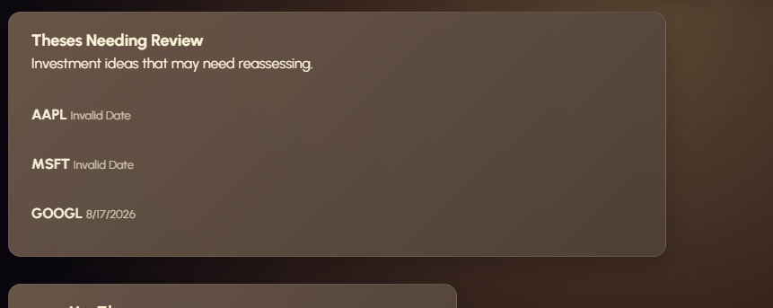  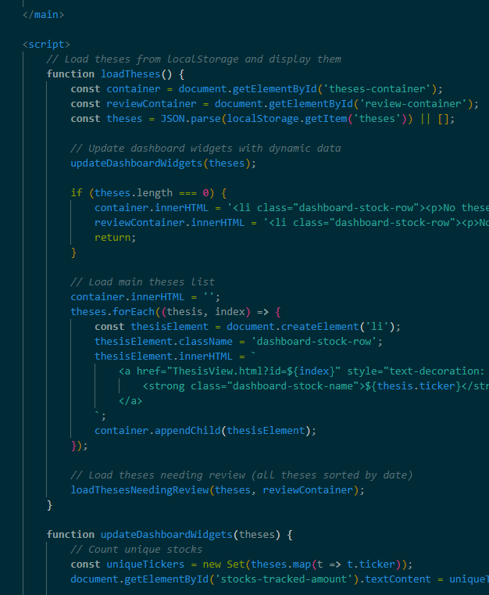 | <div class="dashboard-review-section">  <div class="dashboard-review-header">  <div>  <h2>Theses Needing Review</h2>  <p>Investment ideas that may need reassessing.</p>  </div>  </div>  Just basic HTML section using divs to let me style the different texts individually.  I updated the loadTheses function  const container = document.getElementById('theses-container');  const reviewContainer = document.getElementById('review-container');  const theses = JSON.parse(localStorage.getItem('theses')) || [];  updateDashboardWidgets(theses);  loadThesesNeedingReview(theses, reviewContainer);  }  This code gets both the main theses list container and the review container. Retrieves all the saved theses from my localstorage,  The second function LoadThesesNeedingReview  Firstly checks to see if any theses exist at all, if they don’t it shows no theses needing review yet.  Then it sorts by date creating a copy of the array of theses and sorting by date putting the oldest first. This means the thesis that most urgently needs review is at the start of the list on the box. Then it loops through these sorted theses finding its original index in the main array, creates an LI element and a clickable link to the thesis write up (thesisview.html) the same thing used in the my theses tab below.  Then it displays the ticker and formatted date to readable format, or if not displays invalid date.
17/08/26 | Flexbox | 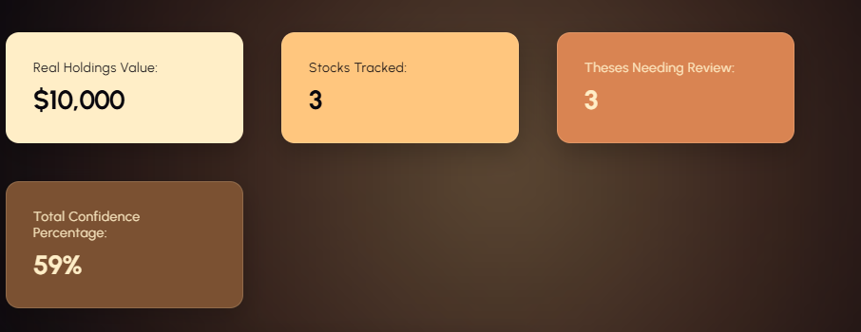  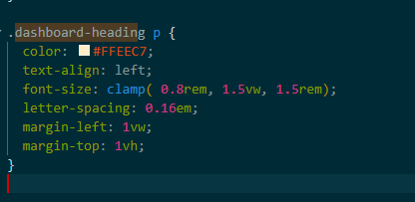  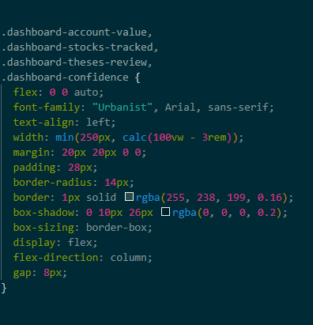 | Cleaning up the dashboard CSS to make it look better and align with flexbox.  Flex box changes for the cards:  display: flex;  flex-direction: column;  justify-content: center;  gap: 8px;  display: flex; turns each card into a flex box  flex direction puts the label and number on top of each other in a column, instead of being beside one another  justify contents center moves these towards the centre of the box.  Gap: 8px; adds 8px of space between the label and number.  Clamp fontsize added for dashboard-heading p  font-size: clamp( 0.8rem, 1.5vw, 1.5rem);  clamp contains three values  small screen, medium screen, large screen.  On the small screen font size wont go above 0.8rem  Medium, wont go above 1.5vw  Large 1.5rem | 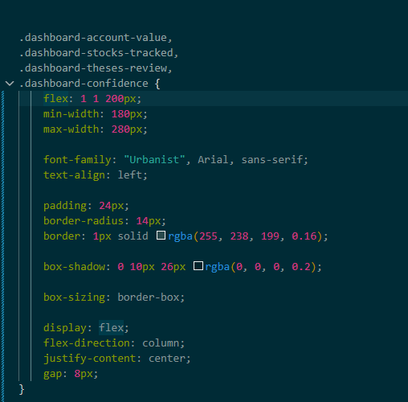  
17/08/26 | Debug | 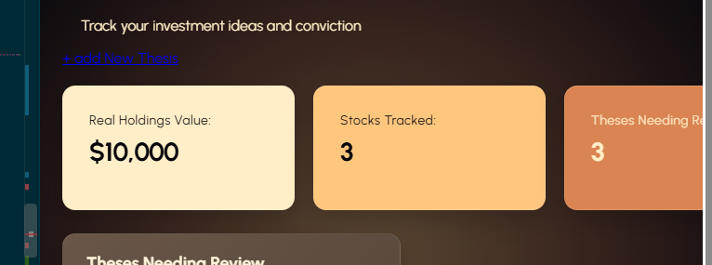 | When using flexbox to ensure all the tiles can be seen when resizing the VW, I notice that the last two get cut off before the boxes start flexing and wrapping around to the next row. I think this is because of the media queries I used, so that it only flexes after reaching a certain VW.  .dashboard-widgets {  display: flex;  flex-direction: row;  flex-wrap: nowrap;  }  Which is the div that these four cards are under also has flex-wrap: nowrap; which applies not wrapping around to the next row as the default – before it is overwritten by my media queries. To fix this I can change it to wrap, and it should wrap at all VW. | 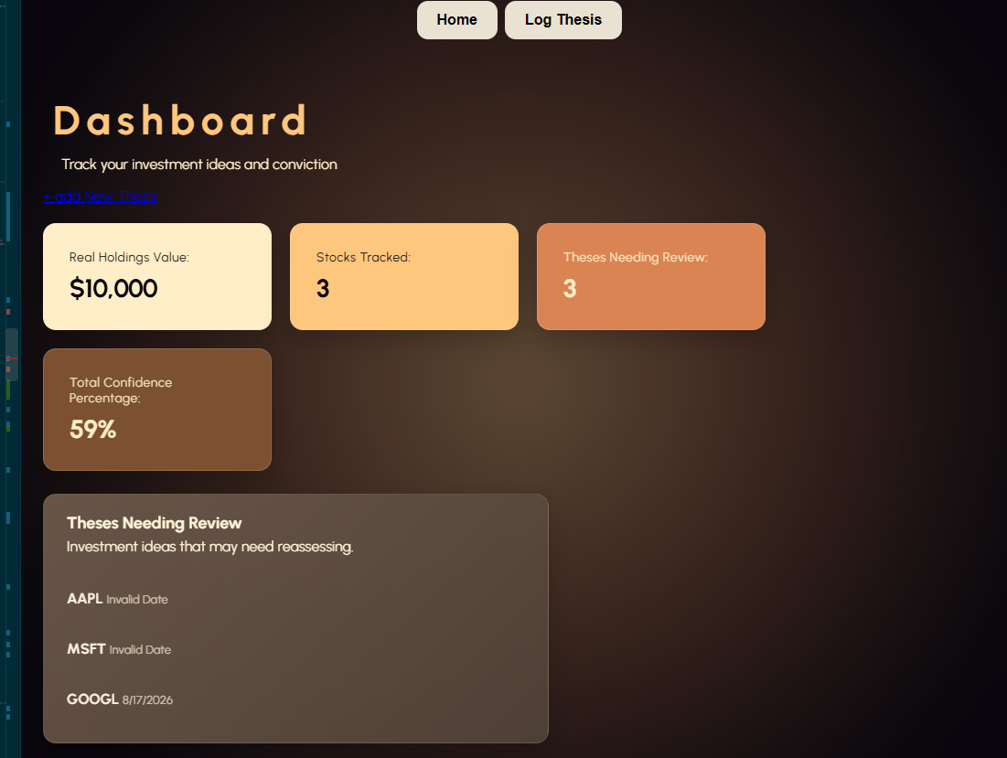
18/08/2026 | Stylistic additions | 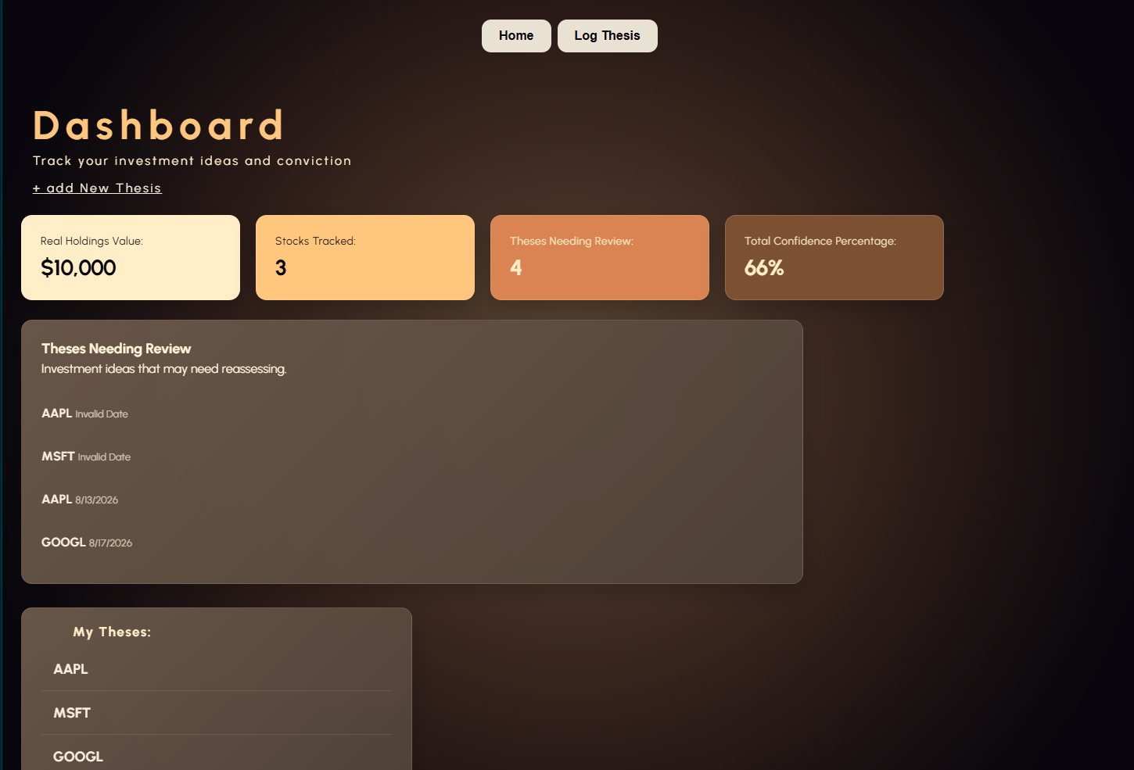 | I want to remove the log thesis button from the top because | 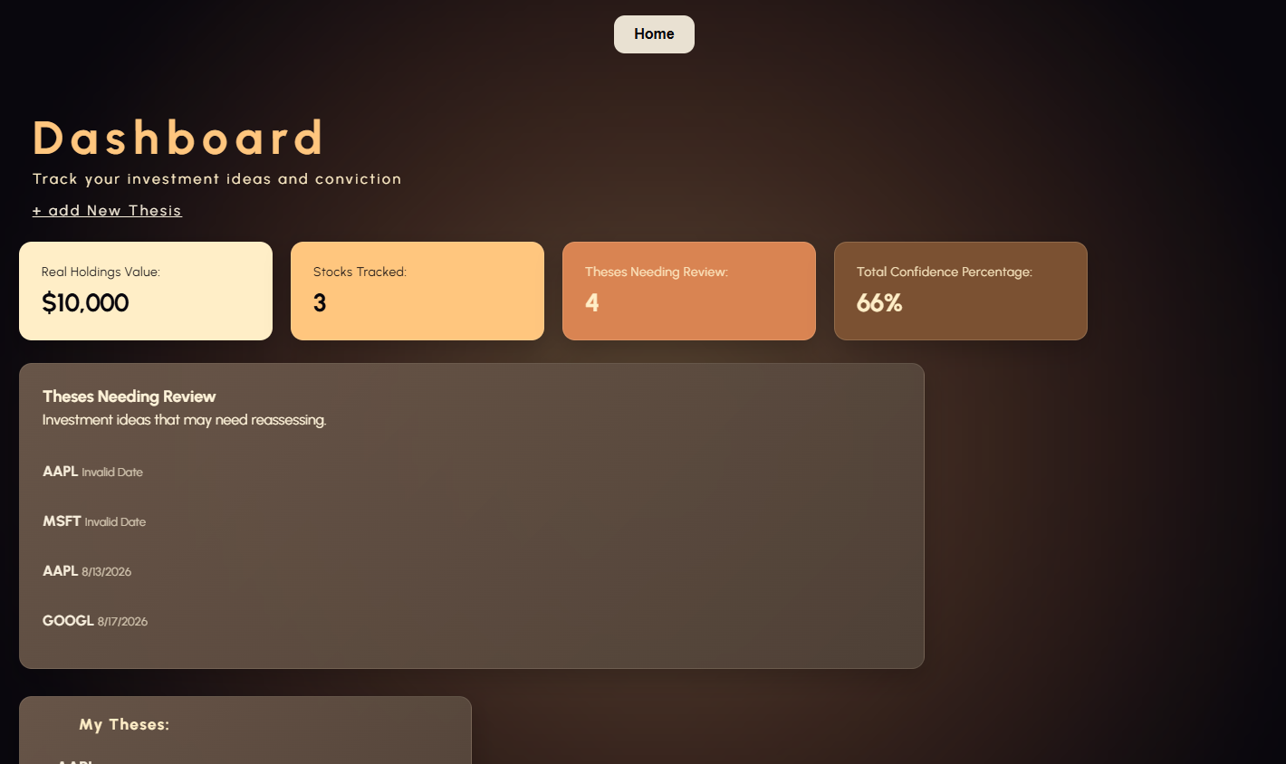  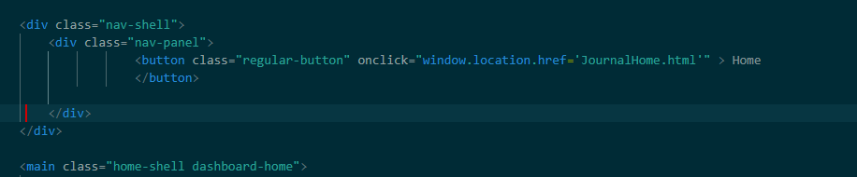
18/08/2026 | Debug + flexbox implementation | 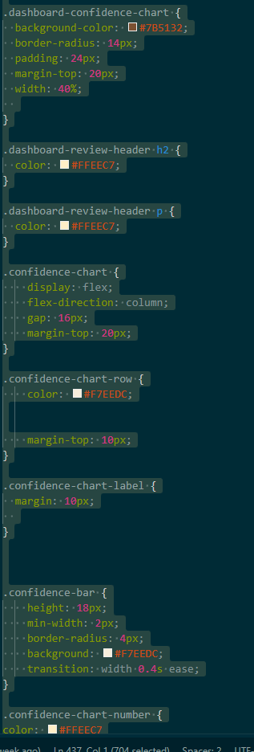  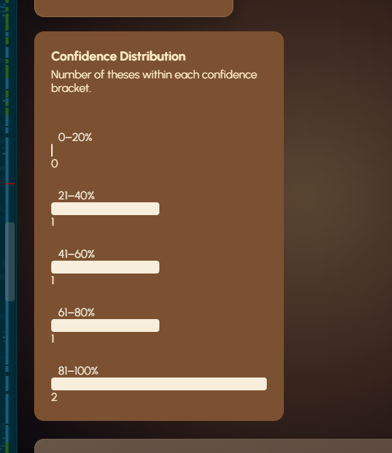 | The confidence chart I added currently has the right colours that I want, but its styled weirdly and looks quite unappealing.  Three things I needed to fix:  - The chart elements were not aligned correctly because the confidence-chart-row only had color and margin-top properties. This meant the confidence label, bar and number weren’t positioned horizontally. To fix this I added display:flex and align-items: center.  - The confidence labels caused inconsistent bar alignment. The confidence-chart-label used margin 10px, creating uneven spacing between labels and bars. I changed this to width: 55px and flex-shrink: - which ensures each bar starts at the same position.  - The numbers weren’t positioned in the correct place. I used flexbox to position them ‘display:flex;’ , places the bar and number next to each other horizontally, so they sit beside each other rather than in a column. | 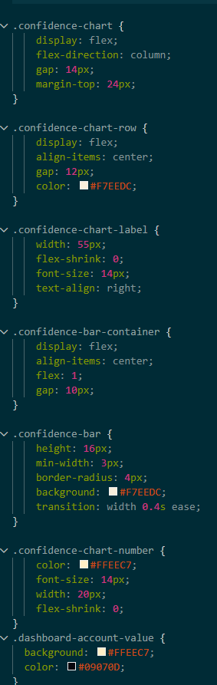  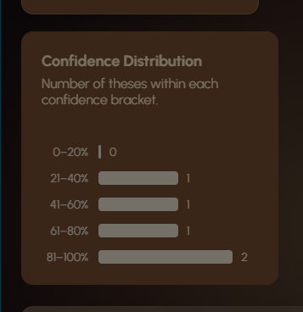  so much better looking!
18/08/2026 | Stylistic addition – Navigation bar styling  + Debugging | 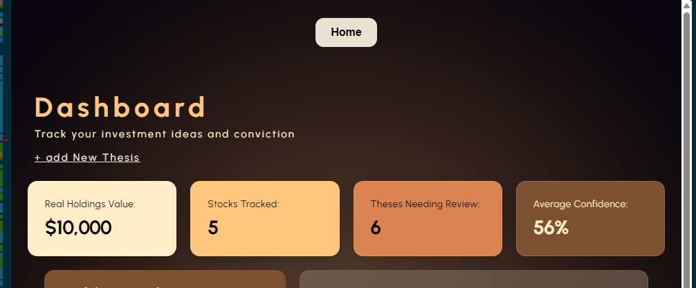  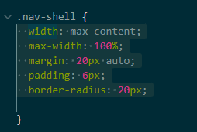 | Fixing the existing ‘navigation bar’ styling.  Changes: made the nav bar wider using width: calc(100% - 3rem) to ensure it lines up with the dashboard elements  I added a dark background to match my colour scheme, and a shadow to make it look more realistic  I changed the home button from a bright solid button to a transparent button.  I added a hover effect to make it change when hovered.  Added branding to the side of the nav bar.  Debugging done:  Fixed the navigation bar from being too small because of width: max-content.  Fixed the general button css affecting the home, button especially the large glow and shadow.  Fixed the hover styling. | 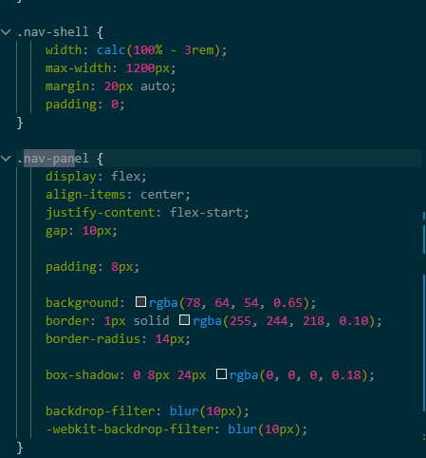  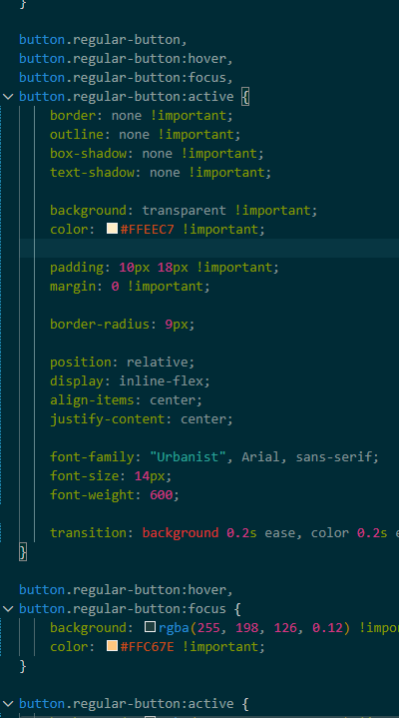  
19/08/26 | Sorting out changes made based on feedback from Nikhil  Debug | 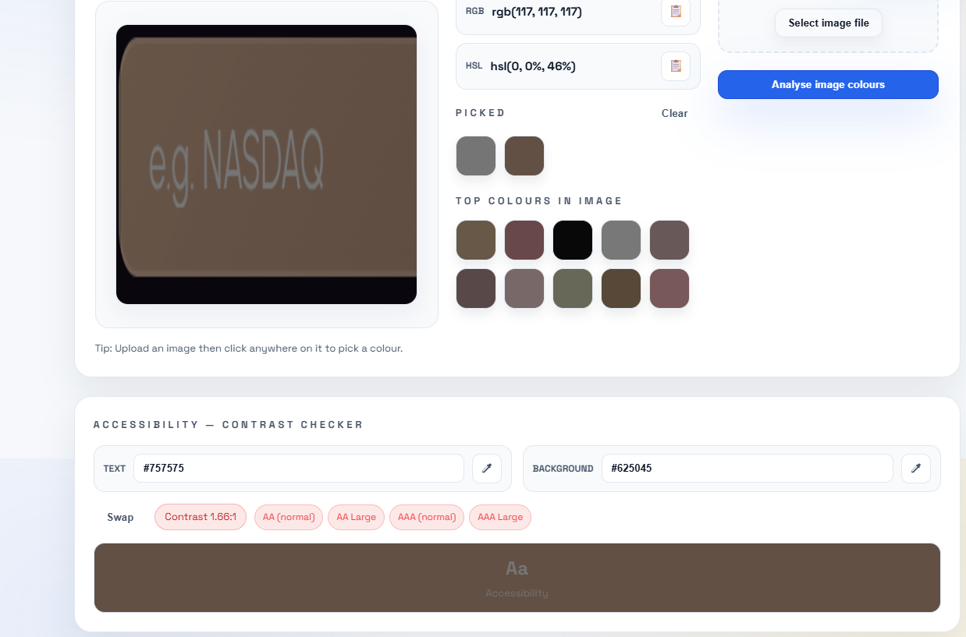 | The issue: placeholder text is being applied the default grey colour on my input boxes in my form, which gives it really poor contrast.  Solution:  input::placeholder,  textarea::placeholder {  color: #F7EEDC;  opacity: 1;  }  Specifically targets the placeholder text on my input boxes and makes it white to give it better contrast. |   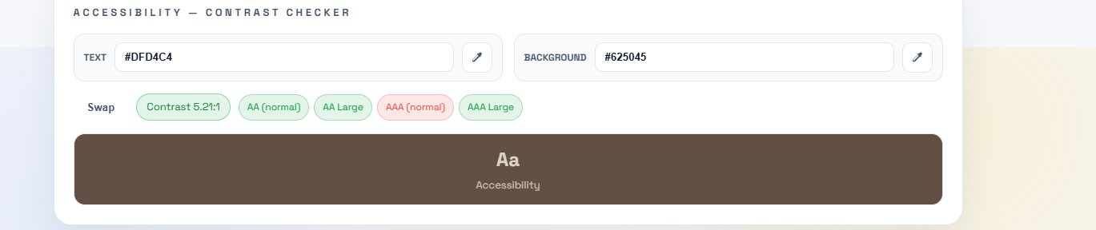
19/08/26 | Stylistic changes  + Debug  + Flex box and media queries | 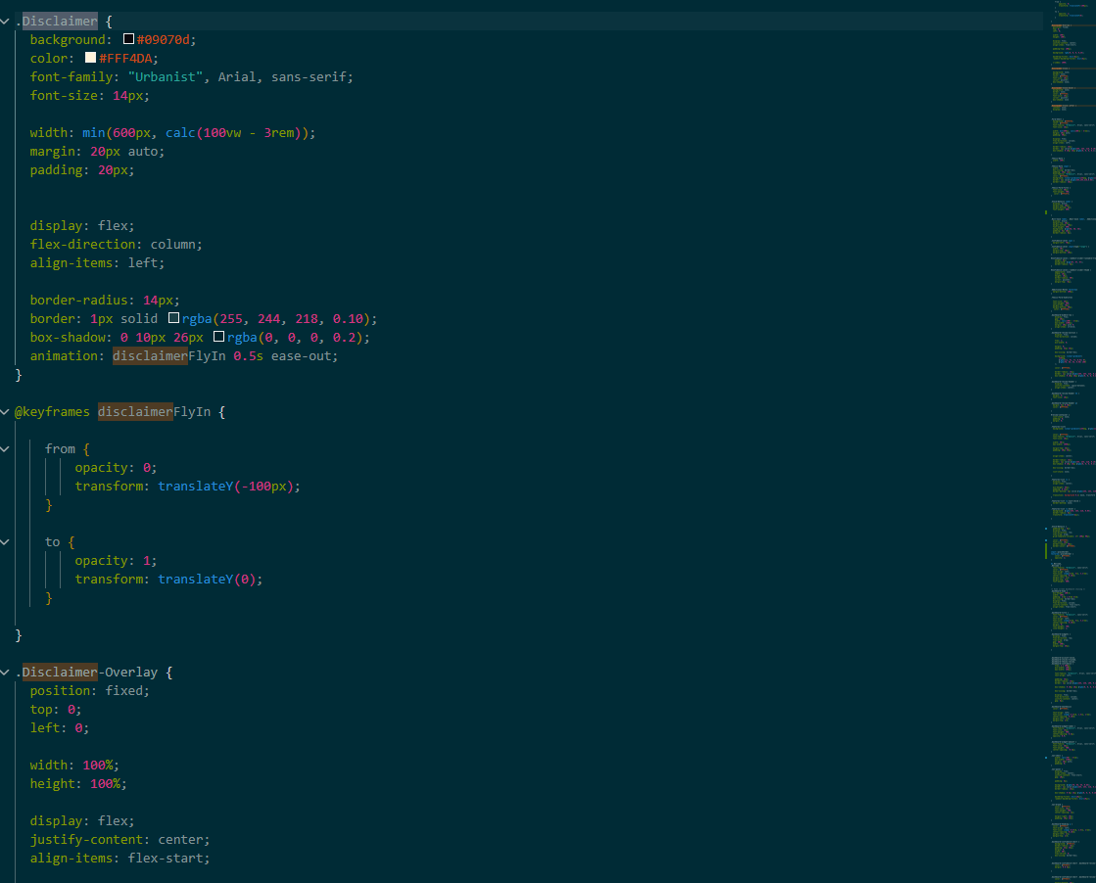  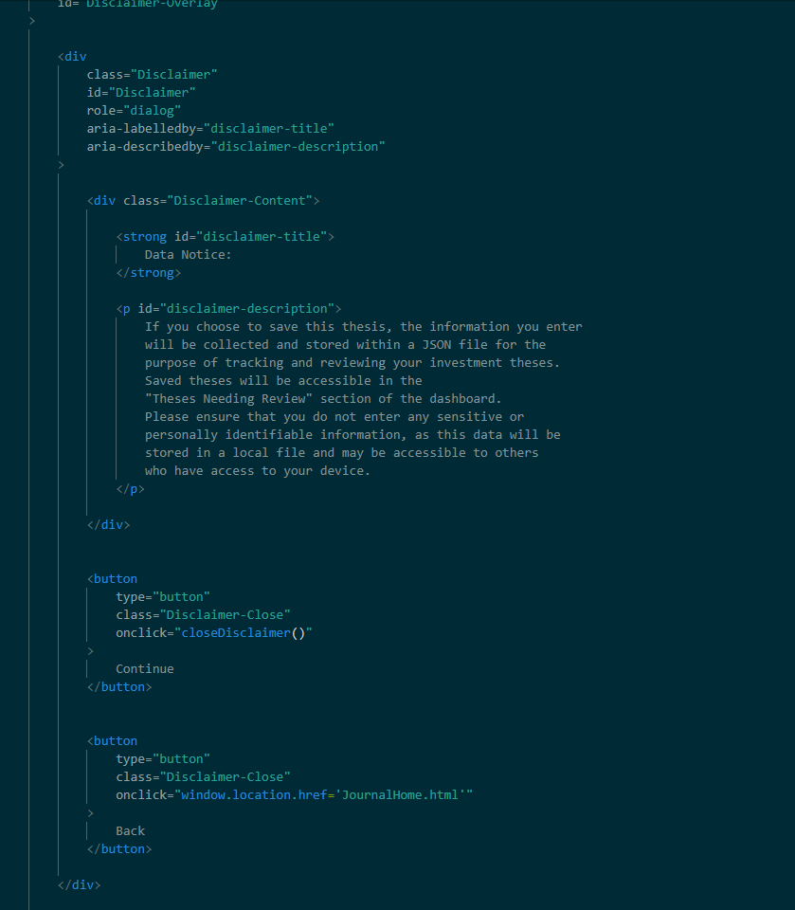  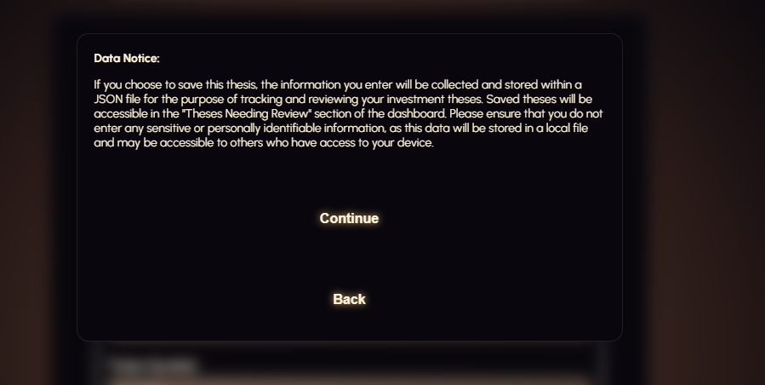 | This disclaimer looks unfinished / quite visually unappealing.  I restructured the HTML to separate my disclaimer into a label, heading and paragraphs, with the warning section having a slightly different background colour to draw the users eye to it.  I added role=”dialog” to improve accessibility so that screen readers can understand what the disclaimer is for.  Debug:  Changed the buttons to have a dedicated disclaimer-button class, and my site’s global button selector was applying the orange glow, border and shadows automatically. I fixed this by explicitly setting background, border, box-shadow, and text shadow to none.  FLEX BOX + MEDIA QUERIES:  I used flexbox on the disclimaer-actions to position back and continue buttons neatly and consistently.  I added a media query at 650px, to reduce the disclaimer’s padding on smaller screens to make it easier to read. | 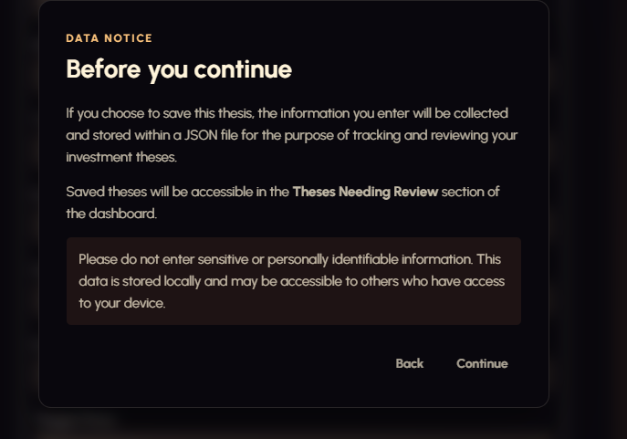  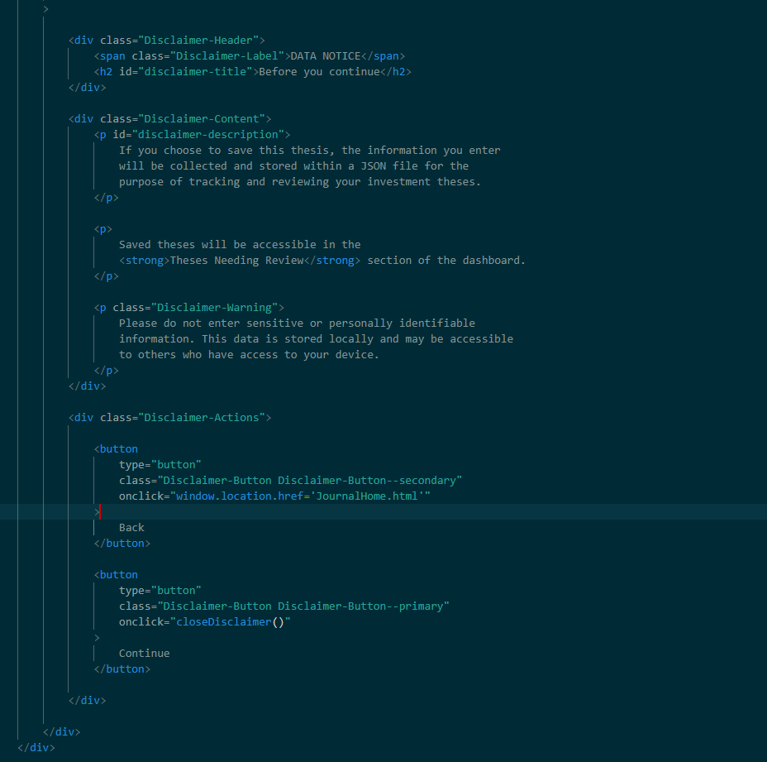  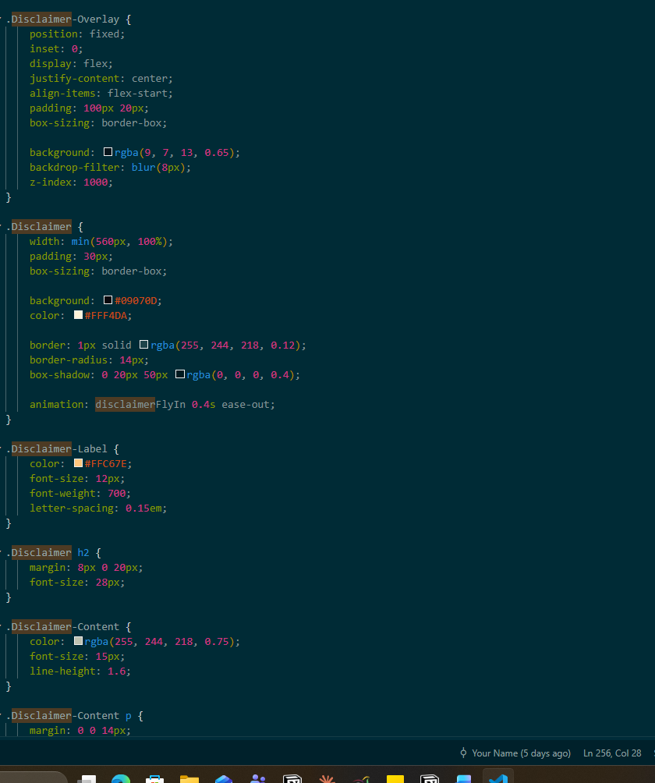
19/08/26 | Testing table refinements + debug |  | Trying to add a part of the validation when sending off my form that snags if no date is entered.  This is the code I’m currently trying to use.  // Validate required fields  if (!Thesis-Date) {  alert(  "Please add a Date"  );  return;  }  While it stops the thesis from logging, it doesn’t display the error message. | 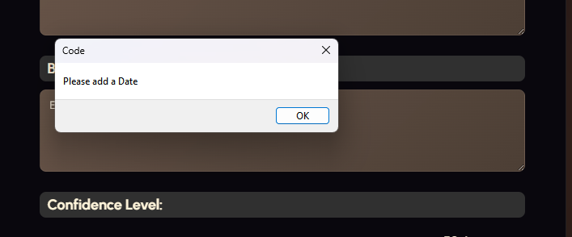  How I fixed it: Thesis-Date isn’t the javascript variable I wanted, its an HTML id. To solve this issue I had to change it to thesis.date which is the actual javascript variable  if (!thesis.date) {  alert("Please add a Date");  return;  }  This line works because thesis.date becomes an empty string if left blank, and an exmpty string is considered false in javascript, so if (!thesis.date) becomes true and the error message occurs.
20/08/2026 | Stylistic refinements | 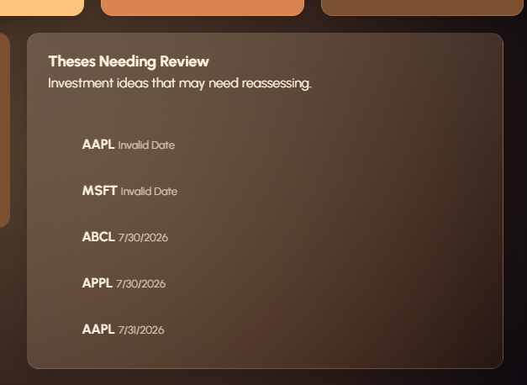 | Currently the theses needing review section has too many theses for the 400px maximum height it set for it. This means that they get cut off. I also think that it looks really bad having the theses needing review section be super tall to accommodate all of them, and if I wanted to keep it like that I would need to make it constantly get bigger.  To solve this problem I’m going to add the ability to scroll on the theses needing review to ensure that the section can be compressed and not take up too much of the dashboard as to be visually appealing.  I added this code to add a scroll bar when there’s too much content to fit on the screen | #review-container {  list-style: none;  padding: 0;  margin: 0;  overflow-y: auto;  flex: 1;  }  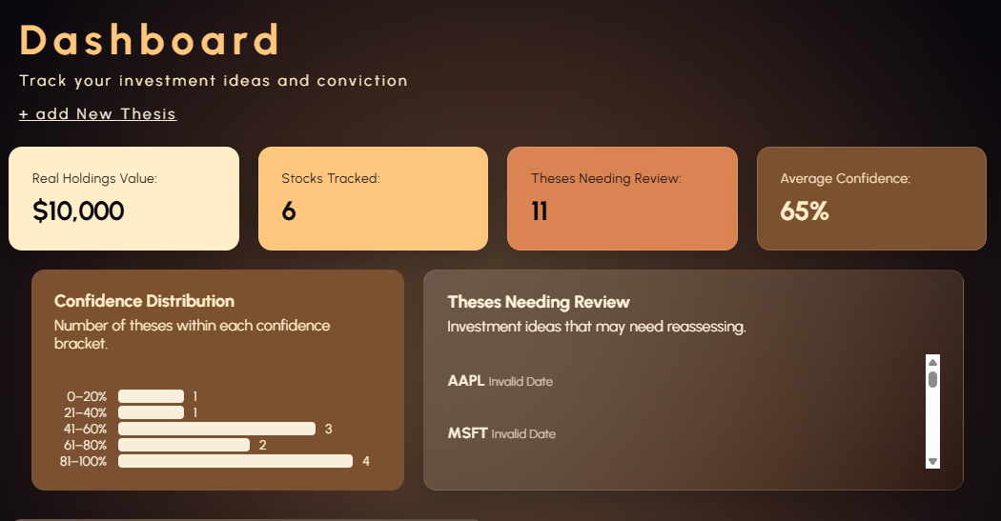
23/08/2026 | CSS validation |  | See code optimization section in my project brief doc
23/08/26 | Debug with layout | 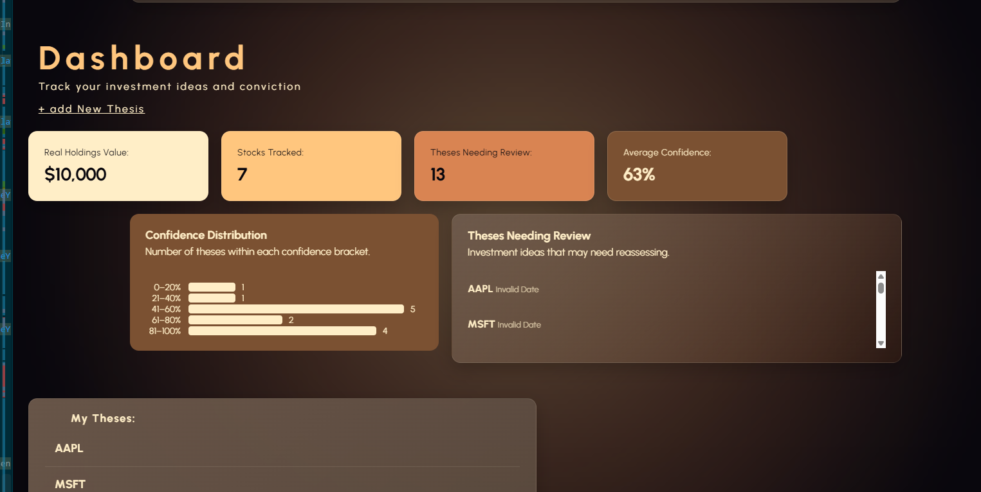 | Theses needing review and confidence chart are stuck on the centre of the screen when resizing to large viewport widths.  This is because the dashboard-middle-row section for my stylesheet aligns centres the entire row that the chart and the review section are in with “margin: 20px auto 0;”  My other widgets aren’t part of the same middle row, hence don’t have the same constraint, that’s why they are aligned to the left of the screen. | 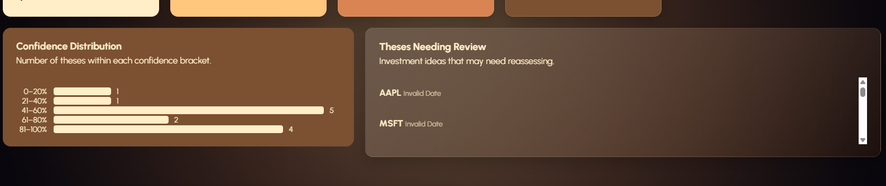  Changes made: removed the max-width: 1200  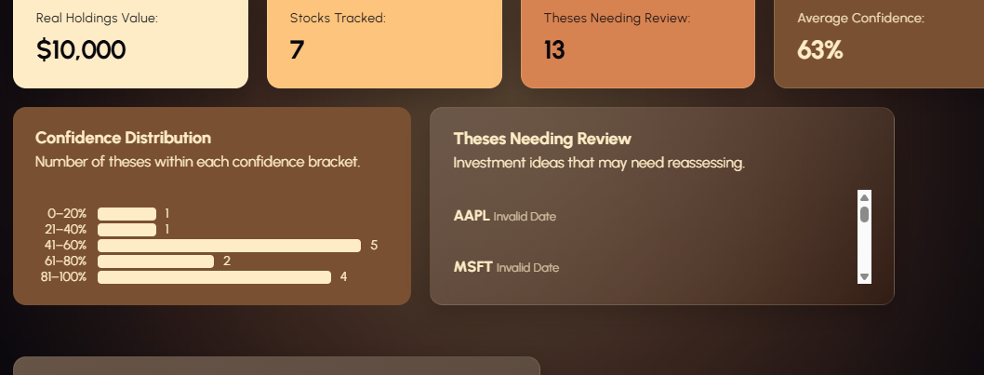  I also fixed the height of the theses needing review section from being slightly too tall, by changing its height to 213px instead of 232.
23/08/26 | Debug | 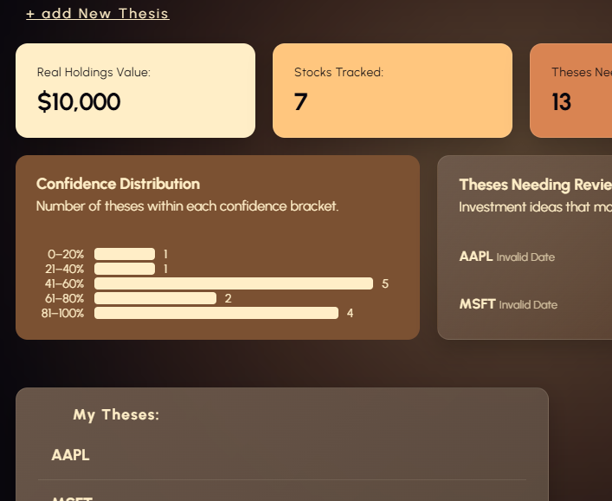 | Margin between the confidence distribution chart and the my theses section too large compared to all the other margins.  This was because of margin-top:25px; applying a 25px margin to the top of the my theses section while also likely having a margin bottom of 20px from the confidence chart above.  Removing the 25 px top margin fixes the issue. | 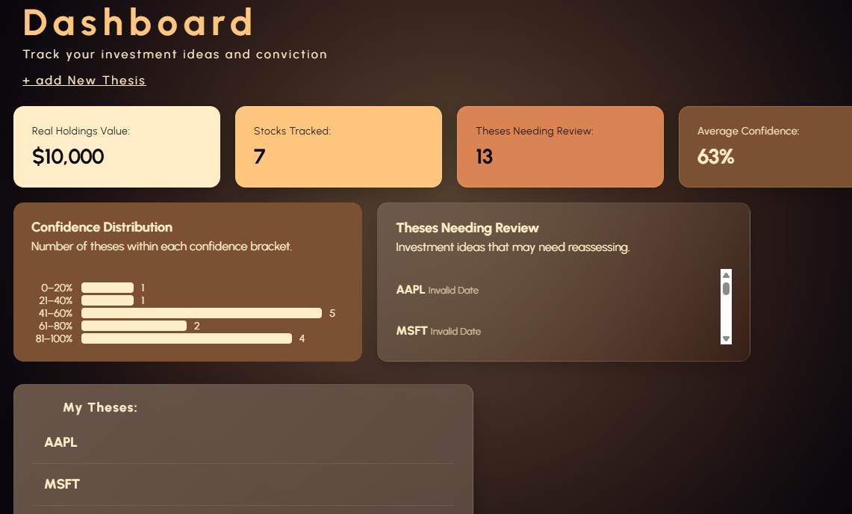
24/08/26 | Feature addition + dashboard refinement | 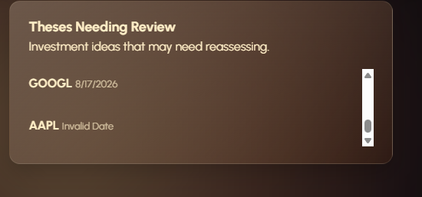 | Currently the theses needing review section displays all the theses, the same as the my theses section, making it effectively redundant.  Instead of removing one of the sections, I want to add a script that checks for theses created at a date older than three months, and then only showing them in the theses needing review section then.  Change log:  Added last reviewed property to each thesis when its created  Set the initial last review date to the theses’s creation date  Added calculation for date three months before the current date  Theses needing review filter identifies theses whose last reviewed date is three months or older  Updated the theses needing review counter to only display theses which have a last reviewed property older than three months | 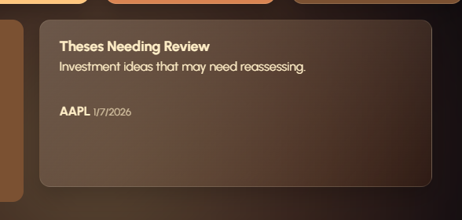
24/08/26 | Visual refinements | 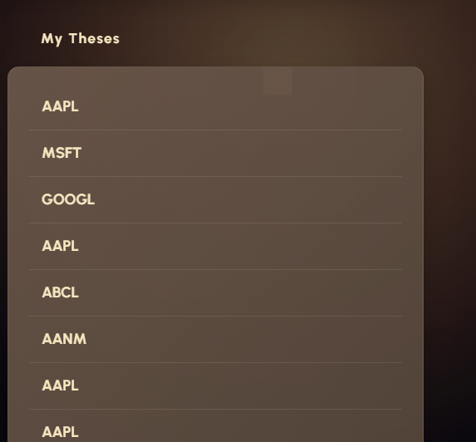 | Full refinement process in  ‘Testing of aesthetics and layout for optimizations and refinement log ‘ | 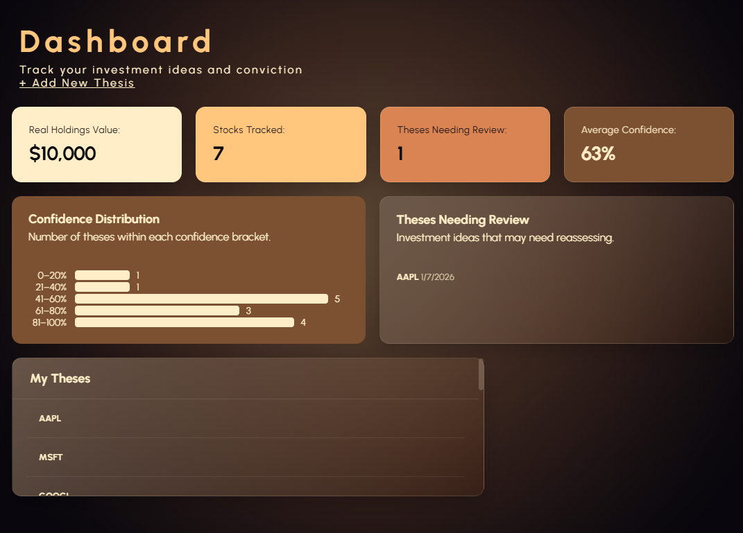
26/08/26 | Debug | 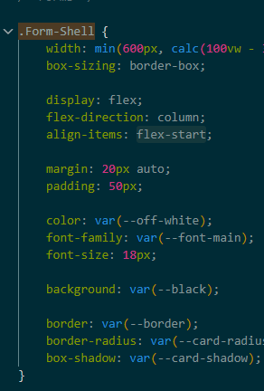  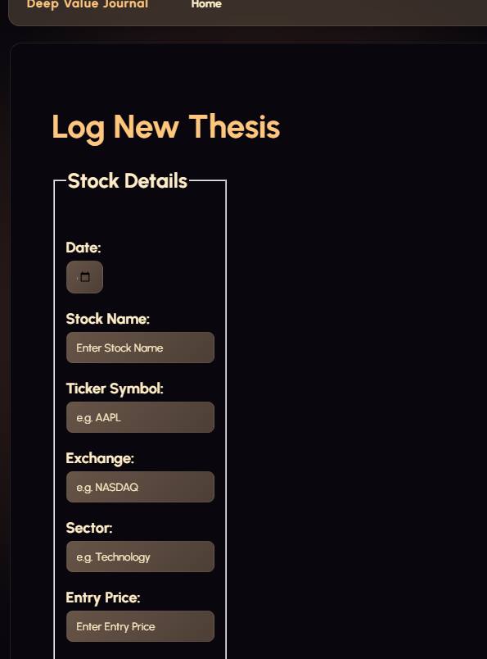 | The stock details and the main thesis sections are all over to the left hand side of the form container within journallanding.html.  The main culprit is the .form-shell css, which has align-items: flex-start; , which tells the flex-container to put the items within it on the left hand side and not allow them to stretch and fill up the whole container.  The fix here is changing it to align-items: stretch;, which allows the items in the container to stretch and fill the available cross-axis width. | 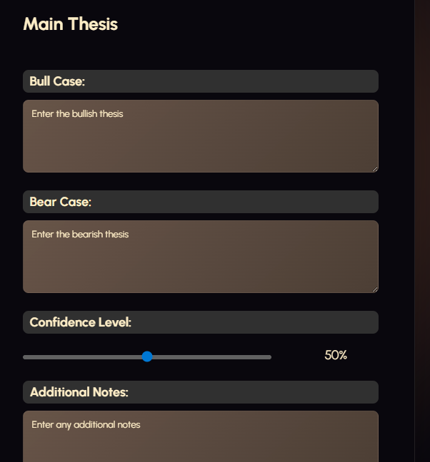  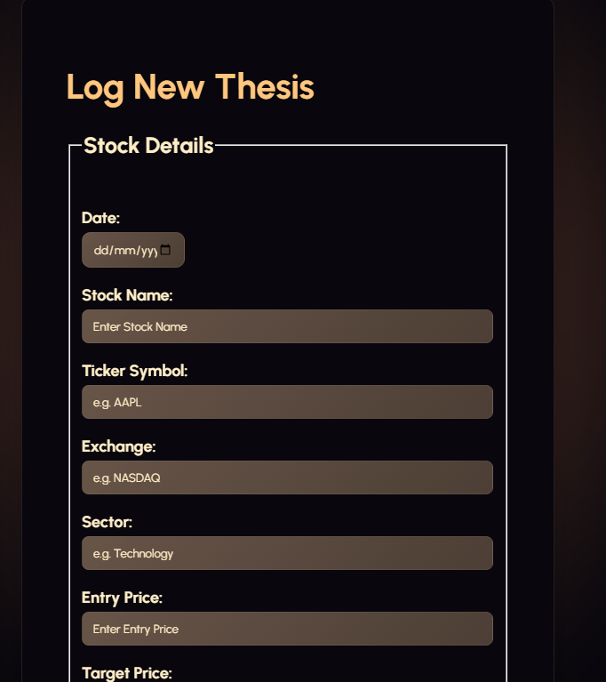
26/08/26 | Accessibility  Refinement process | 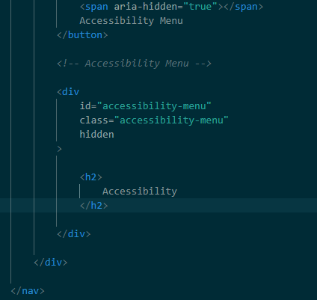 | HTML:  <label for="text-size-slider"> Text Size: </label>  Gives the slider a label.  <input  Type=”range” creates the slider. This is the same way I put a slider into my thesisentry form a bit earlier on.  min="80" max="150" sets the minimum and maximum values for the font size, so they user can choose from 80% the default to 150% of the default,  value=”100” makes 100 percent the default  step="10" makes the text size increase in increments of 10 | 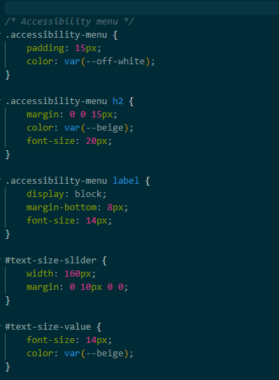
26/08/26 | JavaScript addition process + DEBUG | 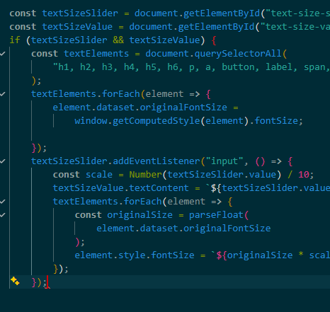 | Debugging errors:  Error 1:  const textSizeValue = document.getElementById("text-size-values");  while the actual html element is text-size-value, therefore I accidentally added and extra s to the end of the values. This means javascript couldn’t find the html element, so textsizevalue returned null. This means that the text-size percentage couldn’t be displayed correctly, nor does the accessibility menu even open.  I fixed this by removing the s.  Error2: if (textSizeSlider && textSizeValue) {  const textElements = document.querySelectorAll(  "h1, h2, h3, h4, h5, h6, p, a, button, label, span, li, legend, input, textarea, select"  );  Starts with {, but I accidentally didn’t put the closing one, so javascript produced a syntax error, as I hadn’t closed the if statement. I fixed this by closing it off.  Error 3:  Calculation error  const scale = Number(textSizeSlider.value) / 10; the slider value is a percentage, if the slider value is at 120, then it should be 1.2x as big. But dividing it by 10 means that it will become 12 times as big instead, far too big.  To fix this I ensured that the percentage calculation used 100 instead of 10. | 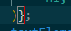  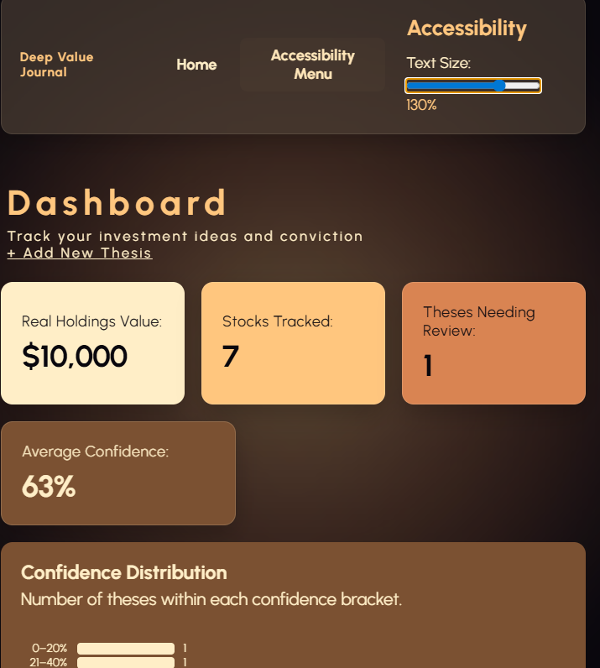  Code explanation  const textSizeSlider = document.getElementById("text-size-slider");  finds the html elemt with text-size-slider and stores it as the variable textsizeslider.  So what ever value the slider is set to, javascript can now use.  const textSizeValue = document.getElementById("text-size-value");  finds the element that displays the current percentage, when it moves it changes the value to what it moved to.  const textElements = document.querySelectorAll( "h1, h2, h3, h4, h5, h6, p, a, button, label, span, li, legend, input, textarea, select" );  is the list of texts that will be resizes, querySelector finds all elements that match, meaning that the slider can resize most of the text throughout my website.,  textElements.forEach(element => {  element.dataset.originalFontSize =  window.getComputedStyle(element).fontSize;  });  Store the orignal font size  textSizeSlider.addEventListener("input", () => {  run this code when the slider moves  const scale = Number(textSizeSlider.value) / 100;  converts the slider percentage into a multiplier. If its at 120% it will multiply the font sizes by 1.2x  textElements.forEach(element => {  goes through the code, finding every heading, paragraph etc and then retrieves the original font size and converts it from ‘20px’ format to a number.  element.style.fontSize = `${originalSize * scale}px`; applys the new font size.
26/08/26 | Visual refinement process | 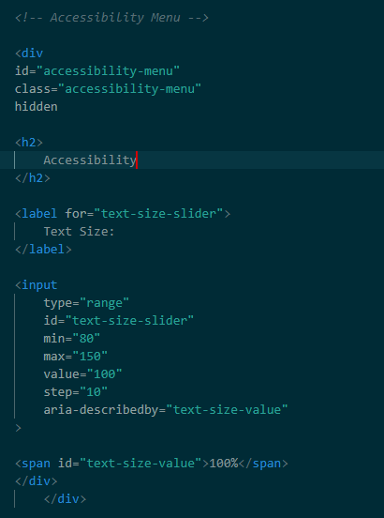  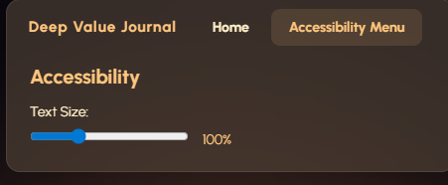 | I do think that the way this is implemented is a bit visually unappealing. It would be much better if it popped up like the disclaimer does when you press on accessibility menu, with a blurred background and an aesthetic design.  I need to add an accessibility overlay div just like I did for the disclaimer. | Changed the CSS to look more visually appealing and match my colour scheme.
26/08/26 | debug | 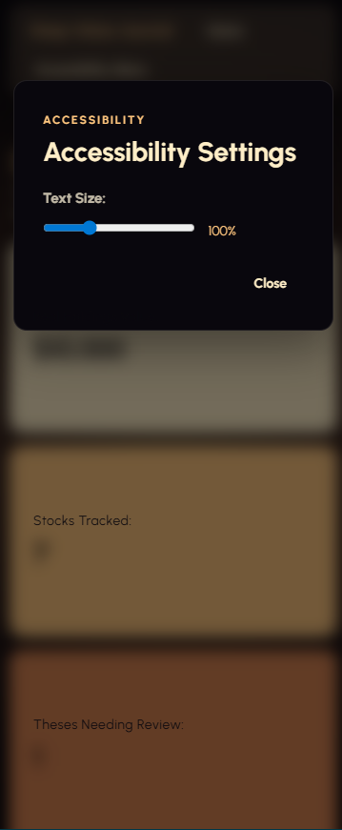  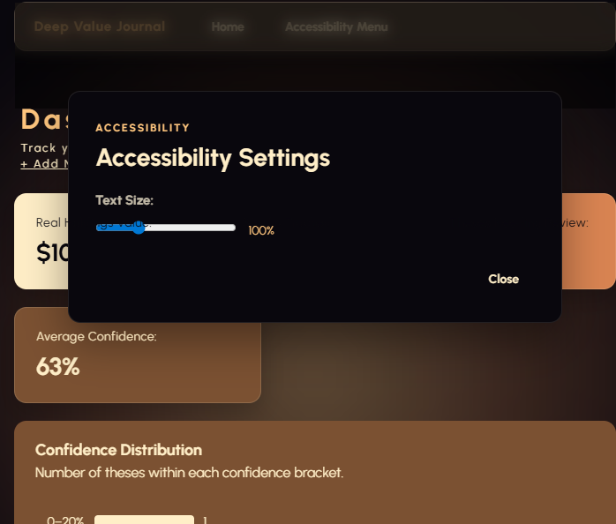  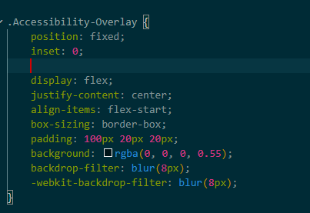  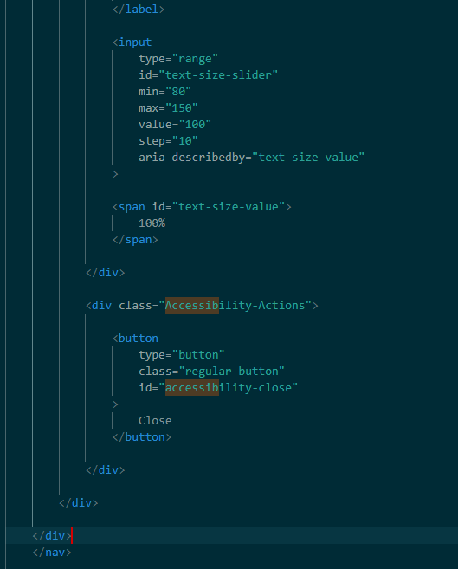 | Debug log:  Problem:  The accessibility menu’s blur only appeared around the top part of the screen and it wasn’t layered properly onto of the background behind it. It looked like the dashboard text and other elements were visually sitting within or over the accessibility menu, rather than the menu clearly appearing ontop.  Cause:  Accessibility overlay did not have the correct positioning and stacking order z-index, meaning other dashboard elements could appear visually above the accessibility menu and blur, which is not what you want for an overlay with a blurred background.  Fix: I gave the accessibility overlay a fixed position covering the entire viewport using z-index: 1000;  The backdrop-filter then blurs the dashboard content behind the overlay without affecting the accessibility settings themselves.  Debug log part 2:  Html changes to accessibility overlay  Problem: originally the accessibility overlay was placed inside the nav element meaning that the overlay was structured as part of the navigation section, that made it appear as part of the navigation rather than s full screen popup. This also made the blur effect appear only over the navigation section and no where else due to the positioning of the nav section.  Changes:  I moved the accessibility overlay outside of the nav element, and put it inside of the <body> elemnt.  The overlay is now a separate element from the navigation. This allows the CSS position: fixed and inset: 0 to make it cover the entire viewport, rather than behaving as part of the navigation layout.  The accessibility popup is therefore layered independently over the dashboard, allowing the whole page behind it to be blurred and darkened. | 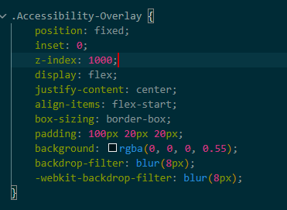  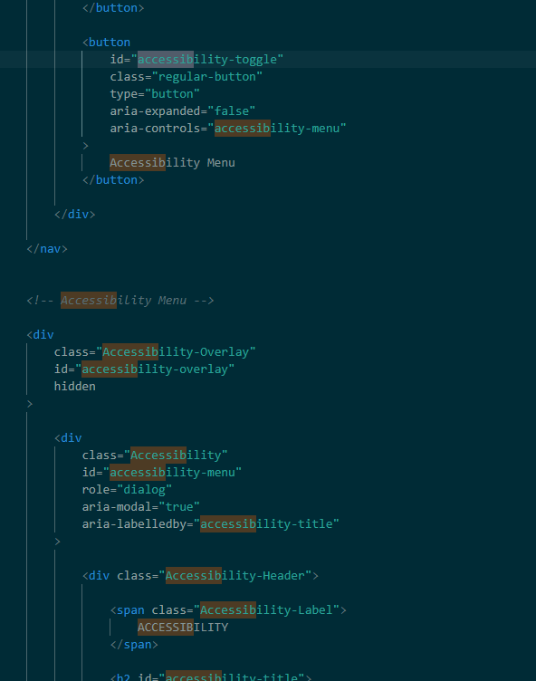  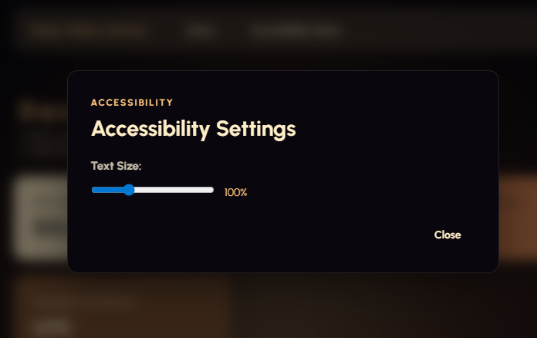
29/08/26 | Debug | 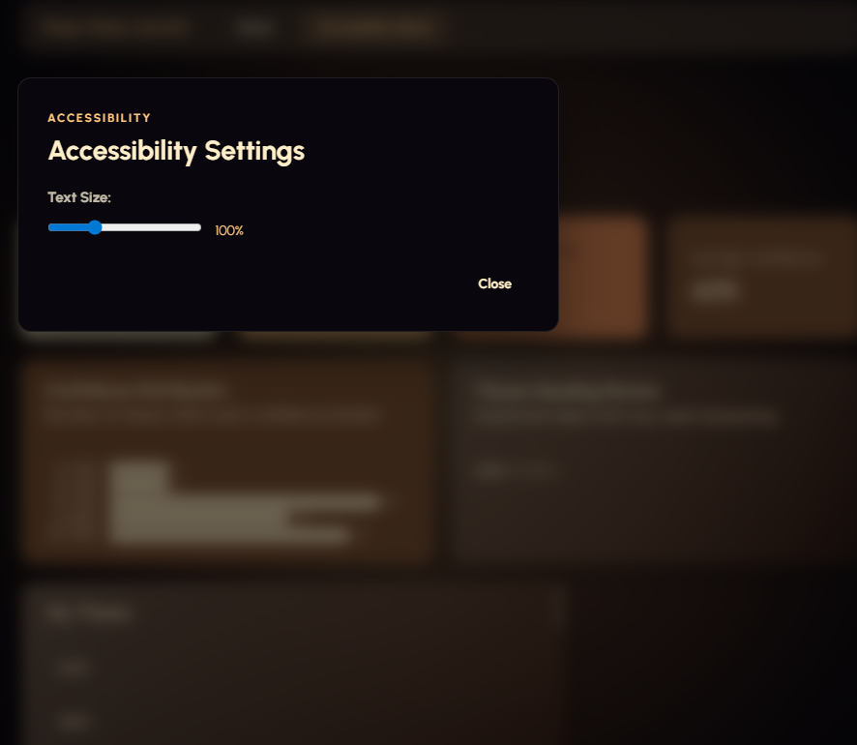  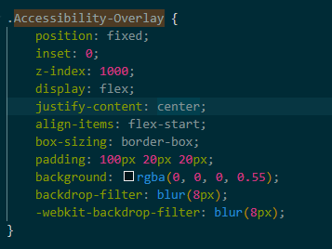  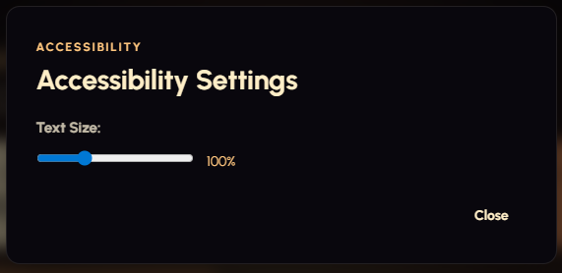 | Button to close the accessibility menu doesn’t work. The home page also opens with the accessibility menu open on the screen.  Debug log:  The issue is with the display: flex; element in my accessibility overlay.  The HTML hidden attribute usually causes the browser to apply display:none;  But this is being over written by display:flex; in my accessibility css.  Hence the disclaimer is not disappearing because it won’t let it assign the display: none;  Removing display: flex; fixes this problem, but it creates another one.  The accessibility disclaimer is now not aligned to the center of the screen, instead is off to the left.  The issue here is cannot add back the display: flex; which would fix the problem, because it just overrides the display:none; that is required for an overlay.  FIX:  I added back the display: flex; property to the accessibility-overlay section. I then defined .accessibility-overlay[hidden] to take the property display: none; when the overlay is closed by the button. Hence it disappears when I want to close it, and when it re opens its centered correctly because display: flex; allows justify-content and align-items to centre it. | 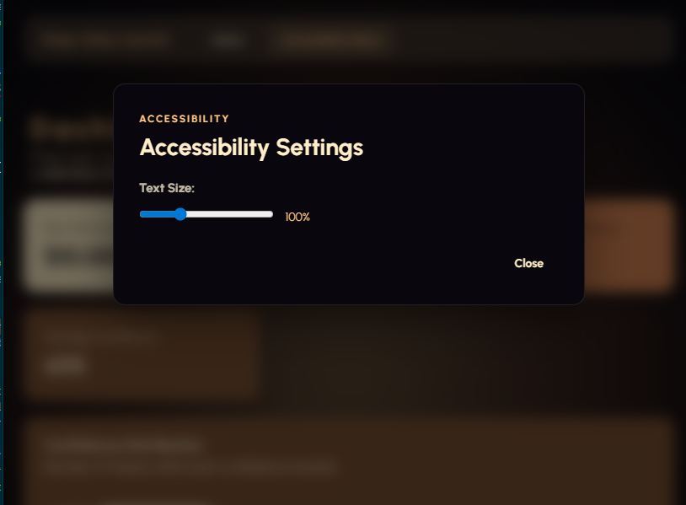  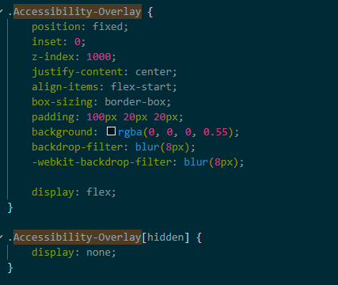  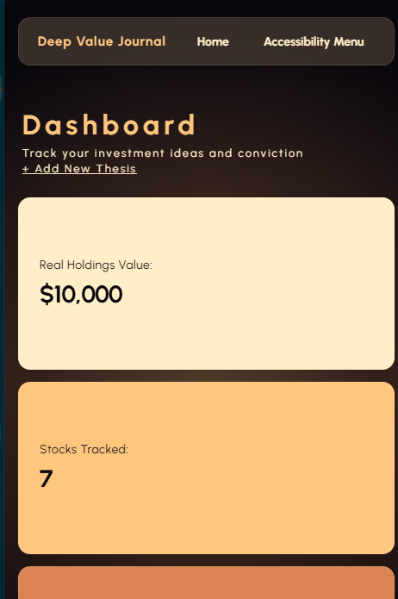
29/08/26 | Adding the ability to edit saved theses. | 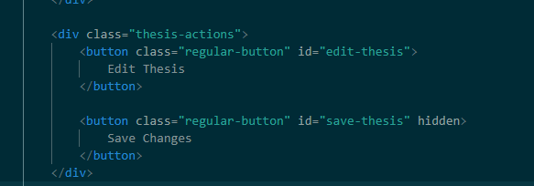  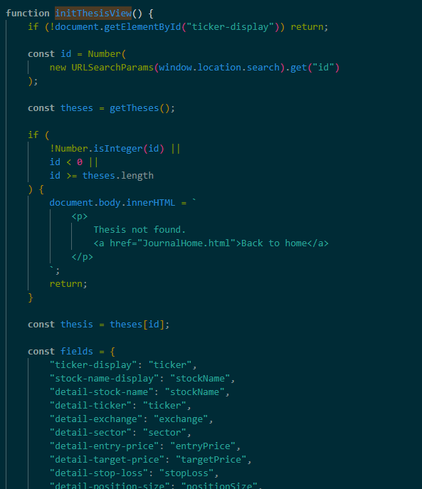 | I added a edit thesis button and a save changes button to thesisview.html. These are aimed at allowing the user to save and edit their Theses.  Changes to initThesisView()  I added an event listener to the Edit thesis button. This means that when I click the edit thesis button, it loops through the different elements of the thesis and creates input and text area elements so that the user can enter changes to their thesis. The existing thesis elements come pre set inside these inputs, ready for the user to modify.  I also added an event listener to the save changes button, which listens for clicking the save button, collecting the new values from the input and text area and updating the corresponding properties inside of the thesis.  This updated thesis is placed back into the original thesis position, with its original ID, stopping a duplicate thesis from being created. It is then saved to local storage for retrieval in the mytheses section. | 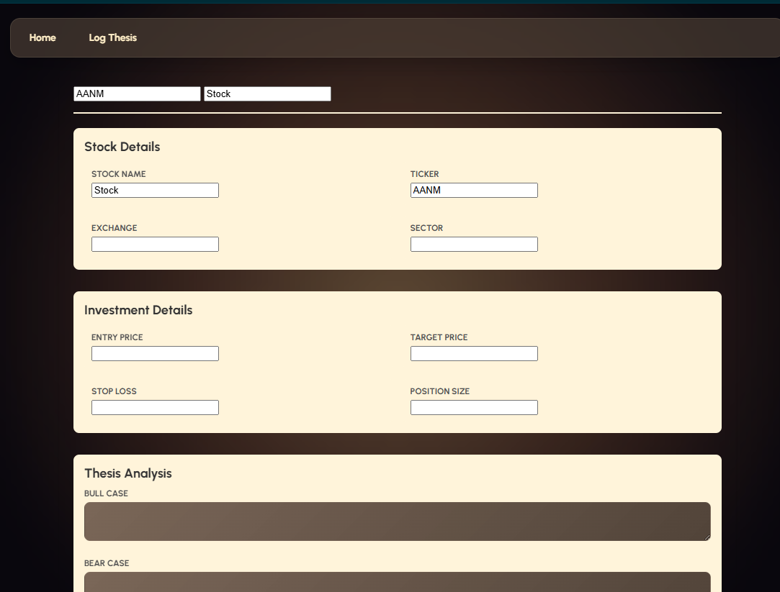
29/08/26 | Testing changes | 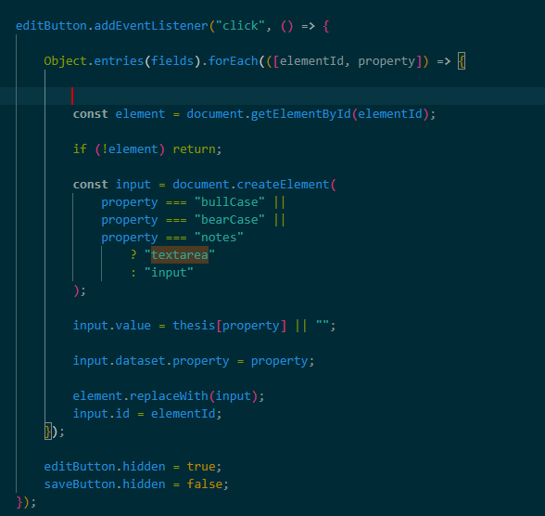 | Stopping the user from changing stock name and stock ticker when editing a thesis in the thesisviewpage  The fix is adding this line of code to my forEach  if (property === "ticker" || property === "stockName") { return; }  it says if the field is the stock ticker or stock name, don’t replace it with an input therefore it cannot be changed. | 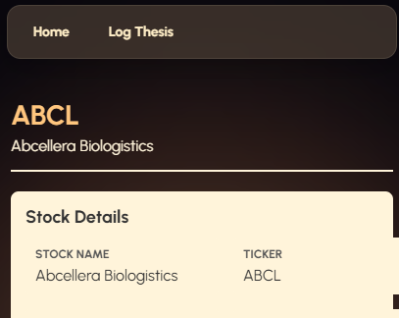
29/08/26 | Testing improvements | 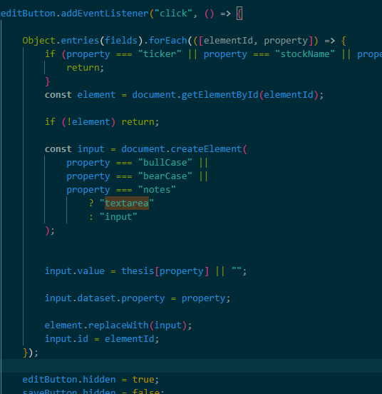 | The issue is that when editing a thesis it allows me to enter letters and special characters into the sections that only allow numbers when actually creating the thesis through the form.  Currently my forEach just treats all the components of my thesis as regular inputs hence they all allow special characters and letters.  I need to specifically set some to only allow numbers.  The code that fixes the issue:  if (  property === "entryPrice" ||  property === "targetPrice" ||  property === "stopLoss" ||  property === "positionSize"  ) {  input.type = "number";  }  if (property === "confidence") {  input.type = "range";  input.min = "0";  input.max = "100";  input.step = "1";  }  Entry price, target price, stop loss and position size now use number inputs, while the confidence section needs a special category as it’s a slider. I have made it so that the confidence slider comes back editing the thesis. This stops the input of letters and is more intuitive that typing confidence percentage as a number.  This helps keep the editing process consistent with the original thesis form. | 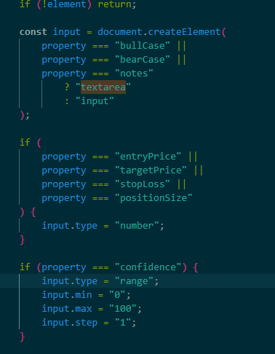  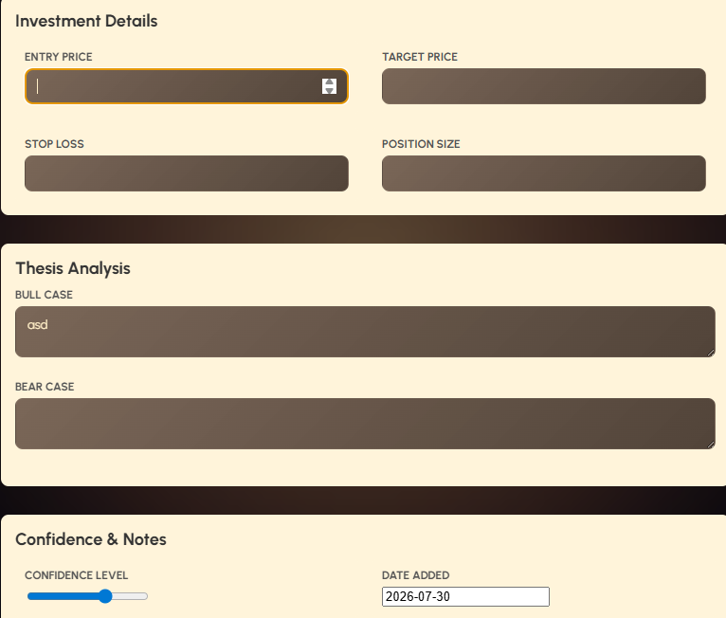
29/08/26 | Testing improvements | 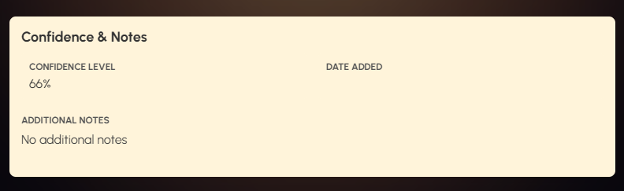  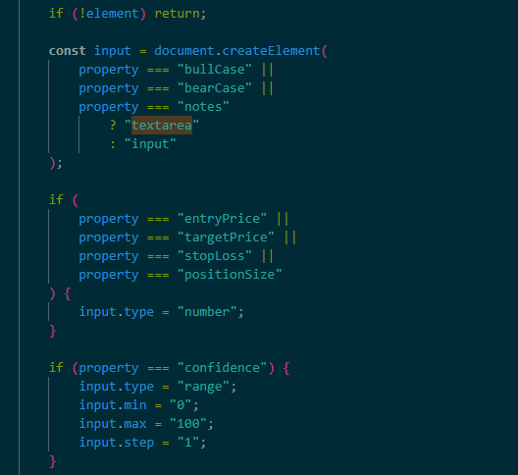 | Issue: the interface lets me remove the date and save the thesis when editing it.  Code fix:  if (property === "date") {  input.type = "date";  input.required = true;  }  This makes the thesis date editable while stopping the user from leaving it blank. This means the user can update dates while maintaining a valid thesis record. | 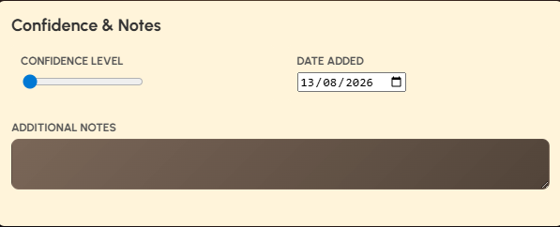
29/08/26 | Debug | 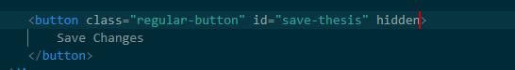  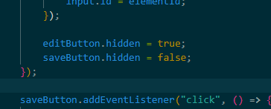 | Edit thesis button and save changes button not disappearing when they need to in the editing process.  The save button should be hidden at the start, while the edit button should hide after it is pressed and edit mode is entered.  Fix:  Changed the save changes button HTML.  The hidden element was not successfully controlling the buttons visibility, which is probably something to do with the css for button’s display property, using style=”display: none;” directly hides the button when not in use  Changed how the edit thesis button is hidden. Instead of relying on the hidden property, the javascript changes the button’s CSS display property to none. This ensures the edit thesis button is removed from the page after its clicked to prevent thesis form data removal error identified in testing. | 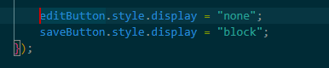  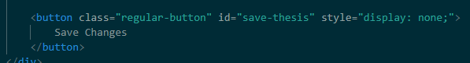
29/08/26 | Testing improvements: |  | Issue:  Text size entered in the accessibility menu does not save when switching html pages.  Fix:  The code used to be like this  element.style.fontSize = `${originalSize * scale}px`;  it would only change the font size for the page currently open  now It stores the slider’s value too  localStorage.setItem("textSize", textSizeSlider.value);  meaning that it will persist when switching pages  we retrieve the saved value when a page loads  const savedTextSize = localStorage.getItem("textSize") || "100";  then we set the slider and apply the saved size  textSizeSlider.value = savedTextSize;  textSizeValue.textContent = `${savedTextSize}%`; | 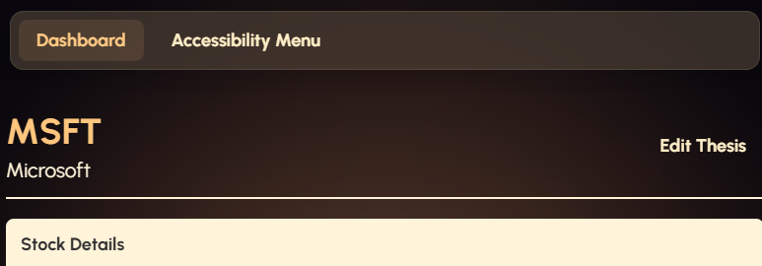  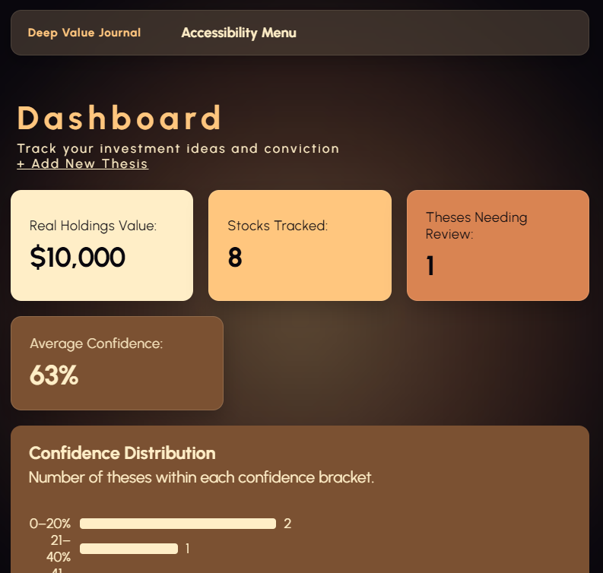
31/08 |  |  | Added comments and simplified some of my css.
1/09/26 | Testing improvements | 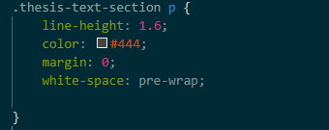  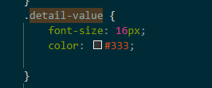  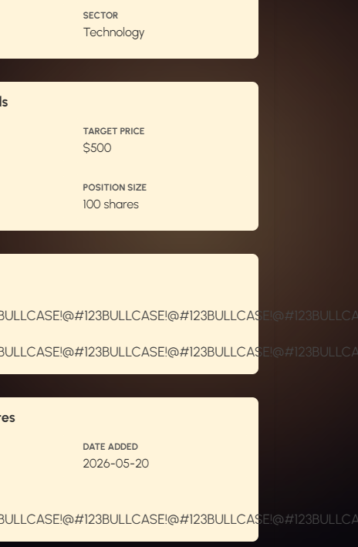 | When extremely long text is entered into the thesis form for bull case, bear case, or additional notes, it gets extruded off the screen when reviewed in the thesis view.html.  To fix this issue I located the thesis-text-section p CSS properties.  The problem was the thesis-text-section p didn’t have any word wrapping css properties. Meaning that my system had no way to handle long text, so it just either overflowed or stayed on one line  I added three different properties to my thesis-text-section p word-wrap: break-word; which breaks words longer than container width, ensuring they move to the next row.  Overflow-wrap: break-word; is the more modern equivalent, I have included both for compatibility and redundancy, in-case a user is running my system on an older browser or device, having readable theses is a super important aspect of my interface.  Overflow-x hidden; prevents the text from creating a horizontal scroll bar when it gets too large.  For extra redundancy purposes I added these same properties to detail-value, ensuring that the number properties in investment details are handled too, even though amounts that large aren’t likely to ever need to be entered.  I have made the design decision not to use a horizontal scroll bar for these theses sections because I think that would become quite annoying if the user had to constantly scroll to find the data they wanted to when reviewing.  However in edit mode I have kept the ability to both resize the boxes and automatic scroll bar additions to simplify the editing process.  The user will still easily be able to find what they want as auto scroll bar is disabled for the non edit mode. | 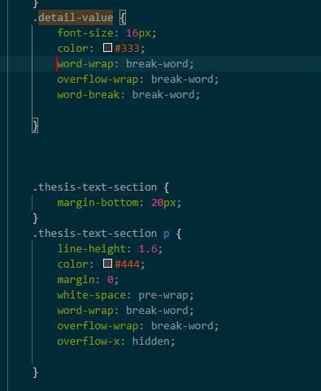  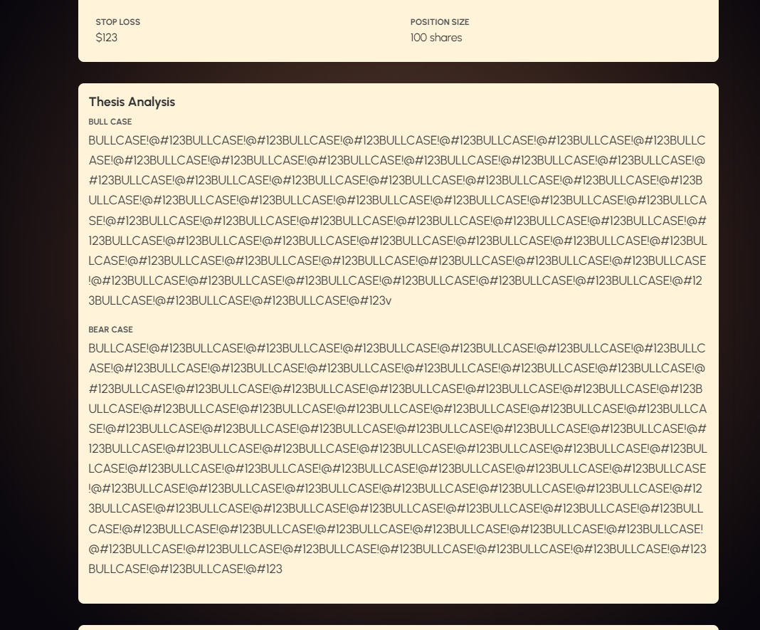
19/09/26 | Debug | 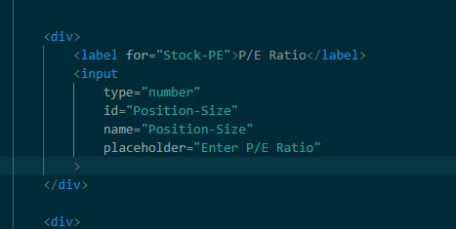 | The change made was updating the IDs for the elements within the stock metrics section to ensure they were actually consistent with the ones being checked in javascript.  When I copied the structure across I was changing the for=”” rather than the actual ID on accident.  This lead to incorrect duplicate IDs, so javascript received null, causing an error when it tried to read .value.  Correcting these IDs ensured each field could be retrieved reliably. | 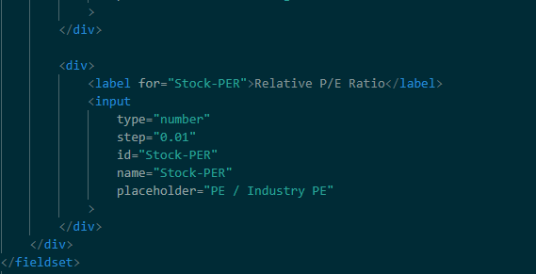
26/09/26 | Final visual polish before submission |  |  | 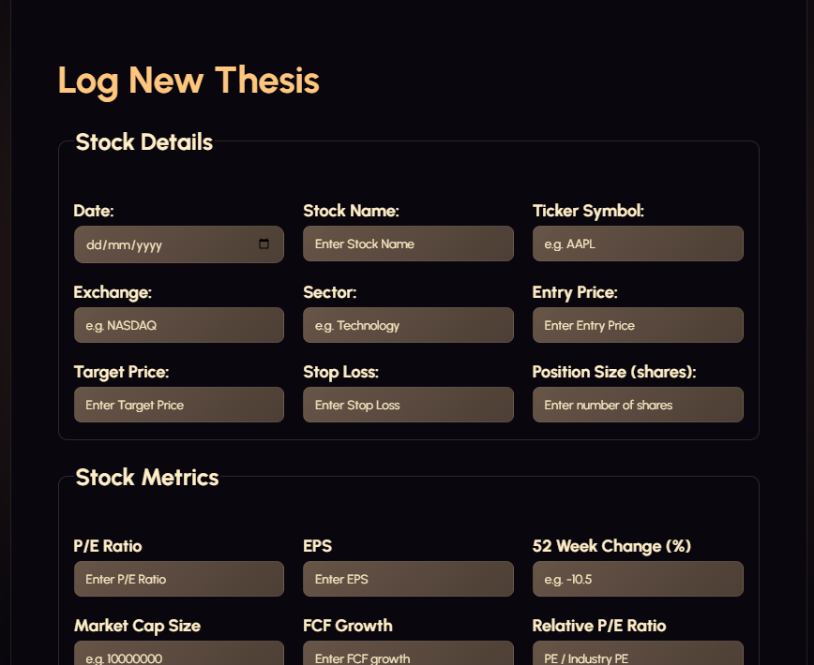  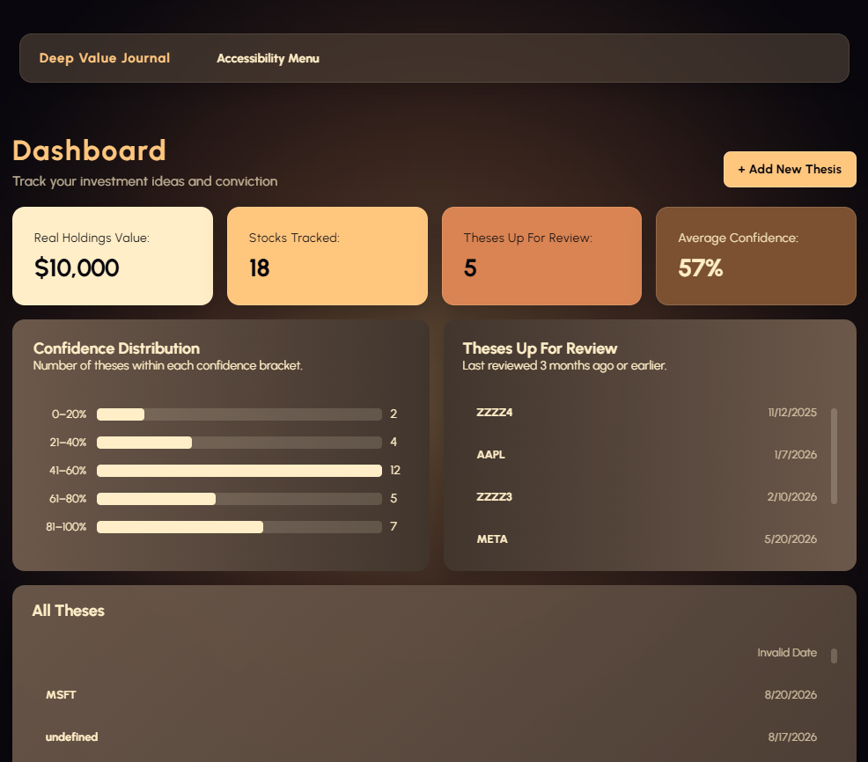

Iterative Improvement:
My worklog demonstrates that I used a process of developing, designing, testing, identifying problems, changing and then retesting them throughout the development of my website. Rather than having 2-3 clear design iteration versions, I regularly tested and debugged my features after creating them to identify problems with the functionality, layout, responsiveness and visual design. I changed my code and design to solve these problems as I went, and re tested them to prove that I had actually fixed the issue.
I also have a dated testing table with initial tests and tests after the change was made, including pictures to show the iterative development process.
Summary of iterative development:
11/08 – 17/08: Dashboard Responsiveness
I developed the dashboard widgets and tested them at different viewport sizes. I found that some of the widgets were being cut off on smaller screens, so I fixed the flexbox and media queries to ensure they wrapped around the to the next row.

13/08 – 17/08: Privacy Disclaimer
I created the privacy disclaimer and tested to see that it worked on my page. It pushed the content down and the blur removed even after I closed it. I decided to change the css for the disclaimer to make it more visually appealing and fixed the javascript so that both the blur and the disclaimer removed correctly.

17/08 – 18/08: Confidence Chart
I created the confidence chart and tested its visual appearance. The labels, bars and numbers were badly aligned and it looked visually unappealing, I used flex box, adjusted the styling and spacing to ensure it looked more organised and readable.

19/08 – 20/08: Form and dashboard testing
Feedback and testing identified issues with placeholder contrast and the review section becoming too large. I changed placeholder styling and added the ability to scroll so that it didn’t take up excessive space and remained readable.

23/08 – 24/08: Dashboard Refinement
I tested the dashboard layout and found alignment and spacing issues. I adjusted the layout and saw that the theses needing review section was redundant because it still showed every thesis just like the my theses section below. I updated the Javascript to ensure that the theses needing review section only displayed theses created at a date older than 3 months to ensure it remains relevant.

