URS

|  |  |
| --- | --- |
| Author | Oscary Cijntje |

Contents

1. User Requirements 3

**1.** **Functional Requirements** 3

**2.** **Non-Functional Requirements** 3

2. Use cases. 4

3. Images of all pages. 18

Introduction

In this document there will be all use cases/functional and non-functional requirements that me and the stakeholders agreed to do for this project.

# User Requirements

## **Functional Requirements**

|  |  |  |
| --- | --- | --- |
|  | **Requirements** | **MOSCOW** |
|  | **Desktop Application** |  |
| FR.01 | Create new Computer | Must |
| FR.02 | Edit existing Computer | Must |
| FR.03 | View existing Computer | Must |
| FR.04 | Delete existing Computer | Must |
| FR.05 | View all Computers | Must |
| FR.06 | Create new Phone | Must |
| FR.07 | Edit existing Phone | Must |
| FR.08 | View existing Phone | Must |
| FR.09 | Delete existing Phone | Must |
| FR.10 | View all Phones | Must |
|  | **Web Application** |  |
| FR.11 | Users can login (Both applications) | Must |
| FR.12 | Users can register | Must |
| FR.13 | Users can update their account | Must |
| FR.14 | Users can delete their account | Must |
| FR.15 | Users can view their account | Must |
| FR.16 | Customers can view products | Must |
| FR.17 | Customers can view products details | Must |
| FR.18 | Customers can search specific products | Must |
| FR.19 | Customers can add products to cart | Must |
| FR.20 | Customers can remove products from cart | Must |
| FR.21 | Customers can purchase products in cart | Must |
| FR.22 | Customers can add products to favorites | Must |
| FR.23 | Customers can remove products from favorites | Must |
| FR.24 | Customers can add a new review for products | Should |
| FR.25 | Customers can edit their review from products | Should |
| FR.26 | Customers can delete their review from products | Should |

## **Non-Functional Requirements**

|  |  |
| --- | --- |
| **Requirements** | **MOSCOW** |
| Security | Should |
| Capacity | Should |
| Compatibility | Should |
| Reliability/Availability | Should |
| Maintainability/Manageability | Should |
| Scalability | Should |
| Useability | Should |

# Use cases.

|  |  |
| --- | --- |
| Use case: **UC-01**  **Functional requirement: FR.01** | **UC-01**: Create new computer |
| Actor: | Admin |
| Pre-condition: | Actor is logged in and is in the computer panel |
| Main Success Scenario: | 1. Actor requests to create new computer. 2. System shows field that required to be entered. 3. Actor filled in required data. 4. Actor adds computer. 5. Computer added. 6. End use case. |
| Extensions: | 3a) Data not valid.   1. System shows error. 2. Return to step 3. |

|  |  |
| --- | --- |
| Use case: **UC-02**  **Functional requirement: FR.02** | **UC-02**: Edit existing computer |
| Actor: | Admin |
| Pre-condition: | Actor is logged in and is in the computer panel |
| Main Success Scenario: | 1. Actor selects the desired computer. 2. Actor requests to edit by pressing the edit button. 3. Actor changes to the edit page. 4. Actor changes the desired data. 5. Actor saves the desired updates by pressing the save changes button. 6. End use case. |
| Extensions: | 2) No computer selected.   1. System shows error. 2. Return to step 1.   5) Invalid data.   1. System shows error. 2. Return to step 4. |

|  |  |
| --- | --- |
| Use case: **UC-03**  **Functional requirement: FR.03** | **UC-03**: View existing Computer |
| Actor: | Admin |
| Pre-condition: | Actor is logged in and is in the computer panel |
| Main Success Scenario: | 1. Actor selects the desired computer. 2. Actor requests to view the computer by pressing the view button. 3. System shows the details of the selected computer. 4. End use case. |
| Extensions: | 2a) No computer selected.   1. System shows error. 2. Return to step 1. |

|  |  |
| --- | --- |
| Use case: **UC.04**  **Functional requirement: FR.04** | **UC-04**: Delete existing Computer |
| Actor: | Admin |
| Pre-condition: | Actor is logged in and is in the computer panel |
| Main Success Scenario: | 1. Actor selects the desired computer. 2. Actor requests for the computer to be deleted by pressing the delete button. 3. System asks if the admin is sure about this decision. 4. Admin confirms and computer is deleted. 5. End use case. |
| Extensions: | 2a) Computer not selected.   1. System shows error. 2. Return to step 1.   4a) Actor says no.   1. System does not delete the computer. 2. End use case. |

|  |  |
| --- | --- |
| Use case: **UC.05**  **Functional requirement: FR.05** | **UC-05**: View all computers |
| Actor: | Admin |
| Pre-condition: | Actor is logged in and is in the computers panel |
| Main Success Scenario: | 1. Actor requests to switch to the computer panel. 2. System automatically shows all existing computers. 3. End use case. |

|  |  |
| --- | --- |
| Use case: **UC.06**  **Functional requirement: FR.06** | **UC-06**: Create new phone |
| Actor: | Admin |
| Pre-condition: | Actor is logged in and is in the phone panel |
| Main Success Scenario: | 1. Actor requests to create new phone. 2. System shows field that required to be entered. 3. Actor filled in required data. 4. Actor adds phone. 5. Phone added. 6. End use case. |
| Extensions: | 3a) Data not valid   1. System shows error. 2. Return to step 3. |

|  |  |
| --- | --- |
| Use case: **UC.07**  **Functional requirement: FR.07** | **UC-07**: Edit existing phone. |
| Actor: | Admin |
| Pre-condition: | Actor is logged in and is in phone panel |
| Main Success Scenario: | 1. Actor selects the desired phone. 2. Actor requests to edit by pressing the edit button. 3. Actor changes to the edit page. 4. Actor changes the desired data. 5. Actor saves the desired updates by pressing the save changes button. 6. End use case. |
| Extensions: | 2a) Phone not selected.   1. System shows error. 2. Return to step 1.   5a) Invalid data.   1. System shows error. 2. Return to step 4. |

|  |  |
| --- | --- |
| Use case: **UC.08**  **Functional requirement: FR.08** | **UC-08**: View existing phone. |
| Actor: | Admin |
| Pre-condition: | Actor is logged in and in the phone panel |
| Main Success Scenario: | 1. Actor selects the desired phone. 2. Actor requests to view the phone by pressing the view button. 3. System shows the details of the selected phone. 4. End use case. |
| Extensions: | 2a) Phone not selected.   1. System shows error. 2. Return to step 1. |

|  |  |
| --- | --- |
| Use case: **UC.09**  **Functional requirement: FR.09** | **UC-09**: Delete existing phone |
| Actor: | Admin |
| Pre-condition: | Actor is logged in and is in the phone panel |
| Main Success Scenario: | 1. Actor selects the desired phone. 2. Actor requests for the phone to be deleted by pressing the delete button. 3. System asks if the admin is sure about this decision. 4. Admin confirms and phone is deleted. 5. End use case. |
| Extensions: | 2a) Phone not selected.   1. System shows error. 2. Return to step 1.   4a) Actor says no.   1. System does not delete the phone. 2. End use case. |

|  |  |
| --- | --- |
| Use case: **UC.10**  **Functional requirement: FR.10** | **UC-10**: View all phones |
| Actor: | Admin |
| Pre-condition: | Actor is logged in |
| Main Success Scenario: | 1. Actor requests to switch to the phone panel. 2. System automatically shows all existing phones. 3. End use case. |

|  |  |
| --- | --- |
| Use case: **UC.11**  **Functional requirement: FR.11** | **UC-11**: Login |
| Actor: | Admin/Customer |
| Pre-condition: | Actor is not logged in and is in the login page |
| Main Success Scenario: | 1. Actor fills in the requested credentials. 2. Actor requests to login by pressing the login button. 3. Actor is successfully logged in. |
| Extensions: | 2a) Credentials not matched.   1. System shows error. 2. Return to step 1. |

|  |  |
| --- | --- |
| Use case: **UC.12**  **Functional requirement: FR.12** | **UC-12**: Register |
| Actor: | Admins/Customer |
| Pre-condition: | Actor is not logged in and is in the register page |
| Main Success Scenario: | 1. Actor goes to the register page. 2. Actor fills in the requested credentials. 3. Actor requests for their account to be made by pressing the register button. 4. System shows that actor is successfully registered. 5. End use case. |
| Extensions: | 3a) Invalid credentials   1. System shows error. 2. Return to step 2. |

|  |  |
| --- | --- |
| Use case: **UC.13**  **Functional requirement: FR.13** | **UC-13**: Update account |
| Actor: | Admin/Customer |
| Pre-condition: | Actor is logged in |
| Main Success Scenario: | 1. Actor goes to the profile page. 2. Actor requests to be allowed to change their current credentials by pressing the edit button. 3. Actor fills in the desired changes to the requested credentials. 4. Actor requests that their changes be updated by pressing the save button. 5. System shows that their account has been successfully updated. 6. End use case. |
| Extensions: | 1a) Error not authorized.   1. System shows error. 2. Return to login page.   4a) Invalid credentials.   1. System shows error. 2. Return to step 3. |

|  |  |
| --- | --- |
| Use case: **UC.14**  **Functional requirement: FR.14** | **UC-14**: Delete account |
| Actor: | Admin/Customer |
| Pre-condition: | Actor is logged in |
| Main Success Scenario: | 1. Actor goes to the profile page. 2. Actor requests to delete their account by pressing the delete button. 3. System asks if actor is sure about their decision. 4. Actor confirms their decision. 5. System successfully deletes their account and shows successful message. 6. End use case. |
| Extensions: | 1a) Error not authorized.   1. System shows error. 2. Return to login page.   4a) Actor says no.   1. System does not delete the account. 2. End use case. |

|  |  |
| --- | --- |
| Use case: **UC.15**  **Functional requirement: FR.15** | **UC-15**: View account |
| Actor: | Admin/Customer |
| Pre-condition: | Actor is logged in |
| Main Success Scenario: | 1. Actor goes to the profile page. 2. System shows the actor’s account credentials. 3. End use case. |
| Extensions: | 1a) Error not authorized.   1. System shows error. 2. Return to login page. |

|  |  |
| --- | --- |
| Use case: **UC.16**  **Functional requirement: FR.16** | **UC-16**: View products |
| Actor: | Customer |
| Pre-condition: | Actor is in any page |
| Main Success Scenario: | 1. Actor goes to the products page. 2. System shows the available products. 3. End use case. |

|  |  |
| --- | --- |
| Use case: **UC.17**  **Functional requirement: FR.17** | **UC-17**: View products details |
| Actor: | Customer |
| Pre-condition: | Actor is in the products page. |
| Main Success Scenario: | 1. Actor requests to view the products details by pressing the desired product. 2. Actor is referred to the details page of the product. 3. System shows all the details of the product. 4. End use case. |
| Extensions: | 2a) Error no product selected   1. System shows error. 2. Return to step 1. |

|  |  |
| --- | --- |
| Use case: **UC.18**  **Functional requirement: FR.18** | **UC-18**: Search product |
| Actor: | Customer |
| Pre-condition: | Actor is in the products page |
| Main Success Scenario: | 1. Actor fills in the credentials that are available to search a product. 2. Products are filtered and shown based on what the actor has filled. 3. End use case. |
| Extensions: | 2a) No products found.   1. System shows that there are no products based on the desired filter. 2. Return to step 1 |

|  |  |
| --- | --- |
| Use case: **UC.19**  **Functional requirement: FR.19** | **UC-19**: Add products to cart |
| Actor: | Customer |
| Pre-condition: | Actor is in a product details page |
| Main Success Scenario: | 1. Actor requests for the product to be added to cart by pressing the add to cart button. 2. Actor is referred to the cart page. 3. System shows that the product has been added to the cart page. 4. End use case. |

|  |  |
| --- | --- |
| Use case: **UC.20**  **Functional requirement: FR.20** | **UC-20**: Remove products from cart |
| Actor: | Customer |
| Pre-condition: | Actor must have a product in cart. |
| Main Success Scenario: | 1. Actor requests for the product to be removed from the cart by pressing the minus (-) button. 2. System removes the product from the cart. 3. End use case. |

|  |  |
| --- | --- |
| Use case: **UC.21**  **Functional requirement: FR.21** | **UC-21**: Purchase products |
| Actor: | Customer |
| Pre-condition: | Only logged in actor can and has a product in the cart page. |
| Main Success Scenario: | 1. Actor requests for their product to be purchased by pressing the buy button. 2. System asks for confirmation. 3. Actor confirms and is registered. 4. System shows that the purchased has been successful. 5. End use case. |
| Extensions: | 3a) Actor denies.   1. End use case. |

|  |  |
| --- | --- |
| Use case: **UC.22**  **Functional requirement: FR.22** | **UC-22**: Add products to favorites |
| Actor: | Customer |
| Pre-condition: | Actor is logged in and is in products page. |
| Main Success Scenario: | 1. Actor requests to add the desired product to their favorite list by pressing the add to favorites button. 2. System shows that the product is added successfully. 3. End use case. |
| Extensions: | 2a) System shows that the product is already added in the favourite list.   1. Return to step 1. |

|  |  |
| --- | --- |
| Use case: **UC.23**  **Functional requirement: FR.23** | **UC-23**: Remove product from favorite |
| Actor: | Customer |
| Pre-condition: | Actor is logged in and is in favorites page |
| Main Success Scenario: | 1. Actor requests to remove the desired product from the favorites list. 2. System asks for confirmation. 3. Actor confirms. 4. System shows that the removal has been successful. 5. End use case. |
| Extensions: | 3a) Actor denies.   1. End use case. |

|  |  |
| --- | --- |
| Use case: **UC.24**  **Functional requirement: FR.24** | **UC-24**: Add review to product |
| Actor: | Customer |
| Pre-condition: | Actor is logged in and is in the product details page. |
| Main Success Scenario: | 1. Actor request to add a review. 2. System allows the actor to add a comment and rate. 3. Actor fills in their comment, rate and confirms. 4. System shows that the rate and comment has been added successful. 5. End use case. |
| Extensions: | 3a) Actor denies.   1. End use case. |

|  |  |
| --- | --- |
| Use case: **UC.25**  **Functional requirement: FR.25** | **UC-25**: Edit review |
| Actor: | Customer |
| Pre-condition: | Actor is logged in and is in the product details page that has been already reviewed |
| Main Success Scenario: | 1. Actor requests for their review to be edited. 2. System allows the actor to edit the review. 3. Actor updates the desired changes and confirms. 4. System shows that the rate and comment has been updated successful. 5. End use case. |
| Extensions: | 2) Actor press cancel.   1. End use case. |

|  |  |
| --- | --- |
| Use case: **UC.26**  **Functional requirement: FR.26** | **UC-26**: Delete review |
| Actor: | Customer |
| Pre-condition: | Actor is logged in and is in a product details page that has been already reviewed |
| Main Success Scenario: | 1. Actor request for their review to be deleted by pressing the delete review button. 2. System asks for confirmation. 3. Actor confirms. 4. System shows that the review has been deleted. 5. End use case. |
| Extensions: | 3a) Actor denies.   1. End use case. |

# Images of all pages.

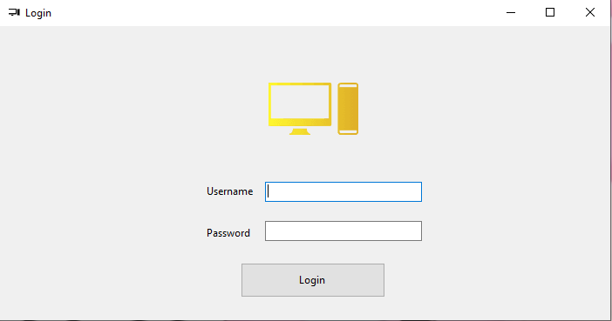  
1. Login form: Here the admins can login.

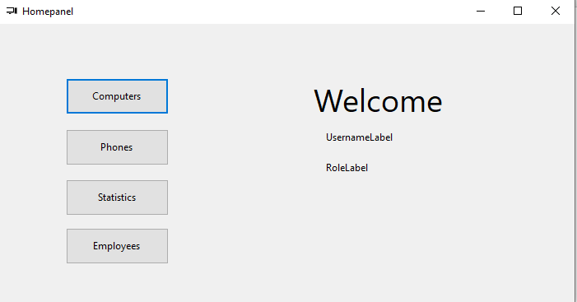

2. Home form: Here the admins can choose which form they can go to.

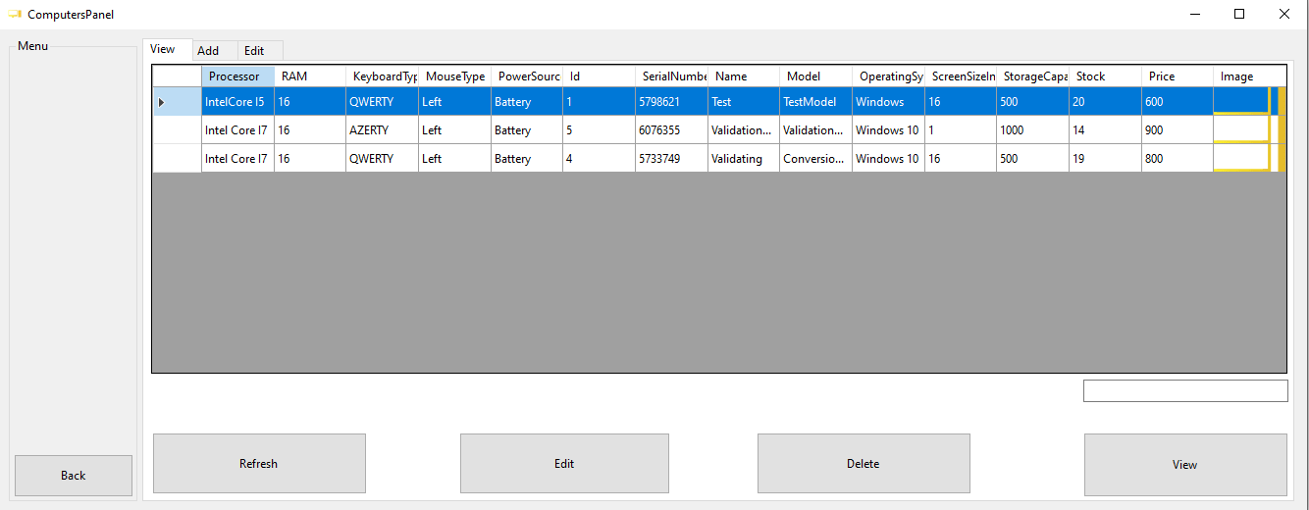

3. Computer form: Here you can view, add, edit and delete computer.

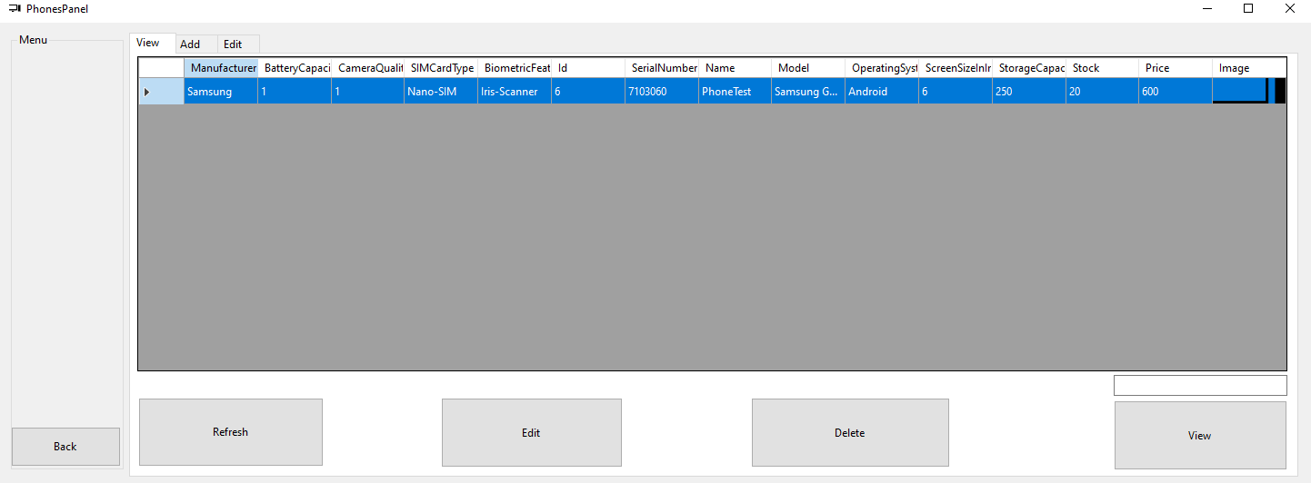  
4. Phone form: Just like computer form you can also view, edit, add and delete phone.

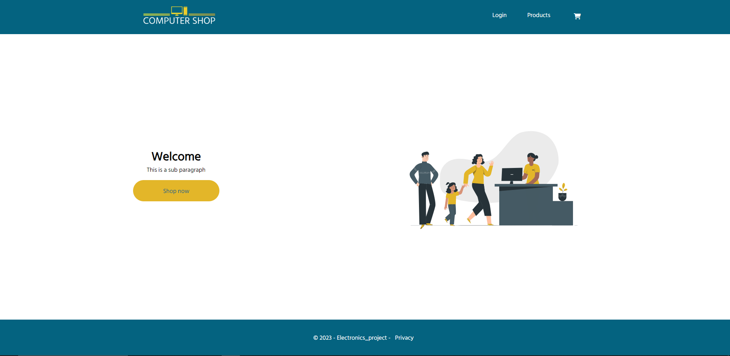  
5. Home page of website: Here is the home page of the website, you can login, view products and also view your cart.

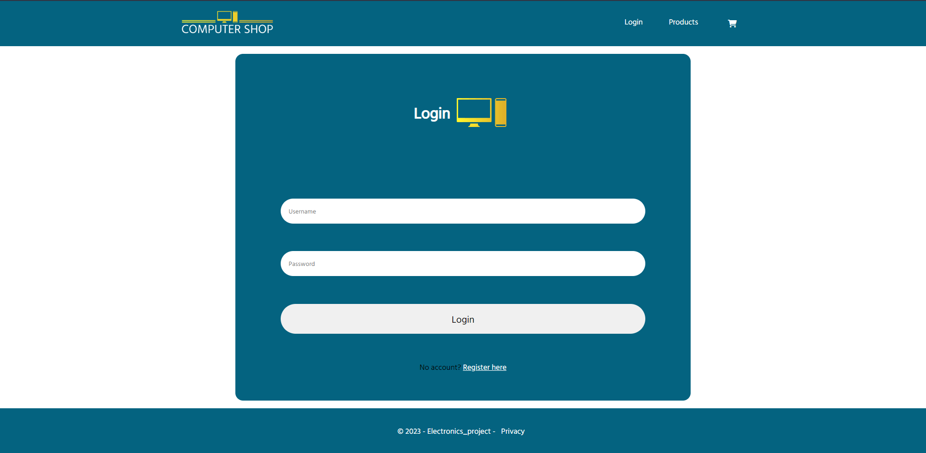

6. Login page: Here customers can login.

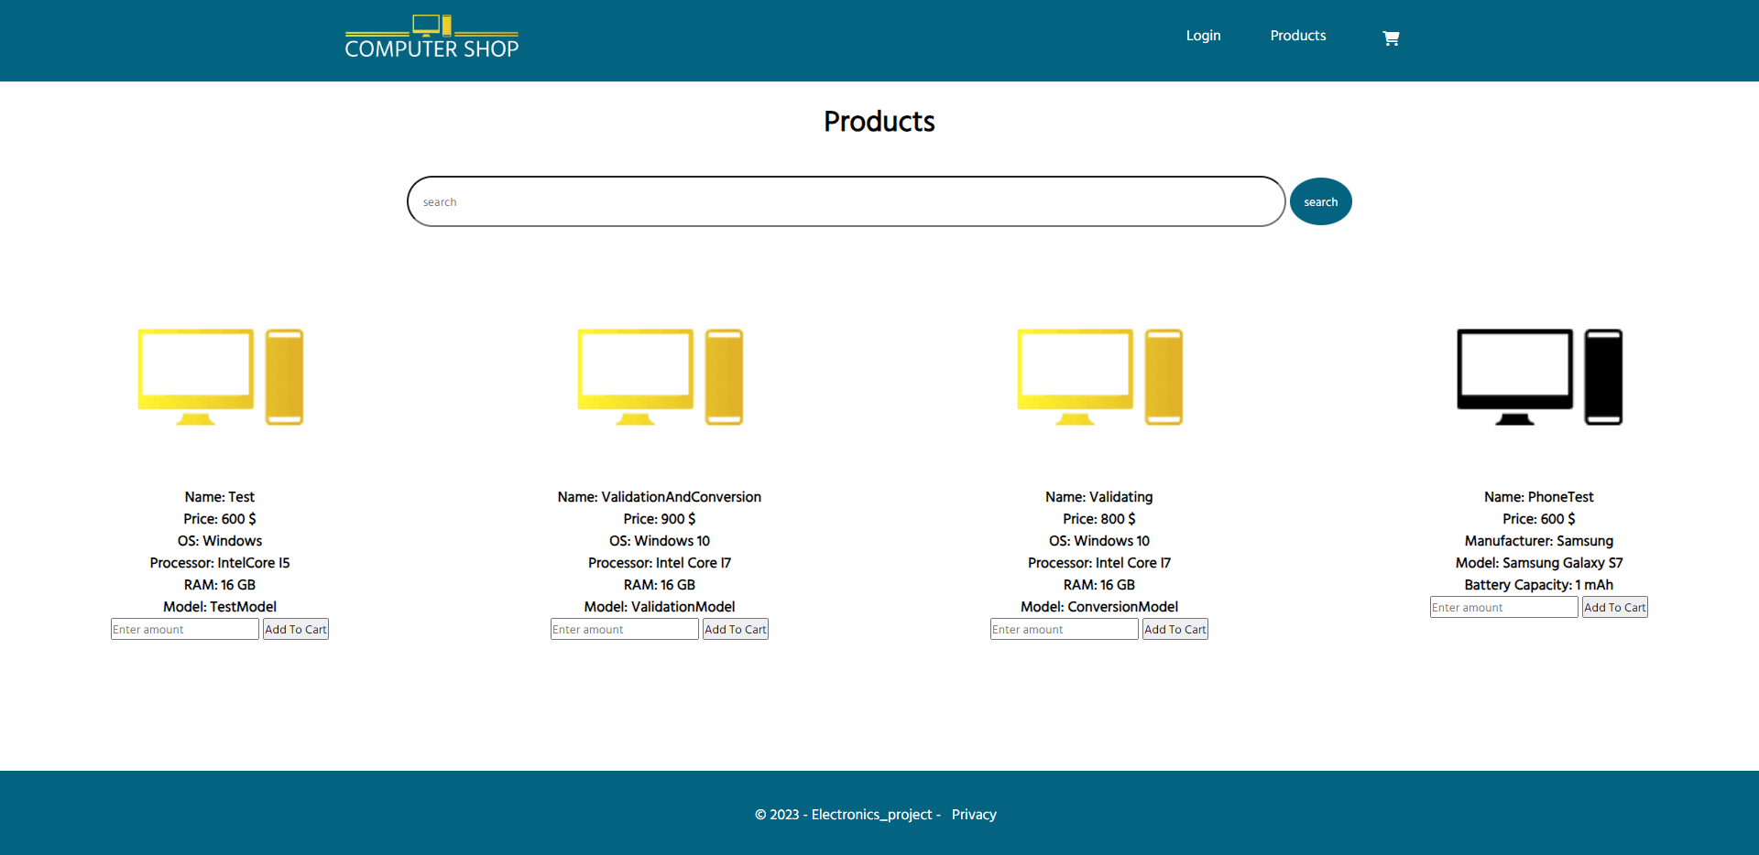

7. Products page: Here you can view all the products.

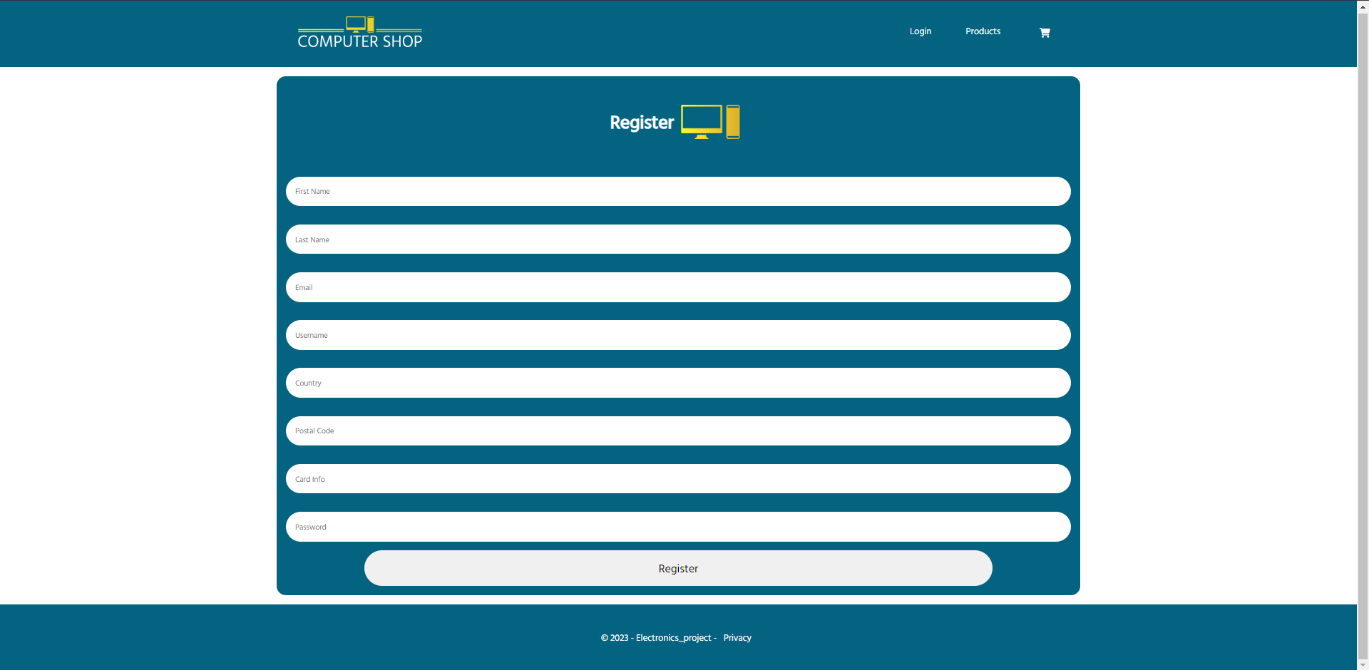

8 Register page: Here customers can make a new account.

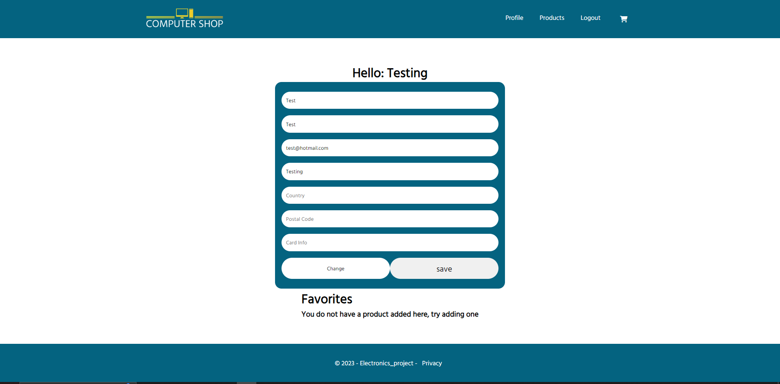

9. Profile page: Here is the profile page. In here users can update their account.

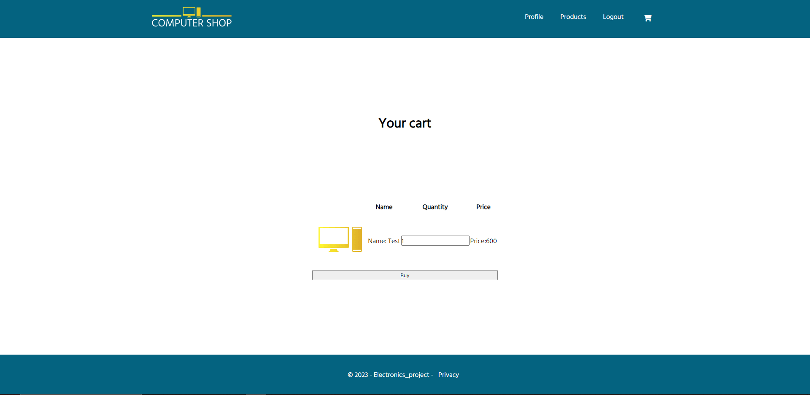

10. Cart page: Here the products will go when the customer adds the products to the cart