My Name is Test FW Document.

Subtitle of .fidus file for testing.

Mahdi; Ali

This is the abstraction of the test file.

Html; Docx; Java

The **body** *begins* here.

# Head 1

## Head 2

### Head 3

#### Head 4

##### Head 5

###### Head 6

C++ code

1. Numbered
2. list
3. items

* Bullet
* list
* items

1. Numbered list

* with
* bullet

1. with
2. numbered
3. inside of

* inside of

1. inside of

A paragraph after a list with a citation see for example ( Banco Central de Nicaragua, 2014, p. 165). And an inline equation: $x=2*y$.

A figure:

$$∀x∈X,∃y≤\text{ε}$$

Photo 1 : Hallo I am the real caption

$$X=4*y^{2}$$

I am a caption but I don't have any type.

Table 1 : I am caption of a table.

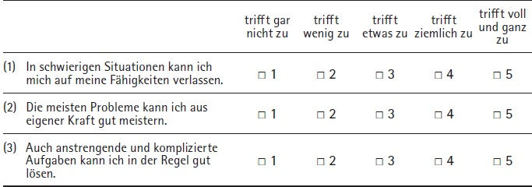

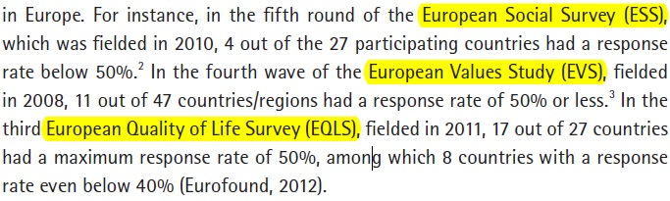

Figure 1 : I am caption of a figure.

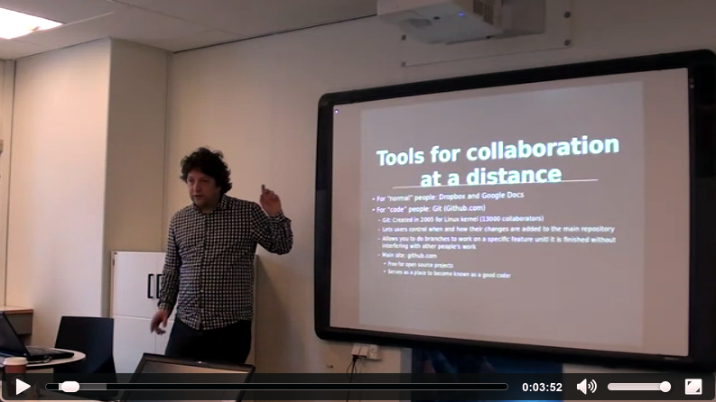

Photo 2 : I am caption of second photo

Some codes came in the following paragraph:

int i=0;

if( i=50)

i++;

Hi. Here is some comment on the 5th word of this line.

And here is some [normal](http://mjza.ir) text.