# 

Date of submission: (MMDDYYYY): 4/13/2017

**ORGANIZATION AND CONTACT INFORMATION**:

**Organization Name:** ­­­­­­­­­­­­­­­­ McGuire Research Institute, Inc.

**Organization Website:** http://www.navref.org/mcguire-research-institute/

**Mailing Address:** VA Medical Center, 1201 Broad Rock Blvd, Richmond, VA, 23249

**Executive Director/CEO:** Robert Dresch **E-Mail:** Robert.Dresch@va.gov

**Name & Title of Contract Signatory (if different from ED): E-Mail:** n/a

**Name & Title of Primary Contact Person for this project:** Drew Moghanaki, MD, MPH, Principal Investigator

**Phone**: 804-675-5105 **E-mail:** drew.moghanaki@va.gov

**PROJECT INFORMATION**

**Title:** Veterans Affairs - Early Lung Cancer Action Program (VA-ELCAP)

**Name and Title of Project Principal investigator:** Drew Moghanaki, MD, MPH, Director of Clinical Radiation Oncology Research, Hunter Holmes McGuire VA Medical Center, Associate Professor, Virginia Commonwealth University Department of Radiation Oncology

**Phone**: 804-675-5105 **Email**: drew.moghanaki@va.gov

**Name and title of Co-Principal Investigators:**

**IT Co-PI:** Ricardo S. Avila, MS **Phone**: (518) 210-4194 **Email**: rick.avila@accumetra.com

**Clinical Co-PI**: Claudia Henschke, MD, PhD **Phone**: (212) 241-2821 **Email**: claudia.henschke@mountsinai.org

**Is IRB approval required:** Yes ____X_____ No ________

**Estimated IRB Submission Date**: February 22, 2017 **Estimated Approval Date**: April 19, 2017

Does your research protocol have a control arm? Yes __X____ No______

Registered nonprofit status: Yes _X___ *No ____ Public entity: Yes X No____

**FUNDING INFORMATION:**

Total amount requested for this project: $5,828,550

Total Project Budget: $5,828,550

Period Covered by the Grant: (MM/YY – MM/YY): 7/1/17 – 6/30/20

# **Proposal Narrative**

## Organizational mission

The US Department of Veterans Affairs (VA) has been dedicated to improving the care of patients with cancer for almost a century. This includes its commitment to fund the first Tumor Research Laboratory at the Chicago Hines VA Hospital in 1932. It is notable that this scientific endeavor predated the discovery of chemotherapy by more than a decade, and goes back to an era when surgical techniques remained unsafe for many tumors.

Since that time, the VA has grown to become the nation’s largest integrated healthcare system. It now provides a myriad of healthcare services for 9 million Veterans with a vast network of over 1,500 outpatient clinics to reach all of its patients who live anywhere in the country. In addition, it continues to dedicate resources to improve the outcomes of approximately 40,000 Veterans who receive cancer care in the VA each year.1 This includes a focus on lung cancer since the 1960’s when the VA made a significant early contribution to the literature regarding asymptomatic solitary pulmonary nodules.2

Today, the VA’s commitment to improving the outcomes for patients with lung cancer is as strong as ever. This is exemplified by the following list of recent high-level contributions to the field:

1. A multi-site project funded by the VA Under Secretary of Health in 2012 to evaluate the feasibility of a national lung cancer screening program.3,4
2. An evidence based review and recommendation, authored by VA investigators in 2013, to the United States Preventive Services Task Force (USPSTF) that in 2014 endorsed lung cancer screening as a preventive service to reduce the risk of lung cancer mortality. This VA contribution ultimately led to the approval of coverage for annual lung cancer screening by the Centers for Medicare & Medicaid Services.5
3. A phase III randomized clinical trial funded in 2015 by the VA Cooperative Studies Program to investigate the optimal treatment for early stage operable lung cancer [VALOR: NCT02984761].
4. A partnership announced in 2016 to create the Applied Proteogenomics Organizational Learning and Outcomes consortium (APOLLO), in collaboration with the Department of Defense and the National Cancer Institute, as part of the wider National Cancer Moonshot Initiative.6

As these recent developments demonstrate, leaders and caregivers within the VA are highly motivated and committed to further improving the quality of care for Veterans with lung cancer.

## Statement of Need

**Veterans represent a population that is at a particularly high risk for developing lung cancer.** This is because millions of soldiers have served in complex work environments that increased their rates of smoking and exposures to carcinogenic chemicals. A recent query of the VA Cancer Cube demonstrates that 77,930 Veterans were diagnosed with non-small cell lung cancer between 2006-2015 (VA Cancer Cube, accessed January 15, 2017). Unfortunately, the majority (58%) presented with advanced stage III-IV disease, which as shown below is often incurable and carries a 5-year overall survival rate of only 2-13%.7

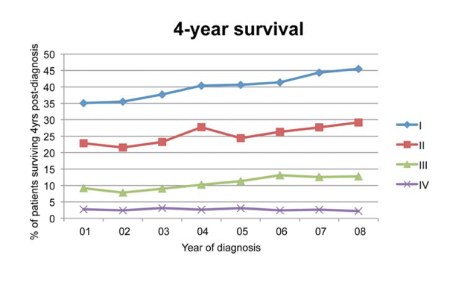

**Figure 1**: **Survival rates goes down with stage.** The 4-year survival rate of Veterans diagnosed with stage I-IV lung cancer within the VA, by year of diagnosis (n=48.844).7

**When patients present with more advanced disease, their treatments aren’t just less effective, they are also more toxic.** For example, when lung tumors are detected <2cm, they can often be removed with a limited sublobar resection instead of a lobectomy which is required for larger tumors.8 They can alternatively be treated with outpatient stereotactic radiotherapy, which offers a 3-year survival rate of over 90%.9 Yet, since lung cancer is initially asymptomatic, patients who are not screened often have delayed access to care and present with more advanced disease that has invaded or spread to other organs. When this occurs, treatment options are not only less effective, but also more toxic as they typically include systemic chemotherapy and/or radiotherapy with treatment fields that are much larger (see **Figure 2**).

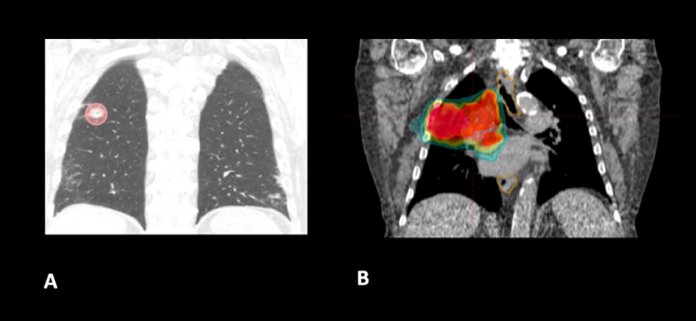

**Figure 2**: **The toxicity of radiotherapy treatments goes up with stage.** Radiotherapy treatment plans for a patient with (A) stage I, and (B) stage III NSCLC.

**A structured lung cancer screening program can save many lives, beyond the 20% reduction in mortality from lung cancer demonstrated in the landmark National Lung Screening Trial (NLST).** It is widely believed that the magnitude of mortality reduction with LCS is 20%.10 However, this is likely an underestimation of the magnitude of the potential the true gains of LCS since that trial was limited to only 3 rounds of screening with 5 years of follow up. The full benefit of screening becomes manifest only when screening continues over many rounds, which was not possible in the context of a trial such as NLST.11 It is important to note that the NLST was not designed to measure the magnitude of the benefit from continued screening, instead it was designed to test the hypothesis of whether screening with CT led to a mortality reduction compared with screening with chest radiography. Thus, it was successful to have met this endpoint, but by no means should that success be thought of as an accurate measurement of the true potential benefit. Additional important factors that reduce the mortality of lung cancer relate to critical elements in the clinical workflow that were unavailable for patients randomized in the NLST study. These include a structured protocol for managing abnormal findings, quality oversight of LDCT interpretations, a dedicated navigator to ensure timely transition from diagnosis to treatment, access to a thoracic oncology multidisciplinary team, and continuous real-time feedback from a management system. As shown in **Figure 3** below, these elements, which are all a component of the I-ELCAP protocol to be introduced into select VA facilities by this project, can result in outcomes that are unmatched by that reported in the NLST trial.12

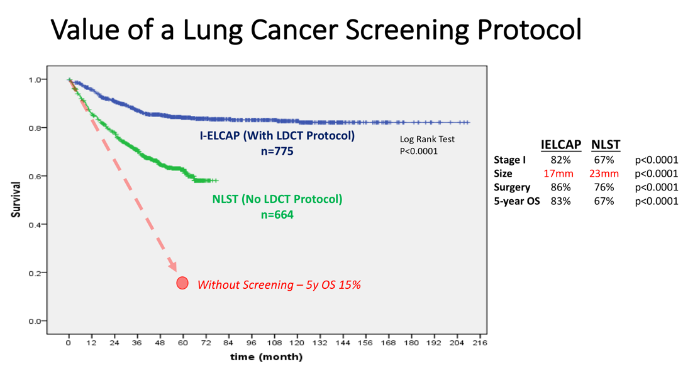

**Figure 3. Lung cancer screening program with a structured protocol is associated with further gains in survival than that demonstrated in the NLST.** This comparison of lung cancer specific survival between the patients diagnosed with stage I NSCLC in the I-ELCAP and NSLT protocols reveals the potential magnitude of benefit when a structured LCS protocol is established to guide elements of LDCT acquisition, image interpretation, and a clinical management workflow that ensures the timely transfer of patients from diagnosis to treatment. LDCT: low dose computed tomography. *(Adapted from Yip, Henschke, Yankelevitz et al, 2015)*12

**Lung cancer screening programs can be complicated.** On face value, it appears that offering LCS to all high-risk Veterans might be uniformly beneficial. However, it is widely recognized that there can be harms if a large scale LCS program is poorly implemented.13 Similar to the experience in breast cancer screening with mammography, there are complex evidence-based clinical algorithms that must be followed when interpreting images to avoid the risks of unnecessary diagnostic procedures. A careful look at the NLST study, for example, reveals that even in the context of a closely monitored clinical trial, there can be up to a two-fold range in difference among radiological interpretations of LDCT scans given the nuances of abnormal findings.14 These challenges were also seen when the VA studied the feasibility of a LCS program through an 8-site demonstration project.4 With a limited budget, and tight study period between 2013-15, it sought to investigate the logistics of implementing a wide-scale LCS program in the VA. It too found wide variability, notably demonstrating a 3-fold difference in abnormal finding between sites (31-85%); this was more than double what is commonly reported in the literature. As the authors of the report suggested, standardization of radiological interpretations would have likely reduced this value, perhaps below 20%.

An additional source of variability that can complicate large scale LCS programs regards how patients are approached and consented when recommended screening LDCT scans. The VA demonstration project provided insights into these sorts of challenges as well. The percent of Veterans who agreed to be screened ranged between 37-65%, depending on the medical center that was making the recommendation. This highlights the need to continuously improve the shared decision making processes that are used to invite patients for screening, particularly for those with poor health literacy who may misinterpret the risk to benefit ratio. In fact, the process of shared decision in regard to understanding the balance of benefit to risk ratio in screening can be quite challenging. The approach commonly taken has been to present the mortality result of NLST as representing the potential benefit. However, this approach is highly misleading as it does not reflect the true benefit that would occur with continued rounds of screening. Nor does it consider the impact on an individual and their family when considering that a lung cancer that would otherwise be fatal within a few years could have actually been cured, if found early.

**Structured informatics systems are essential to facilitate the complex coordination of care needed to safely track abnormal findings in a LCS program.** This was one of the major conclusions from the VA demonstration project. The VA currently has several independently developed lung nodule tracking systems running in different regions across the country to assist clinicians who are engaged in LCS. As a testament to the will of its clinicians to establish new LCS programs, manually operated systems in the VA have been developed with local resources using homegrown Microsoft Excel spreadsheets and Microsoft Access databases. Centralized engineering centers within the VA have helped to map the data from these local systems for data aggregation and reporting, a process which was used to report the results of the VA LCS demonstration project.3 Over time, clinicians have eventually become accustomed to these systems, though all users surveyed during the development of this proposal were encouraged by the opportunity for improvements *(personal communication)*. It was shared that each of these solutions have their own shortcomings, and are considered to be labor-intensive and cumbersome to use.

Meanwhile, a more important shortcoming that remains is that none of these systems communicates directly with VA’s electronic health record system (VistA). This lack of VistA integration misses the opportunity to automate many of the manual processes to reduce the burden of increased clinical workflow. It also misses an opportunity for information technology scalability, as each of these management systems have been set up in parallel databases and as such are not designed for this purpose. This latter issue underlies a fundamental challenge for VA to develop a nationwide LCS program in the near future.

**The VA is unable right now to support a national LCS program.** Ultimately, the final results of the VA demonstration project were recently published in January 2017, and revealed that the VA is not currently ready to launch a wide scale LCS program at this time.3 It concluded that there was too much variability between VA facilities with the limited resources available, and that the management of large cohorts of patients undergoing screening can be difficult with the current tools available. As a result, the VA remains without centralized program to support lung cancer screening at all of its 150 medical centers. A recent survey reported that clinicians at almost all VA facilities are aware of the missed opportunity to save lives with LCS, yet only 26% are ideally prepared to offer this service at this time.15 A few VA facilities are offering their support as resources may allow, but the vast majority of providers in the VA are currently left to develop their own LCS program without structured supervision or support.

**The proposed strategic partnership between BMSF and VA offers a tremendous opportunity to fulfill an unmet need for thousands of Veterans at risk for lung cancer.** That’s because the VA has numerous resources and infrastructure already in place to expand preventive services and care for patients with lung cancer. However, at a time when resources are constrained for the development of new projects in cancer care within the VA, and an absence of a centralized program to supervise the implementation of numerous LCS programs, such an opportunity appears to be in the distant future. Fortunately, the alignment of BMSF with lung cancer experts within and outside the VA offers an ideal opportunity to accelerate the diffusion of LCS programs to improve the quality of care and save the lives of thousands of Veterans. It also helps fulfill the call to action to address a malignancy that kills over 7,000 Veterans each year. It capitalizes on an evidence-based preventive service that can save more lives than any other initiative in oncology, given the magnitude of premature deaths from lung cancer exceeds the next 5 cancers combined. It also helps address a public health dilemma that is commonly ignored due to the stigma of smoking, represented by the major disparities in funding for lung cancer research that are only 1/10th and 1/20th of resources available for prostate and breast cancer research, respectively.

## Executive Summary

**This project is designed to increase Veterans’ access to LCS, increase the likelihood of early detection, and ultimately reduce the mortality rate of lung cancer.** To achieve this goal, it will implement a comprehensive LCS patient management system at 10 VA medical centers through a partnership between I-ELCAP, the VistA Expertise Network, the VA Center for Innovation, and the VA National Teleradiology Program.It brings together dozens of experts in thoracic oncology, radiology, medical imaging, and healthcare information technology to establish a “think tank” that can oversee its progress. The primary goals are to increase Veterans’ access to an evidence-based LCS patient management system that can be easily diffused throughout the VA. This will help increase the probability that Veterans diagnosed with lung cancer are found at an earlier stage and can receive treatments that are less toxic, and more likely to be curative. It will be called the VA-ELCAP system to highlight its customized development for the VA’s healthcare environment. The secondary goals are to analyze the implementation and performance of the VA-ELCAP management system to guide future expansion of LCS services for all Veterans who at risk of dying prematurely from lung cancer.

**The I-ELCAP group was selected as the lead partner for this project because of their 25 years of experience overcoming many of the obstacles and challenges that any new LCS program may face.** It is also because of its focus on disease management processes.16 The International Early Lung Cancer Action Program was born out of the original ELCAP which was founded in 1992 at Cornell University and is now centered at Mt Sinai Hospital in New York City. It was established by Dr. Claudia Henschke who is an international leader in LCS, and a co-PI for this project. I-ELCAP has successfully implemented new LCS programs at over 70 healthcare institutions worldwide, establishing it as the most experienced group in the world. Their processes provide continuous oversight for each center, and as a result the I-ELCAP team has developed the world’s largest LCS registry with over 75,000 patients enrolled globally. This has offered a vast database of clinical data that has resulted in over 270 scientific publications that have primarily focused on improving the quality and safety of LCS.17,18 Their reports have guided evidence-based recommendations for LCS around the world, including standardized processes for patient counseling and smoking cessation,19 data acquisitions and interpretation of LDCT images,20 and clinical management of abnormal findings that include timely transition from diagnosis to treatment.12 Today, their management system leads to 10% abnormal findings in the baseline screening study, a value which declines to 6% during subsequent years.18 Their scientific findings have provided additional insights into technical CT scanning errors that can affect tumor nodule measurements that are otherwise unrecognized by radiologists.21 Their vast amount of clinical data and expertise have also helped explore genetic markers.22 They’ve facilitated cost-effectiveness investigations, to determine the value of screening,23 and their research portfolio even includes investigations into the longer-term outcomes that follow primary treatment for patients with screen detected lung cancers.24 Just this past year, I-ELCAP hosted it’s 35th International Conference on Screening for Lung Cancer which continues to bring together LCS experts from around the world at 6-month intervals to discuss ongoing improvements for this evidence-based preventive service.

**Additional partnerships to facilitate the successful integration of the I-ELCAP management system into the VA will include the VistA Expertise Network (VEN), the VA National Teleradiology Program, and the VA Center for innovation.** As described in the section below on “Collaborating Partners”, these partnerships will help provide the necessary expertise and resources needed to address anticipated, and unanticipated, hurdles in this project that may be unique whenever introducing a new clinical pathway into the VA.

**There are two (2) aims to this project, which is designed to increase Veterans’ access to LCS, increase the likelihood of early detection, and reduce the mortality rate of lung cancer.**

**Aim 1: Implement the evidence-based I-ELCAP screening program at 10 VA medical centers through a process that includes training, oversight, and centralized quality assurance.** It will be supervised by leadership at I-ELCAP, who have decades of experience introducing LCS programs at various healthcare institutions. As detailed below in section 4, it will be integrated directly into the VA’s electronic healthcare record system to simplify the clinical workflow of LCS and facilitate timely transition from diagnosis to treatment under the supervision of a thoracic oncology multi-disciplinary team. Implementation procedures at each VA medical center will focus on training, ensuring the quality of LDCT image acquisition, interpretation, and reporting of findings, and patient management processes. A centralized QA program will be developed to help with oversight. Once established, structured clinical data will be reviewed to monitor interpretations and local decisions that are made along the continuity of care by both navigators and radiologists. This will help reduce the harms that can emerge whenever clinical decisions diverge from protocol recommendations for patient selection, image interpretation, and management recommendation. This real-time evaluation process is ultimately designed to stay ahead of the historical challenges of workflow overload and unnecessary procedures that typically emerge in unsupervised LCS programs.25

**Aim 2: A formal evaluation of the 10 nascent VA-ELCAP patient management systems will measure the impact of increasing Veterans access to LCS, rates of earlier detection, and opportunity for mortality reduction.** This project will also place particular emphasis on studying the processes required to implement this program within the VA’s healthcare environment. It will study its strengths and weaknesses of the VA-ELCAP management system to assess the efficacy and safety of identifying at-risk patients, process of offering LCS, and managing their findings. The results of this analysis will be made available to help guide future clinical management decisions, and policy. This need is critical, given there remains a community of clinicians who believe the harms of screening may often outweigh the benefits.26 These are concerns that may have only been strengthened by the VA LCS demonstration project which concluded that it might be too complicated. Thus, high quality scientific data are needed to better evaluate the value of LCS within the VA, particularly as scientific findings from the VA are commonly referenced to guide healthcare policy around the world.

**The potential benefit to the global lung cancer community.** Once completed, this project will have increased access to LCS and have helped raise further awareness about smoking cessation for thousands of Veterans at the 10 sites included in this project. Results from the formal evaluation described below can be viewed upon not only for internal VA policy decisions, but also non-VA providers who are also interested in developing a large scale LCS program. While the main advantage of this project is to benefit Veterans cared for in the VA, it is important to recognize that this project will also have an opportunity for an even broader global impact on the lung cancer community. That’s because the VistA integration component of this project will offer an agile system that can be diffused to dozens of additional healthcare institutions around the world. VistA is an open source electronic healthcare record software system that is extensively used by commercial and government healthcare providers including healthcare providers in Texas, Arizona, Florida, Hawaii, New Jersey, Oklahoma, West Virginia, New York, Washington, D.C., and California. The addition of LCS services to VistA also has the potential to support American Indians and Alaska Natives. This includes the US Indian Health Service (IHS) which uses core VistA software elements in a closely related EHR called RPMS, and manages the health of approximately 1.8 million American Indians and Alaska Natives who belong to more than 557 federally recognized tribes in 35 states. In addition, VistA is used at numerous international healthcare institutions including the World Health Organization, the country of Jordan, and healthcare sites in Mexico, Samoa, Finland, Germany, Kenya, Nigeria, Egypt, Malaysia, India, Brazil, Pakistan, and Denmark.

## Target Population

A total of 10 VA medical centers were carefully selected for this project that currently do not have a structured LCS program. To identify geographic areas that care for a high volume of patients with NSCLC, the selection process considered the unique geographic distribution of lung cancer rates among Veterans which does not directly overlap with conventional epidemiological data, given Veterans are not uniformly spread across the US (see **Figure 4**).

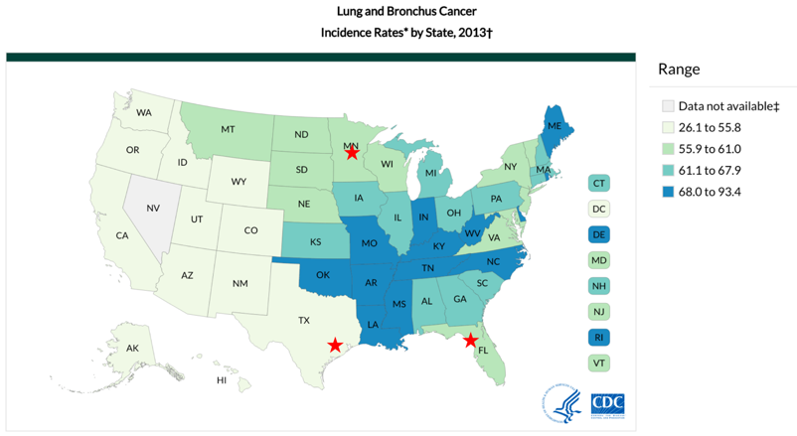

**Figure 4. The distribution of NSCLC among Veterans does not overlap conventional epidemiology maps.** Lung cancer rates by state are provided to illustrate the discordant epidemiological pattern of lung cancer seen in Veteran populations. The red stars reflect the top 3 VA medical centers that have cared for the highest number of lung cancer patients between 2006-15 (source: <https://www.cdc.gov/cancer/lung/statistics/state.htm> accessed February 15, 2017; VA Cancer Cube, accessed January 15, 2017)

The VA Cancer Cube was used to identify a list of VA medical centers that manage a high number of Veterans with newly diagnosed NSCLC. Next, centers were selected that had advanced diagnostic services in pulmonology, radiology, and pathology. Each medical center was also confirmed to have timely access to minimally invasive thoracic surgery, stereotactic radiotherapy, and medical oncology to facilitate a smooth transition from diagnosis to the potential for cure, given the known reduction in benefits of early detection whenever there are delays to treatment (see **Figure 5**).

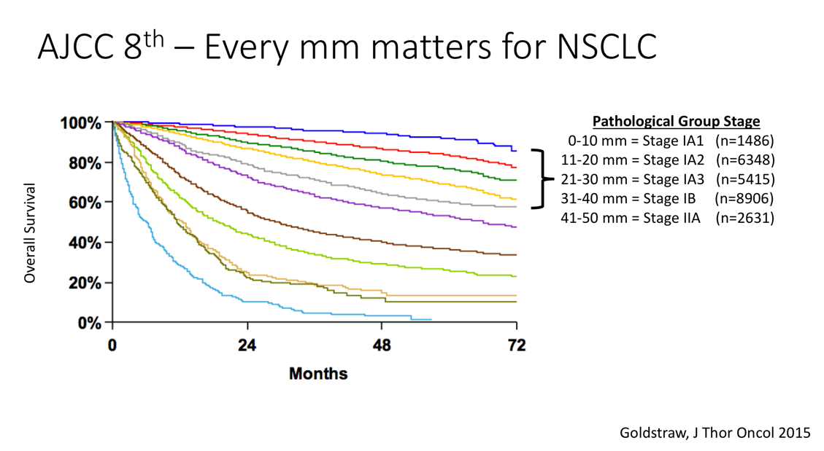

**Figure 5**: **Delays from diagnosis to treatment reduces the benefits of early detection.** The forthcoming 8th edition of the American Joint Committee on Cancer (AJCC) staging system has identified that the survival probability of NSCLC progressively declines with every millimeter of tumor growth that can result from delays in initiating treatment.

The final selection criteria of sites required the identification of a strong clinician at each VA medical center who agreed to serve as a local champion for this project. This resulted in a list of medical centers that were coincidentally all affiliated with an academic institution. Additional services that were identified at each included active smoking cessation programs as well as services for case management, social work, and mental health.

As illustrated below in **Figure 6**, the list of VA medical facilities that agreed to collaborate on this project represents a wide geographic footprint in the US due to the hub-and-spoke model of the VA that delivers care through its network of Community Based Outreach Clinics (CBOCs). This is a critical component of this project, given approximately 24% of Veterans live in rural areas (*Source: Veterans in Rural America: 2011–2015, US Census Bureau, January 2017)*. Estimates show that 38% of rural Veterans are enrolled in VA healthcare, and over 70% with a service connected disability utilize the VA for their care. However, their distance to a VA medical centers may be far, and as a result over 90% of rural Veterans who are service connected turn to the non-VA healthcare sector for their care. This exposes many rural Veterans to the risk of not learning about a LCS program, or receiving fragmented screening services without coordination between radiology or pulmonology appointments. These issues are not unique to Veterans, though can be arguably more effectively addressed by the VA given its fully integrated healthcare system, uniform electronic health record, and ability to disseminate outreach services through its CBOCs.

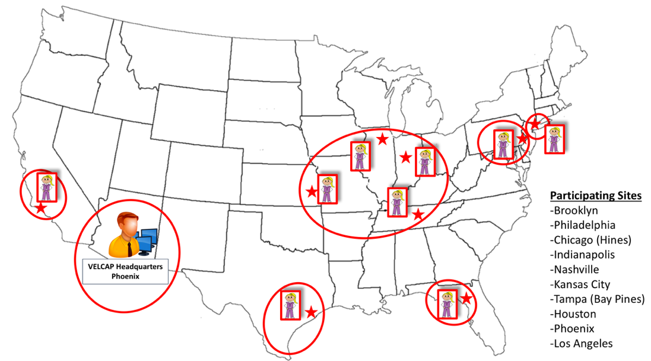

**Figure 6.** **The hub-and-spoke model of care in the VA facilitates a wide geographic footprint for this project.** Each of the 10 VA medical centers selected for this project will offer LCS services through their respective Community Based Outreach Clinics (CBOCs), approximated by the elliptical boundaries represented in this figure.

The final 10 VA medical centers and their respective CBOCs are listed below. They currently care for over 700,000 Veterans, without a LCS program. This includes over 1,200 Veterans a year who are diagnosed with NSCLC at these centers, with a majority presenting with advanced disease that is often incurable.

|  |  |  |
| --- | --- | --- |
| **VA Medical Center &**  **Clinician Champion** | **NSCLC Incidence (2006-15)** | **Community Based Outreach Clinics** |
| **Phoenix, AZ**  **Active pts: 64,403** | **NSCLC Cases** = 1,053  **Stage III/IV** = 64% | Southeast VA Clinic |
| Samuel Aguayo, MD  Pulmonologist |  | Northwest VA Clinic |
|  |  | Show Low VA Clinic |
|  |  | Thunderbird VA Clinic |
|  |  | Globe VA Clinic |
|  |  | Northeast Phoenix VA Clinic |
|  |  | Phoenix Midtown VA Clinic |
|  |  |  |
| **Houston, TX**  **Unique pts: 112,723** | **NSCLC Cases** = 2,239  **Stage III/IV** = 62% | Beaumont VA Clinic |
| Lorraine Cornwell, MD  Thoracic surgeon |  | Charles Wilson VA Outpatient Clinic |
|  |  | Galveston County VA Clinic |
|  |  | Conroe VA Clinic |
|  |  | Katy VA Clinic |
|  |  | Lake Jackson VA Clinic |
|  |  | Richmond VA Clinic |
|  |  | Tomball VA Clinic |
|  |  | Texas City VA Clinic |
|  |  |  |
| **Bay Pines, FL**  **Unique pts: 109,714** | **NSCLC Cases** = 1,685  **Stage III/IV** = 50% | Sarasota VA Clinic |
| Ed Hong, MD  Thoracic surgeon |  | St. Petersburg VA Clinic |
|  |  | Palm Harbor VA Clinic |
|  |  | Bradenton VA Clinic |
|  |  | Port Charlotte VA Clinic |
|  |  | Naples VA Clinic |
|  |  | Sebring VA Clinic |
|  |  |  |
| **Indianapolis, IN**  **Unique pts: 64,567** | **NSCLC Cases** = 1,599  **Stage III/IV** = 53% | Terre Haute VA Clinic |
| Catherine Sears, MD  Pulmonologist |  | Bloomington VA Clinic |
|  |  | Martinsville VA Clinic |
|  |  | Indianapolis West VA Clinic |
|  |  | West Lafayette VA Clinic |
|  |  | Wakeman VA Clinic |
|  |  |  |
| **Chicago (Hines)**  **Unique pts: 61,457** | **NSCLC Cases** = 1,245  **Stage III/IV** = 60% | Joliet VA Clinic |
| Cheryl Czerlanis, MD  Medical oncologist |  | Kankakee County VA Clinic |
|  |  | Aurora VA Clinic |
|  |  | Hoffman Estates VA Clinic |
|  |  | LaSalle VA Clinic |
|  |  | Oak Lawn VA Clinic |
|  |  |  |
| **Nashville, TN**  **Unique pts: 98,111** | **NSCLC Cases** = 1,163  **Stage III/IV** = 55% | Dover VA Clinic |
| Pierre Maison, MD  Pulmonologist |  | Bowling Green VA Clinic |
|  |  | Clarksville VA Clinic |
|  |  | Chattanooga VA Clinic |
|  |  | Tullahoma VA Clinic |
|  |  | Cookeville VA Clinic |
|  |  | Hopkinsville VA Clinic |
|  |  | McMinnville VA Clinic |
|  |  | Roane County VA Clinic |
|  |  | Maury County VA Clinic |
|  |  | Athens VA Clinic |
|  |  | International Plaza VA Clinic |
|  |  | Sumner County VA Clinic |
|  |  |  |
| **Kansas City, KS**  **Unique pts: 61,659** | **NSCLC Cases** = 928  **Stage III/IV** = 65% | Paola VA Clinic |
| Mark Plautz, MD  Pulmonologist |  | Nevada VA Clinic |
|  |  |  |
| **Philadelphia, PA**  **Unique pts: 59,250** | **NSCLC Cases** = 903  **Stage III/IV** = 45% | Burlington County VA Clinic |
| Anil Vacchani, MD  Pulmonologist |  | Victor J. Saracini Department of Veterans Affairs Outpatient Clinic |
|  |  | Gloucester County VA Clinic |
|  |  | Camden VA Clinic |
|  |  |  |
| **Brooklyn, NY**  **Unique pts: 49,313** | **NSCLC Cases** = 788  **Stage III/IV** = 59% | Manhattan VA Medical Center |
| Mohammad Al-Ajam, MD  Pulmonologist |  | Brooklyn VA Medical Center |
|  |  | St. Albans VA Medical Center |
|  |  | Harlem VA Clinic |
|  |  | Staten Island Community VA Clinic |
|  |  | Chapel Street VA Clinic |
|  |  |  |
| **Los Angeles, CA**  **Unique pts: 90,651** | **NSCLC Cases** = 799  **Stage III/IV** = 65% | Santa Barbara VA Clinic |
| Robert Cameron, MD  Thoracic surgeon |  | Gardena VA Clinic |
|  |  | Bakersfield VA Clinic |
|  |  | Los Angeles VA Clinic |
|  |  | East Los Angeles VA Clinic |
|  |  | Antelope Valley VA Clinic |
|  |  | San Luis Obispo VA Clinic |
|  |  | Santa Maria VA Clinic |
|  |  | Oxnard VA Clinic |
|  |  | South Central Los Angeles VA Clinic |

**Table 1. Summary of 10 VA medical centers involved with this project.** Data sources include the Veterans Healthcare Administration Support Service Center and the VA Cancer Cube.

## Project Intervention and Implementation Plan: Goals, Activities and Timeline

This implementation project will be conducted over a 3-year time period to establish a VA-ELCAP patient management system at 10 VA medical centers (see **Figure 7**). This will be a direct replication of the widely used I-ECLAP system, pending customizations that may be needed during its integration into the VA healthcare environment. The project will capitalize on the hub-and-spoke network of the VA to reach thousands of Veterans in rural areas. Once accomplished, a scientific analysis will evaluate its implementation and performance to evaluate the quality of this LCS management system, and to support future opportunities to expand these services to additional VA medical centers.

An overview of the goals, activities, and timeline are summarized in **Figure 7**, and discussed further below:

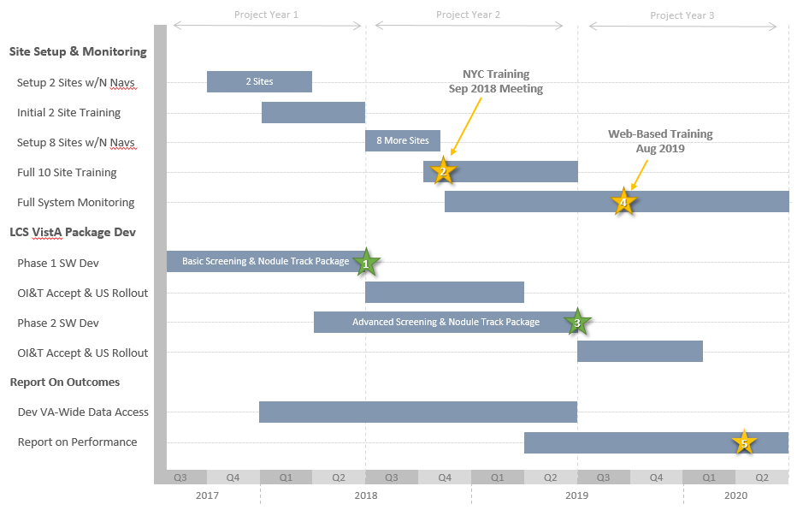

**Figure 7. Overview of major project activities and deliverables of times.** Major milestones are highlighted with numbered stars.

1. **Establish centralized oversight at the Phoenix VA medical center.** This project begins with a 2-site pilot with centralized oversight established at the Phoenix VA Medical Center where efforts have been underway over the past several years to implement the I-ELCAP protocol within the VA; this is also where Dr. Claudia Henschke currently works part-time in addition to her responsibilities at the main I-ELCAP center in New York. The location for clinical supervision was centralized in Phoenix because of pre-existing resources already available under the local leadership of Dr. Samuel Aguayo, who is the medical director and consultant of their respiratory care services at that VA medical center. Dr. Aguayo is also the local champion at the Community Based Outreach Clinic in Prescott, AZ, which is part of the Northern Arizona VA Health Care System that is one of the most rural areas in the VA. As the former Chief of Staff there, he has assured that the CT scanning technology is available for executing the I-ELCAP system at this rural clinic, with commitment from the current Chief of Staff to establish interconnectivity for remote reviews of LDCT scans in Phoenix. In recent years, he has developed agreement from pulmonologists, radiologists, and other key stake holders involved with lung cancer to install and expand the I-ELCAP system from Phoenix to Prescott and other rural outreach clinics. These efforts are aligned with the part-time appointments of Drs. Claudia Henschke and David Yankelevitz in Phoenix who have been involved with establishing a proof-of-principle model for diffusion to similar hub-and-spoke networks across the VA. The Phoenix VA is already providing significant local FTE support for this proposal that includes Clinical Informatics who have developed dashboard tools for LCS at both Phoenix and Prescott. There is also adequate space and equipment needed for centralized operations to take place for this project.

As the project gets underway, a main focus during all phases of implementation will be to ensure adequate training and quality assurance to optimize the benefits of screening that can be achieved with the I-ELCAP patient management system. There will be a similar level of concentration to minimizing the harms that can emerge whenever LCS protocols are not closely followed. To facilitate its success, this project will take advantage of the VA’s integrated electronic health record system to automate many of the processes through the first-ever formal integrating of a LCS clinical management system into the VA’s electronic health record system.

1. **Implementation of VA-ELCAP gets underway with an initial pilot at the Phoenix and Houston VA medical centers.** This initial 2-site pilot will allow the project team to carefully identify any issues that may emerge in the first 6 months so that appropriate solutions can be found early in the project. This will ensure that the phase 1 software development team has strong clinical guidance to deliver a solution that fits well within the VA’s healthcare environment. The CPRS graphical user interface, VistA’s main viewing and interaction windows used for clinical care, will be customized to support lung cancer management tools within VistA’s standard workflow. This will require changes and additions to the VistA MUMPS database to develop algorithms and software methods that represent patient information relevant to lung cancer screening. The Houston VA medical center was selected as the 2nd pilot site because it was found to have two of the strongest local physician champions identified for this project, and because it cares for over 110,000 Veterans in collaboration with 9 regional Community Based Outreach Clinics. As demonstrated in the table above, the Houston VA cares for more lung cancer cases than any other VA medical center in the country. Yet, without a LCS program continues to miss the opportunity to reduce the 60% incidence of stage III or IV disease.

As the I-ELCAP systems are installed at these two sites, these nascent systems will automate many of the clinical processes that are needed to successfully monitor cohorts of patients undergoing LCS. A key advantage is that it will reduce the need for manual data entry, reduce the opportunity for unintentional entry errors, automate alerts for clinicians whenever patients are overdue for their next evaluation(s), and develop a structured dataset of clinical information that will be later used for quality assurance and program evaluation. Its anticipated that this system will be fully tested and ready for installation at the end of project year 1, which as shown in **Figure 7** represents milestone 1. Once established, this system will be ready for installation at the remaining 8 medical centers by the end of Q2 2018 and will provide the following functionalities:

* Identify Veterans in the VistA database who are eligible for screening.
* Communicate, monitor, and schedule eligible Veterans for consultations to discuss enrolling in annual low dose CT screening.
* Communicate, monitor, and schedule participating Veterans for baseline, follow-up, and annual low dose CT scans.
* Communicate, monitor, and assist in scheduling participating Veterans for follow up visits for lung biopsies, PET/CT scans, and incidental findings.
* ensure that lung cancer screening intake rates do not exceed the maximum available medical center resources.
* Track findings including nodules over time with evidenced-based coding standards.
* Recommend screening follow-up next steps based on evidence-based protocols.
* Generate local reports on lung cancer screening performance.

1. **The structured I-ELCAP protocol will be introduced with training for radiologists.** The implementation of I-ELCAP’s patient management system does not merely push out a set of guidelines to follow with a set of tools. Instead, it embraces close communication from the start to facilitate accurate understanding of the I-ELCAP protocol which has been continuously adapted through a longitudinal evidence-based approach over the past several decades to scientifically optimize the benefits of screening. When followed appropriately, it ensures minimization of risks of erroneous interpretations that lead to unnecessary invasive procedures for benign nodules that are not growing. It also assures accurate identification of suspicious nodules and other radiographic abnormalities in the chest that warrant further workup during any round of screening.

The primary responsibility of each local radiologist will be to follow the I-ELCAP screening protocol, and communicate concerns with the I-ELCAP center. Each will have individualized training from the I-ELCAP center with ongoing continuous education through written materials, electronic teaching files, and site visits to provide support from a team of experts, whenever and wherever the need may arise. Formalized training will focus on adherence to the I-ELCAP guidelines for managing findings in both the initial baseline as well as annual repeat round of screening. (See “I-ELCAP Screening and Enrollment Protocol” in appendix). Technical parameters will be provided for image acquisition on CT scanners, display settings for review of images, and a structured reporting system for unsuspected radiographic findings.

In addition to structured characterization and coding of different types and sizes of nodules, the VA˙-ELCAP radiology reporting system will collect a substantial amount of high quality clinical data to facilitate a rigorous evaluation of the population being screened:

* + - * Wall thickening of cystic air spaces, with increased concern for lung cancer
      * Grading of emphysema, with recommendation for pulmonology evaluation
      * Interstitial pneumonitis, with rec for pulmonology evaluation
      * Mediastinal and thymic mass
      * Scoring of coronary artery calcification
      * Breast density
      * Liver steatosis

1. **A radiology quality assurance program will be introduced.** This is considered an important contribution to the success of any large LCS program given the potential for variability that can lead to unnecessary and sometimes harmful invasive procedures. Through a collaboration with the VA National Teleradiology Program, an outward facing Picture Archiving and Communication System (PACS) system will be developed at the I-ELCAP center in New York to display the initial 100 LDCT scans from each participating medical center in this project. This centralized process will provide access to quality assurance reviews by expert chest radiologists at I-ELCAP who will aim to ensure appropriate image acquisition, interpretation, and coding. The reviews will provide discrepancy reports with conference calls to discuss the summary findings. This process, commonly used among all I-ELCAP screening institutions, has frequently found that new LCS programs are more likely to report positive finding when compared to the formal interpretation at the I-ELCAP center, which can be improved through early identification and successive evaluations through continuous learning.25 This QA system will also be developed for internalization at the Phoenix VA through a similar, but inward-facing system. This latter effort, in collaboration with the VA National Teleradiology Program, will aim to explore the potential for expansion of this service to any VA medical center in the country that is offering LCS services, regardless of their participation in this project.
2. **LCS navigators will be trained on how to identify, counsel, and safely track patients at risk for lung cancer.** Their primary role will be to counsel patients interested in screening, communicate abnormal findings with local clinicians to facilitate appropriate and timely follow-up, and serve as the lead liaison between each VA medical center and the principal investigators of this project. They will be hired through a collaboration with the VA Office of _____, which has agreed to ______. They will help guide and coordinate the scheduling of appropriate screening frequency and intervention to minimize burden on patients, providers, and medical facilities. Perhaps most importantly, they will also help ensure timely transition from diagnosis to treatment, given delays to care are known to compromise survival and the opportunity for cure.

Standardized I-ELCAP training protocols will be used to train navigators with teleconferences, site visits, and workshops to ensure navigators are aware about the nuances of the I-ELCAP patient management system. There will be an emphasis on learning how to lead a shared discussion with Veterans whenever they are invited to undergo LCS. As part of the proposed program we would develop shared decision making materials that reflect the more clinically relevant features for patients considering being screened. This would include answers to the following questions:

1. How likely would I be to develop fatal lung cancer?
2. If screened how likely would it be found when it is curable compared to not being screened?
3. What are the associated risks of undergoing annual screening?

As there still remains some concern in regard to whether a screening program increases, or decreases, some patient’s propensity to smoke,19 navigators will also be taught to take advantage of the “teachable moment” that screening offers to counsel patients about smoking cessation.27 This will include former, as well as current, smokers given their potential for relapse. This provides not only an additional effective measure to reduce the risk of death from lung cancer,2,14 but also improve Veterans’ cardiovascular health which provides an even larger benefit than the early detection of lung cancer and can occur even more quickly.15,16 There are numerous resources currently available at all VA medical centers that include written materials, face-to-face counseling, nicotine replacement, or medications through the VA national formulary. Veterans will be informed about the **855-QUIT-VET (1-855-784-8838)** quit line (<http://vaww.publichealth.va.gov/smoking/quitline.asp>)**,** the **SmokefreeVET** text-messaging program (<http://smokefree.gov/vet/>), and a quit smoking mobile application. Navigators will also be informed that each VA Medical Center has a Smoking Cessation Lead Clinician who serves as the local clinical champion and the point of contact between each local medical center and national programs that can be reached at [VHATobaccoProgram@va.gov](mailto:VHATobaccoProgram@va.gov) (<http://vaww.publichealth.va.gov/smoking/index.asp)>.

1. **Begin recruiting patients to undergo screening.** Once the I-ELCAP system and radiology programs are established, and both the radiologists and navigators are trained, the initial 2-pilot sites will begin inviting Veterans to undergo a baseline LDCT. Patient selection will require proper documentation of co-existing symptoms, given screening scans should not be performed whenever patients have evidence of an infectious process. The roadmap to successful recruitment will consist of the following processes:

**Identification of high-risk patients by querying smoking history.** This VistA expertise network (VEN) partnering on this project will help ensure the electronic health record is ascertaining a smoking history for all Veterans registered at each participating VA medical center. Once confirmed, a list of Veterans at risk for lung cancer will be generated for navigators to contact and discuss LCS and smoking cessation.

**Communication with primary care to generate buy-in to refer patents for LCS**. Navigators and local champions will facilitate local efforts to ensure all primary care physicians at their VA medical center, and respective Community Based Outreach Clinics (CBOCs), are aware of a structured LCS patient management system. Communication activities may include distribution of written materials, face-to-face discussions, and presentations in the form of lectures or hospital-wide grand rounds.

1. **Complete integration of the VA-ELCAP patient management system at the remaining 8 VA medical centers, initiate full system monitoring, and continue development of a scalable management system**. As summarized in **Figure 7**, once milestone 1 is completed after the first year, this project will be ready for expansion to the remaining sites and prepare the group for the initial training meeting in New York. From this point, all patients that are undergoing LCS will be monitored for quality and safety using pre-existing I-ELCAP processes.

At the same time, programming efforts with VistA integration will continue to establish scalability and an opportunity for national integration. The completion of the phase 1 software development milestone described above will allow the team to engage with the VA Office of Information & Technology (OI&T) developers so that the lung cancer management system can take the necessary steps to be integrated into VistA at a national level. This process involves a number of software testing and documentation generation steps and is expected to take approximately 9 months.

A full VA project meeting with representatives from all sites will then take place at the I-ELCAP center at Mount Sinai Hospital in New York City to discuss lung cancer screening best practices and how to best use the phase 1 lung cancer screening management software. This is shown in **Figure 7** as milestone 2.

The phase 2 lung cancer screening management software effort will begin midway through project year 1 and will deliver a fully tested upgrade to the system by the end of project year 2. Milestone 3 of **Figure 7** highlights this. The 2nd and final release of the lung cancer management software will provide VA with tighter integration of the lung cancer management system with VistA, the launch of web based management tools, and several new features that allow for the efficient tracking and management of follow-up findings and next steps. This will include support for evidence based management of different forms of therapy. Similar to the training session that occurred at milestone 2, there will be a comprehensive training session in August of 2019 (milestone 4) to provide all sites with information on how to best use the phase 2 lung cancer screening management software and to answer any questions regarding screening methods. However, this training session will occur using web based meeting facilities and will not require participants to travel.

Just as was done at the end of project year 2, the phase 2 software system will be provided to OI&T for inclusion into the main VistA code base. As this will be a software update it is expected that the second interaction with OI&T will go faster and complete in Q1 of 2020. With this update the VA’s open source VistA EHR and the world will have access to a highly advanced, evidence based lung cancer screening management system.

Starting midway through project year 1 and running through two years of the project, a comparatively small programming effort will make sure that lung cancer screening data from all 10 medical centers is sent to VA’s Corporate Data Warehouse (CDW) and can be analyzed to produce key measures of lung cancer screening effectiveness during this project. A final report on the project results, including changes in the ratio of early stage lung cancer patients at the 10 participating VA medical centers, will be achieved at the end of year three of the project (Milestone 5).

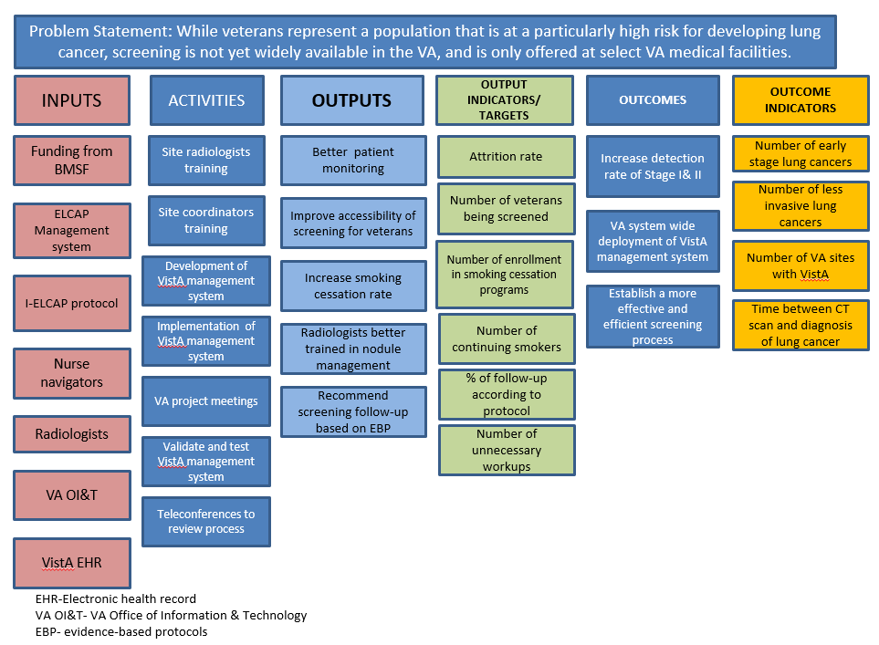

**Figure 8:** **Logic model for tracking project inputs through activities, outputs, and outcomes.**

## Program Evaluation

The structured data reporting systems established will be used to assess many aspects of this implementation project. It offers a dataset that can be scientifically evaluated to assess the performance of LCS at each site that is designed to reduce the incidence of advanced lung cancer to reduce the mortality rate of lung cancer. It also facilitates an evaluation of the feasibility and safety of the I-ELCAP system within the VA, and to ensure minimal burden and risks of unnecessary tests or diagnostic procedures – whether invasive or not. As the retrospective review will collect protected health information for the purposes of making generalized conclusions about whether this screening intervention worked, it is considered a research activity and will therefore seek oversight by the local institutional Review Board at the Hunter Holmes McGuire VA Medical Center in Richmond, Virginia.

**Primary evaluation – implementation and stage migration.** The primary outcome measures of this project will evaluate the process of implementation of the I-ECLAP management system at each of the 10 sites. It will next measure any changes in stage distribution to assess the ability of the VA-ELCAP management system to shift the detection of lung cancer to earlier stages, and ultimately reduce the mortality of lung cancer among Veterans. The magnitude of these findings will be considered preliminary as the true benefits of a LCS program only emerge after several years of screening, which would take a few more years beyond the current scope of this project. The findings will be compared to control groups of patients from the same 10 VA medical centers before project implementation.

**Methods**: In this repeated cross sectional study, descriptive statistics will be presented to examine the comparability of cohorts before and after project implementation, in terms of gender, age, socioeconomic status, level of education, race, smoking status, and comorbid conditions among other factors that may be available. The significance of a difference in participants’ characteristics between pre- and post-program implementation will be tested using χ2 analyses for categorical variables and t-tests or Kruskal-Wallis tests for continuous variables. Subsequently, frequencies and percentages of early stage lung cancer (stage I & II) will be calculated for the two time points (before and after project implementation). Logistic random effects model will be used to examine the change in proportion of early stage lung cancer after project implementation in this multilevel data with binary outcome. The analysis will examine the effect of project implementation (before and after program implementation), gender (male or female), age (continuous variable), SES (level of education, race), smoking status (current versus former, time since quitting) and presence of comorbid conditions (Yes/No or number of conditions), as factors and any potential interaction(s) between these factors. Odds ratios represent the odds of detecting an early stage lung cancer in the VA facilities specified in post-project implementation relative to pre-project implementation. To account for the clustered nature of the data sample, VA facilities will be included as a random effect in the model. We predict there may be differential rates of follow-up by sites, and missing data, which will need to be adjusted for.

**Variables to be evaluated are listed below:**

* **Implementation at each VA medical center**
  + - Time to VistA integration at each site
    - Process of cleaning up smoking history structure and identification of eligible patients
    - How many additional Veterans were identified after modifications were made to ascertainment of smoking history
      * + How many eligible Veterans reside in rural locations
        + How many Veterans are currently seeking care outside the VA
    - Process and satisfaction with training of radiologists & navigators at each site
    - Process and length of time to connect each site for centralized radiology QA
    - Variation with *de novo* implementation between 10 sites
* **Referring physician buy-in and patient adherence to screening**
  + - Referral rate of screening within first 2 years
    - Regional uptake at outreach clinics
    - Patient willingness to be screened when recruited by primary care, compared to navigator outreach via smoking history query
    - Variation between 10 sites
* **Smoking cessation**
  + - Patient agreement to pursue smoking cessation
    - Patient compliance with smoking cessation on follow-up visits
    - What screening programs were used, and which were more successful
    - Variation with uptake between 10 sites
* **Screening performance**
  + - Radiological scan interpretation vs centralized QA
    - Percent abnormal findings (lung, cardiac, mediastinal, breast, liver)
    - How often was additional testing ordered, including invasive procedures
      * Frequency of negative biopsies (including surgical biopsy)
    - How often biopsies led to a diagnosis of cancer
    - Proportion of stage I lung cancer for baseline and repeat rounds
    - Timeliness of follow-up procedures (rescan, biopsy)
    - impact on radiology resources and wait times
    - Referrals to smoking cessation programs and number of nicotine replacement orders
    - Estimate of impact on clinician workload
    - Estimated costs for screening and follow up
    - Variation in screening performance between 10 sites
* **Transition from diagnosis to treatment**
  + - Time between abnormal clinical findings, diagnosis, and evaluation/delivery of treatment.

**Secondary evaluation – comparison of implemented VA-ELCAP program performance with other VA facilities, registries, and screening studies.** A separate analysis will be performed to compare the frequency of early stage lung cancer in the 10 VA facilities post program implementation with all VA facilities not currently screening, the I-ELCAP registry, data available from the NLST, the ACR screening registry, and results reported by the VA LCS demonstration project. Data from the ACR screening registry will be limited, as individual patient data may be unavailable. Thus, simple analyses of differences in the proportion of early stage lung cancers will be performed with stratified analyses depending on the robustness of the data, including the availability of a LCS program and/or multi-disciplinary lung tumor board at screening facilities. It will aim to compare the burden of treatment for lung cancer at different medical centers, such as surgery, radiotherapy, and chemotherapy. The potential for type I error inflation that can result from multiple comparisons will be addressed using Holm’s methods and Bonferroni correction.

## Sustainability Plan

Once each of the 10 new LCS programs launched by this proposal are established, they will be indefinitely sustainable through the processes developed that will at that point be fully integrated into the VA environment. Should any large scale systemic changes occur with the VistA electronic health record system, this management program will have already been embedded and thus will be part of any conversion to a different platform. The sustainability of safe and efficient LCS services will rely upon continuous employment of navigators at each VA medical center. The national LCS QA program in Phoenix will need sustainable support that may be available through the local, VISN, or central office levels in collaboration with the VA National Teleradiology Program. It is instructive to recognize that among the many benefits of this implementation project, each VA medical center involved with this project is in essence joining the broader I-ELCAP community to be involved with a global effort to continuously improve the quality of LCS.

## Results Dissemination Plan

Progress reports on the project will be regularly provided to the Bristol-Myers Squibb Foundation at 6 month intervals throughout the full course of the project. These internal reports will culminate with a final project report outlining the status of the project with respect to all project goals and deliverables, the scientific presentations and publications generated, and the major observations and conclusions of the full project.

The method for presenting results will mirror the current approaches taken in the I-ELCAP program. Each VA medical center will access their own results and have a series of quality reports that are available to them throughout the course of the project. Overall reporting will be available to the central coordinating center in Phoenix as well. These will be reviewed with each individual VA medical center and results presented at semi-annual meetings. These will be held through webinars where all results are reviewed. This type of process has been in place for I-ELCAP, where they are currently planning their 36th international conference.

A series of manuscripts will also be prepared, the first of which will fully outline the process of preparation, implementation and training of sites within the VA. Additional early investigations will focus on the quality assurance aspect of this project. Subsequent manuscripts will fully document the current state of lung cancer including stage and outcomes and more fully characterize patient populations. As data accumulate, we will publish these as well including various performance indicators such as size and stage distribution of cancers, as well as rates of positive results and invasive procedures. We will also incorporate information regarding smoking cessation and various efforts associated with this aspect as well as how ancillary findings, including those related to tobacco associated illnesses are identified and managed.

## Collaborating Partners

**VA Leadership -** The team assembled to lead this project, and the resources being brought to bear, are world class. Executive leadership will be provided by Dr. Drew Moghanaki, an internationally recognized academic Radiation Oncologist currently employed at the Hunter Holmes McGuire VA Medical Center. Dr. Moghanaki is well-positioned to lead this effort as he is an expert in lung cancer research, and chair of the $25M VALOR trial that is sponsored by the VA Cooperative Studies Program, who is currently involved in developing a legislative proposal for lung cancer screening and smoking cessation in the VA. To help guide the success of this VA-ELCAP implementation project, Dr. Moghanaki has also developed important relationships with leadership in the VA that include the Chief Consultant in Diagnostic Services, Chief Consultant for the National Center for Health Promotion and Disease Prevention Services, the Office of Deputy Under Secretary for Health for Patient Care Services, and the Office of the Deputy Under Secretary for Health, Safety, and Quality.

**International Early Lung Cancer Action Project (I-ELCAP)** - As described in the Executive Summary above, the I-ELCAP is centered in New York City and led by Dr. Claudia Henschke who will be a co-PI on this project. The I-ELCAP group remains at the forefront of LCS research, continues to publish new findings from their registry of over 75,000 patients undergoing annual LDCT screening scans, provides guidance to LCS groups such as the LungRADS committee of the American College of Radiology, and leads a bi-annual conference that brings together experts from around to world to continuously optimize the benefits of LCS. For purposes of this project, they will primarily provide training, oversight, and monitoring of the VA-ELCAP patient management system. In addition, through a collaboration with the VA National Teleradiology Program, they will also provide guidance for the development of a National LDCT QA Program that will be internalized within the VA for all LCS programs, whether they are participating in this project, or not.

**Paraxial** - The technical development of the VistA LCS package will be led by Rick Avila, who is the Information Technology co-PI on this project. He has worked directly with I-ELCAP over the past two years to improve the infrastructure of the information technology used for their global LCS program. He also brings experience working within the IT environment of the VA as a former Senior Advisor to the VA Chief Information Officer. He has been the leader of numerous successful open source healthcare initiatives that include serving as the Director of Open Source Operations, and was a co-founder of the Open Source Electronic Health Record Alliance (OSEHRA) that was set up by VA in 2011. He has also served as a Project Manager for the Computer Aided Detection Project at GE Global Research, and was a former Senior Director of Healthcare Solutions at Kitware. Mr. Avila primary role on this project will be to provide Project Management for the IT components required to implement the I-ELCAP management system. He will serve as the lead liaison with the VistA Expertise Network which as described below will provide the software engineering needed for its full integration. His contribution to this project will be instrumental, given his years of experience working with open source systems, understanding of the VA’s technology landscape, and expertise as a consultant for lung cancer screening management systems.

**VistA Expertise Network (VEN) -** Leading the software engineering team’s effort, under guidance from Mr. Rick Avila, will be Rick Marshall. Mr. Rick Marshall is the Executive Director of VEN and has led numerous successful VistA projects for the VA and for external healthcare institutions over the past several decades. The VEN is a nonprofit organization that is comprised of many of the original VistA architects, VistA package experts, and documenters and verifiers who offer their time and knowledge on a full-time or part-time basis. They have a long history of providing support for VistA either remotely or onsite. The VEN is the only organization following the VistA cultural model that includes: a multi-tiered support architecture; user-driven development cycle; convergent community code base; and an autonomous package-based team approach. It also shares some of its people with the VistA Hardhats organization, a group which provides a forum for VistA discussion, quick solutions, and Q&A. As such, the VEN is thus ideally qualified to implement the I-ELCAP patient management system onto VistA.

[Ref: <http://vistaexpertise.net/aboutus.html>]

**VA Center for Innovation (VACI) –** It is recognized that the implementation of any new software solutions in the VA may be disruptive to daily clinical operations. Thus, Mr. Avilla has developed a collaboration with the VA Center for Innovation (VACI) to gain access to the VA innovation Sandbox Cloud for preliminary testing. Supported by its director, VACI has offered access through the Innovation Web Help Desk which is the main communications tool used between the Veterans Health Administration Innovation Program, and innovators who are building innovations. WHD serves as the entry point for gaining access to the Innovation Sandbox Cloud and its services, as well as support and assistance in matters related to innovation from development to procurement and funding depending upon the innovation's relationship to the VA.

[Ref: <https://vacloud.us/groups/sandboxdocs/revisions/92a1e/10>]

## Other Funders

The success of this project relies not only on BMSF funding but also support from VA medical centers to provide all of the healthcare services involved with CT lung cancer screening. This includes resources at each VA medical center to provide annual and follow-up low dose CT scans, as well as any additional procedures that are part of the standard workup for any patient with a radiographic lesion that is suspicious for lung cancer including the lung biopsies to verify the presence of lung cancer, and the PET/CT scans used for staging. VA support of this project will also include the cost of surgery, chemotherapy, radiation therapy, and other early lung cancer treatments for all lung cancers identified. In addition, there will be costs associated with incidental findings related to coronary artery disease, cardiovascular diseases, chronic obstructive pulmonary diseases, breast cancer and other conditions of the thorax. In fact, the follow-up care costs will far surpass the proposed project investment made by Bristol-Myers Squibb Foundation project over time.

## Detailed Budget

The total of this three-year budget is ~~$5,925,105~~ and is fully outlined in the accompanying spreadsheet. It is to fund a duration of three (3) years of activities that involves four (4) main teams. The overall project coordination and oversight will be performed by Dr. Drew Moghanaki through the McGuire Research Institute in Richmond, Virginia which is a 501(c)(3) nonprofit research corporation that is authorized by Congress under 38 USC §§7361-7366 to provide flexible funding mechanisms for the conduct of research at the Hunter Holmes McGuire VA Medical Center in Richmond, Virginia. When compared to the regulatory requirements needed to directly transfer funds into the VA’s operational or research budget, the McGuire Research Institute will be able to provide a simpler process of hiring and invoicing, and will serve as the lead fiduciary for all activities on this project. Meanwhile, oversight of the LCS methods, training, and monitoring for the project will be performed by the I-ELCAP which is led by Dr. Claudia Henschke. Leadership and oversight of the information technology elements of the project will be provided by Rick Avila and his team at Paraxial. The VistA Expertise Network will provide software developers and engineers to implement the proposed LCS improvements into VistA which is VA’s electronic healthcare record system. Individual budget justifications are as follows:

**McGuire Research Institute**

**Personnel**

* + - **Dr. Drew Moghanaki** – Provide overall project leadership with 20% time commitment for the full three years of the project
    - **Project Manager** – Will assist Dr. Moghanaki in the overall running of the project, including communication and coordination between the sub-teams. This person will be applied 100% to this project over the full three years of the project
    - **Programmer** – Provide data management support for Dr. Moghanaki, applied 100% to the project over the full three years of the project
    - **Student Fellowships** – Competitive awards for trainees pursuing a career in healthcare to develop scientific talents and foster interest in lung cancer research.

**Travel**

* + - Site visits to all sites, I-ELCAP, and LCSs conferences at a cost of 10 x $1,500 per year

**Materials**

* + - The project will purchase 2 laptop computers costing $2,500 each in the first year, then 2 additional computers to run VistA costing $2,5000 each in the 2nd and 3rd years of this project.

**VA MEDICAL CENTER, PHOENIX - Carl T. Hayden Medical Research Foundation**

* + - **Nurse Navigator** – Will support the first-year pilot that will occur between the VA medical centers in Phoenix and Houston to set up the VA-ELCAP management system. This position will be applied 100% during the first year. VA will cover the cost of their employment thereafter, as well as remaining nurse navigators needed at the remaining 8 sites.

**VA MEDICAL CENTER, Houston - Houston VA Research and Education Foundation**

* + - **Nurse Navigator** – Will support the first-year pilot that will occur between the VA medical centers in Phoenix and Houston to set up the VA-ELCAP management system. This position will be applied 100% during the first year. VA will cover the cost of their employment thereafter, as well as remaining nurse navigators needed at the remaining 8 sites.

**I-ELCAP (a.k.a. Early Detection and Treatment Research Foundation)**

**Personnel**

* + - **Dr. Claudia Henschke –** Will oversee the training and monitoring of the LCS sites with 30% of her time for the full three-year project duration
    - **Dr. David Yankelevitz (Senior Radiologist)** – Will provide LCS expertise and guidance with 20% of his time over the full three year duration of the project
    - **Arjit Jirapatanakul (Senior Programmer)** – Will oversee installation of the I-ELCAP systems and provide guidance and consultation to VistA developers that will transfer the I-ELCAP protocols to VA’s EHR. He will apply 30% of his time to this project for the first two years, then 20% of his time in the third year.
    - **Daniel Max (Senior Programmer)** – Will support the installation of the I-ELCAP systems and provide guidance and consultation to VistA developers
    - **Rowena Yip (Biostatistician)** – Will provide analytic support for the full project, applying 30% of her time throughout the full three-year duration of the project
    - **Coordinators (2)** – Two coordinators will provide central oversight and support for the 10 VA screening sites. They will each apply 20% of their time to the project over the full three year duration of the project
    - **Radiologists (2)** – Two radiologists will provide LCS reading and quality reviews for the 10 sites. They will each apply 10% of their time to the project over the full three years

**Travel**

* + - Travel to support site training for project year is planned to be $24,000
      * 4 persons x 2 sites x 2 trips x $1,500
    - Travel to support site visits for project year 1 to the pilot sites is planned to be $12,000
      * 4 persons x 2 sites x 1 trip x $1,500
    - Travel to support site training for project year 2 is planned to be $60,000
      * 4 persons x 10 sites x 1 trip x $1,500
    - Travel to support site visits for project years 2 and 3 to the 10 sites is planned to be $60,000 per year
      * 4 persons x 10 sites x 1 trip x $1,500

**Materials**

* + - This project will purchase 2 computers, each costing $1,000 to support the first two LCS sites during the first year of the project.
    - The project will purchase $15,000 of computer data storage for collecting and reviewing LCS CT images.

**Paraxial**

**Personnel**

* + - **Rick Avila –** Willoversee the LCS software development effort with 40% of his time for the full three year duration of the project
    - **Sr. Computer Scientist** – Will support the design, quality assurance testing, and documentation for the VistA LCS software package. This person will be applied 50% for the full three year duration of the project.
    - **Jr. Computer Scientist** – Will support the design, quality assurance testing, and documentation for the VistA LCS software package. This person will be applied 50% for the full three year duration of the project

**Travel**

* + - Travel to support design reviews and testing is planned to be $15,000 per year
      * 2 persons x 5 trips x $1,500

**Materials**

* + - This project will purchase $9,500 in the first year for computer equipment to support 3 people. This will consist of 3 laptops for software development costing $1,5000 each, a server for VistA testing costing $2,000, and $3,000 for development software licenses (Cache, Delphi). For project years 2 and 3, the project will purchase $3,000 per year of development software licenses (Cache, Delphi)

**VistA expertise network**

**Personnel**

* + - **Rick Marshall** – Will support VistA software development with 75%, 68%, and 33% of this time during the three year project duration, respectively
    - **George Lilly** – Will support VistA software development with 88%, 88%, and 38% of this time during the three year project duration, respectively
    - **Linda Yaw** – Will support VistA software development with 75%, 75%, and 33% of her time during the three year project duration, respectively
    - **VistA Programmers (2)** – CTwo MUMPS/Delphi programmers will perform VistA software development with 100% of their time in the first two project years, and 33% in the third year
    - **Technical Writer** – Will provide the project will technical support with 100% of this person’s time during the first project year, and 33% in the third year.

**Travel**

* + - Travel to support design reviews, training, and testing is planned to be $24,5000 per year
      * 5 persons x 2 trips x $2,450

## References

See below

## Appendices

1. Budget spreadsheet
2. I-ELCAP Screening and Enrollment Protocol:

[www.ielcap.org/sites/default/files/I-ELCAP protocol-v21-3-1-14.pdf](http://www.ielcap.org/sites/default/files/I-ELCAP%20protocol-v21-3-1-14.pdf)

1. I-ELCAP Screening and Enrollment Protocol Summary:

[www.ielcap.org/sites/default/files/I-ELCAP-protocol-summary.pdf](http://www.ielcap.org/sites/default/files/I-ELCAP-protocol-summary.pdf)

## Required Attachments

n/a

**REFERENCES**

1. Zullig LL, Jackson GL, Dorn RA, et al. Cancer incidence among patients of the U.S. Veterans Affairs Health Care System. *Mil Med.* 2012;177(6):693-701.

2. Steele JD. The Solitary Pulmonary Nodule. Report of a Cooperative Study of Resected Asymptomatic Solitary Pulmonary Nodules in Males. *J Thorac Cardiovasc Surg.* 1963;46:21-39.

3. Kinsinger LS, Anderson C, Kim J, et al. Implementation of Lung Cancer Screening in the Veterans Health Administration. *JAMA Intern Med.* 2017.

4. Kinsinger LS, Atkins D, Provenzale D, Anderson C, Petzel R. Implementation of a new screening recommendation in health care: the Veterans Health Administration's approach to lung cancer screening. *Ann Intern Med.* 2014;161(8):597-598.

5. Humphrey LL, Deffebach M, Pappas M, et al. Screening for lung cancer with low-dose computed tomography: a systematic review to update the US Preventive services task force recommendation. *Ann Intern Med.* 2013;159(6):411-420.

6. <https://www.cancer.gov/research/key-initiatives/moonshot-cancer-initiative/milestones/nci-activities>.

7. Williams CD, Gajra A, Ganti AK, Kelley MJ. Use and impact of adjuvant chemotherapy in patients with resected non-small cell lung cancer. *Cancer.* 2014;120(13):1939-1947.

8. Wisnivesky JP, Henschke CI, Swanson S, et al. Limited resection for the treatment of patients with stage IA lung cancer. *Ann Surg.* 2010;251(3):550-554.

9. Chang JY, Bezjak A, Mornex F. Stereotactic ablative radiotherapy for centrally located early stage non-small-cell lung cancer: what we have learned. *J Thorac Oncol.* 2015;10(4):577-585.

10. National Lung Screening Trial Research T, Aberle DR, Adams AM, et al. Reduced lung-cancer mortality with low-dose computed tomographic screening. *N Engl J Med.* 2011;365(5):395-409.

11. Yankelevitz DF, Smith JP. Understanding the core result of the National Lung Screening Trial. *N Engl J Med.* 2013;368(15):1460-1461.

12. Yip R, Henschke CI, Yankelevitz DF, Boffetta P, Smith JP, International Early Lung Cancer I. The impact of the regimen of screening on lung cancer cure: a comparison of I-ELCAP and NLST. *Eur J Cancer Prev.* 2015;24(3):201-208.

13. de Koning HJ, Meza R, Plevritis SK, et al. Benefits and harms of computed tomography lung cancer screening strategies: a comparative modeling study for the U.S. Preventive Services Task Force. *Ann Intern Med.* 2014;160(5):311-320.

14. Gierada DS, Pilgram TK, Ford M, et al. Lung cancer: interobserver agreement on interpretation of pulmonary findings at low-dose CT screening. *Radiology.* 2008;246(1):265-272.

15. Tukey MH, Clark JA, Bolton R, et al. Readiness for Implementation of Lung Cancer Screening. A National Survey of Veterans Affairs Pulmonologists. *Ann Am Thorac Soc.* 2016;13(10):1794-1801.

16. Mulshine JL, Henschke CI. Lung cancer screening: achieving more by intervening less. *Lancet Oncol.* 2014;15(12):1284-1285.

17. Henschke CI, Li K, Yip R, Salvatore M, Yankelevitz DF. The importance of the regimen of screening in maximizing the benefit and minimizing the harms. *Ann Transl Med.* 2016;4(8):153.

18. Henschke CI, Yip R, Yankelevitz DF, Smith JP, International Early Lung Cancer Action Program I. Definition of a positive test result in computed tomography screening for lung cancer: a cohort study. *Ann Intern Med.* 2013;158(4):246-252.

19. Zeliadt SB, Heffner JL, Sayre G, et al. Attitudes and Perceptions About Smoking Cessation in the Context of Lung Cancer Screening. *JAMA Intern Med.* 2015;175(9):1530-1537.

20. Henschke CI, Yankelevitz DF, Yip R, et al. Tumor volume measurement error using computed tomography imaging in a phase II clinical trial in lung cancer. *J Med Imaging (Bellingham).* 2016;3(3):035505.

21. Armato SG, 3rd, McLennan G, Bidaut L, et al. The Lung Image Database Consortium (LIDC) and Image Database Resource Initiative (IDRI): a completed reference database of lung nodules on CT scans. *Med Phys.* 2011;38(2):915-931.

22. Gill RK, Vazquez MF, Kramer A, et al. The use of genetic markers to identify lung cancer in fine needle aspiration samples. *Clin Cancer Res.* 2008;14(22):7481-7487.

23. Pyenson BS, Henschke CI, Yankelevitz DF, Yip R, Dec E. Offering lung cancer screening to high-risk medicare beneficiaries saves lives and is cost-effective: an actuarial analysis. *Am Health Drug Benefits.* 2014;7(5):272-282.

24. Schwartz RM, Yip R, Olkin I, et al. Impact of surgery for stage IA non-small-cell lung cancer on patient quality of life. *J Community Support Oncol.* 2016;14(1):37-44.

25. Xu DM, Lee IJ, Zhao S, et al. CT screening for lung cancer: value of expert review of initial baseline screenings. *AJR Am J Roentgenol.* 2015;204(2):281-286.

26. Bach PB, Mirkin JN, Oliver TK, et al. Benefits and harms of CT screening for lung cancer: a systematic review. *JAMA.* 2012;307(22):2418-2429.

27. Ostroff JS, Buckshee N, Mancuso CA, Yankelevitz DF, Henschke CI. Smoking cessation following CT screening for early detection of lung cancer. *Prev Med.* 2001;33(6):613-621.