**Clinical Decision Support (CDS) Content and Health Level 7 (HL7)-Compliant Knowledge Artifacts (KNARTs)**

**Cardiology: (EP) Arrhythmias Clinical Content White Paper**

**Department of Veterans Affairs (VA)**



**Knowledge Based Systems (KBS)**

**Office of Informatics and Information Governance (OIIG)**

**Clinical Decision Support (CDS)**

**Clinical Decision Support (CDS) Content and Health Level 7 (HL7)-Compliant Knowledge Artifacts (KNARTs): Cardiology: (EP) Arrhythmias Clinical Content White Paper**

by Department of Veterans Affairs (VA)

Publication date December 2017

**Contract: VA118-16-D-1008, Task Order (TO): VA-118-16-F-1008-0007**

**Table 1. Summary of Cardiology: (EP) Arrhythmias KNARTs**

| **Cardiology KNART** | **Associated CLIN** |
| --- | --- |
| (EP) Arrhythmias - Composite/Consult Request | N/A |
| (EP) Arrhythmias - Documentation Template | CLIN0005AC |
| (EP) Arrhythmias: Atrial Fibrillation/Atrial Flutter - Order Set | CLIN0004AB |
| (EP) Arrhythmias: Supraventricular Tachycardia - Order Set | CLIN0004AB |
| (EP) Arrhythmias: Bradycardia and Syncope/Presyncope - Order Set | CLIN0004AB |
| (EP) Arrhythmias: Other Arrhythmia - Order Set | CLIN0004AB |

**Table of Contents**

VA Subject Matter Expert (*[SME](#d0e181)*) Panel vi

Introduction vii

Conventions Used viii

1. Cardiology: Arrhythmias 1

1.1. Clinical Context 1

1.2. Knowledge Artifacts 1

2. Composite: Arrhythmias Consult Request 3

2.1. Knowledge Narrative 3

2.2. Consult Request 3

3. Documentation Template: Arrhythmias 4

3.1. Knowledge Narrative 4

3.2. Clinical Stability 4

3.3. History and Physical 4

3.4. Treatment Provided 5

3.5. Laboratory Studies 5

3.6. Imaging and Diagnostic Studies 5

3.7. Reason for Cardiology Arrhythmia Consult 6

3.8. Stroke and Bleeding Risk 7

4. Order Set: Atrial Fibrillation/Atrial Flutter 9

4.1. Knowledge Narrative 9

4.2. Consults and Referrals 9

4.3. Imaging and ECG 9

4.4. Laboratory Tests 9

4.5. Medications 10

5. Order Set: Supraventricular Tachycardia (SVT) 12

5.1. Knowledge Narrative 12

5.2. Consults and Referrals 12

5.3. Imaging and ECG 12

5.4. Laboratory Tests 13

5.5. Medications 13

5.6. Patient and Caregiver Education 14

6. Order Set: Bradycardia and Syncope/Presyncope 15

6.1. Knowledge Narrative 15

6.2. Bradycardia 15

6.3. Syncope/Presyncope 16

7. Order Set: Other Arrhythmia 18

7.1. Knowledge Narrative 18

7.2. Consults and Referrals 18

7.3. Imaging and ECG 18

7.4. Laboratory Tests 19

7.5. Medications 19

Bibliography/Evidence 20

A. Existing Sample VA Artifacts 22

B. Basic Laboratory Panel Definition 29

Acronyms 30

**List of Figures**

A.1. Reason for Request: Holter 22

A.2. Reminder Dialog Template: Cardiology Ambulatory ECG Monitoring Consult 23

A.3. Reminder Dialog Template: Cardiology Ambulatory ECG Monitoring Consult Continued 24

A.4. Reminder Dialog Template: Cardiology Ambulatory ECG Monitoring Consult Continued 25

A.5. Reminder Dialog Template: Cardiology Ambulatory ECG Monitoring Consult Continued 26

A.6. Reminder Dialog Template: Cardiology Ambulatory ECG Monitoring Consult Continued 27

A.7. GLA Screenshot 28

**List of Tables**

1. Summary of Cardiology: (EP) Arrhythmias KNARTs ii

1.1. Clinical Context Domains 1

3.1. Stroke Risk Assessment 7

**VA Subject Matter Expert (*****SME*****) Panel**

| **Name** | **Title** | **Project Role** |
| --- | --- | --- |
| Bruce Bray, MD | Professor, Cardiovascular Medicine, University of Utah School of Medicine; Staff Cardiologist, Salt Lake City VA Medical Center (*VAMC*), 500 Foothill Drive, Salt Lake City, Utah 84148 | SME, Primary |
| Scott Wall, MD | Assistant Professor, Cardiovascular Medicine, University of Utah; School of Medicine Staff Cardiologist, , Salt Lake City VAMC, 500 Foothill Drive, Salt Lake City, Utah 84148 | SME, Secondary |
| Aiden Abidov, MD, PhD | Professor of Medicine, Wayne State University; Section Chief, Cardiology, John Dingell VAMC | SME |

**Introduction**

The VA is committed to improving the ability of clinicians to provide care for patients while increasing quality, safety, and efficiency. Recognizing the importance of standardizing clinical knowledge in support of this goal, VA is implementing the Health Level 7 (*HL7*) Knowledge Artifact Specification for a wide range of VA clinical use cases. Knowledge Artifacts, referred to as (*KNARTs*), enable the structuring and encoding of clinical knowledge so the knowledge can be integrated with electronic health records to enable clinical decision support.

The purpose of this Clinical Content White Paper (*CCWP*) is to capture the clinical context and intent of *KNART* use cases in sufficient detail to provide the *KNART* authoring team with the clinical source material to construct the corresponding knowledge artifacts using the HL7 Knowledge Artifact Specification. This paper has been developed using material from a variety of sources: VA artifacts, clinical practice guidelines, evidence in the body of medical literature, and clinical expertise. After reviewing these sources, the material has been synthesized and harmonized under the guidance of VA subject matter experts to reflect clinical intent for this use case.

Unless otherwise noted, items within this white paper (e.g., documentation template fields, orderable items, etc.) are chosen to reflect the clinical intent at the time of creation. To provide an exhaustive list of all possible items and their variations is beyond the scope of this work.

**Conventions Used**

Conventions used within the knowledge artifact descriptions include:

*<obtain>*: Indicates a prompt to obtain the information listed

* If possible, the requested information should be obtained from the underlying system(s). Otherwise, prompting the user for information may be required
* The technical and clinical notes associated with a section should be consulted for specific constraints on the information (e.g., time-frame, patient interview, etc.)
* Default Values: Unless otherwise noted, <obtain> indicates to obtain the most recent observation. It is recognized that this default time-frame value may be altered by future implementations

*[...]*: Square brackets enclose explanatory text that indicates some action on the part of the clinical user, or general guidance to the clinical or technical teams. Examples include, but are not limited to:

*[Begin ...]*, *[End ...]*: Indicates the start and end of specific areas to clearly delineate them for technical purposes.

*[Activate ...]*: Initiates another knowledge artifact or knowledge artifact section.

*[Section Prompt: ...]*: If this section is applicable, then the following prompt should be displayed to the user.

*[Section Selection Behavior: ...]*: Indicates technical constraints or considerations for the selection of items within the section.

*[Attach: ...]*: Indicates that the specified item should be attached to the documentation template if available.

*[Link: ...]*: Indicates that rather than attaching an item, a link should be included in the documentation template.

*[Clinical Comment: ...]*: Indicates clinical rationale or guidance.

*[Technical Note: ...]*: Indicates technical considerations or notes.

*[If ...]*: Indicates the beginning of a conditional section.

*[Else, ...]*: Indicates the beginning of the alternative branch of a conditional section.

*[End if ...]*: Indicates the end of a conditional section.

☐ *[Check box]*: Indicates items that should be selected based upon the section selection behavior.

**Chapter 1. Cardiology: Arrhythmias**

**1.1. Clinical Context**

[Begin Clinical Context.]

Atrial fibrillation (*AF*) is the most common arrhythmia in the United States. As such, it accounts for substantial morbidity, particularly in the form of preventable cerebrovascular accidents, and expense, with the annual cost of caring for patients with atrial fibrillation estimated to be between $6 billion and $26 billion. Syncope and other arrhythmias are also highly prevalent conditions that have been associated with substantial practice variation. Operationalizing evidence-based practice guidelines, therefore, has the potential to improve outcomes among a large number of patients while delivering more cost-effective care.

This set of Cardiology - KNARTs is intended for users caring for stable adult patients who present to a primary care clinic for evaluation of atrial fibrillation/atrial flutter, supraventricular tachycardia (*SVT*), bradycardia, near syncope, syncope or other arrhythmias needing evaluation by cardiology. The objective of this KNART group is to ensure that a minimum workup is initiated prior to a cardiology consultation and a common set of documentation elements are provided to the consulting cardiologist. This context excludes emergent patients (unstable arrhythmias). Stable patients with an arrhythmia, to be considered for evaluation by cardiology are included. The context domains are summarized in the table below.

**Table 1.1. Clinical Context Domains**

|  |  |
| --- | --- |
| Target User | Provider in a Primary Care Clinic |
| Patient | Adult outpatient needing Cardiology consult for arrhythmia evaluation |
| Priority | Routine |
| Specialty | Primary Care |
| Location | Outpatient |

[End Clinical Context.]

**1.2. Knowledge Artifacts**

[Begin Knowledge Artifacts.]

This section describes the CDS KNARTs intended for clinical providers caring for adult patients who present to a Primary Care Clinic for evaluation of atrial fibrillation, atrial flutter, SVT, bradycardia, syncope, or near syncope. The intent of these artifacts is to ensure a minimum workup is initiated prior to a Cardiology Consultation. Specific constraints for these artifacts are that they:

Apply to outpatients with arrhythmias needing cardiology Consultation

Exclude emergent or unstable patients based on Clinician judgement

The knowledge artifacts that define the arrhythmias clinical use case, and that are described in detail in the following sections include:

* Consult Request: Cardiology: Electrophysiology (*EP*) Arrhythmias
* High-level, encompassing artifact meant to communicate the request for cardiology consultation
* Relies upon the documentation template and order set artifacts
* Documentation Template: Cardiology: Electrophysiology (*EP*) Arrhythmias
* Documents the information provided by the referring provider
* Includes logic for appropriate display of documentation sections
* Order Sets: Cardiology: Electrophysiology (*EP*) Arrhythmias
* Orderable items associated with the consult request
* Includes logic for appropriate display of the order set

[End Knowledge Artifacts.]

**Chapter 2. Composite: Arrhythmias Consult Request**

[Begin Composite.]

**2.1. Knowledge Narrative**

[Begin Knowledge Narrative.]

[See Clinical Context in Chapter 1.]

[End Knowledge Narrative.]

**2.2. Consult Request**

[Begin Consult Request.]

[Technical Note: The following list provides the basic components of the consult request. This is the high-level, encompassing artifact, and must be combined with the documentation template and the order sets to form a fully functional knowledge artifact.]

[Section Prompt: Please provide the following information for a cardiology consult to evaluate arrhythmias in a stable patient.]

[Section Prompt: Reason for Consult?]

<obtain> Consult reason details

Goal of Consult: Would you please provide your recommendations and:

☐ Return to PCP for therapy

☐ Start treatment and return to PCP for follow up and maintenance

☐ Start treatment, monitor for effect and when on stable therapy return to PCP

☐ Treat as long as necessary (or indefinitely)

[Section Prompt: Consult Specialty?]

<obtain> Consult Specialty

Priority: Routine

[Section Prompt: Referring Physician Information?]

<obtain> Referring Physician Name

<obtain> Referring Physician Contact Information

<obtain> Information required by receiving facility

[End Consult Request.]

[End Composite.]

**Chapter 3. Documentation Template: Arrhythmias**

[Begin Documentation Template.]

**3.1. Knowledge Narrative**

[Begin Knowledge Narrative.]

[See Clinical Context in Chapter 1.]

[End Knowledge Narrative.]

**3.2. Clinical Stability**

[Begin Clinical Stability.]

[Section Prompt: This documentation template is not applicable for use with patients who are unstable based on clinician judgement. Examples of unstable patients include, but are not limited to, patients with chest pain pattern suggestive of Acute Coronary Syndrome (*ACS*), symptomatic hypotension, or unstable arrhythmia.

Consider transferring unstable patients to the nearest emergency department immediately.]

[End Clinical Stability.]

**3.3. History and Physical**

[Begin History and Physical.]

***History***

[Technical Note: For this documentation template, the following information should be included, if available.]

<obtain> History, Brief

<obtain> History of prior cardiac evaluations (e.g., prior hospitalization or evaluations for: chest pain, rule/out MI, angina, heart failure, etc.)

<obtain> Results of prior cardiac diagnostic procedures performed (resting ECG, echocardiogram, stress testing (echo, nuclear, MRI), Cardiac CT (*CCT*) and Coronary CT Angiography (*CCTA*)

<obtain> Physical Exam, Pertinent Positive and Negative Findings

[Section Selection Behavior: Optional. More than one may be selected.]

☐ Family History of Sudden Unexplained Death or Drowning

☐ Prior Radiofrequency Catheter Ablation

***Implanted Device History***

[Section Selection Behavior: Select at most one (most recent).]

☐ Prior Implantable Cardioverter-Defibrillator (*ICD*) Device Implantation

☐ Prior Cardiac Resynchronization Therapy plus Implantable Cardioverter-Defibrillator (*CRT-D*) Device Implantation

☐ Prior Cardiac Pacemaker Implantation

[If a device is selected, then <obtain> Current arrhythmia device programmer interrogation report.]

[Technical Note: As interrogation report is generated when an implanted device is queried by its corresponding programmer.]

[End History and Physical.]

**3.4. Treatment Provided**

[Begin Treatment Provided.]

[Technical Note: For this documentation template, the following information should be included, if available.]

<obtain> Pharmacologic Therapy

<obtain> Other Pertinent Therapy

[End Treatment Provided.]

**3.5. Laboratory Studies**

[Begin Laboratory Studies.]

[Technical Note: For this documentation template, the following information should be included (latest value within the past 2 years), if available.]

<obtain> Basic Metabolic Panel Lab Result

<obtain> Complete Blood Count Lab Result

<obtain> Lipid Panel Lab Result

<obtain> Thyroid Function Testing Lab Result

<obtain> Troponin Lab Result

<obtain> Brain Natriuretic Peptide Lab Result

<obtain> D-dimer Lab Result

[End Laboratory Studies.]

**3.6. Imaging and Diagnostic Studies**

[Begin Imaging and Diagnostics Studies.]

[Clinical Comment: Images and diagnostic studies older than one year are not considered for inclusion in this documentation template.]

[Technical Note: For this documentation template, the following information should be included, if available from the prior 1 year.]

[Technical Note: Image and result text should be attached automatically if they are provided for the 12-Lead Electrocardiogram Interpretation field.]

<obtain> resting 12-Lead Electrocardiogram Interpretation

[Attach or link Images: 12-Lead Electrocardiogram]

[Technical Note: Results should be attached automatically if text is provided for the Stress Electrocardiography Interpretation field.]

<obtain> Stress Electrocardiography Interpretation

[Link Images: Stress Electrocardiography]

[Technical Note: Results should be attached automatically if text is provided for the Resting Echocardiogram/Doppler Interpretation field.]

<obtain> Resting Echocardiogram/Doppler Interpretation

[Link Images: Resting Echocardiogram/Doppler Electrocardiography]

[Technical Note: Results should be attached automatically if text is provided for the Stress Echocardiogram Interpretation field. This includes treadmill and dobutamine stress echo.]

<obtain> Stress Echocardiogram Interpretation

[Link Images: Stress Echocardiogram]

[Technical Note: Results should be attached automatically if text is provided for the Stress Myocardial Perfusion Imaging (MPI) Interpretation field.]

<obtain> Stress MPI Interpretation

[Link Images: Stress MPI]

[Technical Note: Results should be attached automatically if text is provided for the Rest/Stress MRI Interpretation field.]

<obtain> Rest/Stress MRI Interpretation

[Link Images: Rest/Stress MRI]

[Technical Note: Result text should be attached automatically if it is provided for the Chest/Coronary/Cardiac CT Angiography (CTA) Interpretation field.]

<obtain> Chest CT or Coronary/Cardiac CTA Interpretation

[Link Images: Chest CT or Coronary/Cardiac CTA]

[Technical Note: Result text should be attached automatically if it is provided for the X-Ray Chest Interpretation field.]

<obtain> X-Ray Chest Interpretation

[Link Images: X-Ray Chest]

[End Imaging and Diagnostics Studies.]

**3.7. Reason for Cardiology Arrhythmia Consult**

[Begin Reason for Cardiology Arrhythmia Consult.]

[Section Selection Behavior: Select One.]

[Section Prompt: Reason for Consult:]

☐ Atrial Fibrillation/Atrial Flutter Evaluation

☐ Bradycardia Evaluation

☐ Supraventricular Tachycardia Evaluation

☐ Syncope/Presyncope Evaluation

☐ Other Arrhythmia Evaluation

[Technical Note: The following 3 are to be implemented by inserting here a link to the implanted device order set KNARTs.]

☐ Pacemaker/ICD follow-up

☐ Pacemaker/ICD generator change

☐ Primary prevention pacemaker/ICD implant ]

[End Reason for Cardiology Arrhythmia Consult.]

**3.8. Stroke and Bleeding Risk**

[Begin Stroke and Bleeding Risk.]

[Technical Note: If atrial fibrillation/atrial flutter selected, then:]

[Begin stroke risk assessment.]

[Section Prompt: Ask the following questions and check any of the following that apply to the patient.]

[Section Selection Behavior: None or as many as all may be selected.]

**Table 3.1. Stroke Risk Assessment**

| **Question** | **Check** | **Score** |
| --- | --- | --- |
| Active problem of congestive heart failure or active problem of left ventricular systolic dysfunction? | ☐ | 1 |
| Active problem of hypertension? | ☐ | 1 |
| Age ≥ 75 years? | ☐ | 2 |
| Active problem of diabetes mellitus? | ☐ | 1 |
| History of stroke or of problem of transient ischemic attack or thromboembolism? | ☐ | 2 |
| Active problem of vascular disease? | ☐ | 1 |
| Age ≥ 65 years and age ≤ 74 years? | ☐ | 1 |
| Female? | ☐ | 1 |

[Technical Note: For each checkbox, total the associated score. This is the CHA2DS2-VASc Score. This should be displayed to the user.]

[Activate Atrial Fibrillation/Atrial Flutter Order Set.]

[End Stroke and Bleeding Risk.]

[If Bradycardia selected, then activate Bradycardia Order Set.]

[If Syncope/Presyncope selected, then activate Syncope/Presyncope Order Set in the Bradycardia Order Set.]

[If Supraventricular Tachycardia selected, then activate Supraventricular Tachycardia Order Set.]

[If Other Arrhythmia selected, then activate Other Arrhythmia Order Set.]

[End Documentation Template.]

**Chapter 4. Order Set: Atrial Fibrillation/Atrial Flutter**

[Begin Atrial Fibrillation/Atrial Flutter Order Set.]

**4.1. Knowledge Narrative**

[Begin Knowledge Narrative.]

Atrial fibrillation is the most common arrhythmia in the United States. As such, it accounts for substantial morbidity, particularly in the form of preventable cerebrovascular accidents, and expense, with the annual cost of caring for patients with atrial fibrillation estimated to be between $6 billion and $26 billion. Syncope and other arrhythmias are also highly prevalent conditions that have been associated with substantial practice variation. Operationalizing evidence-based practice guidelines, therefore, has the potential to improve outcomes among a large number of patients while delivering more cost-effective care.

[End Knowledge Narrative.]

**4.2. Consults and Referrals**

[Begin Consult and Referrals.]

[Section Prompt: Cardiology consult order.]

[Technical Note: Consider other consult modalities which may be available (e.g., e-consult or other rapidly iterative consult method. A simple consult is included here as the overarching clinical intent.]

☐ Referral to cardiology to evaluate atrial fibrillation/atrial flutter

[Section Prompt: Specific goal of the cardiology consultation (e.g., cardiology to manage patient, cardiology to risk stratify and recommend management, etc.).]

<obtain> Goal of cardiology consultation

[End Consults and Referrals.]

**4.3. Imaging and ECG**

[Begin Imaging and ECG.]

[Section Prompt: Consider ordering prior to the cardiology consultation. Resting 12-lead electrocardiogram is required if it has not been obtained within the past two months.]

[Section Selection Behavior: More than one may be selected. Optional]

☐ Resting 12-lead electrocardiogram to evaluate for arrhythmia now

☐ Echocardiogram to evaluate for left ventricular function now

☐ X-ray chest to evaluate for heart failure now

[End Imaging and ECG.]

**4.4. Laboratory Tests**

[Begin Laboratory Tests.]

[Section Prompt: Consider the following tests to be completed prior to the cardiology consultation.]

[Section Selection Behavior: More than one may be selected. Optional.]

☐ Basic metabolic panel now

☐ Complete blood count now

☐ Lipid panel now

☐ Thyroid function testing now

☐ Troponin now

☐ Brain natriuretic peptide now

☐ D-dimer now

[End Laboratory Tests.]

**4.5. Medications**

[Begin Medications.]

[Section Prompt: Based upon clinical judgement, consider initiating a new order for one or more of the following medications prior to the cardiology consultation, if not otherwise contraindicated.]

[Section Selection Behavior: More than one category may be selected. Only one from each category may be selected. Optional.]

***Rate Control Drugs***

☐ Metoprolol tartrate 50 mg tablet oral daily 2 times 60 tablets 2 refills

☐ Metoprolol XL (succinate) 25 mg tablet oral daily 1 time 30 tablets 2 refills

☐ Diltiazem 30 mg tablet oral daily 4 times 120 tablets 2 refills

☐ Diltiazem ER 120 mg capsule oral daily 1 time 30 capsules 2 refills

☐ Digoxin 125 micrograms tablet oral daily 1 time 30 tablets 2 refills

***Antiplatelet Agents***

[Technical Note: If the CHA2DS2-VASc score < 2, then display the list of antiplatelet medications.]

[Section Selection Behavior: Select at most one.]

☐ Aspirin 81 mg tablet oral daily 1 time 30 tablets 2 refills

☐ Clopidogrel 75 mg tablet oral daily 1 time 30 tablets 2 refills

***Anticoagulants***

[Technical Note: If the CHA2DS2-VASc score ≥ 2, then display the list of anticoagulants.]

[Section Prompt: For patients with a CHA2DS2-VASc score of 2 or greater, consider initiating anticoagulation therapy.]

[Section Selection Behavior: Select at most one.]

☐ Apixaban 5 mg tablet oral daily 2 times 60 tablets 2 refills

☐ Apixaban 2.5 mg tablet oral daily 2 times 60 tablets 2 refills

☐ Dabigatran 150 mg capsule oral daily 2 times 60 capsules 2 refills

☐ Dabigatran 75 mg capsule oral daily 2 times 60 capsules 2 refills

☐ Rivaroxaban 20 mg tablet oral daily 1 time 30 tablets 2 refills

☐ Rivaroxaban 15 mg tablet oral daily 1 time 30 tablets 2 refills

☐ Warfarin 2 mg tablet oral daily 1 time 30 tablets 2 refills

[Section Prompt: If warfarin is ordered, the following laboratory test should also be ordered.]

☐ International normalized ratio (INR) now and then every 1 month routine

[End Medications.]

[End Atrial Fibrillation/Atrial Flutter Order Set.]

**Chapter 5. Order Set: Supraventricular Tachycardia (SVT)**

[Begin Supraventricular Tachycardia Order Set.]

**5.1. Knowledge Narrative**

[Begin Knowledge Narrative.]

The Supraventricular Tachycardia (*SVT*) KNART order set is intended for users caring for adult patients who present to a primary care clinic with an initial diagnosis of supraventricular tachycardia to ensure that a minimum workup is initiated prior to Cardiology consultation, including initial evaluation guidance for non-invasive evaluation of a patient, initiating antiarrhythmic drug management and knowing when to refer for more definitive treatment modalities. Patients with a history of SVT should be seen by a general cardiologist or electrophysiologist. The typical workup of patients with SVT involves getting an echocardiogram performed in order for the physician to search for structural heart disease. Patients with prominent symptoms of angina, or risk factors for coronary artery disease, may need stress testing or even a coronary angiography. Patients who may be treated with antiarrhythmic drugs need blood tests for the physician to assess renal and hepatic function. Patients with SVT have four general options for therapy:

1. Doing nothing to prevent or cure SVT (though recognize that there is a subset that do not have “benign” SVT).
2. Taking medications
3. Having a percutaneous ablation for cure performed
4. Having open-heart surgery (extremely rare).

[End Knowledge Narrative.]

**5.2. Consults and Referrals**

[Begin Consults and Referrals.]

[Section Prompt: Cardiology consult order.]

[Consider other consult modalities which may be available (e.g., e-consult or other rapidly iterative consult method. A simple consult is included here as the overarching clinical intent.]

☐ Referral to cardiology to evaluate supraventricular tachycardia

[Section Prompt: Specific goal of the cardiology consultation (e.g., cardiology to manage patient, cardiology to risk stratify and recommend management, etc.).]

<obtain> Goal of cardiology consultation

[End Consults and Referrals.]

**5.3. Imaging and ECG**

[Begin Imaging and ECG.]

[Section Prompt: Consider ordering prior to the cardiology consultation. Resting 12-lead electrocardiogram is required if it has not been obtained within the past two months.]

[Section Selection Behavior: More than one may be selected. Optional]

☐ Resting 12-lead electrocardiogram to evaluate for arrhythmia now

☐ Echocardiogram to evaluate for left ventricular function now

☐ X-ray chest to evaluate for heart failure now

☐ study for possible ablation

[End Imaging and ECG.]

**5.4. Laboratory Tests**

[Begin Laboratory Tests.]

[Section Prompt: Consider the following tests to be completed prior to the cardiology consultation.]

[Section Selection Behavior: More than one may be selected. Optional]

☐ Basic metabolic panel now

☐ Complete blood count now

☐ Lipid panel now

☐ Thyroid function testing now

☐ Troponin now

☐ Brain natriuretic peptide now

☐ D-dimer now

☐ Flecainide level

[End Laboratory Tests.]

**5.5. Medications**

[Begin Medications.]

[Section Prompt: Based upon clinical judgement, consider initiating a new order for one or more of the following medications prior to the cardiology consultation, if not otherwise contraindicated. The clinical provider that orders the medication(s) should provide appropriate follow-up for medication management including titration as applicable and monitoring of adverse effects if any, until and unless the ordering provider establishes that the consultant specialist is going to provide ongoing medication management and surveillance.]

[Section Selection Behavior: More than one category may be selected. Only one from each category may be selected. Optional.]

***Medications to Control Rapid Heart Rate***

☐ Metoprolol tartrate 50 mg tablet oral daily 2 times 60 tablets 2 refills

☐ Metoprolol XL (succinate) 25 mg tablet oral daily 1 time 30 tablets 2 refills

☐ Diltiazem 30 mg tablet oral daily 4 times 120 tablets 2 refills

☐ Diltiazem ER 120 mg capsule oral daily 1 time 30 capsules 2 refills

☐ Verapamil SR 180 mg tablet oral daily 1 time 30 tablets 2 refills

[End Medications.]

**5.6. Patient and Caregiver Education**

[Begin Patient and Caregiver Education.]

[Section Prompt: Consider the following patient education order.]

[Section Selection Behavior: Optional.]

☐ Provide vagal maneuver education

[Technical Note: Provide a link consistent with facility guidance, such as: http://5minuteconsult.com/collectioncontent/3-197921/patient-handouts/vagal-maneuvers-and-their-responses.]

[End Patient and Caregiver Education.]

[End Supraventricular Tachycardia Order Set.]

**Chapter 6. Order Set: Bradycardia and Syncope/Presyncope**

[Begin Bradycardia and Syncope/Presyncope Order Set.]

**6.1. Knowledge Narrative**

[Begin Knowledge Narrative.]

This section describes the knowledge artifacts that are intended for use by clinical providers caring for adult patients who present to a primary care clinic with bradycardia, presyncope or syncope. The intent of this artifact is to ensure a minimum workup is initiated prior to a Cardiology Consultation. Specific constraints for these artifacts are that:

* This order set applies to outpatients with bradycardia, presyncope or syncope episode needing cardiology Consultation
* They exclude emergent/unstable patients.

[End Knowledge Narrative.]

**6.2. Bradycardia**

[Begin Bradycardia.]

[Begin bradycardia section of order set.]

***Consults and Referrals***

[Section Prompt: Cardiology consult order.]

[Consider other consult modalities which may be available (e.g., e-consult or other rapidly iterative consult method. A simple consult is included here as the overarching clinical intent.]

☐ Referral to cardiology to evaluate bradycardia

[Section Prompt: Specific goal of the cardiology consultation (e.g., cardiology to manage patient, cardiology to risk stratify and recommend management, etc.).]

<obtain> Goal of cardiology consultation

***Imaging and ECG***

[Section Prompt: Consider ordering prior to the cardiology consultation. Resting 12-lead electrocardiogram is required if it has not been obtained within the past two months.]

[Section Selection Behavior: More than one may be selected. Optional.]

☐ Resting 12-lead electrocardiogram to evaluate for bradycardia now

☐ Holter monitor to evaluate for bradycardia now

☐ Cardiac event monitor to evaluate for bradycardia now

☐ X-ray chest to evaluate for heart failure now

***Laboratory Tests***

[Section Prompt: Consider the following tests to be completed prior to the cardiology consultation.]

[Section Selection Behavior: More than one may be selected. Optional.]

☐ Basic metabolic panel now

☐ Complete blood count now

☐ Lipid panel now

☐ Thyroid function testing now

☐ Troponin now

☐ Brain natriuretic peptide now

☐ D-dimer now

***Medications***

[Section Prompt: Consider discontinuation of nonessential negative chronotropic drugs (e.g., beta-blockers, calcium channel blockers, etc.).]

[End Bradycardia.]

**6.3. Syncope/Presyncope**

[Begin Syncope/Presyncope.]

***Consults and Referrals***

[Section Prompt: Cardiology consult order.]

☐ Referral to cardiology to evaluate syncope/presyncope

***Imaging and ECG***

[Section Prompt: Consider ordering prior to the cardiology consultation. Resting 12-lead electrocardiogram is required if one has not been obtained within the past two months.]

[Section Selection Behavior: More than one may be selected. Optional.]

☐ Resting 12-lead electrocardiogram to evaluate for syncope/presyncope now

☐ echocardiogram to evaluate for left ventricular function now

☐ Holter monitor to evaluate for syncope/presyncope now

☐ 24 hours

☐ 48 hours

☐ Other <obtain> duration of evaluation

☐ Cardiac event monitor to evaluate for syncope/presyncope now

☐ 24 hours

☐ 48 hours

☐ Other <obtain> duration of evaluation

☐ X-ray chest to evaluate for heart failure now

☐ PA and lateral views

☐ Other <obtain> views

***Laboratory Tests***

[Section Prompt: Consider the following tests to be completed prior to the cardiology consultation.]

[Section Selection Behavior: More than one may be selected. Optional.]

☐ Basic metabolic panel now

☐ Complete blood count now

☐ Lipid panel now

☐ Thyroid function testing now

☐ Troponin now

☐ Brain natriuretic peptide now

☐ D-dimer now

***Medications***

[Section Prompt: Consider discontinuation of nonessential negative chronotropic drugs (e.g., beta-blockers, calcium channel blockers, etc.) or other nonessential medications that may contribute to the patient's symptoms.]

[End Syncope/Presyncope.]

[End Bradycardia and Syncope/Presyncope Order Set.]

**Chapter 7. Order Set: Other Arrhythmia**

[Begin Other Arrhythmia Order Set.]

**7.1. Knowledge Narrative**

[Begin Knowledge Narrative.]

This section provides a general order set to capture situations not included in the other arrhythmia order sets and to include guidance on electrophysiology consultation for pharmacologic therapy and procedural management of dysrhythmias by an electrophysiologist.

[End Knowledge Narrative.]

**7.2. Consults and Referrals**

[Begin Consults and Referrals.]

[Section Prompt: Cardiology consult order.]

[Select Selection Behavior: Select one and only one.]

[Consider other consult modalities which may be available (e.g., e-consult or other rapidly iterative consult method. A simple consult is included here as the overarching clinical intent.]

☐ Referral to cardiology to evaluate for arrhythmia

☐ Referral to cardiology to manage antiarrhythmic therapy

☐ Other (specify)

[Section Prompt: Specific goal of the cardiology consultation (e.g., cardiology to manage patient, cardiology to risk stratify and recommend management, etc.).]

<obtain> Goal of cardiology consultation

[End Consults and Referrals.]

**7.3. Imaging and ECG**

[Begin Imaging and ECG.]

[Section Prompt: Consider ordering prior to the cardiology consultation. Resting 12-lead electrocardiogram is required if it has not been obtained within the past two months.]

[Section Selection Behavior: More than one may be selected. Optional]

☐ Resting 12-lead electrocardiogram to evaluate for arrhythmia now

☐ Echocardiogram to evaluate for left ventricular function now

☐ Cardiac event monitor to evaluate for arrhythmia now

☐ 24 hours

☐ 48 hours

☐ Other <obtain> duration of evaluation

☐ X-ray chest to evaluate for heart failure now

☐ PA and lateral views

☐ Other <obtain> views

[End Imaging and ECG.]

**7.4. Laboratory Tests**

[Begin Laboratory Tests.]

[Section Prompt: Consider the following tests to be completed prior to the cardiology consultation.]

[Section Selection Behavior: More than one may be selected. Optional]

☐ Basic metabolic panel now

☐ Complete blood count now

☐ Lipid panel now

☐ Thyroid function testing now

☐ Troponin now

☐ Brain natriuretic peptide now

☐ D-dimer now

[End Laboratory Tests.]

**7.5. Medications**

[Begin Medications.]

[Section Prompt: Consider discontinuation of nonessential medications that may contribute to the patient's symptoms.]

[End Medications.]

[End Other Order Set.]

**Bibliography/Evidence**

[Heidenreich, 2016] PA Heidenreich, P Solis, and NAM, et al. Estes. “ 2016 ACC/AHA Clinical Performance and Quality Measures for Adults With Atrial Fibrillation or Atrial Flutter”. *Circulation: Cardiovascular Quality and Outcomes*. 2016. 9. (4). 443-488.

[Holbrook, 2012] A Holbrook, S Schulman, and DM, et al; American College of Chest Physicians Witt. “Evidence-based management of anticoagulant therapy: antithrombotic therapy and prevention of thrombosis, 9th ed: American College of Chest Physicians evidence-based clinical practice guidelines”. *Chest*. 2012. 141. (2 suppl). e152S-e1584S.

[January, 2014] CT January, LS Wann, and JS, et. al Alpert. “2014 AHA/ACC/HRS guideline for the management of patients with atrial fibrillation: a report of the American College of Cardiology/American Heart Association Task Force on practice guidelines and the Heart Rhythm Society”. *Circulation*. 2014. 130. (23). e199-e267.

[Kearon, 2016] C Kearon, EA Akl, and J, et. al Ornelas. “Antithrombotic therapy for VTE disease: CHEST guideline and expert panel report”. *Chest*. 2016. 149. (2). 315-352.

[Page, 2016] RL Page, JA Joglar, and MA, et. al Caldwell. “2015 ACC/AHA/HRS guideline for the management of adult patients with supraventricular tachycardia: A Report of the American College of Cardiology/American Heart Association Task Force on Clinical Practice Guidelines and the Heart Rhythm Society”. *Heart Rhythm*. 2016. 13. (4). e136-e221.

[Shen, 2017] W-K Shen, RS Sheldon, and DG, et. al Benditt. “ 2017 ACC/AHA/HRS Guideline for the Evaluation and Management of Patients With Syncope: A Report of the American College of Cardiology/American Heart Association Task Force on Clinical Practice Guidelines, and the Heart Rhythm Society”. *Circulation*. 2017. CIR.0000000000000499.

U.S. National Library of Medicine. *AMIODARONE HCL (amiodarone hydrochloride) tablet [Libertas Pharma, Inc]*. [http://dailymed.nlm.nih.gov/dailymed/lookup.cfm?setid=08641e51-abca-4c1c-ba19-d24435332018](URL). October 2016.

U.S. National Library of Medicine.  *ASPIRIN 81 MG (aspirin) tablet, coated [DOLGENCORP, LLC]*. [http://dailymed.nlm.nih.gov/dailymed/lookup.cfm?setid=b4064039-2345-4227-b83d-54dc13a838d3](URL). January 2017.

U.S. National Library of Medicine. *CARDIZEM (diltiazem hydrochloride) tablet, coated [Valeant Pharmaceuticals North America LLC]*. [https://dailymed.nlm.nih.gov/dailymed/drugInfo.cfm?setid=f3e7ecef-f360-4987-a4f5-933214130ab2](URL) . November 2016.

U.S. National Library of Medicine. *CLOPIDOGREL- clopidogrel bisulfate tablet, film coated [Apotex Corp.]*. [https://dailymed.nlm.nih.gov/dailymed/drugInfo.cfm?setid=edae8df1-caf9-ff72-1304-5ae8b355f8e7](URL). November 2016.

U.S. National Library of Medicine. *COUMADIN (warfarin sodium) tablet [Bristol-Myers Squibb Pharma Company]*. [http://dailymed.nlm.nih.gov/dailymed/lookup.cfm?setid=d91934a0-902e-c26c-23ca-d5accc4151b6](URL). April 2017.

U.S. National Library of Medicine. *DIGOXIN- digoxin tablet [Impax Generics]*. [https://dailymed.nlm.nih.gov/dailymed/drugInfo.cfm?setid=dfac7f13-28be-423d-9389-9089da29da17](URL). February 2016.

U.S. National Library of Medicine. *DILTIAZEM HCL CD (diltiazem hydrochloride) capsule, coated, extended release [Oceanside Pharmaceuticals]*. [http://dailymed.nlm.nih.gov/dailymed/lookup.cfm?setid=5e39be50-ea17-4077-a2dc-668267049f6a.](URL) . June 2016.

U.S. National Library of Medicine. *ELIQUIS (apixaban) tablet, film coated [E.R. Squibb & Sons, L.L.C.]*. [http://dailymed.nlm.nih.gov/dailymed/lookup.cfm?setid=e9481622-7cc6-418a-acb6-c5450daae9b0.](URL) . July 2016.

U.S. National Library of Medicine. *FLECAINIDE ACETATE- flecainide tablet [Ranbaxy Laboratories Inc.]*. [https://dailymed.nlm.nih.gov/dailymed/drugInfo.cfm?setid=fa68b35e-9f50-408b-9e70-e84cecf3fd6e](URL). January 2012.

U.S. National Library of Medicine.  *ISOPTIN SR- verapamil hydrochloride tablet, coated [Ranbaxy Laboratories Inc.]*. [https://dailymed.nlm.nih.gov/dailymed/drugInfo.cfm?setid=6ae13cb4-0316-40d1-9216-c7d5556aaed3.](URL) . March 2008.

U.S. National Library of Medicine. *LOPRESSOR (metoprolol tartrate) tablet [Validus Pharmaceuticals LLC]*. [https://dailymed.nlm.nih.gov/dailymed/drugInfo.cfm?setid=0283bc9d-6998-493a-824a-d4c85f704111](URL). August 2015.

U.S. National Library of Medicine. *PRADAXA (dabigatran etexilate mesylate) capsule [Boehringer Ingelheim Pharmaceuticals Inc.]*. [http://dailymed.nlm.nih.gov/dailymed/lookup.cfm?setid=ba74e3cd-b06f-4145-b284-5fd6b84ff3c9](URL). November 2015.

U.S. National Library of Medicine. *PROPAFENONE HCL- propafenone hydrochloride tablet, film coated [Actavis Pharma, Inc.]*. [https://dailymed.nlm.nih.gov/dailymed/drugInfo.cfm?setid=a313c111-e539-47bc-9d57-c3767f74bcca](URL). February 2017.

U.S. National Library of Medicine.  *TOPROL XL (metoprolol succinate) tablet, extended release [AstraZeneca LP]*. [http://dailymed.nlm.nih.gov/dailymed/lookup.cfm?setid=4a5762c6-d7a2-4e4c-10b7-8832b36fa5f4](URL). June 2016.

U.S. National Library of Medicine. *XARELTO (rivaroxaban) tablet, film coated [Janssen Pharmaceuticals, Inc.]*. [http://dailymed.nlm.nih.gov/dailymed/lookup.cfm?setid=10db92f9-2300-4a80-836b-673e1ae91610](URL). April 2017.

**Appendix A. Existing Sample VA Artifacts**

Cardiology- (EP)- Documentation Template- Portland VA Screenshots

**Figure A.1. Reason for Request: Holter**

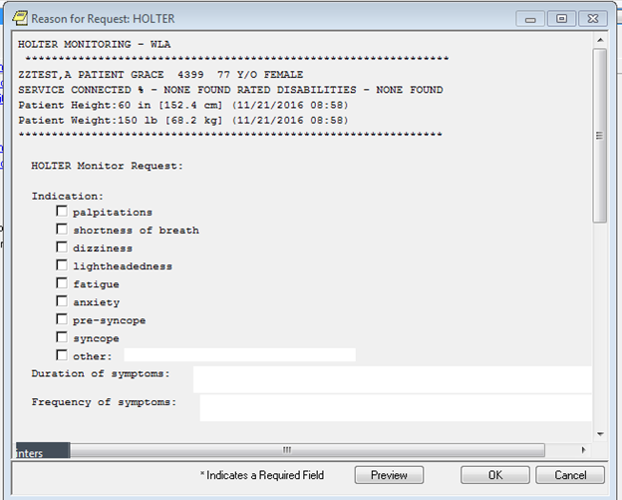

**Figure A.2. Reminder Dialog Template: Cardiology Ambulatory ECG Monitoring Consult**

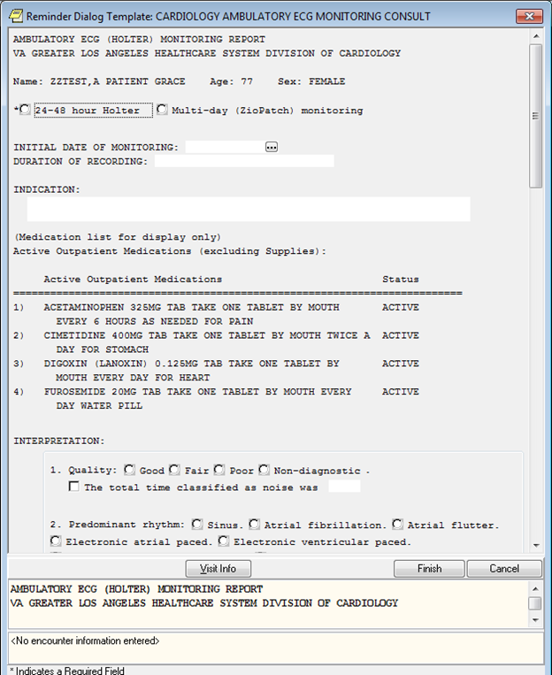

**Figure A.3. Reminder Dialog Template: Cardiology Ambulatory ECG Monitoring Consult Continued**

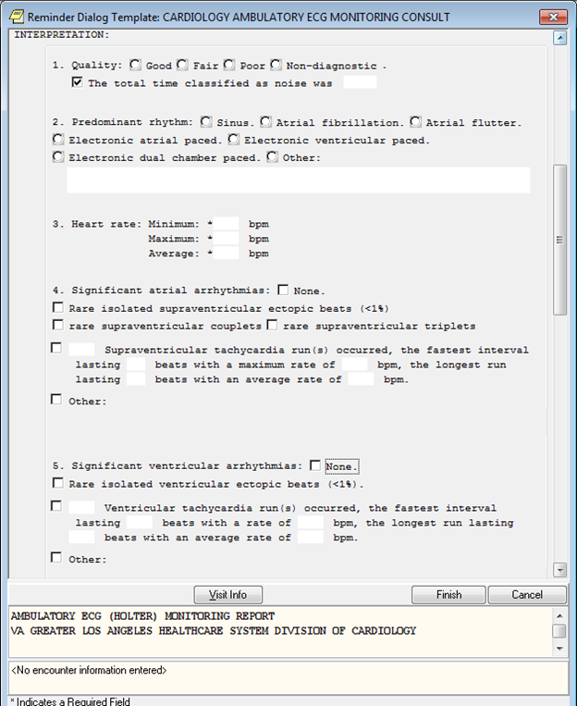

**Figure A.4. Reminder Dialog Template: Cardiology Ambulatory ECG Monitoring Consult Continued**

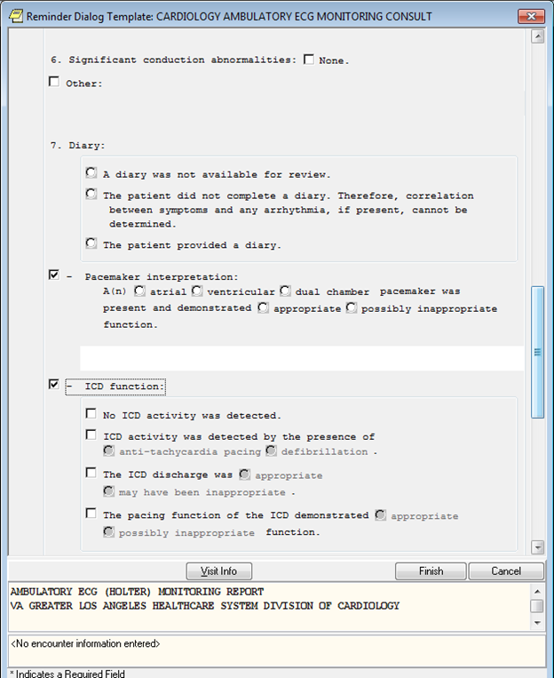

**Figure A.5. Reminder Dialog Template: Cardiology Ambulatory ECG Monitoring Consult Continued**

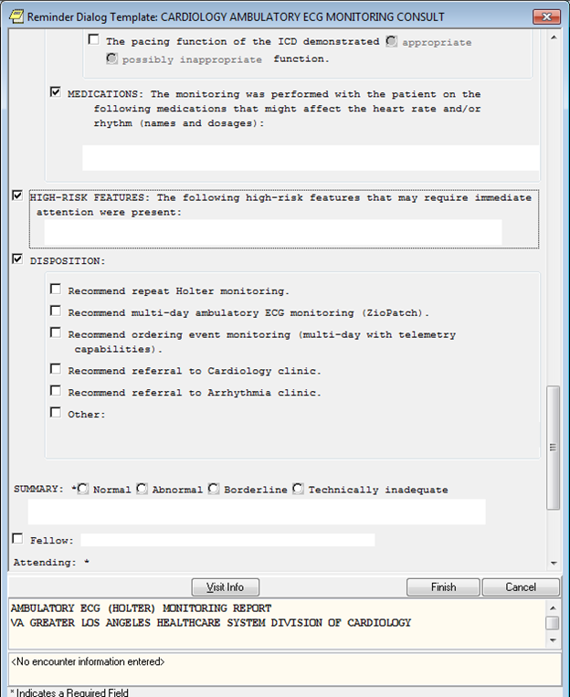

**Figure A.6. Reminder Dialog Template: Cardiology Ambulatory ECG Monitoring Consult Continued**

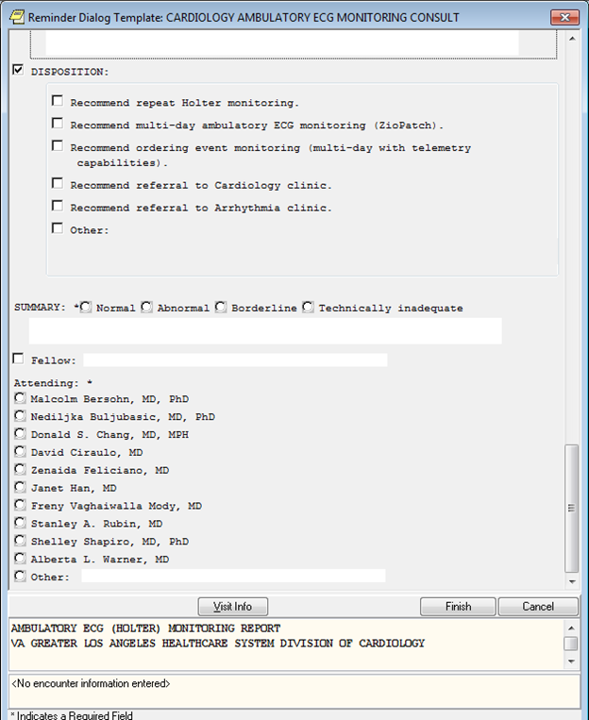

**Figure A.7. GLA Screenshot**

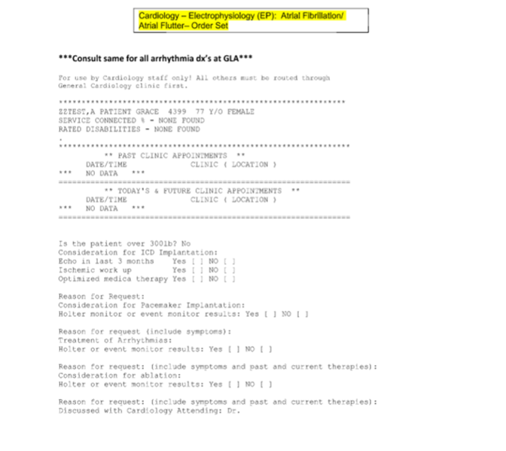

**Appendix B. Basic Laboratory Panel Definition**

* Blood Urea Nitrogen
* Calcium
* Chloride
* CO2 (Carbon Dioxide, Bicarbonate)
* Creatinine
* Glucose
* Potassium
* Sodium

**Acronyms**

ACS Acute Coronary Syndrome

AF Atrial fibrillation

CCT Cardiac CT

CCTA Coronary CT Angiography

CCWP Clinical Content White Paper

CRT-D Implantable Cardioverter-Defibrillator

EP Electrophysiology

HL7 Health Level 7

ICD Implantable Cardioverter-Defibrillator

KNART Knowledge Artifact

KNARTs Knowledge Artifacts

SME Subject Matter Expert

SVT Supraventricular Tachycardia

VAMC VA Medical Center