**Clinical Decision Support (CDS) Content and Health Level 7 (HL7)-Compliant Knowledge Artifacts (KNARTs)**

**Cardiology: Admission Orders - Heart Failure Clinical Content White Paper**

**Department of Veterans Affairs (*****VA*****)**



**Knowledge Based Systems (*****KBS*****)**

**Office of Informatics and Information Governance (*****OIIG***

**Clinical Decision Support (*****CDS*****)**

**Clinical Decision Support (CDS) Content and Health Level 7 (HL7)-Compliant Knowledge Artifacts (KNARTs): Cardiology: Admission Orders - Heart Failure Clinical Content White Paper**

by Department of Veterans Affairs (*VA*)

Publication date May 2018

**Contract: VA118-16-D-1008, Task Order (*****TO*****): VA-118-16-F-1008-0007**

**Table 1. Relevant KNART Information: Cardiology: Admission Orders - Heart Failure**

| **KNART Name** | **Associated CLIN** |
| --- | --- |
| Admission Orders: Heart Failure - Order Set | CLIN0008DA |

**Table of Contents**

VA Subject Matter Expert (SME) Panel vi

Introduction vii

Conventions Used viii

1. Cardiology: Admission Orders - Heart Failure 1

1.1. Clinical Context 1

1.2. Knowledge Artifacts 1

2. Cardiology: Admission Orders - Heart Failure Order Set  2

2.1. Knowledge Narrative 2

2.2. Admit To 2

2.3. Diagnosis 2

2.4. Allergies 2

2.5. Code Status 3

2.6. Vital Signs and Monitoring 3

2.7. Activity 4

2.8. Nursing 4

2.9. Venous Thromboembolism ([*VTE*](#d6e788)) Prophylaxis 5

2.10. Immunizations 6

2.11. Laboratory Tests 6

2.12. Diagnostic Testing 8

2.13. Oxygen 8

2.14. Consults and Referrals 9

2.15. Medications 9

Bibliography/Evidence 11

A. Existing Sample VA Artifacts 13

B. Basic Laboratory Panel Definition 18

Acronyms 19

**List of Figures**

A.1. Inpatient Diet Menu 14

A.2. Congestive Heart Failure ([*CHF*](#d6e302)) Medications 14

A.3. Angiotensin Receptor Blockers ([*ARBs*](#d6e230)) Menu 15

A.4. Angiotensin Receptor Blockers ([*ARBs*](#d6e230)) Conversion 15

A.5. Digoxin Menu 16

A.6. Spironolactone Information and Orders 16

A.7. Inpatient Antilipid Medications 17

A.8. JNC 7 Heart Failure Recommendations 17

A.9. Heart Failure Documentation 18

**List of Tables**

1. Relevant KNART Information: Cardiology: Admission Orders - Heart Failure ii

1.1. Clinical Context Domains 1

**VA Subject Matter Expert (SME) Panel**

| **Name** | **Title** | **Project Role** |
| --- | --- | --- |
| Bruce Bray, MD | Professor, Cardiovascular Medicine University of Utah School of Medicine Staff Cardiologist; Salt Lake City VA Medical Center (*VAMC*), Salt Lake City, UT 84148 | SME, Primary |
| Scott Wall, MD | Assistant Professor, Cardiovascular Medicine University of Utah School of Medicine Staff Cardiologist; Electrophysiology, Salt Lake City *VAMC*, Salt Lake City, UT 84148 | SME, Secondary |
| Aiden Abidov, MD, PhD | Professor of Medicine Wayne State University Section Chief; Cardiology, John Dingell *VAMC*, 4646 John R St, Detroit, MI 48201 | SME |

**Introduction**

The Department of Veterans Affairs (*VA*) is committed to improving the ability of clinicians to provide care for patients while increasing quality, safety, and efficiency. Recognizing the importance of standardizing clinical knowledge in support of this goal, *VA* is implementing the Health Level 7 (*HL7*) Knowledge Artifact Specification for a wide range of VA clinical use cases. Knowledge Artifacts, referred to as KNARTs, enable the structuring and encoding of clinical knowledge so the knowledge can be integrated with electronic health records to enable clinical decision support.

The purpose of this Clinical Content White Paper ([*CCWP*](#d6e284)) is to capture the clinical context and intent of *KNART* use cases in sufficient detail to provide the *KNART* authoring team with the clinical source material to construct the corresponding knowledge artifacts using the *HL7* Knowledge Artifact Specification. This paper has been developed using material from a variety of sources: *VA* artifacts, clinical practice guidelines, evidence in the body of medical literature, and clinical expertise. After reviewing these sources, the material has been synthesized and harmonized under the guidance of *VA* subject matter experts (*SMEs*) to reflect clinical intent for this use case.

Unless otherwise noted, items within this white paper (e.g., documentation template fields, orderable items, etc.) are chosen to reflect the clinical intent at the time of creation. To provide an exhaustive list of all possible items and their variations is beyond the scope of this work.

**Conventions Used**

Conventions used within the knowledge artifact descriptions include:

*<obtain>*: Indicates a prompt to obtain the information listed

* If possible, the requested information should be obtained from the underlying system(s). Otherwise, prompting the user for information may be required
* The technical and clinical notes associated with a section should be consulted for specific constraints on the information (e.g., time-frame, patient interview, etc.)
* Default Values: Unless otherwise noted, <obtain> indicates to obtain the most recent observation. It is recognized that this default time-frame value may be altered by future implementations

*[...]*: Square brackets enclose explanatory text that indicates some action on the part of the user, or general guidance to the clinical or technical teams. Examples include, but are not limited to:

*[Begin ...]* , *[End ...]*: Indicates the start and end of specific areas to clearly delineate them for technical purposes.

*[Activate ...]*: Initiates another knowledge artifact or knowledge artifact section.

*[Section Prompt: ...]*: If this section is applicable, then the following prompt should be displayed to the user.

*[Section Selection Behavior: ...]*: Indicates technical constraints or considerations for the selection of items within the section.

*[Attach: ...]*: Indicates that the specified item should be attached to the documentation template if available.

*[Link: ...]*: Indicates that rather than attaching an item, a link should be included in the documentation template.

*[Clinical Comment: ...]*: Indicates clinical rationale or guidance.

*[Technical Note: ...]*: Indicates technical considerations or notes.

*[If ...]*: Indicates the beginning of a conditional section.

*[Else, ...]*: Indicates the beginning of the alternative branch of a conditional section.

*[End if ...]*: Indicates the end of a conditional section.

☐ *[Check boxes]*: Indicates items that should be selected based upon the section selection behavior.

**Chapter 1. Cardiology: Admission Orders - Heart Failure**

**1.1. Clinical Context**

[Begin Clinical Context.]

The Cardiology Admission Orders: Heart Failure *KNART* is intended for clinical providers caring for adult patients in a Clinic or an Emergency Department (*ED*) setting being admitted with a diagnosis of heart failure, initial or recurrent episode.

The context domains are summarized in the table below:

**Table 1.1. Clinical Context Domains**

|  |  |
| --- | --- |
| Target User | Provider in an outpatient clinic, hospital and *ED* settings |
| Patient | Adult patient being admitted with a diagnosis suggestive of initial or recurrent heart failure |
| Priority | Routine |
| Specialty | Outpatient primary care or cardiology, Emergency Medicine, Hospitalist Medicine, or Intensive Care Unit (*ICU*) Medicine |
| Location | Outpatient or *ED* |

[End Clinical Context.]

**1.2. Knowledge Artifacts**

[Begin Knowledge Artifacts.]

Heart failure is a highly prevalent condition that is associated with significant morbidity and mortality and with tens of billions of dollars of annual expense in the United States [(Yancy 2013)]. While clinical advances and authoritative guidelines have been developed, substantial practice variation still exists among caregivers, denying patients access to potentially life-extending treatment. Operationalizing evidence-based practice guidelines, therefore, has the potential to improve outcomes among a large number of patients while delivering more cost-effective care.

The clinical decision support (*CDS*) knowledge artifact for the heart failure admission order set use case is:

* Cardiology: Admission Orders - Heart Failure Order Set KNART
* Orderable items
* Includes logic for appropriate display of the order set

[End Knowledge Artifacts.]

**Chapter 2. Cardiology: Admission Orders - Heart Failure Order Set**

[Begin Cardiology: Admission Orders - Heart Failure Order Set.]

**2.1. Knowledge Narrative**

[Begin Knowledge Narrative.]

[See Clinical Context in Chapter 1.]

[Section Prompt: This order set should be used during the admission of patients presenting with a diagnosis of heart failure.]

[End Knowledge Narrative.]

**2.2. Admit To**

[Begin Admit To.]

[Section Prompt: Admit To?]

[Section Selection Behavior: Required. Select only one.]

☐ Medical ward

☐ Telemetry

☐ Stepdown unit

☐ *ICU*

☐ Other <obtain> Location

[End Admit To.]

**2.3. Diagnosis**

[Begin Diagnosis.]

[Section Prompt: Diagnosis?]

[Section Selection Behavior: Required. Select only one.]

☐ Congestive heart failure (*CHF*)

☐ Other <obtain> Diagnosis

[End Diagnosis.]

**2.4. Allergies**

[Begin Allergies.]

[Section Prompt: Medication allergies?]

[Section Selection Behavior: Required. Select only one.]

☐ No known drug allergies

☐ Other <obtain> List of allergies

[End Allergies.]

**2.5. Code Status**

[Begin Code Status.]

[Section Prompt: Code status?]

[Section Selection Behavior: Required. Select only one.]

☐ Full code

☐ Do Not Resuscitate (*DNR*)/Do Not Intubate (*DNI*)

[Technical Note: Link to Attending *DNR*/*DNI* order set]

☐ Other <obtain> Code status

[End Code Status.]

**2.6. Vital Signs and Monitoring**

[Begin Vital Signs and Monitoring.]

[Section Prompt: Vital Signs and Monitoring]

[Section Selection Behavior: Optional. Select all that apply.]

☐ Continuous telemetry

☐ Vital signs

☐ Routine

☐ Every <obtain> Hours

☐ With pulse oximetry

☐ Weight daily (pounds)

☐ Height (inches)

[Technical Note: If admitted to medical ward, then display the medical ward section.]

[Begin Medical Ward Section.]

[Section Prompt: Medical Ward Orders]

[Section Selection Behavior: Optional. Select all that apply.]

☐ Oxygen saturation every 4 hours

☐ Intake/output recording

☐ Routine per local policy

☐ Strict per local policy

☐ Every <obtain> Hours

[End Medical Ward Section.]

[Technical Note: If admitted to *ICU*, then display the *ICU* section.]

[Begin *ICU* Section.]

[Section Prompt: *ICU* Orders]

[Section Selection Behavior: Optional. Select all that apply.]

☐ Oxygen saturation continuous

☐ Intake and output

☐ Routine per local policy

☐ Strict per local policy

☐ Every 1 hour

☐ Invasive hemodynamic monitoring

☐ Arterial line

☐ Pulmonary artery catheter

[End *ICU* Section.]

[End Vital Signs and Monitoring.]

**2.7. Activity**

[Begin Activity.]

[Section Prompt: Activity]

[Section Selection Behavior: Optional. Select all that apply.]

☐ Bed rest

☐ Bed rest with bedside commode

☐ Bed rest with bathroom privileges

☐ Ambulate with assistance <obtain> Frequency

☐ Occupational/physical therapy assessment/assistance

☐ Out of bed to chair <obtain> Frequency

☐ Other specify <obtain> Other activity

☐ May be off telemetry for <obtain> Reason

[End Activity.]

**2.8. Nursing**

[Begin Nursing.]

**[Section Prompt: Urinary Catheter]**

[Section Selection Behavior: Optional. Select all that apply.]

☐ Insert Foley (indwelling urinary) catheter (note: routine urinary catheterization not recommended unless benefits outweigh risks)

☐ Discontinue urinary catheter after 48hrs (reorder for continued use)

☐ Condom catheter

[Section Prompt: Peripheral Intravenous (IV) Line]

[Section Selection Behavior: Optional. Select all that apply.]

☐ Insert peripheral *IV* line

☐ Saline lock

☐ Heparin lock

☐ Routine *IV* Care per local policy

[Section Prompt: Fluid Restriction]

[Section Selection Behavior: Optional. Select all that apply.]

☐ Restrict fluids

<obtain> Maximum liters per 24 hours

[Section Prompt: Diet]

[Section Selection Behavior: Required. Select at least one.]

☐ Regular

☐ Nil per os (*NPO*)

☐ *NPO* except meds

☐ Cardiac diet

☐ Low sodium

☐ Low cholesterol

☐ Low fat

☐ 2gm Na

☐ No added salt

☐ Diabetic diet <obtain> Calories

☐ Other [tube feeding, Total Parenteral Nutrition (*TPN*), etc.] <obtain> Other diet

[End Nursing.]

**2.9. Venous Thromboembolism (*****VTE*****) Prophylaxis**

[Begin Venous Thromboembolism (*VTE*) Prophylaxis.]

[Section Selection Behavior: Optional.]

[Technical Note: The order below can be linked to the *VTE* prophylaxis *KNART*, if available.]

☐ Conduct *VTE* prophylaxis risk screening and order appropriate protocol

[Section Prompt: Notify Clinician for:]

[Section Selection Behavior: Optional. Select all that apply.]

[Technical Note: Default values are specified in square brackets below. The user should be able to override the default values.]

☐ Temperature greater than [38.5 degrees Celsius]

☐ Systolic blood pressure (*BP*) greater than [170 mmHg]

☐ Systolic *BP* lower than [90 mmHg]

☐ Diastolic *BP* greater than [110 mmHg]

☐ Diastolic *BP* less than [40 mmHg]

☐ Heart rate greater than [130 bpm]

☐ Heart rate less than [50 bpm]

☐ Respiratory rate greater than [24 breaths per minute]

☐ Respiratory rate less than [10 breaths per minute]

☐ Urine output less than [0.5 mL/kg/hr]

[End Venous Thromboembolism (*VTE*) Prophylaxis.]

**2.10. Immunizations**

[Begin Immunizations.]

[Section Selection Behavior: Optional. Select all that apply.]

☐ Pneumovax

☐ Influenza vaccine

[End Immunizations.]

**2.11. Laboratory Tests**

[Begin Laboratory Tests.]

[Section Selection Behavior: Optional. Select all that apply.]

☐ Basic metabolic profile

☐ Now

☐ Daily

☐ Complete metabolic panel

☐ Now

☐ In am

☐ Brain natriuretic peptide

☐ Now

☐ In am

☐ Complete blood count

☐ Now

☐ In am

☐ Fasting lipid profile

☐ In am

☐ Partial Thromboplastin Time (*PTT*)

☐ Now

☐ In am

☐ Prothrombin Time (*PT*)/International Normalized Ratio (*INR*)

☐ Now

☐ Daily

☐ Liver function testing daily

☐ Thyroid Stimulating Hormone (*TSH*)

☐ Now

☐ In am

☐ Troponin I

☐ Now

☐ q 8 hours x 3

☐ Magnesium

☐ Now

☐ In am

☐ Digoxin level

☐ Now

☐ In am urinalysis

☐ Arterial Blood Gas

☐ Now

[Section Prompt: Point of Care Tests]

[Section Selection Behavior: Optional. Select all that apply.]

☐ Blood glucose every 4 hours

☐ Blood glucose now

[End Laboratory Tests.]

**2.12. Diagnostic Testing**

[Begin Diagnostic Testing.]

[Section Selection Behavior: Optional. Select all that apply.]

☐ 12-lead electrocardiogram (Dx: heart failure)

☐ Now

☐ In am

☐ X-ray chest (Dx: heart failure)

☐ Posterioranterior (*PA*)/Lateral

☐ Now

☐ In am

☐ Portable Anteroposterior (*AP*)

☐ Now

☐ In am

☐ Echocardiogram, transthoracic (*TTE*) (Dx: Heart failure)

☐ Now

☐ In am

☐ Echocardiogram, transesophageal (*TEE*), (Dx: Heart failure)

☐ Now

☐ In am

☐ Thallium Myocardial Perfusion Imaging (*MPI*) viability testing

☐ MPI single-photon emission computed tomography (*SPECT*) for the etiology of cardiomyopathy

☐ Cardiac magnetic resonance imaging (*MRI*) (with Gd delayed enhancement) for viability/etiology of cardiomyopathy

☐ Multigated Acquisition Scan (*MUGA*) to define the Left Ventricular Ejection Fraction (*LVEF*) and/or Right Ventricular Ejection Fraction (*RVEF*)

[End Diagnostic Testing.]

**2.13. Oxygen**

[Begin Oxygen.]

[Section Selection Behavior: Optional. Select all that apply.]

☐ Oxygen therapy per protocol

☐ Nasal cannula 2 L/min or <obtain> L/min

☐ Titrate to oxygen saturation > 90%

☐ Face mask 40% fraction of inspired oxygen (*FiO2*) titrate to oxygen saturation > 90%

☐ Nonrebreather face mask 15 L titrate to oxygen saturation > 90%

[End Oxygen.]

**2.14. Consults and Referrals**

[Begin Consults and Referrals.]

[Section Selection Behavior: Optional. Select all that apply.]

☐ Consult cardiology

☐ Advanced heart failure service for heart failure management

☐ Consult electrophysiology service for consideration of device therapy [(Implantable Cardioverter-Defibrillator (*ICD*), Cardiac Resynchronization Therapy (*CRT*)]

[End Consults and Referrals.]

**2.15. Medications**

[Begin Medications.]

[Section Selection Behavior: Optional. Select all that apply.]

☐ IV Fluid

☐ Normal saline (*NS*)

☐ Lactated Ringers (*LR*)

☐ Dextrose 5%, ½ Normal Saline

☐ Other <obtain> *IV* Fluids

☐ Aspirin enteric coated, select one of the following:

☐ 81 mg daily

☐ 325 mg daily

[Section Prompt: Diuretics]

[Section Selection Behavior: Optional. Select all that apply.]

☐ Furosemide specify: <obtain 20-120 mg> solution *IV* bolus

☐ Now

☐ Every <obtain> hours

☐ Bumetanide specify: <obtain 0.5-2 mg> solution *IV* bolus

☐ Now

☐ Every <obtain> hours

☐ Metolazone <obtain 2.5-5 mg> oral daily, 30 minutes prior to loop diuretic dose

[Section Prompt: Potassium Replacement]

[Section Selection Behavior: Optional. Select all that apply.]

☐ Potassium replacement per protocol

☐ Potassium chloride <obtain 10-20 meq> (max 60 meq) oral

☐ Once

☐ Daily

☐ Bid

[Section Prompt: Angiotensin-Converting Enzyme (ACE-I) Inhibitors [if not on Angiotensin Receptor Blockers (ARBs)]

[Section Selection Behavior: Optional. Select all that apply.]

☐ Captopril [initial 6.25-12.5, max 50] mg oral, three times daily (tid)

☐ Lisinopril [initial 2.5-5, max 40] mg tablet oral daily hold for symptomatic systolic *BP* < 90

☐ Enalapril [initial 2.5, max-20] mg tablet oral daily hold for symptomatic systolic *BP* < 90

[Section Prompt: Angiotensin II Receptor Blockers (ARBs) [if not on ACE-I]]

[Section Selection Behavior: Optional. Select all that apply.]

☐ Losartan [initial 25-50, max 150] mg tablet oral daily hold for symptomatic systolic *BP* < 90

☐ Valsartan [initial 20- 40, max 160] mg tablet oral two times daily hold for symptomatic systolic *BP* < 90

[Section Prompt: Angiotensin Receptor-Neprilysin Inhibitors (ARNIs)]

[Section Selection Behavior: Optional. Select all that apply.]

☐ Valsartan 49 mg/sacubitril 51 mg 1 tablet oral two times daily hold for symptomatic systolic *BP* < 90

[Section Prompt: Beta-Blockers]

☐ Metoprolol succinate [initial 12.5-25, max 200] mg tablet oral daily hold for symptomatic systolic *BP* < 90

☐ Carvedilol [initial 3.125, max 25] mg tablet oral two times daily hold for symptomatic systolic *BP* < 90

[Section Prompt: Aldosterone Antagonists]

☐ Spflironolactone [initial 12.5, max] 25 mg tablet oral daily

☐ Eplerenone [initial 25, max 50] mg tablet oral daily

[Section Prompt: Hydralazine/Nitrates]

[Section Selection Behavior: Optional. Select all that apply.]

☐ Hydralazine 37.5 mg/ Isosorbide dinitrate 20 mg 1 tablet oral three times daily (tid)

[Section Prompt: Cardiac Glycosides]

[Section Selection Behavior: Optional. Select all that apply.]

☐ Digoxin 0.125 micrograms tablet oral daily

[End Medications.]

[End Cardiology: Admission Orders - Heart Failure Order Set.]

**Bibliography/Evidence**

2017 American College of Cardiology (*ACC*)/American Heart Association (*AHA*)/Heart Failure Society of America (*HFSA*) Focused Update of the 2013 American College of Cardiology Foundation (*ACCF*)/*AHA* Guideline for the Management of Heart Failure. *A Report of the American College of Cardiology/American Heart Association Task Force on Clinical Practice Guidelines and the Heart Failure Society of America*. Journal of Cardiac Failure. 2017. 23. 8.

U.S. National Library of Medicine. *BIDIL - hydralazine hydrochloride and isosorbide dinitrate tablet, film coated [Arbor Pharmaceuticals, Inc.]. DailyMed website*. Revised July 2016. <https://dailymed.nlm.nih.gov/dailymed/druginfo.cfm?setid=e1e63cd5-d1e4-4af5-bad5-1ad41ea46b00>.

U.S. National Library of Medicine. *BUMETANIDE - bumetanide injection, solution [Hospira, Inc.]. DailyMed website*. Revised May 2017. <https://dailymed.nlm.nih.gov/dailymed/druginfo.cfm?setid=e71daa68-2744-47da-64b4-0a725c2e8457>.

U.S. National Library of Medicine.  *BUMETANIDE - bumetanide tablet [Teva Pharmaceuticals USA Inc]. DailyMed website*. Revised September 2013. <https://dailymed.nlm.nih.gov/dailymed/druginfo.cfm?setid=04236576-01c4-43a6-ac8a-60e23b5dc692>.

U.S. National Library of Medicine. *CARVEDILOL - carvedilol tablet, coated [Ranbaxy Pharmaceuticals Inc.]. DailyMed website*. Revised October 2007. <https://dailymed.nlm.nih.gov/dailymed/druginfo.cfm?setid=7d485d38-5d43-4a54-bc63-82734035c66a>.

U.S. National Library of Medicine. *DIGOXIN - digoxin tablet [Impax Generics]. DailyMed website*. Revised February 2016. <https://dailymed.nlm.nih.gov/dailymed/druginfo.cfm?setid=dfac7f13-28be-423d-9389-9089da29da17>.

U.S. National Library of Medicine. *ENALAPRIL MALEATE - enalapril maleate tablet [Watson Laboratories Inc.]. DailyMed website*. Revised March 2008. <https://dailymed.nlm.nih.gov/dailymed/druginfo.cfm?setid=ac0289a6-9533-4f8c-b46c-506dce1b90b5>.

U.S. National Library of Medicine. *ENTRESTO - sacubitril and valsartan tablet, film coated [Novartis Pharmaceuticals Corporation]. DailyMed website.* Revised August 2015. <https://dailymed.nlm.nih.gov/dailymed/druginfo.cfm?setid=000dc81d-ab91-450c-8eae-8eb74e72296f>.

U.S. National Library of Medicine. *EPLERENONE - eplerenone tablet [Apotex Corp]. DailyMed website*. Revised March 2017. <https://dailymed.nlm.nih.gov/dailymed/druginfo.cfm?setid=59e27acd-3877-babf-341b-b65968a8a607>.

U.S. National Library of Medicine. *FUROSEMIDE - furosemide injection, solution [Claris Lifesciences Inc.]. DailyMed website*. Revised June 2017. <https://dailymed.nlm.nih.gov/dailymed/druginfo.cfm?setid=c71371a7-75c5-45b8-b762-8d782d4c71bc>.

U.S. National Library of Medicine. *LASIX - furosemide tablet [Sanofi-Aventis U.S. LLC]. DailyMed website*. Revised March 2014. <https://dailymed.nlm.nih.gov/dailymed/druginfo.cfm?setid=eadfe464-720b-4dcd-a0d8-45dba706bd33>.

U.S. National Library of Medicine. *LISINOPRIL 2.5MG - lisinopril tablet; LISINOPRIL 5MG - lisinopril tablet; LISINOPRIL 10MG - lisinopril tablet; LISINOPRIL 20MG - lisinopril tablet; LISINOPRIL 40MG - lisinopril tablet [Mckesson Contract Packaging]. DailyMed website*. Revised March 2014. <https://dailymed.nlm.nih.gov/dailymed/druginfo.cfm?setid=09231502-068b-4439-8238-81c7e43a269c>.

U.S. National Library of Medicine. *LOSARTAN - losartan potassium tablet, film coated [Method Pharmaceuticals, LLC]. DailyMed website*. Revised September 2016. <https://dailymed.nlm.nih.gov/dailymed/druginfo.cfm?setid=3cdcf8cc-4964-4c53-e054-00144ff88e88>.

U.S. National Library of Medicine.  *SPIRONOLACTONE - spironolactone tablet; SPIRONOLACTONE - spironolactone tablet, film coated [Sun Pharmaceutical Industries, Inc.]. DailyMed website*. Revised March 2017. <https://dailymed.nlm.nih.gov/dailymed/druginfo.cfm?setid=c23b6b9b-aec3-48a8-a518-76e4097f6479>.

U.S. National Library of Medicine. *TOPROL XL (metoprolol succinate) tablet, extended release [AstraZeneca LP]. DailyMed website*. Revised June 2016. <http://dailymed.nlm.nih.gov/dailymed/lookup.cfm?setid=4a5762c6-d7a2-4e4c-10b7-8832b36fa5f4>.

U.S. National Library of Medicine. *VALSARTAN - valsartan tablet [Bryant Ranch Prepack]. DailyMed website*. <https://dailymed.nlm.nih.gov/dailymed/druginfo.cfm?setid=0135bbe4-0b38-4e92-8d7c-a4da3b6a544e>. Revised May 2017.

[Yancy, 2017] CW Yancy, M Jessup, B Bozkurt, and et al. “2017 *ACC*/*AHA*/*HFSA* Focused Update of the 2013 *ACCF*/*AHA* Guideline for the Management of Heart Failure: A Report of the American College of Cardiology/American Heart Association Task Force on Clinical Practice Guidelines and the Heart Failure Society of America”. *Circulation*. 2017 April 28. pii: CIR.0000000000000509. doi: 10.1161/CIR.0000000000000509.

[Yancy, 2013] CW Yancy, M Jessup, and et al. “2013 *ACCF*/*AHA* guideline for the management of heart failure: a report of the American College of Cardiology Foundation/American Heart Association Task Force on practice guidelines”. *Circulation*. 2013. 128. 16. e240-e327.

[Yancy, 2016] CW Yancy, M Jessup, and et al. “2016 *ACC*/*AHA*/*HFSA* Focused Update on New Pharmacological Therapy for Heart Failure: An Update of the 2013 *ACCF*/*AHA* Guideline for the Management of Heart Failure: A Report of the American College of Cardiology/American Heart Association Task Force on Clinical Practice Guidelines and the Heart Failure Society of America”. *Circulation*. 2016. 134. 13. e282-e293.

**Appendix A. Existing Sample VA Artifacts**

All of the figures illustrated below are referenced from the Portland *VAMC*.

**Figure A.1. Inpatient Diet Menu**

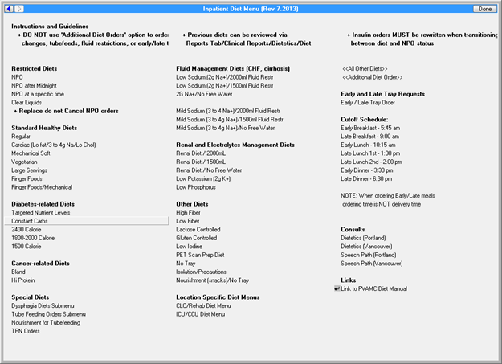

**Figure A.2. Congestive Heart Failure (*****CHF*****) Medications**

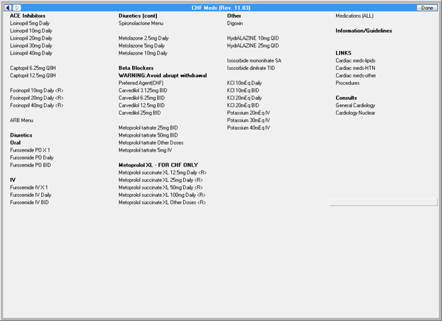

**Figure A.3. Angiotensin Receptor Blockers (*****ARBs*****) Menu**

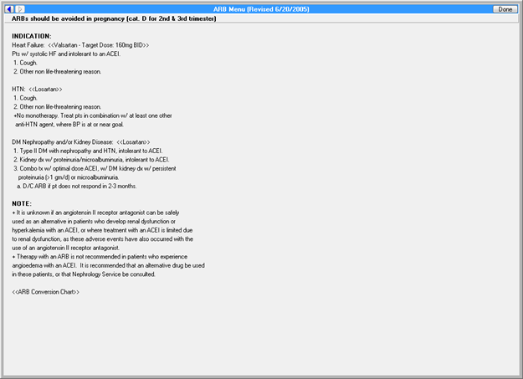

**Figure A.4. Angiotensin Receptor Blockers (*****ARBs*****) Conversion**

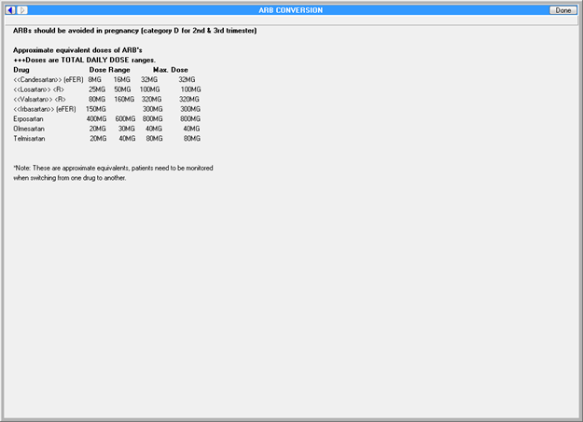

**Figure A.5. Digoxin Menu**

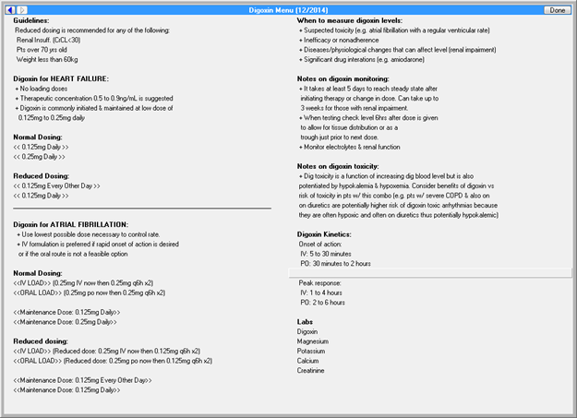

**Figure A.6. Spironolactone Information and Orders**

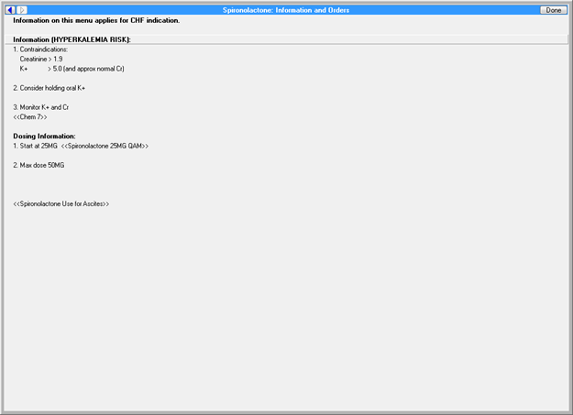

**Figure A.7. Inpatient Antilipid Medications**

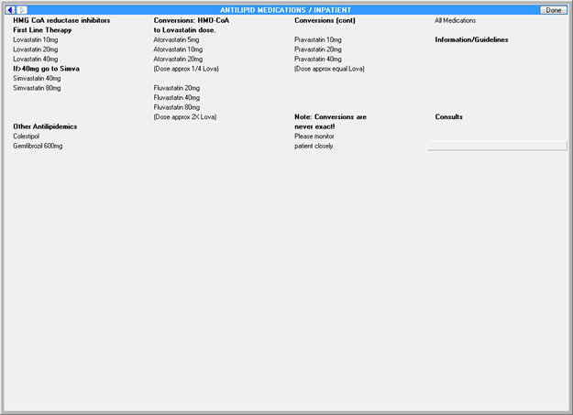

**Figure A.8. JNC 7 Heart Failure Recommendations**

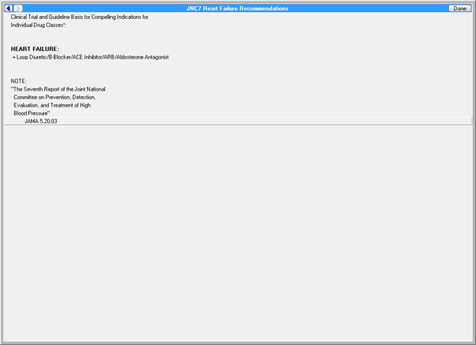

**Figure A.9. Heart Failure Documentation**

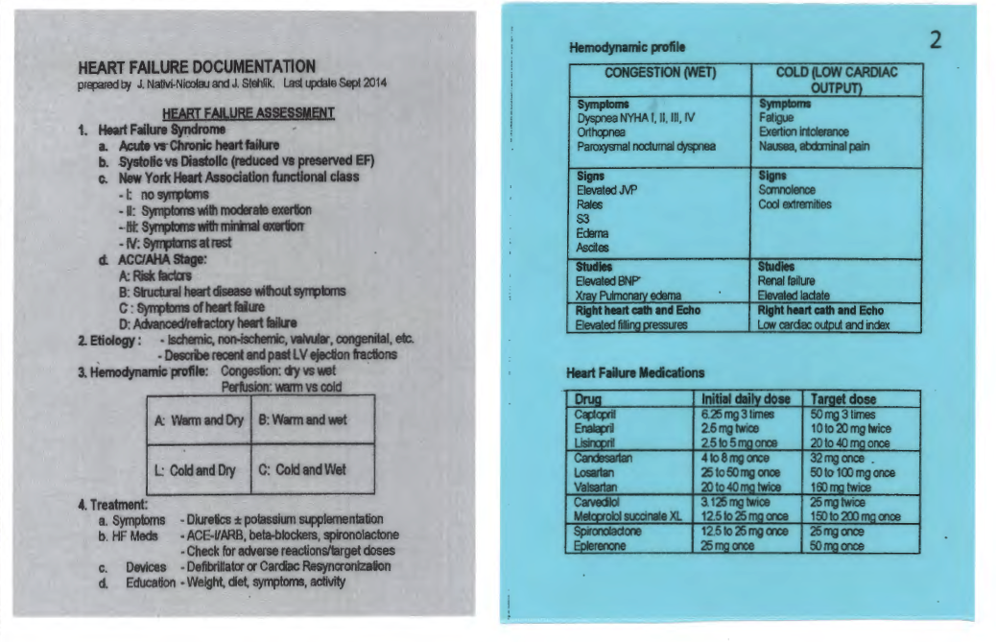

**Appendix B. Basic Laboratory Panel Definition**

* Blood urea nitrogen
* Calcium
* Chloride

* *CO2* (Carbon dioxide, bicarbonate)
* Creatinine
* Glucose
* Potassium
* Sodium

**Acronyms**

ACC American College of Cardiology

ACCF United States Preventive Task Force

ACE-I Angiotensin-Converting Enzyme

AHA American Heart Association

AP Anteroposterior

ARBs Angiotensin Receptor Blockers

ARNIs Angiotensin Receptor-Neprilysin Inhibitors

BP Blood Pressure

CCWP Clinical Content White Paper

CDS Clinical Decision Support

CHF Congestive Heart Failure

CO2 Carbon Dioxide

CRT Cardiac Resynchronization Therapy

DNI Do Not Intubate

DNR Do Not Resuscitate

ED Emergency Department

HFSA Heart Failure Society of America

HL7 Health Level 7

ICD Implantable Cardioverter-Defibrillator

ICU Intensive Care Unit

INR International Normalized Ratio

IV Intravenous

KBS Knowledge Based Systems

KNART Knowledge Artifact

LVEF Left ventricular ejection fraction

MPI Myocardial perfusion

MRI Magnetic Resonance Imaging

MUGA Multigated acquisition scan

NPO Nothing by mouth

OIIG Office of Informatics and Information Governance

PA Posterioranterior

PT Prothrombin Time

PTT Partial Thromboplastin Time

RVEF Right ventricular ejection fraction

SPECT Single-photon emission computed tomography

TEE Transesophageal

TO Task Order

TSH Thyroid Stimulating Hormones

TTE Transthoracic

VA Department of Veteran Affairs

VAMC VA Medical Center

VTE Venous Thromboembolism