**Clinical Decision Support (CDS) Content and Health Level 7 (HL7)-compliant Knowledge Artifacts (KNARTs)**

**Cardiology: Chest Pain (CP) / Coronary Artery Disease (CAD) Clinical Content White Paper**

**Department of Veterans Affairs (VA)**



**Knowledge Based Systems (KBS)**

**Office of Informatics and Information Governance (OIIG)**

**Clinical Decision Support (CDS)**

**Clinical Decision Support (CDS) Content and Health Level 7 (HL7)-compliant Knowledge Artifacts (KNARTs): Cardiology: Chest Pain (CP) / Coronary Artery Disease (CAD) Clinical Content White Paper**

by Department of Veterans Affairs (VA), , , , and

Publication date October, 2017

**Contract: VA118-16-D-1008, Task Order (TO): VA-118-16-F-1008-0007**

**Table 1. Relevant KNART Information**

| **KNART Name** | **Associated CLIN** |
| --- | --- |
| Cardiology: CP/CAD - Order Set | CLIN0004AA |
| Cardiology: CP/CAD - Documentation Template | CLIN0005AC |
| Cardiology: CP/CAD - Consult Request/Composite | CLIN0006AB |

**Table of Contents**

VA Subject Matter Expert (SME) Panel vi

Introduction vii

Conventions Used viii

1. Chest Pain (CP)/Coronary Artery Disease (CAD) 1

1. Clinical Context 1

2. Knowledge Artifacts 1

2. Composite 3

1. Knowledge Narrative 3

2. Consult Request 3

3. Documentation Template 4

1. Knowledge Narrative 4

2. Clinical Stability 4

3. Coronary Artery Disease (CAD) Risk 4

4. History and Physical 4

5. Treatment Provided 4

6. Laboratory Studies 5

7. Imaging and Diagnostic Studies 5

8. Link to Order set 6

4. Order Set 7

1. Knowledge Narrative 7

2. Clinical Stability 7

3. Consults and Referrals 7

4. Imaging and ECG 7

5. Laboratory Tests 8

6. Cardiac Risk Stratification 8

7. Medications 9

Bibliography/Evidence 11

A. Existing VA Artifacts 12

B. Glossary 21

**List of Figures**

A.1. Cardiology - General 12

A.2. Chest Pain (CP)/Coronary Artery Disease (CAD) Screenshot 13

A.3. Chest Pain (CP)/Coronary Artery Disease (CAD) Screenshot with Contraindications 14

A.4. Cardiology ETT Procedure 15

A.5. Order a Procedure 16

A.6. ETT Request Screenshot 17

A.7. Reason for Request: Cardiology - General Output 18

A.8. Order a Consult Screenshot for Cardiology 19

A.9. Consult to Service/Specialty Screen 20

**List of Tables**

1. Relevant KNART Information ii

1.1. Clinical Context Domains 1

**VA Subject Matter Expert (SME) Panel**

| **Name** | **Title** | **Project Role** |
| --- | --- | --- |
| Bruce Bray, MD | Professor, Cardiovascular Medicine, University of Utah School of Medicine; Staff Cardiologist, Salt Lake City VA Medical Center (VAMC) | SME, Primary |
| Scott Wall, MD | Assistant Professor, Cardiovascular Medicine, University of Utah; School of Medicine Staff Cardiologist, Electrophysiology, Salt Lake City VAMC | SME, Secondary |
| Aiden Abidov, MD, PhD | Professor of Medicine, Wayne State University; Section Chief, Cardiology, John Dingell VAMC | SME |

**Introduction**

The VA is committed to improving the ability of clinicians to provide care for patients while increasing quality, safety, and efficiency. Recognizing the importance of standardizing clinical knowledge in support of this goal, VA is implementing the HL7 Knowledge Artifact Specification for a wide range of VA clinical use cases. Knowledge Artifacts, referred to as *KNARTS*, enable the structuring and encoding of clinical knowledge so the knowledge can be integrated with electronic health records to enable clinical decision support.

The purpose of this Clinical Content White Paper (*CCWP*) is to capture the clinical context and intent of KNART use cases in sufficient detail to provide the KNART authoring team with the clinical source material to construct the corresponding knowledge artifacts using the HL7 Knowledge Artifact Specification. This paper has been developed using material from a variety of sources: VA artifacts, clinical practice guidelines, evidence in the body of medical literature, and clinical expertise. After reviewing these sources, the material has been synthesized and harmonized under the guidance of VA subject matter experts to reflect clinical intent.

Unless otherwise noted, items within this white paper (e.g., documentation template fields, orderable items, etc.) are chosen to reflect the clinical intent at the time of creation. To provide an exhaustive list of all possible items and their variations is beyond the scope of this work.

**Conventions Used**

Conventions used within the knowledge artifact descriptions include:

<obtain>*: Indicates a prompt to obtain the information listed*

* If possible, the requested information should be obtained from the underlying system(s). Otherwise, prompting the user for information may be required.
* The technical and clinical notes associated with a section should be consulted for specific constraints on the information (e.g., time-frame, patient interview, etc.)
* Unless otherwise noted, <obtain> indicates to obtain the most recent observation. It is recognized that this default time-frame value may be altered by future implementations

[...]: *Square brackets enclose explanatory text that indicates some action on the part of the user, or general guidance to the clinical or technical teams*. Examples include, but are not limited to:

* [Begin ...], [End ...]: Indicates the start and end of specific areas to clearly delineate them for technical purposes.
* [Activate ...]: Initiates another knowledge artifact or knowledge artifact section.
* [Section Prompt: ...]: If this section is applicable, then the following prompt should be displayed to the user.
* [Section Selection Behavior: ...]: Indicates technical constraints or considerations for the selection of items within the section.
* [Attach: ...]: Indicates that the specified item should be attached to the documentation template if available.
* [Link: ...]: Indicates that rather than attaching an item, a link should be included in the documentation template.
* [Clinical Comment: ...]: Indicates clinical rationale or guidance.
* [Technical Note: ...]: Indicates technical considerations or notes.
* [If ...]: Indicates the beginning of a conditional section.
* [Else, ...]: Indicates the beginning of the alternative branch of a conditional section.
* [End if ...]: Indicates the end of a conditional section.

☐*Check boxes: Indicates items that should be selected based upon the section selection behavior.*

**Chapter 1. Chest Pain (CP)/Coronary Artery Disease (CAD)**

**1. Clinical Context**

Patients often present in the primary care setting with chest pain (CP) that is thought, possibly, to be cardiac in origin. This poses the problem of separating those with non-cardiac CP from those with cardiac CP and separating unstable from stable patients. Unstable patients with cardiac CP [e.g., those suspected with acute coronary syndrome (ACS), ST-segment elevation or non–ST-segment elevation myocardial infarction] require triage to appropriate emergent care, such as to the emergency department. Stable patients with cardiac CP require risk stratification, office-based workup, initiation of disease-specific medications, and subspecialty referral to a cardiologist. The care of patients with clearly non-cardiac CP (e.g., chest pain secondary to gastrointestinal, musculoskeletal or pulmonary causes) is a separate clinical problem not addressed herein. Patients should be risk-stratified to estimate their 10-year cardiovascular disease risk ([D’Agostino 2008]) and guideline-based options for the ordering of diagnostic tests and therapeutic interventions to facilitate efficient resource utilization and subspecialty referral ([Finh 2014]).

The Cardiology CP/CAD group of KNARTs are intended to assist primary care providers in the management of adult patients with stable CP (with or without known CAD); aid in determining when a cardiology consultation is appropriate; provide guidance for initial noninvasive diagnostic orders (stress testing) and provide a structured documentation template for the process. Stable patients with cardiac chest pain require risk stratification, office-based workup, initiation of disease-specific medications, and subspecialty referral to a cardiologist.

This context excludes emergent patients (new/ongoing/unstable pattern CP). Included are those patients with stable CP with or without known CAD, to be considered for evaluation by cardiology. These context domains are summarized below:

**Table 1.1. Clinical Context Domains**

|  |  |
| --- | --- |
| **Target User** | Provider in a Primary Care Clinic |
| **Patient** | Adult with stable CP being considered for cardiology consultation (excluding unstable symptoms and ACS) |
| **Priority** | Routine |
| **Specialty** | Primary Care |
| **Location** | Outpatient |

**2. Knowledge Artifacts**

This section describes the knowledge artifacts that are intended for users caring for adult patients who might present to a Primary Care Clinic with stable CP/CAD. The intent of these artifacts is to ensure a minimum workup is initiated prior to a Cardiology Consultation. Specific constraints for these artifacts are that:

* They apply to outpatients with stable CP with or without prior documented CAD needing cardiology Consultation
* They exclude emergent patients [new/ongoing/unstable pattern CP suggestive of acute coronary syndrome (ACS)]

There are three knowledge artifacts that define this clinical use case, and are described in detail in the following sections. They are:

* Consult Request
* High-level, encompassing artifact meant to communicate the request for cardiology consultation
* Relies upon the documentation template and order set artifacts
* Documentation Template
* Documents the information provided by the referring provider
* Includes logic for appropriate display of documentation sections
* Order Set
* Orderable items associated with the consult request
* Includes logic for appropriate display of the order set

**Chapter 2. Composite**

**1. Knowledge Narrative**

[See Clinical Context in Chapter 1.]

**2. Consult Request**

[Technical Note: The following list provides the basic components of the consult request. This is the high-level, encompassing artifact, and must be combined with the documentation template and order set to form a fully functional knowledge artifact.]

[Section Prompt: To request a cardiology consult to evaluate CP in a stable patient with or without known history of CAD, please provide the following information.]

* Reason for Consult: CP evaluation (with or without known history of CAD)
* Consult Specialty: Cardiology

[Technical Note: Routine priority, as defined by the implementing institution, is the default for this consult. Other priority levels may need to be defined (e.g., stat, today, urgent, emergent, etc.).]

* Priority: Routine
* <obtain> Referring Physician
* <obtain> Referring Physician Contact Information

[Activate associated documentation template]

**Chapter 3. Documentation Template**

**1. Knowledge Narrative**

[See Clinical Context in Chapter 1.]

**2. Clinical Stability**

[Section Prompt: This documentation template is not applicable for use with patients who are unstable based on clinician judgement. Examples of unstable patients include, but are not limited to, patients with CP pattern suggestive of ACS [e.g., those with new onset resting CP, CP with minimal exertion, new unstable angina pattern, ST-segment elevation, non–ST-segment elevation myocardial infarction on electrocardiogram (ECG), or suspected aortic dissection], and patients with any of the following symptoms or findings:

1. Ongoing resting chest pain for > 20 minutes with ST elevation or depression on ECG
2. Onset of new resting chest pain episodes within the past week
3. New onset, recurrent chest pain with minimal exertion over the past 2 months
4. Previously stable exertional angina now occurring with minimal activity over the past 2 months.

[Consider transferring unstable patients to the nearest emergency department immediately.]

**3. Coronary Artery Disease (CAD) Risk**

[Clinical Note: For this documentation template, please assess the patient’s 10-year cardiovascular disease risk using either clinical judgement or a risk calculator such as that provided by the American Heart Association (AHA).]

[Technical Note: Provide a link to the calculator at: <http://static.heart.org/riskcalc/app/index.html#!/baseline-risk>.]

* <obtain> Patient’s 10-Year Cardiovascular Disease Risk

**4. History and Physical**

[Technical Note: For this documentation template, the following information should be included, if available.]

* <obtain> History, Brief - describing symptoms, history of present illness (HPI)
* <obtain> History of prior cardiac evaluations [e.g., prior hospitalization or evaluations for: chest pain, rule/out myocardial infacrtion (MI), angina, heart failure, etc.]
* <obtain> Results of prior cardiac diagnostic procedures performed [resting ECG, echocardiogram, stress testing (echo, nuclear, magnetic resonance imaging (MRI), CCT or angiography]
* <obtain> Physical Exam, Pertinent Positive and Negative Findings
* <obtain> Details of previous invasive diagnostic procedures and resulting interventions [e.g., angiography, Percutaneous Coronary Intervention (PCI)/Stents, or coronary artery bypass grafting (CABG)]

**5. Treatment Provided**

[Technical Note: For this documentation template, the following information should be included, if available.]

* <obtain> Pharmacologic Therapy
* <obtain> Other Pertinent Therapy

**6. Laboratory Studies**

[Technical Note: For this documentation template, the following information should be included (latest value within the past 2 years), if available.]

* <obtain> Basic Metabolic Profile Lab Result
* <obtain> Complete Blood Count Lab Result
* <obtain> Lipid Profile Lab Result
* <obtain> Thyroid Function Testing Lab Result
* <obtain> Troponin Lab Result
* <obtain> Brain Natriuretic Peptide Lab Result
* <obtain> D-dimer Lab Result

**7. Imaging and Diagnostic Studies**

[Clinical Note: Images and diagnostic studies older than one year are not considered for inclusion in this documentation template.]

[Technical Note: For this documentation template, the following information should be included, if available from the prior 1 year.]

[Technical Note: Image and result text should be attached automatically if they are is provided for the 12-Lead Electrocardiogram Interpretation field.]

* <obtain> resting 12-Lead Electrocardiogram Interpretation
* [Attach or link Images: 12-Lead Electrocardiogram]

[Technical Note: Results should be attached automatically if text is provided for the Stress Electrocardiography Interpretation field.]

* <obtain> Stress Electrocardiography Interpretation
* [Link Images: Stress Electrocardiography]

[Technical Note: Results should be attached automatically if text is provided for the Resting Echocardiogram/Doppler Interpretation field.]

* <obtain> Resting Echocardiogram/Doppler Interpretation
* [Link Images: Resting Echocardiogram/Doppler Electrocardiography]

[Technical Note: Results should be attached automatically if text is provided for the Stress Echocardiogram Interpretation field. This includes treadmill and dobutamine stress echo.]

* <obtain> Stress Echocardiogram Interpretation
* [Link Images: Stress Echocardiogram]

[Technical Note: Results should be attached automatically if text is provided for the Stress Myocardial Perfusion Imaging (MPI) Interpretation field.]

* <obtain> Stress MPI Interpretation
* [Link Images: Stress MPI]

[Technical Note: Results should be attached automatically if text is provided for the Rest/Stress MRI Interpretation field.]

* <obtain> Rest/Stress MRI Interpretation
* [Link Images: Rest/Stress MRI]

[Technical Note: Result text should be attached automatically if it is provided for the Chest/Coronary/Cardiac CT Angiography (CTA) Interpretation field.]

* <obtain> Chest CT or Coronary/Cardiac CTA Interpretation
* [Link Images: Chest CT or Coronary/Cardiac CTA]

[Technical Note: Result text should be attached automatically if it is provided for the X-Ray Chest Interpretation field.]

* <obtain> X-Ray Chest Interpretation
* [Link Images: X-Ray Chest]

**8. Link to Order set**

[Activate order set]

[End Documentation Template.]

**Chapter 4. Order Set**

**1. Knowledge Narrative**

[See Clinical Context in Chapter 1.]

**2. Clinical Stability**

[Section Prompt: This order set is not applicable for use with patients who are unstable based on clinician judgement. Examples of unstable patients include, but are not limited to, patients with chest pain pattern suggestive of ACS (e.g., those with new onset resting CP, CP with minimal exertion, new unstable angina pattern, ST-segment elevation, non–ST-segment elevation myocardial infarction on ECG, or suspected aortic dissection), and patients with any of the following symptoms or findings:

1. Ongoing resting chest pain for > 20 minutes with ST elevation or depression on ECG
2. Onset of new resting chest pain episodes within the past week
3. New onset, recurrent chest pain with minimal exertion over the past 2 months.
4. Previously stable exertional angina now occurring with minimal activity over the past 2 months.

Consider transferring unstable patients to the nearest emergency department immediately.]

**3. Consults and Referrals**

[Section Prompt: Cardiology consult order.]

[Technical Note: Consider other consult modalities that might be available (e.g., e-consult, telephone call or other rapidly iterative consult method. A simple consult is included here as the overarching clinical intent.]

* ☐ Referral to cardiology to evaluate chest pain (routine)

**Reason for Consultation.**[Technical note: If the patient, though stable, requires expedited evaluation based upon clinical presentation or test results, placement of the consult request through routine channels should be augmented with prompt direct communication with the cardiology team to effect timely specialty evaluation of the patient.

[Section Selection Behavior: Only one may be selected. At least one must be selected.]

* ☐ Typical angina
* ☐ Atypical chest pain
* ☐ Gradually progressive angina symptoms in a stable patient with known CAD (if the patient is unstable based upon clinical or test results, direct physician-to-physician communication is required)

[Technical Note: If other is selected, the reason must be obtained.]

* ☐ Other: <obtain>Reason for cardiology consultation

[Section Prompt: Specific goal of the cardiology consultations (e.g., cardiology to manage patient, cardiology to risk stratify and recommend management, etc.).]

* Goal of cardiology consultation: <obtain> goal of cardiology consultation

**4. Imaging and ECG**

**Electrocardiogram/Chest X-ray.**[Section Prompt: Consider ordering prior to the cardiology consultation. Resting 12-lead electrocardiogram is required if it has not been obtained within the past two months.]

[Section Selection Behavior: More than one may be selected. Optional]

* ☐ Resting 12-lead electrocardiogram to evaluate chest pain (routine)
* ☐ X-ray chest to evaluate chest pain(routine)

**Coronary CTA.**[Section Prompt: Consider ordering prior to the cardiology consultation.]

[Technical Note: Coronary CTA (cCTA) is included for completeness, but its availability will be facility dependent.]

[Section Selection Behavior: Optional]

* ☐ Coronary CTA angiogram (cCTA) chest to evaluate chest pain (routine)

**Echocardiogram.**[Section Prompt: Consider for patients with suspected pericarditis, myocarditis, hypertrophic cardiomyopathy, or pulmonary hypertension.]

[Section Selection Behavior: Optional]

* ☐ Resting echocardiogram to evaluate chest pain (routine)

**5. Laboratory Tests**

[Section Prompt: Consider the following tests to be completed prior to the cardiology consultation.]

[Section Selection Behavior: More than one may be selected. Optional]

* ☐ Basic metabolic profile (routine)
* ☐ Complete blood count (routine)
* ☐ Fasting lipid profile (routine)
* ☐ Thyroid function testing (routine)
* ☐ Brain natriuretic peptide (routine)

**6. Cardiac Risk Stratification**

[Section Prompt: For stable patients, these orders may assist in cardiac risk stratification.]

[A link to the American College of Cardiology (ACC)/AHA clinical practice guideline for stress testing ([Gibbon 2002]) should be made available to ordering providers: <http://circ.ahajournals.org/content/106/14/1883.long>.]

[Section Prompt: Assess for contraindications to stress testing such as: Acute Congestive Heart Failure (CHF), acute MI or unstable angina, severe aortic stenosis, unstable rhythm, aortic aneurysm/dissection, endocarditis, acute pericarditis, acute pulmonary embolus/infarction, acute systemic illness/infection, severe hypertension, inability to cooperate, inability to exercise (<5 METs), left bundle branch block (LBBB), etc.]

**Exercise Stress Testing.**[Section Prompt: Consider for patients with no known or prior coronary artery disease, low probability for coronary artery disease, ability to exercise, normal electrocardiogram, and heart rate > 60 beats per minute.]

[Section Selection Behavior: Optional.]

* ☐ Exercise ECG (routine)

**Stress Testing with Echocardiography.**[Section Prompt: Consider for patients with no known or prior coronary artery disease, low to intermediate probability for coronary artery disease, ability to exercise, and no evidence of significant regional wall motion abnormalities or conduction abnormalities [Interventricular Conduction Delay (IVCD)/bundle branch block or pacing] of 12-lead electrocardiogram.]

[Section Selection Behavior: Optional.]

* ☐ Exercise echocardiography (routine)

**Dobutamine Stress Testing with MPI.**[Section Prompt: Consider for patients with no known or prior coronary artery disease, intermediate probability for coronary artery disease, inability to exercise, and normal electrocardiogram.]

[Section Selection Behavior: Optional.]

* ☐ Dobutamine stress myocardial perfusion imaging (routine)

**Exercise Stress Testing with MPI.**[Section Prompt: Consider for patients with known or prior CAD, ability to exercise, and normal ST-T.]

[Section Selection Behavior: Optional.]

* ☐ Exercise stress myocardial perfusion imaging (routine)

**Vasodilator Stress Testing with MPI.**[Section Prompt: Consider for patients with known or prior CAD and abnormal electrocardiogram/permanent pacemaker (PPM). This subsection should also be made available to the provider for patients with known or prior CAD, abnormal electrocardiogram, and history of prior myocardial infarction or regional wall motion abnormalities.]

[Section Selection Behavior: Only one should be selected. Optional.]

* ☐ Regadenoson (Lexiscan) stress myocardial perfusion imaging (routine)
* ☐ Adenosine stress testing myocardial perfusion imaging (routine)
* ☐ Dipyridamole stress testing myocardial perfusion imaging (routine)

**Dobutamine Stress Testing with Echocardiography or MPI.**[Section Prompt: Consider for patients with known or prior CAD, inability to exercise, normal electrocardiogram, and no prior myocardial infarction. Only one should be selected.]

[Section Selection Behavior: Only one should be selected. Optional.]

* ☐ Dobutamine stress testing echocardiography (routine)
* ☐ Dobutamine stress testing myocardial perfusion imaging (routine)

**Coronary CT Angiogram.**[Section Prompt: Consider for patients without known coronary artery disease, who have low or intermediate probability for coronary artery disease, especially in presence of a history of any of the following: prior inconclusive or discrepant diagnostic testing results, recurrent symptoms or significant family history of CAD/multiple risk factors in young patients. Additional postprocessing (computed tomography-fractional flow reserve, CT-FFR) or CTA stress perfusion may be ordered where available.]

[Section Selection Behavior: Optional.]

* ☐ Coronary CT angiogram (routine)

**7. Medications**

[Section Prompt: Based upon clinical judgement, consider initiating a new order for one or more of the following medications prior to the cardiology consultation, if not otherwise contraindicated.]

[Section Selection Behavior: Medications from more than one category may be selected. However, only one from each category may be selected. Optional.]

* ☐ Antianginal Therapy
* ☐ Metoprolol tartrate 25 mg tablet oral twice daily (routine)
* ☐ Metoprolol tartrate 50 mg tablet oral twice daily (routine)
* ☐ Amlodipine 5 mg tablet oral daily (routine)
* ☐ Nitroglycerin 0.4 mg tablet sub-lingual every 5 minutes as needed for chest pain; maximum 3 tablets (routine)
* ☐Antiplatelet Therapy
* ☐ Aspirin 81 mg enteric coated tablet oral daily (routine)
* ☐ Risk Factor Reduction
* ☐ Atorvastatin 20 mg tablet oral daily (routine)
* ☐ Atorvastatin 40 mg tablet oral daily (routine)
* ☐ Simvastatin 20 mg tablet oral daily (routine)
* ☐ Simvastatin 40 mg tablet oral daily (routine)
* ☐ Rosuvastatin 5 mg tablet oral daily (routine)
* ☐ Rosuvastatin 10 mg tablet oral daily (routine)
* ☐ Rosuvastatin 20 mg tablet oral daily (routine)

**Bibliography/Evidence**

Framingham Heart Study. *Cardiovascular Disease (10-year risk)*. <https://www.framinghamheartstudy.org/risk-functions/cardiovascular-disease/10-year-risk.php>. July 10, 2017.

[D’Agostino 2008] RB D'Agostino, RS Vasan, and MJ Pencina. “General cardiovascular risk profile for use in primary care: the Framingham Heart Study”. *Circulation*. 2008. 117. 6. 743-753.

[Finh 2014] SD Fihn, JC Blankenship, and KP Alexander. “2014 ACC/AHA/AATS/PCNA/SCAI/STS focused update of the guideline for the diagnosis and management of patients with stable ischemic heart disease: a report of the American College of Cardiology/American Heart Association Task Force on Practice Guidelines, and the American Association for Thoracic Surgery, Preventive Cardiovascular Nurses Association, Society for Cardiovascular Angiography and Interventions, and Society of Thoracic Surgeons”. *Circulation*. 2014. 130. 19. 1749-1767.

[Gibbons 2002] RJ Gibbons, GJ Balady, and JT Bricker. “2002 ACC/AHA guideline update for exercise testing: summary article: a report of the American College of Cardiology/American Heart Association Task Force on Practice Guidelines (Committee to Update the 1997 Exercise Testing Guidelines)”. *Circulation*. 2002. 106. 14. 1883-1892.

U.S. National Library of Medicine. *ASPIRIN 81MG (aspirin), tablet coated [DOLGENCORP, LLC]*. January 10, 2017. <http://dailymed.nlm.nih.gov/dailymed/lookup.cfm?setid=b4064039-2345-4227-b83d-54dc13a838d3>.

U.S. National Library of Medicine. *CLOPIDOGREL - clopidogrel bisulfate tablet, film coated [Apotex Corp.]*. November 30, 2016. <https://dailymed.nlm.nih.gov/dailymed/drugInfo.cfm?setid=edae8df1-caf9-ff72-1304-5ae8b355f8e7>.

U.S. National Library of Medicine. *LIPITOR - atorvastatin calcium tablet, film coated [Aphena Pharma Solutions - Tennessee, LLC]*. May 10, 2013. <https://dailymed.nlm.nih.gov/dailymed/drugInfo.cfm?setid=7fe85155-bc00-406b-b097-e8aece187a8a>.

U.S. National Library of Medicine. *METOPROLOL SUCCINATE EXTENDED-RELEASE - metoprolol succinate tablet, film coated, extended release [Ethex Corporation]*. November 1, 2009. <https://dailymed.nlm.nih.gov/dailymed/drugInfo.cfm?setid=2d948600-35d8-4490-983b-918bdce488c8>.

U.S. National Library of Medicine. *NITROGLYCERIN - nitroglycerin tablet [Ingenus Pharmaceuticals NJ, LLC]*. August 26, 2016. <https://dailymed.nlm.nih.gov/dailymed/drugInfo.cfm?setid=67bf2a15-b115-47ac-ae28-ce2dafd6b5c9>.

U.S. National Library of Medicine. *NORVASC - amlodipine besylate tablet [Pfizer Laboratories Div Pfizer Inc]*. April 19, 2017. <https://dailymed.nlm.nih.gov/dailymed/drugInfo.cfm?setid=abd6a2ca-40c2-485c-bc53-db1c652505ed>.

U.S. National Library of Medicine. *SIMVASTATIN - simvastatin tablet [Micro Labs Limited]*. January 3, 2017. <https://dailymed.nlm.nih.gov/dailymed/drugInfo.cfm?setid=5c1c694c-4b08-469e-b538-08e69df06146>.

[Skinner, 2010] JS Skinner, L Smeeth, JM Kendall, PC Adams, and A Timmis. “Chest Pain Guideline Development Group. NICE guidance. Chest pain of recent onset: assessment and diagnosis of recent onset chest pain or discomfort of suspected cardiac origin”. *Heart*. 2010. 96. 12. 974-978.

**Appendix A.  Existing VA Artifacts**

These artifacts consist of screenshots from the VA Portland Health Care System (Oregon) Cardiology, Chest Pain/Coronary Artery Disease consult request.

**Figure A.1. Cardiology - General**

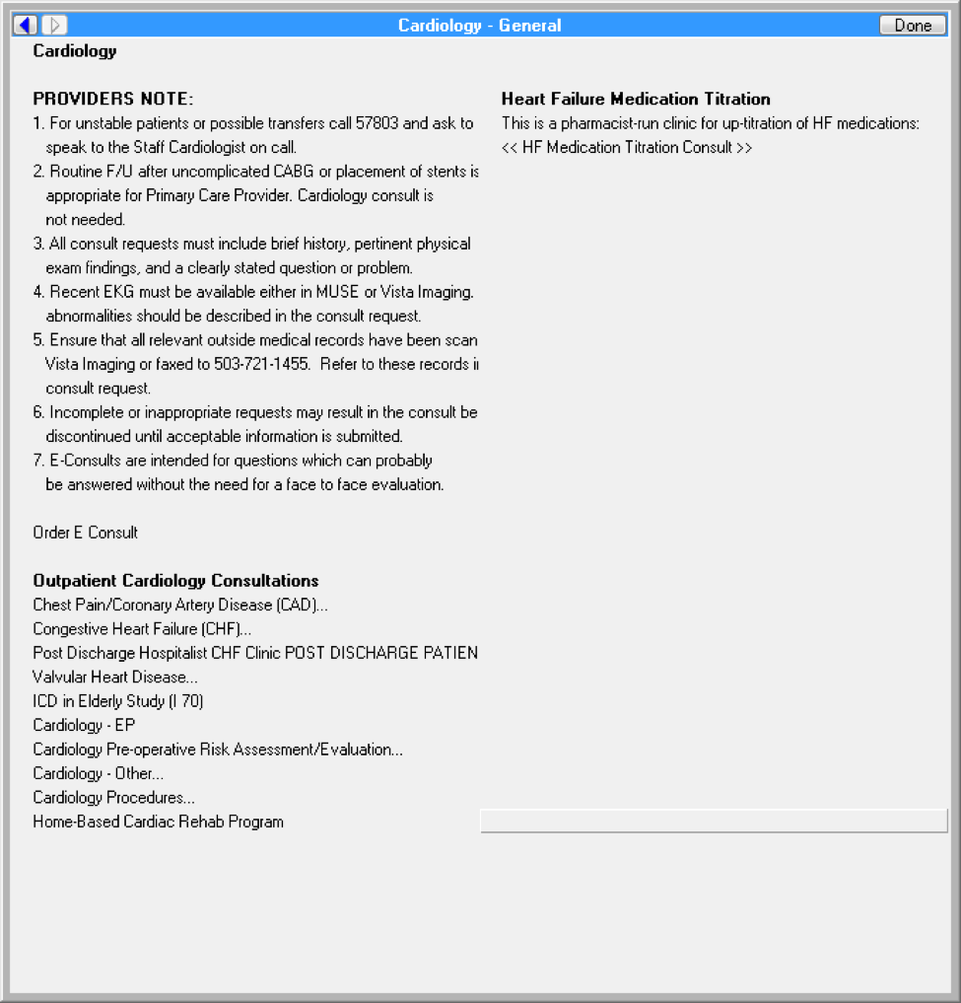

**Figure A.2. Chest Pain (CP)/Coronary Artery Disease (CAD) Screenshot**

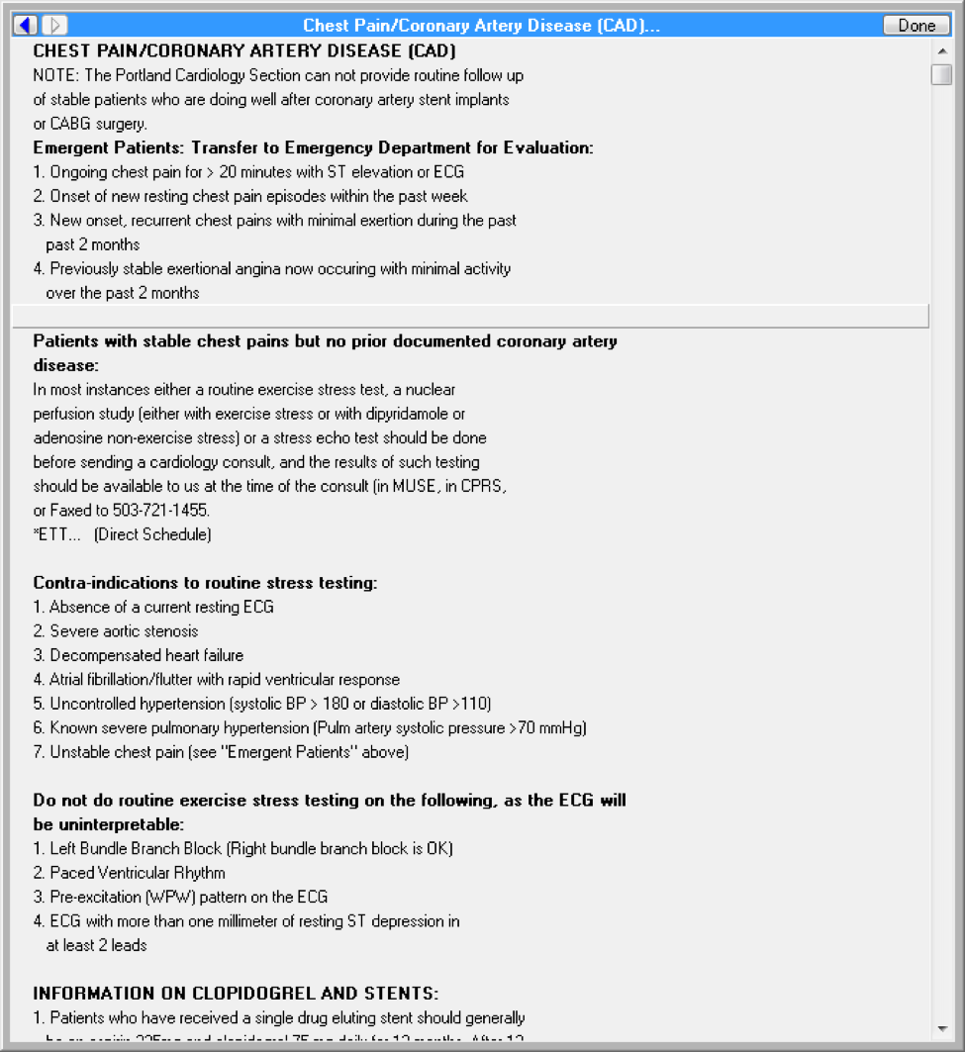

**Figure A.3. Chest Pain (CP)/Coronary Artery Disease (CAD) Screenshot with Contraindications**

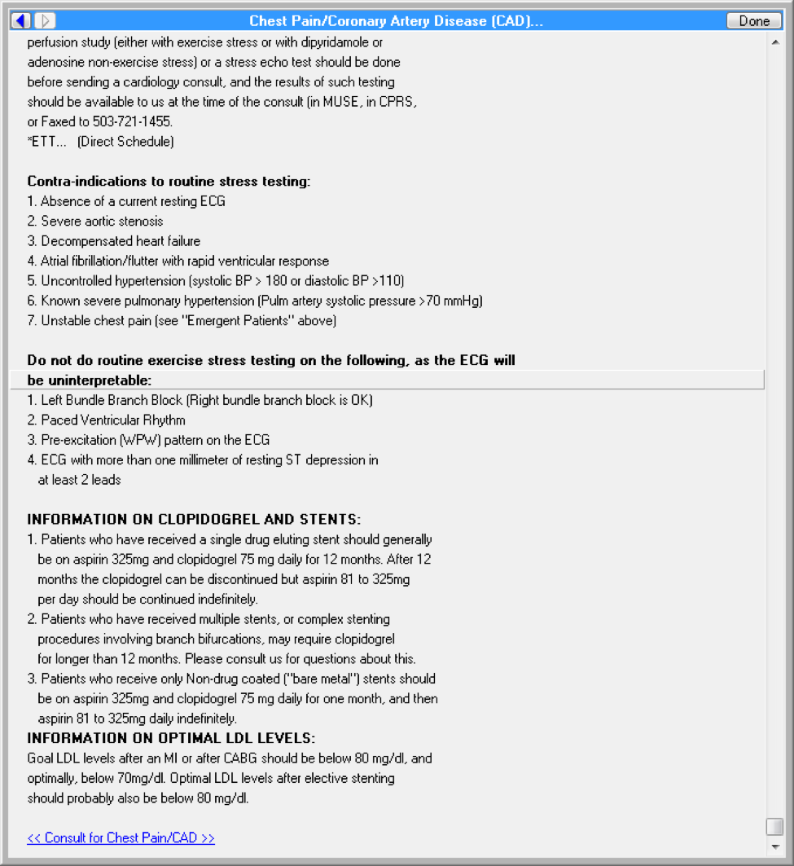

**Figure A.4. Cardiology ETT Procedure**

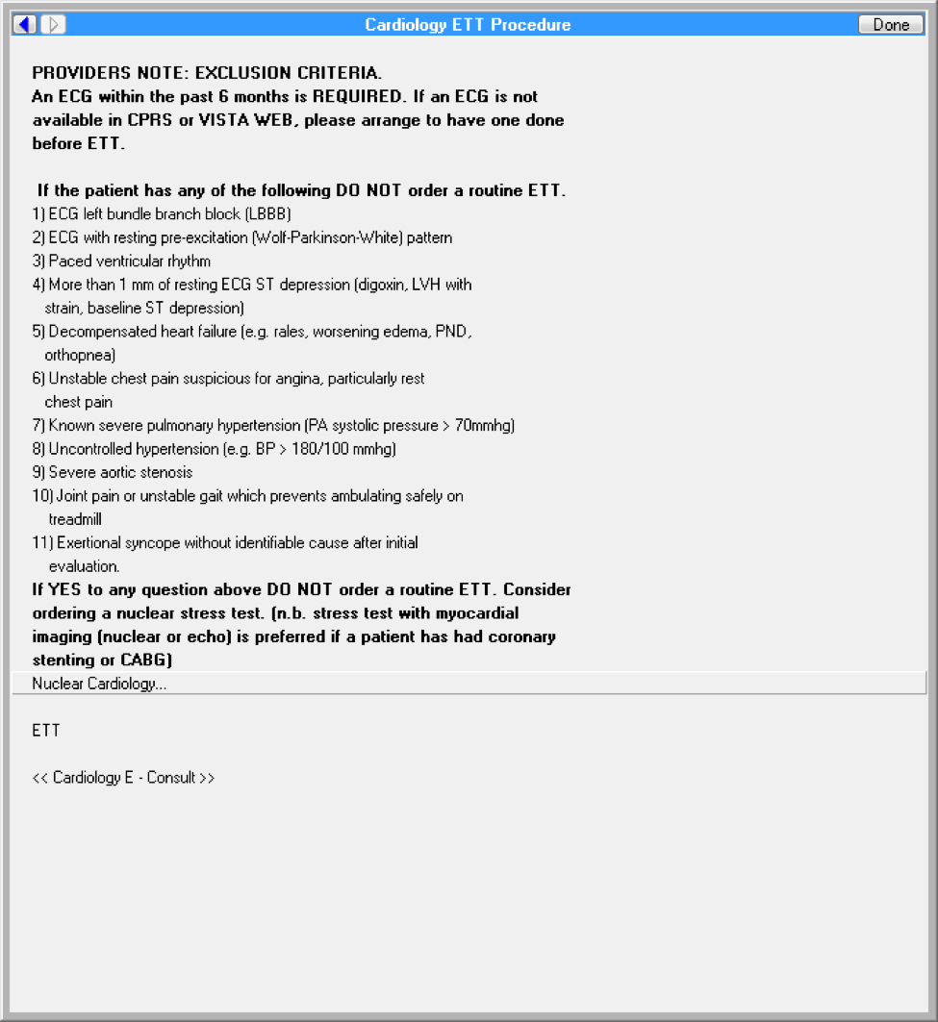

**Figure A.5. Order a Procedure**

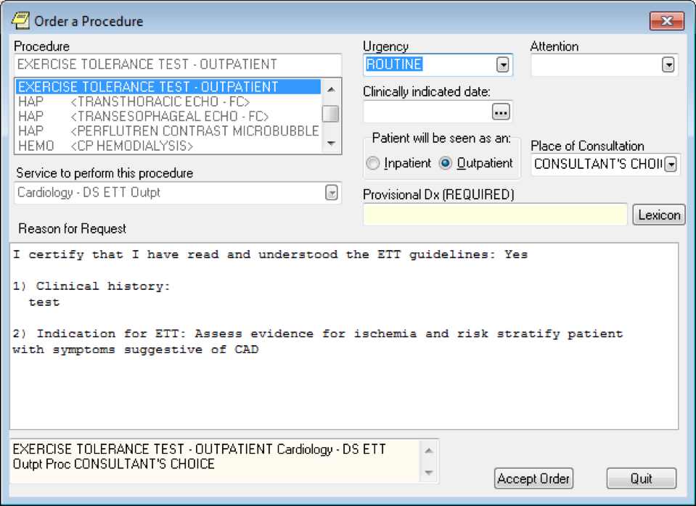

**Figure A.6. ETT Request Screenshot**

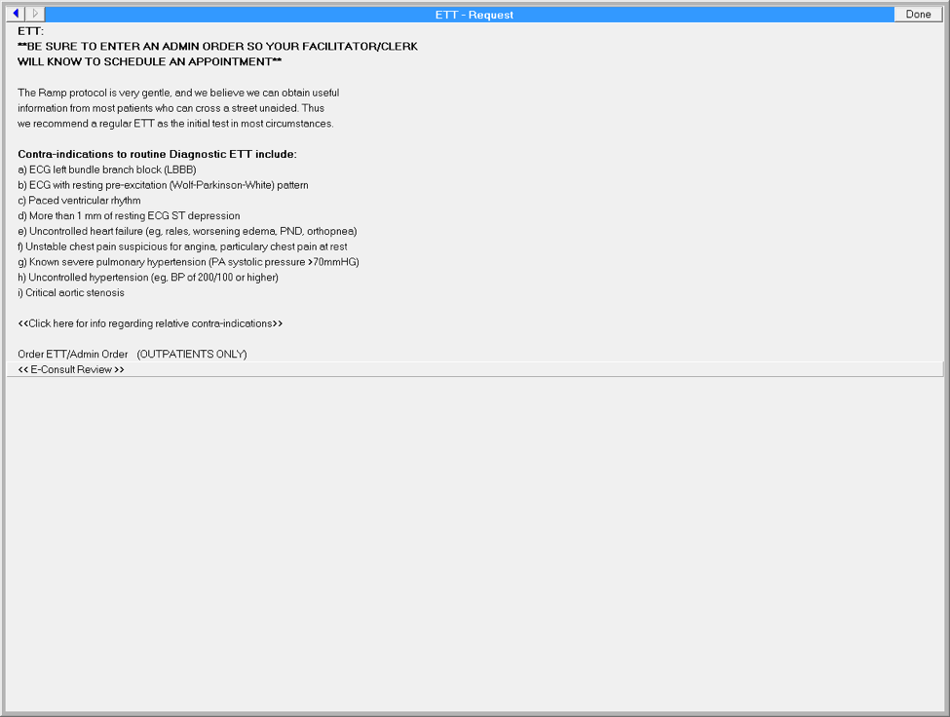

**Figure A.7. Reason for Request: Cardiology - General Output**

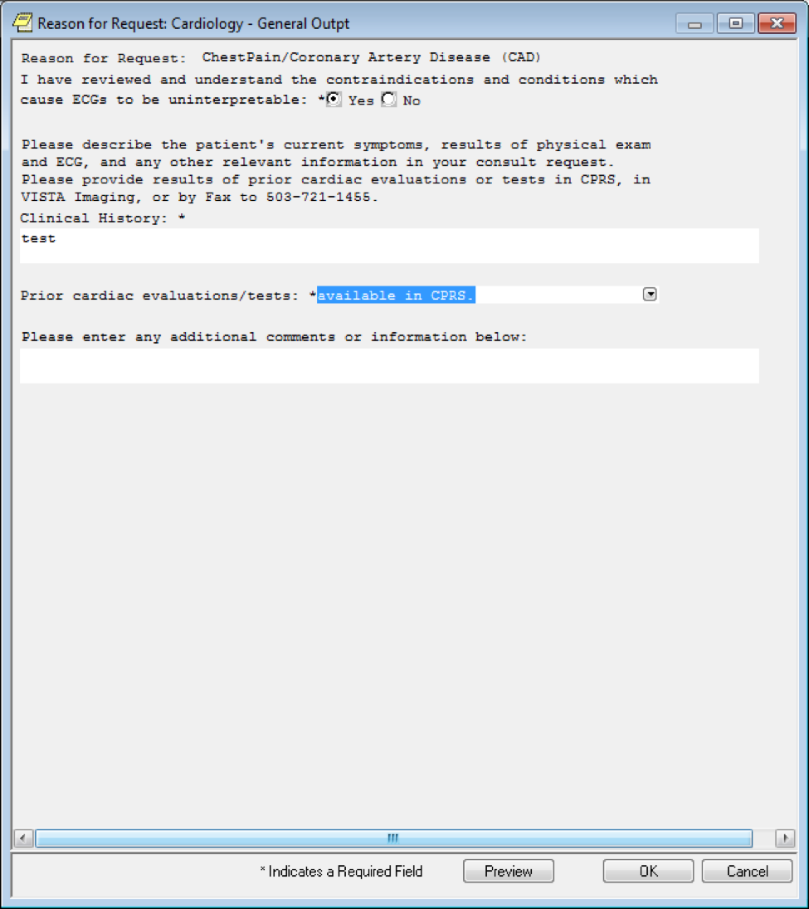

**Figure A.8. Order a Consult Screenshot for Cardiology**

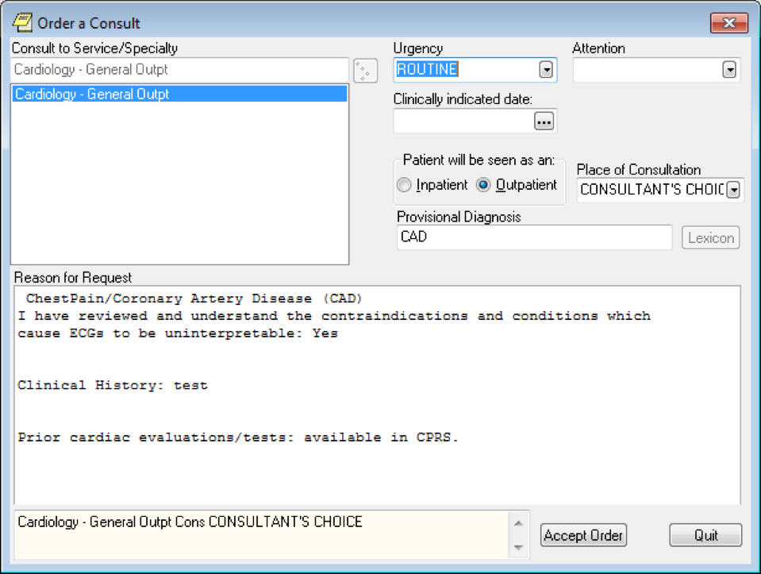

**Figure A.9. Consult to Service/Specialty Screen**

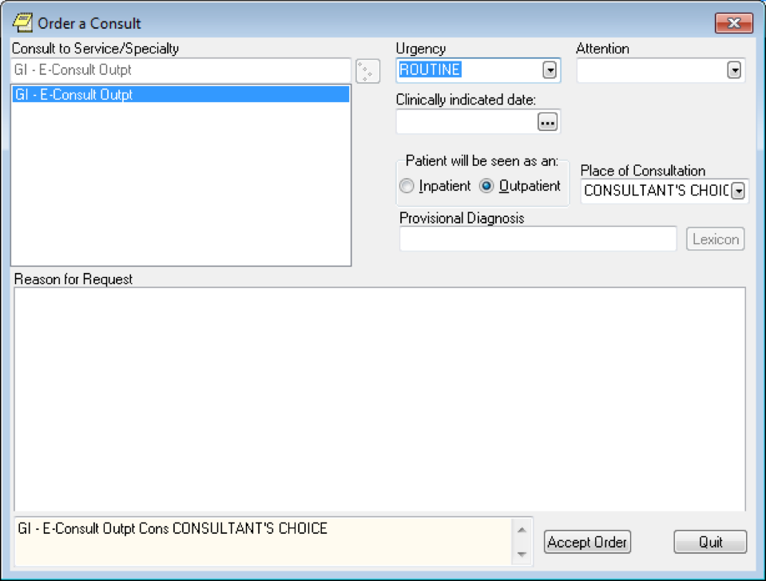

**Appendix B. Glossary**

| **Acronym/Term** | **Description** |
| --- | --- |
| ACC | American College of Cardiology |
| ACS | Acute coronary syndrome |
| AHA | American Heart Association |
| CABG | Coronary artery bypass grafting |
| CAD | Coronary Artery Disease |
| CDS | Clinical Decision Support |
| CHF | Congestive Heart Failure |
| CP | Chest Pain |
| cCTA | Coronary Computed Tomography Angiography |
| CTA | Computed tomography angiography |
| CT-FFR | Computed tomography-fractional flow reserve |
| ECG | Electrocardiogram |
| HL7 | Health Level 7 |
| HPI | History of present illness |
| IVCD | Interventricular Conduction Delay |
| LBBB | Left bundle branch block |
| KBS | Knowledge Based Systems |
| KNART | Knowledge Artifact |
| MI | Myocardial infarction |
| MPI | Myocardial Perfusion Imaging |
| OIIG | Office of Informatics and Information Governance |
| PCI | Percutaneous Coronary Intervention |
| PPM | Permanent pacemaker |
| SME | Subject Matter Expert |
| TO | Task Order |
| VA | Department of Veteran Affairs |
| VAMC | VA Medical Center |