**Clinical Decision Support (CDS) Content and Health Level 7 (HL7)-Compliant Knowledge Artifacts (KNARTs)**

**Cardiology: Electrophysiology (*****EP*****) Implanted Cardiac Devices Clinical Content White Paper**

**Department of Veterans Affairs (*****VA*****)**



**Knowledge Based Systems (*****KBS*****)**

**Office of Informatics and Information Governance (*****OIIG*****)**

**Clinical Decision Support (*****CDS*****)**

**Clinical Decision Support (CDS) Content and Health Level 7 (HL7)-Compliant Knowledge Artifacts (KNARTs): Cardiology: Electrophysiology (*****EP*****) Implanted Cardiac Devices Clinical Content White Paper**

by Department of Veterans Affairs (*VA*)

Publication date April 2018

**Contract: VA118-16-D-1008, Task Order (*****TO*****): VA-118-16-F-1008-0007**

**Table 1. Relevant KNART Information: Cardiology: Electrophysiology (*****EP*****) Implanted Cardiac Devices**

| **KNART** **Name** | **Associated CLIN** |
| --- | --- |
| *EP* Primary Prevention Implantable cardioverter-defibrillator (*ICD*) Implant - Order Set | CLIN0004AB |
| *EP* Pacemaker/*ICD* Follow Up - Order Set | CLIN0004AB |
| *EP* Pacemaker/*ICD* Generator Change - Order Set | CLIN0004AB |

**Table of Contents**

VA Subject Matter Expert (*[SME](#d0e192)*) Panel vi

Introduction vii

Conventions Used viii

1. Cardiology: Electrophysiology ([*EP*](#d6e416)): Implanted Cardiac Devices 1

1.1. Clinical Context 1

1.2. Knowledge Artifacts 1

2. Order Set: Electrophysiology ([*EP*](#d6e416)) Primary Prevention Implantable Cardioverter-defibrillator ([*ICD*](#d6e470)) 2

2.1. Knowledge Narrative 2

2.2. Applicability 2

2.3. Consults and Referrals 2

2.4. Imaging and Electrocardiogram ([*ECG*](#d6e26)) 3

2.5. Laboratory Tests 3

3. Order Set: Electrophysiology ([*EP*](#d6e416)) Pacemaker/Implantable Cardioverter-defibrillator ([*ICD*](#d6e470)) Follow Up 5

3.1. Knowledge Narrative 5

3.2. Applicability 5

3.3. Consults and Referrals 5

3.4. Imaging and Electrocardiogram ([*ECG*](#d6e26)) 6

3.5. Laboratory Tests 6

4. Order Set: Electrophysiology ([*EP*](#d6e416)) Pacemaker/Implantable Cardioverter-defibrillator ([*ICD*](#d6e470)) Generator Change 8

4.1. Knowledge Narrative 8

4.2. Applicability 8

4.3. Consults and Referrals 8

4.4. Imaging and Electrocardiogram ([*ECG*](#d6e26)) 9

4.5. Laboratory Tests 9

Bibliography/Evidence 10

A. Existing Sample [*VA*](#d6e758) Artifacts 11

B. Basic Laboratory Panel Definition 16

Acronyms 17

**List of Figures**

A.1. Cardiology Electrophysiology Guideline Links 11

A.2. Pacemaker/Implantable cardioverter-defibrillator ([*ICD*](#d6e470)) Follow Up Consult Order 12

A.3. Template: Cardiology Consult for Arrhythmia (image 1 of 2) 13

A.4. Template: Cardiology Consult for Arrhythmia (image 2 of 2) 14

A.5. Cardiology Consult Order for Implantable cardioverter-defibrillator ([*ICD*](#d6e470))/Pacemaker Follow Up 15

**List of Tables**

1. Summary of Cardiology: Electrophysiology (*[EP](#d0e56)*) Implanted Cardiac Devices *[KNARTs](#d0e56)* ii

1.1. Clinical Context Domains 1

**VA Subject Matter Expert (*****SME*****) Panel**

| **Name** | **Title** | **Project Role** |
| --- | --- | --- |
| Bruce Bray, MD | Professor, Cardiovascular Medicine, University of Utah School of Medicine; Staff Cardiologist, Salt Lake City VA Medical Center (*VAMC*), 500 Foothill Drive, Salt Lake City, Utah 84148 | *SME*, Primary |
| Scott Wall, MD | Assistant Professor, Cardiovascular Medicine, University of Utah; School of Medicine Staff Cardiologist, Electrophysiology, Salt Lake City *VAMC*, 500 Foothill Drive, Salt Lake City, Utah 84148 | *SME*, Secondary |
| Aiden Abidov, MD, PhD | Professor of Medicine, Wayne State University; Section Chief, Cardiology, John Dingell *VAMC* | *SME* |

**Introduction**

The *VA* is committed to improving the ability of clinicians to provide care for patients while increasing quality, safety, and efficiency. Recognizing the importance of standardizing clinical knowledge in support of this goal, *VA* is implementing the Health Level 7 (*HL7*) Knowledge Artifact Specification for a wide range of *VA* clinical use cases. Knowledge Artifacts, referred to as KNARTs, enable the structuring and encoding of clinical knowledge so the knowledge can be integrated with electronic health records to enable clinical decision support.

The purpose of this Clinical Content White Paper (*CCWP*) is to capture the clinical context and intent of *KNART* use cases in sufficient detail to provide the *KNART* authoring team with the clinical source material to construct the corresponding knowledge artifacts using the *HL7* Knowledge Artifact Specification. This paper has been developed using material from a variety of sources: *VA* artifacts, clinical practice guidelines, evidence in the body of medical literature, and clinical expertise. After reviewing these sources, the material has been synthesized and harmonized under the guidance of *VA* *SME*s to reflect clinical intent for this use case.

Unless otherwise noted, items within this white paper (e.g., documentation template fields, orderable items, etc.) are chosen to reflect the clinical intent at the time of creation. To provide an exhaustive list of all possible items and their variations is beyond the scope of this work.

**Conventions Used**

Conventions used within the knowledge artifact descriptions include:

*<obtain>*: Indicates a prompt to obtain the information listed

* If possible, the requested information should be obtained from the underlying system(s). Otherwise, prompting the user for information may be required
* The technical and clinical notes associated with a section should be consulted for specific constraints on the information (e.g., time-frame, patient interview, etc.)
* Default Values: Unless otherwise noted, <obtain> indicates to obtain the most recent observation. It is recognized that this default time-frame value may be altered by future implementations

*[...]*: Square brackets enclose explanatory text that indicates some action on the part of the clinical user, or general guidance to the clinical or technical teams. Examples include, but are not limited to:

*[Begin ...]*, *[End ...]*: Indicates the start and end of specific areas to clearly delineate them for technical purposes.

*[Activate ...]*: Initiates another knowledge artifact or knowledge artifact section.

*[Section Prompt: ...]*: If this section is applicable, then the following prompt should be displayed to the user.

*[Section Selection Behavior: ...]*: Indicates technical constraints or considerations for the selection of items within the section.

*[Attach: ...]*: Indicates that the specified item should be attached to the documentation template if available.

*[Link: ...]*: Indicates that rather than attaching an item, a link should be included in the documentation template.

*[Clinical Comment: ...]*: Indicates clinical rationale or guidance.

*[Technical Note: ...]*: Indicates technical considerations or notes.

*[If ...]*: Indicates the beginning of a conditional section.

*[Else, ...]*: Indicates the beginning of the alternative branch of a conditional section.

*[End if ...]*: Indicates the end of a conditional section.

☐ *[Check box]*: Indicates items that should be selected based upon the section selection behavior.

**Chapter 1. Cardiology: Electrophysiology (*****EP*****): Implanted Cardiac Devices**

**1.1. Clinical Context**

[Begin Clinical Context.]

The Cardiology *EP*: Implanted Cardiac Devices order set KNARTs are intended for clinical providers caring for adult outpatients in the context of implanted cardiac devices [e.g., pacemakers, implantable cardioverter-defibrillators (*ICD*), cardiac resynchronization therapy (*CRT*) devices, etc.]. Specific constraints for these artifacts are that they apply to:

* Outpatients with existing pacemaker/*CRT*/*ICD* implants
* Outpatients being considered for *ICD*/*CRT* implants for primary prevention

These context domains are summarized in the table below.

**Table 1.1. Clinical Context Domains**

|  |  |
| --- | --- |
| **Target User** | Provider in a Primary Care Clinic or General Cardiology |
| **Patient** | Adult patient with a Pacemaker/*CRT*/*ICD* implant or adult patient being considered for an *ICD*/*CRT* implant for primary prevention |
| **Priority** | Routine |
| **Specialty** | Primary Care/Cardiology |
| **Location** | Outpatient |

[End Clinical Context.]

**1.2. Knowledge Artifacts**

[Begin Knowledge Artifacts.]

This section describes the *CDS* knowledge artifacts that are part of the Cardiology *EP*: Implanted Cardiac Device group. They include:

* Order Sets: Cardiology: *EP* Primary Prevention *ICD* Implant, *EP* Pacemaker/*ICD* Follow Up, and *EP* Pacemaker/*ICD* Generator Change KNARTs
* Orderable items
* Includes logic for appropriate display of the order set

[End Knowledge Artifacts.]

**Chapter 2. Order Set: Electrophysiology (*****EP*****) Primary Prevention Implantable Cardioverter-defibrillator (*****ICD*****)**

[Begin Order Set: Electrophysiology (*EP*) Primary Prevention Implantable Cardioverter-defibrillator (*ICD*).]

**2.1. Knowledge Narrative**

[Begin Knowledge Narrative.]

[See Clinical Context in Chapter 1.]

Implantable cardioverter-defibrillator (*ICD*) placement for primary prevention of sudden death is recommended for high-risk patients with cardiomyopathy, even in the absence of a prior life-threatening arrhythmia event. *ICD* placement for secondary prevention of sudden cardiac death is appropriate after a cardiac arrest event (Epstein 2008, Russo 2013). While *ICD* placement is a proven, life-saving therapy (Epstein 2008), evidence suggests *ICD*s are often placed in patients who do not meet guideline criteria (Al-Khatib 2011). Conversely, many patients who meet criteria are not receiving *ICD*s (Hess 2016; Hess 2013). At a cost of roughly $30,000 to $50,000 per procedure (Owens 2011) and with potential for serious complications (Al-Khatib 2011), the financial and human costs of misallocation are considerable.

[End Knowledge Narrative.]

**2.2. Applicability**

[Begin Applicability.]

[Section Prompt: This order set is applicable for adult outpatients at increased risk of sudden cardiac death and under consideration for:

* *ICD* [e.g., ejection fraction (*EF*) <35%, hypertrophic cardiomyopathy, etc.]

* *CRT* (including patients that meet criteria for upgrade of their currently implanted device).]

[Technical Note: clinical providers should be directed to review the American College of Cardiology (*ACC*)/Heart Rhythm Society (*HRS*)/American Heart Association (*AHA*)/American Society of Echocardiography (*ASE*)/Heart Failure Society of America (*HFSA*)/Society for Cardiovascular Angiography and Interventions (*SCAI*)/Society of Cardiovascular Computed Tomography (*SCCT*)/Society for Cardiovascular Magnetic Resonance (*SCMR*) 2013 Appropriate Use Criteria for Implantable Cardioverter-Defibrillators and Cardiac Resynchronization Therapy. The criteria can be accessed at https://www.clinicalkey.com/service/content/pdf/watermarked/1-s2.0-S073510971206041X.pdf?locale=en_US.]

[End Applicability.]

**2.3. Consults and Referrals**

[Begin Consults and Referrals.]

***Device Placement Referral***

[Section Prompt: Electrophysiology device placement referral.]

[Technical Note: Display link to e-Consult if available.]

[Section Selection Behavior: Select only one.]

☐ Referral electrophysiology placement of *ICD* device

☐ Referral electrophysiology placement of *CRT* device

***Consultation Goal***

[Section Prompt: Specific goal of the electrophysiology consultation (e.g., electrophysiology to manage patient, cardiology to evaluate and recommend management, etc.).]

[Section Prompt: Goal of Consult.]

[Section Selection Behavior: Select one. Required.]

☐ Provide recommendation and return to Referring Physician for therapy

☐ Start treatment and return to Referring Physician for follow up and maintenance

☐ Start treatment, monitor for effect and when on stable therapy return to Referring Physician

☐ Provide recommendations and treat as long as necessary (or indefinitely)

Consult Specialty: Electrophysiology

Priority: Routine

[Section Prompt: Referring Physician Information]

<obtain> Referring Physician Name

<obtain> Referring Physician Contact Information

<obtain> Information required by receiving facility

[End Consults and Referrals.]

**2.4. Imaging and Electrocardiogram (*****ECG*****)**

[Begin Imaging and Electrocardiogram (*ECG*).]

[Section Prompt: Consider ordering prior to the electrophysiology consultation. Resting 12-lead electrocardiogram is required if it has not been obtained within the past two months. Resting echocardiogram and chest x-ray are required if they have not been obtained within the past six months.]

[Section Selection Behavior: More than one may be selected. Optional.]

☐ Electrocardiogram to evaluate for potential *ICD*/*CRT* device implantation

☐ Echocardiogram to evaluate for potential *ICD*/*CRT* device implantation

☐ X-ray chest to evaluate for potential *ICD*/*CRT* device implantation

[End Imaging and Electrocardiogram (*ECG*).]

**2.5. Laboratory Tests**

[Begin Laboratory Tests.]

[Section Prompt: Consider the following tests to be completed prior to the electrophysiology consultation.]

[Section Selection Behavior: More than one may be selected. Optional. Tests are routine unless otherwise specified.]

☐ Comprehensive metabolic panel

☐ Complete blood count

☐ Brain natriuretic peptide

☐ Prothrombin Time/International Normalized Ratio (*INR*)

[End Laboratory Tests.]

[End Order Set: Electrophysiology (*EP*) Primary Prevention Implantable Cardioverter-defibrillator (*ICD*).]

**Chapter 3. Order Set: Electrophysiology (*****EP*****) Pacemaker/Implantable Cardioverter-defibrillator (*****ICD*****) Follow Up**

[Begin Order Set: Electrophysiology (*EP*) Pacemaker/Implantable Cardioverter-defibrillator (*ICD*) Follow Up.]

**3.1. Knowledge Narrative**

[Begin Knowledge Narrative.]

[See Clinical Context in Chapter 1.]

All patients with implanted cardiac devices require periodic and meticulous follow-up to ensure safety and optimal device performance. The goals of *ICD* follow-up include monitoring device system function, optimizing performance for maximal clinical effectiveness and system longevity, minimizing complications, anticipating replacement of system components, ensuring timely intervention for clinical problems, patient tracking, education, and support, and maintenance of *ICD* system records.

[End Knowledge Narrative.]

**3.2. Applicability**

[Begin Applicability.]

[Section Prompt: This order set is applicable to adult outpatients who have previously received an *ICD*, *CRT*, or a similar device, and who are not currently followed by electrophysiology.]

[End Applicability.]

**3.3. Consults and Referrals**

[Begin Consults and Referrals.]

***EP Follow-up Referral***

[Section Prompt: Electrophysiology follow-up consult order.]

☐ Referral to Electrophysiology

***Reason for Consultation***

[Section Prompt: Reason for Electrophysiology consultation.]

[Section Selection Behavior: Only one may be selected. At least one must be selected.]

☐ Follow-up for *ICD*

☐ Follow-up for *CRT* device

☐ Follow-up for pacer device

<obtain> Procedure report for device placement

***Consultation Goal***

[Section Prompt: Specific goal of the electrophysiology consultation (e.g., electrophysiology to manage patient, cardiology to evaluate and recommend management, etc.).]

[Section Prompt: Goal of Consult.]

[Section Selection Behavior: Select one. Required.]

☐ Provide recommendation and return to Referring Physician for therapy

☐ Start treatment and return to Referring Physician for follow up and maintenance

☐ Start treatment, monitor for effect and when on stable therapy return to Referring Physician

☐ Provide recommendations and treat as long as necessary (or indefinitely)

Consult Specialty: Electrophysiology

Priority: Routine

[Section Prompt: Referring Physician Information]

<obtain> Referring Physician Name

<obtain> Referring Physician Contact Information

<obtain> Information required by receiving facility

[End Consults and Referrals.]

**3.4. Imaging and Electrocardiogram (*****ECG*****)**

[Begin Imaging and Electrocardiogram (*ECG*).]

[Section Prompt: Consider ordering prior to the electrophysiology consultation. Resting 12-lead electrocardiogram is required if it has not been obtained within the past two months. Resting echocardiogram and chest x-ray are required if they have not been obtained within the past six months.]

[Section Selection Behavior: More than one may be selected. Optional.]

☐ Resting 12-lead electrocardiogram to evaluate for antiarrhythmic benefit of previously implanted *ICD*/pacer/*CRT* device

☐ Echocardiogram to evaluate for antiarrhythmic benefit of previously implanted *ICD*/pacer/*CRT* device

☐ X-ray chest to evaluate for antiarrhythmic benefit of previously implanted *ICD*/*CRT*/pacer device

[End Imaging and Electrocardiogram (*ECG*).]

**3.5. Laboratory Tests**

[Begin Laboratory Tests.]

[Section Prompt: Consider the following tests to be completed prior to the electrophysiology consultation.]

[Section Selection Behavior: More than one may be selected. Optional. Tests are routine unless otherwise specified.]

☐ Comprehensive metabolic panel

☐ Complete blood count

☐ Brain natriuretic peptide

☐ Digoxin level

[End Laboratory Tests.]

[End Order Set: Electrophysiology (*EP*) Pacemaker/Implantable Cardioverter-defibrillator (*ICD*) Follow Up.]

**Chapter 4. Order Set: Electrophysiology (*****EP*****) Pacemaker/Implantable Cardioverter-defibrillator (*****ICD*****) Generator Change**

[Begin Order Set: Electrophysiology (*EP*) Pacemaker/Implantable Cardioverter-defibrillator (*ICD*) Generator Change.]

**4.1. Knowledge Narrative**

[Begin Knowledge Narrative.]

[See Clinical Context in Chapter 1.]

Patients who have previously received an *ICD*, cardiac resynchronization therapy plus *ICD* (*CRT*), or similar device, may be identified as candidates for a generator change. If this identification occurs outside of a routine electrophysiology follow-up, this order set provides a standard framework for referring the patient to electrophysiology.

[End Knowledge Narrative.]

**4.2. Applicability**

[Begin Applicability.]

[Section Prompt: This order set is applicable to an adult outpatient who has previously received an *ICD*, cardiac resynchronization therapy plus *ICD* (*CRT*), or similar device, and has been identified as a candidate for a generator change based upon the patient's records or history.]

[End Applicability.]

**4.3. Consults and Referrals**

[Begin Consults and Referrals.]

[Section Prompt: Electrophysiology generator change consult order.]

☐ Referral to electrophysiology for generator change

<obtain> Operative report for device placement

<obtain> Currently implanted device interrogation report

[Section Prompt: Specific goal of the electrophysiology consultation (e.g., electrophysiology to manage patient, cardiology to evaluate and recommend management, etc.).]

[Section Prompt: Goal of Consult.]

[Section Selection Behavior: Select one. Required.]

☐ Provide recommendation and return to Referring Physician for therapy

☐ Start treatment and return to Referring Physician for follow up and maintenance

☐ Start treatment, monitor for effect and when on stable therapy return to Referring Physician

☐ Provide recommendations and treat as long as necessary (or indefinitely)

Consult Specialty: Electrophysiology

Priority: Routine

[Section Prompt: Referring Physician Information]

<obtain> Referring Physician Name

<obtain> Referring Physician Contact Information

<obtain> Information required by receiving facility

[End Consults and Referrals.]

**4.4. Imaging and Electrocardiogram (*****ECG*****)**

[Begin Imaging and Electrocardiogram (*ECG*).]

[Section Prompt: Consider ordering prior to the electrophysiology consultation. Resting 12-lead electrocardiogram is required if it has not been obtained within the past two months. Resting echocardiogram and chest x-ray are required if they have not been obtained within the past six months.]

[Section Selection Behavior: More than one may be selected. Optional.]

☐ Resting 12-lead electrocardiogram to evaluate for antiarrhythmic benefit of previously implanted *ICD*/pacer/*CRT* device

☐ Echocardiogram to evaluate for antiarrhythmic benefit of previously implanted *ICD*/pacer/*CRT* device

☐ X-ray chest to evaluate for antiarrhythmic benefit of previously implanted *ICD*/*CRT*/pacer device

[End Imaging and Electrocardiogram (*ECG*).]

**4.5. Laboratory Tests**

[Begin Laboratory Tests.]

[Section Prompt: Consider completing the following tests prior to the electrophysiology consultation.]

[Section Selection Behavior: More than one may be selected. Optional. Tests are routine unless otherwise specified.]

☐ Comprehensive metabolic panel

☐ Complete blood count

☐ Brain natriuretic peptide

☐ Digoxin level

[End Laboratory Tests.]

[End Order Set: Electrophysiology (*EP*) Pacemaker/Implantable Cardioverter-defibrillator (*ICD*) Generator Change.]

**Bibliography/Evidence**

[Al-Khatib, 2011] SM Al-Khatib, A Hellkamp, J Curtis, and et al. “Non–Evidence-Based *ICD* Implantations in the United States”. *JAMA*. 2011. 305. 1. 43-49.

[Epstein, 2008] AE Epstein, JP DiMarco, KA Ellenbogen, and et al. “*ACC*/*AHA*/*HRS* 2008 Guidelines for Device-Based Therapy of Cardiac Rhythm Abnormalities: a report of the American College of Cardiology/American Heart Association Task Force on Practice Guidelines [Writing Committee to Revise the *ACC*/*AHA*/National Association for Sport and Physical Education (*NASPE*) 2002 Guideline Update for Implantation of Cardiac Pacemakers and Antiarrhythmia Devices]: developed in collaboration with the American Association for Thoracic Surgery and Society of Thoracic Surgeons”. *Circulation*. 2008. 117. 21. e350-e408.

[Hess, 2013] PL Hess, MV Grau-Sepulveda, AF Hernandez, and et al. “Get with The Guidelines Steering Committee and Hospitals. Age differences in the use of implantable cardioverter-defibrillators among older patients hospitalized with heart failure”. *J Cardiovasc Electrophysiol*. 2013. 24. 6. 664-671.

[Hess, 2016] PL Hess, AF Hernandez, DL Bhatt, and et al. “Sex and Race/Ethnicity Differences in Implantable Cardioverter-Defibrillator Counseling and Use Among Patients Hospitalized with Heart Failure: Findings from the Get with The Guidelines-Heart Failure Program”. *Circulation*. 2016. 134. 7. 517-526.

[Owens, 2011] DK Owens, A Qaseem, R Chou, P Shekelle, and Clinical Guidelines Committee of the American College of Physicians. “AHigh-value, cost-conscious health care: concepts for clinicians to evaluate the benefits, harms, and costs of medical interventions”. *Ann Intern Med*. 2011. 154. 3. 174-180.

[Russo, 2013] AM Russo, RF Stainback, and SR, et al. Bailey. “American College of Cardiology Foundation (*ACCF*)/*HRS*/*AHA*/*ASE*/*HFSA*/*SCAI*/*SCCT*/*SCMR* 2013 appropriate use criteria for implantable cardioverter-defibrillators and cardiac resynchronization therapy: a report of the American College of Cardiology Foundation appropriate use criteria task force, Heart Rhythm Society, American Heart Association, American Society of Echocardiography, Heart Failure Society of America, Society for Cardiovascular Angiography and Interventions, Society of Cardiovascular Computed Tomography, and Society for Cardiovascular Magnetic Resonance”. *J Am Coll Cardiol*. 2013. 61. 12. 1318-1368.

**Appendix A. Existing Sample** ***VA*** **Artifacts**

**Figure A.1. Cardiology Electrophysiology Guideline Links**

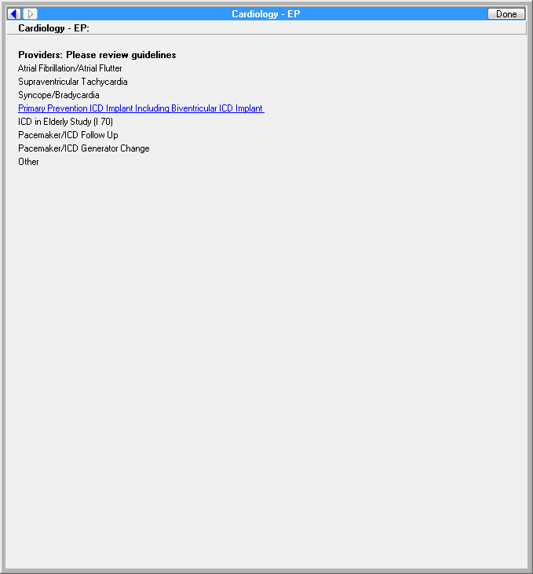

**Figure A.2. Pacemaker/Implantable cardioverter-defibrillator (*****ICD*****) Follow Up Consult Order**

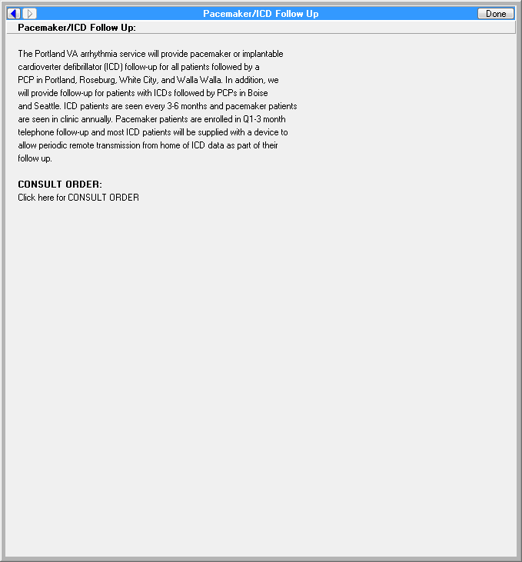

**Figure A.3. Template: Cardiology Consult for Arrhythmia (image 1 of 2)**

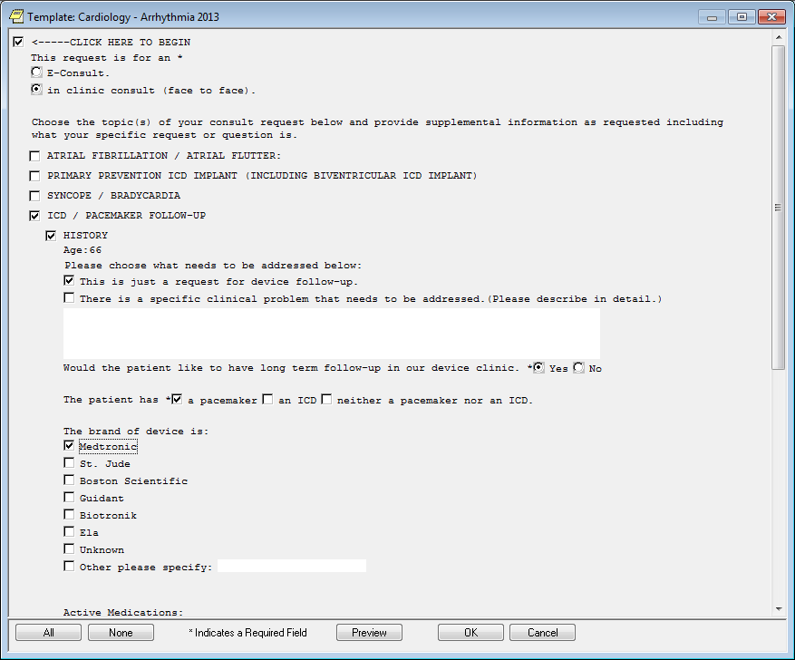

**Figure A.4. Template: Cardiology Consult for Arrhythmia (image 2 of 2)**

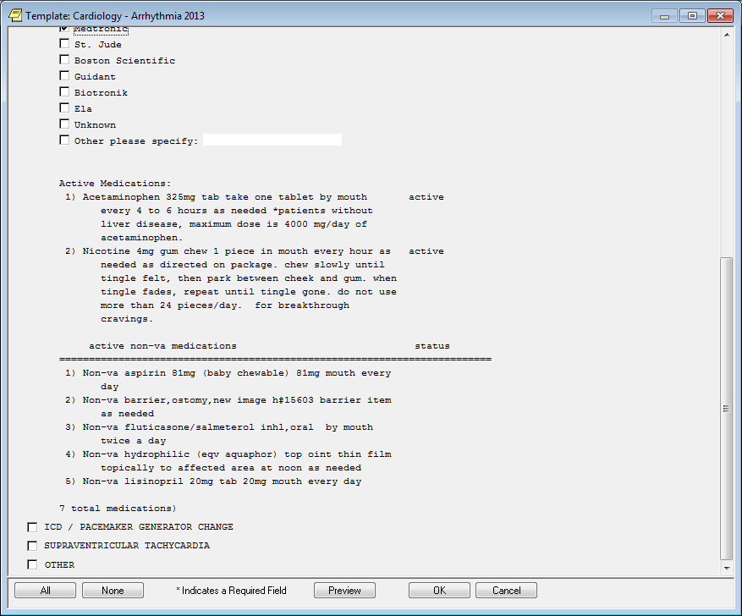

**Figure A.5. Cardiology Consult Order for Implantable cardioverter-defibrillator (*****ICD*****)/Pacemaker Follow Up**

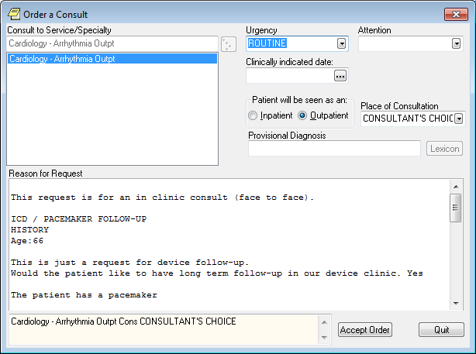

**Appendix B. Basic Laboratory Panel Definition**

* Blood Urea Nitrogen
* Calcium
* Chloride

* *CO2* (Carbon Dioxide, Bicarbonate)
* Creatinine
* Glucose
* Potassium
* Sodium

**Acronyms**

ACC American College of Cardiology

ACCF American College of Cardiology Foundation

AHA American Heart Association

ASE American Society of Echocardiography

CCWP Clinical Content White Paper

CDS Clinical Decision Support

CO2 Carbon Dioxide

CRT Cardiac Resynchronization Therapy

ECG Electrocardiogram

EF Ejection Fraction

EP Electrophysiology

HFSA Heart Failure Society of America

HL7 Health Level 7

HRS Heart Rhythm Society

ICD Implantable Cardioverter-Defibrillator

INR International Normalized Ratio

KBS Knowledge Based Systems

KNART Knowledge Artifact

KNARTs Knowledge Artifacts

NASPE National Association for Sport and Physical Education

OIIG Office of Informatics and Information Governance

PCP Primary Care Provider

SCAI Society for Cardiovascular Angiography and Interventions

SCCT Society of Cardiovascular Computed Tomography

SCMR Society for Cardiovascular Magnetic Resonance

SME Subject Matter Expert

TO Task Order

VA Department of Veteran Affairs

VAMC VA Medical Center