**Clinical Decision Support (CDS) Content and Health Level 7 (HL7)-compliant Knowledge Artifacts (KNARTS)**

**Cardiology: Pre-Op Risk Assessment Clinical Content White Paper**

Consisting of:

* Cardiology: Pre-Op Risk Assessment Documentation Template (B37, CLIN0005AC)
* Cardiology: Pre-Op Risk Assessment Order Set (B13, CLIN0004AC)
* Cardiology: Pre-Op Risk Assessment Consult Request (Composite KNART) (B58)

Contract: VA118-16-D-1008, Task Order (TO): VA-118-16-F-1008-0007

Department of Veterans Affairs (VA)

(VA color seal image)

Knowledge Based Systems (KBS)

Office of Informatics and Information Governance (OIIG)

Clinical Decision Support (CDS)

November, 2017

Version 1.0

**Clinical Decision Support (CDS) Content and Health Level 7 (HL7)-compliant Knowledge Artifacts (KNARTS): Cardiology: Pre-Op Risk Assessment Clinical Content White Paper**

Cardiology: Pre-Op Risk Assessment Documentation Template (B37, CLIN0005AC), Cardiology: Pre-Op Risk Assessment Order Set (B13, CLIN0004AC), Cardiology: Pre-Op Risk Assessment Consult Request (Composite) (B58)

Publication date December, 2017

**Table of Contents**

VA Subject Matter Expert Panel vi

Introduction vii

Conventions Used…………………………………………………………………………………….vii

1. Clinical Context: Cardiology Pre-op Risk Assessment 1

1. Knowledge Artifacts 1

2. Composite 3

1. Knowledge Narrative 3

2. Consult Request 3

3. Evidence 3

3. Documentation Template 4

1. Knowledge Narrative 4

2. Documentation Template Applicability 4

3. Procedure Risk 4

3.1. Low 4

3.2. Medium 5

3.3. High 5

4. Patient Risk 6

5. Laboratory Studies 7

6. Imaging and Diagnostic Studies 8

7. Evidence 9

4. Order Set 10

1. Knowledge Narrative 10

2. Order Set Applicability 10

3. Consults and Referrals 10

4. Risk Stratification 10

A. Appendix: Existing VA Artifacts 12

**List of Figures**

A.1. Provider's Note 12

A.2. Reason for Request: WEBLINK 13

A.3. Basic Surgical Risk Categorization 14

A.4. Met Equivalents 15

A.5. Template: Cardiology Pre-Op Service 16

A.6. Template: Cardiology Pre-Op Service 17

A.7. Template: Cardiology Pre-Op Service 18

A.8. Template: Cardiology Pre-Op Service 19

A.9. Order a Consult 20

A.10. Template: Cardiology Pre-Op Service 21

A.11. Template: Cardiology Pre-Op Service 22

A.12. Template: Cardiology Pre-Op Service 23

A.13. Order a Consult 24

**List of Tables**

1.1. Clinical Context Domains 1

3.1. Duke Activity Status Index (DASI)([Hlatky, 1989]) 6

**VA Subject Matter Expert Panel**

| **Name** | **Title** | **Project Role** |
| --- | --- | --- |
| Bruce Bray, MD | Professor, Cardiovascular Medicine University of Utah School of Medicine Staff Cardiologist, Salt Lake City VAMC | SME, Primary |
| Scott Wall, MD | Assistant Professor, Cardiovascular Medicine University of Utah School of Medicine Staff Cardiologist, Electrophysiology Salt Lake City VAMC | SME, Secondary |
| Aiden Abidov, MD, PhD | Professor of Medicine Wayne State University Section Chief, Cardiology John Dingell VA Medical Center | SME, Secondary |

**Introduction**

The VA is committed to improving the ability of clinicians to provide care for patients while increasing quality, safety, and efficiency. Recognizing the importance of standardizing clinical knowledge in support of this goal, VA is implementing the HL7 Knowledge Artifact Specification for a wide range of VA clinical use cases. Knowledge Artifacts, referred to as KNARTs, enable the structuring and encoding of clinical knowledge so the knowledge can be integrated with electronic health records to enable clinical decision support.

The purpose of this Clinical Content White Paper is to capture the clinical context and intent of KNART use cases in sufficient detail to provide the KNART authoring team with the clinical source material to construct the corresponding knowledge artifacts using the HL7 Knowledge Artifact Specification. This paper has been developed using material from a variety of sources: VA artifacts, clinical practice guidelines, evidence in the body of medical literature, and clinical expertise. After reviewing these sources, the material has been synthesized and harmonized under the guidance of VA subject matter experts to reflect clinical intent for this use case.

Unless otherwise noted, items within this white paper (e.g., documentation template fields, orderable items, etc.) are chosen to reflect the clinical intent at the time of creation. To provide an exhaustive list of all possible items and their variations is beyond the scope of this work.

**Conventions Used**

Conventions used within the knowledge artifact descriptions include:

•    <obtain>: Indicates a prompt to obtain the information listed

•     The requested information should be obtained from the underlying system(s), if possible. If not, prompting the user for information may be required.

•     The technical and clinical notes associated with a section should be consulted for specific constraints on the information (e.g., time-frame, patient interview, etc.).

* Default values: unless otherwise noted, <obtain> indicates to obtain the most recent observation. It is recognized that this default time-frame value may be altered by future implementations.

•    [...]: Square brackets enclose explanatory text that indicates some action on the part of the user, or general guidance to the clinical or technical teams. Examples include, but are not limited to:

• [Begin …], [End …]: The start and end of specific areas to clearly delineate them for technical purposes.

• [Activate …]: Initiate another knowledge artifact or knowledge artifact section.

• Section Prompt: ...]: If this section is applicable, then the following prompt should be displayed to the user.

• [Section Selection Behavior: ....]: Indicates technical constraints or considerations for the selection of items within the section.

• [Attach: ...]: The specified item should be attached to the documentation template if available.

• [Link: ...]: Rather than attaching, a link to the item should be included in the documentation template.

• [Clinical Comments]: Clinical rationale or guidance.

• [Technical Note: ...]: Technical considerations or notes.

• [If …]: The beginning of a conditional section.

• [Else, …]: The beginning of the alternative branch of a conditional section.

      • Check boxes:

Indicate items that should be selected based upon the section selection behavior.

**Chapter 1. Clinical Context: Cardiology Pre-op Risk Assessment**

Primary care providers benefit from a standardized approach for determining whether a patient should be referred to cardiology for an evaluation prior to an elective, non-cardiac surgery. Essentially, any non-low-risk patient who is undergoing a non-low-risk procedure should be referred to cardiology for a preoperative evaluation prior to non-cardiac surgery. The terms “non-low-risk patient” and “non-low-risk procedure” are defined within the documentation template, section 3 and 4 in chapter 3. The consult request portion of the knowledge artifact contains information pertinent to the consult.

The Cardiology Pre-op Risk Assessment group of KNARTs are intended for clinical providers caring for adult patients in a Primary Care Clinic who require referral to a cardiologist for preoperative medical clearance prior to non-cardiac surgery. This consult request as well as the associated documentation template and order set components are intended to ensure that a cardiology consultation is appropriate and, if so, that the necessary workup is initiated prior to a cardiology consultation for a preoperative evaluation. The intent of these artifacts is to ensure a minimum workup is initiated prior to a Cardiology Consultation. Specific constraints for these artifacts are that the artifacts:

* Apply to outpatients undergoing elective, non-cardiac surgery
* Are not appropriate for use for patients with acute coronary syndrome (ACS)
* Are not appropriate for use for patients requiring emergency surgery

These context domains are summarized in the table below.

**Clinical Context Domains**

|  |  |
| --- | --- |
| **Target User** | Provider in a Primary Care Clinic |
| **Patient** | Adult being considered for elective, non-emergent, non-cardiac surgery |
| **Priority** | Routine |
| **Specialty** | Primary Care |
| **Location** | Outpatient |

**1. Knowledge Artifacts**

This section describes the CDS knowledge artifacts that are part of the Cardiology Pre-Op Risk Assessment group, and include:

* A Cardiology: Pre-Op Risk Assessment Consult Request Composite KNART
* High-level, encompassing artifact which uses the Cardiology: Pre-Op Risk Assessment Documentation Template and the Cardiology: Pre-Op Risk Assessment Order Set
* A Cardiology: Pre-Op Risk Assessment Documentation Template KNART
* Documents the information provided by the referring provider
* Includes logic for appropriate display of documentation sections
* A Cardiology: Pre-Op Risk Assessment Order Set KNART
* Orderable items associated with the consult request
* Includes logic for appropriate display of the order set

**Chapter 2. Composite**

[Begin Composite.]

**1. Knowledge Narrative**

[See Clinical Context in Chapter 1.]

**2. Consult Request**

[Technical Note: The following list provides the basic components of the consult request. This is the high-level, encompassing artifact, and must be combined with the documentation template and order set to form a fully functional knowledge artifact.]

[Section Prompt: In order to initiate a Cardiology consult to evaluate a patient for a preoperative assessment for a non-cardiac elective surgery, please provide the following information.]

* Reason for Consult: Preoperative cardiovascular evaluation for adult candidate for non-cardiac surgery
* Consult Specialty: Cardiology
* Priority: Routine
* <obtain> Referring Physician<name>
* <obtain> Referring Physician Contact Information (including specialty and location if referring to outside of VA)

[Activate associated documentation template]

[End Composite.]

**Chapter 3. Documentation Template**

[Begin Documentation Template.]

**1. Knowledge Narrative**

[See Clinical Context in Chapter 1.]

The approach to the assessment of perioperative risk for patients undergoing non-cardiac surgery has been extensively codified and validated by the American College of Cardiology/American Heart Association (ACC/AHA). Additionally, several other instruments have been independently validated, are widely used, and may add further value (Hlatky 1989; Lee 1999). The ACC/AHA approach focuses largely on patient-specific factors, such as age and comorbidity (Fleisher 2014). Alternative procedure-specific approaches have also been developed by other organizations. Of these, the approach selected for use within this documentation template is the Modified Johns Hopkins Surgical Criteria (Donati 2004). These criteria suggest that a NON-LOW-RISK PATIENT who is undergoing a NON-LOW-RISK PROCEDURE should be referred to cardiology for a preoperative evaluation prior to non-cardiac surgery. A NON–LOW-RISK PATIENT is defined using the revised cardiac risk index (RCRI) as a patient with 2 or more Revised Cardiac Risk Index (RCRI) predictors. The RCRI predictors are: high-risk type of surgery, ischemic heart disease, history of congestive heart failure, history of cerebrovascular disease, insulin therapy for diabetes, and preoperative serum creatinine > 2 mg/dL. (Lee 1999.) A NON–LOW-RISK PROCEDURE is defined as any grade II or grade III surgery, based on the modified Johns Hopkins surgical criteria. (Donati 2004.)

**2. Documentation Template Applicability**

[Section Prompt: This documentation template is not applicable to emergency surgery patients or patients with an acute coronary syndrome. It is intended for patients anticipating an elective, non-cardiac surgery.]

**3. Procedure Risk**

[Begin Procedure Risk.]

[Section Prompt: With respect to the surgical procedure that the patient requires, define the procedure as Low, Medium or High surgical risk by selecting the appropriate checkbox from just one of the three category options shown below. Note that a “NON–LOW-RISK PROCEDURE” is defined as any surgery that is medium or high risk, based on the modified Johns Hopkins surgical criteria (Donati 2004). To assist the clinical provider in decision making, representative examples of procedures that would be defined as Low, Medium, or High risk appear below the checkbox options.]

[Section Selection Behavior: Only one checkbox from among Low, Medium, High should be checked. At least one checkbox must be checked.]

☐ Low: minimal to moderately invasive procedure

☐ Medium: moderately to significantly invasive procedures (Note: Medium Risk is a NON-LOW RISK Procedure)

☐ High: highly invasive procedure (Note: High Risk is a NON-LOW RISK Procedure)

The following are representative examples of procedures that would be considered Low, Medium, or High Risk. The list is not exhaustive, and does not supersede clinical judgement regarding the risk a particular surgical procedure carries.

|  |  |  |
| --- | --- | --- |
| **LOW Risk Procedures** | **MEDIUM Risk Procedures** | **HIGH Risk Procedures** |
| Breast biopsy | Thyroidectomy | Major orthopedic-spinal reconstruction |
| Removal of minor skin or subcutaneous lesions | Hysterectomy | Major reconstruction of the gastrointestinal tract |
| Myringotomy tubes | Myomectomy | Major genitourinary surgery (e.g., radical retropubic prostatectomy) |
| Hysteroscopy | Cystectomy | Major vascular repair without postoperative ICU stay |
| Cystoscopy | Cholecystectomy | Cardiothoracic procedure |
| Vasectomy | Laminectomy | Intracranial procedure |
| Fiber-optic bronchoscopy | Hip/knee replacement | Major procedure on the oropharynx |
| Diagnostic laparoscopy | Nephrectomy | Major vascular, skeletal, neurological repair |
| Dilation and curettage | Major laparoscopic procedures |  |
| Fallopian tube ligation | Resection/reconstructive surgery of the digestive tract |  |
| Arthroscopy |  |  |
| Inguinal hernia repair |  |  |
| Laparoscopic lysis of adhesion |  |  |
| Tonsillectomy/rhinoplasty] |  |  |
| Breast biopsy |  |  |

[End Procedure Risk.]

**4. Patient Risk**

[Begin Patient Risk.]

[Section Prompt: Define the patient’s risk for surgery as LOW RISK or NON-LOW RISK. A NON-LOW-RISK PATIENT is defined as a patient with 2 or more revised cardiac risk index (RCRI) predictors. The RCRI predictors are: a NON-LOW-RISK PROCEDURE, ischemic heart disease, history of congestive heart failure, history of cerebrovascular disease, insulin therapy for diabetes, and preoperative serum creatinine > 2 mg/dL.]

**Revised Cardiac Risk Index (RCRI)**

[Section Prompt: Check any of the following that apply to the patient.]

[Section Selection Behavior: None or as many as all may be selected.]

[Technical Note: The first box (“Medium or High Risk procedure”) should be pre-selected if the procedure is a NON-LOW RISK PROCEDURE as defined in chapter 3 above.]

* ☐ Medium or High Risk procedure
* ☐ Ischemic heart disease
* ☐ History of congestive heart failure
* ☐ History of cerebrovascular disease
* ☐ Insulin-dependent diabetes mellitus
* ☐ Preoperative serum creatinine > 2 mg/dL

**Risk of Major Adverse Cardiac Event (MACE)**

* [Technical Note: Add the number of items checked above in the Revised Cardiac Risk Index (RCRI) Section in order to calculate the Risk of MACE:
* If 0 items checked, the risk of a major adverse cardiac event (RISK OF MACE) is 0.4%,
* If 1 item checked, the RISK OF MACE is 0.9%,
* If 2 items checked, the RISK OF MACE is 6.6%,
* If 3 or more items checked, the RISK OF MACE is 11%]
* [Section Prompt: The Risk of MACE is estimated by totaling the number of variables that apply from the Revised Cardiac Risk Indicator.
* If 0 items were selected from the RCRI variables, the risk of a major adverse cardiac event (RISK OF MACE) is 0.4%,
* If any 1 item was selected, the RISK OF MACE is 0.9%,
* If any 2 items were selected, the RISK OF MACE is 6.6%,
* If any 3 items were selected, the RISK OF MACE is 11%]
* [Section Prompt: The patient’s estimated risk of a major adverse cardiac event (RISK of MACE) is:]

Display the RISK OF MACE.

**RISK OF MACE is less than 1%**

[Technical Note: If RISK OF MACE is less than 1%:]

* [Section Prompt: Consider proceeding to surgery without cardiology consultation since the patient’s estimated risk of a major adverse cardiac event is less than 1%.]
* [Documentation Template complete.]

**RISK OF MACE is NOT less than 1%**

* [Section Prompt: Can the patient perform activity of at least 4 metabolic equivalents (METs)? (Examples of 4 METs would include: light yard work, walking slowly on a flat surface at a 15-minute mile pace, or a moderate amount of work around the house like sweeping floors or carrying groceries.) (Jette 1990: https://onlinelibrary.wiley.com/doi/pdf/10.1002/clc.4960130809)]

☐ Yes, the patient can perform at least 4 METs

☐ No, the patient cannot perform at least 4 METs

[Technical Note: If the patient can perform at least 4 METs:]

* [Section Prompt: If the patient is able to perform at least 4 METs, the patient may proceed to surgery since their functional capacity is at least 4 METs.]
* [End Documentation Template.]

[Technical Note: If the patient cannot perform at least 4 METs:]

* [Section Prompt: If the patient cannot perform at least 4 METs, consider referring the patient for cardiology consult for risk stratification due to less than moderate functional capacity.]
* [End Patient Risk.]

**5. Laboratory Studies**

[Technical Note: The following information should be included (latest value within the past 2 years), if available.]

* <obtain> Basic Metabolic Profile Lab Result
* <obtain> Complete Blood Count Lab Result

**6. Imaging and Diagnostic Studies**

[Technical Note: For this documentation template, the following information should be included, if available from the prior 30 days.]

* [Technical Note: Image and result text should be attached automatically if they are provided for the 12-Lead Electrocardiogram Interpretation field.]
* <obtain> resting 12-Lead Electrocardiogram Interpretation
* [Attach/link Images: 12-Lead Electrocardiogram]
* [Technical Note: Result text should be linked automatically if it is provided for the Stress Electrocardiography Interpretation field.]
* <obtain> Stress Electrocardiography Interpretation
* [Attach/link Images: Stress Electrocardiography]
* [Technical Note: Result text should be linked automatically if it is provided for the Resting Echocardiogram/Doppler Interpretation field.]
* <obtain> Resting Echocardiogram/Doppler Interpretation
* [Link Images: Resting Echocardiogram/Doppler Electrocardiography]
* [Technical Note: Result text should be linked automatically if it is provided for the Stress Echocardiogram Interpretation field. This includes treadmill and dobutamine stress echo.]
* <obtain> Stress Echocardiogram Interpretation
* [Link Images: Stress Echocardiogram]
* [Technical Note: Result text should be linked automatically if it is provided for the Stress Myocardial Perfusion Imaging (MPI) Interpretation field.]
* <obtain> Stress MPI Interpretation
* [Link Images: Stress MPI]
* [Technical Note: Result text should be linked automatically if it is provided for the Rest/Stress MRI Interpretation field.]
* <obtain> Rest/Stress MRI Interpretation
* [Link Images: Rest/Stress MRI]
* [Technical Note: Result text should be linked automatically if it is provided for the Chest CT and/or Cardiac CT and/or Coronary CT Angiography (CTA) Interpretation field.]
* <obtain> Chest CT and/or Cardiac CT and/or Coronary CT Angiography (CTA) Interpretation
* [Link Images: Chest CT and/or Cardiac CT and/or Coronary CT Angiography (CTA)]
* [Technical Note: Result text should be linked automatically if it is provided for the X-Ray Chest Interpretation field.]
* <obtain> X-Ray Chest Interpretation
* [Link Images: X-Ray Chest]

[End Documentation Template.]

**Chapter 4. Order Set**

[Begin Order Set.]

**1. Knowledge Narrative**

[See Clinical Context in Chapter 1.]

**2. Order Set Applicability**

[Section Prompt: This order set is not applicable to emergency surgery patients or patients with an acute coronary syndrome. It is intended for patients anticipating an elective, non-cardiac surgery.]

[Section Prompt: This order set should be used for a patient who is being referred to cardiology for preoperative cardiac risk stratification prior to non-cardiac surgery, subsequent to determination during use of the documentation template that the patient requires this evaluation. The referring provider should also consider ordering an appropriate risk stratification study from the options presented within this order set in conjunction with the cardiology consult. All orders are routine unless otherwise specified.]

**3. Consults and Referrals**

[Section Selection Behavior: Optional.]

* ☐ Order referral to cardiology for preoperative assessment prior to elective non-cardiac surgery

**4. Risk Stratification Testing**

**Exercise Stress Testing**

[Section Prompt: Consider for patients with no known or suspected  coronary artery disease, low probability for coronary artery disease, ability to exercise, normal electrocardiogram, and heart rate > 60 beats per minute.]

[Section Selection Behavior: Optional.]

* ☐ exercise stress testing

**Stress Testing with Echocardiography**

[Section Prompt: Consider for patients with no known or suspected  coronary artery disease, low to intermediate probability for coronary artery disease, ability to exercise, and normal electrocardiogram.]

[Section Selection Behavior: Optional.]

* ☐ stress testing echocardiography

**Dobutamine Stress Testing with Myocardial Perfusion Imaging (MPI)**

[Section Prompt: Consider for patients with no known or suspected  coronary artery disease, intermediate probability for coronary artery disease, inability to exercise, inability to tolerate other vasodilator stress agents and normal electrocardiogram.]

[Section Selection Behavior: Only one should be selected. Optional.]

* ☐ dobutamine stress testing myocardial perfusion imaging

**Coronary CT Angiogram**

[Section Prompt: Consider for patients with no known or suspected  coronary artery disease, high probability for coronary artery disease, inability to exercise, and normal electrocardiogram.]

[Section Selection Behavior: Only one should be selected. Optional.]

* ☐ coronary CT angiogram

**Vasodilator Stress Testing with MPI**

[Section Prompt: Consider for patients with no known or suspected  coronary artery disease, intermediate probability for coronary artery disease, inability to exercise, and abnormal electrocardiogram.]

[Section Selection Behavior: Only one should be selected. Optional.]

* ☐ adenosine stress testing myocardial perfusion imaging

**Exercise Stress Testing with MPI**

[Section Prompt: Consider for patients with known or suspected  coronary artery disease, ability to exercise, and normal ST-T.]

[Section Selection Behavior: Optional.]

* ☐ exercise stress testing myocardial perfusion imaging

**Dobutamine Stress Testing with Echocardiography or MPI**

[Section Prompt: Consider for patients with known or suspected  coronary artery disease, inability to exercise, normal electrocardiogram, and no prior myocardial infarction. Only one should be selected.]

[Section Selection Behavior: Only one should be selected. Optional.]

* ☐ dobutamine stress testing echocardiography
* ☐ dobutamine stress testing myocardial perfusion imaging

**Vasodilator Stress Testing with MPI**

[Section Prompt: Consider for patients with known or suspected coronary artery disease who have any of the following: abnormal electrocardiogram; permanent pacemaker with ventricular-paced rhythm; poor exercise tolerance.  Also consider for patients with a history of myocardial infarction (MI) or regional wall motion abnormalities, especially for more severe/extensive disease.]

[Section Selection Behavior: Only one should be selected. Optional.]

* ☐ adenosine stress testing myocardial perfusion imaging

End Order Set.]

**Bibliography:**

*ACS NSQIP Surgical Risk Calculator*. http://riskcalculator.facs.org/RiskCalculator/index.jsp. 2017.

A. Donati and M Adrario. “A new and feasible model for predicting operative risk”. *Br J Anaesth*. 2004. 93. (3). 393-399.

[Daley, 2015] B.J. Daley, W Cecil, PC Clarke, JB Cofer, and OD Guillamondegui . “How slow is too slow? Correlation of operative time to complications: an analysis from the Tennessee Surgical Quality Collaborative.”. *J Am Coll Surg*. 2015. 220(4). 550-558.

[Donati, 2004] A Donati , M Ruzzi , and E Adrario . “A new and feasible model for predicting operative risk”. *Br J Anaesth.*. 2004. 93(3). 393-399.

[Fleisher, 2014] LA Fleisher, KE Fleischmann, and AD Auerbach. “2014 ACC/AHA guideline on perioperative cardiovascular evaluation and management of patients undergoing non-cardiac surgery: a report of the American College of Cardiology/American Heart Association Task Force on Practice Guidelines.”. *Circulation*. 2014. 130(24). e278-e333.

[Hlatky , 1989] MA Hlatky, RE Boineau, and MB Higginbotham. “A brief self-administered questionnaire to determine functional capacity (the Duke Activity Status Index).”. *Am J Cardiol*. 1989. 64(10). 651-654.

[Hu, 2016] WH Hu, HH Chen, and KC Lee. “Assessment of the addition of hypoalbuminemia to ACS-NSQIP surgical risk calculator in colorectal cancer”. *Medicine (Baltimore).*. 2016. 95(10). e2999.

[Jette, 1990] M Jette, K Sidney, G Blumchen. “Metabolic Equivalents (METS) in Exercise Testing, Exercise Prescription, and Evaluation of Functional Capacity.” *[Clin.](https://onlinelibrary.wiley.com/doi/pdf/10.1002/clc.4960130809) Cardiol.* 1990. 13. 555-565.

[Lee , 1999] TH Lee, ER Marcantonio, and CM Mangione. “Derivation and prospective validation of a simple index for prediction of cardiac risk of major non-cardiac surgery”. *Circulation*. 1999. 100(10). 1043-1049.

[McMillan, 2017] MT McMillan, V Allegrini, and HJ Asbun. “Incorporation of procedure-specific risk into the ACS-NSQIP surgical risk calculator improves the prediction of morbidity and mortality after pancreatoduodenectomy.”. *Ann Surg.*. 2017. 265(5). 978-986.

[Neuberger, 2017] JM Neuberger, WO Bechstein, and DR Kuypers. “Practical recommendations for long-term management of modifiable risks in kidney and liver transplant recipients: a guidance report and clinical checklist by the Consensus on Managing Modifiable Risk in Transplantation (COMMIT) Group.”.  *Transplantation*. 2017. 101(4S Suppl 2). S1-S56.

**Appendix A: Existing Sample VA Artifacts**

These artifacts consist of screenshots from the Portland VAMC cardiology pre-op service.

**Figure A.1. Guidance to Referring Provider for Cardiology Pre-Op Consultation**

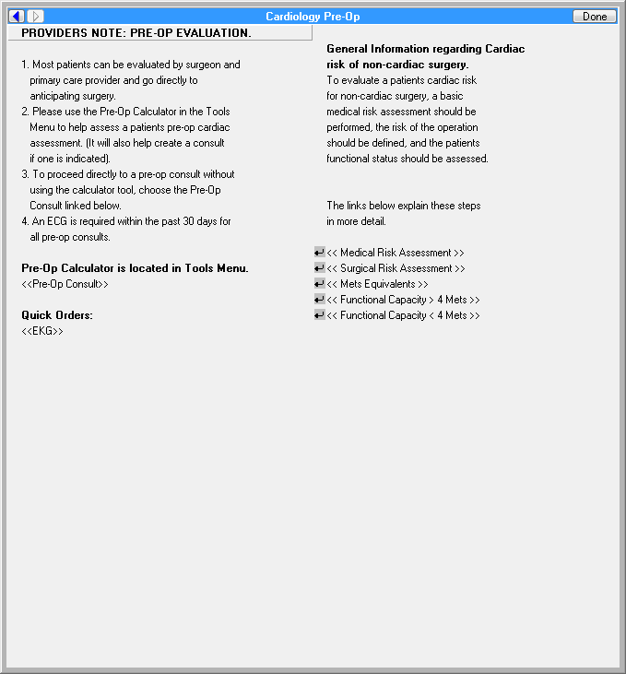

**Figure A.2.  Guidance for Pre-op Medical Risk Assessment**

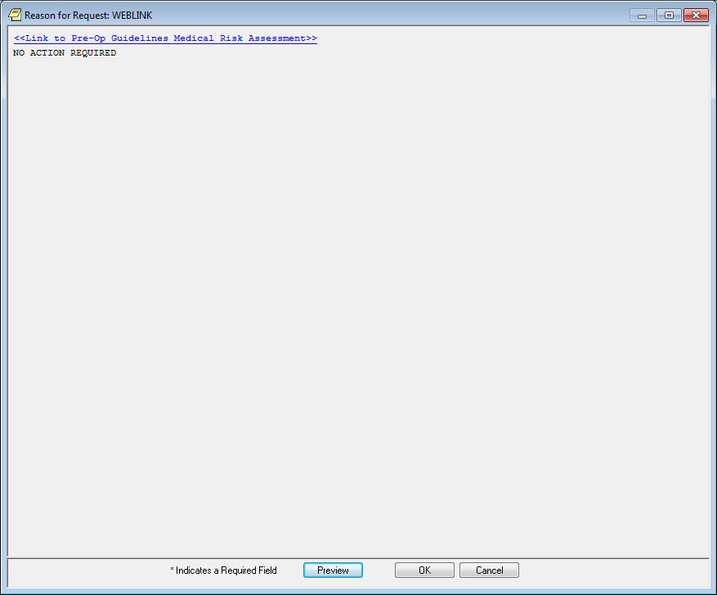

**Figure A.3. Basic Surgical Risk Categorization**

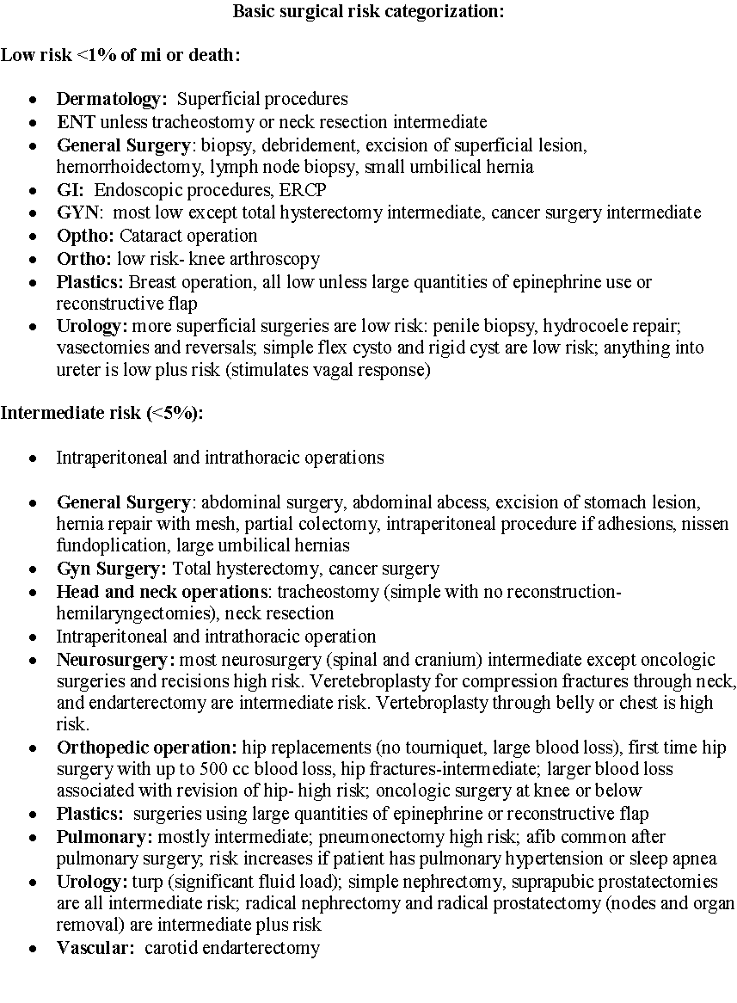

**Figure A.4. Met Equivalents (Jette 1990)**

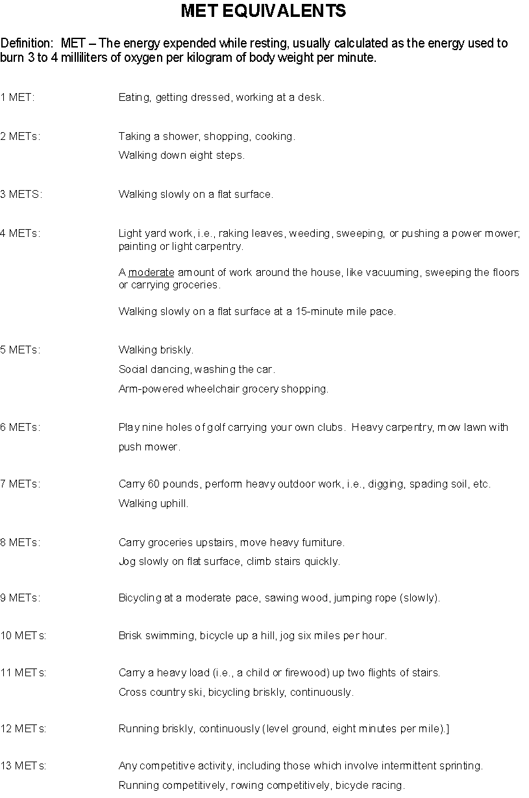

**Figure A.5. Template: Cardiology Pre-Op Consult (Screen 1 of 4)**

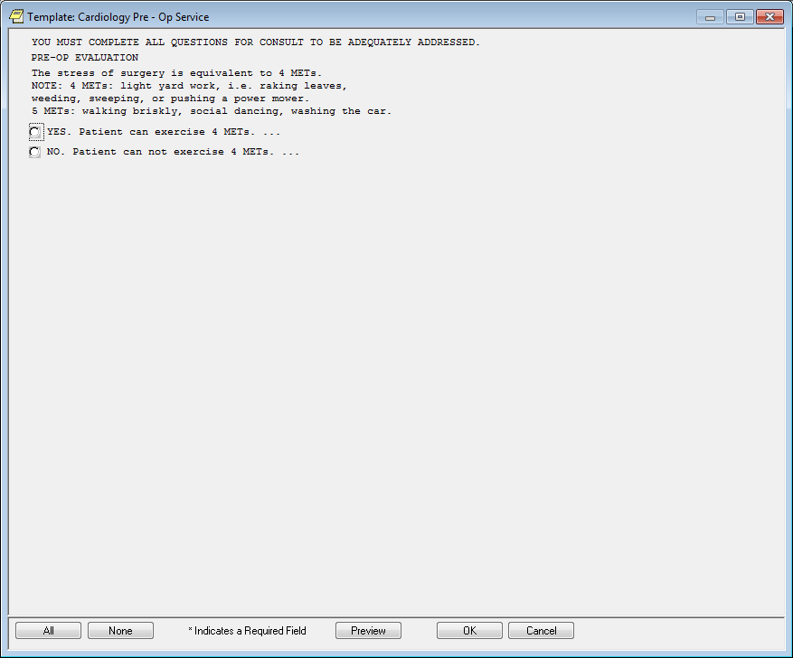

**Figure A.6. Template: Cardiology Pre-Op Consult (Screen 2 of 4)**

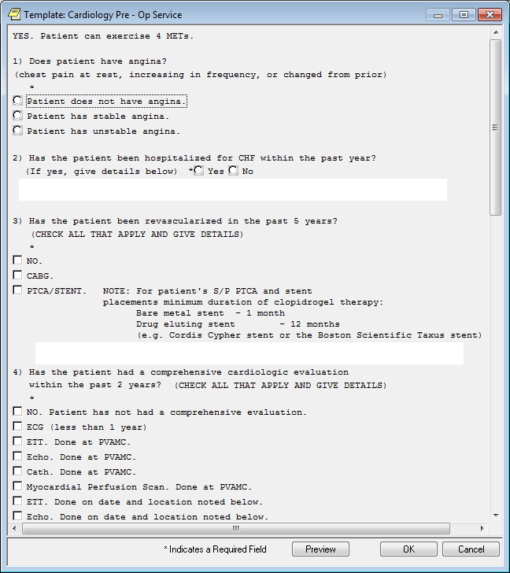

**Figure A.7. Template: Cardiology Pre-Op Consult (Screen 3 of 4)**

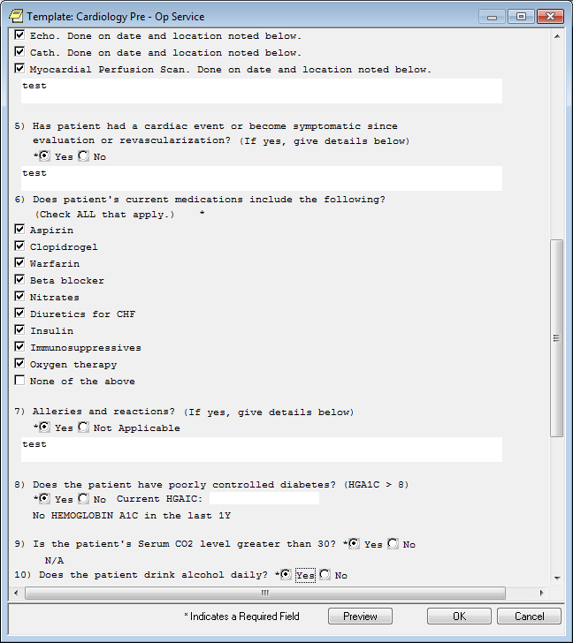

**Figure A.8. Template: Cardiology Pre-Op Consult (Screen 4 of 4)**

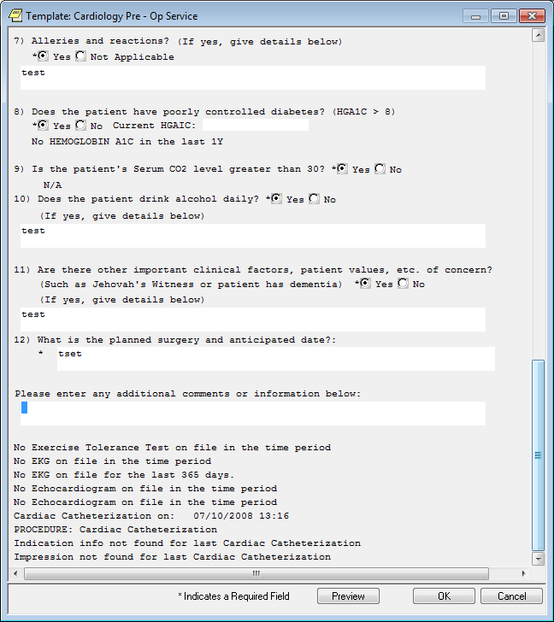

**Figure A.9. Order a Cardiology Pre-Op Consult**

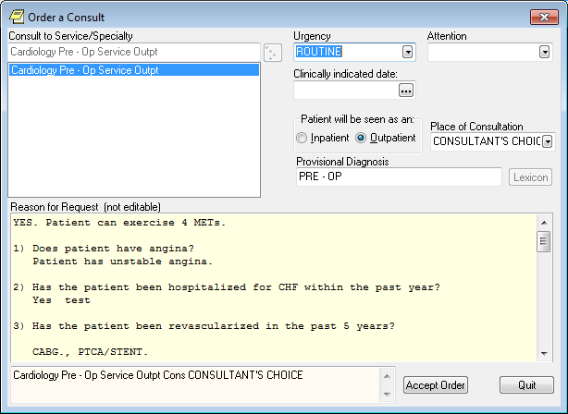

**Figure A.10. Template: Cardiology Pre-Op Consult (Screen 1 of 4)**

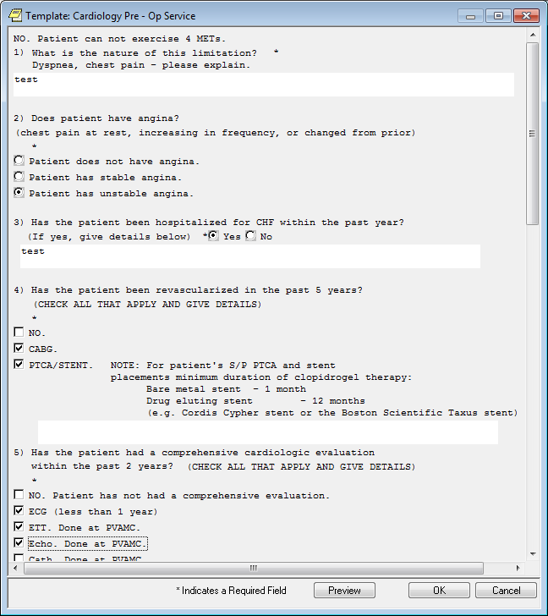

**Figure A.11. Template: Cardiology Pre-Op Consult (Screen 2 of 4)**

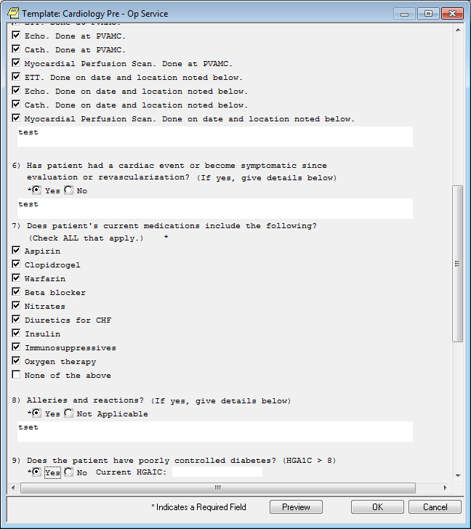

**Figure A.12. Template: Cardiology Pre-Op Consult (Screen 3 of 4)**

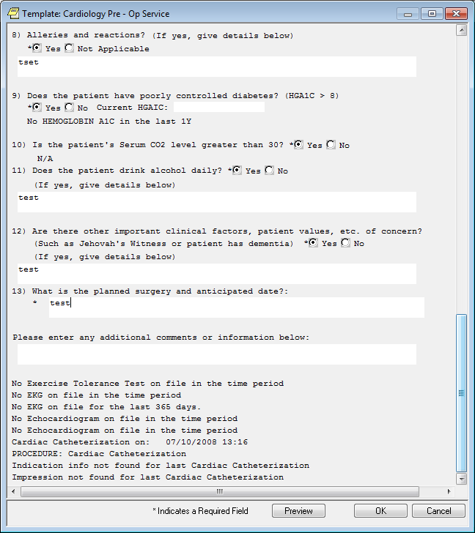

**Figure A.13. Order a Cardiology Pre-Op Consult (Screen 4 of 4)**

