**Clinical Decision Support (CDS) Content and Health Level 7 (HL7)-Compliant Knowledge Artifacts (KNARTs)**

**Endocrinology: Hypoglycemia Clinical Content White Paper**

**Department of Veterans Affairs (VA)**



**Knowledge Based Systems (KBS)**

**Office of Informatics and Information Governance (OIIG)**

**Clinical Decision Support (CDS)**

**Clinical Decision Support (CDS) Content and Health Level 7 (HL7)-Compliant Knowledge Artifacts (KNARTs): Endocrinology: Hypoglycemia Clinical Content White Paper**

by Department of Veterans Affairs (VA)

Publication date May 2018

**Contract: VA118-16-D-1008, Task Order (TO): VA-118-16-F-1008-0007**

**Table 1. Relevant KNART Information: Endocrinology: Hypoglycemia KNARTs**

| **Hypoglycemia KNART** | **Associated CLIN** |
| --- | --- |
| Hypoglycemia – Event Condition Action (ECA) Rule | CLIN0003AA |
| Hypoglycemia – Order Set | CLIN0004AB |
| Hypoglycemia – Documentation Template | CLIN0005AB |

**Table of Contents**

VA Subject Matter Expert (SME) Panel vi

Introduction vii

Conventions Used vii

1. Endocrinology: Hypoglycemia 1

1.1. Clinical Context 1

1.2. Knowledge Artifacts 1

2. Event Condition Action (ECA) Rule: Hypoglycemia 2

2.1. Knowledge Narrative 2

2.2. Global Conditions 2

2.3. Face to Face Encounter for Symptomatic Hypoglycemia 2

2.4. Patient Reported Hypoglycemic Episode  4

2.5. Asymptomatic by at Risk for Hypoglycemia 5

3. Documentation Template: Hypoglycemia 7

3.1. Knowledge Narrative 7

3.2. History of Present Illness 7

3.3. Past Medical History 10

3.4. Medications 10

3.5. Lifestyle 10

3.6. Patient Preferences 11

3.7. Plan 11

4. Order Set: Hypoglycemia 12

4.1. Knowledge Narrative 12

4.2. Medications 12

4.3. Supplies 13

4.4. Laboratory Tests 13

4.5. Point of Care Tests 14

4.6. Consults and Referrals 14

4.7. Patient and Caregiver Education 15

Bibliography/Evidence 16

A. Existing Sample VA Artifacts 17

A.1. Hypoglycemia Screen Clinical Reminder 17

A.1.1. Resources 17

A.1.2. Clinical Reminder Overview 17

A.1.3. Health Factors 17

A.1.4. Clinical Reminder Versus Hypoglycemia Safety Initiative (HSI) Corporate Data Warehouse (CDW) Reports  17

A.1.5. Known Differences Between the Hypoglycemia Screen Clinical Reminder and Hypoglycemia Safety Initiative (HSI) Corporate Data Warehouse (CDW) Reports  18

A.1.6. Reminder Inquiry: Hypoglycemia Screen  18

A.2. Reminder Inquiry: DM A1c Goal Not Entered/Reviewed  21

A.3. Clinical Reminder(s) for Evidence Based, Patient-Centered, Shared Glycemic Goals [Veterans Integrated Service Network (VISN) 12] 24

B. Basic Laboratory Panel Definition 29

C. Logic Diagrams 30

D. Acronyms 32

**List of Figures**

A.1. Reminder Resolution: Diabetic- Annual A1c Needed 24

A.2. Reminder Resolution: Diabetic- A1c Goal Needed 25

A.3. Test Ordering 26

A.4. Reminder Resolution: Diabetic- A1c Not in Range 27

A.5. Final Reminder 28

C.1. ECA Rule: Symptomatic Hypoglycemia 30

C.2. ECA Rule: System Run/Asymptomatic Hypoglycemia 31

**List of Tables**

1. Relevant KNART Information ii

1.1. Clinical Context Domains 7

**VA Subject Matter Expert (SME) Panel**

| **Name** | **Title** | **Project Role** |
| --- | --- | --- |
| Leonard Pogach, MD | National Director Medicine  VA Central Office (VACO), 810 Vermont Ave. NW, Room 662  Washington, DC 20420 | SME, Primary |
| Paul Conlin, MD | Endocrinologist/Chief of Medicine  Boston VA Medical Center (VAMC)  Chair of the Field Advisory Committee for Diabetes/Endocrinology  1400 Veterans of Foreign Wars (VFW) Parkway  Boston, MA 02132 | SME, Secondary |

**Introduction**

The VA is committed to improving the ability of clinicians to provide care for patients while increasing quality, safety, and efficiency. Recognizing the importance of standardizing clinical knowledge in support of this goal, VA is implementing the Health Level 7 (HL7) Knowledge Artifact Specification for a wide range of VA clinical use cases. Knowledge Artifacts, referred to as (KNARTs), enable the structuring and encoding of clinical knowledge so the knowledge can be integrated with electronic health records to enable clinical decision support.

The purpose of this Clinical Content White Paper (CCWP) is to capture the clinical context and intent of KNART use cases in sufficient detail to provide the KNART authoring team with the clinical source material to construct the corresponding knowledge artifacts using the HL7 Knowledge Artifact Specification. This paper has been developed using material from a variety of sources: VA artifacts, clinical practice guidelines, evidence in the body of medical literature, and clinical expertise. After reviewing these sources, the material has been synthesized and harmonized under the guidance of VA subject matter experts to reflect clinical intent for this use case.

Unless otherwise noted, items within this white paper (e.g., documentation template fields, orderable items, etc.) are chosen to reflect the clinical intent at the time of creation. To provide an exhaustive list of all possible items and their variations is beyond the scope of this work.

**Conventions Used**

Conventions used within the knowledge artifact descriptions include:

<obtain>: Indicates a prompt to obtain the information listed

* If possible, the requested information should be obtained from the underlying system(s). Otherwise, prompting the user for information may be required
* The technical and clinical notes associated with a section should be consulted for specific constraints on the information (e.g., time-frame, patient interview, etc.)
* Default Values: Unless otherwise noted, <obtain> indicates to obtain the most recent observation. It is recognized that this default time-frame value may be altered by future implementations

[...]: Square brackets enclose explanatory text that indicates some action on the part of the clinical user, or general guidance to the clinical or technical teams. Examples include, but are not limited to:

[Begin ...], [End ...]: Indicates the start and end of specific areas to clearly delineate them for technical purposes.

[Activate ...]: Initiates another knowledge artifact or knowledge artifact section.

[Section Prompt: ...]: If this section is applicable, then the following prompt should be displayed to the user.

[Section Selection Behavior: ...]: Indicates technical constraints or considerations for the selection of items within the section.

[Attach: ...]: Indicates that the specified item should be attached to the documentation template if available.

[Link: ...]: Indicates that rather than attaching an item, a link should be included in the documentation template.

[Clinical Comment: ...]: Indicates clinical rationale or guidance.

[Technical Note: ...]: Indicates technical considerations or notes.

[If ...]: Indicates the beginning of a conditional section.

[Else, ...]: Indicates the beginning of the alternative branch of a conditional section.

[End if ...]: Indicates the end of a conditional section.

☐: Indicates items that should be selected based upon the section selection behavior.

**Chapter 1.****Endocrinology: Hypoglycemia**

**1.1.****Clinical Context**

[Begin Clinical Context.]

Hypoglycemia is a common problem among patients with both type 1 and type 2 diabetes mellitus and is a source of substantial morbidity and mortality. As hypoglycemia may have multiple causes (e.g., medication errors, food insufficiency, intercurrent illness, etc.), and as these factors are often inadequately recognized by clinicians and patients [VA/Department of Defense (DoD) 2017, American Diabetes Association (ADA) 2017, Seaquist 2013], there is a need for practice standardization around evidence-based recommendations to improve care and to achieve better outcomes. This clinical content white paper is based on ADA and VA/DOD guidelines and with the guidance of the endocrinology VA subject matter experts.

**Table 1.1. Clinical Context Domains**

|  |  |
| --- | --- |
| Target User | Clinical providers |
| Patient | Adult outpatient with an active problem of either diabetes mellitus, type 1 or type 2 |
| Priority | Routine |
| Specialty | Clinical providers caring for adult patients |
| Location | Emergency Department (ED), inpatient hospital, urgent care, or ambulatory care clinic |

[End Clinical Context.]

**1.2.****Knowledge Artifacts**

[Begin Knowledge Artifacts.]

This section describes the CDS knowledge artifacts that are intended for clinical providers who care for adult patients in the ED, during inpatient hospital discharge, in urgent care clinic, or in an ambulatory care clinic.

Three knowledge artifacts define this clinical use case. These artifacts include the ECA Rule, the Documentation Template, and the Order Set KNART which the following sections describe in detail.

* An ECA Rule: Endocrinology: Hypoglycemia KNART
* Rule logic for actions that may include activating the documentation template and order set
* A Documentation Template: Endocrinology: Hypoglycemia KNART
* Provides a structure to document management of diabetic patients for prevention of hypoglycemia
* Includes logic for appropriate display of documentation sections
* An Order Set: Endocrinology: Hypoglycemia KNART
* Orderable items to support management of diabetic patients for prevention of hypoglycemia
* Includes logic for appropriate display of the order set

[End Knowledge Artifacts.]

**Chapter 2.****Event Condition Action (ECA) Rule: Hypoglycemia**

[Begin Event Condition Acton (ECA) Rule: Hypoglycemia.]

**2.1.****Knowledge Narrative**

[Begin Knowledge Narrative.]

[See Clinical Context in Chapter 1.]

There are three main categories of events that function as triggers for hypoglycemia related ECA rules

* Physician documentation of hypoglycemic episode; or
* Patient Reports Hypoglycemic Incident via Patient Portal; or
* Periodic system run of preventive rules.

[End Knowledge Narrative.]

**2.2. Global Conditions**

[Begin Global Conditions.]

The three global conditions for this ECA Rule set are:

* Patient has an active diagnosis of diabetes mellitus, type 1 or 2, and
* Patient's most recent hemoglobin A1c is < 7%; and
* Patient’s life expectancy greater than 10 years.

**2.3.****Face to Face Encounter for Symptomatic Hypoglycemia**

[Begin Face to Face Encounter for Symptomatic Hypoglycemia.]

[Technical note: Implementing facilities will need to implement role-based access, and will need to establish processes to minimize clinically unnecessary actions of ECA rules.]

**Events**

[Begin Events.]

Physician documentation of hypoglycemic episode

[End Events.]

**Conditions**

[Begin Conditions.]

Patient Encounter related conditions

* ED encounter for hypoglycemia; or
* Inpatient hospital discharge with a discharge diagnosis of hypoglycemia; or
* Urgent care encounter with a diagnosis of hypoglycemia; or
* Encounter in physician's office for hypoglycemia

Patient related conditions:

* Cognitive impairment or dementia; or
* Major neurologic disorder; or
* Major depression; or
* Alcohol/substance abuse; or
* Cardiovascular disorder; or
* Chronic kidney disease; or
* History of or at risk for falls; or
* Homelessness; or
* Living alone; or
* Social isolation; or
* Fears and quality of life concerns related to hypoglycemia; or
* Food insufficiency; or
* Potential for self-management difficulties (poor dexterity, active mental health diagnosis, or vision loss.)

[End Conditions.]

**Actions**

[Begin Actions.]

1. Send a message to the independent practitioner saying, “Patient has had an episode of hypoglycemia. Assess hypoglycemia awareness, review management plan, and adjust medications and glycemic target range as appropriate.”
2. Send a message to the pharmacist saying, “Patient has had an episode of hypoglycemia. Review prescriptions and dosing instructions with the patient to help ensure understanding of medication use.”
3. Send a message to the care manager saying, “Patient has had an episode of hypoglycemia. Assess self-management adherence risks, understanding of action plan, hypoglycemia risk factors, and psychosocial barriers. Refer to services as needed.”
4. Send a message to the certified diabetes educator saying, “Patient has had an episode of hypoglycemia. Address any identified self-management issues.”
5. Send a message to the dietitian saying, “Patient has had an episode of hypoglycemia. Address any identified nutritional issues.”
6. Send a message to the social worker saying, “Patient has had an episode of hypoglycemia. Address any identified psychosocial barriers to care.”
7. Send a message to the care coordinator saying, “Patient has had an episode of hypoglycemia. Make sure that an urgent visit with the prescriber of their hypoglycemic medications is scheduled and completed.”
8. Send a message to the patient saying, “Review your self-management plan, including what to do if you have low blood sugar. If you have any questions, do not hesitate to contact your care team.”
9. Activate Documentation Template: Hypoglycemia KNART.
10. Activate Order Set: Hypoglycemia KNART.

[End Actions.]

[End Face to Face Encounter for Symptomatic Hypoglycemia.]

**2.4. Patient Reported Hypoglycemic Episode**

[Begin Patient Reported Hypoglycemic Episode.]

**Events**

[Begin Events.]

* Self-report of hypoglycemia through patient portal (patient health record; PHR) or telemonitoring

[End Events]

**Conditions**

[Begin Conditions.]

Patient related conditions:

* Cognitive impairment or dementia; or
* Major neurologic disorder; or
* Major depression; or
* Alcohol/substance abuse; or
* Cardiovascular disorder; or
* Chronic kidney disease; or
* History of or at risk for falls; or
* Homelessness; or
* Living alone; or
* Social isolation; or
* Fears and quality of life concerns related to hypoglycemia; or
* Food insufficiency; or
* Potential for self-management difficulties (poor dexterity, active mental health diagnosis, or vision loss.)

[End Conditions.]

**Actions**

[Begin Actions.]

1. Send a message to the independent practitioner saying, “Patient has had an episode of hypoglycemia. Assess hypoglycemia awareness, review management plan, and adjust medications and glycemic target range as appropriate.”
2. Send a message to the pharmacist saying, “Patient has had an episode of hypoglycemia. Review prescriptions and dosing instructions with the patient to help ensure understanding of medication use.”
3. Send a message to the care manager saying, “Patient has had an episode of hypoglycemia. Assess self-management adherence risks, understanding of action plan, hypoglycemia risk factors, and psychosocial barriers. Refer to services as needed.”
4. Send a message to the certified diabetes educator saying, “Patient has had an episode of hypoglycemia. Address any identified self-management issues.”
5. Send a message to the dietitian saying, “Patient has had an episode of hypoglycemia. Address any identified nutritional issues.”
6. Send a message to the social worker saying, “Patient has had an episode of hypoglycemia. Address any identified psychosocial barriers to care.”
7. Send a message to the care coordinator saying, “Patient has had an episode of hypoglycemia. Make sure that an urgent visit with the prescriber of their hypoglycemic medications is scheduled and completed.”
8. Send a message to the patient saying, “Review your self-management plan, including what to do if you have low blood sugar. If you have any questions, do not hesitate to contact your care team.”
9. System waits for independent practitioner to open the record.
10. Activate Documentation Template: Hypoglycemia KNART.
11. Activate Order Set: Hypoglycemia KNART.

[End Actions.]

[End Patient Reported Hypoglycemic Episode.]

**2.5.****Asymptomatic but at Risk for Hypoglycemia**

[Begin Asymptomatic but at Risk for Hypoglycemia.]

**Event**

[Begin Event.]

* System run of hypoglycemia rule

[Technical Note: Hypoglycemia rule is run every 150 days.]

[End Event.]

**Conditions**

[Begin Conditions.]

Patient meets all the following conditions:

* Patient is on active medications of insulin or sulfonylurea; and
* Patient meets at least one of the following criteria:
* Age greater than 74 years; or
* Active problem of cognitive impairment; or
* Active problem of dementia; or
* Serum creatinine greater than 1.7 mg/dL within 150 days.

[End Conditions.]

**Actions**

[Begin Actions.]

1. Send a message to the independent practitioner saying, "Patient is at risk for hypoglycemia. Assess hypoglycemia awareness, review management plan, and adjust medications and glycemic target range as appropriate."
2. Send a message to the pharmacist saying, "Patient is at risk for hypoglycemia. Review prescriptions and dosing instructions with the patient to help ensure understanding of medication use.'
3. Send a message to the care manager saying, "Patient is at risk for hypoglycemia. Assess self-management adherence risks, understanding of action plan, hypoglycemia risk factors, psychosocial barriers. Refer to services as needed."
4. Send a message to the certified diabetes educator saying, “Patient is at risk for hypoglycemia. Address any identified self-management issues.”
5. Send a message to the dietitian saying, “Patient is at risk for hypoglycemia. Address any identified nutritional issues.”
6. Send a message to the social worker saying, “Patient is at risk for hypoglycemia. Address any identified psychosocial barriers to care.”
7. Send a message to the care coordinator saying, “Patient is at risk for hypoglycemia. Make sure that a visit with the prescriber of their hypoglycemic medications is scheduled and completed.”
8. Send a message to the patient saying, “Review your self-management plan, including what to do if you have low blood sugar. If you have any questions, do not hesitate to contact your care team.”
9. System waits for independent practitioner to open the record.
10. Activate Documentation Template: Hypoglycemia KNART.
11. Activate Order Set: Hypoglycemia KNART.]

[End Actions.]

[End Asymptomatic but at Risk for Hypoglycemia.]

[End Global Conditions.]

[End Event Condition Acton (ECA) Rule: Hypoglycemia.]

**Chapter 3.****Documentation Template: Hypoglycemia**

[Begin Documentation Template: Hypoglycemia.]

**3.1.****Knowledge Narrative**

[Begin Knowledge Narrative.]

[See Clinical Context in Chapter 1.]

[Clinical Comment: This documentation template facilitates documentation of a clinical practitioner’s assessment and management of hypoglycemia.]

[Technical Note: Clinical providers should enter information into the documentation template form as needed during the evaluation. Information available within the Electronic Health Record (EHR) will auto-populate the documentation template.]

[End Knowledge Narrative.]

**3.2.****History of Present Illness**

[Begin History of Present Illness.]

[Section Prompt: Reason for Evaluation.]

[Section Selection Behavior: Select one. Required.]

☐ Recent hypoglycemic episode

☐ At risk for hypoglycemia without recent episode

☐ Other

<obtain> Descriptions

[Section Prompt: Diabetes Control Status]

<obtain> Type of diabetes

<obtain> Glycated Hemoglobin (HbA1c) goal

<obtain> Most recent HbA1c (%)

<obtain> Date

<obtain> Preprandial blood glucose target range

<obtain> Actual preprandial blood glucose range

[Section Prompt: Medication Reconciliation: Potential medication interactions with antiglycemic agents and/or medication impact on hypoglycemic awareness.]

<obtain> Description of interactions

[Section Prompt: Prior Hypoglycemic Episode(s).]

[Section Selection Behavior: Select one. Required.]

☐ No

☐ Yes

[If yes, then display the hypoglycemic episode detail section.]

[Begin hypoglycemic episode detail.]

[Section Selection Behavior: Select any or none. Optional.]

☐ Hypoglycemia requiring paramedics, ED evaluation, or hospitalization

<obtain> Number of episodes since last visit

<obtain> Number of episodes in the last year

☐ Hypoglycemia requiring bystander intervention

<obtain> Number of episodes since last visit

<obtain> Number of episodes in the last year

☐ Self-managed hypoglycemic episode(s)

<obtain> Number of episodes since last visit

<obtain> Number of episodes in the last year

<obtain> Typical number of hypoglycemic episodes per week

[Section Prompt: Methods Used to Treat Hypoglycemia]

[Section Selection Behavior: Select any or none. Optional.]

☐ Carbohydrate-rich snacks or drinks

☐ Glucose tablets, gels, or drinks

☐ Glucagon injections

<obtain> Number since last visit

<obtain> Number in the last year

[Section Prompt: Ask Patient: How good is your ability to recognize your hypoglycemia symptoms?]

[Section Selection Behavior: Select one. Optional.]

☐ None

☐ Poor

☐ Good

<obtain> Hypoglycemia symptoms

<obtain> Most common causes of hypoglycemia

[End hypoglycemic episode detail.]

[Section Prompt: Hypoglycemia Assessment and Risk Factors:]

<obtain> Age

<obtain> Life expectancy

[Section Selection Behavior: Select any or none. Optional.]

☐ Cognitive Impairment/Dementia

☐ Major neurologic disorder

<obtain> Description

☐ Major depression

<obtain> Description

☐ Cardiovascular disease

<obtain> Description

☐ Chronic kidney disease

<obtain> Description<obtain> Most recent serum creatinine (mg/dL)

<obtain> Date

<obtain> Most recent estimated glomerular filtration rate (mL/min/1.73 m^2)

<obtain> Date

<obtain> Most recent urinary albumin-to-creatinine ratio (mg/g)

<obtain> Date

☐ Fall history or risk

☐ Potential Self-Management Difficulties

☐ Poor manual dexterity

☐ Active mental health diagnosis

☐ Advanced eye disease, including but not limited to visual loss and retinopathy

☐ Food insufficiency

☐ Other

<obtain> Description

☐ Social risk factors

☐ Alcohol/substance abuse

<obtain> Description

☐ Homelessness

☐ Living alone

☐ Social isolation

☐ Other

<obtain> Description

☐ Patient has fears or concerns regarding their diabetes management

<obtain> Description

☐ Other

<obtain> Description

[End History of Present Illness.]

**3.3.****Past Medical History**

[Begin Past Medical History.]

[Section Prompt: History of microvascular disease?]

[Section Selection Behavior: Select one.]

☐ None

☐ Mild (microalbuminuria, background retinopathy, and/or mild nephropathy)

☐ Moderate (persistent, fixed proteinuria; pre-proliferative retinopathy; and/or peripheral neuropathy with sensory loss)

☐ Advanced (renal insufficiency, proliferative retinopathy/prior laser treatment; peripheral neuropathy with insensate extremities, and/or autonomic neuropathy)

<obtain> Functional status

<obtain> Other

[End Past Medical History.]

**3.4.****Medications**

[Begin Medications.]

[Section Selection Behavior: Select any or none. Optional.]

☐ Insulin

<obtain> Prescription details

☐ Sulfonylureas

<obtain> Prescription details

☐ Other glucose-lowering agents

<obtain> Prescription details

<obtain> Prior adverse effects of glucose-lowering agents

[End Medications.]

**3.5.****Lifestyle**

[Begin Lifestyle.]

<obtain> Typical diet

<obtain> Exercise

<obtain> Tobacco, alcohol, or other substance use

<obtain> Description

<obtain> Other

[End Lifestyle.]

**3.6.****Patient Preferences**

[Begin Patient Preferences.]

☐ Patient preferences for glucose-lowering agents assessed

<obtain> Patient preferences for glucose-lowering agents

[End Patient Preferences.]

**3.7.****Plan**

[Begin Plan.]

[Section Prompt: HbA1c Target Range.]

[Section Selection Behavior: Select one. Optional.]

☐ 6.0% to 7.0% (Recommended for those with absent or mild microvascular disease, no major comorbidity, and life expectancy greater than 10 years)

☐ 7.0% to 8.0% (Recommended for those with moderate microvascular disease, no major comorbidity, and life expectancy greater than 10 years or with absent or mild microvascular disease, major comorbidity present but manageable, and life expectancy of 5 to 10 years)

☐ 7.5% to 8.5% (Recommended for those with moderate microvascular disease, major comorbidity present but manageable, and life expectancy of 5 to 10 years or with advanced microvascular disease, major comorbidity present and challenging to manage or end-stage, and life expectancy of at least 5 years)

☐ 8.0% to 9.0% (Recommended for those with major comorbidity present and challenging to manage or end-stage and life expectancy less than 5 years)

☐ Other

<obtain> Description

<obtain> Preprandial blood glucose target range

<obtain> Self-management plan changes

<obtain> Recommended lifestyle changes

<obtain> Consultations

<obtain> Other

[End Plan.]

[End Documentation Template: Hypoglycemia.]

**Chapter 4.****Order Set: Hypoglycemia**

[Begin Order Set: Hypoglycemia.]

**4.1.****Knowledge Narrative**

[Begin Knowledge Narrative.]

[See Clinical Context in Chapter 1.]

[Technical Note: Order sets will include medication, supplies, laboratory tests, point of care tests, consults and referrals, and patient and caregiver education.]

[End Knowledge Narrative.]

**4.2.****Medications**

[Begin Medications.]

[Section Prompt: Medications:]

[Technical Note: The Medications section should be available to clinical providers for any patients presenting for evaluation of a hypoglycemic episode or hypoglycemia risk.]

**Insulin**

[Begin Insulin.]

[Technical Note: The Insulin subtitle of Medications should be available for any patient with an active medication of regular insulin or isophane insulin (*NPH*).]

[Section Selection Behavior: Select any or none. Optional.]

☐ Discontinue regular insulin (now)

☐ Discontinue NPH insulin (now)

☐ Insulin aspart solution subcutaneous 3 refills (routine)

☐ Insulin glargine solution subcutaneous 3 refills (routine)

☐ Insulin detemir solution subcutaneous 3 refills (routine)

[End Insulin.]

**Sulfonylureas**

[Begin Sulfonylureas.]

[Technical Note: The Sulfonylureas subtitle in the Medications section should be made available for any patient with an active sulfonylurea medication.]

☐ Discontinue glyburide (now)

☐ Glipizide 5 mg tablet oral 3 refills (routine)

[End Sulfonylureas.]

**Glucagon**

[Begin Glucagon.]

[Technical Note: The Glucagon subtitle in the "Medications" section should be made available for any patient without an active medication of glucagon.]

[Section Selection Behavior: Select any or none. Optional.]

☐ Glucagon 1 mg solution subcutaneous; Use as needed for clinically significant hypoglycemia when situationally appropriate (e.g., blood glucose less than or equal to 54 mg/dL or other threshold as specified in patient treatment plan, or as directed and required by circumstances); Dissolve glucagon in accompanying diluent before administering; repeat after 15 minutes if delayed response; Dispense 2 kits; 3 refills (routine)

[End Glucagon.]

[End Medications.]

**4.3.****Supplies**

[Begin Supplies.]

[Section Prompt: Supplies:]

[Technical Note: This section should be available to clinical providers for any patient presenting for evaluation of a hypoglycemic episode or hypoglycemia risk.]

[Clinical Comment: Supply orders considered routine unless otherwise specified.]

[Section Prompt: Glucose Monitoring Supplies]

[Section Selection Behavior: Select any or none. Optional.]

☐ Blood glucose monitoring device dispense 1 device

☐ Blood glucose monitoring test strips dispense 1 box; 3 refills

☐ Blood glucose monitoring lancets dispense 1 box; 3 refills

☐ Alcohol swabs dispense 1 box; 3 refills

☐ Blood glucose monitoring control solution dispense 1 bottle; 3 refills

[Section Prompt: Insulin Supplies.]

[Technical Note: This subtitle should be available for any patient with an active medication of any type of insulin.]

[Section Selection Behavior: Select any or none. Optional.]

☐ Insulin syringes dispense 1 box; 3 refills

[End Supplies.]

**4.4.****Laboratory Tests**

[Begin Laboratory Tests.]

[Section Prompt: Laboratory Tests.]

[Technical Note: This section should be available to clinical providers for any patient presenting for evaluation of a hypoglycemic episode or hypoglycemia risk.]

[Clinical Comment: All tests are one time and routine in timing unless specified.]

[Section Selection Behavior: Select any or none. Optional.]

☐ Basic metabolic profile

☐ HbA1c

☐ Fasting blood glucose

☐ Serum creatinine

☐ Urinary albumin-to-creatinine ratio

☐ Urinalysis

☐ Complete blood count

☐ Liver function tests

☐ Fasting lipid profile

[End Laboratory Tests.]

**4.5.****Point of Care Tests**

[Begin Point of Care Tests.]

[Section Prompt: Point of Care Tests.]

[Technical Note: This section should be available to clinical providers for any patient presenting for evaluation of a hypoglycemic episode or hypoglycemia risk.]

[Section Selection Behavior: Select any or none. Optional.]

☐ Fingerstick blood glucose 1 time (now)

☐ Dipstick urine ketones 1 time (now)

☐ Dipstick urine albumin 1 time (now)

[End Point of Care Tests.]

**4.6.****Consults and Referrals**

[Begin Consults and Referrals.]

[Section Prompt: Consults and Referrals]

[Technical Note: This section should be available to clinical providers for any patient presenting for evaluation of a hypoglycemic episode or hypoglycemia risk.]

[Section Selection Behavior: Select any or none. Optional.]

☐ Consult care management to evaluate risks related to the patient's ability to adhere to the treatment plan. Factors evaluated should include access to and ability to use self-monitoring of blood glucose (SMBG) device, glucagon, and insulin injections as directed as well as other factors that may increase the patient's risk of hypoglycemia (e.g., food insufficiency). Actions to be taken may include connecting the patient to appropriate services to mitigate risks, ensuring availability and patient understanding of the patient-specific symptom action plan, and identification and management of any psychosocial barriers to care (routine)

☐ Consult nutrition service (routine)

☐ Consult social services to evaluate psychosocial barriers to care (routine)

☐ Consult occupational therapy to evaluate functional status issues that may interfere with diabetes self-management (routine)

☐ Consult physical therapy to evaluate functional status issues that may interfere with diabetes self-management (routine)

☐ Consult diabetes education to evaluate self-management issues such as knowledge and skill deficiencies (routine)

☐ Consult psychiatry to evaluate mental health issues that may interfere with diabetes self-management (routine)

☐ Consult geriatric medicine to evaluate hypoglycemia risk (routine)

☐ Consult clinical pharmacy to evaluate diabetic medication therapy (routine)

[End Consults and Referrals.]

**4.7.****Patient and Caregiver Education**

[Begin Patient and Caregiver Education.]

[Section Prompt: Patient and Caregiver Education.]

[Technical Note: This section should be available to clinical providers for any patient presenting for evaluation of a hypoglycemic episode or hypoglycemia risk.]

[Technical Note: A referral to the following website will be included in patient take home education: https://www.prevention.va.gov/Talk_with_Your_VA_Provider_to_Avoid_Low_Blood_Sugar.asp.]

[Section Selection Behavior: Select one. Optional.]

☐ Diabetes self-management education (routine)

[End Patient and Caregiver Education.]

[End Order Set: Hypoglycemia.]

**Bibliography/Evidence**

American Diabetes Association (ADA). *Standards of medical care in diabetes-2017*. *Diabetes Care*. 2017. 40. suppl 1. S1-S135. O'Neil G.. *V1-High Risk for Hypoglycemia*. V1_HIGH RISK FOR HYPOGLYCEMIA.PowerPoint.ppt.. June 4, 2015.

Veterans Integrated Service Network (VISN) 1 hypoglycemia reminder PowerPoint (Linda Wedemeyer, MD, email communication, July 10, 2017).

Seaquist, 2013. ER Seaquist, J Anderson, B Childs, and et al. “Hypoglycemia and diabetes: a report of a workgroup of the American Diabetes Association and the Endocrine Society”. *Diabetes Care*. 2013. 36. 5. 1384-1395.

U.S. National Library of Medicine. *GLIPIZIDE- glipizide tablet [Actavis Pharma, Inc.]. DailyMed Website*. <https://dailymed.nlm.nih.gov/dailymed/drugInfo.cfm?setid=ad55dfd7-ffb5-478a-aa84-1009fa921e22>. Revised June 2015.

U.S. National Library of Medicine. *GLUCAGON- glucagon [Eli Lilly and Company]. DailyMed Website.* . <https://dailymed.nlm.nih.gov/dailymed/drugInfo.cfm?setid=f143db10-e889-41c3-84ed-603a0ab02f61>. Revised November 2017.

U.S. National Library of Medicine. *LANTUS- insulin glargine injection, solution, LANTUS SOLOSTAR- insulin glargine injection, solution [sanofi-aventis U.S. LLC]. DailyMed Website*. <https://dailymed.nlm.nih.gov/dailymed/drugInfo.cfm?setid=d5e07a0c-7e14-4756-9152-9fea485d654a>. Revised August 2015.

U.S. National Library of Medicine. *LEVEMIR- insulin detemir injection, solution [Novo Nordisk]. DailyMed Website*. <https://dailymed.nlm.nih.gov/dailymed/drugInfo.cfm?setid=d38d65c1-25bf-401d-9c7e-a2c3222da8af>. Revised February 2015.

U.S. National Library of Medicine. *NOVOLOG- insulin aspart injection, solution [Novo Nordisk]. DailyMed Website.* . <https://dailymed.nlm.nih.gov/dailymed/drugInfo.cfm?setid=3a1e73a2-3009-40d0-876c-b4cb2be56fc5>. Revised March 2017.

U.S. Department of Veterans Affairs and U.S. Department of Defense. *VA/DoD Clinical Practice Guideline for the Management of Type 2 Diabetes Mellitus in Primary Care, version 5.0—2017. VA/DoD Clinical Practice Guidelines website*. <https://www.healthquality.va.gov/guidelines/CD/diabetes/VADoDDMCPGFinal508.pdf>.

**Appendix A. Existing Sample VA Artifacts**

**A.1. Hypoglycemia Screen Clinical Reminder**

**A.1.1. Resources**

[Hypoglycemia Safety Initiative (HSI)](http://www.qualityandsafety.va.gov/ChoosingWiselyHealthSafetyInitiative/HypoglycemiaSite/Hypoglycemia.asp)

[HSI Corporate Data Warehouse (CDW) Reports](https://spsites.cdw.va.gov/sites/QSV_CW/Pages/HSI.aspx)

[HSI Computerized Patient Record System (CPRS) Hypoglycemia Screening Tools](https://spsites.cdw.va.gov/sites/QSV_CW/Pages/HSI_CPRSTools.aspx)

**A.1.2. Clinical Reminder Overview**

The intended cohort for the HSI is:

Patients on insulin and/or a sulfonylurea …

with a recent A1c less than 7 …

and who:

* Are over the age of 74, or
* Have a diagnosis of cognitive impairment or dementia, or
* Have a recent serum creatinine value greater than 1.7

The recommended screening frequency is at least every 6 months for patients at risk

The reminder terms, findings, time frames, etc. included in the Hypoglycemia Screen Clinical Reminder support this intended cohort and recommended screening frequency

It’s recognized that facilities may decide to modify the cohort logic in this clinical reminder to support local practices/approaches. If local changes are pursued, the Choosing Wisely Task Force – Hypoglycemia Safety Initiative kindly asks that the spirit of the intended cohort and recommended screening frequency remain.

**A.1.3. Health Factors**

When installing the Clinical Reminder, please do not modify or remove any of the included health factors nor change the context by which they’re generated.

Local modification of these health factors will adversely impact data capture for and data display in the HSI reports for all VA facilities.

**A.1.4. Clinical Reminder Versus** **Hypoglycemia Safety Initiative (HSI) Corporate Data Warehouse (CDW) Reports**

Clinical Reminder technology and the Corporate Data Warehouse system are two systems that use the same data source (Veterans Information Systems and Technology Architecture, VistA) but have different functionalities and capabilities

Therefore, while most patients will be identified by both tools, it is recognized that the cohort of patients identified by the Clinical Reminder will not be a 100% match to the cohort of patients identified by the HSI CDW reports

It’s estimated that the ‘mismatch’ percentage will be less than 5%.

Both tools accurately implement the intended cohort.

**A.1.5. Known Differences Between the Hypoglycemia Screen Clinical Reminder and Hypoglycemia Safety Initiative (HSI) Corporate Data Warehouse (CDW) Reports**

|  |  |
| --- | --- |
| Hypoglycemia Screen Clinical Reminder | HSI CDW Reports |
| Only pulls data from within facility | Pulls data from across the VA |
| Defines dementia/cognitive impairment slightly differently | |
| Includes of Systematized Nomenclature of Medicine (SNOMED*)* codes results in some additional diagnosis codes | SNOM*ED* codes unavailable |
| Active/Susp or Hold prescriptions that have not yet been released for the first time are not ‘seen’ by the “Hypoglycemia Screen Patient on Diabetic Meds VA/Non-VA” reminder term | Includes all Active/Susp or Hold prescriptions regardless of release history |
| T-30D logic for expired prescriptions means that the last release date plus the days’ supply + 30 days is the time frame used  (e.g., a 30-day supply prescription will be included if it was released within the last 60 days, a 90-day supply prescription will be included it if was released within the last 120 days) | Expired prescriptions are included if they have been released in the last 90 days, regardless of days’ supply |
| Due every 6 months | Parameters and summary data time frame is 1 year for evaluations |

The Choosing Wisely Task Force – Hypoglycemia Safety Initiative encourages facilities to use all available tools (Reminder Dialog Template, Clinical Reminder, and Corporate Data Warehouse Reports) to identify and manage this patient population

**A.1.6. Reminder Inquiry: Hypoglycemia Screen**

HYPOGLYCEMIA SCREEN No. 519  
--------------------------------------------------------------------------------  
Print Name: Hypoglycemia Screen   
  
Class: LOCAL  
  
Sponsor:   
  
Review Date: JULY 6, 2015  
  
Rescission Date:   
  
Usage: CPRS, DATA EXTRACT, REPORTS  
  
Related VA-* Reminder:   
  
Reminder Dialog: HYPOGLYCEMIA SCREEN VISN12  
  
  
Priority:   
   
Description:  
 Screening for hypoglycemia should be performed in patients at risk for   
 hypoglycemia. Studies show an increased risk for hypoglycemia in   
 patients on insulin and/or a sulfonylurea with a recent A1C less than 7   
   
and who:   
   
 - Are over the age of 74 or   
 - Have a diagnosis of cognitive impairment or dementia or   
 - Have a recent serum creatinine value greater than 1.7   
   
 Screening for hypoglycemia is indicated at least every 6 months for   
 patients at risk.   
  
Technical Description:  
  
Baseline Frequency:  
  
 Do In Advance Time Frame: Do if DUE within 30 days  
 Sex Specific:   
 Ignore on N/A:   
 Frequency for Age Range: 6 months for all ages  
 Match Text:  
 No Match Text:  
  
Findings:   
   
 ---- Begin: HYPOGLYCEMIA SCREEN A1C V12 (FI(1)=RT(1149)) -----------------   
 Finding Type: REMINDER TERM   
 Beginning Date/Time: T-18M   
 Condition: I (+V>0)&(+V<7)   
   
 Mapped Findings: LT.HEMOGLOBIN A1C   
   
 ---- End: HYPOGLYCEMIA SCREEN A1C V12 ------------------------------------   
   
 ---- Begin: VA-AGE (FI(2)=CF(39)) ----------------------------------------   
 Finding Type: REMINDER COMPUTED FINDING   
 Condition: I V>74   
 Use Status/Cond in Search: YES   
 ---- End: VA-AGE ---------------------------------------------------------   
   
 ---- Begin: HYPOGLYCEMIA SCREEN V12 (FI(3)=RT(1150)) ---------------------   
 Finding Type: REMINDER TERM   
 Use in Resolution Logic: OR   
   
 Mapped Findings: HF.HYPOGLYCEMIA (2-3 PER MONTH)   
 Health Factor Category: HYPOGLYCEMIA SCREENING   
   
 Mapped Findings: HF.HYPOGLYCEMIA (DAILY)   
 Health Factor Category: HYPOGLYCEMIA SCREENING   
   
 Mapped Findings: HF.HYPOGLYCEMIA (NONE REPORTED)   
 Health Factor Category: HYPOGLYCEMIA SCREENING   
   
 Mapped Findings: HF.HYPOGLYCEMIA (ONCE A WEEK)   
 Health Factor Category: HYPOGLYCEMIA SCREENING   
   
 Mapped Findings: HF.HYPOGLYCEMIA (ONCE)   
 Health Factor Category: HYPOGLYCEMIA SCREENING   
   
 ---- End: HYPOGLYCEMIA SCREEN V12 ----------------------------------------   
  
 ---- Begin: HYPOGLYCEMIA SCREEN DEMENTIA/COGNITIVE IMPAIRMENT V12   
 (FI(4)=RT(1156)) ---------------------------------------------------------   
 Finding Type: REMINDER TERM   
   
 Mapped Findings: TX.HYPOGLYCEMIA SCREEN HISTORY OF   
 DEMENTIA V12 (PL-TX)   
   
 Mapped Findings: TX.HYPOGLYCEMIA SCREEN COGNITIVE   
 IMPAIRMENT V12 (PL-TX)   
   
 Mapped Findings: TX.HYPOGLYCEMIA SCREEN HX OF   
 DEMENTIA V12 (EN-TX)   
 Beginning Date/Time: T-2Y   
 Condition: I  
"170,172,322,323,315,318,319,576,577"[V("STOP CODE") S AUMLOC=V("HOSPITAL  
LOC"),RT="S VAL=$$GET1"_$C(94)_"DIQ(44,AUMLOC,2503)" X RT I (V("HOSPITAL  
LOCATION")'="")&((VAL="")!(VAL["PHYS EXT")!(VAL["PHYSICIAN"))   
 Use Status/Cond in Search: YES   
   
 Mapped Findings: TX.HYPOGLYCEMIA SCREEN COGNITIVE   
 IMPAIRMENT V12 (EN-TX)   
 Beginning Date/Time: T-2Y   
 Condition: I  
"170,172,322,323,315,318,319,576,577"[V("STOP CODE") S AUMLOC=V("HOSPITAL  
LOC"),RT="S VAL=$$GET1"_$C(94)_"DIQ(44,AUMLOC,2503)" X RT I (V("HOSPITAL  
LOCATION")'="")&((VAL="")!(VAL["PHYS EXT")!(VAL["PHYSICIAN"))   
 Use Status/Cond in Search: YES   
   
 Mapped Findings: MH.BOMC   
 Beginning Date/Time: T-2Y   
 MH Scale: 516 - Weighted error score   
 Condition: I +V>10   
   
 ---- End: HYPOGLYCEMIA SCREEN DEMENTIA/COGNITIVE IMPAIRMENT V12 ----------   
   
 ---- Begin: HYPOGLYCEMIA SCREEN CREATININE (LAB) V12 (FI(5)=RT(1148)) ----   
 Finding Type: REMINDER TERM   
 Beginning Date/Time: T-18M   
 Condition: I  
((V("SPECIMEN")="PLASMA")!(V("SPECIMEN")="SERUM"))   
 Condition Case Sensitive: NO   
 Use Status/Cond in Search: YES   
   
 Mapped Findings: LT._CREATININE (OF eGFR PANEL)   
   
 ---- End: HYPOGLYCEMIA SCREEN CREATININE (LAB) V12 -----------------------   
   
 ---- Begin: HYPOGLYCEMIA SCREEN PATIENT ON DIABETIC MEDS VA/NON-VA   
 (FI(7)=RT(1151)) ---------------------------------------------------------   
 Finding Type: REMINDER TERM   
 Status List: ACTIVE   
 DISCONTINUED   
 DISCONTINUED (EDIT)   
 DISCONTINUED (RENEWAL)   
 EXPIRED   
 SUSPENDED   
   
 Mapped Findings: DC.HS501   
 RX Type: N   
 Status List: ACTIVE   
 Use Status/Cond in Search: YES   
   
 Mapped Findings: DC.HS502   
 RX Type: N   
 Status List: ACTIVE   
 Condition: I (V("ORDERABLE ITEM")["GLY")!(V("ORDERABLE  
ITEM")["ACET")!(V("ORDERABLE ITEM")["GLIPIZ")!(V("ORDERABLE  
ITEM")["GLIM")!(V("ORDERABLE ITEM")["TOL")!(V("ORDERABLE ITEM")["CHL")   
 Condition Case Sensitive: NO   
 Use Status/Cond in Search: YES   
   
 Mapped Findings: DC.HS501   
 RX Type: O   
 Status List: ACTIVE   
 HOLD   
 REFILL   
 SUSPENDED   
 Use Status/Cond in Search: YES   
   
 Mapped Findings: DC.HS502   
 RX Type: O   
 Status List: ACTIVE   
 HOLD   
 REFILL   
 SUSPENDED   
 Condition: I (V("DISPENSE  
DRUG")["GLYBUR")!(V("DISPENSE DRUG")["GLIPIZ")!(V("DISPENSE  
DRUG")["GLIM")!(V("DISPENSE DRUG")["ACETOH")!(V("DISPENSE  
DRUG")["CHLORP")!(V("DISPENSE DRUG")["TOL")   
 Condition Case Sensitive: NO   
 Use Status/Cond in Search: YES   
  
  
   
 Mapped Findings: DC.HS501   
 Beginning Date/Time: T-30D   
 RX Type: O   
 Status List: EXPIRED   
 Use Status/Cond in Search: YES   
   
 Mapped Findings: DC.HS502   
 Beginning Date/Time: T-30D   
 RX Type: O   
 Status List: EXPIRED   
 Condition: I (V("DISPENSE  
DRUG")["GLYBUR")!(V("DISPENSE DRUG")["GLIPIZ")!(V("DISPENSE  
DRUG")["GLIM")!(V("DISPENSE DRUG")["ACETOH")!(V("DISPENSE  
DRUG")["CHLORP")!(V("DISPENSE DRUG")["TOL")   
 Condition Case Sensitive: NO   
 Use Status/Cond in Search: YES   
   
 ---- End: HYPOGLYCEMIA SCREEN PATIENT ON DIABETIC MEDS VA/NON-VA ---------   
   
Function Findings:   
   
 ---- Begin: FF(1)---------------------------------------------------------   
 Function String: NUMERIC(5,1,"VALUE")>1.7   
 Expanded Function String:   
 NUMERIC(HYPOGLYCEMIA SCREEN CREATININE (LAB) V12,1,"VALUE")>1.7   
 ---- End: FF(1) ----------------------------------------------------------   
   
   
 ---- Begin: FF(2)---------------------------------------------------------   
 Function String: FI(1)&FI(7)   
 Expanded Function String:   
 FI(HYPOGLYCEMIA SCREEN A1C V12)&FI(   
 HYPOGLYCEMIA SCREEN PATIENT ON DIABETIC MEDS VA/NON-VA)   
 ---- End: FF(2) ----------------------------------------------------------   
   
   
  
Customized PATIENT COHORT LOGIC to see if the Reminder applies to a patient:  
(FI(2)&FF(2))!(FI(4)&FF(2))!(FI(5)&FF(1)&FF(2))  
  
Expanded Patient Cohort Logic:  
(FI(VA-AGE)&FF(2))!  
(FI(HYPOGLYCEMIA SCREEN DEMENTIA/COGNITIVE IMPAIRMENT V12)&FF(2))!  
(FI(HYPOGLYCEMIA SCREEN CREATININE (LAB) V12)&FF(1)&FF(2))  
  
Default RESOLUTION LOGIC defines findings that resolve the Reminder:  
FI(3)  
  
   
Expanded Resolution Logic:  
FI(HYPOGLYCEMIA SCREEN V12)  
  
  
   
Web Sites:  
  
Web Site URL: https://spsites.cdw.va.gov/sites/QSV_CW/Pages/HSI.aspx  
Web Site Title: Choosing Wisely HSI Reports

**A.2. Reminder Inquiry: DM A1c Goal Not Entered/Reviewed**

V12 (CS)-DM A1C GOAL NOT ENTERED/REVIEWED (HINES) No. 646  
--------------------------------------------------------------------------------  
  
Print Name: D: Diabetes - A1C Goal Needed  
  
Class: LOCAL  
  
Sponsor:   
  
Review Date: AUG 26,2013  
  
Rescission Date:   
  
Usage: CPRS, DATA EXTRACT, REPORTS  
  
Related VA-* Reminder:   
  
Reminder Dialog: V12 (CS)-DIABETIC A1C MANAGEMENT RDV08-15-13  
  
Priority:   
  
Description:  
  
 This reminder will be DUE for diabetic patients if:   
 - No A1C Goal health factor has been entered within the past 3 years and   
 - No A1C Goal review health factor has been entered within the past 3 and   
 - NO other A1C reminders are DUE   
  
Technical Description:  
  
 8-26-13: Entered as a coversheet reminder as this is an updated version of  
 V12 (CS)-DM A1C GOAL NEEDED per M. Eskau.--jms   
   
 Replaced V12 (CS)-DIABETIC A1C MANAGEMENT RDV5-31-11 with V12 (CS)-DIABETIC  
 A1C MANAGEMENT RDV08-15-13 reminder dialog per request of M. Eskau as it  
 was updated--jms   
   
 8-15-12: Hines' coversheet naming convention. Placed as a coversheet   
 reminder 8-15-12 to ensure that all diabetic patients have an agreed upon   
 A1C goal documented to comply with the VISN goal of having shared   
 governance between the patient and providers for A1C goals and to ensure   
 that data gets sent to the V12 Data Warehouse   
  
Baseline Frequency:  
  
 Do In Advance Time Frame: Wait until actually DUE  
 Sex Specific:   
 Ignore on N/A:   
 Frequency for Age Range: 0D - Not indicated for all ages  
 Match Text:   
 No Match Text:   
  
Findings:   
   
 ---- Begin: VISN 12 DIABETIC PATIENTS (FI(1)=RT(104)) --------------------   
 Finding Type: REMINDER TERM   
 Match Frequency/Age: 3 years for all ages   
 Use in Patient Cohort Logic: AND   
   
 Mapped Findings: CF.VA-REMINDER DEFINITION   
 Condition: I V="DUE NOW"   
 Use Status/Cond in Search: YES   
 Computed Finding Parameter: V12-FDR DIABETIC PATIENT   
   
 ---- End: VISN 12 DIABETIC PATIENTS --------------------------------------   
   
 ---- Begin: VA-REMINDER DEFINITION (FI(2)=CF(75)) ------------------------   
 Finding Type: REMINDER COMPUTED FINDING   
 Use in Patient Cohort Logic: AND NOT   
 Condition: I V="DUE NOW"!(V="DUE SOON")   
 Use Status/Cond in Search: YES   
 Computed Finding Parameter: V12 (CS)-DM A1C NOT IN RANGE RV7-9-12 (HINES)   
 ---- End: VA-REMINDER DEFINITION -----------------------------------------   
   
 ---- Begin: VA-REMINDER DEFINITION (FI(3)=CF(75)) ------------------------   
 Finding Type: REMINDER COMPUTED FINDING   
 Use in Patient Cohort Logic: AND NOT   
 Condition: I V="DUE NOW"!(V="DUE SOON")   
 Use Status/Cond in Search: YES   
 Computed Finding Parameter: V12 (CS)-DM A1C ANNUAL NEEDED RV7-9-12 (HINES)   
 ---- End: VA-REMINDER DEFINITION -----------------------------------------   
   
 ---- Begin: V12 PATIENT A1C GOAL REVIEWED (FI(4)=RT(1892)) ---------------   
 Finding Type: REMINDER TERM   
 Use in Resolution Logic: OR   
 Beginning Date/Time: T-3Y   
   
 Mapped Findings: HF.PATIENT A1C GOAL REVIEWED   
 Health Factor Category: PATIENT A1C GOAL   
   
 Mapped Findings: HF.PATIENT A1C GOAL DEFERRED   
 Health Factor Category: PATIENT A1C GOAL   
   
 ---- End: V12 PATIENT A1C GOAL REVIEWED ----------------------------------   
   
 ---- Begin: V12 PATIENT A1C GOAL ENTERED (FI(7)=RT(1559)) ----------------   
 Finding Type: REMINDER TERM   
 Use in Resolution Logic: OR   
 Beginning Date/Time: T-3Y   
   
 Mapped Findings: HF.PATIENT A1C GOAL &lt; 7%   
 Health Factor Category: PATIENT A1C GOAL   
   
 Mapped Findings: HF.PATIENT A1C GOAL &lt; 8%   
 Health Factor Category: PATIENT A1C GOAL   
   
 Mapped Findings: HF.PATIENT A1C GOAL &lt;= 9%   
 Health Factor Category: PATIENT A1C GOAL   
   
 ---- End: V12 PATIENT A1C GOAL ENTERED -----------------------------------   
   
 ---- Begin: V12 A1C (FI(8)=RT(1222)) -------------------------------------   
 Finding Type: REMINDER TERM   
   
 Mapped Findings: LT.GLYCATED HEMOGLOBIN   
   
 Mapped Findings: CF.AJEY NUMERIC COMMENT   
 Computed Finding Parameter: OUTSIDE (A1C)   
   
 Mapped Findings: LT.GLYCATED HEMOGLOBIN   
   
 ---- End: V12 A1C --------------------------------------------------------   
   
General Patient Cohort Found Text:  
 This reminder will be DUE for diabetic patients if:  
 - NO A1C Goal has been entered in the past 3 years and   
 - NO Review of A1C Goals has been entered in the past 3 years and  
 - NO other A1C reminder is DUE  
  
Default PATIENT COHORT LOGIC to see if the Reminder applies to a patient:  
(SEX)&amp;(AGE)&amp;FI(1)&amp;'FI(2)&amp;'FI(3)  
  
Expanded Patient Cohort Logic:  
(SEX)&amp;(AGE)&amp;FI(VISN 12 DIABETIC PATIENTS)&amp;'FI(VA-REMINDER DEFINITION)&amp;'  
FI(VA-REMINDER DEFINITION)  
  
Default RESOLUTION LOGIC defines findings that resolve the Reminder:  
FI(4)!FI(7)  
  
Expanded Resolution Logic:  
FI(V12 PATIENT A1C GOAL REVIEWED)!FI(V12 PATIENT A1C GOAL ENTERED)

**A.3. Clinical Reminder(s) for Evidence Based, Patient-Centered, Shared Glycemic Goals [Veterans Integrated Service Network (VISN) 12]**

**Figure A.1. Reminder Resolution: Diabetic- Annual A1c Needed**

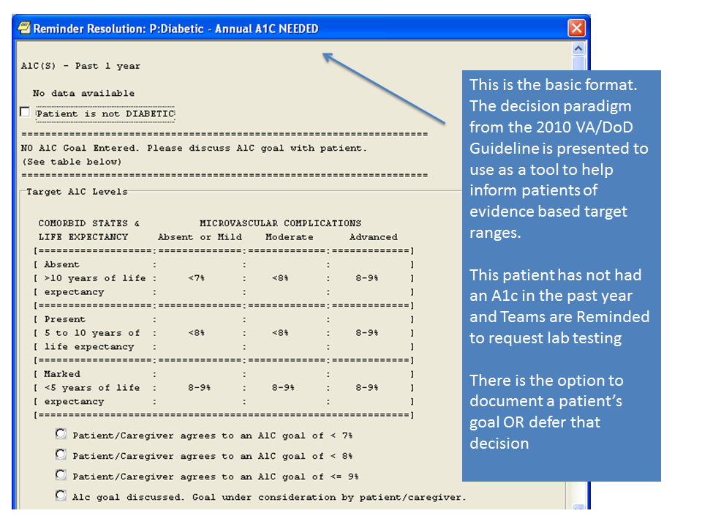

**Figure A.2. Reminder Resolution: Diabetic- A1c Goal Needed**

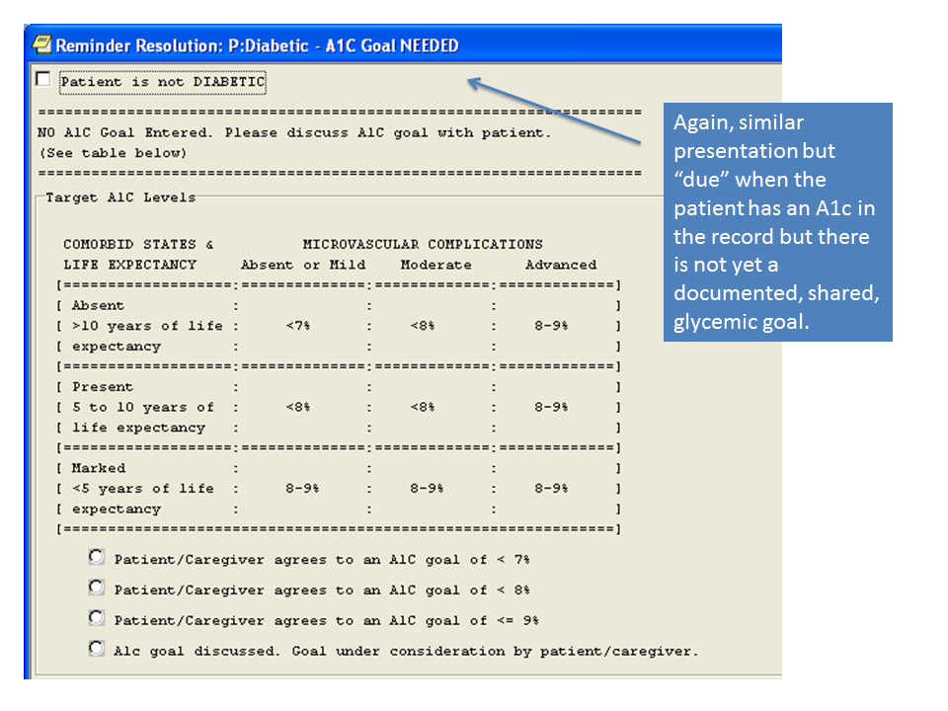

**Figure A.3. Test Ordering**

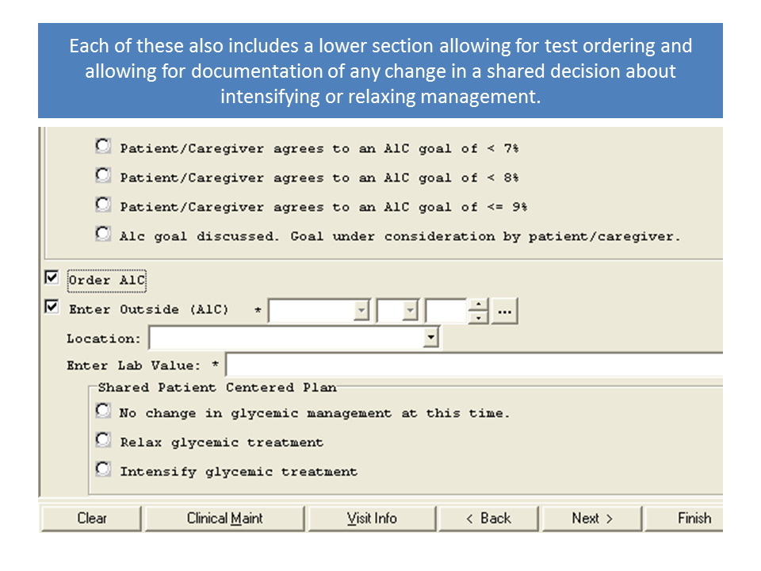

**Figure A.4. Reminder Resolution: Diabetic- A1c Not in Range**

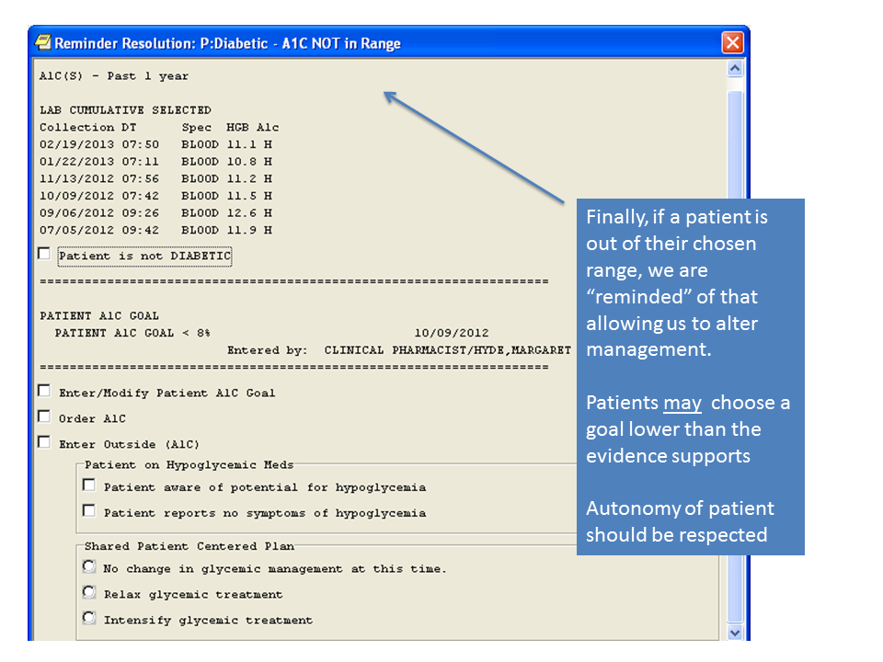

**Figure A.5. Final Reminder**

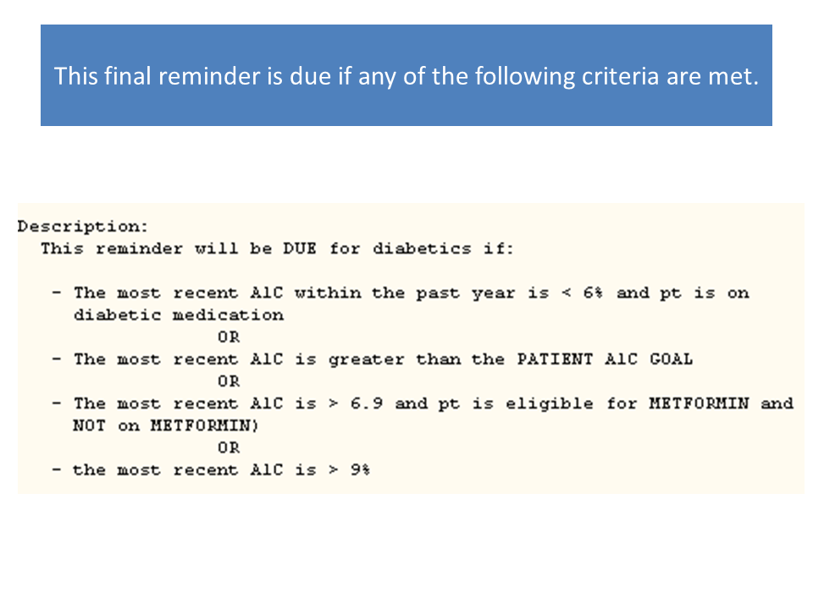

**Appendix B****. Basic Laboratory Panel Definition**

* Blood Urea Nitrogen
* Calcium
* Chloride
* CO2 (Carbon Dioxide, Bicarbonate)
* Creatinine
* Glucose
* Potassium
* Sodium

**Appendix C. Logic Diagrams**

**Figure C.1. ECA Rule: Symptomatic Hypoglycemia**

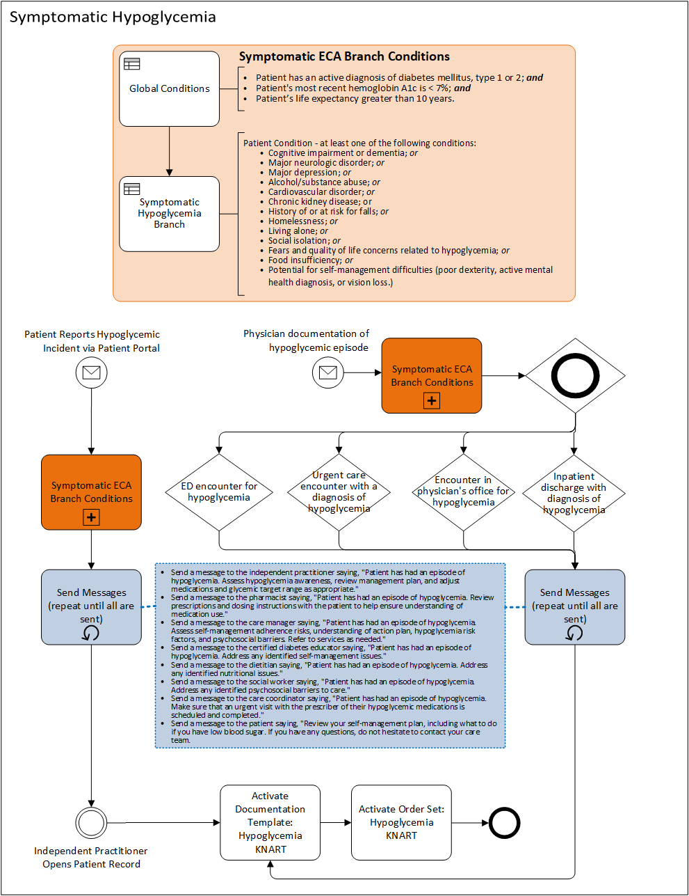

**Figure C.2. ECA Rule: System Run/Asymptomatic Hypoglycemia**

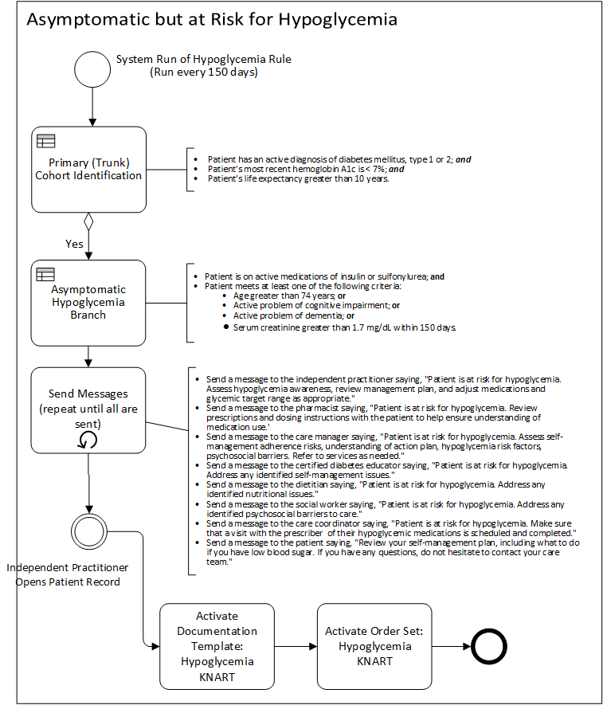

**Appendix D. Acronyms**

|  |  |
| --- | --- |
| ADA | American Diabetes Association |
| CCWP | Clinical Content White Paper |
| CDS | Clinical Decision Support |
| CDW | Corporate Data Warehouse |
| CO2 | Carbon Dioxide |
| CPRS | Computerized Patient Record System |
| DoD | Department of Defense |
| ECA | Event-Condition-Action |
| ED | Emergency Department |
| EHR | Electronic Health Record |
| HbA1c | Glycated Hemoglobin (Hemoglobin A1c) |
| HL7 | Health Level 7 |
| HSI | Hypoglycemia Safety Initiative |
| KBS | Knowledge Based Systems |
| KNART | Knowledge Artifact |
| NPH | Neutral Protamine Hagedorn |
| OIIG | Office of Informatics and Information Governance |
| PHR | Patient Health Record |
| SMBG | Self-Monitoring of Blood Glucose |
| SME | Subject Matter Expert |
| SNOMED | Systematized Nomenclature of Medicine |
| TO | Task Order |
| VA | Department of Veterans Affairs |
| VACO | VA Central Office |
| VAMC | VA Medical Center |
| VFW | Veterans of Foreign Wars |
| VISN | Veterans Integrated Service Network |
| VistA | Veterans Information Systems and Technology Architecture |