**Clinical Decision Support (CDS) Content and Health Level 7 (HL7)-compliant Knowledge Artifacts (KNARTs)**

**Neurosurgery: Radiculopathy (Cervical) Clinical Content White Paper**

**Department of Veterans Affairs (VA)**



**Knowledge Based Systems (KBS)**

**Office of Informatics and Information Governance (OIIG)**

**Clinical Decision Support (CDS)**

**Clinical Decision Support (CDS) Content and Health Level 7 (HL7)-compliant Knowledge Artifacts (KNARTs): Neurosurgery: Radiculopathy (Cervical) Clinical Content White Paper**

by Department of Veterans Affairs (VA)

Publication date April 2018

**Contract: VA118-16-D-1008, Task Order (TO): VA-118-16-F-1008-0007**

**Table 1. Relevant KNART Information**

| **KNART Name** | **Associated CLIN** |
| --- | --- |
| Radiculopathy (Cervical) - Order Set | CLIN0004AB |
| Radiculopathy (Cervical) - Documentation Template | CLIN0005AC |
| Radiculopathy (Cervical) – Composite/Consult Request | N/A |

**Table of Contents**

VA Subject Matter Expert (SME) Panel vi

Introduction vii

Conventions Used viii

1. Radiculopathy (Cervical) 1

1. Clinical Context 1

2. Knowledge Artifacts 1

2. Composite 3

1. Knowledge Narrative 3

2. Consult and Referrals 3

3. Documentation Template 4

1. Knowledge Narrative 4

2. Chief Complaint 4

3. Prior Conservative Therapies 4

4. Medical History 5

5. Surgical History 6

6. Social History 6

7. Imaging History 7

8. Medications 7

9. Surgical Candidacy 7

4. Order Set 9

1. Knowledge Narrative 9

2. Medications 9

3. Procedures 10

4. Imaging 10

5. Additional Consults 10

6. Patient Education 11

Bibliography/Evidence 12

A. Appendix: Existing VA Artifacts 13

B. Acronyms 31

**List of Figures**

A.1. Neurosurgery Consult 13

A.2. Neurosurgery Spine Consults 14

A.3. Cervical/Thoracic Radiculopathy 15

A.4. MRI Orders 16

A.5. Myelogram Consult 17

A.6. Service Prerequisites for Imaging Myelogram Consult 17

A.7. Reason For Request Myelogram 18

A.8. Reason for Request Imaging Myelogram Consult 19

A.9. Reason for Request Short Stay Unit 20

A.10. Order Consult Myelogram 21

A.11. Short Stay Orders 22

A.12. Short Stay Care Unit Consult 23

A.13. Service Prerequisite Questions 23

A.14. Cervical/Thoracic Myelogram, Urgency Criteria and Required Tests 24

A.15. The Neurosurgery Services Prerequisites Cervical/Thoracic Myelopathy Outpatient 24

A.16. Neurosurgery Consult Cervical/Thoracic Myelopathy 25

A.17. Neurosurgery Consult Goals for Cervical/Thoracic Myelopathy 26

A.18. Neurosurgery Consult Order 27

A.19. Neurosurgery Consult Request, Pre-requisite Tests not Completed 27

A.20. Neurosurgery Consult Request 28

A.21. Neurosurgery Consult Request 29

A.22. Neurosurgery Consult Request 30

A.23. Service Prerequisites for Myelogram Consult 30

**List of Tables**

1. Relevant KNART Information ii

1.1. Clinical Context Domains 1

**VA Subject Matter Expert (SME) Panel**

| **Name** | **Title** | **Project Role** |
| --- | --- | --- |
| David (Cory) Adamson, MD | Physician, 1670 Clairmont Rd, Atlanta, GA 30033 | SME, Primary |
| Jacob Rachlin, MD | Chief of Neurosurgery, VA Boston Health Care System, 1400 VFW Parkway, Boston, MA 02132 | SME, Secondary |
| Joseph King, MD | Physician, Surgical Service, VA New England/Connecticut Healthcare System, 950 Campbell Ave, West Haven, CT 06516 | SME |

**Introduction**

The VA is committed to improving the ability of clinicians to provide care for patients while increasing quality, safety, and efficiency. Recognizing the importance of standardizing clinical knowledge in support of this goal, VA is implementing the HL7 Knowledge Artifact Specification for a wide range of VA clinical use cases. Knowledge Artifacts, referred to as KNARTs, enable the structuring and encoding of clinical knowledge so the knowledge can be integrated with electronic health records to enable clinical decision support.

The purpose of this Clinical Content White Paper is to capture the clinical context and intent of KNART use cases in sufficient detail to provide the KNART authoring team with the clinical source material to construct the corresponding knowledge artifacts using the HL7 Knowledge Artifact Specification. This paper has been developed using material from a variety of sources: VA artifacts, clinical practice guidelines, evidence in the body of medical literature, and clinical expertise. After reviewing these sources, the material has been synthesized and harmonized under the guidance of VA subject matter experts to reflect clinical intent for this use case.

Unless otherwise noted, items within this white paper (e.g., documentation template fields, orderable items, etc.) are chosen to reflect the clinical intent at the time of creation. To provide an exhaustive list of all possible items and their variations is beyond the scope of this work.

**Conventions Used**

Conventions used within the knowledge artifact descriptions include:

* <obtain>: Indicates a prompt to obtain the information listed
* If possible, the requested information should be obtained from the underlying system(s). Otherwise, prompting the user for information may be required.
* The technical and clinical notes associated with a section should be consulted for specific constraints on the information (e.g., time-frame, patient interview, etc.).
* Default values: unless otherwise noted, <obtain> indicates to obtain the one most recent observation. It is recognized that this default time-frame value may be altered by future implementations
* [...]: Square brackets enclose explanatory text that indicates some action on the part of the user, or general guidance to the clinical or technical teams. Examples include, but are not limited to:
* [Begin...], [End...]: Indicates the start and end of specific areas to clearly delineate them for technical purposes.
* [Activate...]: Initiates another knowledge artifact or knowledge artifact section.
* [Section Prompt: ...]: If this section is applicable, then the following prompt should be displayed to the user.
* [Section Selection Behavior: ...]: Indicates technical constraints or considerations for the selection of items within the section.
* [Attach: ...]: Indicates the specified item should be attached to the documentation template if available.
* [Link: ...]: Indicates that, rather than attaching, a link to the item should be included in the documentation template.
* [Clinical Comments: ...]: Indicates clinical rationale or guidance.
* [Technical Note: ...]: Indicates technical considerations or notes.
* [If...]: Indicates the beginning of a conditional section.
* [Else, ...]: Indicates the beginning of the alternative branch of a conditional section.
* [Else if...] Indicates the end of a conditional section.
* Check boxes: Indicates items that should be selected based upon the section selection behavior.

**Chapter 1. Radiculopathy (Cervical)**

**1. Clinical Context**

The Neurosurgery Radiculopathy (Cervical) KNART set is intended for referring providers (Primary Care, Pain Clinic, Anesthesiologist, Physical Therapist and sometimes Emergency Department Physicians) performing an initial workup for adult outpatients with symptoms prior to requesting a Neurosurgery Consultation. Diagnostic and treatment modalities include Magnetic Resonance Imaging (MRI), Computed Tomography (CT) Myelogram, medication, physical therapy, acupuncture, steroid injections and pain clinic visits. The provider should also consider both a mental health evaluation and a substance abuse evaluation (alcohol, smoking, opioids/narcotics) where appropriate. The clinical context for this consultation includes only routine, non-urgent referrals to neurosurgery.

**Table 1.1. Clinical Context Domains**

|  |  |
| --- | --- |
| Target User | Provider in Primary Care, Emergency Medicine, Anesthesiology, Pain Clinic, Physical Therapy |
| Patient | Adult outpatient being referred to Neurosurgery for Radiculopathy (Cervical) |
| Priority | Routine/Non-urgent |
| Specialty | Primary Care |
| Location | Outpatient |

**2. Knowledge Artifacts**

This section describes the CDS knowledge artifacts that are specific to Neurosurgery Radiculopathy (Cervical) and is intended for users caring for adult patients who may require a Neurosurgery referral for surgery. Target clinical users include Primary Care physicians, Emergency Department physicians, Physical Therapist, Pain Clinic or Anesthesiologists. Patient cohort includes adult outpatients being referred to Neurosurgery.

The intent of these artifacts is to ensure a minimum workup is initiated prior to a Neurosurgery Consultation. Specific constraints for these artifacts are that:

* They apply to adult outpatients being considered for Neurosurgery referral.
* All imaging studies and treatment modalities are documented and appropriate results are accessible for Neurosurgery consultation.

There are three knowledge artifacts that define this clinical use case. These artifacts are the Consult Request, the Documentation Template and the Order Set and are described in detail in the following sections.

* Consult Request
* This is a high-level, encompassing artifact.
* It relies upon the documentation template and order set artifacts.
* Documentation Template
* This is a template used to document the information provided by the referring provider.
* It includes logic for appropriate display of documentation sections.
* Order Set
* This is the set of orderable items associated with the consult request.
* It includes logic for appropriate display of the order set.

**Chapter 2. Composite**

[Begin Composite.]

**1. Knowledge Narrative**

[See Clinical Context in Chapter 1.]

Cervical radiculopathy is a common problem that exerts a significant impact on functional impairment, chronic pain, disability, absenteeism, and other parameters that negatively affect quality of life. Referring physicians, most commonly primary care physicians and mid-level providers, often respond to the frustration of a patient with cervical radiculopathy by ordering advanced imaging tests and prematurely referring patients to subspecialists before exhausting the full array of conservative treatment modalities that are within their scope of practice. Implementation of an evidence-based approach consistent with the recommendations of authoritative professional societies, such as the American Association of Neurological Surgeons and the Congress of Neurological Surgeons, can optimize resource allocation and facilitate use of appropriate treatment modalities based on clinical presentation.

**2. Consult and Referrals**

[Begin Consul and Referrals.

[Technical Note: The following list provides the basic components of the consult request. This is the high-level, encompassing artifact, and must be combined with the documentation template and order set to form a fully functional knowledge artifact. The information for the consult request can be obtained as part of the composite or within the corresponding order set component in the consult section. If obtained within the composite, this information should pre-populate the respective order set component.]

[Section Prompt: To request a neurosurgery consult for evaluation of cervical radiculopathy, please provide the following information.]

* Reason for Consult: Evaluate patient with cervical radiculopathy for surgery
* Consult Specialty: Neurosurgery
* Priority: Routine
* <obtain> Referring Physician
* <obtain> Referring Physician Contact Information

[Activate Documentation Template.]

[End Consult and Referrals.]

[End Composite.]

**Chapter 3. Documentation Template**

[Begin Documentation Template.]

**1. Knowledge Narrative**

[See Clinical Context in Chapter 1.]

[Section Prompt: This documentation template should be completed by the provider requesting neurosurgical evaluation for a patient with cervical radiculopathy.]

**2. Chief Complaint**

[Begin Chief Complaint section.]

[Section Prompt: Chief Complaint.]

[Section Selection Behavior: Select at least one.]

* ☐ Pain
* ☐ Numbness
* ☐ Weakness
* ☐ Other <obtain>

[Section Prompt: Location of symptoms.]

[Section Selection Behavior: Select at least one.]

* ☐ Neck
* ☐ Left Arm
* ☐ Right Arm
* ☐ Other <obtain> Location

[Section Prompt: If pain is not a chief complaint, then skip to Duration of Symptoms.]

[Section Prompt: Please provide details regarding the character of the pain (e.g., burning, shooting, aching, electric, jabbing, etc.).]

<obtain> Details

[Section Prompt: Duration of Symptoms]

[Section Selection Behavior: Select only one.]

* ☐ Less than 2 weeks
* ☐ Greater than or equal to 2 weeks and less than or equal to 3 months
* ☐ Greater than 3 months

[End Chief Complaint section.]

**3. Prior Conservative Therapies**

[Begin Prior Conservative Therapies section.]

[Section Prompt: Which conservative therapies have been tried?]

**Medications.**[Subsection Prompt: Medications.]

[Section Selection Behavior: Select any. Optional.]

[Technical Note: Details for this subsection include: name of medication, dose, date started, and date ended.]

* ☐ Nonsteroidal anti-inflammatory drug (NSAIDs) <obtain> Details
* ☐ Opioids <obtain> Details
* ☐ Antiepileptics <obtain> Details
* ☐ Tricyclic antidepressants <obtain> Details
* ☐ Other <obtain> Details
* ☐ None

**Other Therapies.**[Subsection Prompt: Other Therapies.]

[Section Selection Behavior: Select any. Optional.]

[Technical Note: Details for this subsection include: therapy summary, date started, date ended, number of times and outcome.]

* ☐ Occupational Therapy <obtain> Details
* ☐ Cervical traction <obtain> Details
* ☐ Acupuncture <obtain> Details
* ☐ Spinal Manipulation <obtain> Details
* ☐ Cognitive behavioral therapy <obtain> Details
* ☐ Pain clinic <obtain> Details
* ☐ Selective nerve root blocks <obtain> Details
* ☐ Epidural steroid injections <obtain> Details
* ☐ Other <obtain> Details

[End Prior Conservative Therapies section.]

**4. Medical History**

[Begin Medical History section.]

[Section Prompt: Applicable Medical History.]

[Section Selection Behavior: Select any. Optional.]

[Technical Note: Details for this section include: summary, consult date, consult results, current status.]

* ☐ Chronic pain <obtain> Details
* ☐ Posttraumatic stress disorder <obtain> Details
* ☐ Anxiety <obtain> Details
* ☐ Depression <obtain> Details
* ☐ Other mental conditions <obtain> Details
* ☐ Oncological conditions <obtain> Details
* ☐ Obesity <obtain> Body Mass Index (BMI)
* ☐ Cardiovascular conditions <obtain> Details

[Technical Note: Provide link to full medical history.]

[End Medical History section.]

**5. Surgical History**

[Begin Surgical History section.]

[Section Prompt: Applicable Surgical History.]

[Section Selection Behavior: Select any. Optional.]

[Technical Note: Details for this section include: surgical summary and surgery date.]

* ☐ Spinal surgery <obtain> Details
* ☐ Other prior surgeries <obtain> Details

[Technical Note: Provide link to full surgical history.]

[End Surgical History section.]

**6. Social History**

[Begin Social History section]

[Section Prompt: Social History.]

[Section Selection Behavior: Select any. Optional.]

[Technical Note: Details for this section include: summary, current status, applicable dates.]

* ☐ Alcohol use/abuse <obtain> Details
* ☐ Rehabilitation or detoxification <obtain> Details
* ☐ Current or former tobacco user <obtain> Details <obtain> Pack years

[Technical Note: Provide link to Tobacco Assessment and Cessation Counseling KNART]

* ☐ Cocaine use/abuse <obtain> Details
* ☐ Other substance use/abuse <obtain> Details
* ☐ Homeless <obtain> Details

[Technical Note: Provide link to Homelessness Documentation Template KNART]

* ☐ Unstable home environment <obtain> Details
* ☐ Home environment conducive to healing <obtain> Details
* ☐ Geographically remote (40+mile drive to medical care) <obtain> Details

[End Social History section.]

**7. Imaging History**

[Begin Imaging History section.]

[Section Prompt: Imaging History]

[Section Prompt: The most recent imaging studies in each category should be included:]

[Technical Note: Result text should be attached automatically if available for the Cervical Spine X-Ray Interpretation field.]

* <obtain> Cervical Spine X-rays Interpretation with dynamic flexion and extension
* [Link Images: Cervical Spine X-Rays.]

[Technical Note: Result text should be attached automatically if available for the Cervical Spine MRI Interpretation field.]

* <obtain> Cervical Spine MRI Interpretation
* [Link Images: Cervical Spine MRI.]

[Technical Note: Result text should be attached automatically if available for the Cervical Spine Myelogram Interpretation field.]

* <obtain> Cervical Spine Myelogram Interpretation
* [Link Images: Cervical Spine Myelogram.]

[Technical Note: Result text should be attached automatically if available for the Cervical Spine CT Interpretation field.]

* <obtain> Cervical Spine CT Interpretation
* [Link Images: Cervical Spine CT.]

[End Imaging History section.]

**8. Medications**

[Begin Medications List section.]

<obtain> Current pain medication list

<obtain> Current anticoagulation and antiplatelet list

[End Medications List section.]

**9. Surgical Candidacy**

[Begin Surgical Candidacy section.]

[Section Prompt: Does patient want to be considered for surgery?

* ☐ Yes
* ☐ No <obtain> reason for neurosurgical consult

[End Surgical Candidacy section.]

[End Documentation Template.]

**Chapter 4. Order Set**

[Begin Order Set.]

**1. Knowledge Narrative**

[See Clinical Context in Chapter 1.]

**2. Medications**

[Begin Medications section]

[Section Prompt: Based upon clinical judgment and if not otherwise contraindicated, consider initiating a new order for one or more of the following medications prior to the neurosurgery consultation.]

[Section Prompt: NSAIDSs]

[Section Prompt: NSAIDs increase the risk of serious gastrointestinal adverse events including bleeding, ulceration, and perforation of the stomach or intestines, which can be fatal. The prevailing recommendations in consensus-based clinical guidelines recommend that NSAID/Cyclo-oxygenase-2 (COX-2) should be avoided in Chronic Kidney Disease (CKD).]

[Technical Note: Provide link to <https://www.ncbi.nlm.nih.gov/pmc/articles/PMC3417055/#R6/link>]

[Section Selection Behavior: Select only one. Optional.]

* ☐ Ibuprofen 400 mg tablet oral every 6 hours as needed for neck or arm pain; may increase dose frequency to one tablet every 4 hours 100 tablets 2 refills
* ☐ Naproxen sodium 550 mg tablet oral every 12 hours as needed for neck or arm pain 100 tablets 2 refills

[Section Prompt: Other Analgesics]

[Section Selection Behavior: Select only one. Optional.]

* ☐ Acetaminophen 325 mg tablet oral two tablets every 6 hours as needed for neck or arm pain; may increase dose frequency to two tablets every 4 hours; do not take more than 10 tablets per day 100 tablets 2 refills

[Section Prompt: Glucocorticoids, Oral]

[Section Selection Behavior: Select only one. Optional.]

* ☐ Methylprednisolone 4 mg tablet oral by taper:
* take 6 tablets at once on day 1
* On day 2 take one tablet before breakfast, one after lunch, one after dinner, and two at bedtime
* On day 3 take one tablet before breakfast, one after lunch, one after dinner, and one at bedtime
* On day 4 take one tablet before breakfast, one after lunch, and one at bedtime
* On day 5 take one tablet before breakfast and one at bedtime
* On day 6 take one tablet before breakfast.
* 21 tablets 0 refills

[End Medications section.]

**3. Procedures**

[Begin Procedures section.]

[Section Prompt: Consider ordering the following procedures in conjunction with the neurosurgery consult. Typically for pain management, unless contraindicated for any reason, one would order glucocorticoid injection from the list below first, and if indicated, proceed to selective nerve block based on clinical outcome of patient's symptoms following completion of the series of 3 glucocorticoid injections.]

[Section Selection Behavior: Select any or none. Optional.]

* ☐ Epidural glucocorticoid injection under fluoroscopic or CT guidance per interventionist (series of three)
* ☐ Selective nerve root block per interventionist to distinguish symptomatic level(s) following identification of compressive lesions at multiple levels on MRI or CT myelography
* ☐ Selective nerve root block per interventionist to distinguish symptomatic level(s) in patient with discordance between clinical symptoms and findings on MRI or CT myelography

[End Procedures section]

**4. Imaging**

[Begin Imaging section]

[Section Prompt: Consider ordering one of the following imaging studies in conjunction with the neurosurgery consult.]

[Section Selection Behavior: Select only one. Optional.]

* ☐ X-ray cervical spine anteroposterior (AP) and lateral for neck pain
* ☐ MRI cervical spine without intravenous (IV) contrast (consider for: chronic neck pain, failed conservative management, candidate for surgical intervention)
* ☐ CT cervical spine without IV contrast (consider for: chronic neck pain, failed conservative management, candidate for surgical intervention, MRI contraindicated, IV contrast contraindicated)
* ☐ CT myelography cervical spine (consider for: chronic neck pain, failed conservative management, candidate for surgical intervention, MRI contraindicated)
* ☐ CT myelography cervical spine (consider for: chronic neck pain, failed conservative management, candidate for surgical intervention, clinical findings discordant with MRI findings)

[End Imaging Section.]

**5. Additional Consults**

[Begin Additional Consults section.]

[Section Prompt: Consider ordering the following consults in conjunction with the neurosurgery consult.]

[Section Selection Behavior: Optional. Select as many as desired.]

* ☐ Consult physical therapy to evaluate for conservative therapy for cervical radiculopathy (e.g., cervical halter traction, electrical stimulation, acupuncture, exercise instruction)
* ☐ Consult psychiatry to evaluate for depression and other psychological factors that may affect patient's perception of pain and ability to manage pain
* ☐ Consult social services to evaluate social factors (e.g., joblessness, homelessness, financial concerns) that may affect patient's ability to adhere to conservative treatment
* ☐ Consult pain management to address modalities for treating chronic pain

[End Additional Consults section.]

**6. Patient Education**

[Begin Patient Education section.]

[Section Prompt: Consider ordering patient education in conjunction with the neurosurgery consult.]

[Section Selection Behavior: Select any or none. Optional.]

* ☐ Cervical radiculopathy education (level-appropriate materials on natural progression, conservative management, and procedural management)

[End Patient Education section.]

[End Order Set.]

**Bibliography/Evidence**

[Bono, 2011] CM Bono, G Ghiselli, and TJ Gilbert. “An evidence-based clinical guideline for the diagnosis and treatment of cervical radiculopathy from degenerative disorders”. *Spine J*. 2011. 11. 1. 64-72.

Joint Section on Disorders of the Spine and Peripheral Nerves of the American Association of Neurological Surgeons and Congress of Neurological Surgeons.  *Guidelines for the surgical management of cervical degenerative disease*. J Neurosurg Spine. 2009. 11. 2. 97-252.

[Kuijper, 2009] B Kuijper, JTJ Tans, A Beelen, F Nollet, and M de Visser. “Cervical collar or physiotherapy versus wait and see policy for recent onset cervical radiculopathy: randomised trial”. *BMJ*. 2009. 11. 339-b3883.

[Newman, 2013] JS Newman, BN Weissman, PD Angevine, and et al. “Expert Panel on Musculoskeletal Imaging. ACR Appropriateness Criteria: Chronic Neck Pain”. *American College of Radiology Website*. 2013. <https://acsearch.acr.org/docs/69426/Narrative/>.

U.S. National Library of Medicine.  *IBU- ibuprofen tablet [Dr. Reddy's Laboratories Limited]*. DailyMed website. Revised October 2016. <https://dailymed.nlm.nih.gov/dailymed/drugInfo.cfm?setid=24731405-219c-79b4-ecf0-7d5fbfda94ba>.

U.S. National Library of Medicine.  *MEDROL- methylprednisolone tablet [Pharmacia and Upjohn Company LLC]*. DailyMed website. Revised November 2016. <https://dailymed.nlm.nih.gov/dailymed/drugInfo.cfm?setid=39d5270b-d957-4821-93d6-501b7b9f02d4>.

U.S. National Library of Medicine.. *NAPROSYN- naproxen tablet; EC-NAPROSYN- naproxen tablet, delayed release; NAPROSYN- naproxen suspension; ANAPROX- naproxen sodium tablet; ANAPROX DS- naproxen sodium tablet [Genentech, Inc.]*. DailyMed website. Revised March 2016. <https://dailymed.nlm.nih.gov/dailymed/drugInfo.cfm?setid=68848217-03c9-4377-9be6-6f567e629129>.

U.S. National Library of Medicine. *Tylenol Regular Strength-acetaminophen tablet[Johnson &Johnson Consumer Inc.,McNeil Consumer Healthcare Division]*. DailyMed website. Revised March 2016. <https://dailymed.nlm.nih.gov/dailymed/drugInfo.cfm?setid=68848217-03c9-4377-9be6-6f567e629129>.

**Appendix A. Appendix: Existing VA Artifacts**

**Figure A.1. Neurosurgery Consult**

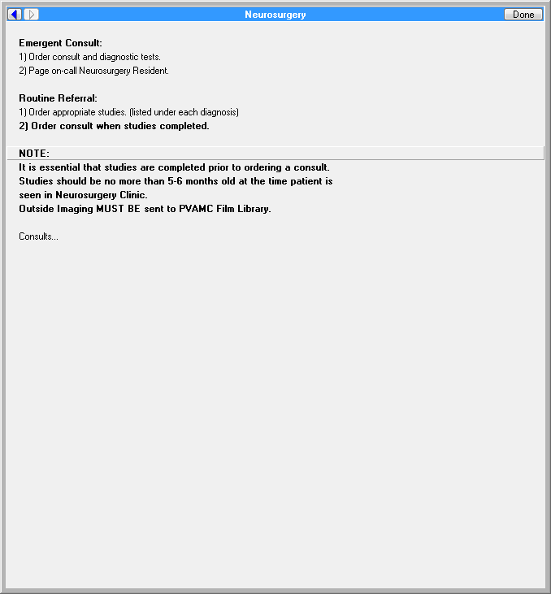

**Figure A.2. Neurosurgery Spine Consults**

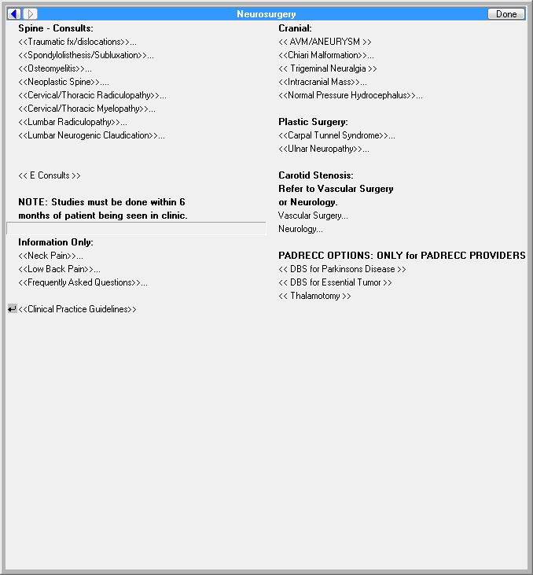

**Figure A.3. Cervical/Thoracic Radiculopathy**

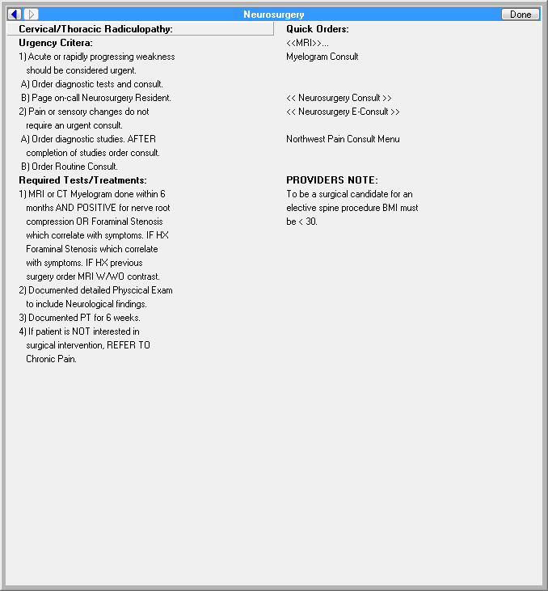

**Figure A.4. MRI Orders**

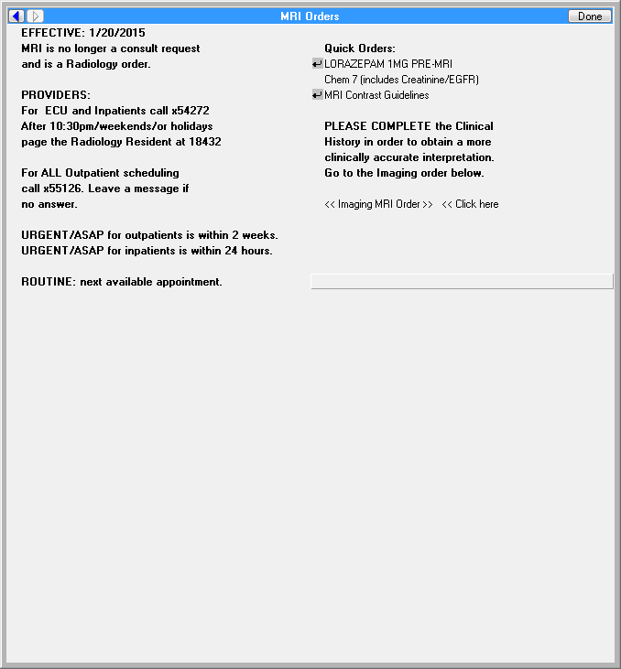

**Figure A.5. Myelogram Consult**

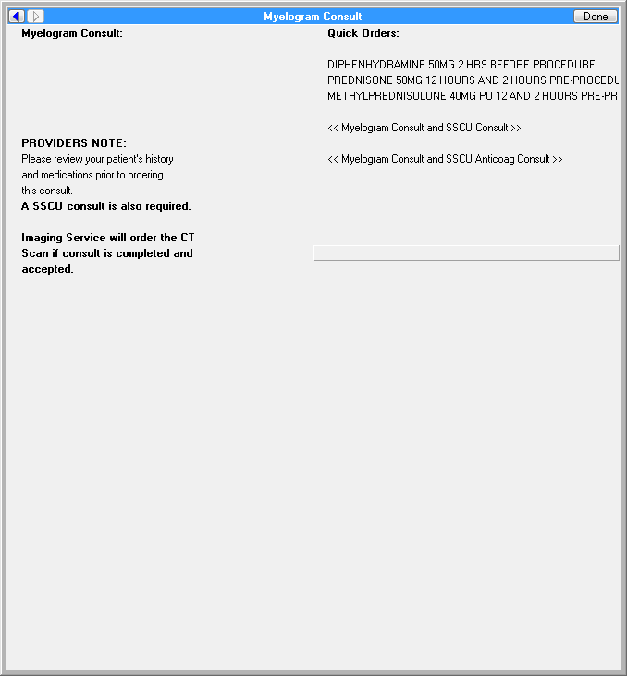

**Figure A.6. Service Prerequisites for Imaging Myelogram Consult**

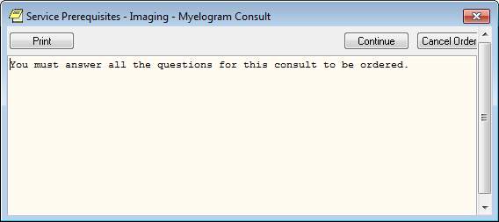

**Figure A.7. Reason For Request Myelogram**

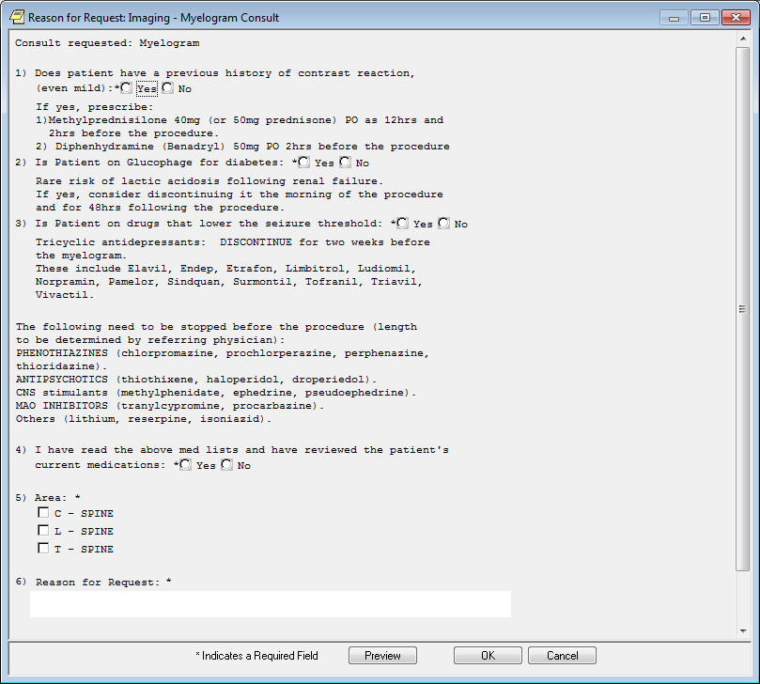

**Figure A.8. Reason for Request Imaging Myelogram Consult**

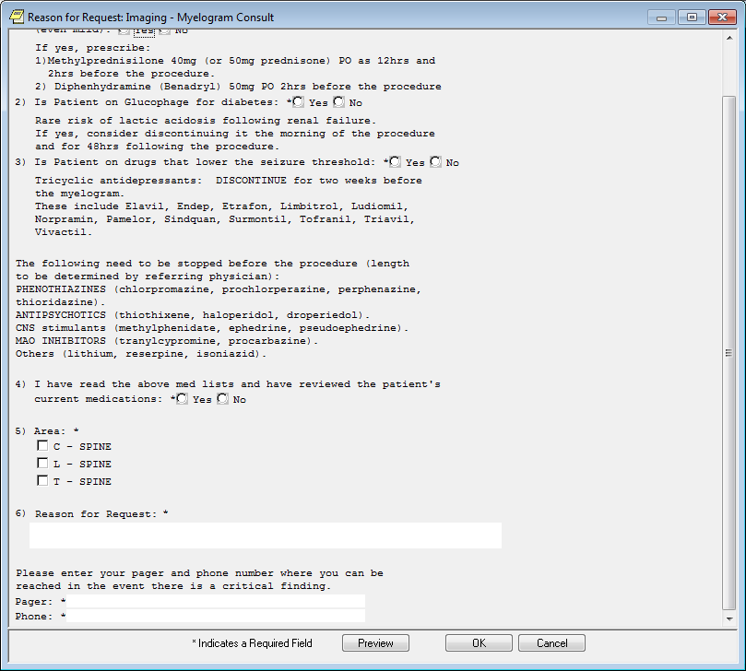

**Figure A.9. Reason for Request Short Stay Unit**

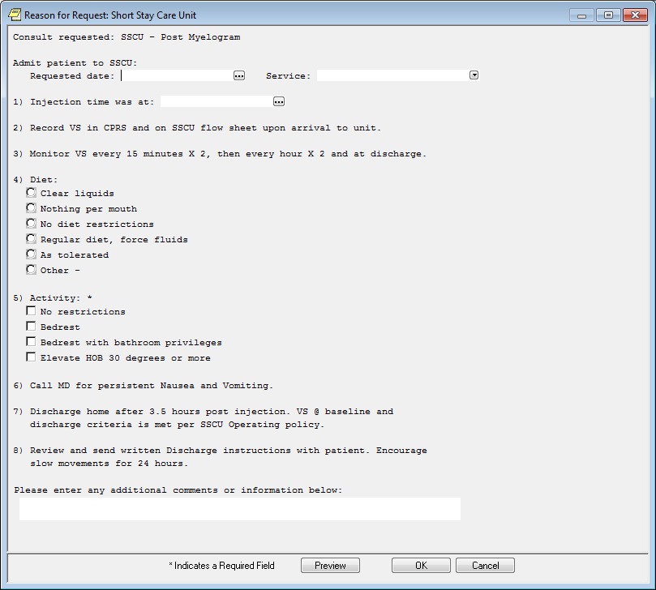

**Figure A.10. Order Consult Myelogram**

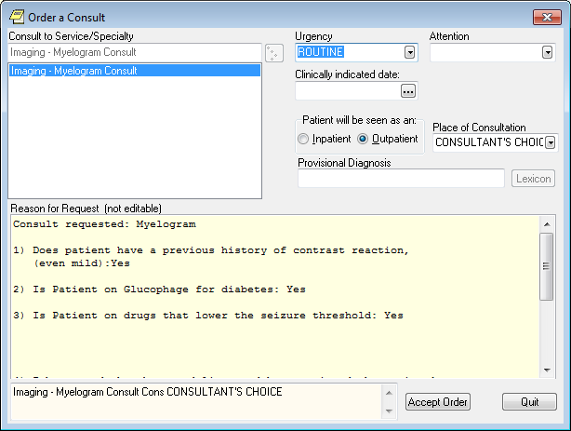

**Figure A.11. Short Stay Orders**



**Figure A.12. Short Stay Care Unit Consult**

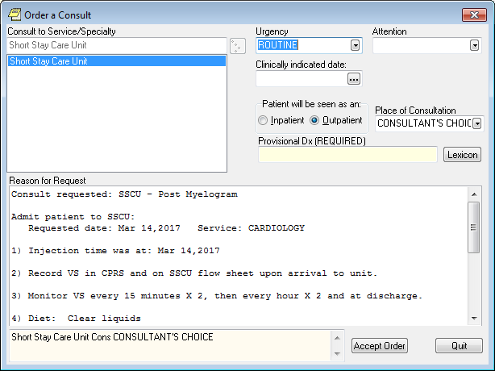

**Figure A.13. Service Prerequisite Questions**

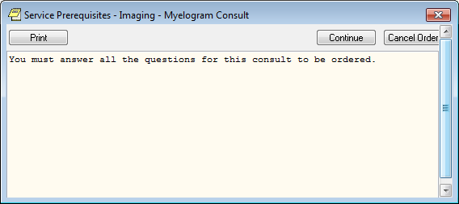

**Figure A.14. Cervical/Thoracic Myelogram, Urgency Criteria and Required Tests**

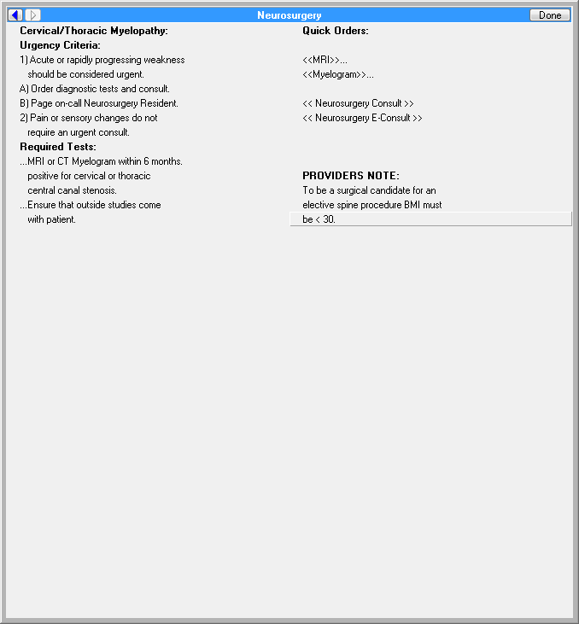

**Figure A.15. The Neurosurgery Service Prerequisites Cervical/Thoracic Myelopathy Outpatient**

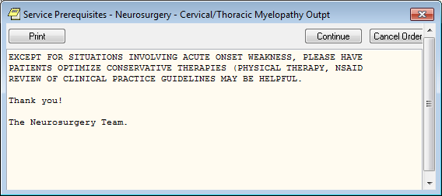

**Figure A.16. Neurosurgery Consult Cervical/Thoracic Myelopathy**

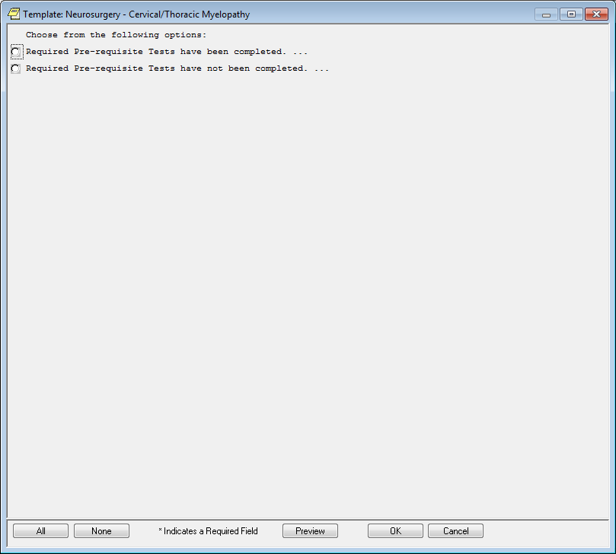

**Figure A.17. Neurosurgery Consult Goals for Cervical/Thoracic Myelopathy**

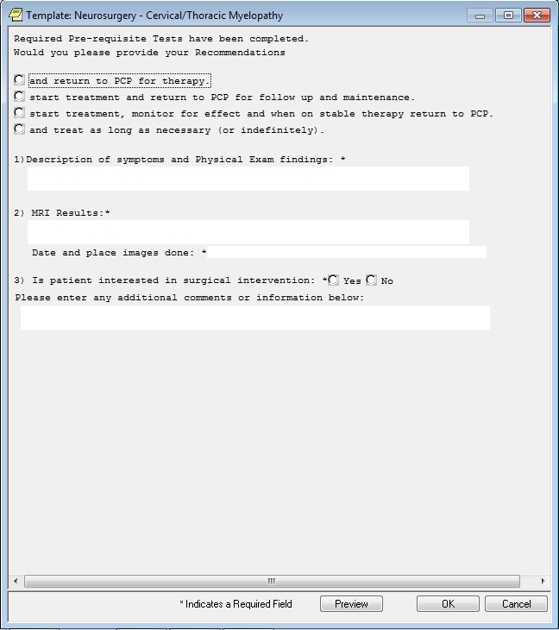

**Figure A.18. Neurosurgery Consult Order**

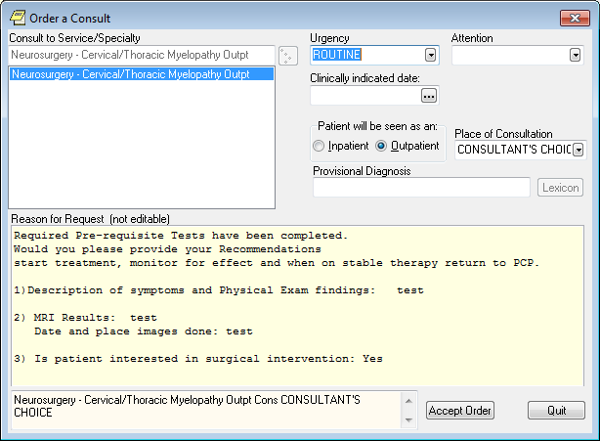

**Figure A.19. Neurosurgery Consult Request, Pre-requisite Tests not Completed**

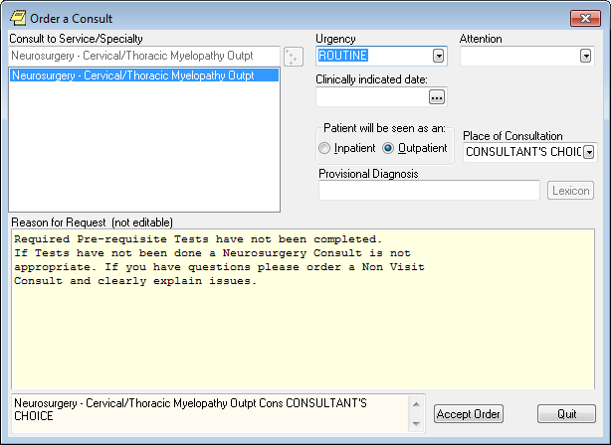

**Figure A.20. Neurosurgery Consult Request**

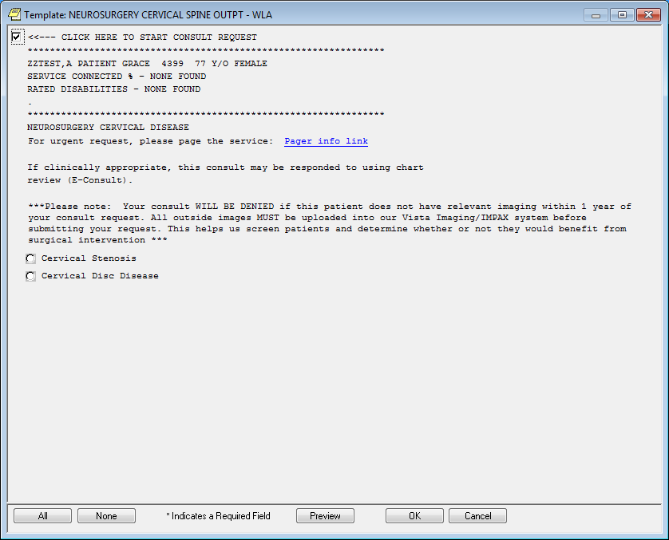

**Figure A.21. Neurosurgery Consult Request**

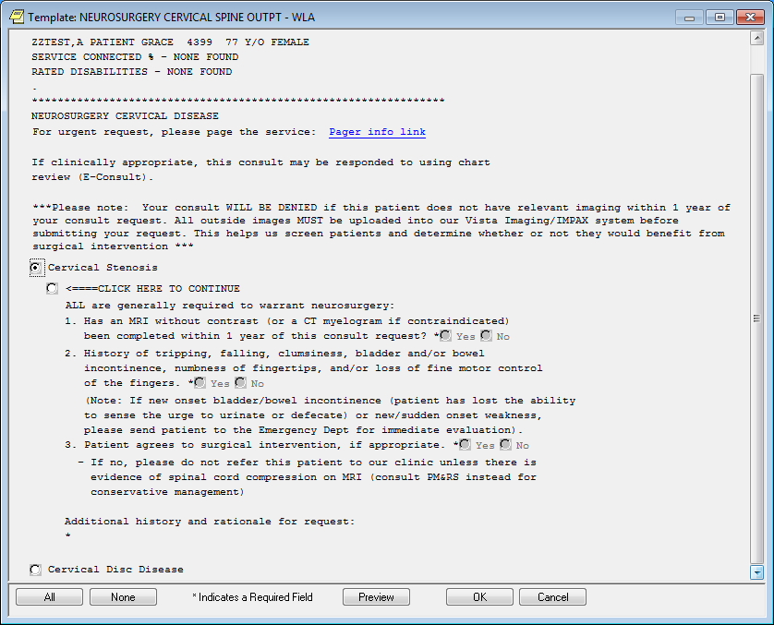

**Figure A.22. Neurosurgery Consult Request**

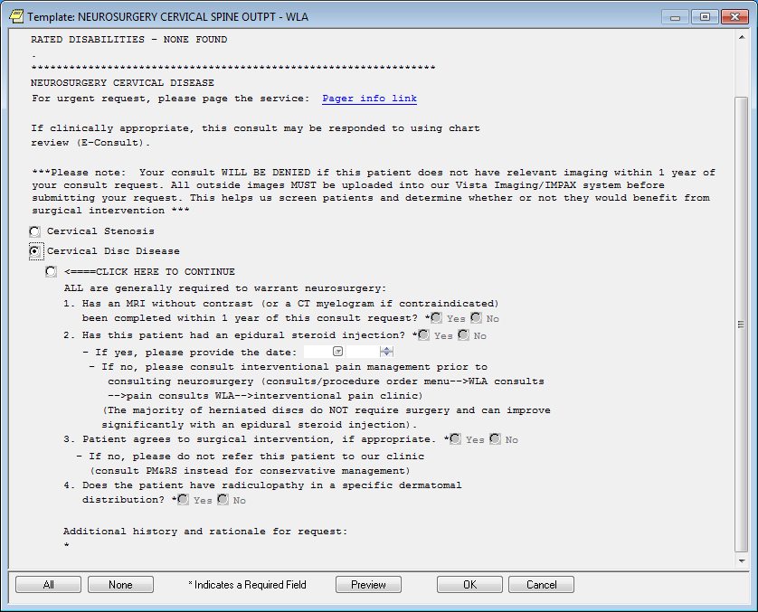

**Figure A.23. Service Prerequisites for Myelogram Consult**



**Appendix B. Acronyms**

| **Acronym** | **Definition** |
| --- | --- |
| AP | Anteroposterior |
| BMI | Body Mass Index |
| CDS | Clinical Decision Support |
| CKD | Chronic Kidney Disease |
| COX-2 | Cyclo-oxygenase-2 |
| CT | Computed Tomography |
| HL7 | Health Level 7 |
| IV | Intravenous |
| KBS | Knowledge Based Systems |
| KNART | Knowledge Artifact |
| MRI | Magnetic Resonance Imaging |
| NSAID | Nonsteroidal anti-inflammatory drug |
| OIIG | Office of Informatics and Information Governance |
| SME | Subject Matter Expert |
| TO | Task Order |
| VA | Department of Veterans Affairs |