**Clinical Decision Support (CDS) Content and Health Level 7 (HL7)-Compliant Knowledge Artifacts (KNARTs)**

**Failed Visits and Failed or Delayed Consults Clinical Content White Paper**

**Department of Veterans Affairs (*****VA*****)**



**Knowledge Based Systems (****KBS****)**

**Office of Informatics and Information Governance (****OIIG****)**

**Clinical Decision Support (****CDS****)**

**Clinical Decision Support (CDS) Content and Health Level 7 (HL7)-Compliant Knowledge Artifacts (KNARTs): Failed Visits and Failed or Delayed Consults Clinical Content White Paper**

by Department of Veterans Affairs (VA)

Publication date February 2018

**Contract: VA118-16-D-1008, Task Order (*****TO*****): VA-118-16-F-1008-0007**

**Table 1. Relevant KNART Information: Failed Visits and Failed or Delayed Consults KNART**

| **Failed Visits and Failed or Delayed Consults KNART** | **Associated CLIN** |
| --- | --- |
| Failed Visits - ECA Rule | CLIN0007BA |
| Failed or Delayed Consults - ECA Rule | CLIN0007BA |

**Table of Contents**

VA Subject Matter Expert ([SME](#d0e144)) Panel vi

Introduction vii

Conventions Used viii

1. Failed Visits and Failed or Delayed Consults 1

1.1. Clinical Context 1

1.2. Knowledge Artifacts 1

2. Event Condition Action (ECA) Rule: Failed Visits 2

2.1. Knowledge Narrative 2

2.2. Failed Visits 2

3. Event Condition Action (ECA) Rule: Failed or Delayed Consults 3

3.1. Knowledge Narrative 3

3.2. Failed or Delayed Consults 3

Bibliography/Evidence 5

A. Logic Diagrams 6

Acronyms 7

**List of Figures**

A.1. Failed Visit ECA Rule 6

A.2. Failed or Delayed Consult/Referral ECA Rule 6

**List of Tables**

1. Relevant KNART Information: Failed Visits and Failed or Delayed Consults KNART ii

1.1. Clinical Context Domains 1

**VA Subject Matter Expert (****SME****) Panel**

| **Name** | **Title** | **Project Role** |
| --- | --- | --- |
| Angela Denietolis, MD | Primary Care Physician, James A. Haley Veterans Hospital, Tampa VA Medical Center (VAMC), Tampa, FL 33612 | SME, Primary |
| Pat Dumas, RN | Clinical Program Director, VA Central Office (VACO), 810 Vermont Ave NW, Washington, DL 20420 | SME, Secondary |
| Manish Merchant, MD | Health Informatician, Albany VAMC, 113 Holland Ave, Albany, NY 12208 | SME |
| Timothy Dresselhaus, MD | San Diego VAMC - MEDS, 3350 La Jolla Village Dr, San Diego, CA 92161 | SME |

**Introduction**

The VA is committed to improving the ability of clinicians to provide care for patients while increasing quality, safety, and efficiency. Recognizing the importance of standardizing clinical knowledge in support of this goal, VA is implementing the Health Level 7 (HL7) Knowledge Artifact Specification for a wide range of VA clinical use cases. Knowledge Artifacts, referred to as (KNARTs), enable the structuring and encoding of clinical knowledge so the knowledge can be integrated with electronic health records to enable clinical decision support.

The purpose of this Clinical Content White Paper (CCWP) is to capture the clinical context and intent of KNART use cases in sufficient detail to provide the KNART authoring team with the clinical source material to construct the corresponding knowledge artifacts using the HL7 Knowledge Artifact Specification. This paper has been developed using material from a variety of sources: VA artifacts, clinical practice guidelines, evidence in the body of medical literature, and clinical expertise. After reviewing these sources, the material has been synthesized and harmonized under the guidance of VA subject matter experts to reflect clinical intent for this use case.

Unless otherwise noted, items within this white paper (e.g., documentation template fields, orderable items, etc.) are chosen to reflect the clinical intent at the time of creation. To provide an exhaustive list of all possible items and their variations is beyond the scope of this work.

**Conventions Used**

Conventions used within the knowledge artifact descriptions include:

<obtain>: Indicates a prompt to obtain the information listed

* If possible, the requested information should be obtained from the underlying system(s). Otherwise, prompting the user for information may be required
* Default Values: Unless otherwise noted, <obtain> indicates to obtain the most recent observation. It is recognized that this default time-frame value may be altered by future implementations

[...]: Square brackets enclose explanatory text that indicates some action on the part of the clinical user, or general guidance to the clinical or technical teams. Examples include, but are not limited to:

[Begin ...], [End ...]: Indicates the start and end of specific areas to clearly delineate them for technical purposes.

[Activate ...]: Initiates another knowledge artifact or knowledge artifact section.

[Section Prompt: ...]: If this section is applicable, then the following prompt should be displayed to the user.

[Section Behavior: ...]: Indicates technical constraints or considerations for the selection of items outlined in the section prompt.

[Attach: ...]: Indicates that the specified item (e.g. procedure or result interpretation) should be attached to the documentation template if available.

[Link: ...]: Indicates that rather than attaching an item (e.g. image), a link should be included in the documentation template.

[Clinical Comment: ...]: Indicates technical considerations or notes to be utilized for KNART authoring and at time of implementation planning.

[Technical Note: ...]: Indicates technical considerations or notes to be utilized for KNART authoring and at time of implementation planning.

[If ...]: Indicates the beginning of a conditional section.

[Else, ...]: Indicates the beginning of the alternative branch of a conditional section.

[End if ...]: Indicates the end of a conditional section.

☐ [Check box]: Indicates items that should be selected based upon the section selection behavior.

**Chapter 1. Failed Visits and Failed or Delayed Consults**

[Begin Failed Visits and Failed or Delayed Consults]

**1.1. Clinical Context**

[Begin Clinical Context]

Gaps in office visits, including unscheduled referrals and patient "no-shows" for scheduled appointments, are a widespread problem that not only wastes resources but also hinders effective patient care. Common reasons for missed appointments, such as forgetting and miscommunication, may be amenable to follow-up interventions. Addressing this problem through a systematic operating mechanism offers the potential for better patient care, better patient outcomes, and higher patient satisfaction.

**Table 1.1. Clinical Context Domains**

|  |  |
| --- | --- |
| Target User | Outpatient scheduling staff |
| Patient | Adult patients |
| Priority | Routine |
| Specialty | All |
| Location | Outpatient |

[End Clinical Context]

**1.2. Knowledge Artifacts**

[Begin Knowledge Artifacts]

This section describes the knowledge artifacts that are intended to facilitate identification of unscheduled and missed appointments and initiate the actions to schedule or reschedule those appointments.

The knowledge artifact consists of two separate Event Condition Action (ECA) Rule KNARTs: Failed Visits; Failed or Delayed Consults. The clinical use cases include:

* ECA Rule: Failed Visits KNART
* Rule logic that describes the behavior of the scheduling system
* Actions that include communication requests to reschedule the missed appointment
* ECA Rule: Failed or Delayed Consults KNART
* Rule logic that describes the behavior of the consult tracking system
* Actions that include communication requests to schedule or reschedule failed or delayed consult appointment requests.

[End Knowledge Artifacts]

[End Failed Visits and Failed or Delayed Consults]

**Chapter 2. Event Condition Action (ECA) Rule: Failed Visits**

[Begin Event Condition Action (ECA) Rule: Failed Visits.]

**2.1. Knowledge Narrative**

[Begin Knowledge Narrative]

[See Clinical Content in Chapter 1.]

[End Knowledge Narrative]

**2.2. Failed Visits**

[Begin Failed Visits]

**Event**

[Begin Event]

* Any access of the patient appointment calendar for clinical or health related services.

[End Event]

**Conditions**

[Begin Conditions]

The following criteria are met:

* An appointment has been scheduled; and
* The date and time of the scheduled appointment occurred in the past; and
* The patient did not attend the scheduled appointment; and
* The missed appointment has not been rescheduled for a future date and time.

[End Conditions]

**Actions**

[Begin Actions]

* Notify the scheduler that the patient should be contacted, and the appointment should be rescheduled.

[End Actions]

[End Failed Visits]

[End Event Condition Action (ECA) Rule: Failed Visits]

**Chapter 3. Event Condition Action (ECA) Rule: Failed or Delayed Consults**

[Begin Event Condition Action (ECA) Rule: Failed or Delayed Consults]

**3.1. Knowledge Narrative**

[Begin Knowledge Narrative]

[See Clinical Context in Chapter 1.]

[End Knowledge Narrative]

**3.2. Failed or Delayed Consults**

[Begin Failed or Delayed Consults]

**Event**

[Begin Event]

Any access to consult tracking application.

[End Event]

**Conditions**

[Begin Conditions]

The following criteria are met:

1. The patient has been referred or a consult has been requested:

* A referral request exists; or
* A consult request exists; or
* A referral order exists; or
* A consult order exists; and

1. An encounter with the designated referral or consult provider has not been completed; and either
2. An appointment with the designated referral or consult provider has not been scheduled for the patient for a future date and time; or
3. If the requesting provider specified a preferred date (PD) for completing the referral or consult, and the date and time of any scheduled appointment with the designated referral or consult provider exceeds the PD.

[End Conditions]

**Actions**

[Begin Actions]

Notify the scheduler that the patient should be contacted, and the appointment should be scheduled or rescheduled.

[End Actions]

[End Failed or Delayed Consults]

[End Event Condition Action (ECA) Rule: Failed or Delayed Consults]

**Bibliography/Evidence**

[Kaplan-Lewis, 2013] E Kaplan-Lewis and S Percac-Lima. “No-show to primary care appointments: why patients do not come”. J Prim Care Community Health. 2013. 4. 251-255.

[Rose, 2011] KD Rose, JS Ross, and LI Horowitz. “Advanced access scheduling outcomes: a systematic review”. Arch Intern Med. 2011. 171. 13. 1150-1159.

U.S. Department of Veterans Affairs. Veterans Health Administration (VHA). Consult Processes and Procedures. VHA Directive 1232(1). VHA Publications website. <https://www1.va.gov/vhapublications/ViewPublication.asp?pub_ID=3230>. Published August 24, 2016. Accessed October 12, 2017.

U.S. Department of Veterans Affairs. VHA. Outpatient Scheduling Processes and Procedures. VHA Directive 1230. VHA Publications website. <https://www1.va.gov/vhapublications/ViewPublication.asp?pub_ID=3218>. Published July 15, 2016. Accessed October 12, 2017.

U.S. Department of Veterans Affairs. Memorandum: Scheduling and consult policy updates (VAIQ# 7798804). 06052017 -- Scheduling and Consult Policy Updates.pdf. June 5, 2017.

**Appendix A. Logic Diagrams**

**Figure A.1. Failed Visit ECA Rule**

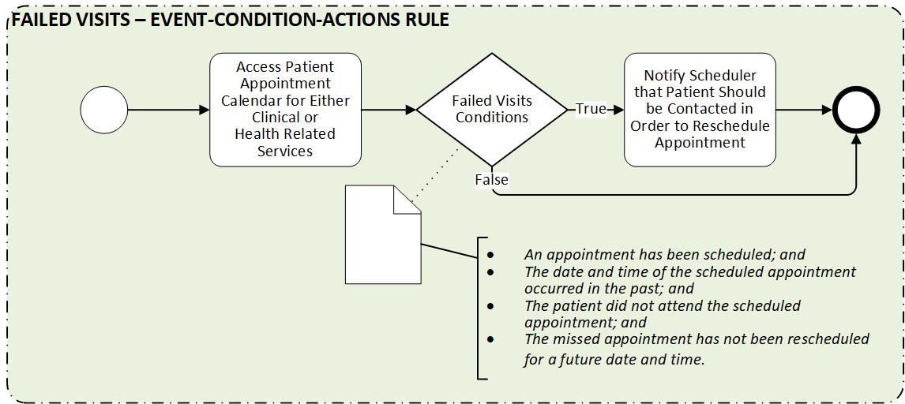

**Figure A.2. Failed or Delayed Consult/Referral ECA Rule**

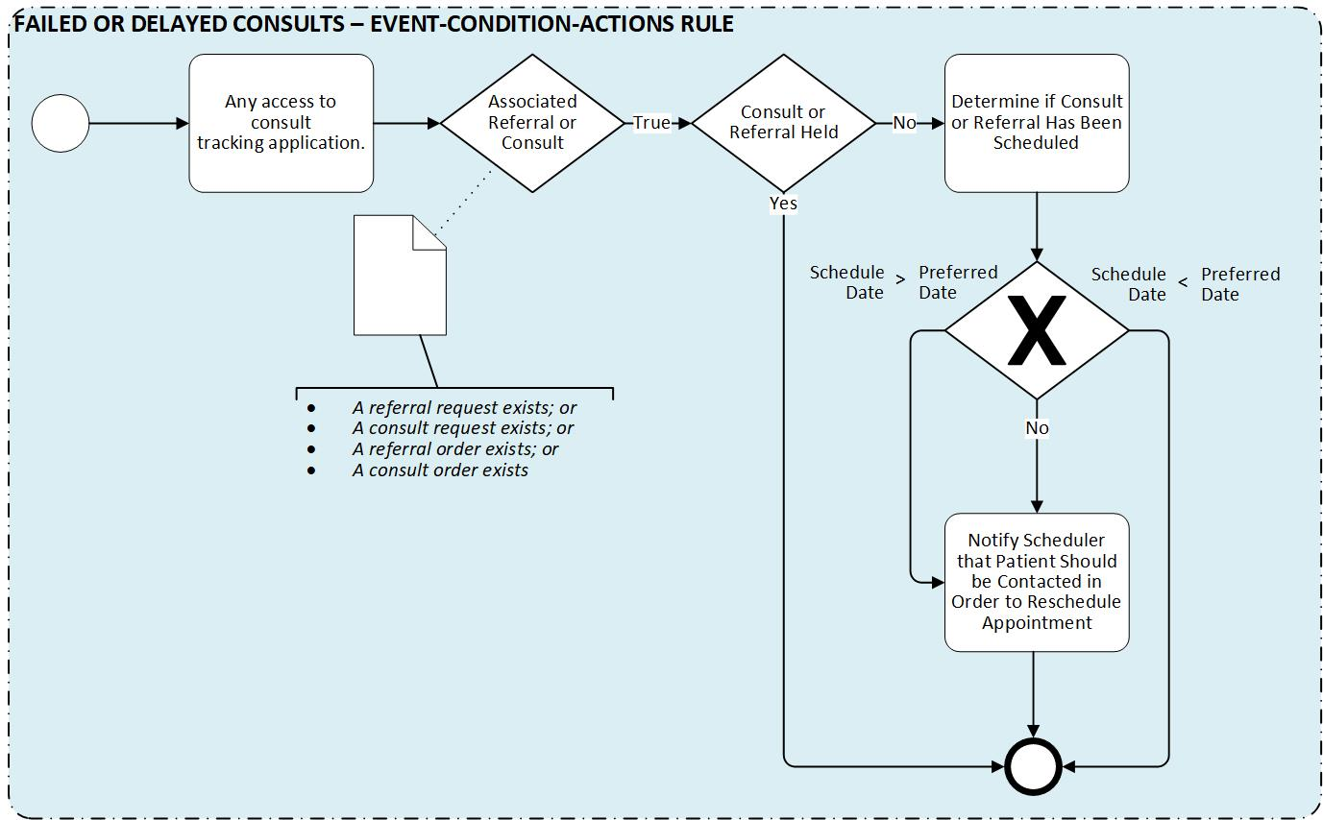

**Acronyms**

CCWP Clinical Content White Paper

CDS Clinical Decision Support

ECA Event Condition Action

HL7 Health Level 7

KBS Knowledge Based Systems

KNART Knowledge Artifact

KNARTs Knowledge Artifacts

OIIG Office of Informatics and Information Governance

PD Preferred Date

SME Subject Matter Expert

TO Task Order

VA Department of Veteran Affairs

VACO VA Central Office

VAMC VA Medical Center

VHA Veterans Health Administration