**Clinical Decision Support (CDS) Content and Health Level 7 (HL7)-Compliant Knowledge Artifacts (KNARTs)**

**Primary Care: Abnormal and Panic Laboratory Value Alerts Clinical Content White Paper**

**Department of Veterans Affairs (VA)**



**Knowledge Based Systems (KBS)**

**Office of Informatics and Information Governance (OIIG)**

**Clinical Decision Support (CDS)**

**Clinical Decision Support (CDS) Content and Health Level 7 (HL7)-Compliant Knowledge Artifacts (KNARTs): Primary Care: Abnormal and Panic Laboratory Value Alerts Clinical Content White Paper**

by Department of Veterans Affairs (VA)

Publication date April 2018

**Contract: VA118-16-D-1008, Task Order (TO): VA-118-16-F-1008-0007**

**Table 1. Relevant KNART Information: Primary Care: Abnormal and Panic Laboratory Value Alerts**

| **KNART Name** | **Associated CLIN** |
| --- | --- |
| Abnormal Laboratory Value Alert - ECA Rule | CLIN0007AA |
| Panic Laboratory Value Alert - ECA Rule | CLIN0007AA |

**Table of Contents**

VA Subject Matter Expert (SME) Panel v

Introduction vi

Conventions Used vii

1. Primary Care: Abnormal and Panic Laboratory Value Alerts 1

1.1. Clinical Context 1

1.2. Knowledge Artifacts 1

2. Abnormal Laboratory Value Alert - Event Condition Action (ECA) Rule  3

2.1. Knowledge Narrative 3

2.2. Abnormal Laboratory Value Alert - ECA Rule 3

3. Panic Laboratory Value Alert - Event Condition Action (ECA) Rule 5

3.1. Knowledge Narrative 5

3.2. Panic Laboratory Value Alert - ECA Rule 5

Bibliography/Evidence 6

A. Existing VA Sample Artifacts 7

B. Basic Laboratory Panel Definition 8

C. Logic Diagrams 9

D. Acronyms 10

**List of Tables**

1. Summary of Primary Care: Abnormal and Panic Laboratory Value Alerts KNARTs ii

1.1. Clinical Context Domains 1

**VA Subject Matter Expert (SME) Panel**

| **Name** | **Title** | **Project Role** |
| --- | --- | --- |
| Angela Denietolis, MD | Primary Care Physician, James A. Haley Veterans Hospital, Tampa VAMC, Tampa, FL 33612 | SME, Primary |
| Pat Dumas, RN | Clinical Program Director, VACO, 810 Vermont Ave NW, Washington, DL 20420 | SME, Secondary |
| Manish Merchant, MD | Health Informatician, Albany VAMC, 113 Holland Ave., Albany, NY 12208 | SME |
| Timothy Dresselhaus, MD | Chief, Primary Care Service, San Diego VAMC - MEDS, 3350 La Jolla Village Drive, San Diego, CA 92161 | SME |
| Michael Icardi, MD | Pathologist, Iowa City VAMC, 601 Highway 6 West, Iowa City, IA 52246 | Laboratory Expert |

**Introduction**

The VA is committed to improving the ability of clinicians to provide care for patients while increasing quality, safety, and efficiency. Recognizing the importance of standardizing clinical knowledge in support of this goal, VA is implementing the Health Level 7 (*HL7*) Knowledge Artifact Specification for a wide range of VA clinical use cases. Knowledge Artifacts, referred to as (*KNARTs*), enable the structuring and encoding of clinical knowledge so the knowledge can be integrated with electronic health records to enable clinical decision support.

The purpose of this Clinical Content White Paper (*CCWP*) is to capture the clinical context and intent of *KNART* use cases in sufficient detail to provide the *KNART* authoring team with the clinical source material to construct the corresponding knowledge artifacts using the HL7 Knowledge Artifact Specification. This paper has been developed using material from a variety of sources: VA artifacts, clinical practice guidelines, evidence in the body of medical literature, and clinical expertise. After reviewing these sources, the material has been synthesized and harmonized under the guidance of VA subject matter experts to reflect clinical intent for this use case.

Unless otherwise noted, items within this white paper (e.g., documentation template fields, orderable items, etc.) are chosen to reflect the clinical intent at the time of creation. To provide an exhaustive list of all possible items and their variations is beyond the scope of this work.

**Conventions Used**

Conventions used within the knowledge artifact descriptions include:

*<obtain>*: Indicates a prompt to obtain the information listed

* If possible, the requested information should be obtained from the underlying system(s). Otherwise, prompting the user for information may be required
* The technical and clinical notes associated with a section should be consulted for specific constraints on the information (e.g., time-frame, patient interview, etc.)
* Default Values: Unless otherwise noted, <obtain> indicates to obtain the most recent observation. It is recognized that this default time-frame value may be altered by future implementations

*[...]*: Square brackets enclose explanatory text that indicates some action on the part of the user, or general guidance to the clinical or technical teams. Examples include, but are not limited to:

*[Begin ...]* , *[End ...]*: Indicates the start and end of specific areas to clearly delineate them for technical purposes.

*[Activate ...]*: Initiates another knowledge artifact or knowledge artifact section.

*[Section Prompt: ...]*: If this section is applicable, then the following prompt should be displayed to the user.

*[Section Selection Behavior: ...]*: Indicates technical constraints or considerations for the selection of items within the section.

*[Attach: ...]*: Indicates that the specified item should be attached to the documentation template if available.

*[Link: ...]*: Indicates that rather than attaching an item, a link should be included in the documentation template.

*[Clinical Comment: ...]*: Indicates clinical rationale or guidance.

*[Technical Note: ...]*: Indicates technical considerations or notes.

*[If ...]*: Indicates the beginning of a conditional section.

*[Else, ...]*: Indicates the beginning of the alternative branch of a conditional section.

*[End if ...]*: Indicates the end of a conditional section.

☐ *[Check boxes]*: Indicates items that should be selected based upon the section selection behavior.

**Chapter 1. Primary Care: Abnormal and Panic Laboratory Value Alerts**

**1.1. Clinical Context**

[Begin Clinical Context.]

Physician workflow could be facilitated by the use of clinical decision support to follow up on abnormal and panic-level test results. The consequences of non-timely follow-up include: delays in treatment, missed diagnoses, and preventable morbidity and mortality “(Callen 2012); VA/VHA 2015 VHA Directive 1088).” Implementing a systematic approach to this problem across the VA has the potential to improve patient care and patient safety, while improving resource utilization by enabling clinicians to intervene at an earlier stage of disease.

[Clinical Comments:

According to the 2015 VHA Directive 1088, three types of abnormal test results require action or therapeutic intervention; these are defined as follows:

* Critical Life Threatening: Abnormal test results that are deemed "Critical Life Threatening" are defined as "Any diagnostic finding which must be acted upon by the ordering provider or their designee immediately or within a short window of time and could result in severe morbidity or mortality if left untreated. (Example: critically elevated Potassium)."
* Urgent Non Life Threatening: Abnormal test results that are deemed "Urgent Non Life Threatening" are defined as "Any diagnostic finding which must be acted upon by the ordering provider or their designee within a relatively urgent timeframe (as clinically indicated to ensure timeline, appropriate and effective therapeutic action). An example of urgent matters is a Chest x-ray with newly discovered nodule, which is categorized as "Critical Not Life Threatening" with an Equivalent Radiology code such as 1001-Significant abnormality - attention needed or 1003-Possible malignancy."
* Clinically Significant: Abnormal test results that are deemed "Clinically Significant" are defined as "A diagnostic finding that requires action by the ordering provider, or their designee, but not necessarily in an immediate or urgent time-frame. (Example: High Cholesterol)."]

**Table 1.1. Clinical Context Domains**

|  |  |
| --- | --- |
| Target User | Includes all clinical providers |
| Patient | All Patients |
| Priority | Routine unless otherwise stated |
| Specialty | All |
| Location | All |

[End Clinical Context.]

**1.2. Knowledge Artifacts**

[Begin Knowledge Artifacts.]

This section describes the CDS knowledge artifacts that are intended for users caring for adult patients who present to a Primary Care Clinic.

One type of knowledge artifact will define these clinical use cases and is described in detail in the following sections. The artifacts consist of two Event Condition Action (ECA) Rules. The Abnormal Laboratory Value and the Panic Laboratory Value Alert ECA Rules are::.

* (1) Primary Care: Abnormal Laboratory Value Alert - ECA Rule KNART:
* Rule logic describes the behavior of abnormal laboratory values and communications to the care team for follow-up.
* Action: Communicate abnormal lab result to the clinical provider for the abnormal lab value KNART.
* (2) Primary Care: Panic Laboratory Value Alert - ECA Rule KNART:
* Rule logic describes the behavior of critical laboratory values and communication to the care team for follow-up.
* Action: Communicate panic lab value result to the clinical provider for the panic lab value KNART.

[End Knowledge Artifacts.]

**Chapter 2. Abnormal Laboratory Value Alert - Event Condition Action (ECA) Rule**

**2.1. Knowledge Narrative**

[Begin Knowledge Narrative.]

[See Clinical Context in Chapter 1.]

[End Knowledge Narrative.]

**2.2. Abnormal Laboratory Value Alert - ECA Rule**

[Begin Abnormal Laboratory Value Alert – ECA Rule.]

[Clinical Comments: Current rules for urgency of response required for each laboratory test result are determined by local hospital policy in accordance with VHA Directive 1088 – see definitions of urgency in Section 1.1, “Clinical Context” of this white paper.]

**Event**

[Begin Event.]

Any receipt of a laboratory result by the laboratory management system.

[End Event.]

**Conditions**

[Begin Conditions.]

The received laboratory result meets the following criterion:

* • Value is defined as outside the defined normal reference range for test as established by local hospital policy as either “Urgent Non Life Threatening” or “Clinically Significant”.

Received laboratory tests results meeting the following criterion are excluded:

* • Value is defined as outside the defined normal reference range for test as established by local hospital policy as “Critical Life Threatening”.

[End Conditions.]

**Actions**

[Begin Actions.]

1. Notify the clinical provider of the noncritical abnormal laboratory test result through the laboratory management system.

[Technical Note: In most cases, the laboratory management system is used synonymously with the Laboratory Information System (i.e. computer).]

[Technical Note: Policy and procedure by facility for Abnormal Laboratory Values. Reference Appendix.]

[End Actions.]

[End Abnormal Laboratory Value Alert – ECA Rule.]

**Chapter 3. Panic Laboratory Value Alert - Event Condition Action (ECA) Rule**

**3.1. Knowledge Narrative**

[Begin Knowledge Narrative.]

[See Clinical Context in Chapter 1.]

[End Knowledge Narrative.]

**3.2. Panic Laboratory Value Alert - ECA Rule**

[Begin Panic Laboratory Value Alert – ECA Rule.]

**Event**

[Begin Event.]

Any receipt of a laboratory test result by the laboratory management system.

[End Event.]

**Conditions**

[Begin Conditions.]

The received laboratory result meets both of the following criteria:

* Value outside of defined normal reference range for the test.
* Value beyond the critical threshold (i.e., having critical/panic lab value).

[End Conditions.]

**Actions**

[Begin Actions.]

1. Notify the clinical provider of the critical threshold laboratory test result through the laboratory management system.

[Clinical Comment: The laboratory is required to communicate critical/panic values via a telephone call. Per VHA Directive 1088: Diagnostic provider is responsible for documenting in the medical record the time and means of communication of critical life-threatening results and the name of the ordering provider or designee informed of these results.”]

[Technical Note: In most cases, the laboratory management system is used synonymously with the Laboratory Information System (i.e. computer).]

[Technical Note: Policy and procedure by facility for Critical/Panic Laboratory Values. [VHA Directive 1088](https://www1.va.gov/vhapublications/ViewPublication.asp?pub_ID=3148).]

[End Actions.]

[End Panic Laboratory Value Alert – ECA Rule.]

**Bibliography/Evidence**

[Callen, 2012] JL Callen, JI Westbrook, A Georgiou, and J Li. “Failure to follow-up test results for ambulatory patients: a systematic review”. *J Gen Intern Med*. 2012. 27. 10. 1334-1348.

[Hickner, 2005] JM Hickner, DH Fernald, DM Harris, EG Poon, NC Elder, and JW Mold. “Issues and initiatives in the testing process in primary care physician offices”. *Jt Comm J Qual Patient Saf*. 2005. 31. 2. 81-89.

U.S. Department of Veterans Affairs; Veterans Health Administration, Communicating Test Results to Providers and Patients. *VHA Directive 1088*. October 7, 2015. <https://www1.va.gov/vhapublications/ViewPublication.asp?pub_ID=3148>. Accessed October 16, 2017.

U.S. Department of Veterans Affairs; Veterans Health Administration. *VHA Handbook 1106.01: Pathology and Laboratory Medicine Service (P&LMS) procedures*. January 29, 2016. <https://www.va.gov/vhapublications/ViewPublication.asp?pub_ID=3169>. Accessed August 29, 2017.

**Appendix A. Existing Sample VA Artifacts**

See FAQs on the Communication of Test Results Toolkit SharePoint Site. NOTE: This is an internal VA Web site and is not available to the public.

<http://vaww.vha.vaco.portal.va.gov/sites/DUSHOM/10NC/10NC3/CTR/default.aspx.>

The following site is available to the public:

<https://www.va.gov/vhapublications/ViewPublication.asp?pub_ID=3148.>

**Appendix B. Basic Laboratory Panel Definition**

* Blood Urea Nitrogen
* Calcium
* Chloride
* CO2 (Carbon Dioxide, Bicarbonate)
* Creatinine
* Glucose
* Potassium
* Sodium

**Appendix C. Logic Diagrams**

**Figure C.1. Abnormal and Panic Laboratory Value Alerts Event Condition Action Rule**

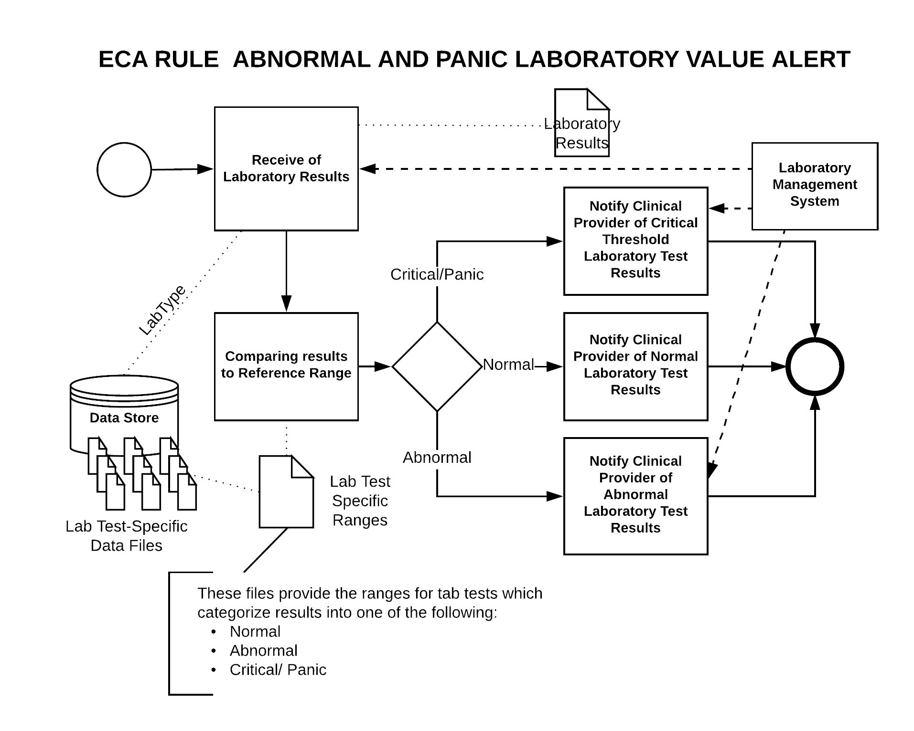

**Appendix D. Acronyms**

| **Acronym** | **Definition** |
| --- | --- |
| CDS | Clinical Decision Support |
| CO2 | Carbon Dioxide |
| ECA | Event Condition Action |
| HL7 | Health Level 7 |
| OIIG | Office of Informatics and Information Governance |
| KBS | Knowledge Based Systems |
| KNART | Knowledge Artifact |
| SME | Subject Matter Expert |
| TO | Task Order |
| VA | Department of Veteran Affairs |
| VAMC | VA Medical Center |