**Clinical Decision Support (CDS) Content and Health Level 7 (HL7)-Compliant Knowledge Artifacts (KNARTs)**

**Women's Health: Osteoporosis Screening Clinical Content White Paper**

**Department of Veterans Affairs (****VA****)**



**Knowledge Based Systems (****KBS****)**

**Office of Informatics and Information Governance (****OIIG****)**

**Clinical Decision Support (****CDS****)**

**Clinical Decision Support (CDS) Content and Health Level 7 (HL7)-Compliant Knowledge Artifacts (KNARTs): Women's Health: Osteoporosis Screening Clinical Content White Paper**

by Department of Veterans Affairs (VA)

Publication date April 2018

**Contract: VA118-16-D-1008, Task Order (****TO****): VA-118-16-F-1008-0007**

**Table 1. Relevant KNART Information: Women's Health: Osteoporosis Screening**

| **Women's Health KNART** | **Associated CLIN** |
| --- | --- |
| Osteoporosis Screening - Event-Condition-Action (ECA) Rule | CLIN0007BA |
| Osteoporosis Screening - Documentation Template | CLIN0005AB |
| Osteoporosis Screening - Order Set | CLIN0008CA |

**Table of Contents**

VA Subject Matter Expert ([SME](#d0e203)) Panel vi

Introduction vii

Conventions Used viii

1. Women's Health: Osteoporosis Screening 1

1.1. Clinical Context 1

1.2. Knowledge Artifacts 1

2. Event Condition Action (ECA) Rule: Osteoporosis Screening 3

2.1. Knowledge Narrative 3

2.2. Outpatient Visit, >= 65 Years of Age, No Prior Dual-Energy X-ray Absorptiometry (DXA) 3

2.3. Outpatient Visit, < 65 Years of Age 4

2.4. >= 15 Years Since Previous Dual-Energy X-ray Absorptiometry (DXA) Scan, >= 65 Years of Age, Most Recent T-Score >= -1.5 4

2.5. 5 Years Since Previous Dual-Energy X-ray Absorptiometry (DXA) Scan, >= 65 Years of Age, Most Recent T-Score is > -2.0 and < -1.5 5

2.6. 1 Year Since Previous Dual-Energy X-ray Absorptiometry (DXA) Scan, >= 65 Years of Age, Most Recent T-Score is >= -2.49 and <= -2 6

2.7. Patient-Preferred Screening Interval 7

3. Documentation Template: Osteoporosis Screening 8

3.1. Knowledge Narrative 8

3.2. Patient Preference for Screening 8

3.3. Age >= 65 Years 8

3.4. Age < 65 Years and Postmenopausal 9

4. Order Set: Osteoporosis Screening 11

4.1. Knowledge Narrative 11

4.2. Laboratory Testing 11

4.3. Imaging Studies 11

4.4. Patient and Caregiver Education 11

4.5. Consults and Referrals 11

Bibliography/Evidence 13

A. Existing Sample VA Artifacts 14

B. Basic Laboratory Panel Definition 16

C. Logic Diagrams 17

Acronyms 18

**List of Figures**

A.1. Reminder Resolution: Osteoporosis Screen 14

A.2. Reminder Resolution: Osteoporosis Education 15

C.1. Osteoporosis Screening Event-Condition-Action (ECA) Rule 17

**List of Tables**

1. Relevant KNART Information: Women's Health: Osteoporosis Screening  ii

1.1. Clinical Context Domains 1

**VA Subject Matter Expert (****SME****) Panel**

| **Name** | **Title** | **Project Role** |
| --- | --- | --- |
| C. Yvette Williams-Harris, MD, MPH | Physician, 1670 Clairmont Rd, Atlanta, GA 30033 | SME, Primary |
| Megan Gerber, MD, MPH | Physician, VA Boston Health Care System, 150 South Huntington Ave, Boston, MA 02130 | SME, Secondary |
| Caitlin M. Cusack, MD, MPH | Contractor-Physician Informaticist, Office of Women's Health Services, 8455 Colesville Rd, 12th Floor, Silver Spring, MD 20910 | SME |

**Introduction**

The VA is committed to improving the ability of clinicians to provide care for patients while increasing quality, safety, and efficiency. Recognizing the importance of standardizing clinical knowledge in support of this goal, VA is implementing the Health Level 7 (HL7) Knowledge Artifact Specification for a wide range of VA clinical use cases. Knowledge Artifacts, referred to as (KNARTs), enable the structuring and encoding of clinical knowledge so the knowledge can be integrated with electronic health records to enable clinical decision support.

The purpose of this Clinical Content White Paper (CCWP) is to capture the clinical context and intent of KNART use cases in sufficient detail to provide the KNART authoring team with the clinical source material to construct the corresponding knowledge artifacts using the HL7 Knowledge Artifact Specification. This paper has been developed using material from a variety of sources: VA artifacts, clinical practice guidelines, evidence in the body of medical literature, and clinical expertise. After reviewing these sources, the material has been synthesized and harmonized under the guidance of VA subject matter experts to reflect clinical intent for this use case.

Unless otherwise noted, items within this white paper (e.g., documentation template fields, orderable items, etc.) are chosen to reflect the clinical intent at the time of creation. To provide an exhaustive list of all possible items and their variations is beyond the scope of this work.

**Conventions Used**

Conventions used within the knowledge artifact descriptions include:

<obtain>: Indicates a prompt to obtain the information listed

* If possible, the requested information should be obtained from the underlying system(s). Otherwise, prompting the user for information may be required
* Default Values: Unless otherwise noted, <obtain> indicates to obtain the most recent observation. It is recognized that this default time-frame value may be altered by future implementations

[...]: Square brackets enclose explanatory text that indicates some action on the part of the clinical user, or general guidance to the clinical or technical teams. Examples include, but are not limited to:

[Begin ...], [End ...]: Indicates the start and end of specific areas to clearly delineate them for technical purposes.

[Activate ...]: Initiates another knowledge artifact or knowledge artifact section.

[Section Prompt: ...]: If this section is applicable, then the following prompt should be displayed to the user.

[Section Behavior: ...]: Indicates technical constraints or considerations for the selection of items outlined in the section prompt.

[Attach: ...]: Indicates that the specified item (e.g. procedure or result interpretation) should be attached to the documentation template if available.

[Link: ...]: Indicates that rather than attaching an item (e.g. image), a link should be included in the documentation template.

[Clinical Comment: ...]: Indicates technical considerations or notes to be utilized for KNART authoring and at time of implementation planning.

[Technical Note: ...]: Indicates technical considerations or notes to be utilized for KNART authoring and at time of implementation planning.

[If ...]: Indicates the beginning of a conditional section.

[Else, ...]: Indicates the beginning of the alternative branch of a conditional section.

[End if ...]: Indicates the end of a conditional section.

☐ [Check box]: Indicates items that should be selected based upon the section selection behavior.

**Chapter 1. Women's Health: Osteoporosis Screening**

**1.1. Clinical Context**

[Begin Clinical Context.]

Osteoporosis is a highly prevalent condition with significant attendant morbidity. As osteoporosis is generally silent until a fracture occurs, it is imperative that patients who are at risk be screened according to evidence-based guidelines. Such screening is consistent with public health initiatives and is highly cost-effective, as the cost of care for preventable osteoporosis-related fractures is considerable [American College of Obstetricians and Gynecologists (ACOG) 2012; US Preventive Services Task Force (USPSTF) 2015]. Fostering adherence across the VA to guideline-recommended screening for osteoporosis could improve resource utilization and promote good patient care.

The latest guidelines chosen by the VA will be used for these knowledge artifacts. In addition, other constraints for these artifacts are that they apply to:

Women aged >= 18 years, with no documented history of osteopenia/osteoporosis, who are outpatients.

Clinical context is summarized in the table below.

**Table 1.1. Clinical Context Domains**

|  |  |
| --- | --- |
| Target User | To include primary care and designated women's health providers. |
| Patient | Females aged >= 18 years |
| Priority | Routine |
| Specialty | Primary Care and Gynecology |
| Location | Outpatient |

[End Clinical Context.]

**1.2. Knowledge Artifacts**

[Begin Knowledge Artifacts.]

This section describes the CDS knowledge artifacts intended for clinical providers, and include:

* An ECA Rule: Women's Health: Osteoporosis Screening KNART
* Rule logic for activation of the documentation template and order set
* Actions that may include activating documentation templates or order sets
* A Documentation Template: Women's Health: Osteoporosis Screening KNART
* Documents a patient's risk for osteoporosis, and patient screening preferences
* Includes logic for appropriate display of documentation sections
* An Order Set: Women's Health: Osteoporosis Screening KNART
* Orderable items associated with osteoporosis screening
* Includes logic for appropriate display of the order set

[End Knowledge Artifacts.]

**Chapter 2. Event Condition Action (ECA) Rule: Osteoporosis Screening**

[Begin ECA Rule.]

**2.1. Knowledge Narrative**

[Begin Knowledge Narrative.]

[See Clinical Context in Chapter 1.]

[Technical Note: All adult female outpatients should be included.]

[End Knowledge Narrative.]

**2.2. Outpatient Visit, >= 65 Years of Age, No Prior Dual-Energy X-ray Absorptiometry (DXA)**

[Begin Outpatient Visit, >=65 Years of Age, No Prior Dual-Energy X-ray Absorptiometry (DXA).]

**Event**

[Begin Event.]

* Access of the patient record in a preventive care encounter at a primary care clinic or in an Obstetrics/Gynecology (OB/GYN) or women's health outpatient department.

[End Event.]

**Conditions**

[Begin Conditions.]

* Patient is aged >= 65 years; and
* Patient has not been diagnosed with osteoporosis; and
* Patient has not undergone DXA scanning previously; and
* No patient-preferred screening interval has been set.

[End Conditions.]

**Actions**

[Begin Actions.]

* Identify the patient as an osteoporosis screening candidate; and
* Open Documentation Template: Osteoporosis Screening; and
* Open Order Set: Osteoporosis Screening; and
* Make screening guideline recommendations available for review.

[End Actions.]

[End Outpatient Visit, >=65 Years of Age, No Prior Dual-Energy X-ray Absorptiometry (DXA).]

**2.3. Outpatient Visit, < 65 Years of Age**

[Begin Outpatient Visit, < 65 Years of Age.]

**Event**

[Begin Event.]

* Access of the patient record in a preventive care encounter at a primary care clinic or in an OB/GYN or women's health outpatient department.

[End Event.]

**Conditions**

[Begin Conditions.]

* Patient is aged < 65 years; and
* Patient is postmenopausal; and
* Patient has one or more risk factors associated with osteoporosis (history of fragility fracture; or body weight < 127 lbs; or bone loss caused by medication; or bone loss caused by disease; or parental medical history of hip fracture; or current tobacco smoker; or alcoholism; or rheumatoid arthritis); and
* Patient has not been diagnosed with osteoporosis; and
* No patient-preferred screening interval has been set.

[End Conditions.]

**Actions**

[Begin Actions.]

* Identify the patient as an osteoporosis screening candidate; and
* Open Documentation Template: Osteoporosis Screening KNART; and
* Open Order Set: Osteoporosis Screening KNART; and
* Make screening guideline recommendations available for review.

[End Actions.]

[End Outpatient Visit, < 65 Years of Age.]

**2.4. >= 15 Years Since Previous Dual-Energy X-ray Absorptiometry (DXA) Scan, >= 65 Years of Age, Most Recent T-Score >= -1.5**

[Begin >= 15 Years Since Previous Dual-Energy X-ray Absorptiometry (DXA) Scan, >= 65 Years of Age, Most Recent T-Score >= -1.5.]

**Event**

[Begin Event.]

* Previous DXA scan >= 15 years before today.

[End Event.]

**Conditions**

[Begin Conditions.]

* Patient is aged >= 65 years; and
* Most recent DXA scan result of T-score >= -1.5; and
* Patient has not been diagnosed with osteoporosis; and
* No patient-preferred screening interval has been set.

[End Conditions.]

**Actions**

[Begin Actions.]

* Identify the patient as an osteoporosis screening candidate; and
* Open Documentation Template: Osteoporosis Screening KNART; and
* Open Order Set: Osteoporosis Screening KNART; and
* Make screening guideline recommendations available for review

[End Actions.]

[End >= 15 Years Since Previous Dual-Energy X-ray Absorptiometry (DXA) Scan, >= 65 Years of Age, Most Recent T-Score >= -1.5.]

**2.5. 5 Years Since Previous Dual-Energy X-ray Absorptiometry (DXA) Scan, >= 65 Years of Age, Most Recent T-Score is > -2.0 and < -1.5**

[Begin 5 Years Since Previous Dual-Energy X-ray Absorptiometry (DXA) Scan, >= 65 Years of Age, Most Recent T-Score is > -2.0 and < -1.5.]

**Event**

[Begin Event.]

* Previous DXA scan >= 5 years before today.

[End Event.]

**Conditions**

[Begin Conditions.]

* Patient is aged >= 65 years; and
* Most recent DXA scan result of T-score is > -2.0 and < -1.5; and
* Patient has not been diagnosed with osteoporosis; and
* No patient-preferred screening interval has been set.

[End Conditions.]

**Actions**

[Begin Actions.]

* Identify the patient as an osteoporosis screening candidate; and
* Open Documentation Template: Osteoporosis Screening KNART; and
* Open Order Set: Osteoporosis Screening KNART; and
* Make screening guideline recommendations available for review.

[End Actions.]

[End 5 Years Since Previous Dual-Energy X-ray Absorptiometry (DXA) Scan, >= 65 Years of Age, Most Recent T-Score is > -2.0 and < -1.5.]

**2.6. 1 Year Since Previous Dual-Energy X-ray Absorptiometry (DXA) Scan, >= 65 Years of Age, Most Recent T-Score is >= -2.49 and <= -2**

[Begin 1 Year Since Previous Dual-Energy X-ray Absorptiometry (DXA) Scan, >= 65 Years of Age, Most Recent T-Score is >= -2.49 and <= -2.]

**Event**

[Begin Event.]

* Previous DXA scan >= 1 year before today.

[End Event.]

**Conditions**

[Begin Conditions.]

* Patient is aged >= 65 years; and
* Most recent DXA scan result of T-score is >= -2.49 and <= -2; and
* Patient has not been diagnosed with osteoporosis; and
* No patient-preferred screening interval has been set.

[End Conditions.]

**Actions**

[Begin Actions.]

* Identify the patient as an osteoporosis screening candidate; and
* Open Documentation Template: Osteoporosis Screening KNART; and
* Open Order Set: Osteoporosis Screening KNART; and
* Make screening guideline recommendations available for review.

[End Actions.]

[End 1 Year Since Previous Dual-Energy X-ray Absorptiometry (DXA) Scan, >= 65 Years of Age, Most Recent T-Score is >= -2.49 and <= -2.]

**2.7. Patient-Preferred Screening Interval**

[Begin Patient-Preferred Screening Interval.]

**Event**

[Begin Event.]

* End of set patient-preferred screening interval.

[End Event.]

**Conditions**

[Begin Conditions.]

* Patient has not been diagnosed with osteoporosis; and
* A patient-preferred screening interval has previously been set.

[End Conditions.]

**Actions**

[Begin Actions.]

* Identify the patient as an osteoporosis screening candidate; and
* Open Documentation Template: Osteoporosis Screening KNART; and
* Open Order Set: Osteoporosis Screening KNART; and
* Make screening guideline recommendations available for review.

[End Actions.]

[End Patient-Preferred Screening Interval.]

[End ECA Rule.]

**Chapter 3. Documentation Template: Osteoporosis Screening**

[Begin Documentation Template.]

**3.1. Knowledge Narrative**

[Begin Knowledge Narrative.]

[See Clinical Context in Chapter 1.]

[Clinical Comment: The Osteoporosis Screening Documentation Template provides a mechanism for documenting a patient’s risk for osteoporosis and screening preferences. Although the template is a series of questions and answers, any information that can be obtained from the system should be pre-filled in a manner that is displayed to the user. Users should revise the information provided in the documentation template form as needed during the evaluation.]

[End Knowledge Narrative.]

**3.2. Patient Preference for Screening**

[Begin Patient Preference for Screening.]

[Section Prompt: Patient preference for screening.]

[Section Selection Behavior: Select only one. Required.]

☐ Screen as recommended.

☐ Screen on patient-preferred interval:

<obtain> Interval (years between screening)

☐ Stop screening.

<obtain> Age (years)

[Section Prompt: Postmenopausal?]

[Section Selection Behavior: Select only one. Required.]

☐ Yes

☐ No

[Section Prompt: Previously diagnosed with osteoporosis?]

[Section Selection Behavior: Select only one. Required.]

☐ Yes

☐ No

[End Patient Preference for Screening.]

**3.3. Age >= 65 Years**

[Begin Age >=65 Years.]

[Technical Note: This section should be presented for patients aged >= 65 years.]

[Section Prompt: Previously undergone DXA scanning?]

[Section Selection Behavior: Select only one. Required.]

☐ Yes

<obtain> Last DXA scan date

[Section Selection Behavior: Select only one. Optional.]

☐ Most recent T-score >= -1.5

☐ Most recent T-score is > -2.0 and < -1.5

☐ Most recent T-score is >= -2.49 and <= -2

☐ No

[End Age >=65 Years.]

**3.4. Age < 65 Years and Postmenopausal**

[Begin Age < 65 Years and Postmenopausal.]

[Technical Note: This section should be presented for patients aged < 65 years who are postmenopausal.]

[Section Prompt: History of fragility fracture?]

[Section Selection Behavior: Select only one. Required.]

☐ Yes

☐ No

<obtain> Body weight (pounds)

[Section Prompt: Bone loss caused by medication or disease?]

[Section Selection Behavior: Select only one. Required.]

☐ Yes

[Section Prompt: Medications.]

[Section Selection Behavior: Select one or more. Optional.]

☐ Glucocorticoid therapy (5 mg per day for longer than 3 months)

☐ Anticonvulsant therapy greater than 2 years

☐ Androgen deprivation therapy (ADT)/hypogonadism

☐ Other

<obtain> Details

[Section Prompt: Disease.]

[Section Selection Behavior: Select one or more. Optional.]

☐ History of gastrectomy/malabsorption/celiac disease/metabolic surgery

☐ Other

<obtain> Details

☐ No

[Section Prompt: Parental history of fragility fracture?]

[Section Selection Behavior: Select one. Required.]

☐ Yes

☐ No

[Section Prompt: Do you currently use tobacco?]

[Section Prompt: Tobacco includes cigarettes, pipe, cigars, and smokeless tobacco, such as dip, chew, snuff, and snus. Excludes e-cigarettes, ENDS (electronic nicotine delivery systems), and vaping devices.]

[Section Selection Behavior: Select only one. Required.]

* Every day
* Some days
* Not at all

[Technical Note: Those patients reporting use every day or some days will be considered a Current Tobacco User.]

[Technical Note: Display the following only if “Not at all” is selected in section “Do you currently use tobacco?”]

[Section Prompt: Have you ever used tobacco?]

[Section Selection Behavior: Select only one. Required.]

* Never user
* Former user

[Section Prompt: Alcoholism?]

[Section Selection Behavior: Select one. Required.]

☐ Yes

☐ No

[Section Prompt: Rheumatoid arthritis?]

[Section Selection Behavior: Select one. Required.]

☐ Yes

☐ No

[End Age < 65 Years and Postmenopausal.]

[End Documentation Template.]

**Chapter 4. Order Set: Osteoporosis Screening**

[Begin Order Set.]

**4.1. Knowledge Narrative**

[Begin Knowledge Narrative.]

[See Clinical Context in Chapter 1.]

[This order set applies to any patient who requires osteoporosis screening. All orders are routine unless otherwise specified.]

[End Knowledge Narrative.]

**4.2. Laboratory Testing**

[Begin Laboratory Testing.]

[Section Prompt: Laboratory Testing]

[Section Selection Behavior: Select one or more. Optional.]

☐ Complete blood count

☐ Complete metabolic panel

☐ Thyroid stimulating hormone

☐ 25- hydroxyvitamin D

☐ 24-hour urinary calcium

[End Laboratory Testing.]

**4.3. Imaging Studies**

[Begin Imaging Studies.]

[Section Prompt: Imaging Studies]

[Section Selection Behavior: Select one. Optional.]

☐ Dual-energy x-ray absorptiometry screen for osteoporosis

[End Imaging Studies.]

**4.4. Patient and Caregiver Education**

[Begin Patient and Caregiver Educations.]

[Section Prompt: Patient and Caregiver Education]

[Section Selection Behavior: Select one. Optional.]

☐ Osteoporosis education

[End Patient and Caregiver Education.]

**4.5. Consults and Referrals**

[Begin Consults and Referrals.]

[Section Prompt: Radiology consult for osteoporosis screening.]

[Section Prompt: A radiology consult order would be used to refer a patient to radiology outside the VA]

[Section Selection Behavior: Optional.]

Consult Specialty: Radiology

Reason for Consult: Osteoporosis Screening

Priority: Routine

[Section Prompt: Referring Physician Information]

<obtain> Referring Physician Name

<obtain> Referring Physician Contact Information

[End Consults and Referrals.]

[End Order Set.]

**Bibliography/Evidence**

Committee on Practice Bulletins-Gynecology and ACOG. “AGOG Practice Bulletin N. 129. Osteoporosis”. Obstet Gynecol. 2012. 120. 3. 718-734.

[Cosman, 2014] F Cosman, S.J. de Beur, M.S. LeBoff, E.M. Lewiecki, B Tanner, S Randall, and R Lindsay. “Clinician's Guide to Prevention and Treatment of Osteoporosis”. Osteoporosis International. 2014. 25. 10. 2359-2381. <http://doi.org/10.1007/s00198-014-2794-2>.

[Gourlay, 2012] ML Gourlay, JP Fine, JS Preisser, RC May, C Li, LY Lui, DF Ransohoff, JA Cauley, and KE Ensrud. “Bone-density testing interval and transition to osteoporosis in older women”. New England Journal of Medicine. 2012 Jan. 19. 366. 225-33.

National Institutes of Health. Calcium Fact Sheet for Health Professionals. <https://ods.od.nih.gov/factsheets/Calcium-HealthProfessional/>. Accessed August 2017.

USPSTF. Final Update Summary: Osteoporosis: U.S. Preventive Services Task Force website. <https://www.uspreventiveservicestaskforce.org/Page/Document/UpdateSummaryFinal/osteoporosis-screening>. Reviewed July 2015.

**Appendix A. Existing Sample VA Artifacts**

**Figure A.1. Reminder Resolution: Osteoporosis Screen**

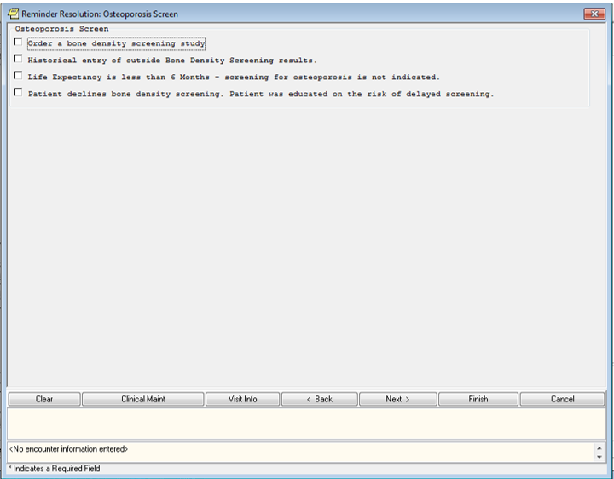

**Figure A.2. Reminder Resolution: Osteoporosis Education**

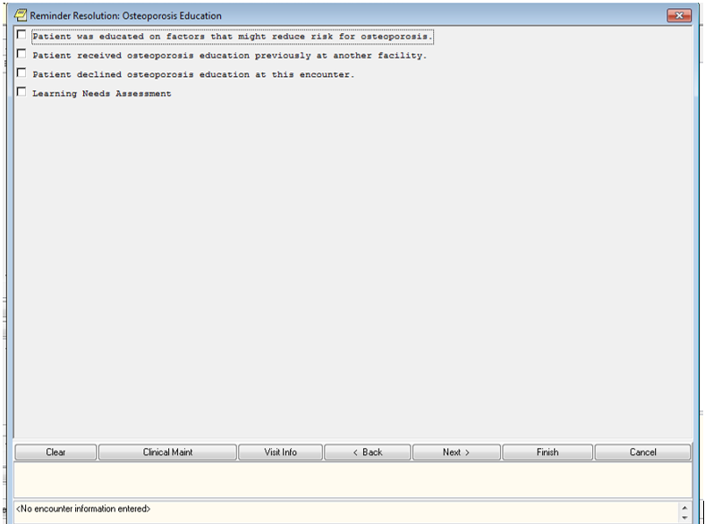

**Appendix B. Basic Laboratory Panel Definition**

* Blood Urea Nitrogen
* Calcium
* Chloride
* CO2 (Carbon Dioxide, Bicarbonate)
* Creatinine
* Glucose
* Potassium
* Sodium

**Appendix C. Logic Diagrams**

**Figure C.1. Osteoporosis Screening Event-Condition-Action (ECA) Rule**

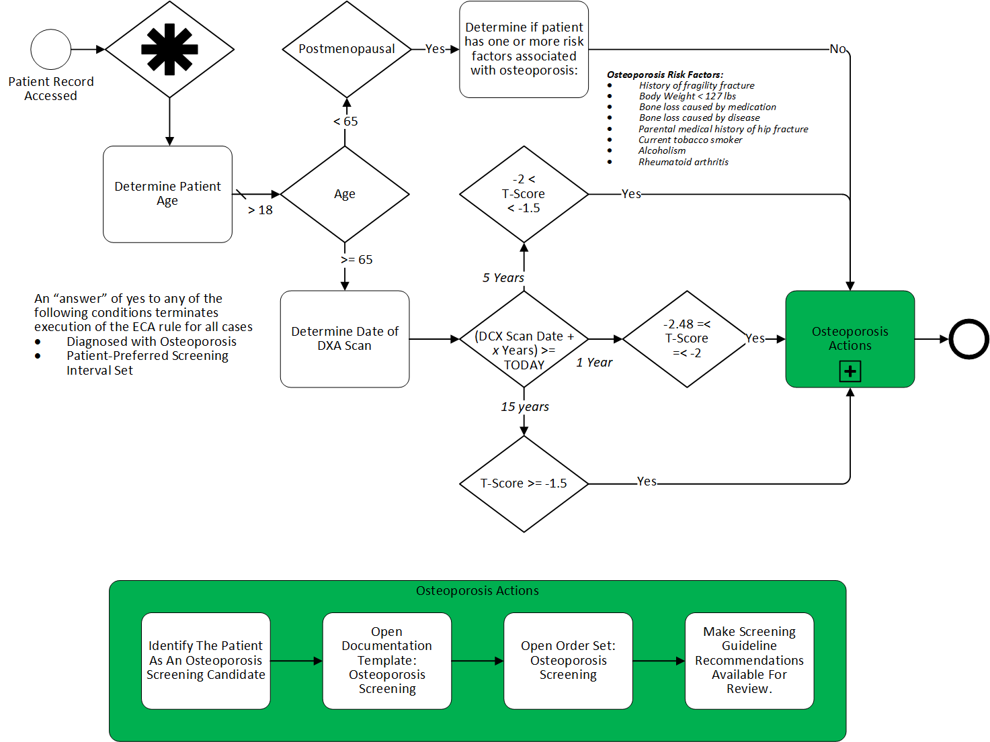

**Acronyms**

ACOG American College of Obstetricians and Gynecologists

CCWP Clinical Content White Paper

CDS Clinical Decision Support

DXA Dual-energy X-ray absorptiometry (previously DEXA)

ECA Event Condition Action

HL7 Health Level 7

KBS Knowledge Based Systems

KNART Knowledge Artifact

OB/GYN Obstetrics/Gynecology

OIIG Office of Informatics and Information Governance

PCP Primary Care Provider

SME Subject Matter Expert

TO Task Order

USPSTF US Preventive Services Task Force

VA Department of Veteran Affairs