**Clinical Decision Support (CDS) Content and Health Level 7 (HL7)-Compliant Knowledge Artifacts (KNARTs)**

**Women's Health: Reproductive Health Clinical Content White Paper**

**Department of Veterans Affairs (VA)**



**Knowledge Based Systems (KBS)**

**Office of Informatics and Information Governance (*OIIG*)**

**Clinical Decision Support (*CDS*)**

**Clinical Decision Support (CDS) Content and Health Level 7 (HL7)-Compliant Knowledge Artifacts (KNARTs): Women's Health: Reproductive Health Clinical Content White Paper**

by Department of Veterans Affairs (VA)

Publication date April 2018

**Contract: VA118-16-D-1008, Task Order (TO): VA-118-16-F-1008-0007**

**Table 1. Relevant KNART Information: Women's Health: Reproductive Health**

| **Women's Health KNART** | **Associated CLIN** |
| --- | --- |
| Reproductive Health - Event Condition Action (ECA) Rule | CLIN0007CA |
| Reproductive Health - Order Set | CLIN0008BA |
| Reproductive Health - Documentation Template | CLIN0005AC |

**Table of Contents**

VA Subject Matter Expert (SME) Panel vi

Introduction vii

Conventions Used viii

1. Women's Health: Reproductive Health 1

1.1. Clinical Context 1

1.2. Knowledge Artifacts 1

2. Event Condition Action (ECA) Rule 3

2.1. Knowledge Narrative 3

2.2. ECA Rule: Reproductive Health 3

2.2.1. Event 3

2.2.2. Conditions 3

2.2.3. Actions 3

3. Documentation Template 4

3.1. Knowledge Narrative 4

3.2. Menstrual History 4

3.3. Medical Ability to Conceive 5

3.4. Reproductive History 5

3.5. Sexual History 7

3.6. Medical/Surgical History 8

3.7. Social History 9

3.8. Pertinent Medical History 10

3.9. Reproductive Goals Assessment 11

3.10. Same Day Start Criteria for Contraceptives 12

3.11. Plan 13

4. Order Set 15

4.1. Knowledge Narrative 15

4.2. Laboratory Tests 15

4.3. Point of Care Tests 15

4.4. Medications and Devices 15

4.5. Procedures 17

Bibliography/Evidence 18

A. Existing Sample VA Artifacts 20

B. Basic Laboratory Panel Definition  35

C. Reproductive Health Logic Diagram 36

Acronyms 37

**List of Figures**

A.1. Reminder Resolution 20

A.2. Contraceptive Resources 21

A.3. Medically Unable to Conceive? (image 1 of 2) 22

A.4. Medically Unable to Conceive? (image 2 of 2) 23

A.5. Pregnancy Status (image 1 of 3) 24

A.6. Pregnancy Status (image 2 of 3) 25

A.7. Pregnancy Status (image 3 of 3) 26

A.8. Pregnancy Intentions 27

A.9. Pregnancy Status 28

A.10. Contraceptive Methods (image 1 of 3) 29

A.11. Contraceptive Methods (image 2 of 3) 30

A.12. Contraceptive Methods (image 3 of 3) 31

A.13. Notes Resulting from Template Use 32

A.14. Clinical Reminder Dialog 33

A.15. Pregnancy Prevention 34

C.1. Reproductive Health ECA Rule Diagram 36

**List of Tables**

1. Relevant KNART Information: Women's Health: Reproductive Health ii

1.1. Clinical Context Domains 1

**VA Subject Matter Expert (SME) Panel**

| **Name** | **Title** | **Project** |
| --- | --- | --- |
| C. Yvette Williams-Harris, MD, MPH | Physician, 1670 Clairmont Rd Atlanta, GA 30033 | SME, Primary |
| Megan Geber, MD, MPH | Physician, VA Boston HealthCare System, 150 South Huntington Ave Boston, MA 02130 | SME, Secondary |
| Caitlin M. Cusack, MD, MPH | Contractor - Physician Informaticist, Office of Women's Health Services, 8455 Colesville Rd, 12th Floor Silver Spring, MD 20910 | SME |

**Introduction**

The VA is committed to improving the ability of clinicians to provide care for patients while increasing quality, safety, and efficiency. Recognizing the importance of standardizing clinical knowledge in support of this goal, VA is implementing the HL7 Knowledge Artifact Specification for a wide range of VA clinical use cases. Knowledge Artifacts, referred to as *KNARTs*, enable the structuring and encoding of clinical knowledge so the knowledge can be integrated with electronic health records to enable clinical decision support.

The purpose of this Clinical Content White Paper (*CCWP*) is to capture the clinical context and intent of *KNART* use cases in sufficient detail to provide the *KNART* authoring team with the clinical source material to construct the corresponding knowledge artifacts using the HL7 Knowledge Artifact Specification. This paper has been developed using material from a variety of sources: VA artifacts, clinical practice guidelines, evidence in the body of medical literature, and clinical expertise. After reviewing these sources, the material has been synthesized and harmonized under the guidance of VA subject matter experts to reflect clinical intent for this use case.

Unless otherwise noted, items within this white paper (e.g., documentation template fields, orderable items, etc.) are chosen to reflect the clinical intent at the time of creation. To provide an exhaustive list of all possible items and their variations is beyond the scope of this work.

**Conventions Used**

Conventions used within the knowledge artifact descriptions include:

<obtain>: Indicates a prompt to obtain the information listed

* If possible, the requested information should be obtained from the underlying system(s). Otherwise, prompting the user for information may be required
* Default Values: Unless otherwise noted, <obtain> indicates to obtain the most recent observation. It is recognized that this default time-frame value may be altered by future implementations

[...]: Square brackets enclose explanatory text that indicates some action on the part of the clinical user, or general guidance to the clinical or technical teams. Examples include, but are not limited to:

[Begin ...], [End ...]: Indicates the start and end of specific areas to clearly delineate them for technical purposes.

[Activate ...]: Initiates another knowledge artifact or knowledge artifact section.

[Section Prompt: ...]: If this section is applicable, then the following prompt should be displayed to the user.

[Section Behavior: ...]: Indicates technical constraints or considerations for the selection of items outlined in the section prompt.

[Attach: ...]: Indicates that the specified item (e.g. procedure or result interpretation) should be attached to the documentation template if available.

[Link: ...]: Indicates that rather than attaching an item (e.g. image), a link should be included in the documentation template.

[Clinical Comment: ...]: Indicates technical considerations or notes to be utilized for KNART authoring and at time of implementation planning.

[Technical Note: ...]: Indicates technical considerations or notes to be utilized for KNART authoring and at time of implementation planning.

[If ...]: Indicates the beginning of a conditional section.

[Else, ...]: Indicates the beginning of the alternative branch of a conditional section.

[End if ...]: Indicates the end of a conditional section.

☐ [Check box]: Indicates items that should be selected based upon the section selection behavior.

**Chapter 1.****Women's Health: Reproductive Health**

[Begin Women’s Health: Reproductive Health]

**1.1.****Clinical Context**

[Begin Clinical Context.]

Reproductive health is an important concern for most women. Many factors (e.g., emotional, cultural, and gender identity) can have a bearing upon the reproductive health encounter. Often the focus of the reproductive health visit is to determine the most appropriate method of delaying or preventing pregnancy. Each woman has priorities that impact her contraceptive choices. Some women prefer long-acting reversible contraceptives such as intrauterine devices or contraceptive implants. Although these methods are highly effective, some women prefer shorter-acting, yet still highly effective hormonal contraceptives such as the depot medroxyprogesterone acetate birth control shot, combined oral contraceptive pills, the combined contraceptive vaginal ring, or the progestin-only contraceptive pill. Still other women prefer nonhormonal barrier methods such as condoms, the diaphragm, the cervical cap, spermicides, or the sponge. Although barrier methods are less effective than other birth control methods, they are immediately reversible and, especially in the case of condoms, offer protection against sexually transmitted infections. Other methods of birth control, such as periodic abstinence and the lactational amenorrhea method, may be appropriate for some women. Dual method, consisting of condoms plus a more effective birth control method, is recommended for women who wish to have the combined benefit of sexually transmitted infection protection plus effective contraception. Authoritative guidance from clinicians can assist patients in achieving their goals for reproductive health (ACOG Committee Opinion 699 2017).

* The target users are primary care providers (PCPs), including designated women's health providers and gynecologists. The patient cohort is women the system has classified as medically able to conceive and being seen as outpatients.
* Women who are medically able to conceive:
* Are under the age of 52.
* Do not have International Classification of Diseases (ICD), Systematized Nomenclature of Medicine (SNOMED), or Current Procedural Terminology (CPT) codes consistent with hysterectomy, bilateral oophorectomy, tubal ligation, or menopause.
* Have not been previously designated as medically unable to conceive by their provider.

**Table 1.1. Clinical Context Domains**

|  |  |
| --- | --- |
| **Target User** | Provider to include Primary Care, designated women's health providers, and gynecologists |
| **Patient** | Females of reproductive potential |
| **Priority** | Routine |
| **Specialty** | Primary Care, Women's Health Providers, Gynecology |
| **Location** | Outpatient |

[End Clinical Context.]

**1.2.****Knowledge Artifacts**

[Begin Knowledge Artifacts.]

The CDS knowledge artifacts that define this clinical use case are described in detail in the following sections. They are:

* An Event Condition Action (ECA) Rule: Reproductive Health KNART
* Prompt providers to have conversations with women of reproductive age to assess their:
* Pregnancy and lactation status.
* Ability to conceive.
* Desire to be pregnant now and in the future.
* Method of pregnancy avoidance when pregnancy is not desired.
* Rule logic for activating documentation templates or order sets
* Actions may include activating documentation templates or order sets
* A Documentation Template: Reproductive Health KNART
* Documents the reproductive health focused clinical encounter.
* Includes logic for appropriate display of documentation sections.
* An Order Set: Reproductive Health KNART
* Provides the ordering clinician with a reproductive health focused order set.
* Includes logic for appropriate display of the order set to manage specific patients in accordance with their desires.

[End Knowledge Artifacts.]

[End Women’s Health: Reproductive Health.]

**Chapter 2.****Event Condition Action (ECA) Rule**

**2.1.****Knowledge Narrative**

[Begin Knowledge Narrative.]

[See Clinical Context in Chapter 1.]

[End Knowledge Narrative.]

**2.2.****ECA Rule: Reproductive Health**

[Begin ECA Rule.]

**2.2.1. Event**

[Begin Event.]

Access of patient record at time of female visit to primary care clinic or an Obstetrician/Gynecologist (OB/GYN) or women's health outpatient visit.

[End Event.]

**2.2.2. Conditions**

[Begin Conditions.]

* Patient is at least 13 years of age but less than 52 years of age; and
* Patient is not postmenopausal; and
* Patient has not been diagnosed as unable to conceive, and
* Patient has not had any of the following:
* Hysterectomy; or
* Bilateral oophorectomy; or
* Tubal ligation.

[End Conditions.]

**2.2.3. Actions**

[Begin Actions.]

* Notify the provider the patient is a candidate for a discussion regarding reproductive health; and
* Activate the Reproductive Health KNART Documentation Template; and
* Activate the Reproductive Health KNART Order Set.

[End Actions.]

[End ECA Rule.]

**Chapter 3.****Documentation Template**

[Begin Documentation Template.]

**3.1.****Knowledge Narrative**

[Begin Knowledge Narrative.]

[See Clinical Context in Chapter 1.]

[Section Prompt: Reason for visit?]

<obtain> Details

<obtain> Patient age

[End Knowledge Narrative.]

**3.2.****Menstrual History**

[Begin Menstrual History.]

[Section Prompt: Menstrual History.]

* [Section Prompt: Age of Menarche?]
* <obtain> Age

[Section Prompt: Date of Last Menstrual Period (LMP)?]

* <obtain> Date

[Section Prompt: Menstrual Cycle Pattern?]

* ☐ Regular

<obtain> Cycle duration (days)

<obtain> Flow duration (days)

* ☐ Irregular

<obtain> Details

[Section Prompt: Menstrual Symptoms.]

* [Section Selection Behavior: Select one. Optional.]
* ☐ Yes

<obtain> Details

* ☐ No
* [Additional Menstrual History.]

<obtain> Details

[End Menstrual History.]

**3.3.****Medical Ability to Conceive**

[Begin Medical Ability to Conceive.]

[Section Prompt: Does this patient have a medical reason that makes her permanently unable to conceive?]

[Section Selection Behavior: Select yes or no. If yes is selected, a reason must also be selected.]

* ☐ Yes
* ☐ Hysterectomy
* ☐ Menopause
* ☐ Bilateral Oophorectomy
* ☐ Tubal Ligation
* ☐ Other

<obtain> Reason

* ☐ No

[Technical Note: If yes is selected, then documentation template is complete.]

[End Medical Ability to Conceive.]

**3.4.****Reproductive History**

[Begin Reproductive History.]

[Section Prompt: Prior pregnancies?]

[Section Selection Behavior: Select one. Required.]

* ☐ Yes

<obtain> Total number

* ☐ No

[Technical Note: For “Yes” responses, create one instance of the Pregnancy History: Pregnancy # subsection for each prior pregnancy, based on the answer to “Total number” under the “Yes” answer choice above. Replace the character “#” with the numeral representation of the pregnancy number to be recorded in the created subsection (“Pregnancy 1,” “Pregnancy 2,” etc.). These Pregnancy History: Pregnancy # subsections should be autopopulated and updated with any new pregnancies.]

[Section Prompt: Pregnancy Outcome.]

[Section Selection Behavior: Select any. Optional.]

* ☐ Vaginal delivery

☐ Cesarean section

☐ Stillbirth

☐ Spontaneous abortion

☐ Elective abortion

☐ Ectopic pregnancy

* <obtain> Medical treatment

<obtain> Surgical treatment

[Section Prompt: Other pregnancy outcome details?]

* <obtain> Other details

[Section Prompt: Currently breastfeeding?]

* ☐ Yes

☐ No

[Section Prompt: Prior contraceptive use?]

[Section Selection Behavior: Select all that apply. Optional.]

* ☐ Intrauterine device

☐ Contraceptive implant

☐ Contraceptive shot

☐ Contraceptive ring, pill, or patch

☐ Male condom

☐ Female condom

☐ Diaphragm

☐ Cervical cap

☐ Contraceptive sponge

☐ Spermicide

☐ Natural family planning (e.g., lactational amenorrhea, rhythm, calendar, or cervical mucus methods)

☐ Nothing

[Section Prompt: Current contraceptive use?]

[Section Selection Behavior: Select all that apply. Optional.]

* ☐ Intrauterine device

☐ Contraceptive implant

☐ Contraceptive shot

☐ Contraceptive ring, pill, or patch

☐ Male condom

☐ Female condom

☐ Diaphragm

☐ Cervical cap

☐ Contraceptive sponge

☐ Spermicide

☐ Natural family planning (e.g., lactational amenorrhea, rhythm, calendar, or cervical mucus methods)

☐ Nothing

[Section Prompt: Prior emergency contraception use?]

[Section Selection Behavior: Select only one. Optional.]

* ☐ Yes
* <obtain> Details

☐ No

[End Reproductive History.]

**3.5.****Sexual History**

[Begin Sexual History.]

[Section Prompt: Sexual History.]

* [Section Prompt: Sexually Active?]

<obtain> Sexually Active

[Section Selection Behavior: Select One. Required.]

* ☐ Yes

☐ No

[Section Selection Behavior: If yes to "Sexually Active" then display questions below.]

<obtain> Gender Identity

<obtain> Sexual Orientation

* [Section Selection Behavior: If no to "Sexually Active," then skip questions below.]

[Section Prompt: Sexual practices?]

* [Section Selection Behavior: Select any. Optional.]
* ☐ Vaginal sex

☐ Anal sex

☐ Oral sex

☐ Other

* [Section Prompt: Types of Sexual Partner(s)?]
* [Section Selection Behavior: Select any. Optional.]
* ☐ Men

☐ Women

☐ Both

☐ None

<obtain> Number of Sexual Partners

* [Section Prompt: Prior sexually transmitted infections?]

[Section Selection Behavior: Select one. Required.]

* ☐ Yes
* <obtain> Details

☐ No

* <obtain> Types of Contraceptives/Sexually Transmitted Infection Prevention Used
* [Section Prompt: High-risk sexual behaviors?]
* [Clinical Comment: High-risk sexual behaviors are defined as having multiple or casual sex partners without the use of protective behaviors (e.g., condom use) as well as sex in exchange for money or drugs.]

[Section Selection Behavior: Select one. Optional.]

* ☐ Yes
* <obtain> Details

☐ No

[End Sexual History.]

**3.6.****Medical/Surgical History**

[Begin Medical/Surgical History.]

[Section Prompt: Current or prior medical problems?]

[Section Selection Behavior: Select only one. Optional.]

* ☐ Yes
* <obtain> Description

☐ No

[Section Prompt: Mental Health History?]

[Section Selection Behavior: Select any. Optional.]

* ☐ Anxiety

☐ Depression

☐ Eating Disorder

☐ Schizophrenia

☐ Bi-Polar Disorder

☐ Other

* <obtain> Description

[Section Prompt: Prior surgeries?]

[Section Selection Behavior: Select only one. Optional.]

[Technical Note: Enable entry of multiple surgeries for a patient.]

* ☐ Yes
* <obtain> Date

<obtain> Surgical Description

☐ No

[End Medical/Surgical History.]

**3.7.****Social History**

[Begin Social History.]

[Section Prompt: Social History.]

[Section Prompt: Substance Use History.]

[Section Selection Behavior: Select one or more. Optional.]

* ☐ Current or former tobacco user
* <obtain> Link to Tobacco Screening and Cessation Counseling KNART

[Technical Note: Link to Tobacco Assessment and Cessation Counseling Documentation Template KNART.]

☐ Alcohol Use

* <obtain> Details

[Technical Note: Link to Substance Use KNART (not currently available).]

☐ Rehabilitation or detoxification

* <obtain> Details

☐ Cocaine Use

* <obtain> Details

[Technical Note: Link to Substance Use KNART (not currently available).]

☐ Other substance use history

* <obtain> Details

[Technical Note: Link to Substance Use KNART (not currently available).]

☐ Homeless

* <obtain> Details

☐ Unstable Home Environment

* <obtain> Details

☐ Geographically Remote (40+ Mile Drive to Medical Care)

* <obtain> Details

[Section Prompt: Neglect and Abuse History.]

[Section Selection Behavior: Select one or more. Optional.]

* ☐ Yes
* ☐ Sexual
* <obtain> Details

☐ Physical

* <obtain> Details

☐ Emotional

* <obtain> Details

☐ No

[Section Prompt: Additional Social History.]

* <obtain> Details

[End Social History.]

**3.8.****Pertinent Family Medical History**

[Begin Pertinent Family Medical History.]

[Section Prompt: Pertinent Family Health History.]

[Link to Primary Care: Family Health History Documentation Template KNART.]

[Technical Note: In the future, use the following list of conditions to populate the conditions of interest in the linked family health history documentation template.]

[Section Selection Behavior: Select any. Optional.]

* ☐ Endometriosis

☐ Polycystic Ovarian Syndrome

☐ Uterine Fibroids

☐ Other Gynecological Conditions

☐ Diabetes Mellitus

☐ Hypertension

☐ Cardiovascular Disease

☐ Venous Thromboembolism

☐ Colorectal, Breast, Ovarian, or Uterine Cancer

☐ Alcohol or substance abuse

☐ Mental Illness

[Technical Note: For each condition selected in the "Pertinent Family Health History" section, provider should be presented with the following "Family Members" section.]

[Technical Note: In the future, this list of family members should be removed because the provider will be presented with the "Family Members" section in the Family Health History KNART.]

☐ Sister

☐ Brother

☐ Daughter

☐ Son

☐ Mother

☐ Maternal Grandmother

☐ Maternal Grandfather

☐ Maternal Half-Sister

☐ Maternal Half-Brother

☐ Maternal Aunt

☐ Maternal Uncle

☐ Father

☐ Paternal Grandmother

☐ Paternal Grandfather

☐ Paternal Half-Sister

☐ Paternal Half-Brother

☐ Paternal Aunt

☐ Paternal Uncle

[Section Prompt: Other family members.]

[Technical Note: Each time a family member is selected display for completion.]

[Technical Note: In the future, this section should be removed because the provider will be presented with the Family Health History KNART.]

* <obtain> Age at Diagnosis

<obtain> Detail

[End Pertinent Family Medical History.]

**3.9.****R****eproductive Goals Assessment**

[Begin Reproductive Goals Assessment.]

[Section Prompt: Please ask the patient, "Do you want to become pregnant within the next year?"]

[Section Selection Behavior: Select only one. Required.]

* ☐ Yes

☐ No

[Technical Note: If "Yes" is selected, the Documentation Template is complete. Provide link to Preconception Counseling KNART if available.]

[Technical Note: If "No" is selected display questions below.]

[Section Prompt: Contraceptive priorities?]

[Section Selection Behavior: Select any. Optional.]

* ☐ Permanence

☐ Reversibility

☐ Short-acting

☐ Long-acting

☐ High efficacy

☐ High safety

☐ Ease of use

☐ Noncontraceptive benefits

☐ Nonhormonal

☐ Personal control

☐ Prevention of sexually transmitted infections

☐ Declines contraceptive counseling

☐ Other

* <obtain> Description

[Technical Note: If "Declines contraceptive counseling" is selected, then Documentation Template is complete.]

[End Reproductive Goals Assessment.]

**3.10.****Same Day Start Criteria for Contraceptives**

[Begin Same Day Start Criteria for Contraceptives.]

[Section Prompt: Criteria for beginning immediate contraception (to include ring, patch, pill or the injectable).]

[Section Selection Behavior: Select any. Required.]

* ☐ First day of the LMP occurred less than or equal to 7 days ago

☐ No intercourse since start of the LMP

☐ Negative pregnancy test

[End Same Day Start Criteria for Contraceptives.]

**3.11.****Plan**

[Begin Plan.]

[Section Prompt: Review with patient the contraceptive options and the associated levels of effectiveness of those methods:

* Permanent methods (less than 1 pregnancy per year among 100 women with typical use)
* Tubal ligation (female sterilization)
* Tubal implant
* Vasectomy (male sterilization)
* Highly effective methods (1 or fewer pregnancies per year among 100 women with typical use)
* Intrauterine device
* Progesterone implant
* Progesterone shot
* Very effective methods (about 5 pregnancies per year among 100 women with typical use)
* Contraceptive ring, pill, or patch
* Less effective methods (about 15 to 32 pregnancies per year among 100 women with typical use)
* Diaphragm with spermicide
* Cervical cap with spermicide
* Contraceptive sponge
* Male condom
* Female condom
* Spermicide alone
* Natural family planning (e.g., lactational amenorrhea, rhythm, calendar, or cervical mucus methods)
* Not effective
* Nothing.]

[Section Prompt: Review with patient emergency contraceptives in case of unprotected sex.

* Emergency contraceptive (less than 1 pregnancy per year among 100 women if used within 72 hours)]

[Section Prompt: If appropriate, address sexually transmitted infection risk reduction with use of barrier methods.]

* [Section Prompt: Contraceptive plan?]
* <obtain> Description
* [Section Prompt: Sexually transmitted infection risk reduction plan?]
* <obtain> Description

[End Plan.]

[End Documentation Template.]

**Chapter 4.****Order Set**

[Begin Order Set.]

**4.1.****Knowledge Narrative**

[Begin Knowledge Narrative.]

[See Clinical Context in Chapter 1.]

[End Knowledge Narrative.]

**4.2.****Laboratory Tests**

[Begin Laboratory Tests.]

[Section Prompt: If the patient is not known to be pregnant, then consider ordering a pregnancy test.]

[Section Selection Behavior: Select one. Optional.]

* ☐ Quantitative human chorionic gonadotropin-serum now
* ☐ Qualitative human chorionic gonadotropin-urine now

[Section Prompt: Sexually Transmitted Infection Screening.]

[Section Selection Behavior: Select any. Optional.]

* ☐ Chlamydia nucleic acid amplification testing vaginal swab now
* ☐ Gonorrhea nucleic acid amplification testing vaginal swab now
* ☐ HIV screen-serum now

[End Laboratory Tests.]

**4.3.****Point of Care Tests**

[Begin Point of Care Tests.]

* ☐ Point of Care Urine pregnancy test now

[End Point of Care Tests.]

**4.4.****Medications and Devices**

[Begin Medications and Devices.]

[Section Prompt: If the patient is not known to be pregnant, then consider ordering a pregnancy test prior to ordering any contraceptive options.]

* [Section Prompt: Please consider the following contraception options.]
* ☐ Etonogestrel 68 mg implant subdermal for implantation now
* ☐ Levonorgestrel 20 micrograms/day device intrauterine for insertion now
* ☐ Levonorgestrel 14 micrograms/day device intrauterine for insertion now
* ☐ Copper T 380A device intrauterine for insertion now

**Contraceptive Injection**

[Section Prompt: Contraceptive Injection.]

[Section Selection Behavior: Select one. Optional.]

* ☐ Medroxyprogesterone acetate injectable suspension 150 mg/mL. Give 1 mL solution intramuscular every 3 months, first dose now

**Combined Oral Contraceptives**

[Section Prompt: Select Oral Contraceptives from the following list for patients where "same day criteria" for contraceptives are met.]

[Section Selection Behavior: Select only one. Optional.]

* ☐ Desogestrel 0.15 mg/ethinyl estradiol 0.03 mg. Take 1 tablet oral daily. Take pills in sequence; do not skip pills. Dispense 3 kits. 3 refills.
* ☐ Ethinyl estradiol 0.02 mg/levonorgestrel 0.1 mg. Take 1 tablet oral daily. Take pills in sequence; do not skip pills. Dispense 3 kits. 3 refills.
* ☐ Ethinyl estradiol 0.03 mg/levonorgestrel 0.15 mg. Take 1 tablet oral daily. Take pills in sequence; do not skip pills. Dispense 3 kits. 3 refills.
* ☐ Ethinyl estradiol 0.03 mg/levonorgestrel 0.05 mg, ethinyl estradiol 0.04 mg/levonorgestrel 0.075 mg, ethinyl estradiol 0.03 mg/levonorgestrel 0.125 mg (triphasic). Take 1 tablet oral daily. Take pills in sequence; do not skip pills. Dispense 3 kits. 3 refills.
* ☐ Ethinyl estradiol 0.035 mg/norethindrone 1 mg. Take 1 tablet oral daily. Take pills in sequence; do not skip pills. Dispense 3 kits. 3 refills.
* ☐ Ethinyl estradiol 0.035 mg/norethindrone 0.5 mg, ethinyl estradiol 0.035 mg/norethindrone 0.75 mg, ethinyl estradiol 0.035 mg/norethindrone 1 mg (triphasic). Take 1 tablet oral daily. Take pills in sequence; do not skip pills. Dispense 3 kits. 3 refills.
* ☐ Ethinyl estradiol 0.035 mg/norgestimate 0.25 mg. Take 1 tablet oral daily. Take pills in sequence; do not skip pills. Dispense 3 kits. 3 refills.
* ☐ Ethinyl estradiol 0.035 mg/norgestimate 0.18 mg, ethinyl estradiol 0.035 mg/norgestimate 0.215 mg, ethinyl estradiol 0.035 mg/norgestimate 0.25 mg (triphasic). Take 1 tablet oral daily. Take pills in sequence; do not skip pills. Dispense 3 kits. 3 refills.
* ☐ Mestranol 0.05 mg/norethindrone 1 mg. Take 1 tablet oral daily. Take pills in sequence; do not skip pills. Dispense 3 kits. 3 refills.
* ☐ Ethinyl estradiol 0.03 mg/levonorgestrel 0.15 mg, ethinyl estradiol 0.01 mg. Take 1 tablet oral daily. Take pills in sequence; do not skip pills. Dispense 3 kits. 3 refills.

**Combined Contraceptive Vaginal Ring**

[Section Prompt: Select Combined Contraceptive Vaginal Ring from the following list.]

[Section Selection Behavior: Select one. Optional.]

* ☐ Ethinyl estradiol 0.015 mg/day/etonogestrel ethinyl 0.120 mg/day. 1 vaginal ring. Insert ring into vagina. Leave in place continuously for 3 weeks. Remove for 1 week. Then immediately replace. Dispense 1 box. 3 refills

**Progestin-Only Contraceptive Pill**

[Section Prompt: Select Progestin-Only Contraceptive Pill from the following list.]

[Section Selection Behavior: Select one. Optional.]

* ☐ Norethindrone 0.35 mg. Take 1 tablet oral daily. Take pills in sequence; do not skip pills. Dispense 3 kits. 3 refills.

**Emergency Contraceptive**

[Section Prompt: Select Emergency Contraceptive from the following list.]

[Section Selection Behavior: Select one. Optional.]

[Clinical Comment: "1 refill now" allows the patient to take home medications for future emergency use when indicated.]

* ☐ Levonorgestrel 0.75 mg tablet. Take one tablet oral every 12 hours. Take first tablet as soon as possible after and within 72 hours of unprotected intercourse. Take second tablet 12 hours after first tablet. Dispense 1 box containing 2 tablets. 1 refill now
* ☐ Levonorgestrel 1.5 mg tablet oral 1 time. Take as soon as possible after and within 72 hours of unprotected intercourse. Dispense 1 box containing 1 tablet. 1 refill now

[End Medications and Devices.]

**4.5.****Procedures**

[Begin Procedures.]

[Section Prompt: Select procedures from the following list. All procedures are priority of "now" unless otherwise specified.]

* ☐ Essure permanent contraceptive device. Schedule for insertion now.
* ☐ Contraceptive implant implantation
* ☐ Intrauterine device insertion
* ☐ Diaphragm fitting
* ☐ Cervical cap fitting

[End Procedures.]

[End Order Set.]

**Bibliography/Evidence**

American College of Obstetricians and Gynecologists Committee on Adolescent Health Care. *Committee Opinion No 699: Adolescent Pregnancy, Contraception, and Sexual Activity*. *Obstet Gynecol*. 2017. 129. (5). e142-e149.

American College of Obstetricians and Gynecologists. ACOG Committee Opinion no. 598: Committee on Adolescent Health Care: The initial reproductive health visit. 2014. 123. (5). 1143-1147.

Bayer Pharma AG. *Essure: Permanent Birth Control.* http://labeling.bayerhealthcare.com/html/products/pi/essure_ifu.pdf.. Berlin, Germany: 2002.

[Bellanca, 2013] Helen K Bellanca and Michele Stranger Hunter. “"ONE KEY QUESTION®: preventive reproductive health is part of high quality primary care"”. *Contraceptive 88.1*. 2013. 3-6.

*Center for Disease Control, US Medical Eligibility Criteria (US MEC) for Contraceptive Use*. https://www.cdc.gov/reproductivehealth/unintendedpregnancy/pdf/legal_summary-chart_english_final_tag508.pdf . July 2017.

U.S. National Library of Medicine. *BREVICON- norethindrone and ethinyl estradiol; NORINYL- norethindrone and ethinyl estradiol; NORINYL- norethindrone and mestranol [Actavis Pharma, Inc.]*. https://dailymed.nlm.nih.gov/dailymed/drugInfo.cfm?setid=aaaf32ea-045b-436c-b125-767f95f4cf0e.August 2014.

U.S. National Library of Medicine. *IMPLANON- etonogestrel implant [Organon USA Inc.]*. https://dailymed.nlm.nih.gov/dailymed/drugInfo.cfm?setid=50ed7e31-b9b7-4f0a-8e36-91ed5af86b81. May 2017.

U.S. National Library of Medicine. *LUTERA- levonorgestrel and ethinyl estradiol [Watson Pharma, Inc.].*https://dailymed.nlm.nih.gov/dailymed/drugInfo.cfm?setid=435f565c-771d-44ff-88b7-4e089767c25f. March 2012.

U.S. National Library of Medicine. *MEDROXYPROGESTERONE ACETATE- medroxyprogesterone acetate injection, suspension [Teva Parenteral Medicines, Inc.].*https://dailymed.nlm.nih.gov/dailymed/drugInfo.cfm?setid=d279981c-e9e4-4989-bafb-1e184a6d3dd2. January 2017.

U.S. National Library of Medicine. *MIRENA- levonorgestrel intrauterine device [Bayer HealthCare Pharmaceuticals Inc.]*. https://dailymed.nlm.nih.gov/dailymed/drugInfo.cfm?setid=92231d6f-f4d8-43b0-aa95-f7cec1cc18c5. February 2013.

U.S. National Library of Medicine.  *MONONESSA- norgestimate and ethinyl estradiol; TRINESSA- norgestimate and ethinyl estradiol [Actavis Pharma, Inc].* https://dailymed.nlm.nih.gov/dailymed/drugInfo.cfm?setid=704ba4ae-edd0-4298-a399-03a49f8411c7.. December 2015.

U.S. National Library of Medicine.  *NECON 777- norethindrone and ethinyl estradiol [Watson Pharma Inc]*. https://dailymed.nlm.nih.gov/dailymed/drugInfo.cfm?setid=db3b28a4-15d3-43e0-bb65-e625300c452c. November 2013.

U.S. National Library of Medicine.  *NOR QD- norethindrone tablet [Watson Pharma, Inc.].* https://dailymed.nlm.nih.gov/dailymed/drugInfo.cfm?setid=aa34bfca-06c3-4916-bb51-4bfbfc0ee371. June 2012.

U.S. National Library of Medicine. *NUVARING- etonogestrel and ethinyl estradiol insert, extended release [Organon USA Inc.]*. https://dailymed.nlm.nih.gov/dailymed/drugInfo.cfm?setid=017343fb-86c4-45ab-9c47-52cc5b9f3a02.  May 2017.

U.S. National Library of Medicine. *PARAGARD T 380A- copper intrauterine device [Teva Women's Health, Inc.]*. https://dailymed.nlm.nih.gov/dailymed/drugInfo.cfm?setid=2b009ddb-378e-40d8-a8d8-00211f10e06c. August 2015.

U.S. National Library of Medicine. *PLAN B - levonorgestrel tablet [Physicians Total Care, Inc.]*. https://dailymed.nlm.nih.gov/dailymed/drugInfo.cfm?setid=fffebd01-3815-425f-8293-1ad909d0d0ab. April 2012.

U.S. National Library of Medicine. *PLAN B ONE-STEP- levonorgestrel tablet [Teva Women's Health, Inc.]*. https://dailymed.nlm.nih.gov/dailymed/drugInfo.cfm?setid=0ce3ccc4-23f2-4e0a-9650-856cf026c72c. May 2016.

U.S. National Library of Medicine. *RECLIPSEN 28 DAY- desogestrel and ethinyl estradiol [Teva Pharmaceuticals USA, Inc.]*. https://dailymed.nlm.nih.gov/dailymed/drugInfo.cfm?setid=a1e00bc6-7487-4057-9dcc-d0e2327d1d12. May 2017.

U.S. National Library of Medicine. *SEASONIQUE- levonorgestrel / ethinyl estradiol and ethinyl estradiol [Teva Women's Health, Inc.]*. https://dailymed.nlm.nih.gov/dailymed/drugInfo.cfm?setid=95e06935-8788-420c-b4a4-dc6ea339c7d0. November 2016.

U.S. National Library of Medicine.  *SKYLA- levonorgestrel intrauterine device [Bayer HealthCare Pharmaceuticals Inc.].* https://dailymed.nlm.nih.gov/dailymed/drugInfo.cfm?setid=9f44ff35-e052-49cd-a1c2-0bfd87d49309. March 2017.

U.S. National Library of Medicine. *TRIVORA- levonogestrel and ethinyl estradiol [Watson Pharma, Inc.]*. https://dailymed.nlm.nih.gov/dailymed/drugInfo.cfm?setid=ae220f22-24b0-41a8-a10d-28839b300fe1. February 2010.

*US Selected Practice Recommendations (US SPR) for Contraceptive Use, 2016.* July 2017.

**Appendix A. Existing Sample VA Artifacts**

**Figure A.1. Reminder Resolution**

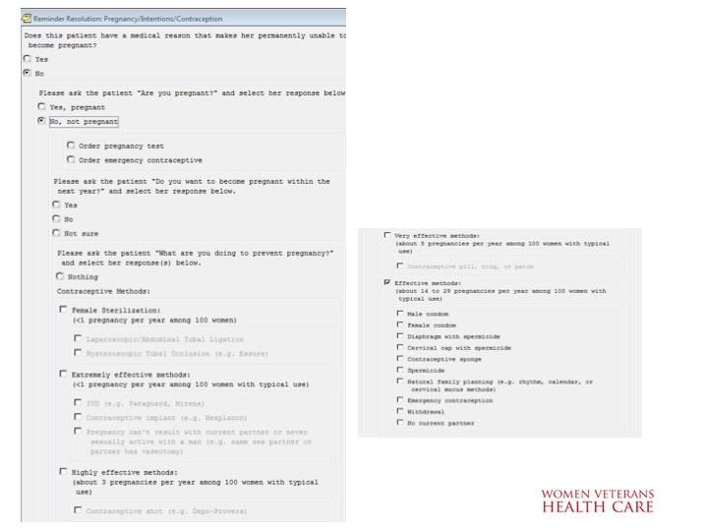

**Figure A.2. Contraceptive Resources**

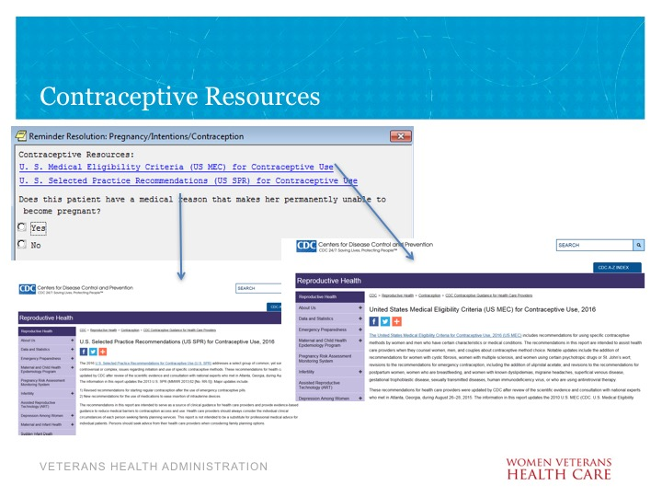

**Figure A.3. Medically Unable to Conceive? (image 1 of 2)**

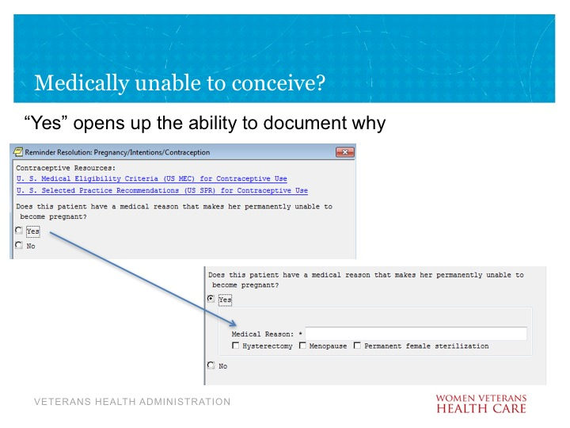

**Figure A.4. Medically Unable to Conceive? (image 2 of 2)**

(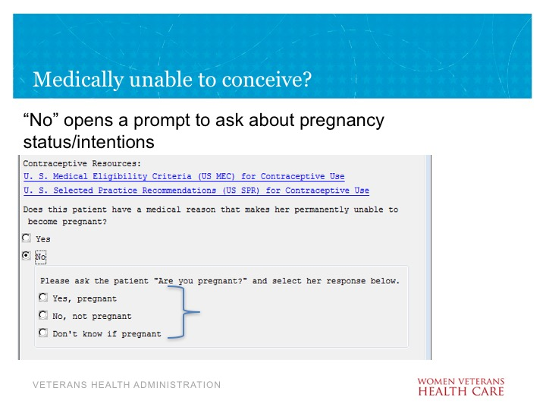

**Figure A.5. Pregnancy Status (image 1 of 3)**

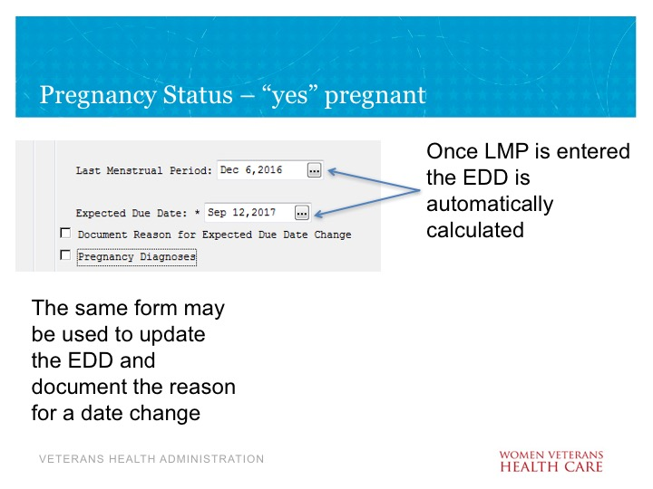

**Figure A.6. Pregnancy Status (image 2 of 3)**

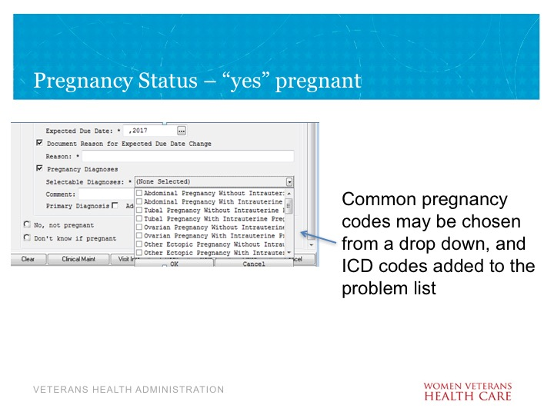

**Figure A.7. Pregnancy Status (image 3 of 3)**

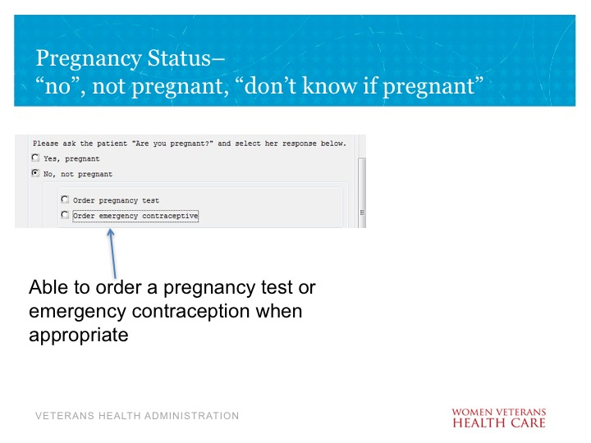

**Figure A.8. Pregnancy Intentions**

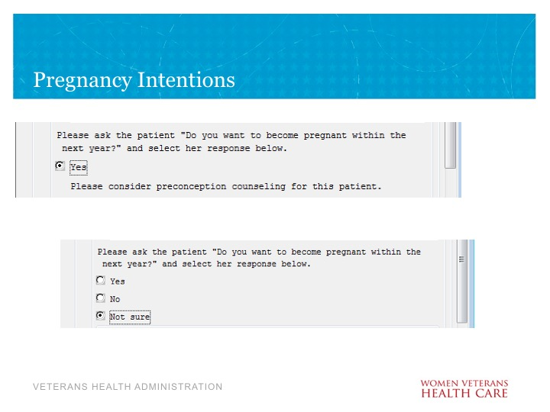

**Figure A.9. Pregnancy Status**

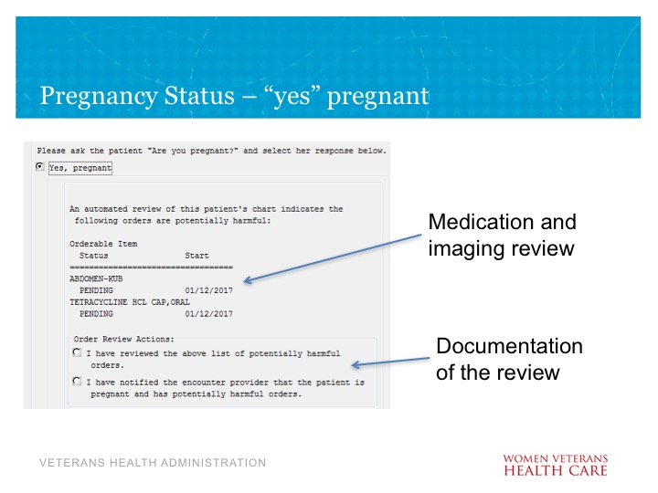

**Figure****A.10. Contraceptive Methods (image 1 of 3)**

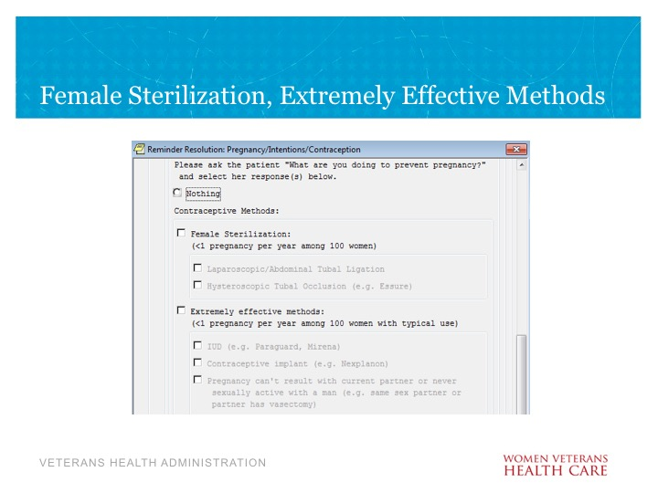

**Figure A.11. Contraceptive Methods (image 2 of 3)**

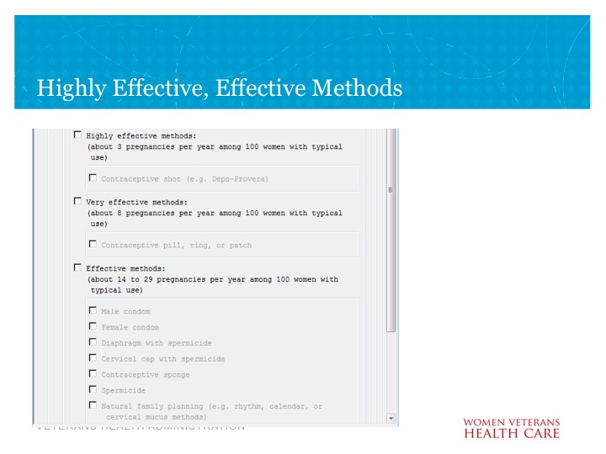

**Figure A.12. Contraceptive Methods (image 3 of 3)**

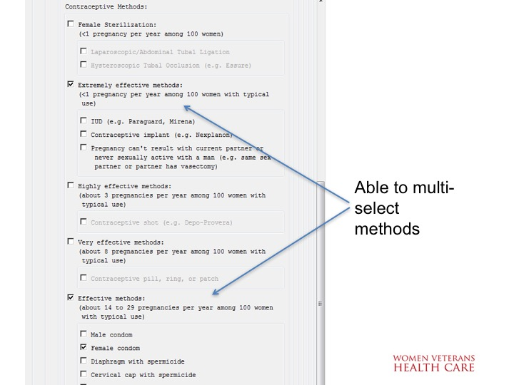

**Figure****A.13. Notes Resulting from Template Use**

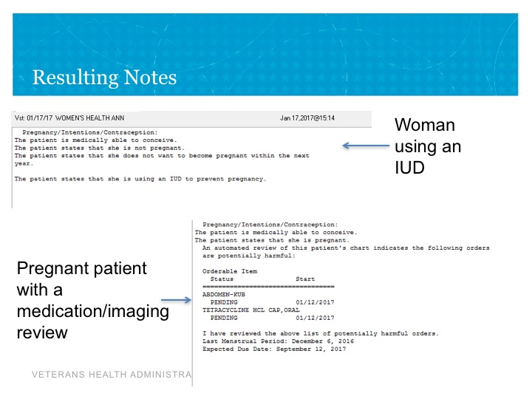

**Figure A.14. Clinical Reminder Dialog**

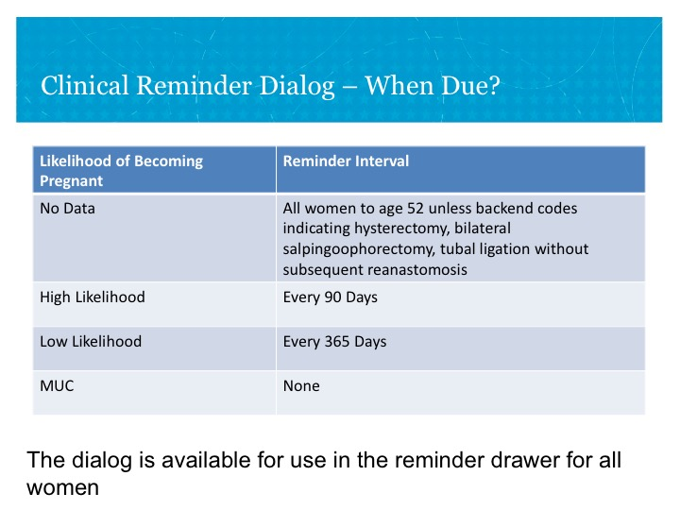

**Figure A.15. Pregnancy Prevention**

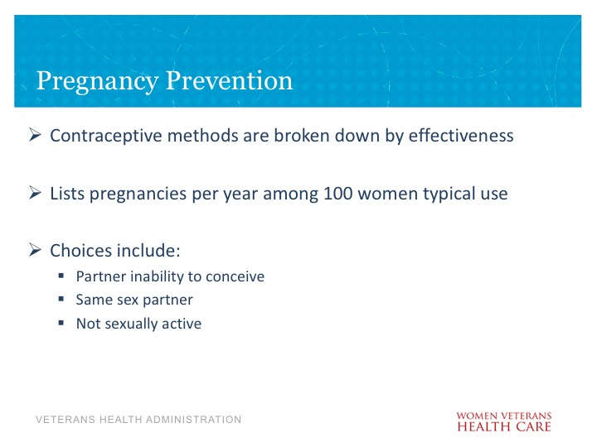

**Appendix B. Basic Laboratory Panel Definition**

* Blood Urea Nitrogen
* Calcium
* Chloride
* CO2 (Carbon Dioxide, Bicarbonate)
* Creatinine
* Glucose
* Potassium
* Sodium

**Appendix C. Reproductive Health Logic Diagram**

**Figure C.1. Reproductive Health ECA Rule Diagram**

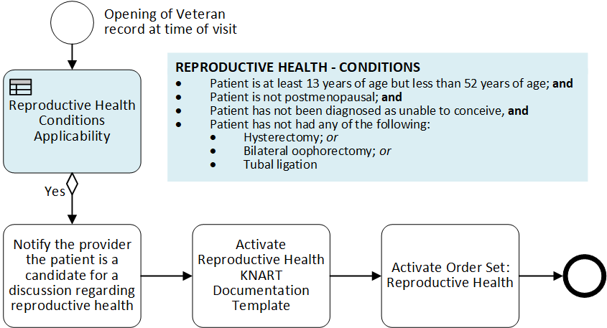

**Acronyms**

ACOG American College of Obstetricians and Gynecologists

CCWP Clinical Content White Paper

CDS Clinical Decision Support

CPT Current Procedural Terminology

ECA Event Condition Action

HL7 Health Level 7

ICD International Classification of Diseases

KBS Knowledge Based Systems

KNART Knowledge Artifact

LMP Last Menstrual Period

OB/GYN Obstetrician/Gynecologist

OIIG Office of Informatics and Information Governance

PCP Primary Care Provider

SNOMED Systematized Nomenclature of Medicine

VA Department of Veterans Affairs