**Clinical Decision Support (CDS) Content and Health Level 7 (HL7)-Compliant Knowledge Artifacts (KNARTs)**

**Cardiology: Venous Thromboembolism (VTE) Prophylaxis Clinical Content White Paper**

**Department of Veterans Affairs (VA)**



**Knowledge Based Systems (KBS)**

**Office of Informatics and Information Governance (OIIG)**

**Clinical Decision Support (CDS)**

**Clinical Decision Support (CDS) Content and Health Level 7 (HL7)-Compliant Knowledge Artifacts (KNARTs): Cardiology: Venous Thromboembolism (VTE) Prophylaxis Clinical Content White Paper**

by Department of Veterans Affairs (VA)

Publication date April 2018

**Contract: VA118-16-D-1008, Task Order (TO): VA-118-16-F-1008-0007**

**Table 1. Relevant KNART Information: Cardiology: Venous Thromboembolism (VTE) Prophylaxis KNARTs**

| **KNART Name** | **Associated CLIN** |
| --- | --- |
| VTE Prophylaxis - Order Set | CLIN0008CA |

**Table of Contents**

VA Subject Matter Expert (SME) Panel vi

Introduction vii

Conventions Used viii

1. Cardiology: Venous Thromboembolism Prophylaxis 1

1.1. Clinical Context 1

1.2. Knowledge Artifacts 1

2. VTE Prophylaxis - Order Set 3

2.1. Knowledge Narrative 3

2.2. Resources and Risk Stratification: Medical Patients 3

2.3. Medications: Medical Patients 3

2.4. Procedures: Medical Patients 4

2.5. Resources and Risk Stratification: Nonorthopedic Surgical Patients 4

2.6. Activity: Nonorthopedic Surgical Patients 5

2.7. Medications: Nonorthopedic Surgical Patients 5

2.8. Procedures: Nonorthopedic Surgical Patients 7

2.9. Activity: Orthopedic Surgical Patients 8

2.10. Medications: Orthopedic Surgical Patients 8

2.11. Procedures: Orthopedic Surgical Patients 8

2.12. Laboratory Tests 9

Bibliography/Evidence 10

A. Existing Sample VA Artifacts 11

B. Basic Laboratory Panel Definition 36

C. VTE Guidelines 37

Acronyms 38

**List of Figures**

A.1. Surgical Inpatient Menu 11

A.2. General Surgery Inpatient Orders 12

A.3. DVT Surgical Prophylaxis Orders 13

A.4. Cardiothoracic Surgery DVT Preoperative Prophylaxis Options 14

A.5. Early Ambulation Order - Preoperative Low DVT Risk 14

A.6. Reason for Request for Mechanical DVT 15

A.7. ENT DVT Preoperative Prophylaxis - Low and Medium Risk 16

A.8. Early Ambulation Orders - Preoperative Low DVT Risk 16

A.9. General Surgery Preoperative DVT Prophylaxis Options 17

A.10. OB-GYN Preoperative DVT Prophylaxis - Low, Medium, and High Risk 18

A.11. Hospital Specialty Medicine DVT Prophylaxis - Low, Medium, and High Risk 19

A.12. Exemplar Alert Contraindication for Pharmacologic DVT 19

A.13. Neurology Preoperative DVT Prophylaxis - Low, Medium, and High Risk 20

A.14. Neurosurgery Preoperative DVT Prophylaxis - Low, Medium, High, and Very High Risk 21

A.15. Orthopedic DVT Preoperative Prophylaxis 22

A.16. Urologic Surgery Preoperative DVT Prophylaxis - Low, Medium, and High Risk 23

A.17. Vascular Surgery Preoperative DVT Prophylaxis - Very Low, Low, Medium, and High Risk 24

A.18. Vascular Surgery Preoperative DVT Prophylaxis - Very Low, Low, Medium, and High Risk 25

A.19. Postoperative DVT Prophylaxis 26

A.20. Cardiothoracic Surgery Postoperative DVT Prophylaxis 27

A.21. DVT Prophylaxis in Presence of a Bleeding Diathesis 28

A.22. ENT DVT Postoperative Prophylaxis  29

A.23. General Surgery DVT Postoperative Prophylaxis 30

A.24. OB-GYN DVT Postoperative Prophylaxis 31

A.25. Neurosurgery DVT Postoperative Prophylaxis 32

A.26. Orthopedic Surgery DVT Postoperative Prophylaxis 33

A.27. Urologic Surgery DVT Postoperative Prophylaxis 34

A.28. Vascular Surgery DVT Postoperative Prophylaxis 35

**List of Tables**

1. Summary of Cardiology: Venous Thromboembolism (VTE) Prophylaxis KNARTs ii

1.1. Clinical Context Domains 1

**VA Subject Matter Expert (SME) Panel**

| **Name** | **Title** | **Project Role** |
| --- | --- | --- |
| Bruce Bray, MD | Professor, Cardiovascular Medicine, University of Utah School of Medicine; Staff Cardiologist, Salt Lake City VA Medical Center (*VAMC*) | SME, Primary |
| Scott Wall, MD | Assistant Professor, Cardiovascular Medicine, University of Utah; School of Medicine Staff Cardiologist, Electrophysiology, Salt Lake City VAMC, Salt Lake City, UT 84148 | SME, Secondary |
| Aiden Abidov, MD, PhD | Professor of Medicine, Wayne State University; Section Chief, Cardiology, John Dingell VAMC, 4646 John R St, Detroit, MI 48201 | SME |
| Claibe Yarbrough, MD | National Program Director, North Texas VHCS, Pulmonary/Critical Care/Sleep Medicine, Dallas, TX, 4500 S Lancaster, Dallas, TX 75216 | SME |
| Benjamin Brooke, MD | Attending SLC VAMC, Surgery Services, Salt Lake City, UT, 508 Fulton St, Durham, NC 27705 | SME |

**Introduction**

The VA is committed to improving the ability of clinicians to provide care for patients while increasing quality, safety, and efficiency. Recognizing the importance of standardizing clinical knowledge in support of this goal, VA is implementing the Health Level 7 (*HL7*) Knowledge Artifact Specification for a wide range of VA clinical use cases. Knowledge Artifacts, referred to as (*KNARTs*), enable the structuring and encoding of clinical knowledge so the knowledge can be integrated with electronic health records to enable clinical decision support.

The purpose of this Clinical Content White Paper (*CCWP*) is to capture the clinical context and intent of *KNART* use cases in sufficient detail to provide the *KNART* authoring team with the clinical source material to construct the corresponding knowledge artifacts using the HL7 Knowledge Artifact Specification. This paper has been developed using material from a variety of sources: VA artifacts, clinical practice guidelines, evidence in the body of medical literature, and clinical expertise. After reviewing these sources, the material has been synthesized and harmonized under the guidance of VA subject matter experts to reflect clinical intent for this use case.

Unless otherwise noted, items within this white paper (e.g., documentation template fields, orderable items, etc.) are chosen to reflect the clinical intent at the time of creation. To provide an exhaustive list of all possible items and their variations is beyond the scope of this work.

**Conventions Used**

Conventions used within the knowledge artifact descriptions include:

*<obtain>*: Indicates a prompt to obtain the information listed

* If possible, the requested information should be obtained from the underlying system(s). Otherwise, prompting the user for information may be required
* The technical and clinical notes associated with a section should be consulted for specific constraints on the information (e.g., time-frame, patient interview, etc.)
* Default Values: Unless otherwise noted, <obtain> indicates to obtain the most recent observation. It is recognized that this default time-frame value may be altered by future implementations

*[...]*: Square brackets enclose explanatory text that indicates some action on the part of the clinical user, or general guidance to the clinical or technical teams. Examples include, but are not limited to:

*[Begin ...]*, *[End ...]*: Indicates the start and end of specific areas to clearly delineate them for technical purposes.

*[Activate ...]*: Initiates another knowledge artifact or knowledge artifact section.

*[Section Prompt: ...]*: If this section is applicable, then the following prompt should be displayed to the user.

*[Section Selection Behavior: ...]*: Indicates technical constraints or considerations for the selection of items within the section.

*[Attach: ...]*: Indicates that the specified item should be attached to the documentation template if available.

*[Link: ...]*: Indicates that rather than attaching an item, a link should be included in the documentation template.

*[Clinical Comment: ...]*: Indicates clinical rationale or guidance.

*[Technical Note: ...]*: Indicates technical considerations or notes.

*[If ...]*: Indicates the beginning of a conditional section.

*[Else, ...]*: Indicates the beginning of the alternative branch of a conditional section.

*[End if ...]*: Indicates the end of a conditional section.

☐ *[Check box]*: Indicates items that should be selected based upon the section selection behavior.

**Chapter 1. Cardiology: Venous Thromboembolism Prophylaxis**

**1.1. Clinical Context**

[Begin Clinical Context.]

The Venous Thromboembolism (*VTE*) Prophylaxis KNART is intended for users caring for hospitalized adult patients. This KNART is designed to facilitate ordering for mechanical and/or pharmacological VTE prophylaxis in medical and surgical inpatients without known VTE.

The American Academy of Orthopedic Surgeons (*AAOS*) and the American College of Chest Physicians (*ACCP*) are the primary sources for this KNART:

* American Academy of Orthopaedic Surgeons. Preventing venous thromboembolic disease in patients undergoing elective hip and knee arthroplasty: evidence-based guideline and evidence report, second edition. American Academy of Orthopaedic Surgeons website. Published 2011.
* Gould MK, Garcia DA, Wren SM, et al. Prevention of VTE in nonorthopedic surgical patients: Antithrombotic Therapy and Prevention of Thrombosis, 9th ed: American College of Chest Physicians Evidence-Based Clinical Practice Guidelines. Chest. 2012 Feb;141(2 Suppl):e227S-e277S.
* Kahn SR, Lim W, Dunn AS, et al. Prevention of VTE in nonsurgical patients: Antithrombotic Therapy and Prevention of Thrombosis, 9th ed: American College of Chest Physicians Evidence-Based Clinical Practice Guidelines. Chest. 2012 Feb;141(2 Suppl):e195S-e226S.
* VA Pharmacy Benefits Management Services, Medical Advisory Panel, and VISN Pharmacist Executives, Direct Oral Anticoagulants (DOACs) (formerly called TSOACs), Rivaroxaban (Xarelto), Apixaban (Eliquis), and Dabigatran (Pradaxa), Criteria for Use for VTE Prophylaxis for Total Hip or Total Knee Replacement Surgery. February 2015

This KNART also includes a link to the American College of Chest Physicians Pregnancy Anticoagulation Guidelines in Appendix C (<https://www.ncbi.nlm.nih.gov/pmc/articles/PMC3278054/>), although pregnancy shall not be a primary focus of the KNART. The clinical context domains are summarized in Table 1, below.

**Table 1.1. Clinical Context Domains**

|  |  |
| --- | --- |
| Target User | Hospitalist, residents, and other ordering providers involved in managing the patient cohort, and nurses |
| Patient | Adult inpatients without known VTE and not pregnant |
| Priority | Routine |
| Specialty | Medical and/or Surgical Service |
| Location | Inpatient |

[End Clinical Context.]

**1.2. Knowledge Artifacts**

[Begin Knowledge Artifacts.]

The CDS knowledge artifact that defines the clinical use case is described in detail in the following sections:

* Order Set: VTE KNART
* Orderable items
* Logic for appropriate display of the order set

[End Knowledge Artifacts.]

**Chapter 2. VTE Prophylaxis - Order Set**

[Begin VTE Prophylaxis - Order Set.]

**2.1. Knowledge Narrative**

[Begin Knowledge Narrative.]

[See Clinical Context in Chapter 1, Section 1.1.]

Venous thromboembolism (VTE) is a common medical problem that results in substantial morbidity and mortality. Despite its prevalence, physicians often fail to appreciate the risks for VTE and often fail to recognize its signs and symptoms; this has led the National Academy of Sciences to cite it as a frequent cause of diagnostic error (National Academies of Sciences 2015). The problem of diagnostic error in VTE is compounded by therapeutic error—largely involving anticoagulants, which are perennially among the medications most often associated with adverse drug events (Shehab 2016). Remediating the problem requires the adoption of evidence-based guidelines, notably those of the American College of Chest Physicians for medical patients and nonorthopedic surgery patients and those of the American College of Orthopedic Surgeons for orthopedic surgery patients, across an entire health system. Rendering such guidelines operational requires meticulous curation of an array of granular elements across the full spectrum of clinical conditions (e.g., medical versus surgical patients, orthopedic versus nonorthopedic surgical patients, intracranial/spinal surgery, etc.) and the management of numerous comorbidities and factors that have potential to complicate care and predispose patients to iatrogenic bleeding (hemorrhagic diathesis, renal failure, etc.). Deploying such decision support within the VA system offers the potential for significant cost savings, improvement in patient care, and avoidance of preventable morbidity and mortality.

[End Knowledge Narrative.]

**2.2. Resources and Risk Stratification: Medical Patients**

[Begin Resources and Risk Stratification: Medical Patients.]

[Section Prompt: This section should be available for all medical patients.]

[Technical Note: A link to the Padua prediction scoring algorithm (https://www.mdcalc.com/padua-prediction-score-risk-vte) should be provided.]

[End Resources and Risk Stratification: Medical Patients.]

**2.3. Medications: Medical Patients**

[Begin Medications: Medical Patients.]

[Section Prompt: Medications: Medical Patients]

[Technical Note: This section should be available for all medical patients requiring pharmacological VTE prophylaxis.]

[Section Prompt: Acutely Ill Patients - This subsection applies to all acutely ill medical patients at increased risk of thrombosis who are not bleeding or at high risk for bleeding.]

☐ Enoxaparin 40 mg subcutaneous once daily (routine)

☐ Dalteparin 5000 Units subcutaneous once daily (routine)

☐ Heparin 5000 Units subcutaneous two times daily (routine)

☐ Heparin 5000 Units subcutaneous three times daily (routine)

☐ Fondaparinux 2.5 mg subcutaneous once daily(routine)

[Section Prompt: Critically Ill Patients - This subsection applies to all critically ill medical patients at increased risk of thrombosis who are not bleeding or at high risk for bleeding.]

☐ Enoxaparin 40 mg subcutaneous once daily (routine)

☐ Dalteparin 5000 Units subcutaneous once daily (routine)

☐ Heparin 5000 Units subcutaneous two times daily (routine)

[End Medications: Medical Patients.]

**2.4. Procedures: Medical Patients**

[Begin Procedures: Medical Patients.]

[Section Prompt: Mechanical VTE Prophylaxis, Medical Patients]

[Technical Note: This section should be available for all medical patients requiring mechanical VTE prophylaxis, particularly those who are at increased risk of bleeding events.]

[Section Prompt: Acutely Ill Patients - This subsection applies to all acutely ill medical patients at increased risk of thrombosis who are bleeding or at high risk for major bleeding.]

☐ Graduated compression stockings (routine)

☐ Intermittent pneumatic compression (routine)

[Section Prompt: Critically Ill Patients - This subsection applies to all critically ill medical patients at increased risk of thrombosis who are bleeding or at high risk for major bleeding.]

☐ Graduated compression stockings (routine)

☐ Intermittent pneumatic compression (routine)

[End Procedures: Medical Patients.]

**2.5. Resources and Risk Stratification: Nonorthopedic Surgical Patients**

[Begin Resources and Risk Stratification: Nonorthopedic Surgical Patients.]

[Section Prompt: VTE Risk Stratification for surgical patients]

[Technical Note: This section should be available for all nonorthopedic surgical patients.]

[Technical Note: A link to the Rogers scoring algorithm (<http://www.journalacs.org/article/S1072-7515(07)00327-4/fulltext>) should be provided.]

[Technical Note: A link to the Caprini scoring algorithm (<http://venousdisease.com/caprini-dvt-risk-assessment/>) should be provided.]

[Technical Note: A link to the American College of Chest Physicians pregnancy anticoagulation guidelines (<https://www.ncbi.nlm.nih.gov/pmc/articles/PMC3278054/>) should be provided.]

[End Resources and Risk Stratification: Nonorthopedic Surgical Patients.]

**2.6. Activity: Nonorthopedic Surgical Patients**

[Begin Activity: Nonorthopedic Surgical Patients.]

[Section Prompt: Activity Order for nonorthopedic surgical patients]

[Technical Note: This section should be available for all nonorthopedic surgery patients requiring VTE prophylaxis.]

[Section Prompt: General and Abdominal-Pelvic Surgery Patients at Very Low Risk for VTE

☐ Ambulate with assistance 1 time per shift (routine)

☐ Bed to chair 1 time per shift (routine)

☐ Up ad lib now

[End Activity: Nonorthopedic Surgical Patients.]

**2.7. Medications: Nonorthopedic Surgical Patients**

[Begin Medications: Nonorthopedic Surgical Patients.]

[Section Prompt: Medications – Nonorthopedic Surgical Patients]

[Technical Note: This section should be available for all nonorthopedic surgery patients requiring pharmacological VTE prophylaxis.]

[Section Prompt: General and Abdominal-Pelvic Surgery Patients at Moderate Risk for VTE - This subsection applies to all general and abdominal-pelvic surgery patients at moderate risk for VTE who are not at high risk for major bleeding complications.]

☐ Enoxaparin 40 mg subcutaneous once daily (routine)

☐ Dalteparin 2500 Units subcutaneous once daily (routine)

☐ Heparin 5000 Units subcutaneous two times daily (routine)

[Section Prompt: General and Abdominal-Pelvic Surgery Patients at High Risk for VTE - This subsection applies to all general and abdominal-pelvic surgery patients at high risk for VTE who are not at high risk for major bleeding complications.]

☐ Enoxaparin 40 mg subcutaneous once daily (routine)

☐ Dalteparin 5000 Units subcutaneous once daily (routine)

☐ Heparin 5000 Units subcutaneous two times daily (routine)

[Section Prompt: General and Abdominal-Pelvic Surgery Patients at High Risk for VTE with Inability to Use Either LMWH or UFH - This subsection applies to all general and abdominal-pelvic surgery patients at high risk for VTE for whom both LMWH and UFH are contraindicated or unavailable and who are not at high risk for major bleeding complications.]

☐ Fondaparinux 2.5 mg subcutaneous once daily (routine)

☐ Aspirin 160 mg tablet oral once daily (routine)

[Section Prompt: Cardiac Surgery Patients with Nonhemorrhagic Surgical Complications - This subsection applies to all cardiac surgery patients whose inpatient stay is prolonged by nonhemorrhagic surgical complications.]

☐ Heparin 5000 Units subcutaneous two times daily (routine)

☐ Enoxaparin 40 mg subcutaneous once daily (routine)

☐ Dalteparin 5000 Units subcutaneous once daily (routine)

[Section Prompt: Thoracic Surgery Patients at Moderate Risk for VTE - This subsection applies to all thoracic surgery patients at moderate risk for VTE who are not at high risk for perioperative bleeding.]

☐ Heparin 5000 Units subcutaneous two times daily (routine)

☐ Enoxaparin 40 mg subcutaneous once daily (routine)

☐ Dalteparin 5000 Units subcutaneous once daily (routine)

[Section Prompt: Thoracic Surgery Patients at High Risk for VTE - This subsection applies to all thoracic surgery patients at high risk for VTE who are not at high risk for perioperative bleeding.]

☐ Heparin 5000 Units subcutaneous two times daily (routine)

☐ Enoxaparin 40 mg subcutaneous once daily (routine)

☐ Dalteparin 5000 Units subcutaneous once daily (routine)

[Section Prompt: Craniotomy Patients at Very High Risk for VTE - This subsection applies to all craniotomy patients at very high risk for VTE once adequate hemostasis is established and the risk of bleeding decreases.]

☐ Heparin 5000 Units subcutaneous two times daily (routine)

☐ Enoxaparin 40 mg subcutaneous once daily (routine)

☐ Dalteparin 5000 Units subcutaneous once daily (routine)

☐ Fondaparinux 2.5 mg subcutaneous once daily (routine)

[Section Prompt: Spinal Surgery Patients at High Risk for VTE - This subsection applies to all spinal surgery patients at high risk for VTE once adequate hemostasis is established and the risk of bleeding decreases.]

☐ Heparin 5000 Units subcutaneous two times daily (routine)

☐ Enoxaparin 40 mg subcutaneous once daily (routine)

☐ Dalteparin 5000 Units subcutaneous once daily (routine)

☐ Fondaparinux 2.5 mg subcutaneous once daily (routine)

[Section Prompt: Major Trauma Patients - This subsection applies to all major trauma patients without contraindication.]

☐ Heparin 5000 Units subcutaneous two times daily (routine)

☐ Enoxaparin 40 mg subcutaneous once daily (routine)

☐ Dalteparin 5000 Units subcutaneous once daily (routine)

[End Medications: Nonorthopedic Surgical Patients.]

**2.8. Procedures: Nonorthopedic Surgical Patients**

[Begin Procedures: Nonorthopedic Surgical Patients.]

[Section Prompt: This section applies to all nonorthopedic surgical patients requiring mechanical VTE prophylaxis, particularly those who are at increased risk of bleeding events.]

[Technical Note: This section should be available for all nonorthopedic surgical patients requiring mechanical VTE prophylaxis, particularly those who are at increased risk of bleeding events.]

[Section Prompt: General and Abdominal-Pelvic Surgery Patients at Low Risk for VTE]]

☐ Intermittent pneumatic compression (routine)

[Section Prompt: General and Abdominal-Pelvic Surgery Patients at Moderate Risk for VTE]

☐ Intermittent pneumatic compression (routine)

[Section Prompt: General and Abdominal-Pelvic Surgery Patients at High Risk for VTE}

☐ Intermittent pneumatic compression (routine)

☐ Graduated compression stockings (routine)

[Section Prompt: Cardiac Surgery Patients]

☐ Intermittent pneumatic compression (routine)

[Section Prompt: Thoracic Surgery Patients at Moderate Risk for VTE - This subsection applies to all thoracic surgery patients at moderate risk for VTE who are not at high risk for perioperative bleeding.]

☐ Intermittent pneumatic compression (routine)

[Section Prompt: Thoracic Surgery Patients at High Risk for VTE]

☐ Intermittent pneumatic compression (routine)

☐ Graduated compression stockings (routine)

[Section Prompt: Craniotomy Patients]

☐ Intermittent pneumatic compression (routine)

[Section Prompt: Spinal Surgery Patients]

☐ Intermittent pneumatic compression (routine)

[Section Prompt: Major Trauma Patients - This subsection applies to all major trauma patients without contraindication due to lower-extremity injury.]

☐ Intermittent pneumatic compression (routine)

[End Procedures: Nonorthopedic Surgical Patients.]

**2.9. Activity: Orthopedic Surgical Patients**

[Begin Activity: Orthopedic Surgical Patients.]

[Section Prompt: Activity Orders for Orthopedic Surgical Patients]

[Technical Note: This section should be available for all orthopedic surgical patients requiring VTE prophylaxis.]

[Section Prompt: Consider early postoperative mobilization as indicated for the given surgery, context, and objectives related to weightbearing status.]

[End Activity: Orthopedic Surgical Patients.]

**2.10. Medications: Orthopedic Surgical Patients**

[Begin Medications: Orthopedic Surgical Patients.]

[Section Prompt: VTE Prophylaxis Medication Orders for Orthopedic Surgical Patients]

[Technical Note: This section should be available for all orthopedic surgery patients requiring pharmacological VTE prophylaxis.]

[Section Prompt: Total Hip Arthroplasty, Total Knee Arthroplasty, and Hip Fracture Surgery Patients]

☐ Enoxaparin 30 mg subcutaneous every 12 hours (routine)

☐ Enoxaparin 40 mg subcutaneous once daily (routine)

☐ Dalteparin 5000 Units subcutaneous once daily (routine)

☐ Fondaparinux 2.5 mg subcutaneous once daily (routine)

☐ Warfarin tablet oral per protocol (routine)

☐ Apixaban 2.5 mg tablet oral two times daily (routine)

☐ Rivaroxaban 10 mg tablet oral once daily (routine)

☐ Aspirin 81 mg tablet oral once daily with intermittent pneumatic compression device begun intraoperatively and continued postoperatively through duration of hospital stay (routine)

[End Medications: Orthopedic Surgical Patients.]

**2.11. Procedures: Orthopedic Surgical Patients**

[Begin Procedures: Orthopedic Surgical Patients.]

[Technical Note: This section should be available for all orthopedic surgical patients requiring mechanical VTE prophylaxis, particularly those who are at increased risk of bleeding events.]

[Section Prompt: Total Hip Arthroplasty, Total Knee Arthroplasty, and Hip Fracture Surgery Patients

☐ Intermittent pneumatic compression (routine)

[End Procedures: Orthopedic Surgical Patients.]

**2.12. Laboratory Tests**

[Begin Laboratory Tests.]

[Technical Note: This section should be available for all patients requiring VTE prophylaxis.]

[Section Prompt: The following laboratory studies should be considered for patients who will receive warfarin. These laboratory studies may also be indicated for patients on other medications for VTE prophylaxis if clinically indicated per clinician judgment.]

☐ Complete blood count once daily (routine)

☐ Basic metabolic panel once daily (routine)

☐ Activated partial thromboplastin time once daily (routine)

☐ International normalized ratio once daily (routine)

[End Laboratory Tests.]

[End VTE Prophylaxis - Order Set.]

**Bibliography/Evidence**

American Academy of Orthopedic Surgeons. *Preventing venous thromboembolic disease in patients undergoing elective hip and knee arthroplasty: evidence-based guideline and evidence report, second edition*. Published 2011. <https://www.aaos.org/research/guidelines/VTE/VTE_full_guideline.pdf>.

[Bates, 2012] SM Bates, IA Greer, S Middledrop, DL Veenstra, AM Prabulos, and PO Vandrik. “VTE, Thrombophilia, Antithrombotic Therapy, and Pregnancy: Antithrombotic Therapy and Prevention of Thrombosis, 9th ed: American College of Chest Physicians Evidence-Based Clinical Practice Guidelines”. *Chest*. 2012. 141. 2 Suppl. e691S-e736S.

Caprini score: DVT risk assessment. *Venous Resource Center website*. August 8, 2017.. <http://venousdisease.com/caprini-dvt-risk-assessment/>.

[Douketis, 2012] JD Douketis, AC Spyropoulos, and FA Spencer. “Perioperative Management of Antithrombotic Therapy: Antithrombotic Therapy and Prevention of Thrombosis, 9th ed: American College of Chest Physicians Evidence-Based Clinical Practice Guidelines”.  *Chest*. 2012. 141. (2 Suppl). e326S-e350S.

[Gould, 2012] MK Gould, DA Garcia, and SM Wren. “Prevention of VTE in nonorthopedic surgical patients: Antithrombotic Therapy and Prevention of Thrombosis, 9th ed: American College of Chest Physicians Evidence-Based Clinical Practice Guidelines”. Chest. February, 2012. 141. (2 Suppl). e227S-e277S.

[Kahn, 2012] SR Kahn, W Lim, and AS Dunn. *Prevention of VTE in nonsurgical patients: Antithrombotic Therapy and Prevention of Thrombosis, 9th ed: American College of Chest Physicians Evidence-Based Clinical Practice Guidelines*. Chest. February 2012. 141. (2 Suppl). e195S-e226S.

National Academies of Sciences, Engineering, and Medicine. *Improving Diagnosis in Health Care. Washington, DC: The National Academies Press*. 2015. <https://doi.org/10.17226/21794>.

Padua Prediction Score for Risk of VTE. *MDCalc website*. August 8, 2017. <https://www.mdcalc.com/padua-prediction-score-risk-vte>.

[Rogers, 2007] SO,Jr Rogers, RK Kilaru, and P Hosokawa. WG Henderson. MJ Zinner. SF Khuri. *Multivariable predictors of postoperative venous thromboembolic events after general and vascular surgery: results from the patient safety in surgery study*. J Am Coll Surg.. 2007. 204. (6). 1211-1221.

[Shehab, 2016] N Shehab, MC Lovegrove, and AI Geller. KO Rose. NJ Weidle. DS Budnitz. *US Emergency Department Visits for Outpatient Adverse Drug Events*. JAMA. 2016. 316. (20). 2115-2125.

U.S. National Library of Medicine. *ARIXTRA- fondaparinux sodium injection, solution [Mylan Institutional LLC]*. Revised October 2015. <https://dailymed.nlm.nih.gov/dailymed/drugInfo.cfm?setid=d3b30c68-cf45-4b46-8ba6-72090f7ba01a>.

U.S. National Library . *ASPIRIN 81 MG- aspirin tablet, coated [DOLGENCORP, LLC]*. Revised January 2017. <https://dailymed.nlm.nih.gov/dailymed/drugInfo.cfm?setid=b4064039-2345-4227-b83d-54dc13a838d3>.

U.S. National Library of Medicine. *ELIQUIS- apixaban tablet, film coated [Cardinal Health]*. Revised March 2017. <https://dailymed.nlm.nih.gov/dailymed/drugInfo.cfm?setid=a454cd24-0c6d-46e8-b1e4-197388606175>.

U.S. National Library of Medicine. *ENOXAPARIN SODIUM- enoxaparin sodium injection [Amphastar Pharmaceuticals, Inc.]*. Revised June 2017. <https://dailymed.nlm.nih.gov/dailymed/drugInfo.cfm?setid=ab8118dc-aca8-478b-8290-a468cbe36ae1>.

U.S. National Library of Medicine. *FRAGMIN- dalteparin sodium injection, solution [Pfizer, Inc.]*. Revised March 2009. <https://dailymed.nlm.nih.gov/dailymed/drugInfo.cfm?setid=529711c6-6029-4e50-8ece-c0e59b06ff38>.

U.S. National Library of Medicine. *HEPARIN SODIUM- heparin sodium injection [Pfizer Laboratories Div Pfizer Inc]*. Revised August 2016. <https://dailymed.nlm.nih.gov/dailymed/drugInfo.cfm?setid=56dc3074-f1c5-45a3-b923-f1d14858e06d>.

U.S. National Library of Medicine. *PRADAXA- dabigatran etexilate mesylate capsule [Boehringer Ingelheim Pharmaceuticals Inc.]*. Revised July 2017. <https://dailymed.nlm.nih.gov/dailymed/drugInfo.cfm?setid=ba74e3cd-b06f-4145-b284-5fd6b84ff3c9>.

U.S. National Library of Medicine. *WARFARIN SODIUM- warfarin tablet [Exelan Pharmaceuticals Inc.]*. Revised May 2016. <https://dailymed.nlm.nih.gov/dailymed/drugInfo.cfm?setid=c0cc4511-e656-4b6d-96cd-e02e76173b9d>.

U.S. National Library of Medicine. *XARELTO- rivaroxaban tablet, film coated [Avera McKennan Hospital]*. Revised December 2015. <https://dailymed.nlm.nih.gov/dailymed/drugInfo.cfm?setid=1166231a-b23a-4c86-8cda-45d41b724e57>.

**Appendix A. Existing Sample VA Artifacts**

The following sample artifacts are referenced from the Portland VAMC.

**Figure A.1. Surgical Inpatient Menu**

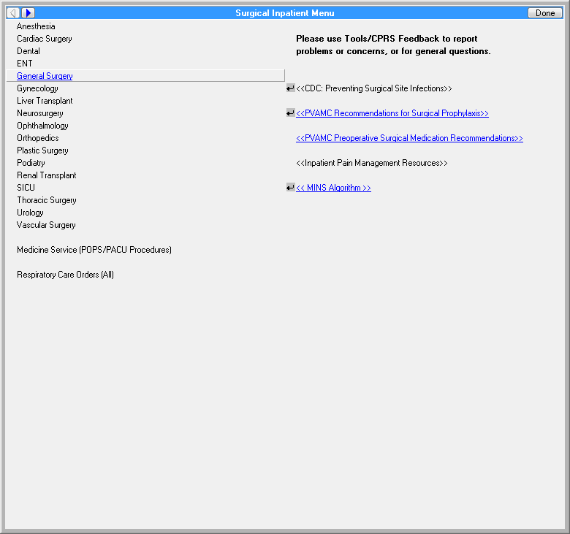

**Figure A.2. General Surgery Inpatient Orders**

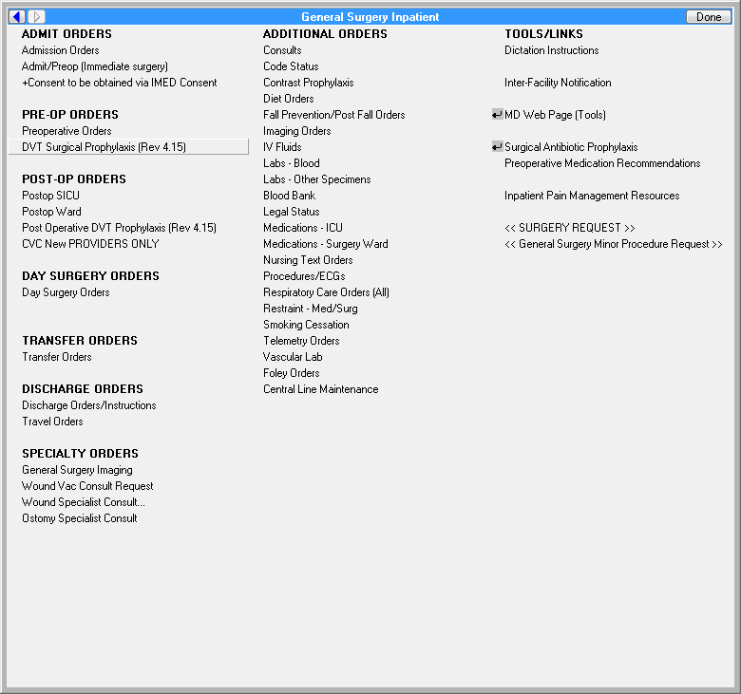

**Figure A.3. DVT Surgical Prophylaxis Orders**

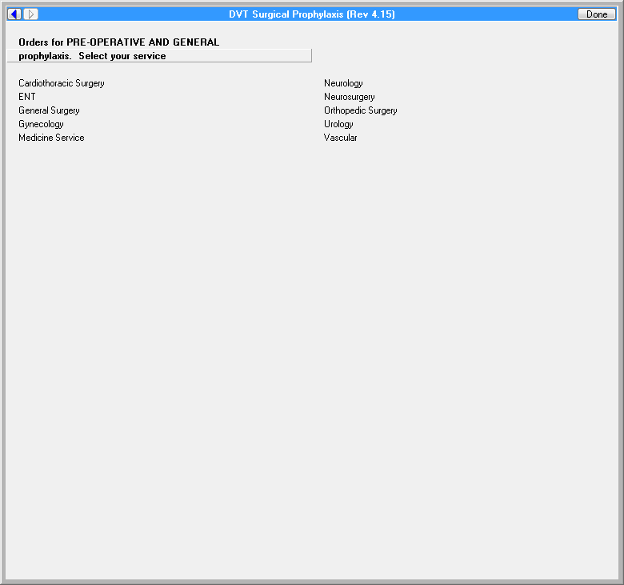

**Figure A.4. Cardiothoracic Surgery DVT Preoperative Prophylaxis Options**

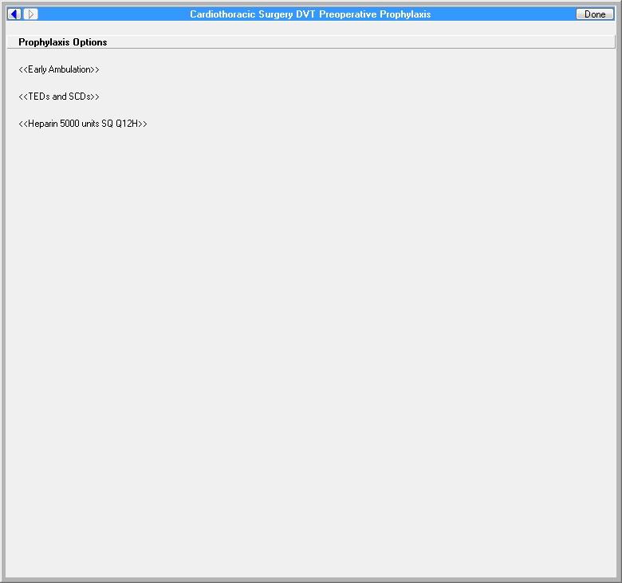

**Figure A.5. Early Ambulation Order - Preoperative Low DVT Risk**

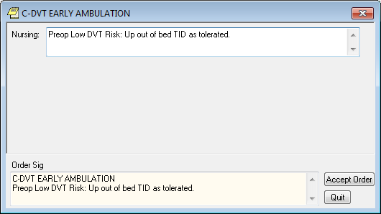

**Figure A.6. Reason for Request for Mechanical DVT**



**Figure A.7. ENT DVT Preoperative Prophylaxis - Low and Medium Risk**

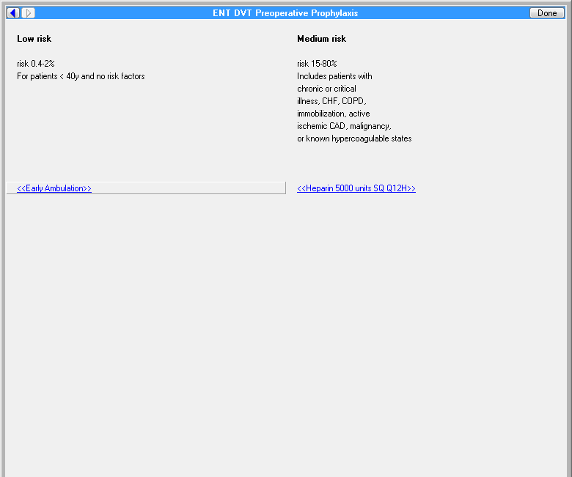

**Figure A.8. Early Ambulation Orders - Preoperative Low DVT Risk**

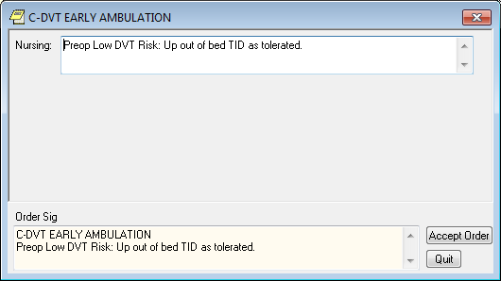

**Figure A.9. General Surgery Preoperative DVT Prophylaxis Options**

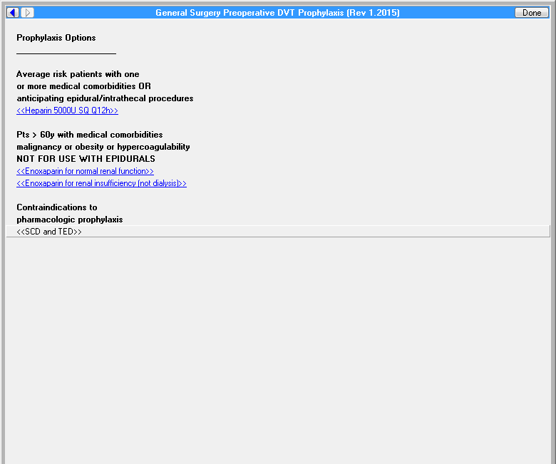

**Figure A.10. OB-GYN Preoperative DVT Prophylaxis - Low, Medium, and High Risk**

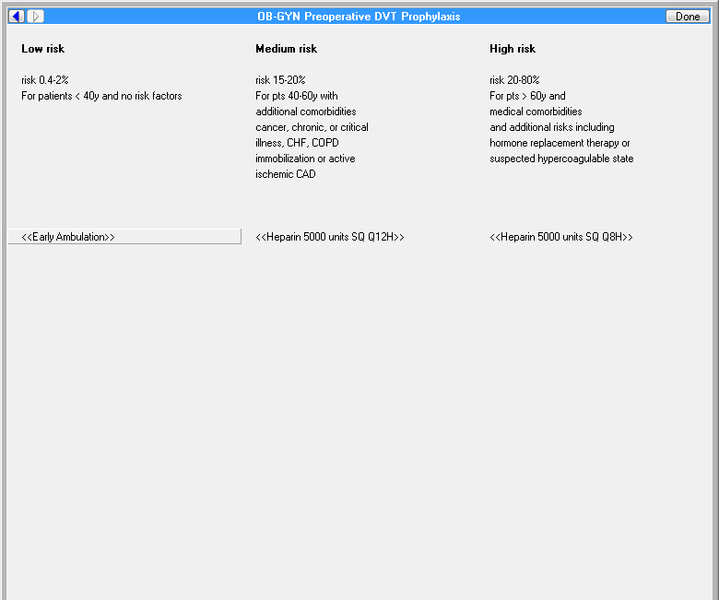

**Figure A.11. Hospital Specialty Medicine DVT Prophylaxis - Low, Medium, and High Risk**

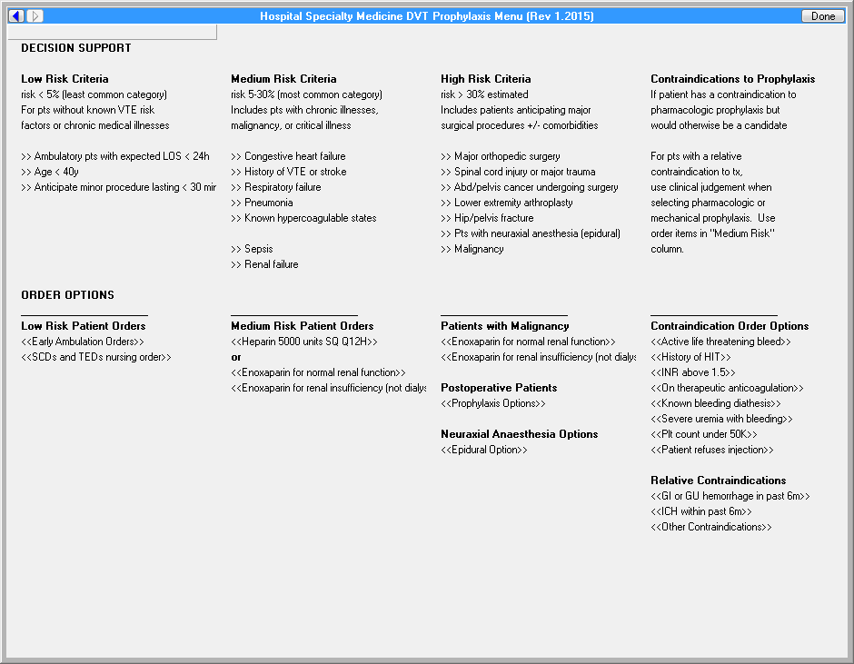

**Figure A.12. Exemplar Alert Contraindication for Pharmacologic DVT**

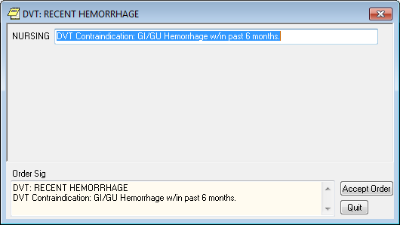

**Figure A.13. Neurology Preoperative DVT Prophylaxis - Low, Medium, and High Risk**

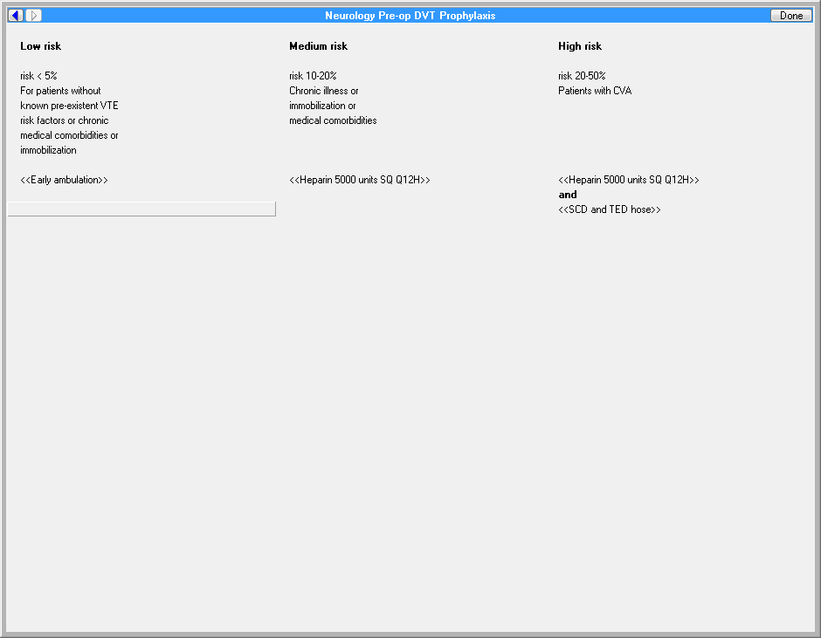

**Figure A.14. Neurosurgery Preoperative DVT Prophylaxis - Low, Medium, High, and Very High Risk**

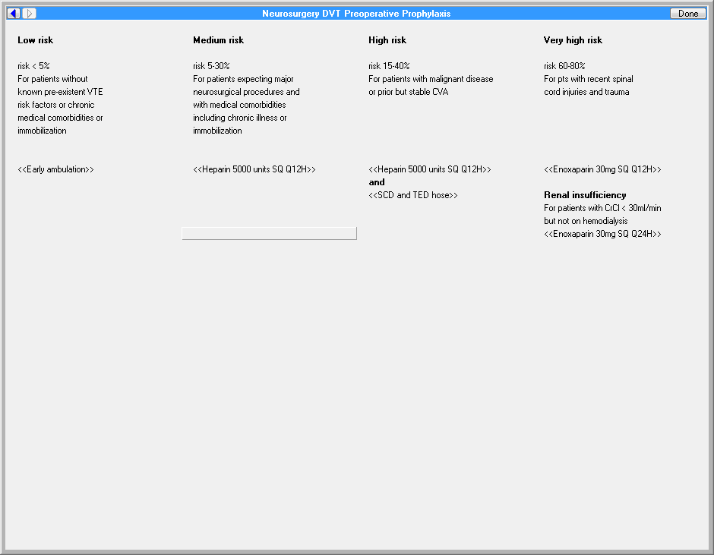

**Figure A.15. Orthopedic DVT Preoperative Prophylaxis**

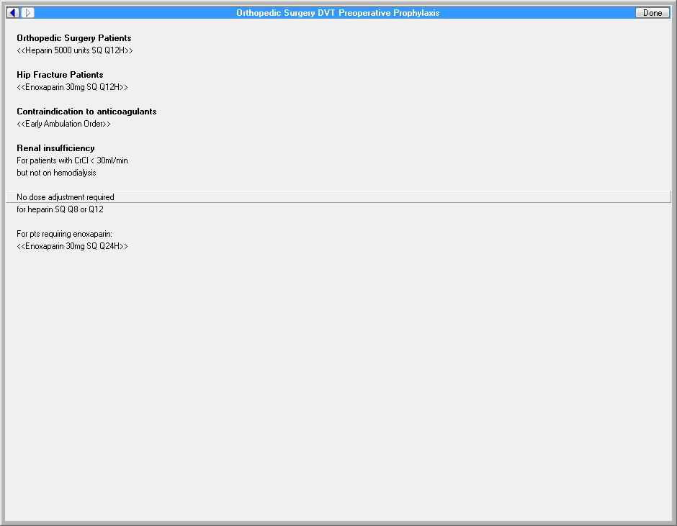

**Figure A.16. Urologic Surgery Preoperative DVT Prophylaxis - Low, Medium, and High Risk**

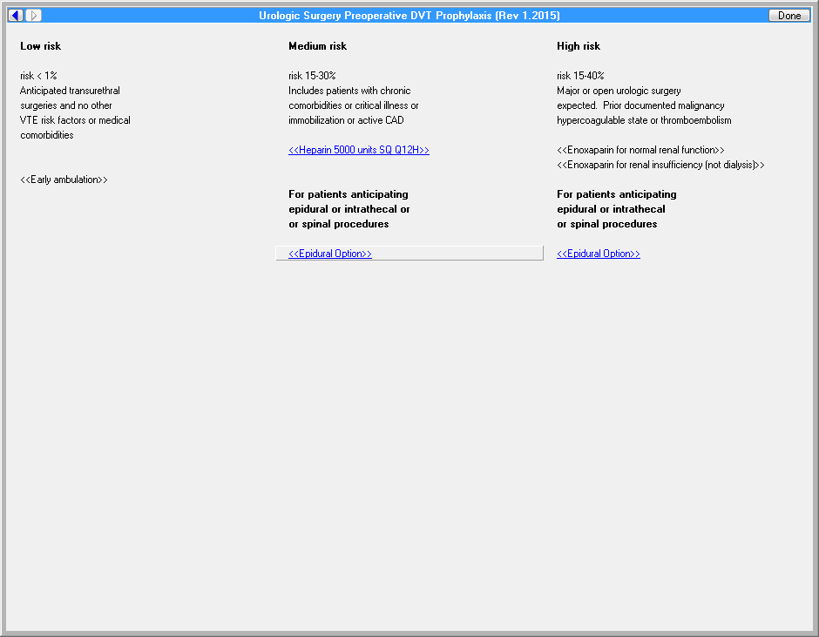

**Figure A.17. Vascular Surgery Preoperative DVT Prophylaxis - Very Low, Low, Medium, and High Risk**

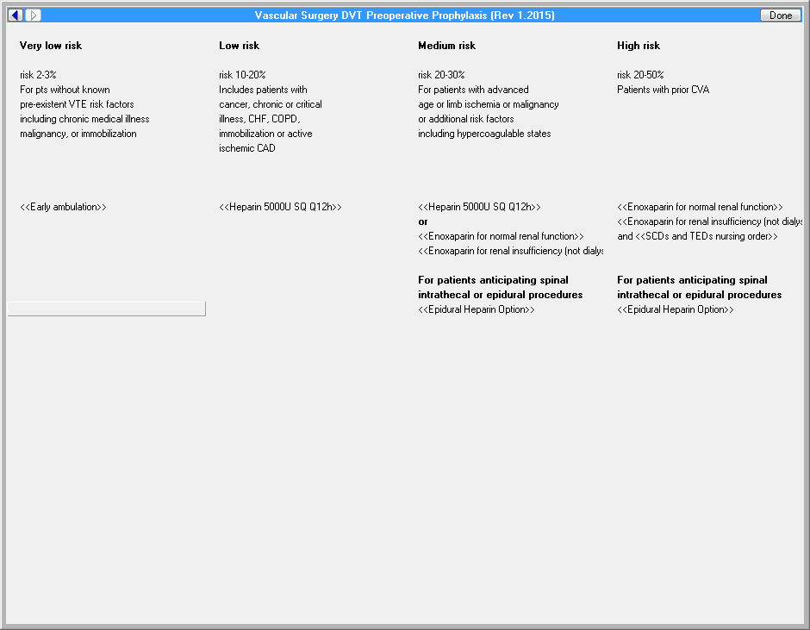

**Figure A.18. Vascular Surgery Preoperative DVT Prophylaxis - Very Low, Low, Medium, and High Risk**



**Figure A.19. Postoperative DVT Prophylaxis**

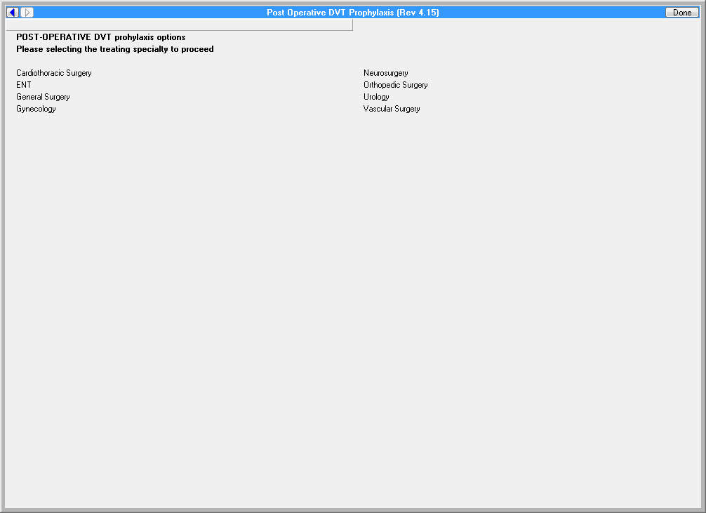

**Figure A.20. Cardiothoracic Surgery Postoperative DVT Prophylaxis**

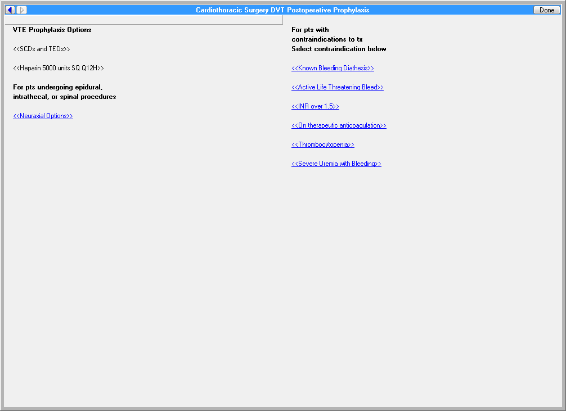

**Figure A.21. DVT Prophylaxis in Presence of a Bleeding Diathesis**



**Figure A.22. ENT DVT Postoperative Prophylaxis**

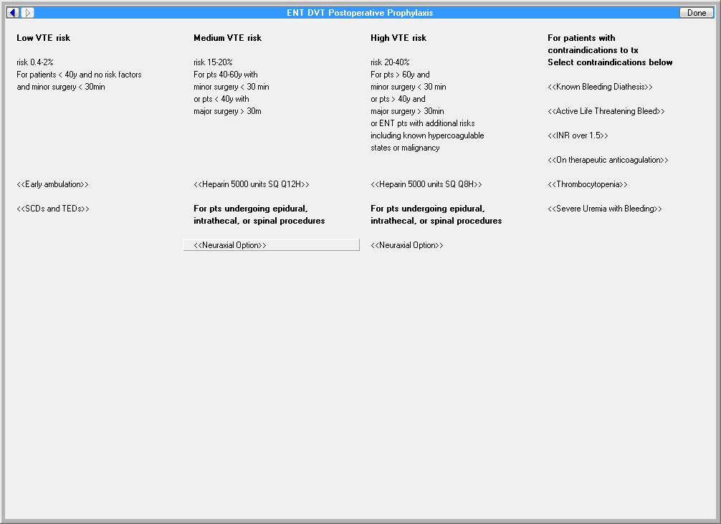

**Figure A.23. General Surgery DVT Postoperative Prophylaxis**

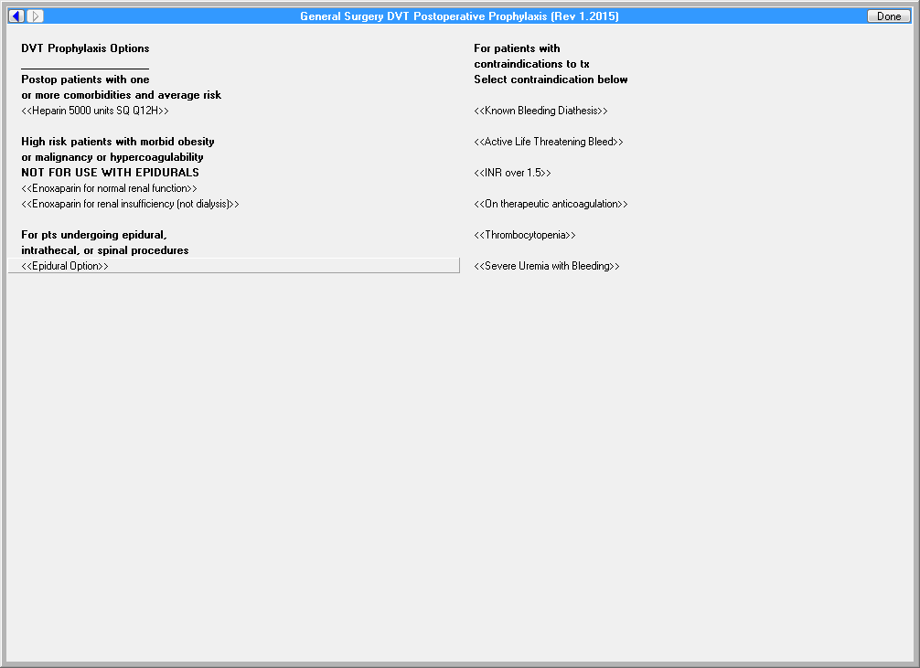

**Figure A.24. OB-GYN DVT Postoperative Prophylaxis**

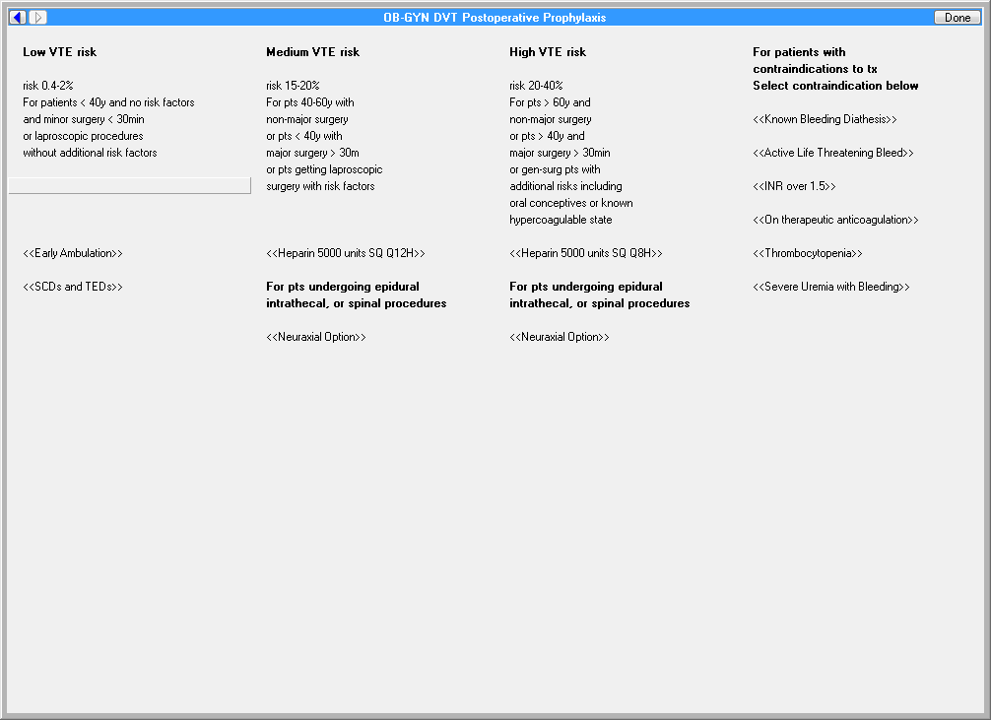

**Figure A.25. Neurosurgery DVT Postoperative Prophylaxis**

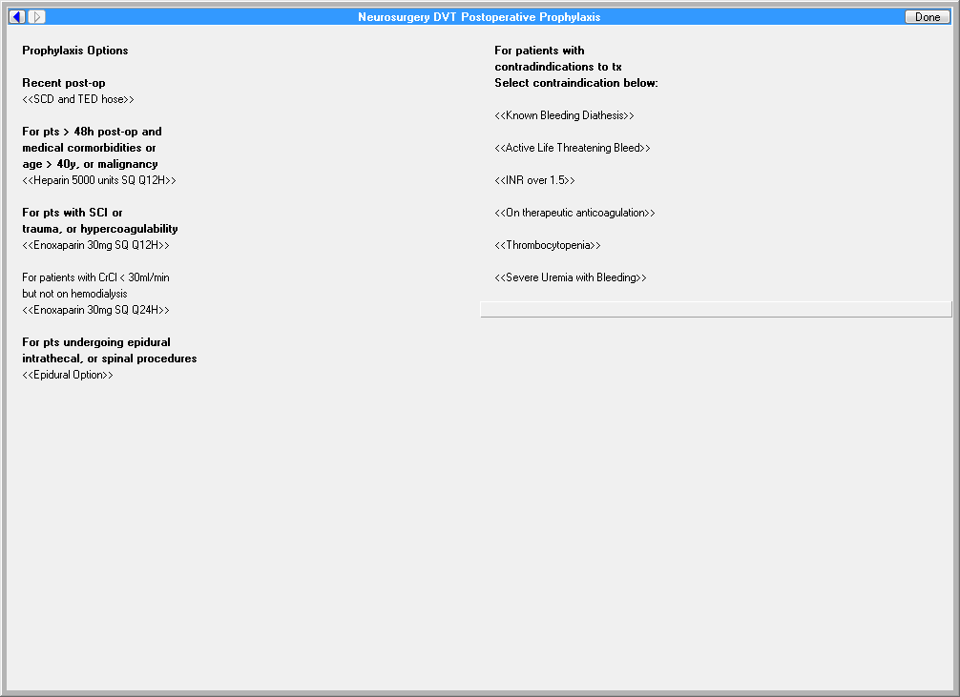

**Figure A.26. Orthopedic Surgery DVT Postoperative Prophylaxis**

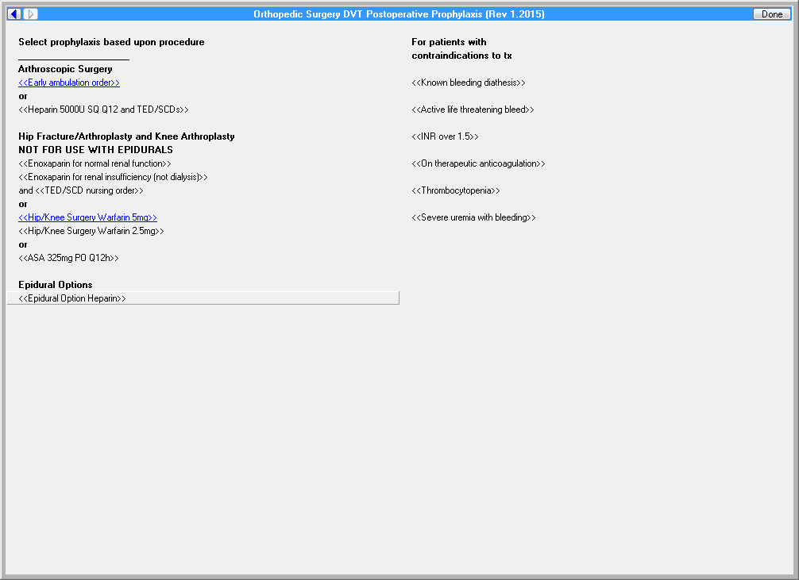

**Figure A.27. Urologic Surgery DVT Postoperative Prophylaxis**

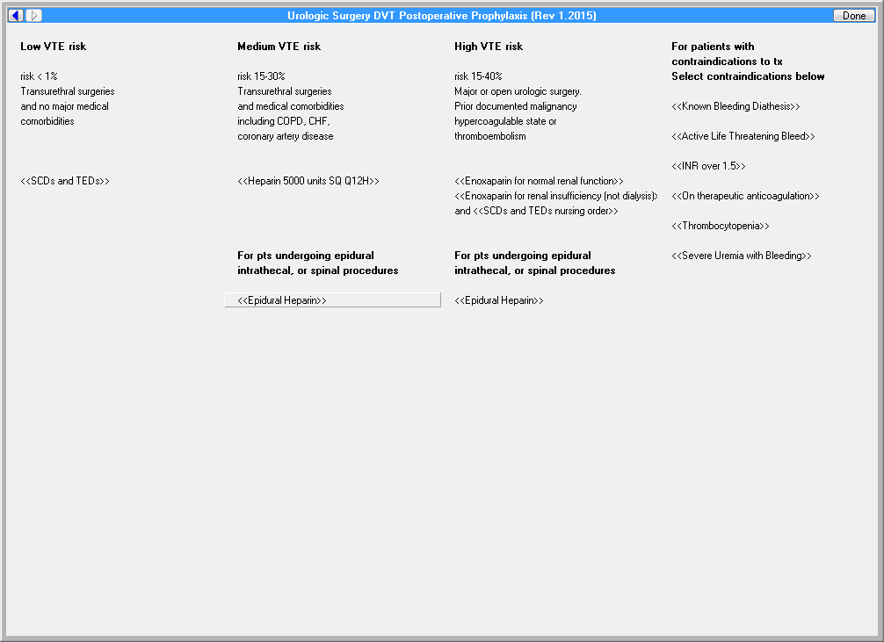

**Figure A.28. Vascular Surgery DVT Postoperative Prophylaxis**

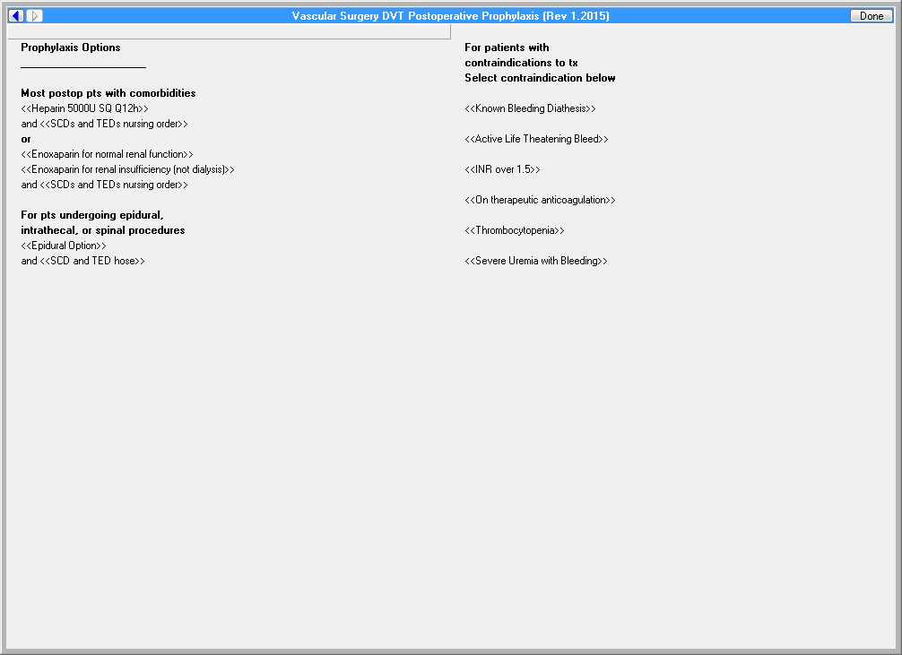

**Appendix B. Basic Laboratory Panel Definition**

* Blood Urea Nitrogen
* Calcium
* Chloride
* CO2 (Carbon Dioxide, Bicarbonate)
* Creatinine
* Glucose
* Potassium
* Sodium

**Appendix C. VTE Guidelines**

American College of Chest Physicians pregnancy anticoagulation guidelines (<https://www.ncbi.nlm.nih.gov/pmc/articles/PMC3278054/>>

**Acronyms**

ACCP American College of Chest Physicians

AAOS American Academy of Orthopedic Surgeons

CCWP Clinical Content White Paper

HL7 Health Level 7

KNART Knowledge Artifact

KNARTs Knowledge Artifacts

VAMC VA Medical Center

VTE Venous Thromboembolism