**Clinical Decision Support (CDS) Content and Health Level 7 (HL7)-Compliant Knowledge Artifacts (KNARTs)**

**Gastroenterology: Colorectal Cancer Risk Clinical Content White Paper**

**Department of Veterans Affairs (VA)**



**Knowledge Based Systems (KBS)**

**Office of Informatics and Information Governance (OIIG)**

**Clinical Decision Support (CDS)**

**Clinical Decision Support (CDS) Content and Health Level 7 (HL7)-Compliant Knowledge Artifacts (KNARTs): Gastroenterology: Colorectal Cancer Risk Clinical Content White Paper**

by Department of Veterans Affairs (VA)

Publication date May 2018

Copyright © 2018 B3 Group, Inc.

Copyright © 2018 Cognitive Medical Systems, Inc.

**B3 Group, Inc.**

NOTICE OF GOVERNMENT COPYRIGHT LICENSE AND UNLIMITED RIGHTS LICENSE

Licensed under the Apache License, Version 2.0 (the "License"); you may not use this file except in compliance with the License.

You may obtain a copy of the License at http://www.apache.org/licenses/LICENSE-2.0

Unless required by applicable law or agreed to in writing, software distributed under the License is distributed on an "AS IS" BASIS, WITHOUT WARRANTIES OR CONDITIONS OF ANY KIND, either express or implied. See the License for the specific language governing permissions and limitations under the License.

Portions of this content are derivative works from content produced by Cognitive Medical Systems, Inc. licensed under the Apache License, Version 2.0.

Additional portions of this content are derivative works from content contributed by Motive Medical Intelligence Inc., under Creative Commons Attribution-ShareAlike 4.0.

Contributions from 2013-2018 were performed either by US Government employees, or under US Veterans Health Administration contracts.

US Veterans Health Administration contributions by government employees are work of the U.S. Government and are not subject to copyright protection in the United States. Portions contributed by government employees are USGovWork (17USC §105). Not subject to copyright.

See: https://www.usa.gov/government-works

Contribution by contractors to the US Veterans Health Administration during this period are contractually contributed under the Apache License, Version 2.0 and US Government sponsorship is acknowledged under Contract VA118-16-D-1008, Task Order VA11817F10080007.

**Cognitive Medical Systems, Inc.**

Licensed under the Apache License, Version 2.0 (the "License"); you may not use this file except in compliance with the License.

You may obtain a copy of the License at http://www.apache.org/licenses/LICENSE-2.0

Unless required by applicable law or agreed to in writing, software distributed under the License is distributed on an "AS IS" BASIS, WITHOUT WARRANTIES OR CONDITIONS OF ANY KIND, either express or implied. See the License for the specific language governing permissions and limitations under the License.

This and related content produced by Cognitive Medical Systems, Inc. licensed under the Apache License, Version 2.0 is available at: https://bitbucket.org/cogmedsys/hl7-kas-examples

Additional portions of this content are derivative works from content contributed by Motive Medical Intelligence Inc., under Creative Commons Attribution-ShareAlike 4.0. https://bitbucket.org/cogmedsys/kas-source-material

Contributions from 2013-2018 were performed either by US Government employees, or under US Veterans Health Administration contracts.

US Veterans Health Administration contributions by government employees are work of the U.S. Government and are not subject to copyright protection in the United States. Portions contributed by government employees are USGovWork (17USC §105). Not subject to copyright. See: https://www.usa.gov/government-works

Contribution by contractors to the US Veterans Health Administration during this period are contractually contributed under the Apache License, Version 2.0 and US Government sponsorship is acknowledged under Contract VA118-16-D-1008-0007.

**Contract: VA118-16-D-1008, Task Order (TO): VA-118-16-F-1008-0007**

**Table 1. Relevant KNART Information: : Gastroenterology: Colorectal Cancer Risk KNARTs**

| **Gastroenterology KNART** | **Associated CLIN** |
| --- | --- |
| Colorectal Cancer Risk: Colorectal Cancer Screening, Diagnostics, and Surveillance – Event Condition Action (ECA) Rule | CLIN0003AB |
| Colorectal Cancer Risk: Colorectal Cancer Risk – Documentation Template/Consult Request | CLIN0005AB |
| Colorectal Cancer Risk: Personal History of Colon Cancer or Polyp – Order Set | CLIN0004AB |
| Colorectal Cancer Risk: Family History of Colon Cancer, Colon Cancer Syndrome, or Advanced Adenoma – Order Set | CLIN0004AB |
| Colorectal Cancer Risk: Inflammatory Bowel Disease – Order Set | CLIN0004AB |
| Colorectal Cancer Risk: Iron Deficiency – Order Set | CLIN0004AB |
| Colorectal Cancer Risk: Rectal Bleeding, Positive Screening Test - Order Set | CLIN0004AB |
| Colorectal Cancer Risk: Average Risk Screening – Order Set | CLIN0004AB |
| Colorectal Cancer Risk: Fecal Immunochemical Test (FIT) – Order Set | CLIN0004AB |
| Colorectal Cancer Risk: Other Issues – Order Set | CLIN0004AB |
| Colorectal Cancer Risk – Composite/Consult Request | N/A |

**Table of Contents**

VA Subject Matter Expert (SME) Panel viii

Introduction ix

Conventions Used x

1. Gastroenterology: Colorectal Cancer Risk 1

1.1. Clinical Context 1

1.2. Knowledge Artifacts 1

2. Composite/Consult Request: Colorectal Cancer Risk 3

2.1. Knowledge Narrative 3

2.2. Consult Request 3

3. Event Condition Action (ECA) Rule: Colorectal Cancer Risk 4

3.1. Knowledge Narrative 4

3.2. Event Condition Action (ECA) Rule: Colorectal Cancer Screening, Diagnostics and Surveillance – General 4

3.3. Colorectal Cancer Screening: Average Risk 5

3.4. Colorectal Cancer Screening: Colorectal Cancer or Advanced Adenoma Diagnosed in Multiple First-Degree Relatives or in One First-Degree Relative before Age 60 Years, Familial Colorectal Cancer Syndrome Type X, or Lynch Syndrome 6

3.5. Colorectal Cancer Screening: One First-Degree Relative Diagnosed with Colorectal Cancer or Advanced Adenoma at Age 60 Years or Older 7

3.6. Colorectal Cancer Screening: Repeat Colonoscopy Indicated 8

3.7. Colorectal Cancer Diagnosis: Positive Imaging or Endoscopy Screening Test 9

3.8. Colorectal Cancer Diagnosis: Positive Colorectal Cancer Screening Stool Test 10

3.9. Colorectal Cancer Surveillance: Personal History of Colon Cancer or Polyp 11

3.10. Colorectal Cancer Surveillance: Inflammatory Bowel Disease 12

4. Documentation Template/Consult Request: Colorectal Cancer Risk 14

4.1. Knowledge Narrative 14

4.2. Reason for Presentation 14

4.3. Reason for Consult 14

4.4. Colorectal Cancer Screening History: Average Risk Patients 15

4.5. Colorectal Cancer Diagnostics History: Positive Stool Test 16

4.6. Colorectal Cancer Diagnostics History: Positive Imaging Screening Test 16

4.7. Colorectal Cancer Evaluation History: Abnormal Flexible Sigmoidoscopy 17

4.8. Colorectal Cancer Evaluation History: Abnormal Colonoscopy 17

4.9. Personal History of Colorectal Polyp 18

4.10. Personal History of Colorectal Cancer 19

4.11. - Family History of Colon Cancer, Colon Cancer Syndrome or Advanced Adenoma 21

4.12. Inflammatory Bowel Disease 22

4.13. Additional Pertinent History 23

4.13.1. Signs and Symptoms 23

4.13.2. Diagnostic Procedures 24

4.13.3. Medical History 24

4.13.4. Surgical History 24

4.13.5. Medications 25

4.13.6. Laboratory Test Results 25

4.13.7. Plan 25

5. Screening Order Sets: Colorectal Risk 27

5.1. Knowledge Narrative 27

5.2. Order Set: Colorectal Cancer Risk – Average Risk Screening 27

5.2.1. Knowledge Narrative 27

5.2.2. Consults and Referrals 27

5.2.3. Patient and Caregiver Education 27

5.3. Order Set: Colorectal Cancer Risk - Family History of Colon Cancer, Colon Cancer Syndrome, or Advanced Adenoma 27

5.3.1. Knowledge Narrative 27

5.3.2. Consults and Referrals 28

5.3.3. Patient and Caregiver Education 28

6. Diagnostic Order Sets: Colorectal Cancer Risk 29

6.1. Knowledge Narrative 29

6.2. Order Set: Colorectal Cancer Risk – Iron Deficiency 29

6.2.1. Knowledge Narrative 29

6.2.2. Laboratory Tests 29

6.2.3. Section 6.2.3. – Consults and Referrals 29

6.2.4. Section 6.2.4. – Patient and Caregiver Education 29

6.3. Order Set: Colorectal Cancer Risk – Rectal Bleeding or Positive Screening Test 30

6.3.1. Knowledge Narrative 30

6.3.2. Consults and Referrals 30

6.3.3. Patient and Caregiver Education 30

6.4. Order Set: Colorectal Cancer Risk – Fecal Immunochemical Test (FIT) 30

6.4.1. Knowledge Narrative 30

6.4.2. Laboratory Tests 30

6.4.3. Consults and Referrals 31

6.4.4. Patient and Caregiver Education 31

7. Surveillance Order Sets: Colorectal Cancer Risk 32

7.1. Knowledge Narrative 32

7.2. Order Set: Colorectal Cancer Risk – Personal History of Colon Cancer or Polyp 32

7.2.1. Knowledge Narrative 32

7.2.2. Consults and Referrals 32

7.2.3. Patient and Caregiver Education 32

7.3. Order Set: Colorectal Cancer Risk – Inflammatory Bowel Disease 32

7.3.1. Knowledge Narrative 33

7.3.2. Consults and Referrals 33

7.3.3. Patient and Caregiver Education 33

7.4. Order Set: Colorectal Cancer Risk – Other Issues 33

7.4.1. Knowledge Narrative 33

7.4.2. Consults and Referrals 33

7.4.3. Patient and Caregiver Education 33

Bibliography/Evidence 35

A. Existing Sample VA Artifacts 36

B. Acronyms/Abbreviations 64

**List of Figures**

A.1. Colorectal Cancer Screening - ECA Rule 36

A.2. GI Colonoscopy Request Menu 42

A.3. Reason for Request: GI Clinic – Colonoscopy Outpt 43

A.4. Order a Consult 44

A.5. Colonoscopy Screening for Family Hx 45

A.6. GI Clinic - Colonoscopy Outpt 46

A.7. Order a Consult 47

A.8. GI Clinic - Colonoscopy Outpt 48

A.9. Order a Consult 49

A.10. Reason for Request: GI Clinic - Colonoscopy Outpt 50

A.11. Order a Consult 51

A.12. GI Clinic - Colonoscopy Outpt 52

A.13. Order a Consult 53

A.14. Reason for Request: GI Clinic - Colonoscopy Output 54

A.15. Reason for Request GI Clinic - Colonoscopy Output 55

A.16. Order a Consult 56

A.17. GI Colonoscopy Request Menu 57

A.18. Template CHOICE-FIRST screening colonoscopy 58

A.19. CHOICE-FIRST screening colonoscopy 59

A.20. CHOICE-FIRST screening colonoscopy 60

A.21. Order a Consult 61

A.22. Order a Lab Test 62

**List of Tables**

1. Relevant KNART Information: : Gastroenterology: Colonoscopy KNARTs iii

2. VA Subject Matter Expert (SME) Panel viii

1.1. Clinical Context Domains 1

**VA Subject Matter Expert (SME) Panel**

**Table 2. VA Subject Matter Expert (SME) Panel**

| **Name** | **Title** | **Project Role** |
| --- | --- | --- |
| Jason A. Dominitz, MD, MHS | National Gastroenterology Program Director  Department of Veteran Affairs (VA)  Puget Sound Health Care System  Seattle, WA | Primary, SME |
| Lyn Sue Kahng, MD | Section Chief, GI  Jesse Brown VA Medical Center (VAMC)  Chicago, IL 60612 | Secondary, SME |
| David Kaplan, MD, MSc | GI Staff Physician  Philadelphia, PA 19104 | SME |
| Brian Hertz, MD | Senior Medical Advisor  Office of Veterans Access to Care  Hines VAMC  Hines, IL | SME |

**Introduction**

The VA is committed to improving the ability of clinicians to provide care for patients while increasing quality, safety, and efficiency. Recognizing the importance of standardizing clinical knowledge in support of this goal, VA is implementing the Health Level 7 (HL7) Knowledge Artifact Specification for a wide range of VA clinical use cases. Knowledge Artifacts, referred to as (KNARTs), enable the structuring and encoding of clinical knowledge so the knowledge can be integrated with electronic health records to enable clinical decision support.

The purpose of this Clinical Content White Paper (CCWP) is to capture the clinical context and intent of KNART use cases in sufficient detail to provide the KNART authoring team with the clinical source material to construct the corresponding knowledge artifacts using the HL7 Knowledge Artifact Specification. This paper has been developed using material from a variety of sources: VA artifacts, clinical practice guidelines, evidence in the body of medical literature, and clinical expertise. After reviewing these sources, the material has been synthesized and harmonized under the guidance of VA subject matter experts to reflect clinical intent for this use case.

Unless otherwise noted, items within this white paper (e.g., documentation template fields, orderable items, etc.) are chosen to reflect the clinical intent at the time of creation. To provide an exhaustive list of all possible items and their variations is beyond the scope of this work.

**Conventions Used**

Conventions used within the knowledge artifact descriptions include:

<obtain>: Indicates a prompt to obtain the information listed

* If possible, the requested information should be obtained from the underlying system(s). Otherwise, prompting the user for information may be required
* Default Values: Unless otherwise noted, <obtain> indicates to obtain the most recent observation. It is recognized that this default time-frame value may be altered by future implementations

[...]: Square brackets enclose explanatory text that indicates some action on the part of the clinical user, or general guidance to the clinical or technical teams. Examples include, but are not limited to:

[Begin ...], [End ...]: Indicates the start and end of specific areas to clearly delineate them for technical purposes.

[Activate ...]: Initiates another knowledge artifact or knowledge artifact section.

[Section Prompt: ...]: If this section is applicable, then the following prompt should be displayed to the user.

[Section Selection Behavior: ...]: Indicates technical constraints or considerations for the selection of items within the section.

[Attach: ...]: Indicates that the specified item should be attached to the documentation template if available.

[Link: ...]: Indicates that rather than attaching an item, a link should be included in the documentation template.

[Clinical Comment: ...]: Indicates clinical rationale or guidance.

[Technical Note: ...]: Indicates technical considerations or notes.

[If ...]: Indicates the beginning of a conditional section.

[Else, ...]: Indicates the beginning of the alternative branch of a conditional section.

[End if ...]: Indicates the end of a conditional section.

☐: Indicates items that should be selected based upon the section selection behavior.

**Chapter 1.****Gastroenterology: Colorectal Cancer Risk**

**1.1.****Clinical Context**

[Begin Clinical Context.]

Screening techniques have greatly decreased the incidence of colon cancer (Shaukat, 2013). Assisting clinicians in ordering the appropriate screening modality and screening interval requires authoritative, evidence-based decision support. Implementing such decision support across the VA could save lives, decrease morbidity, and manage constrained resources in a cost-effective manner. Although surveillance colonoscopy may be warranted based on numerous potential indications, emphasis should be placed on identifying veterans for whom screening colonoscopy is recommended based on age or for whom surveillance is recommended based on personal or family history of neoplasia or the most significant risk factors for colorectal cancer (Rex, 2017).

[Clinical Comments: Intended to identify patients for whom colorectal cancer screening, diagnostic evaluation, or surveillance is recommended, facilitate discussion between the primary care provider and the patient regarding risk factors and screening preferences, support decision-making and documentation related to the screening discussion, and promote appropriate ordering based on patient-specific risk factors and preferences.]

**Table 1.1. Clinical Context Domains**

|  |  |
| --- | --- |
| Target User | Primary Care Provider |
| Patient | Adult |
| Priority | Routine unless otherwise identified |
| Specialty | Primary Care |
| Location | Outpatient |

[End Clinical Context.]

**1.2.****Knowledge Artifacts**

[Begin Knowledge Artifacts.]

This section describes the CDS knowledge artifacts that are part of the Gastroenterology: Colorectal Cancer Risk group, and include:

* A Composite/Consult Request: Gastroenterology: Colorectal Cancer Risk KNART
  + High-level, encompassing artifact
  + Relies upon the documentation template and order set artifacts
* An Event-Condition-Action (ECA) Rule: Gastroenterology: Colorectal Cancer Screening, Diagnostics, and Surveillance KNART
  + Rule logic that describes the behavior of the consult
  + Actions may include activating documentation templates or order sets
* A Documentation Template Consult Request: Gastroenterology: Colorectal Cancer Risk KNART
  + Documents the information provided by the referring provider
  + Includes logic for appropriate display of documentation sections
* Order Sets: Gastroenterology: Colorectal Cancer Risk – Average Risk Screening, Family History of Colon Cancer, Colon Cancer Syndrome or Advanced Adenoma, Iron Deficiency, Rectal Bleeding or Positive Screening Test, Fecal Immunochemical Test (FIT), Personal History of Colon Cancer or Polyp, Inflammatory Bowel Disease, Other Issues KNARTs
  + Orderable items associated with a consult request
  + Includes logic for appropriate display of the order set

[End Knowledge Artifacts.]

**Chapter 2.****Composite/Consult Request: Colorectal Cancer Risk**

[Begin Composite/Consult Request: Colorectal Cancer Risk.]

**2.1.****Knowledge Narrative**

[Begin Knowledge Narrative.]

[See Clinical Context in Chapter 1.]

[End Knowledge Narrative.]

**2.2.****Consult Request**

[Begin Consult Request.]

[Section Selection Prompt: Only applicable for consult order to an outside facility.]

[Section Selection Prompt: To determine appropriate Gastroenterology Colorectal Cancer Risk, please provide the following information.]

Reason for Consult: Colorectal Cancer Risk Assessment

Consult Specialty: Gastroenterology

[Section Prompt: Goal of Consult.]

[Section Selection Behavior: Required. Select one.]

☐ Return to primary care provider (PCP) for therapy

☐ Start treatment and return to PCP for follow up and maintenance

☐ Start treatment, monitor for effect and when on stable therapy return to PCP

☐ Treat as long as necessary (or indefinitely)

Priority: Routine unless otherwise specified

<obtain> Referring Physician

<obtain> Referring Physician Contact Information

[Technical Note: Activate Documentation Template.]

[End Consult Request.]

[End Composite/Consult Request: Colorectal Cancer Risk.]

**Chapter 3.****Event Condition Action (ECA) Rule: Colorectal Cancer Risk**

[Begin Event Condition Acton (ECA) Rule: Colorectal Cancer Risk.]

**3.1.****Knowledge Narrative**

[Begin Knowledge Narrative.]

[See Clinical Context in Chapter 1.]

[End Knowledge Narrative.]

**3.2.****Event Condition Action (ECA) Rule: Colorectal Cancer Screening, Diagnostics and Surveillance – General**

[Begin Event Condition Action (ECA) Rule: Colorectal Cancer Screening, Diagnostics and Surveillance – General.]

**Event**

[Begin Event.]

1. Any access of the patient record
2. System run on routine frequency

[Technical Note: These events apply to all subbranches.]

[End Event.]

**Conditions**

[Begin Conditions.]

Include adult outpatients who meet any of the following criteria:

1. Have a first-degree family member with a history of colorectal cancer or advanced adenoma
2. Have a family or personal history of Lynch Syndrome or familial colorectal cancer syndrome type X
3. Have a personal history of colorectal cancer or advanced adenoma
4. Are age >= 50.

Exclude patients who meet any of the following criteria:

1. Who have had a total colectomy
2. Are receiving hospice or end-of-life care
3. Have a documented decision to stop colorectal cancer screening
4. Are age >= 85 years.

[Technical Note: The decision to stop screening can be documented in the documentation template-consult request.]

[Technical Note: Additional criteria are included in the specific sub-branches.]

[End Conditions.]

**Actions**

[Begin Actions.]

[Technical note: The actions are determined in the subbranches.]

[End Actions.]

[End Event Condition Action (ECA) Rule: Colorectal Cancer Screening, Diagnostics and Surveillance – General.]

**3.3.****Colorectal Cancer Screening: Average Risk**

[Begin Colorectal Cancer Screening: Average Risk.]

**Events**

[Begin Events.]

[Technical Note: Events are addressed in the main branch of the rule.]

[End Events.]

**Conditions**

[Begin Conditions.]

Include adult outpatients aged >= 50 years who have not had any of the following:

1. Flexible sigmoidoscopy within 5 years
2. Colonoscopy within 10 years
3. Double-contrast barium enema within 5 years
4. Computed tomography colonography within 5 years
5. Guaiac-based fecal occult blood test with high test sensitivity for cancer within 1 year
6. Fecal immunochemical test with high test sensitivity for cancer within 1 year
7. Stool Deoxyribonucleic Acid (DNA) testing within 3 years

Exclude patients who meet any of the following criteria:

1. Have any first-degree relative diagnosed with colorectal cancer or advanced adenoma
2. Have a personal history of colorectal cancer or other colorectal neoplasia
3. Are known to have Lynch syndrome or have a first-degree relative with Lynch Syndrome
4. Have a family history of familial colorectal cancer syndrome type X
5. Have a personal history of inflammatory bowel disease
6. Had a positive result on the most recent imaging colorectal cancer screening test (double-contrast barium enema or computed tomography colonography) and have not had a follow-up colonoscopy
7. Had an abnormal result on the most recent flexible colonoscopy colorectal cancer screening and have not had a follow-up colonoscopy
8. Had a positive result on the most recent stool-based colorectal cancer screening test (guaiac-based fecal occult blood test, fecal immunochemical test, or stool DNA test) and have not had a follow-up colonoscopy
9. Had a finding of inadequate bowel prep on most recent colonoscopy.

[End Conditions.]

**Actions**

[Begin Actions.]

1. Identify the patient as a colorectal cancer screening candidate
2. Open Documentation Template/Consult Request: Gastroenterology: Colorectal Cancer Risk KNART
3. Open Order Set: Gastroenterology: Colorectal Cancer Risk - Average Risk Screening KNART
4. Make sure guideline recommendations are available to care team

[End Actions.]

[End Colorectal Cancer Screening: Average Risk.]

**3.4.****Colorectal Cancer Screening: Colorectal Cancer or Advanced Adenoma Diagnosed in Multiple First-Degree Relatives or in One First-Degree Relative before Age 60 Years, Familial Colorectal Cancer Syndrome Type X, or Lynch Syndrome**

[Begin Colorectal Cancer Screening: Colorectal Cancer or Advanced Adenoma Diagnosed in Multiple First-Degree Relatives or in One First-Degree Relative before Age 60 Years, Familial Colorectal Cancer Syndrome type X, or Lynch Syndrome.]

**Events**

[Begin Events.]

[Technical Note: Events are addressed in the main branch of the rule.]

[End Events.]

**Conditions**

[Begin Conditions.]

[Technical Notes: Include adult outpatients who have never had a colonoscopy, who did not receive a colonoscopy within the timeframe specified for re-scoping, or do not have a set timeframe for re-scoping who meet at least one of the following criteria]:

1. Have a family history of familial colorectal cancer syndrome type X and are at or older than the age 10 years younger than the age at diagnosis of the youngest diagnosed relative.
2. Have Lynch Syndrome or have a first-degree relative with Lynch Syndrome and are at or older than the patient’s documented screening start age; if the screening start ages is not documented, use the age 5 years younger than the age at diagnosis of the youngest diagnosed relative or age 20 years whichever is youngest.
3. Have two or more first-degree relatives diagnosed with colorectal cancer or advanced adenomas and are at or older than the age 10 years younger than the age at diagnosis of the youngest diagnosed relative or age >=40 years, whichever is youngest.
4. Have one first-degree relative diagnosed with colorectal cancer or advanced adenoma at age < 60 years and are at or older than the age 10 years younger than the age at diagnosis of the affected relative or are >= 40 years, whichever is youngest.

[Technical Note: Providers have the option of documenting the screening start age for patients with a personal or family history of Lynch Syndrome in the documentation template-consult request form.]

[End Conditions.]

**Actions**

[Begin Actions.]

1. Identify the patient as a colonoscopy candidate
2. Open Documentation Template—Consult Request: Gastroenterology: Colorectal Cancer Risk KNART
3. Open Order Set: Gastroenterology: Colorectal Cancer Risk – Family History of Colon Cancer, Colon Cancer Syndrome or Advanced Adenoma KNART
4. Make sure guideline recommendations are available to care team.

[End Actions.]

[End Colorectal Cancer Screening: Colorectal Cancer or Advanced Adenoma Diagnosed in Multiple First-Degree Relatives or in One First-Degree Relative before Age 60 Years, Family Colon Cancer Syndrome X, or Lynch Syndrome.]

**3.5.****Colorectal Cancer Screening: One First-Degree Relative Diagnosed with Colorectal Cancer or Advanced Adenoma at Age 60 Years or Older**

[Begin Colorectal Cancer Screening: One First-Degree Relative Diagnosed with Colorectal Cancer or Advanced Adenoma at Age 60 Years or Older.]

**Events**

[Begin Events.]

[Technical Note: Events are addressed in the main branch of the rule.]

[End Events.]

**Conditions**

[Begin Conditions.]

[Technical Note: Include adult outpatients aged >= 40 years with exactly one first-degree relative diagnosed with colorectal cancer or advanced adenoma if the affected relative was diagnosed at age >= 60 years and the patient has not had any of the following:]

1. Flexible sigmoidoscopy within 5 years
2. Colonoscopy within 10 years
3. Double-contrast barium enema within 5 years
4. Computed tomography colonography within 5 years
5. Guaiac-based fecal occult blood test with high test sensitivity for cancer within 1 year
6. Fecal immunochemical test with high test sensitivity for cancer within 1 year
7. Stool DNA testing within 3 years.

Exclude patients who meet any of the following criteria:

1. Have multiple first-degree relatives diagnosed with colorectal cancer or advanced adenoma
2. Have one first-degree relative diagnosed with colorectal cancer or advanced adenoma at age < 60 years
3. Have a personal history of colorectal cancer or other colorectal neoplasia
4. Are known to have Lynch syndrome or have a first-degree relative with Lynch Syndrome
5. Have a family history of familial colorectal cancer syndrome type X
6. Have a personal history of inflammatory bowel disease
7. Had an abnormal result on the most recent imaging colorectal cancer screening test (double-contrast barium enema or computed tomography colonography) and have not had a follow-up colonoscopy
8. Had a positive result on the most recent flexible colonoscopy colorectal cancer screening and have not had a follow-up colonoscopy
9. Had a positive result on the most recent stool colorectal cancer screening test (guaiac-based fecal occult blood test, fecal immunochemical test, or stool DNA test) and have not had a follow-up colonoscopy
10. Had a finding of inadequate bowel prep on most recent colonoscopy.

[End Conditions.]

**Actions**

[Begin Actions.]

1. Identify the patient as a colorectal cancer screening candidate
2. Open Documentation Template—Consult Request: Gastroenterology: Colorectal Cancer Risk KNART
3. Open Order Set: Family History of Colon Cancer, Colon Cancer Syndrome or Advanced Adenoma KNART
4. Open Order Set: Fecal Immunochemical Test (FIT)
5. Make sure guideline recommendations are available to care team.

[End Actions.]

[End One First-Degree Relative Diagnosed with Colorectal Cancer or Advanced Adenoma at Age 60 Years or Older.]

**3.6.****Colorectal Cancer Screening: Repeat Colonoscopy Indicated**

[Begin Colorectal Cancer Screening: Repeat Colonoscopy Indicated.]

**Events**

[Begin Events.]

[Technical Note: Events are addressed in the main branch of the rule.]

[End Events.]

**Conditions**

[Begins Conditions.]

[Technical Note: Include adult outpatients whose most recent colorectal cancer screening colonoscopy results indicated that the bowel prep was inadequate where either the timeframe specified for rescoping the patient has been exceeded or no timeframe for rescoping the patient was indicated.]

[End Conditions.]

**Actions**

[Begin Actions.]

1. Identify the patient as a colonoscopy candidate
2. Open Documentation Template—Consult Request: Gastroenterology: Colorectal Cancer Risk KNART
3. Open Order Set: Gastroenterology: Colorectal Cancer Risk – Other Issues
4. Make sure guideline recommendations are available to care team.

[End Actions.]

[End Colorectal Cancer Screening: Repeat Colonoscopy Indicated.]

**3.7.****Colorectal Cancer Diagnosis: Positive Imaging or Endoscopy Screening Test**

[Begin Colorectal Cancer Diagnosis: Positive Imaging or Endoscopy Screening Test.]

**Events**

[Begin Events.]

[Technical Note: Events are addressed in the main branch of the rule.]

[End Events.]

**Conditions**

[Begin Conditions.]

[Technical Note: Include adult outpatients who meet the following criteria:]

1. Most recent colorectal cancer screening imaging tests (double-contrast barium enema or computed tomography colonography) were positive and no follow-up colonoscopy completed
2. Most recent flexible sigmoidoscopy colorectal cancer screening tests were positive, and no follow-up colonoscopy completed

[End Conditions.]

**Actions**

[Begin Actions.]

1. Identify the patient as a colonoscopy candidate
2. Open Documentation Template—Consult Request: Gastroenterology: Colorectal Cancer Risk KNART
3. Open Order Set: Gastroenterology: Colorectal Cancer Risk – Rectal Bleeding or Positive Screening Test
4. Make sure guideline recommendations are available to care team.

[End Actions.]

[End Colorectal Cancer Diagnosis: Positive Imaging or Endoscopy Screening Test.]

**3.8.****Colorectal Cancer Diagnosis: Positive Colorectal Cancer Screening Stool Test**

[Begin Colorectal Cancer Diagnosis: Positive Colorectal Cancer Screening Stool Test.]

**Events**

[Begin Events.]

[Technical Note: Events are addressed in the main branch of the rule.]

[End Events.]

**Conditions**

[Begin Conditions.]

[Technical Note: Include adult outpatients who meet the following criteria:]

1. Most recent colorectal cancer screening stool-based tests (guaiac-based fecal occult blood test, fecal immunochemical test, or stool DNA test) were positive who have not yet had a follow-up colonoscopy
2. Significant lower gastrointestinal bleeding with a procedure request for colonoscopy per provider documentation with the requested colonoscopy not yet received.

[End Conditions.]

**Actions**

[Begin Actions.]

1. Identify the patient as a colonoscopy candidate
2. Open Documentation Template—Consult Request: Gastroenterology: Colorectal Cancer Risk KNART
3. Open Order Set: Gastroenterology: Colorectal Cancer – Rectal Bleeding or Positive Screening Test
4. Make sure guideline recommendations are available to care team.

[End Colorectal Cancer Diagnosis: Positive Colorectal Cancer Screening Stool Test.]

**3.9.****Colorectal Cancer Surveillance: Personal History of Colon Cancer or Polyp**

[Begin Colorectal Cancer Surveillance: Personal History of Colon Cancer or Polyp.]

**Events**

[Begin Events.]

[Technical Note: Events are addressed in the main branch of the rule.]

[End Events.]

**Conditions**

[Begin Conditions.]

[Technical Note: Include adult outpatients who meet the following criteria and either the timeframe specified for rescoping the patient has been exceeded or no timeframe for rescoping the patient was set:]

1. No repeat colonoscopy after piecemeal removal of a polyp > 15 mm in size where the polyp is either flat or sessile and either serrated or adenomatous
2. No repeat colonoscopy after recent colonoscopy with findings of colorectal neoplasia:

[Technical Note: Include the following in a table with the appropriate timeframes.]

1. > 10 adenomas
2. 3–10 adenomas < 10 mm in size
3. >= 1 adenoma with villous features
4. >= 1 adenoma with high-grade dysplasia
5. no adenomas on first surveillance colonoscopy follow-up of prior finding of high-risk adenoma
6. no adenomas on first surveillance colonoscopy follow-up of prior finding of low-risk adenoma
7. >= 1 tubular adenoma >= 10 mm in size
8. 1–2 tubular adenomas < 10 mm in size with inadequate bowel preparation
9. 1–2 tubular adenomas < 10 mm in size with no cecal intubation
10. 1–2 tubular adenomas < 10 mm in size on first surveillance colonoscopy follow-up of prior finding of adenomas
11. no polyps >= 10 mm with 1–2 tubular adenomas with low-grade dysplasia and/or >= 1 serrated polyp without cytological dysplasia
12. >= 1 sessile serrated polyp that either is >= 10 mm in size or has cytological dysplasia
13. distal hyperplastic polyps < 10 mm in size
14. No 1-Year Follow-Up Colonoscopy after Colorectal Cancer Resection Clearing
15. No 3-Year Surveillance Colonoscopy after First Follow-Up for Colorectal Cancer Resection
16. No 5-Year Surveillance Colonoscopy after Second Follow-Up for Colorectal Cancer Resection
17. No repeat colonoscopy within 5 years of most recent ongoing colorectal cancer surveillance colonoscopy, providing the patient record does not indicate that surveillance colonoscopy should be discontinued.

[Technical Note: Providers have the option of indicating that post-resection surveillance should be discontinued in the documentation template—consult request.]

[End Conditions.]

**Actions**

[Begin Actions.]

1. Identify the patient as a colonoscopy candidate
2. Open Documentation Template—Consult Request: Gastroenterology: Colorectal Cancer Risk KNART
3. Open Order Set: Gastroenterology: Colorectal Cancer Risk– Personal history of colon cancer or polyp KNART
4. Make sure guideline recommendations are available to care team.

[End Actions.]

[End Colorectal Cancer Surveillance: Personal History of Colon Cancer or Polyp.]

**3.10.****Colorectal Cancer Surveillance: Inflammatory Bowel Disease**

[Begin Colorectal Cancer Surveillance: Inflammatory Bowel Disease.]

**Events**

[Begin Events.]

[Technical Note: Events are addressed in the main branch of the rule.]

[End Events.]

**Conditions**

[Begin Conditions.]

[Technical Note: Include adult outpatients diagnosed with inflammatory bowel disease who have never had a colonoscopy and are at or older than the documented surveillance start age (see section 4.14 of the documentation template) or who did not receive a colonoscopy within the timeframe specified for rescoping or did not have a timeframe for rescoping set. If a surveillance start age has not been set, use the age at diagnosis plus 8 years as the surveillance start age.]

[Technical Note: Providers have the option of setting the surveillance start age in the documentation template-consult request form.]

[End Conditions.]

**Actions**

[Begin Actions.]

1. Identify the patient as a colonoscopy candidate
2. Open Documentation Template—Consult Request: Gastroenterology: Colorectal Cancer Risk KNART
3. Open Order Set: Gastroenterology: Colorectal Cancer Risk Inflammatory Bowel Disease Surveillance KNART
4. Make sure guideline recommendations are available to care team.

[End Actions.]

[End Colorectal Cancer Surveillance: Inflammatory Bowel Disease]

[End Event Condition Acton (ECA) Rule: Colorectal Cancer Risk]

**Chapter 4.****Documentation Template/Consult Request: Colorectal Cancer Risk**

[Begin Documentation Template: Colorectal Cancer Risk.]

[Technical Note: This documentation template/consult request should be made available for clinical providers caring for patients meeting the criteria for any branch of ECA Rule KNART and at provider request.]

**4.1.****Knowledge Narrative**

[Begin Knowledge Narrative.]

[See Clinical Context in Chapter 1.]

[End Knowledge Narrative.]

**4.2.****Reason for Presentation**

[Begin Reason for Presentation.]

[Section Prompt: Reason for Presentation.]

[Technical Note: This section should be made available for all clinical users of this documentation template/consult request.]

<obtain> Chief Complaint

<obtain> Additional Details

[End Reason for Presentation.]

**4.3.****Reason for Consult**

[Begin Reason for Consult.]

[Section Prompt: Reason for Consult.]

[Section Selection Behavior: Any or none. Optional.]

[Technical Note: This section should be made available for all clinical users of this documentation template/consult request.]

<obtain> Age (Years)

☐ Positive Finding on Most Recent Stool Test

☐ Abnormal Finding on Most Recent Colorectal Imaging

☐ Abnormal Finding on Most Recent Flexible Sigmoidoscopy

☐ Abnormal Finding on Most Recent Colonoscopy

☐ Personal History of Colorectal Polyp

☐ Personal History of Colorectal Cancer

☐ Family History of Colon Cancer, Colon Cancer Syndrome or Advanced Adenoma

☐ Inflammatory Bowel Disease

☐ Gastrointestinal Bleeding

☐ Iron Deficiency Anemia

<obtain> Additional Details

[Technical Note: Although iron deficiency anemia has been intentionally omitted from ECA Rule: Gastroenterology: Colorectal Cancer Risk, it may be a symptom of colon cancer. It must be considered in combination with other clinical factors, such as unintentional weight loss, changes in bowel habits, visible blood in the stool, and recent hemoglobin lab test results.]

[Section Prompt: Iron deficiency anemia may be a symptom of colon cancer. It must be considered in combination with other clinical factors, such as unintentional weight loss, changes in bowel habits, visible blood in the stool, and recent hemoglobin lab test results.]

[End Reason for Consult.]

**4.4.****Colorectal Cancer Screening History: Average Risk Patients**

[Begin Colorectal Cancer Screening: Average Risk.]

[Technical Note: This section should be made available for clinical providers caring for patients without any risk factors selected in Section 4.3 - Reason for Consult and for clinical providers caring for patients meeting criteria for the Average Risk Screening branch of the ECA Rule Gastroenterology: Colorectal Cancer Screening, Diagnostics, and Surveillance KNART.]

[Section Prompt: Test Results]

☐ Guaiac-Based Fecal Occult Blood Test

<obtain> Date

☐ Fecal Immunochemical Test

<obtain> Date

☐ Stool DNA Test

<obtain> Date

☐ Double-Contrast Barium Enema

<obtain> Date

☐ Computed Tomography (CT) Colonography

<obtain> Date

☐ Flexible Sigmoidoscopy

<obtain> Date

☐ Colonoscopy

<obtain> Date

☐ No Prior Screening

<obtain> Additional Details

[End Colorectal Cancer Screening: Average Risk.]

**4.5.****Colorectal Cancer Diagnostics History: Positive Stool Test**

[Begin Colorectal Cancer Screening Diagnostics: Follow-up Positive Stool Test.]

[Technical Note: This section should be made available only if Positive Finding on Most Recent Stool Test was selected in Section 4.3 - Reason for Consult or if the patient meets criteria for the Positive Colorectal Cancer Screening Stool Tests branch of ECA Rule: Gastroenterology: Colorectal Cancer Screening, Diagnostics, and Surveillance KNART.]

[Section Prompt: Stool Screening Test Results]

☐ Guaiac-Based Fecal Occult Blood Test

<obtain> Date

☐ Fecal Immunochemical Test

<obtain> Date

☐ Stool DNA Test

<obtain> Date

<obtain> Additional Details

[End Colorectal Cancer Screening Diagnostics: Follow-up Positive Stool Test.]

**4.6.****Colorectal Cancer Diagnostics History: Positive Imaging Screening Test**

[Begin Colorectal Cancer Diagnostics: Positive Imaging Screening Test.]

[Section Prompt: Positive Imaging Screening Test Results]

[Technical Note: This section should be made available only if Abnormal Finding on Most Recent Colorectal Imaging was selected in Section 4.3 - Reason for Consult or if the patient meets criteria for the Positive Imaging or Endoscopy Screening Test branch of ECA Rule: Gastroenterology: Colorectal Cancer Screening, Diagnostics, and Surveillance KNART.]

[Link: Links should be attached automatically.]

[Section Selection Behavior: Any or none. Optional]

☐ Double-Contrast Barium Enema

<obtain> Date

<obtain> Adequacy of Bowel Preparation

☐ Adequate

☐ Inadequate

[Link: Link to Full Report and Images.]

☐ Computed Tomography

<obtain> Date

<obtain> Adequacy of Bowel Preparation

☐ Adequate

☐ Inadequate

[Link to Full Report and Images.]

<obtain> Additional Details

[End Colorectal Cancer Diagnostics: Positive Imaging Screening Test.]

**4.7.****Colorectal Cancer Evaluation History: Abnormal Flexible Sigmoidoscopy**

[Begin Follow-up Abnormal Flexible Sigmoidoscopy.]

[Section Prompt: Follow-up Abnormal Flexible Sigmoidoscopy.]

[Technical Note: This section should be made available only if Abnormal Finding on Most Recent Flexible Sigmoidoscopy was selected in Section 4.3 - Reason for Consult or if the patient meets criteria for the Colorectal Cancer Diagnosis: Positive Imaging or Endoscopy Screening Test branch of ECA Rule: Gastroenterology: Colorectal Cancer Screening, Diagnostics, and Surveillance KNART.]

[Link: Links should be attached automatically.]

☐ Flexible Sigmoidoscopy

<obtain> Date

<obtain> Adequacy of Bowel Preparation

☐ Adequate

☐ Inadequate

[Link to Full Report and Images.]

<obtain> Additional Details

[End Follow-up Abnormal Flexible Sigmoidoscopy.]

**4.8.****Colorectal Cancer Evaluation History: Abnormal Colonoscopy**

[Begin Follow-up Abnormal Colonoscopy.]

[Section Prompt: Follow-up Abnormal Colonoscopy]

[Technical Note: This section should be made available only if Abnormal Finding on Most Recent Colonoscopy was selected in the Section 4.3 - Reason for Consult or if the patient meets criteria for the Colorectal Cancer Diagnosis: Positive Imaging or Endoscopy Screening Test branch of ECA Rule: Gastroenterology: Colorectal Cancer Screening, Diagnostics, and Surveillance KNART.]

☐ Most Recent Colonoscopy

<obtain> Date

[Link: Link to Full Report and Images.]

[Section Prompt: If the Colonoscopy Report Is Not Available, please provide as much Information as possible regarding key findings, including: Adequacy of Bowel Preparation, Depth of Insertion, Any Abnormalities (e.g., Polyps or Masses), and Any Sedation Requirements for Patient.]

<obtain> Additional Details

[End Follow-up Abnormal Colonoscopy.]

**4.9.****Personal History of Colorectal Polyp**

[Begin Personal History of Colorectal Polyp.]

[Section Prompt: Personal History of Colorectal Polyp.]

[Technical Note: This section should be made available only if Personal History of Colorectal Polyp was selected in Section 4.3 - Reason for Consult or if the patient meets criteria for the: Personal History of Cancer or Polyp branch of ECA Rule: Gastroenterology: Colorectal Cancer Screening, Diagnostics, and Surveillance KNART.]

[Link: Links should be attached automatically.]

[Technical Note: The following form components should be provided as auto populated information for all exams in this section, to be displayed only if the information is available and can be used to auto populate these fields for the given exam:]

1. No Polyps
2. Hyperplastic Polyps < 10 mm in Rectum or Sigmoid
3. >= 1 and =< 2 Tubular Adenomas < 10 mm
4. >= 1 and =< 10 Tubular Adenomas
5. > 10 Adenomas
6. >= 1 Tubular Adenomas >= 10 mm
7. >= 1 Villous Adenomas
8. Adenoma with High-Grade Dysplasia
9. Serrated Lesions
10. >= 1 Sessile Serrated Polyp < 10 mm without Dysplasia
11. >= 1 Sessile Serrated Polyp >= 10 mm
12. Sessile Serrated Polyp with Dysplasia
13. Traditional Serrated Adenoma
14. Serrated Polyposis Syndrome.

[Technical Note: Users should not be prompted to complete these form components manually; they should appear only if they are auto populated with existing information. These form components are derived from Table 1 in Lieberman 2012, which should be cited if the form components are displayed.]

[Section Prompt: Baseline Pathology.]

<obtain> Date

[Link: Link to Full Report and Images.]

<obtain> Additional Details

[Section Prompt: Baseline Polypectomy.]

<obtain> Date

<obtain> Additional Details

[Section Prompt: Baseline Colonoscopy.]

<obtain> Date

[Link: Link to Full Report and Images.]

[Section Prompt: First Surveillance Colonoscopy Performed?]

☐ Yes

<obtain> Date

[Link: Link to Full Report and Images.]

☐ No

[Section Prompt: Second Surveillance Colonoscopy Preformed?]

[Technical Note: Second Surveillance Colonoscopy question should be displayed only if the answer to the First Surveillance Colonoscopy Performed is yes.]

☐ Yes

<obtain> Date

[Link: Link to Full Report and Images.]

☐ No

[Section Prompt: Surveillance Completed?]

[Technical Note: Surveillance Completed question should be displayed only if the answer to Second Surveillance Colonoscopy Performed is yes.]

☐ Yes

<obtain> Additional Details

☐ No

[End Personal History of Colorectal Polyp.]

**4.10.****Personal History of Colorectal Cancer**

[Begin Personal History of Colorectal Cancer.]

[Section Prompt: Follow-up Personal History of Colorectal Cancer.]

[Technical Note: This section should be made available only if Personal History of Colorectal Cancer is selected in Section 4.3 - Reason for Consult or if the patient meets criteria for the Colorectal Cancer Screening: Personal History of Cancer or Polyp branch of ECA Rule: Gastroenterology: Colorectal Cancer Screening, Diagnostics, and Surveillance KNART.]

<obtain> Diagnosis

<obtain> Date of Diagnosis

[Section Prompt: Colorectal Cancer Resection Performed?]

☐ Yes

<obtain> Date

☐ No

[Section Prompt: Colorectal Cancer Resection Clearing Colonoscopy Performed?]

☐ Yes

<obtain> Date

[Link: Link to Full Report and Images.]

☐ No

[Section Prompt: First Follow-up Colonoscopy Performed?]

[Section Prompt: Recommended surveillance interval: Follow-Up Colonoscopy at 1 Year after Colorectal Cancer Resection Clearing.]

[Technical Note: First Follow-up Colonoscopy question should be displayed only if the answer to Colorectal Cancer Resection Clearing Colonoscopy Performed is yes.]

☐ Yes

<obtain> Date

[Link: Link to Full Report and Images.]

☐ No

[Section Prompt: Second Surveillance Colonoscopy Performed?]

[Section Prompt: Recommended surveillance interval: Follow-up Colonoscopy at 3 Years after First Surveillance Colonoscopy for Colorectal Cancer Resection.]

[Technical Note: Second Surveillance Colonoscopy question should be displayed only if the answer to First Follow-up Colonoscopy Performed is yes.]

☐ Yes

<obtain> Date

[Link: Link to Full Report and Images.]

☐ No

[Section Prompt: Third Surveillance Colonoscopy Performed?]

[Section Prompt: Recommended surveillance interval: Follow-up Colonoscopy at 5 Years after Second Surveillance Colonoscopy for Colorectal Cancer Resection.]

[Technical Note: Third Surveillance Completed question should be displayed only if the answer to Second Year Surveillance Colonoscopy Performed is yes.]

☐ Yes

<obtain> Date

[Link: Link to Full Report and Images.]

☐ No

[Section Prompt: Subsequent Surveillance Completed?]

[Section Prompt: Recommended surveillance interval: Follow-Up Colonoscopy at 5 Years after Third Surveillance Colonoscopy for Colorectal Cancer Resection.]

[Technical Note: Subsequent Surveillance Completed question should be displayed only if the answer to Third Surveillance Colonoscopy Performed is yes.]

☐ Yes

<obtain> date

[Link: Link to Full Report and Images]

[Technical Note: include date and links for all subsequent surveillance colonoscopies.]

☐ No

[Section Prompt: Surveillance Completed?]

[Technical Note: Surveillance Completed question should be displayed only if the answer to Third Surveillance Colonoscopy Performed? is Yes.]

☐ Yes

☐ No

<obtain> Additional Details

[End Personal History of Colorectal Cancer.]

**4.11.****- Family History of Colon Cancer, Colon Cancer Syndrome or Advanced Adenoma**

[Begin Family History of Colon Cancer, Colon Cancer Syndrome or Advanced Adenoma.]

[Technical Note: This section should be made available only if Family History of Colon Cancer, Colon Cancer Syndrome or Advanced Adenoma is selected in Section 4.3 - Reason for Consult Risk Assessment section or if the patient meets criteria for the Colorectal Cancer Screening: Colorectal Cancer or Advanced Adenoma Diagnosed in Multiple First-Degree Relatives or in One First-Degree Relative before Age 60 Years, Family Colon Cancer Syndrome X, or Lynch Syndrome branch or the Colorectal Cancer Screening: One First-Degree Relative Diagnosed with Colorectal Cancer or Advanced Adenoma at Age 60 Years or Older branch of the ECA Rule: Gastroenterology: Colorectal Cancer Risk KNART.]

[Technical Note: Please include a citation for Table 5 in Rex 2017 and for Table 10 in Giardiello 2014, which are the sources of the form components in this section.]

[Section Prompt: Family History of Colon Cancer, Colon Cancer Syndrome or Advanced Adenoma?]

☐ Patient Personal or Family History of Lynch Syndrome?

<obtain> Youngest Age at Diagnosis of Youngest Affected individual (Years)

<obtain> Screening Start Age (Years) for this patient

[Technical Note: Display “Screening Start Age (Years)” if “Youngest Age at Diagnosis (Years)” is >= 25.]

☐ Family History of Colon Cancer Syndrome Type X?

<obtain> Youngest Age at Diagnosis of Youngest Affected Individual (Years)

[Section Prompt: One First-Degree Relative Diagnosed with Colorectal Cancer or Advanced Adenoma?]

<obtain> Age at Diagnosis (Years)

☐ Multiple First-Degree Relatives Diagnosed with Colorectal Cancer or Advanced Adenoma

<obtain> Youngest Age at Diagnosis of Youngest Affected Individual (Years)

<obtain> Additional Details

[End Family History of Colon Cancer, Colon Cancer Syndrome or Advanced Adenoma.]

**4.12.****Inflammatory Bowel Disease**

[Begin Inflammatory Bowel Disease.]

[Technical Note: This section should be made available only if Inflammatory Bowel Disease was selected in Section 4.3 - Reason for Consult or if the patient meets criteria for the Colorectal Cancer Screening: Inflammatory Bowel Disease branch of ECA Rule: Gastroenterology: Colorectal Cancer Risk KNART.]

[Link: Links should be attached automatically.]

[Technical Note: The Diagnosis field below should be auto populated with either “ulcerative colitis” or “Crohn’s disease” if that information is available for the patient.]

<obtain> Diagnosis

<obtain> Date of Diagnosis

<obtain> Date of most recent colonoscopy

[Link: Link to Full Report and Images.]

[Technical Note: The following form components should be provided as auto populated information, to be displayed only if the information is available and can be used to auto populate these fields:

[Section Prompt: Was Inflammatory Bowel Disease (IBD) dysplasia found on colonoscopy?]

☐ No dysplasia

☐ Low grade dysplasia

☐ High grade dysplasia

[Section Prompt: Were polyps found on the most recent colonoscopy?]

☐ No Polyps

☐ Hyperplastic Polyps < 10 mm in Rectum or Sigmoid

☐ >= 1 and =< 2 Tubular Adenomas < 10 mm

☐ >= 1 and =< 10 Tubular Adenomas

☐ > 10 Adenomas

☐ >= 1 Tubular Adenomas >= 10 mm

☐ >= 1 Villous Adenoma

☐ Adenoma with High-Grade Dysplasia

☐ Serrated Lesions

☐ >= 1 Sessile Serrated Polyp < 10 mm without Dysplasia

☐ >= 1 Sessile Serrated Polyp >= 10 mm

☐ Sessile Serrated Polyp with Dysplasia

☐ Traditional Serrated Adenoma

☐ Serrated Polyposis Syndrome.

[Technical Note: Users should not be prompted to complete the form components above manually; they should appear only if they are auto populated with existing information. These form components are derived from Table 1 in Lieberman 2012, which should be cited if the form components are displayed.]

[Section Prompt: Surveillance Start Age]

<obtain> Surveillance Start Age (Years)

<obtain> Additional Details

[End Inflammatory Bowel Disease.]

**4.13.****Additional Pertinent History**

[Begin Pertinent History]

**4.13.1. Signs and Symptoms**

[Begin Signs and Symptoms.]

[Section Prompt: Signs and Symptoms.]

[Section Selection Behavior: Any or None. Optional.]

☐ Unintentional Weight Loss

☐ Change in Bowel Habits

☐ Visible Blood in Stool

☐ Significant Lower Tract Bleeding

☐ Minor Lower Tract Bleeding

☐ Occult Blood

☐ Abdominal Pain

☐ Anemia

<obtain> Additional Details

[End Signs and Symptoms.]

**4.13.2. Diagnostic Procedures**

[Begin Diagnostic Procedures]

[Section Prompt: Prior Colonoscopies?]

[Technical Note: All prior colonoscopies should be provided automatically, with the date and a link for each colonoscopy.]

<obtain> Date

[Link: Link to Full Report and Images]

[Section Prompt: Prior Esophagogastroduodenoscopies?]

[Technical Note: All prior esophagogastroduodenoscopies should be provided automatically, with the date and a link for each esophagogastroduodenoscopy.]

<obtain> Date

[Link: Link to Full Report and Images]

☐ Other Diagnostic Procedures

<obtain> Additional Details

[End Diagnostic Procedures.]

**4.13.3. Medical History**

[Begin Medical History.]

[Link: Links should be attached automatically.]

[Technical Note: This section should be auto populated if the information is available for the patient.]

<obtain> Relevant Medical History

[Link: Link to Full Detail in Patient Record]

[End Medical History.]

**4.13.4. Surgical History**

[Begin Surgical History.]

[Link: Links should be attached automatically.]

[Technical Note: This section should be auto populated if the information is available for the patient.]

<obtain> Relevant Surgical History

[Link: Link to Full Detail in Patient Record]

[End Surgical History.]

**4.13.5. Medications**

[Begin Medications.]

[Link: Links should be attached automatically.]

[Technical Note: This section should be auto populated if the information is available for the patient.]

<obtain> Current Medication List

[Link: Link to Full Detail in Patient Record]

[End Medications.]

**4.13.6. Laboratory Test Results**

[Begin Laboratory Test Results]

[Technical Note: The most recent lab results should be auto populated for the tests below.]

<obtain> Complete Blood Count

<obtain> Date

<obtain> Iron

<obtain> Date

<obtain> Ferritin

<obtain> Date

<obtain> Total Iron Binding Capacity

<obtain> Date

[Link: Links should be attached automatically.]

[Link: Link to Full Detail in Patient Record for each lab test result above]

[End Laboratory Test Results.]

[End Pertinent History.]

**4.14****Plan**

[Begin Plan.]

[Section Prompt: Plan, including tests, referrals, screening intervals, and screening start and discontinuation age as applicable, discussed with and agreed to by patient.]

☐ Refer for Colonoscopy

<obtain> Screening Interval (Years)

[Technical Note: Screening Interval should be displayed for all patients who have started screening, except those who have stopped screening, are of average risk, or with exactly one first-degree relative diagnosed with colorectal cancer or advanced adenoma at age >= 60 years.]

[Technical Note: Screening interval may be set or updated during the consult.]

<obtain> Surveillance Start Age (Years)

[Technical Note: Surveillance Start Age should only be available for those who have inflammatory bowel disease who have not had their first colonoscopy. If a Surveillance Start Age has already been determined, it should be auto populated, and the provider should be able to edit the field.]

☐ Stop Screening for patients aged >= 75 years

[Technical Note: Show Stop Screening option only for patients aged >= 75 years.]

☐ Gastroenterology Consult

<obtain> Details

☐ Other

<obtain> Description

☐ Plan discussed with and agreed to by the patient

<obtain>Date

<obtain> Other pertinent plan details

[End Plan.]

[End Documentation Template: Colorectal Cancer Risk.]

**Chapter 5.****Screening Order Sets: Colorectal Risk**

[Begin Screening Order Sets: Gastroenterology: Colorectal Risk.]

**5.1.****Knowledge Narrative**

[Begin Knowledge Narrative.]

[See Clinical Context in Chapter 1.]

[End Knowledge Narrative.]

**5.2.****Order Set: Colorectal Cancer Risk – Average Risk Screening**

[Begin Order Set: Average Risk Screening.]

**5.2.1. Knowledge Narrative**

[Begin Knowledge Narrative.]

[See Clinical Context in Chapter 1.]

[End Knowledge Narrative.]

**5.2.2. Consults and Referrals**

[Begin Consults and Referrals.]

☐ Referral Gastroenterology evaluate for colonoscopy (routine)

[End Consults and Referrals.]

**5.2.3. Patient and Caregiver Education**

[Begin Patient and Caregiver Education.]

☐ Colonoscopy screening education (routine)

☐ Bowel prep for colonoscopy screening education (routine)

[End Patient and Caregiver Education.]

[End Order Set: Average Risk Screening.]

**5.3.****Order Set: Colorectal Cancer Risk - Family History of Colon Cancer, Colon Cancer Syndrome, or Advanced Adenoma**

[Begin Order Set: Family History of Colon Cancer, Colon Cancer Syndrome or Advanced Adenoma.]

**5.3.1. Knowledge Narrative**

[Begin Knowledge Narrative.]

[See Clinical Context in Chapter 1.]

[End Knowledge Narrative.]

**5.3.2. Consults and Referrals**

[Begin Consults and Referrals.]

[Technical Note: This section should be available for all patients.]

☐ Referral Gastroenterology evaluate colorectal cancer risk (routine)

[End Consults and Referrals.]

**5.3.3. Patient and Caregiver Education**

[Begin Patient and Caregiver Education.]

[Technical Note: This section should be available for all patients.]

☐ Colorectal cancer screening and surveillance education (routine)

☐ Bowel prep for colonoscopy education (routine)

[End Patient and Caregiver Education.]

[End Order Set: Family History of Colon Cancer, Colon Cancer Syndrome or Advanced Adenoma.]

[End Screening Order Sets: Gastroenterology: Colorectal Risk.]

**Chapter 6.****Diagnostic Order Sets: Colorectal Cancer Risk**

[Begin Diagnostic Order Set: Gastroenterology: Colorectal Risk.]

**6.1. Knowledge Narrative**

[Begin Knowledge Narrative.]

[See Clinical Context in Chapter 1.]

[End Knowledge Narrative.]

**6.2. Order Set: Colorectal Cancer Risk – Iron Deficiency**

[Begin Order Set: Colorectal Cancer Risk – Iron Deficiency.]

**6.2.1.****Knowledge Narrative**

[Begin Knowledge Narrative.]

[See Clinical Context in Chapter 1.]

[End Knowledge Narrative.]

6.2.**2. Laboratory Tests**

[Begin Laboratory Tests.]

[Technical Note: Display only if no lab results for these tests are seen within the system for the last two months.]

☐ Complete blood count 1 time (routine)

☐ Iron 1 time (routine)

☐ Ferritin 1 time (routine)

☐ Total iron binding capacity 1 time (routine)

[End Laboratory Tests.]

**6.2.3.****Consults and Referrals**

[Begin Consults and Referrals.]

☐ Referral Gastroenterology evaluate iron deficiency (routine)

[End Consults and Referrals.]

**6.2.4.****Patient and Caregiver Education**

[Begin Patient and Caregiver Education.]

☐ Colorectal cancer testing education (routine)

☐ Bowel prep for colonoscopy education (routine)

[End Patient and Caregiver Education.]

[End Order Set: Gastroenterology: Colorectal Cancer Risk – Iron Deficiency.]

**6.3.****Order Set: Colorectal Cancer Risk – Rectal Bleeding or Positive Screening Test**

[Begin Order Set: Colorectal Cancer Risk – Rectal Bleeding or Positive Screening Test.]

**6.3.1. Knowledge Narrative**

[Begin Knowledge Narrative.]

[See Clinical Context in Chapter 1.]

[End Knowledge Narrative.]

**6.3.2. Consults and Referrals**

[Begin Consults and Referrals.]

☐ Referral Gastroenterology evaluate for colonoscopy (routine)

[End Consults and Referrals.]

**6.3.3. Patient and Caregiver Education**

[Begin Patient and Caregiver Education.]

☐ Diagnostic Colonoscopy education (routine)

☐ Bowel prep for colonoscopy education (routine)

[End Patient and Caregiver Education.]

[End Order Set: Colorectal Cancer Risk – Rectal Bleeding or Positive Screening Test.]

**6.4.****Order Set: Colorectal Cancer Risk – Fecal Immunochemical Test (FIT)**

[Begin Order Set: Colorectal Cancer Risk – Fecal Immunochemical Test (FIT).]

**6.4.1. Knowledge Narrative**

[Begin Knowledge Narrative.]

[See Clinical Context in Chapter 1.]

[End Knowledge Narrative.]

**6.4.2. Laboratory Tests**

[Begin Laboratory Tests.]

☐ Fecal immunochemical test 1 time (routine)

[End Laboratory Tests.]

**6.4.3. Consults and Referrals**

[Begin Consults and Referrals.]

☐ Referral to gastroenterology to evaluate colorectal cancer risk (routine)

[End Consults and Referrals.]

**6.4.4. Patient and Caregiver Education**

[Begin Patient and Caregiver Education.]

☐ Colorectal cancer screening education (routine)

[End Patient and Caregiver Education.]

[End Order Set: Colorectal Cancer Risk – Fecal Immunochemical Test (FIT).]

[End Diagnostic Order Set: Colorectal Risk.]

**Chapter 7.****Surveillance Order Sets: Colorectal Cancer Risk**

[Begin Surveillance Order Sets: Colorectal Risk.]

**7.1.****Knowledge Narrative**

[Begin Knowledge Narrative.]

[See Clinical Context in Chapter 1.]

[End Knowledge Narrative.]

**7.2.****Order Set: Colorectal Cancer Risk – Personal History of Colon Cancer or Polyp**

[Begin Order Set: Colorectal Cancer Risk – Personal History of Colon Cancer or Polyp.]

**7.2.1. Knowledge Narrative**

[Begin Knowledge Narrative.]

[See Clinical Context in Chapter 1.]

[End Knowledge Narrative.]

**7.2.2. Consults and Referrals**

[Begin Consults and Referrals.]

[Technical Note: This section should be available for all patients.]

☐ Referral gastroenterology evaluate for colonoscopy and treatment (routine)

[End Consults and Referrals.]

**7.2.3. Patient and Caregiver Education**

[Begin Patient and Caregiver Education.]

[Technical Note: This section should be available for all patients.]

☐ Colorectal cancer surveillance education (routine)

☐ Bowel prep for colonoscopy education (routine)

[End Patient and Caregiver Education.]

[End Order Set: Gastroenterology: Colorectal Cancer Risk – Personal History of Colon Cancer or Polyp.]

**7.3.****Order Set: Colorectal Cancer Risk – Inflammatory Bowel Disease**

[Begin Order Set: Colorectal Cancer Risk – Inflammatory Bowel Disease.]

**7.3.1. Knowledge Narrative**

[Begin Knowledge Narrative.]

[See Clinical Context in Chapter 1.]

[End Knowledge Narrative.]

**7.3.2. Consults and Referrals**

[Begin Consults and Referrals.]

[Technical Note: This section should be available for all patients.]

☐ Referral gastroenterology evaluate for colonoscopy and treatment (routine)

[End Consults and Referrals.]

**7.3.3. Patient and Caregiver Education**

[Begin Patient and Caregiver Education.]

[Technical Note: This section should be available for all patients.]

☐ Colonoscopy education (routine)

☐ Bowel prep for colonoscopy education (routine)

[End Patient and Caregiver Education.]

[End Order Set: Colorectal Cancer Risk – Inflammatory Bowel Disease.]

**7.4.****Order Set: Colorectal Cancer Risk – Other Issues**

[Begin Order Set: Colorectal Cancer Risk – Other Issues.]

**7.4.1. Knowledge Narrative**

[Begin Knowledge Narrative.]

[See Clinical Context in Chapter 1.]

[End Knowledge Narrative.]

**7.4.2. Consults and Referrals**

[Begin Consults and Referrals.]

[Technical Note: This section should be available for all patients.]

☐ Referral gastroenterology evaluate for colonoscopy and treatment (routine)

[End Consults and Referrals.]

**7.4.3. Patient and Caregiver Education**

[Begin Patient and Caregiver Education.]

[Technical Note: This section should be available for all patients.]

☐ Colonoscopy education (routine)

☐ Bowel prep for colonoscopy education (routine)

[End Patient and Caregiver Education.]

[End Order Set: Colorectal Cancer Risk – Other Issues.]

[End Surveillance Order Sets: Colorectal Risk.]

**Bibliography/Evidence**

FM Giardiello, JI Allen, and JE Axilbund, et al. “Guidelines on genetic evaluation and management of Lynch syndrome: a consensus statement by the US Multi-Society Task Force on colorectal cancer”. *Am J Gastroenterol*. August 2014. 109. 8. 1159-79.

DA Johnson, AN Barkun, and LB Cohen, et al. “US Multi-Society Task Force on Colorectal Cancer. Optimizing adequacy of bowel cleansing for colonoscopy: recommendations from the US multi-society task force on colorectal cancer”. *Gastroenterology*. 2014. 147. 4. 903-924.

B Levin, DA Lieberman, and B McFarland, et al. “American Cancer Society Colorectal Cancer Advisory Group; US Multi-Society Task Force; American College of Radiology Colon Cancer Committee. Screening and surveillance for the early detection of colorectal cancer and adenomatous polyps, 2008: a joint guideline from the American Cancer Society, the US Multi-Society Task Force on Colorectal Cancer, and the American College of Radiology”. *CA Cancer J Clin*. 2008. 58. 3. 130-160.

DA Lieberman, DK Rex, SJ Winawer, FM Giardiello, DA Johnson, and TR Levin. “Guidelines for colonoscopy surveillance after screening and polypectomy: a consensus update by the US Multi-Society Task Force on Colorectal Cancer”. *Gastroenterology*. 2012. 143. 3. 844-857.

“National Center for Health Promotion and Disease Prevention. Get Recommended Screening Tests and Immunizations for Men”. *National Center for Health Promotion and Disease Prevention website*. Accessed August 25, 2017. https://www.prevention.va.gov/Healthy_Living/Get_Recommended_Screening_Tests_and_Immunizations_for_Men.asp.

“National Center for Health Promotion and Disease Prevention. Get Recommended Screening Tests and Immunizations for Women”. *National Center for Health Promotion and Disease Prevention website.*. Accessed August 25, 2017. https://www.prevention.va.gov/Healthy_Living/Get_Recommended_Screening_Tests_and_Immunizations_for_Women.asp.

DK Rex, CR Boland, and JA Dominitz, et al. “Colorectal cancer screening: recommendations for physicians and patients from the U.S. Multi-Society Task Force on Colorectal Cancer”. *Gastroenterology*. 2017. 153. 1. 307-323.

A Shaukat, SJ Mongin, and MS Geisser, et al. “Long-term mortality after screening for colorectal cancer”. *N Engl J Med*. 2013. 369. 12. 1106-1114.

*U.S. Department of Veterans Affairs. Colorectal cancer screening/surveillance (CRCS/S): reminder system*. Jason Dominitz, MD, email communication, November 2, 2017. PowerPoint. CRCS-S CR F2F 20171018 KGALPIN.pptx.

“U.S. Preventive Services Task Force. Final Recommendation Statement: Colorectal Cancer”. *U.S. Preventive Services Task Force website*. Reviewed June 2016. https://www.uspreventiveservicestaskforce.org/Page/Document/RecommendationStatementFinal/colorectal-cancer-screening2.

**Appendix A. Existing Sample VA Artifacts**

**Figure A.1. Colorectal Cancer Screening - ECA Rule**

691 CRS-INITIAL SCREENING-V050914 No. 711  
--------------------------------------------------------------------------------  
   
   
Print Name: Colorectal Ca Screening  
   
Class: LOCAL  
   
Sponsor: LEEO  
   
Review Date:   
   
Rescission Date:   
   
Usage: CPRS, REPORTS  
   
Related VA-* Reminder:   
   
Reminder Dialog: 691 CRS-INITIAL SCREENING  
   
Priority:   
   
Description:  
   
   
   
Technical Description:  
   
 02/23/12 - Designed to replace the current CRS screening reminider  
   
   
Baseline Frequency:  
   
 Do In Advance Time Frame: Do if DUE within 3 months  
 Sex Specific:   
 Ignore on N/A:   
 Frequency for Age Range: 1 year for ages 50 to 75  
 Match Text: Screening for colorectal cancer is  
 recommended for patients between the ages 50  
 and 75 years old.   
 No Match Text: Screening for colorectal cancer is  
 recommended for patients between the ages 50  
 and 75 years old.   
 Frequency for Age Range: 0Y - Not indicated for ages 1 to 49  
 Match Text: Routine colorectal cancer screening starts  
 at the age of 50-75 yo.   
 No Match Text:   
 Frequency for Age Range: 0Y - Not indicated for ages 76 to 120  
 Match Text:   
 No Match Text:   
   
   
Findings:   
   
 ---- Begin: VA-PROGRESS NOTE (FI(1)=CF(22)) ------------------------------  
 Finding Type: REMINDER COMPUTED FINDING  
 Use in Resolution Logic: OR  
 Computed Finding Parameter: `6216  
 Found Text: Patient is a current participant in GI's  
 CONFIRM Study  
 ---- End: VA-PROGRESS NOTE -----------------------------------------------  
   
 ---- Begin: 691 TR CRS RESOLVING HFs (FI(2)=RT(550)) ---------------------  
 Finding Type: REMINDER TERM  
 Match Frequency/Age: 12 months for all ages  
 Use in Resolution Logic: OR  
 Beginning Date/Time: T-12M  
 Within Category Rank: 3  
 Found Text: Patient already scheduled for screening  
 procedure  
   
 Mapped Findings: HF.CRS-SCREENING SCHEDULED   
 Health Factor Category: COLON CA-SCREENING HF  
 Beginning Date/Time: T-2M  
   
 Mapped Findings: HF.ACUTE ILLNESS   
 Health Factor Category: HIV RELATED  
 Beginning Date/Time: T-1M  
   
 ---- End: 691 TR CRS RESOLVING HFs ---------------------------------------  
   
 ---- Begin: 691 CRS EXCLUSION-HX OF CA (FI(3)=RT(922)) -------------------  
 Finding Type: REMINDER TERM  
 Use in Patient Cohort Logic: AND NOT  
 Found Text: Patient has hx of colon ca or total colectomy  
   
 Mapped Findings: TX.ZZVA-COLORECTAL CA   
 Beginning Date/Time: T-24M  
   
 Mapped Findings: HF.CRS-HX OF TOTAL COLECTOMY   
 Health Factor Category: REMINDER FACTORS  
 Within Category Rank: 0  
   
 Mapped Findings: HF.LIFE EXPECTANCY < 6 MONTHS   
 Health Factor Category: REMINDER FACTORS  
 Beginning Date/Time: T-12M  
 Within Category Rank: 0  
   
 Mapped Findings: HF.CRS-NO FURTHER SCREENING NEEDED  
 Health Factor Category: COLON CA-SCREENING HF  
 Within Category Rank: 0  
   
 Mapped Findings: HF.CRS-COMORB OR LIMITED LIFE   
 EXPECTANCY   
 Health Factor Category: CRS-HEALTH FACTORS  
 Within Category Rank: 0  
   
 ---- End: 691 CRS EXCLUSION-HX OF CA -------------------------------------  
   
 ---- Begin: XYZ 691 CSP 577 CONFIRM - CRS RE-ENABLE (FI(4)=RT(1195)) -----  
 Finding Type: REMINDER TERM  
 Use Status/Cond in Search: YES  
 Computed Finding Parameter: `6217  
 Found Text: Patient no longer active in GI's CONFIRM Study  
   
 Mapped Findings: CF.VA-PROGRESS NOTE   
 Computed Finding Parameter: `6217  
   
 Mapped Findings: CF.VA-PROGRESS NOTE   
 Computed Finding Parameter: CSP 577 CONFIRM TRIAL TRACKING NOTE  
   
 ---- End: XYZ 691 CSP 577 CONFIRM - CRS RE-ENABLE ------------------------  
   
 ---- Begin: 691 CRS COLONOSCOPY PREV DONE (FI(5)=RT(643)) ----------------  
 Finding Type: REMINDER TERM  
 Match Frequency/Age: 10 years for ages 50 to 75  
 Rank Frequency: 1  
 Use in Resolution Logic: OR  
 Within Category Rank: 0  
 Found Text: Patient had colonoscopy done within the past  
 10 years  
   
 Mapped Findings: TX.VA-MHV COLONOSCOPY   
   
 Mapped Findings: HF.CRS-NORMAL COLONOSCOPY   
 Health Factor Category: COLON CA-SCREENING HF  
   
 Mapped Findings: HF.CRS-COLONOSCOPY PREV DONE   
 Health Factor Category: COLON CA-SCREENING HF  
   
 Mapped Findings: HF.CRS-ABNORMAL COLONOSCOPY   
 Health Factor Category: CRS-HEALTH FACTORS  
   
 Mapped Findings: HF.CRS-KNOWN FOBT POSITIVE-W/U   
 COMPLETED   
 Health Factor Category: COLON CA-SCREENING HF  
   
 ---- End: 691 CRS COLONOSCOPY PREV DONE ----------------------------------  
   
 ---- Begin: OCCULT BLOOD, STOOL (FI(6)=LT(145)) --------------------------  
 Finding Type: LABORATORY TEST  
 Rank Frequency: 5  
 Beginning Date/Time: T-1Y  
 Condition: I V["POS"!(V["NEG")  
 Condition Case Sensitive: NO  
 ---- End: OCCULT BLOOD, STOOL --------------------------------------------  
   
 ---- Begin: 691 CRS-FAMILY HX OF GI CA (FI(7)=TX(691027)) ----------------  
 Finding Type: REMINDER TAXONOMY  
 Beginning Date/Time: T-36M  
 Found Text: Patient has hx of close relative with colon  
 ca.   
 ---- End: 691 CRS-FAMILY HX OF GI CA -------------------------------------  
   
 ---- Begin: FIT (FI(8)=LT(10243)) ----------------------------------------  
 Finding Type: LABORATORY TEST  
 Use in Resolution Logic: OR  
 Beginning Date/Time: T-12M  
 ---- End: FIT ------------------------------------------------------------  
   
 ---- Begin: 691 CRS SCREENING DONE (FI(11)=RT(926)) ----------------------  
 Finding Type: REMINDER TERM  
 Rank Frequency: 3  
 Use in Resolution Logic: OR  
 Beginning Date/Time: T-12M  
 Found Text: Pt recently had Colorectal Cancer Screening  
 done  
   
 Mapped Findings: TX.ZZVA-COLORECTAL CANCER SCREEN   
   
 Mapped Findings: HF.CRS-FOBT PREV DONE   
 Health Factor Category: COLON CA-SCREENING HF  
 Beginning Date/Time: T-12M  
 Within Category Rank: 0  
   
 ---- End: 691 CRS SCREENING DONE -----------------------------------------  
   
 ---- Begin: 691 CRS GI CONSULT PENDING (FI(12)=RT(691018)) ---------------  
 Finding Type: REMINDER TERM  
 Use in Resolution Logic: OR  
 Beginning Date/Time: T-2M  
 Ending Date/Time: +2M  
 Status List: ACTIVE  
 COMPLETE  
 PARTIAL RESULTS  
 PENDING  
 SCHEDULED  
 Found Text: GI consult submitted.   
   
 Mapped Findings: OI.SCREENING FLEX SIG PRIMARY   
 CARE-SACC   
 Beginning Date/Time: T-2M  
   
 Mapped Findings: OI.ZZZGI SCREENING   
 Beginning Date/Time: T-2M  
   
 Mapped Findings: OI.GI OPT COLONOSCOPY SCR/SURV 0905  
 Beginning Date/Time: T-2M  
   
 Mapped Findings: OI.SCREENING FLEX/SIG-BACC   
 Beginning Date/Time: T-2M  
   
 Mapped Findings: OI.PRIMARY CARE SCREENING   
 FLEX/SIG-BACC   
 Beginning Date/Time: T-2M  
   
 Mapped Findings: OI.GI GENERAL OUTPATIENT - WLA   
 Beginning Date/Time: T-2M  
   
 Mapped Findings: OI.GI GENERAL OUTPATIENT   
 Beginning Date/Time: T-2M  
   
 Mapped Findings: OI.ZZZGI OTHER PROCEDURES - WLA   
 Beginning Date/Time: T-2M  
   
 Mapped Findings: OI.GI GENERAL OUTPT-(SACC)   
 Beginning Date/Time: T-9M  
 Status List: COMPLETE  
 PARTIAL RESULTS  
 PENDING  
 SCHEDULED  
   
 Mapped Findings: OI.GASTROENTEROLOGY-SACC   
 Beginning Date/Time: T-2M  
   
 Mapped Findings: OI.GI OUTPT FLEXSIG -GLA 0905   
 Beginning Date/Time: T-2M  
   
 Mapped Findings: OI.GI OUTPT ROUTINE -GLA 0905   
 Beginning Date/Time: T-2M  
   
 Mapped Findibngs: OI.GI OPT(SAM) COLONOSCOPY SCR/SURV  
 Beginning Date/Time: T-2M  
 Status List: ACTIVE  
 PENDING  
   
 Mapped Findings: OI.GI COLONOSCOPY SURVEILLANCE   
   
 Mapped Findings: OI.GI OPT SO CAL CONTRACT   
 COLONOSCOPY   
   
 Mapped Findings: OI.GI FOBT+ DIAGNOSTIC COLONOSCOPY  
 OUTPT   
   
 Mapped Findings: OI.CSP 577 CONFIRM COLORECTAL   
 CANCER SCREENING OUTPT STUDY   
 Beginning Date/Time: T-30  
 Ending Date/Time: T+30  
 Use Status/Cond in Search: YES  
   
 Mapped Findings: OI.CP COLONOSCOPY SCREENING   
 PROCEDURE   
   
 ---- End: 691 CRS GI CONSULT PENDING -------------------------------------  
   
 ---- Begin: 691 CRS OCCULT BLOOD TEST ORDERS (FI(14)=RT(921)) ------------  
 Finding Type: REMINDER TERM  
 Match Frequency/Age: 12 months for ages 75 and younger  
 Rank Frequency: 3  
 Use in Resolution Logic: OR  
 Beginning Date/Time: T-1W  
 Ending Date/Time: T+4W  
 Status List: ACTIVE  
 PENDING  
 Found Text: Pending stool occult blood test pending  
   
 Mapped Findings: OI.FIT   
 Status List: ACTIVE  
 COMPLETE  
 PENDING  
   
 Mapped Findings: OI.FIT SCREEN   
 Status List: ACTIVE  
 PENDING  
   
 Mapped Findings: OI.OCCULT BLOOD, STOOL   
 PANEL-Cancer Screen   
 Status List: ACTIVE  
 PENDING  
   
 Mapped Findings: HF.CRS-FOBT CARDS GIVEN   
 Health Factor Category: COLON CA-SCREENING HF  
 Beginning Date/Time: T-7  
 Within Category Rank: 0  
   
 Mapped Findings: HF.CRS-FOBT CARDS RECEIVED FROM   
 NURSE/MAIL   
 Health Factor Category: REMINDER FACTORS  
 Beginning Date/Time: T-7  
 Within Category Rank: 0  
   
 Mapped Findings: HF.CRS-FOBT ORDERED   
 Health Factor Category: REMINDER FACTORS  
 Beginning Date/Time: T-7  
 Within Category Rank: 0  
   
 ---- End: 691 CRS OCCULT BLOOD TEST ORDERS -------------------------------  
   
 ---- Begin: OCCULT BLOOD, STOOL # 2 (FI(24)=LT(9351)) --------------------  
 Finding Type: LABORATORY TEST  
 Rank Frequency: 5  
 Beginning Date/Time: T-12M  
 Condition: I V["POS"!(V["NEG")  
 Condition Case Sensitive: NO  
 ---- End: OCCULT BLOOD, STOOL # 2 ----------------------------------------  
   
 ---- Begin: OCCULT BLOOD, STOOL # 3 (FI(25)=LT(9352)) --------------------  
 Finding Type: LABORATORY TEST  
 Rank Frequency: 5  
 Beginning Date/Time: T-12M  
 Condition: I V["POS"!(V["NEG")  
 Condition Case Sensitive: NO  
 ---- End: OCCULT BLOOD, STOOL # 3 ----------------------------------------  
   
 ---- Begin: 691 CRS DECLINED (FI(29)=RT(535)) ----------------------------  
 Finding Type: REMINDER TERM  
 Use in Resolution Logic: OR  
 Beginning Date/Time: T-6M  
 Found Text: Patient previously declined colorectal ca  
 screening  
   
 Mapped Findings: HF.CRS-SCREENING DECLINED   
 Health Factor Category: COLON CA-SCREENING HF  
   
 ---- End: 691 CRS DECLINED -----------------------------------------------  
   
 ---- Begin: 691 TR CRS FLEXSIG/SIGMOID/BARIUM/V.COLO PREV DONE  
 (FI(30)=RT(517)) ---------------------------------------------------------  
 Finding Type: REMINDER TERM  
 Match Frequency/Age: 5 years for ages 50 to 75  
 Rank Frequency: 2  
 Use in Resolution Logic: OR  
 Beginning Date/Time: T-5Y  
   
 Mapped Findings: HF.CRS-FLEXSIG PREV DONE   
 Health Factor Category: COLON CA-SCREENING HF  
 Beginning Date/Time: T-5Y  
 Within Category Rank: 0  
   
 Mapped Findings: HF.CRS-NORMAL FLEXSIG   
 Health Factor Category: COLON CA-SCREENING HF  
 Beginning Date/Time: T-5Y  
 Within Category Rank: 0  
   
 Mapped Findings: TX.691 CRS SIGMOIDOSCOPY CODES   
 Beginning Date/Time: T-5Y  
   
 Mapped Findings: HF.CRS-VIRTUAL COLONOSCOPY PREV   
 DONE   
 Health Factor Category: COLON CA-SCREENING HF  
 Beginning Date/Time: T-5Y  
 Within Category Rank: 0  
   
 Mapped Findings: HF.CRS-BARIUM ENEMA PREV DONE   
 Health Factor Category: COLON CA-SCREENING HF  
 Beginning Date/Time: T-5Y  
 Within Category Rank: 0  
   
 ---- End: 691 TR CRS FLEXSIG/SIGMOID/BARIUM/V.COLO PREV DONE -------------  
   
 ---- Begin: 691 CRS NEEDS SURV COLONOSCOPY (FI(34)=RT(636)) --------------  
 Finding Type: REMINDER TERM  
 Use in Resolution Logic: OR  
 Beginning Date/Time: T-10Y  
 Found Text: Colorectal Screening reminder is turned  
 off.Pt's 'surveillance' reminder has been  
 turned on.   
   
 Mapped Findings: HF.CRS-NEEDS COLONOSCOPY IN 3YRS   
 Health Factor Category: COLON CA-SCREENING HF  
   
 Mapped Findings: HF.CRS-NEEDS COLONOSCOPY IN 1YR   
 Health Factor Category: COLON CA-SCREENING HF  
   
 Mapped Findings: HF.CRS-NEEDS COLONOSCOPY IN 2YRS   
 Health Factor Category: COLON CA-SCREENING HF  
   
 Mapped Findings: HF.CRS-NEEDS COLONOSCOPY IN 5YRS   
 Health Factor Category: COLON CA-SCREENING HF  
   
 ---- End: 691 CRS NEEDS SURV COLONOSCOPY ---------------------------------  
   
 Function Findings:  
   
 ---- Begin: FF(1)---------------------------------------------------------  
 Function String: MRD(29)>MRD(5,12,34,14,11,30,2)  
 Expanded Function String:  
 MRD(691 CRS DECLINED)>MRD(691 CRS COLONOSCOPY PREV DONE,  
 691 CRS GI CONSULT PENDING,691 CRS NEEDS SURV COLONOSCOPY,  
 691 CRS OCCULT BLOOD TEST ORDERS,691 CRS SCREENING DONE,  
 691 TR CRS FLEXSIG/SIGMOID/BARIUM/V.COLO PREV DONE,  
 691 TR CRS RESOLVING HFs)  
 Match Frequency/Age: 6 months for all ages  
 Rank Frequency: 5  
 Found Text: Patient previously declined, freq changed to  
 q6 months  
 ---- End: FF(1) ----------------------------------------------------------  
   
   
 ---- Begin: FF(2)---------------------------------------------------------  
 Function String: MRD(1)>MRD(4)  
 Expanded Function String:  
 MRD(VA-PROGRESS NOTE)>MRD(XYZ 691 CSP 577 CONFIRM - CRS RE-ENABLE)  
 Match Frequency/Age: 10 years for all ages  
 Use in Resolution Logic: OR  
 ---- End: FF(2) ----------------------------------------------------------  
   
   
   
Default PATIENT COHORT LOGIC to see if the Reminder applies to a patient:  
 (SEX)&(AGE)&'FI(3)  
   
Expanded Patient Cohort Logic:  
 (SEX)&(AGE)&'FI(691 CRS EXCLUSION-HX OF CA)  
   
Customized RESOLUTION LOGIC defines findings that resolve the Reminder:  
 FI(8)!FI(5)!FI(14)!FI(30)!FI(2)!(FI(1)&FF(2))  
   
Expanded Resolution Logic:  
 FI(FIT)!FI(691 CRS COLONOSCOPY PREV DONE)!  
 FI(691 CRS OCCULT BLOOD TEST ORDERS)!  
 FI(691 TR CRS FLEXSIG/SIGMOID/BARIUM/V.COLO PREV DONE)!  
 FI(691 TR CRS RESOLVING HFs)!(FI(VA-PROGRESS NOTE)&FF(2))

Figures 2-4 for the GI Colorectal Cancer Risk – Personal history of colon cancer or polyp – Order Sets are from the Portland VAMC

**Figure A.2. GI Colonoscopy Request Menu**

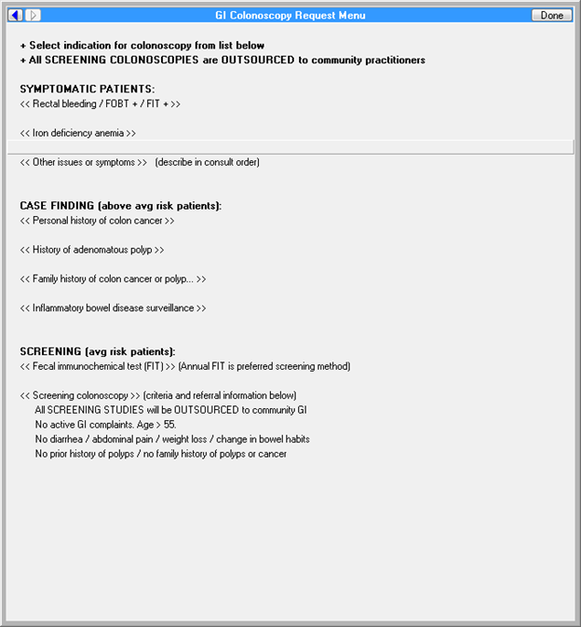

**Figure A.3. Reason for Request: GI Clinic – Colonoscopy Outpt**

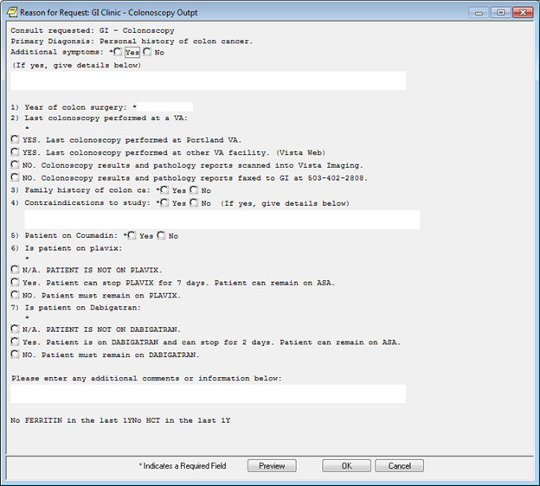

**Figure A.4. Order a Consult**

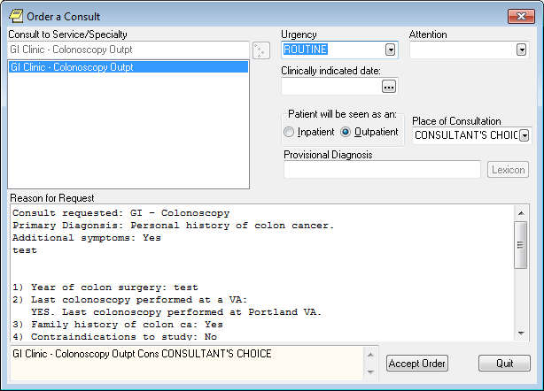

Figures 5-7 for the GI Colorectal Cancer Risk – Family history of colon cancer, colon cancer syndrome, or advanced adenoma – Order Sets are from the Portland VAMC

**Figure A.5. Colonoscopy Screening for Family Hx**

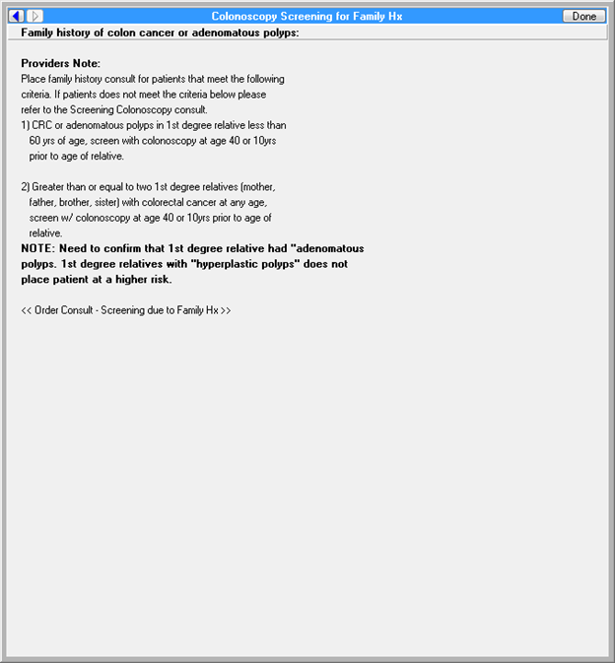

**Figure A.6. GI Clinic - Colonoscopy Outpt**

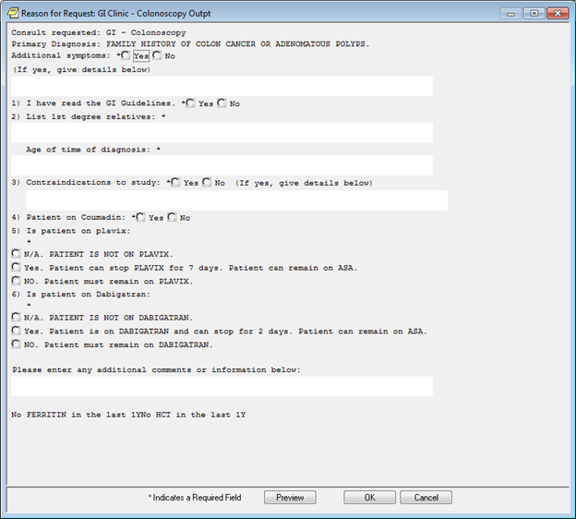

**Figure A.7. Order a Consult**

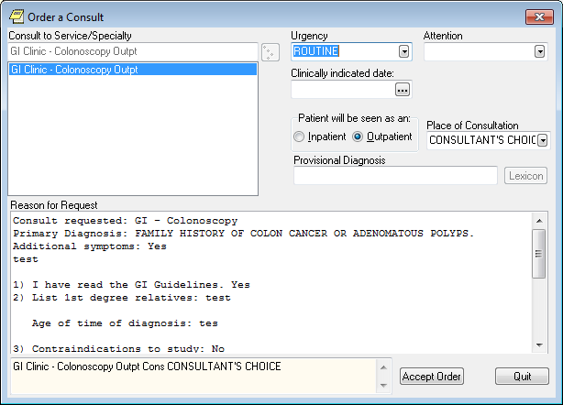

Figures 8-9 for the GI Colorectal Cancer Risk – Inflammatory bowel disease – Order Sets are from the Portland VAMC

**Figure A.8. GI Clinic - Colonoscopy Outpt**

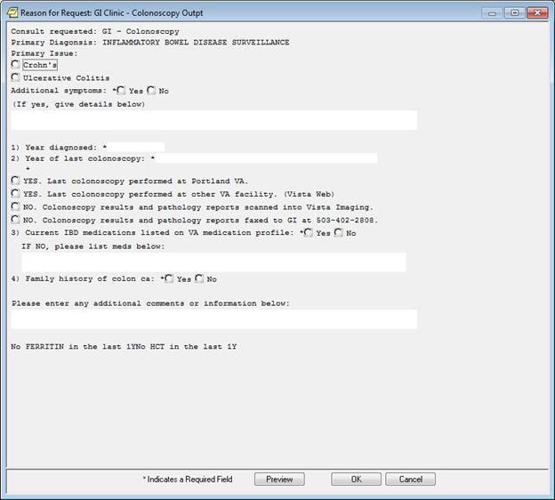

**Figure A.9. Order a Consult**

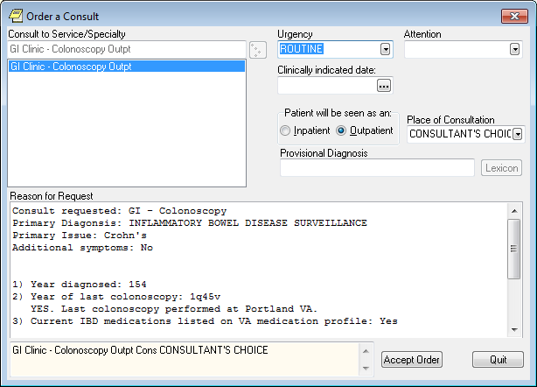

Figures 10-11 for the GI Colorectal Cancer Risk – Iron deficiency – Order Sets are from the Portland VAMC

**Figure A.10. Reason for Request: GI Clinic - Colonoscopy Outpt**

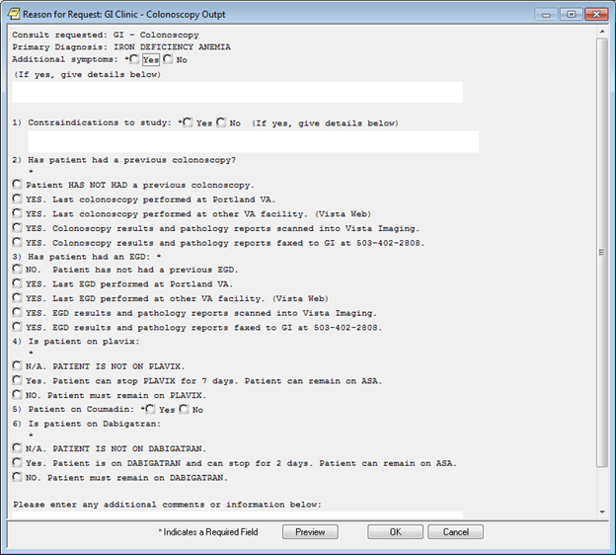

**Figure A.11. Order a Consult**

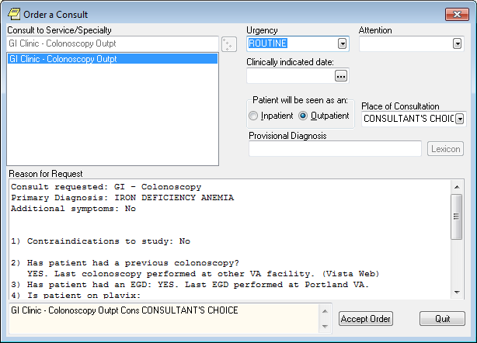

Figures 12-13 for the GI Colorectal Cancer Risk – Rectal bleeding, or positive screening test– Order Sets are from the Portland VAMC

**Figure A.12. GI Clinic - Colonoscopy Outpt**

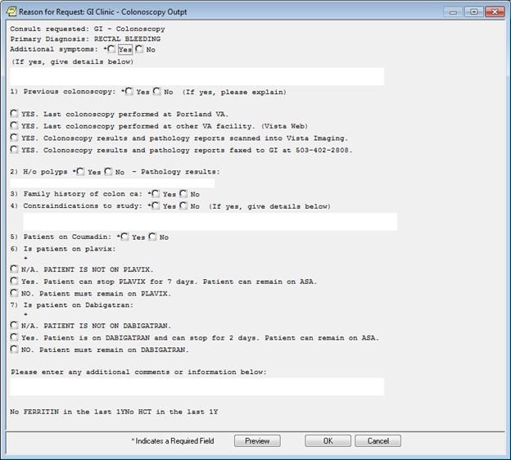

**Figure A.13. Order a Consult**

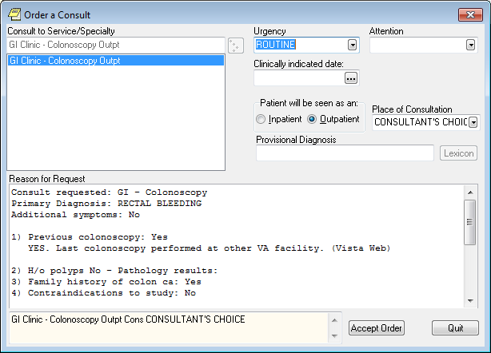

Figures 14-16 for the GI Colorectal Cancer Risk – Other Issues– Order Sets are from the Portland VAMC

**Figure A.14. Reason for Request: GI Clinic - Colonoscopy Output**

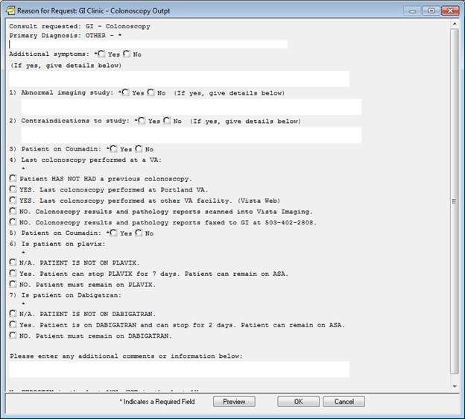

**Figure A.15. Reason for Request GI Clinic - Colonoscopy Output**

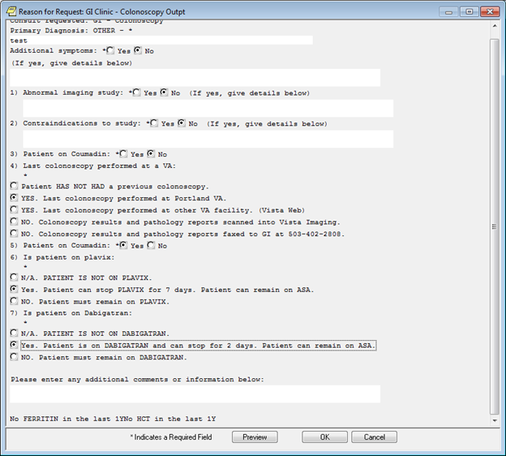

**Figure A.16. Order a Consult**

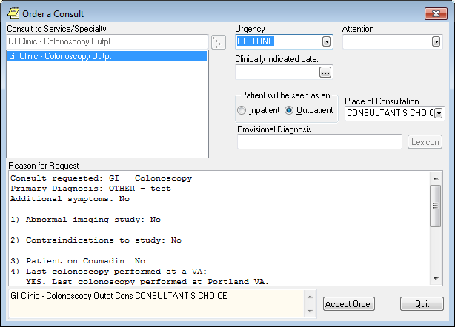

Figures 17-21 for the GI Colorectal Cancer Risk – Average risk screening– Order Sets are from the Portland VAMC

**Figure A.17. GI Colonoscopy Request Menu**

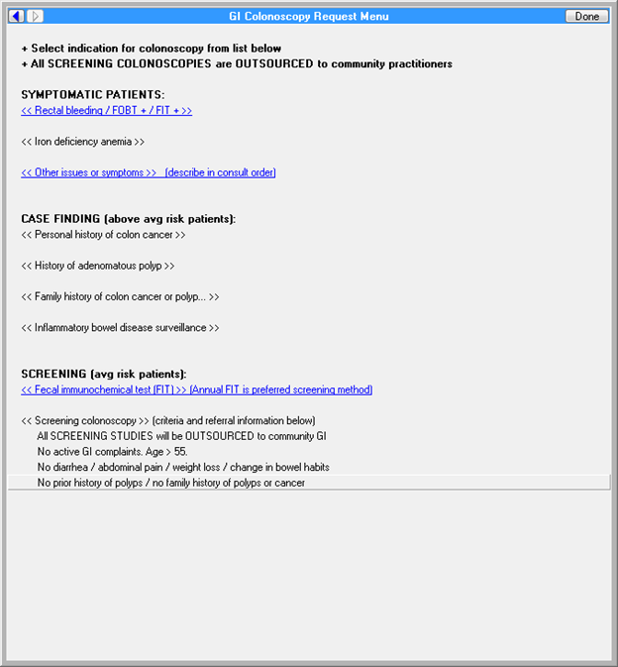

**Figure A.18. Template CHOICE-FIRST screening colonoscopy**

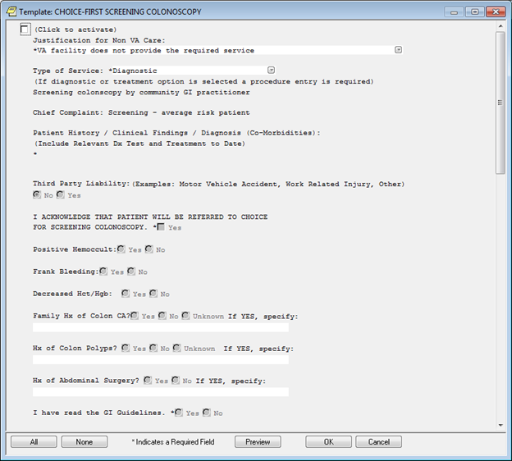

**Figure A.19.****CHOICE-FIRST screening colonoscopy**

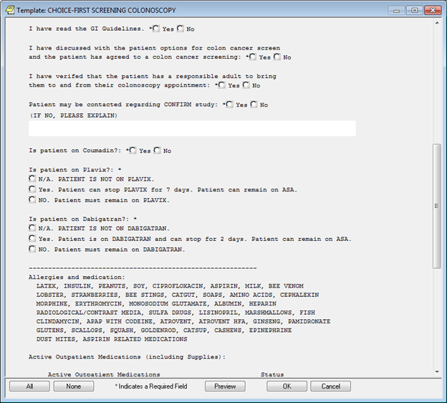

**Figure A.20.****CHOICE-FIRST screening colonoscopy**

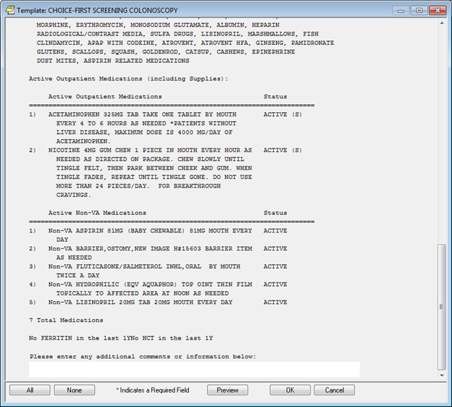

**Figure A.21. Order a Consult**

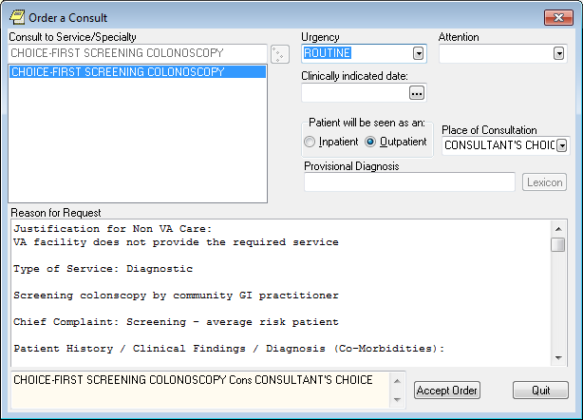

Figure 22 is for the GI Colorectal Cancer Risk – Fecal Immunochemical Test (FIT)– Order Sets are from the Portland VAMC

**Figure A.22. Order a Lab Test**

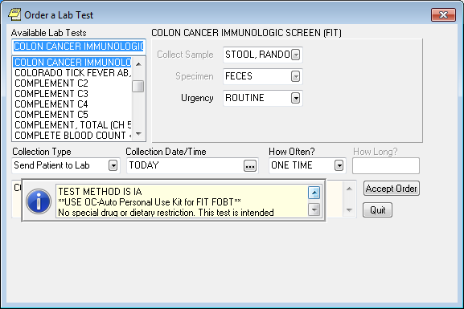

TEST METHOD IS IA

**USE OC-Auto Personal Use Kit for FIT FOBT**

No special drug or dietary restriction. This test is intended

only for the detection of hemoglobin in feces.

Patients with the following conditions should not be

considered for testing, as these conditions may interfere with

test results:

Bleeding hemorrhoids

Menstrual bleeding

Constipation bleeding

Urinary bleeding

Once the bleeding has ceased, collection may occur and

testing can be performed.

Testing will be routinely performed Monday through Friday 8am

to 3:30 pm. If fecal occult blood testing is needed outside of

these hours, submit guaiac occult blood card or send fresh

specimen to the lab, and order the Occult Blood, Random test.

**Appendix C.****Acronyms/Abbreviations**

| **CCWP** | **Clinical Content White Paper** |
| --- | --- |
| CCWP | Clinical Content White Paper |
| CDS | Clinical Decision Support |
| CT | Computed Tomography |
| DNA | Deoxyribonucleic Acid |
| ECA | Event Condition Action |
| FIT | Fecal Immunochemical Test |
| GI | Gastroenterology |
| HL7 | Health Level 7 |
| IBD | Inflammatory Bowel Disease |
| KBS | Knowledge Based Systems |
| KNART | Knowledge Artifact |
| OIIG | Office of Informatics and Information Governance |
| PCP | Primary Care Provider |
| SME | Subject Matter Expert |
| TO | Task Order |
| VA | Department of Veterans Affairs |
| VAMC | VA Medical Center |